NOTICE OF ORDER

Wildlife and Countryside Act 1981 – Section 53
CORNWALL COUNCIL
The Cornwall Council (Addition of Restricted Byways at Greenbottom in the Parish of Kenwyn) Modification Order 2023

Notice is hereby given that the above referenced Order has been submitted to the Secretary of State for Environment, Food and Rural Affairs for determination. An Inspector will be appointed by the Secretary of State to determine the Order.

The start date for the above Order is 30 December 2025.

Consideration of the Order will take the form of a public local inquiry.

The Inquiry will be held at New County Hall, Treyew Road, Truro, Cornwall, TR1 3AY on Tuesday 9 June 2026 at 10.00am.

The effect of the Order, if confirmed without modifications, will be to modify the definitive map and statement for the area by:
i) Adding a length of Restricted Byway in the Parish of Kenwyn commencing at the Parish Boundary and existing Byway Open to All Traffic 32 in the Parish of Chacewater approximately 280 metres west-south-west of “Trevone House” at Ordnance Survey Grid Reference (OSGR) SW 7592/4573, shown as point “A” on the attached Order map, then running in a generally east-north-easterly direction for a distance of 119 metres to
its junction with existing Footpath 22 Kenwyn at OSGR SW 7603/4577 shown as point “B” on the attached Order map, then running in a generally east-south-easterly, then easterly direction for a distance of 282 metres to its junction with another Restricted Byway to be added by this Order, approximately 118 metres east-south-east of “Trevone House” at OSGR SW 7631/4577 shown as point “C” on the attached Order map.
ii) Adding a length of Restricted Byway in the Parish of Kenwyn commencing at Classified Road A390, approximately 149 metres north-east of “Trevone House” at OSGR SW 7632/4586 shown as point “D” on the attached Order map then running in in a generally south-south-westerly direction for a distance of 91 metres to its junction with another Restricted Byway to be added by this Order at OSGR SW 7631/4577 shown as point “C” on the attached Order map, then running in in a generally south-south-easterly, then west-south-westerly,then southerly direction for a distance of 652 metres to its junction with another Restricted Byway to be added by this Order at OSGR SW 7634/4518 shown as point “E” on the attached Order map, then running in a generally south-south-westerly direction for a distance of 213 metres, terminating at its junction with Classified Road C723, approximately 380 metres south-south-west of “Penstraze Moors” at OSGR SW 7632/4497 shown as point “F” on the attached Order map.
iii) Adding a length of Restricted Byway in the Parish of Kenwyn commencing at its junction with another Restricted Byway to be added by this Order, approximately 170 metres south-south-west of “Penstraze
Moors” at OSGR SW 7634/4518 shown as point “E” on the attached Order map, then running in a generally easterly, then north-north easterly direction for a distance of 215 metres, to its junction with another Restricted Byway to be added by this Order at OSGR SW 7647/4534 shown as point “G” on the attached Order map, then running in a generally north-north-easterly direction for a distance of 413 metres terminating at its junction with Classified Road A390 approximately 474 metres north-east of “Penstraze Moors” at OSGR SW 7672/4567 shown as point “H” on the attached Order map.
iv) Adding a length of Restricted Byway in the Parish of Kenwyn commencing at its junction with another Restricted Byway to be added by this Order, approximately 100 metres east of “Penstraze Moors” at OSGR
SW 7647/4534 shown as point “G” on the attached Order map, then running in a generally east-south-easterly,then southerly direction for a distance of 183 metres to its junction with another Restricted Byway to be added by this Order at OSGR SW 7653/4520 shown as point “I” on the attached Order map, then running in a generally southerly direction for a distance of 169 metres terminating at its junction with Classified Road C723 approximately 356 metres south-south-east of “Penstraze Moors” at OSGR SW 7652/4503 shown as point “J” on the attached Order map.
v) Adding a length of Restricted Byway in the Parish of Kenwyn commencing at its junction with another Restricted Byway to be added by this Order, approximately 220 metres south-east of “Penstraze Moors” at OSGR SW 7653/4520 shown as point “I” on the attached Order map, then running in a generally north-easterly direction for a distance of 358 metres, to its junction with another Restricted Byway to be added by this Order at OSGR SW 7681/4541 shown as point “K” on the attached Order map, then running in a generally north-easterly direction for a distance of 90 metres to its junction with another Restricted Byway to be added by this Order, at OSGR SW 7689/4546 shown as point “L” on the attached Order map, then running in a generally north-easterly direction for a distance of 96 metres, terminating at its junction with Classified Road A390 approximately 332 metres north-north-east of “Pol-Chy” at OSGR SW 7696/4553 shown as point “M” on the attached Order map.
vi) Adding a length of Restricted Byway in the Parish of Kenwyn commencing at its junction with another Restricted Byway to be added by this Order, approximately 207 metres north-north-west of “Pol-Chy” at
OSGR SW 7681/4541 shown as point “K” on the attached Order map, then running in a generally south-south-easterly direction for a distance of 274 metres, to its junction with another Restricted Byway to be added by this Order at OSGR SW 7692/4516 shown as point “N” on the attached Order map, then running in a generally south-westerly, then southerly direction for a distance of 51 metres terminating at its junction with Classified Road C723 approximately 112 metres south-south-east of “Pol-Chy” at OSGR SW 7693/4511 shown as point “O” on the attached Order map.
vii) Adding a length of Restricted Byway in the Parish of Kenwyn commencing at its junction with another Restricted Byway to be added by this Order, approximately 73 metres south-south-east of “Pol-Chy” at OSGR SW 7692/4516 shown as point “N” on the attached Order map, then running in a generally easterly, then southerly direction for a distance of 157 metres terminating at its junction with Classified Road C723 approximately 190 metres south-east of “Pol-Chy” at OSGR SW 7705/4514 shown as point “P” on the attached Order map.
viii) Adding a length of Restricted Byway in the Parish of Kenwyn commencing at its junction with another Restricted Byway to be added by this Order, approximately 252 metres north-north-east of “Pol-Chy” at
OSGR SW 7689/4546 shown as point “L” on the attached Order map, then running in a generally south-south-easterly, then south-westerly, then south-south-easterly, then southerly direction for a distance of 415 metres terminating at its junction with Classified Road C723 approximately 216 metres east-south-east of “Pol-Chy” at OSGR SW 7708/4515 shown as point “Q” on the attached Order map.

Any queries relating to this Order should be referred to Helen Sparks by email: helen.sparks@planninginspectorate.gov.uk quoting reference number ROW/3354505 on all correspondence. Alternatively, queries may be sent in writing to The Planning Inspectorate, c/o QUADIENT, 69 Buckingham Avenue, Slough, Berkshire, SL1 4PN. Telephone: 0303 444 5682.

Any person wishing to view the statements of case and other documents
relating to this Order may do so by appointment at New County Hall,
Treyew Road, Truro, Cornwall TR1 3AY. Please contact Mr Tim Passmore by
email: PROW@cornwall.gov.uk or Telephone: 01872 322222.
Alternatively, the documents can be viewed online at:
https://www.cornwall.gov.uk/environment/countryside/definitive-map-and-statement/submissions-to-the-secretary-of-state-dmmo/
If you have any queries, please contact Mr Tim Passmore by e-mail PROW@cornwall.gov.uk or Telephone: 01872 322222.

Timetable for sending in statements of case and proofs of evidence

Within 8 weeks of the start date by [by 24 February 2026]

The Order Making Authority, or where the Order Making Authority is taking a neutral stance and the applicant or other party are taking the case forward in support of the order, must ensure their statement of case is received by the Secretary of State. As soon as possible after the deadline, the Secretary of State will send a copy (excluding copies of any supporting documents - these will be available to view at the Authority’s offices) to everyone who has made an objection or representation and the applicant and any other person who has written to us in respect of the Order.

Within 14 weeks of the start date [by 7 April 2026]

Everyone who has made an objection or representation and anyone who wishes to give evidence at the Inquiry must ensure their statement of case is received by the Secretary of State. As soon as possible after the deadline, the Secretary of State will send full copies to the Authority. Copies will also be sent to the applicant, every person who has made an objection or representation and any other person who has written to us in respect of the Order (excluding copies of any supporting documents - these will be available to view at the Authority’s offices).

Within the same period the applicant (if applicable) must ensure their statement of case is received by the Secretary of State. As soon as possible after the deadline, the Secretary of State will send a full copy to the Authority. Copies will also be sent to everyone who has made an objection or representation and any other person who has written to us in respect of the Order (excluding copies of any supporting documents - these will be available to view at the Authority’s offices).

4 weeks before the date of the inquiry [by 12 May 2026]

The Authority, everyone who has made an objection or representation, the applicant (if applicable) and anyone who wishes to give evidence at the Inquiry must ensure their proof of evidence (together with any summary) is received by the Secretary of State. As soon as possible after the deadline, the Secretary of State will send copies of:

- the Authority’s proof of evidence to everyone who has made an objection or representation, the applicant and anyone who has submitted a statement of case (including copies of any supporting documents – although none should be submitted with a proof of evidence);

- the applicant’s proof of evidence to the Authority, everyone who has made an objection or representation and anyone else who has submitted a statement of case (including copies of any supporting documents – although none should be submitted with a proof of evidence); and

- all other proofs of evidence to the Authority, the applicant, everyone who has made an objection or representation and anyone else who has submitted a statement of case (including copies of any supporting documents – although none should not be submitted with a proof of evidence).

All parties must keep to the timetable set out above and ensure that statements of case and proofs of evidence are received by the Secretary of State on time. Late documents will be returned.

We cannot accept any inflammatory, discriminatory or abusive comments. Any documents containing such comments will be returned.

If you use Artificial Intelligence (AI) to create or alter any part of your documents, information or data, you should tell us that you have done this when you provide the material to us. See the detailed guidance for further information.

Notice of order for inquiry

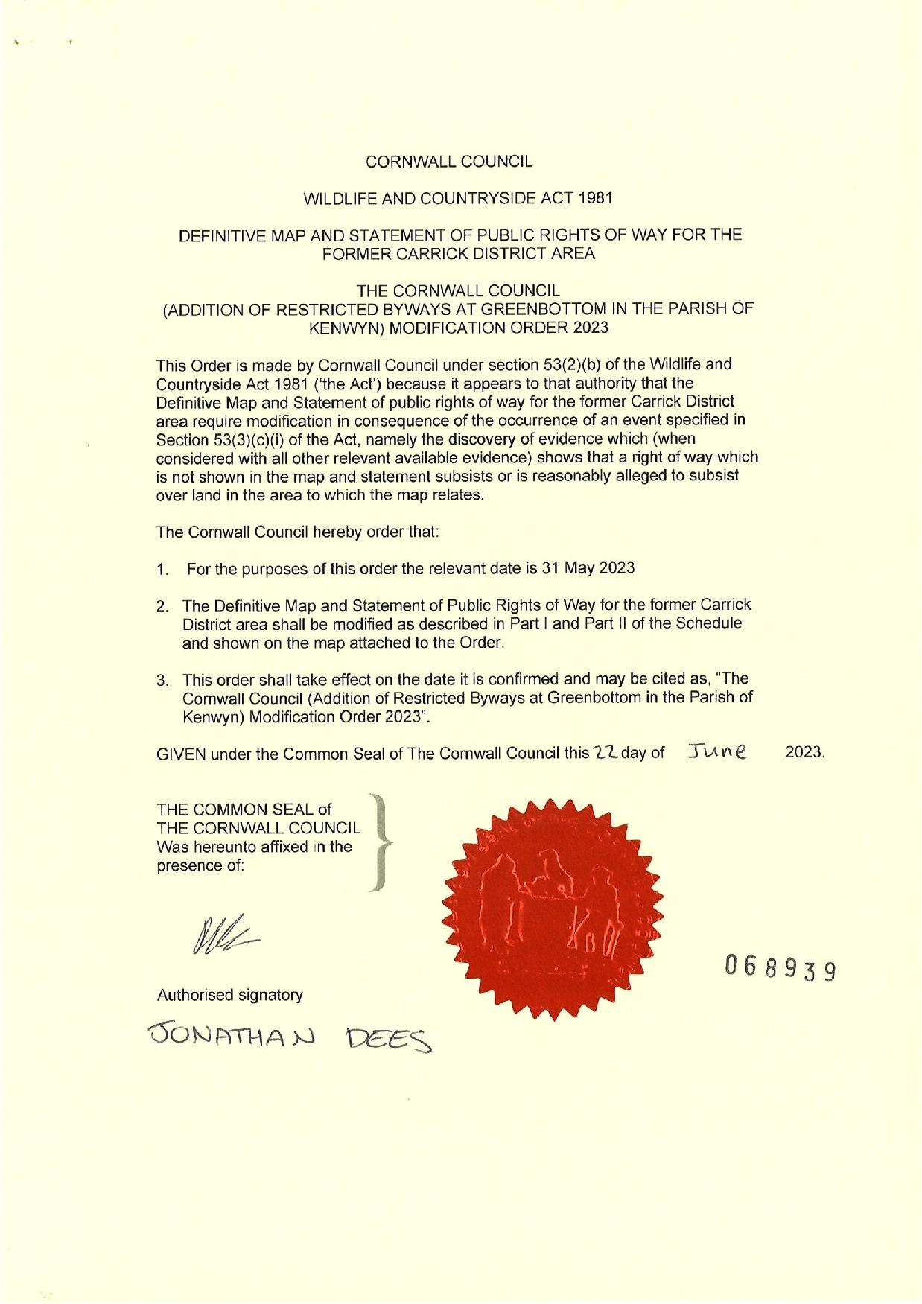

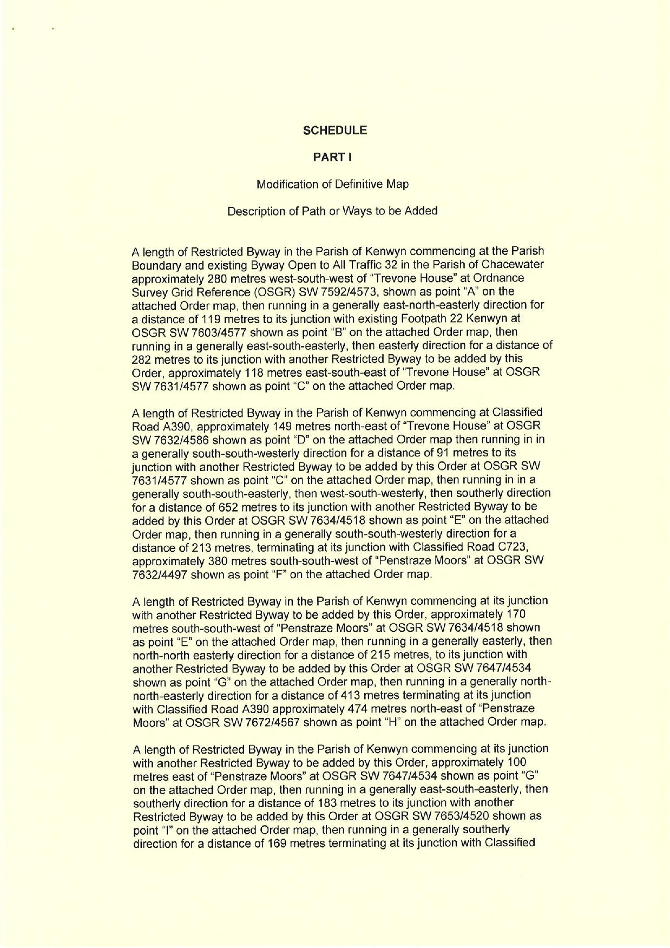

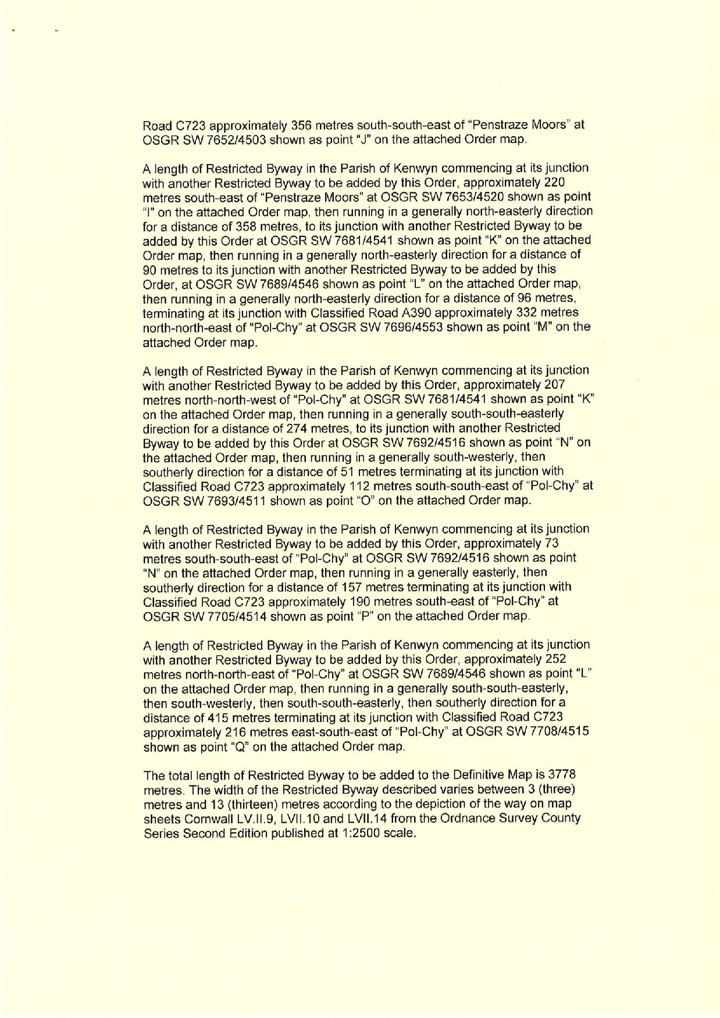

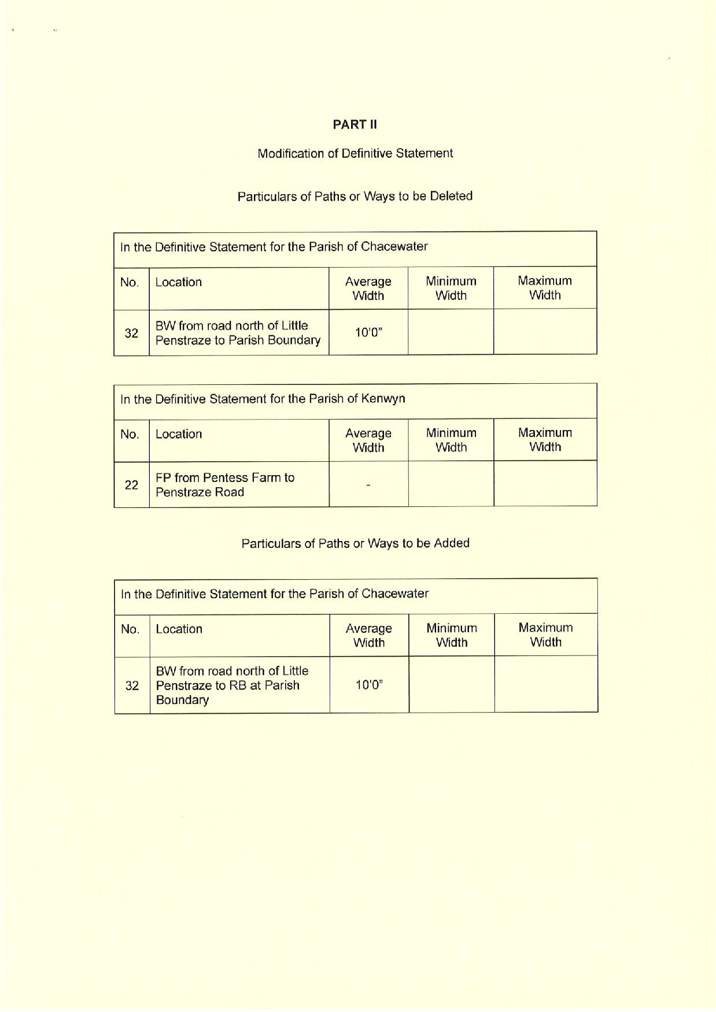

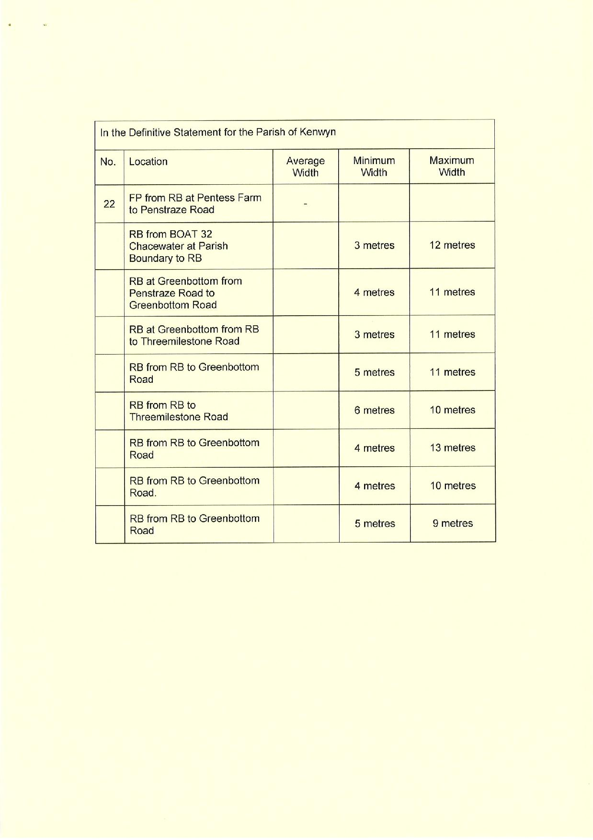

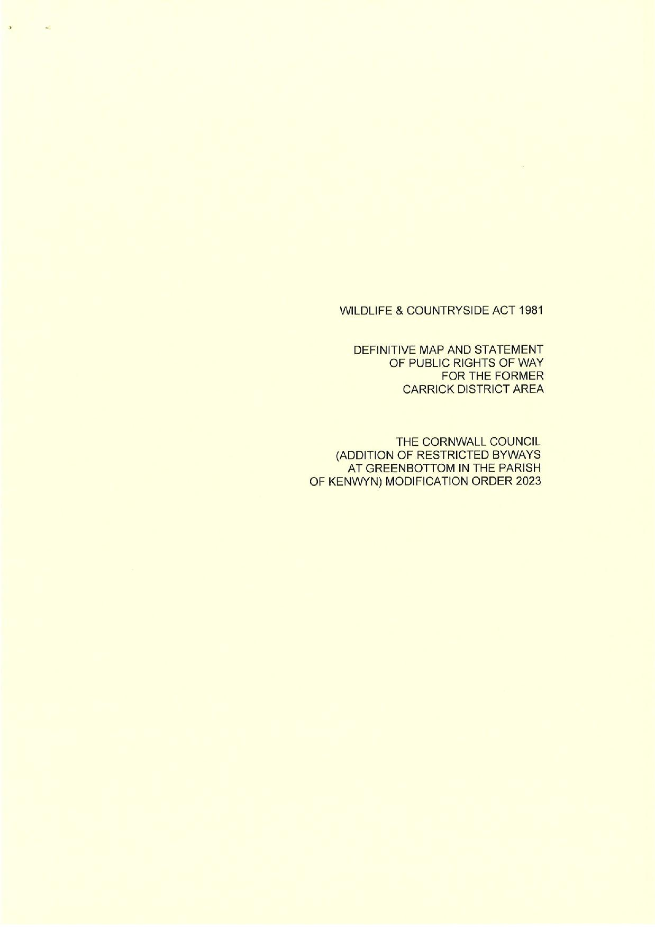

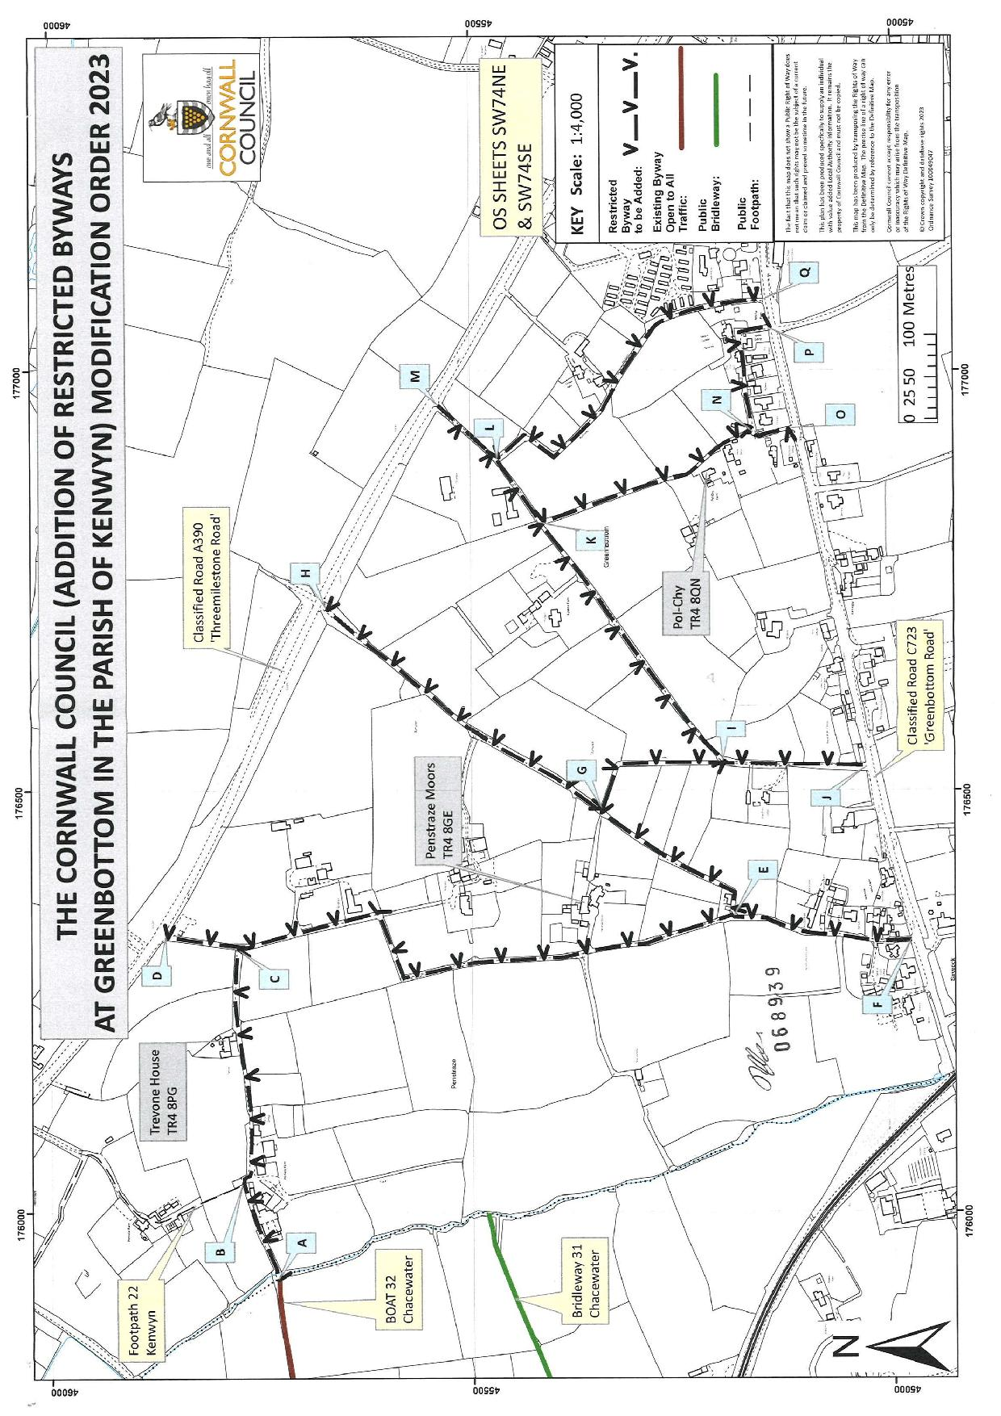

If you wish to make a legal submission, this should be submitted at the same time as your statement of case. Otherwise legal submissions will have to be submitted in writing on the day of the inquiry.

