NOTICE OF ORDER

Wildlife and Countryside Act 1981 – Section 53
CORNWALL COUNCIL
The Cornwall Council (Addition of a Footpath at Choone Farm in the Parish of St. Buryan, Lamorna & Paul) Modification Order 2023

Notice is hereby given that the above referenced Order has been submitted to the Secretary of State for Environment, Food and Rural Affairs for determination. An Inspector will be appointed by the Secretary of State to determine the Order.

The start date for the above Order is 18 November 2025.

Consideration of the Order will take the form of a public local inquiry.

The Inquiry will be held at New County Hall, Treyew Road, Truro, Cornwall, TR1 3AY on Tuesday 5 May 2026 at 10.00am.

The effect of the Order, if confirmed without modifications, will be to modify the definitive map & statement for the area by:
Adding a length of Public Footpath in the Parish of St Buryan, Lamorna & Paul commencing at Classified Road C0157, approximately 175 metres west of “Choone Farm”, at Ordnance Survey Grid Reference (OSGR) SW
4224/2464 shown as point “A” on the attached Order map, then running in a generally east-south-easterly direction for a distance of 645 metres terminating at its junction with existing Public Footpath 83 St Buryan,
Lamorna & Paul approximately 474 metres east-south-east of “Choone Farm”, at OSGR SW 4287/2452 shown as point “B” on the attached Order map.

Any queries relating to this Order should be referred to Helen Sparks by email: helen.sparks@planninginspectorate.gov.uk quoting reference number ROW/3353568 on all correspondence. Alternatively, queries may be sent in writing to The Planning Inspectorate, Rights of Way Section, Room 3/A Eagle Wing, Temple Quay House, 2 The Square, Temple Quay, Bristol, BS1 6PN. Telephone: 0303 444 5682.

Any person wishing to view the statements of case and other documents relating to this Order may do so by appointment at New County Hall, Treyew Road, Truro, Cornwall TR1 3AY. If there are any queries, please contact Mr Tim Passmore by E-mail: PROW@cornwall.gov.uk or by Telephone: 01872 322222. Alternatively, the documents can be viewed online at:
https://www.cornwall.gov.uk/environment/countryside/definitive-map-and-statement/submissions-to-the-secretary-of-state-dmmo/

As the Authority have indicated that they will not be supporting the Order at the Inquiry, the case for the Order will be presented by Ms Anna McClary. She will be expected to adhere to the following timetable as if she were the Authority.

Timetable for sending in statements of case and proofs of evidence

Within 8 weeks of the start date by [by 13 January 2026]

The Order Making Authority, or where the Order Making Authority is taking a neutral stance and the applicant or other party are taking the case forward in support of the order, must ensure their statement of case is received by the Secretary of State. As soon as possible after the deadline, the Secretary of State will send a copy (excluding copies of any supporting documents - these will be available to view at the Authority’s offices) to everyone who has made an objection or representation and the applicant and any other person who has written to us in respect of the Order.

Within 14 weeks of the start date [by 24 February 2026]

Everyone who has made an objection or representation and anyone who wishes to give evidence at the Inquiry must ensure their statement of case is received by the Secretary of State. As soon as possible after the deadline, the Secretary of State will send full copies to the Authority. Copies will also be sent to the applicant, every person who has made an objection or representation and any other person who has written to us in respect of the Order (excluding copies of any supporting documents - these will be available to view at the Authority’s offices).

Within the same period the applicant (if applicable) must ensure their statement of case is received by the Secretary of State. As soon as possible after the deadline, the Secretary of State will send a full copy to the Authority. Copies will also be sent to everyone who has made an objection or representation and any other person who has written to us in respect of the Order (excluding copies of any supporting documents - these will be available to view at the Authority’s offices).

4 weeks before the date of the inquiry [by 7 April 2026]

The Authority, everyone who has made an objection or representation, the applicant (if applicable) and anyone who wishes to give evidence at the Inquiry must ensure their proof of evidence (together with any summary) is received by the Secretary of State. As soon as possible after the deadline, the Secretary of State will send copies of:

- the Authority’s proof of evidence to everyone who has made an objection or representation, the applicant and anyone who has submitted a statement of case (including copies of any supporting documents – although none should be submitted with a proof of evidence);

- the applicant’s proof of evidence to the Authority, everyone who has made an objection or representation and anyone else who has submitted a statement of case (including copies of any supporting documents – although none should be submitted with a proof of evidence); and

- all other proofs of evidence to the Authority, the applicant, everyone who has made an objection or representation and anyone else who has submitted a statement of case (including copies of any supporting documents – although none should not be submitted with a proof of evidence).

All parties must keep to the timetable set out above and ensure that statements of case and proofs of evidence are received by the Secretary of State on time. Late documents will be returned.

We cannot accept any inflammatory, discriminatory or abusive comments. Any documents containing such comments will be returned.

If you use Artificial Intelligence (AI) to create or alter any part of your documents, information or data, you should tell us that you have done this when you provide the material to us. See the detailed guidance for further information.

Notice of order for inquiry

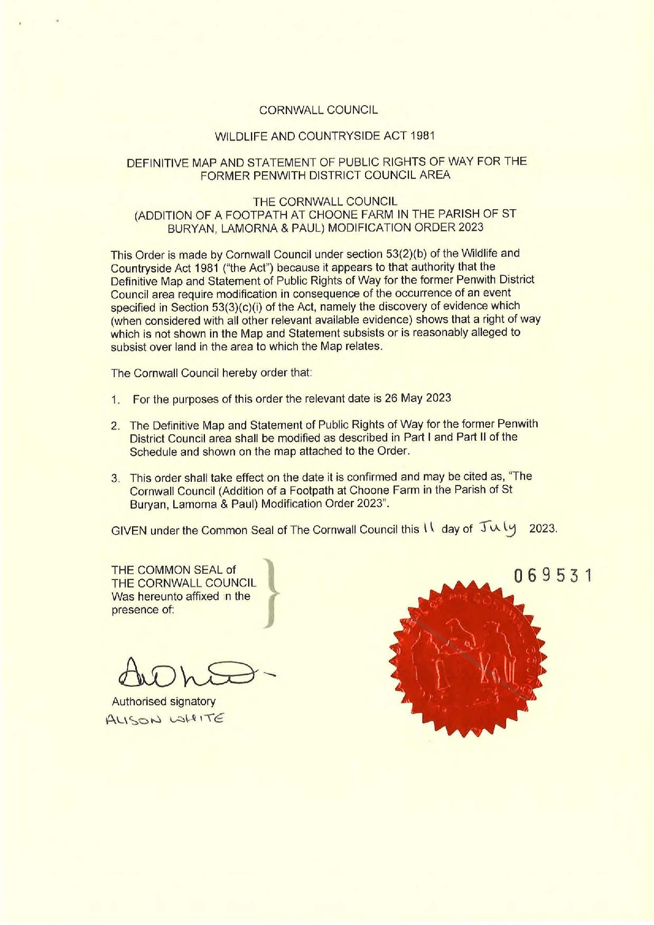

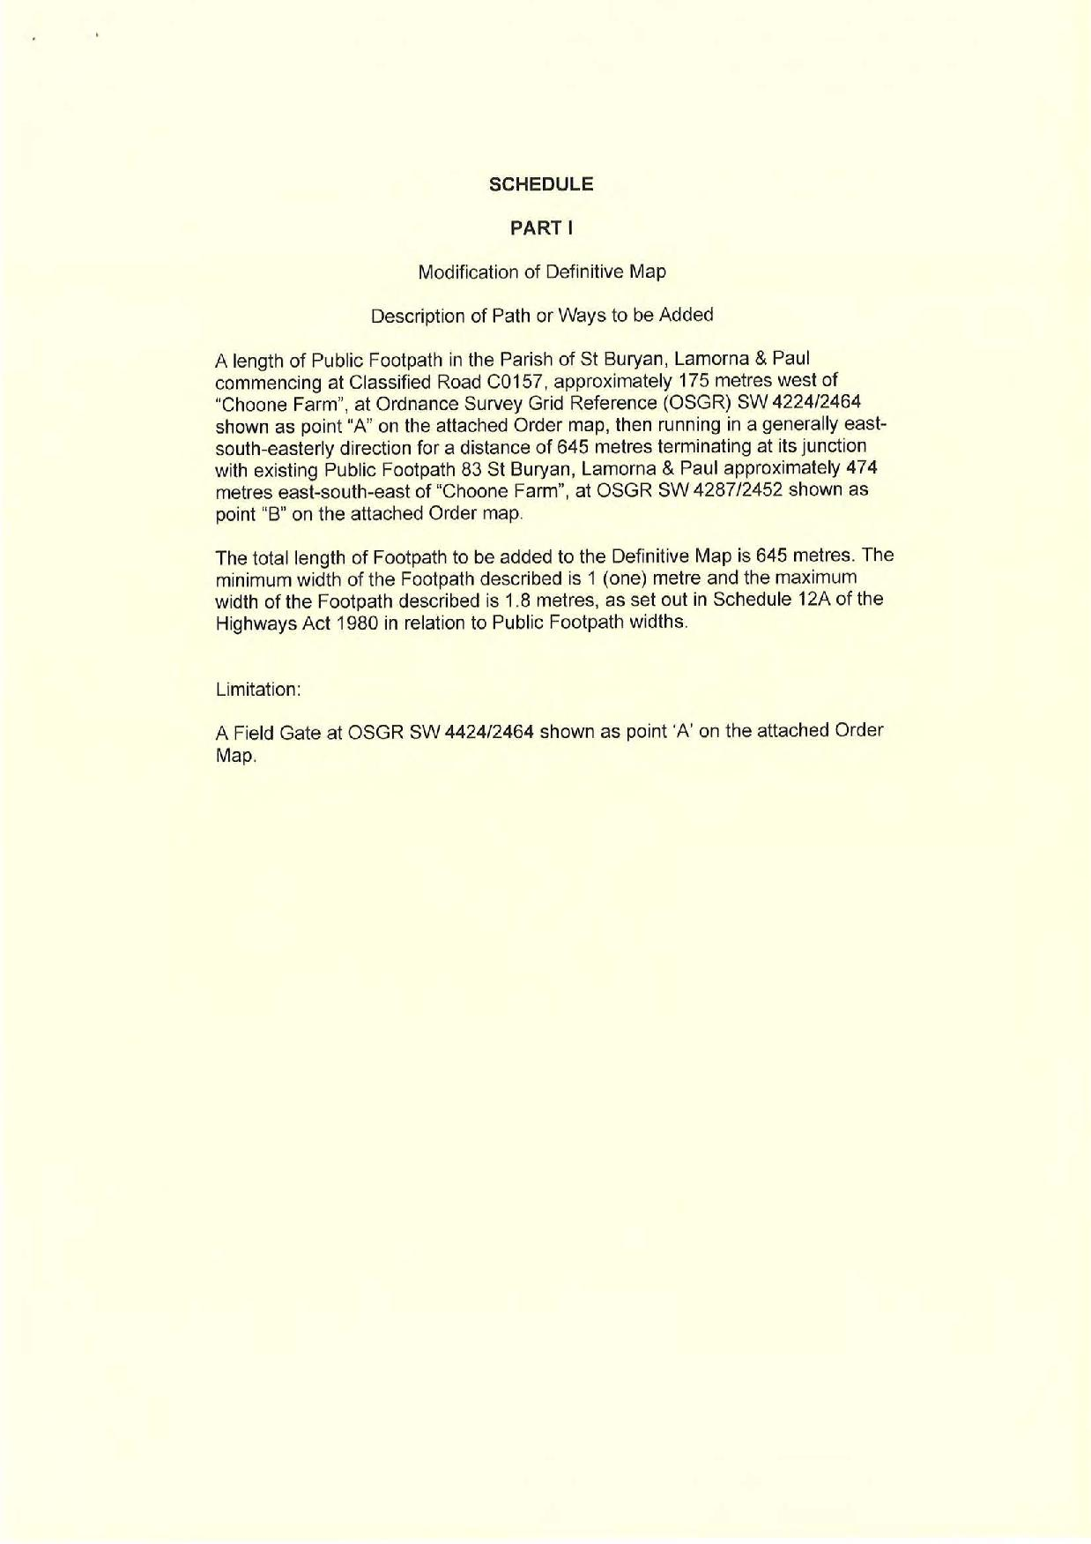

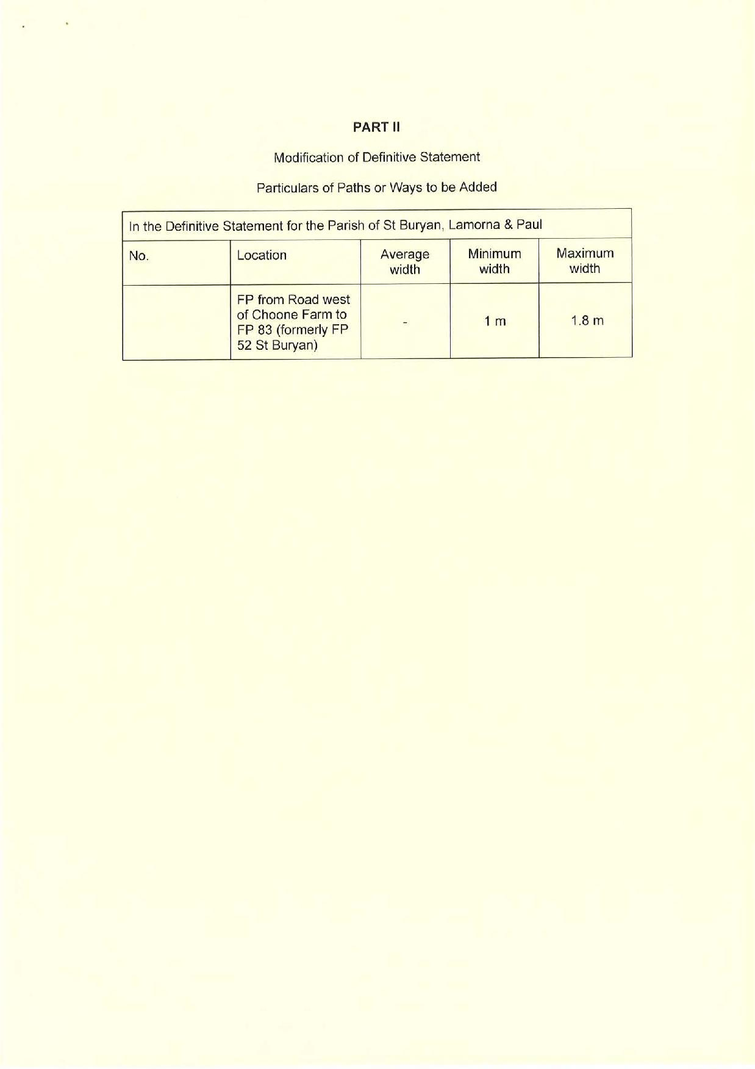

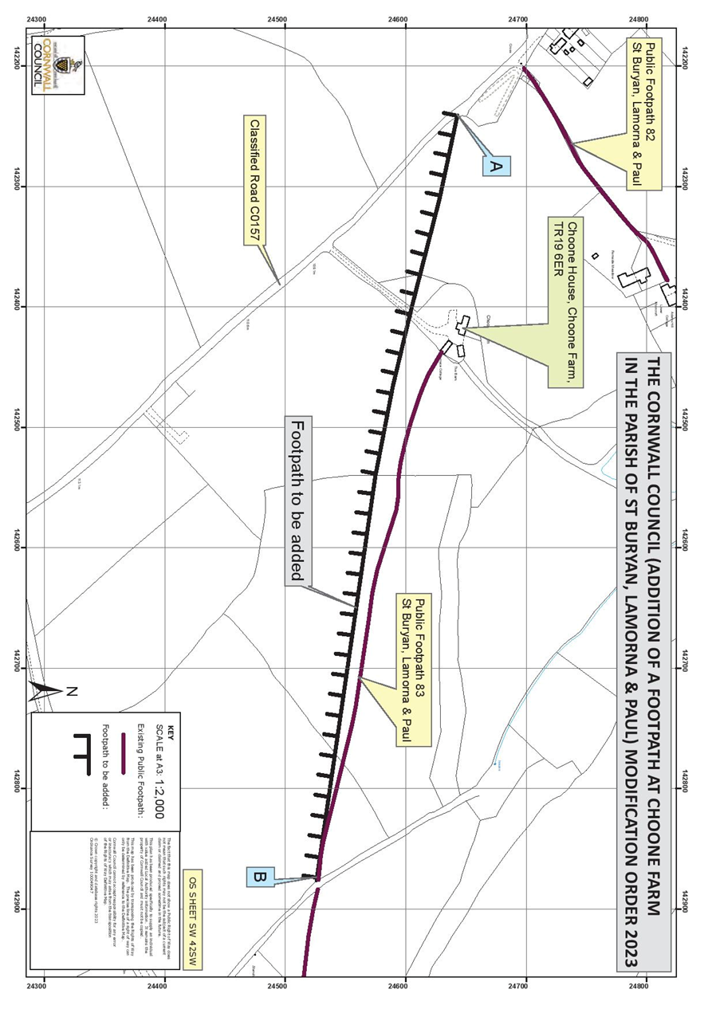

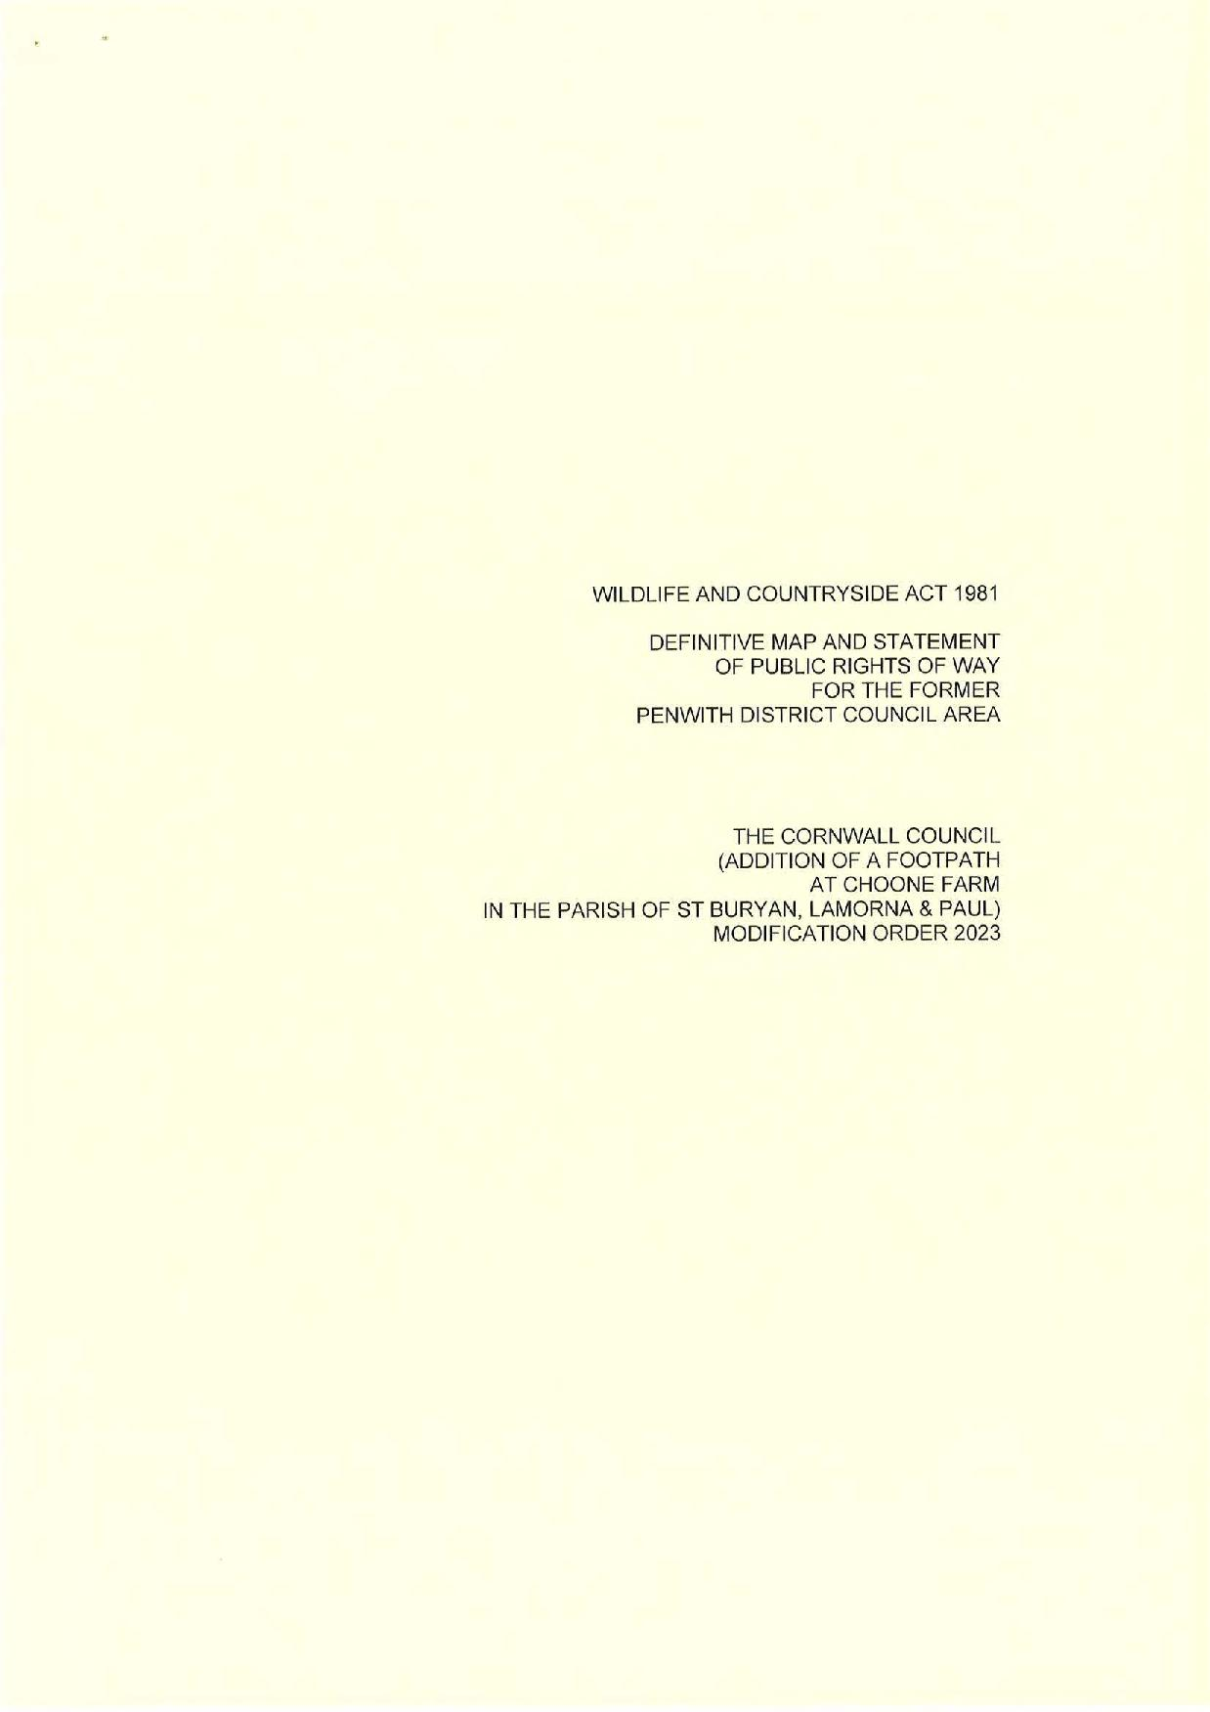

If you wish to make a legal submission, this should be submitted at the same time as your statement of case. Otherwise legal submissions will have to be submitted in writing on the day of the inquiry.

