NOTICE OF ORDER

Wildlife and Countryside Act 1981
Lancashire County Council
THE LANCASHIRE COUNTY COUNCIL (FOOTPATH FROM CLITHEROE STREET TO GUY STREET, PADIHAM, BURNLEY) DEFINITIVE MAP MODIFICATION ORDER 2017

Notice is hereby given that the above referenced Order has been submitted to the Secretary of State for Environment, Food and Rural Affairs for determination. An Inspector will be appointed by the Secretary of State to determine the Order.

The start date for the above Order is 9 December 2025. Consideration of the Order will take the form of a public local inquiry.
The Inquiry will be held at Padiham Town Council, Town Hall, Burnley Road, Padiham, Burnley, BB12 8BS on 12 MAY 2026 at 10.00am.

The effect of the Order, if confirmed without modifications, will be to add a footpath starting at the junction with Clitheroe Street at SD 7947 3408 (point A) ascending a flight of 5 stone steps and running in an approximately northerly direction along a stone flagged path across a car park to ascend a further flight of 5 stone steps at SD 7947 3409 (point B) and then continuing along a flagged pathway to terminate at a junction with the tarmac footway of Guy Street at SD 7947 3409 (point C) as shown on the attached plan.

Any queries relating to this Order should be referred to Paul Scrivener by email: paul.scrivener@planninginspectorate.gov.uk quoting reference number ROW/3357102 on all correspondence. Alternatively, queries may be sent in writing to The Planning Inspectorate, Rights of Way Section, Room 3/A Eagle Wing, Temple Quay House, 2 The Square, Temple Quay, Bristol, BS1 6PN. Telephone: 0303 444 5000.
Any person wishing to view the statements of case and other documents relating to this Order may do so by appointment at County Hall, Fishergate, Preston, PR1 0LD, for further information please contact Simon Moore at simon.moore@lancashire.gov.uk or on 01772 531280. Documents have also been made available online via URL address: https://www.lancashire.gov.uk/council/transparency/dmmos/guy-street-2017

Timetable for sending in statements of case and proofs of evidence Within 8 weeks of the start date by 3 February 2026.
The Order Making Authority, or where the Order Making Authority is taking a neutral stance and the applicant or other party are taking the case forward in support of the order, must ensure their statement of case is received by the Secretary of State. As soon as possible after the deadline, the Secretary of State will send a copy (excluding copies of any supporting documents - these will be available to view at the Authority’s offices) to everyone who has made an objection or representation and the applicant and any other person who has written to us in respect of the Order.

Within 14 weeks of the start date by 17 March 2026.
Everyone who has made an objection or representation and anyone who wishes to give evidence at the Inquiry must ensure their statement of case1 is received by the Secretary of State. As soon as possible after the deadline, the Secretary of State will send full copies to the Authority. Copies will also be sent to the applicant, every person who has made an objection or representation and any other person who has written to us in respect of the Order (excluding copies of any supporting documents - these will be available to view at the Authority’s offices).

Within the same period the applicant (if applicable) must ensure their statement of case is received by the Secretary of State. As soon as possible after the deadline, the Secretary of State will send a full copy to the Authority. Copies will also be sent to everyone who has made an objection or representation and any other person who has written to us in respect of the Order (excluding copies of any supporting documents - these will be available to view at the Authority’s offices).

4 weeks before the date of the inquiry by 14 April 2026.
The Authority, everyone who has made an objection or representation, the applicant (if applicable) and anyone who wishes to give evidence at the Inquiry must ensure their proof of evidence (together with any summary) is received by the Secretary of State. As soon as possible after the deadline, the Secretary of State will send copies of:
- the Authority’s proof of evidence to everyone who has made an objection or representation, the applicant and anyone who has submitted a statement of case (including copies of any supporting documents – although none should be submitted with a proof of evidence);

1 If you wish to make a legal submission, this should be submitted at the same time as your statement of case. Otherwise legal submissions will have to be submitted in writing on the day of the inquiry.
- the applicant’s proof of evidence to the Authority, everyone who has made an objection or representation and anyone else who has submitted a statement of case (including copies of any supporting documents – although none should be submitted with a proof of evidence); and
- all other proofs of evidence to the Authority, the applicant, everyone who has made an objection or representation and anyone else who has submitted a statement of case (including copies of any supporting documents – although none should not be submitted with a proof of evidence).

All parties must keep to the timetable set out above and ensure that statements of case and proofs of evidence are received by the Secretary of State on time. Late documents will be returned.

We cannot accept any inflammatory, discriminatory or abusive comments. Any documents containing such comments will be returned.
If you use Artificial Intelligence (AI) to create or alter any part of your documents, information or data, you should tell us that you have done this when you provide the material to us. See the detailed guidance for further information.

Notice of order for inquiry
WILDLIFE AND COUNTRYSIDE ACT 1981

THE DEFINITIVE MAP AND STATEMENT OF PUBLIC RIGHTS OF WAY FOR THE COUNTY OF LANCASHIRE
THE LANCASHIRE COUNTY COUNCIL (FOOTPATH FROM CLITHEROE STREET TO GUY STREET, PADIHAM, BURNLEY) DEFINITIVE MAP MODIFICATION ORDER 2017

This Order is made by Lancashire County Council ("the Authority'') under Section 53(2)(b) of the Wildlife and Countryside Act, 1981 ("the Act") because it appears to that Authority that The Definitive Map and Statement of Public Rights of Way for the County of Lancashire require modification in consequence of the occurrence of an event specified in 53(3)(c)(i) namely the discovery by the Surveying Authority of evidence which (when considered with all other relevant evidence available to them) shows that a right of way which is not shown in the map and statement subsists or is reasonably alleged to subsist over land in the area to which the map relates, namely a public footpath.

The Authority have consulted with every local authority whose area includes the land to which the Order relates. Lancashire County Council hereby order that:

  - For the purposes of this Order, the "relevant date" is the 27th Septemper 2017.
  - The Definitive Map and Statement of Public Rights of Way for the County of Lancashire shall be modified as described in Part I and Part II of the Schedule and shown on the map attached to the Order.

  - This Order shall take effect on the date it is confirmed and may be cited as The Lancashire County Council (Footpath from Clitheroe Street to Guy Street, Padiham, Burnley) Definitive Map Modification Order 2017.


Dated this 27th day of September 2017

THE COMMON SEAL of the )
Lancashire County Council ) Was hereunto affixed in the presence of)

Authorised Signatory

�
SCHEDULE
PART 1
MODIFICATION OF THE DEFINITIVE MAP

DESCRIPTION OF PATH TO_BEADDED
A public footpath varying in width between 1.1 metres and 1.5 metres from the northern end of Clitheroe Street, Padiham adjacent to the Kingdom Hall (point A on the Order plan) ascending five stone steps and running in a northerly direction along a stone flagged path through the Victoria Mill apartment car park to ascend a further set of 5 stone steps (point B) and then continuing along a flagged pathway to the tarmac footway of Guy Street at point C. A distance of approximately 13 metres.

PART II
MODIFICATION OF DEFINITIVE STATEMENT

YARIATJON OF PARTICULARS OF PATH
Add to the Definitive Statement for Padiham the following

"Footpath 36 from a junction with Clitheroe Street at SD 7947 3408 ascending a flight of 5 stone steps and running in an approximately northerly direction along a stone flagged path across a car park to ascend a further flight of 5 stone steps at SD 7947 3409 and then continuing along a flagged pathway to terminate at a junction with the tarmac footway of Guy Street at SD 7947 3409.
Width: Varying between 1.4 and 1.5 metres from SD 7947 3408 to SD 7947 3409 with width reducing to 1.10 metres where path passes through gap in wall at
SD 7947 3409
Limitations and Conditions: None Length: 13 metres"
R"..<. -C- L\ffE. s,to:,'-
I -··""-
379500 ,·;
''.. .

.- .-
..
---- ---- ------ -::::::::::::: ----------• _,
........---
. ,,I
I'• I
t I
.
'
•I ••
' 'I.
-· .. ..
,, ,,.
,
..
'• '•
.'. ,

102.7m
,, , .
..,..-,·,,
.
..-.. ...
\•... --
..

·""C.:�
.
.
I

)

.. ----··
, --·
. ·..
-· , ..-
'.... �
....,...,.. ..�. •
, I
...,.

,•
.. ---- - -·
. I
--
_ --
-------' ----

..
Cl
) --.:::::::::�::::-:'.:::::::::::::::::::::::::------
t
�
t - . - - - - - -_-_-_-_- - - -_-_-_-_-_-_-_-_-_-_-_-_-_-_-_-_-_-_:_-_c_,.-_-_-_-_-_-_-_-_·_-_-_-_-_-:_-_-_-_-_-_-.-_._._�- - - - - - - - -
.C.l..
M

El Sutw;ta
•
-..- - ..

\,.-<irr,,- '- ,·,• ..,_ --,
'I
'

I I I
-
0)
,_.),,

g,
'N
•I
•'.I
' _,. ',
•, �'
- ,r\ \
-:c.
I \I� I
1. I
t O �
I ', .',,.;,- I

·-· .
I
'I
I •
'I (Jli
'1
·,
�-'
Ir- I
Victoria Apartments

: :c
Im I
:
,:]
0m·.
(/) :I

Garage

1
I I :.-\ \
i • ...,,.
1- t � ,_
It i-f\ t
I I \'I� I
I 'I� I
', :...\ \
I l
l I
•
...-,. '"1, --I I ' .
·l �,W ·I
'
'I
'I .I


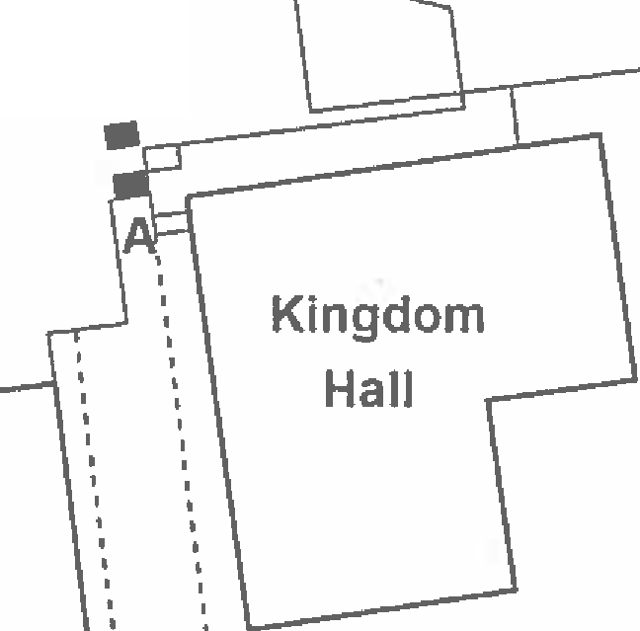
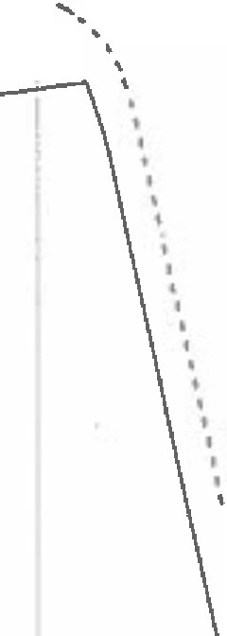

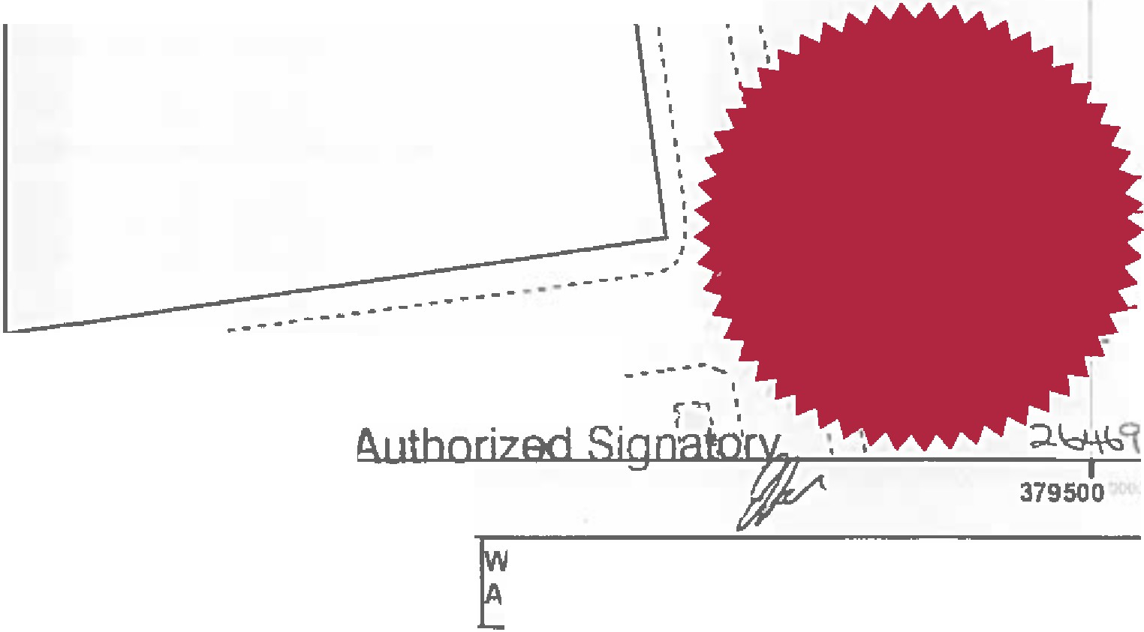
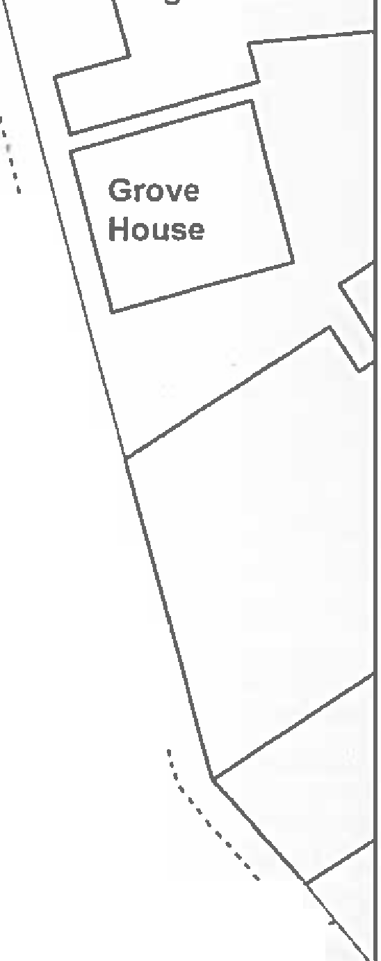
'I
''
'' .
'I
t
..-- I
88.4m··--
I '
-·,c;HlENH..i_..-L_
. ...
Hi.ENH\LL SiREE'T
----------------------------------
.
-----�}-��� I I I
·r�
----------
Order route1-.�
."..
510
IIIIII
I!I
20 Meters I·
·
Lcaa,n.ntcyastte
Cc>.n:11
:500�♦.•
The digitiaed Rlghls of Way lnlonnatlon should be t110d lor guidance only as lls accuracy canno1 be guaranteed. Rlght1 ol Way lnlomiation 1nu1t be ••rifled on the current Denn�I.,. Map belore being supplied o, used 1<,r fflf purpose,
Thi• Map Is reproduced lram Ordnance Sur,ey material wllh the penniulon ol Ordnance Survey on behall ol the controller ol Her MijHty'1 Stallonef'J Office (Cl Crawn Copyright.
Unaulhorind <fl'roducllon ftfringe• Crtl'MI Copyright and rnay !tad to PrDSKUtlon ..- cMI p,oceedlngs, lancashi-e County Coundl Ucenco No. 100023320
Andrew Mullaney
Head of Planning and Environmentddition of public footpath from Clitheroe Street to Guy Street, Padiham, Burnleyl1
ildlife and Countryside Act 1981
69 O\�
�·�rn�I
I

I I
t
'

'
'
'I
'I

