NOTICE OF ORDER

Wildlife and Countryside Act 1981
Lancashire County Council

THE LANCASHIRE COUNTY COUNCIL (FOOTPATH FROM CLITHEROE ROAD TO CHAPEL LANE, WEST BRADFORD) DEFINITIVE MAP MODIFICATION ORDER
2018

Notice is hereby given that the above referenced Order has been submitted to the Secretary of State for Environment, Food and Rural Affairs for determination. An Inspector will be appointed by the Secretary of State to determine the Order.

The start date for the above Order is 16 December 2025.

Consideration of the Order will take the form of exchanges of statements of case and comments on statements of case.

The effect of the Order, if confirmed without modifications, will be to add a public footpath from the junction with Clitheroe Road at SD 7436 4435 (point A on the order map), passing to the south of 26 Millbrook Court in a south easterly direction to a point adjacent to the south west corner of the rear of 25 Millbrook Court at SD 7438 4435 (point B), then ascending 12 concrete steps to the top, adjacent to the rear of 23 Millbrook Court at SD 7439 4435 (point C). The footpath then follows an enclosed route between the rear of Millhouse, to the south and the fencing of the rear of 23 and 22 Millbrook Court, to the north to the rear of 22 Millbrook Court at SD 7440 4435 (point D) and continuing in a generally north easterly direction enclosed by a stone wall and garage building, to the south and garden fences to the rear of 18, 19 and 20 Millbrook Court, to the north up to the end of the stone garage at SD 7441 4436 (point E). From point E the footpath continues in a generally north easterly direction to the rear of 19, 18 and 17 Millbrook Court to the open junction with Chapel Lane at SD 7443 4437 (point F).

Any queries relating to this Order should be referred to Paul Scrivener by email: paul.scrivener@planninginspectorate.gov.uk quoting reference number ROW/3355145 on all correspondence. Alternatively, queries may be sent in writing to The Planning Inspectorate, Rights of Way Section, Room 3/A Eagle Wing, Temple Quay House, 2 The Square, Temple Quay, Bristol, BS1 6PN. Telephone: 0303 444 5000.

Any person wishing to view the statements of case and other documents relating to this Order may do so by appointment at County Hall, Fishergate, Preston, PR1 0LD, for further information please contact Ansar Sadiq at ansar.sadiq@lancashire.gov.uk or on 01772 532435. Documents have also been made available online. To access the documents, please use the following URL address: http://www.lancashire.gov.uk/council/transparency/dmmos/chapel-lane-west-bradford-2018/

Timetable for sending in statements of case and comments
Within 2 weeks of the start date by 30 December 2025.
The Order Making Authority, or where the Order Making Authority is taking a neutral stance and the applicant or other party are taking the case forward in support of the order, must ensure their statement of case is received by the Secretary of State. As soon as possible after the deadline, the Secretary of State will send a copy (excluding copies of any supporting documents - these will be available to view at the Authority’s offices) to everyone who has made an objection or representation, the applicant and any other person who has written to us in respect of the Order.
Within 8 weeks of the start date by 10 February 2026.
Everyone who has made an objection or representation or any other written representation or any other person wishing to make representations in writing must ensure their statement of case is received by the Secretary of State. As soon as possible after the deadline, the Secretary of State will send full copies to the Authority. Copies (excluding copies of any supporting documents - these will be available to view at the Authority’s offices) will also be sent to the applicant, every person who has made an objection or representation and any other person who has written to us in respect of the Order.

Within the same period the applicant (if applicable) must ensure their statement of case is received by the Secretary of State. As soon as possible after the deadline, Secretary of State will send a full copy to the Authority. Copies will also be sent to everyone who has made an objection or representation and any other person who has written to us in respect of the Order (excluding copies of any supporting documents - these will be available to view at the Authority’s offices).

Within 14 weeks of the start date by 24 March 2026.
Everyone who has made an objection or representation, the Authority, the applicant (if applicable) and anyone who has written to us in respect of the Order must ensure that their comments on any or every other statement of case is received by the Secretary of State. As soon as possible after the deadline, the Secretary of State will send copies of these comments to everyone else.

In fairness to the other parties everyone should keep to the timetable to ensure that statements of case and comments are received on time. Late documents will be returned.
We cannot accept any inflammatory, discriminatory or abusive comments. Any documents containing such comments will be returned.

If you use Artificial Intelligence (AI) to create or alter any part of your documents, information or data, you should tell us that you have done this when you provide the material to us. See the detailed guidance for further information.

Notice of order for w/r
WILDLIFE AND COUNTRYSIDE ACT 1981

THE DEFINITIVE MAP AND STATEMENT OF PUBLIC RIGHTS OF WAY FOR THE COUNTY OF LANCASHIRE

THE LANCASHIRE COUNTY COUNCJL (FOOTPATH FROM CLITHEROE ROAD TO CHAPEL LANE, WEST BRADFORD) DEFINITIVE MAP MODIFICATION ORDER 2018
This Order is made by Lancashire County Council (11the Authority") under Section 53(2)(b) of the Wildlife and Countryside Act, 1981 ("the Act") because it appears to that Authority that The Definitive Map and Statement of Public Rights of Way for the County of Lancashire require modification in consequence of the occurrence of an event specified in Section 53(3)(c)(i) of the Act namely the discovery by the Authority of evidence which (when considered with all other relevant evidence available to them) shows that a right of way which is not shown in the map and statement subsists or is reasonably alleged to subsist over land in the area to which the map relates, namely a footpath.
The Authority have consulted with every local authority whose area includes the land to which the Order relates. Lancashire County Council hereby order that:
- For the purposes of this Order, the "relevant date" is the 16th May 2018.

- The Definitive Map and Statement of Public Rights of Way for the County of Lancashire shall be modified as described in Part I and Part II of the Schedule and shown on the map attached to the Order.

- This Order shall take effect on the date it is confirmed and may be cited as The Lancashire County Council (Footpath from Clitheroe Road to Chapel Lane, West Bradford) Definitive Map Modification Order 2018.

Dated this 16th day of May 2018.


THE COMMON SEAL of the )
Lancashire County Council ) was hereunto affixed in the presence of )

Authorised Signatory� �
z.
7tJ(,�
SCHEDULE

PARTI
MODIFICATION OF THE DEFINITIVE MAP
DESCRIPTION OF PATH OR WAY TO BE ADDED

A footpath varying in width between 0.90 metres and 5 metres commencing at a junction with Clitheroe Road immediately north of Mill Bridge (Point A on the Order Map) running in a south easterly direction to Point B adjacent to the south west corner of the rear of 25 Millbrook Court (Overbrook House). It then continues in an east north easterly direction ascending a flight of steps and continuing to the rear of properties on Millbrook Court to Point F where it exits onto Chapel Lane. The total length of the route is approximately 80 metres, shown A-B-C-D-E-F on the Order Map and marked as a bold broken black line with short intervals.

PART II

MODIFICATION OF DEFINITIVE STATEMENT

VARIATION_ OF PARTICULARS OF PATH OR WAY

Add to the Definitive Statement for West Bradford the following:

Path No:53
Kind of Path: •Footpath·

Position: 11Footpath from the junction with Clitheroe Road immediately north of Mill Bridge at SD 7436 4435 running an east south easterly direction over the tarmac suriace bounded by 26 Millbrook Court and the stone wall adjacent to the watercourse known as West Bradford Brook to SD 7438 4435. It then continues in an east north easterly direction to the rear of 25 and 24 Millbrook Court and ascends 12 concrete steps at SD 7439 4435 before following an enclosed route to the rear of Millhouse to the south and the rear of 23 and 22 Millbrook Court to the north to SD 7440 4435. It passes a stone garage at SD 7441 4436 and continues in a generally north north easterly direction to the rear of 19, 18 and 17 Millbrook Court to SD 7443 4437 where it exits onto Chapel Lane. All compass direction given are approximate"
Length: ·o.oa km" Other Particulars:
"Width: Between 0.9m and Sm as shaded on The Lancashire County Council (Footpath from Clitheroe Road to Chapel Lane, West Bradford) Definitive Map Modification Order 2018 Map

Limitations: None"

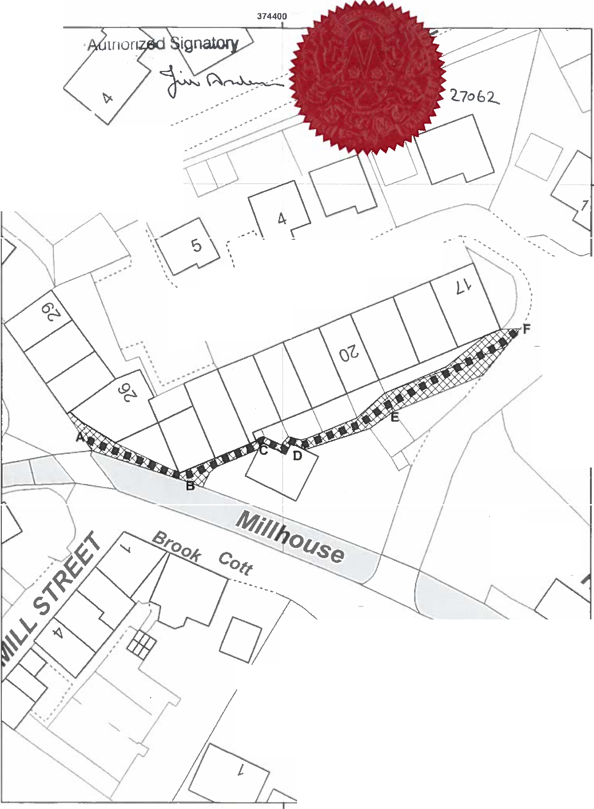
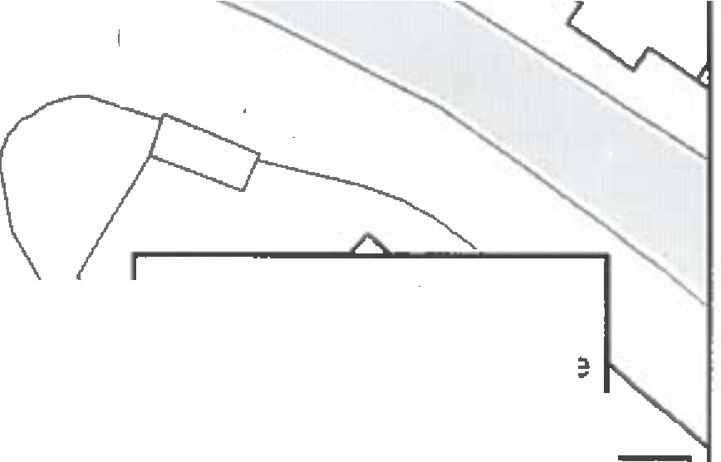


� ..
ill Pond'� \.-···
!iHouse �
; F: '..,
\

.- ' ,\_.,,.-

_. \·J••�1

Q
!
0
.-·
·--·-- -· Qi,_C.0--· •• .-.---·

tfl\\-...\..�iO-·
6

G

Gov,

�1o
'°�
��

�
0 : 8
�
6�it'�

'·:I■■I Orderroute
·--, --=;:: C'h'j� Width of Order Rout I
,," 'n , < , ,
O 5 10 20 Meiers
_, I I I I I ! ! I I

374400

�:�ie  Councl | Andrew Mullaney  Head of Plilflning andEnvironment | Wildlife and Countryside Act 1961  Addition of a public footpath from Clitheroe Road to Chapel Lane, West Bradford, Ribble Vallev | 1 500 | --r.zi,!.l-_
The digitind Rights of Way intonnation should bt 111td for guidonca only n Its acC1Jracy cannot be guarantetd, Righi• of Way inlorrn.ation must be -mif ed on lhc curr•nl o.tin�ive Map before being supplied or uscd for any purpote
This M•p Isrep!1'duced from Ordnance SuNty m1teri1I wtth lhe permission of Ordnance Survey onbchaW of the controller of Her Mojnly's Sloticnery Office ICICrown Copyright. llnauthorised reproduction Infringes Crown Copyright and may Ind to Prosecu�on o,civil proceedings, L•ncashite County Council Licence No. 100023320

