NOTICE OF ORDER

Wildlife and Countryside Act 1981 Section 53
Nottinghamshire County Council
THE NOTTINGHAMSHIRE COUNTY COUNCIL (CUCKNEY BRIDLEWAY NOS. 8, 9, 10, 11, 12 & 13 AND NORTON BRIDLEWAY NOS. 5 & 6 AND WARSOP FOOTPATH NOS. 36, 37 & 38 AND WARSOP BRIDLEWAY NOS. 61, 62, 63, 64 & 65) MODIFICATION ORDER 2023

Notice is hereby given that the above referenced Order has been submitted to the Secretary of State for Environment, Food and Rural Affairs for determination. An Inspector will be appointed by the Secretary of State to determine the Order.

The start date for the above Order is 10 December 2025

Consideration of the Order will take the form of a public local inquiry.

The Inquiry will be held at Civic Corner Venue, Civic Centre, Chesterfield Road South, Mansfield, NG19 7BH on 28 April 2026 at 10.00am.

The effect of the Order, if confirmed without modifications, will be to modify the Definitive Map and Statement for the area by: 1) adding to them the bridleway from the A60 south of Metz Lodge at grid reference SK 5671 6973 via SK 5683 7014 & SK 5856 7100 to the upgraded bridleway by Gleadthorpe Plantation at SK 5939 7073 and, 2) by adding to them the bridleway from the added bridleway at SK 5683 7014 to Sandy Lane at SK 5668 7020 and, 3) by adding to them the bridleway from the added bridleway at SK 5856 7100 to the upgraded bridleway and Warsop Footpath No.37 at SK 5914 7044 and, 4) adding to them the bridleway from Hatfield Avenue, Meden Vale at SK 5859 7008 to the footpath and upgraded
bridleway at SK 5897 7033 and, 5) by upgrading to a bridleway part of the public right of way Warsop Footpath No.36 from the added bridleway at SK 5897 7033 via SK 5914 7044 & SK 5939 7073 & SK 5940 7074 to Hazel Gap SK 5987 7131 and, 6) by upgrading to a bridleway the public right of way Warsop Footpath No.38 from Netherfield Lane SK 5973 7033 to the upgraded bridleway at SK 5940 7074, and 7) by varying the particulars relating to the footpath Warsop No.37 from Netherfield Lane to the upgraded bridleway at SK 5914 7044.

Any queries relating to this Order should be referred to Philip Wilton by email: Rightsofway2@planninginspectorate.gov.uk quoting reference number ROW/3353980 on all correspondence. Alternatively, queries may be sent in writing to The Planning Inspectorate, Rights of Way Section, c/o QUADIENT, 69 Buckingham Avenue, Slough, SL1 4PN. Telephone: 0303 444 5228.

Any person wishing to view the statements of case and other documents relating to this Order may do so by appointment at County Hall, West Bridgford, Nottingham, NG2 7QP. Please contact Stephen Tipping on countryside.access@nottscc.gov.uk or 0115 993 4381.

Timetable for sending in statements of case and proofs of evidence

Within 8 weeks of the start date by [by 4 February 2026]

The Order Making Authority, or where the Order Making Authority is taking a neutral stance and the applicant or other party are taking the case forward in support of the order, must ensure their statement of case is received by the Secretary of State. As soon as possible after the deadline, the Secretary of State will send a copy (excluding copies of any supporting documents - these will be available to view at the Authority’s offices) to everyone who has made an objection or representation and the applicant and any other person who has written to us in respect of the Order.

Within 14 weeks of the start date [by 18 March 2026]

Everyone who has made an objection or representation and anyone who wishes to give evidence at the Inquiry must ensure their statement of case is received by the Secretary of State. As soon as possible after the deadline, the Secretary of State will send full copies to the Authority. Copies will also be sent to the applicant, every person who has made an objection or representation and any other person who has written to us in respect of the Order (excluding copies of any supporting documents - these will be available to view at the Authority’s offices).

Within the same period the applicant (if applicable) must ensure their statement of case is received by the Secretary of State. As soon as possible after the deadline, the Secretary of State will send a full copy to the Authority. Copies will also be sent to everyone who has made an objection or representation and any other person who has written to us in respect of the Order (excluding copies of any supporting documents - these will be available to view at the Authority’s offices).

4 weeks before the date of the inquiry [by 31 March 2026]

The Authority, everyone who has made an objection or representation, the applicant (if applicable) and anyone who wishes to give evidence at the Inquiry must ensure their proof of evidence (together with any summary) is received by the Secretary of State. As soon as possible after the deadline, the Secretary of State will send copies of:

- the Authority’s proof of evidence to everyone who has made an objection or representation, the applicant and anyone who has submitted a statement of case (including copies of any supporting documents – although none should be submitted with a proof of evidence);

- the applicant’s proof of evidence to the Authority, everyone who has made an objection or representation and anyone else who has submitted a statement of case (including copies of any supporting documents – although none should be submitted with a proof of evidence); and

- all other proofs of evidence to the Authority, the applicant, everyone who has made an objection or representation and anyone else who has submitted a statement of case (including copies of any supporting documents – although none should not be submitted with a proof of evidence).

All parties must keep to the timetable set out above and ensure that statements of case and proofs of evidence are received by the Secretary of State on time. Late documents will be returned.

We cannot accept any inflammatory, discriminatory or abusive comments. Any documents containing such comments will be returned.

If you use Artificial Intelligence (AI) to create or alter any part of your documents, information or data, you should tell us that you have done this when you provide the material to us. See the detailed guidance for further information.

Notice of order for inquiry

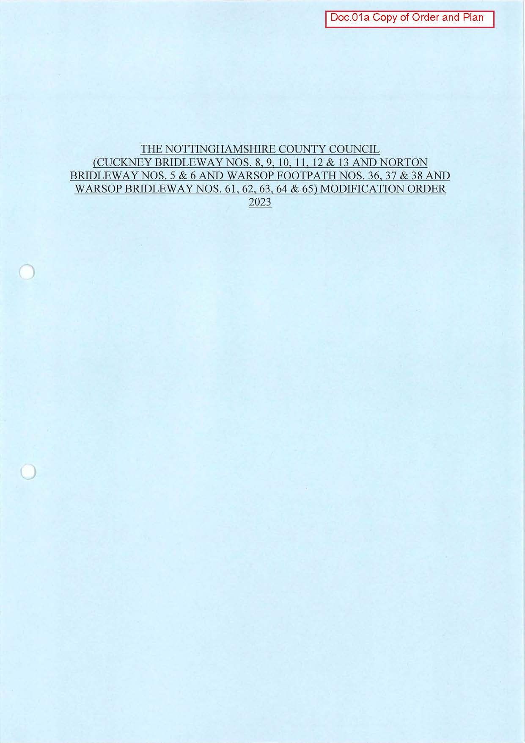

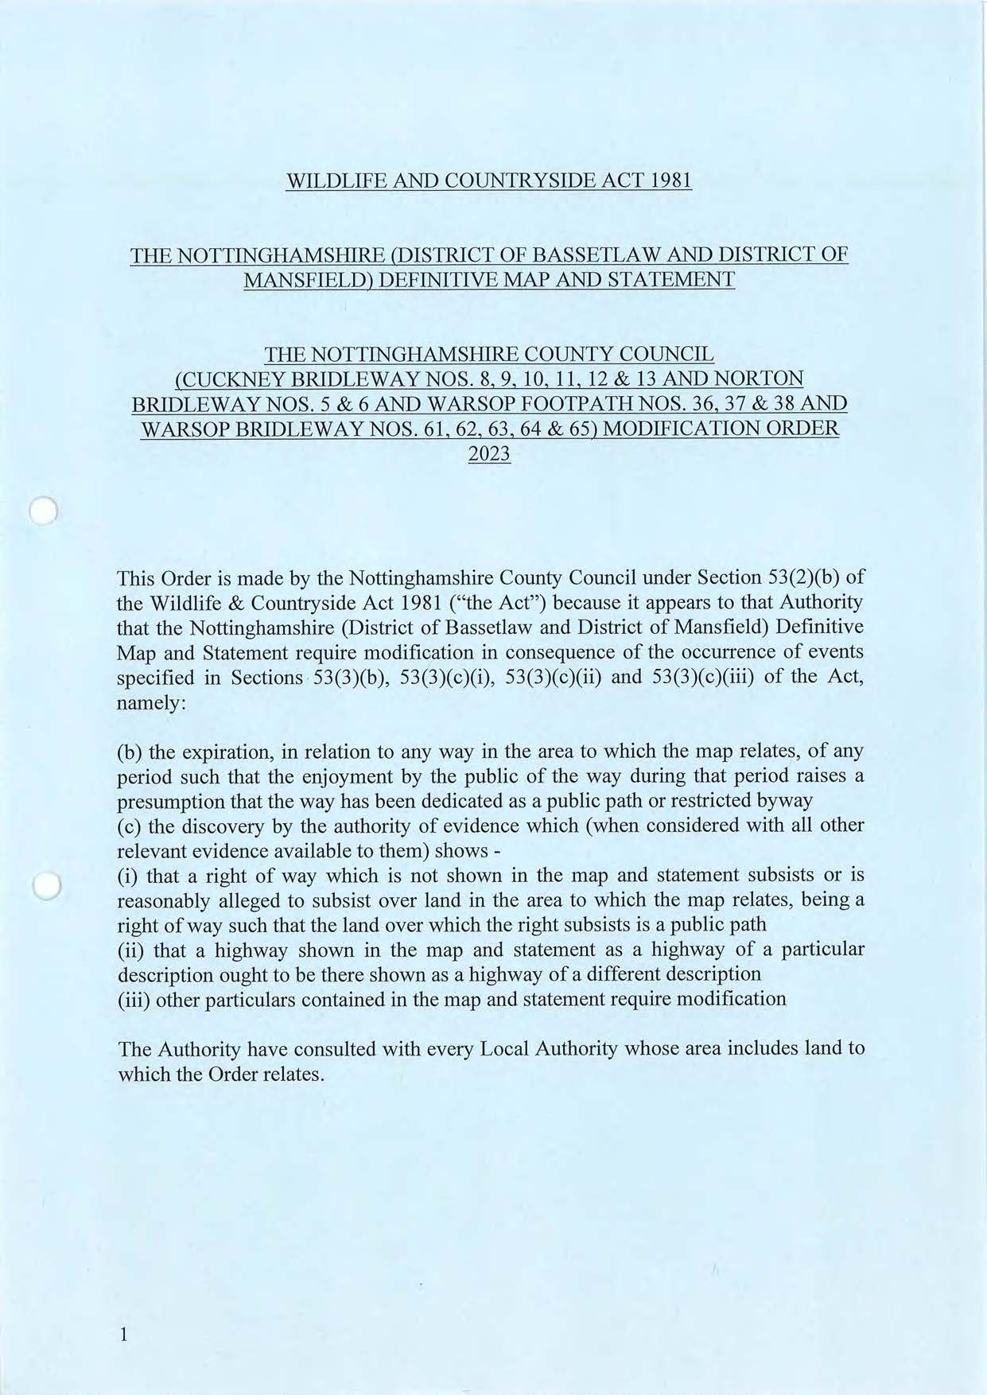

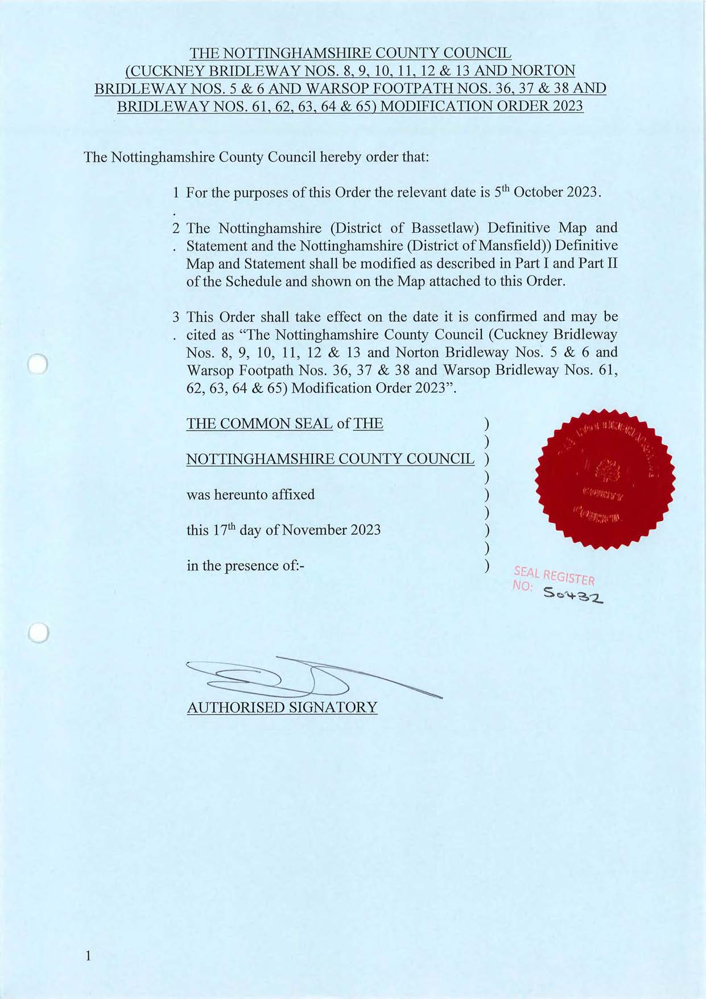

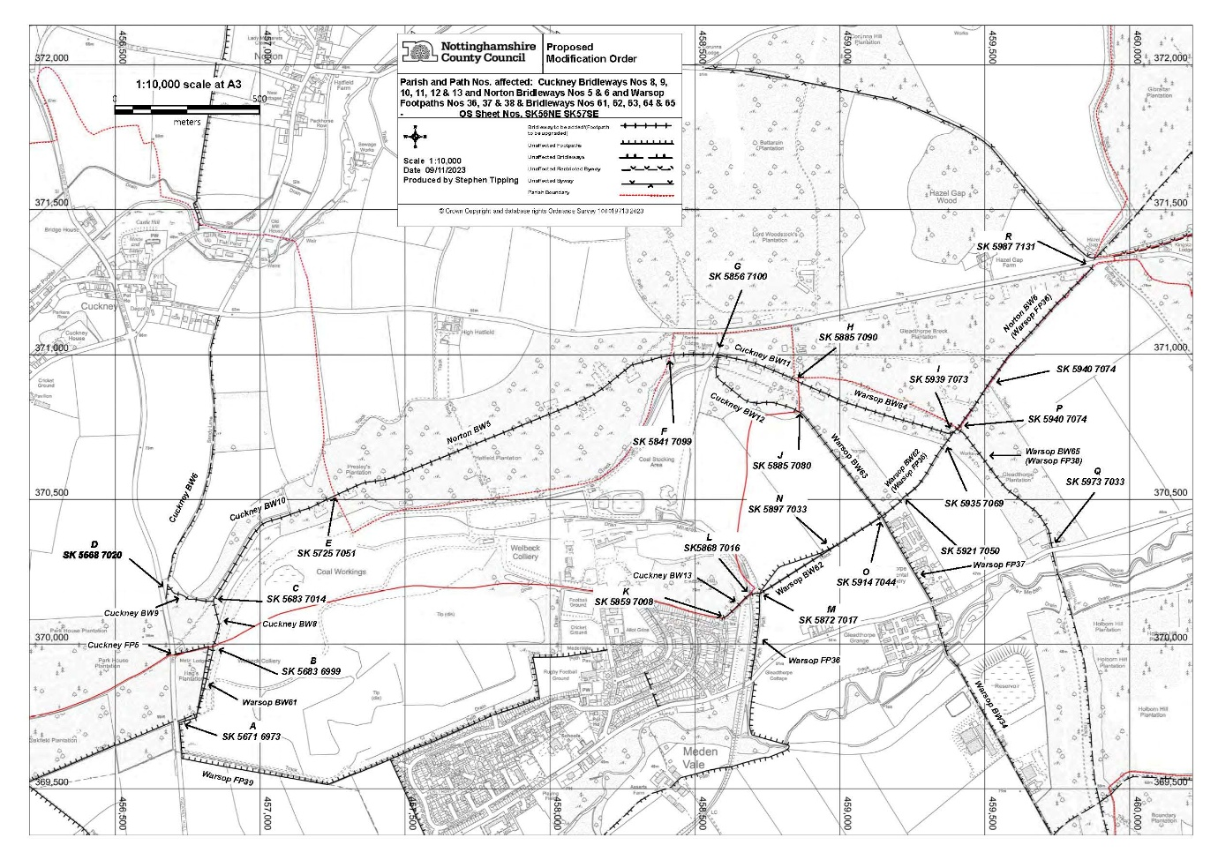

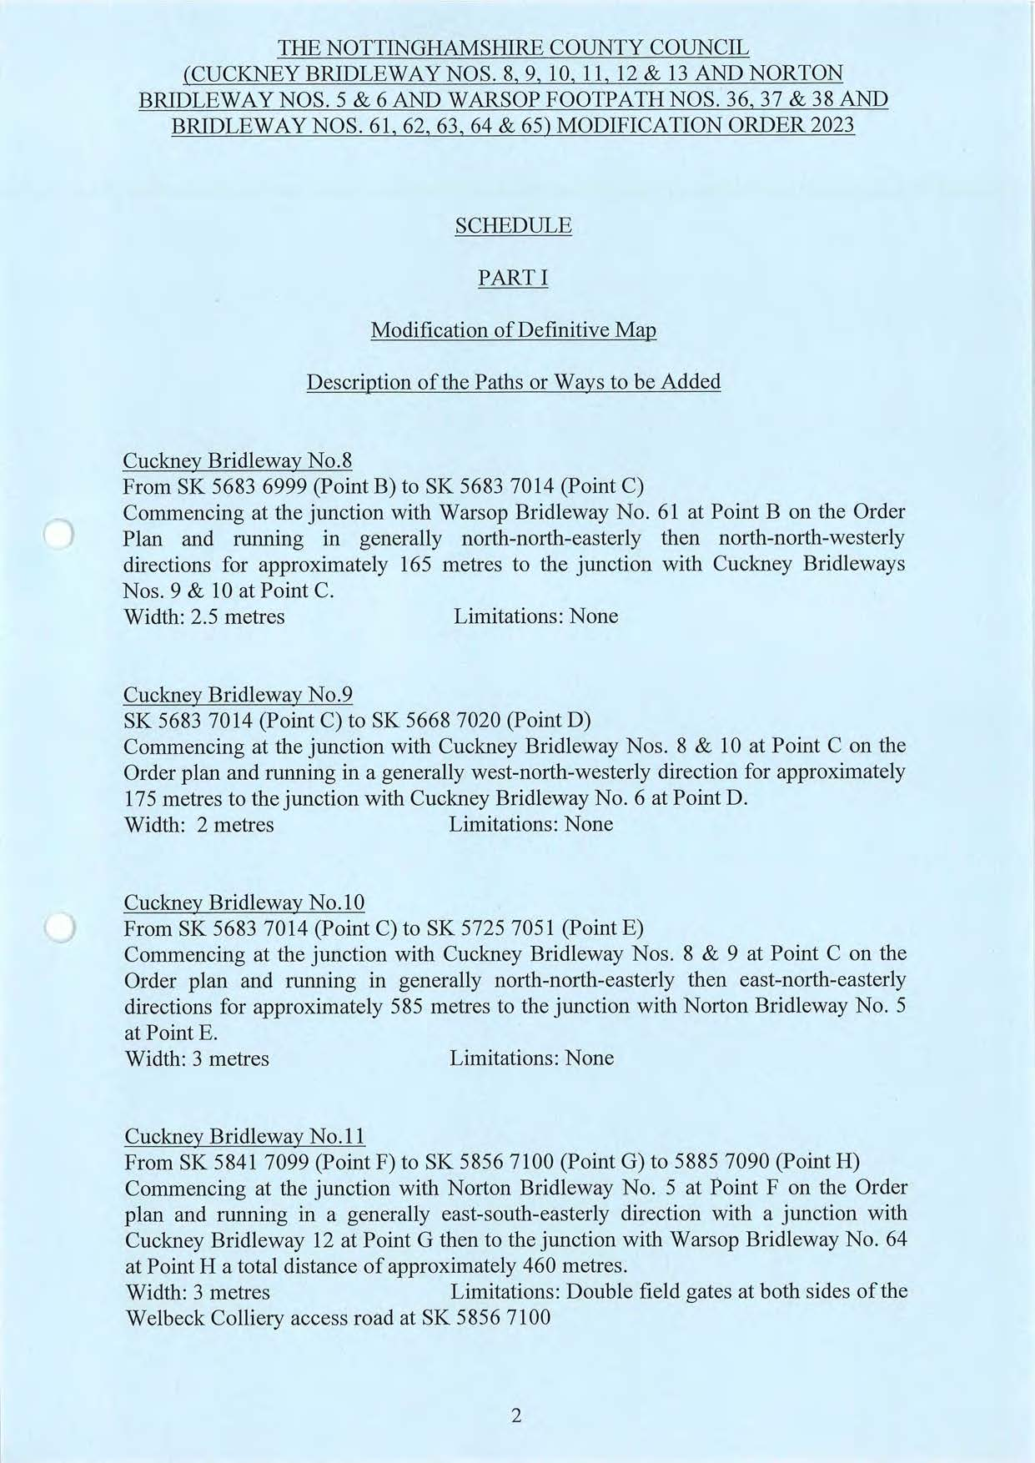

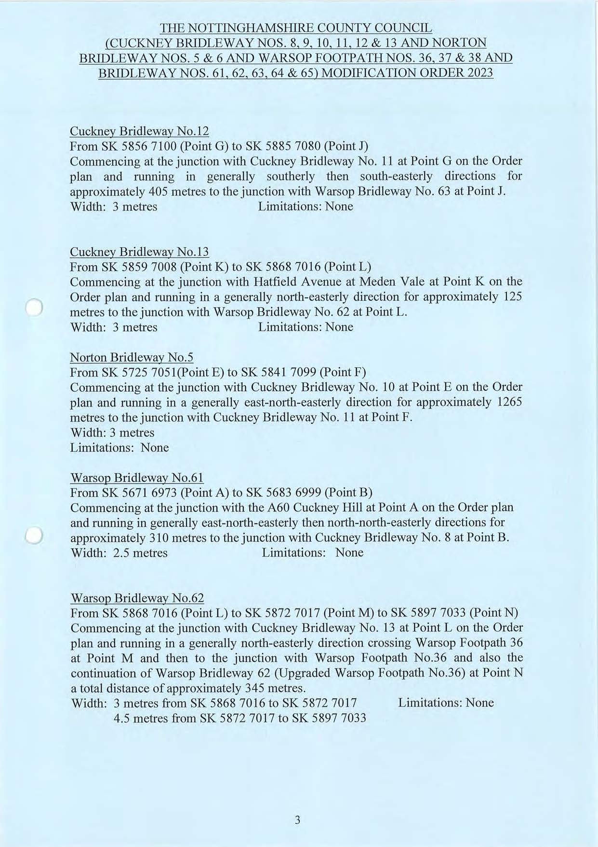

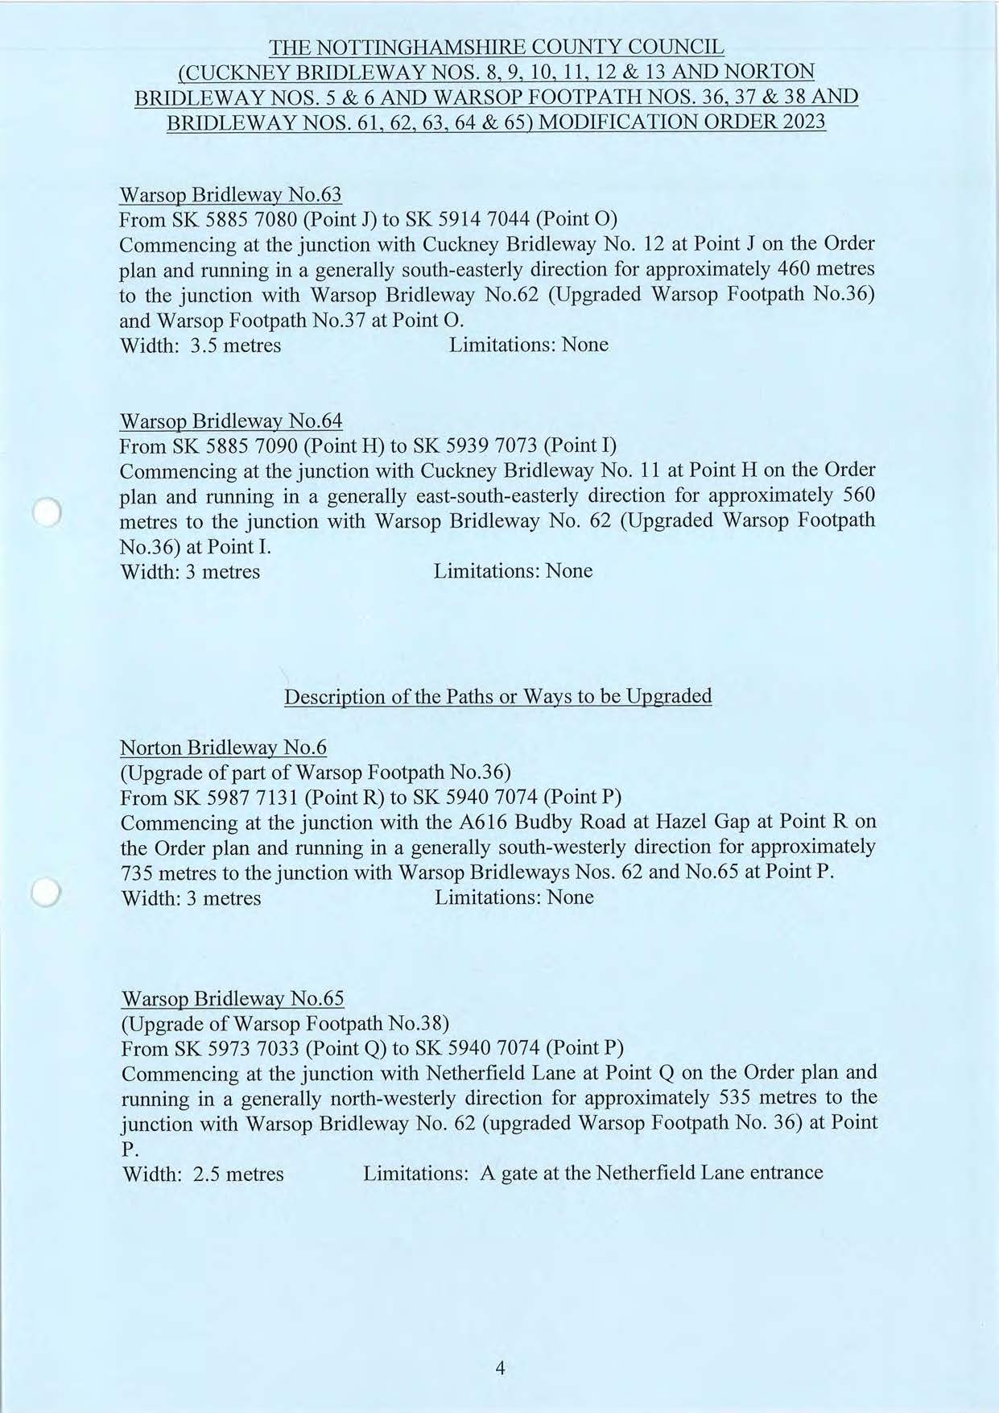

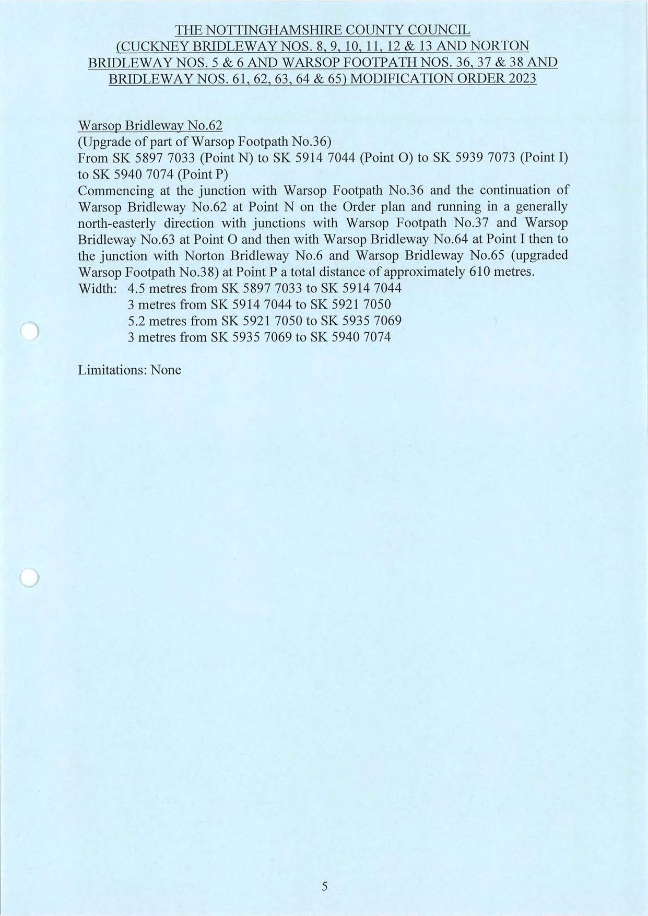

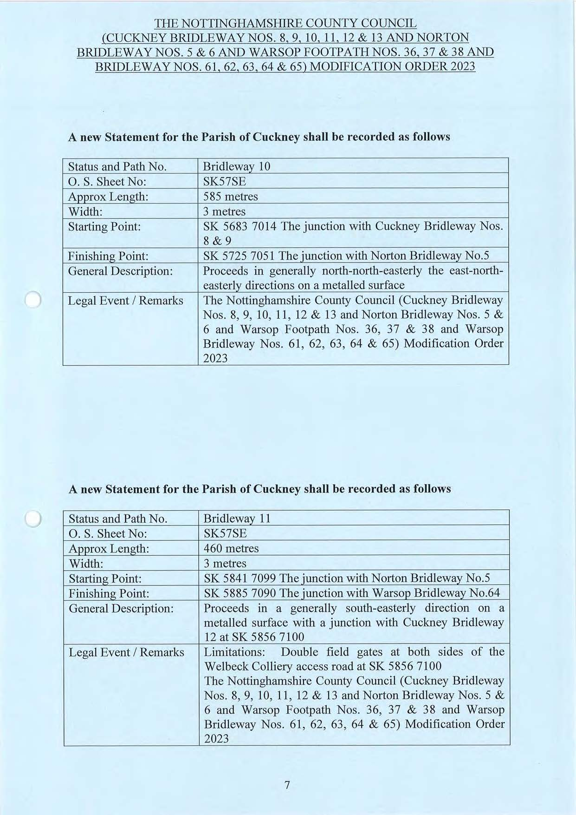

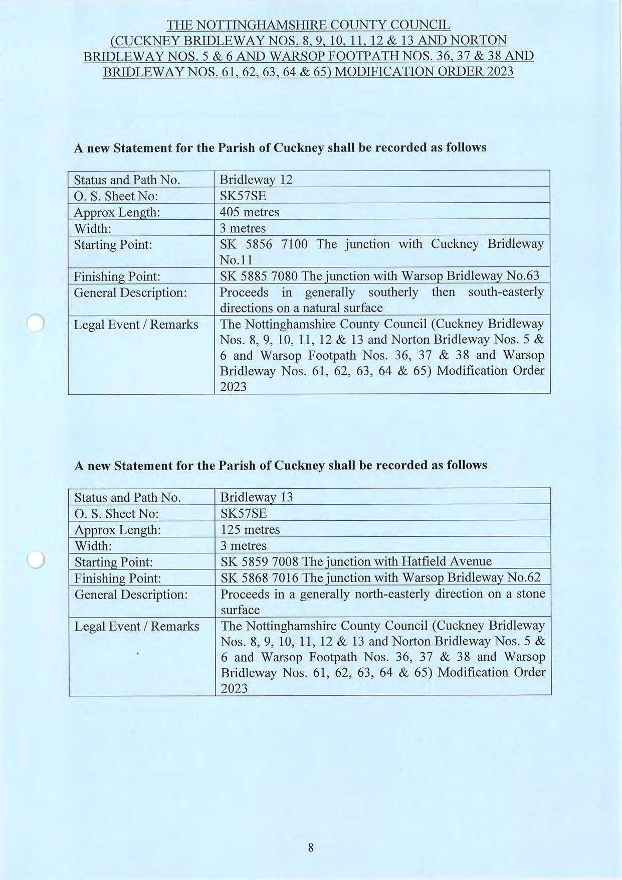

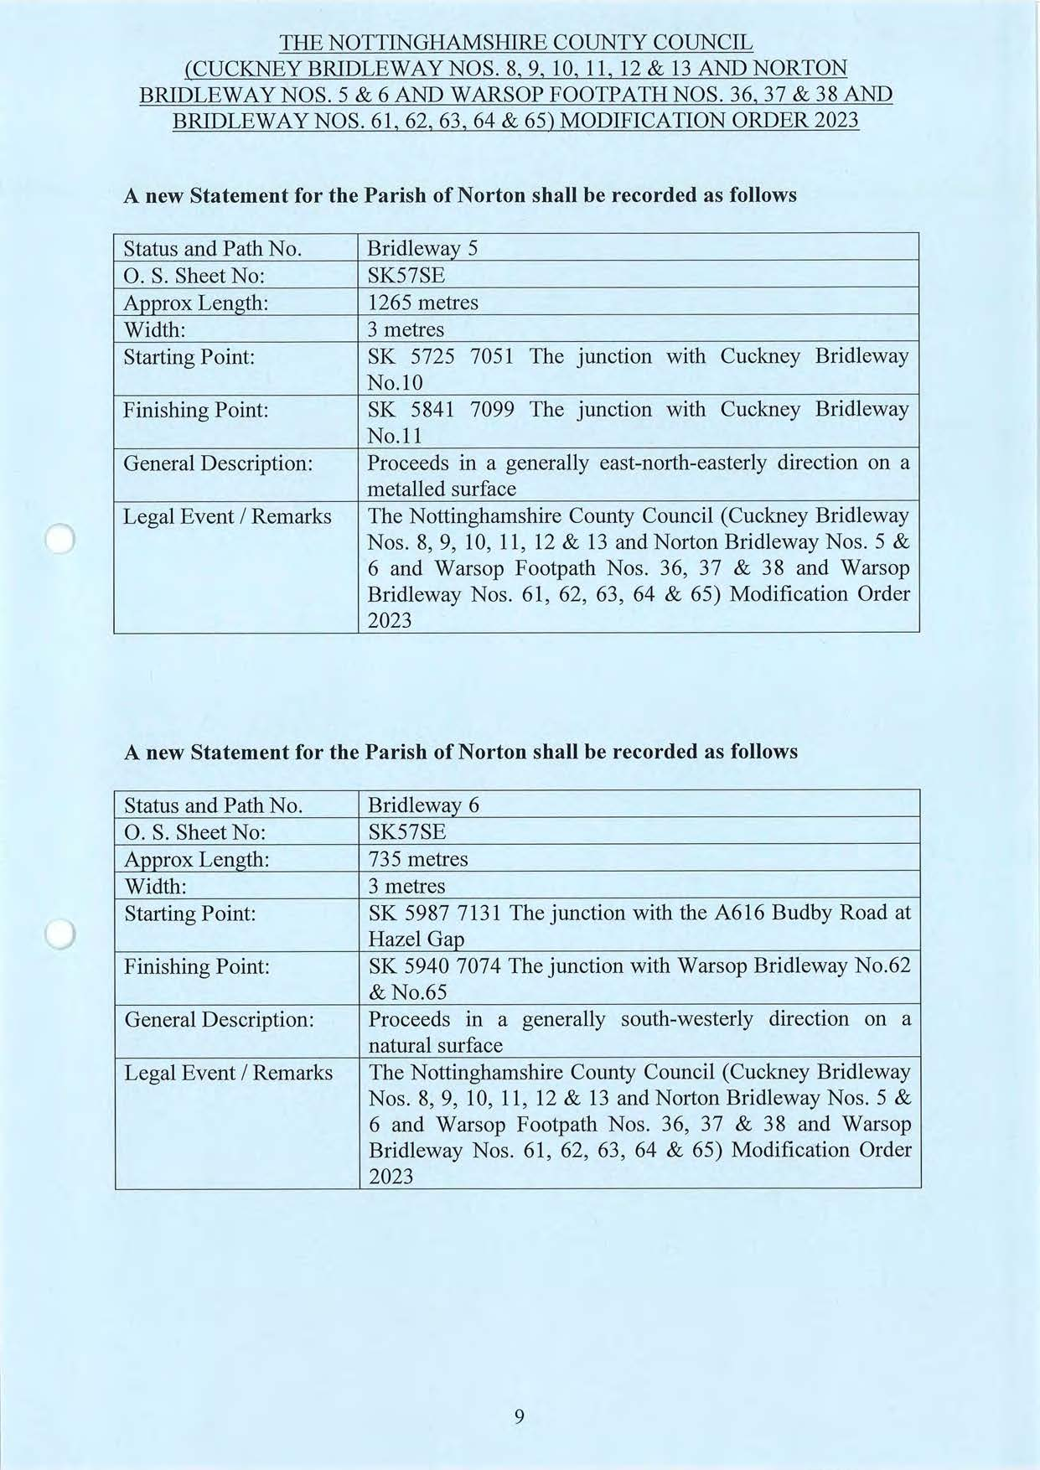

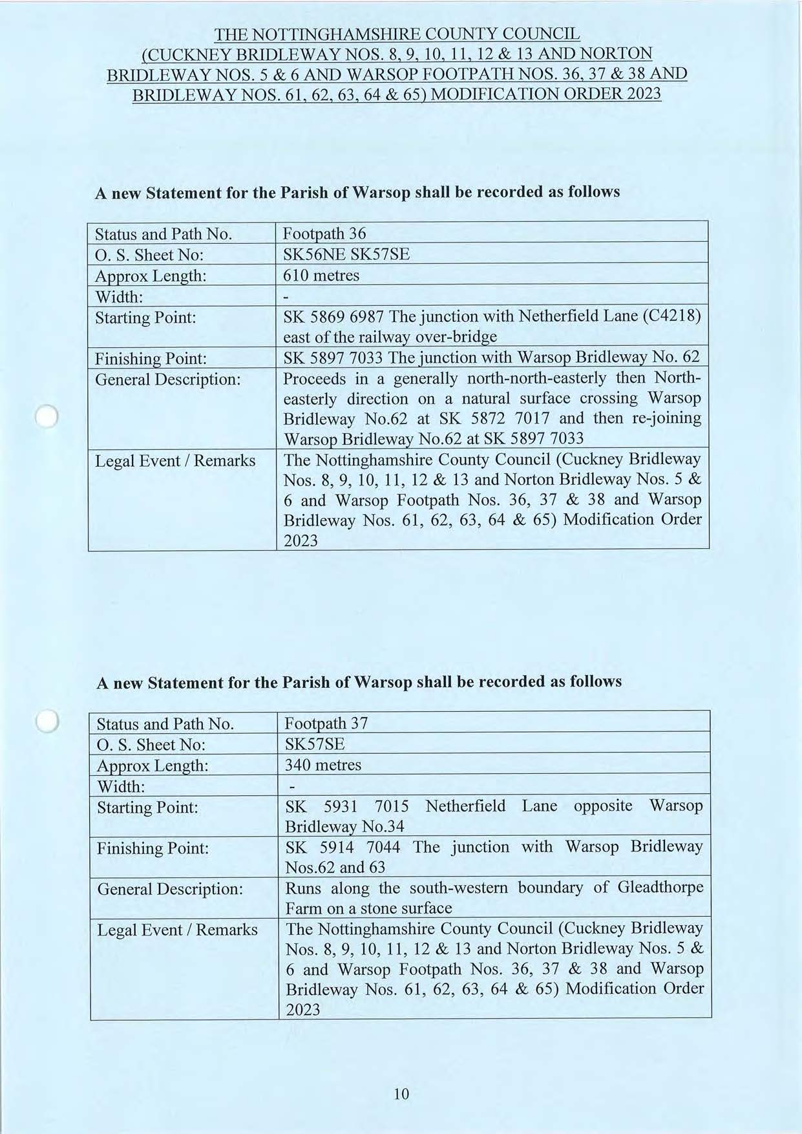

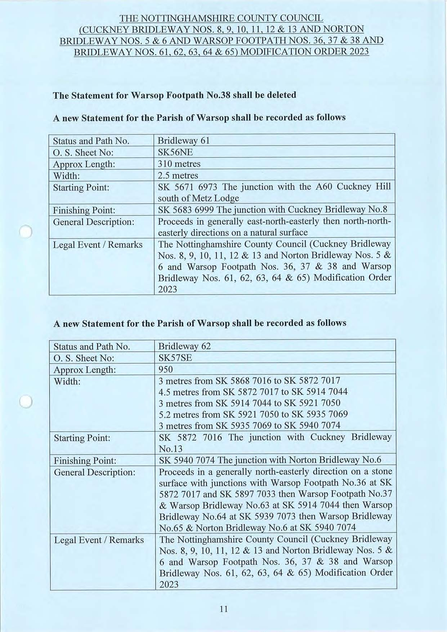

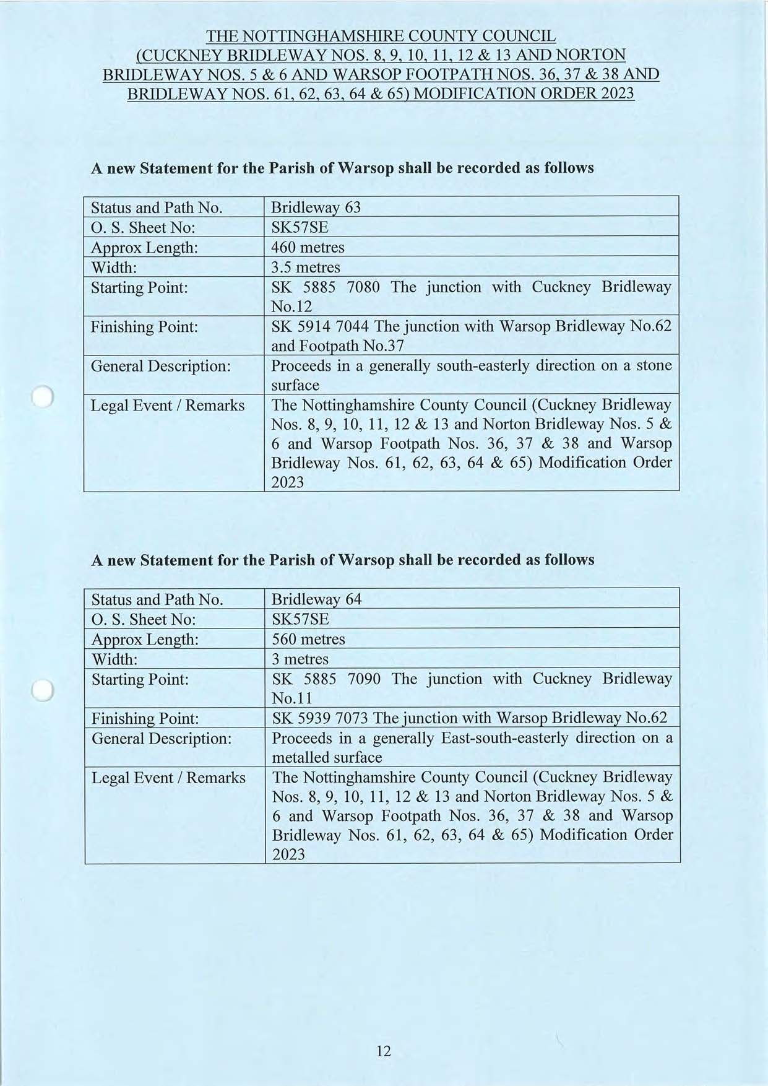

If you wish to make a legal submission, this should be submitted at the same time as your statement of case. Otherwise legal submissions will have to be submitted in writing on the day of the inquiry.

