

Order Decision
by D M Young JP BSc (Hons) MPlan MRTPI MIHE
an Inspector appointed by the Secretary of State for Environment, Food and Rural Affairs
Decision date: 12 November 2025

Order Ref: ROW/3336636
- This Order is made under Section 53 (2) of the Wildlife and Countryside Act 1981 (the 1981 Act) and is known as the City of Doncaster Council Public Footpath Sprotbrough Number 22 Definitive Map Modification Order 2023.
- The Order is dated 7 February 2023 and proposes to modify the Definitive Map and Statement for the area by adding a Public Footpath as shown in the Order plan and described in the Order Schedule.
- There was one objection outstanding when the Order was submitted to the Secretary of State. This has since been formally withdrawn.
Summary of Decision: The Order is Confirmed Subject to the Modifications set out in the Formal Decision.

Preliminary Matters
- The application to add a public footpath between Nursery Lane and Cadeby Lane, Sprotbrough to the Definitive Map and Statement (DMS) was made by the Peak and Northern Footpath Society in 2009. The application was based on the public’s use of the route. Following investigation by the City of Doncaster Council (the Order Making Authority (OMA)), it was considered there was a reasonable allegation of the route having historic highway rights. The Order was subsequently made on 7 February 2023.
- The Order route is shown between points A-B-C-D on the Order Plan (see Appendix A) and comprises a linear route of some 416 metres. The route commences at point A on Cadeby Road (Grid Ref: SE5340 0181) and runs in a southerly direction along a field boundary to point B. From thence it continues in a southerly direction through woodland to point C. The order route terminates at point D on Nursery Lane (Grid Ref: SE 5323 0146). The width of the Order route varies between 1.5-1.8m.
- The OMA has requested a number of modifications to the Order plan and schedule. These arise from minor drafting errors with the original Order plan. The position of point A on the order plan was incorrectly drawn in correspondence with the grid reference and point D on the Order schedule and Order plan were incorrect, the steps at the end of the route were also incorrectly positioned. The amended Order plan and schedule are attached as Appendix B. Considering the Order as a whole and taking account of the lack of public objections and landowner interests, I am satisfied no prejudice would arise from the modifications. Accordingly, I do not feel it necessary to advertise the modifications.
- The majority of the land crossed by the Order route is owned by the OMA. A section of the route between points B and C along a field boundary is in private ownership.
- As there are no outstanding objections to the Order a site visit was not considered necessary.

Main Issues
- The Order has been made under section 53(2)(b) of the 1981 Act in consequence of an event specified in section 53(3)(c)(i).
- The main issue is whether the discovery by the authority of evidence, when considered with all other relevant evidence, is sufficient to show that a right of way which is not shown in the map and statement subsists over the land in the area to which the map relates. The test to be applied to the evidence is on the balance of probabilities.
- The Council rely on the statutory dedication of the way under Section 31 of the Highways Act 1980 which provides that where a way, other than a way of such a character that use of it could not give rise at common law to any presumption of dedication, has been actually enjoyed by the public, as of right and without interruption, for a period of twenty years, the way is deemed to have been dedicated as a highway unless there is sufficient evidence that the landowner demonstrated a lack of any intention during this period to dedicate the route. The 20-year period applies retrospectively from the date on which the right of the route was brought into question.

Reasons

Statutory dedication – Section 31 of the Highways Act 1980

When the right to use the way was brought into question
- Section 31(7B) of the 1980 Act states that in the absence of the landowner taking any positive steps to call the right of the public to use a route then the ‘date of challenge’ will be the date on which the application was duly made i.e. 2009. The twenty-year period under consideration is therefore, 1989-2009.

Evidence of use 1989 to 2009
- The application was supported by 37 user statements. These document use of the route by local people for leisure. The summary provided by the OMA demonstrates the Order route has been in continuous use since at least 1989 up to the present day. There is no evidence to suggest that users were challenged during the relevant 20-year period nor were any notices or signs erected to challenge the public’s use of the route ‘as of right’. The majority of users refer to use of the route by others on foot.
- The amount of credible user evidence in this case is sufficient, on the balance of probabilities, to raise a presumption of dedication of a public footpath. That being the case it is necessary to consider whether any landowner demonstrated a lack of intention to dedicate the way as a public footpath.

Whether any landowner demonstrated a lack of intention to dedicate
- As noted above it is necessary to consider whether any landowner, that is a person who is entitled to dispose the fee simple of the land, demonstrated a lack of intention to dedicate the way. For there to be sufficient evidence that there was no intention to dedicate the way there must be evidence of some overt acts on the part of the landowner, during the relevant period, such as to show the public who used the path, that they had no intention to dedicate. The test is whether a reasonable user would have understood that the landowner was intending to disabuse the user of the notion that the way was public. This is the approach established in the case of R (Godmanchester Town Council) v Secretary of State for the Environment, Food and Rural Affairs [2007] UKHL 28.
- Correspondence sent to the OMA on behalf of the current landowner for the section of path between point B-C and his tenant farmer suggests that verbal challenges were made, along with the placement of hay bales and ploughing along the route. The current tenant has farmed the land since 2005. The landowner claims that notices were erected in 2020 challenging the public’s use of the route. This is however outside the relevant 20-year period.
- Evidence to demonstrate a lack of intention to dedicate during the relevant 20-year period is scant. If verbal challenges were issued by the tenant farmer prior to 2009 or obstructions placed across the route, there is nothing to suggest that this was sufficient to bring home to users that their use of the route was being resisted or questioned. The user evidence shows that use of the route by the public remained consistent even after 2005.
- In light of the foregoing, there is insufficient evidence before me to demonstrate a lack of intention to dedicate and as such the dedication of a public footpath on the Order route is made out.

Conclusions
- Having regard to above I conclude that the Order should be confirmed with modifications.

Formal Decision
- The Order is confirmed subject to the following modifications:
- Part 1 of the Schedule to the Order shall be deleted and replaced with the following:

Public Footpath commencing at its junction Cadeby Road, grid reference SE5341 0181(Point A) and proceeding south for approximately 60 metres, with a width of 1.5 metres turning in a south west direction grid reference SE5339 0175(Point B) continuing for 145 metres along a headland field boundary, width of 1.8 metres to SE5330 0165 (Point C) proceeding south through woodland with a width of 1.5, for a distance of 238 metres ending after descending a flight of steps with a width of 0.91 metres at grid reference SE 5327 0144 (Point E) Nursery Lane. Length of path 443 metres”.
- By deleting the Grid Reference “D SE5323 0146” in the key on the Order plan, deleting point D on the Order plan, amending the position of Point A and adding point E on the Order plan – as shown on the Modified Order plan at Appendix B.

Formal Decision
- The Order is confirmed.

D M Young

INSPECTOR

Appendix A – Original Order Plan

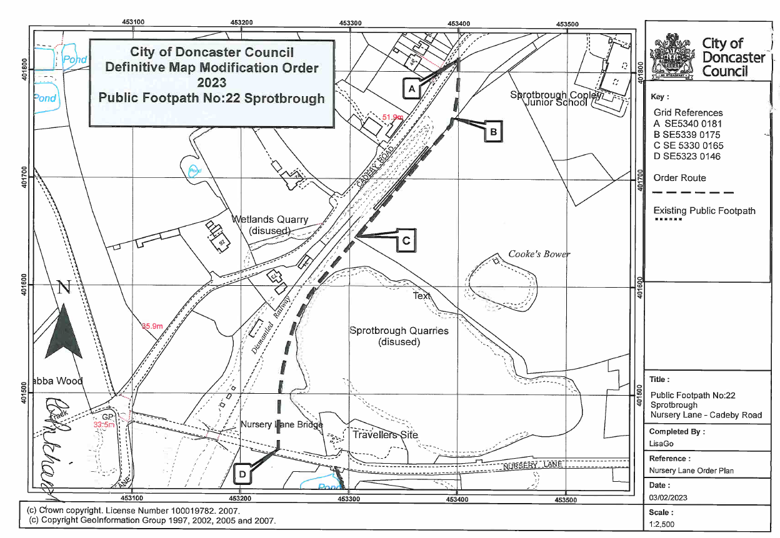

Appendix B – Modified Order Plan and Schedule

