
Phosphorus and freshwater eutrophication: challenges for the water environment
October 2025

Contents
Background 3
Summary 3
1. Current and potential future problems with P in freshwaters 10
2. Current solutions and the extent of the challenge 22
3. Potential future solutions 31
Annex 1: Main national stakeholders for P 38
Annex 2: Consolidated list of planning assumptions for P from the river basin management plans 40
Annex 3: Possible control measures for the main sources of P in water 43
Annex 4: Progress with sewage treatment works total P reduction through water industry periodic price reviews 47
References 49

Background

Relevance and accuracy of data
This document has been produced by bringing together the readily available information on the topic. Quality assurance of the information included so far is not complete. As a result, the document may contain some errors or inaccuracies.
Please let us know of any other relevant evidence or if you are aware of any issues with the information. This will help us to build a comprehensive and robust evidence base to underpin decision-making in river basin management planning.

Summary

What eutrophication means
This is when there is too much nutrient in rivers, lakes, reservoirs, estuaries or the sea, causing excessive growth of algae and plants. This adversely affects the quality of the water and our uses of it, as well as damaging the local ecology.

The nutrients involved in eutrophication
Phosphorus (P) and N (N) are the main nutrients involved in eutrophication, with P the main cause of eutrophication in freshwaters. Standards for P in UK rivers and lakes were introduced under the Water Environment (Water Framework Directive) Regulations (hereafter referred to as the WFD Regulations) in 2009 and the river standards were updated in 2015. These aim to prevent and limit eutrophication.
N can contribute to freshwater eutrophication in some situations, particularly in lakes. Under the Nitrate Pollution Prevention Regulations, some affected lakes in England already have control measures to reduce N pollution caused by agriculture. The UK Technical Advisory Group (UKTAG) for the WFD Regulations consulted in 2019 on proposed lake N standards, for use alongside the current P standards for eutrophication control. These were introduced for the 2022 river basin management plans (RBMPs).
In saline waters, N is usually the key nutrient involved in eutrophication, but P may also be important in some estuarine situations. There are many groundwater bodies where diffuse rural or nutrient management are the Reasons for Not Achieving Good Status (RNAGS). The main element resulting in these reasons is N. Groundwater bodies where N is a concern have been designated as groundwater nitrate vulnerable zones. Phosphate generally is not an elementary RNAG, however it does cause some concern especially in chalk aquifers, where soils are thin and where iron minerals are absent. Where groundwater provides baseflow to rivers and lakes, and inflows to the sea, bathing waters and estuaries, any nutrients within it will be a nutrient source and contribute to any eutrophication in the receiving surface water body. Phosphate, from industrial sources may also be more of a groundwater pollutant of concern where groundwater discharges or inflows into estuaries and coastal waters. In considering ways of controlling P pollution, particularly from agriculture, we should also consider current and future measures for tackling N pollution (which are often driven by drinking water resource protection rather than eutrophication). This is because the measures for P and N are related.

The problems of eutrophication
For more than two decades, the Environment Agency and other interested groups have identified the risks and impacts of freshwater eutrophication in England as a significant concern. Eutrophication:
- increases the cost of drinking water abstraction and treatment
- adversely affects angling, water sports and other recreational activities
- causes the loss of sensitive plants and animals in rivers and lakes
P concentrations in our rivers increased significantly between 1950 and the 1980s due to the introduction of P-based detergents, population growth and the growing use of artificial P fertilisers. Despite good progress in tackling P pollution since 1990, 55% of assessed river water bodies and 75% of assessed lake water bodies in England fail the current WFD Regulations P standards for good ecological status which aim to prevent eutrophication. In fact, P is the most common cause of water quality failures under the WFD Regulations in England - the number one reason for water bodies not achieving good ecological status. There are few superficial groundwater bodies designated in England and hence there will be limited to no supporting chemical evidence to identify the nutrient source where lakes are impacted by eutrophication. It is recommended in the light of lack of evidence that the wrong assumption could be made; that is, it is often assumed the source of nutrients is either or a combination of run off or from sediment. However, it could be due to infiltration to shallow groundwater and then inflow from impacted groundwater.
Some waters are formally designated as affected by freshwater eutrophication. These are waters formally identified by the Department for Environment, Food and Rural Affairs (Defra) and the Welsh Government as Sensitive Areas or Polluted Waters affected by eutrophication under the Urban Waste Water Treatment or Nitrate Pollution Prevention Regulations (7,242 km of rivers, 39 lakes and reservoirs in England). The Environment Agency has also reviewed the extent of eutrophication impacts in river and lakes more generally, see section 1.2.
The ecological risks from P in rivers and lakes that have been designated for their nature conservation interest are also a concern. Nutrients are one of the main reasons for such protected sites not achieving favourable condition.
Action to manage the risks and impacts of eutrophication is an important aspect of the government’s Environmental Improvement Plan (EIP) aims to achieve clean and plentiful water and thriving plants and wildlife.

Sources of P in surface freshwaters
The main sources of P in rivers and lakes are:
- sewage effluent (primarily from water industry sewage treatment works – STWs)
- losses from agricultural land
Food waste, food and drink additives and P dosing of drinking waters all contribute to sewage P loadings. Septic tanks and package sewage treatment plants are small sources nationally but can be important locally, particularly in the headwaters of catchments. Leaking water mains are a newly identified P source entering ground and surface waters. Areas impacted by mining, or where the subsurface is heavily used, phosphate is much more mobile or easily transported by man-made pathways.
P loadings to English rivers from water industry STWs have reduced dramatically since 1995. It has been seen in the north-east of England where iron rich mine water was discharged to rivers, the iron had been mitigating the impact of phosphate. Treatment of mine water to remove iron temporarily exacerbated the phosphate impact from STWs. Almost 60% of England drains to rivers designated as sensitive to eutrophication with P reduction in place or planned at the major STWs (see Figure 6). Since 2000, the STW P load has been cut by 79% (to 4.7kt/year) by 2025, at a cost of £2.4bn capital, with further reductions committed for PR24 (2024 water industry price review for action in 2025 to 2030).
There have been significant reductions in agricultural fertiliser P inputs to land over recent decades (since the 1980s), related to:
- improved manure use
- plateauing of yields
- economic pressure, including the cost of fertiliser
However, there has been a surplus of P applied to agricultural land over the last 70 years that has created large 'legacy' reserves of P in the soil which contribute to the risks of surface water pollution. Agriculture and rural land management has now overtaken water industry STWs as the most common cause of water bodies not achieving good status for P (see Figure 3). This is a significant change from the second cycle of RMBPs when water industry sewage works were the most common cause.
The heavy reliance on P rock (a non-renewable resource) for supplies of P fertiliser in the UK and Europe more generally, added to insufficient attention given to recovering and recycling other sources of P, is a further concern. We need to consider this when assessing ways of controlling P pollution in the future.

Why this is a nationally important water management issue
Despite significant progress in reducing river P concentrations over the last 30 years, the level of non-compliance with good ecological status for P remains high. Current and planned measures to control eutrophication will not achieve good ecological status in densely populated areas. Given what we know about the scale and location of population growth, they may also not prevent waters deteriorating. While the risks are difficult to quantify, the evidence suggests that climate change is likely to exacerbate the risks and impacts of freshwater eutrophication.
Lower summer river flows will reduce the dilution for effluents and, with higher temperatures, increase the potential for algal or plant growth. Wetter winters are predicted to lead to increased runoff and erosion which will increase P losses to water from agricultural land. In the coming decades, agricultural intensification to meet an increasing population may give rise to greater livestock densities and loss of permanent pasture for increased fodder crop production, increasing nutrient losses to water. Population growth is increasing P loadings to STWs.
Therefore, we need to consider further national and catchment-level measures to control P. These catchment measures should include groundwater in terms of source, pathway or receptor, and hence the groundwater body risk, pressures, RNAGs as well as understanding the elemental pressures or RNAGS. The costs and benefits of these extra measures are considered when agreeing priority actions for the WFD Regulations RBMPs. A catchment solution includes measures to improve soil health to retain agricultural phosphate, with careful consideration to recycle phosphate in sewage sludge removed by end of pipe measures from phosphate stripping at STWs. In the event these solutions (that suitably address the mitigation of phosphate pollution) need time before they are effective, we may need to set less stringent objectives in places where P pressures are particularly high.

The most cost effective and affordable solutions
A mix of national measures and catchment-based planning to target water industry and agricultural measures has been demonstrated to be the most effective way to reduce P.
It is important to recognise that timescales for improving eutrophic water bodies can be lengthy – several decades. This is particularly the case if diffuse agricultural sources are significant (the 'legacy' soil P issue), or if internal loadings of P are present (for example in lake or river sediments). Ecological recovery (from eutrophication) can be lengthy and uncertain . This supports the need to prevent deterioration of our best rivers and lakes, alongside restoration measures.
A programme of P reduction trials at STWs was undertaken by the water companies, through investigations in the National Environment Programme of the 2014 Periodic Review. These trials and the follow-up experience with the new or improved techniques are helping to determine which technologies, suited to UK conditions, can reliably reduce P at STWs to very low levels. As a result of the trials, the Technically Achievable Limit (TAL) for P reduction at STWs was tightened from 0.5 mgP/l to 0.25 mgP/l for PR19 and PR24. This improves the prospects of achieving river P standards.
Further to the P trials and in response to the challenges with river P compliance, a large programme of P reduction at STWs is committed as part of PR24, the most recent water industry price review. Capital expenditure of around £4bn on P reduction is planned, with schemes at around 1800 STWs. It is predicted that this will reduce the P loading from STWs to rivers by 87% by 2030, relative to loadings in 2000. This is primarily to progress towards the WFD Regulations good status for P and to meet Urban Waste Water Treatment Regulations (UWWTR).
With major P reductions by 2027 planned by the water industry, the contribution of agriculture to total P (TP) loads in freshwaters is increasingly significant. Our latest analysis suggests that, without further agricultural P load reductions, the agricultural contribution to national river P loadings will increase from around 25% at present to around 30% to 35% by 2027. Major reductions of agricultural P losses (in the order of 40%) are needed, alongside further point source reductions, to achieve good ecological status. Water industry STWs will be around 70% compliant with their 'fair share' (polluters are responsible for their pollution removal) of the reductions to achieve good status for P in 2027. Agriculture is only about 48% compliant with 'fair share' and this constrains the overall progress that can be made with P compliance.
STW measures are not predicted to achieve significant improvements in river P compliance unless agricultural contributions are reduced. Reductions of around 40% are at the upper extremes in terms of estimates of the load reductions that agricultural measures might realistically achieve. The issue of legacy soil P reserves also needs to be considered. Over 40% of UK soils are over-fertilised, with soil P levels above the agronomic optimum. A key challenge for the next cycle of the RBMPs is how to achieve greater reductions in agricultural P losses, particularly given the risks from climate change.
The current approach to delivering the required agricultural reductions balances:
- regulatory advice and enforcement
- support to improve farm practices
- land management change in acute areas of risk (for example farming close to sensitive rivers)
- innovation
Regulation requires farmers to reduce agricultural pollution through:
- Farming Rules for Water
- Storing Silage, Slurry and Agricultural Fuel Oil Regulations
- Nitrate Pollution Prevention Regulations
- Pig and Poultry Permitting
- Sludge Use in Agriculture Regulations.
The Environment Agency led farm compliance inspections are increasing from ~4,000 a year in 2023 to ~6,000 a year by 2029, supported by more investment in advice-led regulation. New environmental land management schemes (ELMS) began in 2021 to transition away from the EU Common Agricultural Policy to a domestic approach to agriculture and the environment. This rewards farmers and land managers for producing public goods including habitat protection or creation, water quality and biodiversity recovery. These now include the Sustainable Farming Incentive (SFI), Countryside Stewardship Higher Tier (CSHT) and Landscape Recovery (LR). The first round of LR projects (large-scale, long-term management of land) aimed to recover threatened species and habitats, as well as improve water quality and biodiversity in streams and rivers. There is also a Farming Investment Fund offering capital grants for equipment and infrastructure to help farmers to increase their productivity whilst reducing pollution. Targeted advice-based voluntary schemes including Catchment Sensitive Farming (CSF) and Farming Advice Service (FAS) are contributing to improvements alongside incentive-based approaches such as:
- third party payments for natural capital
- catchment partnerships
- industry led approaches (for example Voluntary Initiative and Championing the Farmed Environment)
- whole farm third party assurance schemes
Further attention should be given to tackling small rural sewage sources, particularly in the headwaters of catchments . Since 2015, a regime involving general binding rules for most septic tank and small package treatment plants has been in place, with permits required for higher risk situations. In urban areas, leaking water mains and sewers, and misconnections are sources of P entering rivers and lakes that deserve more attention.
The Environmental Targets (Water) (England) Regulations 2023 set out ambitious statutory targets for reducing nutrient pollution from wastewater and agricultural sources. This includes an 81% reduction in P loadings from treated wastewater by 2027 (against a 2020 baseline) alongside action to reduce pollution from agriculture (40% reductions in TP, total N and sediment by 2037 – against a 2018 baseline). If the targets are met by 2037 this will be a major step forward in tackling the risks and impacts of nutrient pollution in England. The proposed load reductions of 80% for wastewater P inputs and 40% for agricultural P, if achieved, are predicted to improve compliance with the river P standards for good ecological status from around 46% to 74% based on Environment Agency modelling.
Alongside these proposals the government published a policy paper on reducing the impact of nutrients on protected ‘habitats sites’ which are in unfavourable condition. This included details about nutrient pollution and new development, including requirements for nutrient neutral development. The paper set out various forms of government support for local authorities and others in implementing nutrient neutrality. The initial tranche is expected to include protected sites that are failing for nutrient pollution. It also described plans for addressing the sources of pollution to restore our protected sites and reduce. Since the publishing of this policy paper, the Planning and Infrastructure Bill has also been brought forward by government, which includes the proposed Nature Restoration Fund (NRF). The NRF is proposed to support development via the production of environmental development plans (EDPs). These will model and deliver conservation measures to prevent further deterioration to the protected site and support its recovery for the environmental feature.
In addition, following the policy paper, the Levelling-Up and Regeneration Act (2023) placed a legal duty on water companies in England to upgrade wastewater treatment works by 2030. Certain protected sites which are unfavourable due to excess nutrients must be upgraded to the highest achievable technological levels.
Larger wastewater treatment works in these protected areas, are required to upgrade treatment to achieve 0.25mg/l TP or 10mg/l total N (TN) or both, depending on which is the nutrient of concern.
Also, a Nutrient Mitigation Scheme has been established by Natural England, helping wildlife and boosting access to nature by investing in projects like new and expanded wetlands and woodlands. This will allow local planning authorities to grant planning permission for new developments in areas with nutrient pollution issues, providing for the development of sustainable new homes and ensuring building can go ahead.
The Environment Agency supports the increasing attention being given by the EU and UK governments to sustainability as an issue in the terms of the supply, uses and disposal of P. As a nation, we need to use P more efficiently, reducing excessive imports and wasteful surpluses that result in damaging losses to the environment. The potential for wider adoption of source control, recovery and recycling of P is something we wish to explore further with government, sector groups and other stakeholders in managing P for the future.

1. Current and potential future problems with P in freshwaters

1.1 Phosphorus and eutrophication
Eutrophication is an undesirable disturbance of aquatic ecosystems due to increasing levels of nutrients enriching the water. The nutrients are typically from compounds of N or P, or both. These compounds accelerate the growth of algae and higher forms of plant life, which in turn effect the quality of the water body and upsets the balance of organisms present.
Eutrophication can adversely impact on a range of water uses and societal benefits including:
- drinking water abstraction and treatment
- water contact sports
- angling
- wildlife and conservation interest
- livestock watering
- navigation
- general amenity
- tourism and waterside property values
The adverse ecological effects include:
- excessive growth of algae or plants
- increased prevalence of toxic algal blooms
- loss of sensitive plants which are replaced by nutrient tolerant species
- a shift from plant to algal dominated lakes
- reduced oxygen levels
- associated impacts on invertebrates and fish
The effects in lakes and rivers are more fully characterised in the scientific literature .
Eutrophication is an international concern and has been recognised as an issue in England and Wales, particularly in fresh waters, since the 1990s . An absence of eutrophication problems is part of achieving good ecological status under the as the WFD Regulations.
P is an essential element for life on earth; a nutrient required for plants and animals to grow. Modern society has radically altered the natural cycling and supply of P in the environment by mining P-rich rock and processing it to produce fertilisers, animal feed, our food and drink, detergents and other industrial applications.
Readily recoverable supplies of P-rich rock are found only in a few countries globally. Those resources are being depleted with implications for global food security. Reliance on mined P rock can be reduced by source control, waste reduction, recovery and recycling. Some of this P, as soluble phosphates or bound to particulate matter, is discharged or lost to the water environment in sewage effluents or land runoff and drainage.
The main issue of concern with P in the water environment is freshwater eutrophication. N can contribute to freshwater eutrophication in some situations, particularly in lakes (see section 1.6). The UK Technical Advisory Group for the WFD Regulations consulted in 2019 on proposed lake N standards, for use alongside the current P standards for eutrophication control. These standards were introduced for the 2022 RBMPs.
In saline waters, N is usually the key nutrient involved in eutrophication, but P may also be important in some estuarine situations.

1.2 The current situation
P concentrations in our rivers increased significantly between 1950 and the 1980s due to the introduction of P-based detergents, population growth and the growing use of artificial P fertilisers. Sewage treatment and other measures have reduced P significantly since 1990. The P loadings to rivers in England and Wales from water company STWs were reduced by more than half between 1995 and 2010 and by 63% to 2020 through the introduction of further P reduction treatment
In addition, the contribution of detergents to sewage P loadings has fallen from around 50% in the 1970s to minimal levels . Reductions in fertiliser use and livestock numbers over the last 30 years have helped to reduce national soil P balances. However, there is still a P surplus in UK agriculture with greater P inputs (in fertilisers and manures) than removed through crop and fodder production. P continues to accumulate in our soils increasing the risk of water pollution from agricultural sources.
Figure 1 is a good illustration of the rise of river P concentrations after World War II and their decline in recent decades, using the River Thames as an example. Concentrations were low at around 0.1 mg/l from 1939, but then steadily began rising after 1950, peaking in 1990 at around 2.5 mg/l. Rapid improvement since 1990 followed, leading to concentrations of 0.2 to 0.3 mg/l since 2007.

Figure 1. Total reactive P concentrations in the river Thames 1936 to 2024 (source: , updated with Environment Agency data)
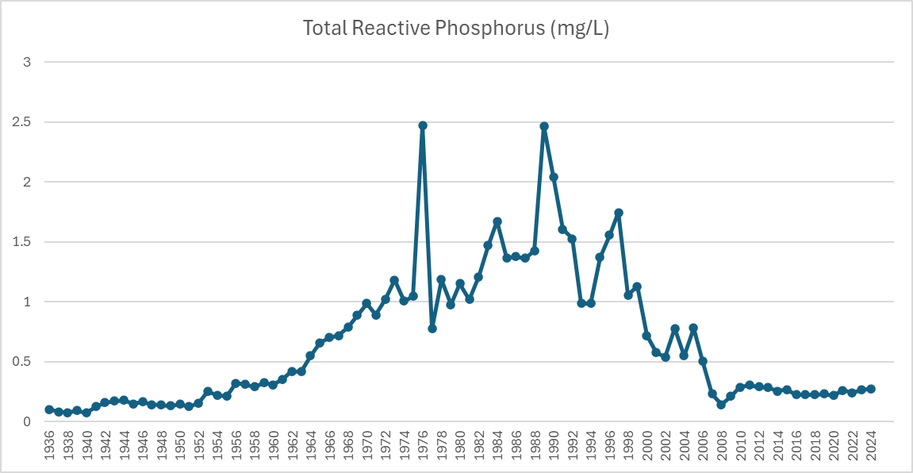
The very significant improvements since about 1990 in the River Thames are reflected in other rivers throughout England (see Figure 2).This shows the annual average P concentration from pooling P data for all Harmonised Monitoring Scheme points in English rivers. These points are mostly located at the lower end of rivers. The smoothed trend on this graph indicates that the geometric mean orthophosphate concentration decreased by 68% over the period 1980 to 2024 and from the year of peak orthophosphate concentration (1987), it has decreased by 78%. These major reductions in river P have been achieved since the late 1990s when, among others, P reduction measures at STWs first began to be introduced.

That same data was used in a study that showed that despite that P has significantly decreased in the las 40 years, river algal blooms have not improved for two reasons:
- Nutrient concentrations remain above limiting levels.
- Rising water temperatures have increased the number of days with water temperatures favourable for diatom blooms in March to April and for cyanobacterial growth in July to August.

These results highlight the challenges of eutrophication management in a warming climate.

Figure 2. Geometric mean concentration of orthophosphate over time for Harmonised Monitoring Scheme sites in England, from 1980 to 2024.
Green lines: smooth trend over long-term. Orange points: unsmoothed. Vertical orange lines and green ribbon: 95% confidence intervals.
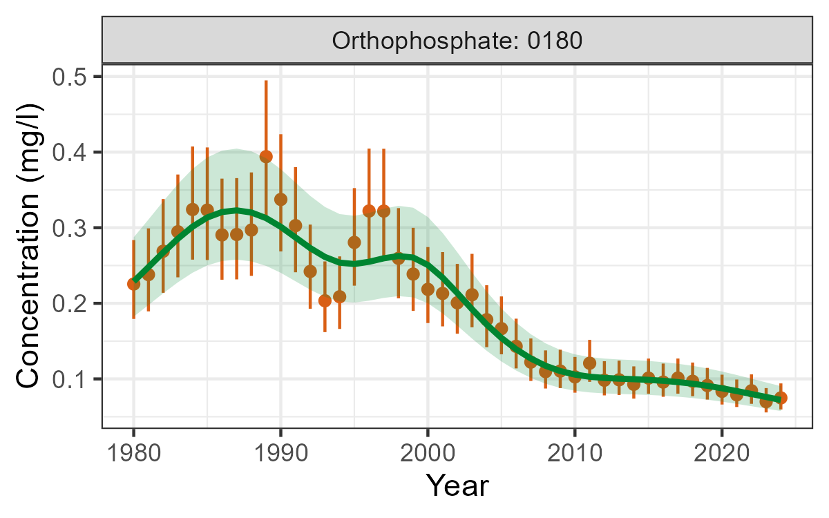
However, despite this very significant progress, much of our river length still has P levels which are too high. There is widespread failure of the WFD Regulations P standards for good ecological status in rivers and lakes in England.
Fifty-three per cent (2,008 out of 3,716) of river water bodies assessed for P in England fail the P standards for good ecological status. Seventy-two per cent of assessed lake water bodies in England also fail their good status standard for P. Compliance with the P standards is worst in lowland high alkalinity rivers – the dominant river type in England.
In the 2022 River Basin Management Plans, 36 groundwater bodies failed to meet environmental objectives due to P concentrations exceeding established threshold values. This represents an increase from 24 groundwater bodies in 2015. The reasons for this rise remain uncertain but may be partially attributed to the long lag times associated with P transport from the soil surface to groundwater, which can span several decades. Additionally, P is typically considered to have low mobility in the subsurface environment due to its strong sorption to soil and geological materials, which retards its movement through the unsaturated and saturated zones. Attenuation through sorption is possible where bedrock or superficial deposits and soil condition have high mineral iron content. Sorption is not a one-way process as reabsorption can occur in particular conditions. Neither is it a continuous process as attenuation declines over time as sorption sites reduce.
All these groundwater body failures in 2022 were classified on the basis that elevated P concentrations in groundwater contributed to the failure of associated surface water bodies to meet their environmental objectives. More water bodies in England fail good status due to P than any other WFD water quality pressure. Some freshwater bodies are formally designated as affected by eutrophication. These are waters formally identified by Defra and WG as Sensitive Areas or Polluted Waters affected by eutrophication under UWWTR or Nitrates Regulations. Thirty-nine lakes and reservoirs and 7,242km river length in England. The Environment Agency also reviewed the extent of eutrophication impacts in river and lakes more generally based on the WFD Regulations monitoring and investigations – see section 1.2.1.

1.2.1 WFD Regulations assessments of eutrophication in rivers, lakes and reservoirs
In the run-up to 2023 Sensitive Area Eutrophic designations, the Environment Agency assessed the certainty of eutrophication impacts in rivers, lakes and reservoirs at risk from P. These assessments are used in applying Defra and UKTAG guidance on the WFD Regulations nutrient standards, whereby expensive regulatory measures to control nutrients are targeted to water bodies with firm evidence of eutrophication. This confirmation is necessary because exceeding the WFD Regulations nutrient standard alone is considered insufficient to judge the risk of impacts on the biology. An approach has been developed which combines the latest the WFD Regulations classification results with wider evidence in a structured way, to make best use of all evidence in identifying whether there is a problem to solve in a given water body. The assessments are available as part of the supporting information to the river basin management plans. Results from these assessments of certainty of eutrophication impacts in English water bodies were as follows.
Lakes and reservoirs – Assessments were undertaken for 332 WFD Regulations water bodies, with around three quarters failing the good status P standard, 34% categorised as 'very certain' and 19% being 'quite certain' of a eutrophication problem.
Rivers – Assessments were undertaken for 3,752 WFD Regulations water bodies, of which around 53% fail the P standard for good status, around 27% were categorised as 'very certain' and 15% as 'quite certain' of a eutrophication problem.
The results confirm that eutrophication is a significant issue in freshwaters in England. Many of the affected water bodies will be those designated under the UWWTR or Nitrates Regulations.
The risks and eutrophication impacts of P in designated European Sites Protected Areas and Sites of Special Scientific Interest (SSSI) rivers and lakes also remain a concern. Nutrients are one of the main reasons for sites not achieving their targets for favourable condition.
Problems associated with algae and eutrophication are also one of the reasons for Drinking Water Protected Areas (DrWPAs) being designated 'at risk'. Of the 439 surface DrWPAs in England, 272 (62%) are assessed as at risk for one or more substances, with algae or eutrophication a causal factor in 81 cases (mostly lake and reservoir sites). Algae can:
- block filters in water treatment works
- make abstraction from reservoirs problematic
- give rise to taste or odour problems in water
As discussed, some groundwater bodies are at poor status for phosphate. This is because elevated concentrations of phosphate in groundwater were causing impacts in associated surface water bodies. Generally, P does not cause widespread pollution problems in groundwater. This is because P in the subsurface often becomes attached to clay or iron minerals. However, once this sorption capacity in the subsurface is used up it is possible for P to move through groundwater to reach surface water receptors. Some aquifers also have naturally elevated concentrations of P. In the 2019 classifications, 36 of 271 (13.3 %) groundwater bodies were at poor chemical status or failed the trend test for phosphate.

1.3 Sources of P and reasons for not achieving good status
The largest source of P to rivers is sewage effluent (about 55% of the total for England) with agriculture contributing around 27% and urban pollution a further 11% in 2020. Due to improvements in P treatment at STWs, the relative importance of these sectors will have changed by 2030. Since the contribution of sewage discharges will reduce to 27% of the sources of P, urban pollution and agriculture will increase to 19% and to 41% respectively.
Sewage effluent and agriculture are the largest P sources and the most common reasons for water bodies not achieving good status for P. Of the 5,721 reasons for not achieving good status for phosphate (see Figure 3) agriculture and rural land management is the main sector responsible in 2,609 cases and the water industry in 1,976 cases (August 2025). This is a change from the second cycle of river basin plans when water industry sewage works were the most common cause.
Within sewage, detergents are now a minor source since EU and UK restrictions were introduced in recent years. Domestic laundry detergents and dishwasher detergents comprised 7% and 9% respectively but became subject to EU regulation from 2013 and 2017. Food waste (5%), food and drink additives (around 5% to 10%), and P dosing of drinking water supplies (6%) are all relatively significant sources of P in sewage . The greatest quantities of P come from urine (44%) and faeces (24%).

Figure 3 Counts of numbers of Reasons for Not Achieving Good Status for P (RNAG – not numbers of water bodies). Data source: Environment Agency August 2025
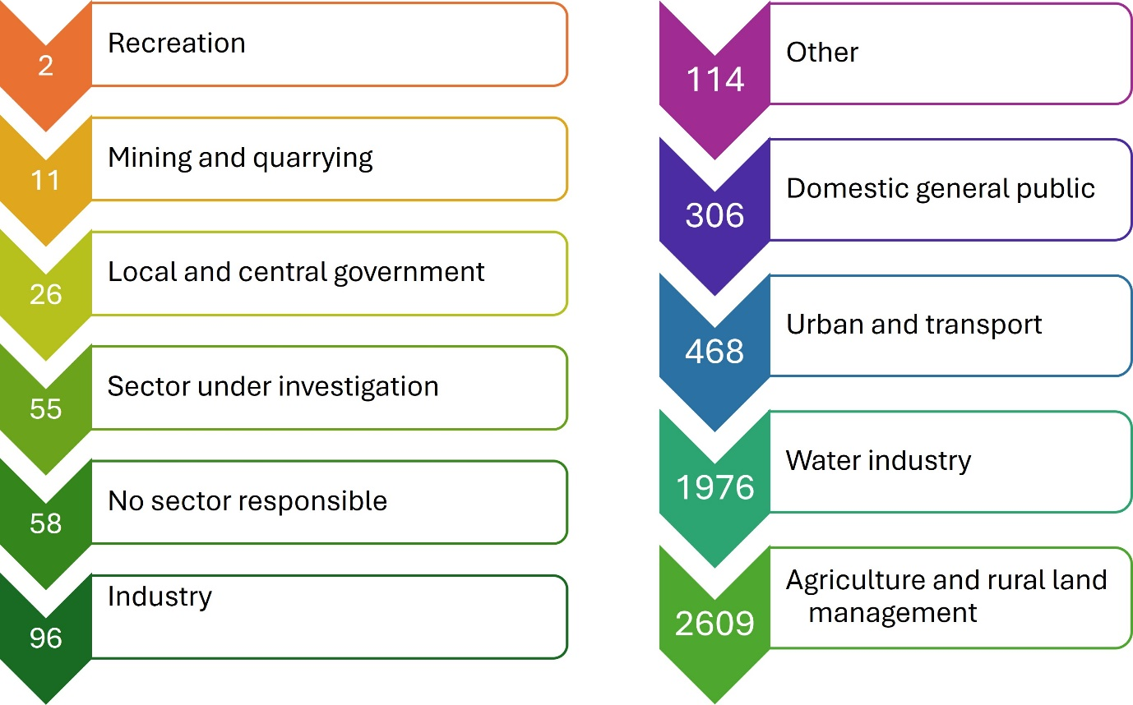
Other minor contributors to P levels in water nationally include industry, misconnections, urban drainage, leaking sewers, combined sewer overflows, septic tanks and small package plants . However, these sources can be locally significant such as in the headwaters of catchments . Leaking water mains are a further source as the large UK water companies lose about 25% of mains water to ground and surface waters through leakage. Since tap water is dosed with P, this adds significant amounts of P (around 1,200 tonnes per annum) to our ground and surface waters (equivalent to up to 25% of the STW P input to rivers in some urban areas). Figure 4 is an approximate national apportionment for the sources of P in English rivers in 2020-2030.

Figure 4. National apportionment for sources of P in English rivers (2020 to 2030)
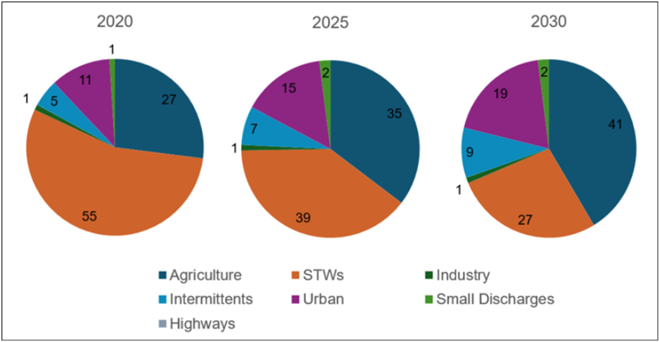
P loadings to English rivers from water industry STWs have been reduced dramatically since 1995. In 2025, the STW P load has been cut by 80% with further reductions committed for PR24 (90% reduction expected in 2035). For agriculture there have been reductions in fertiliser P inputs to land over recent decades, related to improved manure use, plateauing of yields and economic pressure, including the cost of fertiliser. The input to grassland in England and Wales in 1983 was 26 kgP/ha, falling to 3 kg/ha by 2024. Input to arable land was 54 kgP/ha falling to 13 kgP/ha by 2024. Average fertiliser practice on crops and grassland by River Basin District in 2024 shows significant spatial variation, with the highest application rates in the Solway Tweed (average of 26 kgP/a across all crops) and lowest in Thames (average of 8 kgP/a across all crops). There has been a surplus of P applied to agricultural land for many decades. The overall England P balance remained in surplus throughout the period 2000 to 2023 but decreased by 7.6 kg/ha (-90.5%) from 8.4 kg/ha in 2000 to 0.8 kg/ha in 2023. This surplus has created large ‘legacy’ reserves of P in the soil which could take decades to run down.
P concentrations in groundwater in England are typically very low under natural baseline conditions. However, in certain areas, locally elevated levels may arise due to the dissolution of phosphate-bearing minerals, particularly apatite. Although P is generally regarded as having limited mobility in the subsurface, due to strong sorption to soils and geological materials, these natural mineral sources can be locally significant. Such natural background contributions should be accounted for when assessing groundwater to surface water interactions and when evaluating compliance with relevant surface water quality standards.
The input of P from STWs to rivers and lakes is generally relatively constant through the year and readily used by algae and plants (except where chemical P reduction treatment is in place). Agricultural inputs are much more closely linked to rainfall events and are more seasonal, with greater inputs to water in the autumn and winter when algae and plant growth is limited. They are more variable in terms of their forms and immediate bioavailability. However, most forms of P can become bioavailable to algae and plants over time, contributing to ongoing eutrophication risks .

1.4 Failure of P standards in combination with other pressures
P standard failures in rivers commonly occur alongside sediment (and morphology) failures, particularly in relation to the losses from land. For all water bodies where the pressure is known to be from agriculture and rural land management, phosphate accounts for the greatest proportion of failures (58%), followed by fine sediment (11%) and physical modification (16%). P failures also often coincide with high nitrate (for example in Nitrate Vulnerable Zones). It is difficult to distinguish between the enrichment effects of elevated P and N, but in freshwaters it is generally assumed that P is the main causal nutrient and the prime focus for control action. N can contribute to freshwater eutrophication in some situations, particularly in lakes.

1.5 Future risks of eutrophication and P failures
There are a number of issues that could pose a risk of future deterioration and additional eutrophication problems or in some cases reduce P pressures on water and hence eutrophication risks.
Climate change is likely to exacerbate the likelihood of eutrophication, through warmer summers, changes in precipitation and reduced summer river flows. A recent study by the Environment Agency indicated that reduced future river flows were projected to result in small, but variable increases in annual average P concentrations in rivers. At most sites, these changes would not by themselves be expected to result in deterioration in the WFD Regulations P status classification. However, greater rates of increase in P concentrations were predicted for summer or low river flow periods.
Greater storm runoff may also lead to increased nutrient loads from land to water, particularly in winter. A recent study of 3 rural English catchments suggests that average winter P losses to water from agricultural land may increase by up to 30% by the 2050s. Increased temperatures and sunlight are likely to encourage more algal/plant growth and reduced summer river flows would lead to increased nutrient concentrations and longer water residence times during the algal growing season. However, more frequent storms may reduce eutrophication impacts .
Increased population pressure, leading to new housing and sewage treatment infrastructure (particularly in southern and south-east England) will increase P loadings to STWs. Many of the locations desirable for new housing are areas where P already exceeds the WFD Regulations standards. In the near term this pressure presents the most likely risk of deterioration in rivers and has been estimated to pose a risk to 2% of rivers water bodies in England.
Increases in the P dosing of water supplies (to meet tighter Drinking Water Regulations standards for lead) would increase P loadings to water where the receiving sewage works have no P reduction treatment, and P loadings to STWs generally.
The UK is almost entirely dependent on imported P in fertilisers and animal feed. Unstable geo-political circumstances are significantly impacting global fertilizer prices, leading to increased costs and potential disruptions to agricultural production. Recent events, such as the ongoing war in Ukraine and the conflict in the Middle East have created uncertainty and volatility in the fertilizer market.
Agricultural intensification to meet an increasing population may give rise to greater livestock densities and loss of permanent pasture for increased fodder crop production, with increased nutrient losses to water. Although the annual P surplus has been reducing, it applied for many decades and has given rise to a major ‘legacy’ issue with P having accumulated in soils. It may take several more decades and the adoption of more efficient nutrient management methods in agriculture if we are to run down these reserves and reduce the risks of pollution. This needs to be factored into thinking on agricultural P measures and timescales for reducing P losses to water.

1.6 Evidence gaps and uncertainties around the problem
There are significant uncertainties in assessing and managing the risks associated with P and eutrophication . Key areas of uncertainty are outlined in this section.
Links between P (in its different forms) and ecological responses are complex and influenced by a range of factors. This leads to uncertainty in deriving standards and underlines the need for a weight of evidence approach to confirming eutrophication.
Ecological recovery times are long and can vary considerably between catchments. In lakes the role of internal sediment P loading can be important and delay recovery by several decades.
Recent science suggests that N can contribute to freshwater eutrophication in some situations, particularly in lakes. The UK Technical Advisory Group (UKTAG) for the WFD Regulations were consulted on freshwater N standards for lakes, for use alongside those for P, in controlling eutrophication. The standards were introduced for the 2022 river basin management plans. This development builds on the use of lake N thresholds for Nitrates Regulations and European Sites and SSSI purposes.
The importance of P alongside N in estuarine and coastal eutrophication. In oceanographic studies, the N:P ratio provides linkages between the availability of key nutrients, primary productivity and carbon sequestration. Changes in N:P ratios can have cascading effects on the carbon cycle, N cycle, and marine food-web dynamics. The significant deviations in elemental biochemistry of primary producers caused by eutrophication might impair their capacity of nutrient supply for organisms at higher trophic-levels of the food chains (such as fish) in the local coastal ecosystem and thus damage its health.
The extent and nature of climate change’s influences on nutrient delivery to waters and eutrophication is a further area of uncertainty. Further research and development work is needed to improve our understanding of the most effective management interventions. An increased population will have greater food and energy needs which is likely to lead to further intensification of farming practices and increased growth of bio crops. Every year, England and Wales lose 2.9 million tonnes of topsoil to erosion; this could increase due to the influence of climate change.
Contributions from septic tanks and small package plants can be locally important. Assessing the risks relies on good information on locations, construction, maintenance. There is a lack of quantitative studies.
In order to confirm whether targeted regulatory measures may be needed at water body level, we require firm evidence of ecological impacts. We must also understand causes of failure. Since the start of the river basin management plans the evidence base has since been greatly improved through a large programme of investigations and monitoring, informing decisions on measures. For some water bodies, uncertainty over eutrophication and its causes will remain, requiring further investigation if expensive regulatory measures may be required.
Monitoring is fundamental to manage eutrophication in rivers and streams. However, in recent decades, the frequency and spatial coverage of regulatory sampling have been reduced due to funding and infrastructure limitations. Data obtained by trained citizen scientists can be used to fill spatial and temporal gaps in agency monitoring and contribute to improve the management of eutrophication in rural catchments.

1.7 Stakeholders involved in P and eutrophication
The main stakeholders contributing to or affected by or interested in P and eutrophication nationally are listed in Annex 1.

2. Current solutions and the extent of the challenge

2.1 Evidence for improvements resulting from control measures
Ecological recovery from eutrophication can be lengthy and uncertain. Despite significantly reducing P concentrations in rivers, the control measures to date have generally produced minimal ecological benefit. This is considered to be mainly because the actions have not reduced P enough to improve the biology. It will in part be due to legacy issues such as P release from riverbed sediments and soils. However, there are examples of long-term success. Some of the Norfolk Broads have improved markedly following from measures to control P, but it has taken 30 years indicating that long recovery times, particularly for lakes, are an important consideration in managing eutrophication.

2.2 Solutions for point source P inputs
The regulatory mechanisms to control P at STWs are tried and tested. There are two main technical control options – chemical dosing or biological nutrient removal (BNR). Effectiveness of chemical dosing is high, with costs dependent on the size of the STW. BNR has not been widely used in the UK. It appears expensive in terms of cost, energy and carbon but is becoming more common and can enable recovery of the P which is not possible with chemical dosing methods.
By 2015, 650 STWs serving 24 million people (60% of those served by STWs discharging to freshwaters) had P removal in place, for the UWWTR and conservation policies.
By 2027, with the addition of the large programme of P reduction for as the WFD Regulations, around 95% of the population served by STWs discharging to freshwaters will be connected to a STW with P removal. This is based on populations in 1995. The measures are mainly to improve P status, but in some places are to prevent deterioration from population growth causing an increase in P loadings to STWs.
Annex 4 summarises the progress made in reducing STW P loadings, also indicating capital expenditure, numbers of P reduction schemes, km of river protected or improved, and populations served.
As shown in Figure 5, the rivers and their catchments associated with UWWTR Sensitive Areas (Eutrophic), where P reduction is required at large STWs, now cover 65% of England. This follows the latest review of designations which was completed in May 2023.

Figure 5. Urban Waste Water Treatment Regulations (UWWTR) freshwater sensitive areas (eutrophic) and their catchments
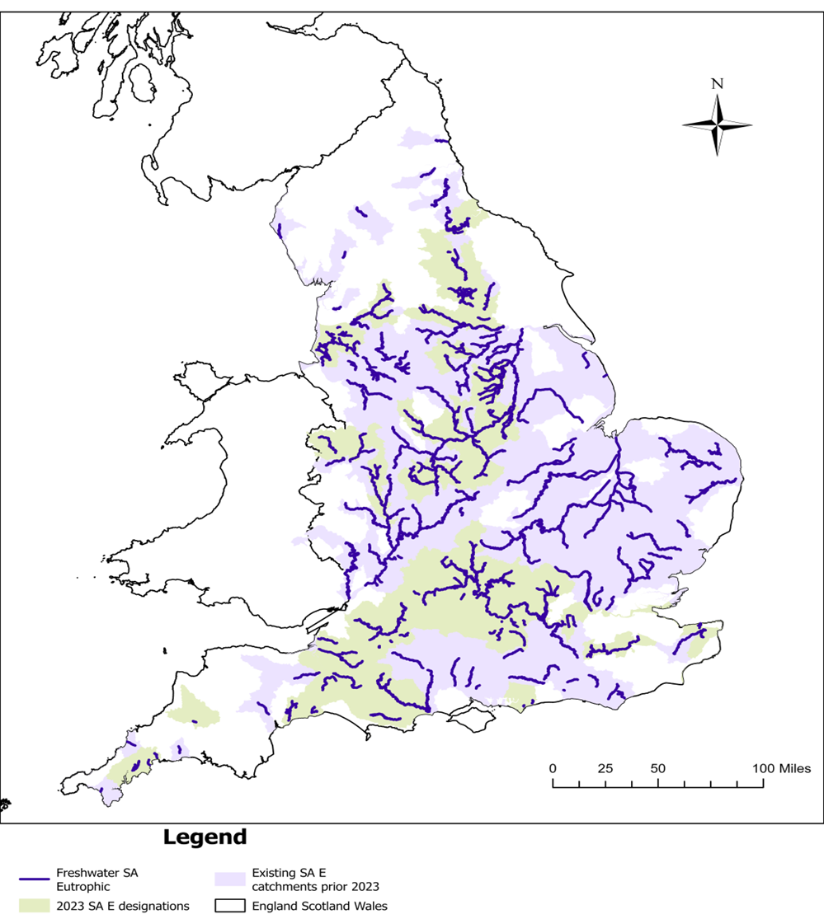
The new UWWTR measures are part of a large programme of further STW P reduction measures proposed for PR19 (2020 to 2025). These measures are mainly targeted at progress towards the water industry’s fair share of the WFD Regulations good ecological status for P and will improve some 5,500km of river at a capital cost of around £2.4bn. Under this programme, around 900 STWs serving 15 million population equivalent will have new or tighter P reduction by 2027. This will result in a reduction of 83% in the STW P loading to rivers compared to the position in 1995 - see Figure 6 and Annex 4. A further 10% reduction (up to 93%) is expected by 2035.

Figure 6. Reductions in loads of P (as ortho phosphate) from STWs to rivers (1995 to 2035)
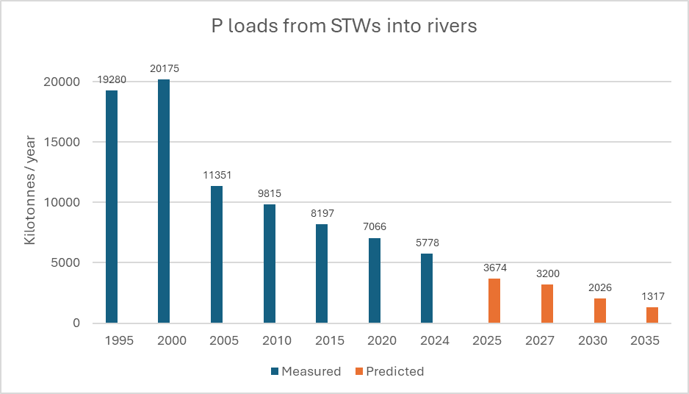

2.3 Solutions for diffuse agricultural pollution
There are limited controls over the use of agricultural land for example the types of farming practised. In addition, there were until recently no direct regulatory controls on agricultural P inputs (to limit the accumulation of surplus P in soils) or the prevention of P losses to water from agricultural activities. However, the Reduction and Prevention of Agricultural Diffuse Pollution (England) Regulations 2018 – commonly known as the Farming Rules for Water (FrFW) – came into force from April 2018. These provide a baseline of good practice measures that could reduce P (and nitrate) losses by typically 8% if they are adhered to. They embed in law various recommended good practices such as nutrient planning, and soil and manure management. They provide a step-by-step checklist aimed at ensuring that fertilisers are spread to meet crop and soil needs. Other rules safeguard water quality by requiring farmers to judge when it is best to apply fertilisers, where to store manures and how to avoid pollution from soil erosion. In June 2025 Defra updated its statutory guidance on the FRfW, which tells the Environment Agency how to enforce the regulations.
The Nitrate Pollution Prevention Regulations 2015 implement the Nitrates Directive in England. Farmers within Nitrate Vulnerable Zones (NVZs), areas designated as being at risk from agricultural nitrate pollution, are legally obligated to comply with the requirements of the Action Programme. The NVZ measures, which apply across 55% of England, while aimed at nitrate, will also indirectly reduce P losses by 1% to 2%. Most Environment Agency farmyard inspections also include checking a farm’s slurry and silage and fuel installations against the SSAFO (Silage, Slurry and Agricultural Fuel Oil) regulations.
New measures announced by the government in March 2022, to help enforce current regulations and support farmers to reduce pollution and deliver for nature, included funding for additional Environment Agency agriculture officers. This increased farm inspections from 400 to over 4,000 a year. Increased funding announced in June 2025 will see the expected number of inspections reach a record 6,000 a year by 2029, supported by more investment in advice-led regulation.
The government’s new Environmental Land Management (ELM) schemes, introduced between 2021 and 2024, are an important mechanism for reducing diffuse pollution from agriculture. They form the main part of the transition away from the EU Common Agricultural Policy to a domestic approach to agriculture and the environment which rewards farmers and land managers for producing public goods. This includes habitat protection and creation, water quality and biodiversity recovery. This currently comprises three schemes - Sustainable Farming Incentive, Countryside Stewardship Higher Tier and Landscape Recovery – and is supported by the Farming Investment Fund offering grants for equipment and infrastructure to help farmers to increase their productivity whilst reducing pollution.
CSF, which started in 2006, is an important government funded voluntary initiative to work with farmers and partners across England to produce food in a way that protects water, air and soil. CSF was initially targeted at priority catchments for water quality; however, the scheme was extended across the whole of England in 2023.
- as of November 2024, CSF had delivered advice on over 200,000 practices to 28,761 farm holdings, representing 49% of the farmed area of England (4.4 million hectares)
- most advice focussed on water quality, but the more recent CSF objectives were increasingly reflected in the advice delivered – 4,782 farms (representing 796,759 hectares) received advice on ammonia emissions to air and 3,916 farms (representing 799,006 hectares) received advice on Natural Flood Management
- 85% of farmers who met their CSF Adviser indicated they were a person they could trust
- between 2006 and 2018, CSF advice led to a 4% reduction in nitrate, an 8% reduction in P and 12% reduction in sediment losses in Phase 1 target areas
The Catchment Based Approach (CaBA) is maturing into a further initiative that is particularly important in the context of reducing diffuse pollution from agriculture and other sources. It is an inclusive, civil society-led initiative that works in partnership with Government, Local Authorities, Water Companies, businesses and more, to maximise the natural value of the environment. CaBA partnerships are actively working in all 100+ river catchments across England and cross-border with Wales. There are several examples emerging of local initiatives to tackle P. One such example is the Welland Valley Partnership where the group has set up a 'working with farmers' scheme offering advice on reducing pollution, free soil nutrient testing and capital grants. The group has also promoted advice on good practice to septic tank owners and use of P-free detergents in selected villages. The Welland was one of three river basin catchments used for a study of P use in the food system (The Role of P in the Resilience and Sustainability of the UK Food System - RePhoKUS). As a result, they have an unparalleled understanding of how this essential nutrient is used and where improvements can be made to improve water quality and nutrient use efficiency.
A range of other voluntary approaches, including the provision of advice and financial incentives exist. These include (but are not limited to):
- Industry led initiatives (for example Voluntary Initiative, Tried and Tested)
- Farm Assurance or certification schemes (for example LEAF)
- Water Industry funded initiatives
- those led by Wildlife Trusts or organisations
Funding sources are varied, for example, in the financial year April 2024 to March 2025, Defra increased funding to the Water Environment Improvement Fund (WEIF) by £11.5 million. This funded 180 local projects led by Catchment Partnerships across England.
Preliminary findings of the latest (2024) Environment Agency modelling indicate that an average agricultural load reduction of 47% is needed to achieve agriculture's 'fair share' of good status for river P, and up to 90% as a catchment average in some European Sites Protected Area catchments. This used the Source Apportionment Geographical Information System-SIMulation of Catchment (SAGIS-SIMCAT) model. This assumes that the burden of reductions is proportionate to the contributions from water company discharges and agriculture.
It is predicted that the current uptake of mitigation methods (excluding agri-environment schemes) produces an average reduction in P loads of 8% at England scale. The additional reduction due to agri-environment scheme (AES) measures is around 1% for P. However, catchment scale impacts can be more substantive, especially when these are well targeted through local initiatives, with reductions in individual waterbodies of up to 16% for P. Their modelling work suggested a cost-effective approach to reduction in P loads could potentially be achieved by using a targeted approach to combine changes in land use, livestock numbers and fertiliser inputs. This includes selected mitigation methods that are known to have a large impact on pollutant loads and have a low level of uptake currently.
A subsequent modelling project in 2025 appraised the contributions of AES to the achievement of the Environment Act 2021 agriculture water target. This is that the load of (a) total N, (b) total P, and (c) sediment entering the water environment through agricultural diffuse pollution is, by 2038, at least 40% lower than the 2018 baseline. The project analysed the extent to which AES could reduce diffuse agricultural pollution at farm level. This aggregated the assessment to a national scale across different farm types, providing an illustration of the prospects of meeting the EA21 agriculture water target across various scenarios. The results suggest that current impacts of AES on P pollution occurring on farms in scheme are reductions of 5% for CS and 9% for SFI. Accounting for the fact that potentially only 55% of the farms in England are in scheme then the overall national impacts of the schemes across all farmland are reductions in P loads of ~4%. The future scenarios predicted national reductions in pollutant losses of up to 10%, but only when large (10%) reductions in fertiliser use and livestock numbers were included as part of the schemes. More detailed analysis showed that for some farm types under some environmental conditions, reductions in pollutant losses associated with these future scenarios could be over 20%. AES could therefore potentially make a larger contribution to the 40% reduction targets, particularly in some catchments, and if scheme coverage was expanded to more farms. However, the larger pollutant reductions associated with these future scenarios are mostly a result of the changes in land use (arable reversion to woodland) and reduced inputs to grassland. This would likely result in comparable reductions in farm productivity.
Recent Environment Agency analysis has been undertaken of catchment-scale source apportionment and estimated diffuse sector reductions required to meet protected area water quality targets. In almost all catchments, the ‘fair share’ reduction required by the diffuse sector is estimated to be several times greater than the reduction in losses achieved when applying current rural land management measures (regulatory and through AES). This suggests additional or alternative measures would need to be explored to achieve the diffuse sector share of the target.
Cost effectiveness of measures to tackle diffuse P pollution, for agriculture, is better when parallel reductions in other pressures (sediment, nitrate, Faecal Indicator Organisms) are considered. The benefits, in terms of P and N loss reduction, of nutrient management planning (including avoidance of incidental losses from poor timing and placement of applications), manure storage and separation of clean and dirty water in farmyards, are widely recognised.

2.4 Modelled national scenarios for river P based on point and diffuse source reductions
The SAGIS-SIMCAT catchment modelling system has been used to assess compliance for P under a range of theoretical diffuse and planned point source P reduction scenarios.
Compliance was estimated in terms of percentage river length compliance with the P standards for good status for a range of STW and diffuse reduction scenarios.

STW Reduction scenarios
- 2020 – after AMP6 measures have been applied
- 2027 – after AMP7 measures have been applied
- future AMPs – these are the combined effect of AMP8 through to AMP10 estimates at face value estimated concentrations and lower confidence estimated concentrations (the most optimistic predictions)

Diffuse Reductions
Percentage reductions from 2020 estimates (0 to 60%).
Fair share:
- in accordance with the Polluter Pays Principle, which defines how sector pollutions are to be reduced
- reductions are applied where needed to meet this Principle, in contrast to the percentage reductions, which are applied everywhere
Figure 7 shows the level of compliance with WFD Good status under different diffuse P reduction scenarios. These reductions are applied equally to agricultural and urban pollution. It indicates that compliance is constrained if there are limited diffuse reductions.

Figure 7. Compliance with WFD Good status under different P reduction scenarios
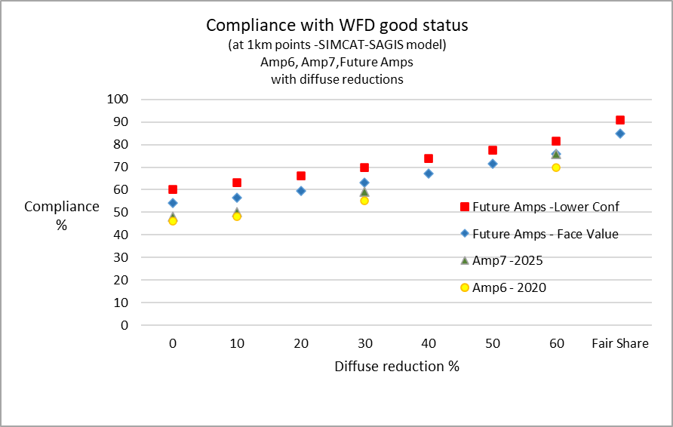

2.5 Solutions for non-agricultural diffuse pollution
EU measures for restricting P content of both domestic laundry (from June 2013) and dishwasher detergents (from 2017) were agreed in March 2012. While reductions in P loadings to water will be quite small, these national source controls complement targeted measures for STWs and agriculture, therefore:
- reducing P inputs from combined sewer overflows, septic tanks and small treatment plants
- reducing P removal costs and chemical usage at STWs
Other mechanisms for non-agricultural diffuse pollution may also reduce P losses, for example general binding rules for site management, washing activities and misuse of drainage systems (for example misconnections), and the use of sustainable urban drainage systems (SUDS). However, data on costs and effectiveness are limited. Since 2015, a regime involving general binding rules for discharges from most septic tank and small package treatment plants has been in place, with permits required for higher risk situations.
Defra consulted in 2012 on the wider issue of non-agricultural diffuse pollution and published a summary of the responses to the consultation in summer 2013 .

2.6 Evidence gaps and uncertainties around the solutions
Technologies to achieve very low levels of P in STW effluent have only recently been widely tested in UK conditions and experience in using them on an operational basis is still developing. See section 3.3 for details of trials of innovative and ambitious methods.
Recycling of P in rivers is complex and not easily accounted for in models, leading to uncertainty in assessing options of measures to meet standards and predict recovery times. There is uncertainty over timescales and the effectiveness of measures to tackle diffuse agricultural P pollution. Much of this uncertainty stems from the challenges of scaling up from small (for example field) scale studies to larger (for example catchment) scale.
The effects of climate change on nutrient losses to water and our ability to mitigate those losses is another area of uncertainty needing further research.
There is limited information on costs and effectiveness of control measures for non-agricultural diffuse pollution in terms of P reduction (other than for detergents).
Recent research has shown the potential benefits of more sustainable practices in relation to P use, treatment, recovery, recycling and impacts . Further work to quantify the predicted impacts of these practices on water quality targets could usefully be undertaken. More focus is needed on scaling up efficiently, avoiding pollutant swapping or other harmful impacts, and reducing costs to increase adoption of these practices.

3. Potential future solutions

3.1 Overview and policy direction
Predictive analysis in the first round of river basin management plans suggested that there are major challenges in achieving P standards nationally. Preliminary results from our latest river P modelling (see section 2.4) suggest that, even with the proposed PR19 measures for STWs and if major reductions in agricultural P losses were achieved, some 25% of national river length may still exceed the P standards. Progress towards good status is largely dependent on the reductions that can be achieved by agriculture. More detailed analysis for individual river basin districts will confirm the extent of the challenge and how it varies across river basins and catchments in England.
Taking into account the extent of challenges and uncertainties, the original cost-effectiveness analysis for previous river basin management plans suggested that the way forward would require a mix of national measures, catchment-based planning to target water industry and agricultural measures in the most effective way, and a likely need for alternative objectives (both extended deadlines and less stringent objectives) in some areas. Our latest modelling, of the effectiveness of potential further measures, supports these conclusions.
Ecological recovery (from eutrophication) can be lengthy and uncertain . This supports the need to prevent deterioration of our best rivers and lakes, alongside restoration measures. Further, the potential to rationalise P standards and targets across as the WFD Regulations, European Sites and SSSI policies needs additional consideration.
The WFD Regulations provide a good framework for managing eutrophication. In line with EU guidance we advocate a harmonised approach, across the key policies, to assessing eutrophication problems. We also suggest that multi-sectoral and partnership approaches are needed in considering measures.
We assume retention of the current approach whereby expensive targeted regulatory measures for the WFD Regulations and UWWTR require evidence of a local eutrophication problem (due to the uncertainty in nutrient standards). This does not preclude 'no regrets' measures based on P failure without biological corroboration . Our current planning assumptions with respect to dealing with P and the problems of eutrophication are shown in Annex 2. A consolidated list of possible control measures is shown in Annex 3.
With regard to policy direction, the Environmental Targets (Water) (England) Regulations 2023 set out ambitious legally-binding targets for reducing nutrient pollution from wastewater and agricultural sources. The targets are an 80% reduction in TP loadings discharged into freshwaters from treated wastewater by 2038 (against a 2020 baseline) and a 40% reduction in TN, TP and sediment from agriculture by 2038 (against a 2018 baseline). If the legally binding targets are met this will be a major step forward in tackling the risks and impacts of nutrient pollution in England. As mentioned in section 2.4, the proposed P load reductions are predicted to significantly improve compliance with the river P standards.

3.2 Scenarios
In considering potential strategies for managing P at river catchment level it may be useful to distinguish and consider the relative priority for action of the following 2 scenarios:
Scenario 1
High P concentrations, often in high alkalinity lowland rivers, due to sewage and agricultural sources, with good local evidence of ecological harm (eutrophication), high confidence that some reduction in concentration or load will be achieved but low likelihood it will be sufficient to achieve P standards and thus uncertainty over ecological improvement. Tackling P from STWs is an essential starting point in these situations but agricultural sources are increasingly important.
Scenario 2
Low P concentrations, often in sensitive low alkalinity or headwater river reaches, where local evidence of eutrophication is likely to be weaker, but deterioration needs to be prevented and measures for agriculture, small STWs and rural sewage sources might reduce P concentrations from just failing to levels that will deliver ecological improvement or prevent impacts.

3.3 Point sources – innovation
A programme of P reduction trials at STWs was undertaken by the water companies through investigations in the National Environment Programme of the 2014 Periodic Review. These trials and the follow-up application of new improved techniques are helping to determine which technologies (suited to UK conditions) can reliably reduce P at STWs to very low levels. The focus is on new technologies and innovation, as well as making best use of existing technology and assets.
As a result of the trials, the Technically Achievable Limit (TAL) for P reduction at STWs was tightened by the Environment Agency from 0.5 mgP/l to 0.25 mgP/l for PR19 (action from 2020 to 2025). This has significantly improved the prospects of achieving river P standards and reducing the risks and impacts of eutrophication, in terms of water industry contribution to river P.
P recovery at STWs is not widely practised in the UK, but following trials at Slough and Derby, a full-scale biological nutrient removal plant with P recovery (producing high grade fertiliser pellets) was opened at Slough STW in 2013 and a further plant has been constructed at Stoke Bardolph STW in Nottingham. We suggest that further consideration is given to the potential wider adoption of biological nutrient reduction and P recovery practices at UK STWs. Recovery of P is only possible where biological P removal is used, and this is only feasible in certain situations.
Wider use in the UK would require a shift away from chemical dosing and require major rebuilding of assets in some cases. Incentives such as more flexible, catchment-based permitting are being trialled and could facilitate the adoption of more sustainable approaches.

3.4 Point sources - designations
In May 2019, Defra designated 20 new river stretches as Sensitive Areas under the UWWTR requiring P reduction at 82 STWs - the measures were part of the PR19 water industry price review. The latest review of Sensitive Areas was completed in 2023. Seventy new Sensitive Areas were designated (68 rivers and 2 lakes) requiring P reduction at over 90 STWs. These measures will be part of PR24 WINEP.
Some waters are designated for conservation purposes under the Habitats and Birds Regulations or national SSSI legislation. For these, Natural England targets for P in designated Natura 2000 and SSSI rivers and lakes underpin the conservation objectives for the sites. The targets for P in rivers were tightened through the release of revised Common Standards Monitoring Guidance in 2016. Interim goals for P in Natura 2000 rivers were included in the 2015 RBMPs and movement toward long-term P targets is an important aspect of the 2022 RBMPs.
In March 2022, the government published a policy paper on reducing the impact of nutrients on protected ’habitats sites’ which are in unfavourable condition and where housing development can only proceed if it is ’nutrient neutral’. The paper set out various forms of government support for local authorities and others in implementing nutrient neutrality as well as plans for addressing the sources of pollution. This was to restore protected sites and reduce nutrient pollution more widely via the Environment Act targets.
In addition, following the policy paper, the Levelling-Up and Regeneration Act (2023) placed a legal duty on water companies in England to upgrade wastewater treatment works by 2030, in certain protected sites which are unfavourable due to excess nutrients, to the highest achievable technological levels.
Larger wastewater treatment works in these protected areas, are required to upgrade treatment to achieve 0.25mg/l TP or 10mg/l TN or both, depending on which is the nutrient of concern.
Also, a Nutrient Mitigation Scheme has been established by Natural England, helping wildlife and boosting access to nature by investing in projects like new and expanded wetlands and woodlands. This will allow local planning authorities to grant planning permission for new developments in areas with nutrient pollution issues, providing for the development of sustainable new homes and ensuring building can go ahead.

3.5 Diffuse pollution approaches
As discussed in sections 2.3 and 2.4, major reductions of agricultural P losses (in the order of 50%) would be needed alongside point source reductions, in areas affected by agricultural sources of P, to achieve good ecological status. That figure is above the statutory target of 40%, which in itself is extremely ambitious. It’s also important to mention that this is a national average reduction, while in some catchments the required reductions are far in excess of 40%, up to 85% to 90% in some cases.
A key challenge is to determine the best mix of measures and mechanisms to encourage adoption of good practice in tackling the range of related diffuse agricultural pressures:
- P
- nitrate
- sediment
- faecal indicator organisms
In 2019 Defra published a review of the evidence of diffuse water pollution from agriculture and the policy options for addressing such pollution103. This informed the level of ambition for the Environmental Targets (Water) (England) Regulations 2023.
In 2018, Defra released its 25 Year Environment Plan (25 YEP) and a Command Paper ’Health and Harmony: the future of food, farming and the environment in a Green Brexit.’ These recognise that, in order to secure the required water quality improvements, more farmers and rural land managers will need to take significant steps towards adopting good practices. The 25 YEP sets clear targets including ‘clean and plentiful’ water. Defra subsequently published the EIP 2023 for England, the first revision of the 25YEP. The EIP included the statutory target to reduce N, P and sediment pollution from agriculture into the water environment by at least 40% by 2038, compared to a 2018 baseline. It also had an interim target of 10% by 31 January 2028, and 15% in catchments containing protected sites in unfavourable condition due to nutrient pollution by 31 January 2028.
Defra’s ELMS aim to encourage land managers to use fertilisers and organic manures efficiently, protect crops whilst reducing the environmental impact of fertilisers and improve soil health. Under the transition to ELMS, direct payments to farmers will be phased out over a seven-year period (concluding in 2028), bringing a new era for farming based on public money for public goods. A number of actions for nutrient management are within the Sustainable Farming Incentive building on existing pilots. In addition, the first round of Landscape Recovery projects focusses on species recovery and river restoration, encouraging improvements in protected sites and reducing pollution.
There is also an aspiration is for a strong regulatory baseline and increased ‘earned recognition’. The government has signalled that farm assurance could play a role in delivering government policy on regulation and other mechanisms that generate environmental outcomes. It has also signalled that increased data sharing between assurance schemes and regulators will be necessary to target poor performers effectively and reward good performers. The Environment Agency will continue to work together with farmers to bring the changes and improvements which will protect our future land and resources and secure better compliance with environmental regulations. This is largely through farm inspections to check compliance against environmental regulations for farming which govern the storage and application of organic and inorganic fertilisers, aspects of livestock management, and other aspects of farming infrastructure and practices where there is a risk of pollution or environmental harm.
For diffuse nutrient pollution, learning from ongoing pilot and research studies should influence our future approach.

Examples of future considerations
In designing improved measures to reduce agricultural P losses to water, it will be important to take into account the legacy P issue and ongoing surplus described previously (and in section 3.6) and the likelihood that climate change will increase P losses.
For lakes where external nutrient inputs have been controlled, in-lake measures (for example sediment capping or bio-manipulation) continue to warrant consideration. The importance of in-stream cycling of P in rivers including timing, forms and the relative importance of P inputs from different sources . This is complex and not easily accounted for in models, leading to uncertainty in assessing options to meet standards and in recovery times.
Further attention should be given to tackling small rural sewage sources, particularly in the headwaters of catchments . These can be either 'diffuse' or 'point' sources. In 2015 Defra introduced a new regime for controlling pollution from small sewage discharges, based on general binding rules in the main, with permits still required for sensitive locations.

3.6 Improving sustainability – P circular economy
As a nation, we need to use P more efficiently, reducing excessive imports and wasteful surpluses that result in damaging losses to the environment. All sectors need to adopt more source control, recovery and recycling of P.
Suitable measures could include:
- assessing and reducing the P content of materials imported to the UK
- switching from imported P based raw materials in industry and fertiliser to recovered P based raw materials
- finding alternatives to P dosing of water supplies
- increasing transparency and accountability for soil P content and crop need in agriculture
- reducing the P content of animal feed
- increasing the efficiency of P uptake by crops and livestock
- farm scale and catchment scale nutrient budgeting
- recognising and using ‘legacy’ P in the soil
- making greater use of recycled and recovered P in storable forms
- treating waste containing P so that the P is recovered to storable products and achieves ‘end of waste’
- reducing crop P demand, including through plant breeding programmes
- development of more efficient forms of fertiliser and methods for their application
- education, societal awareness raising and debate to make the public more aware of the links between dietary choices, food production, waste management and sustainability
- development and adoption of wastewater treatment processes to reduce effluent P to low levels whilst also facilitating effective P recycling and/or recovery into storable forms
- increase recycling and recovery of P from biosolids, slurry and digestate to facilitate efficient circular use of P without transferring pollutants to land or creating surpluses
- addressing inefficiencies in the food chain could also significantly improve wider P sustainability – around 55% of P in food is lost between ‘farm and fork’
- more sustainable human diets for example reducing the amount of meat consumed could reduce the main source of P in sewage
- reducing food waste and increasing recycling, with less disposal to landfill, could also significantly improve the sustainable management of P
- the concept of ’payments for ecosystem services’ (PES) deserves consideration as an approach to controlling nutrient loads, at a catchment level
- net reductions in nutrient pollution secured through Environmental Delivery Plans will be part of the suite of mechanisms available for controlling nutrient loads, as will nutrient markets more generally – these cannot solve the problem at source however and need to be seen in context with the concerted cross-sector effort to increase the sustainability and circularity of P use

Annex 1: Main national stakeholders for P

Stakeholders contributing to P pressure and eutrophication
These stem from the main uses of P in society (in agriculture, food or drink and animal feed supplements, detergents and other industrial applications) and the routes by which P enters the water environment (sewerage, sewage treatment and land runoff). The list of stakeholders, which may not be exhaustive, is:
- mineral P industry (for example Rhodia or Solvay)
- water industry – sewage treatment and sewerage – includes companies and Water UK
- water industry – water treatment (P dosing of drinking waters)
- agriculture – fertiliser manufacturers and retailers for example Agricultural Industries Confederation, International Fertiliser Society
- animal feed manufacturers and retailers
- agrochemicals
- horticulture for example Agriculture and Horticulture Development Board
- National Farmers Union for England
- farmers – livestock (dairy, beef, sheep, pigs and poultry), arable
- forestry sector for example Forestry Commission
- Country Land and Business Association and large land owners, for example National Trust, Crown Estate
- food and drink sector for example Food and Drink Federation
- retail (supermarket) sector
- paper and pulp industry
- detergents industry – laundry and dishwasher – for example UK Cleaning Products Industry Association
- SMEs
- waste management sector
- other industry for example toothpaste, lighting, flame retardants, metal finishing
- developers, local authorities and home owners
- manufacturers, suppliers and owners of package plants and septic tanks

Stakeholders affected by P or interested in P and eutrophication in our rivers and lakes include:
- Office of Environmental Protection, Defra, Welsh Government, other UK Administrations
- Environment Agency and NRW including the water leaders group
- WFD UK Technical Advisory Group
- Ofwat
- Natural England
- catchment groups
- Farming community
- NGOs - Rivers Trusts, Angling Trust, RSPB, WWF, Pond Conservation, Plantlife, Wildlife Trusts, Salmon and Trout Conservation, Wildlife and Countryside Link
- water sports and outdoor amenity groups
- National Trust, Country Land and Business Association and other landowners
- national park authorities
- local authorities
- tourism interests
- CC Water
- abstractors – water companies, farmers, industry
- Internal Drainage Boards
- angling groups
- Canal and River Trust
- water body owners including water companies
- general public
- Academic and research organisations and consultancies providing services in this area
- MHCLG – Ministry of Housing, Communities and Local Government

Annex 2: Consolidated list of planning assumptions for P from the river basin management plans
This is a list of the technical and policy assumptions which underpinned action to tackle the risks and impacts from P in rivers and lakes in England and Wales in the river basin management plans. These assumptions will be reviewed and potentially updated as part of updating the plans, particularly those assumptions where there have been changes in policy and advances in technology and understanding.

P standards and targets and their application include:
- the aim is to achieve the WFD Regulations Good Ecological Status standards for P in rivers and lakes by 2021 except where alternative objectives apply
- deterioration of status under the WFD Regulations must be prevented and the ’no deterioration’ approach applies to P standards under the WFD, at least in the context of Water Industry STWs measures (to control growth)
- restoring the health of currently protected aquatic sites is a key goal to be addressed in the 2022 river basin management plans – this includes meeting water related objectives for our network of international sites designated under the Habitats Regulations for expensive targeted regulatory measures for P to be in considered under the WFD Regulations and UWWTR, firm evidence of a local eutrophication problem is required (in addition to P failure); this is in line with Defra River Basin Planning guidance and Defra and UKTAG standards reports, reflecting the uncertainty in nutrient standards
- softer targeted 'no regrets' measures or national measures (such as source control) under the WFD Regulations may be progressed based on extent of P failure (sometimes in combination with other agricultural pressure failures) without confirming eutrophication at a local level
- ecological recovery when P measures are put in place can take many years, for example, typically 10 to 15 years for shallow lakes

Water industry measures:
- UWWTR Sensitive Areas are required where water bodies are found to be affected by eutrophication and there are qualifying discharges (STWs >10,000pe) involved; there is no assessment of disproportionate costs in these cases, although there is some flexibility as to which indirect qualifying discharges (in the upstream catchment) require treatment
- Defra is applying a targeted approach rather than a 'whole territory' approach in relation to Sensitive Areas under the Urban Waste Water Treatment Directive (UWWTD)
- the technically achievable limit for P in STWs effluent is 0.25 mgP/l except in cases where the water company agrees locally to a more stringent limit
- P recovery at STWs has been considered, in the main, uneconomic in the UK – this is beginning to change with trials and in some cases full scale P recovery at some UK STWs is now commencing
- sewage sludge recycling to land remains a viable option in most cases – sewage biosolids are considered a useful, slow-release alternative to artificial agricultural P fertiliser
- replacing lead pipes as an alternative to P dosing of drinking waters is assumed to be prohibitively expensive in general – pipe lining technology may have some promise as an alternative to P dosing

Detergents:
P in domestic laundry detergents in the EU was restricted from 1 June 2013 and has been controlled in dishwasher detergent from 2017 (New EU measures published in March 2012 brought forward the UK laundry detergent ban which had been intended to come into effect from 2015). In accordance with the Defra Impact Assessment, the restrictions for laundry detergents can be assumed to reduce the total P loading to freshwaters nationally by 3% and the P content of crude sewage by 7.5%.

Agriculture:
- there are limited controls over the use of agricultural land, such as the types of farming practised
- increase in the number of Environment Agency farm inspections of non-permitted farms, reaching ~6,000 a year by 2029, supported by more investment in advice-led regulation
- farmers adhere to DEFRA’s updated guidance on "How to comply with the Farming Rules for Water" which clarifies that manure application must meet crop or soil needs at the time of application
- Defra is applying a targeted approach rather than a 'whole territory' approach to Nitrate Vulnerable Zones (which indirectly reduce agricultural P losses a little) in England and Wales
- government is funding farmers and landowners to take the underpinning actions to improve water quality (as well as other outcomes) through the Farming Countryside Programme (FCP). Land management and land use change actions are being delivered through schemes such as Landscape Recovery, Countryside Stewardship and the Sustainable Farming Incentive. It is also funding farming advice activities such as Catchment Sensitive Farming (CSF). FCP infrastructure and productivity grants, for example the slurry infrastructure grant and farming equipment and technology fund, are also available.
- Government funded schemes such as Defra’s Farming Innovation Programme in England will support innovation and technological advances to improve nutrient management and circularity.
- land use change (converting agricultural land to new habitats and woodland) in a highly spatially targeted way to locations that specifically deliver maximum contribution to water quality objectives is required – this will align with Defra’s proposed Land Use Framework which will provide the principles, advanced data and tools to support decision-making by local government, landowners, businesses, farmers, and nature groups to make the most of our land.
- 36 European Sites Protected Areas have Diffuse Water Pollution Plans to address catchment-wide agricultural pollution sources at protected sites. They are non-statutory and are produced jointly by Natural England and Environment Agency
- Environment Agency heat maps of percentage reductions for WFD indicate 61% to 100% reductions in P are needed in as many catchments based on fair share approach to achieve the EQS for P
- at a farm level a package of the best available measures might reduce P losses by 20% to 40% – this assumes similar levels of effort and efficiency in relation to current measures and mechanisms (for example existing advisory schemes, incentives and regulation)
- at a operational catchment level, reductions in agricultural P losses of 19 to 52% might be achieved if the following mechanisms are applied – regulation (at 85% compliance), agri-environment scheme uptake (at 85%), land use change (10% of farmland to woodland, 10% of arable land to grassland, all maize to barley) and a 10% reduction in grazing stocking density103
- between 2006 and 2018, CSF advice led to an 8% reduction in total P using the target areas of phase 1 priority catchments, although local catchment specific reductions can be much higher

Annex 3: Possible control measures for the main sources of P in water
This outlines some the main control measures available for reducing P losses to water. It is not exhaustive and does not attempt to set out all the detailed options. It focuses mainly on control measures rather than mechanisms (policies or approaches) for their uptake. The headings relate to the sources of P for potential control.
Key:
- [C] denotes a current measure in the UK
- [F] denotes a possible future measure, little or not yet used in the UK

Water company STW control measures include:
- chemical (iron or aluminium) dosing – the current UK norm (using iron) [C]
- biological P removal – not much used in UK [C/F]
- as 1st two bullets with effluent polishing to achieve very low P (for example 0.1 mg/l) [F]
- getting the best we can from current treatment plants [F]
- membrane filtration, reverse osmosis and other novel technologies [F]
- reed beds with adsorption media for tertiary P polishing at rural STWs [F]
- sludge recycling to agricultural land, or sludge to landfill, or to incineration [C]
- P recovery from sludge or effluent for example to produce fertiliser pellets [F]
- trade effluent control [C]
- catchment permitting strategies to meet obligations across a number of water company discharges [C]

Agriculture control measures include:
- source control and P mobilisation measures
- nutrient management planning – matching inputs from manure and fertiliser to crop needs, and including routine testing of soils and equipment [C]
- avoiding incidental losses (due to poor placement or timing of manure/fertiliser applications) particularly in high risk areas [C]
- provision of adequate and appropriate manure and fertiliser storage [C]
- clean and dirty water separation in farm yards [C]
- reduction/control of stocking rates on livestock farms [C/F]
- cover crops and incorporation of crop residues into the soil [C]
- conversion to grass [C]
- tillage practices to reduce erosion and alleviate compaction [C]
- precision-targeted application of fertilisers and manures with soil and manure testing and fertiliser spreader calibration [C/F]
- restricting stock access to watercourses and livestock feeding station locations [C]
- reduction of dietary P intake by livestock and optimisation of livestock and poultry feed conversion to reduce nutrient in manures [F]
- land use change in high risk areas [F]
- crop research for better use of nitrate and P [C]
- pathway control measures [C]
- buffer strips, wetlands, field drain management, track/gateway management, rural SUDS [C/F]

Dosing of drinking water supplies with P (to meet lead standards) control measures include:
- removal of lead pipes as an alternative to P dosing [C/F]
- use of pipe lining technology as an alternative to P dosing [F]
- optimisation of dosing to minimise residual P [C/F]

Food and drink additives control measures include:
- restrictions or voluntary reductions on P content of additives leading to less P in food and drink. [F]

Septic tanks and package plants (nationally small but can be locally important) control measures include:
- environment Agency campaigns in high risk areas [C]
- planning controls eg general binding rules on siting and operation/maintenance [C/F]
- planning measures in high risk areas eg require mitigation (Loch Leven example) [F]

Detergents (measures coming in) control measures include:
- restrictions on P content of domestic laundry detergent (implemented in 1.1.2015 in the UK, with an EU Regulation brought in 1.6.2013). [C/F]
- restrictions on P content of domestic dishwasher detergents (brought in from 2017 through the EU Regulation subject to EU impact assessment). [C/F]
- local initiatives targeted at householders (and retailers?) in high risk areas. [F]

Misconnections (a small source nationally) control measures include:
Range of control measures/mechanisms – for example awareness raising, plumbing control measures, transfer of powers between authorities, incentives, general binding rules [C/F]

Urban drainage (a small source nationally) control measures include:
- sustainable drainage systems (SuDs) in high risk areas [C]
- Drainage and Wastewater Management Plans (DWMP) [C]
- general binding rules to require good practice [F]
- local action to tackle unsatisfactory combined sewer overflows [C]
- Storm Overflows Discharge Reduction Plan [C]

Industrial discharges to water (a small source nationally) control measures include:
- local solutions involving treatment plants to meet the requirements of UK and EU legislation. [C]
- in-lake or river control measures for P and eutrophication
- sediment capping or sediment removal [F]
- biomanipulation [C/F]
- mixing or de-stratification [C]
- barley straw [C]
- continued risk-based response to toxic/nuisance algal incidents [C]
- controlled production of algae for commercial uses (algal farming) [F]

Annex 4: Progress with sewage treatment works total P reduction through water industry periodic price reviews
Period of Spend | Capex on installing P reduction at water industry STWs in England | Population equivalent served | P reduction in place for what proportion of population served by STWs discharging to freshwaters (P standards apply on to freshwaters) | Number of STWs with P reduction in place | Km of river protected or improved for P (not fully additive as some STWs have been improved more than once over time) | Kilotonnes of P per annum discharged to rivers from water industry STWs | Percentage reduction in STW P load to rivers in England relative to 2000
1995 to 2015 (actual)  AMP2,3,4 and 5 | £1.3bn  Comprising:  AMP3 £220m  AMP4 £710m  AMP5 £370m | 24 million |  | 91 in 2000  224 in 2005  413 in 2010  552 in 2015 | 4,500km | - 22.9 in 2000  - 12.8 in 2005  - 11.2 in 2010  - 9.6 in 2015 | - 2000: 0%  - 2005: 44%  - 2010: 51%  - 2015: 58%
2015 to 2020 (PR14/AMP6) | £800m (£0.8 bn) | 4 million | 63% | 786 | 2000km | 8.34 in 2020 | 64%
2020 to 2025 (PR19/AMP7) | £2.4bn in draft water company business plans (for final determination Dec 2019). | 10 million with 1st time P limits.  5 million with tighter P limits. | 83% | 1354  250 with tightened P limits. | 5500km | 4.7 by AMP7 | 79%
2025 to 2030 (PR24/AMP8) | £4bn allocated to P removal (final determination) |  | 91% | 1401 by 2027  1817 by AMP8 |  | 4.3 by 2027  2.9 by AMP8 | 81% by 2027  87% by AMP8

References

Environment Agency, 2019 classifications for phosphorus in river and lake water bodies.
Environment Agency, National RBMP Evidence and Data Report – RBD Breakdown – Table 32 - December 2015
White PJ and Hammond JP, The Sources of Phosphorus in the Waters of Great Britain, Journal of Environmental Quality, 38:13-16, 2009.
Mains water leakage: Implications for phosphorus source apportionment and policy responses in catchments. Goody, D C et al, Science of the Total Environment 579 (2017) 702–708.
Regulating for people, the environment and growth, 2019. Environment Agency, Bristol 2019.
Chapter 11: Agri-environment - GOV.UK
Agriculture in the UK Evidence Pack Sept 2022
Climate change and eutrophication risk in English rivers
Preliminary Cost Effectiveness Analysis for the WFD 1st River Basin Plans – Chapter 4.3 – Nutrients. Defra, 2008.
Lake responses to reduced nutrient loading – an analysis of contemporary long-term data from 35 case studies, Jeppesen et al, Freshwater Biology, 2005, doi:10.1111/j.1365-2427.2005.01415x.
Freshwater Eutrophication Assessment, Background Report for EEA European Environment State and Outlook Report 2010, European Topic Centre (ETC) Water Technical Report 2/2010.
Water quality along a river continuum subject to point and diffuse sources, Neal C, Jarvie H P, Love A, Neal M, Wickham H, Harman S, Journal of Hydrology (2008) 350, 154– 165.
Changes in water quality of the River Frome (UK) from 1965 to 2009: Is phosphorus mitigation finally working? Bowes M J et al, Science of the Total Environment 409 (2011) 3418–3430.
Phosphorus in English rivers – apportionment and future compliance predictions. By Murdoch N, Environment Agency internal report, October 2022.
Murdoch, N. August 2014. Agricultural proportional reductions for WFD phosphorus compliance, draft v2. Internal EA report
Reducing soil phosphorus fertility brings potential long-term environmental gains: A UK analysis. Paul J A Withers et al 2017 Environ. Res. Lett. 12 063001
Major boost to cut agricultural pollution - GOV.UK
Spending Review 2025: a commitment to farming – Farming
The Impact of Phosphorus Inputs from Small Discharges on Designated Freshwater Sites, Final report to Natural England and Broads Authority, by CEH and University of Edinburgh, 2010.
Quantifying the impact of septic tank systems on eutrophication risk in rural headwaters, Withers P J A, Jarvie H P, Stoate C. Environment International 37 (2011) 644–653
Linking agricultural land use and practices with a high risk of phosphorus loss to chemical and ecological impacts in rivers. Report of projects PE0116 and WT0705CSF by ADAS to Defra, 2008.
The Environmental Targets (Water) (England) Regulations 2023
Phosphorus in English rivers – apportionment and future compliance predictions. Murdoch N, Environment Agency internal report, October 2022.
https://www.gov.uk/government/publications/nutrient-pollution-reducing-the-impact-on-protected-sites/nutrient-pollution-reducing-the-impact-on-protected-sites
Aquatic eutrophication in England and Wales: a proposed management strategy. Environmental Issues Series. Environment Agency, Bristol, UK, 1998.
Common Implementation Strategy for the Water Framework Directive: Guidance Document (No. 23) on Eutrophication Assessment in the context of European water policies. European Communities, May 2009.
Mainstone, C.P. (2010) An evidence base for setting nutrient targets to protect river habitat. Natural England Research Reports, Number 034, Natural England, Sheffield.
A revised approach to setting Water Framework Directive phosphorus standards, draft report by WFD UKTAG, March 2012
How green is my river? A new paradigm of eutrophication in rivers, Hilton J, O'Hare M, Bowes M J, Jones J I, Science of the Total Environment 365 (2006) 66–83
Aquatic eutrophication in England and Wales: a proposed management strategy. Environmental Issues Series. Environment Agency, Bristol, UK, 1998.
Aquatic eutrophication in England and Wales: a management strategy. Environmental Issues Series. Environment Agency, Bristol, UK, 2000.
European Sustainable Phosphorus Platform - Home
http://www.wfduk.org/stakeholders/uktag-work-area
Treatment of Industrial Effluents, Callely A G, Forster C F, Stafford D A, 1977. ISBN 0 340 19799 4. Chapter 10 – Eutrophication of Rivers – Effects, Causes and Control.
State of the water environment: long-term trends in river quality in England: 2022 - GOV.UK
B1: Pollution loads entering waters
Treatment of Industrial Effluents, Callely A G, Forster C F, Stafford D A, 1977. ISBN 0 340 19799 4. Chapter 10 – Eutrophication of Rivers – Effects, Causes and Control.
Impact Assessment of Ban on Phosphorus in Domestic Laundry Cleaning Products, Defra, 21.09.2009 AND Consultation on options for controls on phosphates in domestic laundry cleaning products in England, Defra February 2008.
https://www.gov.uk/government/statistics/agriculture-in-the-united-kingdom-2024
UK Phosphorus Transformation Strategy: Towards a circular UK food system
A 150-year river water quality record shows reductions in phosphorus loads but not in algal growth potential | Communications Earth & Environment
State of the water environment: long-term trends in river quality in England: 2024 - GOV.UK
Jarvie, H.P., Worrall, F., Burt, T.P. et al. A 150-year river water quality record shows reductions in phosphorus loads but not in algal growth potential. Commun Earth Environ 6, 62 (2025). https://doi.org/10.1038/s43247-024-01978-4
Environment Agency 2019 classification for phosphorus in river water bodies.
Environment Agency, Reasons for Not Achieving Good Status data, March 2019.
Urban waste water treatment: updated sensitive areas maps 2023 - GOV.UK
State of the Natural Environment 2008, Natural England.
Surface Water Drinking Water Protected Area Master Database – as of 13th August 2025 Environment Agency.
Environment Agency, 2019 water body classifications.
Phosphorus in English rivers – apportionment and future compliance predictions. By Murdoch N, Environment Agency internal report, October 2024.
White PJ and Hammond JP, The Sources of Phosphorus in the Waters of Great Britain, Journal of Environmental Quality, 38:13-16, 2009.
Review of phosphorus pollution in Anglian River Basin District, report for Environment Agency and NFU, Environment Agency May 2012. http://publications.environment-agency.gov.uk/pdf/SCHO0512BUWF-E-E.pdf
Phosphorus Lifecycle Management, UKWIR Ltd Report No. 10/SL/02/9 by Atkins Ltd, University of Oxford and University of Abertay, 2010.
Identifying the Gap to meet the Water Framework Directive - Lakes Baseline, Report WT0750CSF by ADAS UK and CEH to Defra, March 2008. Table 5.1.
Identifying number of sewage treatment works for Phosphorus (P) removal from the UE1 and UE2 National SIMCAT scenarios, Hannah Green and Andrzej Nowosielski, Environment Agency, October 2007 AND Personal communication – Keith Davis (E and B), Matthew Pursall (Ofwat).
Phosphorus in Food Additives, Report – EA - 14912BH-SB, Environment Agency 2013
Impact Assessment of Ban on Phosphorus in Domestic Laundry Cleaning Products, Defra, 21.09.2009 AND Consultation on options for controls on phosphates in domestic laundry cleaning products in England, Defra February 2008.
Phosphorus Lifecycle Management, UKWIR Ltd Report No. 10/SL/02/9 by Atkins Ltd, University of Oxford and University of Abertay, 2010.
Phosphorus Lifecycle Management, UKWIR Ltd Report No. 10/SL/02/9 by Atkins Ltd, University of Oxford and University of Abertay, 2010.
Identifying the Gap to meet the Water Framework Directive - Lakes Baseline, Report WT0750CSF by ADAS UK and CEH to Defra, March 2008. Table 5.1.
Risk assessment methodology for determining the potential contribution of septic tanks and other small point sources to phosphorus losses to rivers. Draft method statement, Chris Burgess, Environment Agency Risk and Forecasting team, 2011.
Identifying the Gap to meet the Water Framework Directive - Lakes Baseline, Report WT0750CSF by ADAS UK and CEH to Defra, March 2008. Table 5.1.
The Impact of Phosphorus Inputs from Small Discharges on Designated Freshwater Sites, Final report to Natural England and Broads Authority, by CEH and University of Edinburgh, 2010.
Mains water leakage: Implications for phosphorus source apportionment and policy responses in catchments. Goody, D C et al, Science of the Total Environment 579 (2017) 702–708.
Regulating for people, the environment and growth, 2019. Environment Agency, Bristol 2019.
Latest British survey of fertiliser practice report - GOV.UK
The British Survey of Fertiliser Practice: Fertiliser Use on Farm Crops for Crop Year 2021. Defra, 2021. ISBN 978-0-99297-357-5.
Latest British survey of fertiliser practice report - GOV.UK
Soil nutrient balances England, 2023 - statistics notice - GOV.UK
Preliminary Cost Effectiveness Analysis for the WFD 1st River Basin Plans – Chapter 4.3 – Nutrients. Defra, 2008.
Phosphorus Lifecycle Management, UKWIR Ltd Report No. 10/SL/02/9 by Atkins Ltd, University of Oxford and University of Abertay, 2010.
Review of phosphorus pollution in Anglian River Basin District, report for Environment Agency and NFU, Environment Agency May 2012. http://publications.environment-agency.gov.uk/pdf/SCHO0512BUWF-E-E.pdf
Phosphorus contributions from WWtW discharges to watercourses and their long term impacts relative to other sources. UKWIR,12/WW/20/5, 2012, ISBN 1 84057 652 9.
Ecological impact of other (non-soluble reactive) phosphorus fractions. UKWIR/Environment Agency report reference No.20/WW/20/9. UKWIR, 2020. ISBN 978-1-84057-900-0.
Update to the river basin management plans in England - National Evidence and Data Report, RBD Breakdown. Environment Agency, December 2015.
Eutrophication and Health, European Commission and WHO Regional Office for Europe, European Communities, 2002 — 28 pp., ISBN 92-894-4413-4
Climate change and eutrophication risk in English rivers. Report – SC140013/R. Environment Agency, Bristol, March 2016.
Allied attack: climate change and eutrophication, Moss et al, 2011. Inland Waters (2011) 1, pp. 101-105.
Understanding phytoplankton behaviour in rivers and predicting their reaction to climate change (focusing on the Thames), presentation of ongoing research by CEH, January 2012.
Whitehead, P.G., Wilby, R.L., Battaerbee, R.W., Kernan, M. And Wade, A. (2009) A review of the potential impacts of climate change on surface water quality, Hydrological Sciences Journal 54 (1), 101-123.
Jeppesen, E. Moss, B., Bennion, H., Carvalho, L., DeMeester, L., Feuchtmayr, H., Friberg, N., Gessner, M.O., Hefting, M., Lauridsen, T.L., Libriussen, L., Malmquist, H.J., May, L., Meerhoff, M., Olafsson, J.S., Soons, M.B. and Verhoeven, J.T.A. (2010) Interaction of climate change and eutrophication. In: Kernan, M., Battarbee, R.W., Moss, B. (Eds.) Climate change impacts on freshwater ecosystems. Wiley-Blackwell, 119-151.
Moss, B. (2012) Cogs in the endless machine: Lakes, climate change and nutrient cycles: A review, Science of the Total Environment 434 (0), 130-142.
Whitehead, P.G. and Crossman, J. (2012) Macronutrient cycles and climate change: Key science areas and an international perspective, Science of the Total Environment 424, 13-17.
IPCC Fifth Assessment Report Climate Change 2014: Impacts, Adaptation, and Vulnerability
Cordell, D., Jacobs, B., Anderson, A., Camargo-Valero M., Doody, D., Forber, K., Lyon, C., Mackay, E., Marshall, R., Martin-Ortega, J., May, L., Okumah, M., Rothwell, S., Shahvi, S., Sherry, E., Spears, B. and Withers, P. (2022), UK Phosphorus Transformation Strategy: Towards a circular UK food system, RePhoKUs project, doi.org/10.5281/zenodo.7404622 [UK Phosphorus Transformation Strategy: Towards a circular UK food system]
Review of phosphorus pollution in Anglian River Basin District, report for Environment Agency and NFU, Environment Agency May 2012. http://publications.environment-agency.gov.uk/pdf/SCHO0512BUWF-E-E.pdf
Preliminary Cost Effectiveness Analysis for the WFD 1st River Basin Plans – Chapter 4.3 – Nutrients. Defra, 2008.
Uncertainty assessment for phosphorus risk to surface waters, Environment Agency Science Report – SC050035/SR, by Centre for Sustainable Water Management, LEC, Lancaster University, 2012.
Mainstone, C.P. (2010) An evidence base for setting nutrient targets to protect river habitat. Natural England Research Reports, Number 034, Natural England, Sheffield.
A revised approach to setting Water Framework Directive phosphorus standards, draft report by WFD UKTAG, March 2012
http://www.wfduk.org/stakeholders/uktag-work-area
Lake Nitrogen UKTAG Method Statement Sep 2020.pdf
Tanioka, T., Garcia, C.A., Larkin, A.A. et al. Global patterns and predictors of C:N:P in marine ecosystems. Commun Earth Environ 3, 271 (2022). https://doi.org/10.1038/s43247-022-00603-6
X. Lu, W. Yu, B. Chen, Z. Ma, G. Chen, F. Ge, S. An, W. Han Imbalanced phytoplankton C, N, P and its relationship with seawater nutrients in Xiamen Bay, China Mar. Pollut. Bull., 187 (2023), Article 114566
The state of the environment: soil. Environment Agency, Bristol, June 2019.
Loiselle, S., Bishop, I., Moorhouse, H. et al. Citizen scientists filling knowledge gaps of phosphate pollution dynamics in rural areas. Environ Monit Assess 196, 220 (2024). https://doi.org/10.1007/s10661-024-12389-5
Preliminary Cost Effectiveness Analysis for the WFD 1st River Basin Plans – Chapter 4.3 – Nutrients. Defra, 2008.
Review of phosphorus pollution in Anglian River Basin District, report for Environment Agency and NFU, Environment Agency May 2012. http://publications.environment-agency.gov.uk/pdf/SCHO0512BUWF-E-E.pdf
Enforcing the Farming Rules for Water - GOV.UK
Johnson, D., Hodgkinson, R., Lord, E., Silgram, M., Cotterill, B., Gooday, R., Morrow, K., Smith, S. and Hulin, A. 2011a. Nitrate Directive Consultation document: Environmental Impact of the 2009-13 Nitrates Action Programme and of potential further measures. Report for Defra. 20pp
Storing silage, slurry and agricultural fuel oil - GOV.UK
Major boost to cut agricultural pollution - GOV.UK
https://www.gov.uk/government/publications/nutrient-pollution-reducing-the-impact-on-protected-sites/nutrient-pollution-reducing-the-impact-on-protected-sites
Catchment Sensitive Farming Evaluation Report – Water Quality Phases 1 to 4 (2006-2018) - NE731
Resilience Phosphorus UK – Re-focusing phosphorus use in the UK food system
Welland-RePhoKUs-summary.pdf
Murdoch, N. August 2024. Phosphorus reductions and prognosis. Draft Internal EA report.
Elliott et al. 2019. A national scale assessment of current and future actions to reduce diffuse pollution of water by agriculture. Final report for Defra project WT1594.
Appraisal of agri-environment scheme actions for achieving agriculture water pollution targets | Office for Environmental Protection
Indicative catchment statistics for nutrient pollution - GOV.UK
Preliminary Cost Effectiveness Analysis for the WFD 1st River Basin Plans – Chapter 4.3 – Nutrients. Defra, 2008.
Murdoch, N, August 2024. Phosphorus reductions and Prognosis, draft Internal Environment Agency report.
Environmental principles policy statement - GOV.UK
Regulation (EU) No 259/2012 of the European Parliament and of the Council, of 14 March 2012 amending Regulation (EC) No 648/2004 as regards the use of phosphates and other phosphorus compounds in consumer laundry detergents and consumer automatic dishwasher detergents.
Impact Assessment of Ban on Phosphorus in Domestic Laundry Cleaning Products, Defra, 21.09.2009 AND Consultation on options for controls on phosphates in domestic laundry cleaning products in England, Defra February 2008.
Phosphorus Lifecycle Management, UKWIR Ltd Report No. 10/SL/02/9 by Atkins Ltd, University of Oxford and University of Abertay, 2010.
Preliminary Cost Effectiveness Analysis for the WFD 1st River Basin Plans – Chapter 4.3 – Nutrients. Defra, 2008.
Regulation (EU) No 259/2012 of the European Parliament and of the Council, of 14 March 2012 amending Regulation (EC) No 648/2004 as regards the use of phosphates and other phosphorus compounds in consumer laundry detergents and consumer automatic dishwasher detergents.
Tackling water pollution from the urban environment consult-udwp-doc-20121120.pdf
Summary of responses to the consultation on "Tackling water pollution from the urban environment"
Uncertainty assessment for phosphorus risk to surface waters, Environment Agency Science Report – SC050035/SR, by Centre for Sustainable Water Management, LEC, Lancaster University, 2012.
Uncertainty assessment for phosphorus risk to surface waters, Environment Agency Science Report – SC050035/SR, by Centre for Sustainable Water Management, LEC, Lancaster University, 2012.
Regulation (EU) No 259/2012 of the European Parliament and of the Council, of 14 March 2012 amending Regulation (EC) No 648/2004 as regards the use of phosphates and other phosphorus compounds in consumer laundry detergents and consumer automatic dishwasher detergents.
Review of the feasibility of recycling phosphates at sewage treatment plants in the UK, report to Defra by the Advisory Committee on Hazardous Substances, 2009.
Cordell, Dana & Jacobs, Brent & Anderson, Aine & Camargo-Valero, Miller & Doody, Donnacha & Forber, Kirsty & Lyon, Christopher & Mackay, Eleanor & Marshall, Rachel & Martin-Ortega, Julia & May, Linda & Okumah, Murat & Rothwell, Shane & Shahvi, Shervin & Sherry, Erin & Spears, Bryan & Withers, Paul & Keep, Elisha. (2022). UK Phosphorus Transformation Strategy - RePhoKUs final. 10.5281/zenodo.7404622.
Investment requirements for England’s river basin management plans - GOV.UK
Lake responses to reduced nutrient loading – an analysis of contemporary long-term data from 35 case studies, Jeppesen et al, Freshwater Biology, 2005, doi:10.1111/j.1365-2427.2005.01415x.
Freshwater Eutrophication Assessment, Background Report for EEA European Environment State and Outlook Report 2010, European Topic Centre (ETC) Water Technical Report 2/2010.
Water quality along a river continuum subject to point and diffuse sources, Neal C, Jarvie H P, Love A, Neal M, Wickham H, Harman S, Journal of Hydrology (2008) 350, 154– 165.
Changes in water quality of the River Frome (UK) from 1965 to 2009: Is phosphorus mitigation finally working? Bowes M J et al, Science of the Total Environment 409 (2011) 3418–3430.
A revised approach to setting Water Framework Directive phosphorus standards, draft report by WFD UKTAG, March 2012
Eutrophication Assessment – the Environment Agency’s proposed approach for the Water Framework Directive 2nd Cycle of river basin management, briefing note for Defra/Environment Agency stakeholder workshop on eutrophication, 7.10.2011.
Aquatic eutrophication in England and Wales: a management strategy. Environmental Issues Series. Environment Agency, Bristol, UK, 2000.
Eutrophication Assessment – the Environment Agency’s proposed approach for the Water Framework Directive 2nd Cycle of river basin management, briefing note for Defra/Environment Agency stakeholder workshop on eutrophication, 7.10.2011.
Defra and Welsh Government River Basin Planning Guidance Volume 2, August 2008 AND Environment Agency 1st WFD River Basin Plans – Annex E - Actions appraisal and justifying objectives - E4 Ammonia, dissolved oxygen, acidity, nutrients, temperature and faecal pollution in surface waters.
https://consult.defra.gov.uk/natural-environment-policy/consultation-on-environmental-targets/supporting_documents/Environment%20Targets%20Public%20Consultation.pdf
https://www.gov.uk/government/publications/nutrient-pollution-reducing-the-impact-on-protected-sites/nutrient-pollution-reducing-the-impact-on-protected-sites
Information about nutrient significant plants - GOV.UK
Notice of designation of sensitive catchment areas 2024 - GOV.UK
Indicative Catchment Statistics for Nutrient Pollution
Environmental Improvement Plan 2023 - GOV.UK
A guide to the restoration of nutrient-enriched shallow lakes, Moss B, Madgwick J and Phillips G, Environment Agency and Broads Authority, 1995. ISBN 0-948119-29-2.
Sewage-effluent phosphorus: A greater risk to river eutrophication than agricultural phosphorus? Jarvie H P, Neal C, Withers P J A, Science of the Total Environment 360 (2006) 246– 253
Linking agricultural land use and practices with a high risk of phosphorus loss to chemical and ecological impacts in rivers. Report of projects PE0116 and WT0705CSF by ADAS to Defra, 2008.
The Impact of Phosphorus Inputs from Small Discharges on Designated Freshwater Sites, Final report to Natural England and Broads Authority, by CEH and University of Edinburgh, 2010.
Quantifying the impact of septic tank systems on eutrophication risk in rural headwaters, Withers P J A, Jarvie H P, Stoate C. Environment International 37 (2011) 644–653
Linking agricultural land use and practices with a high risk of phosphorus loss to chemical and ecological impacts in rivers. Report of projects PE0116 and WT0705CSF by ADAS to Defra, 2008.
https://www.gov.uk/government/consultations/small-sewage-discharges-new-approach-to-how-we-regulate-in-england
Cordell et al., 2009 Global Environmental Change, 19, 292–305
Cordell and White (2013), Agronomy, 3, 86-116
Major boost to cut agricultural pollution - GOV.UK
How to comply with the Farming Rules for Water - GOV.UK
Storm Overflows Discharge Reduction Plan

