STATEMENT OF OUTCOMES – BUILDING PEACE AND STABILITY IN IRAQ
*This document should be read in conjunction with the Call for Proposals Invitation Form
SUMMARY: The UK Government’s Foreign Commonwealth and Development Office (FCDO) is running a call for proposals to identify a new partner to deliver one component of its Building Peace and Stability in Iraq (BPSI) programme.
OVERALL PROGRAMME BACKGROUND
BPSI aims to support the reintegration of internally displaced persons (IDPs) and returnees from Northeast Syria in areas of return. The programme is currently implemented by the International Organization for Migration (IOM) and six local NGOs managed by the International Rescue Committee (IRC). The programme delivers peacebuilding and social cohesion activities, legal and livelihoods support, and small-scale community infrastructure rehabilitation, alongside policy, advocacy and capacity building initiatives to further durable solutions. The programme also funds the role of the Durable Solutions Advisor to the UN Resident Coordinator.
The programme component delivered by IRC has been running since 2023. Due to IRC’s planned departure from Iraq in 2026, the FCDO is seeking a new partner to manage this component of the programme, deliver against existing programme outcomes and take over existing programmatic relationships with local NGOs.
The theory of change for the programme is summarised below:
Programme logic
à
Grassroots work in communities enables FCDO to 1) address the barriers to return and reintegration of people returning from Daesh-induced displacement, 2) Capacity change leads to a reduction in the potential for local conflict, 3) Behaviour change results in improved motivation and capacity to support the return and reintegration of the displaced, 4) Security threats and lack of political will are no longer barriers to return, 4) The displaced are rehabilitated and returned to their areas of origin.
à
Grassroots action gives FCDO credibility when working with Government and international agencies: FCDO is acting as well as talking.
à
Grassroots action gives a valuable evidence base for influencing. The perspective of the most-affected people is brought into the national debate.
à
Combining the knowledge acquired through grass-roots action with information from other programmes and research, the FCDO is in a strong position to influence the policies of the Government and international organisations.

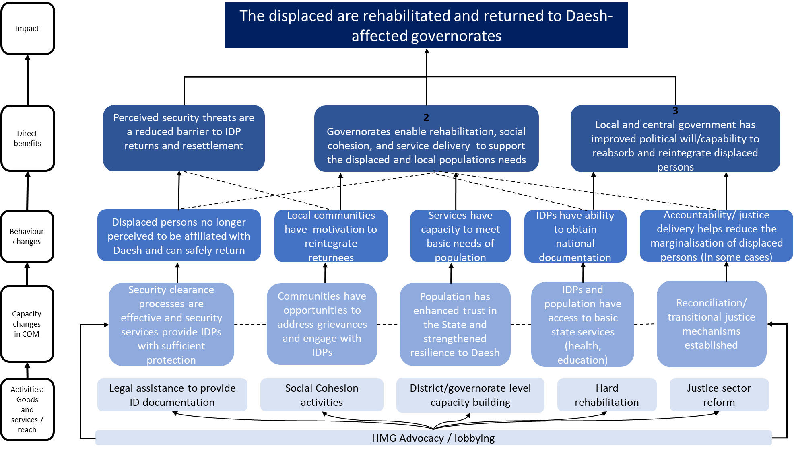
For more information on BPSI, including the latest annual review of the programme, please refer to the programme information on devtracker: DevTracker Programme GB-GOV-1-301223 Documents.
IRC PROJECT BACKGROUND
Role of IRC
As the lead on this project currently, IRC serves as the lead partner, coordinating interventions, advocacy initiatives, and technical support across all project locations and local NGOs. IRC is responsible for management of and support to the local NGOs, including on compliance and monitoring and evaluation, and holds the grant with FCDO and is responsible for submitting consolidated reporting to FCDO.
IRC has also led on gender mainstreaming across the consortium, conducting gender assessments, collecting sex-disaggregated data, engaging male allies, and holding partners accountable for gender-sensitive implementation.
Finally IRC directly delivers policy, advocacy and capacity building to government stakeholders to complement work delivered by local partners. Some recent examples of this include work to progress the implementation of the legal aid law, training for the Ministry of Migration and Displacement on the role of women in leadership and advocacy, coordinating with Ministry of Labour and Social Affairs on jobs and employability, and a workshop on community policing with the Ministry of Interior.
Local partners, activities and locations
Currently under this project IRC manage six local NGOs who deliver most of the activities in areas of high return in Iraq. The partners, and their current activities and project locations are summarised below.
Organisation | Locations | Activities
Peace and Freedom Organization (PFO) | Kirkuk (Kirkuk Centre, Dibis, Hawija, Daquq) | - Social cohesion  - Establishment of and capacity building to peace committees  - Establishment of and capacity building to natural resource management committees (NRMCs) and supporting participants to develop community action plans and deliver events/advocacy  - Production and publication of positive-narrative stories on social media to drive social cohesion  - Implementation of community peacebuilding initiatives, engaging local authorities  - Delivery of community-level peacebuilding and social cohesion trainings and workshops
Al Tahreer Association for Development | Qayarrah, Salahadin (Yankaja and Tuz Khurmatu), Anbar (Al Qa’im, Ana, Rawa, Heet, Ramadi)
Justice Center | Qayarrah, Salahadin (Yankaja and Tuz Khurmatu), Kirkuk (Kirkuk Centre, Dibis, Hawija, Daquq) | - Legal services: awareness, counselling and representation to support beneficiaries with civil documentation, housing, land and property rights, family law and access to state services.  - Livelihoods and skills-building activities. Support to improve employability, i.e. job counselling, and financial literacy. Financial health education and budgeting support.  - Establishment of job opportunity platforms (LCN only).
Legal Clinics Network (LCN) | Anbar (Al Qa’im, Ana, Rawa, Heet, Ramadi)
House of Coexistence | Sinjar | All activities listed above and also:  - Organisation of inclusive community dialogues  - In-person sessions to promote peaceful coexistence, tolerance, and collaboration  - Advocacy on the Yazidi Survivors’ Law
Investigator Organization for the Rule of Law (IOL) | National-level | - Advancing key initiatives under Iraq’s Rule of Law Strategy (2025–2029), focusing on awareness, advocacy, and system strengthening, i.e. workshops for parliamentarians, capacity building for government officials.  - Associated awareness-raising efforts.

Project outcomes
The current outcomes for the IRC component of BPSI are as follows:
- Outcome 1: Constructive dialogue and engagement: Community groups —including men, women, marginalized groups, youth, and community leaders—engage to identify specific drivers of conflict, promote social cohesion, and reduce discrimination.
- Outcome 2: Access to justice and durable solutions: People impacted by displacement can access justice and exercise their rights to achieve durable solutions
- Outcome 3: Strengthening Policy Advocacy & Institutional Reforms
Other BPSI components
Under BPSI, the FCDO also currently provides funding to IOM and UNDP. IOM also sub-grants to some CSOs in specific locations.
The successful applicant will be expected to collaborate effectively with other organisations delivering under BPSI. Currently, local NGOs under the IRC component deliver in some of the same locations as IOM. Additionally, under BPSI a livelihoods referral mechanism system between IOM and IRC is in place.
More detail on BPSI funding to IOM is summarised below:
- IOM are currently delivering BPSI activities in Markaz Sinjar, Salahadin (Yankaja and Tuz Khurmatu), and Anbar (Al Qa’im).
- IOM activities include:
  - Community-based planning and small-scale infrastructure rehabilitation
  - Small business development and expansion grants
  - Grants to small- and medium-enterprises
  - Cash and rental assistance to returnees from Al Amal Rehabilitation Centre
  - Family reunification support in Al Amal Rehabilitation Centre
  - Policy, advocacy and capacity building support to further Durable Solutions
BPSI also funds the role of the Durable Solutions Advisor to the UN Resident Coordinator, who plays a strategy and coordination role for Durable Solutions efforts in Iraq.
POLICY OUTCOMES TO BE DELIVERED (LEAD PARTNER)
The FCDO is seeking a lead partner to deliver against the stated policy objectives and continue our work with existing local actors. We do not anticipate major changes to the existing policy outcomes outlined above or the overall aim of the BPSI programme. The key policy outcomes we expect the successful applicant to deliver are:
- Ensuring smooth management of a group of local NGOs including existing partners and any new partners proposed. This will include prompt completion of any due diligence requirements, inducting local NGOs on any required standard operating procedures or compliance requirements, and establishment of governance, reporting and monitoring and evaluation procedures for the group of NGOs. To support this, IRC will hand over any existing project and compliance documentation relating to existing partners required by the successful applicant.
- Assessing the technical and compliance capacity of the local NGOs, then designing and delivering tailored support to each NGO to support them to work towards meeting donor compliance requirements. Working with local NGOs on financial sustainability planning and fundraising strategies.
- Effectively managing local NGOs, supporting their successful delivery against agreed activities and results, and providing capacity building as needed. To support this IRC will work with existing local partners on project planning and budgets for financial year 26/27 – the successful applicant will then be able to adapt and amend these with local partners.
- Supporting local partners to deliver peacebuilding and social cohesion activities, legal assistance and advocacy. Based on programme learning to date, FCDO plans to phase out livelihoods support under this component after 31st March 2026. We are interested in proposals that include plans to sustainably embed peace committees and natural resource management committees into local leadership structures (for example, exploring the link between peace committees and the community police) and transition these to community ownership. FCDO are keen to see proposals that maintain a strong focus on legal assistance and on delivering positive social cohesion narratives. We are interested in proposals that suggest evidence-based ways in which to improve upon activities delivered under BPSI to date.
- Effectively mainstreaming climate and inclusion throughout the programme, building on work already done, and building local NGO capacity to do so.
- Delivering effective policy, advocacy and capacity building initiatives that further the Durable Solutions agenda in Iraq, including initiatives related to inclusion and climate mainstreaming objectives. Organisations are free to propose initiatives in this space that align with their expertise and leverage existing networks and relationships. Organisations must ensure activities proposed align with existing Durable Solutions initiatives in Iraq, are well coordinated with other relevant actors and do not duplicate existing interventions. We are interested in proposals that consider how to further existing work in this space delivered by BPSI including: advocacy on the implementation of the Rule of Law strategy and access to justice, including strategy and advocacy work to progress the implementation of the Legal Aid Law.
We expect the successful applicant to take an empowering approach to working with local NGOs, ensuring our local NGO partners have voice, agency and decision-making ability within the consortium, and are fairly compensated for their work, including the provision of fair overheads, operational and security costs.
The successful applicant will also be able to propose new downstream partners.
OUTCOMES TO BE DELIVERED (LOCAL PARTNERS)
Due to the timeframes available, IRC will work with the existing local partners to develop plans and budgets for FY 26/27 (1st April 2026 – 31st March 2027). Therefore, we do not expect applicants to include detailed plans relating to the existing local partners in their bid. We expect project activities and locations to remain largely the same as outlined above, however, we will cease support to livelihoods activities.
The successful applicant will have an opportunity to work with existing local partners to refine activities, planned results and budgets in the first quarter o FY26/27.
Applicants are welcome to propose additional downstream partners to add to the consortium if they can deliver activities that are complementary to existing downstream partners or if they will support the lead applicant to deliver on the outcomes outlined above.

