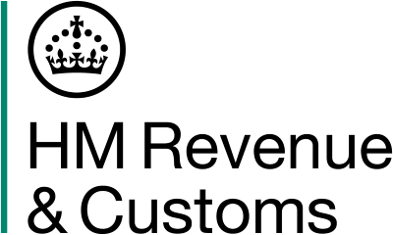

Gov.uk Minutes
Taxpayers Data Standards Forum
06 November 2025: 10:30 – 16:00

General HMRC Update

HMRC reported progress on customer service and digital transformation initiatives. Improvements in telephony have reduced self-assessment calls, and work continues to digitalise outgoing post and streamline internal processes.

Disputed Charges and Data Quality
New digital tools have significantly reduced manual intervention in resolving disputed charges. Efforts to improve data quality remain a priority, with attention on payment discrepancies and sector-specific challenges.

Technology and Software Strategy
The discussion focused on the evolving tax software strategy, highlighting collaboration with software providers and the importance of third-party solutions.

Policy and Stakeholder Engagement
Recent policy updates and communications for employers and agents were shared. Members feedback on the HMRC stakeholder conference underscored a shared commitment to modernising the tax system, improving accessibility, and investing in technology and skills.

Next meeting

The next forum will be held on 10 February 2026.

