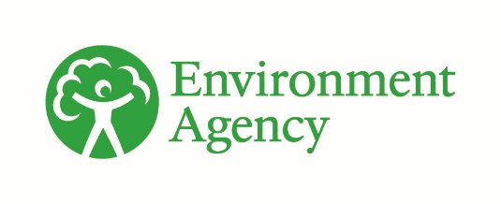


Drinking Water Protected Areas: challenges for the water environment
Review: September 2025
Contents
Drinking Water Protected Areas: challenges for the water environment 1
1. Background 2
2. The problem 3
3. Future challenges to meeting DrWPA objectives 19
4. Choices 23
5. References 31

1. Background

1.1 Relevance and accuracy of data
This document has been produced by bringing together the readily available information on the topic. Quality assurance of the information included so far is not complete. As a result, the document may contain some errors or inaccuracies. Please let us know of any other relevant evidence or if you are aware of any issues with the information. This will help us to build a comprehensive and robust evidence base to underpin decision-making in river basin management planning.
All groundwater data are taken as correct on 1 September 2025. All surface water data are taken as correct on 13 August 2025.

2. The problem
To safeguard public health and ensure long-term sustainability, we must protect our drinking water sources from pollution and strengthen their resilience against future challenges, including climate change. Water bodies such as rivers, lakes, and groundwater that currently supply, or are expected to supply, more than 10 cubic metres of water per day for human consumption, or serve over 50 individuals, are designated as Drinking Water Protected Areas (DrWPAs). Drinking water is public drinking water supplied by water companies to their customers and private water supplies for domestic dwellings or the food and drink industry.
The objectives for Drinking Water Protected Areas are:
- to ensure the necessary protection of the supply by avoiding deterioration in water quality to reduce the level of purification treatment required in producing drinking water
- for groundwater, to meet good chemical status and reverse upward trends in pollution
It is important to recognise water treatment is applied, as needed, to ensure the water taken from the environment meets drinking water standards at consumers taps. The Drinking Water Inspectorate (DWI) is the authority responsible for meeting the requirements of the Water Supply (Water Quality) Regulations 2016.
The DWI stated that the quality of supply in England was very high in their Annual Report for 2024. Only 0.03% of tests failed to meet standards at tap.
The failure rate was higher for private water supplies in 2024 at 2.5%.
Significant investment has been made by water companies, funded through their customers' bills, to remove pollutants and meet the standards. The DWI Chief Inspector’s letter to Ministers in July 2025, stated that ‘the provision of clean drinking water is fundamental to the health and wellbeing of society and economic prosperity, and access to clean water is a basic human right recognised by the United Nations. The advances in water safety planning and systems management underpinned by robust water quality regulation provide some of the best drinking water in the world’ but also warned that ‘our water supply system is under pressure from a range of different threats, and these are made more urgent by climate change and population growth’.
The primary goal of Drinking Water Protected Areas is to safeguard environmental water sources from pollution. By maintaining high water quality at the source, these protections help reduce reliance on costly and unsustainable treatment processes.
Understanding the risks posed to drinking water sources in a catchment is a central part of the World Health Organisation’s water safety planning approach.
Investing in collaborative catchment management to prevent pollution at its source can be more cost-effective than relying on additional treatment or blending with cleaner water. This approach can also deliver broader environmental benefits.

2.1 England's drinking water sources
In England approximately 30% of drinking water sources are from groundwater and 70% from surface water. However, as shown in Figure 1, in the south and south east, over 75% of drinking water supplies are from groundwater. 17-18 million people in the south and east rely on groundwater as a sole source of drinking water and as a growth focussed area, pollution prevention is paramount to protecting groundwater water supplies in those areas. In the north and south west of England, and in Wales, only 0-25% of drinking water supplies are from groundwater (see Figure 1). Figure 1 describes the distribution of water supply sources as a percentage of either groundwater or surface water.

Figure 1: The percentage of total public water supply (“deployable output”) that is from groundwater, 2021 (BGS 2021. Groundwater resources in the UK - British Geological Survey)
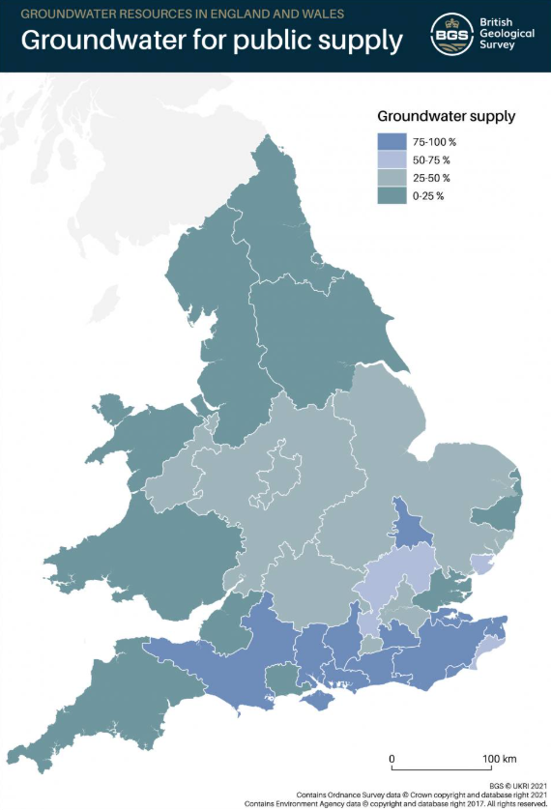
The Water Environment Regulations 2017 (Water Framework Directive) (England and Wales) Article 8.1 places a statutory duty on the Environment Agency to identify “Drinking Water Protected Areas” (DrWPAs). DrWPAs are defined as bodies of water used for the abstraction of drinking water and providing more than 10 cubic meters of such water per day as an average, or supplying more than 50 persons. All 271 groundwater bodies in England meet this definition, so are identified as drinking water protected areas, covering 84% of the country.
There are 439 lakes, rivers and canals identified as surface water DrWPAs, covering just 7.5% of England. Where a surface water DrWPA is considered ‘at risk’ of not meeting DrWPA objectives, the upstream catchment area is designated as a safeguard zone. Surface water safeguard zones (SGZ) cover 35% of country.

2.2 Pressures on drinking water sources
Many drinking water sources are deteriorating because of pollution from nutrients and chemicals. This will be exacerbated by pressure from future development, population growth and climate change. Nitrate is a continuing concern in groundwater bodies and will remain so for decades without a step change in nitrogen management. Chemicals in groundwater such as pesticides, solvents, plasticisers and industrial chemicals are also issues1.
DrWPAs are ‘at risk’ when the quality of water abstracted does not, or is unlikely to meet, one or more of the objectives set out Section 2. Across England, 272 of the 439 (62%) surface water DrWPAs at ‘at risk’. A DrWPA can be ‘at risk’ for one or more reasons.
Figure 2 shows the broad categories of reasons why surface water DrWPAs are ‘at risk’ in each river basin district:
- sediment and colour, including turbidity, dissolved organic carbon (DOC), total organic carbon (TOC) and colour
- pesticides
- nutrients – algae related
- nutrients – nitrogen compounds
- ‘other’ – including metals such as manganese

Figure 2: Reason for surface water DrWPAs being ‘at risk’ grouped by substance type and river basin district (Note: A DrWPA can be ‘at risk’ for one or more substances.)
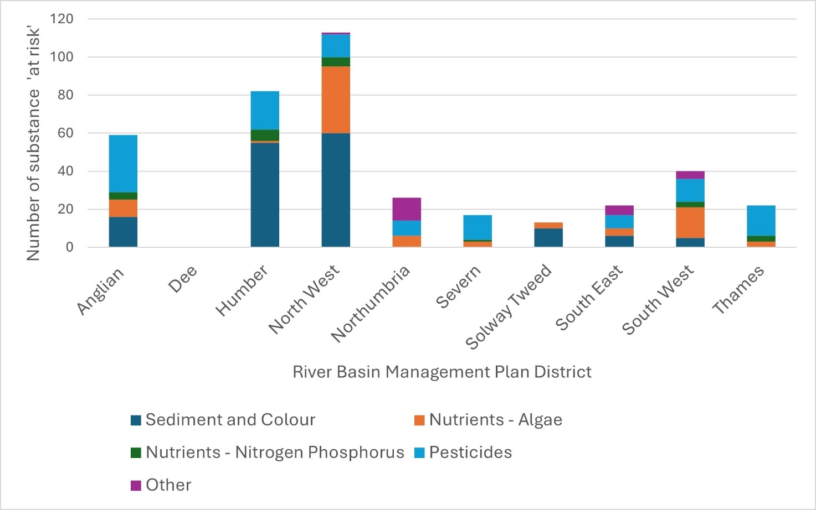
Figure 2 Description: The North West River Basin District has the largest number of substances ‘at risk’ (113), followed by the Humber (82), Anglian (59) and South West (40). Northumbria has the next largest number of substances ‘at risk’ (26), with Thames and South East having the same number (22). The Severn has 17 substances ‘at risk’ followed by the Solway Tweed (13.) The Dee has no surface water DrWPAs.
Across river basin districts, sediment and colour are the leading causes of ‘at risk’ Drinking Water Protected Areas (DrWPAs) in the North West and Humber regions, with 60 and 55 sites affected respectively. Overall, pesticides are the most frequently cited cause of surface water DrWPA risks, with the highest number of ‘at risk’ sites recorded in the Anglian region (30).
Of the 271 groundwater DrWPAs, 175 (65%) contain safeguard zones. Over a quarter of groundwater bodies (71 of the 271, 26%) are not meeting good chemical status because the water quality in DrWPAs is deteriorating, and almost all of these have an upward trend in pollution. There is no equivalent status requirement for surface water bodies.
Figure 3 shows the broad categories why groundwater DrWPAs are not meeting good status in each river basin district:
- nutrients – nitrogen compounds
- nutrients – phosphate
- pesticides
- solvents
- metals/metalloid
- ‘other’

Figure 3: Reasons groundwater DrWPAs are classed at poor chemical status grouped by substance type and river basin district
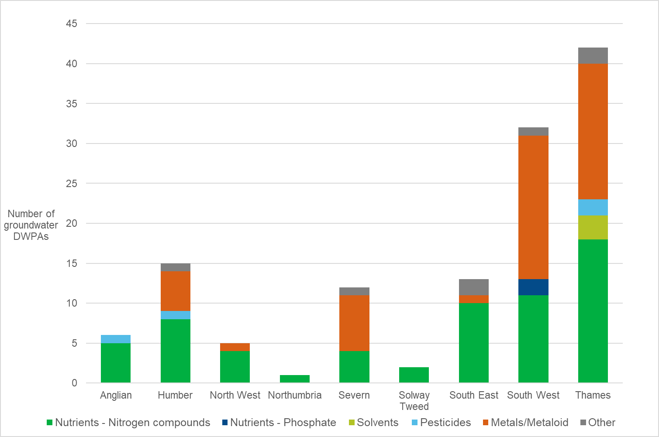
Figure 3 description: Thames river basin district has the highest number of groundwater DrWPAs classed at poor chemical status (42), followed by South West (32); the Humber (15), the South East (13), Severn (12) and Anglian (6). The North West river basin district has 5 groundwater DrWPAs classed as poor chemical status, the Solway Tweed has 2 and Northumbria only 1. All the river basin districts have nitrogen compounds as a reason for poor chemical status with metals and metaloids being the second highest reason for river basin districts being classed as poor. South West is the only river basin district with phosphate as a reason for poor chemical status and solvents are only identified as a reason in the Thames river basin district. Pesticides are identified as one of the reasons in Thames, Anglian and the Humber districts.
South West and Thames river basin districts had the greatest number of groundwater DrWPAs at poor chemical status at just over 30 and 40 respectively. Metals/metalloids and nutrients, nitrogen compounds were identified as responsible in both regions. Nutrients (nitrogen) are also responsible for most poor chemical status areas in the South East.
Where a DrWPA is ‘at risk’, a non-statutory safeguard zone (SgZ) is established identifying the catchment area where land use practices are most likely to be causing, or have caused, water quality in the DrWPA to deteriorate. Safeguard zones focus pollution prevention and regulatory actions where they are most needed.
England has 154 Surface Water Safeguard Zones (SgZs) and 256 Groundwater SgZs. Each zone may be identified for one or more specific reasons. As illustrated in Figure 4, the primary drivers for establishing surface water SgZs include pesticides, sediment, colour, and algal-related concerns. In contrast, groundwater SgZs are predominantly identified due to elevated concentrations of nutrients, particularly nitrogen compounds.

Figure 4: Reasons for establishing safeguard zones
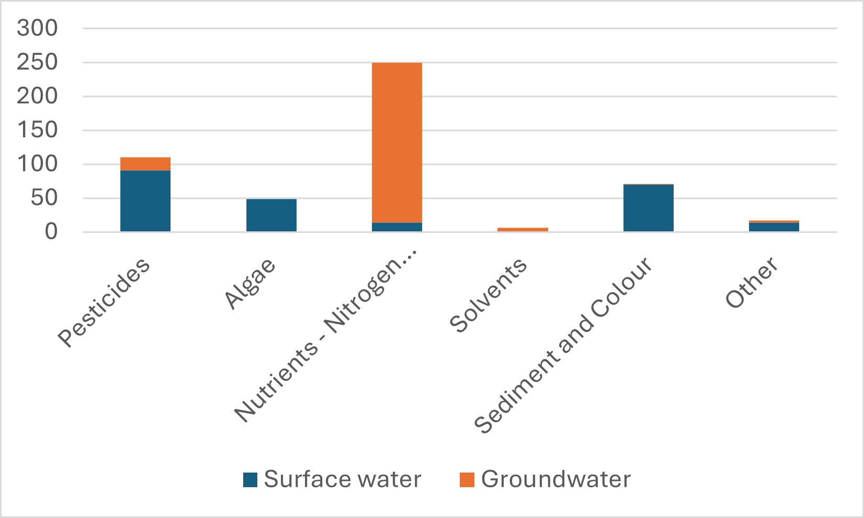
An interactive map showing groundwater and surface water SgZs is also available.

2.3 Nitrate
High levels of nitrate are a concern in drinking water resources and supplies. The World Health Organisation standard for nitrate is below 50 mg/l. This is equivalent to 11.3 mg/l as nitrogen at the tap.
In England, there are 29 surface water DrWPAs where water quality is deteriorating due to the presence of high nitrate or ammoniacal nitrogen. There are 63 groundwater DrWPAs at poor chemical status for nitrogen compounds – 60 DrWPAs because of nitrate and 3 because of ammoniacal nitrogen. There are 223 SgZs established to reduce nitrate concentrations in groundwater (see figure 5).
Removing nitrate from drinking water is expensive and energy intensive. As an example: by 2018, Anglian Water had already invested over £100 million, plus ongoing annual running costs of £250,0002. Similar investments by other water companies are being made. The estimated economic cost of lost fertiliser in the EU is £18bn per year.
Nitrate contamination in groundwater originates from multiple sources. Modelling shows in rural areas in the UK, more than 80% of nitrate in groundwater may come from agricultural practices3. Data from ADAS, based on farming activities in 2010, shows that the nitrate concentrations in water that leaches from soils, contributing to aquifer recharge and river base flow, is close to or above the safe drinking water nitrate concentration in many parts of England4. However, there can be significant additional input from aerial deposition and industry.

Figure 5: Nitrogen issues in groundwater bodies

The historic overuse of artificial fertilisers has resulted in widespread nitrate pollution across many groundwater sources4. When overapplied, a portion of the nitrate becomes lodged within microscopic pores in the rock and gradually migrates through the unsaturated zone toward the water table5, a process that can take up to 60 years. As a result, current nitrate concentrations reflect both present-day and legacy agricultural practices. This delayed response is often referred to as the "nitrate time bomb", highlighting the long-term environmental consequences of past fertiliser use and importance of not losing nitrogen from current practices.
Historic nitrate contamination in groundwater cannot be practically removed. However, we can prevent further deterioration by reducing current nitrate losses to the environment, ensuring concentrations remain below the drinking water standard of 50 mg/l (as NO₃). Although fertiliser applications have declined slightly since the 1990s, nitrate levels in leachate reaching groundwater often still exceed safe limits. In 2023, England recorded a nitrogen surplus of 80.8 kg/ha, an 8.6% increase (6.4 kg/ha) compared to 2022, but a 22% reduction from the 104.5 kg/ha surplus reported in 2000. This long-term decline is largely due to reductions in the use of inorganic fertilisers and livestock manure production.
The reductions in total nitrogen could have been higher but reductions in grazing livestock and reduced cereal crops, has meant the amount of nitrogen taken off the land was also reduced. These are offset however, by a decrease in the total nitrogen offtake caused decreasing grazing livestock numbers and their pasture consumption and reduced cereal offtake.
Fertiliser application rates recommended within Nitrate Vulnerable Zones (NVZs) are the optimal for the crop rather than meeting the environmental or drinking water standard, so there is a choice to make, or challenge to be met, if we are to achieve optimal crop yield and drinking water standards. Whilst crop nutrient planning guidance may help to inform assessments of pollution prevention and control under environmental regulations, they are not directly developed, nor peer reviewed to ensure environmental obligations are met. As such they should not be relied upon as the sole source of nutrient management guidance for informing environmental assessments.
Local work to apportion sources of nitrate confirms that agriculture is the dominant source of nitrate in groundwater. For example, studies in 3 public water supply catchments in East Anglia demonstrated that agriculture was responsible for 74%, 94% and 95% of the nitrate in the water4.
Recent modelling work indicates a mixed picture for peak nitrate concentrations across UK aquifers (that is, rocks which are good at storing water). The modelling has shown that the year peak nitrate concentrations are expected to occur varies greatly between different aquifers. For example, the Jurassic limestone in the Cotswolds peaked in 1994, whereas the chalk in Yorkshire will not peak until 2078. Any delay in peak nitrate concentrations needs to be considered in our response to managing these aquifers.
The modelling study also showed there were slightly more aquifers with increasing trends rather than decreasing trends. As fertiliser inputs have reduced since around 1990 it is hoped that there will be more aquifers with decreasing trends in the future. This won't occur without strategic oversight of nitrate use in England. Our most recent borehole monitoring also shows a mixed picture with respect to nitrate concentrations over much of England, with slightly more increasing trends compared to decreasing. Against this mixed picture a significant number of boreholes still show exceedances of nitrate standards (50 mg/l) in groundwater6.
Nitrate Vulnerable Zones are designated under the Nitrates Pollution Prevention Regulations (2015) to prevent nitrate pollution arising from agriculture. The NVZ action programme contains measures to reduce nitrogen losses from farmland, including controls on fertiliser application to reduce leaching from soils. NVZ coverage is around 25% of England, remaining roughly consistent in land area since 2009. 92% of groundwater NVZs are on high or medium vulnerability aquifers, Johnson and Lord (2011)7 found that since NVZs were introduced, within them there was a very gradual reduction in the total nitrogen applied by farming overall. However, the reduction was judged to be mostly influenced by reductions in managed grasslands due to the greater restrictions on fertiliser inputs introduced as part of the NVZ expansion in 2002 and reduced livestock densities. In the arable sector there was no significant reduction in net nitrogen balance where fertiliser nitrogen inputs and yields per hectare of individual crops were noted to have changed little since NVZ inception. As a result, between 1990 and 2009 nitrogen balance remained largely stable for all harvest crops including grassland.
The 2025 NVZ report indicated 36% monitoring points showed a weak (+1mg/l to +5 mg/l NO3) or strong (>5 mg/l NO3) increase in annual average Total Inorganic Nitrogen compared to 2016 to 19. Similarly weak (-1mg/l to -5 mg/l NO3) or strong (> -5 mg/l NO3) decrease was seen at 33% of monitoring points. The number of monitoring points with stable concentrations (-1mg/l to +1 mg/l NO3) reduced from 45% to 31% from 2016-19 to 2020-23.
A small gradual reduction in manufactured fertiliser has been identified in the livestock sector which has been offset by increased manure use, and there appears to have no substantial change in the arable sector. Estimates of the effectiveness of NVZs (based on the 2002 programme), put the overall national reduction of nitrate lost to the water environment in NVZs as between 2 and 7%. Additional measures to meet DrWPA objectives often need to go beyond NVZ requirements to protect drinking water quality from further deterioration.
Whilst public supplies have robust systems in place to ensure that the nitrate standard is not exceeded at consumers’ taps, this may not be the case for private supplies. Of 7,229 private supply samples analysed for nitrate at consumers’ taps in England in 2019, 7.5% exceeded the limit8. In 2024, 8.42 % samples failed and 17 notices were served. Many of these supplies are in rural areas away from public mains supplies. Whilst there is a downward trend in nitrate failures it is suspected that this is due to a combination of improved treatment and enforcement rather than local improvements in water quality, which goes against the DrWPA aim to reduce treatment.
Nitrate concentrations in groundwater can be affected by leakage from public mains water supplies. Although the nitrate concentration in public main water leakage is always below the drinking water limit, it contributes significantly to the nitrogen loading, particularly in urban areas. The amount of nitrogen released to groundwater through this route is expected to increase in coming years as a result of greater use of treated water transfers9. Nitrates, which are frequently present due to sewage contamination or agricultural runoff, are best managed by protecting the source water from contamination.
Nitrate concentrations in groundwater are expected to continue to deteriorate between now and 2050 unless further policy interventions are taken. Climate change and population growth will also need to be mitigated.
Further information on nitrates can be found in the nitrate challenge report which includes details of the standards, obligations and measures relevant to nitrates.

2.4 Algae and organic compounds
Algae naturally thrive in slow-moving or standing water bodies such as lakes and reservoirs. Their growth depends on nutrient availability, sunlight, water movement, retention time, and temperature. Phosphorus, primarily from sewage effluent and agricultural runoff, is the leading cause of excessive algal and plant growth in freshwater systems, a phenomenon known as eutrophication. In some lakes, nitrogen also plays a significant role
Excess plant and algal growth affect the quality of the raw water. It can have physical impacts on treatment through clogging of filters as well as causing taste and odour problems. Some algae are toxic to people and animals.
Excess nutrients that contribute to algal growth or eutrophication can impact the ecological status of waterbodies. Measures to address algal problems aim to reduce nutrient loading and manage water movement within the water body or reservoir.
Algae impact 57 lake and reservoir DrWPAs, 22 river DrWPAs and 1 canal DrWPA. Algae are not a concern in groundwater DrWPAs, but the nutrients contained within groundwater can contribute to algal growth and eutrophication where they contribute to river and lake flows. There are 49 surface water Safeguard Zones targeting measures to address algal impacts.
Algal impacts can be through elevated counts of total algae, green algae (chlorophyll) or blue green algae. The formation of the organic compounds, geosmin or 2-methylisoborneol, can result in taste and odour issues. It was thought that their levels were related to algal growth, but investigations have shown that there may be other causes and that there is a lot more to learn to understand the factors influencing the formation of these compounds (Figure 6).
Figure 6: Number of 'at risk' surface water DrWPAs due to algae and organic compounds
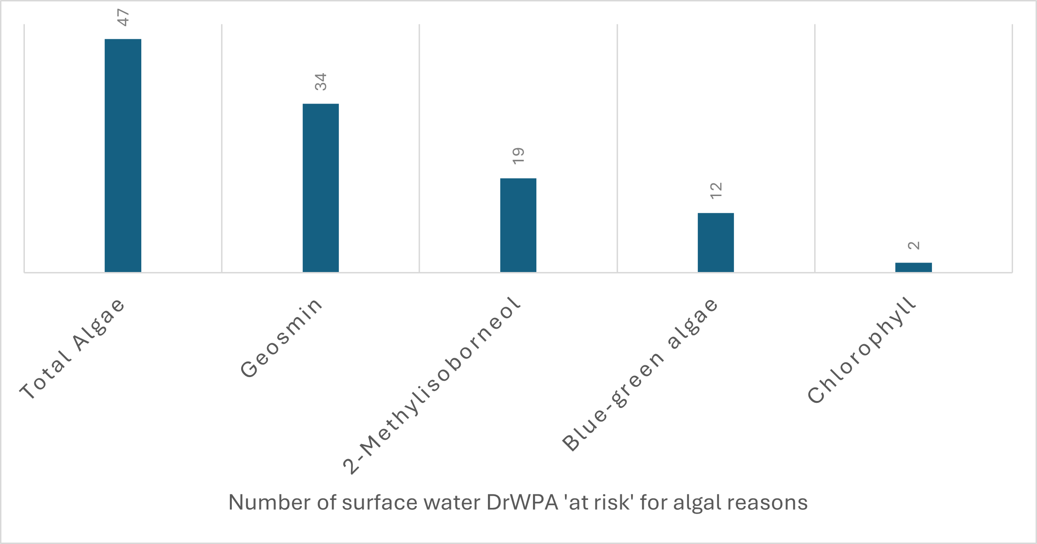
Figure 6 description: 47 DrWPA are considered ‘at risk’ for total algae counts, 21 for Geosmin, 12 for Blue Green Algae,11 for 2-Methylisoborneol and 2 for chlorophyll.
Further information can be found in the phosphorus and nitrate challenge reports.

2.5 Colour
Dissolved organic carbon (DOC) released from organic soils and vegetation increases colour in water supplies from upland catchment areas particularly in catchments dominated by peat soils. Water draining from upland catchments is often peaty (brownish) in colour. It feeds into streams, rivers and many upland reservoirs used to supply drinking water. Damaged peat landscapes are more readily washed away increasing the problem and cost of removing colour from water supplies.
This deteriorating trend is causing 119 surface water DrWPAs to be 'at risk' of not meeting DrWPA objectives. Deterioration in colour is not evident in groundwater.
Elevated levels of DOC can interfere with the effectiveness of disinfection processes at water treatment works and cause disinfection by-products, such as trihalomethanes (THM) to occur. The presence of DOC in the final treated water can increase the potential for bacterial growth in the water distribution system.
To limit the potential for THM production, levels of DOC are reduced before chlorine, an essential part of the treatment process, is added. Levels of DOC can be reduced by various methods, including Granulated Activated Carbon filters. To meet the Drinking Water Standard, levels of DOC should be below 20mg/l (or 20 Hazen).
Peatlands are wetlands, they should be wet to surface with high water tables. Land management activities such as drainage, heather burning to promote sheep and grouse production, wildfires and forestry all alter the natural hydrology, lowering the water table and changing the natural vegetation communities found on peatland areas. When the surface layer of peat bogs dries out, conditions change from anaerobic to aerobic allowing aerobic bacteria to breakdown peat, resulting in an increase in colour generation. Areas of deeper peat appear to generate higher colour levels. Desiccation and drying leads to more erosion of soils, and more sediment, DOC and increased colour levels feeding into water bodies.
Historic atmospheric pollution impacted on peatland areas by changing vegetation communities, killing vital sphagnum mosses and leaving vast areas of bare peatland vulnerable to erosion. The acidification caused by sulphur deposition supressed DOC levels, due to acid saturation, and DOC levels have been increasing since legislation curbed air pollution issues, meaning alternative ways to manage DOC are required. Assessing causes of increased DOC from peatland bodies is challenging, however it is clear that damaged, drained and unvegetated peatlands deliver large quantities DOC and sediment into water bodies and this needs to be addressed.
Outcomes from peatland restoration should be monitored on a long-term basis as full restoration can take many years to fully establish and may require further interventions. This is important to remember when considering issues of water quality.
Future climate scenarios, drier springs and summers and wetter winters will add further pressure to degraded peatland habitats. Hydrological restoration will help build resilience whilst delivering other benefits such as carbon storage, flood mitigation, drought alleviation and nature rich spaces. To find out more about peatland degradation and restoration, see the Peatland Degradation report.

2.6 Turbidity
Turbidity is the amount of suspended sediment, or particulate, in water. Low levels of turbidity are important to avoid particulate in drinking water and to prevent micro-organisms attaching to these particulates and shielding from disinfection treatment. Land uses such as mining, quarrying and agriculture, that disturb the ground, can cause fine particles to mix with water. Sediment is transported to rivers and into groundwater from land uses that disturb sediment and increase the speed of water movement in the catchment. Heavy rainfall can accelerate this process increasing surface water run-off and increasing the amount of sediment and other pollutants the run-off carries. Land uses that slow water, encourage infiltration, reduce soil compaction and prevent gully formation are less likely to cause turbidity problems for drinking water sources.
More information can be found in the fine sediment challenge report.

2.7 Chemicals
Chemicals enter the water environment through our day-to-day activities including what we put down the drain, spray in our gardens, apply to agricultural land, as well as from historic pollution and industrial land uses.
Chemicals including pesticides, herbicides, solvents and fungicides impact the quality of drinking water sources. Increased levels of expensive purification treatment, using raw materials and energy, are often needed before the water reaches our taps.
Figure 7 shows that 96 groundwater bodies, equating to 35%, were classified as poor chemical status in the 2019 classifications.

Figure 7: Groundwater DrWPA chemical status results (2019 classification)

There are a number of emerging chemicals in groundwater which have potential to affect long term quality and lead to an increased need to treat our drinking water sources. These include bentazone, butanedioic acid, caffeine, diethylhexyl phthalate (DEHP) and perfluoroalkyl substances (PFAS).
The Chemicals Investigation Programme (CIP) is the UK water industry’s response to current and emerging legislation on chemicals in the water environment. It brings together the water and wastewater companies in England and Wales with the various regulators in a collaborative programme.
Introducing the 4th Phase of the Chemical Investigations Programme - Jenni Hughes, UKWIR Strategic Programme Manager said that CIP 4 ‘will be building on the microplastics and Antimicrobial Resistance work previously completed, and will now also include an integrated constructed wetlands investigation. There will also be sampling for emerging substances, as well as continuing trend monitoring. CIP4 will also include investigations on PFAS (per and poly fluoroalkyl substances) and PFOS (perfluorooctane sulfonate); the companies will be trying to identify sources of PFOS within sewerage catchments and collecting data on a number of PFAS substances. There’s also going to be an investigation looking at the impact of spreading biosolids to soils and groundwater.’
Solvents, including trichloroethene and tetrachloroethene, have been identified in 16 groundwater SgZs. Solvents are often associated with historic pollution incidents or previously contaminative land uses such as metal degreasing and dry cleaning. Plumes can travel long distances in groundwater affecting abstractions many miles away. There are also historic land contamination issues which affect drinking water sources. Remediation by landowners, polluters or local authorities will be key to preventing further deterioration from substances such as solvents.
The Water Supply (Water Quality) Regulations 2016 requires that no individual pesticide is present in tap water above 0.1 µg/l, and that total pesticide concentrations are not above 0.5 µg/l. In surface water DrWPAs impacted by pesticides, one of the largest concerns is a small group of herbicides used on oil seed rape, cereals, and grassland. Concentrations of these pesticides peak in surface waters at times of the year coinciding with their use and increased rainfall encouraging runoff. Higher risk catchments include those where land drainage is required (for example catchments with heavier clay soils), catchments with thin, sandy, or stony soils overlying chalk, limestone, or sandstone, and where there is predominance of certain crops which require the use of these 'hard to treat' pesticides. These herbicides are interchangeable, and use will depend on cost and availability which makes it more difficult to track from year to year.
Metaldehyde, which was used in slug pellets and was difficult to treat, was withdrawn from outdoor use in 2022. Reported incidents of levels in abstracted water for supply above the drinking water standard have reduced significantly from 33 in 2016 to 17 to 1 in 2023 to 24. The use of carbetamide as a pesticide has been withdrawn since November 2022. Domestic, agricultural and turf use of carbendazim was withdrawn in 2017. Occasional spikes of these substances are still identified as stocks are used up or disposed of illegally. Substances are removed from ‘at risk’ status when at least 3 years of monitoring demonstrates the effectiveness of the withdrawals from normal use. The Health and Safety Executive are responsible for regulation of substances that are no longer authorised for use.
Pesticides are the second largest reason for surface water DrWPAs being 'at risk' of not meeting DrWPA objectives in England, with 91 surface water DrWPAs ‘at risk’ for one or more pesticides in 2025, a decrease from 125 in 2022. Figure 8 shows the frequency certain pesticides at assessed as ‘at risk’ in surface water DrWPAs: metaldehyde (88), propyzamide (53), MCPA (35), carbetamide (34), total pestcides (28), mecoprop (23), flufenacet (20) clopyralid (18) and quinmerac (14) are the key pesticides of concern.
Pesticides are found to a lesser extent in groundwater though their presence is an indication of long-term pollution and they are unlikely to degrade. Of the 79 groundwater DrWPA water bodies, 2 are classified as poor chemical status due to the presence of pesticides.

Figure 8: Surface water DrWPAs ‘at risk’ from individual pesticides
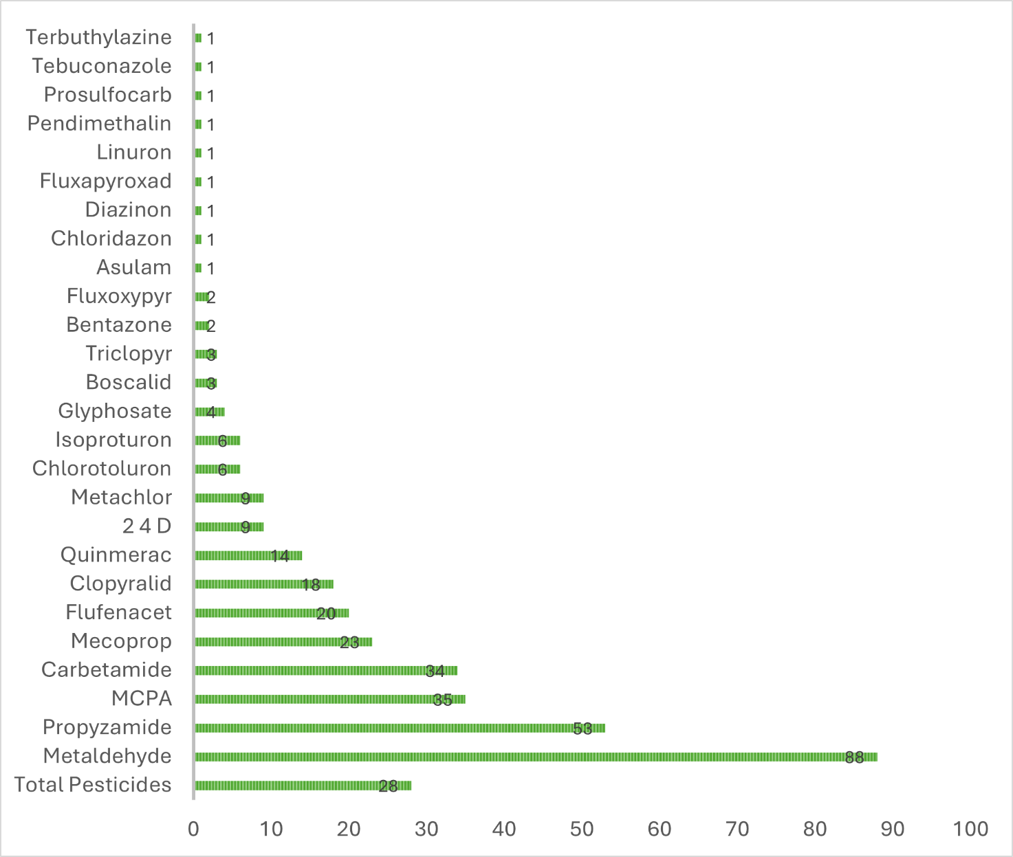
The Voluntary Initiative (VI) promotes best practice regarding the use of most oilseed rape herbicides, except for propyzamide, which continues to be problematic due to application timing and the requirement to apply at the correct growth stage of the target weed (usually mid-winter). The VI is looking at other product groups associated with specific crops to enable better stewardship opportunities.
Microplastics are also of concern, although evidence for their impacts on human health via drinking water is limited and uncertain. The average concentration of microplastics in potable water is 0.00011particles per litre (Sink to River - River to Tap - A review of potential risks from nano-particles & microplastics). Microplastics in drinking water can either be addressed at source, for example by reducing use of plastic products or their release into potable water sources, or through advance treatment processes. More information on microplastics can be found in Chemicals: challenges for the water environment.

Figure 9: Number of groundwater DrWPAs and associated Safeguard Zones established for individual pesticides
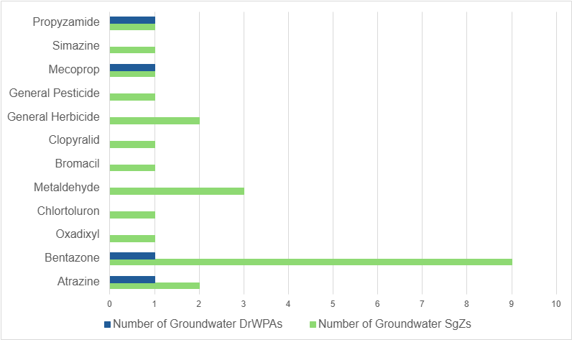Figure 9 description: Nine groundwater sgzs have been established for Bentazone relating to 1 groundwater DrWPA. Metaldehyde is the reason for establishment of 3 sgzs but the issues with this should have been addressed by the ban on outside use in 2022. Two sgzs and a DrWPA have been established for Atrazine and and 2 sgzs for general herbicides. A sgz has been established for propyzamide (as well as a DrWPA); Simazine, Mecoprop, general pesticides; Clopyralid, Bromacil, Chlortoluron, and Oxadixyl.

2.8 Microbiology
Cryptosporidium is a protozoan parasite found in water contaminated by both human and animal wastes. Catchment sources include sewage works, farms, soil run-off, drainage and livestock using or crossing watercourses. The Drinking Water Inspectorate is responsible for the wholesomeness of water. The safe limit for cryptosporidium at the tap is zero. It has been decided that bacteria and cryptosporidium will no longer be designated as ‘at risk’ substances for DrWPAs and will be removed from those where is has been designated. Work to reduce pollution and poor drainage relating to sediment, algae and nutrients will help improve compliance.
Microbiological contaminants can also impact groundwater abstractions and are potentially serious as there is potential to impact public health. There are 3 groundwater safeguard zones considered ‘at risk’ for coliforms.
Public or private water supplies may be contaminated with harmful pathogens if the borehole headworks are not sealed properly, there is ingress of surface water, livestock or septic tanks are too close to the abstraction or there is access to spring sources allowing water sources to be contaminated by faecal matter. A key source of faecal contamination for private supplies is from nearby septic tanks. If a septic tank is within 50m of the private supply an environmental permit is required and good practice followed to avoid microbiological contamination of groundwater. Private water supplies are often located in rural areas and manures should not be spread or stored within 50 m of a borehole, well or spring to avoid biological contamination.
In 2019, of the 12,890 samples for Escherichia coli (E. coli) taken, 5.4 % failed the standard, and of the 7,201 samples for enterococci 6.6% failed the standard8. The DWI note the 2019 testing shows that despite an overall improvement over previous years private supplies continue to be of unsafe microbiological quality. E. coli and Enterococci failed 4.93% and 5.98% tests in 2023 (Drinking Water 2023 - Drinking Water Inspectorate) and 4.46% and 5.40% in 2024 (Drinking Water 2024 - Drinking Water Inspectorate) with 69 notices served to prevent bacterial contamination of private water supplies.

2.9 Manganese
Eleven surface water DrWPAs and 16 groundwater DrWPAs are affected by manganese. Sources of manganese tend to be from natural sources in surrounding catchments and mobilisation can depend on the (acidic) pH of upland soils. Water company investigations are looking into the sources and pathways of manganese and whether catchment management is appropriate.

3. Future challenges to meeting DrWPA objectives
A Green Future: Our 25 Year Plan to Improve the Environment sets out under ‘clean and plentiful water’ an aim of ‘reaching or exceeding objectives for rivers, lakes, coastal and ground waters, that are specially protected, whether for biodiversity or drinking water as per our River Basin Management Plans’.
Solving the problems affecting our drinking water sources and moving towards cleaner, more sustainable sources, challenges us to reduce our impact on the environment. In some cases, such as land contamination, remediation to reverse the damage done by previous generations may be needed.
Reducing our impact on the environment can be challenging but we can make choices about how we live and have a positive impact on the quality of our drinking water sources. We need them to support life.

3.1 Education
Improving our knowledge and understanding of the water cycle, the source-pathway-receptor approach of pollutants and effective pollution prevention measures will help protect water sources.
Dependence on costly yet effective water treatment can lead to complacency, with safe drinking water often taken for granted or viewed as someone else’s responsibility. As a result, the protection of drinking water sources is not consistently prioritised by planners, businesses, or the public. This mindset must shift if we are to meet the growing challenges of safeguarding and improving our water supply, particularly in the context of national food security, economic growth, sustainable development, and a changing climate.

3.2 Competing priorities
Competing priorities and goals can make reaching a common understanding of catchment issues and improving drinking water sources extremely challenging. Safeguard zone action plans set out catchment actions and schemes, agreed with partners, required to protect drinking water supplies. There are challenges in completing catchment actions. For example, short term or differing funding mechanisms may hinder long term (20+ years) progress and success of catchment schemes, particularly for groundwater where a sustained effort is needed over many decades to reduce nitrate and pesticide concentrations.

3.3 Evidence
It is essential to distinguish between short-term pollution incidents, long-term deteriorating trends, and the legacy of historic activities.
There is a monitoring network in place using both our data as well as that provided to the DWI by water companies to identify where raw water quality concerns arise and evidence gaps are identified.
Third party data is often collected for different purposes or legislative drivers and there be restrictions on sharing due to commercial or other sensitivities. This can make comparisons between datasets, coming to a common understanding of the catchment, agreeing a common goal, and sharing data between parties difficult, hindering progress in improving drinking water sources. Maximising the use of all evidence available would improve decision making and strengthen investment decisions. The current approach for sharing data could be improved by greater openness and improved working across organisations to agree common goals.
The application of innovative monitoring technologies, modelling and remote sensing to drinking water source protection need further exploration.

3.4 Private drinking water supplies
Whilst most of the environmental information available in DrWPAs is from public water supplies, our understanding of smaller private water supplies needs improving. Local councils are the lead authorities for private water supplies, with the DWI providing technical advice and support. Greater collaboration between authorities is needed to identify environmental risks that could affect private supplies, to raise awareness of what to do should a pollution incident occur at or near a private water supply, and to clarify environmental permitting and licensing requirements for activities affecting private water supplies. This will support the local councils risk assessments and decision making as regulators for private supplies.
The British Geological Survey must be notified of boreholes drilled to a depth of 15 m or more for water supply purposes10. Abstractions greater than 20m3 per day need an abstraction licence from the Environment Agency. We recommend the local authority are notified if an abstraction is used for a private water supply.
Surface water bodies from which private water supplies are abstracted at more than 10 m3 per day, or serving more than 50 people, should be identified as a DrWPA. As all groundwater bodies are DrWPAs, and most private supplies are from groundwater, we do not expect many new DrWPAs to be identified for private supplies.
Measures to improve DrWPAs form part of the ‘programme of measures’ in the river basin management plans. Measures can cover large areas of land benefitting multiple private and public supplies and could be used to support local authorities when assessing environmental risks to private water supplies.
See the:
- Groundwater Safeguard Zone Action Plans
- Surface water Safeguard Zone Action Plans
Whilst the Environment Agency is the competent authority for meeting the DrWPA objectives we hold limited information on the location and quality of private water supplies. This is partially due to the way legislation is written to protect personal data of private supply owners. This can result in decisions being made with limited evidence, a lack of environmental protection around those supplies, and potentially expensive increases in treatment for supply owners.
Work is needed in partnership with Defra, the DWI, well drillers, supply owners, and local authorities towards improving water quality for private supplies and including them to a greater extent in spatial planning and permitting to protect them from pollution or over abstraction. However, without data on their quality or location, a common goal of improving raw water quality becomes harder to achieve. Over the coming years we want to improve the way we share appropriate data, identify any further DrWPAs and SgZs, and improve environmental protection for private drinking water supplies.

3.5 Continued change and lag times
The range of substances posing risks to drinking water will change over time as the environment, society, and the economy change. Risk assessment and implementing pollution prevention measures will remain an ongoing process. The environmental response time for measures to improve raw water quality can take years or even decades. Safeguard zone action plans will remain a key mechanism to improve raw water quality as we develop our understanding of the success of the measures for different pollutants.
An advisory group, set up by the DWI has made recommendations to the government on changing and updating drinking water standards.
Nitrate already within the ground will continue to drain to the water table for many decades. It will therefore not be possible to predict with accuracy, when peak concentrations of nitrate will occur in groundwater and poses difficulties in ensuring current activities do not cause deterioration. A collaborative water company led and Ofwat funded innovation project titled ‘Diffusing the nitrate timebomb’ explores innovative modelling to accurately predict nitrate concentration in groundwater and their effect on public water supplies.

3.6 Population growth
Over the 25-year period between mid-2022 and mid-2047, England's population is projected to increase by 14.5%. More people will live in urban areas. A growing population and smaller family units will mean that the number of households is forecast to increase. This scale of growth has significant implications for protecting the quality of drinking water sources especially when combined with the challenges of climate change. Growth focussed areas in the South and East of England will exacerbate pressure on groundwater without a significant change in environmental policy and spatial planning to better protect groundwater.

3.7 Climate change
The Climate Change Impacts and Adaptation (2018)11 report highlights that the climate is changing and will continue to do so. UK Climate Change projections (UK Climate Projections (UKCP18) - Met Office) suggest that hotter drier summers, milder wetter winters, rising sea levels and more extreme weather events are expected. As atmospheric temperatures rise so will river temperatures. Rainfall patterns are likely to change – winter rainfall is likely to occur in heavy events whilst summer rainfall is likely to decrease. The trend of more intense rainfall events is expected to continue.
The water environment is already under considerable pressure from a range of human activities and a growing population. Climate change adds to this pressure through changes to river flow, groundwater recharge, and water temperatures. The impact of climate change on groundwater quality is highly uncertain. A study by Stuart and others 2011 found that the implications for nitrate leaching to groundwater because of climate changes are not yet well enough understood to be able to make useful predictions without more site-specific data. The few studies which address the whole cycle show possible changes in nitrate leaching ranging from limited increases to a doubling of aquifer concentrations by 2100. These changes may be masked by nitrate reductions from improved agricultural practices, but a range of adaption measures need to be identified. Future impact may also be driven by economic responses to climate change.
Semiquantitative mapping of climate and land use change impacts on groundwater quality in 2023 based on potential land use futures showed divergence of changes in some areas and commonality in others. Stable land use (and limited change in contaminant risk) in eastern England associated with ongoing need for food production; afforestation (and reduction in contaminant risk) in southern England; urbanisation and intensification of arable land in northern England (an increase in contaminant risk) were the main findings. Whilst the outputs are exploratory, they are aimed at helping policymakers evaluate existing groundwater protection policies and guide future modelling and prioritisation efforts.
Decreasing summer river flows will increase the variation in river and reservoir water quality and bring about an increased use of additional treatment at water treatment works for algae related nutrient issues, concentrated levels of chemicals in rivers, and will inevitably impact on the river's ability to support healthy aquatic ecosystems. The frequency of heavier rainfall events will increase pollutant runoff from land to water and increase storm discharges from sewage outfalls.
Adaptation is important to protect the quality of water bodies against climate change impact. For example, water companies will have to work closely with the Environment Agency, land managers and other catchment partners to identify what measures are needed to adapt to climate change building resilience in the quality and quantity of natural drinking water sources.
More information can be found in the climate change challenge report.

4. Choices
A range of organisations are involved in designing, promoting, supporting and delivering measures to improve raw water quality, including water companies, the crop protection sector, farmers, agronomists, trade bodies, manufacturers, voluntary organisations and government bodies.
There are choices in how we meet DrWPA objectives. A range of voluntary measures along with targeted enforcement are the chosen way to meet the objectives. There is scope, however, for altering the measures and mechanisms used to prevent or limit the amount of pollution. Greater industry and societal ownership of drinking water sources may be crucial to make change happen.

4.1 Current measures
This section describes the current measures available to improve raw quality and the choices we have, to enable us to secure a sustainable future for our drinking water supplies.
During the fourth river basin management cycle, further evidence will be gathered improving our understanding of pollutant sources and pathways impacting raw water quality. We work with the water industry, manufacturers and the agricultural sector to deliver various pollution prevention approaches. They are encouraged to understand the fate, transport and impact of their products on the environment, develop best practice guidelines to protect the environment, and undertake voluntary and catchment-based initiatives to protect drinking water resources.

4.2 Statutory water industry measures
Water companies deliver a significant proportion of measures for both surface and groundwater SgZ action plans. Their commitment to preventing deterioration and improving the quality of raw water is vital.
The Water Industry's National Environment Programme sets a legal obligation on water companies to complete catchment measures to prevent further deterioration and improve raw water quality within SgZs. Between 2025 and 2030, water companies will complete:
- 29 schemes of measures to improve the quality of water abstracted from the environment
- 171 schemes of measures to prevent deterioration of abstracted potable water quality
- 89 investigations into why raw water quality is deteriorating resulting in
recommendations for new schemes and measures for future programmes.
Indicative costs for the improvement and no deterioration measures are £119 million. This equates to 0.5% of the indicative national environment plan costs (£22.1 billion) that companies will spend between 2025 and 30. Between 2020 and 2025 approximately £104 million was allocated to water companies to implement 170 DrWPA schemes of measures identified in safeguard zones.
More information can be found in the water industry challenge report.

4.3 Private water supply measures
Local authorities are the lead regulator for private supplies supported with technical and scientific advice from the Drinking Water Inspectorate. Roles, Responsibilities and Pollution Prevention Advice for private supplies can be found on the DWI’s website.
Little information is held by the Environment Agency for private water supplies making it difficult to target specific protection. In the absence of information on private supplies good practice pollution prevention measures should be implemented by owners of private water supplies and their neighbours. If a pollution incident occurs and affects a private water supply, we encourage to contact the Environment Agency through the national incident hotline. We will record the incident and may require further investigation and remedial works to protect private water supplies.
Individual, and proliferation of, non-mains sewerage systems can lead to pollution for private water supplies, first time sewerage or upgraded treatment may need to be implemented to prevent drinking water supplies from deteriorating. Individuals can apply to water companies for first time rural sewerage in areas on non-mains drainage. Local communities could invest in upgrading existing private sewerage facilities where they impact drinking water
Where a septic tank is within 50m of a private supply or in a source protection zone 1, it must have an environmental permit to ensure the system will not pollute a private supply. Small package treatment plants and septic tank owners are responsible for ensuring they meet general binding rules, and if not apply for a permit. There’s guidance on permits you need for septic tanks.
Spills from domestic heating oil tanks can also impact private supplies.

4.4 Nitrate vulnerable zone action programme
In places where DrWPAs overlap with areas designated as Nitrate Vulnerable Zones (NVZs), the measures set out in the statutory NVZ action programme may contribute to progress towards DrWPA objectives. The measures which farmers must follow includes nutrient management practices to prevent water pollution. NVZs and the action programme are reviewed every 4 years. The government is reviewing the success of the current regime for nitrates. It will consider the findings as part of its wider regulatory review for agriculture and the environment post EU exit.

4.5 Other measures
A range of other voluntary and statutory measures are in place to protect and improve raw water sources. We have a choice to look for wider benefits of environmental measures looking at the water cycle holistically in terms of how pollution is created and transferred through the environment to a receptor such as a drinking water supply. These include:
- Environment Land Management Schemes: Future of farming in England – aim is to help the environment while supporting farming and food production. There are 3 main schemes include Sustainable Farming Incentive: Countryside Stewardship Higher Tier and Landscale Recovery
- Farming Rules for Water: How to comply with the Farming Rules for Water – set out what land managers need to do to reduce and prevent agricultural pollution of water.
- Catchment Sensitive Farming (CSF): advice for farmers and land managers – a partnership between Defra, the Environment Agency and Natural England working with farmers, and a range of other partners, to improve water and air quality in high priority areas. CSF offers farmers free training, advice and support for grant applications
- Campaign for the Farmed Environment (CFE) – encouraging farmers and land managers across England to protect and enhance the environmental value of farmland, through measures that sit alongside productive agriculture
- Protecting our Water, Soil and Air: a Code of Good Agricultural Practice for farmers, growers and land managers (the ‘CoGAP’) offers practical interpretation of legislation and provides good advice on best practice
- Groundwater protection guides covering requirements, permissions, risk assessments, and controls (previously covered in GP3).
- Voluntary Initiative – an industry led programme promoting the responsible use of pesticides through an IPM-based approach to sustainable agriculture through schemes, tools, and messages
- Initiatives by the River Trusts Together, for Rivers and the Catchment Based Approach
- BASF's bentazone stewardship programme
- Locally targeted projects and initiatives including Water Environment Improvement Fund projects

4.6 Meeting current and future standards
The DrWPA requirement protects water sources that could be used for drinking water in the future.
The Environment Audit Committee on Nitrate noted "We are particularly concerned that existing standards are not weakened and there appears a danger that this will happen to the EU goal of all water bodies reaching a good status by 2027. The government have said that they will replace the current Common Agricultural Policy with a new regime based on payments for the delivery of public goods. However, it is important that the polluter pays principle is not undermined and use of public money is effectively scrutinised”13
Groundwater body status and the measures needed to meet good status are reviewed every 6 years and published in the river basin management plans. Safeguard zone action plans support delivery of the programme of measures in the river basin management plans. The ‘at risk’ status of surface water DrWPAs are kept under review and the SgZ catchment areas, and action plans measures, are also frequently reviewed.
New deterioration risks are identified as early as possible to enable catchment actions to have effect well before treatment levels could be impacted. Once identified as 'at risk' the waters are likely to remain 'at risk' for several years, potentially decades for groundwater, before it is clear whether the deterioration risks are being adequately managed. Where measures are effective this knowledge is shared.
In September 2020 restrictions on the outdoor use of metaldehyde were announced taking effect from March 2022 to address the risks posed to birds and mammals. The restrictions have resulted in metaldehyde levels significantly declining in raw water sources and have already led to the removal of risk status for metaldehyde at several surface water DrWPA At least 3 years of evidence is required to remove ‘at risk’ status, so it is expected the risk status for metaldehyde will decline rapidly in the next few years. The licence to use carbetamide as an herbicide was also withdrawn in 2022. The risk status of this substance will also decrease in the next few years as evidence becomes available. Domestic, agricultural and turf use of carbendazim was withdrawn in 2017.
We have a choice around how we manage pests and weeds in future. The cumulative effect of individuals and businesses making a conscious choice to use less-polluting alternatives can have a significant positive affect on drinking water sources. The importance of soil health and the long-term impacts of the use of certain chemicals and pesticides is investigated and reviewed regularly. Legislative standards take longer to change.

4.7 The 25 Year Environment Plan and 2023 Environment Improvement Plan (1st Revision of the 25 Year Environment Plan)
The 25 Year Environment Plan and Environment Improvement Plan include an aim to achieve clean and plentiful water by improving at least three quarters of our waters to be close to their natural state as soon as is practicable.
While the ambitions outlined in current plans are high-level, they provide a framework for long-term goals, including interim milestones and deadlines for reducing pollutants.
Despite ongoing efforts, progress toward achieving Drinking Water Protected Area (DrWPA) objectives remains limited for several reasons including economic and population changes, a changing climate both in terms of temperatures and rainfall and pressures from global food markets and agricultural costs.
To deliver cross-sector benefits, spanning water quality, agriculture, soil health, climate resilience, and productivity, greater alignment across policy areas is essential.

4.8 Regulatory review
To enhance communication and advance environmental goals more effectively, legislative requirements must be harmonized. Water quality legislation should be agile enough to respond swiftly to emerging threats, while long-term challenges demand consistent policy and funding support, resilient to shifts in political landscapes. Implementation of some of the recommendations of the Independent Water Commission may provide opportunities to address these challenges.

4.9 Catchment management
There is a lot to understand in terms of maximising the wider benefits that the ecosystem services can provide. Working closely with farmers and land managers, water companies, and local authorities, as well as a range of other partners in developing that understanding and putting in place measures that will secure long term improvements is key.
Our understanding has improved significantly in the past 10 years but there is a long way to go in terms of land use planning to have sustainable and unpolluted water supplies. In the event of current mechanisms and measures not improving the water quality, the Secretary of State for the Environment can designate a water protection zone if shown to be appropriate.
Further work is being undertaken by UK Water Industry Research to develop tools to determine the effectiveness of catchment management for a range of substances.

4.10 Cultural change
Perceptions of the environment are changing. There is an increased awareness of the benefits a clean and healthy environment can bring to businesses and people's health, as well as building natural capital for industry and the public. However, societal awareness of environmental problems that are out of sight, or not obviously visible, are often out of mind.
For example, for water quality issues that cannot be easily seen our awareness and social attitudes are less developed and more difficult to change. Because the impacts on the environment are not seen, we assume that following the manufacturer's guidance is sufficient to protect our drinking water supplies.
Increased education, such as work by the Voluntary Initiative, are a step in the right direction but much more could be done by working with non-governmental organisations, education providers, improved product labelling and guidance to improve our social understanding of the choices we make and impacts they have on the environment.
We can improve visibility of environmental problems in the media and other routes, encouraging greater public interest. Companies and manufacturers can increase their diligence and responsibility for the effects of their products in the environment.

4.11 Policy development
Whilst much has changed in England since the introduction of NVZs and DrWPAs, significant decreases in nitrogen have not come to fruition and policy development hasn’t changed significantly. There is concern that targets will not be met from the public and the Office for Environmental Protection (OEP). The OEP has raised concerns about the approach to tracking nitrate pollution, particularly in relation to the effectiveness of regulations and enforcement. In 2018, the UK's House of Commons Environmental Audit Committee (EAC) published a report titled "UK Progress on Reducing Nitrate Pollution,"13 which found significant nitrate pollution from agricultural sources in UK groundwater, particularly in the south east of England. Seventeen to 18 million people source their water from groundwater in the South East so nitrate is a significant challenge to drinking water treatment in that area. In July 2025, the Environment and Climate Change Committee published its report, ‘Time to reduce, recycle and reuse nitrogen’, which calls for the UK to be more ambitious and strategic in its plans to manage nitrogen.
A summary of the recommendations to develop a National Nitrogen Strategy are
1. Government Coordination
- Develop a unified nitrogen strategy across departments.
- Create a nitrogen pollution balance sheet to track sources, flows, and sinks.
2. Regulatory Reform
- Simplify and clarify nutrient management regulations.
- Strengthen enforcement by defining roles and distinguishing advice from legal requirements.
3. Circular Nitrogen Management
- Reduce inputs: Limit fertiliser uses and nitrate discharges.
- Maximise efficiency: Promote soil testing and best practices.
- Reuse nitrogen: Expand nutrient recovery technologies in agriculture and wastewater sectors.
4. Agriculture Focus
- Prioritise cost-effective measures like slurry store covers and low emission spreading by 2027.
5. Wastewater Collaboration
- Encourage joint efforts with agriculture for catchment-based and nature-based solutions.
- Support innovative nitrogen reuse in waste management.
6. Transport & Industry
- Update the Clean Air Strategy with clear funding, accountability, and improved local coordination and monitoring.

5. References
- BGS, 2019. Micro-organic contaminants in groundwater in England: summary results from the Environment Agency LC/MS and GC/MS screening data [Report]. Keyworth, Nottinghamshire
- The South West Farmer, 2019. (Rising nitrates: working with farmers to protect our drinking water | South West Farmer Online, accessed 24/10/25)
- Environment Agency, 2010. Cumulative impacts on groundwater from phosphorus and nitrogen loadings, Entec
- Environment Agency, 2014. Progressing towards WFD objectives – the role of agriculture. Progressing-towards-WFD-objectives-the-role-of-agriculture.pdf (waterlife.org.uk).
- L. Wang, M.E. Stuart, M.A. Lewis, R.S. Ward, D. Skirvin, P.S. Naden, A.L. Collins and M.J. Ascott. 2016. The changing trend in nitrate concentrations in major aquifers due to historical nitrate loading from agricultural land across England and Wales from 1925 to 2150. Science of the Total Environment Volume 542, Part A Pages 694-704.
- House of Commons Environmental Audit Committee, 2018. 11th Report - UK Progress on Reducing Nitrate Pollution HC656
- D. Johnson and E. Lord, 2011. Assessment of Trends in N and P Balance in Agriculture, by Sector, with Likely Causes. Environment Agency: EPCRS Framework Project 14627
- Drinking water 2019 - Drinking Water Inspectorate
- Ascott M, Gooddy D C, Surridge B W, 2018. Public water supply is responsible for significant fluxes of inorganic nitrogen in the environment. Environmental Science and Technology, 52, 14050-14060
- UKRI, 2021 National Geoscience Data Centre, Online, accessed 24/10/25
- Environment Agency, 2018 Climate change impacts and adaptation
- M.E. Stuart, D.C. Goody, J.P. Bloomfield and A.T. Williams 2011. A review of the impact of climate change on future nitrate concentrations in groundwater of the UK. Science of the Total Environment. Volume 409, Issue 15, 1 July 2011, Pages 2859-2873
- House of Commons Environmental Audit Committee, 2018. 11th Report - UK Progress on Reducing Nitrate Pollution HC65

