
Polycyclic aromatic hydrocarbons (PAHs): challenges for the environment
October 2025

Contents
Executive Summary 4
1. Introduction 7
2. Use pattern 9
3. Sources, emissions and pathways 9
3.1. Atmospheric emissions 9
3.2. Emissions to water 12
4. Environmental monitoring data 19
4.1. Biota monitoring 20
4.2. Water monitoring 24
4.3. Trends 31
5. Control measures 38
5.1. Restrictions 38
5.2. Managing risks from diffuse pollution 40
6. Summary 41
Appendix 44
References 50
List of abbreviations and acronyms 60
Glossary 62

Executive Summary
Polycyclic aromatic hydrocarbons (PAHs) are a group of structurally related hydrocarbons. This report focuses on five PAHs listed in Annex I of the Environmental Quality Standards Directive (EQSD; Directive 2008/105/EC amended by Directive 2013/39/EU): benzo(a)pyrene, benzo(b)fluoranthene, benzo(k)fluoranthene, benzo(g,h,i)perylene, and indeno(1,2,3-cd)pyrene.
These PAHs persist in the environment, accumulate in biota and food chains, and have potential adverse effects on aquatic life and humans, including carcinogenic properties. They are classed as priority hazardous substances and ubiquitous persistent, bioaccumulative and toxic (uPBT) compounds under the Water Framework Directive (WFD) in the related EQSD (2008/105/EC amended by 2013/39/EU). Four of these, (benzo(a)pyrene, benzo(b)fluoranthene, benzo(k)fluoranthene, and indeno(1,2,3-cd)pyrene) are listed in Annex III of the Persistent Organic Pollutants (POPs) Regulation (EC 850/2004). In June 2016, January 2019, and June 2018, benzo(a)pyrene, benzo(k)fluoranthene, and benzo(g,h,i)perylene, respectively, were listed as substances of very high concern (SVHCs) under the REACH Regulation (EC/1907/2006).
Most PAHs are not deliberately produced and there are very few remaining intentional uses of compounds that contain them. They occur naturally in fossil fuels, such as coal and oil, and in other hydrocarbon-based materials like bitumen, used for the construction of roads. Substances containing PAHs include coal tar pitch and creosote, and PAHs are present in some of the raw materials used in industrial processes, such as those to make plastic and rubber. There are restrictions under REACH relating to the marketing and use of these substances.
Atmospheric emissions of PAHs are significantly greater than those to water. PAHs are mainly released to the atmosphere from combustion sources. Combustion of wood as a domestic fuel is a major diffuse source of PAHs to the atmosphere. Domestic combustion represents approximately 67% of the total atmospheric load. PAHs released to the atmosphere can then find their way into the water environment following atmospheric deposition to surfaces and subsequent run-off following rainfall. Natural fires are estimated to contribute approximately 21% and are the second largest diffuse source, whilst road transport contributes 2%, comparable with the main point source contributions from regulated industry.
Much of the PAH contamination in the environment can be considered as 'background' from natural sources and past industrial activity, giving rise to a legacy of contaminants already present in the soil and sediment. Source apportionment models suggests that this historical contamination contributes a significant PAH load to surface waters. As some PAHs can accumulate through food chains, we monitor for them in biota when assessing risks from long-term exposure. We do not monitor in fish because fish are able to metabolise and break down PAHs.
Concentrations of PAHs in biota are below the biota environmental quality standard (EQS) set in 2013 (2013/39/EU) at almost all our monitoring sites. Benzo(a)pyrene is used as a marker for the other PAHs and its biota EQS is based on a food standard for PAHs. The value is intended to cover risks to or through the water environment from these substances.
Our biota monitoring programme is limited by several practical and ethical constraints including animal welfare concerns and the availability of suitable animals. Although we can analyse benzo(a)pyrene in water at relevant concentrations, we have not been able to establish a relationship between the levels observed and those in biota. We cannot therefore use compliance with the annual average water column EQS to infer compliance or non-compliance with the biota standard.
However, water monitoring can still be useful to check that exposure to contaminant levels in water does not present a risk to the organisms themselves. Comparison of environmental concentrations of PAHs against maximum allowable concentration (MAC) EQSs set in 2013 for surface waters (2013/39/EU) indicate greater short-term risks to the aquatic environment at saline sites than in freshwaters. Overall, there are no consistent national trends in concentrations of PAHs in either fresh or saline waters or biota over time. However, modelled data show some localised increases to certain PAHs.
There are a number of controls already in place on the release of PAHs which have brought about significant reductions in some sources of PAHs to the environment. For example, the Industrial Emissions Directive (2010/75/EU), implemented in England by The Environmental Permitting (England and Wales) (Amendment) Regulations 2013 (SI 2016/1154) has brought about significant reductions in atmospheric PAH emissions from industrial sources since the 1990s through the requirement to use abatement technologies.
In contrast, contributions from domestic combustion have changed little over this time and represent a significant contribution to the overall total load of PAH from diffuse atmospheric sources. This should change moving forwards, with the implementation of the Government’s Environmental Improvement Plan which seeks to build on existing programs like the National Air Pollution Control Programme (NAPCP) and the 2019 Clean Air Strategy. These programmes outline a number of actions to tackle emissions from domestic burning which will have an impact on PAH emissions.
Increasing use of sustainable urban drainage systems (SUDS) has the potential to manage and mitigate risks from the PAH load in urban run-off to watercourses. However, we still need to understand more about the breakdown of PAHs and other hydrocarbons within these systems and understand any impacts through connected systems such as groundwater.

1. Introduction
Polyaromatic hydrocarbons (PAHs) are a group of organic compounds with two or more fused aromatic rings. Most PAHs are not deliberately produced but are formed as by-products of combustion. PAHs are released mainly to the atmosphere from natural processes such as forest fires, incomplete combustion, industrial processes and other human activities. Most anthropogenic sources are associated with combustion, particularly domestic combustion.
For those products containing PAHs, such as creosote or extender oils, restrictions have been put in place over the last couple of decades.
This report looks at a group of five PAHs covered under the Water Framework Directive (WFD) (Directive 2000/60/EC) to assess their likely sources and potential risk to the surface water environment. This group is listed in Annex I of the related Environmental Quality Standards Directive (EQSD) (2008/105/EC) amended by the Priority Substances Directive (2013/39/EU) and consists of benzo(a)pyrene, benzo(b)fluoranthene, benzo(k)fluoranthene, benzo(g,h,i)perylene, and indeno(1,2,3-cd)pyrene.
These PAHs tend to partition to particulate matter and are persistent in the environment with biodegradation rates in the order of months to years (European Union, 2008, 2012). They have been found to bioaccumulate within organisms and are toxic, with effect concentrations reported in the low µg/l range (European Union, 2008, 2012).
Bioaccumulation refers to the buildup of substances, like PAHs, in an organism over time, often because the substance is absorbed faster than it is metabolised or excreted.
- PAHs are lipophilic (fat-loving), meaning they tend to accumulate in the fatty tissues of organisms.
- Aquatic organisms, especially benthic invertebrates and fish, can accumulate PAHs from contaminated sediments and water.
The rate of bioaccumulation depends on the molecular mass of the PAH; low molecular mass PAHs are more water-soluble and may be more readily metabolised, while high molecular weight PAHs are more persistent and bioaccumulative. With the exception of benzo(g,h,i)perylene, these compounds have been identified as carcinogenic, with benzo(a)pyrene being the most carcinogenic of the group (European Union, 2012).
Benzo(a)pyrene, benzo(k)fluoranthene and benzo(g,h,i)perylene have been listed as substances of very high concern (SVHCs) under the Registration, Evaluation, Authorisation and Restriction of Chemicals (REACH) Regulation (EC/1907/2006) (see Section 5). Benzo(a)pyrene is listed because of its carcinogenic, mutagenic and reprotoxic (CMR), persistent, bioaccumulative and toxic (PBT), and very persistent and very bioaccumulative (vPvB) properties. CMR substances are chemicals known to cause cancer (carcinogenic), induce genetic mutations (mutagenic), or impair fertility or harm the unborn child (reprotoxic).
In addition, the following PAHs have been identified as substances of very high concern (SVHCs): benzo(k)fluoranthene, due to its carcinogenic, persistent, bioaccumulative and toxic (PBT), and very persistent and very bioaccumulative (vPvB) properties; and benzo(g,h,i)perylene, due to its PBT and vPvB properties.
As these PAHs persist in the environment, accumulate in biota and food chains, and have potential adverse effects on aquatic life and humans, they are classed as priority hazardous substances and ubiquitous PBTs (uPBTs) under the EQSD (2008/105/EC amended by 2013/39/EU).
The Priority Substances Directive (2013/39/EU) introduced a biota Environmental Quality Standard (EQS) of 5 microgram per kilogram (µg/kg) wet weight for benzo(a)pyrene in crustaceans and molluscs. Benzo(a)pyrene is used as an environmental marker for the other PAHs. The stringent setting of a biota EQS reflects the PBT characteristics of this group of substances. EQSs are widely used to protect the environment and human health from substances released by human activity. They usually relate to doses or concentrations in the environment for specific chemicals, below which unacceptable effects are not expected to occur.
The biota EQS is driven by risks to human health. The standard is based on a limit set under Commission Regulation 1881/2006 for benzo(a)pyrene in crustaceans and cephalopods, such as squid, intended for human consumption. The Directive (2013/39/EU) also specifies maximum allowable concentration EQSs (MAC EQSs) for the individual PAHs, except indeno(12,3-cd)pyrene. MAC EQSs are thresholds set to protect aquatic life from short-term toxic effects.
The requirements of the 2013 Priority Substances Directive (2013/39/EU) took effect in December 2015 through national legislation (UK Government, 2015).
The focus of this report is on contributing effects to and assessment of the condition of surface waters in relation to PAHs. However, the contribution that groundwater makes to the surface water status failures is also considered as part of the WFD and the Groundwater Directive (2006/118/EC as amended by 2014/80/EU). If groundwater contributes more than 50% of the PAH load in any surface water status failure, then the groundwater body will also go to poor chemical status.

2. Use pattern
PAHs are not deliberately manufactured, and they do not perform any specific function within a product (Commission Regulation (EU) No 1272/2013). They occur naturally in fossil fuels, such as coal and oil, and in other hydrocarbon-based materials like bitumen, used for the construction of roads.
PAHs are also present in some of the raw materials used to make plastic and rubber such as extender oils (used to soften) and carbon black (used as a reinforcing agent). Consequently, they can be present in finished goods, such as tyres, toys, shoes, and bicycle grips (Federal Institute for Risk Assessment, 2010). The allowable PAH content is limited in these products, as described in Section 5.1 (Commission Regulation (EU) No 1272/2013).

3. Emissions, sources and pathways
PAHs are typically released to the environment as by-products of both natural and anthropogenic processes. They are formed during the incomplete combustion of organic materials, such as coal and wood, or during forest and moorland fires. Atmospheric emissions of PAHs are significantly greater than direct releases to water.

3.1. Atmospheric emissions
The UK reports emissions information to meet various international and EU commitments. Such data help provide a picture of important sources and trends over time. Further information on the purpose of the emissions inventories mentioned in this section, as well as the methodologies used to build them, can be found within the corresponding references.
For 2023, the UK Pollutant Release and Transfer Register (UK PRTR) (Defra, 2025) identifies paper and wood processing (1,645kg) and iron and steel manufacturing (50kg) at individual facilities in Northumbria and the Humber river basin districts respectively as the largest reported atmospheric point source emitters of PAHs covered by this report. The Environment Agency's Pollution Inventory (PI) – which compiles emissions data from regulated industries in England at lower thresholds – also describes atmospheric point source emissions of PAHs from surface metal treatment (53kg), energy from waste facilities (22kg), and refinery and fuel plants (7kg) for 2023 (Environment Agency, 2025).
The UK's National Atmospheric Emissions Inventory (NAEI) reports emissions data that include estimates for diffuse sources of 16 PAHs. In 2022, an estimated total of 34,976kg of the five PAHs under discussion were released to the atmosphere (NAEI, 2025).
Domestic combustion is identified as the main source of all PAH emissions to the atmosphere. The NAEI reports estimated total atmospheric emissions of 23,309kg in 2022 for all five PAHs, representing approximately 67% of the total load to the atmosphere. In contrast, the next largest source is natural fires, which contribute 7,320kg (approximately 21%), whilst road transport contributes 670kg (approximately 2%) of estimated UK emissions to the atmosphere for the five PAHs (NAEI, 2025).
The last coal-fired power station in the UK, Ratcliffe-on-Soar Power Station in Nottinghamshire, officially ceased operations on 30 September 2024. As a result, PAHs from industrial coal combustion, apart from emissions from coking coal used in steel blast furnaces, are now considered a legacy source of pollution in the UK environment.
Figure 1 is a graph showing the atmospheric emissions (kg) of the five Water Framework Directive polycyclic aromatic hydrocarbons from combustion sources from 1990 to 2022. Figure 1 shows emissions from industrial processes and domestic combustion of benzo[b]fluoranthene, benzo[k]fluoranthene, benzo(a)pyrene, indeno(1,2,3-cd)pyrene and benzo(g,h,i) perylene declined in the 1990s. This is because of significant decreases in aluminium production and in the use of coal as a domestic fuel. However, in more recent years (since 2010) there has been a slight increase in emissions of the five PAHs. This increase has been attributed to a significant increase in the use of wood as a domestic fuel in wood burning stoves (NAEI, 2025). The NAEI reported benzo(a)pyrene emissions from coal as 5,570kg in 1990, declining to 461kg in 2022. Conversely, 146kg of benzo(a)pyrene emitted to the atmosphere was attributed to the use of wood in domestic combustion in 1990, compared with 1,002kg in 2022 (NAEI, 2025).

Figure 1. Atmospheric emissions of five Water Framework Directive polycyclic aromatic hydrocarbons from UK combustion sources from 1990 to 2022 (NAEI, 2025)
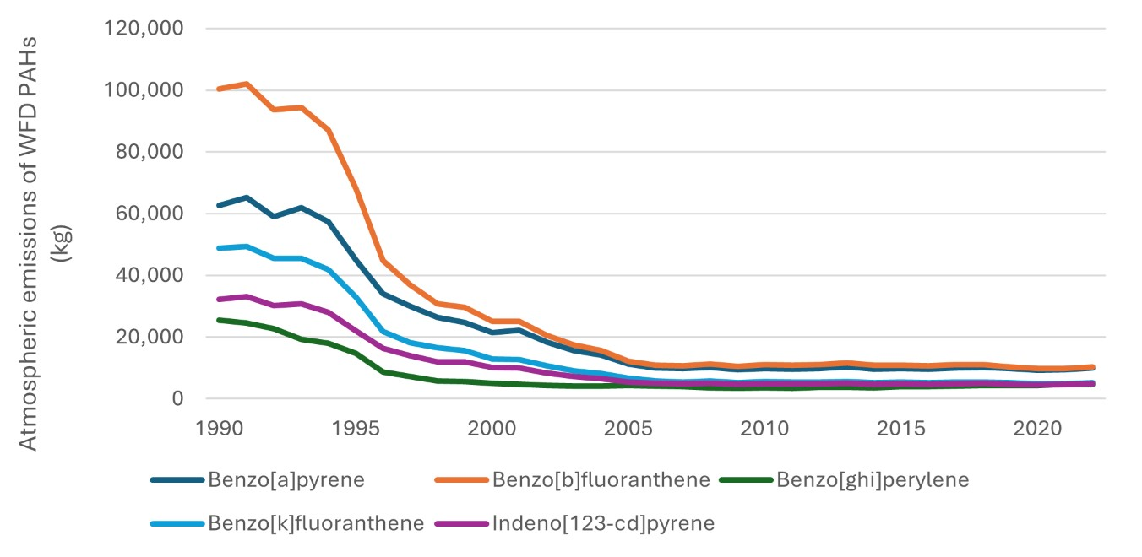
There has been a decrease in atmospheric emissions of PAHs from road transport since the 1990s (NAEI, 2025). Over the 30-year period between 1992 and 2022, total emissions for the five PAHs were reported to have reached a peak of 3,784kg in 1992 compared with 670kg in 2022.
Keyte and others (2016) also reported a decrease in the emissions of PAHs from road transport sources. The authors observed a decline of 86% in mean total (particulate and vapour) concentrations of 16 PAHs – including the five PAHs considered in this report – in the Queensway Road Tunnel in Birmingham between 1992 and 2012. The higher molecular weight PAHs showed declines of up to 96%. The reductions were mainly attributed to the introduction of catalytic converters and progressively stringent EU legislation on vehicle emissions.
There are many other sources emitting the five PAHs as by-products of combustion processes at lower levels than road transport. These include industrial off-road mobile machinery, coke production, agricultural mobile machinery, accidental fires, power stations, and sinter production. A peak in emissions of PAHs from bonfires on and around 5th November each year in the UK (bonfire night) is also significant enough to be noted as a source (Environment Agency, 2023; NAEI (2025).
The NASA Earth Observatory (2019) has detected more wildfires across the UK since 2017 compared with previous years, linking them to warm, dry weather. Such events would be expected to increase concentrations of PAHs in the atmosphere, although corresponding information is scarce. This is mainly due to the practical difficulties in obtaining such data.
The higher molecular weight PAHs, such as benzo(a)pyrene and other PAHs under discussion here, tend to be associated with atmospheric particulate matter (Li and others, 2007; Živković and others, 2015). The sorption of PAHs to particles increases their chemical stability and resistance to degradation (Teinemaa and Kirso, 1999). Because of their stability, they can be transported long distances (Mastral and others, 2003).
Annual mean ambient levels of benzo(a)pyrene in the UK appear to have decreased by nearly 50% between 2008 to 2009 and then been steady to 2014, followed by a slight overall downward trend (Defra, 2023). This is considered to be a reflection of dramatic drops in emissions of benzo(a)pyrene of around an order in magnitude from the 1990s as a result of banning agricultural stubble burning in 1993 and reductions in emissions from industry. However, as noted above, domestic combustion has changed little over this time.
For benzo(a)pyrene, ambient annual mean concentrations in most UK urban areas are below the EU target value of 1ng/m3. Results from the latest air quality assessment show that none of the zones in England had exceeded their target values (Defra, 2023).

3.2. Emissions to water
PAHs released to the atmosphere subsequently reach the ground through dry and wet deposition (Environment Agency, 2007). Once deposited in soil, polycyclic aromatic hydrocarbons (PAHs) tend to accumulate and persist due to slow degradation rates. Their fate in the environment is governed by partitioning, degradation, and transport processes influenced by their chemical properties and the presence of microorganisms (Bozlaker and others, 2008). PAHs can enter water bodies directly either through deposition from the air or surface run-off following rainfall, particularly in urban areas where high levels of PAHs may be present (Neff and Burns, 1996; Neff and others, 2005; Pies and others, 2008).
The main anthropogenic sources and pathways of PAHs into surface waters are illustrated in Figure 2. Figure 2 is an infographic showing the sources and pathways of PAHs into the environment, with arrows illustrating the links between sources and pathways. PAHs from fuel combustion, transport, manufacturing process and some other minor sources such as bonfires enter the water through deposition from the air. They may also be deposited in soils. Direct sources of PAHs to watercourses come from run-off from urban areas and industry/wastewater treatment. Sewage sludge from the latter, containing PAHs, is also deposited directly on soils and will enter watercourses through run-off.

Figure 2. Anthropogenic sources and pathways of PAHs into the environment
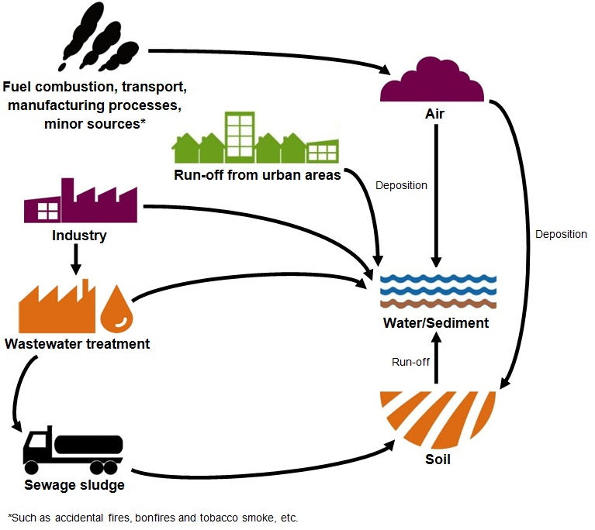
Data reported to the Pollution Inventory (PI) (Environment Agency, 2025) for 2023 show the largest point source releases of PAHs to water in England are from urban wastewater treatment works (WwTWs) (369kg), and iron and steel works (40kg).
The inventory of emissions, discharges and losses of priority and priority hazardous substances is a formal requirement of the WFD under the EQSD 2008 (2008/105/EC). The inventory for England can be found under the Emissions Inventory and Chemical Trends information for the three River Basin Management Plans. The cycle 3 inventory I provides estimates of emissions, discharges and losses of benzo(b)fluoranthene, benzo(g,h,i)perylene and benzo(k)fluoranthene from both point and diffuse sources, by river basin district, for 2018 (Environment Agency, 2025).
Estimates have been determined using SAGIS (Source Apportionment Geographic Information System, v2010), a GIS-based source apportionment tool and surface water model (Comber and others, 2012), for benzo(a)pyrene, benzo(g,h,i)perylene and indeno(1,2,3-cd) pyrene. Loads were calculated using Chemical Investigations Programme (CIP) data available at the time and flow information for benzo(b)fluoranthene and benzo(k)fluoranthene. These have been combined with estimates of releases to sea from long sewer outfalls reported to the Pollution Inventory.
The Chemical Investigations Programme is the UK water industry’s response to current and emerging legislation on trace chemical substances in the water environment. It brings together the ten large water and wastewater companies in England and Wales with regulators (Defra, the Environment Agency, and Natural Resources Wales) to investigate a range of chemical substances that may be present in untreated and treated effluent or sludge bio-waste. CIP1, CIP2, and CIP3 occurred over the years 2010-2013, 2015-2020, and 2020-2021, respectively. Each investigation phase progressively discovered new insights into chemicals of concern passing through WwTWs. CIP4 is currently underway from 2025-2027.
We estimate that approximately 656kg of PAHs were released to surface waters in England in 2010; 111kg were from point sources and 545kg from diffuse sources. Overall estimates are similar for benzo(g,h,i)perylene (196kg) and indeno(1,2,3-cd)pyrene (200kg), but higher for benzo(a)pyrene (250kg). Emissions of benzo(b)fluoranthene (5kg) and benzo(k)fluoranthene (5kg) are relatively small.
Total emissions, discharges and losses of PAHs to water per river basin district are shown in Figure 3 (results for Solway Tweed are reported by the Scottish Environmental Protection Agency, and the Dee by Natural Resources Wales). Figure 3 is a map of England showing the river basin districts, with different brown grade colours to show the different quantities of PAHs from point source emissions for each river basin district in 2010. Darker brown shades indicate higher emissions. The highest emissions are in the Severn, Humber, and Northwest river basin districts with discharges and losses of 126-150 kg. Thames (76-100 kg), and the South West (51-75 kg) follow. Anglian, South East and Northumbria have the least with 26-50kg.

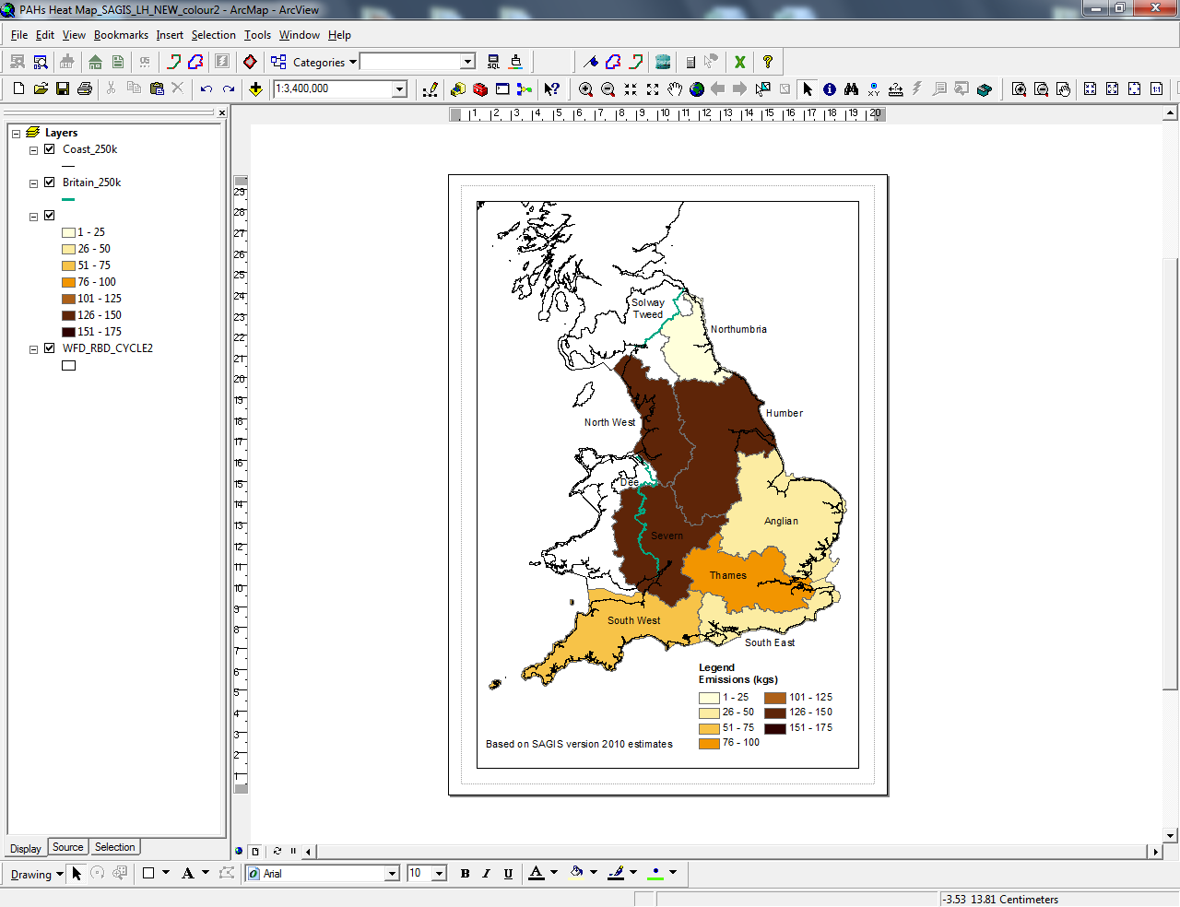
Figure 3. Baseline year (2010) total emissions, discharges and losses to water for PAHs (as listed in Annex I EQSD 2013/39/EU) for each river basin district
Estimates of emissions of PAHs vary across river basin districts, with emissions ranging from 23kg/year (Northumbria) to just over 150kg/year (Humber).
Point source and diffuse emissions show different patterns across each river basin district. Point source emissions range from approximately 2kg/year in Northumbria to 32kg/year in Humber. Diffuse inputs range from 20kg/year (Northumbria) to 125kg/year (Severn). With only one year of data in the inventory we cannot yet describe any temporal trends in emissions until the SAGIS model is updated.
Inventory results compared with PI data for 2023 suggest increased emissions within the South East and Thames river basin districts and potentially a decrease across all other districts. Loads released to surface waters in England for the different substances range from 39kg for benzo(k)fluoranthene to 150g for indeno(1,2,3-cd)pyrene, suggesting a greater contribution from benzo(b)fluoranthene and benzo(k)fluoranthene than previously estimated.
Given the PI data are generated in a different manner to the baseline inventory and focus solely on point sources, it is not possible to draw any further conclusions.
Figure 4 shows emissions of benzo(a)pyrene to water, split by source, using the modelled outputs from SAGIS (v2010). Figure 4 is an infographic with a circle for each benzo(a)pyrene source. The size of a circle represents the relative size of that source. The largest source is ‘background/ambient’, followed in decreasing order by ‘urban run-off’, ‘waste water treatment works’, ‘intermittent discharges’, ‘atmospheric inputs’, and the smallest source is ‘on site waste water treatment works’. Data for benzo(a)pyrene have been presented as a surrogate for all five compounds. Estimates of emissions for benzo(g,h,i)perylene and indeno(1,2,3-cd)pyrene, also determined using SAGIS, follow the same pattern. We do not have source apportionment data for benzo(b)fluoranthene and benzo(k)fluoranthene.

Figure 4. Sectorial analysis of emissions (kg/year) to water for benzo(a)pyrene as modelled by SAGIS v2010
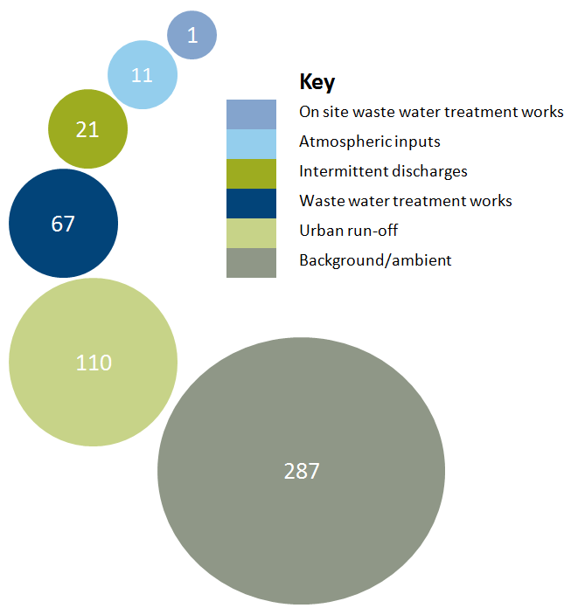
SAGIS uses measured PAH concentrations reported by the soil and herbage survey (Environment Agency, 2007) as input values for modelling background/ambient emissions of PAHs at the water body scale. These data are extremely variable between and within sites, reflecting the high degree of spatial variability in PAH concentrations across the UK. Concentrations of PAHs in urban and industrial soils are five to eight times higher than those in rural areas and similarly, concentrations of PAH in urban herbage are two to five times higher than those in rural herbage (Environment Agency, 2007). A study by Vane and others (2014) of 16 PAHs also showed greater concentrations in soils in more-urbanised areas.
At the river basin district level or a more local scale, there is likely to be variability in the relative significance of different sources, depending on the degree of urbanisation and type of industry present as well as the degree of historical contamination. A study of 18 PAHs, including the five discussed in this report in upland areas subject to moorland burning showed increased levels in local soils, sediments, moorland vegetation, upland peat, and stream water (Vane and others, 2013). Therefore, although modelling may provide a broad indication of national risk, it is likely to be much more uncertain at the individual water body level or wider local scale.
Background/ambient discharges contribute the largest proportion of the total PAH load to water, based on our modelled source apportionment (Figure 4). Natural processes, incomplete combustion, industrial processes, and other human activities have led to a general build-up of PAHs in the environment over time.
Urban run-off is a significant contributor to the PAH load to water, particularly near to industrialised and densely populated urban areas where PAHs are typically at their highest environmental concentrations (Neff and Burns, 1996; Neff and others, 2005; Pies and others, 2008; Zgheib and others, 2012).
PAHs are deposited on to road surfaces following the combustion of fuel by vehicles. Residual PAHs from bitumen used in road surfacing materials, fuel spills and particulates from brake and tyre wear can also contribute to the accumulation of PAHs on road surfaces. Various studies report concentrations of PAHs near to road environments (Harrison and others, 2003; Zhou and others, 2014; Rothwell and others, 2015; Keyte and others, 2016; Pant and others, 2017). Following a rainfall event, surface runoff from roads and other urban surfaces enters nearby water courses. Concentrations of PAHs in this runoff are highly variable and strongly linked to the prevailing weather conditions, with highest concentrations being linked to long dry periods followed by a storm event (Hill and Whiting, 2015).
Monitoring of WwTWs influent and final treated effluent as part of the CIP (UKWIR, 2014a, 2014b) demonstrated that typically 90% of the PAH load is removed during waste water treatment, although removal rates differ for individual PAHs (Gardner and others, 2013). Further investigations in the second phase (CIP2) showed that the ubiquitous presence of benzo(a)pyrene in surface waters is likely to be from sources other than WwTWs (UKWIR, 2019), which is in agreement with the data presented above on emissions.
Higher molecular weight, hydrophobic PAHs such as those under discussion here tend to sorb to particulate material during wastewater treatment, especially during primary treatment. Removal of PAHs during wastewater treatment results in their presence in sewage sludge which may subsequently be spread on agricultural land.
Land spreading of sewage sludge is regulated by the Sludge (Use in Agriculture) (Amendment) Regulations 1990 (SI 1990/880) which set limits for the amounts of certain trace metals; there are no statutory limits for PAHs.
Soil acts as an environmental sink for high molecular weight PAHs as they adsorb strongly onto soil particles. However, they do not penetrate deeply in soils, other than sandy soils, so leaching to groundwater and uptake by plants is low (European Commission, 2002).
Sediments in waterbodies also act as a sink for the higher molecular weight PAHs (Environment Agency, 2007). The larger PAHs such as benzo(a)pyrene have a low water solubility and tend to associate with suspended particles in the water column, subsequently settling on bottom sediments where they may persist (Prabhukumar and Pagilla, 2010). These PAHs are degraded slowly by microorganisms with reported half lives in soil and sediment for benzo(a)pyrene ranging from 229 to >1,400 days (European Union, 2008).
Re-suspension of contaminated sediment could be a potential source for release of PAHs into the overlying water column, but there is often uncertainty of the ecological significance of re-suspended contaminated sediments (Roberts, 2012; Nicolaus and others, 2015).

4. Environmental monitoring data
We have recent monitoring data for PAHs in surface waters and biota (crayfish and blue mussels) for benzo(a)pyrene from both English freshwaters and estuarine and coastal waters. In addition, the CIP2 measured concentrations of PAHs in and around WwTWs across England (UKWIR, 2019); the results from both sets of data are summarised in Section 4.2. Marine monitoring programmes under the Oslo Paris Convention (OSPAR) have also included the analysis of levels of PAHs in biota and sediment in UK saline waters over time (Section 4.4). We use saline waters in this report to cover estuaries and coastal waters out to 12 nautical miles (territorial waters).
We can compare our data against EQSs to get an understanding of risk. The 2013 Priority Substances Directive (2013/39/EU) lists the five PAHs given in Section 1 of this report as WFD priority hazardous substances. It specifies a biota EQS of 5µg/kg wet weight for benzo(a)pyrene – as a marker for the other PAHs – for the first time. This EQS refers to the presence of this substance in crustaceans and molluscs. It is based on a food threshold for human health (concentration in crustaceans and cephalopods of 5µg/kg; Commission Regulation 1881/2006/EC, setting maximum levels of contaminants in foodstuffs).
It is theoretically possible to derive an equivalent water threshold that corresponds to a biota standard. The approach is described in detail in the EC Technical Guidance for Deriving Environmental Quality Standards (EC, 2011) and results in a value sometimes termed the ‘back-calculated’ threshold.
For benzo(a)pyrene, the Directive (2013/39/EU) gives a revised annual average (AA) EQS of 1.7 x 10-4µg/l for inland and other surface waters. This concentration in water is the lowest value obtained from the back calculation of three different foodstuff thresholds for fish, crustaceans and cephalopods, and molluscs ranging from 2 to 10µg/kg wet weight. It is a water value for the same protection goal – human health through consumption – as the biota EQS.
The new AA EQS for water is 300 times lower than the previous EQS (2008/105/EC) for benzo(a)pyrene in surface waters because it has a different protection goal of human health rather than direct long-term toxic effects to the aquatic environment.

4.1. Biota monitoring
As part of the programme of work to assess risks from PBT substances in England, we have gathered data on benzo(a)pyrene residues in freshwater and saline biota from a limited number of locations around England.
Monitoring in molluscs and crustaceans is recommended for PAHs because these substances are readily metabolised by fish. Consequently, monitoring in fish may underestimate the environmental risk posed by these substances.
Our EQSD sampling programme began in 2014. The data assessed for this report range from 2018 to 2024, which includes samples from 35 freshwater and 46 saline sites. The number of sites and their locations have varied year on year, although a subset of sites have been reviewed for trends in concentrations over time (see Section 4.3).
As benzo(a)pyrene is used as a marker for other PAHs, and its biota EQS is based on a food standard for PAHs, only the benzo(a)pyrene data are presented in the tables and maps below. This serves as a proxy and visualisation of the trends and patterns for the five PAHs included in the Water Framework Directive (WFD) assessment.
The mean measured concentration is based on data from 2018 to 2025 where available. Some sites have means generated from only one or two years' data. We compare these data against the biota EQS to assess potential risk. The mapped results shown in Figures 5 and 6 provide a detailed look at the spatial variation between sites and which sites have results above the MAC EQS for biota in signal crayfish (Figure 5) and blue mussels (Figure 6). Annual mean concentrations of benzo(a)pyrene in crayfish are comparable with the mean range, suggesting little temporal variation over the time we have sampled.
Figures 5 and 6 are maps showing the PAH concentrations (benzo(a)pyrene, in ug/kg) in signal crayfish (Figure 5) and blue mussels (Figure 6) in England from 2018 to 2025. The size of the circles represents the concentrations; the higher the concentration, the bigger the circle. Those concentrations above the environmental quality standard are represented by the border of the circle in red. For the concentrations below the environmental quality standard, the border of the circle is in black.
Figure 5 shows that in freshwater biota, mean measured concentrations of benzo(a)pyrene in crayfish range from 0.6 to 8.9 µg/kg wet weight. Eighty-nine percent of measurements are below the EQS. There are 8 sites in total where the mean concentrations of benzo(a)pyrene in crayfish exceed the EQS with one site, located in the Midlands on the River Sowe, recording the highest values. Continued monitoring of these sites will give us a better understanding of whether the high concentrations in some animals are anomalies caused by sample variability or a true reflection of the ambient levels.

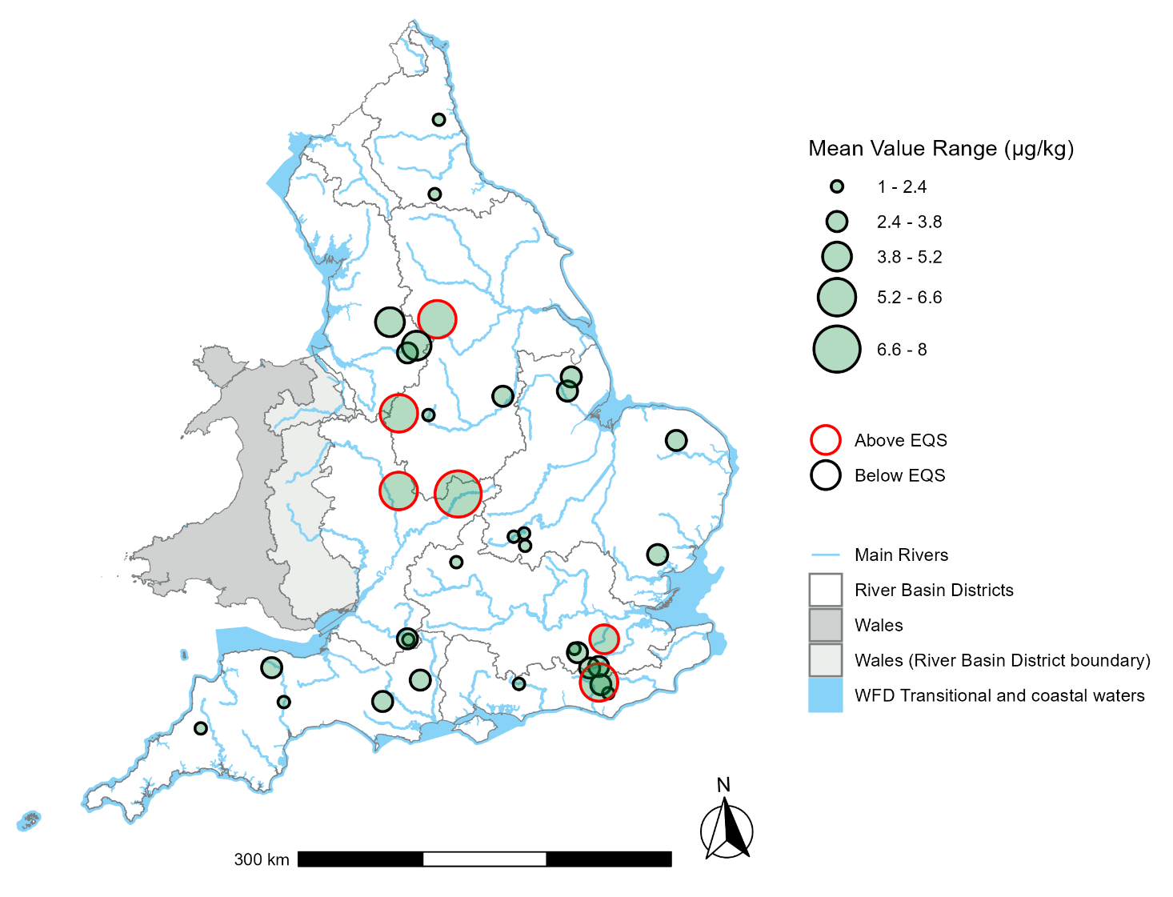
Figure 5. Geometric mean results across English monitoring sites for concentrations of benzo(a)pyrene (in ug/kg) measured in signal crayfish ‘Pacifastacus leniusculus’ in freshwaters and from 2018 to 2025 compared against the biota EQS. Environment Agency data.
A summary of the mean concentrations of benzo(a)pyrene measured in signal crayfish ‘Pacifastacus leniusculus’ in freshwaters can be found in Table 1 in the Appendix of this report.
Figure 6 shows that in saline waters, mean measured concentrations in mussels range from 0.1 to 8.4 µg/kg wet weight (normalised). Benzo(a)pyrene concentrations were recorded above the EQS at one saline site on the Tees in the North East at the Phillips Buoy monitoring site. An annual mean value of 7.3 µg/kg wet weight in blue mussels was recorded for this site – higher than typically reported concentrations. This high value is suspected to be due to a legacy of sediment disturbance leading to the re-release of benzo(a)pyrene, previously bound to sediment, back into the water column.
Ninety seven percent of the yearly saline site results had annual averages below the EQS. Again, there was little variation in the annual means from the mean range, with the exception of the Tees site. However, it should be noted that the data presented in the Environment Agency’s monitoring tables, for both biota and water, are expressed as geometric means. Consequently, comparison with the Environmental Quality Standard (EQS) is only illustrative, as true compliance is assessed using site-specific annual arithmetic means for each water body, rather than geometric means.

Figure 6. Geometric mean results across English monitoring sites for concentrations of benzo(a)pyrene (in ug/kg) measured in blue mussels in estuarine/coastal waters and from 2018 to 2025 compared against the biota EQS. Environment Agency data.

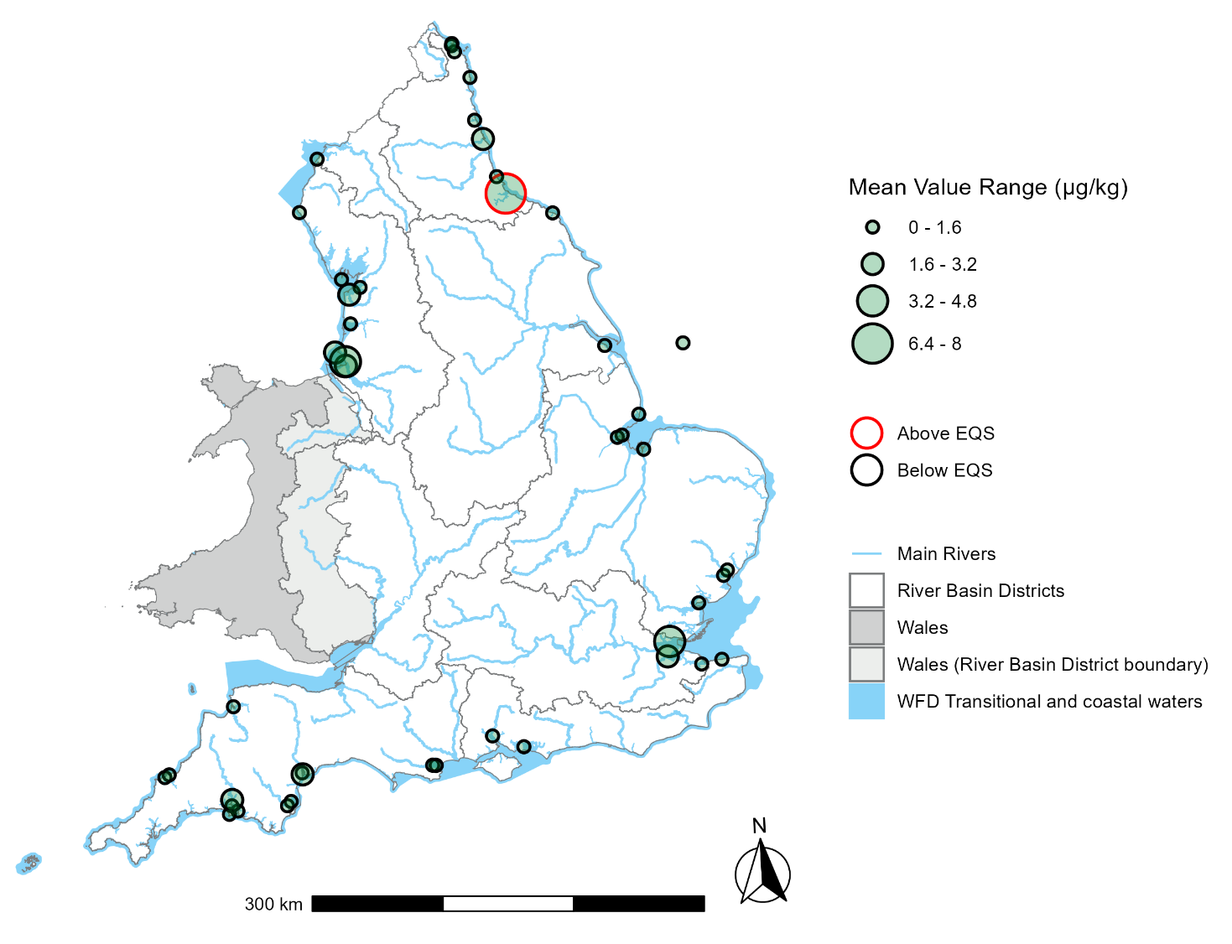
A summary of the mean concentrations of benzo(a)pyrene measured in blue mussels ‘Mytilus edulis’ in saline waters can be found in Table 2 in the Appendix of this report.
For the most up-to-date Water Framework Directive (WFD) compliance figures for PAHs or any other WFD element, you can either download the raw compliance dataset or explore the data interactively via the Environment Agency’s Catchment Data Explorer tool. This allows you to drill down to view data for individual water bodies.
Our biota monitoring data suggest that the national risk to surface waters for benzo(a)pyrene is low with average concentrations slightly higher in freshwater than saline waterbodies. There is no obvious national pattern as to why there is higher risk at certain sites.

4.2. Water monitoring

4.2.1. Investigative monitoring to assess long-term risks
The CIP2 investigations included monitoring of contaminants in rivers upstream and downstream of over 600 WwTWs, as well as in the sewage effluent from those works. The sites were selected because the receiving waters for their effluent are low dilution and so represent the greatest risk of noncompliance with the EQS downstream.
The findings from the CIP2 included sites monitored for benzo(a)pyrene between 2015 and 2020 (UKWIR, 2019). The CIP2 investigations concluded that the presence of benzo(a)pyrene in those surface waters was not primarily derived from sewage effluents as the high concentrations in the upstream samples were generally not impacted further by WwTWs.
The CIP3 programme, between 2020 and 2022, sought to assess trends across a wider range of elements in wastewater, biosolids, and the environment whilst also assessing potential removals from influent to effluent sampling locations. The data available at the time of publication shows an upward trend in concentrations of benzo(a)pyrene and were found to exceed the EQS in all WwTWs effluents, “requiring large dilutions to remain below the EQS in receiving waters” (UKWIR, 2023)

4.2.2. Freshwater: Environment Agency monitoring
This section of the report focuses solely on the updated Environment Agency data since the previous PAHs narrative update in 2021. The number of monitoring sites and the total number of samples collected between 2021 and 2024, across freshwater, saline, and groundwater environments, are presented in Table 3 in the Appendix of this report.
The map in Figure 7 below provides a visual representation of the data summarised in Table 5 (Appendix A). Figure 7 is a map showing the PAH concentrations (benzo(a)pyrene) in freshwater in England. The size of the circles represents the concentrations; the higher the concentration, the bigger the circle. Those concentrations above the environmental quality standard are represented by the border of the circle in red. For the concentrations below the environmental quality standard, the border of the circle is in black. Geometric mean concentrations of benzo(a)pyrene at freshwater sites ranged from 0.000528 to 0.002223 μg/l, based on amalgamated data for each River Basin District (RBD). This map highlights the highest concentrations of PAHs in River Basin Districts located in the Midlands and North West of England, and the lowest concentrations in the South West RBD. This map of individual site locations indicates that the majority of freshwater sites sampled in 2023 exceeded the AA EQS for surface waters.

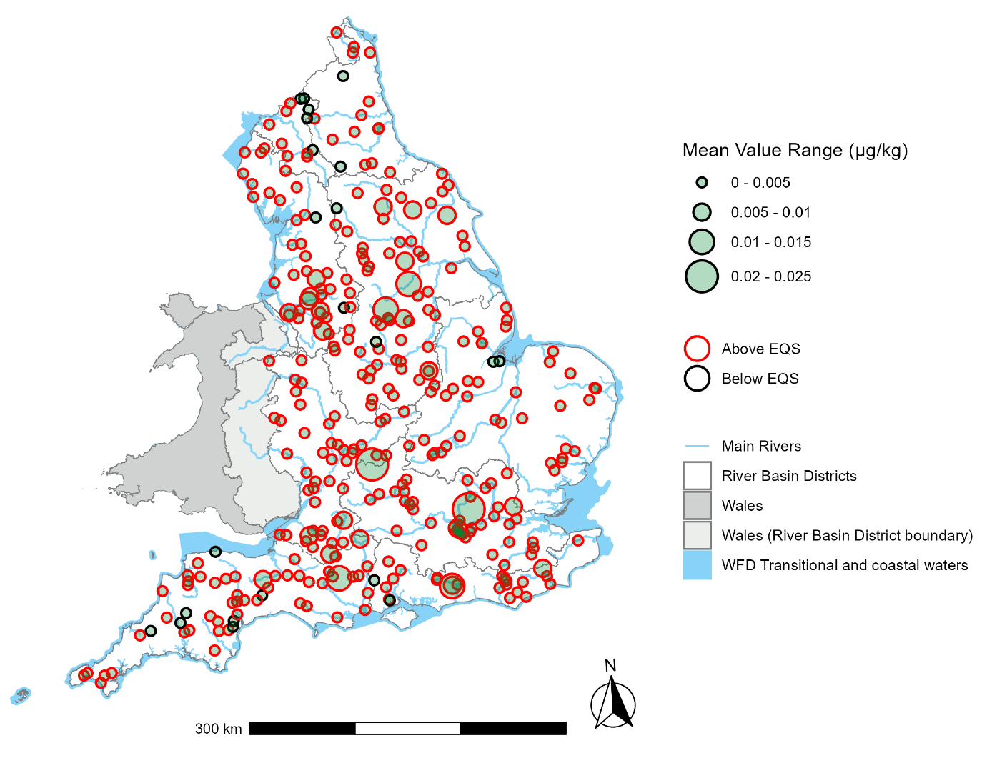
Figure 7. Map illustrating the geometric mean concentration of benzo(a)pyrene (expressed in µg/l) in freshwater bodies, in relation to the Environmental Quality Standard (EQS). Data collected in 2023 by the Environment Agency.
The map in Figure 8 below provides a snapshot of a 2023 subset of data extracted from Table 4 which can be found in the Appendix of this report.
Figure 8 is a map of England, Scotland, and Wales showing the mean concentration of benzo(a)pyrene for each RBD in 2023. Each RBD is coloured according to a concentration scale (µg/l), where lower concentrations are yellow, medium concentrations are orange/brown, and the highest concentrations are purple/blue. The highest concentration is in the Thames RBD and the lowest concentration is in the Solway Tweed RBD.

Figure 8. Map showing the mean concentration of benzo(a)pyrene (in ug/l) samples in freshwater waterbodies by River Basin District in 2023. Environment Agency data.
A summary of the four-year average (2021-2024) of the geometric mean concentration of benzo(a)pyrene in estuarine/coastal water bodies in each River Basin District (RBD) can be found in Table 5 in the Appendix of this report.

4.2.3. Estuarine and coastal: Environment Agency water column monitoring
Figure 9 is a map showing the PAH concentrations (benzo(a)pyrene) in estuarine and coastal waters in England in 2023. The size of the circles represents the concentrations; the higher the concentration, the bigger the circle. Those concentrations above the environmental quality standard are represented by the border of the circle in red. For the concentrations below the environmental quality standard, the border of the circle is in black. Geometric mean concentrations of benzo(a)pyrene at freshwater sites ranged from 0.000232 to 0.530816 μg/l, based on amalgamated data for each River Basin District (RBD). This map highlights the highest concentrations of PAHs in River Basin Districts located in the Anglian RBD, and the lowest concentrations in South East RBD.

Figure 9. Map illustrating the geometric mean concentration of benzo(a)pyrene (expressed in µg/l) in estuarine and coastal water bodies at specific sampling locations, in relation to the Environmental Quality Standard (EQS). Data collected in 2023 by the Environment Agency
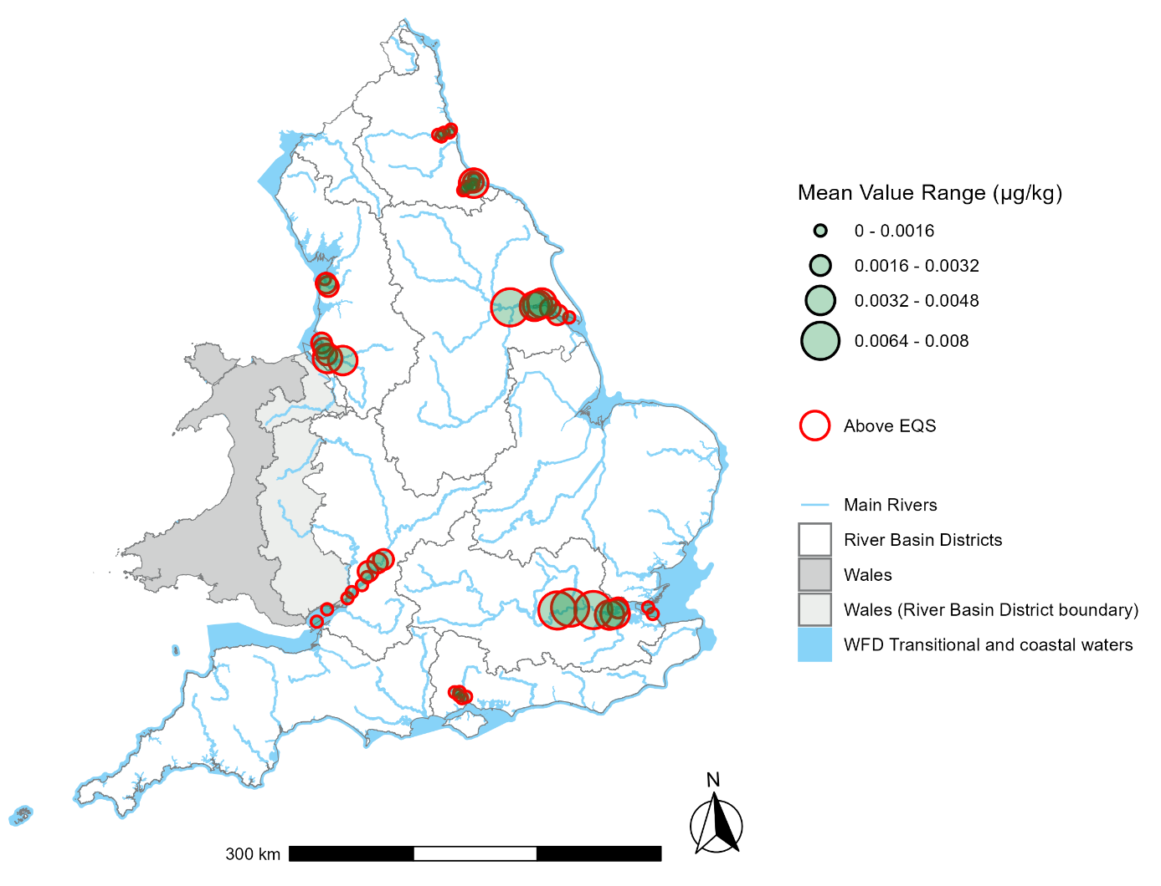
A summary of the four-year average (2021-2024) of the geometric mean concentration of benzo(a)pyrene in estuarine/coastal water bodies in each River Basin District (RBD) can be found in Table 5 in the Appendix of this report.

4.2.4. Groundwater monitoring
During the data review period (2021–2024), data on PAHs in groundwater were available for the Humber and Thames RBDs (see Table 7). Data from the Chemicals Investigation Programme Phase 3 (CIP3) identified low but persistent detections of PAHs in groundwater at several industrially influenced sites, and CIP4 will expand this work by including PAHs in both the groundwater chemicals monitoring and biosolids spreading investigations to strengthen the evidence base on their occurrence and potential pathways to groundwater.
The Thames RBD recorded the highest average concentration, with a mean value of 0.003274 µg/L, and a 95% confidence interval ranging from 0.001902 to 0.005678 µg/L. The Humber RBD had the lowest reported average concentration, with a mean of 0.002124 µg/L, and a confidence interval from 0.001056 to 0.004670 µg/L. All other RBDs either had no available data.
A summary of the four-year average (2021-2024) of the geometric mean concentration of benzo(a)pyrene in groundwater waterbodies in each River Basin District (RBD) can be found in Table 6 in the Appendix of this report.
In the 2022 River Basin Management Plans one groundwater body was at poor chemical status as a result of PAH concentrations. Limited EA monitoring data for PAHs in groundwater may have impacted on our ability to run this test in many groundwater bodies in the 2022 River Basin Management Plans.
Separately, data from CIP3 identified low but persistent detections of PAHs in groundwater at several industrially influenced waste water treatment sites that discharge to ground. CIP4 will expand this work by including PAHs in both the groundwater chemicals monitoring and biosolids spreading investigations to strengthen the evidence base on their occurrence and potential pathways to groundwater.

4.2.5 Summary of monitoring data
The monitoring data for freshwater, estuarine and coastal waters, and groundwater suggest current widespread pressure on the environment from benzo(a)pyrene. This pressure is not reflected in the biota results. This difference may be due to analytical reasons – the surface waters AA EQS is set as a total concentration and so this may include small particles with adsorbed PAHs that are not subsequently taken up by biota – and/or the assumptions used to back calculate the water threshold from the biota EQS on which it is based (see the beginning of Section 4). Differences between the biota results and the CIP2 monitoring may also be due to the biota not being in the most-polluted locations.
Measurement in biota allows a more relevant assessment of the risk given the goal to protect organisms further up the food chain from the effects of environmental exposure. Water data gives combined concentrations of benzo(a)pyrene on particulates and in the dissolved form; this may result in an overestimation of risk, as PAHs adsorbed to suspended particulate matter may be less bioavailable. There is also a level of uncertainty around back-calculated water thresholds based on toxicological data. This is because they rely on bioaccumulation factors which are not always available or consistent.
We have used our surface water monitoring data to examine the potential risks from PAHs by comparing the results against the EQSs. The above maps show widespread contamination from PAHs. This reflects the diffuse nature of the main sources of the PAHs. Higher risk is indicated for our major estuarine areas that would have industrial and urban inputs and historically contaminated sediment.

4.3. Trends
We have analysed benzo(a)pyrene using the latest available monitoring data for biota (2018 to 2025) and freshwater, estuarine and seawater, and groundwater (2021 to 2025) concentrations. The results of trend analysis are shown in the Figures below.
The modelled data show an upwards trend in concentrations for biota in both freshwater and estuarine and coastal monitoring sites in England. The graph in Figure 10 shows this this trend is higher and slightly steeper for freshwater (green line) compared to saline (orange line).

Figure 10. Modelled trend data for geometric mean of benzo(a)pyrene concentration with 95% confidence interval, expressed as dry weight µg/g, plotted for all England-amalgamated data for biota collected between 2018 and 2025 at Environment Agency monitoring sites. Environment Agency data. 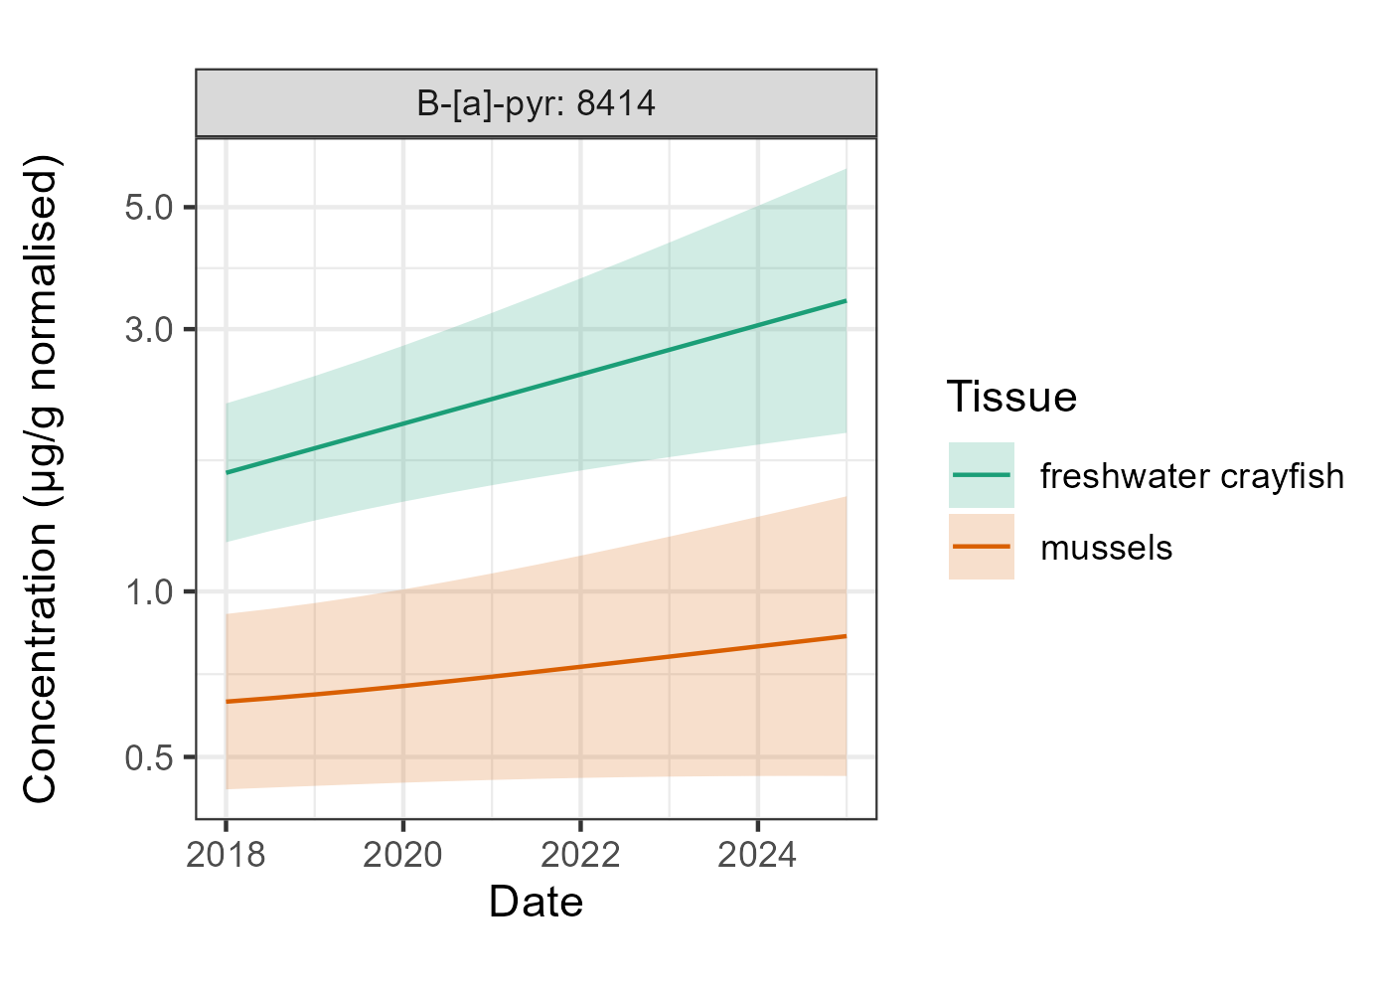
The amalgamated dataset has been modelled to show benzo(a)pyrene concentrations with and without seasonality between 2018 and 2025 in Figure 11. The “without seasonality” straight orange line shows a general linear trend, with a slight rise in benzo(a)pyrene concentrations over the sampling period. The “with seasonality” modelled green line still shows the slight rise in benzo(a)pyrene concentration over the same period. In addition, it shows a very distinct seasonal pattern, with concentrations greatest in winter and lowest in the summer months, a pattern repeated in each sample year.

Figure 11. Modelled trend data for geometric means of benzo(a)pyrene concentration with 95% confidence interval, expressed in µg/l, plotted for all England amalgamated data collected between 2021 and 2025 at Environment Agency surface freshwater monitoring sites, showing modelled trend data with and without seasonality. Environment Agency data. 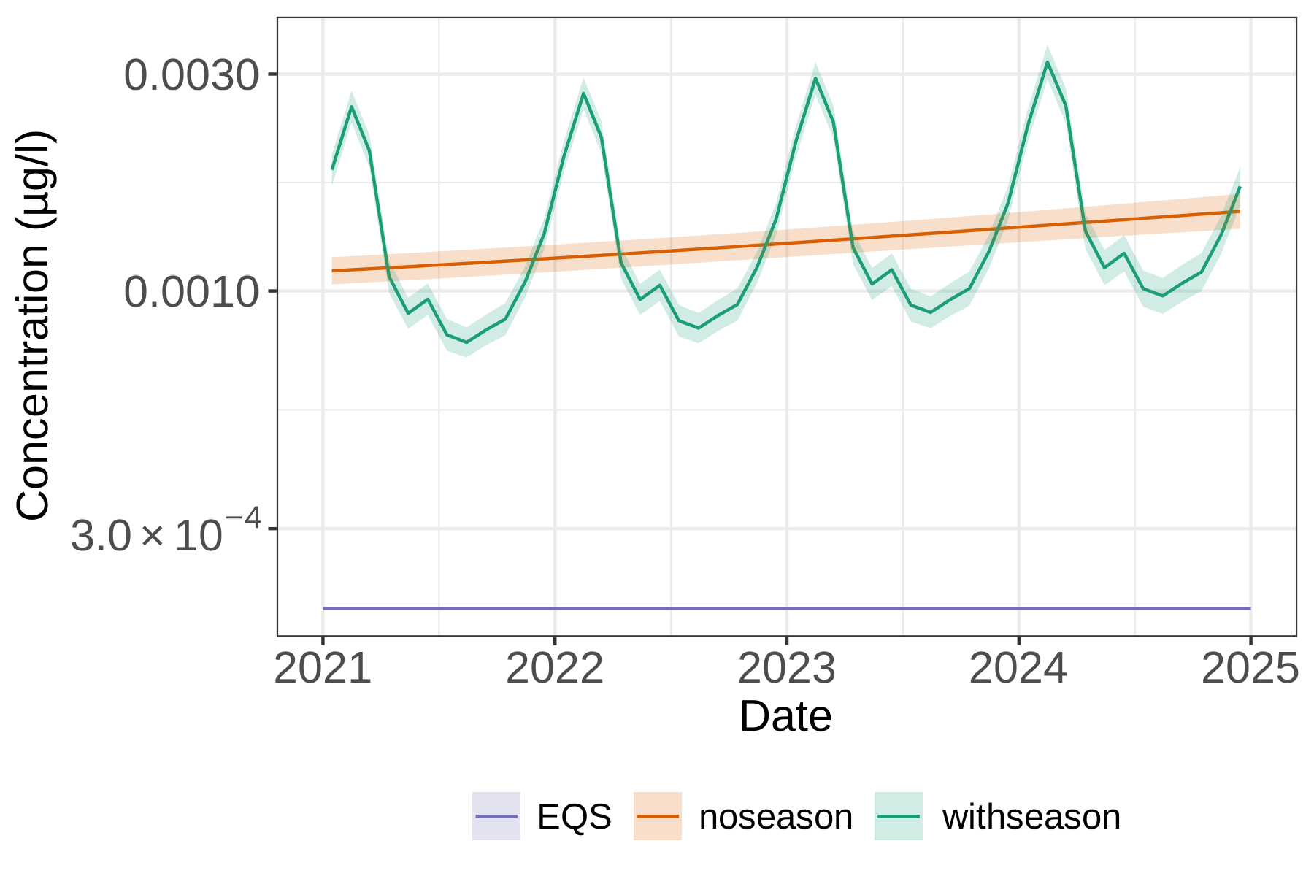
The seasonality in freshwater concentrations is likely to be driven by changes in environmental conditions like temperature, precipitation, and wind patterns as well as the sources of these pollutants themselves. Temperature can affect deposition rates, increased precipitation can enhance the transport of benzo(a)pyrene to terrestrial and aquatic ecosystems, whilst wind direct and air mass can influence the distribution of atmospheric pollution. As discussed previously, increased emissions of benzo(a)pyrene from combustion activities such as domestic sources can occur during winter, further contributing to levels in the atmosphere and subsequently in freshwater. Additionally, increased winter rainfall can lead to greater surface runoff and higher river flow, enhancing the transport of these substances into aquatic environments.
The figures below show data plots for individual sites and their respective RBD catchments. Figures 12, 13, and 14 are a series of graphs presenting all England amalgamated benzo(a)pyrene data collected between 2021 and 2025 in Environment Agency monitoring sites, now disaggregated by individual sites and their corresponding RBD catchments. On each graph, the mean is plotted as an orange line, and individual sites are plotted as green lines. For Figures 12 and 13, the EQS, based on the annual average concentration, is plotted for reference as a purple line.
Figure 12 shows the geometric means of benzo(a)pyrene (in µg/L) plotted for all England amalgamated data collected between 2021 and 2025 in Environment Agency surface freshwater monitoring sites. This alternative view of the data shows that in several of the RBDs there is a slightly upward linear trend in freshwater sites but overall there is not a significant variation in concentrations.
Figure 13 shows the geometric means of benzo(a)pyrene (in µg/L) plotted for all England amalgamated data collected between 2021 and 2025 in Environment Agency estuarine and seawater monitoring sites. There is significant variation in concentrations between the RBDs for the coastal and seawater sites, with the Severn having the highest and the South East the lowest, both of which show a slightly increasing trend.
Figure 14 shows the geometric means of benzo(a)pyrene (in µg/L) plotted for all England amalgamated data collected between 2021 and 2025 in Environment Agency groundwater monitoring sites. There is a significant upward trend in the Humber RBD and Northumbria RBD which also have the highest concentrations but where there is less data. The Thames RBD shows a moderate upward trend in concentration, whereas the South East RBD has the lowest concentrations with levels showing little change.
It should be noted that benzo(a)pyrene geometric means and the mean EQS shown in these graphs are for indicative purposes only, as this graph does not represent true Water Framework Directive (WFD) compliance, which is calculated using site-specific annual arithmetic mean averages for EQS comparison.

Figure 12. Geometric means of benzo(a)pyrene expressed as µg/l, plotted for all England amalgamated data collected between 2021 and 2025 in Environment Agency surface freshwater monitoring sites. Data plotted for individual sites in each WFD River Basin District (RBD). Environment Agency data. 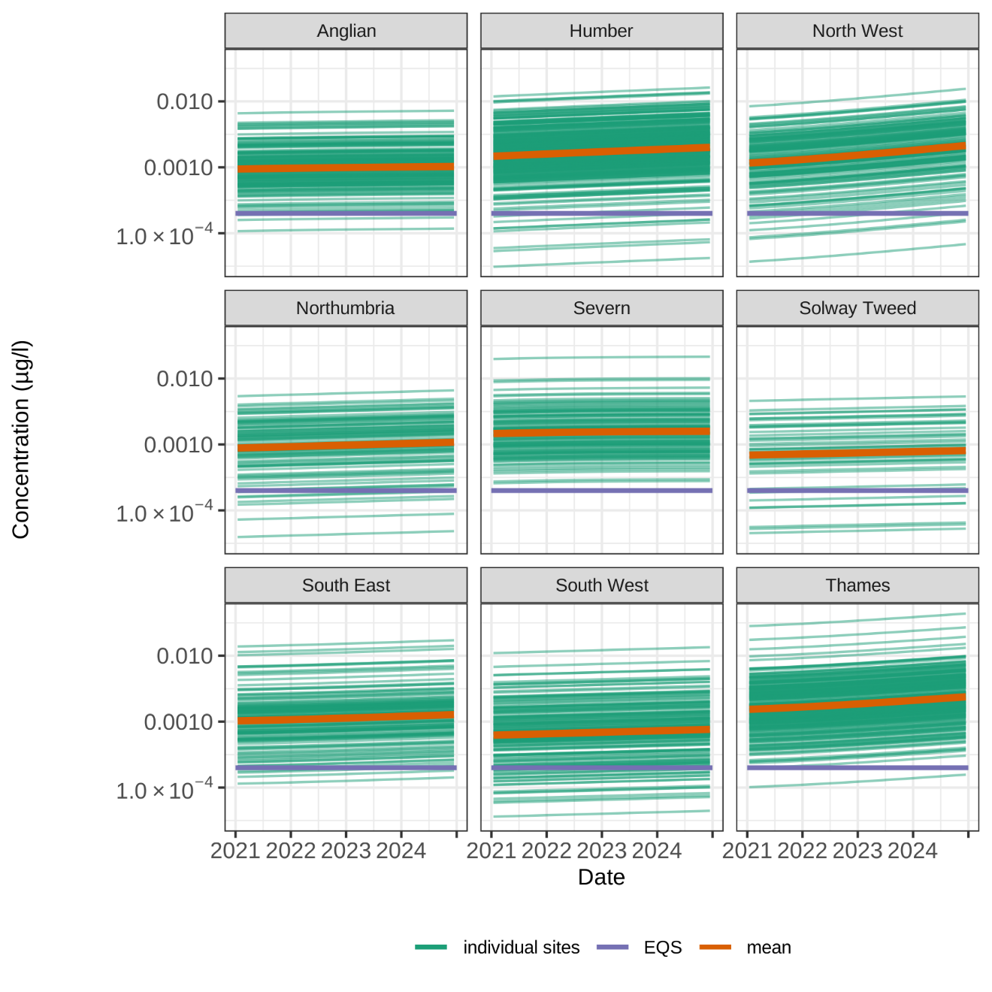

Figure 13. Geometric means of benzo(a)pyrene expressed as µg/l, plotted for all England amalgamated estuarine and seawater data collected between 2021 and 2025. Data plotted for individual sites in each WFD River Basin District (RBD). Environment Agency data.

Figure 14. Geometric means of benzo(a)pyrene expressed as µg/l, plotted for all England amalgamated groundwater data collected between 2021 and 2025. Data plotted for individual sites in each WFD River Basin District (RBD). Environment Agency data.

4.3.1. Other monitoring data
Under OSPAR, the Coordinated Environmental Monitoring Programme (CEMP) has collected data on concentrations of PAHs in sediment and biota (blue mussels) in UK marine waters. Data generated under this programme are collated for the International Council for the Exploration of the Sea (ICES) and can be viewed using the OHAT - OSPAR Hazardous Substances Assessment Tool online map viewer. Data are available for benzo(a)pyrene, as well as benzo(g,h,i)perylene and indeno(1,2,3-cd)pyrene.
There is a change in concentration in the most recent 20 monitoring years between 2003 and 2022 (the assessment only includes data up to 2022). An overview of the trend monitoring data collected under the CEMP for benzo(a)pyrene within English territorial waters, the saline area to which the Priority Substance Directive (2013/39/EU) applies, shows only a single site off the river Tees coast in the north-east exhibiting a statistically significant downward trend in sediment concentrations (OSPAR 2025 assessment based on data extracted on 10th January 2025). This area is known to be historically contaminated by industry.
Under the CEMP, blue mussels have been sampled from 28 sites for benzo(a)pyrene around England from 2002 to 2022. Four of these sites can be assessed for trends using the Background Assessment Concentration (BAC) and Environmental Assessment Criteria (EAC). Mean concentrations significantly below the BAC are near background whereas concentrations below the EAC should not cause any chronic effects on marine organisms (cited on OHAT). Only one statistically significant trend has been reported for concentrations of this substance in mussel tissue: a downward trend at Teesmouth in the North East. This trend is also seen for benzo(g,h,i)perylene and indeno(1,2,3-cd)pyrene at this site.
The CEMP have also monitored benzo(a)pyrene in sediments at 11 sites. Seven of these sites can be assessed for trends. The data show a couple of downward trends in the North East offshore from the Tyne and Tees areas. The data corresponding to the other two substances show no change. Sites in the Lower Medway and South West present sediment contaminated with benzo(a)pyrene at levels that could potentially cause adverse effects to marine life, based on comparisons with thresholds used to assess the environmental status (Effects Range Low) developed by the US Environmental Protection Agency (cited on OHAT).
The latest OSPAR (2024) assessment for PAHs in shellfish and sediment on data for the OSPAR maritime region is available through the OSPAR Assessment Portal (OAP). The assessment shows the mean concentrations of PAHs, as a group, using data from the period 2017 to 2022 which are summarised in the table below.

OSPAR Trend Assessment: Polycyclic aromatic hydrocarbons, Parent Group.
OSPAR Region | Biota | Sediment | Water
2: Central Northern Sea | 24%↓ | 19%↓ | 11%↓
2: Southerhn North Sea/Channel | 3%↑ | 3%↑ | 5%↑
3: Northern Celtic Sea | 12%↓ | 19%↓ | n/a
3: Southern Celtic Sea | 9%↑ | 4%↑ | n/a
*Note: ↑↓ indicates the overall direction of trend
Within the two OSPAR regions relevant to English coastal waters, the trend analysis shows an overall decrease in PAH concentrations. Areas with decreasing PAH concentrations included the English Channel for all media and the Southern North Sea for PAH concentrations in shellfish.
Mean concentrations in shellfish were above OSPAR background levels in all areas, although not at concentrations likely to cause adverse effects. Levels in sediment were also unlikely to cause adverse biological effects.
The above assessment considers PAHs as a group and combines data for sites in a defined area which can hide the variation seen when looking at individual compounds and sites. Very limited data are reported in the scientific literature for the specific PAHs under discussion here.
Studies from individual sites show there is a high spatial variability, with concentrations influenced by adjacent land use. For example, sediment cores taken from 10 lakes across the UK showed a tarn in the Lake District to have the lowest levels of total PAHs of those sites sampled, and a site in South Yorkshire, located close to an urban centre, to have the highest (Rippey and others, 2008).
Additional data on concentrations of benzo(a)pyrene in English coastal areas can be viewed on the European Marine Observation and Data Network (EMODnet, version 2024) online mapping tool - https://emodnet.ec.europa.eu/geoviewer/. The concentration is expressed as median value of the last six available years at various monitoring locations and depths. The measurement units are ug/kg for biota and sediment. The medium values are calculated using data included in EMODnet validated datasets and quality flagged as "good data", namely data with Quality Flag 1, 2, 6, Q. Definitions of the SeaDataNet “Quality Flag Schema” can be found on the NERC Vocabulary Server.
The EMODnet map viewer shows that median concentrations for benzo(a)pyrene in sediment are mainly distributed within a range of 1.7-22 ug/kg (25-75% of data) for monitoring points around the English coastal region. The distribution of median values for benzo(a)pyrene in biota are mainly within a range of >1.5 ug/kg (>90% of data). The higher values are associated with Northumbria, Humber, Thames and Southwest River Basin Districts.
Historical industrial contamination may also have a significant influence on local PAH concentrations. Rumney and others, (2015) examined data for PAHs in sediments at 12 saline sites around the coast of England, spanning the years 2008 to 2013, although not all sites had data for each year. Highest concentrations were seen in sediments from the Inner Tees in the north east in 2008 and the Tyne and Tees in what year ? and this was attributed to high levels of PAHs from historical industrial activities persisting in sediments (CEFAS, 2012; Rumney and others, 2015).
The relationships, if any, between current emissions of PAHs, environmental concentrations and any trends are likely to be complex. For the studies summarised above, there appears to be little relationship between emissions of PAHs, as reported in the emissions inventory (Section 3) and measured environmental concentrations.
Total emissions to surface waters for the North West river basin district are predicted to be amongst the highest in England (see Section 3) so the low concentrations reported for the Lake District tarn illustrates the high degree of variability in emissions expected across a river basin district. In contrast, high concentrations of PAHs are reported in sediment in the Tees; however, Northumbria is a river basin district reporting relatively low emissions of PAHs compared with other river basin districts. At these sites in the north east, historical contamination appears to be significant, although there are some indications of environmental improvement from the CEMP data.
Contaminants such as PAHs contained in sediment may be mobilised by human activities, such as dredging, as well as natural events including tidal surges and extreme weather events (Eggleton and Thomas, 2002). Considering historical CSEMP data, Nicolaus and others, (2015) also concluded that re-suspension of sediment containing such contaminants may still cause a threat to the saline environment.
Where we see higher concentrations in our biota monitoring data (Section 4.1), these locations appear to be in river basin districts with higher predicted emissions to surface waters. However, again the biota data show variability across these river basin districts.

5. Control measures

5.1. Restrictions
There are a number of source control measures that control emissions of PAHs. Regulation of industrial point source emissions is implemented in England by The Environmental Permitting (England and Wales) (Amendment) Regulations 2013 (SI 2016/1154). Under this legislation emissions from major industrial sources must be permitted. Abatement measures are used to reduce PAH emissions and to comply with permits. Target values are set for benzo(a)pyrene and other PAHs in ambient air under the Directive on Ambient Air Quality and Cleaner Air for Europe (2008/50/EC).
Industrial and consumer substances manufactured or imported into Great Britain (GB) above 1 tonne per year by a company must be registered under The REACH etc. (Amendment etc.) (EU Exit) Regulations 2019 [UK REACH] (SI 2019/758). If supply is above 10 tonnes/year, and the PAH content is above the relevant hazard classification threshold, the company must also provide a Chemical Safety Report. This report states the conditions under which the substance can be safely used. This offers some level of control over the use of substances containing PAHs, but transitional arrangements mean that this information is not yet available for all substances within GB.
Eight PAHs are classed as carcinogenic and entry 50 of Annex 17 of UK REACH – implemented in the UK by the REACH Enforcement Regulations 2008 (SI 2008/2852) – restricts several product types in relation to these PAHs. The listed PAHs in this restriction include benzo(a)pyrene, benzo(b)fluoranthene and benzo(k)fluoranthene. Examples of product types affected include:
- extender oils, which have been prohibited from being placed on the market or used in the production of tyres or parts of tyres that contain more than 0.0001% by weight of benzo(a)pyrene or more than 0.001% by weight of the sum of all listed PAHs; and
- the placing on the market and supply to the general public of articles containing rubber or plastic components that come into contact with the skin. Articles are restricted if they contain >0.0001% by weight of any of the listed PAHs and these include:
- sport equipment such as bicycles, golf clubs, racquets
- household utensils, trolleys, walking frames
- tools for domestic use
- clothing, footwear, gloves and sportswear
- watch-straps, wrist-bands, masks, head-bands
Toys and childcare articles that may come into direct contact with the skin or oral cavity are also restricted if they contain more than 0.00005% by weight of any of the listed PAHs.
Annex 17 entry 31 of UK REACH also places restrictions on creosote, coal tar, and other sources of PAHs for use by the general public. Since 2003, the marketing and use of these products is prohibited for the treatment of wood except in certain industrial facilities and for commercial purposes under certain conditions. Wood treated with these substances cannot be used for a variety of purposes such as in children’s playgrounds and garden furniture.
Benzo(a)pyrene, benzo(k)fluoranthene and benzo(g,h,i)perylene are also listed as substances of very high concern (SVHCs) under UK REACH. SVHCs are recognised as having serious effects on human health or the environment. Inclusion on the list triggers specific legal obligations for businesses that manufacture, import, or supply these substances. Controls on use of the substance may follow; for example, anthracene oil and high-temperature coal tar pitch are subject to authorisation requirements because of their PAH content. Alternatively, substances could be proposed for restriction. For example, since 2019 the EU has proposed further restrictions of PAHs in rubber crumb and clay pigeons (further information is available on the European Chemicals Agency (ECHA) website: Substances restricted under REACH - ECHA). These have not been prioritised for consideration under UK REACH yet.
Benzo(a)pyrene, benzo(b)fluoranthene, benzo(k)fluoranthene, and indeno(1,2,3-cd)pyrene are listed in Annex III of The Persistent Organic Pollutants Regulations 2007 (SI 2007/3106) – which requires that PAH emissions are recorded in an emissions inventory and an action plan produced to eliminate releases.
Legislation that places a maximum limit on the PAH content of diesel has been in existence for several years and in 2009 the upper limit for PAH content in diesel was reduced from 11 to 8% by weight (2009/30/EC; implemented in the UK by SI 2021/894). However the PAH content of diesel in the UK is considerably lower than 8% (Department for Transport, 2010).
Maximum limits on the levels of certain PAHs in foodstuffs such as oils and fats, fish, meat, and infant formula are specified under the Contaminants in Food (England) Regulations (SI 2013/2196).

5.2. Managing risks from diffuse pollution
The government outlines actions to tackle pollutant emissions resulting from domestic burning in the Clean Air Strategy (Defra, 2019). These steps will contribute to addressing emissions of PAHs such as benzo(a)pyrene. The actions include:
- legislating to prohibit the sale of the most polluting fuels
- changing existing smoke control legislation to make it easier to enforce
- giving local authorities new power to tackle problem areas of pollution
- improving awareness on the environmental impacts of domestic burners through a communications campaign
- aligning government work on air quality, clean growth and fuel poverty in future policy design
- working with industry to establish standards for new fuels entering the market
The strategy also highlights the difference between methods of heating and the relative cleanness of different fuels, for example the use of seasoned wood over wet wood, as well as advice on ways to cut down on domestic combustion. The government has conducted evidence consultations on “cleaner domestic burning” which have informed the strategy and gathered views on proposals to help households transition to cleaner fuels for burning. For more information on the call for evidence, see the government report.
The Government’s Environmental Improvement Plan (EIP) (Defra, 2023) aims to build on existing programs such as the National Air Pollution Control Programme (NAPCP) and the 2019 Clean Air Strategy. Goal 2 of the EIP “clean air” sets targets for cutting overall air pollution by tackling the key sources of emissions, including reducing the maximum limits for domestic burning appliances in Smoke Control Areas.
We still need a broader understanding of impacts of urban pollution on soil, water, sediment and wildlife but conventional drainage infrastructure allows pollutants accumulated on hard surfaces to be washed directly into water courses as urban run-off. Risks from urban run-off are increasingly being mitigated using sustainable urban drainage systems (SuDS), a wide-ranging term covering a variety of solutions to intercept and remove sediment, metals and PAHs from urban run-off. There is still an evidence gap around the breakdown of hydrocarbons and PAHs within these systems; however, the higher molecular weight PAHs, such as those under discussion here, tend to be found in the sediment phase of run-off.
A study to investigate the effectiveness of various SuDS techniques in attenuating and degrading a range of diffuse source pollutants, including PAHs, has been undertaken (SNIFFER, 2008). Pathway intervention measures such as grass filter strips, swales, and detention areas are advocated as priority features of sustainable urban drainage networks serving urbanised areas and highways where oil contamination may be significant.

6. Summary
PAHs are released to the environment as by-products of both natural and anthropogenic combustion processes, resulting in widespread contamination of the environment. There is a high degree of temporal and spatial variability in environmental concentrations of PAHs across the UK, with highest concentrations reported in urban areas (Environment Agency, 2007).
The UK's National Atmospheric Emissions Inventory (NAEI, 2025) identifies domestic combustion as the main source of PAHs to the atmosphere. The increasing use of wood as a domestic fuel has led to an increase in emissions from domestic combustion over approximately the past 15 years (NAEI, 2025).
Road transport, including vehicle emissions, tyre and brake wear and road abrasion also contributes to the total diffuse PAHs load to the atmosphere, although this has been steadily declining since the 1990s (NAEI, 2025). As the second largest diffuse source it is considerably less significant (approximately 3% of the total load) than domestic combustion and its contribution to atmospheric load is more comparable to those reported for regulated point sources (Defra, 2018, Environment Agency, 2019, NAEI, 2025).
There are many other domestic and industrial sources emitting PAHs as by-products of combustion processes, including industrial off-road mobile machinery, fireworks, coke production, agricultural mobile machinery, accidental fires, power stations and sinter production (used in smelting) (Environment Agency, 2023; NAEI, 2025).
Atmospheric emissions of PAHs are significantly greater than those direct to water. PAHs released directly to the atmosphere are deposited on land and in water. The significance of atmospheric deposition and subsequent accumulation of PAHs on land over time is demonstrated through the large contribution that background/ambient sources make to our modelled PAH emissions to water (Figure 4, Section 3.2). Urban run-off is also a significant source of PAHs to water.
Previous estimated emissions have indicated that WwTWs are the next significant source of PAHs to water (Figure 4 and Environment Agency, 2019). However, environmental monitoring near and at such works suggests the presence of benzo(a)pyrene in surface waters is not primarily derived from sewage effluent. The higher dilution arising from wastewater discharges from WwTWs often reduces PAH concentrations immediately below them.
At a local scale, the relative significance of different sources is likely to vary depending on the degree of urbanisation and local industry present.
Controlling environmental releases of PAHs is especially difficult because of the very high number of diffuse sources producing them.
There are a significant number of controls on the release of PAHs already in place under EU legislation (Section 5). The gradual replacement of older combustion processes with newer ones, which are generally more efficient and cleaner, will have helped reduce releases. Benzo(a)pyrene emissions have dropped by an order of magnitude since the 1990s. However, the contribution from domestic combustion has changed little over this time and annual mean ambient levels have been steady from 2009 to 2014, with a slight drop until 2016 (Defra, 2017). This diffuse source is being tackled through the Clean Air Strategy 2019 (Defra, 2019).
Our biota monitoring data in surface waters up to 2025 indicate very low risk from benzo(a)pyrene. Only a few sites exceed the biota EQS based on mean concentrations. However, mean water concentration data from the water industry CIP2 and from samples taken at some of our biota sites suggest the ubiquitous presence of benzo(a)pyrene at levels exceeding the water AA EQS.
Our surface water monitoring data suggest widespread short-term risks to the aquatic environment, particularly in some saline areas. The saline areas are commonly large active estuaries likely to contain sediment historically contaminated with PAHs. However, water results are taken as total concentrations and may include PAHs adsorbed to fine sediments which may not be subsequently accumulated by organisms and so may overestimate risk. However, our biota monitoring of crayfish is mostly in less populated areas because they prefer river substrates higher up river catchments and so may not reflect more-polluted urban waters.
The modelled trend analysis based on amalgamated EA monitoring data from 2018-2025 shows a slightly upwards trend in the overall concentration of benzo(a)pyrene in biota and freshwater with a pronounced seasonal variation though the data does not show a consistent pattern across sites.
It will be difficult to reduce PAH exposure, and we will need continued engagement with stakeholders and relevant policymakers to continue to reduce inputs and mitigate potential effects from historical environmental contamination. Where risks from urban sources of PAHs are identified, we will collaborate with relevant stakeholders to influence the development and joint delivery of effective risk mitigation solutions. For example, water companies can help address such risks through the development and delivery of drainage and water management plans (DWMPs), working closely with other stakeholders such as the National Highways.

Appendix

Table 1. Average (2018-2025) of the geometric mean concentration of benzo(a)pyrene in freshwater crayfish expressed as µg/kg wet weight. Note: this tabulated data was used to produce the map shown in Figure 5 of the main document.
Year | Annual geometric mean benzo(a)pyrene, expressed as µg/kg ww | Lower Confidence Limit | Upper Confidence Limit | Results above MAC EQS
2018 | 1.643248189 | 1.228736738 | 2.197594104 | 0
2019 | 1.821613998 | 1.346108575 | 2.465089087 | 0
2020 | 2.019340404 | 1.456495999 | 2.79968889 | 1
2021 | 2.238528899 | 1.56037455 | 3.211415896 | 1
2022 | 2.481509084 | 1.659329378 | 3.711069915 | 5
2023 | 2.750863424 | 1.75513589 | 4.311489284 | 5
2024 | 3.049454701 | 1.84934002 | 5.028374378 | 7
2025 | 3.380456432 | 1.943167129 | 5.880855802 | 8

Table 2. Average (2018-2025) of the geometric mean concentration of benzo(a)pyrene in mussels in estuarine/coastal waterbodies expressed as µg/kg wet weight. Note: this tabulated data was used to produce the map shown in Figure 6 of the main document.
Year | Annual geometric mean benzo(a)pyrene, expressed as µg/kg ww | Lower Confidence Limit | Upper Confidence Limit | Results above MAC EQS
2018 | 0.630227776 | 0.436532105 | 0.909869045 | 1
2019 | 0.649479355 | 0.442891499 | 0.952430635 | 1
2020 | 0.672873972 | 0.448910951 | 1.008572817 | 1
2021 | 0.699745435 | 0.454034566 | 1.078428188 | 1
2022 | 0.729382145 | 0.457925394 | 1.161757615 | 1
2023 | 0.761098718 | 0.4604369 | 1.258090434 | 1
2024 | 0.79444113 | 0.46161872 | 1.367225119 | 1
2025 | 0.829277005 | 0.461664348 | 1.489611131 | 1

Table 3. The variation in numbers of water monitoring sites and samples per year from the current assessment period (2021-2024). Environment Agency data.
Freshwater |  |  | Estuarine/Seawater |  |  | Groundwater
Year | No. of Sites | No. of  Samples | Year | No. of Sites | No. of Samples | Year | No. of Sites | No. of Samples
2021 | 69 | 596 | 2021 | 38 | 265 | 2021 | 11 | 11
2022 | 138 | 1327 | 2022 | 48 | 433 | 2022 | 64 | 70
2023 | 226 | 1724 | 2023 | 49 | 488 | 2023 | 61 | 64
2024 | 193 | 1540 | 2024 | 48 | 442 | 2024 | 60 | 63

Table 4. Four-Year average (2021-2024) of the geometric mean concentration of benzo(a)pyrene in freshwater surface waterbodies in each River Basin District (RBD), expressed as µg/l. Note: this tabulated data was used to produce the map shown in Figure 7 of the main document.
RBD | Average | Lower Confidence Limit | Upper Confidence Limit
Anglian | 0.000998 | 0.000691 | 0.001441
Humber | 0.001786 | 0.001344 | 0.002374
North West | 0.001726 | 0.001205 | 0.002472
Northumbria | 0.000952 | 0.000514 | 0.001766
Severn* | 0.001507 | 0.001066 | 0.002131
Solway Tweed* | 0.000528 | 0.000293 | 0.000954
South East | 0.001040 | 0.000665 | 0.001626
South West | 0.000653 | 0.000479 | 0.000890
Thames | 0.002223 | 0.001570 | 0.003148
Overall mean | 0.001268
*Note – data is for only the England part of the RBD

Table 5. Four-Year average (2021-2024) of the geometric mean concentration of benzo(a)pyrene in estuarine/coastal water bodies in each River Basin District (RBD), expressed as µg/l. Note: this tabulated data was used to produce the map shown in Figure 8 of the main document.
RBD | Average | Lower Confidence Limit | Upper Confidence Limit
Anglian | 0.530816 | 0.000212 | 10812.1
Humber | 0.009657 | 0.005384 | 0.01732
North West | 0.003892 | 0.001949 | 0.007776
Northumbria | 0.001339 | 0.000855 | 0.002099
Severn* | 0.011136 | 0.006521 | 0.019022
Solway Tweed* | n/a | n/a | n/a
South East | 0.000232 | 0.000115 | 0.00047
South West | n/a | n/a | n/a
Thames | 0.003655 | 0.00217 | 0.006157
*Note – data is for only the England part of the RBD

Table 6. Four-Year average (2021-2024) of the geometric mean concentration of benzo(a)pyrene in groundwater waterbodies in each River Basin District (RBD), expressed as µg/l. Environment Agency data.
RBD | Average, benzo(a)pyrene expressed as µg/L | Lower Confidence Limit | Upper Confidence Limit
Anglian | n/a | n/a | n/a
Humber | 0.002124 | 0.001056 | 0.004670
North West | n/a | n/a | n/a
Northumbria | n/a | n/a | n/a
Severn* | n/a | n/a | n/a
Solway Tweed* | n/a | n/a | n/a
South East | n/a | n/a | n/a
South West | n/a | n/a | n/a
Thames | 0.003274 | 0.001902 | 0.005678
Overall mean: | 0.002700
*Note – data is for only the England part of the RBD

References
Agency for Toxic Substances and Disease Registry (ATSDR). ‘Public Health Statement for Polycyclic Aromatic Hydrocarbons (PAHs)’ 1995 (viewed January 2025)
Agency for Toxic Substances and Disease Registry (ATSDR). ‘Toxic Substances Portal – Polycyclic Aromatic Hydrocarbons (PAHs)’ 1996 (viewed January 2025)
Agency for Toxic Substances and Disease Registry (ATSDR). ‘Public Health Assessment’ 2009 (viewed January 2025)
Bauer MJ and others. ‘Chemodynamics, transport behaviour and treatment of phthalic acid esters in municipal landfill leachates’. Water Science and Technology 1998: volume 38, pages 185-192 (viewed January 2025)
Bozlaker A and others. ‘Atmospheric concentrations, dry deposition and air–soil exchange of polycyclic aromatic hydrocarbons (PAHs) in an industrial region in Turkey’. Journal of Hazardous Materials 2008: volume 153, pages 1093-1102 (viewed January 2025)
Canadian Council of Ministers of the Environment (CCME). ‘Canadian water quality guidelines’. 2003: Prepared by the task force on water quality guidelines of the Canadian Council of Ministers of the Environment, Eco-health branch, Ottawa, Ontario, Canada
Centre for Environment, Fisheries and Aquaculture Science (CEFAS). ‘Monitoring of the quality of the marine environment, 2008-2010’. 2012: Science Series Aquatic Environment Monitoring Report, CEFAS Lowestoft. 2012: report number 63
Chen BL and others. ‘Distributions of polycyclic aromatic hydrocarbons in surface waters, sediments and soils of Hangzhou City, China’. Water Research 2004: volume 38, pages 3558-3568 (viewed January 2025)
Comber S and others. ‘Chemical source apportionment under the Water Framework Directive’. 2012: UKWIR, report number WW02
‘Commission Directive 2009/90/EC of 31 July 2009 laying down, pursuant to Directive 2000/60/EC of the European Parliament and of the Council, technical specifications for chemical analysis and monitoring of water status’. Official Journal of the European Union: pages L201/36–L201/38 (viewed January 2025)
‘Commission Directive 2014/80/EU of 20 June 2014 amending Annex II to Directive 2006/118/EC of the European Parliament and of the Council on the protection of groundwater against pollution and deterioration’. Official Journal of the European Union: pages L182/52–L182/55 (viewed January 2025)
‘Commission Regulation (EC) No 1881/2006 of 19 December 2006 setting maximum levels for certain contaminants in foodstuffs’. 2006: R1881-EN- 01.07.2010-004.001, pages 1-26
‘Commission Regulation (EC) No 552/2009 of 22 June 2009 amending Regulation (EC) No 1907/2006 of the European Parliament and of the Council on the Registration, Evaluation, Authorisation and Restriction of Chemicals (REACH) as regards Annex XVII’. Official Journal of the European Union, pages L164/7–L164/31 (viewed January 2025)
‘Commission Regulation (EU) No 1272/2013 of 6 December 2013 amending Annex XVII to Regulation (EC) No 1907/2006 of the European Parliament and of the Council on the Registration, Evaluation, Authorisation and Restriction of Chemicals (REACH) as regards polycyclic aromatic hydrocarbons’. Official Journal of the European Union, pages L328/69-L328/71 (viewed January 2025)
‘Commission Regulation (EU) No 431/2014 of 24 April 2014 amending Regulation (EC) No 1099/2008 of the European Parliament and of the Council on energy statistics, as regards the implementation of annual statistics on energy consumption in households’. Official Journal of the European Union, pages L131/1-L131/50 (viewed January 2025)
Cousins IT and others. ‘Measuring and modelling the vertical distribution of semi-volatile organic compounds in soils. I: PCB and PAHs soils core data’. Chemosphere 1999: volume 39, issue 14, pages 2507-2518 (viewed January 2025)
Delistraty D. ‘Toxic equivalency factor approach for risk assessment of polycyclic aromatic hydrocarbons’. Toxicology and Environmental Chemistry 1997: volume 64, pages 81-108
Department for Environment, Food & Rural Affairs (Defra). ‘Air Pollution in the UK 2016’. 2017 (viewed January 2025)
Department for Environment, Food & Rural Affairs (Defra). ‘Clean Air Strategy 2019’. 2019 (viewed January 2025)
Department for Environment, Food & Rural Affairs (Defra). ‘Environmental Improvement Plan’. (viewed January 2025)
Department for Environment, Food and Rural Affairs, (Defra). ‘UK Pollutant Release and Transfer Register (UK PRTR)’ 2025 (viewed January 2025)
Department for Transport Explanatory Memorandum to the Motor fuel (Composition and Content) and Merchant Shipping (Prevention of Air Pollution from Ships) Regulations 2010. 2010: number 3035 (viewed January 2025)
DiBlasi CJ and others. ‘Removal and fate of polycyclic aromatic hydrocarbons pollutants in an urban stormwater bioretention facility’. Environment Science and Technology 2009: volume 43, issue 2, pages 494-502 (viewed January 2025)
‘Directive 2000/60/EC of the European Parliament and of the Council of 23 October 2000 establishing a framework for Community action in the field of water policy’. Official Journal of the European Communities 2000: pages L327/1-L327/72 (viewed January 2025)
‘Directive 2001/80/EC of the European Parliament and of the Council of 23 October 2001 on the limitation of emissions of certain pollutants into the air from large combustion plants’. 2001: Official Journal of the European Communities, pages L309/1-L309/21 (viewed January 2025)
Directive 2006/118/EC of the European Parliament and of the Council of 12 December 2006 on the protection of groundwater against pollution and deterioration. Official Journal of the European Union, pages L372/19, (viewed January 2025)
‘Directive 2008/50/EC of the European Parliament and of the Council of 21 May 2008 on ambient air quality and cleaner air for Europe’. (viewed January 2025)
Directive 2008/105/EC of the European Parliament and of the Council of 16 December 2008 on environmental quality standards in the field of water policy, amending and subsequently repealing Council Directives 82/176/EEC, 83/513/EEC, 84/156/EEC, 84/491/EEC, 86/280/EEC and amending Directive 2000/60/EC of the European Parliament and of the Council. Official Journal of the European Union, pages L348/84-L348/97 (viewed January 2025)
‘Directive 2009/30/EC of the European Parliament and of the Council of 23 April 2009 amending Directive 98/70/EC as regards the specification of petrol, diesel and gas-oil and introducing a mechanism to monitor and reduce greenhouse gas emissions and amending Council Directive 1999/32/EC as regards the specification of fuel used by inland waterway vessels and repealing Directive 93/12/EEC’. Official Journal of the European Union (viewed January 2025)
‘Directive 2010/75/EU of the European Parliament and of the Council of 24 November 2010 on industrial emissions (integrated pollution prevention and control)’. (viewed January 2025)
‘Directive 2013/39/EU of the European Parliament and of the Council of 12 August 2013 amending Directives 2000/60/EC and 2008/105/EC as regards priority substances in the field of water policy’. Official Journal of the European Union, pages L226/1-L226/14 (viewed January 2025)
Dissanayake A and others. ‘Seasonal differences in the physiology of Carcinus maenus (Crustacea: Decapoda) from estuaries with varying levels of anthropogenic contamination’. Estuarine, Coastal and Shelf Science 2011: volume 93, issue 4, pages 320-327
Edwards NT. ‘Polycyclic hydrocarbons (PAHs) in the terrestrial environment. A review’. Journal of Environmental Quality 1983: volume 12, pages 427-441
Eggleton J and Thomas TV. ‘A review of factors affecting the release and bioavailability of contaminants during sediment disturbance events’. Environment International 2002: volume 30, issue 7, pages 973-980 (viewed January 2025)
Eibes Gonzalez GM. ‘Enzymatic degradation of polycyclic aromatic hydrocarbons (PAHs) by manganese peroxidase in reactors containing organic solvents’. 2006 (viewed January 2025)
Ekundayo JA and Benka-Coker MO. ‘Effects of exposure of aquatic snails to sublethal concentrations of waste drilling fluid’. Environmental Monitoring and Assessment 1994: volume 30, pages 291-297
Enell A and others. ‘A column method for determination of leaching of polycyclic aromatic hydrocarbons from aged contaminated soil’. Chemosphere 2004: volume 54, pages 707-715 (viewed January 2025)
Entec UK Limited. 'Water Framework Directive supporting plan - polycyclic aromatic hydrocarbons (PAHs)’. 2008: Final draft report
Environment Agency. ‘UK Soil and Herbage Pollutant Survey Report No. 9. Environmental concentrations of polycyclic aromatic hydrocarbons in UK soil and herbage’ 2007 (viewed January 2025)
Environment Agency. ‘Polyaromatic Hydrocarbons - Plan to Meet the Requirements of the Water Framework Directive’. Unpublished.
Environment Agency. ‘Guidance Note Polycyclic-aromatic hydrocarbons (PAH) July 2010’. Environment Agency.
Environment Agency (2023) UK PAH Monitoring and Analysis Network - Annual Report for 2022. (viewed January 2025)
Environment Agency. ‘Pollution Inventory 2023 data’. 2025 (viewed January 2025)
Eriksson E and others. ‘Sludge management paradigms: impact of priority substances and priority hazardous substances’. 12th International Conference on Urban Drainage 2011: Porto Alegre, Brazil, 11–16 September
European Chemicals Agency, ECHA. ‘Registry of Intention’. 2015 (viewed January 2025)
European Commission. ‘Opinion of the Scientific Committee on Food on the risks to human health of Polycyclic Aromatic Hydrocarbons in food’. 2002 (viewed 23 July 2015)
European Union. ‘Coal-tar pitch, high temperature. Summary Risk Assessment Report’. 2008 (viewed January 2025)
European Union. ‘PAH 5-6 rings EQS dossier 2011’. 2011 (viewed January 2025)
Federal Institute for Risk Assessment, BfR. ‘Carcinogenic polycyclic aromatic hydrocarbons (PAHs) in consumer products to be regulated by the EU - risk assessment by BfR in the context of a restriction proposal under REACH’. 2010 (viewed January 2025)
Gardner M and Jones V. ‘The National Chemical Investigations Programme 2015–2020. Volume 1, Part 1 (2015–2017) Monitoring of Sewage Effluents, Surface Waters and Sewage Sludge’. 2018. Report Ref. No. 18/EQ/01/12. London: UK Water Industry Research Limited.
Gardner M and others. ‘Performance of UK wastewater treatment works with respect to trace contaminants’. Science of the Total Environment 2013: volumes 456-457, pages 359-369
Harrison RM and others.. ‘A study of trace metals and polycyclic aromatic hydrocarbons in the roadside environment’. Atmospheric Environment 2003: volume 37, issue 17, pages 2391-2402 (viewed January 20225)
Hill K and R Whiting. ‘Review of release estimates for ‘persistent organic pollutants’ covered by the priority/priority hazardous substance inventory of releases and losses (draft). July 2015’. 2015: Amec Foster Wheeler Environment & Infrastructure UK Limited
Jones V and others. ‘Concentrations of trace substances in sewage sludge from 28 wastewater treatment works in the UK’. Chemosphere 2014: volume 111, pages 478-484
Kanaly RA and Harayama S. ‘Biodegradation of high-molecular-weight polycyclic aromatic hydrocarbons by bacteria’. Journal of Bacteriology 2000: volume 182, issue 8, pages 2059-2067 (viewed January 2025)
Keyte IJ and others. ‘On-road traffic emissions of polycyclic aromatic hydrocarbons and their oxy- and nitro- derivative compounds measured in road tunnel environments’. Science of The Total Environment 2016: volumes 566-567, pages 1131-1142 (viewed January 2025)
Khan ZM and Law FCP. ‘Adverse effects of pesticides and related chemicals on enzyme and hormone systems of fish, amphibians and reptiles: A review’. Proceedings of the Pakistan Academy of Sciences 2005: volume 42, issue 4, pages 315-323
Li A and others. ‘Persistent Organic Pollutants in Asia sources, distributions, transport and fate’. Developments in Environmental Science 2007: Oxford: Elsevier (viewed January 2025)
Lundstedt S. ‘Analysis of PAHs and their transformation products in contaminated soil and remedial processes’. (viewed January 2025)
Maliszewska-Kordybach B. ‘Persistent organic contaminants in the environment: PAHs as a case study’. 1999 (viewed January 2025)
Mastral AM and others ‘Critical review on atmospheric PAH’. Assessment of reported data in the Mediterranean basin, Fuel Process’. Technolology 2003: volume 80, pages 183-193
Meador JP and others. ‘Bioaccumulation of polycyclic aromatic hydrocarbons by marine organisms’. Reviews of Environmental Contamination and Toxicology 1995: volume 143, pages 79-165 (viewed January 2025)
Napier F and others. ‘A review of vehicle related metals and polycyclic aromatic hydrocarbons in the UK environment’. Desalination 2008: volume 226, issues 1-3, pages 143-150 (viewed January 2025)
NASA Earth Observatory. ‘Fires burn across the UK’. 7 May 2019 (viewed January 2025)
National Atmospheric Emissions Inventory (NAEI). ‘UK emissions data selector’. Crown 2025 copyright Defra via naei.gov.uk, licensed under the Open Government Licence (OGL) (viewed January 2025)
Neff JM and Burns WA. ‘Estimation of polycyclic aromatic hydrocarbon concentrations in the water column based on tissue residues in mussels and salmon: an equilibrium partitioning approach’. Environmental Toxicology and Chemistry 1996: volume 15, pages 2240-2253
Neff JM and others. ‘Ecological risk assessment of polycyclic aromatic hydrocarbons in sediments: identifying sources and ecological hazard’. Integrated Environmental Assessment and Management 2005: volume 1, issue 1, pages 22–33
Nicolaus EEM and others. ‘Spatial and temporal analysis of the risks posed by polycyclic aromatic hydrocarbon, polychlorinated biphenyl and metal contaminants in sediments in UK estuaries and coastal waters’. Marine Pollution Bulletin 2015: volume 95, issue 1, pages 469-479 (viewed January 2025)
Nielsen T and others. ‘City air pollution of polycyclic aromatic hydrocarbons and other mutagens: occurrence, sources and health effects’. Science of the Total Environment 1996: volumes 189/190, pages 41-49
OSPAR Commission. ‘Status and trends in the concentrations of polycyclic aromatic hydrocarbons (PAHs) in shellfish’. 2017a: Intermediate Assessment (viewed January 2025)
OSPAR Commission. ‘Status and trends in the concentrations of polycyclic aromatic hydrocarbons (PAHs) in sediment’. 2017b: Intermediate Assessment (viewed January 2025)
Pant P and others.. ‘Characterization of Traffic-Related Particulate Matter Emissions in a Road Tunnel in Birmingham, UK: Trace Metals and Organic Molecular Markers’. Aerosol and Air Quality Research 2017: volume 17, pages 117-130 (viewed January 2025)
Pies C and others. ‘Characterization and source identification of polycyclic aromatic hydrocarbons (PAHs) in river bank soils’. Chemosphere 2008: volume 72, issue 10, pages 1594-1601
Prabhukumar G and Pagilla K. ‘Polycyclic Aromatic Hydrocarbons in Urban Runoff – Sources, Sinks and Treatment: A Review’. (viewed January 2025)
Readman JW and others. ‘Aquatic distribution and eterotrophic degradation of polycyclic aromatic hydrocarbons in the Tamar Estuary, England, United Kingdom’. Estuarine Coastal Shelf Science 1982: volume 14, pages 369–389
‘Regulation (EC) No 1907/2006 of the European Parliament and of the Council of 18 December 2006 concerning the Registration, Evaluation, Authorisation and Restriction of Chemicals (REACH), establishing a European Chemicals Agency, amending Directive 1999/45/EC and repealing Council Regulation (EEC) No 793/93 and Commission Regulation (EC) No 1488/94 as well as Council Directive 76/769/EEC and Commission Directives 91/155/EEC, 93/67/EEC, 93/105/EC and 2000/21/EC. 30 December 2006’. Official Journal of the European Union, pages L396/1-L396/849 (viewed January 2025)
‘Regulation (EU) 2019/1021 of the European Parliament and of the Council of 20 June 2019 on persistent organic pollutants’. Official Journal of the European Union, pages L158/7-L158/24 (viewed January 2025)
‘Regulation (EC) No 166/2006 of the European Parliament and of the Council of 18 January 2006 concerning the establishment of a European Pollutant Release and Transfer Register and amending Council Directives 91/689/EEC and 96/61/EC’. Official Journal of the European Union, pages L 33/1–L 33/17 (viewed January 2025)
‘Regulation (EC) No 1907/2006 of the European Parliament and of the Council of 18 December 2006 concerning the Registration, Evaluation, Authorisation and Restriction of Chemicals (REACH), establishing a European Chemicals Agency, amending Directive 1999/45/EC and repealing Council Regulation (EEC) No 793/93 and Commission Regulation (EC) No 1488/94 as well as Council Directive 76/769/EEC and Commission Directives 91/155/EEC, 93/67/EEC, 93/105/EC and 2000/21/EC. 30 December 2006’. Official Journal of the European Union, pages L396/1–L396/849 (viewed January 2025)
Rengarajana T and others. ‘Exposure to polycyclic aromatic hydrocarbons with special focus on cancer’. Asian Pacific Journal of Tropical Biomedicine 2015: volume 5, issue 3, pages 182-189
Rippey B and others. ‘An assessment of toxicity in profundal lake sediment due to deposition of heavy metals and persistent organic pollutants from the atmosphere’. Environment International 2008: volume 34, issue 3, pages 345-356 (viewed January 2025)
Roberts DA. ‘Causes and ecological effects of re-suspended contaminated sediments (RCS) in marine environments’. Environment International 2012: volume 40, pages 230-243 (viewed January 2025)
Rothwell JJ and others. ‘Gully Pots as Hotspots of Urban Diffuse Pollution. Key Findings from the Gully Pot Project’. 2015. The University of Manchester
Rule KL and others. ‘Sources of priority substances entering an urban wastewater catchment - trace organic chemicals’. Chemosphere 2006: volume 63, pages 581–591 (viewed January 2025)
Rumney HS and others. ‘Polycyclic aromatic hydrocarbons in sediments at dredged material disposal sites around England: Concentrations in 2013 and time trend information at selected sites 2008–2013’. Marine pollution bulletin 2015: volume 92, issues 1-2, pages 80–185
Sato M and others. ‘Investigation of polycyclic aromatic hydrocarbon (PAHs) content in bottom ashes from some Japanese waste incinerators and simple estimation of their fate in landfill’. Sustainable Environment Research 2011: volume 21, pages 219-227 (viewed January 2025)
Shaw JP and others. ‘Integration of biochemical, histochemical and toxicogenomic indices for the assessment of health status of mussels form the Tamar Estuary, U.K.’ Marine Environmental Research 2011: volume 72, issues 1-2, pages 13-24
Smith DJT and Harrison RM. ‘Concentrations, trends and vehicle source profile of polynuclear aromatic hydrocarbons in the U.K. atmosphere’. Atmospheric Environment 1996: volume 30, issue 14, pages 2513-2525 (viewed January 2025)
SNIFFER, (2008). Source Control of Pollution. SUDS Pollution Degradation. SNIFFER Project UEUW02. Published February 2008 (viewed January 2025)
Statutory Instrument number 880. ‘The Sludge (use in Agriculture) (Amendment) Regulations 1990’. (viewed January 2025)
Statutory Instrument number 3106. ‘The Persistent Organic Pollutants Regulations 2007’. (viewed January 2025)
Statutory Instrument number 2852. ‘The REACH Enforcement Regulations 2008’. (viewed 2025)
Statutory Instrument number 2196. ‘The Contaminants in Food (England) Regulations 2013’. (viewed January 2025)
Statutory Instrument number 1154. ‘The Environmental Permitting (England and Wales) Regulations 2016’. (viewed January 2025)
Statutory Insturment number 894. ‘The Motor Fuel (Composition and Content) and the Biofuel (Labelling) (Amendment) (No. 2) Regulations 2021’. (viewed August 2025)
Teinemaa E and Kirso U. ‘Photochemical transformation of polycyclic aromatic hydrocarbons on solid particles’. Polycyclic Aromatic Compounds 1999: volume 14/15, pages 275-284
Tudararo-aherobo LE and others. ‘Comparative study of the acute toxicity of petroleum sludge on fresh and brackish water shrimp’. Journal of Environmental Chemistry and Ecotoxicology 2013: volume 5, issue 9, pages 234-241 (viewed January 2025)
UK Government. ‘The Water Framework Directive (Standards and Classification) Directions (England and Wales) 2015’. (viewed January 2025)
UKWIR. ‘Chemical Investigation Programme: Volume 1 – Main report’. 2014a: 13/EQ/01/6, ISBN: 1 84057 667 7
UKWIR. ‘Chemical Investigations Programme: Volume 4 – Overview of technical investigations’. 2014b: 13/EQ/01/9, ISBN 1 84057 714 2
UKWIR. ‘The national Chemical Investigations Programme 2015-2020. Volume 1 Part 3 (2017-2019): monitoring of sewage effluents and surface waters - tranche 3’. 2019: Final report, internal. London: UK Water Industry Research Ltd.
UKWIR. ‘The national Chemical Investigations Programme 2020-2022. Volume 9 Trend Analysis Report’. 2023: Prepared by Atkins, ISBN 978-1-84057-968-0.
Ullrich S and others. ‘An Inventory and Assessment of Options for Reducing Emissions: PAH’. 2009: Source Control of Priority Substances in Europe’. Work Package 3 – D.3.1 (viewed January 2025)
‘United Nations Economic Commission for Europe (UNECE) Protocol on Pollutant Release and Transfer Registers’ (viewed January 2025)
Valerio F and others. ‘Chemical and photochemical degradation of polycyclic aromatic hydrocarbons in the atmosphere’. Science of the Total Environment 1984: volume 40, pages 169-188
Vane CH and others. ‘Sedimentary transport and fate of polycyclic aromatic hydrocarbons (PAH) from managed burning of moorland vegetation on a blanket peat, South Yorkshire, UK’. Science of The Total Environment 2013: volume 449, pages 81-94 (viewed January 2025)
Vane CH and others. ‘Polycyclic aromatic hydrocarbons (PAH) and polychlorinated biphenyls (PCB) in urban soils of Greater London, UK’. Applied Geochemistry 2014: volume 51, pages 303-314 (viewed January 2025)
Wilcke WG and others. ‘PAHs-pools in soils along a PAHs-deposition gradient’. Environment Pollutant 1996: volume 92, issue 3, pages 307-313 Available at: (viewed January 2025)
World Health Organisation, WHO. (2010) Polycyclic aromatic hydrocarbons (PAHs) Air Quality Guidelines - Second Edition’. 2010: Chapter 5.9, pages 1-24 (viewed January 2025).
World Wildlife Fund, WWF. ‘Briefing: Marine Polyaromatic Hydrocarbons (PAHs)’. 1997 (viewed January 2025)
Zheng Y and others. ‘Enrichment behaviour and transport mechanism of soil-bound PAHs during rainfall-runoff events’. Environmental Pollution 2012: volume 171, pages 85-92 (viewed January 2025)
Zgheib S and others. ‘Priority pollutants in urban stormwater: Part 1 Case of separate storm sewers’. Water Research 2012: volume 46, pages 6683-6692
Zhou JL and others. ‘Estimation of uncertainty in the sampling and analysis of polychlorinated biphenyls and polycyclic aromatic hydrocarbons from contaminated soil in Brighton, UK’. Science of The Total Environment 2014: 497-498, pages 163-171 (viewed January 2025)
Živković M and others. ‘PAH levels in gas and particle-bound phase in schools at different locations in Serbia’. Chemical Industry and Chemical Engineering Quarterly 2015: volume 21, issue 1, pages 159–167 (viewed January 2025)

List of abbreviations and acronyms
CEFAS: Centre for Environment, Fisheries and Aquaculture Science
CEMP : OSPAR Coordinated Environment Monitoring Programme
CIP: Chemical Investigations Programme
CIP2: Chemical Investigations Programme, phase 2
CIP3: Chemical Investigations Programme, phase 3
CSEMP: Clean Seas Environment Monitoring Programme
DOME: Database on Oceanography and Marine Ecosystems
EQS: Environmental quality standard
EQSD: Environmental Quality Standards Directive
ERL: Effects range low
ICES: International Council for the Exploration of the Sea
IED: Industrial Emissions Directive
LOD: Limit of Detection
OSPAR: Oslo Paris Convention
PAH: Polyaromatic hydrocarbon
PBT: Persistent, bioaccumulative and toxic
POPs: Persistent organic pollutants
RBMPs: River Basin Management Plans
SAGIS: Source Apportionment Geographic Information Systems
SI: Statutory Instrument
SVHC: Substance of Very High Concern
uPBT: Ubiquitous PBT
UK NAEI: UK National Atmospheric Emissions Inventory
UK PRTR: UK Pollutant Release and Transfer Register
WFD: Water Framework Directive
WwTWs: Waste water treatment works

Glossary
Adsorb: A sorption process in which one substance becomes attached to another through adhesion to the surface.
Atmospheric particulate matter: Also known as particulate matter (PM) or particulates. Microscopic solid or liquid matter suspended in the Earth's atmosphere.
Bioaccumulate: The accumulation of a substance, such as a toxic chemical, in various tissues of a living organism.
Biomagnify: The concentration of a substance in an organism exceeds the background concentration of the substance in its diet.
Effects range low: Thresholds developed by the US Environmental Protection Agency for assessing whether contaminants in sediment concentrations are of ecological significance. Concentrations below these thresholds rarely cause adverse effects in marine wildlife.
Geometric mean: the average value of data points calculated from the nth root (with n = total number of data points) of the product of all data points.​
Isomers: Molecules that have the same molecular formula but have a different arrangement of the atoms in space.
Limit of quantification Detection: The lowest concentration at which an analyte can be reliably detected with precision and accuracy.
OSPAR: The mechanism by which 15 governments and the EU cooperate to protect the marine environment of the North-East Atlantic.
Passive samplers: Sampling device left in situ in the water column.
Pollution Inventory: The inventory collates data from large regulated industrial sites on emissions of specified substances to air and controlled waters and sewers, as well as quantities of waste transferred off site. The thresholds for reporting are generally lower than those under the UK PRTR.
SVHCs: Substances meeting one or more criteria defined in Article 57 of the REACH Regulation (EC 1907/2006) can be identified as SVHCs. SVHCs are included on the ‘Candidate List’ for consideration as a priority for authorisation.
UK PRTR: The register collates data from industrial and business facilities on emissions to air, water and soil, as well as data on quantities of waste transferred off site. Data from the PI that meet the required reporting thresholds form a subset of the UK PRTR, as well as data from Local Authorities.

