
Perfluorooctane sulfonate (PFOS) and related substances: challenges for the water environment
October 2025
Contents
Executive Summary 3
1. Introduction 5
1.1 Isomers and PFOS related substances 6
2. Use Pattern 7
3. Emissions, sources and pathways 8
3.1. Emissions to water 9
3.2. Emissions to land 14
3.3. Atmospheric emissions 16
3.4. Emissions from waste 17
4. Environmental monitoring data 18
4.1. Biota monitoring: EA data 19
4.2. Freshwater monitoring: EA data 23
4.3 Groundwater: EA data 27
4.4 Estuaries and coastal waters: EA data 33
5. Trends in our data 36
5.1 Other data 38
6. Control measures 39
7. Summary 41
Appendix A 43
References 45
Relevant legislation 60
List of Abbreviations 61
Glossary 63

Executive Summary
Perfluorooctane sulfonate (PFOS) belongs to a large and diverse class of synthetic organofluorine substances known as per and polyfluoroalkyl substances (PFAS). These substances are valued for their exceptional chemical and thermal resistance, low surface tension, and water, oil and stain repellent properties. Over the past 50 years, perfluoroalkyl substances, including PFOS and PFOS related substances, have been among the most widely used and studied PFAS, with applications across industrial sectors, consumer products and in aqueous film-forming foams (AFFF).
Because of its extreme persistence, toxicity, and ability to bioaccumulate and biomagnify in the food web, all uses of PFOS have since been phased out, banned or restricted under several UK, EU, and international laws and agreements. In Europe, PFOS sales were restricted to “essential uses” in 2006, and in 2009 PFOS was internationally listed as a persistent organic pollutant (POP) under Annex B (restriction) of the Stockholm Convention. In the Priority Substances Directive (2013/39/EU), PFOS is classed as a Water Framework Directive priority hazardous substance.
Despite the restrictions on use, legacy emissions from older consumer products, such as carpets, textiles, and upholstery treated with PFOS or PFOS-related substances, remain a source of contamination. Emissions can occur during product use, washing, recycling, or disposal of such items, often entering wastewater treatment works (WwTWs) and waste management facilities. WwTWs are recognised as a pathway through which PFOS enters the environment, as removal during sewage treatment remains technically challenging. Evidence from scientific literature and the UK Water Industry’s Chemical Investigations Programme (CIP) indicates that conventional wastewater treatment processes offer limited removal of PFOS. Furthermore, PFOS may be formed during wastewater treatment and in the environment through the transformation of other PFOS-related substances. Therefore, PFOS can enter the environment either via treated effluent discharged to waters or through the application of PFOS-contaminated biosolids to agricultural land.
Risk screening by the Environment Agency has identified several other potentially significant sources of PFOS in the environment. These include landfill sites, where contaminated leachate may enter the environment via direct discharge, transfer to WwTWs, or leakage from sites with inadequate containment. Other sources include historic industrial discharges and local historic contamination at sites where AFFF were used, such as fire stations, air transport sites, fire training areas and COMAH-regulated facilities. PFOS has gradually leached from these sites into surrounding water bodies and soil.
Monitoring programmes conducted by the Environment Agency under the Water Framework Directive, River Surveillance Network and EA PFAS surveillance monitoring, together with evidence from the CIP, confirm that PFOS is a widespread environmental contaminant. PFOS continues to be detected in surface waters, groundwater, estuarine and coastal waters, biosolids, wastewater effluents, sediment, soil and biota across England. Concentrations in some respective locations remain above established environmental quality standards (EQS), which are set to protect both wildlife and people. However, it is important to note that the PFOS data presented in this report are indicative only and have not undergone the full process required for formal classification.
There are currently no UK statutory standards for PFOS in food or food contact materials. In 2020, the European Food Safety Authority (EFSA) set a Tolerable Weekly Intake (TWI) of 4.4 ng/kg body weight for the combined exposure to four PFAS (PFOA, PFOS, PFNA, and PFHxS), through food and drink. The UK Committee on Toxicity (COT) has reviewed the underpinning evidence and raised uncertainties regarding the assumptions used to derive this TWI.
Our monitoring data, supported by certain academic studies, indicates a general national downward trend in PFOS concentrations across several environmental compartments, reflecting the impact of regulatory restrictions and interventions. Declines are most evident in freshwaters and in both freshwater and estuarine/coastal fish. However, certain environmental compartments, such as estuarine/coastal waters and groundwater, show weak upward trends. This variability reflects PFOS persistence, differing pathways and geographic variation. Trend analysis remains relatively limited by the short monitoring period included in this report and by changes in monitoring networks. However, reporting will improve as longer-term datasets become available, providing greater understanding of the nature and spatial variation of these trends.
We continue to develop a clearer understanding of the sources, pathways, and relative significance of elevated PFOS concentrations, including the significance of PFOS concentrations in groundwater and the impact on surface water quality. Several targeted initiatives are already underway. To support future management for WwTW emissions, further investigations into PFOS in sewage catchments, groundwater, estuaries, biosolids, and receiving waters are underway in CIP4, the fourth phase of the Chemical Investigation Programme, with sampling scheduled for completion in 2027. These will be complemented by additional analysis of our existing evidence to help address this.
Recognising that PFOS contamination is primarily a legacy issue, we are actively reviewing measures to mitigate further impacts. Previous work has included providing assurance that past legal supply and specialist permitted uses of PFOS did not pose an unacceptable environmental risk. We are strengthening our analytical capabilities and reviewing the range of regulatory tools we use to regulate sectors. These include our use of permitting under the Environmental Permitting Regulations. This also includes implementation of an Environment Agency strategy for safe and sustainable sludge use, which will modernise the regulation of biosolids use on agricultural land. We continue to collaborate with Defra agencies, public bodies, local authorities, academia, consultancies, and international partners to share knowledge and inform policy on PFOS.

1. Introduction
Perfluorooctane sulfonate (PFOS) and its salts belong to a large and diverse class of synthetic organofluorine substances, known collectively as per- and polyfluoroalkyl substances (PFAS) (Buck and others, 2011; OECD, 2018).
The Organisation for Economic Co-operation and Development (OECD, 2021) defines PFAS as any substance containing at least one perfluorinated methyl (-CF₃) or methylene (-CF₂-) group. PFOS fits this definition as a perfluoroalkyl sulfonate, consisting of an eight-fluorocarbon backbone and a sulfonate functional group (Jarvis and others, 2021).
For over 50 years, PFOS and PFOS-related substances were widely used in consumer products and industrial applications for their surfactant properties, offering durability and resistance to water, oil, and stains (Glüge and others, 2020; Wee and others, 2023). All uses have now been phased out, banned or restricted in favour of alternatives under several UK, EU and international laws and agreements (Section 6).
The term ‘PFOS related substances’ (or precursors) is commonly used to refer to any or all of the substances which contain the PFOS moiety (C₈F₁₇SO₂) that may break down in the environment or biota to form PFOS (Environment Agency, 2004; Liu and others, 2023; Liu and Avendaño, 2013).
PFOS enters the environment through the use, washing, and disposal of historically treated consumer products, via landfills and wastewater treatment works (WwTWs) (Lenka and others, 2021; Tolaymat and others, 2023; Houde and others, 2006). In addition, historical industrial discharges and use of PFOS-based firefighting foams has caused long term contamination (Reinikainen and others, 2022; Dimitrakopoulou and others, 2024).
PFOS and its related substances are highly stable and resistant to degradation due to their strong carbon–fluorine bonds (Hussain and others, 2025). Because of their extreme persistence, they are capable of long-range transport and have been detected in environmental media and biota worldwide, including remote regions such as the Arctic (Miner and others, 2021; Lohmann and others, 2024).
PFOS can bioaccumulate and biomagnify in fish, wildlife, and humans, primarily binding to proteins rather than fats (Brunn and others, 2023; Miranda and others, 2022). It has been detected globally at low levels in human blood, breast milk, and liver samples (Fenton and others, 2021; Ankley and others, 2021). The main route of human exposure is through the consumption of contaminated food and drinking water (Sunderland and others, 2019; Bonato and others, 2025).
High level exposures in laboratory mammals have been linked to a range of adverse health effects (USEPA, 2024; ATSDR, 2021; Zeng and others, 2019; COT, 2022). The International Agency for Research on Cancer (IARC) has classified PFOS as a possible carcinogenic to humans (Group 2B) (IARC, 2025).
PFOS is also toxic to aquatic organisms (Krupa and others, 2022; Ma and others, 2022; Mao and others, 2023), contributing to ecological harm across trophic levels (Death and others, 2023; Andrews and others, 2023). Although results are complicated by species specific differences in exposure, elimination, and contamination levels (Bangma and others, 2022). Emerging evidence suggests PFOS may also impact soil and plant health, but data remains limited (Li and others, 2022; Xu and others, 2023; Knight and others, 2021).
PFOS is currently the only PFAS classified as a priority hazardous substance under the Water Framework Directive. It was added to the EU’s list of priority substances through the revised Priority Substances Directive (2013/39/EU), with the objective of achieving good chemical status in surface waters by 2027.
The Water Framework Directive requires the establishment of Environmental Quality Standards (EQS) for priority substances to protect both the environment and human health, while also providing benchmarks for assessing chemical status and for the monitoring and classification of water bodies (Reinikainen and others, 2024). The annual average (AA) EQS for inland surface waters is 0.00065 µg/L and the AA EQS for estuarine and coastal waters is 0.00013 µg/L. The biota EQS is 9.1µg/kg wet weight. Although there is no directly comparable quality standard for PFOS in groundwater, the (AA) EQS for PFOS is used to assess the chemical status of groundwater bodies through the surface water impacts test.

1.1 Isomers and PFOS related substances
In water at environmentally relevant pH, PFOS is not present as perfluorooctane sulfonic acid (C₈F₁₇SO₃H) or as one of its salts, but instead as the fully dissociated anion, perfluorooctane sulfonate (C₈F₁₇SO₃⁻) (ITRC, 2023; Environment Agency, 2004). Depending on the manufacturing process, PFOS may occur as linear or branched isomers (Benskin, DeSilva, and Martin, 2010; Schultz and others, 2020), with these structural differences influencing environmental behaviour and detection (Londhe and others, 2022; Greaves and Letcher 2013; Gebbink and others, 2015).
PFOS can also form via the degradation of PFOS-related substances (Glaser and others, 2021; Kolanczyk and others, 2023; Van Hees and others, 2017), which were historically produced in large volumes and are now detected across various environmental compartments (Eriksson and others, 2017; Houtz and others, 2013). More than 160 of these related substances, many polymers, are currently classified as persistent organic pollutants (POPs) (UK Government, 2015; 2025; Henry and others, 2018). Given the large number of compounds and limited understanding of their potential to degrade into PFOS in the environment, early risk assessments grouped them into three categories: PFOS, PFOS-related substances, and PFOS-polymers (OECD,2002). Appendix A summarises these groupings and historic uses. To support the identification and assessment of these related substances, the Environment Agency is using advanced analytical methods, including the Total Oxidizable Precursor (TOP) assay (Houtz and Sedlak, 2012).
While PFOS remains a regulatory priority, it represents just one of many PFAS compounds. A more detailed overview of PFAS sources and monitoring is provided in a separate Environment Agency report (Environment Agency, 2021). In addition, the Regulatory Management Options Analysis (RMOA) provides a detailed assessment of the health and environmental risks associated with PFAS (HSE, 2023).

2. Use Pattern
PFOS-based compounds were first produced by 3M in 1949, with production increasing from the 1960s and peaking between 1990 and 2000 (Paul and others, 2009; Lindstrom and others, 2011). In 2001, 3M, then the largest PFOS producer, voluntarily phased out production, retaining limited use for specialised applications.
Due to their surface-active properties and resistance to oil, water, grease, and heat, PFOS and its related substances were widely used as surfactants and processing aids in a broad range of industrial and consumer applications. These included textiles, carpets, leather goods, sealants, medical devices, photolithography, hydraulic fluids, paper and packaging, upholstery, insecticides, surface coatings, aqueous film-forming foams (AFFFs), and mist suppressants in electroplating (UNEP, 2023; Glüge and others, 2020; Environment Agency, 2004; ITRC, 2023). They also had uses in technical products such as floor and car polishes, inks, paints and dyes. One of the most well-known uses was as the main ingredient in 3M’s stain-resistant product Scotchgard. Restrictions on the use of PFOS and PFOS related substances are described fully in Section 6.
Among these applications, the historical use of PFOS in AFFFs is considered one of the most significant contributors to environmental contamination and human exposure (UNEP, 2023; Lim and others, 2011). These foams were widely used in firefighting and training to suppress flammable liquid fires and were valued for their ability to form stable, heat-resistant foam films (ECHA, 2023; Dlugogorski & Schaefer, 2021; Pancras and others, 2016). The Environment Agency (2004) estimated that around 2.4 million litres of PFOS-related foams were stockpiled in the UK at the time (equivalent to 114 kg per year of PFOS-related substances). While estimates from the early 2000s reflected the best available data at the time, they likely underestimate total PFOS usage due to reporting gaps and an incomplete understanding of sources and pathways. Nonetheless, they provide a useful indication of the overall scale of PFOS-based product use prior to regulatory intervention.
The use of PFOS in AFFF is discussed in detail in the recent Health and Safety Executive (HSE) UK REACH Annex 15 restriction dossier on PFAS in firefighting foams (HSE, 2025).

3. Emissions, sources and pathways
PFOS does not occur naturally; its presence in the environment is entirely due to human activity. While global production and use of PFOS, its salts, and the manufacturing precursor perfluorooctane sulfonyl fluoride (PFOSF) have declined significantly since 2000, due to regulatory action and voluntary phase-outs, PFOS remains extremely persistent in the environment (Jarvis and others, 2021; Stockholm Convention, 2023; Cheng and others, 2023).
Legacy consumer products treated with PFOS and related substances continue to release PFOS during use, washing, disposal, or recycling (Bečanová and others, 2016; Robel and others, 2017). According to 3M, losses from such products may account for up to 85% of total indirect emissions (Paul and others, 2009; Armitage and others, 2009). Ongoing releases may also originate from stockpiles and degradation of unmanaged PFOS related substances.
Between 2020 and 2024, the Environment Agency’s PFAS Risk Screening Project (Phases 1–4) delivered national-scale mapping and risk prioritisation of potential PFAS and PFOS source sites. Helping all parties involved in the regulation, investigation and remediation of sites where these problem chemicals present a risk to health and the wider environment. As part of the project, site profiles were developed for specific UK industrial sectors identified as potentially important historic or current sources of PFAS, either from use or manufacture, with the potential for release into the environment.
In 2024, the Environment Agency commissioned surveys across these sectors including chemicals, paper and pulp, textiles, refineries and fuel, and metals manufacturing and finishing, to improve understanding of PFAS use, emissions, and potential risks to the environment. While participation was voluntary, the information received confirmed PFOS is no longer in active use, with many having transitioned to alternative C6 PFAS, polymer PFAS, or non-fluorinated substances (Wang and others, 2019). The Environment Agency continues to engage with these industries to understand the risk to the environment PFAS associated activities pose.
Figure 1 is an infographic showing the sources and pathways of PFOS into the environment with arrows illustrating the links between sources and pathways. PFOS from historic household and consumer products, along with potential other waste streams, release PFOS into the air, landfills, and WwTWs. Historic industrial releases were also made to WwTWs. Since PFOS is resistant to breakdown in conventional WwTW processes, it can be transported via treated effluent into surface waters and through the application of contaminated sewage sludge (biosolids). PFOS can then be transported to land, eventually reaching groundwater and watercourses/sediments by run-off. In addition, urban run-off provides a direct pathway for PFOS to enter watercourses. Landfill leachate both from permitted and historic sites can be further sources of PFOS to groundwater and WwTWs.

Figure 1. Sources and pathways of PFOS and its precursors into the environment.
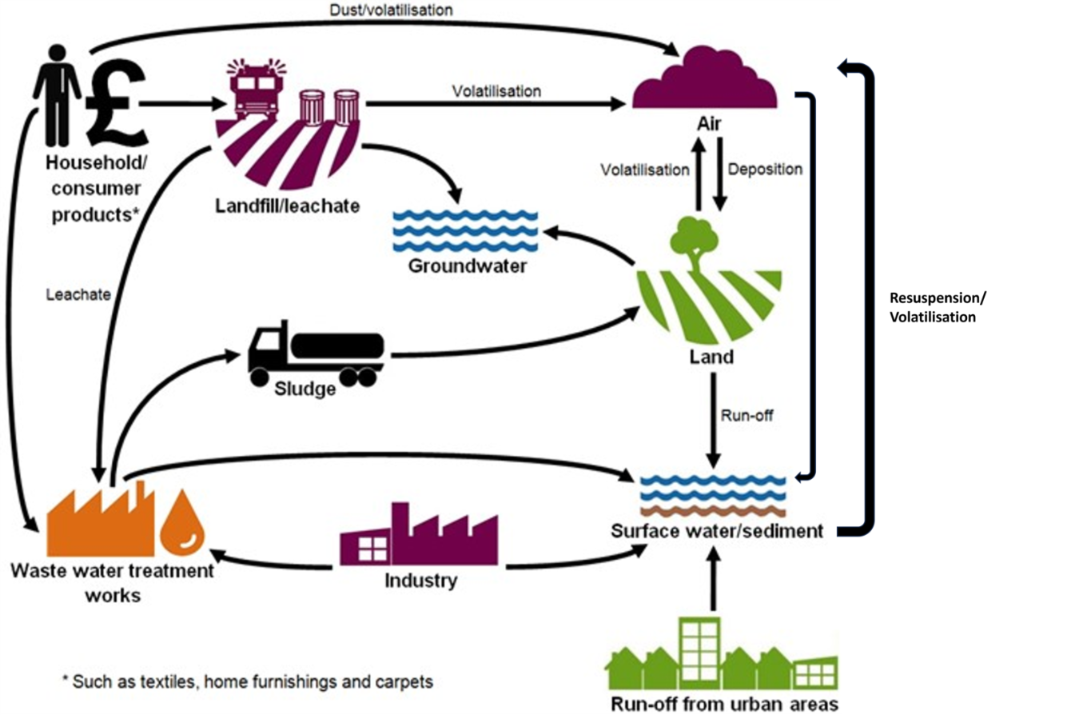

3.1. Emissions to water
PFOS does not degrade naturally in water and is transported via advection, dispersion, and sorption to particles. As a result, aquatic environments serve as both reservoirs and pathways, facilitating PFOS movement between air, soil, and sediments. Between 1980 and 2002, an estimated 42,000 tonnes of PFOS were released globally into water bodies, and 235 tonnes into the atmosphere (Jarvis and others, 2021). Identifying nonpoint PFOS sources and quantifying their contributions to aquatic ecosystems can be challenging.
In 2012, UK PFOS emissions were estimated at 300–800 kg to water and 5 kg to land as part of the POPs inventory reporting requirements (Whiting and others, 2012). By 2014, reported releases had declined to 150 kg to water and 2 kg to land, with no recorded emissions to air (Defra, 2017). These values were broadly in agreement with estimates of the total mass of PFOS discharged annually through UK rivers determined by Earnshaw and others (2014). These authors used modelled and monitored data collected from the rivers Aire and Calder to estimate the total mass of PFOS discharged through UK rivers to be in the range of 215 to 310kg. Emissions are assumed to have declined further since this time.
More recently, Bryne and others, (2024) estimated that the annual export of PFAS from the River Mersey catchment is approximately 68.1kg, with loads of PFOS estimated to be 9.81kg/year. The study also indicated that up to 50% of PFOS detected in the river may originate from sources other than WwTWs.
PFOS is moderately soluble in water (~600 mg/l), with water solubility decreasing as salinity increasing. Therefore, PFOS can be transported in the dissolved phase in water and has the potential for long-range transport. Globally, reported concentrations of PFOS in surface water, raw water, and drinking water typically range from 1 to 100 ng/L (Antonopoulou and others, 2024). In England, PFOS is frequently identified as the most prevalent PFAS in raw water (DWI, 2024; McLaughlin and others, 2011).
PFOS also exhibits a potential to sorb to soils and suspended sediments (Wei and others, 2017; Kurwadkar and others, 2022; Wee and others, 2023; Chen and others, 2021). Which may later act as a secondary source and transport, making it hard to directly link PFOS levels in water with the levels found in sediments (Liu and Li, 2024; Reif and others, 2022; Loken and others, 2025). The degree of sorption in sediment varies with environmental conditions such as the level of salinity, temperature, pH, and total organic carbon (ITRC, 2023; Pan and You, 2010; You and others, 2010). However, the partitioning of PFOS between water and sediment needs to be better understood as it varies in different water-sediment systems (Chen and others, 2023).
In 2020, Centre for Environment, Fisheries and Aquaculture Science (CEFAS) in collaboration with the Environment Agency analysed estuarine sediments from 15 estuaries across England for 31 selected PFAS. PFAS were found above the limit of quantification in 85 of the 103 samples collected. PFOS was the most frequently detected compound, present in 58% of samples. PFOS also showed the highest concentrations among the PFAS detected (Barber, 2021).
Simpson and others (2021), provides an advisory limit of 60 μg/kg dry weight (normalised to 1% total organic carbon) in sediment which is considered protective for 99% of benthic marine species. This threshold was exceeded at 5 of the 103 sampling stations. Globally, data on the concentrations of PFOS precursor compounds in sediments remains limited (Mussabek and others, 2019).
Ice, groundwater, and estuaries may also act as sinks for PFOS. Estuaries serve this role due to changes in salinity, which influence PFOS solubility and partitioning behaviour (Pan and You, 2010; Wang and others, 2015). At high salinity, the concentration of PFOS is likely to be higher in sediment but low in the water column compared with freshwaters. Estuaries can also play a role in the transport of PFOS from freshwater sources to the marine environment (Chen and others, 2023).

CIP 2
The Chemical Investigations Programme (CIP) is the UK water industry’s response to current and emerging legislation on trace chemical substances in the water environment (https://chemicalinvestigations.ukwir.org/). It brings together the 10 large water and wastewater companies in England and Wales with regulators (Defra, the Environment Agency, Natural Resources Wales and Ofwat), gaining a better understanding of the occurrence, behaviour, and management of trace contaminants including PFOS that may be present in wastewater treatment and effluents. CIP1, CIP2, and CIP3 occurred over the years 2010-2015, 2015-2020, and 2020-2022, respectively. Each investigation phase progressively discovered new insights into chemicals of concern passing through wastewater treatment works (WwTWs). CIP4 is being delivered in 2025-2027.
Monitoring carried out under CIP2 for PFOS took place between 2015 and 2020. Due to the scale of the work, CIP2 was divided into four ‘tranches’ and involved sampling effluent from 609 WwTWs, alongside upstream and downstream river samples. CIP2 focused on sites discharging to low dilution receiving waters, where the risk of failing Environmental Quality Standards (EQS) is highest downstream. The WwTWs ranged in size from 250 to 1.6 million population equivalents (pe), with most being between 5,000 and 50,000 pe (Gardner and others, 2022).
In each tranche approximately 150 works were sampled 20 times over 12 months. Upstream and downstream environmental samples were taken 36 times over two years, providing a detailed picture of chemical concentrations at these sites. A summary of measured PFOS concentrations in the WWTW effluents, sites sampled upstream of the WwTW, and the downstream sites are presented in Table 1.

Table 1: Summary of PFOS concentrations in WWTW effluent, upstream samples and downstream of discharges measured as part of CIP2 tranche 3 (UKWIR,2020).
Sample | units | mean | standard deviation | median | 25 %ile | 75 %ile | 95 %ile
Effluent | µg/l | 0.0053 | 0.0044 | 0.0018 | 0.0039 | 0.0063 | 0.0147
Upstream | µg/l | 0.0047 | 0.0063 | 0.0005 | 0.0026 | 0.0061 | 0.0159
Downstream | µg/l | 0.0052 | 0.0060 | 0.0009 | 0.0032 | 0.0064 | 0.0164
The mean concentration of PFOS in effluent across all WwTW sampled was 0.0053µg/l, with a standard deviation of 0.0044µg/l. This number is approximately eight times greater than the EQS of 0.00065µg/l for PFOS. The mean PFOS concentration measured at sites upstream of the CIP2 WwTWs was 0.0047µg/l and downstream of the discharge a mean value of 0.0052µg/l was reported (Environment Agency, 2021; UKWIR,2020). CIP2 demonstrated that PFOS is often found in both WwTW effluent and upstream and downstream of discharges in receiving waters, at sites across England, frequently at concentrations above or close to the water column EQS (UKWIR,2020; UKWIR, 2019; Chen and others, 2018).
A large variability in mean concentration between individual WwTWs was observed, with a high number of samples having PFOS concentrations above the water column EQS. Downstream concentrations exceeded the water column EQS at over 80% of the 609 WwTWs sampled (UKWIR,2020), a far higher exceedance rate than reported for many other monitored substances, where exceedance typically occurred at fewer than 10% of sites. Additionally, concentrations of PFOS upstream of many WwTWs were close to, or above, the PFOS EQS, suggesting that local WwTW discharges may not be the only source. On average, the concentration of PFOS was 19% higher downstream of WwTWs compared with upstream samples (Comber and others, 2021). As PFOS is highly stable, persistent, and water-soluble at environmentally relevant pH levels, it is possible discharges near the headwaters of a catchment can elevate concentrations early in the river system (UKWIR, 2018a).
Some of the CIP2 sites with elevated upstream concentrations had no obvious point sources such as other WwTWs or legacy sites above them. These findings suggest that unidentified or diffuse sources may be significantly influencing downstream PFOS levels (UKWIR,2020; UKWIR, 2019). These sources are likely to vary depending on the degree of urbanisation and the presence of past industrial activity within the catchment. Catchment investigations indicate that emissions from certain industrial facilities, landfills and domestic sources can lead to locally elevated concentrations (UKWIR, 2018b).
Comparison of modelled and monitored PFOS data from the rivers Aire and Calder in England showed that spatial concentration trends were reasonably well predicted using population density. Earnshaw and others, 2014 concluded for the areas studied that the majority of PFOS emissions arose from WwTWs receiving municipal waste waters, and that PFOS emissions could be mostly attributed to local population rather than major industrial, firefighting or landfill emissions. However, some WwTWs may not accept municipal wastewater or landfill leachate, which may influence local emission patterns.

CIP 3
The aim of the CIP3 sewer and river catchment investigation (UKWIR, 2023 - 22/EQ/01/32) was to determine the sources of some of the trace substances that have been identified in earlier studies as posing the greatest risk of non-compliance with EQSs, including PFOS. The study sampled ten river catchments and ten sewer catchments to try to locate, and where possible mitigate, sources of PFOS. CIP3 found PFOS to be widespread across the sewer and river catchments, with mean concentrations exceeding the annual average AA-EQS in all sewer catchments and most river catchments. Sources of PFOS in sewers include landfill leachate, trade effluent from metal plating and manufacturing, as well as domestic effluent.
Elevated river concentrations were also detected upstream of any obvious point sources, suggesting diffuse inputs. These sites did receive surface water drainage and were located in sites with urban land uses. Other potential sources with notably high concentrations include residue in site drainage from use of fire-fighting foam, and sites which have the potential to be impacted by historic landfill sites. Some of the sites with high concentrations are located downstream of storm overflows or WwTW with trade inputs; however, the highest concentrations are not consistently observed downstream of the WwTW in each of the catchments.
Data from the CIP3 groundwater study also showed PFOS to be present in groundwater beneath and downgradient of sewage treatment works discharging to ground, with concentrations at some sites exceeding the AA-EQS. Although there is no directly comparable quality standard for PFOS in groundwater, the AA-EQS for PFOS is used to assess the chemical status of groundwater bodies through the surface water impacts test. These findings indicate that treated effluent discharges to ground can act as a pathway for PFOS to enter groundwater and potentially contribute to surface water loads.
Overall, the evidence we have from both CIP and wider scientific literature suggests that the PFOS load in effluent from WwTWs across England varies according to the nature of the inputs received by WwTWs. However, concentration appears to be statistically related to the degree of urbanisation (Earnshaw and others, 2014; UKWIR,2020; UKWIR, 2019; Lindim and others, 2016). In addition to emissions from domestic sources of PFOS, landfill leachate and historic industrial discharges contribute to the PFOS load emitted to WwTWs. A large variability in measured concentrations, removal efficiencies and per capita emissions of PFOS from WwTWs has been reported in published studies in the scientific literature (Lenka and others, 2021). Variability in concentration was noted even for WwTWs with equivalent technology and similar population equivalents (Arvaniti and Stasinakis, 2015).
There is some evidence that PFOS can be formed in WwTWs through the oxidation or biotransformation of precursors. Higher concentrations of PFAS have been reported in the effluents from some WwTWs compared to incoming wastewater, suggesting transformation of precursors, or additional loadings from external inputs such as tanker wastewater (Lenka and others, 2021; Thompson and others, 2022; Zhang and others, 2024). This may occur during secondary treatment, such as activated sludge, where PFOS levels can significantly increase and may interfere with treatment processes (Earnshaw and others, 2014; Becker and others 2008; Lu and others, 2022). Secondary biological treatment has been shown not to be effective in removing PFAS from wastewater (Moneta and others, 2023). A smaller amount of oxidisable PFAS precursors has also been reported in the influent and effluent during warmer months, suggesting that seasonal factors or temperatures may influence microbial breakdown of these compounds before they enter or while they pass through WwTWs (Tavasoli and others 2021).
Data on PFAS precursor levels in WwTWs and the conditions influencing their transformation are limited (Lenka and others, 2021), but evidence suggests that operational factors and the specific treatment methods affect PFAS removal transformation rates (O’Connor and others, 2022).

3.2. Emissions to land
Understanding of PFAS behaviour and occurrence in UK soils is still developing. However, PFOS is known to migrate from soil into surface waters or leach into groundwater. Globally, it is one of the most frequently detected PFAS in soils (Brusseau and others, 2020; Sim and others 2021; Rankin and others, 2016; Sharifan and others, 2021).
PFOS sorption to soil is driven by electrostatic and hydrophobic interactions and is strongly influenced by soil characteristics, particularly total organic carbon (TOC) and soil organic matter (SOM) (Wang and others, 2023; Liu and others, 2020; Milinovic and others, 2016). Other influencing factors include pH, dissolved organic carbon, electrolytes, co-contaminants, metal oxides, and the isomer of PFOS (Liu and others, 2020; Umeh and others, 2021). Sorption processes of PFAS can also be impacted by nonlinear sorption, hysteresis, and mass-transfer limitations (ITRC, 2023).
As part of the Environment Agency’s PFAS Risk Screening Project, the British Geological Survey assessed the feasibility of measuring anthropogenic background PFAS concentrations in English soils, the first study of its kind. Using 25 archived and 9 contemporary samples from paired locations, PFOS was detected in 21 archived samples (mean: 0.63 µg/kg dry weight) and 8 contemporary samples (mean: 0.72 µg/kg) (Beriro and others, 2025).
Historic use of PFOS AFFF at air transport sites, fire training areas, and major incident sites has led to contamination of soils, groundwater, and nearby surface waters globally, including in England (Jacobs, 2023; Li and others, 2023; Filipovic, 2015; Bräunig and others, 2019). The Environment Agency is currently investigating both historic and current PFAS use at air transport sites in England and working with operators and site owners. PFOS based AFFF has also been routinely used and discharged at Ministry of Defence sites during training, testing, and firefighting operations. The Environment Agency is working closely with these sites to assess historical PFOS use and associated contamination. Detection of PFOS close to known firefighting foam sources in the UK are discussed in detail in the recent Health and Safety Executive (HSE) UK REACH Annex 15 restriction dossier on PFAS in firefighting foams (HSE, 2025).
Another major route for PFOS buildup in soils is the application of biosolids (Li and others, 2023; Behnami and others, 2024). Land application of biosolids is common practice in England, helping to maintain soil fertility with nutrients (UKWIR, 2024;Collivignarelli and others, 2019). In the UK, the use of biosolids is regulated by The Sludge (Use in Agriculture) (Amendment) Regulations 1990 (SI 1990/880), which set limits for trace metals but do not currently include statutory limits for PFOS.
Rigby and others (2021) investigated PFAS levels in biosolids applied to agricultural land in the UK. These biosolids originated from both municipal and industrial wastewater treatment plants. The study found total concentrations of nine PFAS compounds ranging from 99 to 231 μg/kg, with PFOS being identified as one of the most prevalent PFAS. Concentration of total summed PFAS decreased in the following order: biosolids > compost-like material > raw waste wood > dried paper sludge.
The Environment Agency also investigated PFAS presence in five UK paper mills processing various types of recycled paper. PFOS was not detected above the limit of detection in any input paper samples, including food packaging and coffee cups. However, low concentrations were found in some input water, effluent, and sludge samples. These findings suggest that PFOS in paper mill waste streams likely originates from the water supply rather than the recycled paper itself, with possible concentration during processing. However, further investigation is needed, as the study was based on a limited sample size (Environment Agency, 2023)
The spreading of materials to land is regulated through the Environmental Permitting Regulations (England and Wales) 2016; the Environment Agency is the key regulatory body in England. The Environment Agency introduced soil screening values (SSVs) for PFOS and PFOA to help operators assess the potential ecotoxicological impacts from PFAS in waste being spread to land (Environment Agency, 2022; Environment Agency, 2021). Additionally, work is underway by the Environment Agency to implement a sludge strategy, aiming to modernise the regulatory framework for the spreading of sludge to land and aid in the mitigation of risks to the water environment from land spreading.

CIP 3 and 4
At the time of the CIP2 investigations, information on levels of PFOS in sewage biosolids was unknown, CIP3 built further knowledge and understanding of PFAS in WwTW. A study within the CIP3 investigations looked at chemical data from biosolids collected from 11 sludge treatment centres (STC) across England and Wales (UKWIR, 2023 – 22/EQ/01/33). Findings from this CIP3 report confirm that standard wastewater treatment processes are generally ineffective at removing PFAS. Analysis of biosolids from 11 STC across England and Wales found PFOS to be near ubiquitous, detected in all samples at nine sites and in most samples at the remaining two. PFOS removal during treatment was generally poor, with some sites showing negative removal rates. The limited and variable performance of real-world treatment systems reflects a broader uncertainty regarding the mechanisms responsible for PFOS removal.
CIP3 studies also investigated the effectiveness of WwTW technologies at removing PFOS (UKWIR, 2023 – 22/EQ/01/31). PFOS was found to exceed EQS before and after treatment at most sites. While some advanced treatment processes, such as the activated sludge process (ASP) combined with membrane filtration or powdered activated carbon (PAC), showed improved performance, they generally failed to reduce PFOS concentrations below EQS. PFOS exhibited some of the lowest or even negative removal efficiencies across the monitored substances. These findings are consistent with previous research suggesting limited PFOS removal due to precursor transformation and partitioning behaviour.
CIP4 will run from 2025 to 2027 and will build on the chemicals of concern outputs from CIP3 with further investigations into biosolids, groundwater, soil, estuaries, microplastics and antimicrobial resistance (AMR), as well as expanding previous work on emerging substances to quantify risks from these chemicals (UKWIR, 2024).
One investigation will target 65 WwTWs with above-average effluent PFOS levels, with monthly sampling of influent, effluent, and receiving waters over two years. The study will examine PFOS sources, including trade effluent from industries (e.g. metal plating, laundries), landfills, contaminated land, fire training sites, and domestic inputs. Where sources are unclear, the sewer network will be investigated to trace PFOS inputs. Biosolids will also be sampled at selected sites. CIP4 will also explore ways to optimise treatment processes and reduce PFOS in biosolids through mass balance studies across sewage and biosolids treatment systems (UKWIR, 2025).
The CIP4 Biosolids Spreading Project will also assess how applying biosolids to agricultural land may affect groundwater quality. Building on CIP3 findings that biosolids contain metals, organic contaminants, pharmaceuticals, PFAS, microplastics and antimicrobial agents, the study will monitor whether these substances leach through soils to groundwater. Field-scale monitoring at paired test and control sites on key aquifer types will be combined with laboratory experiments and modelling. Boreholes will be installed to sample soil, unsaturated and saturated zones for around 100 priority and emerging substances. The results will provide the first robust evidence on long-term biosolids application as a potential pathway for contaminants to groundwater, informing future regulation and sustainable land management practices.

3.3. Atmospheric emissions
Varying concentrations of PFOS have been detected in indoor air and dust from homes, offices, classrooms, and vehicles globally, including in England (Bjorklund and others, 2009; Winkens and others, 2017; Goosey and Harrad, 2011, 2012; Harrad and others, 2019). These findings suggest that indoor environments are both a route of human exposure and a source of emissions to the water environment (DeLuca and others, 2022; De Silva and others, 2021).
Although PFOS is not considered volatile in its ionised form, it can be released to the atmosphere and attach to airborne particles. PFOS tends to bind to coarse particulate matter due to its low vapour pressure and high-water solubility (Ge and others, 2017). Once airborne, it may deposit onto land or water surfaces, particularly through dust and surface run-off (Pfotenhauer and others, 2022; Sasaki and others, 2003). Elevated levels have been found in particulate matter and surface run-off samples from industrial and commercial areas (ITRC, 2023; Zhou and others 2021; Xiao and others, 2012).
While data on atmospheric PFOS levels in England are limited, emissions are expected to be very low following its phase-out. However, the relative contribution of local sources versus long-range atmospheric transport remains uncertain (Faust, 2022). Evidence suggests that other mechanisms such as degradation of volatile airborne precursors, ocean-to-atmosphere transfer via sea spray aerosols, and marine currents may also enable PFOS entry into the atmosphere (Sha and others, 2023; Wang and others, 2017). The detection of PFOS in remote and urban regions across all continents, including areas with little to no industrial activity, provides strong evidence that long-range atmospheric transport plays a significant role in its global distribution (Miner and others, 2021).

3.4. Emissions from waste
The disposal of household and consumer products treated with PFOS, and its related substances contributes to elevated PFOS concentrations in landfill leachate (Gaines and others, 2022). For example, a report by the major industrial manufacturer 3M estimated that approximately 53% of the initial concentration of fluoro-chemicals in treated carpets remain in the carpet prior to disposal (Kim and others, 2015).
Modern engineered landfills are designed with liners, leachate drainage, and gas extraction systems to minimise PFAS migration. However, older landfills (pre-2001), constructed with lower engineering standards, may pose a higher risk of contaminant discharge through the base, sidewalls, and surface, increasing the potential for environmental contamination (Environment Agency, 2025). Concentrations of PFOS in leachate can also vary from site to site, with factors such as pH, temperature and ionic strength influencing concentrations in leachate (Kim and others, 2015). In England, there are nearly 20,000 historic landfills and around 1,800 permitted sites. International studies including England, indicate that landfill leachate is a source of PFAS to the environment (Tolaymat and others, 2023).
While it remains difficult to provide an exact industry-wide estimate for PFOS in landfill leachate, monitoring by the Environment Agency has produced a robust dataset that reflects current conditions. A recent UK study by Defra, 2024 and the Environment Agency provides evidence of PFAS contamination, detecting PFAS in all 35 leachate samples from 24 operational, closed, and historical landfills at concentrations ranging from 1.04 to 107 µg/L (median: 14 µg/L). However, the most dominant compounds, accounting for 85–90% of total PFAS were PFOA, PFHxA, 5:3 FTCA, PFBA and PFBS, not PFOS. Although PFOS was not among the most abundant compounds, it was still detected at nearly all sites, typically at concentrations below 1 µg/L. It is possible that at a local scale, landfill leachate containing PFOS levels in the µg/l range could still contribute a relatively noteworthy load to the local environment.
PFAS releases may occur directly through leakage from landfill sites or indirectly when raw or treated leachate is transported to WwTWs via tanker or sewer. Leachate may also be directly discharged to controlled groundwater/surface water from leachate treatment plants (LTP) with discharge consents. LTPs are not typically designed to treat PFAS compounds.
PFAS may also be sequestered in landfills, potentially leading to delayed emissions when environmental conditions change. The need to manage leachate over the long term through ongoing pumping and treatment, remains a challenge. The Environment Agency is reviewing restrictions on PFAS-containing waste across all landfill types, with soils currently making up a significant proportion of landfill inputs.
Reverse osmosis (RO) has demonstrated effectiveness in removing PFOS and other PFAS compounds in leachate, but its use remains limited. RO does not destroy PFAS; instead, it concentrates them into a waste stream with very high contamination levels, which requires careful management. The high cost and complexity of RO systems have further limited their application, particularly in the landfill sector. A recent rapid evidence assessment by the Environment Agency provides further detail on current remediation technologies for PFOS and other PFAS compounds (Environment Agency, 2025).
Studies also suggest PFOS may also be present in landfill gas emissions (Tolaymat and others, 2023; Ahrens and others, 2011), representing a potential airborne transport pathway and source of PFAS deposition to aquatic environments. To address this, the Environment agency is planning further studies on PFAS releases via landfill gas. Although landfill leachate can contain elevated concentrations of PFAS, its overall contribution to final effluent discharges from WwTWs is generally limited due to the relatively small volumes involved.

4. Environmental monitoring data
As part of the programme to assess risks from persistent, bioaccumulative, and toxic substances in England, we have compiled Environment Agency monitoring data on PFOS in water and biota from both estuarine/coastal and freshwater sites. Groundwater monitoring data has also been included, where the predominant monitoring splits PFOS into concentrations of its linear and branched isomers. PFOS monitoring sites are distributed across England and form part of several monitoring networks, including those supporting river basin planning, local investigations, and surveillance activities. For rivers, data are now included from the River Surveillance Network which began in 2021. We summarise the Environment Agency data shown in this section as geometric means at site, river basin (within England) and national (England) scale.
For this assessment, we used data between 2018 and 2024 (inclusive) for PFOS in biota and data between January 2021 and May 2025 for PFOS in water, although graphs show trends to the end of 2025. Use of geometric means is a requirement of the available tools to summarise data across scales, dealing correctly with data flagged as below the analytical limit of detection. The later start date for analysis of water data is because of the introduction of the River Surveillance Network in 2021. Which is a major change to the design of our monitoring programmes making it challenging to analyse trends before and after 2021. We summarised and graphed trends in concentrations over time using generalised additive mixed models. Maps show concentrations from a single year extracted from the same models.
Between 2021 and 2025, monitoring of PFOS in water included approximately 370 sites with 4,700 samples in freshwater, 60 sites with 1,500 samples in estuarine and coastal waters, and 1,500 sites with 2,600 samples in groundwater. For PFOS in biota between 2018 and 2024, sampling covered 60 freshwater fish sites with 91 visits and 34 estuarine and coastal fish sites with 118 visits.
For information only, on the graphs we have included Environmental Quality Standards (EQSs) where available. However, it is important to note that to assess compliance, an EQS should strictly only be compared to a site-specific arithmetic mean, following procedures laid down by the UK Technical Advisory Group (UKTAG). A calculated geometric mean will always be lower than a calculated arithmetic mean of the same data. Site-by-site classification results for PFOS will be published under the River Basin Planning process in 2026.

4.1. Biota monitoring: EA data
The Priority Substances Directive (2013/39/EU) specifies the biota EQS for PFOS of 9.1µg/kg wet weight, which is set to protect both wildlife and people and is based on human health endpoints as these are the most sensitive. Comparison of measured concentrations in fish with the biota EQS is used to assess long term risks to wildlife and people because it measures chemical concentrations found in organisms living in water.
Monitoring of biota presents several challenges that are not encountered when we sample water, including animal welfare concerns and practical considerations driven by the availability of suitable animals, accessibility and ecological impact of sampling. This constrains the extent of the biota surveillance programme compared with our water column monitoring programme.
A whole fish sampling programme for PFOS was instigated in 2018. Between 2018 and 2024 for this report we analysed data from 91 sampling visits to 60 freshwater sites for fish (roach, Rutilus rutilus, brown trout, Salmo trutta and chubb Squalius cephalus) and 118 sampling visits to 34 estuarine and coastal sites for dab, Limanda limanda and flounder, Platichthys flesus. Sampling location and number of sites has varied from year to year.
Normalisation to a default dry weight content reduces the variability in the data and allows comparison between different fish from different locations. Therefore, when we consider fish results for PFOS, the concentrations we use are dry weight normalised. It is described in detail in the Technical Guidance Document on biota monitoring (EC, 2014).
Although the biota EQS applies to fish, we have the flexibility to apply an EQS for an alternative matrix or biota taxon, for example the blue mussel 'Mytilus edulis'. On this basis and building on the Oslo Paris Convention (OSPAR) monitoring programme established since 1999, PFOS analysis in mussels Mytilus edulis has been included as part of our saline waters sampling programme at 15 sites from 2016. However, PFOS has not been detected in any mussel samples collected. There is evidence to suggest that mussels are not a suitable substrate for analysis of PFOS as they have an internal detoxification process that limits bioaccumulation of PFOS (Fernández-Sanjuan and others, 2010).
Dietary intake is considered a primary route of PFOS exposure, with fish and seafood being major contributors (Langberg and other, 2024; Marín-García and others, 2023). However, fish sampled in our programme are generally smaller than those typically consumed by humans.
There are currently no regulatory limits for PFOS in food in England. However, in 2020, the European Food Safety Authority (EFSA) conducted a scientific evaluation on the health risks associated with PFAS in food/drink and established a group tolerable weekly intake (TWI) of 4.4 ng/kg body weight for the combined exposure to PFOA, PFNA, PFHxS, and PFOS (EFSA, 2020). While these findings inform current risk assessments, the COT has reviewed the EFSA opinion and highlighted several uncertainties surrounding the derivation of the TWI (COT, 2022).

4.1.1 Freshwater Fish
We have provided an overview of the geometric mean range of PFOS concentrations across various freshwater river districts in England compared against the biota EQS for PFOS. PFOS was found in measurable concentrations in all freshwater fish at all locations sampled.
Figure 2 is a map showing the mean PFOS concentrations (expressed as ug/kg, dry weight, normalised) in freshwater fish in England. The size of the circles represents the concentrations, the higher the concentration, the bigger the circle. Those concentrations above the environmental quality standard (EQS) are represented by the border of the circle in red. For the concentrations below the EQS, the border of the circle is in black. Mean measured concentrations of PFOS ranged from 24.7µg/kg in the Bristol area to 0.6µg/kg in the East Riding of Yorkshire for freshwater fish. This map of individual site locations indicates that some freshwater sites sampled in 2023 exceeded the biota EQS.

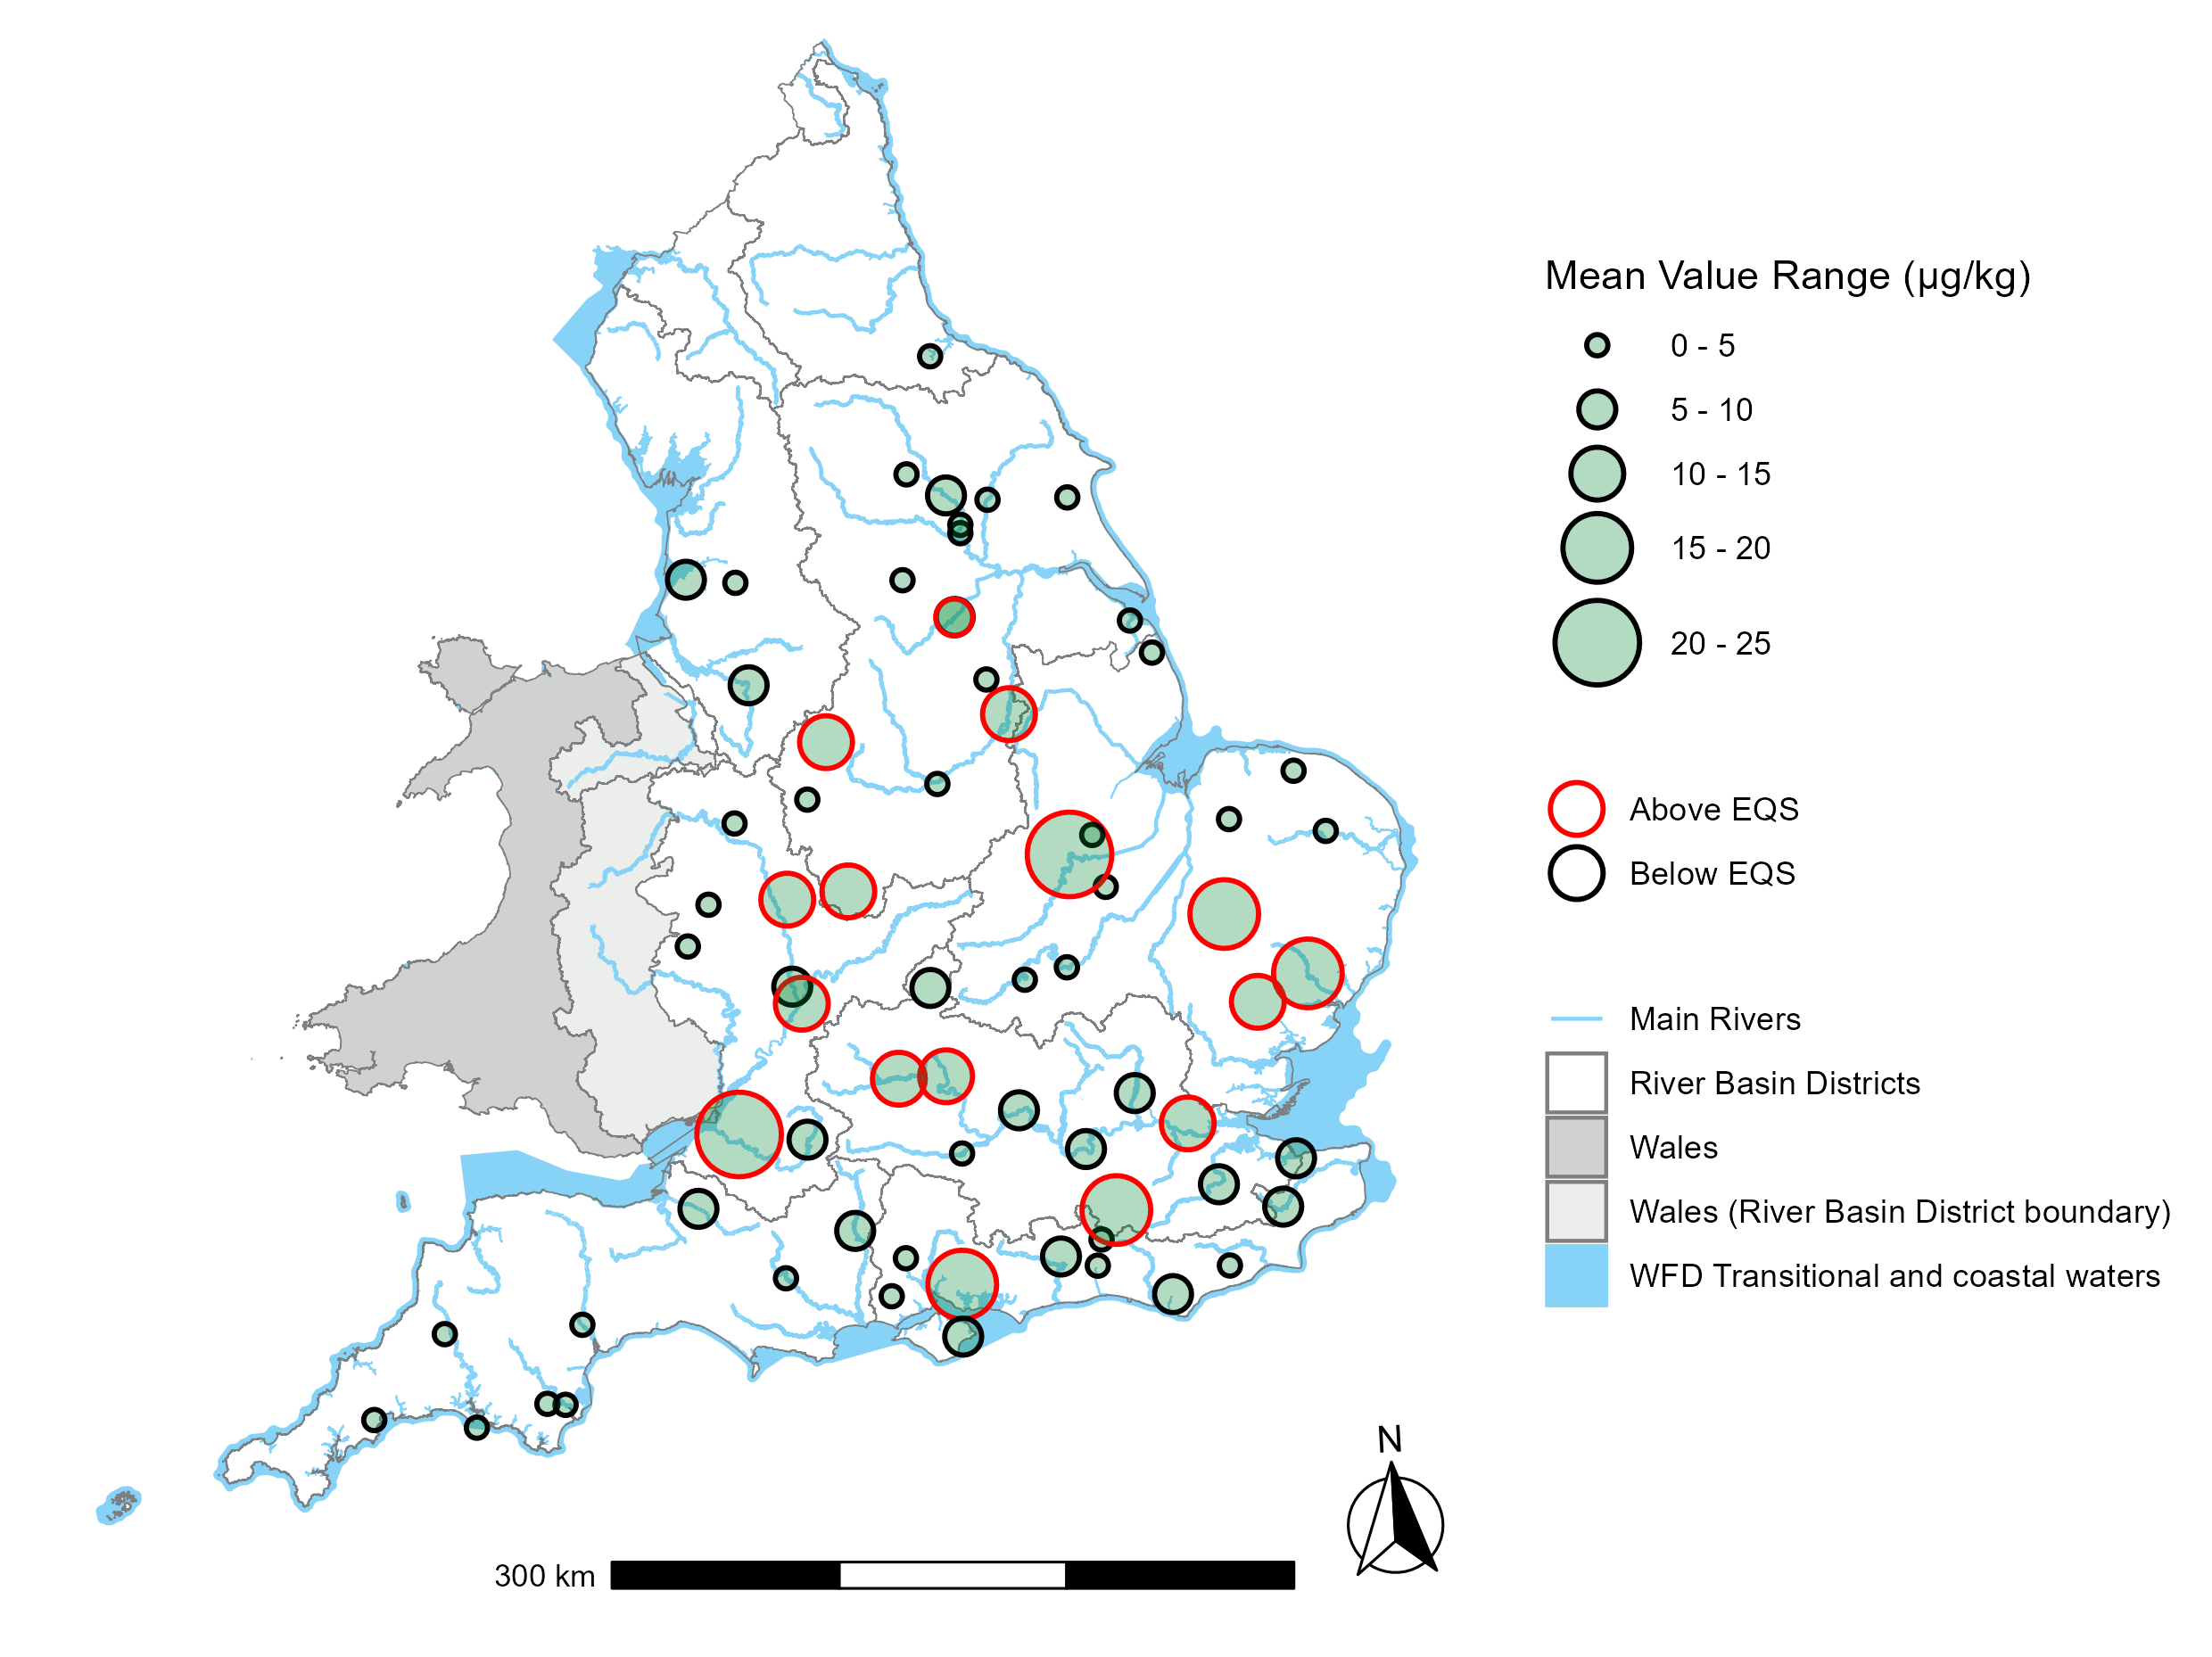
Figure 2: Mean PFOS concentrations (expressed as ug/kg, dry weight, normalised) in freshwater fish compared with the 9.1µg/kg biota EQS for PFOS for individual monitoring sites sampled in 2023. Note: above / below EQS is indicative only and not a substitute for classification.

4.1.2 Estuarine/coastal fish
We have provided an overview of the mean range of PFOS concentrations across various estuarine and coastal districts in England compared against the biota EQS for PFOS. PFOS was found in measurable concentrations in all estuarine/coastal fish at all locations sampled.
Figure 3 is a map illustrating the annual geometric average PFOS concentrations in freshwater fish in England. The size of the circles represents the concentrations: the higher the concentration, the bigger the circle. Those concentrations above the EQS are represented by the border of the circle in red. For the concentrations below the EQS, the border of the circle is in black. Mean measured concentrations of PFOS ranged from 4.1 µg/kg in the River Humber and Thames estuaries to 0.2 µg/kg in the River Exe. This map of individual site locations indicates no estuarine/coastal sites sampled in 2023 exceeded the biota EQS.

Figure 3: Annual geometric average PFOS concentrations in estuarine/coastal fish (expressed as ug/kg, dry weight, normalised) compared with biota EQS for PFOS at individual monitoring sites across England in 2023.
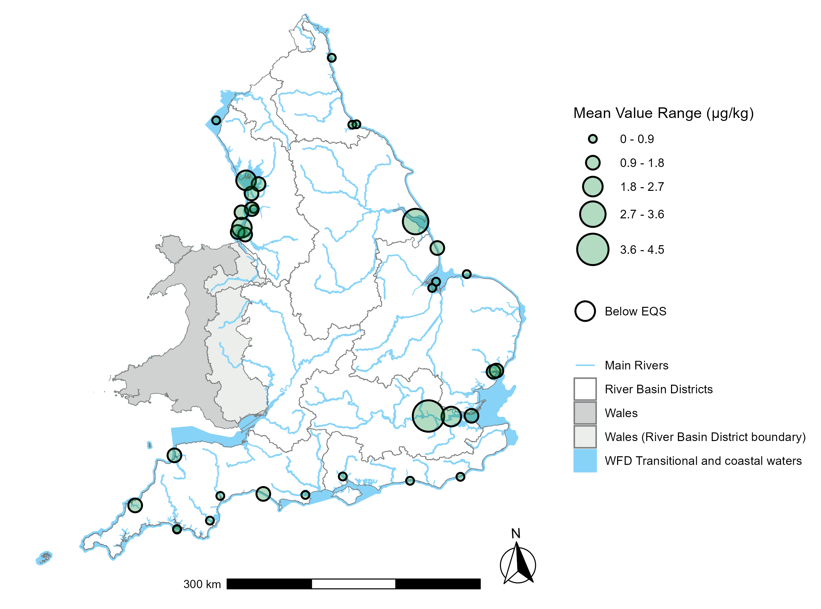
Figure 4 presents a graph showing trends in geometric PFOS mean concentrations in freshwater (orange line) and estuarine/coastal fish (green line) from 2018 to 2024. The data indicate an overall decline in PFOS concentrations in both environments over this period. Mean concentrations remained consistently higher in freshwater fish compared to estuarine and coastal species. This may be due to greater dilution in marine environments. In contrast, freshwater systems located near high-emission point sources may develop localised hotspots of contamination (Augustsson and others, 2021). However, the extent of accumulation is likely influenced by a range of other factors. Additionally, these results should be interpreted with some caution, as the number and location of sampling sites varied across years, with new sites introduced later in the monitoring period.

Figure 4: Modelled trend data for geometric mean PFOS concentration in whole fish tissue with 95% confidence interval, based on data collected across England at Environment Agency monitoring sites between 2018 and 2024. Concentrations are expressed in µg/g (dry weight, normalised).
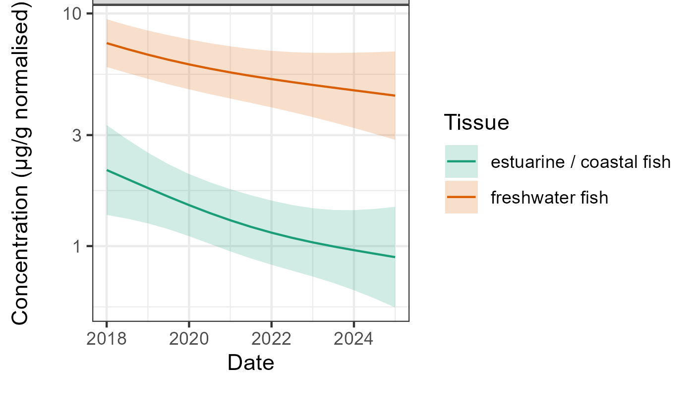

4.2. Freshwater monitoring: EA data
From 2021 to 2025 we sampled approximately 370 river and running water sites with 4,700 samples in England for PFOS as part of our monitoring programmes.
Figure 5 is a graph displaying the geometric means of PFOS concentrations (expressed in µg/L) across amalgamated data from Environment Agency surface fresh (running) water monitoring sites in England, collected between 2021 and 2025. A statistical model has been fitted to the data to describe both the long-term trend and the seasonal pattern in PFOS concentration, with associated 95% confidence interval. Results are then presented as the long-term trend only (‘no season’ – orange line), and long-term trend including seasonality (‘with season’ – green line). Over this period, the seasonality component is fixed to be the same across all years. There is a slight downward trend in PFOS concentrations over the four-year period presented here. The green line also highlights distinct seasonal patterns, with concentrations peaking in summer and dropping to their lowest levels in winter. Likely reasons for these seasonal patterns are discussed later in Section 5.

Figure 5. Geometric means of PFOS with 95% confidence intervals, expressed as µg/L, plotted for all England amalgamated data collected between 2021 and 2025 at Environment Agency fresh (running) water monitoring sites, showing the trend with and without seasonality.
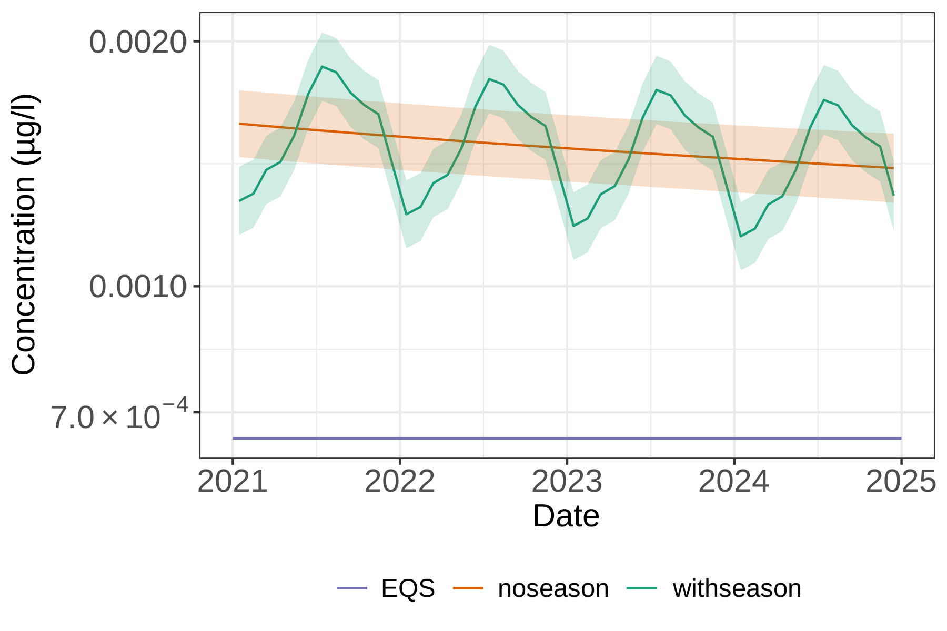
Figure 6 below describes the same fresh (running) water dataset by individual sites and their respective River Basin District (RBD) catchments, showing only the long-term trend, with seasonality removed.
Figure 6 is a series of graphs showing the geometric means of PFOS (expressed as µg/L) plotted for all England amalgamated data collected between 2021 and 2025 in Environment Agency surface freshwater monitoring sites. The data is shown plotted for individual sites in each WFD River Basin District (RBD). On each graph the surface water EQS of 0.00065 µg/L is plotted for reference as a purple line, the mean is plotted as an orange line, and individual sites are plotted as green lines. This alternative view of the data reveals a slight downward trend over the four-year reporting period in most RBDs. However, a few RBDs show a slight increasing trend. Across individual sites, the data illustrate a wide range in concentrations of PFOS across England and, in some cases, above the EQS. 6 out of the 9 geometric mean RBD catchment concentrations were above the freshwater EQS for PFOS. However, it should be noted that any comparison with EQS values shown in these graphs are for indicative purposes only, as this graph does not represent Water Framework Directive (WFD) compliance, which requires the EQS to be compared with site-specific annual arithmetic mean averages.

Figure 6: Geometric means of PFOS expressed as µg/L, plotted for individual fresh (running) water sites in each RBD in England between 2021 and 2025.
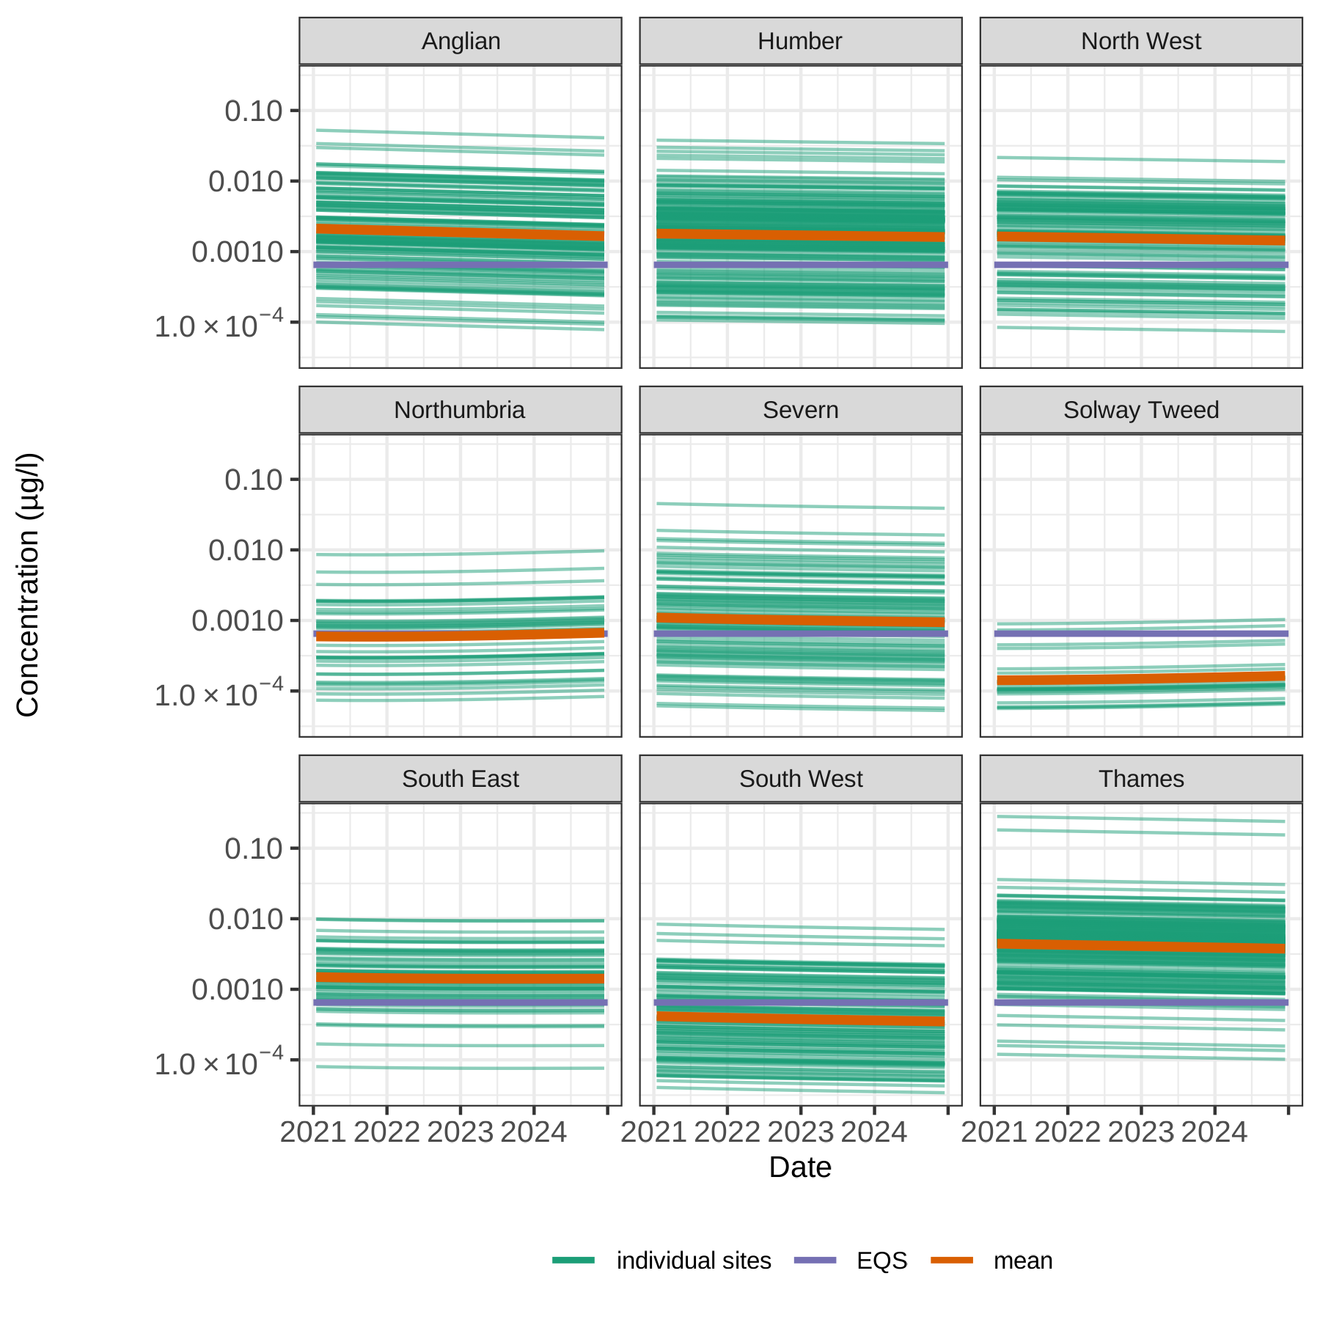
PFOS concentrations in Figure 6 likely vary significantly due to multiple anthropogenic sources. Elevated levels are typically linked to urbanised areas and proximity to known sources. Variations between river basin districts (RBDs) are likely influenced by a mix of point and diffuse inputs, including historical industrial and consumer use, legacy AFFF applications, surface runoff, wastewater treatment work (WwTW) discharges, land-applied biosolids, atmospheric deposition, and local hydrological conditions affecting dilution and transport.
Figure 7 is a map of England, Scotland, and Wales, where each RBD is coloured according to a concentration scale in µg/l, where lower concentrations are yellow, medium concentrations are orange/brown, and the highest concentrations are purple/blue. The data represents the four-year average (2021-2024) of the geometric mean concentration of PFOS in freshwater surface waterbodies in each RBD. The RBD with the highest geometric mean PFOS concentration was the Thames RBD at 0.0042 µg/l. The RBD with the lowest PFOS concentration was Solway Tweed RBD at 0.00015 µg/l.

Figure 7: Variation between RBD catchments. The data represents the four-year geometric mean (2021-2024) of the geometric mean concentration of PFOS in freshwater surface waterbodies in each River Basin District (RBD), expressed as µg/l. 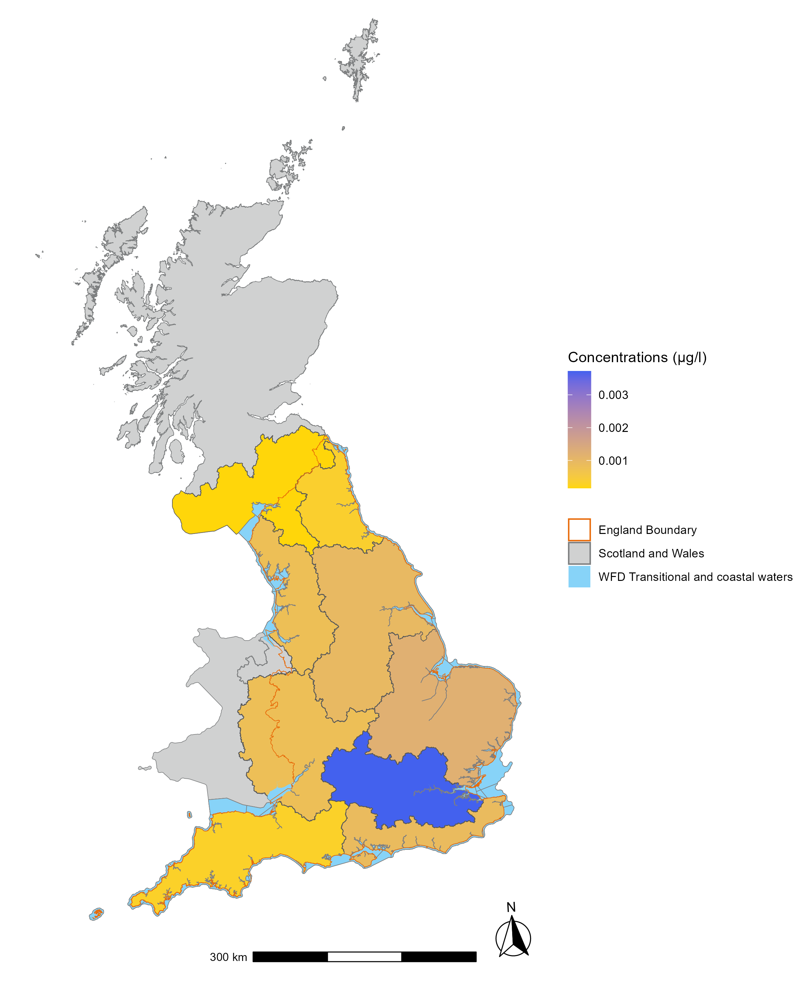
Figure 8 is a map illustrating the annual average concentrations of PFOS (expressed in µg/L) at individual surface water monitoring sites sampled in 2023. The size of the circles represents the concentrations, the higher the concentration, the bigger the circle. Those concentrations above the environmental quality standard are represented by the border of the circle in red. For the concentrations below the environmental quality standard, the border of the circle is in black. Numerous exceedances of the EQS are identified.

Figure 8: Annual geometric mean PFOS concentrations (expressed as µg/L) at freshwater individual monitoring sites sampled in 2023.
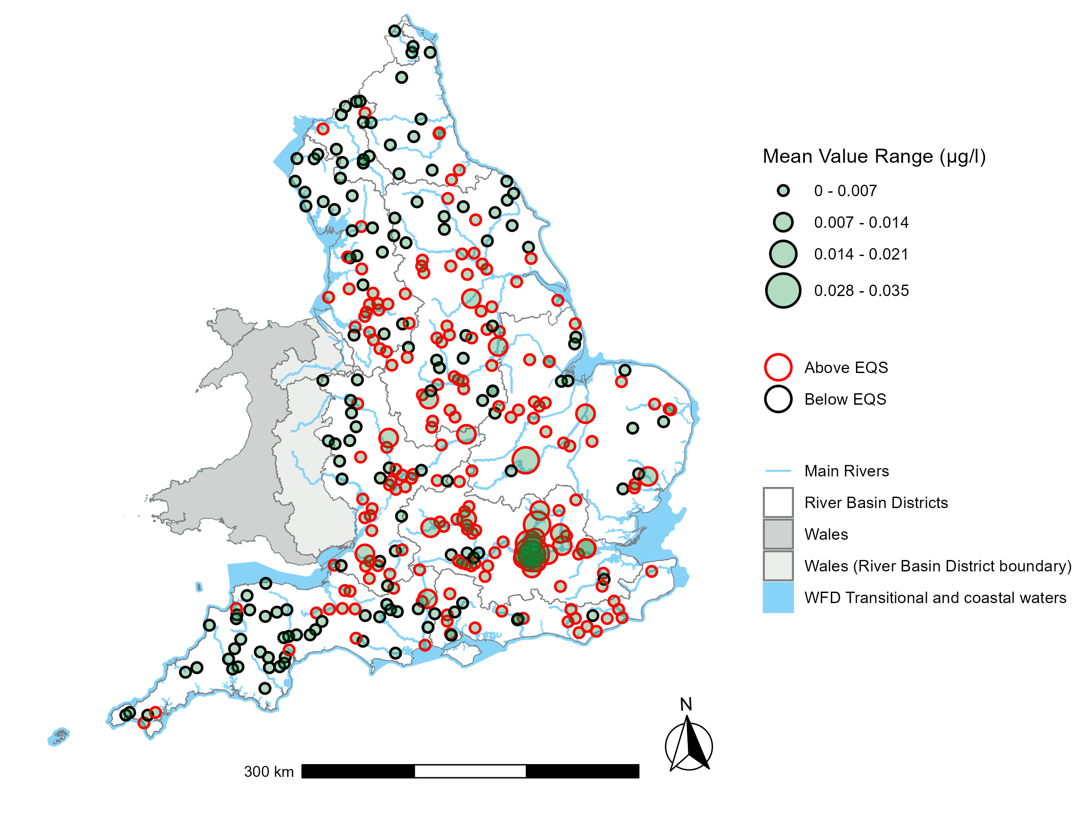Please note that the raw data used for trend analysis in the figures above is based on a combination of geometric means and an amalgamated dataset. Consequently, it is not directly comparable with the WFD classification status for PFOS. The inclusion of the Environmental Quality Standard (EQS) benchmark in the graphs and maps is intended solely for indicative and illustrative purposes.

4.3 Groundwater: Environment Agency data
Routine groundwater monitoring between 2014 and 2019, using a semi-quantitative method, indicated the widespread presence of PFOS in groundwater. This data was collected from sites across our Groundwater Quality Monitoring Network (GWQMN). Sites within this network are selected by local groundwater staff to represent aquifer water quality and are sampled on a three-year rolling basis as part of investigations into organic contaminants.
PFOS was among the most frequently detected micro-organic contaminants using the semi-quantitative method between 2016 and 2017, with positive detections in 30% of analyses (limit of detection: 0.01 µg/L; median concentration: 0.0003 µg/L; maximum concentration: 0.44 µg/L) (Lapworth and others, 2018). Detections were mainly in the London area; the authors suggest that this contamination may be a consequence of the use of PFOS containing foams to control the fire during a major incident at Buncefield in 2005. However, because the screening method was semi-quantitative, and influenced by detection limits, results should be interpreted with some caution. A worst-case ranking analysis was conducted on the semi-quantitative data using hazard quotient and detection frequency and this ranked PFOS highly, indicating the need for more detailed assessment (Spurgeon, 2022).
In the 2022 River Basin Management Plans, only one groundwater body was classified as having poor chemical status due to the presence of PFOS, as determined through the surface water impacts test. At the time of groundwater classification, the available PFOS monitoring data was very limited, which may have influenced the number of groundwater bodies identified as meeting the criteria for poor chemical status. More groundwater PFOS data will be available for the next River Basin Management Plans, and this is likely to increase the number of groundwater bodies that are classified at poor chemical status due to the presence of PFOS.
Since 2021, we have developed and implemented a quantitative analytical method for PFOS isomers (Linear, L-PFOS and Branched, B-PFOS) in groundwater as part of a broader method for multiple PFAS compounds. This enables more accurate environmental assessments and representing a critical step in understanding their environmental implications. To date, PFOS has been sampled at over 1500 GWQMN sites using the quantitative analytical method, but groundwater monitoring for PFOS remains limited, with most sites only sampled once. Over the next few years, we will expand monitoring to include more sites with repeated sampling (a minimum of three samples per site) to strengthen the evidence base.
Figure 9 is a graph of the geometric means of B-PFOS (expressed as µg/L) for data collected between 2021 and 2025 at Environment Agency groundwater monitoring sites. A purple line shows the surface water EQS of 0.00065 µg/L for reference, as no groundwater quality standard for PFOS currently exists. A statistical model has been fitted to the data to describe both the long-term trend and the seasonal pattern in B-PFOS concentration in groundwater, with associated 95% confidence interval. Results are then presented as the long-term trend only (‘no season’, orange line), and long-term trend including seasonality (‘with season’, green line). Over this period, the seasonality component is fixed to be the same across all years. Both the orange and green lines are below the EQS, and very close to each other, almost overlapping completely. There is a slight upward trend in PFOS concentrations over the four-year period presented here, albeit with considerable uncertainty. The green line also highlights a slight seasonal pattern (much less than for fresh (running) waters), with concentrations slightly peaking in November and dropping to their lowest levels in Spring. Likely reasons for these slight seasonal patterns are discussed later in Section 5.

Figure 9. Geometric means of B-PFOS, expressed as µg/L, data collected between 2021 and 2025 at Environment Agency groundwater monitoring sites. 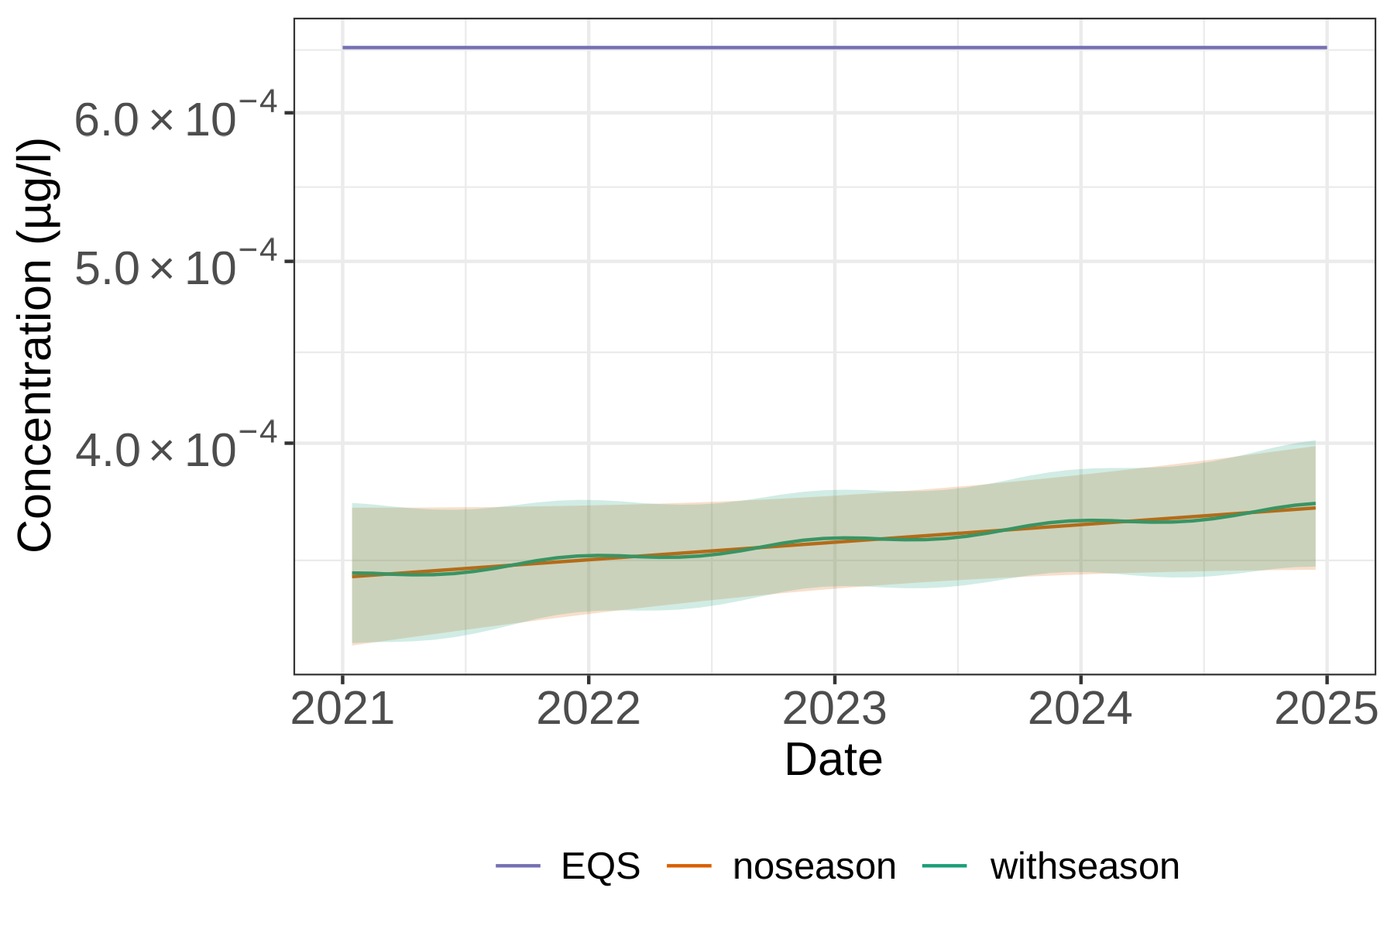
Similarly, Figure 10 below presents the geometric mean concentrations of L-PFOS (µg/L) measured at Environment Agency groundwater monitoring sites between 2021 and 2025. For reference, the surface water EQS of 0.00065 µg/L is shown as a purple line. Across all years, L-PFOS concentrations remained below the EQS and showed only a very slight upward trend, with a high degree of uncertainty. There was no seasonal pattern detected for L-PFOS, so this is not shown.

Figure 10. Geometric means of L-PFOS, expressed as µg/L, data collected between 2021 and 2025 at Environment Agency groundwater monitoring sites. 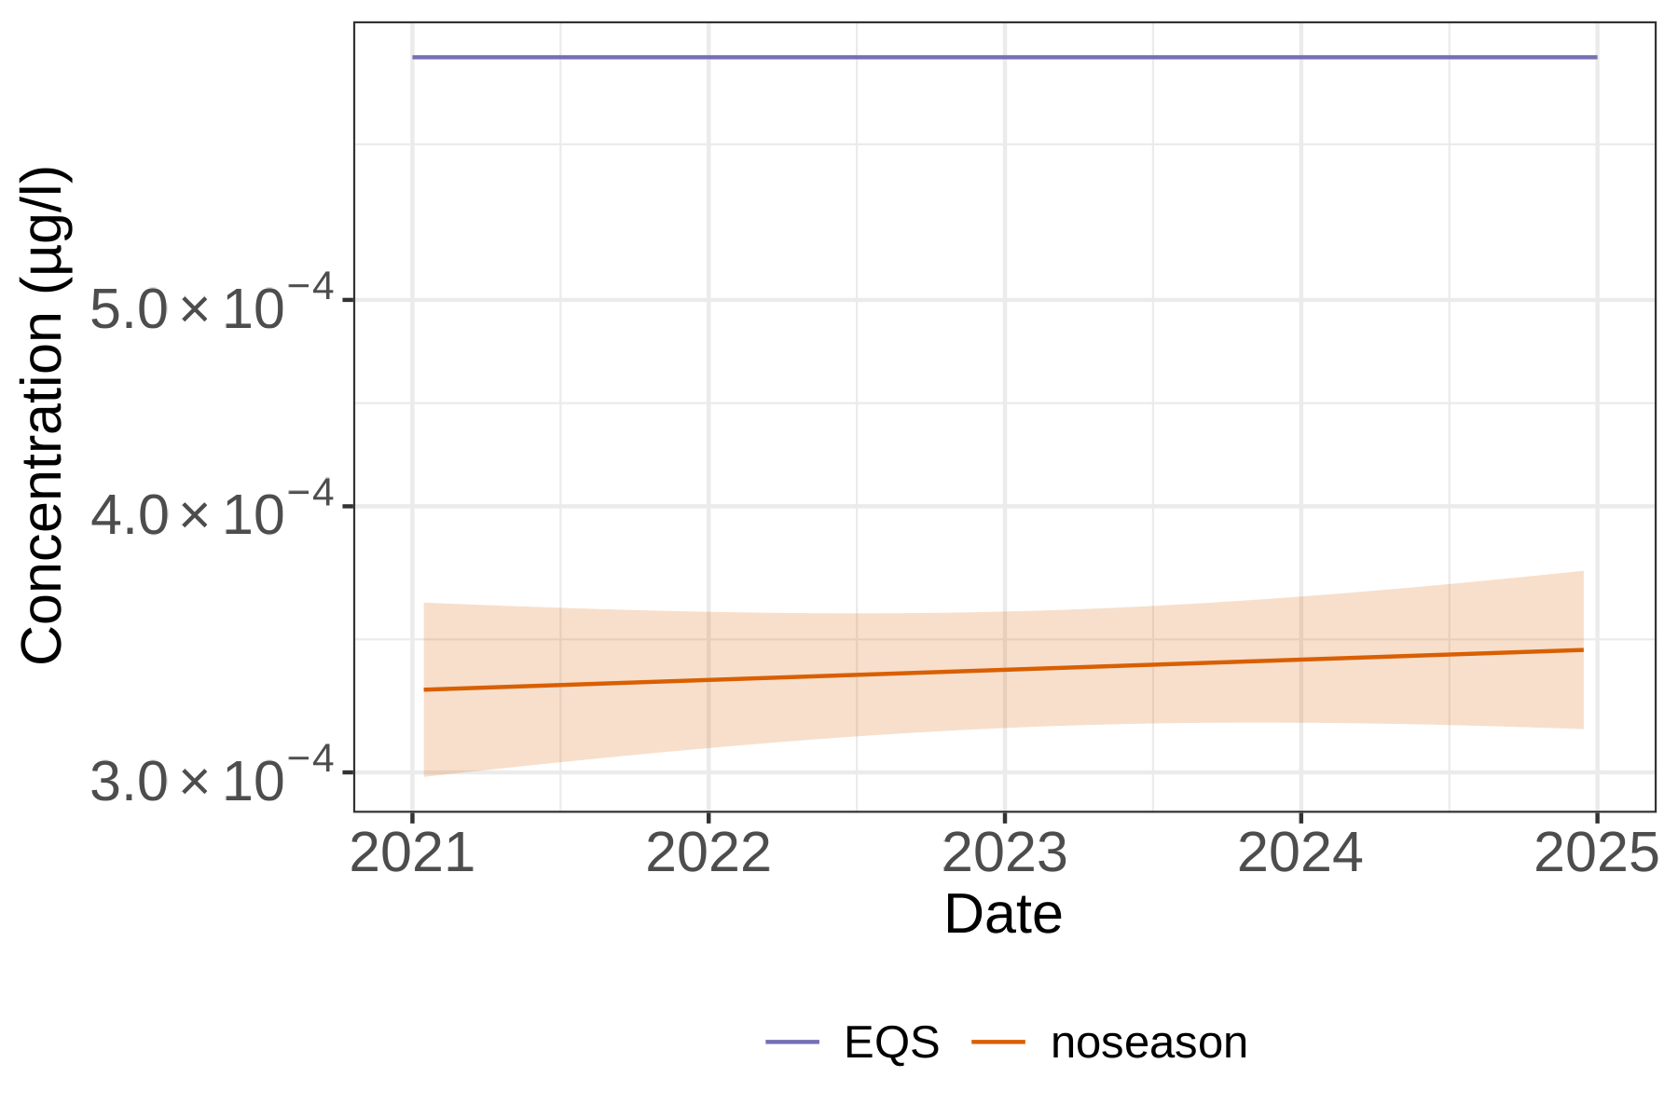
Figures 11 and 12 below plot the same B-PFOS and L-PFOS data described in Figure 9 and Figure 10 as geometric means over time by individual sites and their respective river basin districts (RBD). Trends may vary between RBDs; for sites within RBDs the data allows us to view the variation in mean concentration, however there is not enough data to evaluate separate trends for individual sites, so all sites within a RBD have to the follow the same trend. Confidence intervals are not shown in this figure to avoid clutter.
Figure 11 below is a series of graphs presenting the previous dataset, now disaggregated by individual sites and their corresponding River Basin District (RBD) catchments. Showing the geometric means of B-PFOS (expressed as µg/L) plotted for all England amalgamated data collected between 2021 and 2025 in Environment Agency groundwater monitoring sites. On each graph the surface water EQS of 0.00065 µg/L is plotted for reference as a purple line, the mean is plotted as an orange line, and individual sites are plotted as green lines. This view of the data shows variable trends in each RBD, and that the concentration sometimes exceeds the environmental quality standard (EQS) at individual sites. However, it should be noted that any comparison with EQS values shown in these graphs are for indicative purposes only, as this graph does not represent Water Framework Directive (WFD) compliance, which requires the EQS to be compared with site-specific annual arithmetic mean averages.
Figure 11: Geometric means of B-PFOS expressed as µg/L, plotted for all England amalgamated data collected between 2021 and 2025 in Environment Agency surface groundwater monitoring sites. Data plotted for individual sites in each WFD River Basin District (RBD). 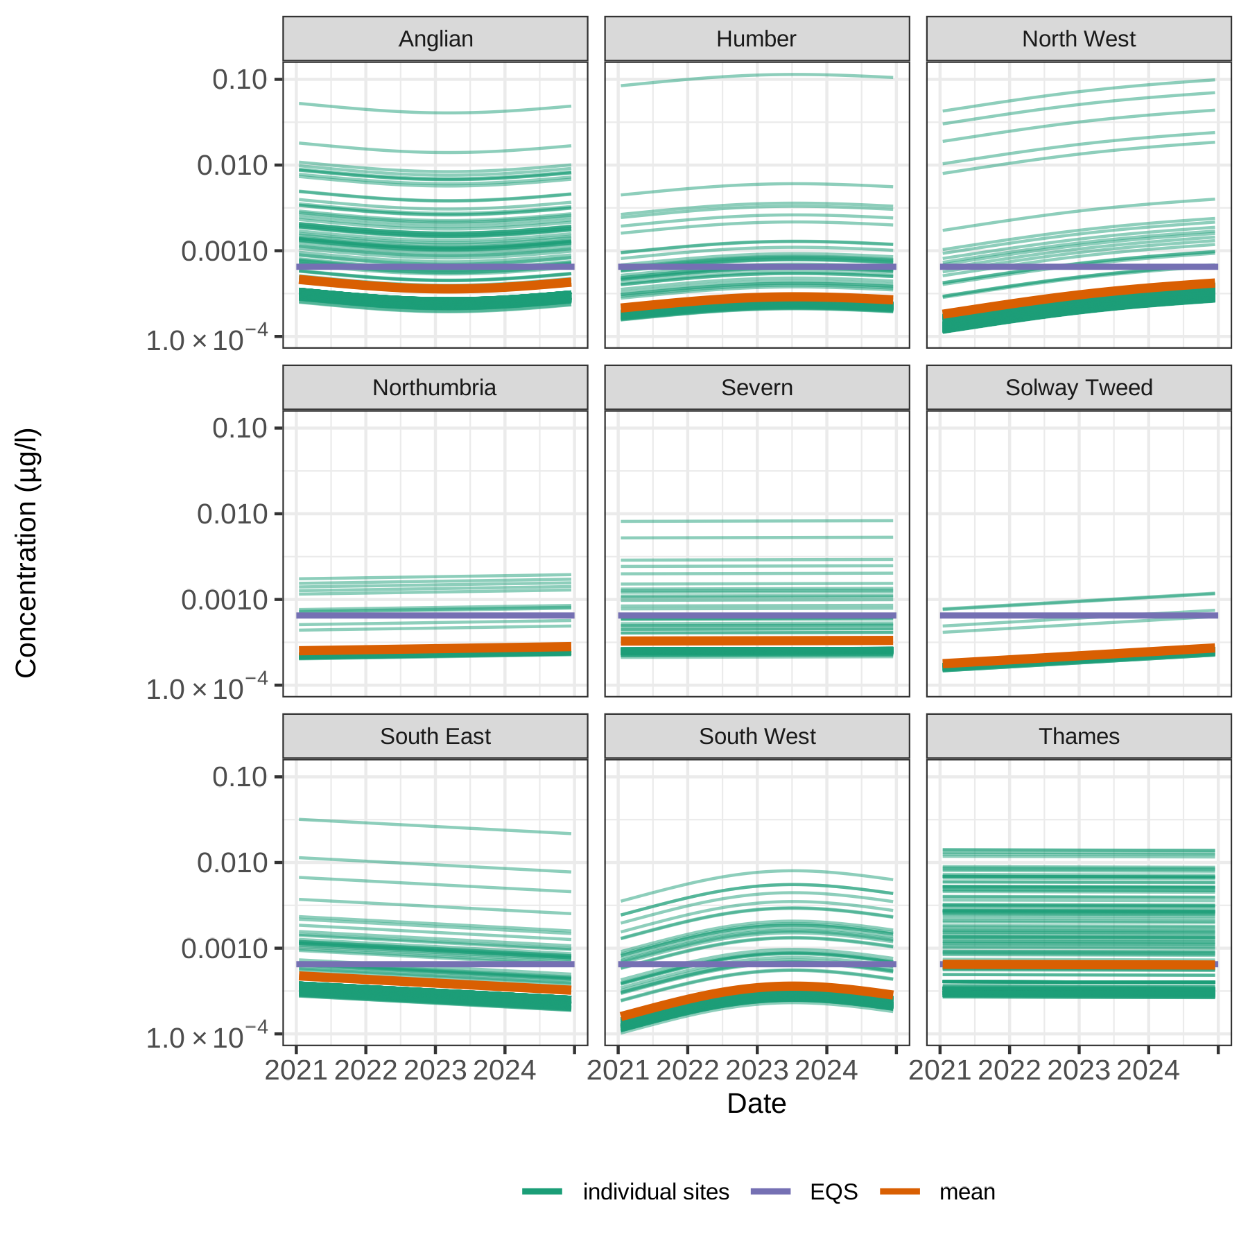
Figure 12 below is a series of graphs presenting the previous dataset (Figure 10), now disaggregated by individual sites and their corresponding River Basin District (RBD) catchments. Showing the geometric means of L-PFOS (expressed as µg/L) plotted for all England amalgamated data collected between 2021 and 2025 in Environment Agency groundwater monitoring sites. The surface water EQS of 0.00065 µg/L is also plotted for reference. For each RBD graph, the mean is plotted as an orange line, and individual sites are plotted as green lines. This view of the data shows variable trends in each RBD, and that the concentration sometimes exceeds the environmental quality standard (EQS) at individual sites.
Figure 12: Geometric means of L-PFOS expressed as µg/L, plotted for all England amalgamated data collected between 2021 and 2025 in Environment Agency surface groundwater monitoring sites. Data plotted for individual sites in each WFD River Basin District (RBD). 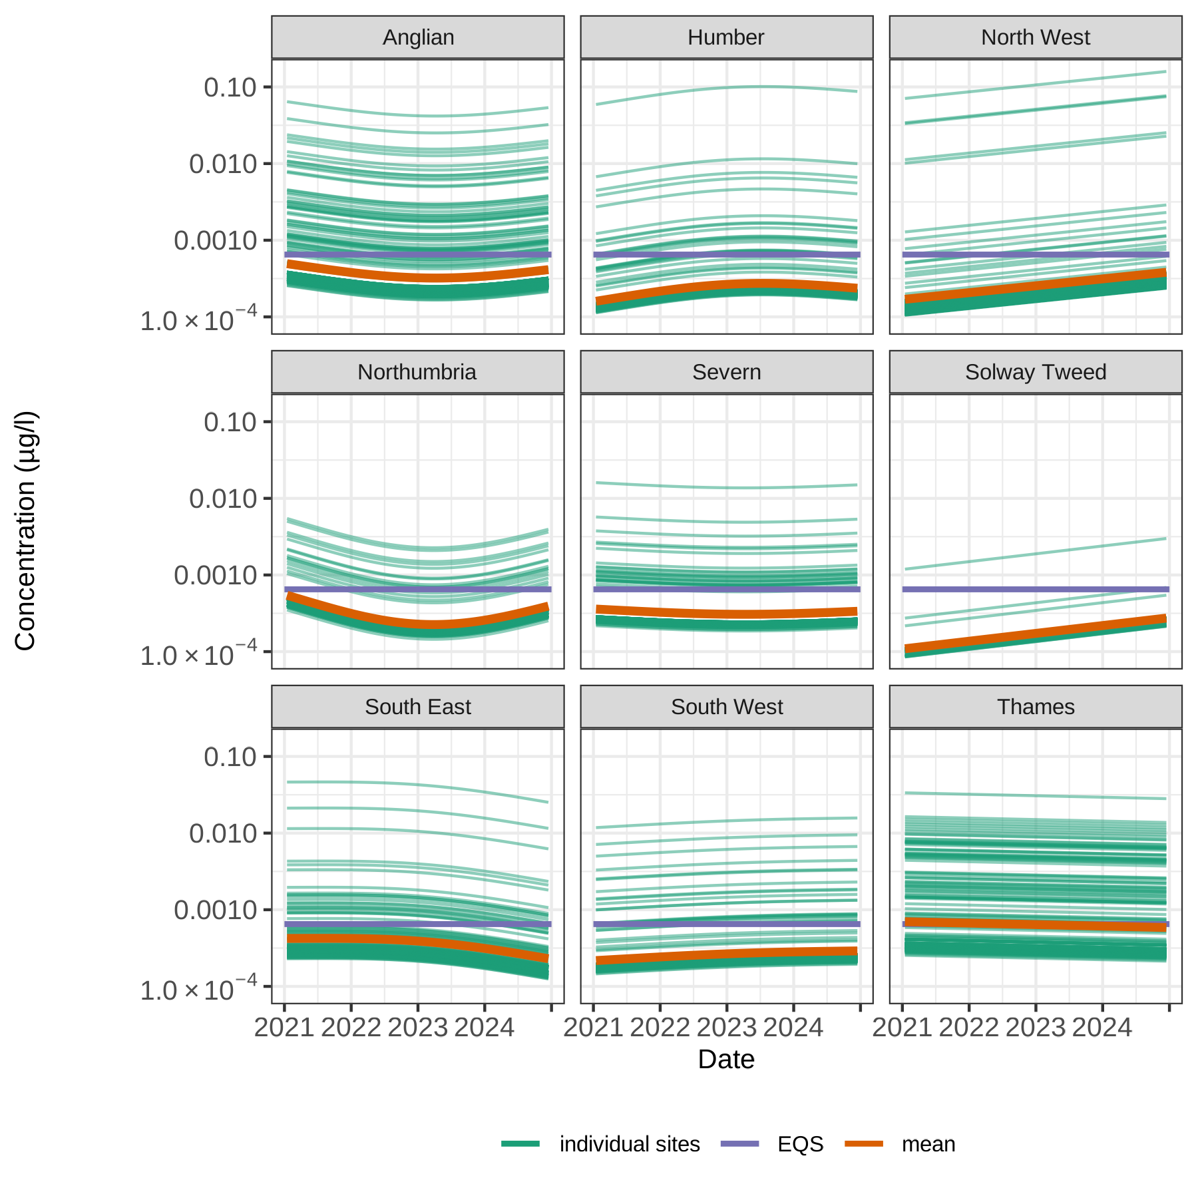
Overall, Figures 11 and 12 show a wide range of B-PFOS and L-PFOS concentrations across individual sites in England. While statistical, geochemical, and temporal evidence strongly suggests infiltration of PFOS from surface to groundwater, direct confirmation of the migration pathways remains an area for further research. Although PFOS concentrations in groundwater are generally lower than in surface waters, they may accumulate over time due to the compound’s persistence. Groundwater contamination may arise from both direct sources and the gradual degradation of precursors into more mobile forms capable of reaching aquifers, with each pathway potentially influencing the final PFOS isomer profile. Subtle variations in isomer distribution across catchments are discussed further in Section 5.

4.4 Estuaries and coastal waters: EA data
Between 2021 and 2025 we have measured PFOS concentrations in water at approximately 60 estuarine and coastal sites with 1,500 samples as part of our routine surveillance monitoring programme. The PFOS AA EQS is lower in saline waters (0.00013µg/l).
Figure 13 is a graph showing the geometric means of PFOS concentrations. Results are presented as the long-term trend only (‘no season’, orange line), and long-term trend including seasonality (‘with season’, green line). The orange line represents the general positive trend, showing an increase in PFOS concentrations over the four-year sampling period. The modelled green line also shows a general increase trend in PFOS concentrations but highlights distinct seasonal patterns, with concentrations peaking in spring and dropping to their lowest levels in Autumn. This seasonal pattern is consistently repeated each year. Likely reasons for these seasonal patterns are discussed later in Section 5.

Figure 13. Geometric means of PFOS, expressed as µg/L, plotted for all England amalgamated data collected between 2021 and 2025 at Environment Agency estuarine and coastal water monitoring sites, showing modelled trend data with and without seasonality. 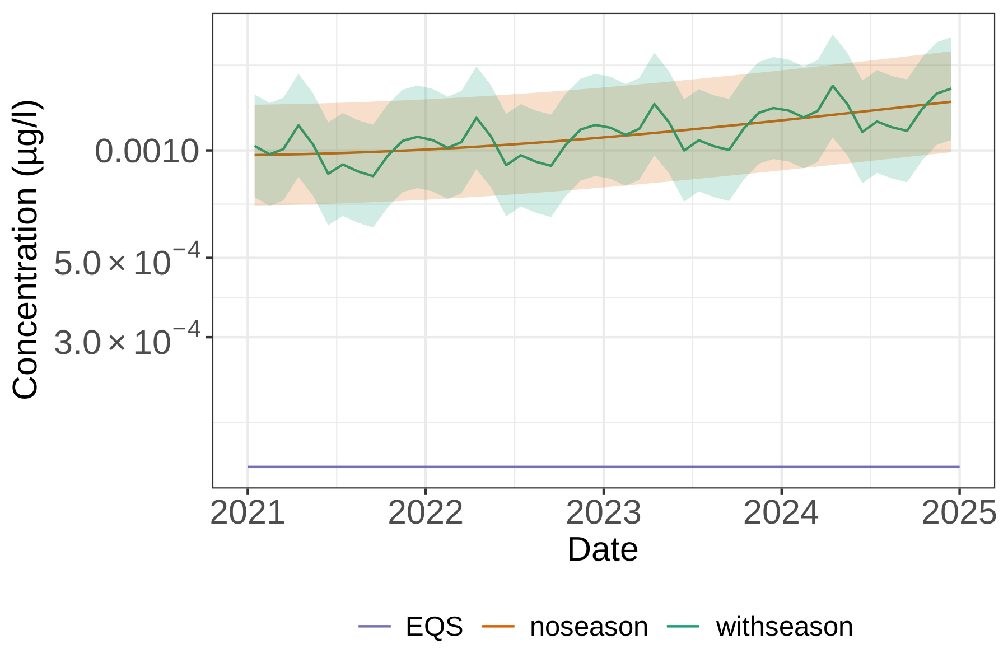
Figure 14 below is a series of graphs plotting the previous dataset by individual sites and their respective river basin district (RBD) catchments. For each RBD graph, the mean is plotted as an orange line, and individual sites are plotted as green lines. The water AA EQS is plotted as a purple line (0.00013 µg/l). This alternative view of the data reveals an upward trend over the four-year reporting period in most RBDs. The data illustrate a range in concentrations of PFOS across England. Samples from the Humber and Thames estuaries had the highest concentrations, likely related to urbanisation. Concentrations of PFOS were highest in the upper estuaries where salinity was lower and decreased towards the mouth of the estuaries.

Figure 14: Geometric means of PFOS expressed as µg/L, plotted for all England amalgamated data collected between 2021 and 2025 in Environment Agency estuarine/costal water monitoring sites. Data plotted for individual sites in each WFD River Basin District (RBD). 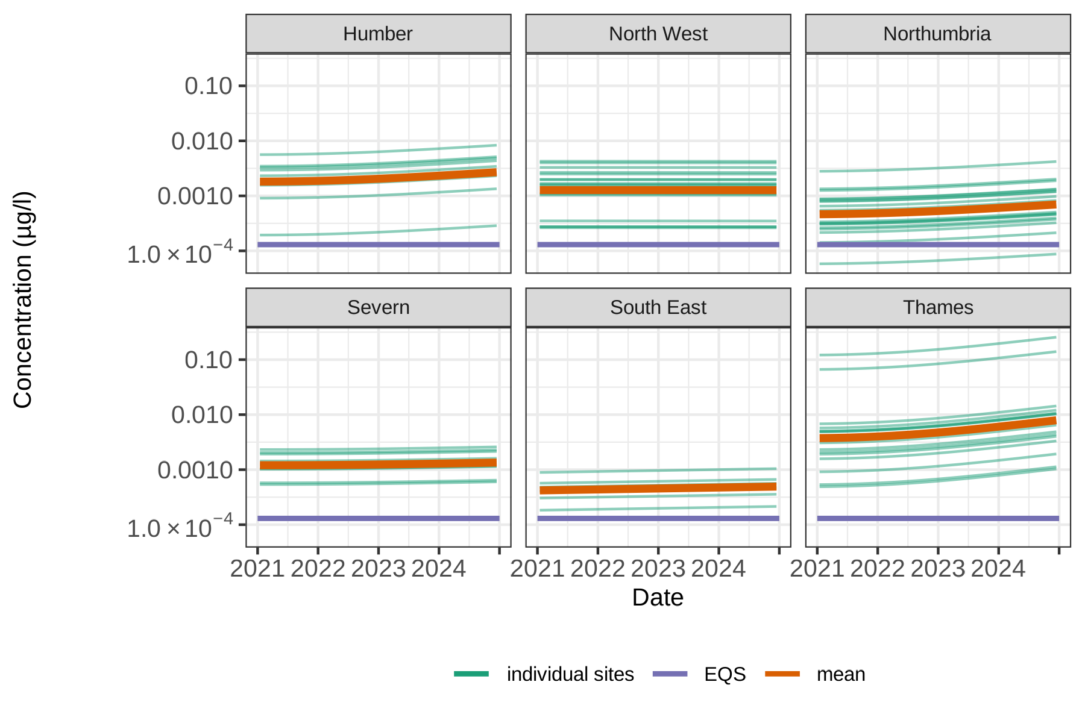
Figure 15 is a map illustrating the annual average concentrations of PFOS (expressed in µg/L) at estuarine and coastal sites sampled in 2023. The size of the circles represents the concentrations, the higher the concentration, the bigger the circle. Those concentrations above the environmental quality standard are represented by the border of the circle in red. For the concentrations below the environmental quality standard, the border of the circle is in black. All sites were above EQS.

Figure 15: Annual average PFOS concentrations (expressed as µg/L,) at esturaine and coastal individual monitoring sites sampled in 2023.
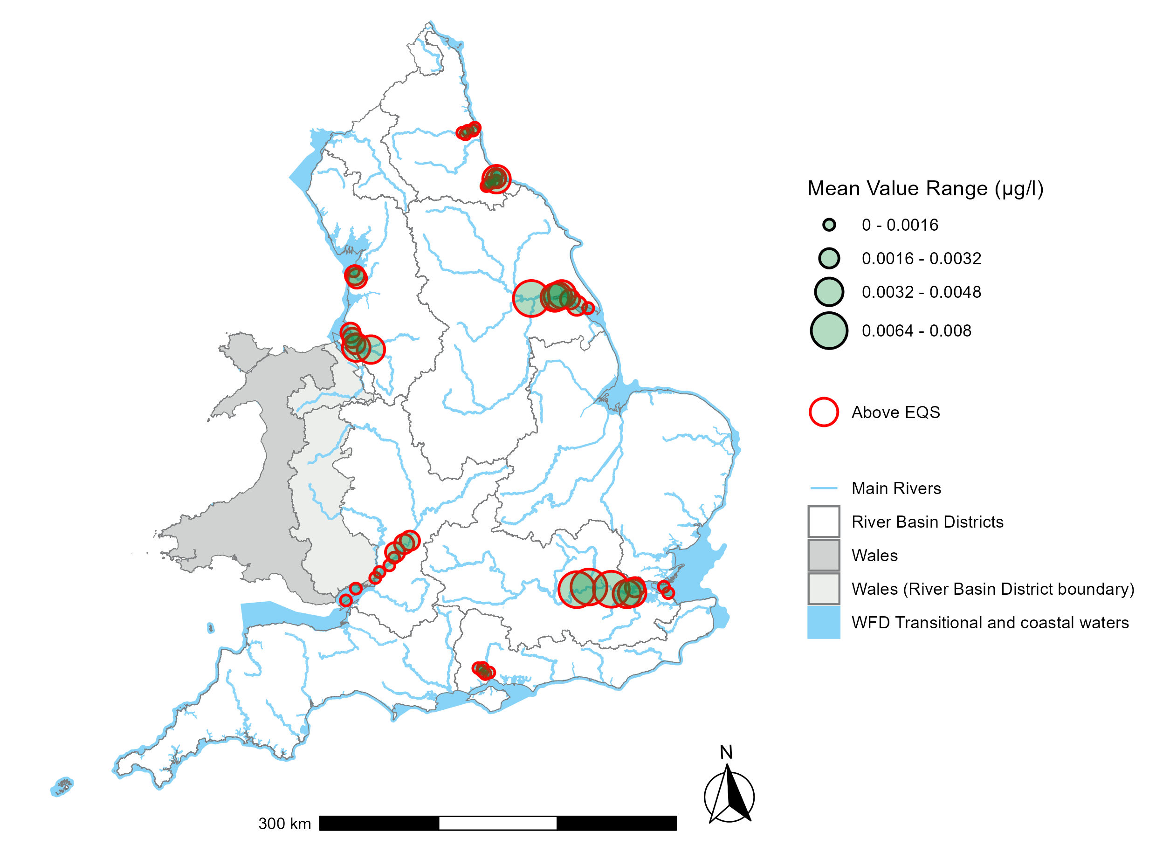
The mean concentration of PFOS for the amalgamated data for the whole of England, sampled over the same period for freshwater, groundwater, biota and coastal waters, is shown in Table 2 below. For the latest WFD compliance figures for PFOS or any other WFD element, you can download the raw compliance dataset or drill down via the interactive catchment maps until the data for each water body are displayed on the EA catchment data explorer tool
Table 2: All-England three-year (2022-2024) geometric mean concentration of PFOS in freshwater, biota, estuarine and coastal waters, and groundwaters. Data from EA monitoring. Figures in brackets are the 95% confidence interval, data are rounded to 2 significant figures. Biota data are normalised to standard dry weight.
Environmental compartment | PFOS concentration
Fresh (running) water | 0.0015 (0.0013, 0.0016) µg/l
Freshwater fish | 5.0 (3.7, 6.9) µg/kg
Estuarine and coastal fish | 1.1 (0.77, 1.5) µg/kg
Estuarine and coastal water | 0.0012 (0.0009, 0.0017) µg/l
Groundwater (L-PFOS) | 0.00033 (0.00031, 0.00036) µg/l
Groundwater (B-PFOS) | 0.00035 (0.00033, 0.00038) µg/l

5. Trends in our data
Understanding both longer-term trends and seasonal patterns in PFOS concentrations is important for assessing exposure risks in the English environment and for ensuring effective regulation and monitoring.
Reporting of long-term trends is affected by the relatively short time we have been monitoring these chemicals. In addition, for freshwater, changes in our monitoring networks have further hampered trend reporting, although in the longer term, our reporting ability will improve. Over the period evaluated here, nationally, PFOS concentrations in freshwaters and freshwater fish appear downwards. The same downward trend is observed in estuarine/coastal fish. In contrast, PFOS concentrations in estuarine and coastal waters show an upward trend, while groundwater data indicate a very slight upward trend. In all cases, more years of monitoring and further data analysis are likely required to understand the full nature and spatial variation in these trends.
Seasonal fluctuations can potentially determine whether PFOS levels exceed EQS thresholds, with implications for compliance, mitigation, and source control. Explaining these seasonal variations is complex, as multiple factors may influence PFOS concentrations in water and animal tissue at the local scale. These may include rainfall / river flow, microbial activity, temperature and the presence of point and diffuse sources (Chen and others, 2018; Nguyen and others, 2022; Podder and others, 2021). Differences in the behaviour of PFOS isomers under varying environmental conditions may also play a role (Londhe and others, 2022). However, few studies have examined seasonal variability in PFAS in aquatic environments, and those available are often geographically specific, making direct comparisons challenging.
In our dataset, PFOS concentrations in fresh (running) water demonstrate seasonality with higher PFOS concentrations observed during June-August and lower concentrations in January-February. Potentially reflecting seasonal influences such as agricultural activity or fluctuations in industrial discharge. While individual sites are likely to differ in their seasonality, this national pattern is suggestive of a dominance of point sources over diffuse. However more work is needed with longer data series to apportion the contributions of point and diffuse sources and hence understand these patterns better.
At the site scale, during wetter seasons or high-flow events, concentrations may decline due to dilution or rise as diffuse sources from land are mobilised. In addition, elevated suspended solids and dissolved organic carbon at these times may alter PFOS partitioning between water, sediment, and soils, sometimes leading to temporary reductions in dissolved concentrations. Agricultural runoff, stormwater discharges, and snowmelt are also possibly contributors to seasonal variation (Ford and others, 2024). Seasonal variations in concentrations likely reflect differing source types and surface–groundwater interactions. Identifying key sources and understanding their behaviour across hydrological periods is important to assess potential impacts on aquatic environments.
At the national scale, groundwater PFOS concentrations are lower than freshwater, with only weak seasonal patterns visible in the B-PFOS data collected since 2021. Nonetheless, some seasonal trends can still be observed, suggesting partial removal during infiltration from surface to groundwater as well as the influence of lag times. Groundwater typically shows signs of contamination later than surface water when the pollution originates from runoff or wastewater effluent (Agarwal and others, 2025). PFOS occurrence in groundwater may be influenced by site-specific factors and the characteristics of the aquifer. Such as infiltration pathways, groundwater flow direction, and variations in redox conditions (Sadia and others, 2023).
For B-PFOS in groundwater, there are stable low concentrations in spring followed by slight increases in November. This suggests that B-PFOS may exhibit different transport or degradation behaviours in the environment compared to its linear form. Though the pattern is weak and should be interpreted cautiously. L-PFAS isomers are generally more prone to sorption to sediments and organic matter than branched forms leading to possible stronger adsorption in surface water systems (Beesoon and Martin, 2015). In contrast, B- PFOS exhibits lower sorption potential, making it more mobile in subsurface environments and therefore possibly more likely to infiltrate groundwater (Agarwal and others, 2025; Fang and others, 2014). Microbial degradation may also slightly favour L-PFOS, leading to a relative enrichment of B-PFOS in groundwater over time. Possibly explaining their slightly higher concentration in our data (Agarwal and others, 2025; Nilsson and others, 2022).
Although L-PFOS occurs at lower concentrations in groundwater than in surface water, its measurable presence indicates that linear variants are capable of infiltrating aquifers. Our findings generally align with global studies showing that B-PFOS seems to be more prevalent in groundwater (Chen and other 2015; Grung and others, 2024; Agarwal and others, 2025).
For estuaries and coastal waters, our data show peak PFOS levels occurring in spring and lower concentrations in summer, albeit a weaker and more uncertain than for freshwater. Estuaries and coastal waters also exceed the EQS proportionally more than other bodies of water. The fate of PFAS in estuarine ecosystems is shaped by hydrological conditions, biogeochemical processes, and the proximity to contamination sources (Anik and others, 2025).
These contrasting seasonal patterns between systems highlight the difficulty of generalising trends, as seasonal drivers are likely to be site-specific and influenced by a combination of physical, chemical, and biological processes (Podder and others, 2021).

5.1 Other data
Patterns of PFOS contamination in wildlife vary significantly by species and location. However, PFOS is frequently one of the most dominant PFAS detected in England (Environment Agency, 2021; O’Rourke and others, 2024; 2022, Pereira and others, 2021; Fernandes and others 2015; Vendl and others, 2024; Androulakakis and others, 2022).
Recent environmental monitoring data from the H4 indicator, developed under the Defra 25-Year Environment Plan, tracks chemical concentrations and their effects on wildlife and ecosystems across terrestrial, freshwater, and marine environments (Environment Agency, 2024). PFOS is a key substance monitored, reported separately from other PFAS to avoid masking trends due to its higher concentrations.
In the most recent H4 chemical indicator triennial report, freshwater concentrations declined between 2016 and 2022. Similarly, freshwater fish (Roach, Brown Trout, Chub) sampled between 2015 and 2022 showed a decreasing trend. Data from Eurasian otters (2015–2021) did not show any statistically significant trend. Estuarine and Coastal Fish (Mainly Dab, Flounder, Plaice) also show declining PFOS levels, though limitations in data coverage prevent definitive conclusions. Long-term monitoring of harbour porpoises (2001–2021) shows a significant decline (Law and others, 2008; Huber and others, 2012). In terrestrial species, such as common buzzards (2018, 2019, 2021) and red foxes (2018–2021), PFOS was detected, but trends remain unclear. These PFOS water and biota trends are summarised in the H4 chemicals dashboard which is viewable online at - https://oifdata.defra.gov.uk/themes/biosecurity-chemical-and-noise/H4/.
Some temporal trends in PFOS concentrations are beginning to emerge. Several studies indicate PFOS concentrations generally increased until the early 2000s, followed by subsequent levelling off or decreasing concentration, although trends reported may not always be statistically significant (Badry and others, 2025; Rupp and others, 2025; Sun and others, 2023; Cookson and others, 2022; Muir and Miaz, 2021).
However, PFOS remains widespread, and in some environmental compartments, species and regions, concentrations have continued to rise or show no clear change (EEB, 2025). A systematic review covering 186 articles and 26 grey literature reports of the effect of restrictions on PFAS, including PFOS, on global concentrations was published by Land and others (2018). Overall, the evidence suggests that PFOS concentrations in human samples are declining, while environmental samples show no clear downward trend yet. Insignificant and decreasing trends were equally predominant in studies reporting times series concentrations of PFOS in fish, mussels and loggerhead sea turtles.

6. Control measures
The Stockholm Convention on POPs was adopted in 2001 and became international law in 2004. In 2006, the EU recognised “PFOS fulfil the criteria for classification as a very persistent, very bioaccumulative and toxic chemical”. In 2006 the use of PFOS and PFOS related substances was restricted under the Marketing & Use Directive (Directive 2006/122/EC) which has since been repealed due to updated legislation.
In 2009, PFOS, its salts, and PFOSF (key precursor used to manufacture PFOS) were listed under Annex B (restricted use) of the Stockholm Convention, restricting their production and use in most circumstances (Brennan and others, 2021). Several specialist uses were initially exempt, including PFOS in photoresistors or anti-reflective coatings for photolithography, photographic coatings on films, papers, or printing plates, mist suppressants for non-decorative hard chromium (VI) plating in closed-loop systems, hydraulic fluids for aviation, and firefighting foams. A time-limited exemption also applied to the use of PFOS as a wetting agent in controlled electroplating systems. Previous checks by the Environment Agency found no significant non-compliance with PFOS use restrictions in England. Viable alternatives have been identified for uses.
A decade later, at the convention’s ninth meeting, members agreed to remove the remaining exemptions for PFOS use (Brennan and others, 2021). As a signatory to the Stockholm Convention, the UK implements these obligations through domestic legislation. These provisions are enacted via 2019 recast of the EU POPs Regulation (Commission Regulation (EU) 2019/1021), which continues to apply as assimilated EU law post EU-Exit. PFOS-related substances or “derivatives” are also regulated under this framework due to their potential to degrade into PFOS. This includes compounds that have the moiety C8F17SO2X, where X = OH, Metal salt (O-M+), halide, amide, and other derivatives including polymers.
In the UK, competent authorities, enforcement powers, and penalties for breaches are set out under the Persistent Organic Pollutants Regulations 2007 (No. 3106), with the Environment Agency designated as the enforcement authority in England. Under Regulation (EU) 2019/1021, prohibitions apply to:
- Substances or preparations with a PFOS concentration greater than 0.001% by weight
- Semi-finished products or articles (or parts of these items) with a concentration equal to or greater than 0.1% by weight
- Textiles or coated materials with levels equal to or greater than 1 μg/m² of the coated material
Lower concentrations were reasoned as ‘unintentional trace contamination’. Additionally, articles already in use in the EU before 25 August 2010 containing PFOS as a constituent of such articles are allowed.
The sole time remaining exception of PFOS was its use as a mist suppressant in non-decorative hard chromium (VI) plating in closed-loop systems, permitted until September 2025. In these processes, PFOS reduced surface tension, helping to suppress toxic chromium (VI) mist and acting as a wetting agent to improve corrosion resistance and surface finish (Glüge and others, 2020). In 2018, a stockpile of 56.8 kg of neat PFOS for use as mist suppressants was notified to the Environment Agency. A subsequent notification was received in 2020 for the same use. No active notifications were received prior to the expiry of the specific exemption in September 2025.
The legislation also requires holders of a stockpile greater than 50kg consisting of or containing PFOS for exempt uses to notify the Environment Agency. This applies to manufacturers, importers, suppliers and users. There are general exemptions which allow the selling of POPs such as PFOS to laboratories for research and development purposes (EU) No 2019/1021; Article 4).
Waste containing PFOS above 50 mg/kg (50ppm), as listed in Annex IV, must be classified as POPs waste and as such they must be disposed of, or recovered, in such a way to destroy or irreversibly transform the POP content of the waste. High-temperature incineration at 1,100°C, with a 2–3 second residence time in the secondary combustion chamber, sufficient turbulence, and properly balanced stoichiometry, is currently the most recognised method for near complete mineralisation (defluorination) of PFAS AFFF (Environment Agency, 2025). Any waste with a PFOS concentration less than 50mg/kg, should be disposed of in line with the relevant waste legislation.
Where such a derogation concerns production or use of PFOS in an installation regulated under the Environmental Permitting Regulations 2016 (ERR), the relevant Best Available Techniques (BAT) for the prevention and minimisation of environmental emissions must be applied. The Industrial Emissions Directive (IED) aims to prevent and reduce harmful industrial emissions, while promoting the use of techniques that reduce pollutant emissions. This ensures that even permitted uses operate under strict environmental safeguards.
PFOS is also defined for the purposes of Schedule 22 of EPR as a "hazardous substance" in England for groundwater. This requires discharges of PFOS into groundwater to be prevented in line with the environmental objectives set out in The Water Environment (Water Framework Directive) (England and Wales) Regulations 2017.
While England and Wales do not currently have statutory standards for PFAS levels in drinking water, the Drinking Water Inspectorate (DWI) issued updated guidance in March 2025. This guidance advises water companies to expand monitoring programmes to include a wider list of PFAS compounds and to update their risk assessments accordingly. It introduces a tiered approach to managing PFAS in drinking water and recommends a guidance value of 100 ng/L for the combined concentration of 48 specified PFAS, including PFOS.
Where land is affected by historic PFOS and wider PFAS contamination, voluntary remediation or redevelopment under the planning regime provides the opportunity to address risks to human health and the wider environment making land suitable for its current or proposed future use. The Environment Agency expects developers and consultants to follow the Land Contamination Risk Management (LCRM) guidance when managing the risks from land contamination. Regulatory action under Part 2A of the EPA 1990 (Contaminated Land Regime) provides a means of dealing with unacceptable risks posed by land contamination to human health and the environment, where no other appropriate solution exists.
Through a combination of international treaties, domestic regulation, and targeted enforcement, the UK continues to address the risks associated with PFOS and reduce its environmental legacy.

7. Summary
The exceptional stability and oil, grease, and water-repellent properties of PFOS and related substances made them highly effective for use in a wide range of historical consumer and industrial applications. However, this very stability and the unusual mobility of PFOS have resulted in a legacy of environmental contamination that is exceptionally difficult to deal with.
Despite international restrictions and a decline in global production, legacy consumer products treated with PFOS or PFOS-related substances continue to act as ongoing sources of emissions as they degrade or enter the waste stream. Although certain specialist uses were permitted under time-limited exemptions, these exemptions have now expired. To further mitigate emissions, there may be a need to investigate whether cost-effective measures exist to identify, isolate, and destroy PFOS in legacy waste streams before environmental release occurs.
Other sources of PFOS emissions include WwTWs, historic industrial discharges, landfill leachate (which may enter WwTWs), and sites where AFFF were used. Additionally, PFOS related substances still in circulation can degrade into PFOS during wastewater treatment as well as within the environment and biota. This presents a significant challenge as there are potentially hundreds to thousands of these substances in use.
Monitoring data from the Environment Agency and the UK Water Industry’s Chemical Investigations Programme (CIP) confirm the widespread presence of PFOS in the English environment. Concentrations do exceed the Environmental Quality Standards (EQS) in some respective locations: 0.00065 µg/L in inland waters, 0.00013 µg/L in coastal waters, and 9.1 µg/kg wet weight in biota.
Our monitoring data, supported by certain academic studies, indicates a general national downward trend in PFOS concentrations in several environmental compartments, reflecting the impact of regulatory restrictions and interventions. Declines are most evident in freshwaters and in both freshwater and estuarine/coastal fish. However, estuarine/coastal waters and groundwater, show weak upward trends. This variability reflects PFOS persistence, differing pathways and geographic variation. Trend analysis remains relatively limited by the short monitoring period included in this report and by changes in monitoring networks. However, reporting will improve as longer-term datasets become available, providing greater understanding of the nature and spatial variation of these trends.
We continue to develop a clearer understanding of the sources, pathways, and relative significance of elevated PFOS concentrations, while implementing measures to prevent further impacts. Earlier work has provided assurance that historic legal supply and permitted specialist uses did not result in unacceptable environmental harm. Current efforts are focused on ensuring that legacy contamination is effectively managed, and that potential ongoing emissions are prevented.
We are enhancing our analytical capabilities to improve the detection and monitoring of PFOS related substances. We are also reviewing the range of regulatory tools we use to regulate sectors. These include use of permitting under the Environmental Permitting Regulations. Several other targeted initiatives are already underway to improve our evidence and guide effective control measures. This includes implementation of an Environment Agency strategy for safe and sustainable sludge use, which will modernise the regulation of biosolids use on agricultural land. To support future management for WwTW emissions and targeted catchment-level source tracking, further investigations into PFOS in sewage catchments, groundwater, estuaries, biosolids, and receiving waters are planned under the CIP4, with sampling scheduled for completion in 2027. These will be complemented by additional analysis of our existing evidence to help address this.
Given the environmental persistence and widespread historical use of PFOS, some level of contamination is likely to persist in the environment for the foreseeable future. However, this should not prevent us taking targeted and proactive measures to mitigate the effects of this persistent problem.

Appendix A
Perfluorooctyl Sulfonates: Major Product Categories (OECD, 2002)
electro-chemical fluorination (ECF) cells
(octanesulphonyl fluoride + HF + electricity
 | ↓
perfluorooctanesulphonyl fluoride (PFOSF)
(chemical intermediate)
 | ↓
Perfluorooctane sulphonic acid  (PFOSA)  chemical intermediate  acid catalyst for | N-alkylperfluorooctane sulphonamide  (FOSA)  chemical intermediate  pesticide active ingredient | N-alkylperfluorooctane sulphonamidoethanol  (FOSE)  chemical intermediate
↓ | ↓ | ↓
K+, Li+, DEA, NH4+ Salts  surfactant in fire-fighting foam;  surfactant for alkaline cleaners;  emulsifier in floor polish;  mist suppressant for metal plating baths;  surfactant for etching acids for circuit boards; and  Pesticide active ingredient for ant bait traps. | carboxylates  Antistatic agent in photographic paper.  amides  Pesticide active ingredient.  oxazolidinones  Waterproofing casts/wound dressings. | Alcohols*  Silanes*  Alkoxylates*  fatty acid esters*  adipates*  urethanes*  polyesters*  acrylates*/**  co-polymers*/**  phosphate esters**
* soil/oil/water repellency for carpet; fabric/upholstery; apparel; leather; metal/glass
** oil/water repellency for plates; food containers; bags; wraps; folding cartons; containers; carbonless forms; masking papers

References
Agarwal V and others. ‘Isomers of perfluorooctanesulfonate exhibit preferential infiltration and contrasting ionic associations between surface water and groundwater.’ Journal of Hazardous Materials 2025: volume 494 page 138445
Ahrens L and others. ‘Wastewater treatment plant and landfills as sources of polyfluoroalkyl compounds to the atmosphere’ Environmental Science and Technology 2011: volume 45, issue 19, pages 8098–8105 Available at:
Ahrens L and Bundschuh M. ‘Fate and effects of poly‐ and perfluoroalkyl substances in the aquatic environment: a review’ Environmental Toxicology and Chemistry 2014: volume 33, issue 9, pages 1921–1929
Andrews DQ and others. ‘Has the human population become a sentinel for the adverse effects of PFAS contamination on wildlife health and endangered species?’ Science of The Total Environment 2023: volume 901, page 165939.
Androulakakis A and others. ‘Determination of 56 per- and polyfluoroalkyl substances in top predators and their prey from Northern Europe by LC-MS/MS’ Chemosphere 2022: volume 287 (Part 2), page 131775
Anik AH and others. ‘Unveiling the emerging concern of per- and polyfluoroalkyl substances (PFAS) and their potential impacts on estuarine ecosystems’ 2025 Marine Pollution Bulletin Volume 212
Ankley GT and others. ‘Assessing the ecological risks of per- and polyfluoroalkyl substances: Current state-of-the-science and a proposed path forward’ 2021 Environmental Toxicology and Chemistry 40, 564–605
Antonopoulou M and others. ‘Current state of knowledge of environmental occurrence, toxic effects, and advanced treatment of PFOS and PFOA’ Science of The Total Environment 2024: volume 913, article 169332
Armitage JM and others. ‘Modeling the global fate and transport of perfluorooctane sulfonate (PFOS) and precursor compounds in relation to temporal trends in wildlife exposure’ Environmental Science & Technology 2009: volume 43, issue 24, pages 9274–9280.
Arvaniti OS and Stasinakis AS. ‘Review on the occurrence, fate and removal of perfluorinated compounds during wastewater treatment’ Science of the Total Environment 2015: volume 524–525, pages 81–92 https://doi.org/10.1016/j.scitotenv.2015.04.023
Augustsson A and others. ‘Consumption of freshwater fish: A variable but significant risk factor for PFOS exposure’ Environmental Research 2021, Volume 192, Article 110284.
Badry A and others. ‘Pre-regulatory actions as a driver for reduced PFAS emissions? Long-term trends and change points for human and environmental samples from Germany’ Environmental Sciences Europe 2025: volume 37, article 84
Bangma J and others. ‘Understanding the dynamics of physiological changes, protein expression, and PFAS in wildlife’ Environment International 2022: volume 159, page 107037
Barber J L. ‘Determining levels of PFAS chemicals in estuarine and coastal sediments’ CEFAS Project Report for the Department for Environment, Food and Rural Affairs (Defra) 2021: project code C8115
Bečanová J and others. ‘Screening for perfluoroalkyl acids in consumer products, building materials and wastes’ Chemosphere 2016: volume 164, pages 322–329
Becker AM and others. ‘Perfluorooctane surfactants in waste waters, the major source of river pollution’ Chemosphere 2008: volume 72, issue 1, pages 115–121
Beesoon S and others. ‘Exceptionally high serum concentrations of perfluorohexanesulfonate in a Canadian family are linked to home carpet treatment applications’ Environmental Science & Technology 2012: volume 46, pages 12960–12967
Beesoon S and Martin JW. ‘Isomer-specific binding affinity of perfluorooctanesulfonate (PFOS) and perfluorooctanoate (PFOA) to serum proteins.’ Environmental Science & Technology 2015: volume 49, issue 9, pages 5722–5731
Behnami A and others. ‘Biosolids, an important route for transporting poly- and perfluoroalkyl substances from wastewater treatment plants into the environment: a systematic review’ Science of the Total Environment 2024: volume 925, page 171559
Benskin JP and others. ‘PFOS or PreFOS? Are perfluorooctane sulfonate precursors (PreFOS) important determinants of human and environmental perfluorooctane sulfonate (PFOS) exposure?’ Journal of Environmental Monitoring 2010: volume 12, issue 11, pages 1979–2004
Benskin JP and others. ‘Isomer profiling of perfluorinated substances as a tool for source tracking: a review of early findings and future applications.’ Reviews of Environmental Contamination and Toxicology 2010: volume 208, pages 111–160
Beriro DJ and others. ‘A comparative analysis of PFAS in archive and fresh soil samples in England and implications for large-scale surveys’ Environmental Pollution 2025: volume 379, page 126401
Björklund JA and others. ‘Perfluoroalkyl compounds (PFCs) in indoor dust: concentrations, human exposure estimates, and sources’ Environmental Science and Technology 2009: volume 43, issue 7, pages 2276–2281
Bonato T and others. ‘Contamination of the terrestrial food chain by per- and polyfluoroalkyl substances (PFAS) and related human health risks: A systematic review’ Science of the Total Environment 2025: volume 961, page 178337
Bräunig J and others. ‘Leaching and bioavailability of selected perfluoroalkyl acids (PFAAs) from soil contaminated by firefighting activities’ Science of the Total Environment 2019: volume 647, pages 471–479
Brennan N and others. ‘Trends in the regulation of per- and polyfluoroalkyl substances (PFAS): a scoping review’ International Journal of Environmental Research and Public Health 2021: volume 18(20), article 10900
Brunn H and others. ‘PFAS: forever chemicals—persistent, bioaccumulative and mobile. Reviewing the status and the need for their phase out and remediation of contaminated sites’ Environmental Sciences Europe 2023: volume 35, article 20
Brusseau ML and others. ‘PFAS concentrations in soils: background levels versus contaminated sites’ Science of the Total Environment 2020: volume 740, page 140017
Buck RC and others. ‘Perfluoroalkyl and polyfluoroalkyl substances in the environment: Terminology, classification, and origins’ Integrated Environmental Assessment and Management 2011: volume 7, pages 513–541
Byrne P and others. ‘PFAS river export analysis highlights the urgent need for catchment-scale mass loading data’ Environmental Science and Technology Letters 2024: volume 11, issue 3, pages 266–272
Byrne P and others. ‘Spatially resolved source apportionment of per- and polyfluoroalkyl substances (PFAS) within a post-industrial river catchment’ Science of The Total Environment 2025: volume 1001, article 180502
Chen J and others. ‘Perfluorooctane sulfonate in water and sediment from the Yangtze Estuary and coastal waters: occurrence, partitioning and diffusion behaviour and risk assessment’ Emerging Contaminants 2023: volume 9, article 100260
Chen S and others. ‘Seasonal and annual variations in removal efficiency of perfluoroalkyl substances by different wastewater treatment processes’. Environmental Pollution 2018: volume 242 (Part B), pages 2059-2067
Chen X and others. ‘Isomeric specific partitioning behaviors of perfluoroalkyl substances in water dissolved phase, suspended particulate matters and sediments in Liao River Basin and Taihu Lake, China’ Water Research 2015: volume 80, pages 235–244.
Cheng Y and others. ‘Temporal Trends of Legacy and Emerging PFASs from 2011 to 2021 in Agricultural Soils of Eastern China: Impacts of the Stockholm Convention’ Environmental Science & Technology, 2023, Volume 57, pages 9277–9286.
Collivignarelli MC and others. ‘Legislation for the reuse of biosolids on agricultural land in Europe: overview’ Sustainability 2019: volume 11, issue 21, page 6015
Comber DW and others. ‘Perfluorinated alkyl substances: sewage treatment and implications for receiving waters’ Science of The Total Environment 2021: volume 791, article 148391
Committee on Toxicity of Chemicals in Food, Consumer Products and the Environment. ‘Statement on the EFSA Opinion on the risks to human health related to the presence of perfluoroalkyl substances in food’ 2020
Cookson E and others. ‘Global patterns and temporal trends of perfluoroalkyl substances in municipal wastewater: A meta-analysis’ Water Research 2022: volume 221, page 118784
De Silva AO and others. ‘PFAS exposure pathways for humans and wildlife: A synthesis of current knowledge and key gaps in understanding’ Environmental Toxicology and Chemistry 2021: volume 40, issue 3, pages 631–657
Death C and others. ‘Per- and polyfluoroalkyl substances (PFAS) in livestock and game species: A review’ Science of The Total Environment 2021: volume 774, page 144795 (viewed on 9 October 2025)
DeLuca NM and others. ‘Human exposure pathways to poly- and perfluoroalkyl substances (PFAS) from indoor media: a systematic review’ Environment International 2022: volume 162, page 107149
Department for Environment, Food and Rural Affairs (Defra). ‘National Implementation Plan for the Stockholm Convention on Persistent Organic Pollutants’ United Kingdom of Great Britain and Northern Ireland, 2017
Dimitrakopoulou ME and others. ‘Comprehensive analysis of PFAS presence from environment to plate.’ NPJ Science of Food 2024: volume 8, page 80
Dlugogorski BZ and Schaefer TH. ‘Compatibility of aqueous film-forming foams (AFFF) with sea water’. Fire Safety Journal 2021: volume 120, page 103288
Drinking Water Inspectorate. ‘Perfluoroalkyl and polyfluoroalkyl substances (PFAS) - Drinking Water Inspectorate’ 2024 (Viewed on 31 August 2025)
Earnshaw MR and others. ‘Comparing measured and modelled PFOS concentrations in a UK freshwater catchment and estimating emission rates’ Environment International 2014: volume 70, pages 25–3
ECHA. ‘Annex XV restriction report proposal for a restriction’. 2023
European Environmental Bureau (EEB). ‘Forever chemicals’ poisoning Europe’s waters and fish: The tip of the PFAS iceberg – contaminated fish, harmed ecosystems, and the urgent need for regulation.’ Brussels: EEB, September 2025
EFSA Panel on Contaminants in the Food Chain (EFSA CONTAM Panel). ‘Risk to human health related to the presence of perfluoroalkyl substances in food’ EFSA Journal 2020: volume 18, issue 9, article e06223
Environment Agency. An Investigation of PFAS Emissions from UK Paper Mills Environment Agency and WRC 2023
Environment Agency. ‘Derivation and use of soil screening values for assessing ecological risks’ Environment Agency 2022: ShARE Report id26 (revised)
Environment Agency. ‘Poly- and perfluoroalkyl substances (PFAS): sources, pathways and environmental data’ 2021
Environment Agency. ‘Rapid evidence assessment of PFAS incineration and alternative remediation methods‘. 2025
Environment Agency. ‘Environmental risk evaluation report: perfluorooctanesulphonate (PFOS)’ 2004
Environment Agency. ‘H4 - Exposure and Adverse Effects of Chemicals on Wildlife in the Environment - Outcome Indicator Framework for the 25 Year Environment Plan.’ 2024
Eriksson and others. ‘Contribution of precursor compounds to the release of per- and polyfluoroalkyl substances (PFASs) from wastewater treatment plants (WWTPs)’ Journal of Environmental Sciences 2017: volume 61, pages 80–90.
European Commission. ‘Common Implementation Strategy for the Water Framework Directive (2000/60/EC): Guidance Document No. 32 on Biota Monitoring (The Implementation of EQS-Biota) under the Water Framework Directive’
Fang S and others. ‘Distribution of perfluoroalkyl substances (PFASs) with isomer analysis among the tissues of aquatic organisms in Taihu Lake, China’ Environmental Pollution 2014: volume 193, pages 224–232
Faust, JA. ‘PFAS on atmospheric aerosol particles: a review.’ Environmental Science: Processes & Impacts 2023, volume 25, issue 2, pages 237–251
Fenton SE and others. ‘Per‐ and Polyfluoroalkyl Substance Toxicity and Human Health Review: Current State of Knowledge and Strategies for Informing Future Research’ Environmental Toxicology and Chemistry 2021: volume 40, pages 606–630.
Fernandes M and others. ‘Geographical investigation for chemical contaminants in fish collected from UK and proximate marine waters’ The Food and Research Agency 2015, Sand Hutton, York
Fernández-Sanjuan M and others. ‘Simultaneous analysis of perfluorinated compounds in water samples by solid-phase extraction–liquid chromatography–tandem mass spectrometry’ Analytical and Bioanalytical Chemistry 2010: volume 398, pages 1447–1455
Filipovic M and others. ‘Historical usage of aqueous film forming foam: a case study of the widespread distribution of perfluoroalkyl acids from a military airport to groundwater, lakes, soil and fish’ Chemosphere 2015: volume 129, pages 39–45
Gaines, LGT. ‘Historical and current usage of per- and polyfluoroalkyl substances (PFAS): A literature review.’ American Journal of Industrial Medicine 2023, volume 66, issue 5, pages 353–378
Gardner MJ and others. ‘Summary of data from the UKWIR chemical investigations programme and a comparison of data from the past ten years' monitoring of effluent quality.’ Science of The Total Environment 2022, volume 832, page 155041
Ge H and others. ‘Particle size specific distribution of perfluoroalkyl substances in atmospheric particulate matter in Asian cities’ Environmental Science: Processes & Impacts 2017: volume 19, issue 4, pages 549–560
Gebbink, WA and others. 2015. ‘Estimating human exposure to PFOS isomers and PFCA homologues: The relative importance of direct and indirect (precursor) exposure.’ Environment International 2015, volume 74, page 160–169
Giannelli Moneta B and others. ‘Occurrence of per- and polyfluorinated alkyl substances in wastewater treatment plants in Northern Italy’ Science of the Total Environment 2023: volume 894, page 165089
Glaser D and others. ‘The impact of precursors on aquatic exposure assessment for PFAS: Insights from bioaccumulation modeling’ Integrated Environmental Assessment and Management 2021: volume 17, pages 705–715
Glüge J and others. ‘An overview of the uses of per- and polyfluoroalkyl substances (PFAS)’ Environmental Science: Processes & Impacts 2020: volume 22, pages 2345–2373
Goosey E and Harrad S. ‘Perfluoroalkyl compounds in dust from Asian, Australian, European, and North American homes and UK cars, classrooms, and offices’ Environment International 2011: volume 37, issue 1, pages 86–92
Goosey E and Harrad S. ‘Perfluoroalkyl substances in UK indoor and outdoor air: spatial and seasonal variation, and implications for human exposure’ Environment International 2012: volume 45, pages 86–90
Greaves, AK and Letcher, RJ ‘Linear and branched perfluorooctane sulfonate (PFOS) isomer patterns differ among several tissues and blood of polar bears.’ Chemosphere 2013: volume 93, issue 3, pages 574-580
Grung M and others. ‘Low levels of per- and polyfluoroalkyl substances (PFAS) detected in drinking water in Norway, but elevated concentrations found near known sources’ Science of The Total Environment 2024: volume 947, page 174550
Harrad S and others. ‘Perfluoroalkyl substances in drinking water, indoor air and dust from Ireland: implications for human exposure’ Environmental Science and Technology 2019: volume 53, pages 13449–13457
Health and Safety Executive . ‘Analysis of the most appropriate regulatory management options (RMOA): Poly- and perfluoroalkyl substances (PFAS)’ 2023
Health and Safety Executive. ‘Annex 15 restriction report, proposal for a restriction: per- and polyfluoroalkyl substances (PFAS) in firefighting foams’ Health and Safety Executive – Citizen Space 2025
Henry BJ and others. ‘A critical review of the application of polymer of low concern and regulatory criteria to fluoropolymers’ Integrated Environmental Assessment and Management 2018; volume 14, pages 316–334
Houde M and others. ‘Biological monitoring of polyfluoroalkyl substances: A review.’ Environmental Science & Technology 2006: volume 40, issue 11, pages 3463–3473
Houtz EF and others. ‘Persistence of perfluoroalkyl acid precursors in AFFF-impacted groundwater and soil’ Environmental Science & Technology 2013: volume 47, pages 8187–8195
Houtz EF and Sedlak DL. ‘Oxidative conversion as a means of detecting precursors to perfluoroalkyl acids in urban runoff’ 2012 Environmental Science & Technology, Volume 46, 9342–9349
Huber S and others. ‘Temporal trends and spatial differences of perfluoroalkylated substances in livers of harbour porpoise (Phocoena phocoena) populations from Northern Europe, 1991–2008’ Science of The Total Environment 2012: volume 419, pages 216–224
Hussain HN, and others. ‘Advances in the removal of Polyfluoroalkyl Substances (PFAS) from water using destructive and non-destructive methods’ Green Analytical Chemistry 2025: volume 12, page 100225
IARC Working Group on the Identification of Carcinogenic Hazards to Humans. ‘Perfluorooctanoic Acid (PFOA) and Perfluorooctanesulfonic Acid (PFOS)’ IARC Monographs on the Identification of Carcinogenic Hazards to Humans 2025: International Agency for Research on Cancer
Interstate Technology & Regulatory Council (ITRC). ‘PFAS Technical and Regulatory Guidance Document and Fact Sheets PFAS-1. Updated 2023’. Washington, D.C.: ITRC, PFAS Team
Jacobs UK Limited. PFAS – Evaluating the economic burden of remediating high-risk sites. On behalf of the Environment Agency, PFAS Risk Screening Project – Phase 4. 2023
Jarvis AL and others. ‘Perfluorooctane sulfonate in US ambient surface waters: A review of occurrence in aquatic environments and comparison to global concentrations’ Environmental Toxicology and Chemistry 2021: volume 40, pages 3031–3044
Kim M and others. ‘Compositional effects on leaching of stain-guarded (perfluoroalkyl and polyfluoroalkyl substance-treated) carpet in landfill leachate’ Environmental Science and Technology 2015: volume 49, pages 6564–6573
Knight ER and others. ‘An investigation into the long-term binding and uptake of PFOS, PFOA and PFHxS in soil–plant systems’ Journal of Hazardous Materials 2021: volume 404, page 124065
Kolanczyk RC and others. ‘PFAS Biotransformation Pathways: A Species Comparison Study’ Toxics 2023: volume 11, issue 1, page 74
Krupa PM, and others. ‘Chronic aquatic toxicity of perfluorooctane sulfonic acid (PFOS) to Ceriodaphnia dubia, Chironomus dilutus, Danio rerio, and Hyalella azteca’ Ecotoxicology and Environmental Safety 2022: volume 241, page 113838
Kurwadkar S, and others. ‘Per- and polyfluoroalkyl substances in water and wastewater: A critical review of their global occurrence and distribution’ Science of The Total Environment 2022: volume 809, page 151003
Langberg HA and others. ‘Human exposure to per- and polyfluoroalkyl substances (PFAS) via the consumption of fish leads to exceedance of safety thresholds’ Environment International 2024; volume 190
Land M and others. ‘What is the effect of phasing out long-chain per- and polyfluoroalkyl substances on the concentrations of perfluoroalkyl acids and their precursors in the environment? A systematic review’ Environmental Evidence 2018: volume 7, article 4
Lapworth DJ and others. ‘Micro-organic contaminants in groundwater in England: summary results from the Environment Agency LC-MS and GC-MS screening data.’ Nottingham: British Geological Survey: 2018
Law R and others. ‘PFOS and PFOA in the livers of harbour porpoises (Phocoena phocoena) stranded or by caught around the UK’ Marine Pollution Bulletin 2008: volume 56, pages 792–797
Lenka SP and others. ‘A review of the occurrence, transformation, and removal of poly- and perfluoroalkyl substances (PFAS) in wastewater treatment plants’ Water Research 2021: volume 199
Li H and others. ‘Occurrence, fate, and remediation of per- and polyfluoroalkyl substances in soils: a review’ Current Opinion in Environmental Science and Health 2023: volume 34, page 100487
Li J and others. ‘Exposure routes, bioaccumulation and toxic effects of per- and polyfluoroalkyl substances (PFASs) on plants: a critical review’ Environment International 2022: volume 158, page 106891
Lim TC and others. ‘Emission inventory for PFOS in China: review of past methodologies and suggestions’ The Scientific World Journal 2011;11:1963–1980
Lin P D and others. ‘Temporal trends of concentrations of per- and polyfluoroalkyl substances among adults with overweight and obesity in the United States: Results from the Diabetes Prevention Program and NHANES’ Environment International 2021: volume 157, page 106789
Lindim C and others. ‘Europe-wide estuarine export and surface water concentrations of PFOS and PFOA’v Water Research 2016: volume 103, pages 124–132
Lindstrom AB and others. ‘Polyfluorinated compounds: past, present, and future.’ Environmental Science & Technology 2011: volume 45, issue 19, pages 7954–7961
Liu D and others. ‘Distribution of per- and poly-fluoroalkyl substances and their precursors in human blood.’ Journal of Hazardous Materials 2023: volume 441, page 129908
Liu J and Mejia Avendaño S. ‘Microbial degradation of polyfluoroalkyl chemicals in the environment: a review’ Environment International 2013;61:98–114
Liu N and Li M. ‘Distinctive adsorption and transport behaviours of short-chain versus long-chain perfluoroalkyl acids in a river sediment’ Environmental Science and Pollution Research 2024: volume 31, pages 66854–66865
Liu Y and others. ‘The effects of soil properties and co-contaminants on sorption of perfluorooctane sulfonate (PFOS) in contrasting soils’ Environmental Technology and Innovation 2020: volume 19, page 100965
Lohmann R, and others ‘Cross-cutting studies of per- and polyfluorinated alkyl substances (PFAS) in Arctic wildlife and humans’ Science of The Total Environment 2024;954:176274
Loken LC and others. ‘Per- and polyfluoroalkyl substances in surface water and sediment in Great Lakes tributaries and relations with watershed attributes’ Environmental Toxicology and Chemistry 2025: volume 44, issue 6, pages 1503–1524
Londhe K and others. ‘The Need for Testing Isomer Profiles of Perfluoroalkyl Substances to Evaluate Treatment Processes.’ Environmental Science & Technology 2022, volume 56, pages 15207–15219.
Lu B, and others. ‘Effects of long-term perfluorooctane sulfonate (PFOS) exposure on activated sludge performance, composition, and its microbial community’ Environmental Pollution 2022; volume 295
Ma T and others. ‘Toxicity of per- and polyfluoroalkyl substances to aquatic invertebrates, planktons, and microorganisms’ International Journal of Environmental Research and Public Health 2022: volume 19 issue 24, pages 16729
Mao W and others. ‘Bioaccumulation and toxicity of perfluorooctanoic acid and perfluorooctane sulfonate in marine algae Chlorella sp.’ Science of the Total Environment 2023: volume 870, page 161882
Marín-García M and others. ‘Accumulation and dietary risks of perfluoroalkyl substances in fish and shellfish: A market-based study in Barcelona’ Environmental Research 2023: volume 237, part 2, article 117009
McLaughlin CL and others. ‘Perfluorooctane sulphonate in raw and drinking water sources in the United Kingdom’ Water and Environment Journal 2011: volume 25, pages 13–21
Milinovic J and others. ‘Sorption behaviour of perfluoroalkyl substances in soils’ Science of the Total Environment 2015: volume 511, pages 63–71
Miner KR, and others. ‘Deposition of PFAS “forever chemicals” on Mt. Everest’ Science of The Total Environment 2021: volume 759, page 144421
Miranda D and others. ‘A worldwide evaluation of trophic magnification of per- and polyfluoroalkyl substances in aquatic ecosystems’ Integrated Environmental Assessment and Management 2022: volume 18, pages 1238–1250
Muir D, Miaz LT. ‘Spatial and Temporal Trends of Perfluoroalkyl Substances in Global Ocean and Coastal Waters’ Environmental Science & Technology 2021: volume 55, pages 9527–9537
Mussabek D and others. ‘Temporal trends and sediment–water partitioning of per- and polyfluoroalkyl substances (PFAS) in lake sediment’ Chemosphere 2019: volume 227, pages 624–629
Nguyen MA and others. ‘Seasonal trends of per- and polyfluoroalkyl substances in river water affected by fire training sites and wastewater treatment plants.’ Chemosphere 2022: volume 308 (Part 3), page 136467
Nilsson S and others. ‘Apparent half-lives of chlorinated-perfluorooctane sulfonate and perfluorooctane sulfonate isomers in aviation firefighters.’ Environmental Science & Technology 2022: volume 56 issue 24, pages 17052–17060
O’Connor J and others. ‘Distribution, transformation and remediation of poly- and per-fluoroalkyl substances (PFAS) in wastewater sources’ Process Safety and Environmental Protection 2022: volume 164, pages 91–108
O’Rourke E and others. ‘Anthropogenic drivers of variation in concentrations of perfluoroalkyl substances in otters (Lutra lutra) from England and Wales’ Environmental Science and Technology 2022: volume 56, pages 1675–1687
O’Rourke E and others. ‘Persistence of PFOA pollution at a PTFE production site and occurrence of replacement PFASs in English freshwaters revealed by sentinel species, the Eurasian otter (Lutra lutra)’ Environmental Science and Technology 2024: volume 58, pages 10195–10206
OECD. ‘Reconciling Terminology of the Universe of Per- and Polyfluoroalkyl Substances: Recommendations and Practical Guidance’ OECD Series on Risk Management of Chemicals No. 61 2021
OECD. ‘Toward a new comprehensive global database of per- and polyfluoroalkyl substances (PFASs): summary report on updating the OECD 2007 list of per- and polyfluoroalkyl substances (PFASs)’ Series on Risk Management No. 39. OECD 2018
OECD. ‘Hazard Assessment of Perfluorooctane Sulfonate (PFOS) and Its Salts.’ Organisation for Economic Co-operation and Development, 2002
Pan G and You C. ‘Sediment–water distribution of perfluorooctane sulfonate (PFOS) in the Yangtze River Estuary’ Environmental Pollution 2010: volume 158, issue 5, pages 1363–1367
Pancras T and others. ‘Environmental Fate and Effects of Poly and Perfluoroalkyl Substances (PFAS).’ 2016
Paul AG and others. ‘A first global production, emission, and environmental inventory for perfluorooctane sulfonate.’ Environmental Science & Technology 2009;43(2):386–392
Pereira M and others. ‘Contrasting long-term temporal trends in perfluoroalkyl substances (PFAS) in eggs of the northern gannet (Morus bassanus) from two UK colonies’ Science of The Total Environment 2021: volume 754, page 141900
Pfotenhauer D and others. ‘PFAS concentrations and deposition in precipitation: an intensive 5-month study at National Atmospheric Deposition Program – National Trends Sites (NADP-NTN) across Wisconsin, USA’ Atmospheric Environment 2022: volume 291, article 119368
Podder A and others. ‘Per- and polyfluoroalkyl substances (PFAS) as a contaminant of emerging concern in surface water: A transboundary review of their occurrences and toxicity effects.’ Journal of Hazardous Materials 2021; 419: 126361:
Rankin K and others. ‘A North American and global survey of perfluoroalkyl substances in surface soils: distribution patterns and mode of occurrence’ Chemosphere 2016: volume 161, pages 333–341
Reif D and others. ‘Pollutant source or sink? Adsorption and mobilization of PFOS and PFOA from sediments in a large shallow lake with extended reed belt’ Journal of Environmental Management 2022: volume 320, article 115871
Reinikainen J and others. ‘Inconsistencies in the EU regulatory risk assessment of PFAS call for readjustment.’ Environment International 2024;186:108614.
Reinikainen J and others. ‘The occurrence, distribution, and risks of PFAS at AFFF-impacted sites in Finland’ Science of The Total Environment 2022: volume 829
Rigby H and others. ‘Concentrations of organic contaminants in industrial and municipal bioresources recycled in agriculture in the UK’ Science of the Total Environment 2021: volume 765, page 142787
Robel A E and others. ‘Closing the mass balance on fluorine on papers and textiles’ Environmental Science & Technology 2017: volume 51(16), pages 9022–9032
Rupp J and others. ‘Long term trends of legacy per- and polyfluoroalkyl substances (PFAS), their substitutes and precursors in archived wildlife samples from the German Environmental Specimen Bank’ Environment International 2025: volume 201, page 109592
Sadia M and others. ‘Forever legacies? Profiling historical PFAS contamination and current influence on groundwater used for drinking water’. Science of The Total Environment 2023; 890: 164420
Sasaki K and others. ‘Impacts of air-borne perfluorooctane sulfonate on the human body burden and the ecological system’ 2003
Schulz K and others. ‘Distribution and effects of branched versus linear isomers of PFOA, PFOS, and PFHxS: A review of recent literature.’ Science of The Total Environment 2020: volume 733, page 139186
Sha B and others. ‘Constraining global transport of perfluoroalkyl acids on sea spray aerosol using field measurements’ Science Advances 2024;10
Sharifan H and others. ‘Fate and transport of per- and polyfluoroalkyl substances (PFASs) in the vadose zone’ Science of the Total Environment 2021: volume 771, page 145427
Sim W and others. ‘Characteristic distribution patterns of perfluoroalkyl substances in soils according to land-use types’ Chemosphere 2021: volume 276, page 130167
Simpson SL and others. ‘Chronic effects and thresholds for estuarine and marine benthic organism exposure to perfluorooctane sulfonic acid (PFOS)-contaminated sediments: influence of organic carbon and exposure routes’ Science of The Total Environment 2021: volume 776, article 146008 https://doi.org/10.1016/j.scitotenv.2021.146008
Spurgeon D and others. ‘Worst-case ranking of organic chemicals detected in groundwaters and surface waters in England.’ Science of The Total Environment 2022; 835: 155101
Sun J and others. ‘Global ocean contamination of per- and polyfluoroalkyl substances: A review of seabird exposure’ Chemosphere 2023: volume 330, page 138721
Sunderland EM and others. ‘A review of the pathways of human exposure to poly- and perfluoroalkyl substances (PFASs) and present understanding of health effects’ Journal of Exposure Science and Environmental Epidemiology 2019: volume 29, pages 131–147
Tavasoli E and others. ‘Distribution and fate of per- and polyfluoroalkyl substances (PFAS) in wastewater treatment facilities’ Environmental Science: Processes and Impacts 2021: volume 23, issue 6, pages 869–883
Thompson KA and others. ‘Poly- and perfluoroalkyl substances in municipal wastewater treatment plants in the United States: seasonal patterns and meta-analysis of long-term trends and average concentrations’ ACS ES&T Water 2022: volume 2, issue 5, pages 690–700
Tolaymat T and others. ‘A critical review of perfluoroalkyl and polyfluoroalkyl substances (PFAS) landfill disposal in the United States’ Science of The Total Environment 2023: volume 905
Toxicological Profile for Perfluoroalkyls. ‘Toxicological profile for perfluoroalkyls.’ 2021
UK Government. ‘Guidance, Perfluorooctane sulfonates (PFOS) and related compounds.’ 2015
UK Government. ‘Using persistent organic pollutants (POPs).’ 2025
UK Water Industry Research (UKWIR). Monitoring of sewage effluents, surface waters and sewage sludge – review of programme results and conclusions (Volume 1, Part 2: 2015–2020). UKWIR reference 20/EQ/01/20. London: UKWIR, 2020. ISBN 978-1-84057-909-3.
UK Water Industry Research (UKWIR). National Chemical Investigations Programme 2015–2020. Volume 1, Part 1 (2015–2017): monitoring of sewage effluents, surface waters and sewage sludge. London: UKWIR, 2018a.
UK Water Industry Research (UKWIR). The National Chemical Investigations Programme 2020–2022. Volume 10: Substances Removal by Installed Technologies. London: UKWIR, 2023. Report Ref. 22/EQ/01/31. ISBN 979-1-84057-969-7.
UK Water Industry Research (UKWIR). The National Chemical Investigations Programme 2020–2022. Volume 11: Sewer and River Catchment Investigations. London: UKWIR, 2023. Report Ref. 22/EQ/01/32. ISBN 978-1-84057-970-3.
UK Water Industry Research (UKWIR). The National Chemical Investigations Programme 2020–2022. Volume 12: Biosolids Report. London: UKWIR, 2023. Report Ref. 22/EQ/01/33. ISBN 978-1-84057-0.
UK Water Industry Research (UKWIR). The National Chemical Investigations Programme 2015–2020. Volume 1, Part 4 (2015–2017): catchment investigations. London: UKWIR, 2018b.
UK Water Industry Research (UKWIR). The National Chemical Investigations Programme 2015–2020. Volume 1, Part 3 (2017–2019): monitoring of sewage effluents and surface waters – tranche 3. Final report, internal. London: UKWIR, 2019.
UKWIR. ‘CIP4 Project Resume: groundwater, soil and biosolids investigation’ UK Water Industry Research 2024
UKWIR. ‘CIP4 Project Resume: sludge investigations’ UK Water Industry Research 2025: Project outset summary for CIP4 – groundwater, soil and biosolids investigation’
Umeh AC and others. ‘Sorption of PFOS in 114 well-characterized tropical and temperate soils: application of multivariate and artificial neural network analyses’ Environmental Science and Technology 2021: volume 55, issue 3, pages 1779–1789
UNEP. ‘Guidance on preparing inventories of PFOS, PFOA and PFHxS’ Secretariat of the Basel, Rotterdam and Stockholm Conventions, United Nations Environment Programme, Geneva 2023
United States Environmental Protection Agency (USEPA) ’ Human health toxicity assessment for perfluorooctane sulfonic acid (PFOS) and Related Salts’. EPA Document No. 815R24007. 2024
Stockholm Convention. Perfluorooctane Sulfonic Acid (PFOS), its salts and Perfluorooctane Sulfonyl Fluoride (PFOSF): Effectiveness Evaluation – 2023 Highlights. United Nations Environment Programme 2023.
Van Hees P. ‘Analysis of the unknown pool of PFAS: Total Oxidizable Precursors (TOP), PFOS Precursor (PreFOS) and Telomer Degradation’ Eurofins Environment Testing Sweden AB and Man-Technology-Environment Research Centre, Örebro University 2017
Vendl C and others. ‘Profiling research on PFAS in wildlife: Systematic evidence map and bibliometric analysis’ Ecological Solutions and Evidence 2024
Wang S and others. ‘Investigation on the distribution and fate of perfluorooctane sulfonate (PFOS) and perfluorooctanoate (PFOA) in a sewage-impacted bay’ Environmental Pollution 2015: volume 205, pages 186–198
Wang Y and others. ‘Occurrence of per- and polyfluoroalkyl substances (PFAS) in soil: sources, fate, and remediation’ Soil and Environmental Health 2023: volume 1, issue 1, page 100004
Wang Y, and others. ‘A review of sources, multimedia distribution and health risks of novel fluorinated alternatives’. Ecotoxicology and Environmental Safety 2019; 182: 109402
Wang Z, and others. ‘Toward a comprehensive global emission inventory of C4–C10 perfluoroalkanesulfonic acids (PFSAs) and related precursors: Focus on the life cycle of C8-based products and ongoing industrial transition’ Environmental Science & Technology 2017;51(8):4482–4493
Wang Z, and others. ‘Global emission inventories for C4–C14 perfluoroalkyl carboxylic acid (PFCA) homologues from 1951 to 2030, Part I: production and emissions from quantifiable sources’ Environment International 2014; volume 70, pages 62–75.
Wee SY and Aris AZ. 'Environmental impacts, exposure pathways, and health effects of PFOA and PFOS' Ecotoxicology and Environmental Safety 2023: 267, 115663.
Wei C and others. ‘Sorption kinetics, isotherms and mechanisms of PFOS on soils with different physicochemical properties’ Ecotoxicology and Environmental Safety 2017: volume 142, pages 40–50
Whiting R and others. ‘A further update of the UK source inventories for emissions to air, land and water of dioxins, dioxin-like PCBs, PCBs and HCB, incorporating multimedia emission inventories for nine new POPs under the Stockholm Convention’
Winkens K and others. ‘Perfluoroalkyl acids and their precursors in indoor air sampled in children's bedrooms’ Environmental Pollution 2017: volume 222, pages 423–432
Xiao F and others. ‘Perfluoroalkyl acids in urban stormwater runoff: influence of land use’ Water Research 2012: volume 46, issue 20, pages 6601–6608
Xu B and others. ‘Effects of perfluoroalkyl and polyfluoroalkyl substances (PFAS) on soil structure and function’ Soil Ecology Letters 2023: volume 5, pages 108–117
You C and others. ‘Effect of salinity and sediment characteristics on the sorption and desorption of perfluorooctane sulfonate at the sediment–water interface’ Environmental Pollution 2010: volume 158, issue 5, pages 1343–1347
Zeng Z and others. ‘Assessing the human health risks of perfluorooctane sulfonate by in vivo and in vitro studies.’ Environment International. 2019;126:598–610.
Zhang Y and others. ‘Removal of 48 per- and polyfluoroalkyl substances (PFAS) throughout processes in domestic and general industrial wastewater treatment plants: implications for emerging alternatives risk control’ Journal of Hazardous Materials 2024: volume 480, page 136130
Zhou J and others. ‘PFOS dominates PFAS composition in ambient fine particulate matter (PM2.5) collected across North Carolina nearly 20 years after the end of its US production’ Environmental Science: Processes & Impacts 2021: volume 23, issue 4, pages 580–587

Relevant legislation
Directive 2006/122/ecof the European Parliament and of the Council of 12 December 2006 Directive - 2006/122 - EN - EUR-Lex
Directive 2013/39/EU of the European Parliament and of the Council of 12 August 2013 amending Directives 2000/60/EC and 2008/105/EC as regards priority substances in the field of water policy. Official Journal of the European Union L226/1-L226/17 Available at: Directive 2013/39/EU of the European Parliament and of the Council of 12 August 2013 amending Directives 2000/60/EC and 2008/105/EC as regards priority substances in the field of water policy Text with EEA relevance
Environmental Protection England and Wales. The Environmental Permitting (England and Wales) Regulation 2016. Statutory Instruments. 2016 No. 1154. Available at: https://www.legislation.gov.uk/uksi/2016/1154/contents/made
Industrial emissions standards and best available techniques: Industrial emissions standards and best available techniques - GOV.UK
Land contamination risk management (LCRM): Land contamination risk management (LCRM) - GOV.UK
Regulation (EU) 2019/1021 of the European Parliament and of the Council of 20 June 2019 on persistent organic pollutants. Available from: Regulation - 2019/1021 - EN - EUR- Lex (europa.eu)
The Persistent Organic Pollutants Regulations 2007. Available from: The Persistent Organic Pollutants Regulations 2007
The Sludge (Use in Agriculture) (Amendment) Regulations 1990: Available from: The Sludge (Use in Agriculture) (Amendment) Regulations 1990
The Water Environment (Water Framework Directive) (England and Wales) Regulations 2017. Available from: The Water Environment (Water Framework Directive) (England and Wales) Regulations 2017
UK BAT. Best Available Techniques (BAT) aim to prevent or reduce emissions and impacts on the environment. UK BAT - GOV.UK
Part 2A of the Environmental Protection Act 1990. Available from: Environmental Protection Act 1990

List of Abbreviations
AA – Annual Average
AFFF – Aqueous Film-Forming Foams
BAT – Best Available Technology
B-PFOS – Branched PFOS
CEFAS – Centre for Environment, Fisheries and Aquaculture Science
CIP – Chemical Investigations Programme
CIP2 – Chemical Investigations Programme, Phase 2
CIP3 – Chemical Investigations Programme, Phase 3
CIP4 – Chemical Investigations Programme, Phase 4
COMAH – Control of Major Accident Hazards (COMAH-regulated facilities)
Defra – Department for Environment, Food & Rural Affairs
DWI – Drinking Water Inspectorate
EFSA – European Food Safety Authority
EQS – Environmental Quality Standard
EC – European Commission
EU – European Union
HSE – Health and Safety Executive
IED – Industrial Emissions Directive
kg – Kilogram
L – Litre
LOD – Limit of Detection
L-PFOS – Linear PFOS
OECD – Organisation for Economic Co-operation and Development
OSPAR – Convention for the Protection of the Marine Environment of the North-East Atlantic
PFAS – Per- and Polyfluoroalkyl Substances
PFOS – Perfluorooctane Sulfonate / Perfluorooctane Sulfonic Acid
PFOSA – Perfluorooctane Sulfonamide
PFOSF – Perfluorooctane Sulfonyl Fluoride
PI – Pollution Inventory
POPs – Persistent Organic Pollutants
RBD – River Basin District
REACH – Registration, Evaluation, Authorisation and Restriction of Chemicals
RMOA – Risk Management Option Analysis (under REACH)
SSVs – Soil Screening Values
STC – Sludge Treatment Centres
TOC – Total Organic Carbon
TOP – Total Oxidizable Precursor (Assay)
UK – United Kingdom
UKTAG – UK Technical Advisory Group
UKWIR – UK Water Industry Research
WFD – Water Framework Directive
WwTW – Wastewater Treatment Works

Glossary
Adsorb – A sorption process in which one substance adheres to the surface of another.
Advection - The transport of a substance by the bulk movement of a fluid such as water or air
Bioaccumulate – The accumulation of a substance, such as a toxic chemical, in the tissues of a living organism at levels higher than in the surrounding environment.
Bioavailability – The extent to which a substance can be absorbed by a living organism and made available at the site of physiological activity.
Biomagnify – The concentration of a substance in an organism exceeds the background concentration of the substance in its diet.
Biota – The animal and plant life of a particular region, habitat, or geological period.
Biosolids – Organic materials derived from sewage sludge during wastewater treatment. When applied to agricultural land, contaminated biosolids can be a major route for PFOS buildup in soils.
Dispersion - The spreading of a substance within a fluid due to variations in velocity at different points within the flow. In environmental systems, dispersion causes contaminants to spread out from areas of higher concentration to lower concentration, resulting in a dilution effect over time.
Environmental Quality Standard (EQS) – A limit set for specific substances under the Water Framework Directive (WFD) to protect the environment and human health; used as a benchmark in water quality monitoring.
Geometric mean: the average value of data points calculated from the nth root (with n = total number of data points) of the product of all data points.​
Hysteresis – A non-linear sorption behaviour that affects PFOS binding and release in soils and sediments, potentially limiting its mobility.
Isomers – Molecules with the same molecular formula but different arrangements of atoms, resulting in varied chemical or physical properties.
Limit of quantification Detection: The lowest concentration at which an analyte can be reliably detected with precision and accuracy.
Moiety – A distinct part or functional group within a larger molecule.
OSPAR – The mechanism by which 15 governments and the EU cooperate to protect the marine environment of the North-East Atlantic.
PFOS Related Substances – Any substance that contains the PFOS moiety and may degrade in the environment or biota to form PFOS.
Sorption – A general term encompassing both adsorption and absorption, describing the physical or chemical process by which one substance takes up or holds another.
Stockholm Convention – A global treaty that aims to protect human health and the environment from persistent organic pollutants (POPs); it entered into force in May 2004.
Surfactant – A substance that reduces surface tension, allowing oil and water to mix; used in many industrial and consumer applications.
Wet Weight – The weight of a sample in its natural, moist state, including any water it contains (e.g. fresh fish tissue as received).

