

Agriculture in England: significant water management issues
October 2025

Contents

1. Summary 3
2. Agriculture and the water environment 6
3. Mechanisms for improvement 19
4. Innovation and technology 28
5. Challenges to improving the water environment 31
6. Working together to improve the environment 35
7. Supporting information 36

Summary
Agriculture shapes much of England’s landscape, with over 100,000 farms covering 68% of the country's land. The sector plays a critical role in the country’s food production, environmental and economic wellbeing including flood and drought resilience. However, the sector also exerts significant pressure on the water environment, contributing to pollution, abstraction stress and habitat degradation. This report outlines the key water management challenges associated with agriculture, the mechanisms in place to address them, and the future change required to meet environmental targets.

1.1 Key agriculture pressures on the water environment
- Nutrient pollution: although significant local variation, phosphorus and nitrate pollution from agriculture can lead to eutrophication and biodiversity loss.
- Groundwater drinking water resource pollution: 17 to 18 million people in England rely on groundwater for their water supply, extensive and expensive treatment is needed to remove agricultural nitrate pollution to make this water wholesome to drink.
- Slurry and silage management: inadequate infrastructure and poor management leading to non-compliance with regulations have led to frequent pollution incidents, particularly in the dairy sector.
- Organic manure applications, including use of sludge: digestates from anaerobic digestion of food waste and biosolids from wastewater treatment are widely applied to land, raising concerns over contaminants and nutrients in excess of crop and soil need.
- Chemical contaminants: pesticides, veterinary medicines, and emerging pollutants such as per- and poly-fluoroalkyl substances (PFAS) and microplastics.
- Water abstraction: peak summer demand for agricultural use can rival public supply in some regions.
- Flooding and soil degradation: agricultural activity can increase flood risk by compacting soil, removing vegetation and disrupting natural floodplains - pressures that are being exacerbated as flooding becomes more frequent and severe due to climate change.

1.2 Agriculture - mechanisms for improvement
- Advice-led regulation: the Environment Agency has significantly increased non-permitted farm inspections since 2022, identifying approximately 50% non-compliance and issuing over 20,000 improvement actions to farmers, taking an advice-led collaborative approach.
- Advice campaigns: for example, the Environment Agency’s ‘winter ready’ campaign, supporting farmers facing slurry and manure storage and management issues.
- Permitted farms: intensive pig and poultry farms are regulated under the Environmental Permitting Regulations (EPR) and have fewer serious incidents impacting on the water environment.
- Compliance activities: EPR controlled land spreading of wastes for agricultural benefit to address the potential for over application of nutrients and accumulation of chemicals of concern.
- Environmental land management schemes (ELMs): ELMs support sustainable practices across approximately 5.6 million hectares of land in England.
- Nature based solutions: can effectively mitigate agricultural pressures on water by restoring natural processes that improve water quality, enhance soil health, and slow and store water in the landscape.
- Catchment Sensitive Farming (CSF): has provided tailored advice to over 28,000 farms, reducing nutrient and sediment losses and supporting investment.
- Industry initiatives: financial support and collaborative projects enhance infrastructure and promote best practices.
- Government and industry investment in innovation, research and development: for example the Farming Innovation Programme and the Nutrient Management Expert Group.
- Working with the supply chain and assurance schemes to raise awareness about environmental challenges linked to modern farming and retailer contracts.
- The Water Industry National Environment Programme (WINEP): includes catchment-based interventions - these schemes often involve working directly with landowners and farmers to reduce agricultural pollution, improve water quality and enhance biodiversity.

1.3 Future challenges
- Climate change: increased droughts and floods necessitate resilient farming systems, healthy soils and natural flood management.
- Population growth: places increased pressure on the need for good water quality and adequate water resources, both of which are at risk from impacts of agriculture.
- Soils: creation of new or improved regulations should be considered that focus on the natural capital value of soil itself, recognising the functions healthy soils can deliver for wider society.
- Policy gaps: modelling suggests current measures alone are insufficient to achieve the targets set out in the Environmental Improvement Plan (EIP).
- Research gaps: development of tools and models to narrow the gap between nutrient planning for crop needs and meeting environmental objectives.

1.4 Innovation and technology
- Tools such as the Environment Agency’s Agricultural Land Environmental Risk and Opportunity Tool (ALERT) and land use planning tools enable spatial targeting of interventions.
- The Defra nutrient management planning tool (NMPT-GB) is a free online tool launching in autumn 2025 to help farmers manage nutrients efficiently and comply with regulations using trusted guidance from AHDB.
- Remote sensing, digital licensing, and precision farming technologies enhance monitoring and compliance.
- Working with natural processes to manage flood risk with natural flood management maps and maintain an evidence base.
- Water abstractor groups and nature-based solutions support local resilience and resource sharing.

1.5 Challenges and opportunities to achieve future improvements
- The Agricultural Transition Plan and EIP have been shifting towards a “public money for public goods” model, with ambitious targets for water quality, habitat creation, and soil health.
- Government have been reviewing the EIP, consulting on a Land Use Framework and engaging on a future Road Map for Farming and Food System Strategy - these may all shape future farming policy.
- Modelling indicates that achieving the targets set out in the EIP will require highly targeted land use changes and enhanced regulatory frameworks.
- Government have committed to agricultural regulatory reform, including the Farming Rules for Water, Nitrate regulations, Silage, Slurry and Agricultural Fuel Oil and Sludge (Use in Agriculture) regulations - these regulations provide significant opportunities to better prevent and reduce agricultural diffuse pollution.

2. Agriculture and the water environment
Farmers in England are vital to the country’s food security. As stewards of the land, they have a critical role in balancing food production while protecting and enhancing the environment. We know that agriculture and other rural activities can impact the environment.
Agriculture shapes much of England’s landscape, with over 100,000 farms covering 68% of the country's land. Farming activities can have a significant effect on the water quality of rivers and groundwaters but the sector also faces growing pressure to mitigate the effects of wider societal issues. This includes allowing land to flood and supporting the circular economy by managing organic waste, such as sewage sludge and other materials spread to land.
Farming and food production are increasingly vulnerable to climate change, with droughts and floods posing significant challenges. However, agriculture also has the potential to support water conservation and flood resilience through natural flood management, helping to slow the flow and store water in the landscape.
Sustainable farming is key to improving nature and achieving the EIP targets, such as the goal of clean and plentiful water, through improved efficiency, regulatory compliance and a reduction in pollution incidents. This is highlighted in Figure 1 which demonstrates that agriculture and rural land management is the most significant sector adversely affecting more than 40% of the water bodies in England. This graph is adapted from the Independent Water Commission report (June 2025) and based on 2019 data published in the state of the water environment indicator report.

Figure 1: Percentage of water bodies impacted environmentally by sector, England, 2019
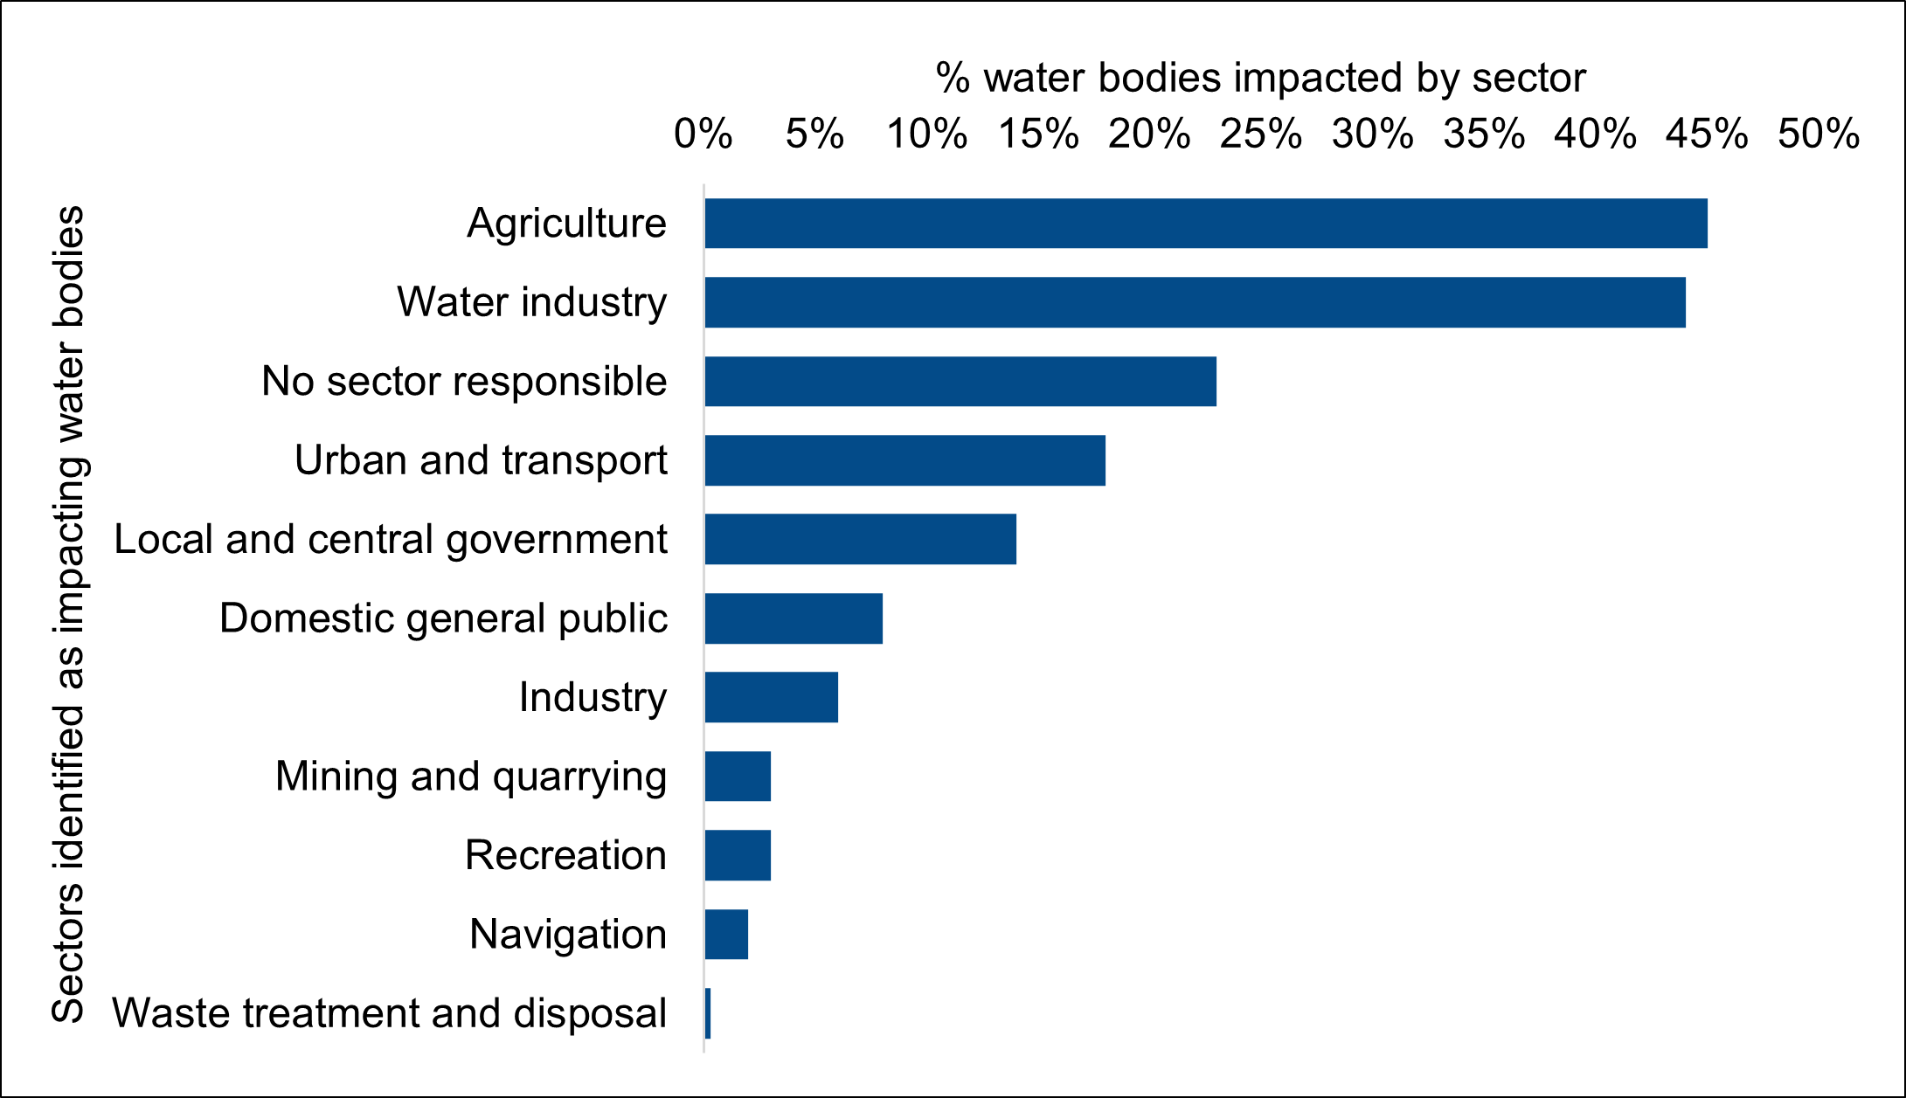
Further information on farming in England can be found in Defra’s Agriculture in the UK Dashboard and farming evidence pack, and wider metrics from the Environment Agency’s Chief Regulator’s Report.
Depending on the location and pressure, water bodies are mainly affected by livestock and arable farming. However, all farming types and the following rural activities can also contribute locally:
- horticulture
- forestry management
- activities leading to peatland degradation
- equine practices (such as manure heaps, poaching and soil compaction)
- amenity and recreation (such as pesticide and fertiliser use and water abstraction on golf courses)

2.1 Agricultural pressures on water quality
A sustainable farming industry is critical to the UK’s economic growth and food security - it is essential to ensuring clean and plentiful waters and supporting nature recovery. These objectives are complementary, not competing interests. While we fully acknowledge the significant pressures facing farmers, agriculture must also take responsibility for protecting the natural resources on which it depends. The main pollutants from farming are:
- nutrients (phosphorus and nitrogen, which is detailed in this parliamentary evidence on nitrogen)
- chemicals including pesticides, veterinary medicines and emerging chemicals (such as organic chemicals and anti-microbial resistance (AMR) found in materials spread to land)
- faecal bacteria and pathogens
- soil run off and erosion from fields (known as sediment when carried away by water)
- microplastics - particularly prevalent in sewage sludge, compost and food based digestate, but other sources such as those derived from astro turf are a growing concern
Agricultural activity can affect all water bodies and is consistently identified as one of the main pressures on groundwater quality in England. Its impacts are primarily associated with diffuse pollution from nutrients, pesticides, and microbiological contaminants. Diffuse pollution, defined as pollution that is a result of widespread activities and does not come from a single identifiable source. Diffuse pollution is difficult to identify, monitor and target effectively. An example would include land spreading – where organic manures (including slurry or waste materials) that have agricultural benefit are spread on to agricultural land when there is no crop or soil need, at excessive rates, or when ground or weather conditions are unsuitable or in highly sensitive locations, such as groundwater source protection zones.
In addition to diffuse pollution, there are often identifiable specific point sources of pollution that can range in size and impact. Point source pollution on the farm site can come from damaged, undersized or poorly constructed or maintained organic manure and silage stores.
Improvements in nutrient management practices, slurry, manure and other organic material storage and precision spreading under suitable soil conditions, would significantly contribute to reducing water pollution.

2.1.1 Pollution from nutrients
Phosphorus and nitrogen are the main components of synthetic inorganic fertilisers. They are also present in organic fertilisers such as manure and slurry, and off-farm sources including anaerobic digestate and sewage sludge. Further information can be found in the respective phosphorus and nitrogen challenge narratives on GOV.UK.
Phosphorus failures often coincide with high nitrogen so it can be difficult to differentiate the effects between them (although phosphorus is the main nutrient causing eutrophication in freshwaters and nitrogen in estuarine and coastal waters). In addition, nitrate concentrations in groundwaters abstracted for potable consumption often exceed drinking water standards. After abstraction, contaminated groundwater and surface water can require blending or treatment to meet safe drinking water standards. These treatment solutions incur substantial costs, which are ultimately borne by water company customers.
Although varying significantly at local scale, estimates indicate that nationally agriculture is responsible for between 60% and 70% of nitrate in water. As the water industry sector invests in improvements through the Water Industry National Environment Programme (WINEP), the proportional contribution of nutrients from the agriculture and rural sector will grow until it is the main contributor. This is illustrated in Figure 2 which shows that the modelled national per cent input load of phosphorus from agriculture in 2020 at 27% is significantly less than sewage treatment works (STWs) at 55%, but by 2030 is likely to have become the main contributor at 41% and STWs decreased to 27%. This is even after accounting for anticipated reductions from the agriculture sector.

Figure 2: Modelled percentage input loads phosphorus based on sector
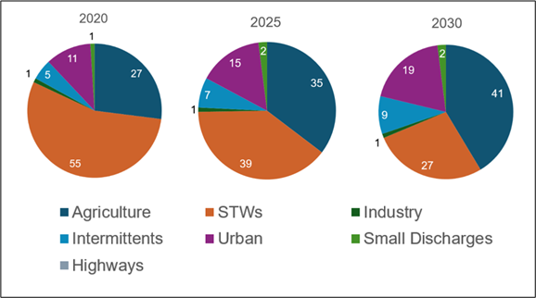
Some actions to reduce pollution can quickly affect groundwater where water moves rapidly through fractured rock. Often though, even after action is taken to reduce nutrient inputs, excess concentrations of phosphorus and nitrogen can take many years to reduce due to their persistence and slow movement through the environment. For example, phosphorus attached to deposited sediments persists in the environment and nitrogen already in the ground can continue to filter through to the water table, a process that can take decades.

2.1.2 Slurry and silage pollution
Key sources of excess nutrients are from silage (a type of animal feed made by fermenting green fodder - typically grass, maize, or other crops - under airtight conditions) and slurry (a nutrient-rich liquid mixture primarily made from animal manure and water). Under the Farming Rules for Water (Reduction and Prevention of Agricultural Diffuse Pollution (England) Regulations 2018), all applications of organic manures must be planned so that they do not:
- exceed the needs of the soil and crop on the land
- give rise to a significant risk of agricultural diffuse pollution
Insufficient storage to last the winter period, when weather and the soil conditions are often unfavourable, means that slurry often has to be spread at inappropriate times which can result in pollution. Pollution from slurry or silage stores can be diffuse, multiple or single point source.

2.1.3 Pollution incidents on farms
Figure 3 shows between fiscal years 2020 and 2025, there were 1759 minor (category 3) incidents recorded on non-permitted agriculture sites that had an effect on water and 268 serious or significant (category 1 and 2) recorded incidents (these figures exclude specific categories of pollution such as waste, burning of waste, anaerobic digestion and composting). Incident classifications are described in the Common Incident Classification Scheme.

Figure 3: Pollution incidents on farms affecting water April 2020 to March 2025 (fiscal year)
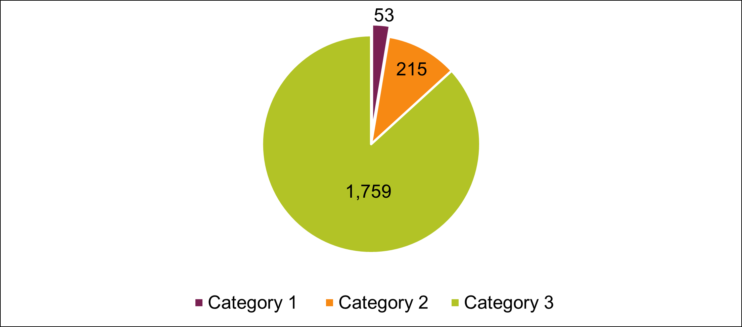
Figure 4 shows there has been no decline in the number of serious or significant incidents affecting water from farms over 5 fiscal years between April 2020 and March 2025, with a combined total of 53 in 2020 to 2021 increasing to 72 in 2024 to 2025. When a major pollution incident is traced to a farm, the Environment Agency officers work with the farmer to identify the source and cause. The responsible party is charged for Environment Agency time and, after investigation, at minimum a warning is issued. In severe cases, civil or criminal sanctions are considered per the enforcement and sanctions policy.

Figure 4: Number of serious or significant incidents affecting water April 2020 to March 2025 (fiscal year)
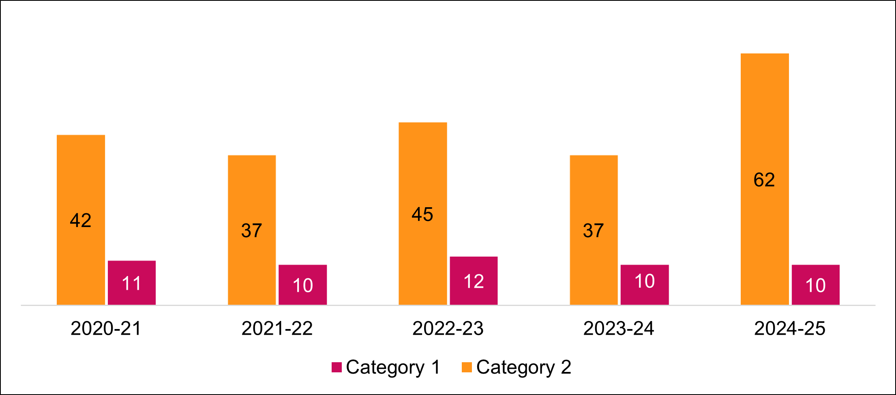
Table 1 highlights that the dairy sector, with 180 serious or significant incidents, is the main cause of agricultural related water pollution incidents in the fiscal years 2020 to 2025. This is despite the number of dairy farms in England decreasing from 9,500 in 2015 to 5,136 in 2023, due to consolidation as smaller farms either exited the industry or merged into larger operations. More cows and a higher milk yield both lead to an increase in the amount of slurry produced which needs to be stored. Environment Agency projects on the River Axe and at Poole Harbour have shown local non-compliance at 95% and 75% respectively - the majority due to failures in slurry or silage storage infrastructure and drainage leading to point source pollution incidents.

Table 1: Serious and significant incidents by farm category affecting water April 2020 to March 2025 (fiscal year)
Source Type | Category 1 | Category 2
Dairy | 33 | 147
Arable | 12 | 38
Other agricultural | 0 | 13
Beef | 5 | 18
Poultry | 0 | 5
Pig | 2 | 1
Horticulture | 2 | 4
Sheep | 0 | 2
Energy Crops | 0 | 5

2.1.3 Chemicals, pesticides and veterinary products
Chemicals entering the environment in rural areas frequently arise from agricultural activities such as the poor storage, disposal or inappropriate use of pesticides, veterinary medicines or materials spread to land. Chemicals can also bind to soil particles and enter water through soil erosion and run off. In the cool and dark subsurface environment, chemicals are slow to degrade having long term impacts on groundwater quality, our drinking water resource.
Plant protection products play an important role in food production. However, poor storage practice and inappropriate usage mean water bodies can be vulnerable to pesticide pollution. Pesticide manufacturers and the agricultural sector need to continue to promote good practice, such as the Voluntary Initiative and other catchment-based activities with water companies and other partners. Where problems persist, national restrictions may need to be considered.
Withdrawing high risk chemicals from certain uses can be the most effective way of reducing their presence in the environment, provided this can be justified on environmental and economic grounds. However, environmental recovery can be slow for those chemicals that persist in the environment for several years, or decades in the case of groundwater. Some chemicals also have multiple uses, such as veterinary medicines and as biocides for professional or home use. The significance of these uses and pathways to the environment may mean that restricting agricultural use in isolation will not return environmental concentrations to acceptable levels.

2.1.4 Spreading of sludge to land
Sludge originates from sewage treatment plants handling domestic, urban, and industrial waste water, as well as septic tanks. Most sludge produced in England ends up on agricultural land, contributing to the circular economy. Section 6 of the Environmental Performance Report 2023 states the 9 water companies dispatched 819,001 tonnes (dry solids) of sewage sludge - 93.8% of this was used in agriculture (across 151,921 hectares of land). Sludge contains organic matter, nutrients, and contaminants such as:
- undesirable metals
- organic contaminants (for example forever chemicals such as per- and poly-fluoroalkyl substances – PFAS)
- anti-microbial agents
- pathogens
- microplastics

These pollutants come from domestic sewage, industrial effluents, and surface runoff. While treatment of waste water improves the quality of final effluent before it is released into the environment, it can concentrate contaminants and nutrients (especially phosphate) in sludge. When sludge is spread on land, these pollutants can leach into water systems, harm soil health or enter the food chain.
Regulations for the use of sludge were implemented in 1989 as the Sludge (Use in Agriculture) Regulations (SUiAR). The Environment Agency is responsible for enforcing these regulations in England, but they are considered outdated, and do not provide an income stream to pay for compliance. Consequently, the use of sludge in agriculture has largely relied on a process of self-regulation and self-reporting by the water and sewerage companies and septic tank operators.
Farmers are not legally required to accept sludge, and its use depends on its perceived value for nutrients and soil health. However, concerns over pollutants (PFAS, microplastics, anti-microbial resistance) and nutrient overload (nitrogen and phosphate) are reducing farmer confidence. Sludge is typically treated via anaerobic digestion, producing biogas and biosolids suitable for agriculture.
Currently viable alternatives to the use of sludge in agriculture do not exist. In the short term the only viable alternative of sufficient capacity is landfill. Future options include forms of thermal destruction technology and recovery of usable products such as nutrients into storable forms that can replace imported or manufactured sources without creating surpluses or swapping for other pollutants. To improve sludge quality and move away from the use of inappropriate sludge to agriculture will require both a government policy direction and significant water industry investment.

2.1.5 Other materials to land
The spreading of organic materials such as compost and digestate on agricultural land is a common practice in England, intended to enhance soil fertility and structure while contributing to the circular economy. However, when mismanaged or applied excessively, these materials pose a significant risk to water quality.

Other waste derived materials spread to land to recover nutrient content or to condition soil include ash from meat, poultry litter or biomass, bone meal, paper crumble, gypsum and cement kiln dust.

During 2024 to 2025, over 840 deployment applications were approved under SR2010 No. 4 Standard Rules permits that cover most land spreading to agricultural land under EPR.

In addition to potentially high level of nutrients that could lead to pollution, organic materials may contain:
- pathogens such as E. coli or Cryptosporidium
- chemical residues: pesticides, veterinary pharmaceuticals and other contaminants present in digestate or composted waste can persist in soils and migrate into nearby water bodies
While the Environment Agency regulates the use of waste to land under EPR, similar materials, such as those that meet a Publicly Available Specification (PAS), receive less direct oversight. The lack of uniform standards, in particular for composts and digestates produced from municipal waste, introduces potential for land contamination to impact upon the water environment.

2.1.6 Soil run-off, erosion and sedimentation
In England and Wales the summary of the state of the environment - soil states:
- almost 4 million hectares of soil are at risk of compaction
- over 2 million hectares of soil are at risk of erosion
- intensive agriculture has caused arable soils to lose about 40% to 60% of their organic carbon
Soil runoff and erosion is exacerbated largely by poor soil health and inappropriate land management practices which can lead to soil sealing and compaction and general soil degradation. These practices include:
- cultivating or trafficking up and down slopes
- leaving soil bare over winter
- removal (without alternative replacement) of crop residues, leading to loss of soil organic matter
- late harvesting of crops, cultivations or land spreading under unsuitable soil conditions (such as waterlogged soil) causing compaction
- overstocking fields during wet periods causing poaching
- unrestricted livestock access to watercourses causing bank erosion and transport of sediments
- unsuitable choice of crop for soil type and topography
These activities can cause soil health problems which lead to sedimentation, discolouration, nutrient loading of water bodies, leaching of natural and applied chemicals spread to land and increase the risk of flooding. The severity of these impacts varies by soil type, slope, climate and land use. Particularly high risk crops that exacerbate the potential for erosion include potatoes and maize. Potatoes, especially on light or sandy soils, can accelerate erosion because:
- the soil is often left bare during cultivation
- harvesting disturbs soil structure
- cultivating sloped fields increases runoff risk
Maize harvesting typically occurs in autumn, when soils are wet and vulnerable to compaction from heavy machinery. This leads to risk of increased runoff and sediment transport into roads and watercourses, contributing to muddy floods and pollution. The Agricultural land use in England statistics show that maize cultivation in England has increased by 8.8% since 2023 to 237,000 hectares in 2024. This increase is largely driven by demand for livestock feed and anaerobic digestion (AD) feedstock.
Sediment problems are often assumed based on harm to wildlife, rather than measured directly. There is no national standard for sediment assessment, though there are turbidity standards for drinking water as increased sediment loading may require additional drinking water treatment. Furthermore, the interaction of fine sediment with other environmental pressures is poorly understood. Further information can be found in the physical modifications narrative.

2.1.7 Microplastics
Microplastics are an emerging contaminant in England’s soils, with growing concern over their persistence and potential ecological impacts. While waste derived organic manures and biosolids are a well-documented source, microplastics enter soils through other pathways that are less regulated and poorly understood. There are no environmental regulations regarding microplastics in agriculture, but some plastics come under waste regulations.
Microplastics can come from plastic mulches, agricultural films, organic manures including composts, irrigation water, and atmospheric deposition. Fragmentation of larger plastic debris from packaging and astroturf also contributes to microplastic accumulation in rural landscapes. These particles, typically less than 5mm in size, can persist in soils for decades, resisting degradation and potentially breaking down into even smaller nanoplastics.
Their presence in soil can act as vectors for harmful chemicals, including persistent organic pollutants and heavy metals, which adhere to their surfaces. This raises concerns about bioaccumulation in soil organisms and potential transfer through the food chain. Earthworms, for example, have been shown to ingest microplastics, which may impair reproduction and soil function.
Despite these risks, there is currently no standardised monitoring framework for microplastics in soils and national scale data remains limited. Addressing this gap is essential for understanding the full extent of microplastic pollution and developing effective mitigation strategies.

2.2 Agricultural water needs and climate resilience
Secure and reliable water supplies are vital for food production, food security and supporting the economy. Abstraction demand for arable agriculture and irrigation is typically a small proportion of the total annual licensed water abstraction in England. However, in some areas, the daily demand for agriculture abstraction can be comparable to abstraction for public water supply. Demand is at its height in the summer months and is concentrated in areas where there is most pressure on supplying water for public use.
The impact of drought on the irrigated agriculture sector can be huge, affecting food production, agri-businesses, food prices, and the quality and availability of produce for food security. As with flooding, climate change is increasing extremes of weather, increasing the likelihood of hotter and drier summers, such as those experienced during 2018, 2022 and 2025.
The scale of pressures on water availability are highlighted in the national framework for water resources, this includes a range of measures to help farmers build water resilience, support local water solutions and build in real-time data to manage water abstraction more sustainably. Such as:
  - helping farmers and growers understand the options available to them to improve water supply resilience through a programme of local resource option screening studies
  - supporting the establishment of water abstractor groups (WAGs) so that groups of farmers can more effectively invest in shared infrastructure and can look at ways of sharing water resources
  - moving towards a system of dynamic catchment management where there is more near real-time information available to water users to enable water to be abstracted when it is available
  - improving inspection targeting using technology and intelligence to look at highest risk abstractions; for example, using satellite information to detect moisture content in fields and crops
In addition to farm inspections to check compliance with regulations to protect and improve water quality (see section 3.1), the Environment Agency carries out separate inspections to check compliance with abstraction and impounding licence conditions. The frequency of these inspections is determined by the potential risk to the environment and compliance history.
There are about 10,000 abstraction and impounding licences with an agricultural purpose in England. The Environment Agency identifies licence breaches by inspecting licences, reviewing abstraction returns and investigating incident reports. Figure 5 shows that, since the fiscal year 2020 to 2021 (when inspections were affected by COVID-19), the Environment Agency have carried out over 1000 agricultural abstraction and impounding licence inspections annually.

Figure 5: Agricultural abstraction and impounding licence inspections 1 April 2020 to 31 March 2025
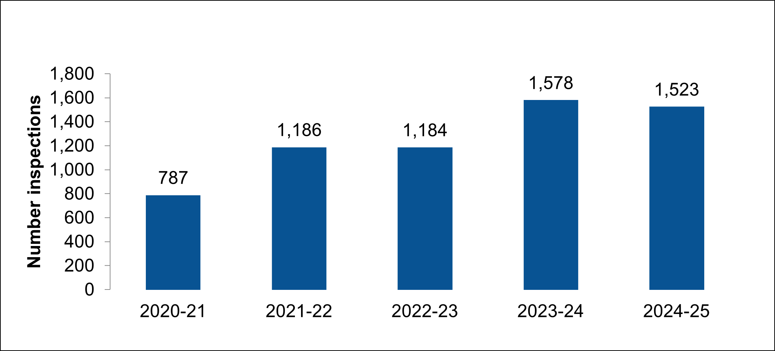

2.3 Flooding on farmland
Farmers and land managers can be adversely affected by flooding through damage to soil and crops and harm caused to livestock. However, adopting natural flood management (NFM) practices which increase infiltration, slow overland flow or store water (also supporting drought resilience efforts) can improve flood resilience both on farm and across the wider local community. Climate change is exacerbating frequent extreme weather, so the sector needs to adapt and become more resilient.
- 74% of the UK’s total floodplain area is agricultural land
- 59% of grade 1 (most fertile) agricultural land is at risk of flooding from rivers and the sea
The national strategy for flood and coastal erosion risk management sets out our vision. The Environment Agency are working closely with the rural sector to encourage changes in agricultural land use and management to prepare for and be resilient to the risk from flooding they face, now and in the future. The rural flood resilience partnership has been established to improve collaboration, deepen understanding of vulnerabilities and support rural communities and agricultural businesses. The rights and responsibilities of riparian owners provides further information on the maintenance of water courses.

2.4 Equine activities impacting on water quality
The equine sector includes horses, ponies and donkeys. Alpaca management can also be of local concern. Activities on both private holdings and equine businesses, if poorly managed, can lead to nearby watercourses or groundwater becoming polluted. Equine activities are not covered by the farming rules for water. While the nutrient content of horse manure is lower than other livestock, the pollution effect can be locally significant, particularly the leachate from manure heaps. Equine activities that can adversely affect the environment include:
- manure storage
- burning stable waste, such as manure and bedding
- hay soaking
- washing down areas
- dirty yards
- exercise pools
- land management (for example soil compaction, over-grazing, grazing wet areas, turn-out areas)
Poor equine land management can lead to:
- nutrients leaching from manure heaps close to watercourses
- poaching where pasture is broken into wet muddy patches by the action of feet on wet ground)
- surface water flooding on compacted soil
- bare areas where soil can erode

3. Mechanisms for improvement

3.1 Regulatory farm inspections (non-permitted) – water quality focussed
During a regulatory inspection on non-permitted farms, Environment Agency officers work with farmers to increase their levels of compliance with existing environmental regulations. The main agricultural regulations for non-permitted farms to protect and improve water quality are the:
- Silage, Slurry and Agricultural Fuel Oil storage regulations (The Water Resources (Control of Pollution) (Silage, slurry and agricultural fuel oil (England) Regulations 2010)
- Farming Rules for Water (the Reduction and Prevention of Agricultural Diffuse Pollution (England) Regulations 2018)
- Nitrate Vulnerable Zones under the Nitrate Pollution Prevention Regulations 2015
- Sludge (Use in Agriculture) Regulations 1989
- Environmental Permitting Regulations
The Environment Agency is also responsible for regulating intensive pig and poultry farms - permitted farms - under the 2016 Environmental Permitting Regulations (EPR). Poultry farms with a capacity of more than 40,000 birds, and pig farms with a capacity of more than 2000 places for production pigs greater than 30 kilograms or more than 750 places for sows, require an environmental permit to operate. Under EPR free range poultry are regulated but not outdoor pigs.
To help the farming sector improve its environmental performance, in 2022 the government allocated £4.7m annually to the Environment Agency to fund 4000 non-permitted farm inspections each year, a ten-fold increase in inspections. As a result, over 100 additional regulatory officers were recruited, the majority with a background in farming or working with farmers. Inspections are targeted in areas most at risk of water pollution from agricultural activity. These include areas with protected status, catchments with high densities of livestock, and those that we know need improving in water quality.
Between April 2022 and March 2025, Environment Agency officers:
- carried out 12,810 inspections of non-permitted farms
- found 6,288 (49%) of these inspections were non-compliant with the regulations assessed
- issued 20,040 improvement actions
- verified that 14,348 actions to improve the environment have been completed
Figure 6 displays the number of annual non-permitted farm inspections (fiscal year) have increased from 270 in 2020 to 2021 to 4,545 in 2024 to 2025, exceeding the annual target of 4000.

Figure 6: Number of Environment Agency non-permitted farm inspections 1 April 2020 to 31 March 2025
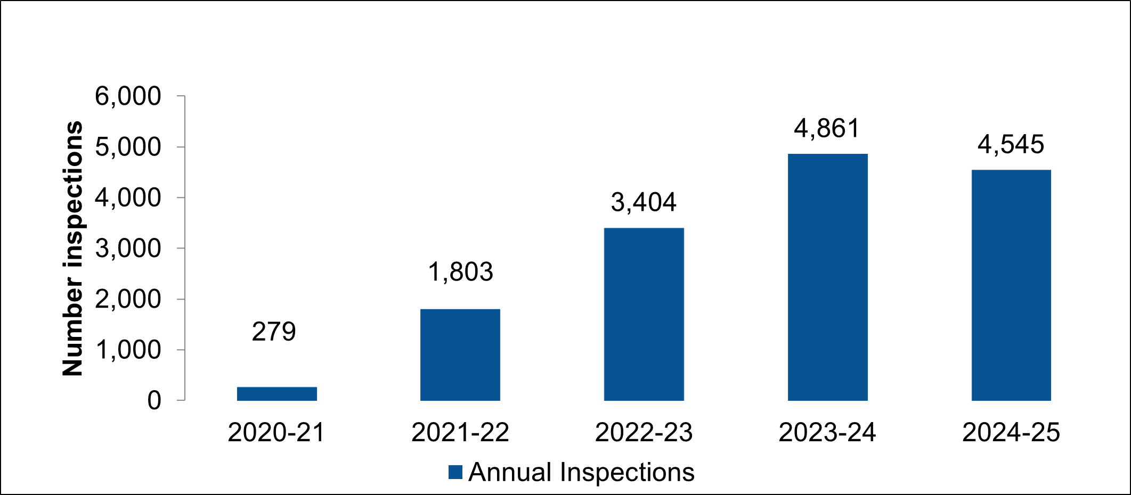
In 2025, the government announced additional funding to the programme allow the number of farm inspections carried out by the Environment Agency to increase to more than 6000 farm inspections annually by 2029.
Figure 7 shows that the trend in per cent compliance with the regulations inspected for has not significantly changed since the start of the enhanced farm inspection programme, with the 2022 to 2023 fiscal year having a 49% rate of non-compliance being the same as in the 2024 to 2025 year. The non-compliance rate of 67% in 2021 to 2022 is higher as we were inspecting a significantly smaller number of farms, exacerbating the margin for error. It is likely that the number of non-compliances will remain high in the short term as we target the highest risk farms in the highest risk areas; however, over a longer period it is anticipated that the performance of the sector will improve as more farms take actions to address non-compliances.

Figure 7: Percent non-compliant inspections on non-permitted farms 1 April 2020 to 31 March 2025
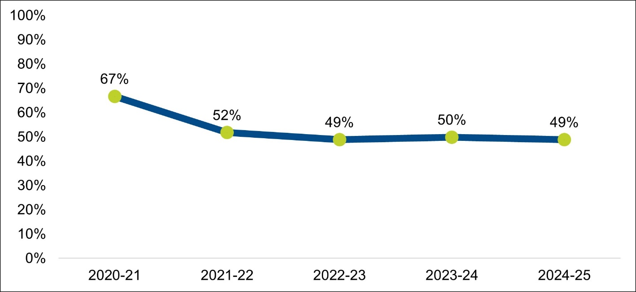
During an inspection, Environment Agency officers work with farmers by providing regulatory advice and guidance, issuing improvement actions reflecting individual circumstances and highlighting other available support, such as Catchment Sensitive Farming advice and environmental land management options. A proportionate approach is taken based on the risk to the environment. Figure 8 shows the trend in improvement actions issued over the last 5 fiscal years, with 342 issued in 2020 to 2021 and 6,884 issued in 2024 to 2025 to non-permitted farms.

Figure 8: Improvement actions issued on non-permitted farms 1 April 2020 to 31 March 2025
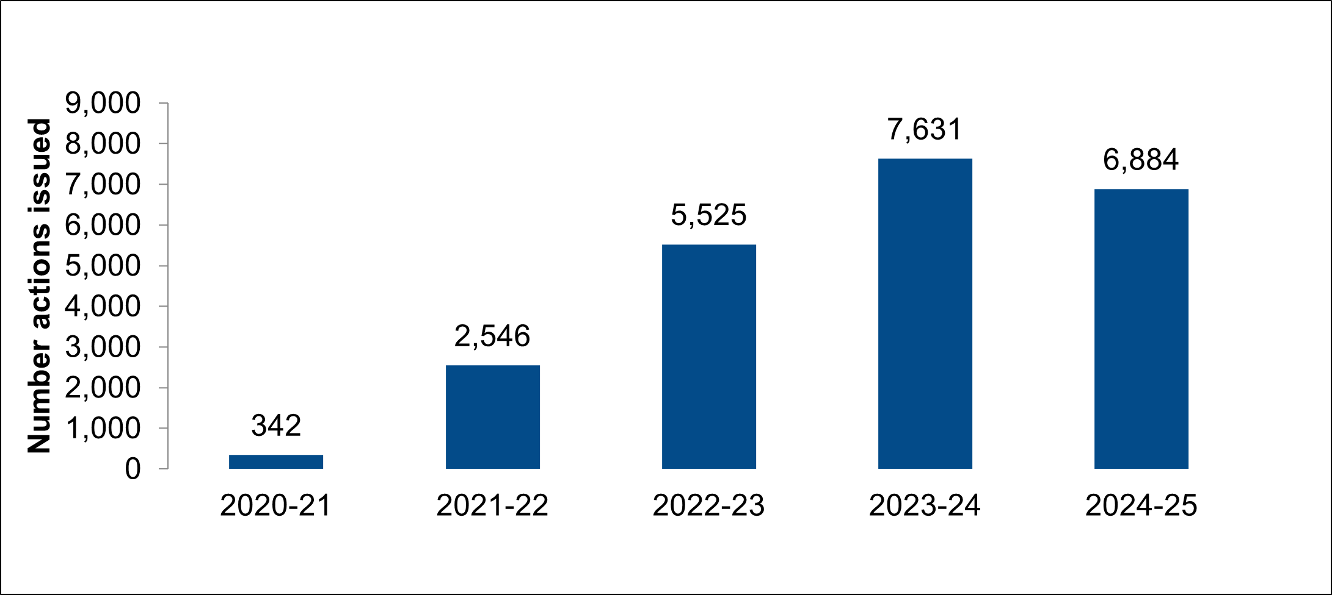
Improvement actions required to address issues vary in scale and complexity. They range from fixing a small piece of guttering - with ‘clean and dirty water’ separation a simple but important action to reduce the volume of water entering slurry lagoons and silage effluent tanks - to the complete replacement of a slurry store. Figure 9 shows that clean and dirty water separation actions were issued 2,971 times and is the top improvement action issued to non-permitted farms between April 2022 and March 2023.

Figure 9: Top 10 improvement actions issued to non-permitted farms 1 April 2020 to 31 March 2025
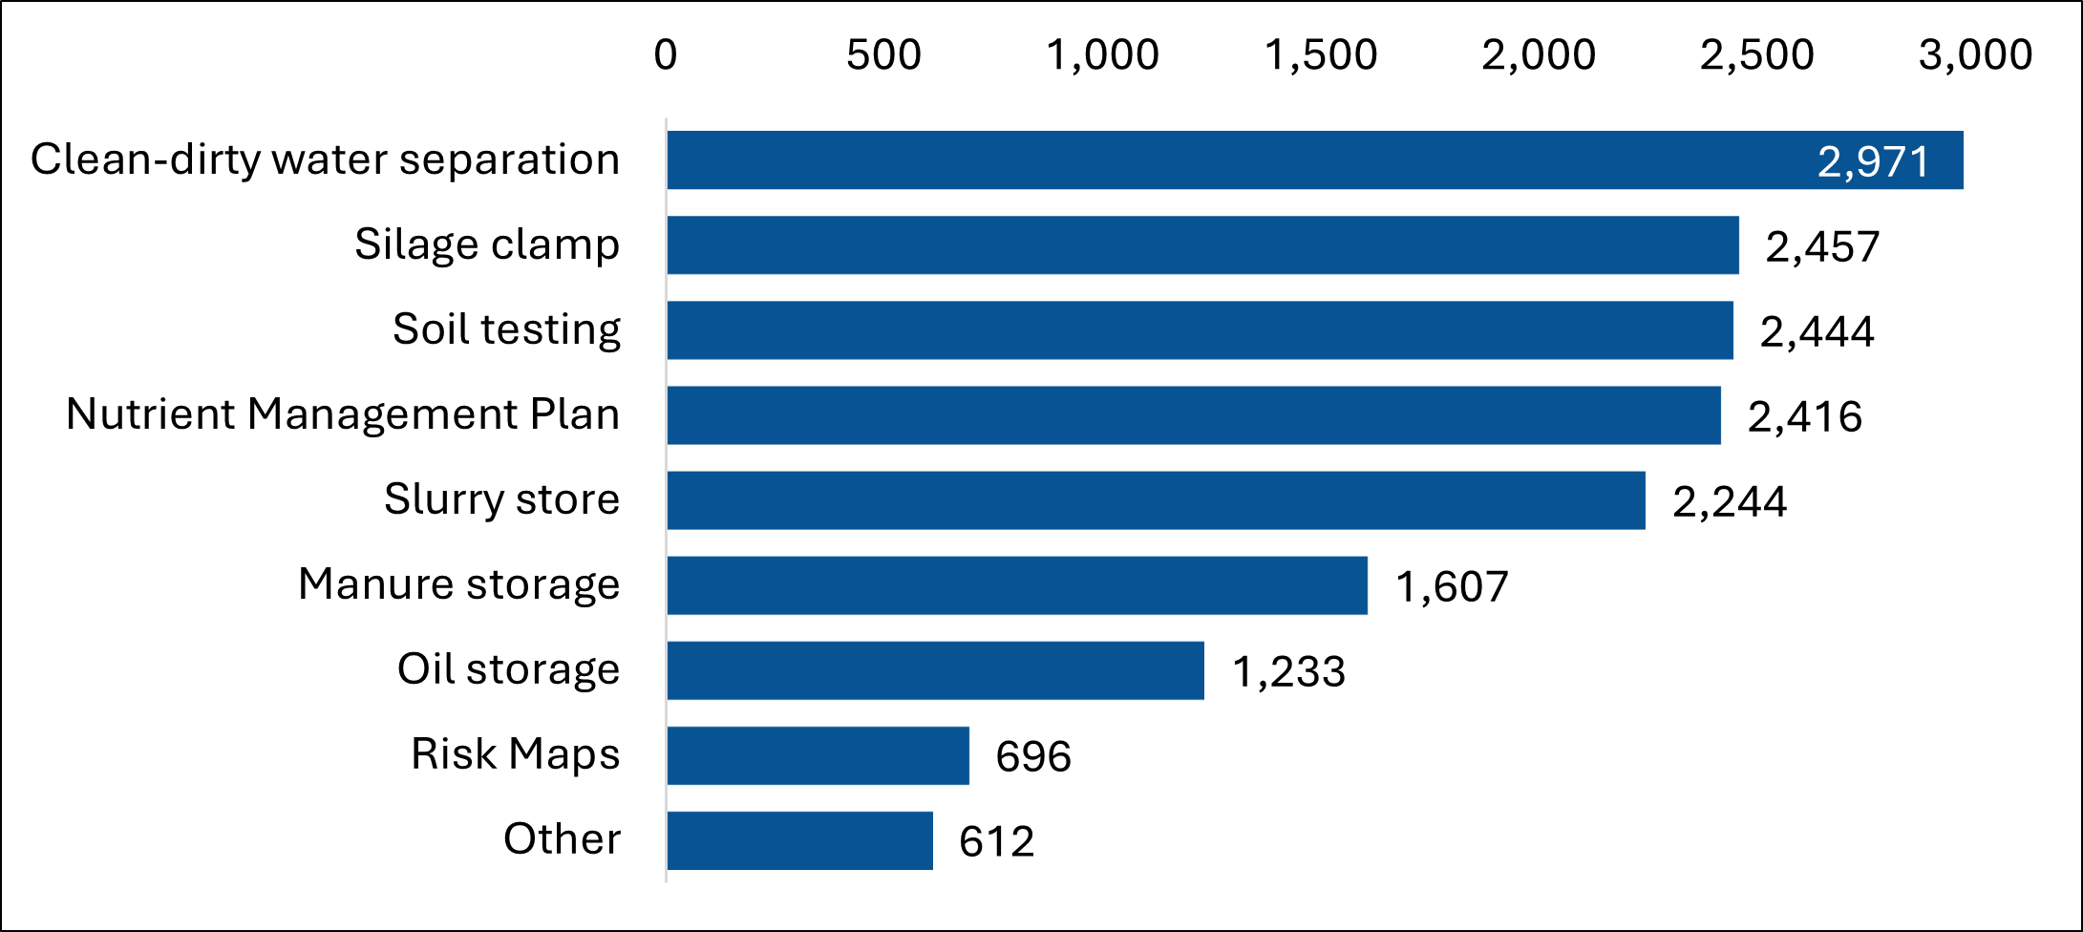
When an improvement action is completed and verified, it is classed as an outcome. Some actions, such as a new slurry store, can take several months or even years to complete due to requirements in gaining the correct permissions, accessing finance and being able to construct in a favourable weather window. Figure 10 shows the increase in the annual number of verified outcomes following the expansion of the Environment Agency farm inspection programme, increasing from 245 in the fiscal year 2020 to 2021 to 6,345 in 2024 to 2025 on non-permitted farms.

Figure 10: Verified outcomes complete on non-permitted farms 1 April 2020 to 31 March 2025
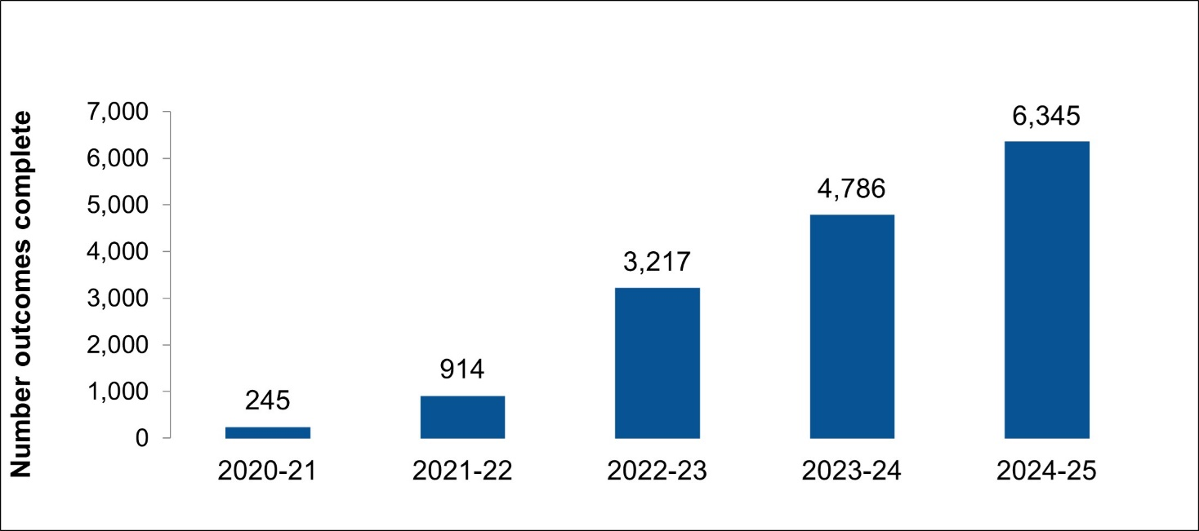
When a farmer does not bring themselves into compliance in agreed timescales, or there is a risk of an actual pollution incident, the Environment Agency will take a further action, which can include warnings, civil sanctions, formal cautions or prosecutions.

3.2 Permitted sites regulated by the Environment Agency
The Environment Agency is responsible for regulating intensive pig and poultry farms -permitted farms - under the 2016 Environmental Permitting Regulations (EPR). As of March 2025, there are a total of 1328 permitted sites (228 pig permits; 1100 poultry permits) in England. 1078 of these farms are in the Pig and Poultry Assurance Scheme (81% of permitted farms). The number of permitted farms has shown a small increase over the last 5 years but has grown substantially since 2010.
Between April 2022 and March 2025, the Environment Agency has carried out:
- 1191 inspections of farms permitted under EPR
- and a further 1494 have been inspected as part of the Pig and Poultry Assurance Scheme
There were 3 serious pollution incidents between April 2022 and March 2025; and there were 356 incidents with little or no ongoing environmental impact - the vast majority of which were a result of odour issues and not related to water pollution. 98% of all permitted sites were within the highest 2 levels of compliance, indicating a low level of risk to the water environment from permitted sites.

3.3 Advice and incentive mechanisms

3.3.1 Agri-environment schemes
Government funded agri-environment schemes support the regulatory approach by incentivising sustainable land management, supporting farmers and land managers in delivering environmental benefits alongside food production. By incentivising practices like planting hedgerows, managing wetlands and reducing nutrient runoff, the schemes contribute to national goals such as achieving net zero emissions and enhancing biodiversity.
Environmental Land Management Schemes (ELMS) were introduced in England as part of the Agricultural Transition Plan and provides the framework for agri-environment schemes going forward.
- Sustainable Farming Incentive (SFI) – rewards farmers for adopting sustainable practices like soil health and nutrient management
- Countryside Stewardship Higher Tier (CSHT) – continues to support biodiversity, water quality, and heritage preservation
- Landscape Recovery (LR) – funds large-scale projects like habitat restoration and rewilding
The Environment Agency is a funded delivery body for ELMS and advises and shapes the scheme design and has a defined operational delivery role in both Landscape Recovery and Countryside Stewardship Higher Tier.
The total area covered by environmental stewardship, including Countryside Stewardship Higher Tier and Sustainable Farming Incentive scheme agreements in England at end December 2024 is:
- estimated to be around 5.6 million hectares
- approximately 55,000 farms farm businesses
- equivalent to 64% of the utilised agricultural area of England (8.7 million hectares)

There is some uncertainty over the total area, due to overlap between schemes and actions, and the way that records are kept.

3.3.2 Sustainable Farming Incentive
The Sustainable Farming Incentive (SFI) pays farmers to adopt sustainable farming practices that enhance the environment and support farm productivity. Although at the time temporarily closed to new applicants, as of March 2025 there were 37,900 active SFI agreements in England. These agreements are:
- held by nearly 32,000 unique farm businesses
- covering 800,000 hectares farmed without insecticide, as part of the Integrated Pest Management action plan
- covering 280,000 hectares of grassland being managed with low inputs, helping to protect biodiversity and water quality
- including 65,000 hectares of grass buffer strips

3.3.3 Countryside Stewardship Higher Tier
Countryside stewardship higher tier (CSHT) is designed for land requiring complex management to protect and improve the natural environment. The scheme offers multi-year agreements and one-off grant payments, supporting projects such as:
- managing woodlands
- improving habitats, water quality and air quality
- enhancing natural flood management
- restoring peatland and moorlands

3.3.4 Landscape Recovery
Landscape Recovery pays for bespoke, longer-term, larger scale projects to enhance the natural environment and adapt to climate change. Natural England and the Environment Agency administer the schemes and manage grant funding for successful projects. Each Landscape Recovery project covers between 500 and 5000 hectares, with farmers and landowners collaborating to restore and enhance natural habitats, including woodlands and river systems. Projects currently planned in England will:
- cover 300,000 hectares (2.3% of England) planning large-scale changes to benefit the environment and climate (across 56 Landscape Recovery projects)
- work with 1200 farmers and land managers across the projects
- cover over 480 kilometres of river length
The Landscape Recovery scheme is driving innovation for nature recovery; the projects will embrace the opportunity to innovate and pilot novel approaches. Together with other ELM schemes, they could help secure a transition to long-term low-nutrient land uses, including habitats and woodlands, reducing the overall nitrogen and phosphorus pollution load from the agriculture sector.

3.3.5 Catchment Sensitive Farming
Catchment Sensitive Farming (CSF) is a collaborative initiative led by Natural England in partnership with Defra, the Environment Agency and the Forestry Commission. CSF now covers all of England, giving farmers access to free, confidential, tailored advice and support for improving water quality, air quality and natural flood management (NFM) practices. As of November 2024:
- CSF had delivered advice on over 200,000 practices to 28,761 farm holdings, representing 49% of the farmed area of England
- 85% of farmers who met their CSF Adviser indicated they were a person they could trust
- Implemented approximately 100,000 on-farm actions across the farmed landscape following CSF advice
Between 2006 and 2018, CSF advice led to an average 4% reduction in nitrate, an 8% reduction in total phosphorus, a 37% reduction in pesticide contamination of surface water and 12% reduction in sediment losses (average across of 4 monitored CSF phase 1 priority catchments).
CSF was expanded in 2022 to include advice for NFM alongside advice for water and air quality and has provided NFM advice directly to more than 2,800 farm holdings, including:
- practices to improve infiltration through better soil management
- buffer strips to slow flow
- how to store and slowly release water (such as run-off attenuation features)
Financial support for NFM options is available through SFI and CSHT. There are also capital grants available to help farmers and landowners reduce the effects of flooding on their more productive land, reduce risks to downstream communities, or adapt their land and farming practices to wetter conditions. 63 of the SFI 2024 actions are expected to provide natural flood management benefits and 86 of the new CSHT actions could be used to support natural flood management, including specific actions for arable and grassland farms, and in woodland, moorland and coastal settings.

3.3.6 Government grants
Alongside advice and guidance and regulation, there are various government grants available to support the sector. The slurry infrastructure grant is aiding some farmers in improving slurry management. This competitive grant funds up to 50% of the costs to replace, build additional, expand or cover existing slurry stores lowing them to reach 6 months storage for beef and dairy cattle and 8 moths for pigs. The grant also funds items to help manage slurry stores, such as reception pits, slurry pumps, agitators and separators.

3.3.7 Funding for nature based solutions through a future flood investment programme
Government recently announced a new flood investment programme. This will allow funding for a more nature based solutions delivering natural flood management to protect rural communities and beyond.

3.3.8 Local Nature Recovery Strategies
Local Nature Recovery Strategies (LNRS) are a nationwide system of locally led spatial strategies that map what and where habitat is most important to create or improve to meet a broad range of local and national environmental objectives, including improving the water environment. LNRS will provide information to farmers and land managers to help them choose which environmental land management options would be appropriate to their land. LNRS responsible authorities will support delivery of LNRS priorities and measures through a range of funding and investment routes. For example, some local authorities are exploring how they can convene utilities, infrastructure and food and drink sectors that are at risk from climate impacts to co-fund catchment resilience actions at a larger scale.

3.3.9 Protected sites strategies
The Environment Act 2021 introduced new powers for Natural England (NE) to prepare and publish Protected Site Strategies (PSS). PSS will bring together key stakeholders to address pressures on protected sites to help restore our most precious habitats and species, safeguard the ability of our natural environment to provide natural capital benefits, now and in the future and unlock green finance and new mechanisms for environmental improvement. Farmers will have a key role to play in the development and delivery of PSS.
PSS will complement and support other nature recovery mechanisms such as Local Nature Recovery Strategies.

3.3.10 Sector initiatives
Initiatives from the water industry, rivers trusts and wildlife trusts, farming industry-led campaigns and retail, such as Nestlé’s Regenerative Milk Plan, are available in many areas to support improved environmental behaviours across catchments.
The catchment-based approach, catchment partnerships and farming initiatives such as the championing the farmed environment encourage farmers to protect water the water environment, highlighting the benefits to the farming business of incorporating environmentally friendly practices and environmental schemes that improve water quality.
Many water companies run catchment management schemes in Safeguard Zones (SgZs). SgZs are areas around public water supplies where poor water quality is leading to the need for additional treatment in the production of drinking water. Schemes can fund or incentivise improvement to farming practices and land management over and above existing initiatives (such as agri-environment or CSF schemes) to improve water quality and reduce the need for treatment in the production of drinking water.

3.3.11 Working with the supply chain and assurance schemes
Environment Agency engagement with the agri-food sector has continued to expand, with efforts focused on raising awareness of the environmental and operational issues from contemporary farming practices and contractual relationships with retailers, while supporting the development and implementation of sector-wide solutions.
There are a number of market-led initiatives, including the WRAP food and drink pact, UK dairy roadmap and farm assurance schemes focusing on environmental standards, such as LEAF (Linking Environment and Farming) and the Soil Association. The food industry, including brands, processors and supermarkets, are also exerting more pressure on their supply farms, to improve brand value, reduce risk of reputational damage and to ensure their businesses are sustainable in the future.
Collaborative work is ongoing with organisations such as Sainsburys, Tesco, WRAP and the dairy sector, alongside supporting the implementation of the National Farmers Union’s review of assurance schemes.

3.3.12 Water Restoration Fund
Through the Water Restoration Fund, local groups can apply for funding to strengthen their capacity and capabilities in delivering on-the-ground initiatives related to farming and the rural environment. In 2024, money collected from fines imposed on water companies between April 2022 and October 2023 was invested into the £11 million Water Restoration Fund. The fund provides grants to support projects that aim to improve the water environment.

4. Innovation and technology
From working with agri-food industries, to harnessing data, technology and innovative strategies, the Environment Agency is transforming work with the agriculture sector to enhance efficiency and effectiveness. Improved technologies such as sediment fingerprinting and advanced digital systems enable the collection, analysis, and integration of environmental data within mapping tools, pinpointing areas where agricultural pollution poses greatest risk. Further information can be found in the Environment Agency Chief Scientist's Annual Review.
A new nutrient management planning tool (NMPT-GB) is a free online tool launching in Autumn 2025 to help farmers manage nutrients efficiently, reduce pollution, and comply with regulations using trusted guidance from the Agriculture and Horticulture Development Board.
The Environment Agency’s Agricultural Land Environmental Risk and Opportunity Tool (ALERT) has been developed to help farmers analyse the landscape and reduce pollution from agriculture. It uses some of the very best spatial data to locate environmental risks and opportunities. Environment Agency officers regularly use these remote sensing technologies - drone imagery, satellite data, and geospatial mapping - to pinpoint environmental risks more precisely. For example, users can locate overland flow pathways and use remote sensing data to look at changes in the landscape over a season. This represents a step change in the ability to target pollution mitigation measures more accurately.

Figure 11: Annual number of remote sensing inspections of non-permitted farms 1 April 2020 to 31 March 2025
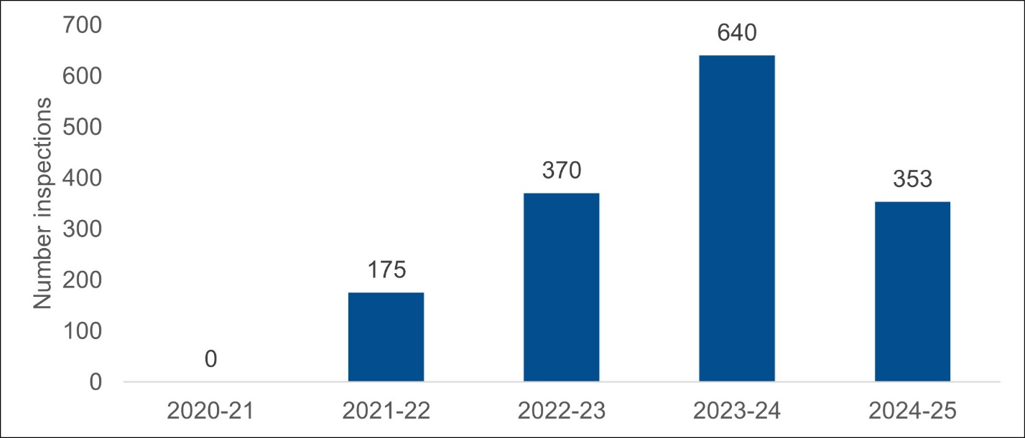
Remote inspections have made an increasingly significant contribution to the Environment Agency’s 4000 farm inspection target since 2021. This is displayed in Figure 11 where remote inspections of non-permitted farms have increased from zero in the fiscal year 2020 to 2021 to 353 in 2024 to 2025. The Environment Agency will look to further embed remote sensing into the farm inspection programme to ensure maximum efficiency with inspections and align with the Environment Agency’s strategy to further embrace innovation and efficiencies.
To support the farmers during the inspection process, the Environment Agency has produced a collaborative video to demystify the inspection process and provide clarity on what to expect when officers inspect a farm. This is complimented with guidance for farmers to support them on compliance with water-based agricultural regulations and tailored campaigns to support preparation for winter.
To address water abstraction issues, the Environment Agency is enabling flexible licensing systems, through dynamic catchment management and near-real-time monitoring of abstraction, discharges, and water availability. Innovations such as precision irrigation and smart farming technology will drive efficiency, reducing unnecessary water use and optimising consumption. A smart metering trial is set to launch 2025 across two East Anglian catchments, enhancing data-driven water management.
The water resources licensing digital service (WRLS) has been further enhanced, equipping it with e-alerts to notify licence holders of changes in hands-off-flow conditions. Looking ahead, further developments to WRLS will integrate real-time river and groundwater level data, cross-referenced against licence requirements, with future capabilities to provide predictive forecasts.

4.1 Land use framework
The Land Use Framework (LUF) for England, due in 2025, is set to reshape how land is managed across sectors, with agriculture playing a central role. The framework aims to protect high quality farmland and ensure long term food security against climate pressures and global instability. It will support local planning authorities, other planners and land managers with advanced land use data to make informed decisions about where to locate development and where to support nature recovery and food production.
Rather than imposing changes, the framework promotes a collaborative, data driven approach that empowers farmers to make informed decisions about land use. It encourages diversification and multi-benefit land management, such as integrating nature recovery or renewable energy, without compromising agricultural productivity.
By aligning agricultural priorities with broader national goals - such as housing, climate mitigation, and biodiversity - the LUF seeks to create a more resilient and sustainable land system. Farmers will have access to the most comprehensive land use data ever published, enabling them to balance economic viability with environmental stewardship (consultation document).
The Environment Agency is developing a Land Use Choices Tool (LUCT), a spatial decision-support tool to assist in identifying where targeted habitat or woodland creation on agricultural land will deliver the greatest environmental benefits and cost effectiveness. The LUCT is designed to support local delivery bodies, landowners, and policymakers to make informed decisions about suitable locations, types and extent of habitat and woodland creation to secure a bigger contribution towards the government’s EIP goals.
The Environment Agency are keen to support landowners to maximise the value and potential of land, alongside contributing more to Defra’s environmental goals, while also protecting against environmental risks and potentially diversifying income opportunities. LUCT moves away from a ‘block-planting’ land conversion approach, to help understand how patches of land across all farms could be used to generate more value from potential biodiversity and woodland creation opportunities.

5. Challenges to improving the water environment

5.1 Population growth and housing development
Population growth and associated housing development are placing increasing pressure on agriculture and the water environment. As demand for food and energy increases, farming practices are becoming more intensive, and the volume of organic waste, such as sewage sludge and food waste, is growing. These materials, often recycled into compost or digestate, require land spreading, which adds further strain to a land bank that is both finite and, in some areas, already saturated with nutrients.
Large intensive livestock units are becoming more common, increasing demand for water abstraction and energy use. The diversion of waste from landfill to land recovery - such as spreading gypsum, food processing residues, or milk - can offer agricultural benefits but also heightens the risk of nutrient overload and pollution. While the use of organic manures and waste derived materials support the circular economy, it introduces logistical and financial challenges that must be carefully managed.
Despite these pressures, a well functioning agricultural sector has a vital role to play in supporting sustainable growth. By investing in infrastructure, such as appropriate slurry storage, and adopting practices like nutrient management planning, farmers can reduce reliance on costly artificial fertilisers, improve soil health, and protect water quality. These actions are not only good for the environment but also make sound business sense.
Moreover, when farming is done sustainably, it helps create environmental capacity – freeing up space and resources for other forms of economic development. In this way, agriculture can contribute to broader growth ambitions, supporting food security, rural economies and environmental resilience.

5.2 Policies to protect soil
Soil has been overlooked in environmental policy in recent decades, but its importance is becoming more widely recognised. Current legislation (such as Farming Rules for Water) aims to protect water quality by reducing diffuse pollution from agriculture, with soil being indirectly protected as it plays a key role in nutrient and other pollutant transport to watercourses. Compliance with the limited soil related legislation is considered poor, or at best inadequately assessed. For example, under Farming Rules for Water, in the 3 years prior to April 2025, 37% of farms inspected by the Environment Agency could not demonstrate adequate soil testing for key nutrients and pH.
To prevent soil degradation and protect soil to deliver essential ecosystem services that we rely on, it is important that policy measures are in place that support and encourage the protection of soil health, its functions (services soil provides) and prevention of soil degradation. The creation of new or improved regulations should be considered that focus on the natural capital value of soil itself, recognising the functions healthy soils can deliver for wider society.

5.3 Policies to protect groundwater
Out of sight and out of mind, groundwater is an essential part of the environment. Groundwater underpins river flow, emerging through riverbeds noticeably in chalk streams or at springs. It is the primary source of drinking water for approximately 18 million people in growth and development focussed areas, such as south and east England. It is also an ongoing source of nutrients from historic pollution, as well as being affected by current pollution. Coupled with climate change, existing pressure on groundwater is exacerbated and it continues to deteriorate. Further specific protection and policies to prevent deterioration caused by current agricultural practices and to improve groundwater need to be developed if we are to:
- achieve environmental targets for water quality and quantity
- increase rural business growth and profitability
- reduce pollutant losses
- avoid increasingly unsustainable water treatment
Policies and incentives recognising groundwater is not solely protected if activities are 50 metres from a borehole, well or spring will need support from multiple sectors to ensure the right specific protections are in place for all sectors to benefit from this undervalued resource.

5.4 Climate change
Farming and food production are increasingly vulnerable to climate change, with droughts and floods posing significant challenges. However, agriculture also holds the potential to support water conservation and natural flood management, helping to store and slow the flow of water.
Climate change is exacerbating frequent extreme weather and the pressure from agricultural practices - so the sector needs to adapt and become more resilient. It is increasing the likelihood of hotter and drier summers, such as those experienced in 2018, 2022 and 2025. Average flows for most southern catchments in England are expected to continue to decrease.
Increased intensity of rainfall leads to run off on soils and associated products spread to land such as nutrient rich fertilisers and pesticides. The upper few centimetres of soil are often the most fertile, so this loss can significantly impact on productivity.
Flooding poses serious risks to farmers through damage to land, crops and livestock, but they can also play a key role in mitigating flood impacts by adopting natural flood management practices. National strategies and partnerships aim to build resilience through land use changes, collaboration, and targeted support. Financial aid and expert advice are available to help farmers implement measures like improved soil management, buffer strips and water storage features to protect both farmland and downstream communities.

5.5 Environmental Improvement Plan
The EIP 2025 (due to be published late 2025) will build on the EIP 2023 which sets out the actions required to help restore nature, tackle environmental pollution and increase the prosperity of the country. It builds on both the 25 Year Environment Plan and the Environment Act 2021. Further information can be found in the supporting nature recovery narrative.
The current EIP (2023) has set goals and targets to achieve clean and plentiful water. The overarching goal is for at least 75% of waters to be close to their natural state as soon as is practicable. Complimenting this goal are statutory targets to reduce nitrogen, phosphorus and sediment pollution from agriculture into the water environment by at least 40% by 2038, compared to a 2018 baseline, with interim targets of 10% by 31 January 2028, and 15% in catchments containing protected sites in unfavourable condition due to nutrient pollution.
The EIP requires farming, through a combination of regulation and public and private schemes, to contribute 80% to 100% of the target to restore or create more than 500,000 hectares of wildlife rich habitat outside of protected areas by 2042. This reflects the unique role that farmers have carrying out actions such as restoring peatland and creating biodiverse woodlands. These changes are needed at scale, but the habitats must be in the right place and have the right management. For that reason, many cases will require targeted advice and support to succeed.
The key levers indicated in the 2023 EIP target pathways for the agriculture sector of direct relevance to water quality include:
- increasing compliance of farms with existing agricultural regulation, with a small component through new regulatory rules
- encouraging engagement with CSF advisers to promote environmentally friendly farming practices
- increasing land management actions through advice and incentives, funded by ELMS
- habitat and woodland creation such as riparian buffer zone planting, cross slope woodlands and creation of wood pasture.
- tree planting on farmland to achieve net zero goals
In January 2024, the Office of Environmental Protection (OEP) report provided an assessment of government’s progress towards legally binding environmental targets and the goals of the EIP. The OEP assessment is that the government remains off track to meet climate and nature crises targets. The report recommended: ensuring the right policies were in place (actions are currently not addressing all major pressures), greater urgency, scaling up delivery and adequate resources to implement actions at the scale required to achieve desired outcomes.

5.6 Modelled improvements with environmental land management
Modelling has demonstrated that there is a significant gap between the expected improvements from current policies and the water quality targets, particularly concerning nitrogen, phosphorus and sediment pollution from agriculture. However, it should be recognised that these models often examine individual measures separately, rather than considering the combined effects of multiple approaches - like regulation, guidance, and incentives - across the entire catchment.
The Environment Agency estimated in 2022 how far ELMS measures were predicted to reduce agricultural nitrogen, phosphorus and sediment by 2027. The modelling assumed that uptake of water quality relevant ELMS measures (typically SFI and CSHT measures that do not remove any land from production) would be contained within 50% of farm agreements in high priority target areas (covering 55% of England) for the schemes but only in 20% elsewhere. This is representative of the levels of uptake seen in schemes with and without CSF support in 2022.
A 2024 Office for Environmental Protection project using the Farmscoper tool assessed pollution reductions (nitrate, phosphorus and sediment) resulting from current ELMS uptake and potential future scenarios - including CSHT and SFI. Data from existing schemes was used to model pollution impacts, comparing farms with and without the mitigation actions. Results show modest reductions in pollution with the implementation of the schemes:
- CSHT: 1 to 7% (1% for nitrate, 5% for phosphorus and 7% for sediment)
- SFI: 5 to 15% (5% for nitrate, 9% for phosphorus and 15% for sediment
The national impact is lower (3% for nitrate, 4% for phosphorus and 6% for sediment) as only about 55% of farms in England are in scheme.

ELMS contain a small proportion of measures that effectively change land use. These include buffers, field corners and margins, up to larger-scale new habitat and woodland creation. Enhanced and targeted scenarios - including reduced fertiliser use, fewer livestock, and land-use changes (e.g. converting arable land to woodland) - could achieve up to 10% national reductions, or even 20% in some cases, but would potentially reduce farm productivity.
Further improvements should be made through alternative approaches ranging from the provision of grant aid through to the role of technological innovation.
However, the evidence suggests that the existing suite of regulation and measures are not sufficiently progressive to drive the step level of change needed to achieve the EIP targets for water quality across a significant proportion of England. Defra has taken action to clarify and simplify farming water regulations to aid increased compliance and pollution reduction.

6. Working together to improve the environment
As the water industry sector invests in improvements though their asset management plans, the proportional contribution of nutrient pollution from agriculture will grow. Environment Agency regulatory farm inspections, alongside government funded advice and agri-environment schemes, will help drive efficiencies and compliance within the sector, improving the environment, flood resilience and adapting to a changing climate.
A sustainable farming sector is essential for national food security and environmental protection. However, these goals are not mutually exclusive - they can and must be achieved together. Even though farmers face significant challenges, farming must also play a role in protecting the finite environmental resources that underpin it as an industry. Environment Agency evidence over the last three years demonstrates that:
- serious water pollution incidents from the sector show no sign of decreasing
- high non-compliance (49%) suggests systemic issues
The spending review 2025 will allow the Environment Agency to expand its farm inspection programme by around 50% over the next 3 years. It will see the expected number of advice-led inspections reach a record 6,000 a year by 2029. This will support more guidance to farmers, compliment links with supply chains and farm networks, make better use of technology like remote sensing, and take stronger action against serious or ongoing pollution.
Internal Environment Agency modelling suggests that, with a combined approach with advice and incentives to address all regulatory issues across all farms, pollution reductions of up to an estimated maximum of 13% to 27% (depending on the specific pollutant) are possible. To achieve greater improvements would require implementation of future policy changes, such as:
- the permitting of intensive dairy farms
- reviewing the approach to the spreading of sewage sludge to land
- highly targeted land use change
The Environment Agency are committed to being a fair, transparent and evidence-led regulator, while expanding engagement work with farmers and the wider sector to promote and adopt better land and water management practices, improve compliance and support long-term environmental resilience. Through strengthened relationships, clearer communication and improved innovation, we can build trust and enable practical, proportionate action. We will continue to regulate through advice and guidance and support development and delivery of ELMS and CSF. However, where advice and guidance are not actioned, we will use all available sanctions where appropriate.
Adapting to a changing climate, reducing water pollution and safeguarding soils are essential to farming now and in the future. Working together, we can ensure farming continues to thrive while protecting the environment for future generations.

7. Supporting information
Supporting information include:
- Defra’s Agriculture in the UK Dashboard and Farming Evidence Pack
- wider metrics from the Environment Agency’s Chief Regulator’s Report and the Environment Agency Chief Scientist's Annual Review
- Environmental Improvement Plan 2023
- 25 Year Environment Plan - GOV.UK
- State of our Rivers Report 2024 | The Rivers Trust
- River basin planning: local measures case studies - GOV.UK
- State of the water environment indicator B3: supporting evidence - GOV.UK
- Independent Water Commission: review of the water sector - GOV.UK
- National Flood and Coastal Erosion Risk Management Strategy for England - GOV.UK
- National Framework for Water Resources 2025: water for growth, nature and a resilient future - GOV.UK

