
Mercury: challenges for the water environment
Date: October 2025

Contents
Executive summary 3
1. Introduction 4
2. Use pattern 5
3. Emissions, sources and pathways 6
3.1 Atmospheric emissions - sources 7
3.2 Atmospheric emissions - trends over time 8
3.3 Emissions of mercury to water - sources 10
3.4 Emissions of mercury to water – trends over time 12
4. Environmental monitoring data 14
4.1 Freshwater fish data 15
4.2 Estuarine and coastal fish data 16
4.3 Mussel data 17
4.4 Fish and mussel trends 19
5. Control measures 19
6. Summary 22
References 23
List of abbreviations and acronyms 27
Glossary 28

Executive summary
Mercury is a naturally occurring metallic element, but its presence in the environment today is largely due to past industrial activities. Mercury exists in various chemical forms, with methylmercury being the most toxic and bioavailable. This transformation occurs through biological processes in water and sediment. Historically, mercury has been used in numerous industrial and domestic applications, many of which are now banned or restricted due to their harmful effects.
Mercury has been widely used in products such as thermostats, batteries, cosmetics, wood preservatives, textile treatment agents, and antifouling agents for boat hulls. One significant industrial use was in the chlor-alkali production process, which has now ceased the use of mercury cells in England. Mercury amalgam dental fillings were also common, but their use is declining due to health concerns and regulatory changes.
Mercury is released into the environment through both natural processes and human activities. Natural sources include geological weathering, volcanic eruptions and wildfires. Human activities, such as fossil fuel combustion, small-scale gold mining and industrial processes, have significantly increased mercury levels in the global cycle. Atmospheric emissions are the largest source, with thermal power plants and combustion installations being major contributors.
Monitoring data indicates that mercury is present in measurable concentrations in fish and mussels across various locations in England. At approximately 80% of freshwater sites, mercury levels in fish exceed the indicative environmental quality standard (EQS) of 20 µg/kg. In estuarine and coastal waters, all sampled fish locations had mercury residues above the indicative EQS. While these levels pose a risk to wildlife, they are below the food regulatory limit for human consumption, if Food Standards Agency guidelines are followed.
Significant efforts have been made to reduce mercury emissions and losses to air and water. The UK is a signatory to the Minamata Convention, which aims to protect human health and the environment from mercury's adverse effects. The convention bans various activities and products to phase out mercury emissions. The UK government has committed to reducing land-based mercury emissions by 50% by 2030 (when compared to 2016 emissions) as part of its Environment Improvement Plan (EIP).
Despite reductions in emissions, mercury remains a persistent environmental issue due to its inability to degrade and potential for remobilisation from soil and sediment. Continued international cooperation and compliance with existing measures are crucial for further reductions. Monitoring programs and regulatory frameworks will play a key role in managing mercury levels and protecting both wildlife and human health.

1. Introduction
Mercury, often abbreviated as Hg, is a volatile, metallic element occurring naturally in the environment as elemental mercury, inorganic mercury or methylmercury compounds. These forms differ in their degree of toxicity and natural processes can change one form to another (UNEP, 2019; Sørmo and others, 2022).
Historically, mercury has had many uses. In recent years many of these applications have been phased out, banned or restricted in favour of safer alternatives.
Mercury is released from both industrial processes and consumer products. Releases to the environment will continue for years to come as products reach their end-of-life and are disposed of.
Mercury is one of the ten chemicals identified by the World Health Organisation (WHO) as a major public health concern (WHO, 2020). The risk to both humans and wildlife from mercury and its compounds, is determined by the likelihood of exposure and the form of mercury present. Methylmercury is the most toxic and bioavailable mercury compound. It is formed primarily by microorganisms in soil, sediment and water converting elemental mercury into methylmercury (UNEP, 2019; Peng and others, 2024).
Mercury and methylmercury differ in how they interact with other substances. Elemental mercury is a shiny, silver liquid metal that consists of single mercury atoms. It doesn’t easily bond with other elements in this form. In contrast, methylmercury is a compound where a mercury atom is chemically bonded to a small carbon-based group called a methyl group. This bond changes how mercury behaves in the environment and in the body. Methylmercury is especially concerning because it can build up in living organisms, particularly in fish, and is much more toxic to humans than elemental mercury. This structural difference—one being a pure element and the other a bonded compound—makes a big impact on how each form affects health and the environment.
Methylmercury can be released from sediments back into the water column, where it readily bioaccumulates and biomagnifies through the food chain (WHO, 2003; Wang and others, 2022). Low levels of mercury in surface waters can lead to high concentrations in insects, fish and birds. This results in very toxic contamination in parts of the ecosystem, especially in higher levels in the food chain (EEA, 2018).
Mercury is highly toxic to humans. Exposure, even to small amounts, may have toxic effects on the nervous, digestive and immune systems, and on the lungs, kidneys, skin and eyes. Methylmercury is particularly damaging to developing embryos, which are five to ten times more sensitive than adults (WHO, 2017; Basu and others, 2023).
Human exposure to methylmercury is almost exclusively through consumption of contaminated fish and shellfish. The Food Standards Agency (FSA, 2024) have set a threshold for the level of mercury in fish intended for human health consumption.
The maximum level for mercury is 0.5 milligrams per kilogram (mg/kg; wet weight). Current advice on safe consumption of fish and shellfish from the FSA with regards to mercury can be found in the Committee on Toxicity of Chemicals in Food, Consumer Products and the Environment (FSA, 2020) and the release of updated guidelines in mercury in fish from the World Health Organisation (WHO, 2021).
The Priority Substances Directive (PSD)(2013/39/EU), a daughter directive of the Water Framework Directive (WFD) (2000/60/EC), introduced a biota Environmental Quality Standards (EQS) of 20 microgram per kilogram (µg/kg) wet weight for mercury in fish tissue. Environmental quality standards (EQS) are widely used to protect the environment and human health from substances released by human activity. They usually relate to doses or concentrations in the environment for specific chemicals, below which unacceptable effects are not expected to occur. More details about the EQS used for mercury is given in Section 4.
In October 2013, the UK became a signatory to the Minamata Convention on mercury. This is a global treaty, which aims to protect human health and the environment from the adverse effects of mercury. In May 2017, the Minamata Convention was ratified by the UK Government (UNEP, 2018) and at present mercury is regulated by the Control of Mercury (Amendment) (EU Exit) Regulations 2022 (SI 1142, 2022).
The government's 25 Year Environment Plan (Defra, 2018) and the Environmental Improvement Plan (Defra, 2023) sets out a commitment to reducing land-based emissions of mercury to air and water by 50% by 2030 as part of its overarching commitment to reducing the levels of harmful chemicals entering the environment.
The focus of this narrative is on contributing effects to and assessment of the condition of surface waters in relation to mercury. However, the contribution that groundwater makes to the surface water status failures is also considered as part of the Groundwater (Water Framework Directive) (England) Direction 2016 (Defra, 2016). If groundwater contributes more than 50% of the mercury load in any surface water status failure, then the groundwater body will also be classified at poor chemical status.

2. Use pattern
The single largest industrial use of mercury in England has been its use as an electrode in the production of sodium hydroxide, chlorine and hydrogen by electrolysis, a process known as chlor-alkali production. The revised EU Mercury Regulation (EC 852, 2017) prohibited the use of mercury in chlor-alkali production from December 2017, was transposed by the Control of Mercury (Amendment) (EU Exit) Regulations 2019 (SI 96, 2019).
In addition to its industrial uses, mercury has had many product applications. A major use of metallic mercury has been in dental amalgam fillings. The European Parliament has voted to ban dental amalgam from 1 January 2025, which will impact supply chains and dental practices in UK. England created a national plan to phase down the use of dental amalgam (Department of Health & Social Care, 2019), however, the ban has raised concerns among dental professionals about alternative materials (British Dental Association, 2024).
Waste mercury-based amalgam is classified as hazardous waste and dental practices must comply with the Hazardous Waste (England and Wales) Regulations (SI 988, 2011) under which there is a duty of care to dispose of mercury contaminated waste via licensed carriers and brokers. Further details are provided in Section 5.
The use of mercury is restricted in a variety of products such as thermometers, barometers, blood pressure monitors, thermostats, fluorescent lamps, batteries, cosmetics, wood preservatives, textile treatment agents and anti-fouling agents for boat hulls are restricted under the EU Regulation EC 852 (2017).

3. Emissions, sources and pathways
Mercury is released from natural reservoirs in the earth’s crust to the atmosphere through degassing, geological weathering, volcanic eruptions, and wildfires. There is a natural biogeochemical cycle of atmospheric transport, deposition to land and water, and volatilisation to the atmosphere. Emitted to the atmosphere in its elemental form, atmospheric mercury travels worldwide before deposition to land and water. Mercury continues to circulate between the atmosphere, oceans and terrestrial system for centuries to millennia before it returns to deep-ocean sediments (UNEP, 2019).
Human activity has significantly increased the amount of mercury in the global cycle principally through combustion of fossil fuels for power and heating, releasing mercury to the atmosphere and small-scale gold mining and metal production (Lambert and others, 2012). Atmospheric emissions account for 37% of all global anthropogenic (man-made) mercury emissions, small-scale gold mining account for 38% and coal combustion account for 25%. Other Hg sources include ferrous and non-ferrous metal manufacturing, cement production, large-scale gold production, municipal and medical wastes, military sites, pesticide and fertiliser usage, and waste from Hg-containing goods (Veeraswamy and others, 2023).

Figure 1 is an infographic showing the sources and pathways of mercury into the environment with arrows illustrating the links between sources and pathways. Atmospheric emissions from combustion can be deposited on land, reaching the water through run-off. Household products are also a source of mercury as they are discarded in landfills, contributing to atmospheric emissions. Industry contributes with emissions to surface waters and wastewater treatment facilities. The sludge produced by these facilities will also end up on land and contribute to the emissions to surface water through run-off.

Figure 1. Anthropogenic sources and pathways of mercury into the environment
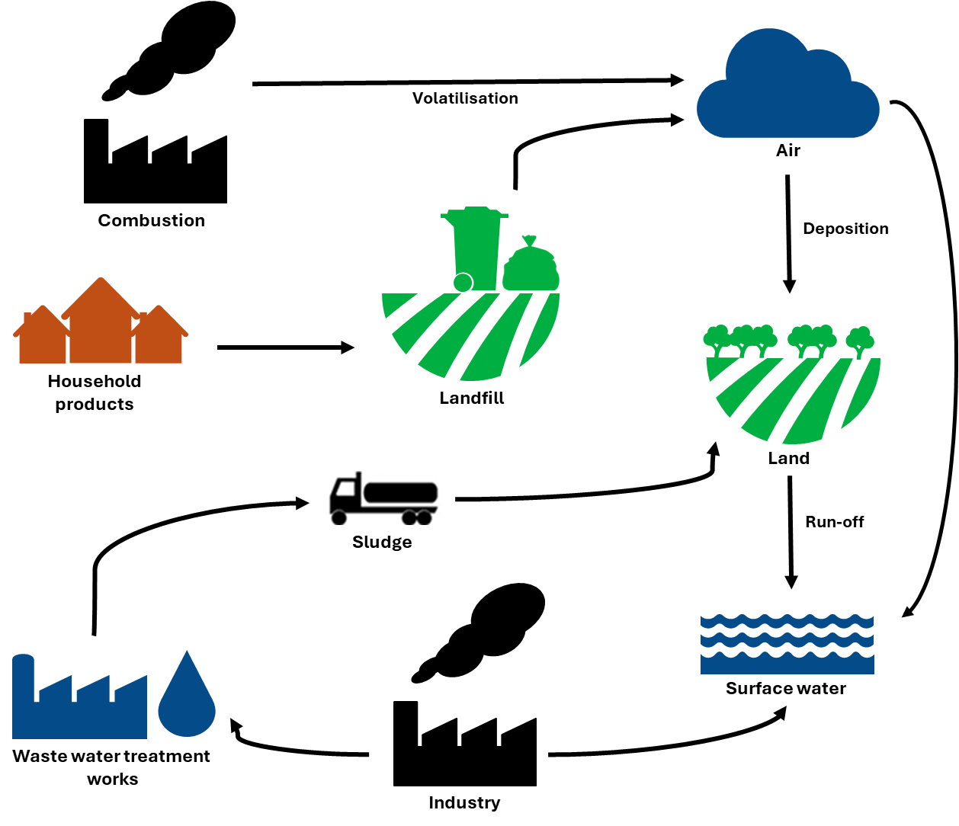

3.1 Atmospheric emissions - sources
The UK reports emissions information to meet one of the ten Environmental Improvement Plan (Defra, 2023) goals: 'managing exposure to chemicals and pesticides'. Such data help provide a picture of important sources and trends over time. More information on the purpose of the emissions inventories mentioned in this section, as well as the methodologies used to build them, can be found within the corresponding references.
Data reported to the UK Pollutant Release and Transfer register (UK-PRTR) show that atmospheric releases of mercury are significantly greater than direct emissions to water.
The UK-PRTR reports that in 2022, the most recently reported year, almost six times as much mercury was released to air (1018kg) compared with reported releases to water (168 kg) from regulated industries. No releases of mercury to soil are reported by the UK-PRTR. This is most probably a consequence of the UK-PRTR only reporting releases from specified activities and installations which meet or exceed stated pollutant thresholds.
Thermal power plants and combustion installations are identified as the largest industrial source emitters of mercury to the atmosphere (379kg). Other industrial processes with significant atmospheric releases include cement production (233kg), incineration of non-hazardous waste (123kg), metal ore roasting/sintering (87kg), pig iron or steel (80kg), and cement clinker production (rotary kilns) (60kg).
The UK’s National Atmospheric Emissions Inventory (NAEI) offers more detailed information on sources of mercury emissions to air, including some emissions not captured by the UK-PRTR, shown in Figure 2.
Figure 2 is a bar char showing the total mercury emissions (kg) from different sources. Figure 2 shows that in 2022, the most significant contribution was from fuel combustion activities at around 1847kg. Power stations contribute around 32% of the reported total load (587 kg) and the remaining 68% come from crematoria (362 kg), cement - non-decarbonising (289 kg), waste disposal - measurement and control equipment (187 kg), foundries (161 kg), other industrial combustion (148 kg), incineration of clinical waste (134 kg), sinter production (113 kg) and waste disposal - electrical equipment (102 kg).
Figure 2. Emissions of mercury to air by sector and sources
Data source: NAEI
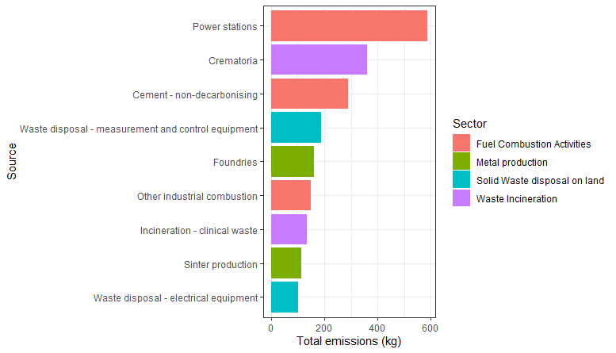

3.2 Atmospheric emissions - trends over time
Over the past 52 years emissions of mercury to air have declined by 94% (NAEI, 2016; Figure 3). Figure 3 is a graph showing mercury emissions (kg) to air between 1970 and 2002. The figure shows mercury air emissions in 1970 were over 60,000 kg declining steeply to just above 50,000 in 1972. Gradual steady decline in emissions followed to the early 1990s when there was a steep decline between 1992 (37,316 kg) and 1993 (22,882 kg). Since 2000 the decline has continued more steadily and by 2016 emissions were below 5,000 kg.
The significant reduction in emissions in the 1990’s is a direct result of tighter regulatory controls and restrictions on mercury use and releases. For example, the Environmental Protection Act 1990 (UK Government, 1990) introduced stricter controls on industrial emissions, including mercury, by requiring the use of Best Available Techniques Not Entailing Excessive Cost (BATNEEC). The BATNEEC refers to the most effective and advanced methods available to minimize emissions considering the costs involved.

Figure 3. Mercury emissions to air, 1970 – 2022
Data source: NAEI
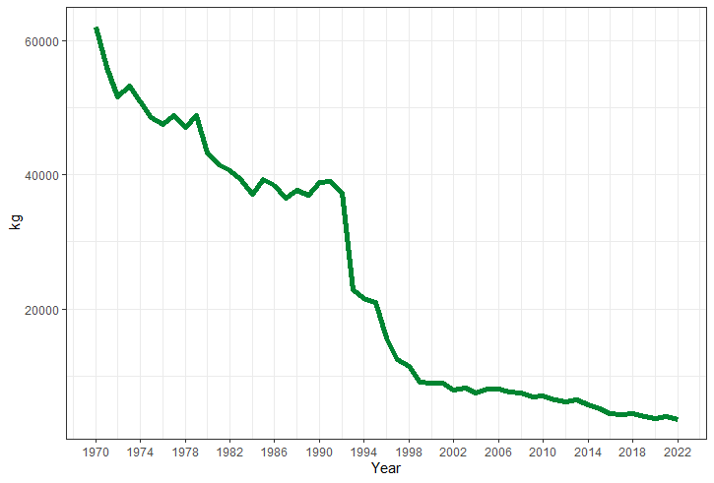
Figure 4 is a collection of graphs showing the data in Figure 3 disaggregated by source. Chemical industry shows an emission of around ten thousand kilograms in 1970 and a consistent decline over time until near zero in 2022. The decrease was observed for all other sources apart from Crematoria, which showed a slight increase until 2010, then a decline until 2022. The high emissions verified before 1992 are mainly related to the following sources: foundries, chemical industry, incineration, power stations, lead and zinc production, and other industrial combustion. After stricter regulatory controls, a clear decline in emissions can be seen in all of these sources. Crematoria, domestic, commercial, and public sector combustion contributed less over time.

Figure 4. Emissions of mercury to air reported by sector between 1970 and 2022
Data source: NAEI
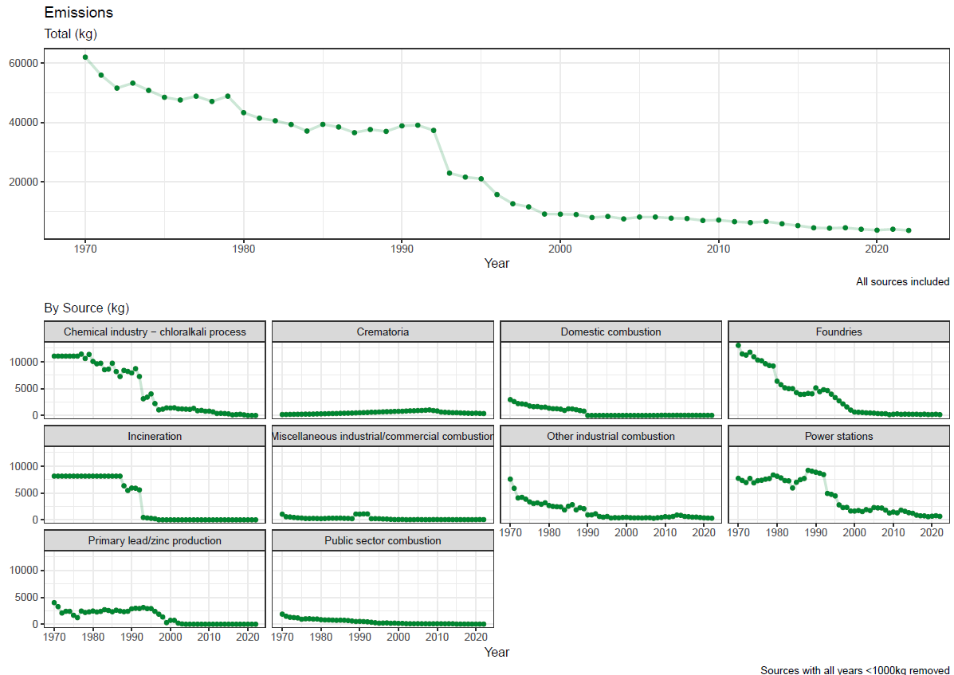

3.3 Emissions of mercury to water - sources
The UK-PRTR identifies thermal power plants and urban wastewater treatment works as the most significant industrial source emitters (126kg) of mercury to controlled waters in England in 2022.
The inventory of emissions, discharges and losses of priority and priority hazardous substances to surface waters is a formal requirement of the WFD under the 2008 Environmental Quality Standards Directive (EQSD) (2008/105/EC). The WFD emission inventory was reported as part of the 2022 river basin management plans. The inventory provides an estimate of emissions of mercury from point, diffuse and total sources to surface waters for the baseline reporting year (2018).
Point source emissions of mercury to water by river basin district as reported in the baseline are shown in Figure 5. Figure 5 is a map of England showing the river basin districts. Each river basin district is coloured in a green grade colour to indicate the different quantities of mercury (in kg) from point source emissions for that river basin district. Darker green indicates a larger quantity. The highest emissions are in the Northwest.

Figure 5. Baseline year (2018) point source emissions to water for mercury for each river basin district
Results for Solway Tweed are reported by the Scottish Environmental Protection Agency and the Dee by Natural Resources Wales
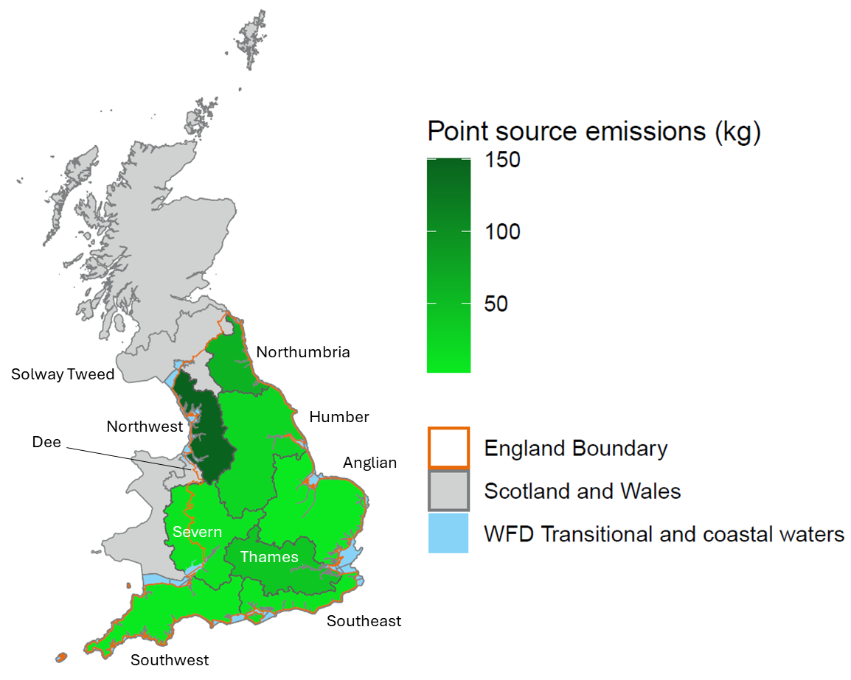
All River Basin Districts (RBD) except for the Severn RBD, estimated emissions using standard Environment Agency monitoring data. This included measured concentrations and discharge information from surface waters, as well as OSPAR reports summarising total heavy metal loads entering the marine environment from rivers, to estimate mercury emissions.
The Severn RBD utilised readily available point source data—such as that reported in the Pollution Inventory, Oslo-Paris Convention (OSPAR) data, and the Water Company Chemical Investigation Programme (CIP).
We estimate that 293kg of mercury was released to surface waters in England in 2018 from point sources. Estimates of emissions released from point sources vary across river basin districts, ranging from about 151kg in North West to around 3kg in the South West and Anglian. Emissions for other river basin districts were estimated to be between 7kg and 61kg.
Results for the Solway Tweed river basin district are reported by the Scottish Environmental Protection Agency and the Dee river basin district by Natural Resources Wales.
The Chemicals Investigation Programme (CIP3) groundwater study (2020–2022) included mercury as a determinand in the monitoring of treated effluent and groundwater at 39 sewage treatment works discharging to ground. Measured mercury concentrations in groundwater were typically very low, with most results reported as below the analytical limit of detection. Where mercury was detected, concentrations were generally in the range of <0.01µg/L to approximately 0.05µg/L, with occasional values close to but rarely exceeding the UK Environmental Quality Standard (EQS) of 0.07µg/L for inland waters. The high proportion of non-detect values indicates that mercury is usually present only at trace levels in groundwater. However, the dataset provides important evidence that mercury can occur in groundwater beneath and down-gradient of sewage discharges, supporting the assessment of groundwater pathways as potential contributors to surface water mercury loadings in some catchments.

3.4 Emissions of mercury to water – trends over time
Mercury emissions to controlled waters from regulated industries have fluctuated year on year between 2013 and 2022, as illustrated below in Figure 6.
Figure 6 is a collection of graphs showing the overall trend of mercury emissions (in kg) and the trend by river basin district since 2013. The top graph presents the total mercury emissions over time between 2013 and 2022. Below, there is a group of smaller line graphs showing the emissions over time between 2013 and 2022 for each river basin district. Three peaks are observed in 2014, 2016 and 2018. The peak in 2014 relates to the emission of around 75kg in Anglian RBD that year. The peak from in 2016 relates to the emission of around 100kg in Humber RBD recorded for that year. In 2018, the highest emission observed relates to peaks of emissions North West RBD (around 200kg) and Northumbria RBD (around 50kg). The peaks in 2018 corroborates with the emissions presented in Figure 4 that shows the 2018 baseline year point source emissions to water for each river basin district. Dee, Severn, Solway Tweed, South East and South West RBDs presented lower and constant emissions. Thames RBD presented constant emission varying between 25kg and 50kg over time. Overall emissions remained constant and lower since 2019.

Figure 6. Total quantity of mercury released to controlled waters as reported by industry to the Pollution Inventory between 2013 and 2022
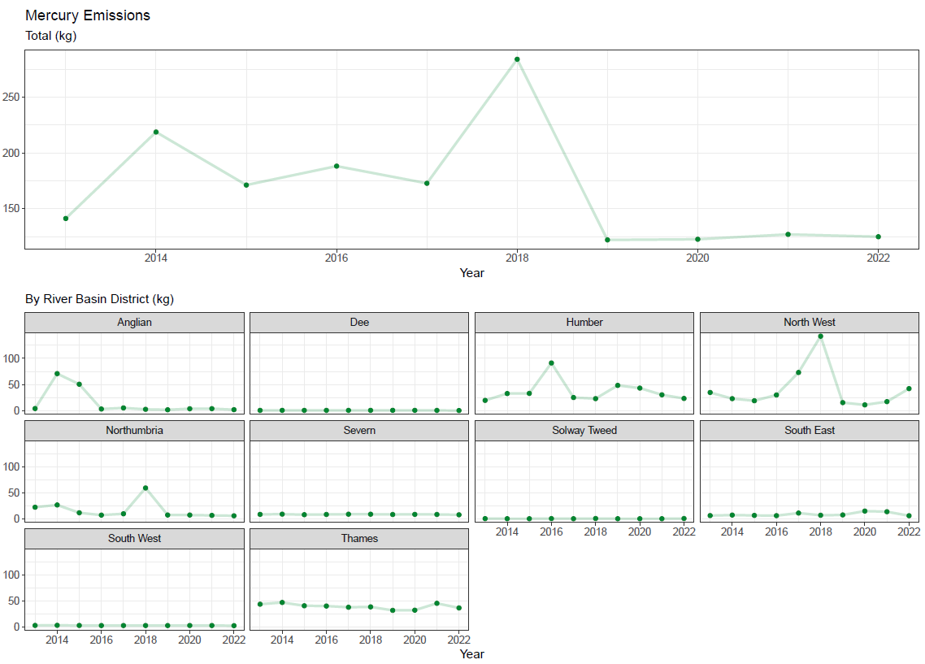

4. Environmental monitoring data
As part of the programme of work to assess risks from PBT substances in England, we have gathered data on Mercury in estuarine/coastal, freshwater and mussel biota from several locations around England. As the Environment Agency data shown in this section is expressed as geometric means (a better model fit for monitoring data), any reference to an EQS baseline can only be indicative of compliance. This is because true EQS compliance is calculated using site-specific annual average arithmetic means, rather than the geometric means reported here.
Our biota sampling began in 2015. However, this latest update of the WFD chemicals narrative considers data generated between 2018 and 2024. Between 2018 and 2024, we have sampled 90 freshwater sites for fish (brown trout, chubb or roach), 111 saline sites for fish (dab and flounder) and at 53 saline sites for blue mussel ‘Mytilus edulis’. The number of sites and their locations have varied year on year, although a subset of sites have been consistently sampled and can be used to observe trends in concentrations over time (see Section 4.4).
We have compared our data against the biota Environmental Quality Standard (EQS) to get an understanding of risk. The Environmental Quality Standards (EQS) Directive (Directive 2008/105/EC, 2008) introduced the biota standard of 20µg/kg wet weight for mercury along with water column standards for the protection of wildlife. The Directive was updated in 2013 by the Directive 2013/39/EU, retaining the biota standard but, where this could be monitored in any biota before, this has now been clarified as applicable only in fish. Environmental Quality Standards (EQS) or Limit Values are widely used to protect the environment and human health from substances released by human activity. They usually relate to doses or concentrations in the environment for specific chemicals, below which unacceptable effects are not expected to occur. Annual averages EQS are derived in relation to the effects of long-term exposure to a chemical.
In 2016, OSPAR proposed a threshold value of 1.6µg/kg wet weight of mercury for mussels. The value of 1.6µg/kg wet weight was achieved converting the fish EQS into an equivalent value for molluscs. However, the uncertainty around this conversation should be considered when using this threshold to understand risks (OSPAR, 2016).
Normalisation to a default dry weight content reduces the variability in the data and allows comparison between different fish and mussels. Therefore, when we consider fish and mussels results for Mercury, the concentrations we use are dry weight normalised using a factor of 26% for fish and 8.3% for mussels (European Commission, 2014).
Sampling locations and mean measured mercury concentrations in freshwater, estuarine and coastal fish, and mussels are shown in Figure 7 to Figure 11.

4.1 Freshwater fish data
In 2023, 84 sites were monitored for freshwater fish and 70 sites (83%) presented concentrations above the EQS (Figure 7). Figure 7 is a map showing the mercury concentrations measured in freshwater fish (dry weight ug/kg) in England in 2023. The size of the circles represents the concentrations; the higher the concentration, the bigger the circle. Those concentrations above the environmental quality standard are indicated by the border of the circle in red. For the concentrations below the environmental quality standard, the border of the circle is in black. Mean measured concentrations of mercury ranged from 160µg/kg in the South East RBD to 12µg/kg in the Anglian RBD for freshwater fish.

Figure 7. Mean mercury concentrations (dry weight µg/kg) measured in each site for freshwater fish (2023) compared against the 20 µg/kg WFD biota EQS concentration
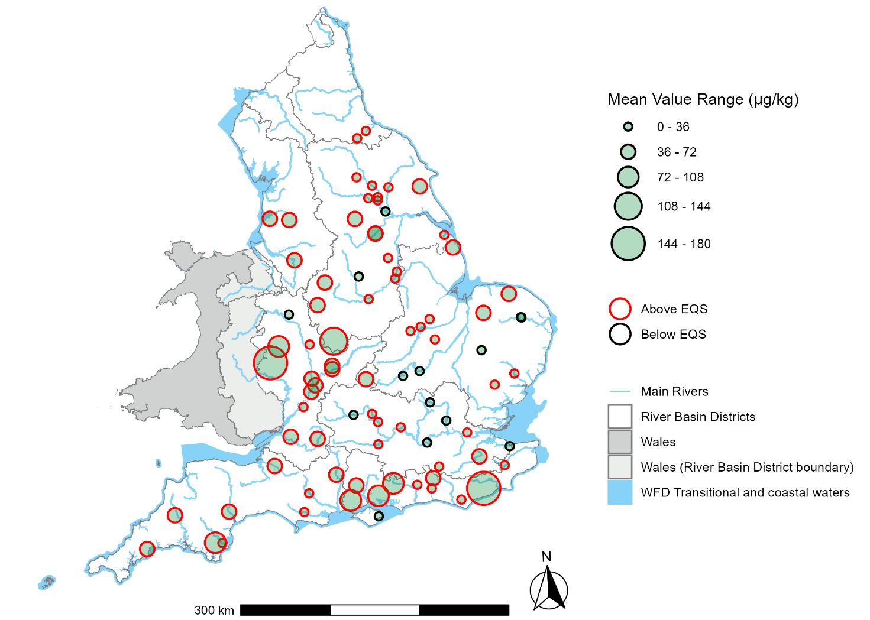

4.2 Estuarine and coastal fish data
Thirty-three sites were monitored for estuarine and coastal fish with all sites presenting concentrations above the EQS (Figure 8). Figure 8 is a map showing the mercury concentrations in estuarine and coastal fish (dry weight ug/kg) in England in 2023. The size of the circles represents the concentrations; the higher the concentration, the bigger the circle. Those concentrations above the environmental quality standard are indicated by the border of the circle in red. For the concentrations below the environmental quality standard, the border of the circle is in black. Mean measured concentrations of mercury ranged from 159µg/kg in the North West RBD to 38µg/kg in the South West RBD for estuarine and coastal fish.

Figure 8. Mean mercury concentrations (dry weight µg/kg) measured in each site for estuarine and coastal fish (2023) compared against the 20µg/kg WFD biota EQS concentration
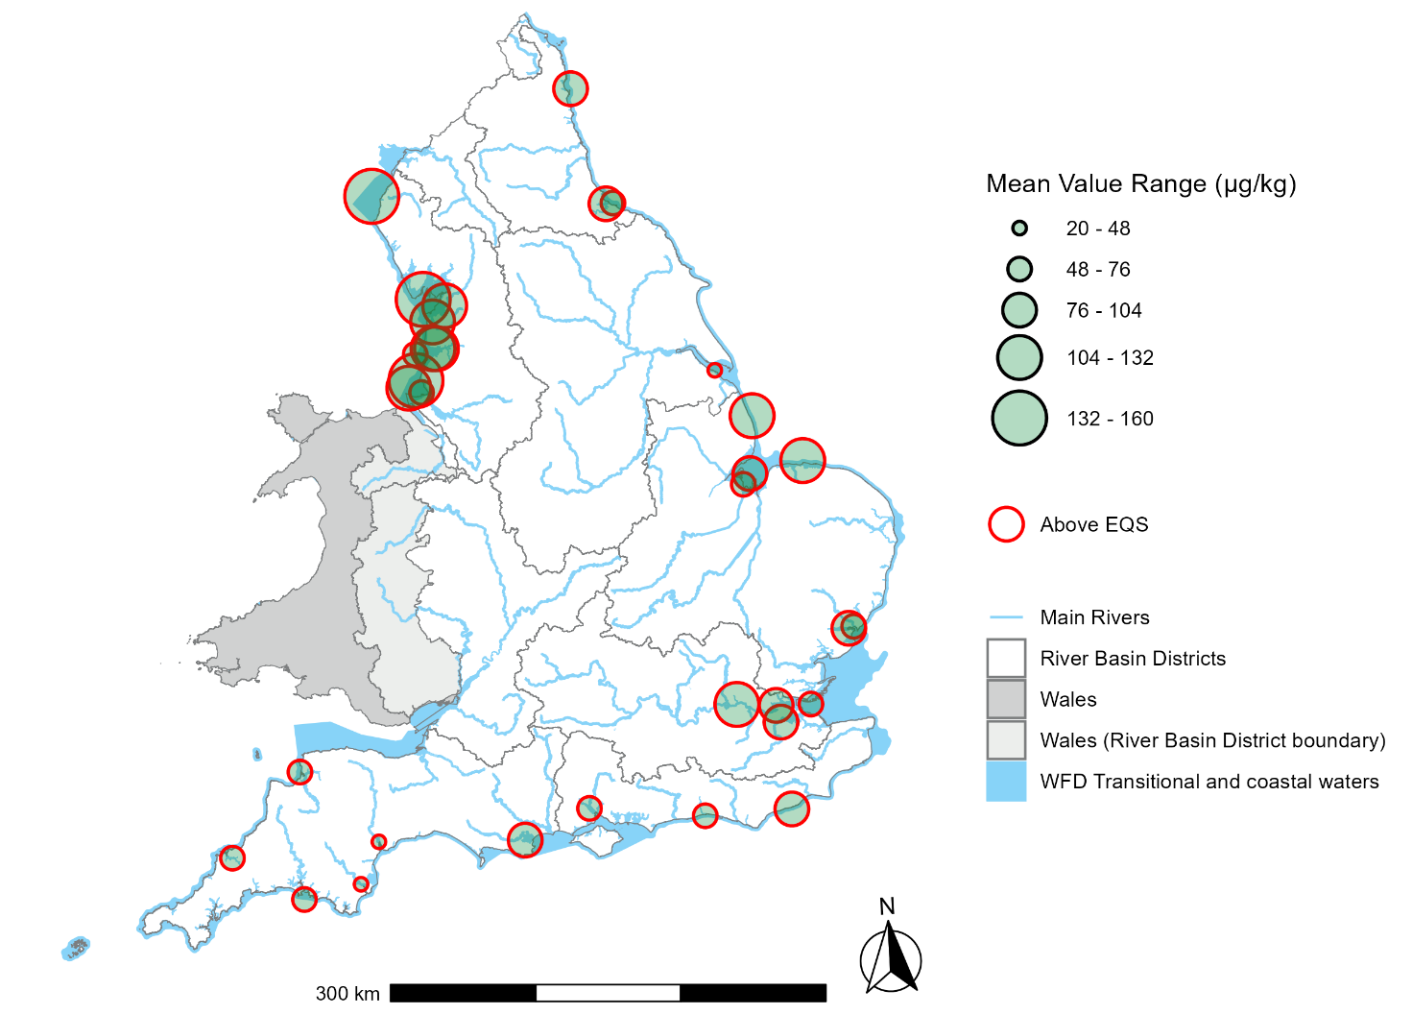

4.3 Mussel data
In 2023, 75 mussel sites were monitored, with 16 sites (21%) presenting concentrations above the EQS when the WFD EQS of 20µg/kg was considered (Figure 9). All sites presented concentrations above the EQS when the proposed OSPAR EQS of 1.6µg/kg was used (Figure 10). Figures 9 and 10 are maps showing the mercury concentrations in mussels (dry weight µg/kg) in England in 2023. The size of the circles represents the concentrations; the higher the concentration, the bigger the circle. Those concentrations above the environmental quality standard are represented by the border of the circle in red. For the concentrations below the environmental quality standard, the border of the circle is in black. Mean measured concentrations of mercury in mussels ranged from 5 µg/kg in the South West RBD to 39µg/kg in the South East RBD.

Figure 9. Mean mercury concentrations (dry weight µg/kg) measured in each site for mussels (2023) compared against the 20 µg/kg WFD EQS concentration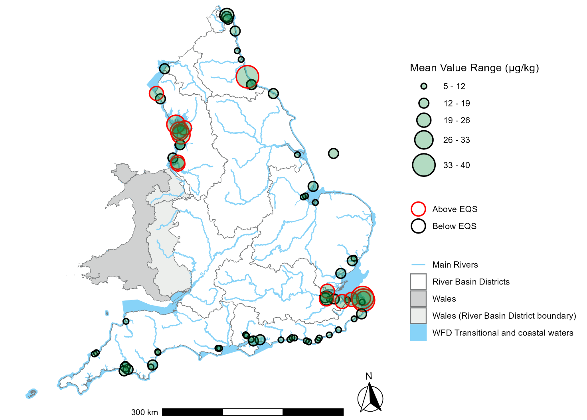

Figure 10. Mean mercury concentrations (dry weight µg/kg) measured in each site for mussels (2023) compared against the 1.6 µg/kg EQS concentration proposed by OSPAR
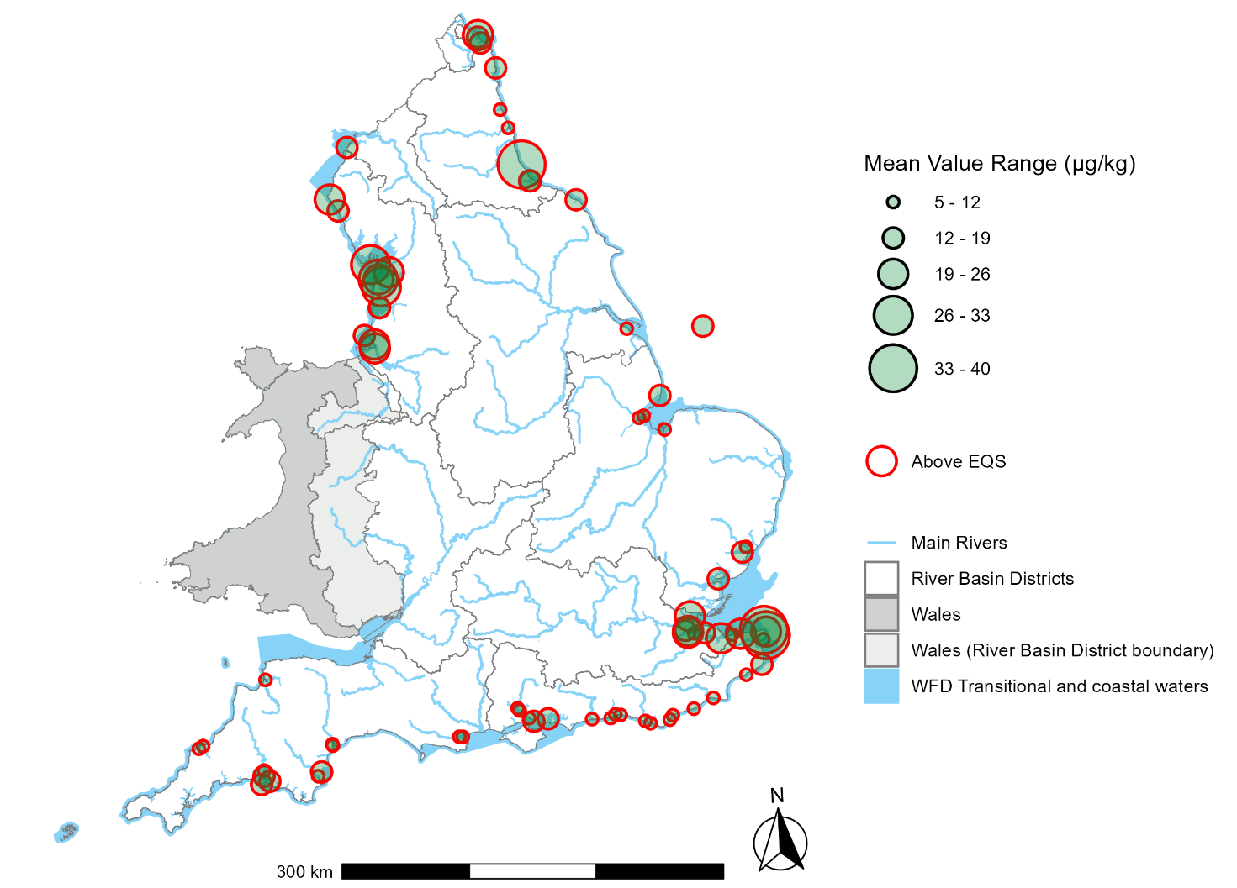

4.4 Fish and mussel trends
Between 2018 and 2024, 90 freshwater fish sites, 111 estuarine and coastal fish sites, and 53 mussel sites were sampled (Figure 11). Figure 11 is a line graph showing the trends of mercury concentration in biota tissue over time between 2018 and 2024. The graph shows a downward trend for estuarine and coastal fish and mussels, and no trend for freshwater fish. Changes in mercury concentrations during the COVID-19 pandemic cannot be included in the analysis due to the lack of data.

Figure 11. Modelled trends of mercury concentration (dry weight µg/g) over time between 2018 and 2024 for estuarine/coastal fish, freshwater fish, and mussels with 95% confidence intervals.
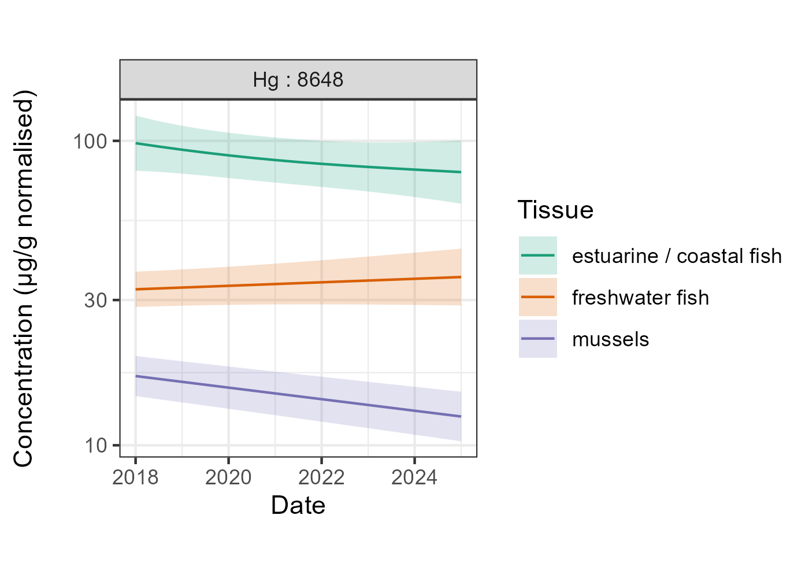

5. Control measures
There are many existing control measures for mercury emissions and restrictions for the use of mercury in products.
The UK is a signatory to the Minamata Convention on mercury. This is a global treaty, ratified in 2017, that aims to protect human health and the environment from the adverse effects of mercury (UK Government, 2017). It bans a range of activities and products with the aim of phasing out emissions of mercury.
The Convention entered into force on 16 August 2017. It limits and prohibits the use mercury in industrial processes and in products from 2020. It requires phase out and phase down of the use of mercury in several products and processes, control measures on emissions to air and releases to land and water and regulates the informal sector of artisanal and small-scale gold mining.
The Convention introduced a ban on new mercury mines, the phase out of existing mercury mines and control measures on air emissions. Amongst other obligations the Convention also requires control of mercury emissions from industrial sources such as coal fired power stations, phasing out of mercury use in products such as batteries and measuring devices, phasing out the use of mercury in manufacturing processes such as chlor-alkali manufacture, and controls over the supply and trade in mercury
The EU Mercury Regulation (EC 852, 2017), implemented in the UK by the Control of Mercury (Enforcement) Regulations (SI 1200, 2017), bans the import into the EU and the export from the EU of mercury, mercury compounds, mixtures of mercury and mercury added products. The use of mercury or mercury compounds is prohibited in a number of manufacturing processes from specified dates, including from 11 December 2017 for chlor-alkali production in which mercury was used as an electrode.
The Regulation also sets requirements for the usage and storage of mercury, mercury compounds and mixtures of mercury, as well as the management of mercury waste to make sure protection of human health and the environment.
Since 2005 waste dental amalgam containing mercury has been classified as hazardous waste under the Hazardous Waste Regulations (EC 98, 2008), implemented in England by the Waste (England & Wales) Regulations (SI 988, 2011). It requires disposal without endangering human health and the environment. This means that waste dental amalgam cannot be flushed down the drain and must be separated using an amalgam separator.
The EU Mercury Regulation (EC 852, 2017) sets out stricter measures to reduce this source. The use of dental amalgam in children under 15 years of age, and pregnant or breastfeeding women, was restricted from July 2018. High performance filters, known as amalgam separators, prevent water contamination by dental clinics and became compulsory in January 2019.
Amalgam wastes need to be handled by an authorised waste management establishment, and dental practitioners must not release mercury to the environment under any circumstances. This regulation revoked and replaced the Mercury Export Ban (EC 1102, 2008) implemented in the UK by the Mercury Export and Data (Enforcement) Regulations (SI 265, 2010).
The European Parliament has voted to ban dental amalgam from 1 January 2025 and England created a national plan to phase down the use of dental amalgam (Department of Health & Social Care, 2019).
The Batteries and Accumulators (Placing on the Market) Regulations (SI 2164, 2008) and Waste Batteries and Accumulators Regulations (SI 890, 2009), prohibits batteries and accumulators (rechargeable batteries) being placed on the market if they contain more than 0.0005% of mercury by weight. Military and space applications are exempt.
The regulations also seek to improve the environmental performance of batteries and accumulators and promotes the safe production, use and disposal of batteries and accumulators by manufacturers, distributors, end users and those involved in the treatment and recycling of waste batteries and accumulators.
The REACH Regulation (EC 1907, 2006) was implemented by the UK REACH Enforcement Regulations 2008 (SI 2852, 2008) and transposed with amendments into UK legislation in 2018 by the Statutory Instrument 758 (2019) and Statutory Instrument 904 (2021).
The REACH Regulation has several entries relating to mercury restrictions. Entry 18 prohibits the placing on the market or use of mercury compounds for antifouling of boats, as a wood preservative, impregnation of industrial textiles and treatment of industrial waters (EC 552, 2009).
Since 2009, under Entry 18a, the placing on the market of measuring devices—such as thermometers, blood pressure monitors (sphygmomanometers), and barometers—containing mercury and intended for sale to the general public has been prohibited, with limited exceptions. After 10 April 2014 this ban was extended to cover measuring devices containing mercury intended for industrial and professional uses, with few exceptions (EU 847, 2012). Entry 62 prohibits the placing on the market or use of five phenylmercury compounds from 10 October 2017 (EU 848, 2012).
The Restriction of the use of certain Hazardous Substances (RoHS) in Electrical and Electronic Equipment (EEE) Directive (EC 65, 2011) was implemented in the UK by the Restriction of the Use of Certain Hazardous Substances in Electrical and Electronic Equipment Regulations (SI 3032, 2012). It prohibits new electrical and electronic equipment containing mercury at levels above 0.1 % from being placed on the market except for some fluorescent lamps. This regulation was amended by the Statutory Instrument 492 (2019) to ensure continuity post-EU-Exit.
The Industrial Emissions Directive (IED) (EU 75, 2010), implemented in England by the Environmental Permitting (England and Wales) (Amendment) Regulations (SI 390, 2013) and assimilated into the UK legislation after EU-Exit by the Statutory Instrument 1154 (2016), aims to minimise emissions of mercury and other substances from major industrial sources and replaced a number of older directives. These sites require permits which place limits on emissions. Emissions to air are addressed by the specific inclusion of mercury in the IED as a substance requiring application of ‘best available techniques’ to minimise emissions.
Mercury is not approved for use in biocidal products under the Biocides Regulations (EU 528, 2012), implemented in the UK by the Biocidal Products and Chemicals (Appointment of Authorities and Enforcement) Regulations (SI 1506, 2013). Use of mercury in cosmetic products is also prohibited under the Cosmetics Regulations (EC 1223, 2009), implemented in the UK by the Cosmetic Products Enforcement Regulations (SI 1478, 2013), and for many years prior to this under the preceding legislation. Both Regulations were retained as part of UK legislation after EU-Exit.

6. Summary
Mercury is a persistent and bioaccumulative pollutant in the environment, posing serious risks to aquatic ecosystems and human health.
The monitoring of atmospheric and water emissions shows declines in mercury emissions suggesting that regulatory restrictions have influenced the release of mercury to some extent. The significant reduction in atmospheric emissions in the 1990’s due to the Environmental Protection Act 1990 (UK Government, 1990) is a good example.
The biota monitoring data suggests that the presence of Mercury is widespread across England and with several orders of magnitude greater than the biota EQS. This confirms the evidence presented in the 2023 Government plan for water, where rivers in England were found not to have achieved good chemical status due to due to three PBT substances including Mercury (DEFRA, 2023). However, as discussed in section four, this narrative simply compares Mercury levels against the EQS and is not indicative of compliance or non-compliance.
The trends of concentrations between 2018 and 2024 showed a decrease in estuarine/coastal fish and mussels, and a less evident trend for freshwater fish. The continuity of Mercury monitoring is crucial for better understanding the trends in the aquatic ecosystems.
The legislation to regulate Mercury emissions is recent. Records of Mercury contamination in English river sediments date back to the 1930s, indicating a legacy of Mercury stored in the sediments. The increase in climate change effects can intensify river and coastal flooding, disturb these sediments, and impact the biota (Vane and others, 2020; Bradley and others, 2025).
Climate change effects can trigger new sources of Mercury in rivers and on the coast. The Environment Agency will continue to work on improving regulatory measures and monitoring programmes, aiming to be prepared for this new challenge.

References
Basu N and others. ‘Our evolved understanding of the human health risks of mercury’, Ambio 2023: volume 52, issue 5, pages 1–20 (viewed on 28 August 2025)
Bradley O and others. ‘Metal contamination in sediments of an estuary impacted by discharges of antifouling waste (Yealm, southwest England)’, Marine Pollution Bulletin 2025: volume 217, pages 1-12 (viewed on 28 August 2025)
British Dental Association. ‘Dental Amalgam’ 2024 (viewed on 28 August 2025)
Department for Environment, Food and Rural Affairs (Defra). ‘The Groundwater (Water Framework Directive) (England) Direction 2016’ 2016: pages 1-9 (viewed on 28 August 2025)
Department for Environment, Food and Rural Affairs (Defra). ‘A Green Future: Our 25 Year Plan to Improve the Environment’ 2018: pages 1-151 (viewed on 28 August 2025)
Department for Environment, Food and Rural Affairs (Defra). ‘Environmental Improvement Plan’ 2023: pages 1-262 (viewed on 28 August 2025)
Department of Health & Social Care. ‘National plan to phase down use of Dental Amalgam in England’ 2019 (viewed on 28 August 2025)
European Commission (EC). ‘Setting maximum levels for certain contaminants in foodstuffs’, Commission Regulation (EC) 1881 2006: pages 1-20 (viewed on 28 August 2025)
European Commission (EC). ‘2011/65/EU of the European Parliament and of the Council of 8 June 2011 on the restriction of the use of certain hazardous substances in electrical and electronic equipment’ 2011: pages 1-23 (viewed on 28 August 2025)
European Commission (EC). ‘Directive 2008/98/EC of the European Parliament and of the Council of 19 November 2008 on waste and repealing certain Directives’ 2008: pages 1-59 (viewed on 28 August 2025)
European Commission (EC). ‘Commission Regulation (EC) No 552/2009 of 22 June 2009 amending Regulation (EC) No 1907/2006 of the European Parliament and of the Council on the Registration, Evaluation, Authorisation and Restriction of Chemicals (REACH) as regards Annex XVII’ 2009: pages 1-25 (viewed on 28 August 2025)
European Commission (EC). ‘Regulation (EU) 2017/852 of the European Parliament and of the Council of 17 May 2017 on mercury and repealing Regulation (EC) No 1102/2008’ 2017: pages 1-21(viewed on 28 August 2025)
European Commission (EC). ‘Regulation (EC) No 1102/2008 of the European Parliament and of the Council of 22 October 2008 on the banning of exports of metallic mercury and certain mercury compounds and mixtures and the safe storage of metallic mercury’ 2008: pages 1-5 (viewed on 28 August 2025)
European Commission (EC). ‘Regulation (EC) No 1223/2009 of the European Parliament and of the Council of 30 November 2009 on cosmetic products’ 2009: pages 1-151 (viewed on 28 August 2025)
European Commission (EC). ‘Regulation (EC) No 1907/2006 of the European Parliament and of the Council of 18 December 2006 concerning the Registration, Evaluation, Authorisation and Restriction of Chemicals (REACH), establishing a European Chemicals Agency, amending Directive 1999/45/EC and repealing Council Regulation (EEC) No 793/93 and Commission Regulation (EC) No 1488/94 as well as Council Directive 76/769/EEC and Commission Directives 91/155/EEC, 93/67/EEC, 93/105/EC and 2000/21/EC’ 2006: pages 1-849 (viewed on 28 August 2025)
European Environment Agency (EEA). ‘Mercury in Europe’s environment: a priority for European and global action’ Publications Office of the European Union 2018: pages 1-72 (viewed on 28 August 2025)
European Union (EU). ‘Directive 2010/75/EU of the European Parliament and of the Council of 24 November 2010 on industrial emissions (integrated pollution prevention and control)’ 2010: pages 1-103 (viewed on 28 August 2025)
European Union (EU). ‘Regulation (EU) No 528/2012 of the European Parliament and of the Council of 22 May 2012 concerning the making available on the market and use of biocidal products’ 2012: pages 1-123 (viewed on 28 August 2025)
European Union (EU). ‘Commission Regulation (EU) No 847/2012 of 19 September 2012 amending Annex XVII to Regulation (EC) No 1907/2006 of the European Parliament and of the Council on the Registration, Evaluation, Authorisation and Restriction of Chemicals (REACH) as regards mercury’ 2012: pages 1-4 (viewed on 28 August 2025)
European Union (EU). ‘Commission Regulation (EU) No 848/2012 of 19 September 2012 amending Annex XVII to Regulation (EC) No 1907/2006 of the European Parliament and of the Council on the Registration, Evaluation, Authorisation and Restriction of Chemicals (REACH) as regards phenylmercury compounds’ 2012: pages 1-3 (viewed on 28 August 2025)
Food Standards Agency (FSA). ‘Safe method: Food that need extra care’ 2020: pages 1-2 (viewed on 28 August 2025)
Food Standards Agency (FSA). ‘Chemical contaminant monitoring’ 2024: pages 1-2 (viewed on 28 August 2025)
Lambert KF and others. ‘Integrating mercury science and policy in the marine context: Challenges and opportunities’ Environmental Research 2012: volume 119, pages 132–142 (viewed on 28 August 2025)
Peng X and others. ‘Recent advance of microbial mercury methylation in the environment’ Applied Microbiology and Biotechnology 2024: volume 108, issue 1, page 235 (viewed on 28 August 2025)
Statutory Instrument (SI) 96. ‘The Control of Mercury (Amendment) (EU Exit) Regulations 2019’ 2019: pages 1-12 (viewed on 28 August 2025)
Statutory Instrument (SI) 265. ‘The Mercury Export and Data (Enforcement) Regulations 2010’ 2010: pages 1-9 (viewed on 28 August 2025)
Statutory Instrument (SI) 390. ‘The Environmental Permitting (England and Wales) (Amendment) Regulations 2013’ 2013: pages 1-34 (viewed on 28 August 2025)
Statutory Instrument (SI) 492. ‘The Restriction of the Use of Certain Hazardous Substances in Electrical and Electronic Equipment (Amendment) Regulations 2019’ 2019: pages 1-4 (viewed on 28 August 2025)
Statutory Instrument (SI) 758. ‘The REACH etc. (Amendment etc.) (EU Exit) Regulations 2019’ 2019: pages 1-111 (viewed on 28 August 2025)
Statutory Instrument (SI) 890. ‘The Waste Batteries and Accumulators Regulations 2009’ 2009: pages 1-68 (viewed on 28 August 2025)
Statutory Instrument (SI) 904. ‘The REACH etc. (Amendment) Regulations 2021’ 2021: 1-12 (viewed on 28 August 2025)
Statutory Instrument (SI) 988. ‘The Waste (England and Wales) Regulations 2011’ 2011: 1-46 (viewed on 28 August 2025)
Statutory Instrument (SI) 1142. ‘The Control of Mercury (Amendment) (EU Exit) Regulations 2022’ 2022: 1-2 (viewed on 28 August 2025)
Statutory Instrument (SI) 1154. ‘The Environmental Permitting (England and Wales) Regulations 2016’ 2016: 1-292 (viewed on 28 August 2025)
Statutory Instrument (SI) 1200. ‘The Control of Mercury (Enforcement) Regulations 2017’ 2017: pages 1-36 (viewed on 28 August 2025)
Statutory Instrument (SI) 1478. ‘The Cosmetic Products Enforcement Regulations 2013’ 2013: pages 1-28 (viewed on 28 August 2025)
Statutory Instrument (SI) 1506. ‘The Biocidal Products and Chemicals (Appointment of Authorities and Enforcement) Regulations 2013’ 2013: pages 1-32 (viewed on 28 August 2025)
Statutory Instrument (SI) 2164. ‘The Batteries and Accumulators (Placing on the Market) Regulations 2008’ 2008: pages 1-15 (viewed on 28 August 2025)
Statutory Instrument (SI) 2852. ‘Consumer Protection, Environmental Protection, Health and Safety. The REACH Enforcement Regulations 2008’ 2008: pages 1-76 (viewed on 28 August 2025)
Statutory Instrument (SI) 3032. ‘The Restriction of the Use of Certain Hazardous Substances in Electrical and Electronic Equipment Regulations 2012’ 2012: pages 1-28 (viewed on 28 August 2025)
Sørmo E and others. ‘Formation and availability of methylmercury in mercury-contaminated sediment: effects of activated carbon and biochar amendments’ Journal of Soils and Sediments 2022: volume 22, issue 3, pages 1041–1053 (viewed on 28 August 2025)
UK Government. ‘Environmental Protection Act’ 1990: pages 1-246 (viewed on 28 August 2025)
UK Government. ‘Minamata Convention on Mercury’ 2017: pages 1-54 (viewed on 28 August 2025)
United Nations Environment Programme. ‘Parties and Signatories - Minamata Convention on Mercury’ 2018 (viewed on 28 August 2025)
United Nations Environment Programme. ‘Global mercury assessment’ UN Environment Programme, Chemicals and Health Branch 2019: pages 1-62 (viewed on 28 August 2025)
Vane CH and others. ‘Trends in heavy metals, polychlorinated biphenyls and toxicity from sediment cores of the inner River Thames estuary, London, UK’ Environmental Science: Processes & Impacts 2020: volume 22, issue 2, pages 1–17 (viewed on 28 August 2025)
Veeraswamy D and others. ‘Exploring the origins and cleanup of mercury contamination: a comprehensive review’ Environmental Science and Pollution Research 2023: volume 31, issue 41, pages 1–30 (viewed on 28 August 2025)
Wang W and others. ‘Effects of physical disturbance of sediment on the cycling of mercury in coastal regions’ Science of The Total Environment 2022: volume 838, pages 1-10 (viewed on 28 August 2025)
World Health Organization (WHO). ‘Elemental mercury and inorganic mercury compounds: human health aspects’ 2003: pages 1-68 (viewed on 28 August 2025)
World Health Organization (WHO). ‘Mercury and health’ 2017 (viewed on 28 August 2025)
World Health Organization (WHO). ‘10 chemicals of public health concern’ 2020 (viewed on 28 August 2025)
World Health Organization (WHO). ‘Exposure to Mercury: a major public health concern. Geneva: World Health Organization’ 2021: pages 1-5 (viewed on 28 August 2025)

List of abbreviations and acronyms
CIP: Chemical Investigations Programme
EEE: Electrical and Electronic Equipment
EQS: Environmental Quality Standard
EQSD: Environmental Quality Standards Directive
IED: Industrial Emissions Directive
OSPAR: The OSPAR convention is the Convention for the Protection of the Marine Environment of the North-East Atlantic. See https://www.ospar.org/convention. It is the mechanism by which 15 Governments & the EU cooperate to protect the marine environment of the North-East Atlantic.
PS: Priority substance
PHS: Priority hazardous substance
RBD: River Basin District
RBMP: River basin management plan
REACH: Registration, Evaluation, Authorisation and Restriction of Chemicals
SAGIS: Source Apportionment Geographic Information Systems
UK-PRTR: UK Pollutant Release Transfer Register
WFD: Water Framework Directive

Glossary
Amalgam: In dentistry, amalgam is an alloy of mercury with various metals used for dental fillings. It commonly consists of mercury (50%), silver (~22–32%), tin (~14%), copper (~8%), and other trace metals.
Anthropogenic: (Chiefly of environmental pollution and pollutants) Originating in human activity.
Bioaccumulate: The accumulation of a substance, such as a toxic chemical, in various tissues of a living organism.
Biota: The animal and plant life of a particular region, habitat, or geological period.
Bioavailability: The extent to which a substance can be absorbed by a living organism.
Biomagnification: The sequence of processes in an ecosystem by which higher concentrations of a particular chemical are reached in organisms higher up the food chain, generally through a series of prey-predator relationships.
Chlor-alkali: The chlor-alkali process (also chlor-alkali and chlor alkali) is an industrial process for the electrolysis of sodium chloride. It is the technology used to produce chlorine and sodium hydroxide (caustic soda), which are commodity chemicals required by industry.
Inorganic: Not consisting of or deriving from living matter.
Limit of detection: smallest concentration of a substance that can be detected by a given analytical method with reasonable confidence.
Microorganisms: A microscopic organism, especially a bacterium, virus, or fungus.
PBT: Persistent, bioaccumulative and toxic. These substances are a class of compounds that have high resistance to degradation from abiotic and biotic factors, high mobility in the environment and high toxicity.
Remobilisation: The process of returning a substance to circulation within a particular system.
uPBT: Ubiquitous PBT. PBTs that are widespread and found everywhere.
Volatile: (Of a substance) Easily evaporated at normal temperatures liable to change rapidly and unpredictably, especially for the worse.

