Cypermethrin: challenges for the water environment
Date: October 2025
Contents
Executive summary 4
1. Introduction 6
1.1 What is Cypermethrin? 6
1.2. Toxicity of Cypermethrin 6
2. Uses of Cypermethrin 7
2.1. Use as a plant protection product 7
2.2. Use as a biocide 11
2.3. Use as veterinary medicine 12
3. Emissions, sources and pathways 12
3.1. Plant protection products 13
3.2. Biocides 14
3.3. Veterinary medicines 14
3.4. Forestry 16
3.5. Landfill 16
3.6. Wastewater treatment works (WwTW) 17
3.7. Paper and pulp industry 19
3.8 Chemical industry 20
4. Environmental monitoring data and risk assessment 20
4.1 Groundwater monitoring data from the Chemical Investigation Programme (CIP) 20
4.2 Surface water monitoring data from the Chemical Investigation Programme (CIP) 21
4.3. Environment Agency surface water monitoring data 25
5. Control measures 32
5.1. Biocides 32
5.2. Plant protection products 33
5.3. Forestry 34
5.4. Veterinary medicines 35
5.5 Industrial processes 35
6. Summary 36
References 41
List of abbreviations 47
Glossary 49
Appendix A 50

Executive summary
Cypermethrin is a synthetic pyrethroid insecticide widely used in the UK for pest control in agriculture, public and commercial buildings, homes, and veterinary medicine. Despite its effectiveness, cypermethrin poses significant environmental challenges, particularly to aquatic life. This report, explores the uses, sources, emissions, pathways, monitoring data, and control measures related to cypermethrin.
Cypermethrin is utilised in three main areas, as Plant Protection Products (PPP), Biocides and Veterinary Medicines. PPP are used to control pests on crops such as wheat, barley, oilseed rape, and various vegetables. It is also applied in forestry and domestic gardens. However, this report highlights a significant decline in cypermethrin use in arable farming from 54,487 kg in 1996 to 4,180 kg in 2022. Cypermethrin containing biocides are approved for use as an insecticide and wood preservative. Such biocides are used in homes, public buildings, and industrial settings. This report notes the potential for environmental exposure through inappropriate use and disposal of such biocides. Veterinary Medicine containing Cypermethrin are used to control lice, ticks, and flies on livestock such as sheep, cattle, and horses. This report discusses the seasonal application patterns and the potential for environmental contamination through runoff and improper disposal.
Cypermethrin enters the water environment through various routes. Agricultural Runoff can occur during rainfall, cypermethrin can wash off treated crops and soil into nearby water bodies. Industrial discharges from effluents from industries like wool scouring and wastewater treatment plants can contain cypermethrin. In domestic use, improper disposal of cypermethrin products by homeowners can lead to environmental contamination. This report identifies specific sources such as plant protection products, biocides, veterinary medicines, forestry, landfill, wastewater treatment works, and the paper and pulp industry.
Monitoring data from the UK Water Industry's Chemical Investigations Programme (CIP) show that cypermethrin is present in wastewater effluents and surface waters, often exceeding environmental quality standards. However, it should be noted that the CIP monitoring programme primarily targeted Wastewater Treatment Works (WwTWs) with a high risk of cypermethrin failure, so that it could investigate cypermethrin sources, pathways and receptors.
In contrast, data from more representative monitoring networks, such as the Environment Agency’s Water Framework Directive (WFD) and the River Surveillance Network (RSN), highlight the variability in cypermethrin concentrations across different river basin districts, with higher levels in areas with dense livestock farming. These catchment data suggest that most sites are below the environmental quality standard for cypermethrin, and that it is not ubiquitously found across the catchment at levels of concern.
Several initiatives aim to mitigate the environmental impact of cypermethrin. The UK has stringent regulations governing the use of cypermethrin in agriculture, biocides, and veterinary medicines. Best practice guidelines and training programs promote the responsible use and disposal of cypermethrin products. Research into alternative pest control methods is ongoing, though finding equally effective and less harmful options remains challenging. This report discusses various legislative measures, national codes of best practice, and guidance documents aimed at promoting the safe use of cypermethrin. It also highlights the role of industry-led schemes and certification standards in reducing cypermethrin use.
Cypermethrin is highly toxic to aquatic organisms, even at very low concentrations. This report emphasises the need for improved source control measures to prevent environmental contamination. Despite regulatory efforts, cypermethrin continues to pose a risk to the water environment. The future approval of cypermethrin as an active ingredient in pesticides remains uncertain, with ongoing scientific evaluations of its benefits versus its’ environmental risks.
Cypermethrin is a valuable tool in pest control but comes with environmental risks if incorrectly used or disposed. By continuing to monitor the substance in the wider environment, identifying and mitigating point sources, reviewing and improving best practice use guidance, and exploring alternative solutions, we can evaluate its risks versus its benefits to mitigate its impact and safeguard our water environments for future generations, until it is withdrawn from use in high-risk scenarios.

1. Introduction

1.1 What is Cypermethrin?
Cypermethrin is a synthetic pyrethroid insecticide. Pyrethroids are a group of man-made pesticides similar to the natural pesticide pyrethrum, which is produced by chrysanthemum flowers. Cypermethrin was first synthesised in 1974 (WHO, 1989). It has a wide range of uses in the UK, including the control of pests on various crops, in public and commercial buildings, and homes. It is also used as a wood preservative and as a veterinary medicine to control lice and ticks on cattle and sheep.

1.2. Toxicity of Cypermethrin
Pyrethroids are synthetic organic insecticides with low mammalian toxicity that are widely used in both rural and urban areas worldwide. However, they are highly toxic to aquatic life, particularly to invertebrates such as insects, crustaceans and fish (Tang and others, 2018). For cypermethrin, adverse effects on aquatic organisms have been observed at concentrations as low as 0.0013 µg/L (EFSA, 2008). To put this into perspective, 1 µg (microgram) is equal to 1000 ng (nanogram). Therefore, 0.0013 µg/L can also be expressed as 1.3 ng/L. Imagine finding a single grain of sand in a bathtub of water—that's roughly the equivalent of 1 ng/L. This incredibly small concentration can still have harmful effects on aquatic life. Cypermethrin has been shown to be toxic to invertebrates, including freshwater shrimp (Gammarus pulex) (Dalhoff and others, 2018), European mayflies (Baetis rhodani and Ecdyonurus venosus), and stonefly nymphs (Isoperla grammatica) (Crowley and others, 2021). It is also toxic to fish, such as common carp (Cyprinus carpio) (Yancheva and others., 2022), as well as other aquatic and terrestrial species (Farag and others, 2021; Haseler and others, 2024; Tang and others, 2018).
Cypermethrin has been designated by the EU as a Priority Substance under the Environmental Quality Standards Directive (2013/39/EU), a daughter directive of the Water Framework Directive (WFD) (2000/60/EC). As a result, an Environmental Quality Standard (EQS) for the protection of aquatic life has been derived by the EU. The EQS for cypermethrin applies to all forms of cypermethrin, including alpha and zeta cypermethrin (2013/39/EU).
Environmental Quality Standards (EQSs) or Limit Values are widely used to protect the environment and human health from substances released by human activity. They usually relate to doses or concentrations in the environment for specific chemicals, below which unacceptable effects are not expected to occur. An annual average (AA) EQS for cypermethrin of 0.00008 µg/L for freshwaters and a tenfold more stringent value of 0.000008 µg/L for saline waters is specified in the Directive (2013/39/EU). Annual averages are derived in relation to the effects of long-term exposure to a chemical.
Cypermethrin exhibits very low solubility in water—less than 9 µg/L (EU, 2013a; ECHA, 2019). Nevertheless, even at full saturation in freshwater, this concentration would exceed the Environmental Quality Standard (EQS) by more than 10,000 times. It binds strongly to soil and sediment. It is not expected to be very mobile in soil and in water will rapidly bind to suspended particles and sediment. It is not highly persistent in surface water, as it is broken down by bacteria and sunlight. However, due to the limited UK data on sediment concentrations, its degradation rate under natural conditions remains unclear. Measured degradation rates in water have been reported in the range of a few days (0.88 to 4 days) (EU, 2013a and ECHA, 2019). In water-sediment systems, studies conducted in Swiss lakes reported degradation rates estimates ranging between 12 to 67 days (ECHA, 2019).
Cypermethrin does not bioaccumulate significantly in aquatic organisms (EFSA, 2008; EU 2013a; ECHA, 2019). It has a low potential to volatilise and will not be present in significant quantities in air (EFSA, 2008). However, cypermethrin is considered highly toxic at low concentrations, making it a chemical of concern regarding environmental risk under WFD regulations.
This report reviews information on the uses of cypermethrin (Section 2), sources and pathways (Section 3), monitoring data (Section 4), and existing controls (Section 5).
The focus of this report is on the contributing effects to, and assessment of, the condition of surface waters in relation to cypermethrin. However, the contribution that groundwater makes to surface water status failures is also considered as part of the Water Environment (Water Framework Directive) (England & Wales) Regulations 2017 (Defra, 2017) and the Groundwater Directive (2006/118/EC as amended by 2014/80/EU). If groundwater contributes more than 50% of the cypermethrin load in any surface water status failure, then the groundwater body will also be classified as having poor chemical status.

2. Uses of Cypermethrin
Cypermethrin is registered for use in the UK as a plant protection product, biocide, and veterinary medicine.

2.1. Use as a plant protection product
Plant Protection Products (PPP) are used to protect crops and other plants against a range of pests and diseases. Cypermethrin is currently used in the UK to control insect pests, including aphids, beetles, and caterpillars, in the following situations:
- on crops, including cereals such as: wheat and barley; fodder beet; oilseed rape; and sugar beet
- on vegetables such as: broccoli; beans; peas; carrots; and cabbage
- as a post-harvest treatment to protect stored grain, such as wheat and barley, from pests, and as a seed treatment prior to sowing
- on ornamental plants, such as roses, including in domestic gardens
- in forestry, on young trees both pre- and post-planting to control large pine weevil and on felled logs for bark beetle (HSEa, The Pesticides Register Database)
The UK Pesticides Register, managed by the Health and Safety Executive (HSE), lists authorised products containing cypermethrin for commercial use, as well as those approved for amateur use in garden pest control.
Information on the amount of cypermethrin used on different crops is collected through pesticide usage surveys undertaken on behalf of the HSE. Various crop types, including arable, orchard, soft fruit, outdoor vegetable, amenity, and edible protected crops, are surveyed on a regular basis.
Cypermethrin is a key insecticide used on arable crops. Figure 1 is a bar graph showing the amount (kg) of cypermethrin applied as an insecticide to various arable crops (plants only) in the UK in 2022. Figure 1 shows the greatest amount applied per annum is to wheat (497 kg) and oilseed rape (370 kg). The total amount used as an insecticide application to arable crops was 1,417 kg.
Figure 2 is a bar graph showing the amount (kg) of cypermethrin applied as an insecticide treatment to arable seeds in UK in 2022. Figure 2 shows a further 2,763 kg per annum was applied as an insecticide seed treatment (all seed types), most of which was applied to wheat seeds (2,421 kg) or oilseed rape (290 kg). A grand total of 4,180 kg per annum was used in either the protection of arable plants or seeds in 2022.
Figure 3 is a bar graph of the total amount (kg) of cypermethrin applied to arable crops and seeds over time in the UK. The data show that there has been a steady decline in the use of cypermethrin in arable farming since 1996 (54,487 kg) and 2016 (20,784 kg), with a sharp decline thereafter to 4,180 kg in 2022.
These figures are considerably lower than those reported in 2016, when over 10,000 kg per annum of zeta-cypermethrin was applied to wheat and over 800 kg to oilseed rape (Fera Science 2018a). The application of this pesticide to arable crops has dropped significantly in recent years, from 33,226 ha of crops treated in 2020 to 6,860 ha in 2022, representing a 79% reduction in the area of fields treated (Fera Science 2022a).

Figure 1: Amount of cypermethrin applied to as an insecticide to various arable crops (plants only) in UK in 2022 (Fera Science, 2022a)
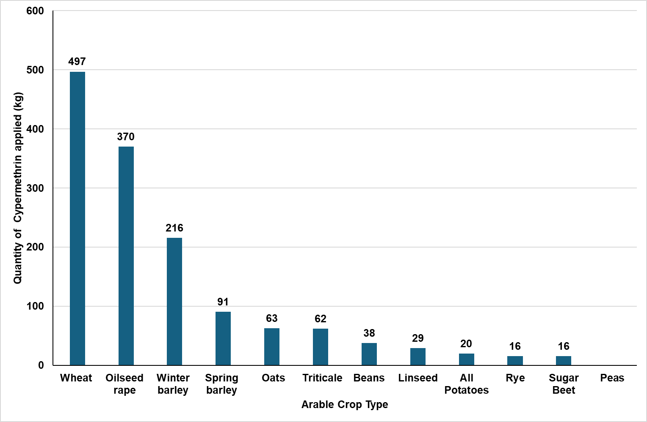

Figure 2: Amount of cypermethrin applied as an insecticide treatment of arable seeds in UK in 2022 (Fera Science, 2022a)
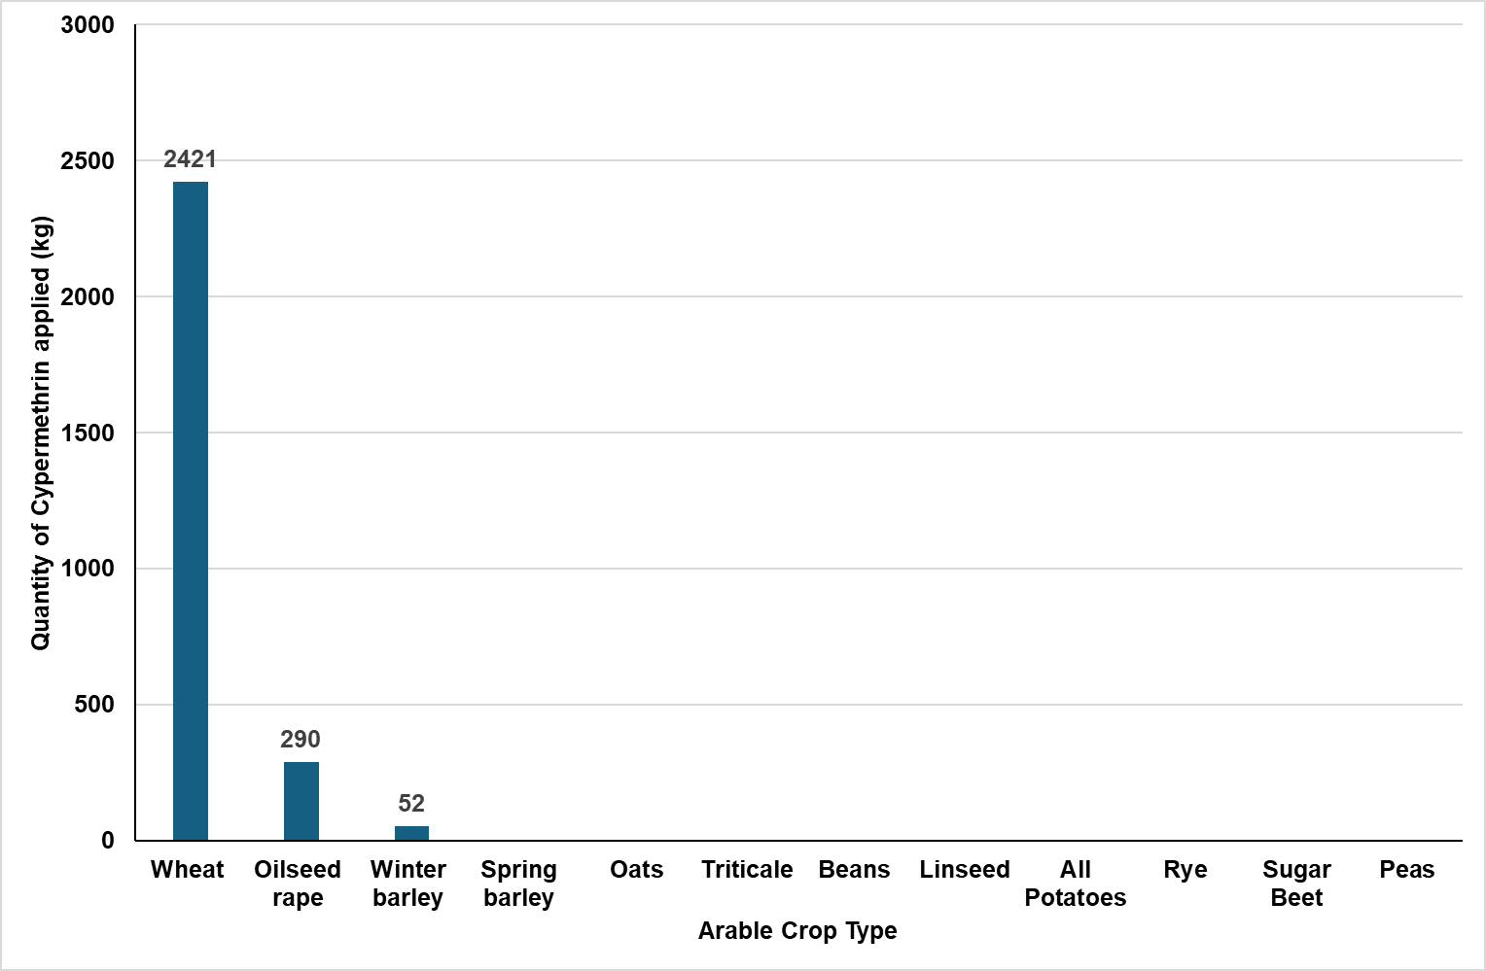

Figure 3: The total amount (kg) of cypermethrin applied to arable crops and seeds over time in the UK
Source: Fera Ltd bespoke pesticide usage data report outputs – all UK data, all surveys, active ingredient cypermethrin
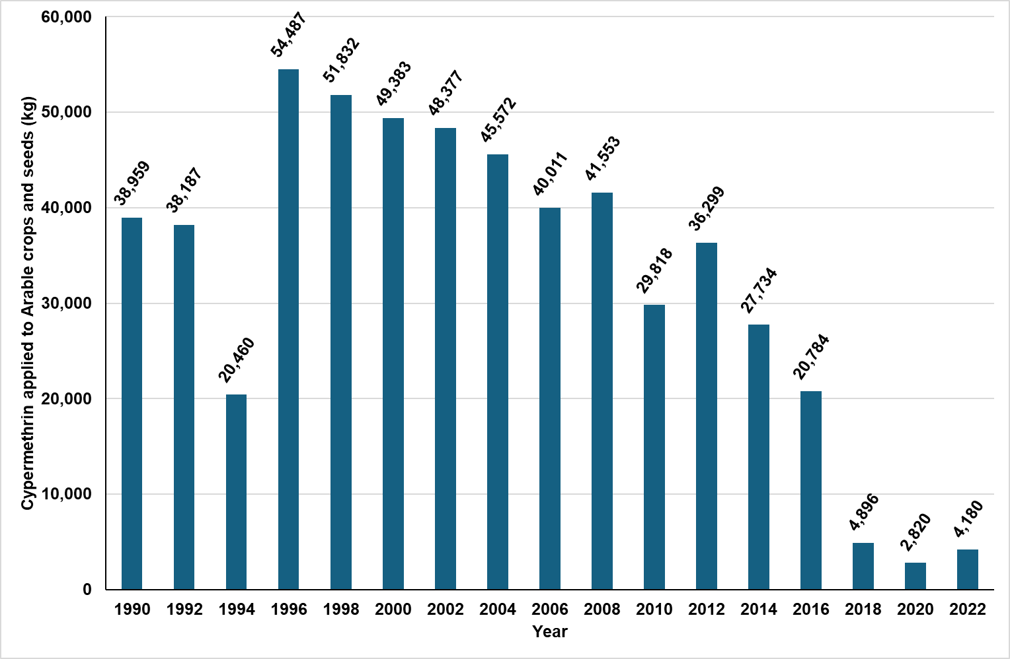
The majority of cypermethrin used as a plant protection product is in arable farming, primarily for the plants and seeds of wheat, oilseed rape, and barley (Figures 1 and 2). While cypermethrin is also used in other crop groups, its application is significantly less prevalent. Since 2010, pesticide usage surveys have followed a biennial cycle, with arable, potato storage, soft fruit, and orchards surveyed in even years (2010, 2012, 2014, 2016, etc.) and outdoor vegetable and edible protected crops surveyed in odd years (2011, 2013, 2015, 2017, etc.). Surveys of grassland and fodder crops (last survey in 2021) are conducted every four years.
The data from these surveys regarding cypermethrin application are presented in Figure 4. Figure 4 is a graph using a logarithmic scale of the total amount (kg) of cypermethrin applied to various crop types identified in pesticide usage surveys in the UK over time. In the most recent survey year (2021), most cypermethrin was applied to outdoor bulbs and flowers and grassland & fodder at 198 kg and 116 kg per annum, respectively. Most other crop groups in recent surveys had applications of less than 20 kg per annum. We do not have information on the quantity of cypermethrin used in forestry and domestic gardens as this is not collected as part of the Pesticide Usage Surveys.
Cypermethrin is used in forestry as a post-planting treatment on saplings to control the large pine weevil. This typically occurs from April to June and August to October - the peak times for damage from this pest (Forest Research, 2017). In the future, there may be a decline in the use of cypermethrin in forestry as it has been identified as a hazardous pesticide in a forest certification scheme (see Section 5.3 for further information).

Figure 4: The total amount (kg) of cypermethrin applied to various crop types identified in pesticide usage surveys in the UK (Log Scale).
Source: Fera Ltd bespoke pesticide usage data report outputs – all UK data, all surveys, active ingredient cypermethrin
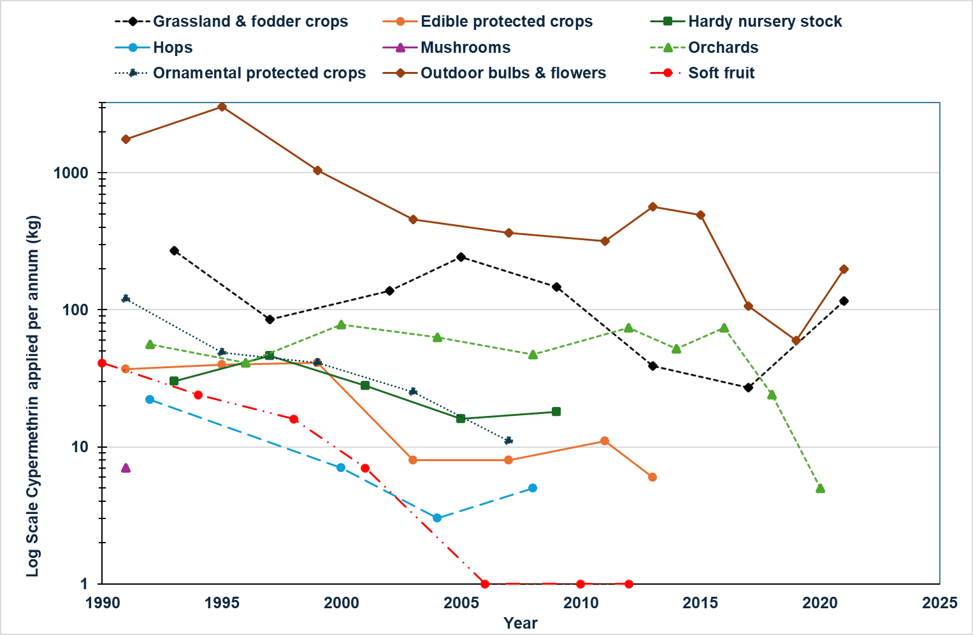

2.2. Use as a biocide
The Control of Pesticides Regulations (COPR) is one of the laws that controls biocides in Great Britain (GB) and Northern Ireland (NI) to ensure that, when used properly, they do not harm people, pets, or the wider environment. COPR is an older law that only applies to some types of biocidal products. The other, newer law that controls biocides in GB is the GB Biocidal Products Regulation (GB BPR)
Cypermethrin is currently approved under the EU Biocidal Products Regulation (528/2012) for use as a wood preservative (EU 2013b) and insecticide (EU 2015; EU 2018). These laws apply to a wider range of biocidal products. To help companies with the transition, some products can continue to be regulated under COPR while the active substance is still being evaluated under GB or EU BPR. Eventually, COPR will become redundant, and all relevant biocidal products (those within the scope of COPR and those that are not) will be regulated under GB or EU BPR.
A list of COPR-approved biocidal products, including those containing the active substance cypermethrin, is maintained by the Health and Safety Executive (HSE). However, many of the products on this list have pending applications under the Biocidal Products Regulation (BPR). The Health and Safety Executive (HSE) also maintains lists of BPR approved biocidal products authorised for use within the UK.
These cypermethrin-containing products are used in homes, public buildings such as hospitals and schools, commercial buildings such as offices, and industrial buildings such as food manufacturers and animal housing. The method of application varies between products. Spray applications are the most common, but smoke generators, bait, and powders are also used. The products are approved for use by professionals or by members of the public in homes and gardens (amateur use).
In the most recent amenity pesticide usage survey in 2022, pest control usage was not recorded, and cypermethrin did not appear in the top list of active substances used as an insecticide by various sectors, such as local authorities, contractors, and railways (Fera 2022a).

2.3. Use as veterinary medicine
Veterinary medicines are used for the prevention and treatment of disease in animals. At the time of writing (data accessed 23/3/25), the Veterinary Medicine Directorate (VMD) Product Information Database listed seven cypermethrin-based veterinary medicines authorised for use in across GB to control lice, ticks, and flies on sheep and cattle. The majority of products are used as ‘pour-on’ products, with one ear tag product available. Pour on products represent the highest risk category for environmental contamination as they are easily washed off the animal in the rain.

3. Emissions, sources and pathways
Cypermethrin does not occur naturally; its presence in the environment is a result of human activity. Cypermethrin can enter the water environment during its use and disposal, as illustrated in Figure 5 and discussed in more detail in the sections below. Figure 5 is an infographic showing the sources and pathways of cypermethrin into the environment. Arrows illustrate the links between diffuse pollution land sources (such as soils, forestry and agriculture), industrial point sources (such as industry, water treatment works, and landfill), and the water environment.

Figure 5: Sources and pathways of cypermethrin into the environment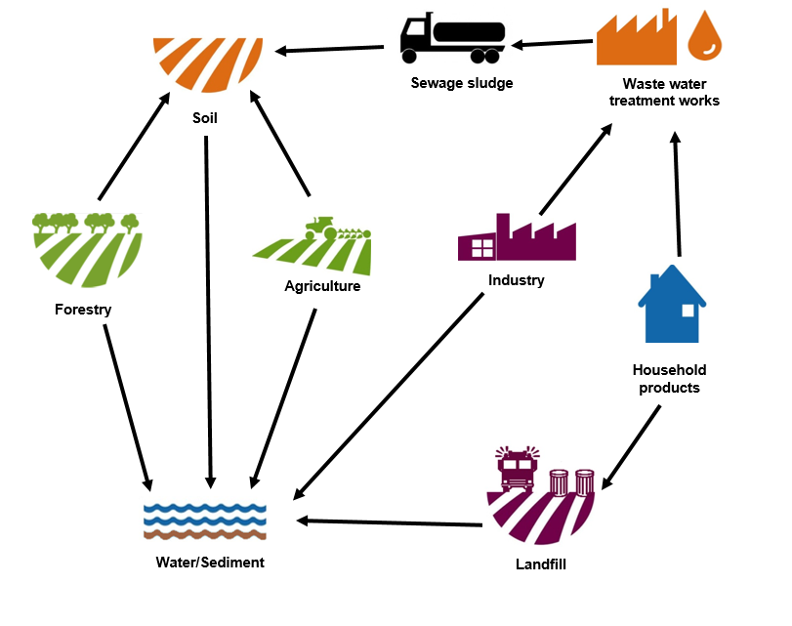

3.1. Plant protection products
Plant protection products containing cypermethrin can reach the water environment through spray drift and surface runoff. Many of the cypermethrin products currently authorised by the Health and Safety Executive for use in the UK have an 18-metre aquatic buffer zone to reduce the risk of exposure to the water environment from spray drift during application. This means that the product cannot be applied to crops within 18m of a watercourse. Low drift spray nozzles are also recommended for application of cypermethrin products.
Surface runoff occurs mainly during periods of high rainfall. Concentrations of pesticides in runoff have been noted to be highest when there is a short time between application and rainfall (Defra, 2009). Cypermethrin was detected at a relatively high concentration of 1.6 µg/L in surface runoff at one site, indicating a potential pathway for aquatic exposure and associated pesticide risk (Defra, 2009). Cypermethrin may reach watercourses following rainfall and subsequent surface run-off from hard standing areas in farms where pesticide spray tanker filling and emptying, and washing down of spray equipment, occurs (Rose and others, 2004).
Cypermethrin containing products are authorised for amateur use in gardens across the UK. The risk of environmental exposure through inappropriate use or disposal is known to be higher in this sector as home users are unlikely to be professionally trained in pesticide use and application. They are usually unaware of the correct disposal routes for waste product and containers and may not understand the risks associated with their actions. For example, disposal of unused product via the sink or drain, disposal of water from the washing of empty containers and disposal of containers containing unused product in household waste by the public was reported by a Pesticides User Habit Survey (HSE, 2016, HSE, 2019).

3.2. Biocides
Cypermethrin is used as an insecticide in homes and public buildings, as well as in industrial buildings and animal housing. It is applied to hard surfaces, such as floors and walls, and to other materials such as textiles, for example, in the control of bed bugs and flies in enclosed spaces.
As a result of this use, cypermethrin may enter surface waters through drains or wastewater from wet cleaning of treated surfaces, washing of textiles, or from rainfall on treated external surfaces. The EU recognised wet cleaning as a potential pathway for cypermethrin to reach the environment, and it is considered an exposure route as part of the risk assessment carried out when approving these types of products (EU, 2015).
Cypermethrin may reach the water environment from use as a wood preservative, either during application or from wash-off and/or leaching from a product following treatment. To mitigate risks and minimise exposure to the aquatic environment, timber treated with cypermethrin must not be used in constructions in or near water. In addition, existing constructions in such locations must not be treated with products containing cypermethrin (Regulation 945/2013).

3.3. Veterinary medicines
The use of cypermethrin to treat sheep and cattle in GB, can potentially result in environmental releases during its use and disposal, as well as from treated animals.
Sheep and cattle are treated with cypermethrin by pouring the product along their backs. Spillages may occur during treatment, which often takes place on hard standing areas on farms. Runoff from hard standings has been identified as a source of pesticides to the water environment (Rose and others, 2004).
Treated animals can be a source of cypermethrin in the water environment if they come into contact with water following treatment, for example, when crossing streams (Ramwell and others, 2007), during rainfall, or through washing the treated animal. Some of the products authorised for use on sheep note that, as a precautionary measure, animals should be kept away from watercourses for a defined period following treatment (VMD Product Information Database).
As noted for plant protection products (Section 3.1) and biocides (Section 3.2), incorrect disposal of excess and unused product, along with rinsings from empty containers, are a source of cypermethrin used in veterinary medicines to the environment.
Livestock markets, which deal with large numbers of sheep and cattle, have the potential to act as a source and pathway for cypermethrin, such as wash-off from animals that have been treated prior to being brought to market.
Sheep fleeces can contain residual amounts of treatment medicines such as cypermethrin (EC, 2003), although wool scouring, undertaken during the processing of fleeces, has been reported to remove more than 90% of these chemicals from the fleeces (EC, 2003). In 1998, a study at seven scouring mills reported the mass load of cypermethrin in greasy wool prior to processing ranged from 3.45 to 7.06 grams per tonne (EC, 2003). Between 86-100% of the cypermethrin was reported to be removed during the scouring process, with the mass load of cypermethrin in the effluent from the scouring mills studied ranging from 0.02 to 0.52 grams per tonne (EC, 2003).
Discharges from wool scouring are therefore a source of cypermethrin to the environment. As a result of increased awareness of this, changes made since the study (see Section 5) may have reduced the amount present in fleeces and therefore released during processing. However, wool scouring remains a potential source and pathway for cypermethrin.
The majority of cypermethrin present in fleeces is removed during scouring, but some remains associated with the fibre produced. For example, cypermethrin has been reported to be present at levels in the range of 0.002–0.014 grams per tonne of textile product (EC, 2003). This may be removed during later stages of wool processing, such as dyeing (EC, 2003).
The Pollution Inventory collates information on mass releases of specified substances to air, controlled waters, and land, as well as quantities of waste transferred off-site from large industrial sites regulated by the Environment Agency. In 2022, the Pollution Inventory recorded that eight textile companies reported cypermethrin discharges into wastewater in excess of the reportable discharge threshold of 0.005 kg. From these companies, the annual discharge amount ranged between 0.1 to 0.5 kg. All these companies were in Yorkshire and were involved in wool scouring, yarn production, or wool dyeing activities.
The wool processed at these sites often originates from a number of countries, including the UK, Australia and New Zealand, as well as Scandinavian and South American countries. The amount of cypermethrin present on the wool processed at these sites is therefore dependent on the extent of use of cypermethrin both within and outside the UK.

3.4. Forestry
Saplings treated with cypermethrin prior to planting can be a source of cypermethrin to the water environment (Forest Research, 2017). Disposal of the bags used to transport the treated plants has also been identified as a potential source (Forest Research, 2017).
Treating saplings with cypermethrin after planting also results in cypermethrin reaching watercourses. Accidental release during preparation of the pesticide for spraying, during application, and through accidental spillage or incorrect disposal are all potential exposure pathways, particularly when application takes place on wet ground or near drains or watercourses (Forest Research, 2017).
In UK forestry, the synthetic pyrethroid insecticides alpha-cypermethrin and cypermethrin have been used for many years to protect young trees planted on restock sites from damage by the large pine weevil, Hylobius abietis L. However, concerns over the toxicity of these insecticides to aquatic life if misused have led to a search for alternative forms of protection (Willoughby and others, 2020). In this study, over 50 combinations of chemical and non-chemical approaches were tested on 16 different UK sites, but most of these approaches proved largely ineffective in controlling the pest under UK environmental conditions. Acetamiprid (a neonicotinoid insecticide) was the only substance that had comparable results to cypermethrin.
With acetamiprid (Gazelle SG) no longer being approved for the control of the large pine weevil (Hylobius abietis) from 1st August 2024, the Forestry Stewardship Council UK has published a UK National Environmental and Social Risk Assessment (ESRA) for the alternative pesticide cypermethrin on their website.

3.5. Landfill
Leachate from landfill is a potential source of cypermethrin to the environment due to the disposal of materials such as timber that have been treated with cypermethrin. Cypermethrin may also be present as a result of the disposal of pesticide containers, sometimes containing unused product, in household waste (HSE, 2016, HSE, 2019). Disposal to waste rather than recycling has been the recommended route for disposal of pesticide containers (Defra, 2013a), although containers for ready-to-use products can now be recycled.
No landfill sites reported emissions of cypermethrin to the Pollution Inventory in 2022 (Environment Agency, Pollution Inventory Data). We have no other information on concentrations of cypermethrin in landfill leachate. As cypermethrin adsorbs to organic matter, the potential for it to leach from landfills may be reduced.

3.6. Wastewater treatment works (WwTW)
Three wastewater treatment works (WwTW) reported releases of cypermethrin to the water environment in the Pollution Inventory in 2022 (Environment Agency, Pollution Inventory Data). The amount released from these three sites ranged from 1.24 to 31.35 kg. All three sites were in Yorkshire, England.
Cypermethrin may enter the sewage network through a wide range of routes. These include effluent from industrial activities, such as the wool scouring and paper and pulp industries, as well as input from domestic sources. The latter includes the disposal of excess or unused pesticide or biocide product down the drain or sink, washings from the cleaning of empty containers (HSE, 2016, HSE, 2019), washing surfaces that have been treated with cypermethrin, for example, for the control of bed bugs, and the washing of treated textiles.
The Chemical Investigations Programme (CIP) is the UK water industry’s response to current and emerging legislation on trace chemical substances in the water environment. It brings together the 10 large water and wastewater companies in England and Wales with regulators (Defra, the Environment Agency, and Natural Resources Wales) to investigate a range of chemical substances that may be present in untreated and treated effluent or sludge bio-waste. CIP1, CIP2, and CIP3 occurred over the years 2010-2013, 2015-2020, and 2020-2022, respectively. Each investigation phase progressively discovered new insights into chemicals of concern passing through WwTWs. CIP4 is currently underway and is being delivered in 2025-2027.

CIP1
Cypermethrin was not ubiquitously detected across all effluents of WwTWs sampled in CIP1, potentially suggesting that localised geographical point or diffuse source pollution may be a factor, which required further investigations. Another key finding of the initial report highlighted that data quality, particularly regarding laboratory limits of detection, was insufficient for the intended monitoring purpose, namely, to provide an accurate picture of effluent quality in relation to current river quality standards (UKWIR, 2014). Analytical techniques were refined and implemented in the phase 2 investigations (CIP2).

CIP2
CIP2 monitored effluent from over 600 WwTWs, focussing on sites with large volumes and low dilution in the receiving waters and thus at greatest risk of causing noncompliance with Environmental Quality Standards (EQS) downstream. The WwTWs sampled ranged in size from 250 to 1.6 million population equivalents, although most were between 5,000 and 50,000 population equivalents (pe).
Cypermethrin was detected in the effluent of all WwTWs monitored. The average concentration of cypermethrin in the effluents in the first group of WwTWs was reported to be 0.00034 µg/L (UKWIR, 2018) and 0.00094 µg/L for a subsequent group (UKWIR, 2019).
A summary of the cypermethrin monitoring data is shown in Table 1 below (Gardner and others, 2022). The mean cypermethrin concentration from all sites measured during CIP2 was 0.0003 µg/L with a standard deviation of 0.00064. This number was approximately three times greater than the Environmental Quality Standard of 0.00008 µg/L for cypermethrin.

Table 1: Summary of CIP2 cypermethrin data (2016–2019)
All concentrations expressed as μg/l, with the 5th (P5) to the 95th percentile (P95) shown. Data taken from table 2 of Gardner and others, 2022.
Mean | Standard Deviation | P5 | P10 | P25 | P50 | P75 | P90 | P95 | Required LOD | % of results reported as <LOD
0.0003 | 0.00064 | 0.00004 | 0.00004 | 0.00006 | 0.00017 | 0.0004 | 0.009 | 0.0015 | 0.00008 | 8%

CIP3
Cypermethrin adsorbs to organic matter and therefore has the potential to be present in sewage sludge, and consequently in sludge spread to land. At the time of the CIP2 investigations, information on levels of cypermethrin in sewage sludge was unknown, hence studies in CIP3 were designed to address this evidence gap. Furthermore, the CIP3 investigations also examined cypermethrin concentrations in sewer networks to identify the best treatment processes and sources of cypermethrin. Additionally, further work was conducted in some parts of the country to quantify trade and animal treatment sources.
UK investigations into the efficiencies of wastewater treatment processes have shown that Activated Sludge Plants (ASP) are more efficient in the removal of cypermethrin from sewage effluent compared to other technologies such as trickling filter works. Furthermore, comparisons of effluent quality from WwTWs that applied a chemical phosphorus removal step in the water treatment process system showed a statistical improvement in cypermethrin levels compared to WwTWs with no phosphorus removal stage in the water treatment system (UKWIR, 2023a). However, it is important to note that sewage effluent treatment may remove chemicals from wastewater into sewage sludge, rather than removing the chemicals from the environment entirely.
The aim of the CIP3 sewer and river catchment investigation (UKWIR, 2023c) was to determine the sources of some of the trace substances that had been identified in earlier studies as posing the greatest risk of non-compliance with environmental quality standards. The substances investigated included cypermethrin. The investigation found that cypermethrin sources included abattoir sites, laundry sites, and pest control trade effluent. Domestic effluent was also found to be another source, likely due to cypermethrin’s use as a biocide in products to control a range of insect pests in homes, buildings, and gardens. The investigation report recommended that cypermethrin sources identified in trade effluent should be investigated further to ensure that concentrations of this substance are fully disclosed, minimised, and controlled through permitting.

CIP4
CIP4 is running from 2025 to 2027 and will build on the chemicals of concern outputs from CIP3 with further investigations into sludge, groundwater, estuaries, microplastics, and antimicrobial resistance (AMR) studies, as well as expanding previous work on emerging substances to quantify risks from these chemicals. Cypermethrin is included in several of these investigations (estuaries, sludge, groundwater and integrated constructed wetlands).

3.7. Paper and pulp industry
Four pulp and paper industry sites reported releases of cypermethrin to the Pollution Inventory in 2022 above the reportable threshold (Environment Agency, Pollution Inventory data). Reported releases to controlled waters from these four sites ranged from 0.0054 to 0.19 kg. Cypermethrin may have been used to treat the wood from which the wood pulp is made. However, cypermethrin may also be present in the water abstracted for use in the process, and as a result of water loss during the manufacturing process, it may be concentrated to a level where it is then detectable in the discharge.

3.8 Chemical industry
A report in 2011 for the EU for the purposes of the Water Framework Directive did not identify any manufacturing or formulating sites for cypermethrin in the UK (ENTEC, 2011). No notifiable releases of cypermethrin from chemical manufacturers were reported to the Pollution Inventory in 2022 (Environment Agency, Pollution Inventory Data).
Formulation is not covered by the Environmental Permitting Regulations (EPR) 2016; therefore, there is no requirement to report emissions from this activity to the Pollution Inventory. Emissions would have only been reported if the site's principal activity is regulated by the EPR. The Environment Agency does not regulate formulation plants, so we currently do not have more information on the extent of this activity or its potential to be a source of cypermethrin in the environment in England.

4. Environmental monitoring data and risk assessment
Cypermethrin is designated by the European Union as a Priority Substance under the Environmental Quality Standards Directive (2013/39/EU), a daughter directive of the Water Framework Directive (WFD) (2000/60/EC). This classification means it is monitored as part of a suite of chemicals used to determine the “Chemical Status” of WFD water bodies across the UK.
UK water companies have monitored cypermethrin through the Chemicals Investigations Programmes (CIP1 to CIP3). CIP1 identified pollution hotspots, prompting targeted investigations to better understand the pathways, sources, and receptors of cypermethrin at their sites. In contrast, the Environment Agency’s monitoring for “Chemical Status” substances—such as cypermethrin—is conducted across a much broader network of sites and catchments throughout England. This approach provides a more comprehensive and representative picture of cypermethrin’s presence and impact in the wider aquatic environment, supporting national assessments and informing regulatory action.

4.1 Groundwater monitoring data from the Chemical Investigation Programme (CIP)
Data from the Chemicals Investigation Programme (CIP3) groundwater study (2020–2022) show that cypermethrin was detected in groundwater at a number of sites associated with sewage treatment works discharging to ground. Concentrations ranged from below detection limits to several µg/L, with many mean values exceeding the annual average Environmental Quality Standard (AA-EQS) of 0.00008 µg/L. At one site (Rossendale catchment, sample point 11), mean and maximum concentrations reached 1.76 µg/L and 5.96 µg/L respectively, far above the EQS. In most cases, downgradient monitoring points recorded higher concentrations than upgradient points, indicating effluent and trade sources as key contributors. These findings highlight that cypermethrin can occur in groundwater at levels relevant to environmental quality assessments, with potential to contribute to surface water status failures where groundwater forms a significant component of the pollutant load.

4.2 Surface water monitoring data from the Chemical Investigation Programme (CIP)
In CIP3, each of the 10 water companies in England had to undertake sewer catchment investigations for cypermethrin in a minimum of two catchments, covering 18 sites in England (UKWIR, 2023c). The summary statistics for the concentrations of cypermethrin in each sewer catchment CIP3 investigation are shown in Table 2 below. The mean concentration of cypermethrin exceeded the Annual Average EQS, and the maximum concentration exceeded the Maximum Allowable Concentration (MAC) EQS in all catchments, in other words, most were non-compliant with the EQS.
However, it must be clearly pointed out that these sites with comparatively high cypermethrin levels are not reflective of the wider WwTW sites across England nor do they reflect overall compliance in rivers, as they were specifically chosen based on data from the previous CIP2 study, which identified sites for further investigations. The aim of the sewer and river catchment investigations was to determine the source or sources of cypermethrin that had been identified as the greatest risk of non-compliance with the EQS.

Table 2: Summary statistics for the concentrations of cypermethrin (expressed as µg/l) in each sewer catchment
(AA-EQS = 0.0008µg/L, and MAC-EQS = 0.0006µg/L). Data taken from UKWIR (2023c)
Catchment | Mean | Ratio of mean: AA-EQS | Standard Deviation | Minimum | Maximum | Ratio of MAC: EQS
Bentley | 0.0095 | 118 | 0.0153 | 0.0009 | 0.0496 | 83
Billingshurst | 0.0026 | 33 | 0.0031 | 0.0002 | 0.0095 | 16
Clavering | 0.0111 | 139 | 0.0232 | 0.0008 | 0.0841 | 140
Crookhall | 0.0030 | 37 | 0.0042 | 0.0001 | 0.0132 | 22
Garforth | 0.0114 | 143 | 0.0158 | 0.0026 | 0.0503 | 84
Gresford | 0.0051 | 64 | 0.0067 | 0.0002 | 0.0226 | 38
Hustledown | 0.0068 | 85 | 0.0099 | 0.0005 | 0.0308 | 51
Manuden | 0.0108 | 135 | 0.0212 | 0.0008 | 0.0704 | 117
Minworth | 0.0595 | 744 | 0.0464 | 0.0144 | 0.1753 | 292
Newmarket | 0.0038 | 47 | 0.0040 | 0.0008 | 0.0136 | 23
Ouzel | 0.0015 | 19 | 0.0013 | 0.0003 | 0.0041 | 7
Penybont | 0.0021 | 26 | 0.0029 | 0.0002 | 0.0094 | 16
Ray Hall | 0.0020 | 25 | 0.0027 | 0.0004 | 0.0107 | 18
Rossendale | 0.1130 | 1412 | 0.1237 | 0.0144 | 0.3851 | 642
Royal Wooton Bassett | 0.0034 | 43 | 0.0037 | 0.0003 | 0.0118 | 20
Stansted Mountfitchet | 0.0074 | 93 | 0.0130 | 0.0013 | 0.0430 | 72
Turnbridge Wells North | 0.0050 | 62 | 0.0060 | 0.0014 | 0.0180 | 30
Wigan | 0.0034 | 43 | 0.0044 | 0.0003 | 0.0136 | 23
Further analysis of the data behind the summary statistics in Table 2 shows that the mean and maximum concentrations of cypermethrin in the Rossendale catchment were greater than in all other catchments. A review of the data from the individual sample points within the Rossendale catchment showed that the mean concentration at sample point number 11 was 1.76 µg/L, and the maximum concentration was 5.96 µg/L, which is in excess of the concentrations recorded at other locations within that catchment, or indeed others investigated in this study. A review of the local water company’s catchment report for Rossendale catchment showed this sample point received trade effluent from an abattoir, the most likely point source of cypermethrin.
A review of the data from the other catchment investigation sampling points shows that there were very few sample points where the mean concentration was less than the AA-EQS of 0.00008 µg/L. Notably high mean concentrations (>0.06 µg/L) were observed at four sample points in the Minworth catchment (at Sample Points 3, 4, 8, and 11). Mean concentrations in the range of 0.02-0.006 µg/L were also observed at 14 other sites spread across eight catchments (Bentley; Billingshurst; Clavering; Garforth; Gresford; Manuden; Minworth; and Stanstead Mountfitchet). Options for reducing cypermethrin concentrations in sewage effluent at all these sites have been considered, and some have been implemented using permitting through the water company price review process (PR24). Permits for the relevant sites will be issued in 2026 or 2027.
An additional study within the CIP3 investigations looked at chemical data from biosolids collected from 11 sludge treatment centres (STC) across England and Wales (UKWIR, 2023d). The occurrence of cypermethrin across the 11 sludge treatment sites was widespread and variable (see Table 3 below). Cypermethrin was detected in all samples (100%) from Ayleford STC and most samples (>85%) from Great Billing and Wanlip STCs, with similar median concentrations of ~0.08 mg/kg dry weight at these sites. Lower median concentrations (but of the same order of magnitude) were also detected at Howdon and Ratfyn STCs but in less than two-thirds of the samples. At all the remaining STCs, cypermethrin was detected in biosolids much less frequently (up to 15% of the time). The data showed no significant difference in the mean dry weight concentrations between sites. Cypermethrin showed near ubiquitous presence in pre-treatment wastewater samples across all WwTWs (data not shown), in contrast to the variable presence in biosolids (UKWIR, 2023d). The removal efficiencies from wastewater into biosolids are variable but generally high for cypermethrin across a range of wastewater treatment technologies, with a few exceptions where removals are poor (e.g., CoMAG, COUF, and one MECANA site). This suggests that variability in the effectiveness of wastewater treatment technologies (and potentially the unknown impact of sludge treatments) may control some of the variability in presence and concentration in biosolids (UKWIR, 2023d).
CIP3 studies investigating the efficacies of WwTW technologies to remove cypermethrin have shown that sites with Activated Sludge Process (ASP) and either membrane filtration or Powdered Activated Carbon (PAC) had the highest removal rates (UKWIR, 2023b). However, post-treatment levels of cypermethrin in sewage effluent at these sites still exceeded the EQS.

Table 3: (a) Percentage of biosolids samples containing detectable concentrations of cypermethrin across all Sludge Treatment Centres. (b) Median dry weight concentration (mg/kg) of cypermethrin in biosolids at each STC
All data taken from UKWIR (2023d)
Measure | (a) % of biosolids with detectable cypermethrin concentration | (b) median (mg/kg) of cypermethrin concentration in biosolids
Aylesford | 100 | 0.081
Buckland | 15 | <0.0050
Crawley | 15 | <0.0050
Five Fords | 10 | <0.0050
Great Billings | 91 | 0.00752
Howdon | 65 | 0.033
Naburn | 5 | <0.0050
Ratfyn | 50 | 0.0129
Stockport | 10 | <0.0050
Wanlip | 86 | 0.0787
Whitlingham | 11 | <0.0050

4.3. Environment Agency surface water monitoring data
For the latest WFD compliance figures for cypermethrin or any other WFD element, you can download the raw compliance dataset or drill down via the interactive catchment maps until the data for each water body are displayed on the EA catchment data explorer tool. However, it should be noted that the raw data presented below for trend analysis is based on a combination of geometric means and an amalgamated dataset. Therefore, it is not directly comparable to the WFD classification status for cypermethrin, which uses a different statistical method. The inclusion of the EQS benchmark in the graphs and maps below is intended solely for indicative and illustrative purposes.
Figure 6 below shows surface water cypermethrin monitoring data collected across England between 2021 and 2024. Figure 6 is a graph displaying the geometric means of cypermethrin concentrations (expressed in µg/L) across amalgamated data from Environment Agency surface freshwater monitoring sites in England, collected between 2021 and 2024. The graph includes modelled trend lines both with and without seasonal adjustment. The “without seasonality” straight orange line shows a general linear trend, with a slight rise in cypermethrin concentrations over the four-year sampling period. The “with seasonality” modelled green line still shows the slight rise in cypermethrin concentration over the same period. In addition, it shows a distinct seasonal pattern, with concentrations greatest in winter and lowest in the summer months, a pattern repeated each sample year. Likely reasons for these seasonal patterns are discussed later in Section 6.

Figure 6: Geometric means of Cypermethrin, expressed as µg/L, plotted for all England amalgamated data collected between 2021 and 2024 at Environment Agency surface freshwater monitoring sites, showing modelled trend data with and without seasonality, with 95 % confidence intervals.
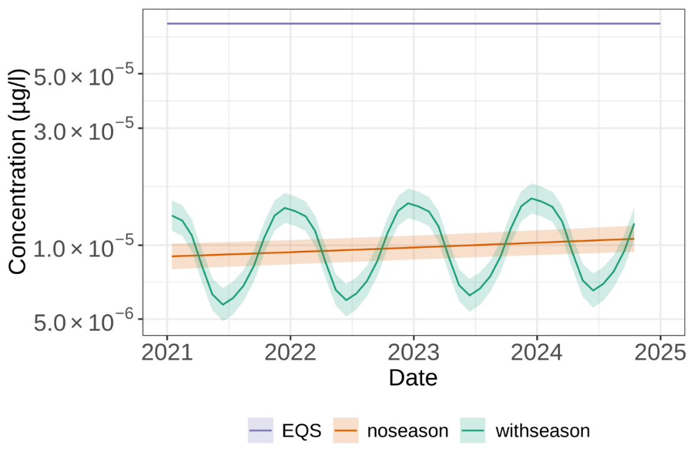
Figure 6 shows a strong annual seasonal pattern, with cypermethrin peaks in winter and lower concentrations in the summer months. In livestock farming, cypermethrin application rates are highest in winter when livestock are brought indoors and treated for ectoparasites. This usage pattern is a strong probable cause for the winter peaks. Winter wheat seeds are often treated with cypermethrin, which could also partially explain a winter spike in environmental cypermethrin levels. UK winters tend to be wetter, with a higher seasonal rainfall pattern compared to the summer months. This is another partial explanation for the winter cypermethrin peak, as it has been shown that surface water runoff can occur during periods of high rainfall. Concentrations of pesticides in runoff have been noted to be highest when there is a short time between application and rainfall (Defra, 2009).
Figure 7 below presents the previous dataset, now disaggregated by individual sites and their corresponding River Basin District (RBD) catchments. Figure 7 is a collection of graphs showing the geometric means of Cypermethrin expressed in µg/L, plotted for all England amalgamated data collected between 2021 and 2024 in Environment Agency surface freshwater monitoring sites. The data is shown plotted for individual sites in each WFD River Basin District (RBD). This view of the data shows that the slightly upward trend over the four-year reporting period (2021-24) is universal across the RBDs and for the majority of the individual sites, but the concentration remains below the environmental quality standard (EQS). However, it should be noted that cypermethrin geometric means and the EQS shown in these graphs are for indicative purposes only. This graph does not represent true Water Framework Directive (WFD) compliance, which is calculated using site-specific annual arithmetic mean averages for EQS comparison.

Figure 7: Geometric means of Cypermethrin expressed as µg/L, plotted for all England amalgamated data collected between 2021 and 2024 in Environment Agency surface freshwater monitoring sites
Data plotted for individual sites in each WFD River Basin District (RBD). 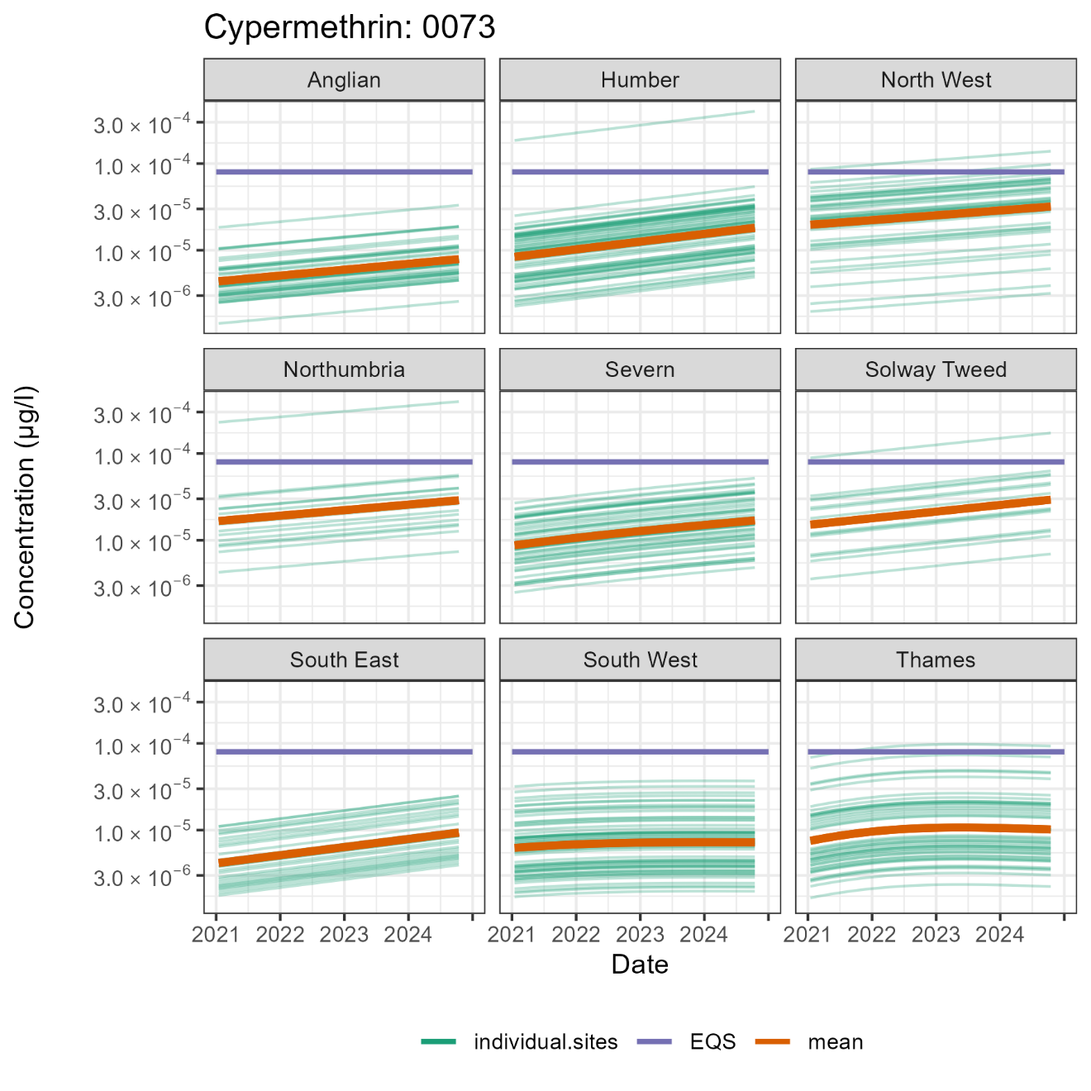
Both Figures 6 and 7 show a slight upward trend over the four-year sampling period 2021-2024. However, caution must be exercised in the interpretation of these data, as the graphed data are only a small snapshot (four years) of the total dataset. Additionally, some of those years were impacted by the Covid pandemic, resulting in a reduction in sample collections. Furthermore, later during that period, new monitoring sites were added to the network, which may have distorted the data.
Summary statistics for the previous surface freshwater dataset, disaggregated by River Basin Districts (RBDs), are presented in Appendix A below. The RBD with the highest geometric mean cypermethrin concentration was the Northwest RBD at 0.000025 µg/l, closely followed by Northumbria RBD at 0.000022 µg/l. The RBD with the lowest cypermethrin concentration was Anglian at 0.000006 µg/l, closely followed by South East RBD with a similar cypermethrin concentration. None of the average RBD catchment concentrations listed in Appendix A were above the EQS for cypermethrin.
A probable reason for the highest concentration in the Northwest and Northumbria RBDs is that these catchments have higher livestock (sheep and dairy) densities compared to those with the lowest concentrations, namely the Anglian and South East RBDs. The Anglian RBD is characterised by a predominantly arable farming-dominated landscape, while the South East RBD is more urbanised. A higher livestock density will inevitably be linked to higher cypermethrin pesticide use to control ectoparasites. A concentration of wool processing industries in the North, along with trade effluent containing wool scouring residues, may partly contribute to elevated environmental pollutant levels.
A visual of the data shown in Appendix A is presented in the map in Figure 8 below. Figure 8 shows the data from Table 5 mapped to visualise the variation between RBD catchments. The data represents the four-year average (2021-2024) of the geometric mean concentration of cypermethrin in freshwater surface waterbodies in each RBD, expressed as µg/l. The RBD with the highest geometric mean cypermethrin concentration was the Northwest RBD at 0.000025 µg/l, closely followed by Northumbria RBD at 0.000022 µg/l. The RBD with the lowest cypermethrin concentration was Anglian at 0.000006 µg/l, closely followed by South East RBD with a similar cypermethrin concentration.
Figure 9 is a map showing the annual average cypermethrin concentration at individual monitoring sites sampled in 2023, which again shows that those RBDs in the north of England have the highest cypermethrin concentrations. Figure 9 is a map illustrating the annual average concentrations of cypermethrin (expressed in µg/L) at individual surface water monitoring sites sampled in 2023. The size of the circles represents the concentrations; the higher the concentration, the bigger the circle. Those concentrations above the EQS are represented by the border of the circle in red. For the concentrations below the environmental quality standard, the border of the circle is in black.
The same dataset, amalgamated data for the whole of England but split by surface freshwater and groundwater, is shown in Table 4. As only a limited amount of data for the marine environment were collected during 2021-24, they are not shown.
For the latest WFD compliance figures for cypermethrin or any other WFD element, you can download the raw compliance dataset or drill down via the interactive catchment maps until the data for each water body are displayed on the EA catchment data explorer tool.

Table 4: All-England amalgamated data for the four-year average (2021-2024) concentration of cypermethrin in freshwater, groundwater, and marine waterbodies in each River Basin District (RBD), expressed as µg/L
Data from EA statutory monitoring.
Environmental compartment | Average, cypermethrin expressed as µg/L | Lower confidence limit | Upper confidence limit
Freshwater | 0.000011 | 0.000008 | 0.000017
Groundwater | 0.000013 | 0.000013 | 0.000014
Table 4 shows similar results between groundwater and freshwater surface water for cypermethrin levels, with the former being statistically slightly higher. However, caution needs to be applied in the interpretation of these data due to the limited data collection over this four-year period.

Figure 8: A map visualising data from Table 5, showing variation in cypermethrin concentrations across River Basin District (RBD) catchments
The data represents the four-year average (2021–2024) of the geometric mean concentration of cypermethrin in freshwater surface waterbodies within each RBD, expressed in µg/L.
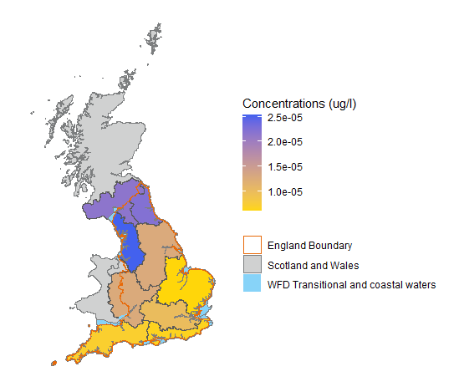

Figure 9: A map showing the annual average cypermethrin concentrations (expressed in µg/L) at individual monitoring sites sampled in 2023.
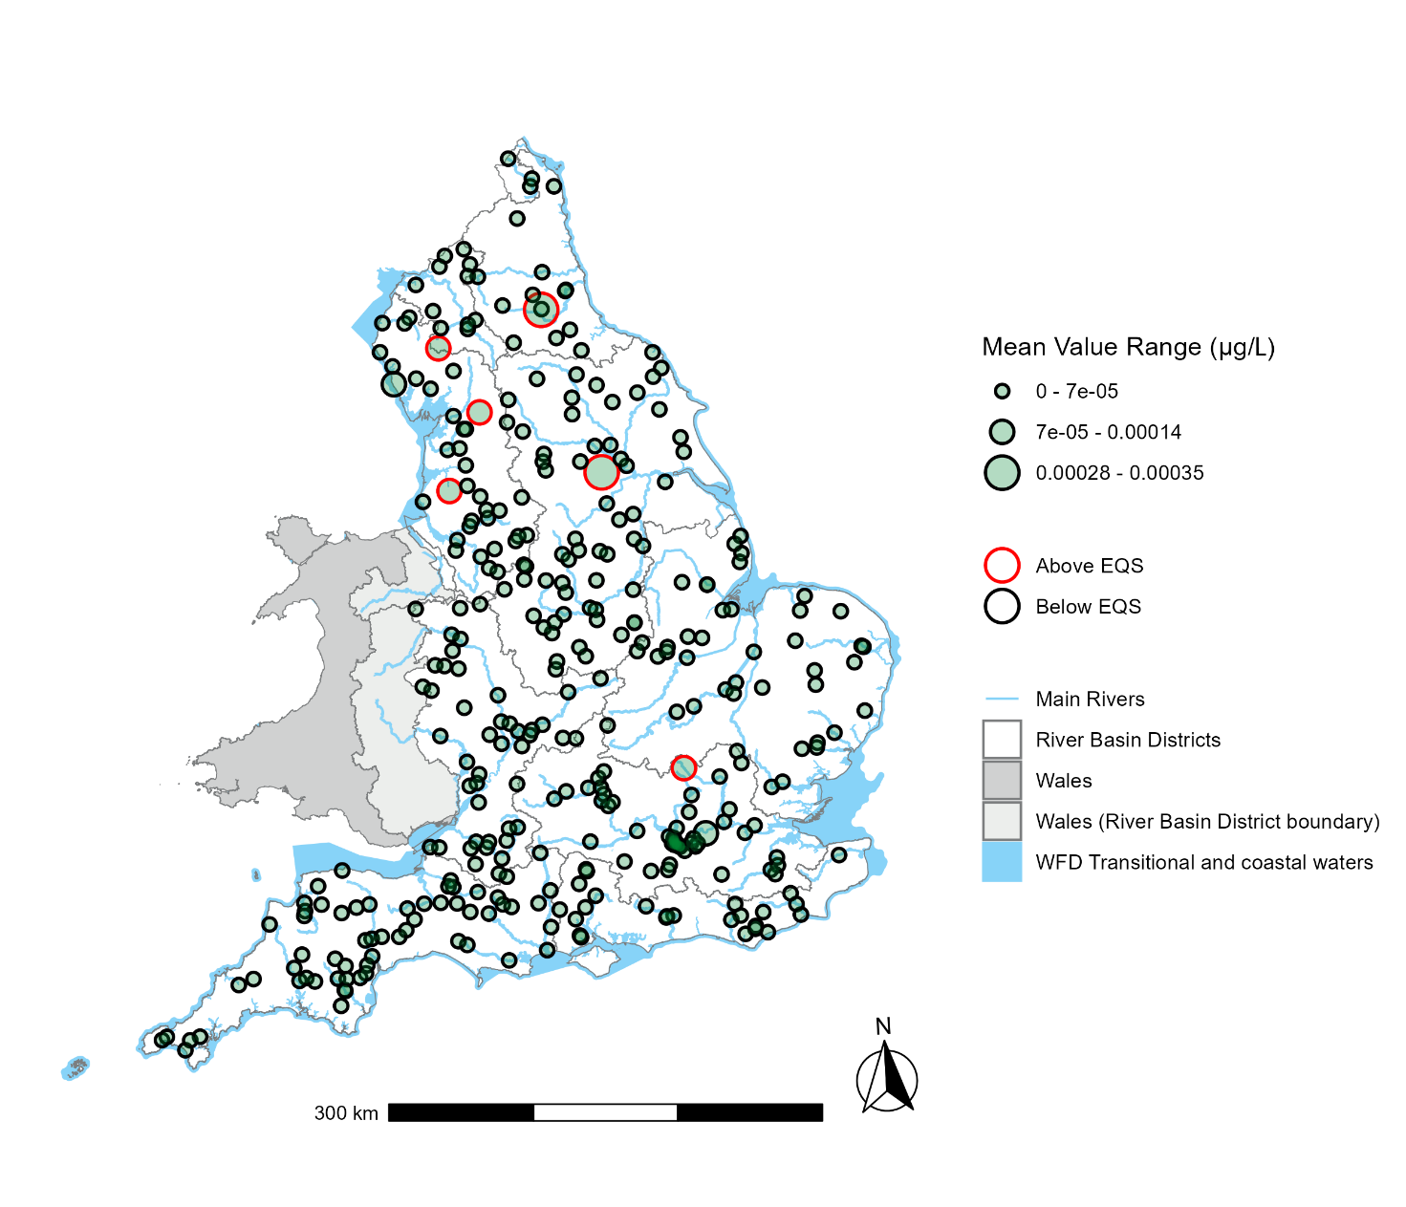

5. Control measures
Many initiatives are currently in place to promote best practices and the safe use of plant protection products, veterinary medicines, and biocides such as cypermethrin. These include EU and national legislation, national codes of best practice, and guidance drawn up by a range of organisations, such as the Forestry Commission and the voluntary, industry-led group “Sustainable Control of Parasites in Sheep (SCOPS).”

5.1. Biocides
As discussed in Section 2.2, prior to the introduction of the Biocidal Products Regulation (BPR), insecticidal biocide products were regulated in the UK under the Control of Pesticides Regulations (COPR) 1986 (amended 1997). This legislation is likely to become redundant as products controlled under COPR gradually move under the scope of the Biocidal Products Regulation (528/2012). Currently, approximately half of the cypermethrin products on the approved COPR list have BPR applications in progress.
Following the end of the EU exit transition period on 31 December 2020, the EU Article 95 list of biocidal active substance suppliers is no longer applicable in Great Britain. Under the GB Biocidal Products Regulation (GB BPR), Great Britain maintains its own, independent list of biocidal active substance suppliers, referred to as the ‘GB Article 95 List.’
Authorised products are labelled with a range of information, including how to apply the product, how much can be applied, and methods of application and disposal. The label will also state whether the product is approved for use by those using it as part of their work and/or by members of the public in home and garden situations. The labelling rules are covered by the Chemicals Classification, Labelling and Packaging Regulations.
General guidance on the use of biocides, provided by HSE, highlights that such products should be used responsibly and correctly and that, where possible, alternatives to biocides should be considered. The guidance states that professional users of such products should receive appropriate training, which is available from several organisations.
In addition to the general guidance provided by the HSE, industry-led voluntary initiatives offer best practice guidelines for managing exposure, including the safe handling, mixing, and disposal of pesticides:
- SCOPUS - Sheep dip disposal advice
- Integrated Pest Management (IPM) - on emergency procedures
- Integrated Pest Management (IPM) - on the pesticide handling areas
- Integrated Pest Management (IPM) - on container cleaning
- Integrated Pest Management (IPM) - on the safe storage of pesticides
- Integrated Pest Management (IPM) - on pesticide disposal
- Integrated Pest Management (IPM) - on keeping go records on pesticide

5.2. Plant protection products
From 1 January 2021, an independent pesticides regulatory regime is in operation in Great Britain (England, Scotland, and Wales). All relevant EU law in relation to the regulation of plant protection products in force on 31 December 2020 was retained in GB law. Under the terms of the Withdrawal Agreement and Northern Ireland Protocol, EU PPP legislation continues to apply in Northern Ireland. New decisions taken under the EU regime do not apply in Great Britain. This includes active substance and maximum residue level (MRL) decisions and any new EU plant protection product (PPP) legislation.
The laws for Great Britain and Northern Ireland have identical titles, but they may result in differences in requirements for duty holders as divergence happens. For example, Regulation (EC) 1107/2009 means:
- in relation to Great Britain, Regulation (EC) 1107/2009 as it has effect in Great Britain
- in relation to Northern Ireland, Regulation (EC) 1107/2009 as it has effect by virtue of the Protocol on Ireland/Northern Ireland in the EU withdrawal
The Health and Safety Executive (HSE) remains the national regulator for the whole of the UK, on behalf of the UK government and the devolved administrations.
The Chemical Regulation Division of HSE is responsible for authorising plant protection products for use in the UK. Each authorised product has conditions for its use, including the crops on which it can be applied, the amount that can be applied, and the timing of application.
The use of cypermethrin, along with other pesticides, will also be influenced by a range of measures that have been put into place to promote the best use of pesticides.
The latest UK Pesticides National Action Plan was published in March 2025. This plan sets out the priorities of the four UK governments for the sustainable management of pests, weeds and diseases. It seeks to minimise the risks and impacts of pesticide use on the environment and human health, while supporting agricultural productivity.
The UK Pesticides National Action Plan focusses on actions against statutory obligations, and covers:
- encouraging the development and uptake of integrated pest management (IPM) and alternative approaches or techniques to reduce dependency on the use of pesticides
- establishing timetables and targets for the reduction of the risks and impacts of pesticide use, including monitoring and setting targets for the reduction of use of pesticides containing active substances of particular concern
- ensuring storage, handling, cleaning and disposal operations do not endanger human health or the environment through effective inspection, enforcement and other official control activities

5.3. Forestry

Use of Cypermethrin in UK Forestry: Policy and Practice
Cypermethrin-based products approved for forestry are classified as plant protection products and are subject to the legislation and guidance outlined in Section 5.2.
The large pine weevil (Hylobius abietis) is a major pest of newly planted or regenerating woodland in the UK. Without protective measures, average tree losses on affected sites can reach 50%, with total failure possible in severe cases (Forest Research, 2022). Forest Research has updated its guidance on integrated pest management for Hylobius, drawing on seven years of collaborative research into alternatives to cypermethrin.

Policy and Certification Frameworks
Several forestry-specific standards and certification schemes regulate pesticide use, including cypermethrin:

UK Forestry Standard (UKFS)
The UKFS (5th edition, 2023) outlines the UK government's approach to sustainable forestry. It promotes minimal pesticide use and mandates:
- restriction to internationally approved pesticides
- preference for non-chemical alternatives
- use only when necessary and in minimal quantities
It also requires compliance with legal standards for pesticide storage, disposal, and application, and promotes best practice to avoid environmental contamination. Additional guidance is available in the UKFS Practice Guides on water protection and pesticide reduction (Forest Research).
Key operational requirements include:
- apply pesticides only in suitable weather and ground conditions
- avoid contamination of watercourses and drainage systems
- use anti-siphon devices when drawing water for spraying
- do not soak treated stock in surface water
- avoid application on impermeable surfaces draining to water systems

Forest Stewardship Council (FSC)
The FSC Pesticides Policy prohibits the use of certain 'highly hazardous' pesticides unless a derogation is granted. Alpha-cypermethrin, while not banned, is listed as a highly restricted substance. Its use in FSC-certified forests is permitted only under strict conditions and with justification (FSC, 2019a–c).

UK Woodland Assurance Standard (UKWAS)
UKWAS (2018) integrates the requirements of the UKFS, FSC, and PEFC. Compliance ensures alignment with all three frameworks, including the FSC’s restrictions on pesticide use.

5.4. Veterinary medicines
In the UK, several voluntary and regulatory guidance measures exist to help mitigate the environmental impact of veterinary medicines. These are primarily overseen by the Veterinary Medicines Directorate (VMD) and supported by professional bodies like the Royal College of Veterinary Surgeons (RCVS).
While no cypermethrin-based sheep dips are currently authorised for use in the UK, there are six products authorised as pour-on treatments for sheep and cattle, and one as an ear tag. Pour on products are recognised as posing the highest risk for contamination of the wider environment as they are often washed off during rainfall events, see section 3.3 for more detail.

5.5 Industrial processes
Wool processing has been identified as a potential route for the release of cypermethrin to the water environment (Section 3). The textile industry, which includes wool processing activities such as wool scouring, is regulated under the Industrial Emissions Directive 2010/75/EU. Following EU Exit, this was adopted into UK law without any changes. The latter regulates emissions from industrial installations through the use of Best Available Technology (BAT). BAT for different industries are outlined in BAT Reference Documents (BREFs). The BREF for the textile industry acknowledges that ectoparasiticides (skin parasite pesticides) such as cypermethrin are removed during processing and considers options to reduce levels in effluents. The latest version of the EU BAT and Bref documents for the Textile industries are available to be viewed or downloaded from the European Bureau for Research on Industrial Transformation and Emissions website.
Best Available Techniques (BAT) means the available techniques which are the best for preventing or minimising emissions and impacts on the environment. The European Commission is updating BREF notes, and the updated versions also include ‘BAT conclusion documents’. These contain emission limits associated with BAT (‘BAT AELs’) that must be complied with unless the Environment Agency agrees certain criteria have been met.
One approach is to minimise the amount of residue on the fleece before it enters the textile processing chain through, for example, product substitution, different methods of application, and withholding treated sheep for certain time periods before shearing. It is noted in the BREF that many of the trade associations across the world have recognised the importance of minimising residues by good flock management, controlled application, and use of recommended withholding periods (EC, 2003).
The EU Ecolabel for textiles is a voluntary ecolabelling scheme which aims to encourage the use of sustainable practices in textile manufacturing. The ecolabel includes several ecological criteria, including restrictions on ectoparasiticides (skin parasite pesticides) concentrations in wool (EU 2014/350/EU, as amended by 2017/1392/EU). A limit of 0.5 parts per million (ppm) is set for the sum total of the synthetic pyrethroids (cypermethrin, deltamethrin, cyhalothrin, and flumethrin) in raw wool prior to scouring. Wool scourers that operate closed-loop water systems that do not discharge wastewater effluent, and which break down the ectoparasiticides, are derogated from the requirement to test wool for these substances (2014/350/EU). The International Wool Textile Organisation (IWTO) has adopted the EU Ecolabel standards as its definition of ‘eco-wool’. IWTO is the international body representing the interests of the world’s wool textile trade and industry.

6. Summary
Cypermethrin is used in the UK as a plant protection product, biocide, and veterinary medicine and derived from processing imported textiles. As a result, it is used in both arable and livestock farming, in homes and gardens, and in public and commercial buildings. Due to the wide range of uses, the sources and potential pathways of cypermethrin to the environment are varied. They include diffuse sources arising from use in arable and livestock farming and point sources including industrial discharges and inputs from WwTWs.
Although cypermethrin is not as persistent and bioaccumulative as some other chemicals monitored as part of the suite of Priority Substances used to determine WFD chemical status, it is nevertheless one of the more toxic substances to aquatic life. Its environmental quality standard in freshwater is extremely low at 0.00008 µg/L, equivalent to 0.08 nanograms per litre (ng/L), akin to parts per trillion.
As a plant protection product, cypermethrin use in UK arable farming has sharply declined—from 54,487 kg in 1996 to 4,180 kg in 2022. This includes foliar and seed treatments, mainly on wheat and oilseed rape. Treated area also fell by 79% between 2020 and 2022. As a biocide, The number of authorised products has declined in recent years, partly due to regulatory changes and EU signals that cypermethrin, as a biocidal active substance, is under review and may be phased out. In Veterinary medicine application, cypermethrin is no longer approved for use as a sheep dip. “Pour-on” products are now the primary option for treating ticks, lice, and blowflies, though all come with strict usage guidelines.
Cypermethrin may enter the water environment through various routes: This could be via agricultural runoff in which during rainfall, cypermethrin can wash off treated crops and soil into nearby water bodies. Industrial discharges effluents from industries like wool scouring and wastewater treatment plants can contain cypermethrin.
Improper disposal of cypermethrin products by homeowners can lead to domestic use sources of contamination.
Several initiatives aim to mitigate the environmental impact of cypermethrin: The UK has stringent regulations governing the use of cypermethrin in agriculture, biocides, and veterinary medicines. Best practices guidelines and training programs promote the responsible use and disposal of cypermethrin products. Research into alternative pest control methods is ongoing, though finding equally effective and less harmful options remains challenging.
Many initiatives are currently in place to promote best practices and the safe use of plant protection products, veterinary medicines, and biocides such as cypermethrin. These initiatives include legislative measures, such as EU Directives and national legislation, as well as national codes of best practice and guidance. These efforts help to promote the best use of cypermethrin and reduce its entry into the water environment. For example, the EU Ecolabel for textiles raises awareness of the need to control cypermethrin levels in sheep fleece before processing. Additionally, the FSC certification scheme is likely to reduce the use of cypermethrin on planted saplings due to restrictions on its use in forests seeking certification, as well as its avoidance near waterways.
It can be seen from both the river basin district WFD monitoring and the CIP data that, although the presence of cypermethrin is not uncommon, it is not ubiquitously found in the environment.
The Chemical Investigations Programme (CIP) is a comprehensive initiative by the UK water industry to address trace chemical substances in the water environment. It has undergone several phases of investigations. During phase 1, conducted between 2010 and 2015, the initial findings indicated localised pollution and highlighted the need for improved data quality and detection methods. In CIP2 (2015-2020), over 600 WwTWs were monitored, revealing that cypermethrin was present in all effluents sampled. Average concentrations were significantly higher than the Environmental Quality Standards (EQS).
In CIP3 (2020-2022) the investigations focused on identifying sources and treatment efficiencies. In these studies it was found that activated sludge plants (ASP) were more effective in removing cypermethrin from wastewater compared to other technologies. Trade effluents, such as those from abattoirs and laundries, were significant sources. Cypermethrin was frequently detected in groundwater near sewage treatment works, often exceeding the AA-EQS, with higher concentrations found downgradient, indicating effluent and trade sources. These results suggest cypermethrin may locally impact surface water quality via groundwater pathways. The prevalence of high cypermethrin levels at these WwTW sites is, in part, an artifact of the site selection. These sites were chosen from the second round of CIP studies where they were identified as having high levels of cypermethrin, so further investigations into potential sources of cypermethrin could be conducted. Thus, they are not representative of the wider environment.
Statutory WFD monitoring data across the River Basin Districts indicate that the presence of cypermethrin varies between districts (Figures 8 and 9), with higher concentrations observed in the north of England compared to the south. This pattern is likely linked to the presence of wool processing industries and higher livestock densities in northern regions. However, the majority of sites individually plotted within most catchments were indicatively shown to be below the Environmental Quality Standard (EQS) for cypermethrin, which is 0.00008 µg/L (Figure 8), based on our indicative method that is not directly comparable with formal compliance assessments.
It is fair to say that the approval of cypermethrin is under scrutiny by both the UK and the EU due to its high toxicity to aquatic wildlife. However, as mentioned in Section 3.4 on forestry, there are limited alternatives for certain situations, necessitating a balance between risk and pragmatism. For forestry, alternatives to cypermethrin are either not effective, too costly, or just as toxic.
In the European Union (EU), all pesticide active ingredients undergo periodic re-evaluation, as laid out in Regulation (EC) No. 1107/2009. The re-evaluation process typically follows the scheme indicated in Figure 10 below, a process not dissimilar to that of the UK. Figure 10 shows a flow chart that includes indicative timeline estimates for each stage of the process. The flow chart begins with application (13 months), and progresses through renewal assessment report (11 months), EFSA peer review (6 months), EC draft regulation (PAFF) (3 months+), WTO/TBT notification (4 months+), before reaching Commission Regulation (EU).

Figure 10: Outline of the EU Re-evaluation Process for Non-renewals or Restricted Renewals
Timeline estimates are indicative, as outlined in Regulation (EC) No. 1107/2009. Notes: WTO = World Trade Organisation, TBT = Technical Barriers to Trade agreement, EFSA = European Food Safety Authority, PAFF = EU Standing Committee on Plants, Animals, Food and Feed.
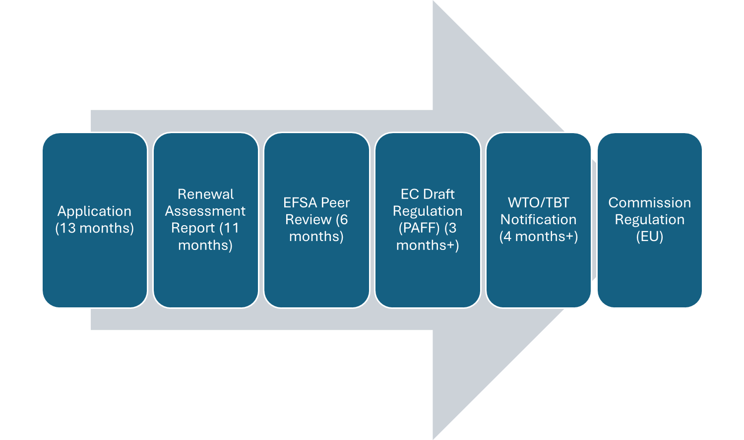
On 11 April 2022, the UK Health and Safety Executive (HSE) announced its intention to withdraw approval for alpha-cypermethrin as a Plant Protection Product (PPP), pending World Trade Organisation consultation. This withdrawal was later confirmed and the statutory register updated. However, on 12 April 2023, the HSE extended approval expiry dates for several active substances, including cypermethrin, in line with retained EU Regulation (EC) No 1107/2009. These extensions, of up to five years, aim to support a coherent renewals programme.
Meanwhile, in the EU, the General Court upheld the European Commission’s decision to renew cypermethrin’s approval until 31 January 2029, despite European Food Safety Authority (EFSA) concerns over risks to aquatic life and pollinators. The Court ruled that the Commission may impose mitigation measures and retains discretion in managing acceptable risk levels.
Although Great Britain is no longer bound by EU regulatory decisions, developments in the EU remain highly relevant. Depending on the UK Government’s appetite for regulatory alignment or divergence, awareness of EU rulings is essential for anticipating potential shifts in domestic policy and maintaining market access.
In conclusion, the high toxicity of cypermethrin to aquatic organisms, even at very low concentrations in surface water, raises serious concerns about its ongoing use. The WFD and CIP monitoring data indicate that current levels of cypermethrin in some water bodies exceed the current more stringent Environmental Quality Standards.
Cypermethrin is a valuable tool in pest control but comes with environmental risks. By continuing to monitor the substance in the wider environment, identifying and mitigating point sources, reviewing and improving best practice use guidance, and exploring alternative solutions, we can evaluate the risks versus the benefits to mitigate its impact and safeguard our water environments.

References
Crowley D and others. ‘Acute toxicity of the insecticide cypermethrin to three common European mayfly and stonefly nymphs.’ Limnologica 2021: volume 88, 2021
Dalhoff K and others. ‘Seasonal sensitivity of Gammarus pulex towards the pyrethroid cypermethrin.’ Chemosphere 2018: volume 200, pages 632 – 640
Defra. ‘Code of Practice for Using Plant Protection Products’ 2006
Defra. ‘Importance of surface run-off as a route of aquatic exposure to pesticides in the UK.’ Final report for Defra Project PS2233, 2009
Defra. ‘The Environmental Permitting (England and Wales) Regulations 2016’ 2016.
Defra. ‘Development of drainflow risk communication tools.’ 2011
Defra. ‘Plant Protection Products (Sustainable Use) Regulations 2012 (SI 1657)’ 2012
Defra. ‘Recycling of home garden pesticide containers.’ 2013a
Defra. ‘UK National Action Plan for the sustainable use of Pesticides (Plant Protection Products).’ 2013b
Defra. ‘Veterinary Medicines Regulations 2013.’ 2013c
Defra. ‘The Water Framework Directive (Standards and Classification) Directions (England and Wales) 2015.’ 2015
Defra. Water Environment (Water Framework Directive) (England & Wales) Regulations 2017.’ 2017
ECHA. ‘Alpha cypermethrin. Product Type 18 (Insecticide) - Assessment report’ 2019
ENTEC. ‘Technical Support for the Impact Assessment of the Review of Priority Substances under Directive 2000/60/EC. Substance: Cypermethrin.’ 2011
Environment Agency/VMD. ‘Sheep Dip Pollution Reduction Programme.’ 2007
Environment Agency. ‘Pollution Inventory data’
Environment Agency. ‘Cypermethrin - Assessment of source control measures. ADAS.' unpublished, internal report 2019
Environment Agency Wales. ‘Cypermethrin use in forestry and its impacts in Welsh streams: an evaluation of the impact of cypermethrin use in forestry on Welsh streams. Report Reference A&R/W/SW/10/01.’ 2010
EU. ‘Directive 2000/60/EC of the European Parliament and of the Council of 23 October 2000 establishing a framework for Community action in the field of water policy [2000]’ Official Journal of the European Communities 2000: pages L327/1-L327/72
EU. ‘Directive 2001/82/EC of the European Parliament and of the Council of 6 November 2001 on the Community Code relating to veterinary medicinal products.’ 2001
EU. ‘Directive 2006/118/EC of the European Parliament and of the Council of 12 December 2006 on the protection of groundwater against pollution and deterioration.’ Official Journal of the European Union 2006: page L372/19
EU. ‘Regulation No 1107/2009 of the European Parliament and of the Council of 21st October 2009 concerning the placing of plant protection products on the market and repealing Council Directive 79/117/EEC and 91/414/EEC.’ 2009a
EU. ‘Directive 2009/128/EC of the European Parliament and of the Council of 21 October 2009 establishing a framework for Community action to achieve the sustainable use of pesticides’. 2009b
EU. ‘Directive 2010/75/EU of the European Parliament and of the Council of 24 November 2010 on industrial emissions (integrated pollution prevention and control).’ 2010
EU. ‘Commission Implementing Regulation (EU) 540/2011 of 25 May 2011 implementing Regulation (EC) No 1107/2009 of the European Parliament and of the Council as regards the list of approved active substances.’ 2011
EU. ‘Regulation (EU) No 528/2012 of the European Parliament and of the Council of 22 May 2012 concerning the making available on the market and use of biocidal products.’ 2012
EU. ‘Cypermethrin cis:trans/40:60. Product Type 8 (Wood Preservative) - Assessment report’ 2013a
EU. ‘Commission Implementing Regulation (EU) No 945/2013 to approve cypermethrin as an existing active substance for use in biocidal products for product-type 8.’ 2013b
EU. ‘Directive 2013/39/EU of the European Parliament and of the Council of 12 August 2013 amending Directives 2000/60/EC and 2008/105/EC as regards priority substances in the field of water policy [2013].’ Official Journal of the European Union 2013c: pages L226/1 - L226/17
EU. ‘Commission Directive 2014/80/EU of 20 June 2014 amending Annex II to Directive 2006/118/EC of the European Parliament and of the Council on the protection of groundwater against pollution and deterioration. Official Journal of the European Union: pp.L182/52–L182/55.’ 2014a
EU. ‘Commission Decision of 5 June 2014 establishing the ecological criteria for the award of the EU Ecolabel for textile products (2014/350/EU).’ 2014b
EU. ‘Commission Implementing Regulation (EU) 2015/405 of 11 March 2015 approving alpha-cypermethrin as an active substance for use in biocidal products for product- type 18.’ 2015
EU. ‘Pesticide Database.’ 2017
EU. ‘Commission Decision (EU) 2017/1392 of 25 July 2017 amending Decision 2014/350/EU establishing the ecological criteria for the award of the EU Ecolabel for textile products (notified under document C(2017) 5069) (Text with EEA relevance. C/2017/5069)’ 2017a
EU. ‘Commission Implementing Regulation (EU) 2018/1130 of 13 August 2018 approving cypermethrin as an existing active substance for use in biocidal products for product type 18.’ 2018a
EU. ‘Commission Implementing Regulation (EU) 2018/1262 of 20 September 2018 amending implementing Regulation (EU) 540/2011 as regards the extension of the approval periods of the active substances 1-methylcyclopropene, beta-cyfluthrin, chlorothaloil, chlorotoluron, clomazone, cypermethrin, daminozide, deltamethrin, dimethenamid-p, diuron, fludioxonil, flufenacet, flurtamone, fosthiazate, indoxacarb, MCPA, MCPB, prosulfocarb, thiophanate-methyl and tribenuron.’ 2018b
EU. ‘Commission Implementing Regulation (EU) 2019/707 of 7 May 2019 amending Implementing Regulation (EU) No 540/2011 as regards the extension of the approval periods of the active substances alpha-cypermethrin, beflubutamid, benalaxyl, benthiavalicarb, bifenazate, boscalid, bromoxynil, captan, cyazofamid, desmedipham, dimethoate, dimethomorph, diuron, ethephon, etoxazole, famoxadone, fenamiphos, flumioxazine, fluoxastrobin, folpet, foramsulfuron, formetanate, metalaxyl-m, methiocarb, metribuzin, milbemectin, phemedipham, phosmet, pirimiphos-methyl, propamocarb, prothioconazole, s-metolachlor and tebuconazole.’ 2019
European Food Safety Authority (EFSA). ‘Conclusion regarding the peer review of the pesticide risk assessment of the active substance zeta cypermethrin.’ EFSA Scientific Report 2008: volume 196, pages 1-119
Farag MR and others. ‘An overview on the potential hazards of pyrethroid insecticides in fish, with special emphasis on cypermethrin toxicity’. Animals 2021: volume 11, issue 7
Fera Science. ‘Pesticide Usage Survey Report 254 - Amenity Pesticide Usage in the United Kingdom 2012.’ 2015
Fera Science. ‘Pesticide Usage Survey Report 271 - Arable crops in the United Kingdom 2016.’ 2018a
Fera Science. ‘Pesticide Usage Survey Report 278 - Amenity Pesticide Usage in the United Kingdom 2016.’ 2018b
Fera Science. ‘Pesticide Usage Survey Report 309 Arable Crops in the United Kingdom 2022.’ 2022a
Forest Research. ‘Interim guidance on the integrated management of Hylobius abietis in UK forestry.’ 2017
Forest Research. ‘The integrated management of Hylobius abietis in UK Forestry.’ 2022
FSC. ‘List of approved derogations for use of 'highly hazardous' pesticides.’ Last updated: 28 October. 2019a
FSC. ‘FSC Pesticide Policy.’ 2019b
FSC. ‘FSC list of highly hazardous pesticides.’ 2019c
Gardner MJ and others. ‘Summary of data from the UKWIR chemical investigations programme and a comparison of data from the past ten years' monitoring of effluent quality.’ Science of The Total Environment 2022: volume 832, issue 1 page 155041
Haseler CJ and others. ‘Environmental impacts of equine parasiticide treatment: The UK perspective.’ Equine Veterinary Education 2024: volume 36, issue 7, pages 381 – 392
Health and Safety Executive (HSEa). ‘The Pesticides Register Database.’
Health and Safety Executive (HSEb). ‘UK Authorised Biocidal Product Database.’
Health and Safety Executive (HSEc). ‘Control of Pesticide Regulation (COPR) database.’
Health and Safety Executive (HSE). ‘Code of Practice for Using Plant Protection Products.’ 2006
Health and Safety Executive (HSE). ‘Guidance for those affected by the Plant Protection Products (Sustainable Use) Regulations 2012.’ 2014
Health and Safety Executive (HSE). ‘Pesticide User Habit Survey.’ 2016
Health and Safety Executive (HSE). ‘Amateur Pesticide User Habits Survey 2019.’ 2019
Ramwell CT and others. ‘Cypermethrin loss from sheep fording a stream. Final Report CSL Project N3MD’ Central Science Laboratory, York 2007
Rose S and others. ‘Development of a design manual for agricultural pesticide handling and wash-down areas.’ R&D Technical Report P2-200/TR/2 2004
SCOPS (Sustainable control of parasites) ‘External parasites.’
Tang W and others. ‘Pyrethroid pesticide residues in the global environment: An overview.’ Chemosphere 2018: volume 191, pages 990–1007
UKWAS. ‘UK Woodland Assurance Standard (Version 4).’ 2018
UKWIR. ‘13/EQ/01/6. Chemicals Investigation Programme: Volume 1- Main Report’ 2014
UKWIR. ‘National Investigation Programme 2015-2020. Volume 1 Part 1 (2015 - 2017). Monitoring of sewage effluents, surface waters and sewage sludge’ 2018
UKWIR. ‘National Investigation Programme 2015-2020. Volume 1 Part 3 (2017-2019). Monitoring of sewage effluents and surface waters’ 2019
UKWIR. ‘22/EQ/01/29. The National Chemicals Investigations Programme 2020-2022, Volume 8, Mechanisms of Removal’ 2023a
UKWIR. ‘22/EQ/01/31. The National Chemicals Investigations Programme 2020-2022, Volume 10, Substances Removal by Installed Technologies’ 2023b
UKWIR. ‘22/EQ/01/32. The National Chemicals Investigations Programme 2020-2022, Volume 11, Sewer and River Catchment Investigations’ 2023c
UKWIR. ‘22/EQ/01/33 - The National Chemical Investigations Programme 2020-2022, Volume 12, Biosolids Report’ 2023d
UKWIR. ‘22/EQ/01/34 - The National Chemicals Investigations Programme 2020-2022, Volume 13, Risked based extension to CIP (Data Mining)’ 2023e
Veterinary Medicines Directorate (VMD). ‘Cypermethrin sheep dips no longer available.’ 2011
Veterinary Medicines Directorate (VMD). ‘Product Information Database.’
Willoughby IH and others. ‘Are there viable chemical and non-chemical alternatives to the use of conventional insecticides for the protection of young trees from damage by the large pine weevil Hylobius abietis L. in UK forestry?’ Forestry: An International Journal of Forest Research 2020, volume 93, issue 5, pages 694–712
World Health Organization. ‘Environmental Health Criteria. Cypermethrin’ Geneva: United Nations Environmental Programme, the International Labour Organization, and the World Health Organization 1989: volume 82
Yancheva V and others. ‘Assessment of the exposure of two pesticides on common carp (Cyprinus carpio Linnaeus, 1758): Are the prolonged biomarker responses adaptive or destructive?’ Comparative Biochemistry and Physiology Part - C: Toxicology and Pharmacology 2022: volume 261, page 109446

List of abbreviations
AA: Annual Average
BAT: Best Available Technology
BREF: BAT reference document
CIP: Chemical Investigation Programme
CIP1: Chemicals Investigation Programme, phase 1
CIP2: Chemicals Investigation Programme, phase 2
CIP3: Chemicals Investigation Programme, phase 3
CIP4: Chemicals Investigation Programme, phase 4
COPR: Control of Pesticide Regulations
EC: European Commission
EMA: European Medicines Agency
EPR: Environmental Permitting Regulations 2010
EQS: Environmental Quality Standard
EU: European Union
FSC: Forestry Stewardship Council
HSE: Health and Safety Executive
IWTO: International Wool Textile Organisation
LOQ: Limit of quantification
MAC: Maximum Allowable Concentration
MRV: Minimum Reporting Value
PEFC: Programme for the Endorsement of Forest Certification
UK: United Kingdom
UKFS: UK Forestry Standard
UKWAS: UK Woodland Assurance Standard
UKWIR: UK Water Industry Research
VMD: Veterinary Medicines Directorate
WFD: Water Framework Directive
WwTW: Wastewater Treatment Works

Glossary
Adsorb: A sorption process in which one substance becomes attached to another through adhesion to the surface.
Annual Average Environmental Quality Standard (AA-EQS): is a regulatory threshold set under the Water Framework Directive (WFD). It represents the average concentration of a particular substance in water over a year, aimed at protecting aquatic life and human health from long-term exposure to pollutants
Bioaccumulate: The accumulation of a substance, such as a toxic chemical, in various tissues of a living organism.
Derogation: A temporary agreed exemption from a restriction on the use of a substance.
Environmental Quality Standard: A threshold for a substance in the water environment below which an adverse effect on the aquatic environment is not expected.
Maximum Allowable Concentration Environmental Quality Standard (MAC-EQS): is another regulatory threshold under the WFD. It specifies the highest concentration of a substance that is allowed in water at any given time. This standard is designed to protect against short-term exposure to high levels of pollutants, ensuring that pollution peaks do not harm the environment or human health
Pollution Inventory: The inventory collates data from large regulated industrial sites on emissions of specified substances to air and controlled waters and sewers, as well as quantities of waste transferred off site.
Priority substance: A substance identified as presenting a significant risk to or through the aquatic environment at an EU level under the Water Framework Directive.
Synthetic pyrethroid: An organic compound, widely used as an insecticide, which is similar to natural pyrethrins produced by the chrysanthemum flower family.

Appendix A

Table 1: Four-year average (2021-2024) of the geometric mean concentration of cypermethrin in freshwater surface waterbodies in each River Basin District (RBD), expressed as µg/l. NB EQS in freshwater is 0.0008µg/L
For Severn and Solway Tweed, the data is for only the England part of the RBD.
RBD | Average, cypermethrin expressed as µg/L | Lower confidence limit | Upper confidence limit | Rank highest concentrations
Anglian | 0.000006 | 0.000004 | 0.000008 | 9
Humber | 0.000013 | 0.000010 | 0.000016 | 4
Northwest | 0.000025 | 0.000019 | 0.000034 | 1
Northumbria | 0.000022 | 0.000014 | 0.000036 | 2
Severn | 0.000013 | 0.000009 | 0.000017 | 5
Solway-Tweed | 0.000021 | 0.000013 | 0.000034 | 3
South East | 0.000006 | 0.000004 | 0.000009 | 8
South West | 0.000007 | 0.000005 | 0.000009 | 7
Thames | 0.000010 | 0.000007 | 0.000014 | 6

