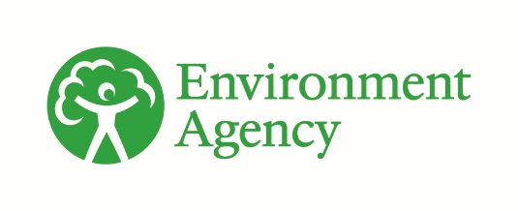



Water levels and flows: challenges for the water environment
Date: November 2025
Contents

1. Summary 3
2. Abstraction pressure on water levels and flows 4
3. Addressing the challenge 9
4. Future challenges and actions 15
5. References 19

1. Summary
Water from rivers and groundwater provides essential water for people, agriculture and industry. In England nearly 15% of surface water bodies, and 27% of groundwater bodies are being impacted by over-abstraction. Having the right allocation of water resources is essential to support a healthy environment and for the achievement of good ecological status.
The natural flow regime of our rivers and estuaries can also be changed by activities such as navigation, recreation, power generation or irrigation. Dams, weirs and other structures, or water released from reservoirs can create pressures on the environment that may mean flows do not always support the ecology.
The effect of groundwater abstraction can have local and regional scale impacts on water availability for dependent environments. Reducing over abstraction from groundwater resources will help achieve healthy river flows, safeguard groundwater dependent features (such as springs and wetlands) and avoid saline intrusion.
It is vital that the Environment Agency and water abstractors address the problems of over-abstraction to:
- protect river and groundwater supplies
- provide the freshwater we all use
- support the ecology and resilience of our rivers, wetlands, estuaries, lakes and groundwater
The damage caused by over abstraction can be severe:
- reduced water slows the flow of rivers and increases the percentage of sediments and pollutants – as a result the quality of water will fall
- the shape of the river can change, and fish will face increased difficulties in navigating over obstructions
- water temperature can increase
- there is less water for habitats which affects fish and other wildlife
- the quality of recreation provided by rivers and wetlands diminishes
- declining wetland conditions
- sea water moving inland impacting the quality of groundwater
Rainfall provides and replenishes our water resources but there is a large variation in the amount of rainfall across England. The south-east of England has the least rainfall and the highest population density which puts pressure on the amount of water available for abstraction (see Figure 1). As well as the amount of rainfall received, a catchment’s topography and different land management practices affects river flow, groundwater and aquifer recharge, including the following:
- steeper catchment slopes can increase the rate of water run-off into rivers
- low catchment slopes can increase recharge to groundwater and aquifers
- nature based solutions can improve water storage capacity across different catchments
The increase in prolonged periods of hot and dry weather can exacerbate these conditions, leading to greater environmental stress and reduced water available for abstraction by abstractors, impacting industries and food production. In the future, demand for water is also expected to increase due to population growth, economic and housing development and the need to maintain food security.
Tackling these issues now will help us to manage water resources more sustainably in the future.

2. Abstraction pressure on water levels and flows

2.1 Understanding the effect of abstraction pressures
The scale of impact of abstraction pressure will depend on how or when the water is abstracted, as well as the location and volume of water returned to the environment. Whether the abstraction pressure comes from groundwater or surface water sources, these abstractions can put protected or sensitive environments at risk.
Changes in river flows and groundwater levels can have the following effects on the river ecology and habitat:
- reduced flows will change the shape of river channels and the geomorphology of the river system, altering natural river habitats and disadvantaging species that need fast flowing and or deeper water
- rivers could dry up more frequently than they would naturally, disrupting the life cycles of species requiring flowing water
- reduced flows can exaggerate the effect of barriers such as weirs which affects migratory and non-migratory species
- reduced flows can increase deposition of fine sediments carried in flowing water, affecting sensitive species
- too much abstraction can lead to unsustainable water bodies with reduced resilience further during prolonged dry weather or drought
- groundwater abstraction can induce poorer quality groundwater to move, for example inducing saline intrusion from deep groundwater or from the sea
- reductions in water levels may prevent bank overtopping and inundation of the floodplain, disrupting life cycles of species requiring floodplain habitats
- reduced flows can increase the risk of toxic algal blooms, especially during drought conditions and warm temperatures
- altered flows may change water temperature which can affect river ecology and habitat
Many catchments are still heavily impacted by the large volumes of water needed to support our industrial heritage and the associated infrastructure of manufacturing and public water supply. Prior to the Water Resources Act 1963 there was no effective regulation having regard to the environmental impact of abstraction and consequently large volumes of water from aquifers or rivers could be taken unsustainably. Legislation since 1963 has focused on balancing environmental needs with the distribution of water.
The Environment Agency is responsible for granting water abstraction licences, which make sure water is reserved to meet the needs of the environment throughout the year and to protect the rights of existing abstractors. Water availability is restricted in parts of catchments, to reduce pressure on the local ecosystem or safeguard lower reaches of catchments with abstraction and flow problems. Environmental effects of abstraction are likely to be magnified in future as the climate changes.
Figure 1 provides an indication of the reliability of water for new abstractions showing the variation in water availability and taking into account any low flow related restrictions on current abstractions. For example, in the palest blue areas (predominantly across central south east England), water from rivers is only available up to 30% of the time which will tend to be in the winter when river flows are higher. In the mid blue areas, water is available at least 50% of the time. In the darkest blue areas (north east, south west and parts of the midlands and north west), water is available most of the time.

2.2 Groundwater pressures
Groundwater is essential both for drinking water supplies and for supporting dependent rivers, streams, lakes and wetlands. About 27% of groundwater bodies in England are not achieving good groundwater quantitative status. Groundwater quantitative status provides an assessment of the condition of groundwater bodies across the country.
To understand the impact of abstraction on groundwater supplies, the Environment Agency uses 4 tests:
- an assessment of abstraction against the available groundwater resources
- the contribution an abstraction might make to a wider area of reduced river flow
- an assessment of the wetlands dependent on groundwater and the
- effects abstraction might have on them
- a water quality test to determine if abstraction will lead to water quality
deterioration
In all 4 tests the assessment result is either ‘good’ or ‘poor’ based on current pressure and not at risk’ or ‘at risk’ under future pressure. A groundwater body is classed as either ‘good’ or ‘poor’ groundwater quantitative status based on groundwater abstraction pressures. The assessment of quantitative status uses a ‘one out all out’ approach where if one of the four tests fails, the groundwater body status is ‘poor’. This approach reflects that groundwater supports a wide range of natural capital assets. For more information see the groundwater quantitative status results and maps.
In some areas, groundwater has been over exploited due to growth in public water supply and historic industrialisation. Where this has occurred, there are difficult choices to make; firstly, there could be little opportunity to transfer the abstraction to other sources of water; secondly, housing development and associated infrastructure may have developed on natural spring areas that, if the water recovers to a natural state, could result in groundwater rebounding to surface.

Figure 1. Water resource reliability map. Percentage of time water would be available for abstraction under a new licence. The map shows that in about half of the catchments in England, water is available less than 30% of the time.
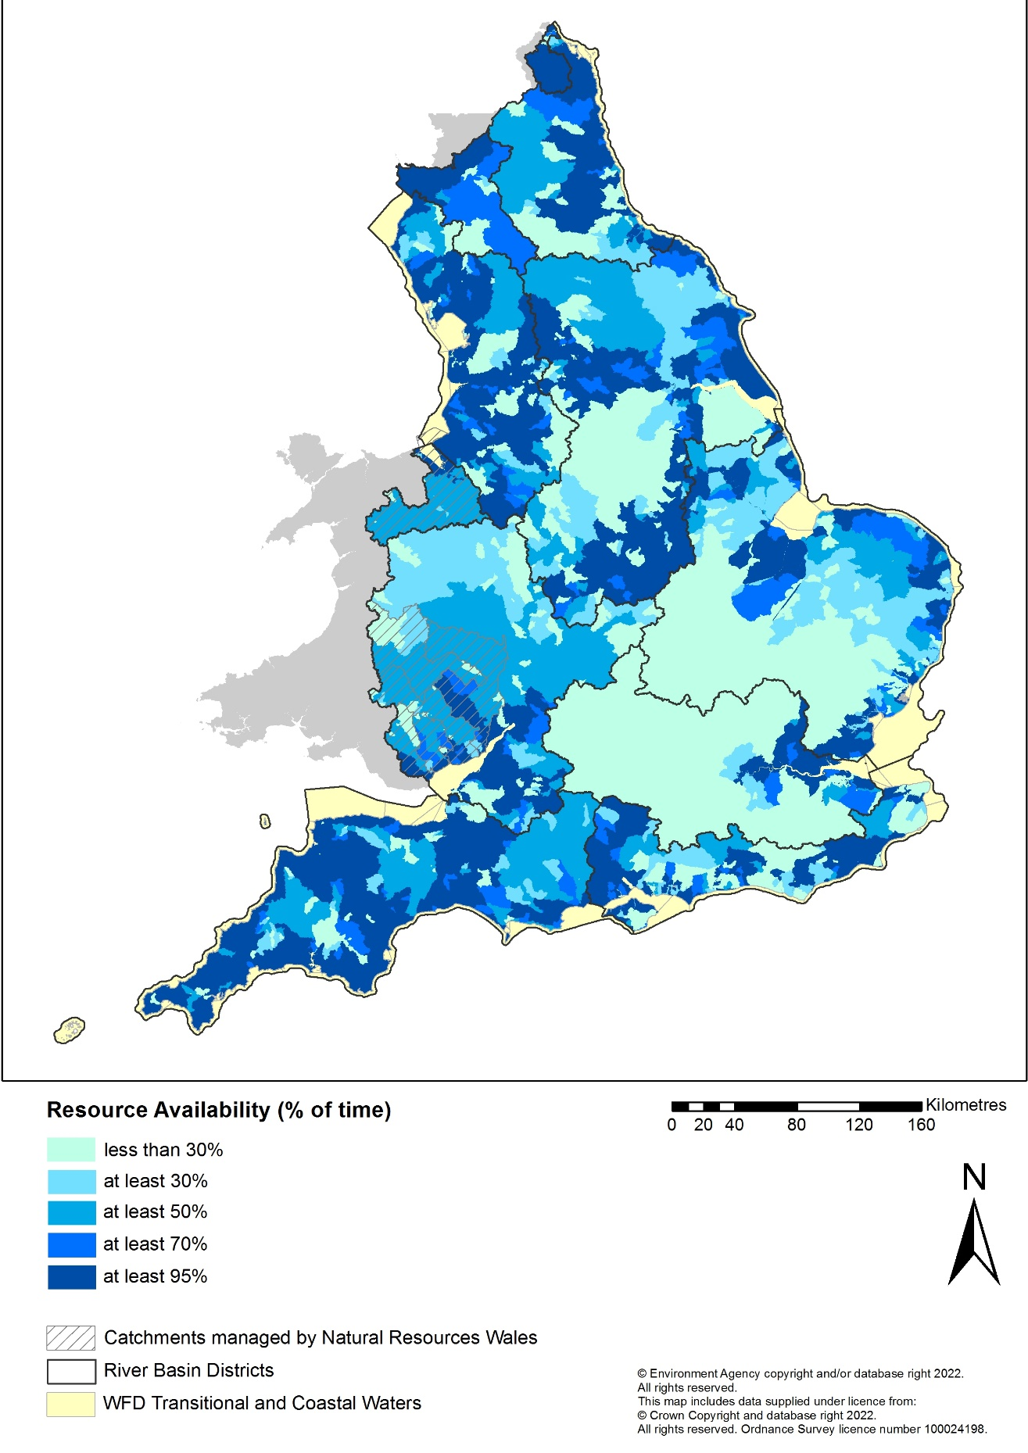

2.3 Surface water pressures
Having the right flow in our rivers is essential to supporting a healthy ecosystem. For rivers and lakes, the UK has developed specific flow thresholds which set a limit of allowable reduction from natural flows (essentially abstraction limits) according to river type. These are implemented by the Environment Agency as the environmental flow indicator (EFI). The EFI is set at a level that is believed to support good ecological status (GES) under the Water Framework Directive (WFD).
The EFI is used in the hydrological classification to identify the water bodies where reduced river flows may be causing or contributing to a failure of good ecological status. This is called the flow compliance assessment, and it is carried out for each surface water body with freshwater flows.
The Environment Agency assess flow compliance at low flows, taking account of current levels of abstraction. The compliance assessment shows where flows are below the EFI and indicates by how much. This is used to identify areas where flows may not be supporting GES, target investigation of actual effect on ecology and identify what measures are needed to achieve GES. Flow compliance results are reported in 4 compliance bands:
- flow compliant with EFI = flow supports GES
- non-compliant band 1 = flow does not support GES (up to 25% lower than EFI)
- non-compliant band 2 = flow does not support GES (between 25% and 50% below EFI)
- non-compliant band 3 = flow does not support GES (greater than 50% lower than EFI)
Figure 2 shows the flow compliance of river and lake water body catchments in England.
Nearly 15% of surface water bodies are impacted by over-abstraction. Investigations confirm that abstraction and flow pressures are preventing achievement of good ecological status/good ecological potential in about 4% of surface water bodies in England. About 5% of surface water bodies are still under review following investigation. The remaining 6% are water bodies where flow does not support good but the reasons are suspected or unknown.
There may be some water bodies where GES can be achieved with a flow regime below the EFI. However, sufficient evidence is needed to have confidence in this and the future risk of deterioration to the ecology, due to abstraction pressure, will still need to be managed.
Some habitats and sites are recognised for their internationally and nationally important wildlife. Some of these receive special legal protection (designated sites). Abstraction and flow pressure is one of the reasons designated riverine sites fail their conservation objectives. The reduction in allowable abstraction needed to improve and protect these sites may differ from that required to meet GES. More information is available in the European site Protected Areas report.

Figure 2. The flow compliance of river and lake water body catchments, which indicates the risk to ecology from current abstraction.
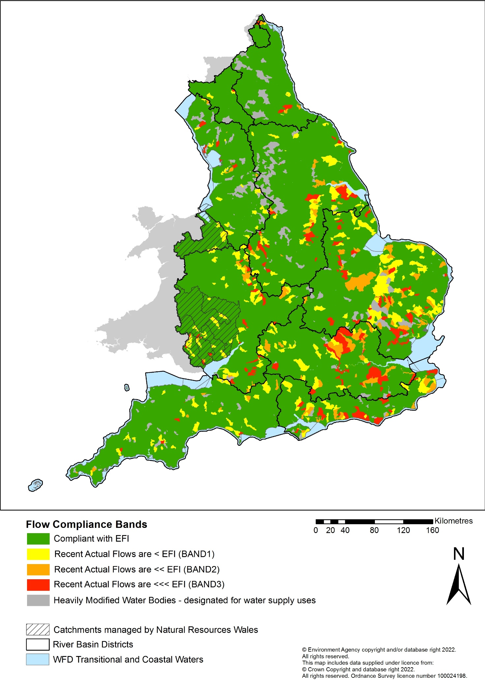

2.4 Heavily modified water bodies (HMWB) for water supply, storage and transfer
The natural flow regime can change where rivers are managed or modified to support various uses and activities. For example, the building of dams to create reservoirs for drinking water or having a weir across a river to support abstraction. Water bodies are designated ‘heavily modified’ because these uses prevent them being restored to GES without compromising their specific use. In these cases, the WFD objective is good ecological potential (GEP).
GEP is determined by the presence or absence of relative mitigation measures that could be implemented to offset the impact of the modification. For water resource HMWB these measures include managing the downstream flow of water and supporting fish passage. Measures will only be implemented if they do not have a significant impact on the designated use of the waterbody.
Approximately 13% of surface water bodies are designated as heavily modified for water supply uses, such as water storage or major transfers of water; these are shown in grey in Figure 2.

3. Addressing the challenge

3.1 What needs to be achieved?
The Environment Agency uses the best available evidence to manage the water environment. For surface water quantity, these are the flow targets used in river basin planning and long-term planning as described in the National Framework for water resources 2025 (see section 3.5). The Environment Agency expect these targets to be used to identify the gap between water resources available now and the water that needs to be recovered to meet the long term needs of the environment. Our plans assume that flow targets (the EFI or a locally agreed alternative) will be met. An adaptive planning pathway may be appropriate so that improved evidence, when it becomes available, can be used in identifying long term environmental needs. The principles for appropriate evidence are set out in the EFI position statement.
Where abstraction does not support GES or GEP or good status for groundwater, flows and resources in these water bodies need to be improved to move towards GES or GEP or good status for groundwater.
Where abstraction is unsustainable and does not support good quantitative status in groundwater bodies, action needs to be taken to move towards good status and prevent deterioration. The Environment Agency have taken a pragmatic approach by addressing dependent features first. This means that it may take longer for groundwater bodies to achieve good status.
Due to historic levels of over exploitation of groundwater, it will not be feasible to achieve good status in some groundwater bodies in the future. Where over exploitation has occurred, we will introduce measures to reduce abstractions to an acceptable level that also considers socio-economic needs.
As well as working towards good status in water bodies, we must prevent deterioration, ensuring that river flows continue to support environmental objectives and that all elements of groundwater quantitative status are maintained or improved where necessary.
Whilst changing abstraction licences is the primary method to resolving unsustainable abstraction and preventing deterioration, it is unlikely that catchments impacts can be resolved in all cases. There may be cases where local information can define more appropriate local water management to support the water body environmental objectives. Implementing measures such as habitat restoration within the river channel or catchment, alongside licence changes, can enhance the ecological benefits of increasing the amount of water in our rivers or prevent deterioration until new sources of sustainable abstractable water are available.
Where ecological problems are caused by a combination of issues, other solutions will also be required to improve ecological status. Wider benefits on the catchment scale will take time to realise and assess but, if effective combinations of measures can be introduced (subject to economic appraisal), then the number of water bodies supporting a healthy ecology are likely to increase.

3.2 Who needs to be involved
The scale of action needed means that collaboration and partnership working between local and national government, water companies, abstractors and local river trusts will be essential to improving in the health, resilience and ecological status of England's rivers and wetlands.

3.3 Water Abstraction Plan
The Water Abstraction Plan 2017 sets out how abstraction management would be reformed and how this would help to protect the environment and improve access to water. The plan sets out how the Environment Agency planned to use its regulatory tools to address unsustainable abstraction and guard against future pressures, including:
- reviewing time limited licences
- adjusting all permanent licences shown to be seriously damaging
- a risk-based programme of revoking licences that are no longer needed
- regulating all significant abstractions that have been exempt historically to make sure that they also play a part in protecting the water environment
The ‘catchment focus’ section of the plan described how the Environment Agency would promote a catchment-based approach working with abstractors and existing catchment partnerships and other local groups to identify and implement local solutions in catchments, starting with 10 priority catchments. The plan supported one of the main themes of the government’s 25 Year Environment Plan, ‘clean and plentiful water’. The abstraction reform report to Parliament in May 2019 outlined some of the progress made and action taken on reform.
3.4 Environment Act 2021
This legislation allows the Environment Agency to change permanent abstraction licences that are causing damage without paying compensation. From 1 January 2028, all abstraction licences will be treated equitably, regardless of when the licence was issued. Current levels of abstraction are damaging or have the potential to damage the environment in some catchments. Where abstraction is still unsustainable after using the mechanisms listed in section 3.3, the Environment Agency will review permits to ensure they are sustainable.

3.5 National Framework for Water Resources
The Environment Agency’s National Framework for Water Resources shows how a sustainable water environment can thrive while supporting a growing economy. It provides a strategic approach for water resources planning to enable actions to be identified and delivered to address England’s long-term water needs. It sets out the scale of action required to ensure resilient water supplies while improving the environment.
Water is fundamental for public health, food, energy supply, a strong and growing economy and a thriving natural environment. Yet all of these depend upon a sustainable, resilient supply of water. At the same time, the climate is changing, and the population is growing. By 2055 current predictions indicate there will be a further 8 million people living in England, requiring housing and new towns.
The first National Framework for Water Resources set out the enormity of the challenge, with demand for water forecast to outstrip supply. It provided a new regional structure to begin tackling this problem. There have been major advancements in our knowledge and understanding on how to close the water deficit gap.
In 2025 we published an update to the National Framework for Water Resources. It describes the next steps that need to be taken to build on the work that has already been done and how planning of water in all sectors needs to change. It includes:
- as part of the Environment Agency’s strategic overview of water resources across all sectors of use, the Environment Agency will continue to assess the scale of the national challenge
- regional water resources groups will develop multi-sector water resources plans and facilitate the delivery of collaborative solutions
- regulators, particularly through RAPID, will help to evaluate proposed solutions and to help facilitate the identification of new options
- the Environment Agency will continue and upscale our engagement with other water using sectors to understand their needs and issues and facilitate early engagement with the water sector and Regional Groups
- the Environment Agency will support the enhancement of the local tier of water resources planning such as Water Abstractor Groups and Catchment Partnerships to better enable delivery and we will continue to work through the National Framework to enable more effective collaboration
Regional water resources groups have produced a set of regional water resources plans. The next iteration of regional plans will set out their initial proposals for achieving an environmentally sustainable abstraction regime in regional water resource plans, taking account of the short term and longer-term actions needed to deliver change. These proposals will develop as plans are updated and will be in line with guidance on how we expect water users to develop the environmental destination to use in water resources planning.
We continue to work with government and regulators, Natural England, regional water resources groups and water abstractor groups, as well as environmental interest groups and organisations to deliver an environmentally sustainable abstraction regime.
See more information in the National Framework for Water Resources (particularly section 3.1 and chapter 5).

3.6 Regulated flows and mitigation
The Environment Agency and water companies have undertaken investigations on how to limit the effect of modifications on heavily modified and artificial water bodies designated for water supply and water resource purposes.
The measures include actions to ensure downstream river flows are appropriate to maintain river habitats and to ensure the influence on the morphological character of the river is reduced, including the mimicking of natural sediment movement.

3.7 Demand management
Reducing the amounts of water consumed and wasted, could make a significant difference to water availability for people and the environment.
Industry, agriculture and other sectors can use methods such as sustainable irrigation, water efficiency targets, awareness raising, water audits and use of good practice guidance.
The government introduced the statutory Water Demand Target under the Environment Act 2021 to reduce water use per person by 20% by 2038 from a 2019/20 baseline. This is on a trajectory to reduce household water use to 110 litres per person per day, halve
leakage and reduce non-household water use (that is businesses) by 15% by 2050.
The previous government set out how it would achieve this in the Environment Improvement Plan and plan for water in 2023. This is currently under review. To achieve the statutory water demand target, the government planned to reduce household water use to 122 litres per person per day (l/p/d), reduce leakage by 37% and reduce non-household (for example, business) water use by 9% by 31 March 2038. This is part of the trajectory to achieving 110 l/p/d household water use, a 50% reduction in leakage and a 15% reduction in non-household water use by 2050.
Proposed government actions include mandatory water efficiency labelling; increasing the water efficiency in new developments and retrofits to improve efficiency; increased smart metering for households and businesses; supporting communications campaigns on the value of water and how we can use it more efficiently.
As water supplies come under increasing pressure, the government needs water companies to better manage the volume of water they distribute. To help with this, water companies in areas which are under serious water stress can charge all household customers for the volume of water used. This is measured by a water meter on each property.
Government determines which water companies are in areas of serious water stress. It updated its assessment in July 2021 in Determining areas of water stress in England, adding 7 more water companies. This means that the water companies in those areas must evaluate compulsory metering as part of their water resources management plans.

3.8 Water resources management plans
Every 5 years water companies have a duty to produce plans which set out how they will continue to supply water and manage demand in their supply area over at least the next 25 years. The plans include how water companies will provide enough water to their customers and increase the resilience to droughts over at least the next 25 years.

3.9 Water Industry National Environment Programme (WINEP)
Where water company abstraction is shown to damage or pose a risk to the environment, companies will work with the Environment Agency to develop solutions to stop or reduce their abstractions. In the case of water resource HMWBs or where the infrastructure allowing abstraction may be having an impact on the environment, the solutions might include fish passage and river restoration schemes. Some of these solutions are included in the Water Industry National Environment Programme (WINEP). The WINEP is a programme of environmental improvement and protection schemes that ensure that water companies meet European and national targets related to water.

3.10 Action on chalk rivers
Chalk streams are a special type of spring-fed river unique to England and northwest Europe. Like other spring-fed streams, chalk streams derive most of their flow from underground chalk aquifers. Chalk rivers emerge from chalk aquifers, so the water is rich in minerals and remains at a fairly constant temperature all year round. They are highly valued culturally and provide valuable recreational fisheries as they naturally support many invertebrate and fish species. They are rare and an important haven for wildlife. Only 200 chalk rivers are known globally, 85% of which are found in the UK in southern and eastern England. Classic examples include the rivers Test and Itchen in Hampshire. They are well represented in both the national and European designated site network, which aims to protect sites of high conservation value.
Currently over 80% of chalk waterbodies are not achieving good ecological status. Approximately 26% of these (over 100 waterbodies) are failing with abstraction or flow as one of the reasons for failure. In 2021 the Catchment Based Approach (CaBA) Chalk Stream Restoration Group (CSRG), with representatives from Defra, Environment Agency, Natural England, Ofwat, water companies National Farmers’ Union and environmental groups, produced a strategy to restore chalk streams. The Chalk Stream Restoration Strategy (CSRS) is a comprehensive, up-to-date analysis of the issues threatening chalk streams in England, and of the ways in which ecological pressures are assessed and regulated. It includes multiple pragmatic recommendations to bring about the ecological recovery and good health of our chalk streams. Improving flow will improve river health by also improving water quality and physical habitat. The benefit of improving flow is greatly increased if water quality and physical habitat are improved too. This was followed in 2022 by an Implementation Plan which updated on progress made towards the recommendations in the CSRS. A further update is expected later in 2025.
Protecting chalk streams is a priority for the government and additional resources were allocated to addressing flow issues in chalk rivers, funded through the 2022 strategic review of charges for abstraction licences.
The Environment Agency is working with water companies, other abstractors and local stakeholders to ensure their plans reflect the need to protect the environment and ensuring new rules for farmers deal with agricultural diffuse pollution in chalk river catchments. The Environmental Destination for Water Resources includes the ambition to provide additional protection for chalk headwaters as outlined in the CSRS and the next steps are for regional water resource groups to consider this in the development of their Regional Water Resource Plan. All areas with principal chalk streams are now included in areas of serious water stress, enabling compulsory water metering by water companies.

3.11 Physical effects of low flows and mitigating pressures
The physical effects of low flows can be reduced by improving river habitats and restoring the natural processes that take place in our rivers. For example, using fencing to stop cattle encroaching into rivers and removing redundant weirs can support recovery to a more naturally functioning ecosystem. Where measures to improve flows are completed in combination with those to improve physical habitat there are multiple benefits.

3.12 Catchment hydrology and land management
Different land management practices can change the way that water moves through or is retained within a catchment. Improved practices include soil improvement, cultivating land early to minimise erosion, establishing ground cover in winter and restoring large areas of upland wetlands which may help to slow runoff. Broadleaf trees planted in the right locations can slow water movement over and through soils, reducing peak flow rates and potentially increasing base flow in streams.
Nature-based solutions (NbS) such as wetland creation and river and floodplain restoration can benefit water management by restoring and enhancing the natural water regulation function of catchments. They can capture and slow runoff, improve infiltration through soil and groundwater recharge, store water naturally and slow down the rate it enters river systems and the wastewater network, reduce sediment inputs and improve water quality. These solutions will help to sustain water in the natural system, increasing biodiversity and making the riverine ecosystem more resilient to a changing climate including the impacts of droughts.
The Environment Agency and our partners are gathering evidence about the effectiveness of NbS to address water management challenges.
SuDS provide an opportunity to mimic natural drainage systems and to deliver surface water management that recognises the value of rainfall and runoff as a resource. Water draining from many SuDS schemes may be allowed to infiltrate into the ground allowing natural drainage pattens. This allows aquifer recharge and may mitigate surface water flooding.

3.13 Water level and site management at wetlands
Some wetland plant communities (for example, the calcareous fen sites in East Anglia) are critically dependent on groundwater. As a result, one of the WFD groundwater quantitative tests is that groundwater abstraction should not cause significant damage at wetland sites. Drainage can also affect water-dependent habitats. Some influences on ecology can be mitigated through water level or site management. An example is through water level management plans (WLMPs) agreed between the Environment Agency, Natural England and Defra; WLMPs have an important role in achieving conservation objectives for European designated sites (see also European site Protected Areas report).

4. Future challenges and actions
In the future, population growth and economic development are likely to increase demand for water. Climate change is likely to significantly change the pattern and volume of rainfall that England receives and the average temperatures we experience. This will result in less water being available for surface water flows and groundwater recharge in the future. Sustainable management of future water supplies, to take account of economic growth and more intensive future food production, will be a significant challenge.
Demand management will play an increasingly important role in ensuring water availability up to the 2050s. However, demand management alone will not fix the problem. Strategic approaches to water resource management, such as the Water resources national framework 2025 and regional water resources planning, are necessary to maintain public water supply resilience and resilience for other water uses including the environment.
Water companies are completing investigations where growth in abstraction is likely to cause deterioration in ecology or groundwater resources and will take action to prevent the deterioration from occurring. The Environment Agency has also set out our approach to capping licences to prevent increasing abstraction causing deterioration.

4.1 Resilience to climate change
The Environment Agency has published the National Framework for Water Resources 2025. Modelling work has been done to update the analysis of long-term abstraction reductions which may be needed to meet environmental flow thresholds under different further scenarios of climate, growth and a range of environmental ambition between now and 2080. This Environmental Destination for water resources identifies where, and by how much, water abstraction needs to change to achieve and maintain a healthy water environment, both now and in the future. In the modelling, it was assumed that reducing groundwater abstraction to achieve sustainable river flows will deliver most environmental improvements, whilst also improving the groundwater status. Three planning scenarios have been developed:
- our current regulatory approach under a changing climate
- our current regulatory approach with additional protections under a changing climate
- full environmental requirements under a changing climate
The baseline is our current regulatory approach in today’s climate. Figure 3 shows how these reductions look at a waterbody scale at fully licensed quantities. This map shows the potential abstraction reductions against today’s baseline environmental requirements – there is a potential need to reduce fully licensed abstraction by up to 3,200 Ml/d to address current unsustainable abstraction. This does not include the proposed reductions associated with WRMP24. In Figure 4, 2 maps show how this may change by the 2050s looking at the range of environmental expectations (from current regulatory requirements to full environmental expectations) under the 2 climate change scenarios (wetter to drier range). These show that, by the 2050s, this total need (full expectations) could rise to 5,400 Ml/d.

Figure 3. Baseline – potential abstraction reduction needed compared to fully licensed amounts, by waterbody.
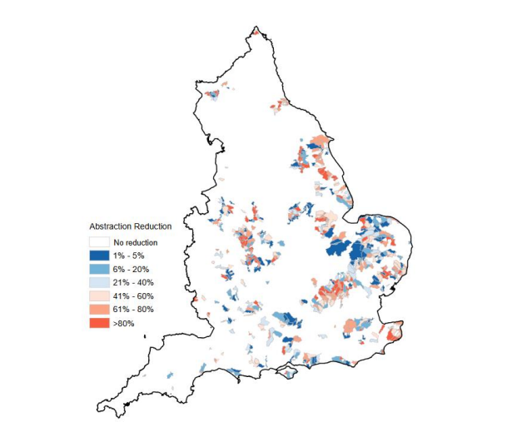

Figure 4. Potential abstraction reduction needed compared to full licensed amounts by waterbody in 2050, excluding actions being taken by water companies as part of their WRMP24.
Map on left: Current regulatory requirements by waterbody in a wetter range climate.
Map on right: Full environmental expectations in a drier range climate.
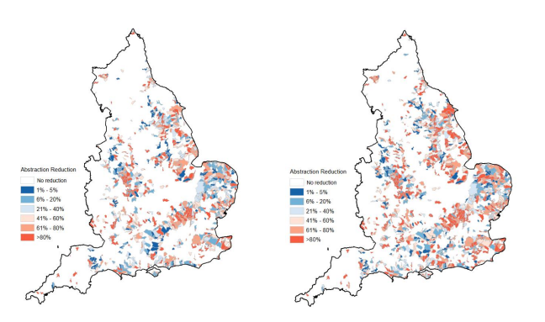
By continuing to implement the 2017 Water Abstraction Plan and the National Framework for Water Resources 2025, we will be better prepared to cope with the pressures of climate change and future demand for water, through a more flexible abstraction licensing system and more resilient water environment.
The Environment agency commissioned BGS to model the scale of aquifer recharge under predicted climate change scenarios (Mansour & Hughes, BGS, 2017). The results confirm the dynamic between climate variability and climate change with a stronger climate signal being observed in the 2080s than either of the 2020s or 2050s.
The recharge season is forecast to become shorter with a greater amount of recharge expected into fewer months. While there is uncertainty, the climate change modelling indicates that a recharge signal leading to flashier groundwater level response and potentially greater drought vulnerability. In considering the later point, if there is below average rainfall for aquifer recharge then the lead in time for reaching groundwater drought status could also be shortened.
Figure 5 highlights the spatial change in monthly recharge when comparing climate change predicted recharge in 2080 against current baseline.

Figure 5 - Median values for percentage change in monthly recharge for all 11 ensemble members (2080).
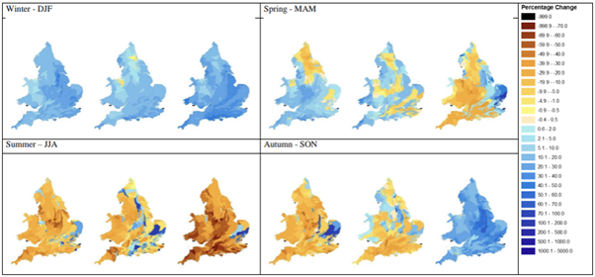
The implications from the BGS report suggest groundwater resource availability will be a key planning risk for future water resource management.

5. References
Mansour M M, Hughes A G.2017. Summary of results for national scale recharge modelling under conditions of predicted climate change. British Geological Survey Commissioned Report, OR/17/026. 145 printed pages.
Figure 1: Water Resources Reliability map, based on 2022 data, Environment Agency (2022).
Figure 2: Recent actual compliance with environmental flow indicators (at low flows), Environment Agency (2022).
Figures 3 and 4: Water Resources National Framework 2025, Environment Agency (2025)
Figure 5: Mansour M M, Hughes A G.2017. Summary of results for national scale recharge modelling under conditions of predicted climate change. British Geological Survey Commissioned Report, OR/17/026. 145pp

Further reading links
Managing water abstraction – GOV.UK
Water abstraction plan 2017 – GOV.UK
Defra Abstraction Reform Report to Parliament, May 2019 – GOV.UK
Water resources national framework 2025 – GOV.UK
Waterwise, how to save water
Water white paper – water for life – GOV.UK
Working with natural processes to reduce flood risk - GOV.UK
National standards for sustainable drainage systems (SuDS) - GOV.UK

