

Online Copyright Infringement (OCI) 2024

Main findings report

Founded in July 2011, AudienceNet is a full-service consumer and social research agency, which in that time has built a reputation for innovative, “real-time” research. We use the latest connected technologies to conduct representative research across the globe. Over the years, AudienceNet has expanded its services to encompass a diverse range of sectors and topics, including music, entertainment, technology, automotive, health and wellbeing, political and social policy.
AudienceNet is recognised as a leading source of intelligence on music and entertainment. We conduct both ad-hoc and global tracking projects for industry organisations such as the IFPI, Entertainment Retail Association (ERA), and BPI, as well as major record labels (Universal, Warner, and Sony) and platforms like SoundCloud and Spotify.

ISBN: 978-1-915090-62-1
Online Copyright Infringement –
Wave 13
Published by The Intellectual Property Office May 2024
1 2 3 4 5 6 7 8 9 10
© Crown Copyright 2025
You may re-use this information (excluding logos) free of charge in any format or medium, under the terms of the Open Government Licence. To view this licence, visit http://www.nationalarchives.gov. uk/doc/open-government-licence/
or email: psi@nationalarchives.gsi.gov.uk
Where we have identified any third party copyright information you will need to obtain permission from the copyright holders concerned.
Any enquiries regarding this publication should be sent to:
The Intellectual Property Office
Concept House
Cardiff Road
Newport
NP10 8QQ
Tel: 0300 300 2000
email:research@ipo.gov.uk
This publication is available from our website at www.gov.uk/ipo

Contents

Executive summary 4
Background, methodology and report navigation 7
Infringement levels 10
Infringer profiles 21
Cyber Security Incidents and Harms 29
Category summary: Music 32
Category summary: Films 35
Category summary: TV programmes 37
Category summary: Live sport 39
Category summary: Video games 41
Category summary: Software 43
Category summary: E-books 45
Category summary: Audiobooks 47
Category summary: Digital visual images 49
Category summary: Digital magazines 50
Overview of recent changes to online media access 52
Technical appendix 53

Executive summary
When compared to the last study (2022), Wave 13 of research (2024) indicates similar results across many online content categories. This is for both engagement and infringement levels.

Infringement levels
The overall level of infringement across online content categories (excluding digital visual images) decreased from 32% to 29%. This is the proportion of the total sample who had accessed any online content illegally. It is important to note that this overall figure should be interpreted with caution. It is subject to error as new methods of access are included in each year of reporting, plus some categories experience changes, while others do not.
When looking at individual content categories, infringement levels were often very close to those of two years ago. The main exception is a decrease in software infringement (falling from 38% to 31%) and an increase in audiobooks infringement (rising from 22% to 30%). Category infringement levels above average include live sports, software, digital magazines and audiobooks. Category levels below average included music, films, television (TV), video games and e-books.
The top legal and illegal sources used across categories also remained largely the same. When looking at how respondents access illegal content, downloading continues to have higher levels of infringement when compared to streaming across the categories of music, film and TV. Across individual categories over the last year, between 28% and 42% of those respondents using illegal downloading/streaming sources indicated that their use of illegal sources had increased.

Infringement profiles
Music and film continue to be the main categories with the highest number of infringers in the UK, with over 8 million estimated.
Across most categories, male respondents are more likely to infringe than female respondents. This is consistent with previous research.
Across all categories, there are higher levels of infringement among the under 35’s.
Infringement tended to correspond to the respondent’s passion for a content category, suggesting that those with the highest passion were most likely to infringe.

Cyber security and harms
Almost half (47%) of all respondents had experienced cyber security incidents and consequent harms in the last year. However, it is important to note that these incidents were not necessarily experienced as a direct result of online infringement activities.
While no definitive causal relationship can be established between cyber security incidents and infringement, the data shows a clear correlation: infringers were more likely to report having experienced a cyber security incident compared to non-infringers. This trend was consistent across all content categories.
It is worth noting that infringers, by their nature, may engage with more unregulated or less secure online platforms, potentially increasing their exposure to risks such as malware, phishing attacks, or data breaches. However, the incidents reported by infringers could also have arisen from general online behaviour unrelated to their infringement activities.

Qualitative summary
The qualitative stage of research consisted of an Online Community in which participants who regularly infringe were asked about their consumption of online entertainment categories in more detail. The Online Community is a week-long internet-based series of guided activities in which participants respond to questions and interact with each other as well as moderators. This wave’s Online Community took place in late May 2024 and was the first wave in which responses did not revolve around the Covid-19 pandemic. This had still been a topic in the last wave of research from 2022. However, many participants did express an anxiety around their finances and a continued rise in prices which had begun with the geopolitical events of 2022.
Although levels of infringement cannot be measured qualitatively, the responses in the Online Community help give insight into what could be driving this behaviour. For some individuals, a rise in costs across various amenities as well as misfortune in personal circumstances such as redundancy or relationship break ups, contributed towards infringement through lesser financial resources. However, rising costs pertaining to the price of legal sources in some industries was also a factor, including subscription price increases for music or TV/film and higher prices for video games.
This aligns with general consumer behaviour insights, particularly among younger respondents, who are often more experimental as their preferences are still developing. Infringement rates tend to peak among younger age groups, particularly under 35, as seen in the report’s quantitative findings. A main driver of illegal content access is the perception of unfair or high pricing for legal services, especially when multiple subscriptions are required for full access. Younger respondents are more likely to turn to illegal sources due to these financial motivations.
For the Online Community of people who regularly infringe, illegal access to content was seen by most as likely continuing to be important to them in the future. The main benefit cited was their belief of the financial savings to be made this way. Some didn’t have the necessary funds to access legal sources whereas some simply wanted to pay less or refused ‘out of principle' to pay above a certain amount for entertainment.
Participants were then asked to look at a range of mocked up as well as previous anti-infringement campaigns. Their task was to evaluate which were most likely to influence them and potentially prevent them from infringing. The existing BeStreamWise campaigns proved most influential, primarily because they effectively depicted an individual hacking into personal data and finances. This conveyed a direct threat to personal safety that resonated with participants. In comparison, other types of campaigns tested were less effective.
Participants were then tasked with creating their own anti-infringement campaigns. They predominantly concentrated on similar themes of security vulnerabilities and the risks posed to individuals by organised crime groups and malware threats.
This year, beyond category specific findings, the qualitative element of the study also set out to dig further into specific points explored in the quantitative research.
One such point was exploring the practise of paying for illegal sources with the purpose of gaining access to exclusive content or content at cheaper prices. This was only seen in a small number in certain categories in the Online Community sample. This was most evident in relation to video games, where some paid for access to accounts which gave them a choice of greater content than they would get by paying legally. In these cases, the mode of payment was either credit card, which some felt was safer, or bank transfer, with their reasoning that this protected more of their details. In the TV and film categories, no one reported paying for illegal sources but did report paying for Kodi boxes. This suggests there may be a lack of understanding of the legal/illegal boundary for this specific source.
We also explored, within the Online Community, if there was any behavioural connection between consuming infringing content and purchasing counterfeit goods. According to participants’ responses, only a small portion also purchased counterfeit goods, and overall, many felt that the two categories of products differed. Some talked about how counterfeit goods were poor quality which they wouldn’t want to use or wear whereas if a stream was poor quality, they didn’t mind as much. They also mentioned a ‘false economy’ by which these goods didn’t last long, and therefore, were not worth the money. Interestingly, participants also felt that counterfeit goods posed a greater threat in terms of not being reliable and potentially harmful to the consumer. Some claimed that purchasing counterfeit goods was immoral or came with questionable ethical supply chains which they didn’t consider a concern regarding infringing content.
There was little awareness regarding criminal links to the supply of illegal content. Most said they had not known about the depth of criminal activity, having never considered in much detail who provided such content. Many said they were shocked that illegal streaming was a way of making money for criminals and that their details could be stolen and used by these same bad actors. Therefore, overall awareness was low according to this smaller qualitative sample. Some, however, felt the claims over criminality were overblown and that this phenomenon was likely not very widespread.

Background, methodology and
report navigation

Background
The UK Intellectual Property Office (IPO) has been tracking consumer behaviour (among the 12+ population in the UK) in relation to online copyright infringement since 2012. Now in its 13th wave of survey data, the Online Copyright Infringement (OCI) tracker has established itself as a comprehensive and insightful study in this space. Globally, Australia, Canada and Germany have sought to replicate the study and the IPO is hopeful that other countries will follow.
The study itself focuses on specific content categories, looking at infringement behaviours as well as other topics that help to contextualise and explain them. Given the rapid nature of technological advancements, the study is currently conducted biannually to ensure that the IPO can monitor the influence of new online platforms on infringement behaviours.
Findings from the IPO’s OCI studies are widely shared and help to inform high-level decision-making. This includes monitoring infringement behaviours, tracking the effectiveness of educational campaigns looking to mitigate such behaviours, facilitating evidence-based policy making and liaising with stakeholders within the relevant content industries.

Methodology
In 2019, IPO commissioned AudienceNet to conduct the OCI study for the first time. IPO wanted AudienceNet to replicate important elements of the existing methodology, to enable comparability with previous waves of data, while also adding value to the study.
Prior to the ninth wave, the research was purely quantitative with 4,500 online and 500 face-to-face interviews. Since the ninth wave, AudienceNet has employed a two-staged, mixed methodology approach. The process was designed to replicate reliable measurement while also offering additional insights.

Stage One: Online Survey
The Stage One survey comprised of:
- online data collection, with fieldwork taking place between 18th April 2024 and 20th May 2024
- a 15 minute survey
- sample size: N = 5,000
- nationally representative of the UK 12+ population
- survey panel recruited via professionally managed, ESOMAR 37-compliant online research panels
Quotas were applied to ensure representation across demographics (age, sex and region), with all respondents having internet access. As part of the data collection process, a less direct approach was taken to identifying illegal sources to encourage honesty. Respondents were shown a list of access options, and the legal or illegal classification was made based on their choices.
For participants under the age of 16, parental consent was required in compliance with ESOMAR 37 guidelines and GDPR regulations. Parents or guardians were informed about the study’s purpose and data collection, and explicit opt-in consent was obtained before minors could participate. Minors were also informed of their rights to withdraw at any time and assured that their responses would be fully anonymised.

Stage Two: Ongoing Qualitative Engagement
The Stage Two survey comprised of:
- online Community, with fieldwork taking place between 27th May 2024 and 31st May 2024
- mixture of research tasks, experimental conditions and discussion topics
- the online community was live for five days
- sample size: N = 50
- individuals aged 16+ identified as infringers (having accessing content via illegal sources)
This stage consisted of an Online Community designed to explore the motivations behind accessing illegal sources in more depth. The qualitative stage allowed for richer insights into behaviours and attitudes around content consumption and included various tasks and discussions over a five-day period.
More detail on the methodology and processes followed for this wave used can be found in the technical appendix at the end of this report.

Report navigation
The report begins with an overview of infringement levels over time. Within this section the profile of infringers and new and emerging infringement trends are also presented. These findings are based on OCI 2024 data, with comparisons made with previous waves of research where relevant. Find previous waves here.
This is followed with bespoke summaries of each of the research categories, presenting headline infringement findings and trends, with general consumption insights for context. Qualitative insights are included for content categories covered within the Online Community.
An annex to this report provides more detailed category level insights, which build upon the overall findings, providing further depth and commentary.
Regarding the rendering of respondent age categories referenced throughout this report and category specific documents, these are broken down as follows:
- 12-15
- 16-24
- 25-34
- 35-44
- 45-54
- 55+ (This includes those aged 55 and above)
The following data tables can be downloaded for use alongside this report: OCI 2024 Main Data Tables (ODS 103KB). References to relevant data tables can be found alongside relevant visualisations in the body of the report.

Infringement levels
As detailed in the methodology section, in 2019 there were changes made as to how the infringement figures are determined. This should be kept in mind when making comparisons between waves prior to 2019 (i.e. Waves 8 and under) and 2019 or later (i.e. Waves 9 and above).

Overall infringement trends
Infringement figures are based on the number of people who had used at least one illegal source in the previous three months. The overall level of respondents who had infringed across any category (excluding digital visual images) decreased from 32% in Wave 12 to 29% in Wave 13 (Table 1). It is, however, important to note why changes to this overall figure should be interpreted with caution. Fluctuation may arise due to new illegal source options being included for certain categories or increases in some categories more so than others.
In most categories the proportion of the sample who had infringed, compared closely to the findings of 2022. Looking at individual categories:
- after a decline in 2020 and 2021 (waves 10 and 11), perhaps due to the effects of the pandemic, music infringement increased notably to 25% in 2022 (wave 12) and has increased marginally again to 26% in 2024 (Table 1)
- film infringement saw decreases in waves 2020 and 2021 – however, in both 2022 and 2024 there were slight rises, now returning to the same level as the peak of 2019
- infringement of TV programmes/series has remained static since 2022
- video games infringement has remained stable at 17%
- live sports infringement has seen a small increase - a figure representing the peak of all waves
- after a notable rise in 2022, this year’s software infringement saw a decrease, dropping to 31% - but is still higher than many of the earlier waves
- changes in the e-publishing categories were mixed – infringement in relation to audiobooks has peaked at the highest level recorded (30%), while both e-books and digital magazines saw small decreases

Infringement levels are largely stable across most categories
Table 1: Infringement levels across each category
 | Wave 5 (2015) | Wave 6 (2016) | Wave 7 (2017) | Wave 8 (2018) | Wave 9 (2019) | Wave 10 (2020) | Wave 11 (2021) | Wave 12 (2022) | Wave 13 (2024)
Music | 24% | 20% | 18% | 19% | 20% | 18% | 15% | 25% | 26%
Films | 23% | 24% | 21% | 19% | 27% | 20% | 20% | 24% | 27%
TV | 21% | 20% | 22% | 23% | 17% | 14% | 14% | 19% | 19%
Video games | 18% | 18% | 16% | 16% | 6% | 11% | 11% | 17% | 17%
Live sports |  |  |  |  | 34% | 37% | 29% | 36% | 38%
Software | 20% | 19% | 26% | 20% | 18% | 20% | 23% | 38% | 31%
E-publishing |  |  |  |  | 35%
E-books | 11% | 12% | 11% | 13% |  | 17% | 14% | 24% | 22%
Digital magazines |  |  |  |  |  | 28% | 27% | 41% | 39%
Audiobooks |  |  |  |  |  | 14% | 24% | 22% | 30%
Overall |  |  |  |  | 25% | 23% | 25% | 32% | 29%
Base for 2024: those who have used an illegal source at least once in that category (i.e. number of infringers) during the past three months with ‘'Download/access for free from the internet, without really being sure where it comes from” not counting as either legal or illegal and those who only selected this option not included in the base (music = 675, film = 626, TV programmes/series = 441, live sport = 268, video games = 202, software = 257, e-books = 222, digital magazines = 162, audiobooks =179)
Note: The bold line after wave 8 (2018) in the above table represents the change in methodology. For more information see the technical appendix.

Overall infringement levels have dropped since 2022
Figure 1: Infringement levels across each category since 2019 (see Table 1 above for proportions from focus chart) 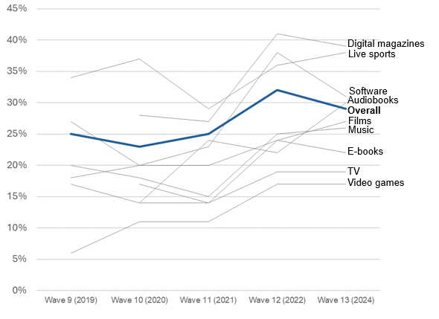

Infringement Trends in Music, Film and TV
In comparison to overall infringement levels, a more nuanced view can be gained by looking at the combination of legal and illegal sources used. As previously highlighted, this year, overall infringement levels in relation to music and film rose slightly but remained static for TV in comparison to 2022 (Figure 2).
Furthermore, while music, film and TV all saw increases in overall infringement in 2022, the proportion using only illegal sources in the last two years has slightly increased (music) or fallen (film and TV).

Few differences in music, film and TV infringement trends over the last two years
Figure 2: Sources used at least once in the past three months (% age of consumers in each category). Download the data from Table 1.3.
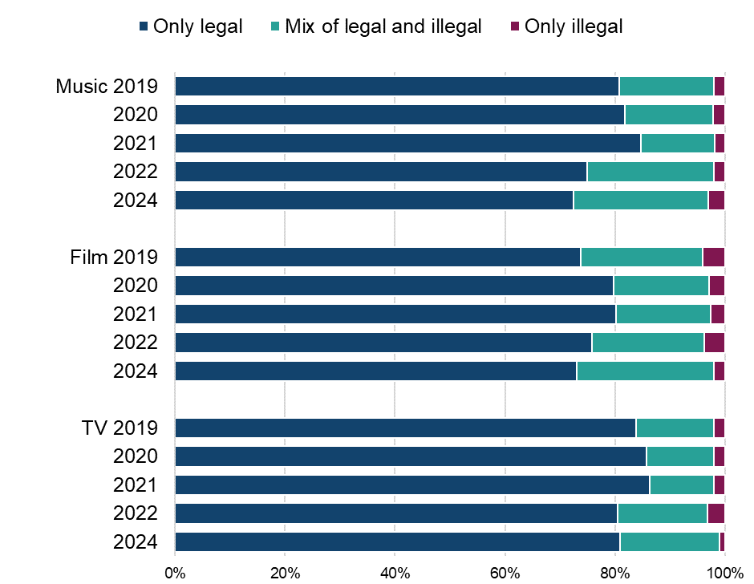
Base for 2024: those who have downloaded or streamed in that category during the past three months with ‘'Download/access for free from the internet, without really being sure where it comes from” not counting as either legal or illegal and those who only selected this option not included in the base (music = 2,855, film = 2,521, TV programmes/series = 2,510)

Infringement Trends in All Other Categories
Video games, e-books and live sports infringement have all remained largely stable in the last two years.
Software saw a notable decrease in infringement levels – falling from 38% to 31% (Figure 3). However, audiobooks have seen a peak in infringement since the study began, with the current infringement figure (30%) more than double the figure recorded in 2020 (14%).

Little difference in infringement trends in other categories over the past two years, with the exceptions of audiobooks and software
Figure 3: Sources used at least once in the past three months (% age of consumers in each category). Download the data from Table 1.4.
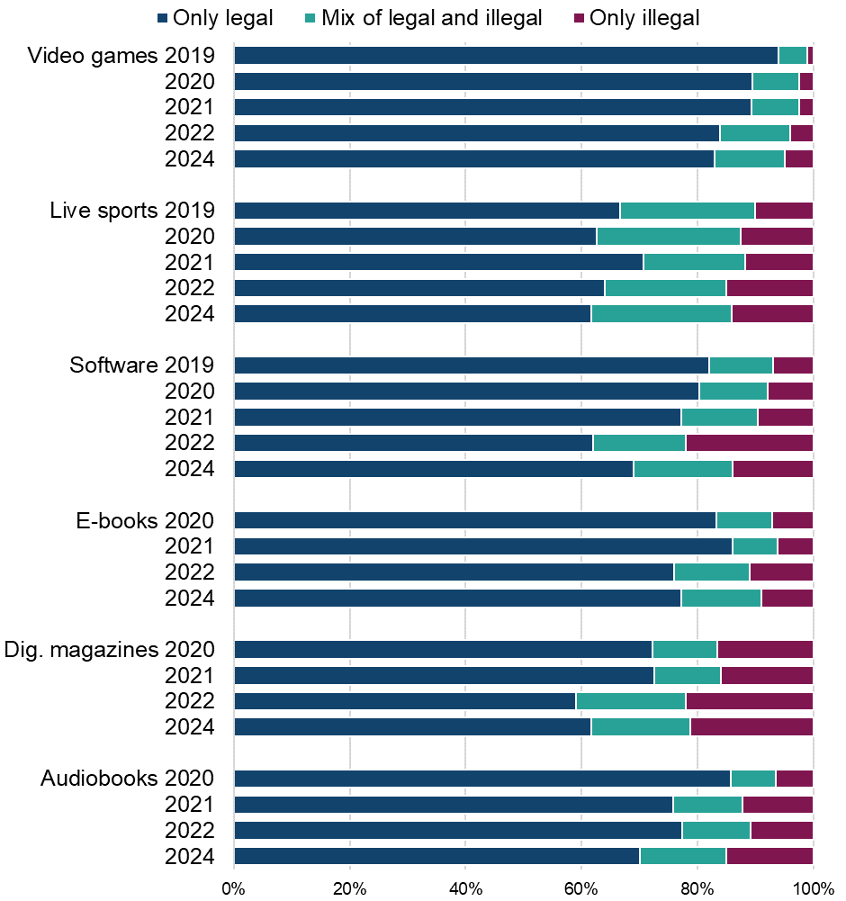
Base for 2024: those who have accessed in that category during the past three months with ‘'Download/access for free from the internet, without really being sure where it comes from” not counting as either legal or illegal and those who only selected this option not included in the base (video games = 1,168, live sport = 708, software = 826, e-books = 992, digital magazines = 419, audiobooks = 588)

Top legal and illegal sources used
Table 2 and Table 3 present the top legal and illegal means of downloading and streaming for Wave 13. Comparisons with the previous wave are given in brackets, which show the percentage point (pp) change from Wave 12 (2022) to Wave 13 (2024).
Consistent with Wave 12 (2022), saving content offline, via paid subscription services for music, film and TV, were the top legal means of downloading. While the percentage of respondents doing so in film and TV was consistent across the waves, there has been an increase of five percentage points in people turning to this method of downloading music (Table 2). In the video games category, there was also an increase of four percent in people downloading free video games from legal sources.
Paid subscriptions remained the top legal method of accessing audiobooks, with an increase of five percentage points in those accessing audiobooks in this way. There has also been an increase of three percentage points in those paying for subscription services to stream music – the top legal method used, at 57% (Table 3).
In contrast, there was a decrease of eight percentage points in those paying for subscription services to stream live sports (Table 3). The percentage of those watching live streams via legal platforms also decreased by six percentage points – 41% of people in the current wave watched live streams in this way. In the qualitative phase, some participants mentioned having to abandon subscriptions to live sports, due to managing this cost alongside other increasing costs. Participants suggested that, in the future, they would need to further decrease their consumption of live sports subscriptions and settle for free broadcasts on terrestrial TV.
Turning to illegal methods of access, online converters remained the most commonly used illegal sources for music in addition to film and TV (Table 2). Illegal behaviours in the video games category were consistent, with file hosting sites or cyberlockers, and peer-to-peer sharing remaining the top methods of downloading.
There was a small increase in those paying for subscriptions to IPTV providers to access live sports (four percentage points) – this was the top method of streaming illegally for this wave (Table 3). In 2022, the top method of access was free websites that host links to live sport streams – this method decreased by five percentage points.
Top legal and illegal sources across all other content categories remained consistent with the previous wave for downloading and streaming.

Paid subscription services enabling content to be saved offline remain the top legal means of downloading across music, film and TV
Table 2: Sources used at least once in the past three months (% of consumers in each category) – downloading. Download the data from Table 1.5a.
 | Legal | Illegal
Music | Saving offline via a paid for subscription service: 60% (+5%) | Downloading music from sites such as YouTube using an online converter: 30% (+4%)
Film | Saving offline via a paid for subscription service: 68% (0%) | Downloading feature films from sites such as YouTube using an online converter: 15% (+3%)
TV | Saving offline on a paid for subscription service: 65% (+3%) | Downloading TV programmes/episodes from sites such as YouTube using an online converter: 10% (0%)
Video Games | Downloading video games for free through Apple App Store, Google Play, PlayStation or Xbox Store, Steam, Origin etc.: 51% (+4%) | Receiving a link to download video games: 4% (0%)
Software | For free via a software creator’s store: 49% (+1%) | Bit torrent or another peer-to-peer service: 9% (+2%)
E-books | Paying a single fee to download individual e-books: 57% (+2%) | Receiving files directly from someone else: 4% (0%)
Digital magazines | Paying for a subscription to a service or publisher: 36% (n/a) | A free website which hosts or links to digital magazines I would otherwise expect to pay for: 20% (n/a)
Audiobooks | Pay for a subscription to a service that allows you listen to audiobooks online: 40% (+5%) | Streaming audiobooks for free from sites such as YouTube: 11% (+1%)

Increasing use of paid subscription services for streaming music, contrasts with decreasing use for paid subscriptions for streaming live sports
Table 3: Sources used at least once in the past three months (% of consumers in each category) – streaming. Download the data from Table 1.6a.
 | Legal | Illegal
Music | A paid for subscription service: 57% (+3%) | A file hosting website or cyberlocker: 2% (-1%)
Film | A paid subscription to an online video streaming service: 81% (-3%) | A paid subscription to an IPTV provider: 9% (+2%)
TV | A paid subscription to an online video streaming service: 75% (0%) | A paid subscription to an IPTV provider: 7% (+2%)
Live Sport | A paid subscription to a sports platform that can be accessed online: 51% (-8%) | A paid subscription to an IPTV provider: 12% (+4%)
Livestream | Watch through a live streaming platform: 41%  (-6%) | Downloading a recording of a live stream after the event using a file hosting website or cyberlocker: 7% (+2%)
Base: those who have streamed in that category during the past three months (music =2,263, film = 2,277, TV = 2,293, live sport = 792, livestream = 1,468)

Analysis of 2024 infringement levels for downloading and streaming of music, film and TV
Music, film and TV has the highest prevalence of infringers. Overall, downloading continued to have higher levels of infringement (Figure 4) compared to streaming across all three categories (Figure 5).
Having previously shown an increase of 12 percentage points between Wave 11 (2021) and Wave 12 (2022), Wave 13 (2024) provided evidence of a further small increase in illegal music downloading.
Meanwhile, streaming infringement remained consistently low in this category. While film downloading infringement remained static, illegal TV downloading showed a small decrease. There are also small increases in illegal film and TV streaming. There remains a clear need for ongoing efforts to reduce downloading infringement.
Music
The proportion using illegal sources to download music showed an increase compared to previous years (47% compared to 45%). In 2024, 53% of respondents downloaded music legally, 28% used a mix of legal and illegal sources, and 19% used only illegal sources. This is a minor change from 2022 when 21% used only illegal sources. Music streaming infringement remained exceptionally low with only 2% using a mix of legal and illegal sources and none using only illegal sources.
Film
In line with Wave 12 (2022), Wave 13 (2024) data showed that 73% of respondents downloaded films legally, 17% used a mix, and 10% used only illegal sources. Streaming infringement was relatively low, with 17% using a mix and only 4% using only illegal sources. There was a decrease in the proportion of respondents relying solely on legal sources to stream films, dropping from 83% to 79% currently.
TV
In 2024, 80% of respondents legally downloaded TV shows, 11% used a mix, and 8% used only illegal sources. This represents a small decrease in illegal downloading compared to 2022. Streaming infringement for TV remained low, with 13% using a mix and 2% using only illegal sources. This was consistent with previous trends.

Downloading continues to have higher levels of infringement compared to streaming across all three categories
Figure 4: Infringement levels – downloading. Download the data from Table 1.7.
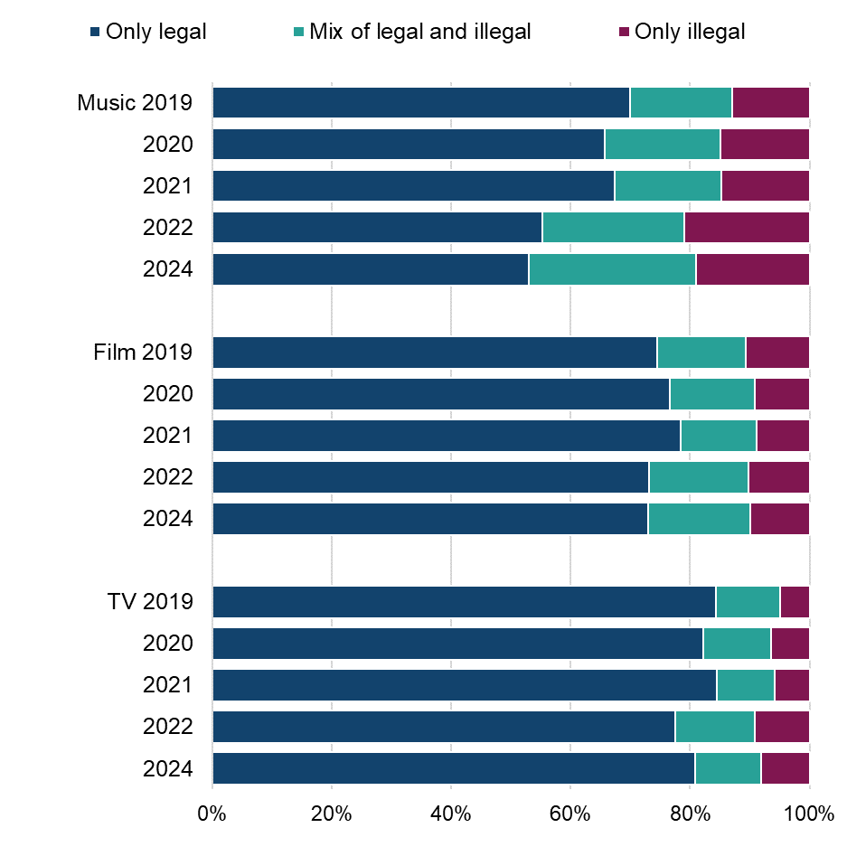Base for 2024: those who downloaded content in that category at least once in the past three months. Those who only selected “Download/streamed for free from the internet, without really being sure where it comes from or “Other” were not included in the base (music = 1,570, film = 1,315, TV programmes/series = 1,080)

Highest levels of streaming infringement continue to be evident in relation to films
Figure 5: Infringement levels – streaming. Download the data from Table 1.8.
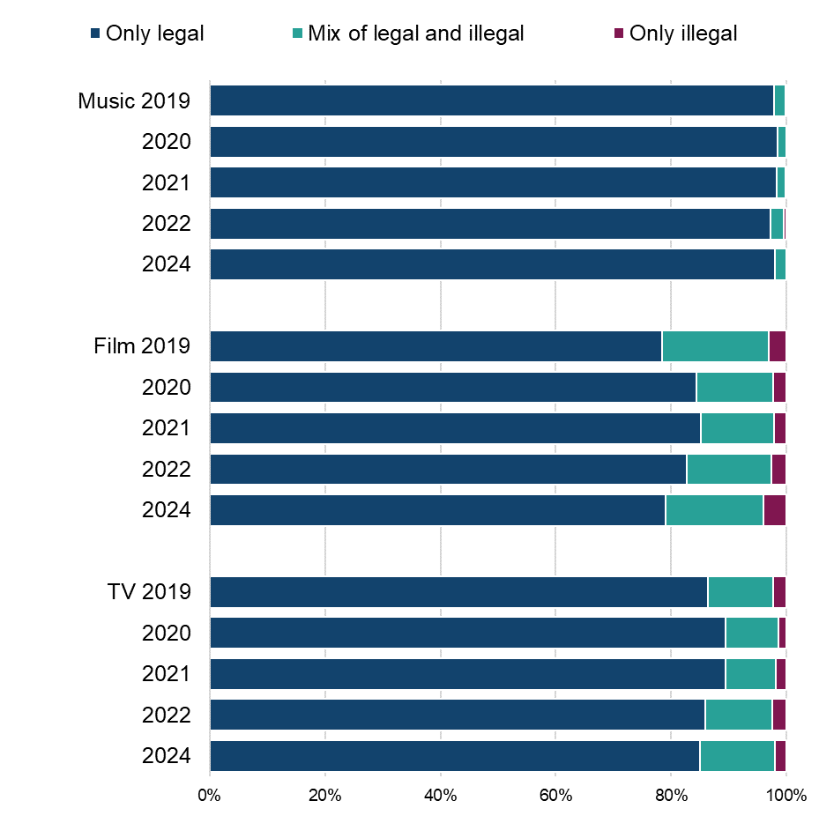Base for 2024: those who streamed content in that category at least once in the past three months. Those who only selected “Download/streamed for free from the internet, without really being sure where it comes from or “Other” were not included in the base (music = 2,609, film = 2,252, TV programmes/series = 2,261)
In this wave, across music, film and TV, nearly 40% of those respondents who were using illegal sources reported increased (‘a bit’ or ‘much more’) use of illegal sources compared with the same time last year.

Infringer profiles
Infringer profiles provide insight into characteristics, including demographics, behaviours, and attitudes, and estimating the size of each group within the UK population. Base sizes for infringers (in each content category) are inclusive of anyone who has used an illegal source within the last three months.
Digital magazines (39%), live sport (38%), software (31%) and audiobooks (30%) had the highest rates of infringement among those who consume each type of content (Figure 6). Music (26%), film (27%) and TV (19%) had lower levels of infringement but more infringers overall. For example, for TV this was 9% of the total sample, which equates to approximately 6,200,000 people in the UK.

Overall infringement prevalence

Infringement peaks in relation to digital magazines, live sport, software and audiobooks
Figure 6: Infringement in each category and in the whole sample (%). Download the data from Table 1.9.
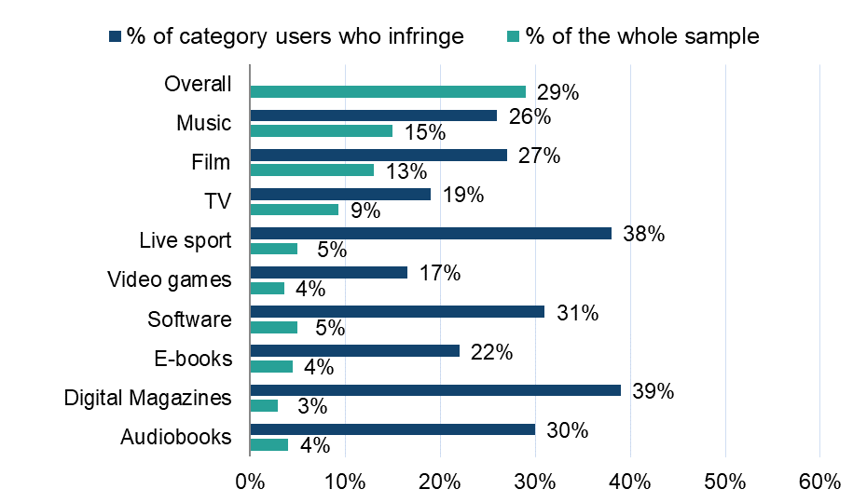Base for 2024: those who have used an illegal source at least once in that category during the past three months with ‘'Download/access for free from the internet, without really being sure where it comes from” not counting as either legal or illegal and those who only selected this option not included in the base (music = 749, film = 673, TV programmes/series = 468, live sport = 268, video games = 202, software = 257, e-books = 222, digital magazines = 162, audiobooks = 179)

Estimated number of infringers for each category in UK population
Wave 13 (2024) findings suggest that infringer numbers in the overall UK population have all seen increases in the music, film, video games, digital magazines and audiobooks categories relative to 2022. The largest increase is in relation to audiobooks.
In contrast the numbers of live sport and software infringers in the UK have decreased since 2022. E-books and TV infringer numbers show no change (Figure 7).

Estimated over eight million infringers in both the music and film categories in the UK
Figure 7: Estimated number of infringers within the UK population. Download the data from Table 1.10

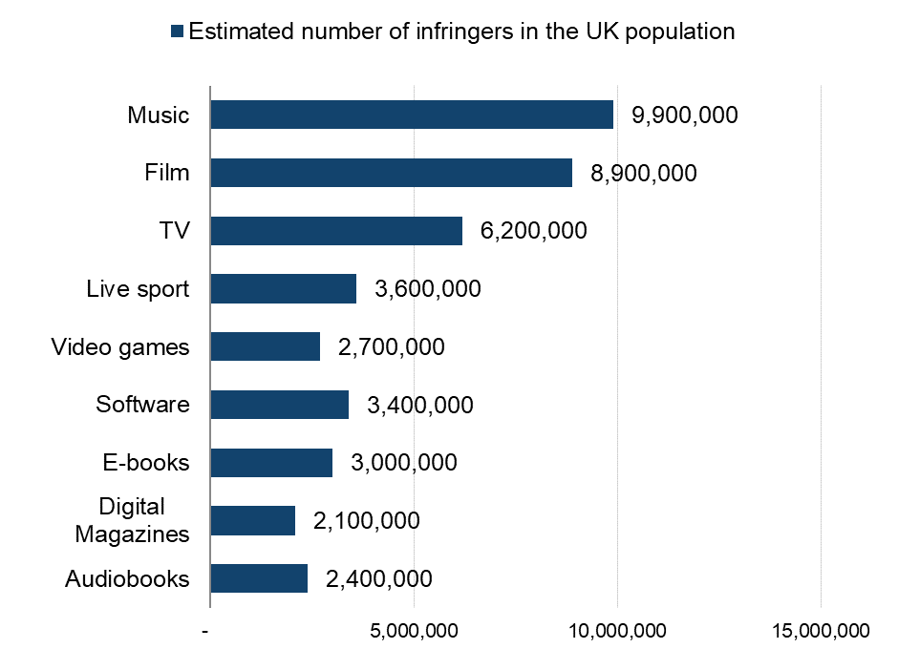Base for 2024: those who have used an illegal source at least once in that category during the past three months with ‘'Download/access for free from the internet, without really being sure where it comes from” not counting as either legal or illegal and those who only selected this option not included in the base (music = 749, film = 673, TV programmes/series = 468, live sport = 268, video games = 202, software = 257, e-books = 222, digital magazines = 162, audiobooks = 179)

Infringement in each category by sex
Across most categories, male respondents were more likely to infringe than female respondents (Figure 8). For music, film, TV, e-books and audiobooks, the infringement difference was between 7 and 13 percent. There was little or no difference between sexes in relation to live sport, video games and software infringement.

Male respondents more likely than female respondents to be infringers
Figure 8: Infringement in each category by sex. Download the data from Table 1.11.
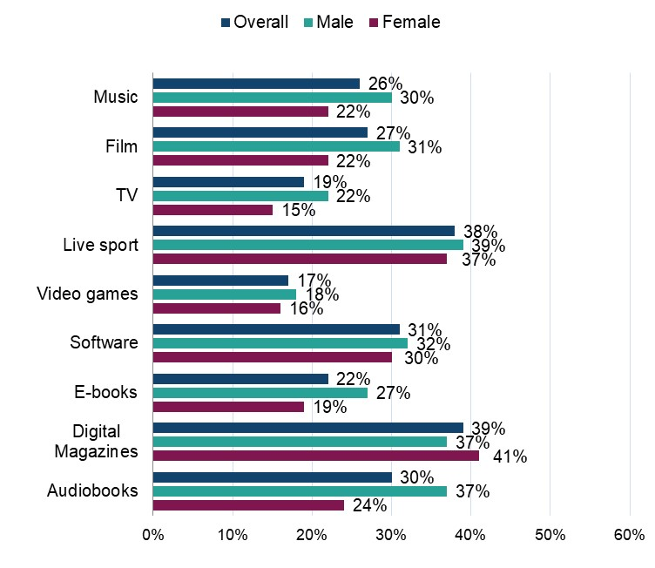
Base for 2024: those who have used an illegal source at least once in that category during the past three months with ‘'Download/access for free from the internet, without really being sure where it comes from” not counting as either legal or illegal and those who only selected this option not included in the base (music = 749, film = 673, TV programmes/series = 468, live sport = 268, video games = 202, software = 257, e-books = 222, digital magazines = 162, audiobooks = 179)

Infringement in each category by age
For most categories, infringement levels tend to drop among older respondents (aged 45 and above). Across most categories, infringement levels among younger age groups (under 45) tend to be relatively similar (Figure 9).
Live sport and digital magazines infringements see notable peaks among some of the youngest age groups.

Infringement tends to decline with age, peaking among the younger age groups and waning among the older age groups
Figure 9: Infringement in each category by age. Download the data from Table 1.12.
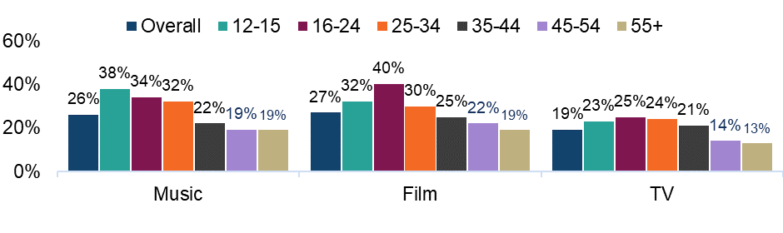
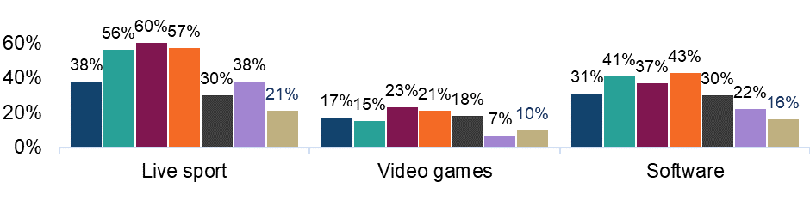
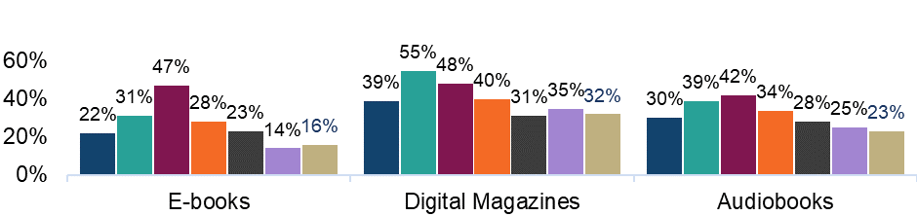
Base for 2024: those who have used an illegal source at least once in that category during the past three months with ‘'Download/access for free from the internet, without really being sure where it comes from” not counting as either legal or illegal and those who only selected this option not included in the base (music = 749, film = 673, TV programmes/series = 468, live sport = 268, video games = 202, software = 257, e-books = 222, digital magazines = 162, audiobooks = 179)

Infringement in each category by social grade
Social Grade is a socio-economic classification used to group respondents, primarily based on their social and financial situation. The grades include higher and intermediate managerial, administrative, and professional occupations (AB); supervisory, clerical, and junior managerial, administrative, and professional occupations (C1); skilled manual occupations (C2); and semi-skilled and unskilled manual and lowest grade occupations (DE). Respondents may opt not to provide this information by selecting "prefer not to say."
In terms of results, infringement levels were fairly even across social grades for most categories (Figure 10). However, infringement of video games, digital magazines, and audiobooks was higher among ABC1s.

A fairly even spread of infringement across social grades, with some differences relating to video games, digital magazines and audiobooks
Figure 10: Infringement in each category by social grade. Download the data from Table 1.13.
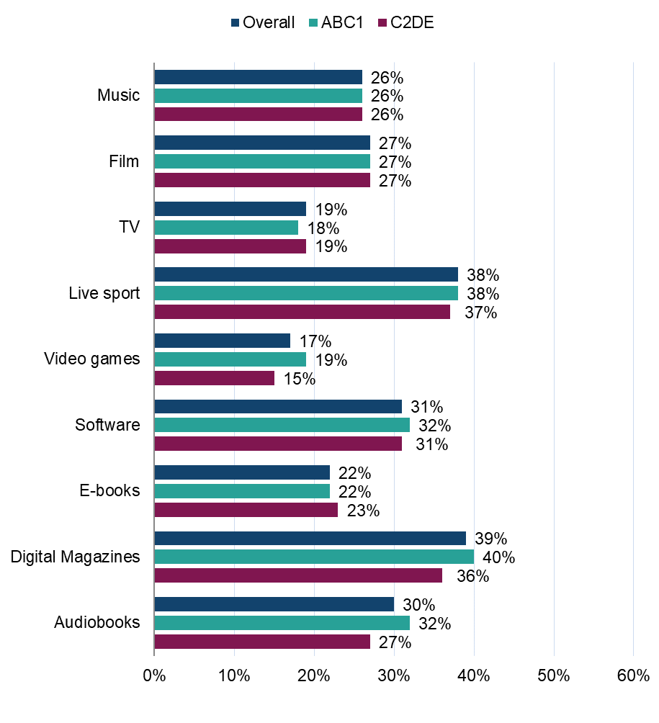Base for 2024: those who have used an illegal source at least once in that category during the past three months with ‘'Download/access for free from the internet, without really being sure where it comes from” not counting as either legal or illegal and those who only selected this option not included in the base (music = 749, film = 673, TV programmes/series = 468, live sport = 268, video games = 202, software = 257, e-books = 222, digital magazines = 162, audiobooks = 179)

General shifts in device and platform usage – across categories
Overall, the majority (64%) had not changed anything regarding the devices or platforms on which they consumed entertainment media. Of those who had made changes to the devices or platforms on which they consumed media, 42% had unsubscribed or stopped using a service to stream or download content. 25% had started using a new device to stream or download content.
Only 27% of those who had made changes to which devices and services they consumed content on in the last year said they now spent more on streaming services. 33% said they now spent less on streaming services and 21% had redirected spending from entertainment budgets to other expenses.
Amongst those who had started using a new streaming service in the last year, 66% of streaming services which saw an increase in usage were legal whilst only 6% were illegal. Netflix (27%), Spotify (17%), Disney+ (16%) and Amazon Prime (15%) were the most prominent services to see an increase. However, amongst those who had stopped using certain streaming services, the majority were also mostly legal platforms (56%), with illegal sources making up only 5% of services which had decreased in usage. Once again, Netflix (15%), Amazon Prime (12%) and Disney+ (11%) saw the greatest drops in usage.
Coming to those who had made changes in the devices they used to consume content, there was a shift towards smartphone usage. 41% of those who used a new device to consume content did so on a smartphone. 30% had started using a Smart TV to stream content and the same proportion had started using their laptop more, followed by 28% who had started using their tablet more.

Infringement in each category, by level of passion for category
Across categories there was a pattern of those with the highest passion being most likely to infringe, which subsequently declined among those with medium and low category passion levels (Figure 11). This was most pronounced in relation to passion for music – where those with a high passion were notably more likely to be infringers than those with a medium or low passion. Passion levels were derived by scoring answers to a range of statements. The full list of statements can be found in the category sections of the report. They were scored based on strongly agree = 1, agree a little = 2, disagree a little = 3; strongly disagree = 4. “High” was a score of 6 - 12, “Medium” 13 - 17 and “Low” was 18 or higher.

High passion mirrors higher infringement levels
Figure 11: Infringement in each category, by level of passion for category. Download the data from Table 1.14.
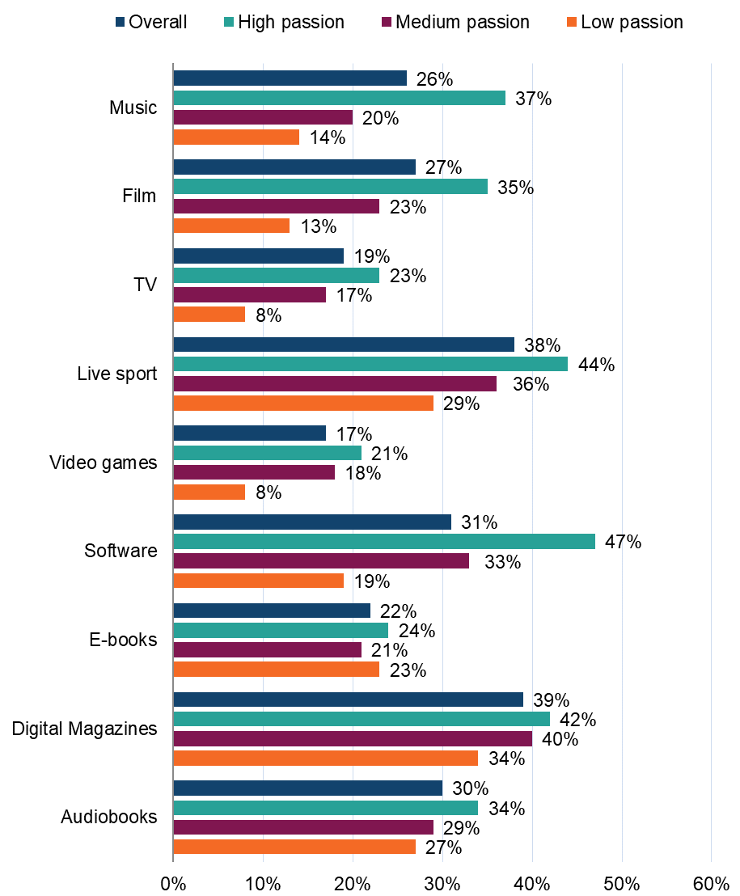
Base for 2024: those who have used an illegal source at least once in that category during the past three months with ‘'Download/access for free from the internet, without really being sure where it comes from” not counting as either legal or illegal and those who only selected this option not included in the base (music = 749, film = 673, TV programmes/series = 468, live sport = 268, video games = 202, software = 257, e-books = 222, digital magazines = 162, audiobooks =179)

Cyber Security Incidents and Harms
With the increasing reliance on smartphones, computers, and online platforms for both business and personal communication, cyber security has become a critical issue. New for Wave 13 was a set of questions that focused on cyber security incidents and the harms that followed. Download the data from Table 1.15 of the OCI 2024 Main Data Tables.

Cyber security incidents
Overall, while many respondents had not directly experienced cyber security incidents (53%), this could suggest either a genuine lack of exposure to cyber threats or a lack of awareness or recognition of such incidents.
One in every four had encountered phishing attempts in the past 12 months. Other reported incidents include malware infections on devices (6%), hacking or attempted hacking of online bank accounts (5%), takeovers or attempted takeovers of personal social media and email accounts (both at 5%), and ransomware attacks targeting devices (4%).

Cyber security harms
A high portion of respondents (54%) did not experience direct consequences because of the cyber security incidents. However, financial loss (12%), unauthorised access to personal information (11%) and disruption of digital access (10%) were the most common outcomes for those affected by cyber security incidents.
Other harms (all experienced by less than 10% of respondents) included having files, photos or data destroyed (9%), experiencing loss of access to devices (7%) or personal email accounts (7%), experiencing damage to devices (6%) and other issues (1%).

Experiencing cyber security incidents in relation to infringement behaviour
In overall terms and across every category, there was a notable difference in the percentage of respondents who had experienced cyber harms in the last 12 months, in relation to infringement behaviour. Figure 12 shows the percentage of those in each category who had experienced cyber incidents in the past 12 months, broken down by infringers and non-infringers. This highlights that infringers were notably more likely to have experienced cyber security incidents, compared to non-infringers.
However, while this is an interesting finding, it cannot be concluded that infringement behaviour directly causes, or increases the likelihood of, cyber security incidents.

Infringers are more likely than non-infringers to experience cyber security incidents
Figure 12: Cyber security incidents in relation to infringement behaviour. Download the data from Table 1.15.
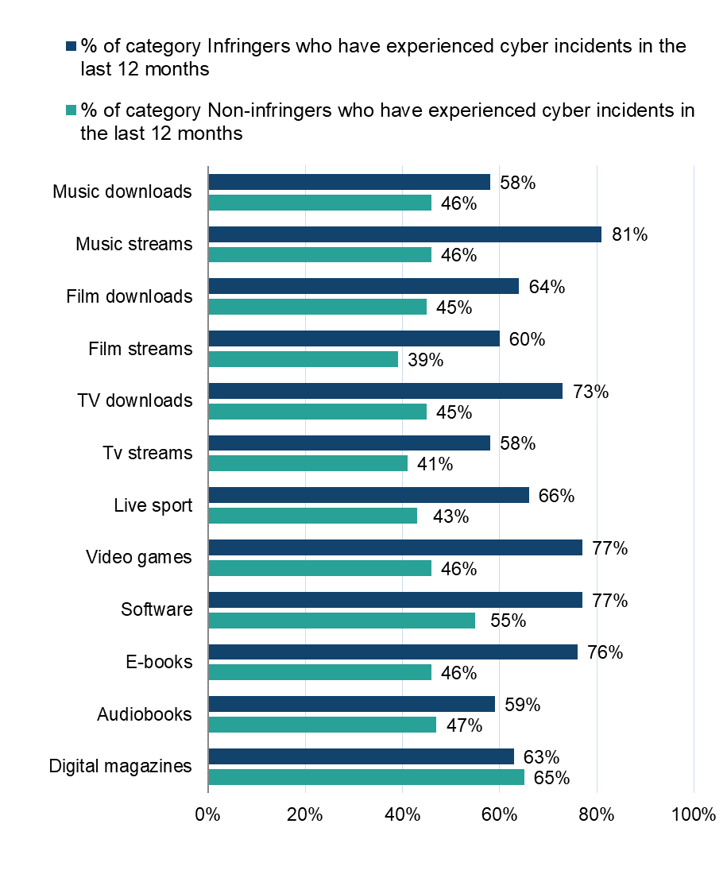
Base: music downloads = 1,185, music streams = 2,309, film downloads = 1,167, film streams = 2,010, TV programmes/series downloads = 989, TV programmes/series streams = 2,056, live sport = 643, video games = 1,010, software = 744, e-books = 946, audiobooks = 551 (who had engaged with a category in the previous 12 months, with those who selected ‘other’ or ‘not sure’ removed from both questions)

Qualitative insight
Reflecting the above, it is difficult to ascertain which security incidents arise from having accessed illegal content. Participants in the Online Community were asked directly if they had experienced security concerns after accessing illegal content. Though a smaller qualitative sample, it is worth highlighting that in line with the quantitative findings, fewer participants reported experiencing such concerns while more said they had not. However, many did report that they were aware of security threats and worried sometimes that they would fall victims to scams as a result of using illegal content sites. This shows it is something on consumers’ minds.
Several participants believed that a serious security incident would only occur if they entered their details into pop-up windows, which occasionally appeared. However, they stated that they would never do this, and as a result, some expressed that they were not overly concerned about security, provided they avoided entering their details anywhere.
When participants did report having fallen foul to security incidents after accessing illegal content, these were reported in the scope of our smaller sample to usually be minor incidents. Some reported annoying pop-up windows which persisted after accessing an illegal site or that they lost access to some of their files which took a while to restore.
Despite low reports qualitatively of any security incidents, many participants did say in a follow-up question that if they experienced a serious security concern, this would impact their use of illegal sources. This included concerns such as having their data stolen or anything effecting their personal finances. Some, however, did say that they would keep consuming illegal content but would install better anti-virus software in order to not lose the benefit of consuming content for free.

Category summary: Music

Trends in overall music consumption in the UK
Music plays an important role in many people’s lives, often being described as their ‘favourite form of entertainment’.
In a typical three months, 42% of the population will stream music (Figure 13). This is a figure which has exceeded 40% in all but one of the last five years.
28% currently download music in a typical three months. Downloading music increased from 23% in Wave 10 (2020) to a steady 26-28% thereafter.
In a typical three month period, 13% will purchase physical copies and 10% will share music.

Streaming remains the most popular means of engaging with music
Figure 13: Have you downloaded/streamed/shared/purchased physical copies of music in the past three months? Download the data from Table 1.16.
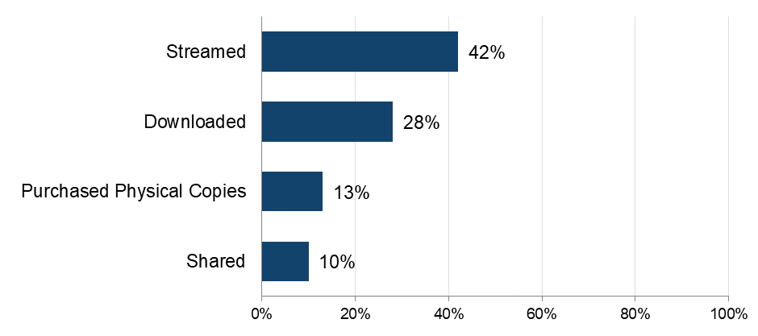
Sample: n = 5,087 (total sample)

Music passion peaks among younger age groups, typically under the age of 34. Streaming is the most common method of engagement (42%), followed by downloading (28%), physically purchasing copies (13%) and sharing (10%). These figures are very similar to those recorded in 2022, suggesting a stability and consistency in engagement methods over the last two years.
Downloading music is often a frequent activity – with more than half (56%) of those who download music doing so at least weekly. Again, this is a finding consistent with that of 2022.
Online music consumption continues to be largely driven by two factors; instant access (52%) and a wide variety (47%).

Music infringement levels
In 2024, downloading infringement in the music category stands at 26%. This is the percentage of respondents who have illegally downloaded/streamed at least one piece of music and is slightly higher than the figure recorded in 2022 (25%).
53% of those who download music use only legal sources (Figure 14). This contrasts with just 19% using solely illegal sources (21% in 2022), and 28% using a mix of legal and illegal.
Streaming is used almost entirely legally (98%), while combined downloading/streaming show predominantly legal use (74%).

74% of those who have downloaded or streamed music have done so using only legal sources
Figure 14: Legality of music being accessed. Download the data from Table 1.17.
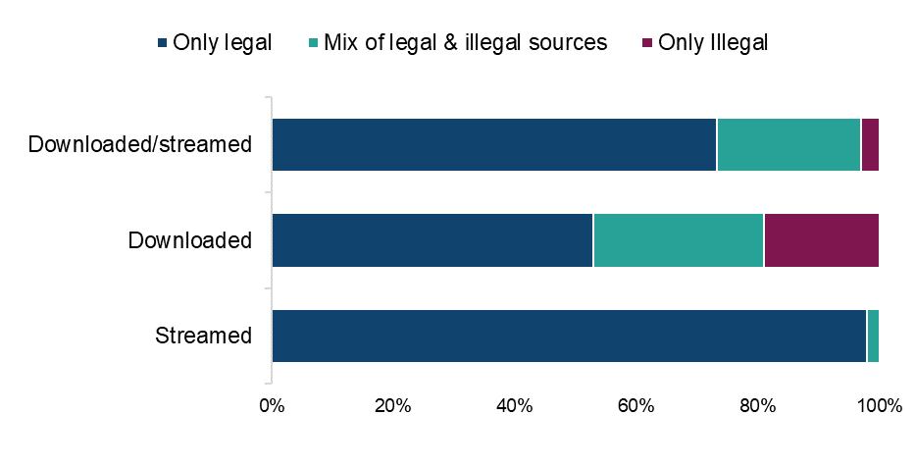
Sample: n = 2,855 (streamed and/or downloaded music from a legal or illegal source, with those who only selected ‘not sure of source’ removed)
Downloading infringement continues to be higher among male respondents (53%) than female respondents (41%). Across age groups, there is a much higher proportion of infringers among the youngest age group (age 12-15, 56%) and a much lower proportion among the oldest age group (age 55 and above, 40%). Infringement also continues to correlate to music passion, with higher levels of passion corresponding with higher levels of infringement.
Saving music offline via a paid subscription service is by far the most used legal source of downloading music (60%). In contrast, the top illegal source, using sites such as YouTube with an online converter or a software, app or browser extension, was being undertaken by just 30%.
As in 2022, around four in every 10 of those using illegal sources to download/stream music indicate that their use of illegal sources has increased over the last year.
In the absence of illegal sources, infringers are likely to switch to a paid subscription service (22%) rather than a free site (such as YouTube or Dailymotion, 17%), to access music.
Those who had downloaded music illegally in the last three months were more likely to have experienced cyber security incidents than those who had used only legal sources (46% compared to 58% for those using illegal sources). This difference was even more pronounced in relation to streaming (81% compared to 46% for those using legal sources).

Category summary: Films

Trends in overall film consumption in the UK
Over half of all respondents (53%) have engaged with films in the previous three months, either by downloading (27%), streaming (45%), sharing (8%) or purchasing physical copies (12%). This overall engagement is very close to that recorded in 2022 (55%) (Figure 15).

Streaming is the most frequent means of engaging with films
Figure 15: Have you downloaded/streamed/shared/purchased physical copies of films in the past three months? Download the data from Table 1.18.
Base: n=5,087 (total sample)
Passion for film is also fairly stable, with 41% continuing to display a high level of passion and many film consumers (75%) continuing to search for new films to watch. This passion also continues to be particularly evident among younger respondents (aged 12-15), and again tails off among older (55 and above) respondents.
Variety and instant access remain as the top two drivers of online film consumption.
Downloading films (in the past three months) remains at a fairly steady 27%, with over half of those downloading films continuing to do so frequently – at least once a week.
Streaming films (in the past three months) is indicated by 45% of respondents – very close to the 46% recorded in 2022. Many film streamers were doing so very regularly (68% indicating at least weekly – slightly lower than the 71% recorded in 2022).

Film infringement levels
The overall infringement level for films is 27%, slightly higher than the 24% recorded in 2022.

Over a quarter have used at least one illegal source to download/stream films
Figure 16: Legality of downloading/streaming films. Download the data from Table 1.19.
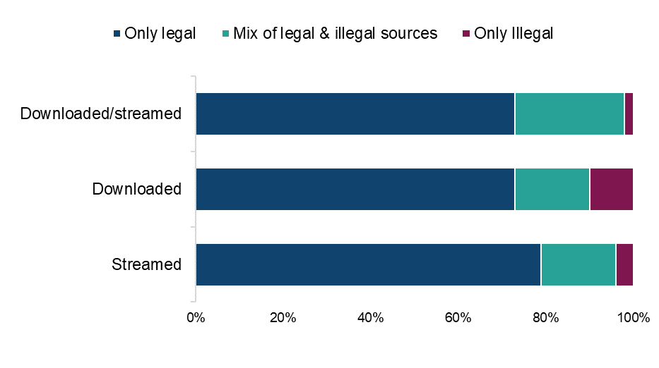
Sample: n = 2,521 (streamed and/or downloaded films from a legal or illegal source, with those who only selected ‘not sure of source’ removed)
27% had used at least one illegal source to download films (26% in 2022), while downloading films from illegal sources accounted for 14% of all film downloads (15% in 2022).
10% of all time spent streaming films was done so using illegal sources (8% in 2022), while 21% had used an illegal source to stream films (17% in 2022).
Those who had downloaded films illegally in the last three months were more likely to have experienced cyber security incidents than those who had used only legal sources (64% v. 45%). A similar ratio was evident in relation to streaming films illegally, with equivalent figures of 60% v. 39% experiencing cyber security incidents.

Category summary: TV programmes

Trends in overall TV programme/series consumption in the UK
Over half of all respondents (52%) have engaged with TV programmes/series in the previous three months (either by downloading, streaming, sharing or purchasing physical copies) (Figure 17). This is a figure almost identical to that recorded in 2022 (51%).
45% have streamed a TV programme episode in the last three months (identical to the figure recorded in 2022) (Figure 17), with 80% of these doing so at least once a week
23% have downloaded a TV programme episode in the last three months, with over 60% of these doing so at least once a week. Both findings are consistent with those recorded in 2022.

Streaming is the most frequent means of engaging with TV programmes/series
Figure 17: Have you downloaded/streamed/shared/purchased physical copies of TV programmes/series in the past three months? Download the data from Table 1.20.
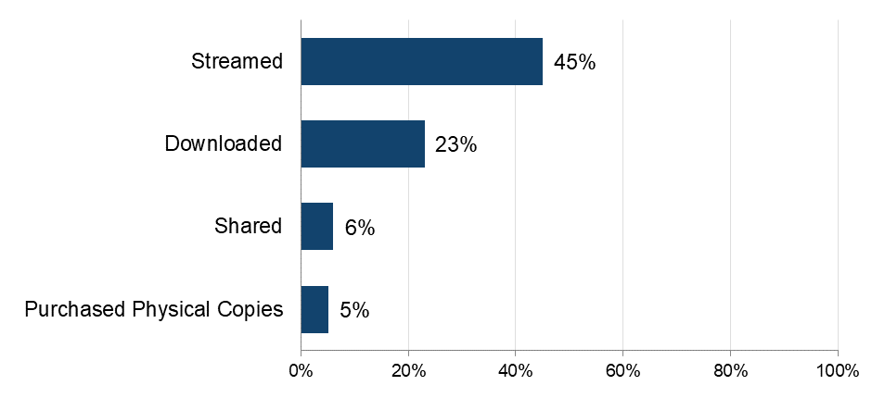
Sample: n = 5,087 (total sample)
Passion for TV programmes/episodes is also fairly stable – with 43% continuing to display a high level of passion. This passion is again more evident among female respondents (46%) than male respondents (41%), and is sustained among most age groups, but dips (as in 2022) among those aged 55 and above. Further data on passion levels for TV can be found in the TV section of the annex report.
Many consumers also continue to actively search for new programmes/series to watch, and regard TV as their favourite kind of entertainment.
Instant access (51%) and variety (48%) continue to strongly drive the consumption of streamed or downloaded TV programmes/episodes.

TV programme infringement levels
The overall infringement level for TV programmes/series is 18%, very close to the 19% recorded in 2022.

Over 80% of those who have downloaded or streamed TV programmes/series have done so using only legal sources
Figure 18: Legality of TV programmes being accessed. Download the data from Table 1.21.
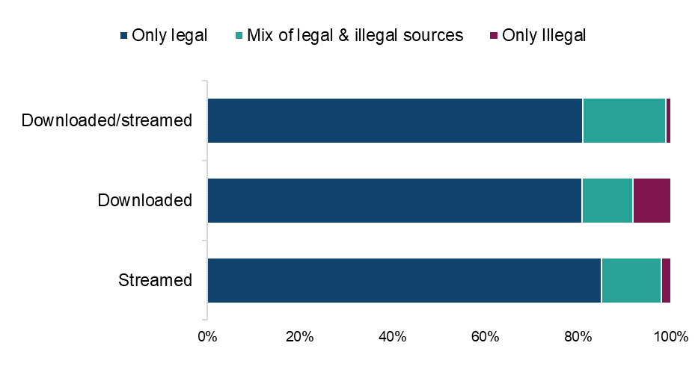
Sample: n = 2,510 (those who have streamed and/or downloaded TV programmes/series from a legal or illegal source with those who only selected ‘not sure of source’ counting as illegal)

19% had used an illegal source to download TV programmes/series, slightly lower than the 22% recorded in 2022. Illegal sources accounted for 13% of all TV downloads, the same proportion as in 2022. Use of illegal sources was highest among those aged 25-34 and those with a high passion for TV (both around a quarter).
Additionally, illegal sources accounted for 7% of all time spent streaming, marginally higher than the 5% recorded in 2022. 15% of respondents had used at least one illegal source to stream TV programmes/series, compared to 14% in 2022. Generally, the younger the respondent, the higher the likelihood of them using illegal sources to stream TV programmes.
Those who had downloaded TV programmes/series illegally in the last three months were more likely to have experienced cyber security incidents (73%) than those who had used only legal sources (45%). The equivalent ratio for streaming was 58% compared to 41%.

Category summary: Live sport

Trends in overall live sport consumption in the UK
Around one in six respondents (17%) have engaged with live sport in the previous three months, either by streaming (16%) or sharing (3%) (Figure 19). This overall engagement figure has remained fairly stable since 2022.

Streaming is the most frequent means of engaging with live sport
Figure 19: Have you streamed/shared live sports events in the past three months? Download the data from Table 1.22. 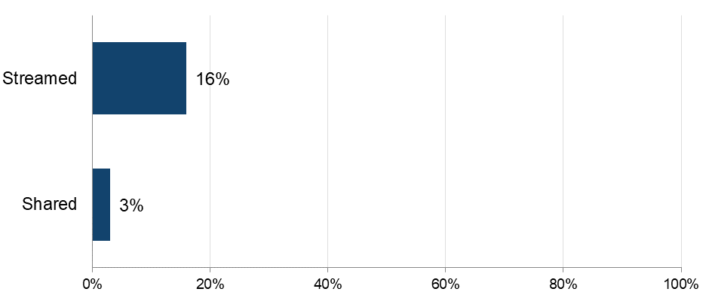
Sample: n = 5,087 (total sample)
Male respondents continue to be notably more likely than female respondents to watch live sports and to do so more frequently. 69% of male respondents who have recently engaged with live sport are frequent viewers, compared to just 47% of female respondents.
Passion for live sports is also stable – with over 40% continuing to display a high level of passion. There’s also an increasing proportion regarding watching live sports as their favourite type of entertainment – rising from 66% in 2022 to 70% currently. This passion continues to be particularly evident among the very youngest (12-15) age group. More on this data can be found in the Appendix report, within the live sport section.
Instant access to live sports continues as the number one driver of online streaming within this category. These data can be found in the Appendix report, within the live sport section.

Live sport infringement levels
The overall infringement level for live sports is 38% - marginally higher than the 36% recorded in 2022.
Findings for 2024 are broadly similar to those of 2022, with little movement in the proportions of legal and illegal behaviour in the past two years (Figure 20).

Almost 40% have used at least one illegal streaming source to access live sport
Figure 20: Legality of streaming/accessing live sports. Download the data from Table 1.23.
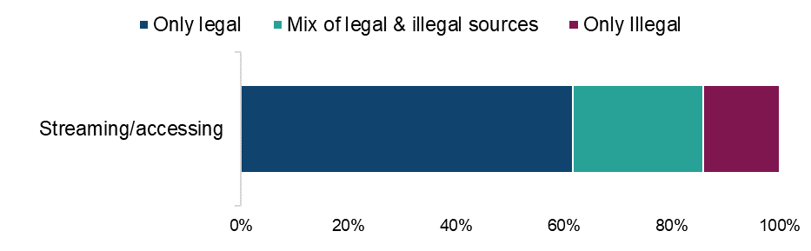
Sample: n = 708 (streamed live sport in the past three months, with those who selected ‘other’ or ‘not sure of source’ removed)
Identical to 2022, 38% had used at least one illegal source to access live sport, with 14% using only illegal sources to access live sport (compared to 15% in 2022). Use of only illegal sources was highest among those aged 16-24 (28%) with figures ranging from 8-20% in all other age groups. Those with a high passion for live sport were again the most likely to use illegal sources, at 44%. Overall, illegal sources accounted for 21% of all live sports watched online (22% in 2022).
Those who had streamed live sports illegally in the last three months were more likely to have experienced cyber security incidents (66%) than those who had used only legal sources (43%).

Category summary: Video games

Trends in overall video games consumption in the UK
29% have engaged with video games in the previous three months, either by downloading (19%), streaming (16%), sharing (6%) or purchasing physical products (11%) (Figure 21). This overall engagement is slightly higher than the 27% recorded in 2022.

Downloading is the most frequent means of engaging with video games
Figure 21: Have you downloaded/streamed/shared/purchased physical copies of Video Games in the past three months? Download the data from Table 1.24. 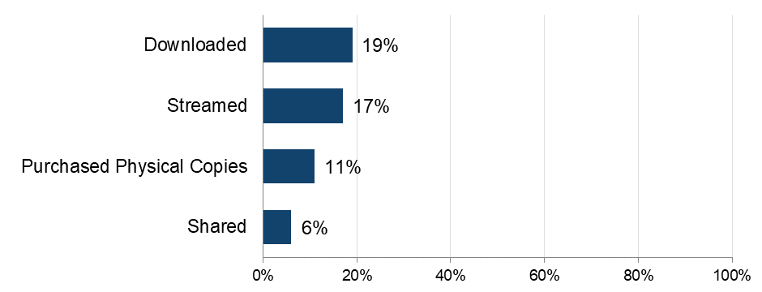
Sample: n = 5,087 (total sample)
Passion for video games is also fairly stable, with almost 40% continuing to display a high level of passion and an increasing percentage of video game consumers (64%) regarding them as their favourite kind of entertainment. This passion also continues to be particularly evident among male respondents and those under the age of 45. These data can be found in the Appendix report, within the live sport section.
Variety (44%) and instant access (43%) remain as the top two drivers of online consumption.
Many recent video game consumers (54%) report frequent access; at least weekly. Again, this is a figure which has remained fairly stable since 2022.

Video games infringement levels
The overall infringement level for video games is 17%, almost identical to the 16% recorded in 2022. The two most frequently specified sources for accessing video games by far were legal sources.

Over 80% have used only legal download sources
Figure 22: Legality of downloading/accessing video games. Download the data from Table 1.25.
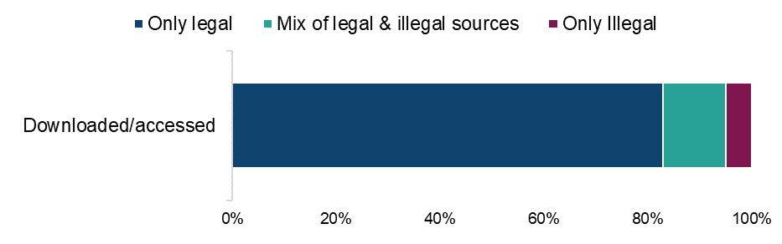

Base: n = 1,168 (downloaded or streamed/accessed video games in the past three months, with those who selected ‘other’ or ‘not sure of source’ removed).
As in 2022, 17% had used at least one illegal source to access video games. This was more common among those aged under 45, than 45 and above.
5% had used illegal sources only to access video games, a figure very close to that recorded in 2022 (4%).
As in 2022, passion for video games tends to increase the likelihood of illegal access. Around 20% of those with a high and medium passion for video games had used an illegal source, which was more than those with a low level (8%).
7% of all download/accessing time and volume of video games is spent illegally. This compares very closely to the 8% recorded in 2022.
Those who had downloaded/accessed video games illegally in the last three months were more likely to have experienced cyber security incidents (77%) than those who had used only legal sources (46%).

Category summary: Software

Trends in overall software consumption in the UK
Around one in five respondents (22%) have engaged with software in the previous three months - either by downloading (16%), streaming/accessing online (10%), sharing (4%) or purchasing physical copies (5%) (Figure 23). This overall engagement figure has remained stable since 2022.

Downloading is the most frequent means of engaging with software
Figure 23: Have you downloaded/streamed/shared/purchased physical copies of software in the past three months? Download the data from Table 1.26. 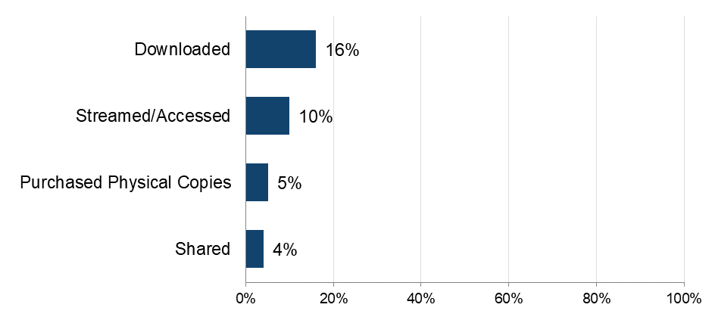
Base: n=5,087 (total sample)
Passion for software is also fairly stable, with over a quarter continuing to display a high level of passion, and many regarding it as a necessity rather than a hobby. Passion for software continues to be particularly evident among male respondents and the under 35 age groups. Passion levels for software and further breakdowns can be found in the software section of the annex report.
As in 2022, low/no cost and value for money most frequently drive online software consumption, alongside security and protection from malware.
As in 2022, 29% of those who have recently engaged with software online are accessing/downloading it at least weekly. Again, there is a higher proportion of male respondents and those in the younger (under 35) age groups who are frequently doing so.

Software infringement levels

The overall infringement level for software is 31% - a decrease on the 38% recorded in 2022. 31% have used at least one illegal download source
Figure 24: Legality of downloading/accessing software. Download the data from Table 1.27.
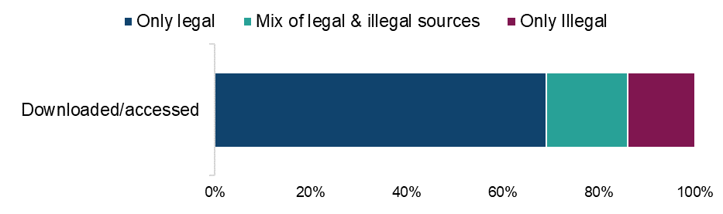
Sample: n = 826 (downloaded/accessed software in the past three months, with those who selected ‘other’ or ‘not sure of source’ removed).
Use of illegal sources has decreased since 2022. 31% had used at least one illegal source to access software (38% in 2022). 14% had only used illegal sources (22% in 2022). More female respondents (17%) than male respondents (12%) had used only illegal sources to access software. The proportion who had used illegal sources is now highest among those aged 25-34 (43%).
Those who had downloaded/accessed software illegally in the last three months were more likely to have experienced cyber security incidents (75%) than those who had used only legal sources (55%).

Category summary: E-books

Trends in overall e-books consumption in the UK
Just under 40% had engaged with books/e-books in the previous three months - either by downloading (18%), streaming/accessing (10%), sharing e-books (3%) or purchasing physical copies (27%) (Figure 25). This overall engagement figure has remained stable since 2022.

Purchasing physical copies is the most typical form of engagement with e-books
Figure 25: Have you downloaded/streamed/shared/purchased physical copies of e-books in the past three months? Download the data from Table 1.28.
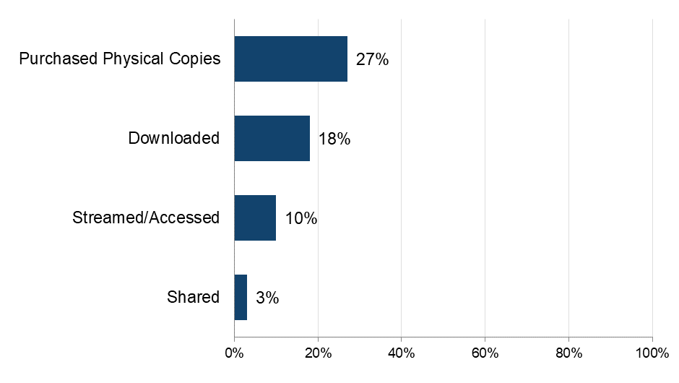
Sample: n = 5,087 (total sample)
Passion for books/e-books is also fairly stable, with over 40% continuing to display a high level of passion. As in 2022, female respondents are more likely than male respondents to display this passion.
The youngest age groups are most likely to be downloading/accessing e-books frequently.
Online consumption of e-books continues to be driven by four factors, digital storage convenience (46%), ease of access (46%), variety (46%) and low/no cost (42%).

E-books infringement levels
The overall infringement level for e-books is 22%, slightly lower than the 24% recorded in 2022.

Over 20% have used at least one illegal download source
Figure 26: Legality of downloading/accessing e-books. Download the data from Table 1.29.
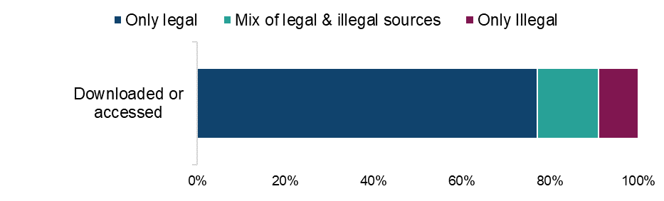
Sample: n = 992 (downloaded or accessed e-books in the past three months, with those who selected ‘other’ or ‘not sure of source’ removed).
22% had used at least one illegal source to download/access e-books. This is a figure very close to the 24% recorded in 2022. Solely illegal downloading/streaming of e-books continues to be mostly prevalent among the youngest (under 35) age groups. 13% of all download/streaming time and volume of e-books is spent illegally. This compares with 14% in 2022.
Those who had downloaded/streamed e-books illegally in the last three months were more likely to have experienced cyber security incidents (76%) than those who had used only legal sources (46%).

Category summary: Audiobooks

Trends in overall audiobook consumption in the UK
Around one in seven respondents (14%) have engaged with audiobooks in the previous three months - either by downloading (10%), streaming/accessing online (9%), purchasing physical copies (3%) or sharing (2%). This overall engagement figure has remained fairly stable since 2022.

Downloading is the most frequent means of engaging with audiobooks
Figure 27: Have you downloaded/streamed/shared/purchased physical copies of audiobooks in the past three months? Download the data from Table 1.30.
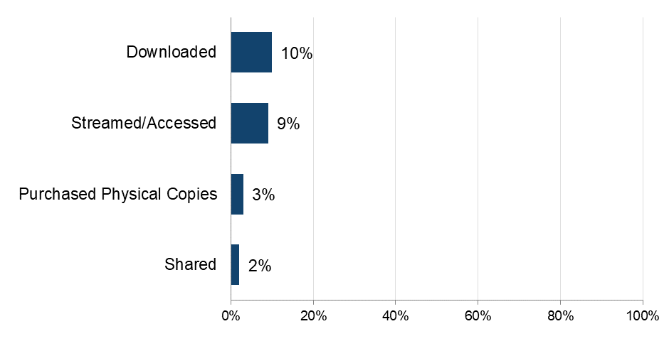
Sample: n = 5,087 (total sample)
Passion for audiobooks is also fairly stable – with over a third continuing to display a high level of passion and many audiobook consumers actively searching for new titles. This passion is particularly evident among the very youngest (12-15) age group. Demographic breakdowns in relation to passion for audiobooks can be found in the Audiobook section of the annex report.
Convenience continues to drive online consumption, with audiobook consumers appreciating anytime access, wide variety and digital storage ability.

Audiobooks infringement levels
The overall infringement level for audiobooks is 30%. This figure represents a peak in infringement in this category and is more than double the 14% recorded in 2020.
However, the top two sources for accessing audiobooks, paid subscriptions (40%) and single fee payments (32%) are both legal.

30% have used at least one illegal download source
Figure 28: Legality of downloading/accessing audiobooks. Download the data from Table 1.31.
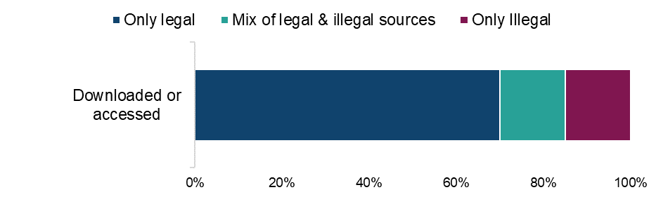
Base: n = 588 (downloaded or streamed audiobooks in the past three months, with those who selected ‘other’ or ‘not sure of source’ removed)
Those who had accessed audiobook books illegally in the last three months were more likely to have experienced cyber security incidents (59%) than those who had used only legal sources (47%).

Category summary: Digital visual images

Trends in overall digital visual images consumption in the UK
One in five respondents (20%) have engaged with digital visual images in the previous three months - either by downloading (14%), accessing online (13%) or sharing (9%) (Figure 29). This overall engagement figure has remained stable since 2022.

Downloading is the most frequent means of engaging with digital visual images
Figure 29: Have you downloaded/accessed/shared copies of digital visual images in the past three months? Download the data from Table 1.32.
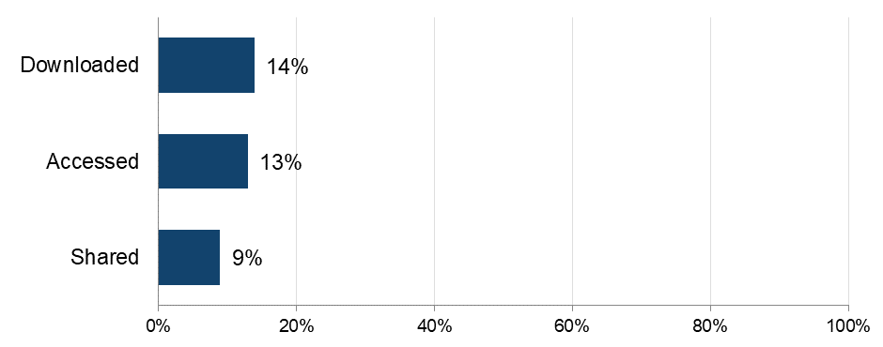
Sample: n = 5,087 (total sample)
The most typical age group engaging with digital visual images is getting younger; moving from 16-24 in 2022 to 12-15 currently.

Digital visual images infringement levels
The top three sources for accessing digital visual images, saving and screenshotting from social media, Google images and other websites, have remained consistent over the last two years. It is unclear whether these are legal or illegal sources.
Use of images accessed continues to be mainly for personal and family/friends consumption, rather than commercial reasons.

Category summary: Digital magazines

Trends in overall digital magazine consumption in the UK
One in five respondents (20%) have engaged with digital magazines in the previous three months - either by purchasing physical copies (14%), streaming/accessing online (7%), downloading (6%) or sharing (3%). These figures are very close to those recorded in 2022.

Purchasing physical copies is the most frequent means of engaging with magazines
Figure 30: Have you downloaded/accessed/shared/purchased physical copies of digital magazines in the past three months? Download the data from Table 1.32. 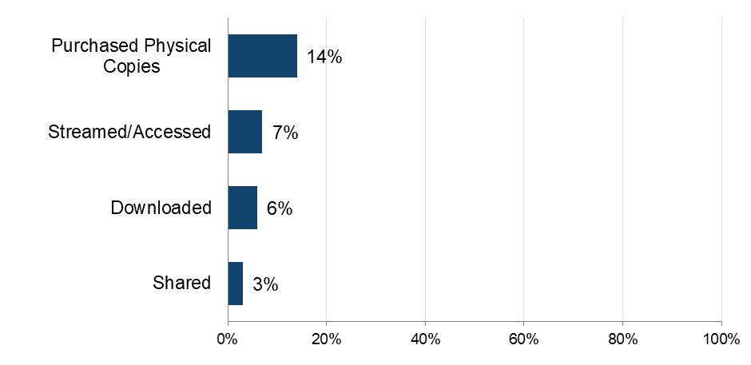
Sample: n = 5,087 (total sample)
The oldest age group (i.e. those aged 55 and above) was most likely to have purchased a physical copy (17%). In all other age groups this ranged between 8-14%.

Digital magazine infringement levels
The overall infringement level for digital magazines is 39%. This figure represents a slight reduction since the peak of 41% in 2022.
The top two sources for accessing digital magazines – paid subscriptions (31%) and accessing content made available for free by publishers on their own social media or website (26%) are both legal.

39% have used at least one illegal download source
Figure 31: Legality of downloading/accessing digital magazines. Download the data from Table 1.34. 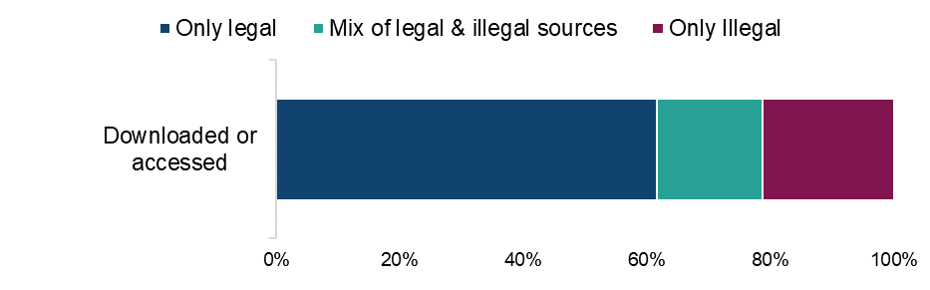
Sample: n=419 (downloaded or streamed/accessed digital magazines in the past three months, with those who selected ‘other’ or ‘not sure of source’ removed)

Overview of recent changes to online media access
Over the past year, almost a quarter of respondents had made changes to their online media access. This change included adjustments to downloading/streaming across categories which could include TV, film, music or games.
Change was particularly prevalent among respondents in the 16-24 age group – where over half (51%) reported changes to their media access.
Across all respondents who had made a change, this change typically involved unsubscribing or stopping using a service (42%) or starting to use a new service to stream or download (35%).
The most frequent new services identified included Netflix (27% of those who had used a new service), Spotify (17%), Disney+ (16%) and Amazon Prime (15%). 10% had begun to use YouTube to download/stream. These were also the most mentioned services which respondents had stopped using, though with lower percentages indicating discontinued use.
25% of those who had made changes to their online media access had used a new device to stream or download content. Among these respondents, Smartphones (42%), Smart TVs (30%), laptops (30%) and tablets (28%) were most frequently being utilised for the first time. Smart speakers (such as Amazon Echo or Google Home) were mentioned by 16% of respondents, as were gaming consoles (such as PlayStation, Xbox etc.). 15% had used a streaming media player (such as Roku, Amazon Fire TV or Google Chromecast).
The effects of online media access change most often highlighted an increase in the amount of content being watched. Over a third (35%) indicated a higher level of consumption, peaking among those aged 12-15.
What is also interesting is that a further effect was a decrease in the amount being spent on streaming services, compared to a year ago (33%).
Combined, these two effects suggest that a change in services/devices often results in increased consumption, at a lower price.

Technical appendix

Method overview
The research is based on a two-stage mixed methodology approach:
Stage One: Online Survey
Survey features included:
- online data collection, with fieldwork taking place between 18th April 2024 and 20th May 2024
- 15 minute survey
- N = 5,000
- nationally representative of the UK +12 aged population
Stage Two: Ongoing Qualitative Engagement
The qualitative research was based on:
- an online community, with fieldwork taking place between 27th May 2024 and 31st May 2024
- a mixture of research tasks, experimental conditions and discussion topics
- five days of engagement
- N = 50
- those identified as infringers aged 16+ in Stage 1

Stage One – Online Survey
The thirteenth wave used the same streamlined questionnaire that had been the basis of the OCI since Wave 9 in 2019. The main change compared to waves preceding the ninth wave was that a less direct approach was taken to finding out whether illegal sources are used, to encourage more honesty. More specifically, rather than asking this outright, respondents were shown a list of options and the classification of legal or illegal was done based on the options chosen.
In addition to conducting annual questionnaire hygiene checks (e.g., updating sources of access), several updates were made in this wave. This included a new section focused on cyber incidents and harms experienced because of these incidents, and references to the pandemic were removed. Rather than asking about pre-pandemic behaviour, respondents were simply asked to compare their relevant behaviours to those from a year ago.
A section on VPN usage was removed, while a new section was added that explored how respondents access media and the extent to which copyright is disregarded. The Reporting Infringement questions, which were introduced in OCI Wave 12, were also removed. The section on cyber incidents and harms was added at the end to maintain the integrity of tracking of issues over time.
Quotas were set to ensure that the survey sample (N = 5,000) was representative of the UK 12+ population in terms of age, sex and region. All respondents had internet access (i.e., the offline population was not included). The survey sample was sourced through AudienceNet’s network of professionally managed, ESOMAR 37 compliant, online UK consumer research panels. While this is a cost-effective approach, one limitation is that it comprises people who have opted in to take part in research, thereby risking a selection bias.
Typically, no pre-survey information is provided to avoid biasing respondents. However, for this study, which touches on how people access content online (such as music, movies, and books), participants were given a brief overview at the start. This introduction outlined the types of data being collected, including demographic and sensitive (special category) data, such as ethnicity. Respondents were informed that their data would be aggregated and anonymised, with the option to skip any sensitive questions by selecting "Prefer not to say."
For participants under the age of 16, strict ethical guidelines are followed to ensure proper parental consent is obtained. In line with ESOMAR 37 guidelines and GDPR regulations, participation by minors requires explicit parental or guardian consent. This involves informing parents or guardians about the nature of the research, the data being collected, and how it will be used. Consent is gathered through an opt-in process where parents or guardians must provide written or digital consent prior to the minor’s participation in the survey.
Additionally, extra precautions are taken to ensure that all minors are fully aware of their rights to withdraw from the survey at any time and that their responses are anonymised to protect their privacy.
The study was conducted in compliance with the Market Research Society (MRS) guidelines, ensuring participants’ informed consent, transparency, and data protection throughout the process. The survey was designed to take no more than 15 minutes. The survey took, on average,10 minutes for respondents to complete. There was a dropout rate of 18%.
This year, 10 content categories were included in the research: music; film; TV programmes/series; live sports; video games; software; e-publishing (split into e-books, digital magazines, and audiobooks); and digital visual images.
The level of detail captured varies for some of the content categories:
- for music, film, TV programmes/series, the largest content categories, respondents were asked about downloading and streaming separately
- for all other categories, respondents were asked about streaming/accessing and downloading together, where relevant
- for digital visual images, respondents were only asked about infringement behaviours and a supplementary question on what they did with the images they had downloaded/accessed
The most recent five waves (2019 to 2024) saw changes for some categories that impact comparability with previous data in relation to the e-publishing categories:
- in the ninth wave the e-book category was broadened out to include all e-publications
- in the tenth wave e-publishing was split out into three separate categories (e-books, digital magazines, and audiobooks) with the ‘passion’ questions still asked at an overall level for these three categories

Stage Two – Ongoing Qualitative Engagement
The primary aim of the Online Community was to investigate, in more depth, the drivers and barriers to accessing online content via illegal sources. This was framed in many instances by the ongoing “cost of living crisis” which many participants said still affected them. As in previous years, it also sought to test and co-create communications materials to inform potential communications to be used by the IPO to foster positive behaviour change.
Upon analysis of the data from the Online Survey, AudienceNet identified priority population segments to focus on in the qualitative stage. N = 50 representatives of these groups were then recruited into a 5-day Online Community. These respondents accessed content via illegal sources, although some were heavier users while others used a more even mix of legal and illegal sources.
The Online Community took place from 27th – 31st May 2024.
For reasons of qualitative validity (i.e., convergence of insights), six of the content categories were focused on in-depth in the Online Community. Due to the low numbers of the sample who consumed digital magazines, the qualitative research on e-publishing focused on e-books.
The quantitative stage of research provides the base of the tracker and remains consistent year on year. In contrast, the qualitative element seeks to unpick the core opportunities for greater insight on certain topics and knowledge building for future communications work. This year, the Online Community focussed on the usual topics of changes in consumption, methods of accessing content, attitudes towards infringement and behaviour change campaigns. However, it also explored phenomena such as paying for illegal content and cyber security this year. It also focussed on the division of content across multiple platforms in the TV, Film and Live Sports categories.
Number of Participants in Community: N = 50 with equal representation across six categories:
- music
- TV
- film
- video games
- E-books / E-publications
- live sports
To gain their trust and encourage honesty, those taking part in the Online Community were given further assurance that their responses would be anonymous and that no action would be taken against anyone indicating that they illegally access content. However, given the sensitive nature of discussions, only those 16 and above were invited to take part.

Interpreting the data
As highlighted in the methodology section, in 2019 there were changes made as to how the infringement figures are determined. This should be kept in mind when making comparisons between waves prior to 2019 (i.e., Waves 8 and under) and 2019 or later (i.e. Waves 9 and above).
The main change was that a less direct approach was taken to finding out whether illegal sources are used, to encourage more honesty. More specifically, rather than asking this outright, respondents were shown a list of options and the classification of legal vs. illegal was done based on the options chosen. While the list was exhaustive, to reduce instances of the wrong source being selected and, thus, results being biased, for each category an option was included for those who may have been less familiar with the terminology. However, this option (“Download/access for free from the internet, without really being sure where it comes from”) was not included within the overall calculations for legal or illegal. Those who only consumed content via this source were also excluded from the base.

Infringement figures
Caution should also be exercised when interpreting results in relation to fluctuations in infringement figures due to new methods of access being included each wave. This is particularly the case for categories where go-to methods are less dominant and public awareness about what is legal vs. illegal is lower.
Digital visual images were not included in the overall infringement figure as respondents were not asked about how they go on to use the images they access, and whether this is mainly for personal or public use (e.g., sharing on social media, including within presentations, etc). As such, the full extent of copyright infringement cannot be known.

Definition of ‘shared’
The definition of ‘shared’ was provided as: “By shared we mean that you personally made the file publicly available or sent or uploaded it online for someone else to download or stream/access. This does not include sending links to content that has already been shared by someone else, unless stated in the answer option.”

‘Passion’ for categories
Passion levels were derived by scoring answers to a range of statements. The full list of statements can be found in the annex category report. They were scored based on strongly agree = 1, agree a little = 2, disagree a little = 3; strongly disagree = 4. “High” was a score of 6 - 12, “Medium” 13 - 17 and “Low” was 18 or higher.

Additional notes
Where (single choice) question percentages do not add up to 100%, this is due to rounding of the data.
Where base sizes are below n = 100, results must be interpreted with particular caution.
Margin of error: The margin of error is a measure of the potential variation in survey results due to sampling rather than surveying the entire population. With any piece of research, it is almost never feasible to measure the entire population and thus achieve results that are 100% accurate, therefore the potential for error should be considered. For this study, the margin of error at a 95% confidence level is approximately ±1.4 percentage points for total sample results. However, when interpreting differences within subgroups or over time, we recommend caution for variations under ±3 percentage points. While the overall margin of error is smaller, the ±3% guideline accounts for increased variability in subgroup analyses and ensures meaningful interpretation by minimising the risk of overemphasising minor fluctuations. As such, caution is advised when interpreting results that have less than a ±3% difference.


Concept House
Cardiff Road
Newport
NP10 8QQ
Tel: 0300 300 2000
Email: information@ipo.gov.uk
Web: www.gov.uk/ipo
Facebook: Intellectual Property Office UK
X: @The_IPO
YouTube: Intellectual Property Office UK
LinkedIn: Intellectual Property Office UK
For copies in alternative formats please
contact our Information Centre.
When you no longer need this booklet,
please recycle it.
© Crown copyright, 2025
This document is free for re-use under the terms of the Open Government Licence.
Published: June 2025

