

Towns, cities and transport: challenges for the water environment
Date: November 2025

Contents
- Introduction.............................................................................................................. 3
- The challenge of pollution from towns, cities and transport..................................... 3
- Addressing the challenge......................................................................................... 8
- Future challenges................................................................................................... 11
- References............................................................................................................. 11

1. Introduction
This document sets out the challenges and risks to the water environment from urban environments and transport. The potential impacts of pollution from these sources to surface and ground water is significant. The text in the following sections doesn’t focus on water industry discharges, which is the subject of the ‘Pollution from water industry waste water’ SWMI document.
The majority of us live and work in urban environments, and most of us regularly use the infrastructure associated with these areas, such as travel by car, bus or train, and use of natural resources supplied into our homes such as drinking water.
Lakes, rivers, bathing waters, estuaries, and groundwater bodies within or close to urban areas often interact with the urban environment they’re set in and are therefore an important asset to the people who live there. However, pollution from urban environments and transport that enters surface and ground water bodies can cause them to fail to meet the water quality standards needed to support wildlife, habitats, and put at risk drinking water provision.
This decreases the environmental and recreational value of water bodies and can require significant investment in treatment processes to make resources such as drinking water available.

2. The challenge of pollution from towns, cities and transport
Urban environments and the associated infrastructure are a source of environmental contaminants, which include hydrocarbons, metals (including zinc, cadmium and copper), plastics (micro and litter), nutrients (including phosphate), per- and poly-fluoroalkyl substances (PFAS) and other Persistent Organic Pollutants (POPs), ammonia, pathogens, heat (including cooling), and both sediment quantity and content (i.e. carrying solid pollutants).
Such contaminants entering surface water bodies (rivers, streams, lakes) and groundwater have an adverse impact on water quality and ecology. Alongside this is the physical modification of water bodies, which also has an impact on the water environment and its habitats.
In March 2019, approximately 18% of water bodies were identified as being impacted on by pollution from towns, cities and transport. As of October 2025, this figure was 14% of water bodies in England (Environment Agency data). This revised figure is due to improved data categorisation. However, pressure on both surface and ground water in urban environments continues to increase.
Some of the principal sources of pollutants entering the water environment are drainage misconnections and urban runoff. It is not always straightforward to identify the source of this type of pollution or those responsible. Additional challenges include where responsibility lies for maintaining, renewing, and operating water quality protection infrastructure, and water drainage and treatment systems.
The pressures resulting from pollution in urban environments and transport are likely to be exacerbated by climate change, urban creep, groundwater recovery, and population growth. In addition, ongoing increases in traffic volume has seen a rise in all motor vehicle traffic by over 10% in the last 15 years (Annual Road Traffic Estimates 2010, Department for Transport (February 2012) and Road traffic estimates in Great Britain: 2024, Department for Transport (June 2025)).
There are numerous pressures from urban and transport sources that affect the water environment. Figure 1 and Table 1 shows which of these pressures are having the greatest impact on surface water bodies in England. Physical modifications to water bodies account for 43% of impacts followed by phosphate (32%), ammonia and dissolved oxygen (both 6%).

Figure 1. Reason for not achieving good counts for each pressure against the ‘Urban and Transport’ sector category. This only includes water bodies and not protected area sites.
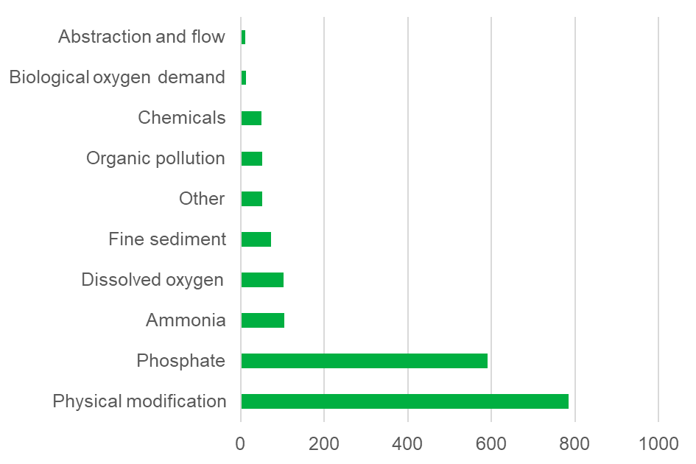

Table 1: Data for Figure 1
Source | Count
Physical modification | 785 (43%)
Phosphate | 591 (32%)
Ammonia | 104 (6%)
Dissolved oxygen | 102 (6%)
Fine sediment | 73 (4%)
Other | 52 (3%)
Organic pollution | 52 (3%)
Chemicals | 50 (3%)
Biological oxygen demand | 13 (1%)
Abstraction and flow | 10 (1%)

2.1 Urban run-off
Poorly managed rainwater that runs off roads, car parks, industrial areas, contaminated land, pavements and roofs can carry pollutants either directly or indirectly into surface water bodies and groundwater. These pollutants include a variety of chemicals, metals, plastics (micro and litter), oils and lubricants, sediment, nutrients, and pathogens.
‘First flush’ events can have a significant negative effect on water quality. This occurs when intense rainfall following an extended dry period washes a large amount of contaminants from urban surfaces into local water environments.

2.2 Misconnections and non-designed use of drainage systems
Misconnections occur where part of a drainage system is connected to the wrong receiving waste water network. An example is a toilet or home appliance pipe discharging to the surface water network instead of the foul sewer or private household system. This results in inadequately treated effluent entering the environment.
The number of households with drainage network misconnections is unknown, but in 2019 it was believed to be between 150,00 to 500,000 household misconnections across England and Wales (The Chartered Institution of Water and Environmental Management, stating Defra data of 2019). This can lead to pollutants entering surface and ground waters resulting in a harmful impact on the environment, drinking water, and ecology. Alongside this is the potential for impacts on bathing and shellfish waters (including pathogen content and excessive algal growth).
The Environment Agency estimates that misconnections affect about 9% of all bathing waters and around 15% of the kilometres of waters covered by the Water Framework Directive, although the exact numbers and impact are difficult to establish because such impacts are cumulative and interrelated.
Inappropriate disposal of domestic materials such as wet wipes, fat and sanitary products through the foul water network also causes overflow discharges and sewer failures. Thames Water identify this issue as the biggest cause of the 75,000 blockages it deals with in a year. Severn Trent Water states that 70% of its 45,000 sewer blockages are due to customers putting the wrong things down our sinks and toilets.
Commercial operations such as factories that discharge or process trade effluent through surface water drainage systems, may pollute water bodies particularly where the drainage system isn’t designed or is inadequate to receive contaminated water. For example, the inappropriate use of sustainable drainage systems (SuDS), where contaminated water is entering these systems without being treated or removed before discharge to the environment.
Other activities and operations at industrial sites and estates can contribute to urban diffuse pollution, including loading and unloading potentially polluting substances, incorrect storage of chemicals and heavy vehicle traffic.

2.3 Drainage network overflows and intermittent or uncontrolled discharges
Intermittent discharges of effluent in the drainage network should only occur in emergencies or as a result of an exceptional weather event. This includes both storm overflows (discharges from storm tanks/facilities) and emergency overflows (due to spills, or mechanical or power failures). These discharges are almost always untreated discharges and pose a risk to the environment, aesthetics and have potential human health risks.
Combined sewerage networks carry both foul water and surface water to sewage treatment works. As part of this system combined sewerage overflows intermittently operate to discharge these waters when the system is unable to accommodate flows. Discharges from combined sewerage overflows often enter nearby water bodies (surface water and groundwater), carrying untreated sewage and urban runoff.
Capacity within drainage and sewerage systems can become reduced overtime as inputs increase. This leads to systems filling more frequently, increasing the chance of flooding and storm overflow spills. Population growth, climate change, and urban development can exacerbate issues of surface run-off and inflows into combined sewers. Installation of appropriately designed green infrastructure and sustainable drainage systems (SuDS) have a role in reducing the impact that such surface run-off has.
Poor sewer condition and performance can result in excess groundwater infiltration and exfiltration (leakage). Infiltration can remove hydraulic and treatment capacity leading to increased spills and sewer flooding, and exfiltration can impact water quality.
Further detail on drainage and sewerage systems and how they are to be managed via statutory Drainage and Wastewater Management Plans (DWMPs) is covered in the SWMI document ‘Pollution for water industry waste water’.

2.4 Transport
The transport network covers long distances and affects both the urban environment and those rural areas it passes through. Runoff from roads and transport infrastructure can potentially contain pollutants. These include spilled fuel, lubricants, metals, plastics and chemicals from the transport network. Serious pollution incidents can occur from accidents, spillages and incorrect or negligent usage of chemicals which result in pollutants entering water bodies and groundwater.
The total miles covered by vehicles in Great Britain is stated as 335.9 billion miles for the year ending March 2025 (an increase of 0.9% over the previous year). Table 2 below sets out the percentage of total vehicle usage by road type for the period April 2024 to March 2025 (Provisional Road Traffic Estimates Great Britain: April 2024 to March 2025; Department for Transport 26 June 2025).

Table 2: Share of traffic by road type April 2024 to March 2025 as a percentage (Department for Transport)
Road type | All vehicle traffic (%)
Motorways | 21
‘A’ roads | 44
Minor roads | 35
Road network pollutants come from tyre and brake wear, exhaust emissions, oil and fuel deposits. All of these can and do enter the water environment, such as Polycyclic aromatic hydrocarbons (PAHs) that are by-products of combustion present in vehicle emissions. These emissions then deposit from the atmosphere to the environment.
Some emissions are notable for the potential risk they pose to human health or wildlife when they accumulate via the food chain. These are substances that are persistent in the environment, have a high potential to build up in plants and animals (bio-accumulate) and are harmful (toxic) above certain concentration.
In addition, it’s estimated that 68,000 tonnes of microplastics are generated from tyre wear in the UK every year of which 7,000 to 19,000 tonnes enter surface waters. This in addition to between 1,400 and 3,700 tonnes of microplastics from paint on buildings and road markings (Source: ‘Reducing Household Contributions to Marine Plastic Pollution' report 22 November 2018, Friends of the Earth). The principal route for these pollutants is through surface water runoff and the drainage outfalls carrying it.
Contamination can also potentially occur from the runoff in winter of de-icing chemicals and salt used inappropriately on roads and runways, plus herbicides used for weed control on the road and rail transport networks. Pollutants also enter water bodies and coastal areas directly from boats discharging sewage, and the washings, paints and chemicals used in maintenance.

3. Addressing the challenge
Urban diffuse pollution has many contributory sources as well as many cumulative impacts. Understanding the rate and variability of discharge volume and consequent pollutant load into the water environment (surface and ground water) is difficult as is assessing the exact scale, impact, and apportionment of the large range of sources of diffuse urban pollution. The reasons for this include:
- the complexity and nature of weather patterns
- drainage network types, operations, ownership and responsibilities
- variations in river systems and groundwater body vulnerability
- land use (current and historic) over the relatively large footprint of England’s urban areas
A multidisciplinary approach to the issues is therefore required. By tackling the pollution sources affecting water bodies there are likely to be multiple benefits for ecology, flood risk management, drinking water protection, and the amenity value of local places.
The Environment Agency will generally support urban and infrastructure developments that provide an environmental benefit and improvement, whilst developers need to ensure that they prevent and mitigate pollution to the water environment at both the planning, design and delivery stages. In addition, infrastructure operators and owners are required to not cause pollution from their activities.
Through our implementation of the Environmental Permitting Regulations 2016 (EPR) a permit for groundwater activities (Schedule 22), including ground source heating or cooling may be required, and for developments that come into contact with groundwater. The Environment Agency's approach to groundwater protection provides the position statements and information on our approach to managing and protecting groundwater.

3.1 Working with stakeholders
The numerous sources of water pollution from urban environments and associated infrastructure mean that multiple organisations, companies and bodies need to address pollution risk. As the environmental regulator the Environment Agency is limited in its powers to influence urban and infrastructure development and the management of diffuse pollution from urban run-off, and it therefore promotes a collaborative approach.
The Environment Agency is actively involved in a number of initiatives to address urban diffuse water pollution issues through working with partners. This includes promoting a catchment based approach, such as the Irwell Catchment Pilot (in the North West of England and Greater Manchester) that’s aiming to reduce urban sources of water pollution and includes having a strategy in place to reduce the impact of point and diffuse sources by 2027.
In addition, we work with stakeholders, business communities and local people to address misconnections, improve drainage network issues and reduce pollution incidents. We also work with National Highways on major road schemes classed as Nationally Significant Infrastructure Projects and their delivery of the environmental part of the Road Investment Strategy (RIS) funding programme, the next round of which runs from 2026 to 2031(RIS3).
The Environment Agency, and other stakeholders, are working with sewerage undertakers on their statutory drainage and wastewater management plans (DWMPs). These plans are due to be published in 2027/8 and will identify the measures and investment needed between 2030 and 2055 to address the environmental risks associated with the sewerage undertaker's drainage and sewerage system, including areas of shared responsibility with other drainage asset owners, e.g. highways runoff and misconnections.
Through our work we also raise awareness of the need to plan, design and carry out the physical modification of water bodies that minimises the impact on the natural environment including water quality, habitat, and ecology. This is done through a variety of ways including the consent process. This is a required part of flood risk operations activity and is also done through the spatial planning system.

3.2 Influencing spatial planning
The government has made economic growth their primary goal, which includes housing delivery of 1.5 million new homes. The Environment Agency is in a position to contribute through our statutory role to protect and enhance the environment while supporting sustainable development. We will deliver this dual mission by:
- supporting economic resilience
- creating investment certainty
- guiding sustainable development
- enabling innovation

Through these approaches, the Environment Agency will provide input to the government’s plans to deliver new homes and support informed decisions on more than 150 major infrastructure projects
To increase certainty and pace to achieve sustainable growth, the Environment Agency looks for opportunities to shape strategic plans for development. This includes providing timely technical advice as a statutory consultee for development plans, planning applications, nationally significant infrastructure projects and other major development projects.
The Environment Agency also provides advice to government on reforms to the planning system, for example through advising on new policy and programmes that help enable sustainable development.
By investing in green infrastructure, new development can avoid adverse impacts on the water environment. Seeking betterment, for example through reducing the risk of flooding, remediating contaminated land and reducing pollution also improves the environment.
The government’s 25 Year Environment Plan highlights the link between personal wealth and local environment. This is measured by proximity of homes to sources of high pollution such as roads, or conversely, homes with access to green space.

3.3 Addressing drainage issues and misconnections
The Environment Agency continues to work with stakeholders, including water companies and local authorities to tackle misconnection issues. It supports the multi-organisational ‘ConnectRight’ initiative that’s aimed at builders and homeowners. It looks to tackle misconnection issues as a preventative approach to protecting the water environment.
In addition to the above the Environment Agency promotes the development of Drainage and Wastewater Management Plans (DWMPs) by water companies in England. These plans bring together the planning of waste water, urban diffuse pollution and resilience in a strategic and integrated approach to the drainage network.
The incorrect usage of drains is in part tackled by the Yellow Fish scheme, which aims to raise awareness of polluting substances, including oil, paints and cleaning chemicals being disposed of through drains and damaging water quality and habitats in rivers, lakes, ponds and coastal areas. The scheme involves marking drains with a Yellow Fish icon to raise awareness of the issue and change behaviours.
In providing a strategic overview of flood risk issues in England, the Environment Agency promotes sustainable drainage systems and Nature-based Solutions (NbS) (Nature-based solutions: Environment Agency position statement) to improve flood and drought resilience by promoting infiltration and/or storage of clean surface water runoff close to the source. As well as helping to reduce the causes and impacts of flooding, SuDS and NbS can also provide additional benefits by maintaining the baseflow in rivers, improving biodiversity and nature recovery, and combining water management with green space.
In June 2025 Defra issued the National standards for sustainable drainage systems (SuDS) that provides guidance on these drainage systems. It includes a section on water quality that sets out potential management and regulatory considerations if there's the potential for contaminated water to enter them. Where this occurs and there’s a risk to the environment then appropriate treatment and a permit may be required.

4. Future challenges
Positive progress has been made in addressing some elements of water pollution from urban environments and their associated infrastructure across different organisations. Further efforts are required to tackle the issue in the face of climate change, potential water scarcity, biodiversity loss, increased travel, development and future plans for growth.
A strategic, partnership approach is required to better understand and address the broader urban diffuse pollution issue, particularly at the catchment scale. There is a need to improve knowledge and awareness of the issues, foster behavioural change, encourage targeted investment and promote the correct action from public and private sectors. This approach will benefit the environment and the economic health and value of communities.

5. References
Chartered Institute of Water Management, Drain misconnections: How they affect our environment - CIWEM (2019, Defra data).
Defra, National standards for sustainable drainage systems (SuDS), June 2025
Defra, Tackling water pollution from the urban environment, 22 November 2012, updated 7 June 2013.
Department for Transport, Provisional road traffic estimates, Great Britain: April 2024 to March 2025, 26 June 2025.
Environment Agency Catchment Planning System data (Counts of numbers of reasons for not achieving good status in England) Source Data: Analysed Pressure and Business_Probable_Confirmed 21 March 2019 and October 2025 (Selection 1 Base Data).
Environment Agency, Nature-based solutions: Environment Agency position statement, July 2025.
Environment Agency, The Environment Agency’s approach to groundwater protection, February 2018.
Environment Agency, Urban pollution – Significant water management issues, PDF, March 2013.
Environment Agency, Update to the river basin management plans in England - National Evidence and Data Report, updated December 2015.
Friends of the Earth, 'Reducing Household Contributions to Marine Plastic Pollution' report, 22 November 2018.
HM Government, A Green Future: Our 25 Year Plan to Improve the Environment, 2018.
Irwell Catchment Pilot Steering Group, Rivers Return: The Irwell Catchment Pilot – the Plan. December 2012.
Ministry of Housing, Communities and Local Government, National Planning Policy Framework.
Severn Trent Water 2019, How to avoid nasty blockages.
Spatial Quantification of Road Runoff Pollution in Greater London – April 2019.
Thames Water 2019, What's blocking the drains?

