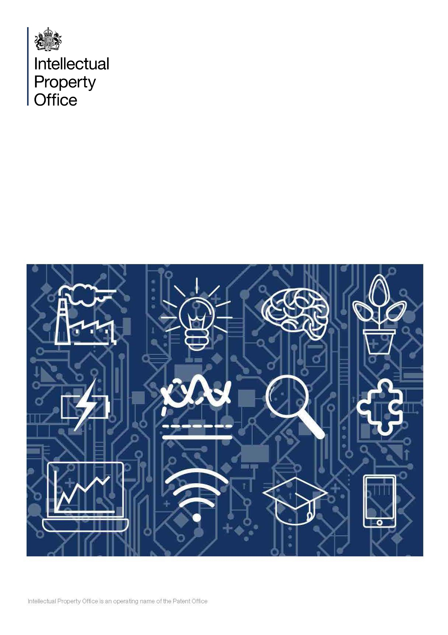

Online Copyright Infringement (OCI) 2024
Annex Report
Founded in July 2011, AudienceNet is a full-service consumer and social research agency, which in that time has built a reputation for innovative, “real-time” research. We use the latest connected technologies to conduct representative research across the globe. Over the years, AudienceNet has expanded its services to encompass a diverse range of sectors and topics, including music, entertainment, technology, automotive, health and wellbeing, political and social policy.
AudienceNet is recognised as a leading source of intelligence on music and entertainment. We conduct both ad-hoc and global tracking projects for industry organisations such as the IFPI, Entertainment Retail Association (ERA), and BPI, as well as major record labels (Universal, Warner, and Sony) and platforms like SoundCloud and Spotify.

ISBN: 978-1-915090-62-1
Online Copyright Infringement –
Annex report
Published by The Intellectual Property Office May 2024
1 2 3 4 5 6 7 8 9 10
© Crown Copyright 2025
You may re-use this information (excluding logos) free of charge in any format or medium, under the terms of the Open Government Licence. To view this licence, visit http://www.nationalarchives.gov. uk/doc/open-government-licence/
or email: psi@nationalarchives.gsi.gov.uk
Where we have identified any third party copyright information you will need to obtain permission from the copyright holders concerned.
Any enquiries regarding this publication should be sent to:
The Intellectual Property Office
Concept House
Cardiff Road
Newport
NP10 8QQ
Tel: 0300 300 2000
email:research@ipo.gov.uk

This publication is available from our website at www.gov.uk/ipo

Contents

Category Insights: Music 5
Trends in overall music consumption in the UK 5
Downloading music 11
Streaming music 19
Combined downloading/streaming of music and infringement behaviours 27
Paying for music 30
Change in use of illegal sources to access music 30
Music: Alternatives to infringement 31
Category Insights: Film 34
Trends in overall film consumption in the UK 34
Downloading films 40
Streaming films 48
Combined downloading/streaming of film and infringement behaviours 55
Paying for films 61
Change in use of illegal sources for film 61
Film: Alternatives to infringement 62
Category Insights: TV Programmes/Episodes 65
Trends in overall TV consumption in the UK 65
Downloading TV programmes/episodes 72
Streaming TV programmes/episodes 80
Combined downloading/streaming of TV programmes/episodes and infringement behaviours 88
Paying for TV programmes/episodes 93
TV programmes/episodes: Change in use of illegal sources 94
TV programmes/episodes: Alternatives to infringement 94
Category Insights: Live Sport 98
Trends in overall live sport consumption in the UK 98
Streaming live sports events 102
Paying for live sports 111
Live sports: Change in use of illegal sources 111
Live sport: Alternatives to infringement 114
Category Insights: Video Games 117
Trends in overall video game consumption in the UK 117
Accessing video games online 123
Paying for video games 132
Video games: Change in use of illegal sources 132
Video games: Alternatives to infringement 135
Category Insights: Software 138
Trends in overall software consumption in the UK 138
Downloading/accessing software 144
Paying for software 151
Software: Change in use of illegal sources 152
Software: Alternatives to infringement 152
Category Insights: E-books 155
Trends in overall e-book consumption in the UK 155
Downloading/accessing e-books 160
Paying for e-books 169
E-books: Change in use of illegal sources 169
E-books: Alternatives to infringement 171
Category Insights: Audiobooks 174
Trends in overall audiobooks consumption in the UK 174
Downloading/streaming audiobooks 178
Paying for audiobooks 185
Audiobooks: Change in use of illegal sources 186
Audiobooks: Alternatives to infringement 187
Category Insights: Digital Visual Images 188
Trends in overall digital visual image consumption in the UK 188
Digital visual images: Infringement behaviours 189
Use of digital visual images 193
Category Insights: Digital Magazines 195
Trends in overall digital magazine consumption in the UK 195
Downloading/accessing digital magazines 200
Digital magazines: Infringement behaviours 201
Paying for digital magazines 207
Digital magazines: Change in use of illegal sources 207
Digital magazines: Alternatives to infringement 208

Category Insights: Music

Further details and demographic breakdowns for the findings in the Music section can be found in Tables 2.1a – 2.18 in OCI 2024 Supplementary Tables – Music (ODS 131KB), which provide a comprehensive analysis of the data.

Trends in overall music consumption in the UK
Prior to presenting information on music infringement levels, it’s useful to initially consider respondents’ engagement with, and consumption of music. In the previous three months, 60% of participants had engaged with music through various methods (i.e. either by downloading, streaming, sharing or purchasing physical products).
The definition of ‘shared’ or ‘sharing’ was provided as: “By shared we mean that you personally made the file publicly available or sent or uploaded it online for someone else to download or stream/access. This does not include sending links to content that has already been shared by someone else, unless stated in the answer option.”

Responses to the 2024 survey found that:
- streaming was the most common method of accessing music, with 42% having done so (Figure 1)
- downloading followed, with 28% participating in this activity
- physical purchasing, although lower, remained almost stable year-on-year, showing encouragingly similar levels across different age groups
- while sharing also remained almost stable and relatively low overall (10%), there were peaks among younger groups
- male respondents demonstrated higher engagement across all categories, including sharing
- across all categories, younger age groups were the most engaged

Streaming remains the most popular means of engaging with music
Figure 1: Downloaded/streamed/shared/purchased physical copies of music in the past three months. Download the data from Tables 2.1a – 2.1d.
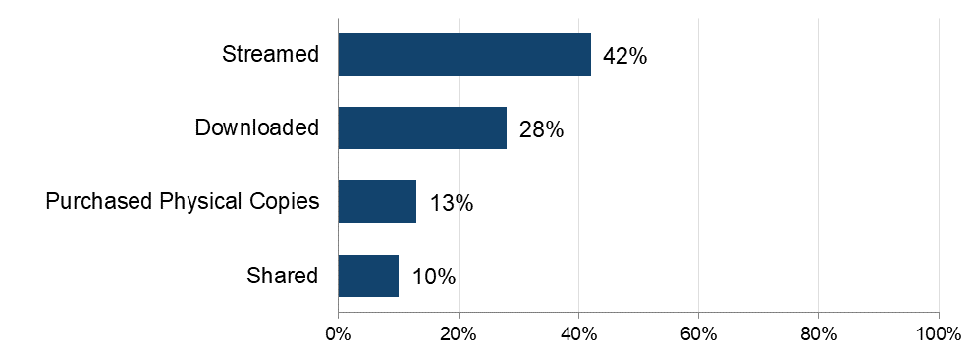Sample: n = 5,087 (total sample).

The importance of music

To get a broader sense of their passion for music, respondents were asked to what extent they agreed with a range of statements and then grouped as High, Medium or Low, based on their responses. Analysis found that:
- over 40% displayed high levels of passion for music (Figure 2)
- this was particularly true of the youngest age group (between 12 and 15, 60%), those aged between 16 and 24 (50%) and those aged between 25 and 34 (53%)
- almost three-quarters describe music as their favourite type of entertainment - 63% actively search for new music and 60% agree that they are always recommending music to others (Figure 3)

Around 4 out of every 10 have a high passion for music
Figure 2: Passion levels for music. Download the data from Table 2.3.

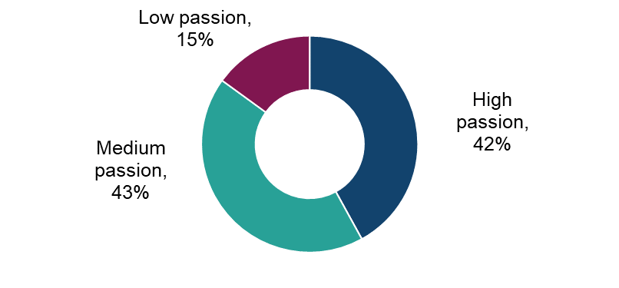
Sample: n = 3,020 (downloaded, streamed, shared and/or purchased physical copies of music in the past three months).

Almost three-quarters describe music to some extent as their favourite entertainment type
Figure 3: Extent of agreement with statements in relation to music. Download the data from Tables 2.2a – 2.2f.
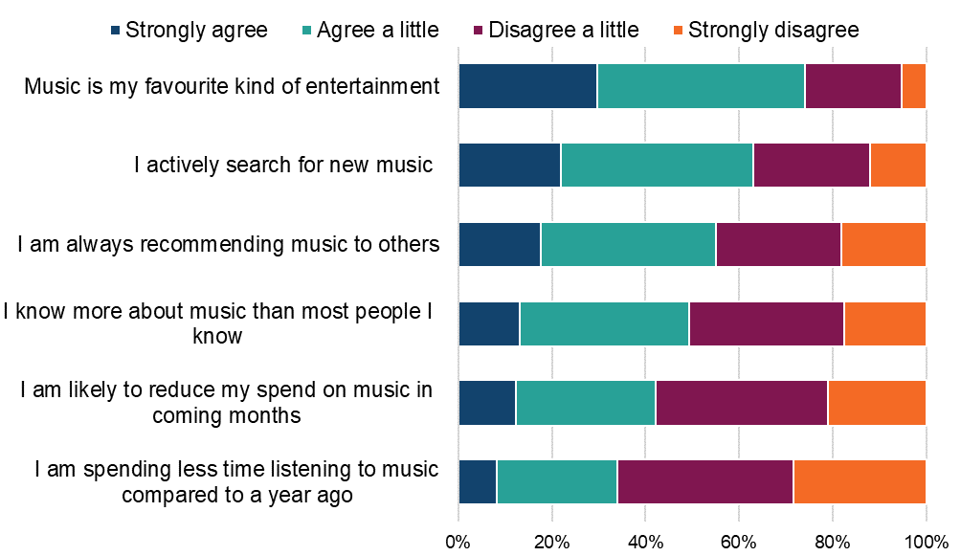

Sample: n = 3,065 (downloaded, streamed, shared and/or purchased physical copies of music in the past three months).

More generally, responses to specific statements indicated the importance of music, with around three-quarters of respondents (74%) indicating it to some extent as their “favourite kind of entertainment” (Figure 3).

Qualitative insight: the importance of music in people’s lives

Music was hailed as an important part of many participants’ lives, influencing their mood and often forming an integral part of their daily routine. Participants emphasised that music helped set the tone for their day and played a critical role in their emotional well-being.

“Music plays a multi-faceted role in life, influencing emotional, cognitive, and social aspects. I often play upbeat music in the morning to help wake up and set a positive tone for the day.”
Female, Music, 31-40

“Major part! It keeps me going and helps me get through bad times as well as keeping my brain active. I listen to music in the morning whilst having my breakfast. If I’m driving, I listen to music on all journeys.”
Male, Music, 61+

“It's very important to me and I can't imagine a life without music. I listen to it every day and it lifts me up when I'm feeling down. As soon as I wake up, I put on the radio so that it puts me in a good mood for the day and sets me up in the best way.”
Female, Music, 21-30

Qualitatively, participants reported no great changes in their consumption of music in general or in their use of unofficial sources. Those who had experienced changes attributed these to changes in personal circumstances as opposed to reasons applicable to broader societal patterns.

“Yes, I have been listening to music more compared to last year. This has happened naturally as it has become a part of my daily routine helping me with various aspects.”
Female, Music, 31-40

“Yes, I have been really stressed out recently over the last year, so I listen to music a lot more to help relax a bit more.”
Female, Music, 21-30

Physical purchasing of music

This section refers to the rate of purchasing of physical copies of music, followed by rates of online purchasing.

Detailed demographic analyses related to these findings can be found in Tables 2.4a – 2.4c in OCI 2024 Supplementary Tables – Music.

The 13% of respondents who had purchased music in physical formats, specifically CDs or vinyl, during the previous three months were asked more questions around frequency and number of purchases made.

Analysis of responses found that almost a quarter (22%) of these respondents were frequent purchasers of CDs or vinyl records, buying at least once a week (Figure 4). interestingly, given their higher consumption of digital music, younger respondents (up to the age of 45) were more likely to be frequent purchasers of physical music compared to older age groups.

The majority of physical purchases were albums (82%) rather than singles (18%). An average of 20 purchases per respondent were made in a three-month period.

Around 1 in every 5 music purchasers buy physical copies of music at least once a week
Figure 4: Frequency of purchasing physical CDs or vinyl records. Download the data from Table 2.4a.
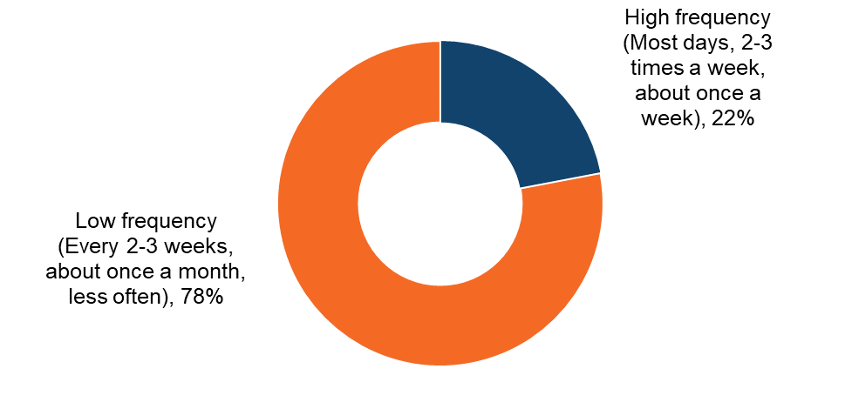
Sample: n = 657 (purchased physical copies of music in the past three months).

Understanding online consumption of music

Detailed demographic analyses related to these findings can be found in Table 2.5 in OCI 2024 Supplementary Tables – Music

To better understand the drivers of online consumption, those who had streamed or downloaded music in the previous three months were asked to select their top three reasons for accessing music online. It is worth noting that respondents were able to select multiple options, so the percentages presented do not sum to 100%.

Responses suggested a broad range of motivations. The two that resonated the most strongly related to convenience and variety (Figure 5):
- “being able to listen to music instantly whenever I want” (52%)
- “having a wide range of music to listen to” (47%)
These two reasons were consistently selected across genders and all age groups.

Price (“It's free or cheap”, 37%) was the third most popular reason, ahead of personalisation (“I can build playlists/compilations of my favourite music”, 32%) and convenience (“The convenience of storing content digitally”, 30%). Other features, such as sound quality and building a digital collection of music, were notably less valued.

Instant access and breadth of variety drive online music consumption
Figure 5: Main reasons for accessing music online (i.e. downloading or streaming). Download the data from Table 2.5.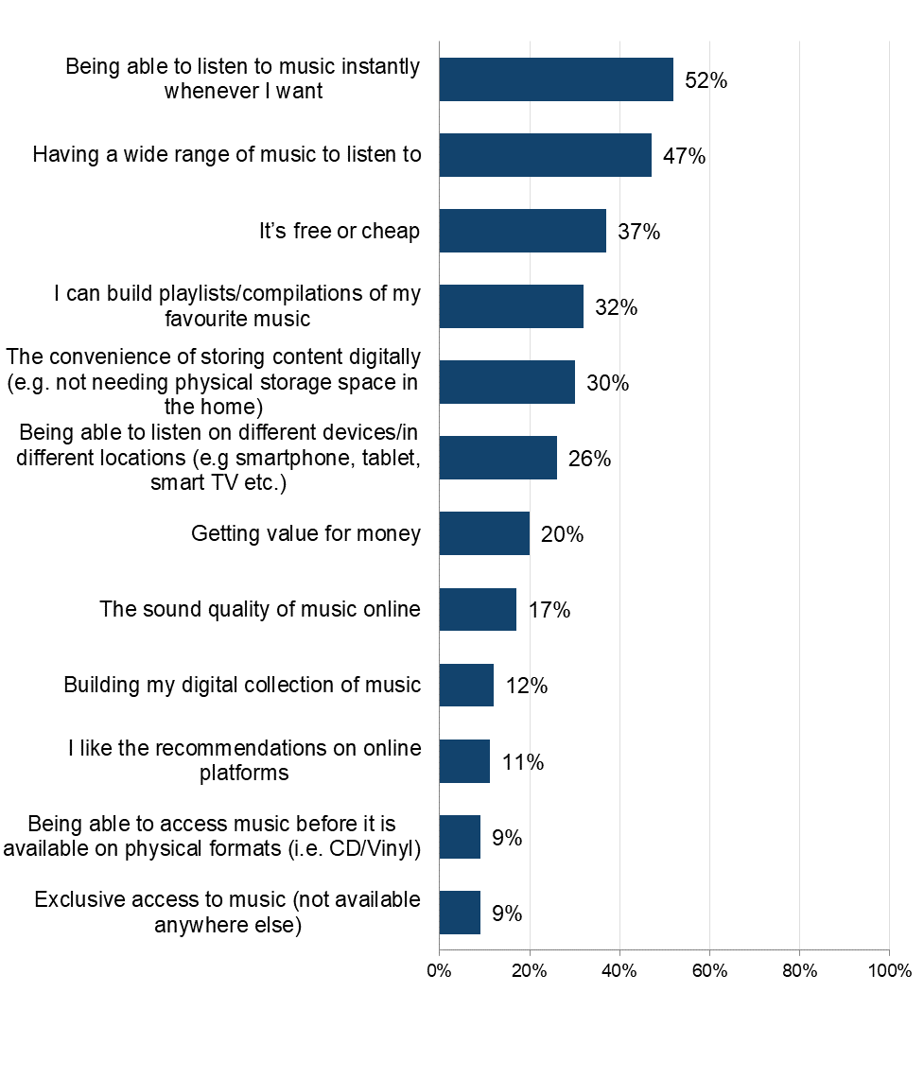
Sample: n = 2,919 (downloaded or streamed music online in the past three months). Note: Respondents were able to select multiple options, so the percentages presented do not sum to 100%.

Downloading music

This section details the rates of downloading of music files from the internet, followed by a deep dive into infringement within this form of accessing music.

Detailed demographic analyses related to these findings can be found in Tables 2.6a - 2.6b in Supplementary Tables – Music.

Frequency and volume of downloading music

The 27% who had downloaded music (including ‘saving offline’ via music streaming services) during the previous three months were asked additional questions about the frequency, volume, and sources used for downloading.

More than half (56%) of those who download music do so frequently (i.e. at least once a week) (Figure 6). Weekly downloading was most common among the three youngest age groups (aged between 12 and 34) with around two thirds (68% to 75%) engaging in this behaviour. The frequency of downloads tended to decrease with age, with only 33% of those aged over 55 downloading music weekly.

Among those who downloaded, an average of 103 music tracks had been downloaded in the previous three months. The highest numbers were among the 16 to 24 and 25 to 34 age ranges, with 117 and 130 tracks downloaded respectively.

High frequency music downloaders outnumber those who download less often
Figure 6: Frequency of downloading music tracks or albums through the internet. Download the data from Table 2.6a.
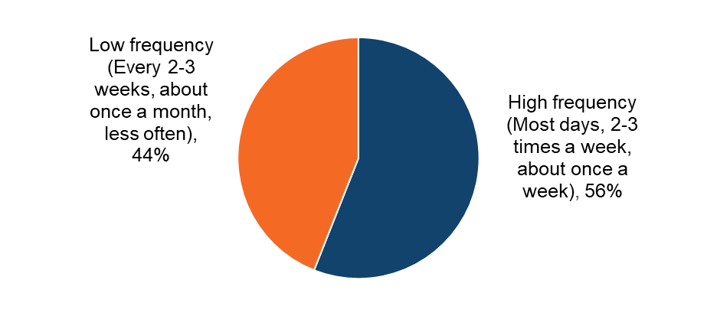

Sample: n = 1,675 (downloaded music in the past three months)

Music downloading: Infringement behaviours

Sources of downloading music

Detailed demographic analyses related to these findings can be found in Tables 2.7-2.9 in OCI 2024 Supplementary Tables – Music.

Respondents were shown a list that encompassed the different ways (legal and illegal) that they could download music. An ‘unknown’ option was also provided to serve as a catch-all for those who were unsure of the exact source. It is worth noting that respondents were able to select multiple options, so the percentages presented do not sum to 100%.

The most used source for downloading music, by a considerable margin, was a legal one (Figure 7). “Saving offline” via a paid-for subscription service was used by 60%. The next most frequently used legal source (26%) was indicated as “Paying a single fee to download individual songs or albums”.

The most common illegal source was downloading music from sites such as YouTube using an online converter, a software, app or browser extension, which was used by 30%. All other illegal sources were used considerably less frequently, with each ranging between 7% and 13% of music downloaders. The most popular illegal source (i.e. downloading music from sites such as YouTube) was used almost twice as often in the youngest age group (43%) than in the oldest, over 55 age group (23%).

Using a paid, legal subscription service is by far the most popular source for music downloads
Figure 7: Sources used to download music in the past three months. Download the data from Table 2.7.
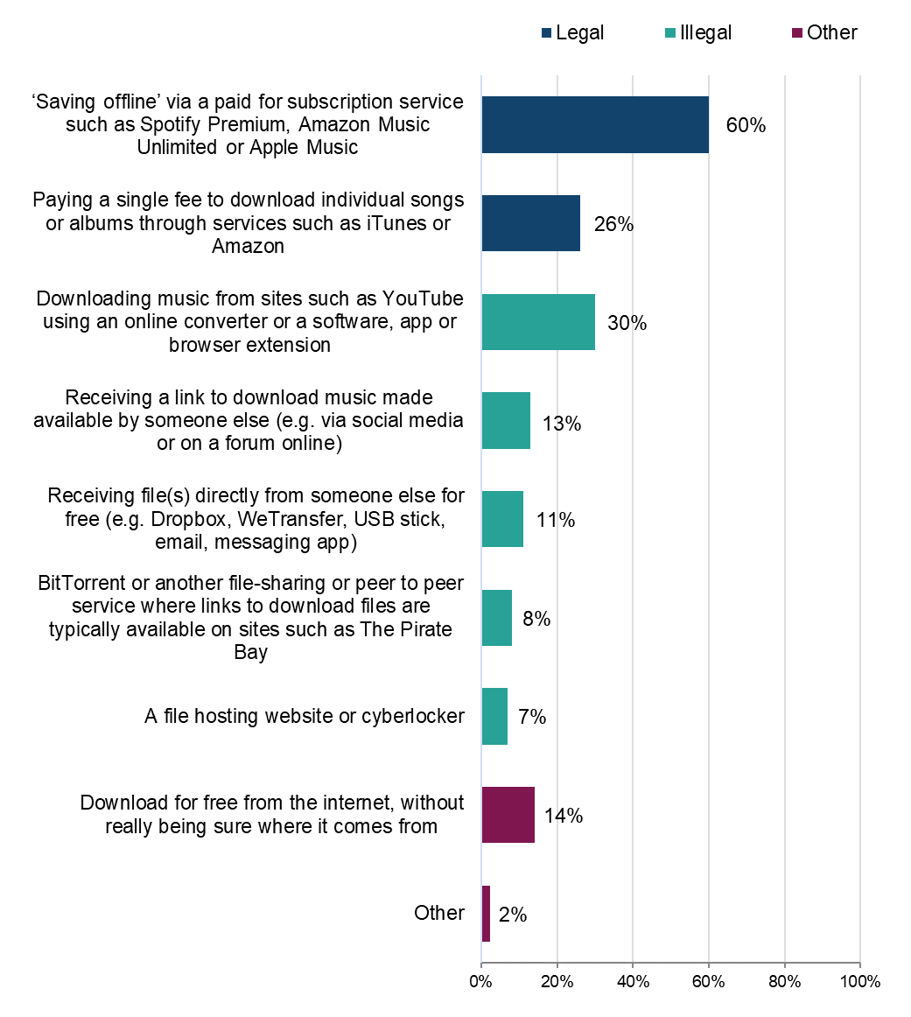

Sample: n = 1,675 (downloaded music during the past three months). Note: Respondents were able to select multiple options, so the percentages presented do not sum to 100%.

Legality of music downloads

To better understand the distribution of sources across legal and illegal categories, those who had downloaded music in the previous three months were grouped into the following (mutually exclusive) categories: using legal sources only, illegal sources only, or a mix of legal and illegal sources.

The answer option “download for free from the internet, without really being sure where it comes from” was not included in the definition of either legal or illegal. Anyone who said they only consumed content in this way was not included in the sample.

The majority of respondents, by some way, had used only legal sources (53%), in comparison to using only illegal (19%) or a mix of legal and illegal sources (28%) (Figure 8). Headline findings for different sources are as follows:
- legal:
  - overall, 81% had used at least one legal source to download music (Figure 8)
  - there were notable differences between age groups, with 44% to 52% of those under 35 using only legal sources, compared to over 58% among respondents aged 35 and older (Figure 10)
- illegal:
  - 47% had used at least one illegal source to download music
  - 19% had used illegal sources only to download music
  - 22% of male respondents had used only illegal sources to download music, compared to 17% of female respondents (Figure 9)
  - those aged above 45 were most likely to have used only illegal sources (between 21% and 26%). For comparison, the range for those aged 12-44 was between 14% and 18% (Figure 10)
  - the lower the passion for music, the higher the likelihood of using only illegal sources. 17% of those with a high passion for music used only illegal sources, compared to 27% of those with a low passion (Figure 11)
- mixed:
  - 28% had used a mix of legal and illegal sources to download
  - this was highest among those aged between 12 and 44 (26% to 42%)

Over 80% have used at least one legal download source
Figure 8: Legality of music downloads. Download the data from Table 2.8.
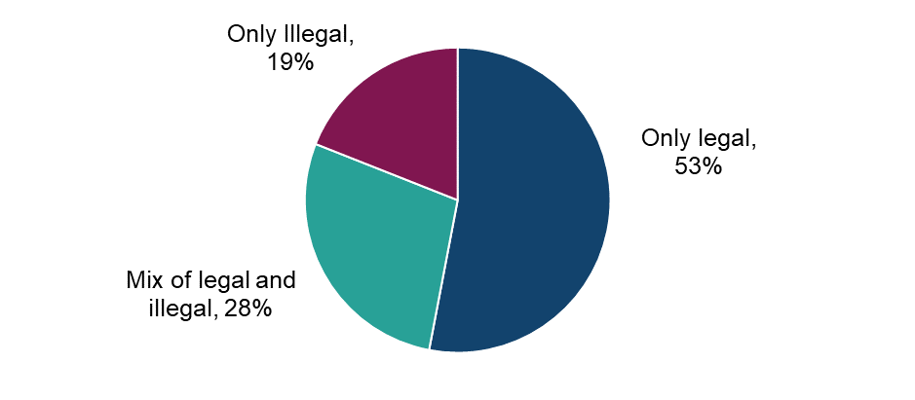
Sample: n = 1,570 (downloaded music in the past three months, with those who selected ‘other’ or ‘not sure of source’ removed).

Male respondents are more likely to use illegal sources to download music than female respondents
Figure 9: Legality of music downloads by sex. Download the data from Table 2.8.
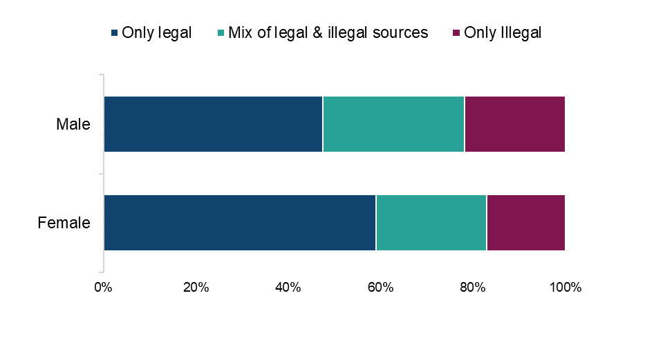
Sample: n = 1,570 (downloaded music in the past three months, with those who selected ‘other’ or ‘not sure of source’ removed).

Higher use of illegal sources to download music among the younger age groups
Figure 10: Legality of music downloads by age. Download the data from Table 2.8. . 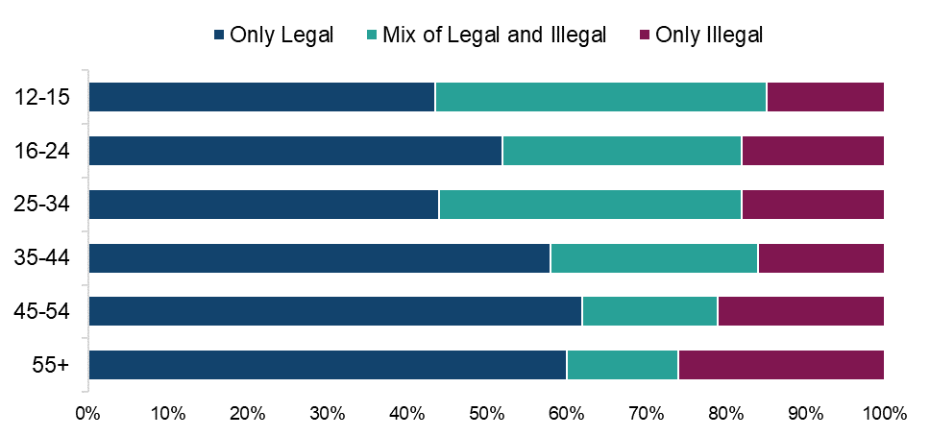

Sample: n = 1,570 (downloaded music in the past three months, with those who selected ‘other’ or ‘not sure of source’ removed).

Higher use of illegal sources to download music among those with a high passion for music
Figure 11: Legality of music downloads by passion level. Download the data from Table 2.8.

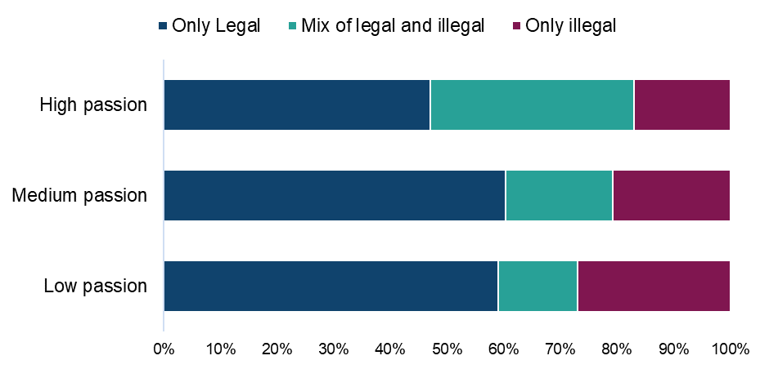
Sample: n = 1,570 (downloaded music in the past three months, with those who selected ‘other’ or ‘not sure of source’ removed).

Paid for subscription services account for half of all music downloads/download time
Table 1: Distribution of music downloads by source (average % age of their time). Download the data from Table 2.9.
Legality | Source | Average % age of usage distribution
Legal | ‘Saving offline' via a paid for subscription service such as Spotify Premium, Amazon Music Unlimited, Apple Music or YouTube Music Premium | 48%
Legal | Paying a single fee to download individual songs or albums through services such as iTunes or Amazon | 15%
Illegal | Downloading music from sites such as YouTube using an online converter or a software, app or browser extension | 15%
Illegal | Receiving a link to download music made available by someone else | 4%
Illegal | BitTorrent or another file-sharing or peer to peer service where links to download files are typically available on sites such as The Pirate Bay | 3%
Illegal | Receiving the file(s) directly from someone else for free | 3%
Illegal | A file hosting website or cyberlocker (Mega, Gofile, MediaFire, Rapidgator etc.) | 3%
Other | Download for free from the internet, without really being sure where it comes from | 8%
Other | Other | 2%
Sample: n = 1,675 (downloaded music in the past three months).

Music downloading: Cyber security incidents

Respondents were asked if they had experienced any of a list of cyber security incidents in the previous 12 months. These incidents included devices being targeted with ransomware, other types of malware, hacking, phishing, social media and/ or email account takeovers, or any other incidents.
We observed a consistent trend: infringers were significantly more likely than non-infringers to report experiencing a cyber security incident. While a definitive causal link cannot be established, this may be influenced by factors such as higher digital engagement among infringers, increased exposure to unverified sources, or reliance on websites that pose a risk, and compromised content platforms.
58% of those who had downloaded music illegally had experienced at least one cyber security incident (Figure 12). This compares with 46% of those who had used only legal sources.

Those who download music illegally are more likely to have experienced cyber security incidents in the last 12 months than those only using legal sources
Figure 12: Looking back over the past 12 months, to your knowledge, have you personally experienced any of the following cyber security incidents? Download the data from Table 1.15 of the Main Data Tables (ODS 103KB)
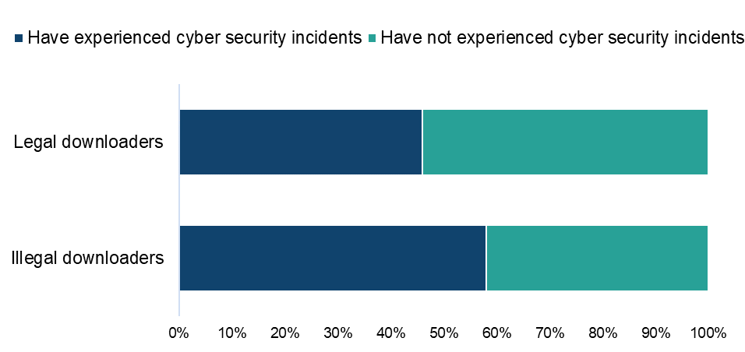
Sample: n = 1,185 (downloaded music from a legal or illegal source, with those who selected ‘other’ or ‘not sure’ removed)

Qualitative insight: Music and cyber security incidents

Qualitatively, only a few participants in the music category of our online community had experienced cyber security incidents. These participants evaluated the incidents as not having too much of an impact because they didn’t lose personal details, one only lost some music files. Other participants merely expressed caution and that they knew there were risks, but that this was worth it in order to get free content.

Yes I did lose nearly all of my musical data. I never banked on the computer then so there was nothing else they could get off me but it did screw up everything that I spent years and years putting together and even with all the backups in the world I still lost quite a bit of stuff and I’m a security expert. Since then, I’ve not used pirating sites.
Music, Male, 61+

No bad experiences but I know I have to be very cautious while accessing unofficial sources as it might lead to data security and privacy related concerns.
Music, Female, 31-40

Streaming music

This section details the rate of streaming of music online, followed by a deep dive into infringement within this form of accessing music.

Detailed demographic analyses related to these findings can be found in Tables 2.10 – 2.11 in OCI 2024 Supplementary Tables – Music.

Frequency and volume of streaming music

The 42% who had streamed music online during the previous three months were asked questions around frequency, volume and sources used.

The majority (80%) of those who streamed music did so frequently (at least once a week) (Figure 13). This was notably higher than the number who had downloaded music within the same time period (56%). Streaming frequently (at least once a week) stands at over 90% among the under 35’s, dropping to 62% among the over 55 age group.

An average of 109 hours were spent streaming in a three-month period - this was highest among those aged between 16 and 34, where it peaked to between 146 and 148 hours.

Around 4 in 5 stream music tracks/albums at least weekly.
Figure 13: Frequency of streaming music tracks or albums through the internet. Download the data from Table 2.11.
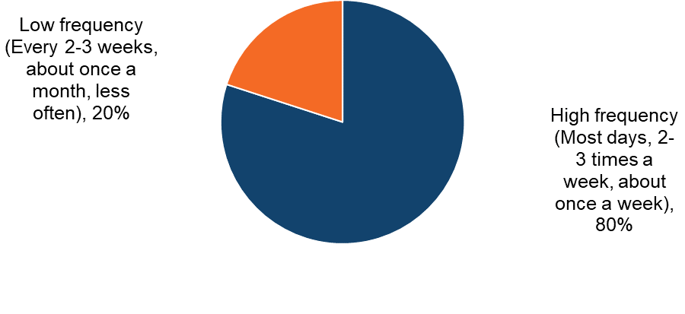
Sample: n = 2,663 (streamed music in the past three months).

Music streaming: infringement behaviours

Sources of music streaming

Detailed demographic analyses related to these findings can be found in Tables 2.12a - 2.13 in OCI 2024 Supplementary Tables – Music.

Respondents were shown a list that encompassed the different ways (legal and illegal) that they could stream music. An ‘unknown’ option was also provided to serve as a catch-all for those who were unsure of the exact source.

Compared to downloading, fewer illegal avenues exist for us to ask about in the survey and, encouragingly, only a very small minority had used these. The only illegal method tested, a “file hosting website or cyberlocker”, was used by just 2% (Figure 14).

The most selected source was a paid one with 57% using “a paid for subscription service” (e.g. Spotify Premium). This was followed by a free source, with 35% watching/listening on sites such as YouTube or Dailymotion. Paid subscription services proved popular among most age groups (between 57% and 65%), dropping slightly among the over 55’s (42%).

Legal sites dominate streaming sources.
Figure 14:Sources used to stream music in the past three months. Download the data from Table 2.12a.

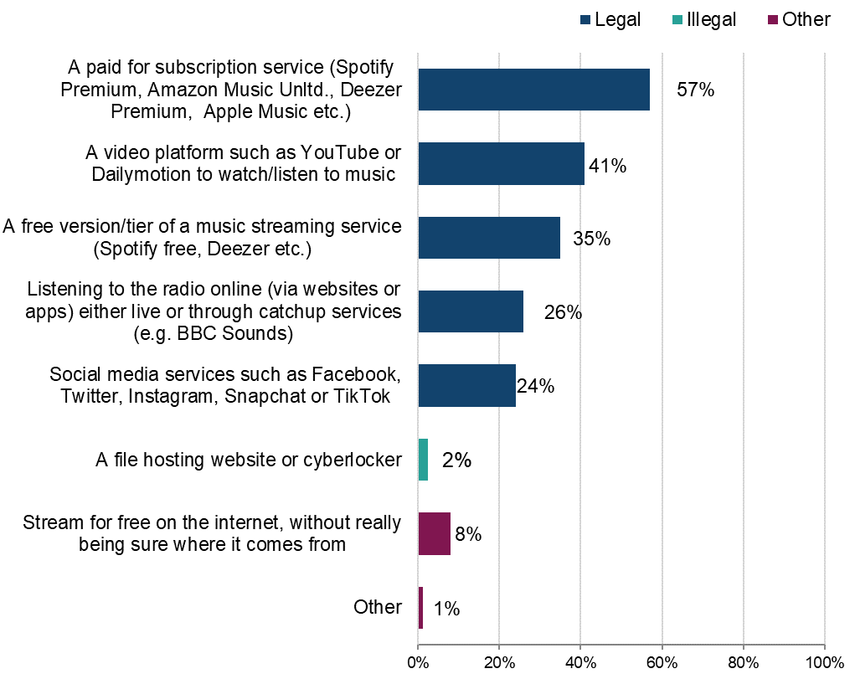
Sample: n = 2,663 (streamed music in the past three months, with those who selected ‘other’ or ‘not sure of source’ removed).

Detailed demographic analyses related to these findings can be found in Tables 2.12a - 2.13 in OCI 2024 Supplementary Tables – Music.

Legality of music streaming

To better understand the distribution of sources across legal and illegal categories, those who had streamed music in the previous three months were grouped into the following (mutually exclusive) categories: using legal sources only; illegal sources only; or a mix of legal and illegal sources.

The answer option “stream for free from the internet, without really being sure where it comes from” was not included in the definition of either legal or illegal. Anyone who said they only consumed content this way was not included in the sample.

Headline findings for different sources are as follows:
- legal:
  - in contrast to downloading, music was being streamed almost entirely legally with all respondents having undertaken legal streams (Figure 15)
  - this was the case for both male and female respondents (Figure 16)
- illegal:
  - just 2% had used any illegal sources to stream music
  - none of the respondents had used only illegal sources to stream music
- mixed:
  - 2% had used a mix of legal and illegal sources to stream music

Music is being streamed almost entirely legally
Figure 15: Legality of music streaming. Download the data from Table 2.13.

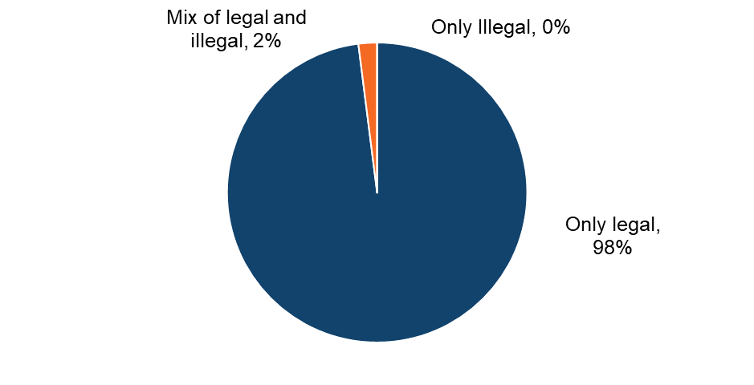
Sample: n = 2,609 (streamed music in the past three months, with those who selected ‘other’ or ‘not sure of source’ removed).

The vast majority of male and female respondents stream music legally
Figure 16: Legality of music streaming by sex. Download the data from Table 2.13.

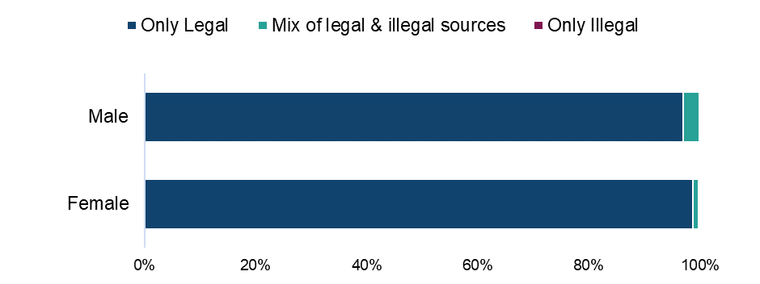

Sample: n = 2,609 (streamed music in the past three months, with those who selected ‘other’ or ‘not sure of source’ removed).

Across all age groups the vast majority stream music legally
Figure 17: Legality of music streaming by age. Download the data from Table 2.13.
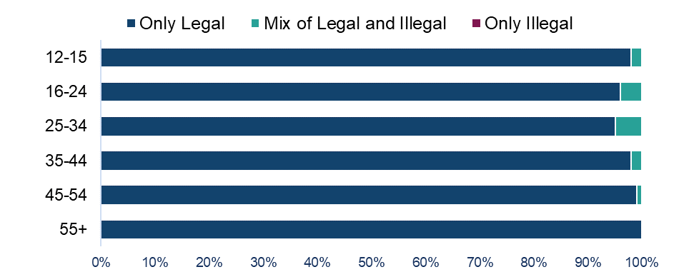
Sample: n = 2,609 (streamed music in the past three months, with those who selected ‘other’ or ‘not sure of source’ removed).

Across all levels of music passion, the vast majority stream music legally
Figure 18: Legality of music streaming by passion level. Download the data from Table 2.13.
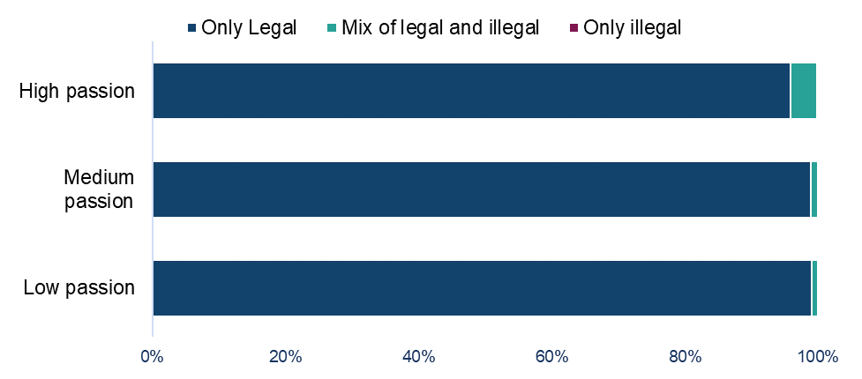
Sample: n = 2,609 (streamed music in the past three months, with those who selected ‘other’ or ‘not sure of source’ removed).

Legal sources account for the majority of all music streaming time
Table 2: Distribution of music streaming by source. Download the data from Table 2.14.
Legality | Source | Average %age of usage distribution
Legal | A paid for subscription service (Spotify Premium, Amazon Music Unlimited, Deezer Premium, Apple Music, YouTube Music Premium etc.) | 43%
Legal | A free version/tier of a music streaming service (Spotify free, Deezer etc.) | 19%
Legal | A video platform such as YouTube or Dailymotion to watch/listen to music | 17%
Legal | Listening to the radio online (via websites or apps) either live or through catchup services (e.g. BBC Sounds) | 10%
Legal | Social media services such as Facebook, Twitter, Instagram, Snapchat or TikTok | 7%
Illegal | A file hosting website or cyberlocker | 1%
Other | Stream for free on the internet, without really being sure where it comes from. | 3%
Other | Other | 1%
Sample: n = 2,663 (streamed music in the past three months).

Music streaming: Cyber security incidents

Respondents were asked if they had experienced any of a list of cyber security incidents in the previous 12 months. These incidents included devices being targeted with ransomware, other types of malware, hacking, phishing, social media and/ or email account takeovers, or any other incidents.
The large majority (81%) of respondents who had streamed music illegally had experienced at least one cyber security incident. This compares with 46% of those who had used only legal sources (Figure 19).

Those who stream music illegally are more likely to have experienced cyber security incidents in the last 12 months than those only using legal sources*
Figure 19: Looking back over the past 12 months, to your knowledge, have you personally experienced any of the following cyber security incidents? Download the data from Table 1.15 of the OCI 2024 Main Data Tables (ODS 103KB)
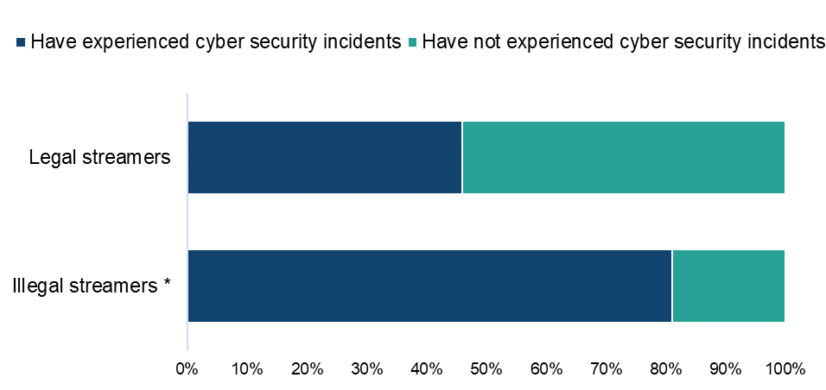

Sample: n = 2,309 (streamed music from a legal or illegal source, with those who selected ‘other’ or ‘not sure’ removed)
* Note: a small sample size (54) of those streaming music illegally
.

Combined downloading/streaming of music and infringement behaviours

Detailed demographic analyses related to these findings can be found in Table 2.16 in OCI 2024 Supplementary Tables – Music.

The use of legal and illegal sources for music access (both downloading and streaming) were combined to allow us to look at the category. We would, however, express caution when interpreting these results, owing to the distinct differences in the legal and illegal figures for downloading and streaming independently.

Overall, 27% of respondents had accessed music through an illegal source at least once. Headline findings for each type of source are as follows:
- legal:
  - 74% had consumed music online using legal sources only (Figure 20)
- illegal:
  - 3% had used illegal sources only to consume music online
- mixed:
  - 24% had used a mix of legal and illegal sources to consume music online
  - those with a high passion level for music were more likely to use a mix of sources (35%), compared to those with either a medium (17%) or low passion level (11%)

Just under three-quarters of those downloading/streaming music only use legal sources
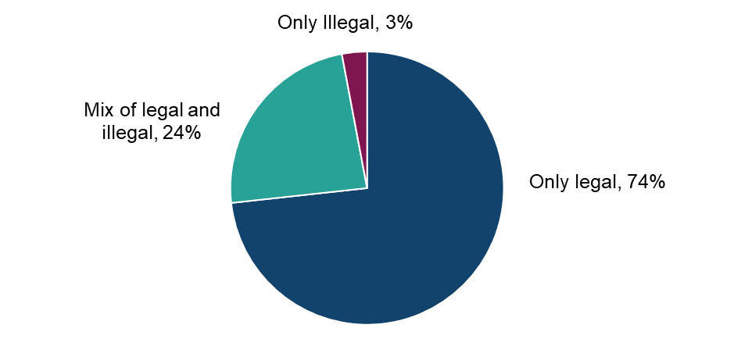
Figure 20: Legality of downloading/streaming music. Download the data from Table 2.16.

Sample: n = 2,855 (streamed and/or downloaded music from a legal or illegal source, with those who only selected ‘not sure of source’ removed).

Male respondents downloading/streaming music are more likely than female respondents to access at least some illegal sources
Figure 21: Legality of downloading/streaming music by sex. Download the data from Table 2.16.
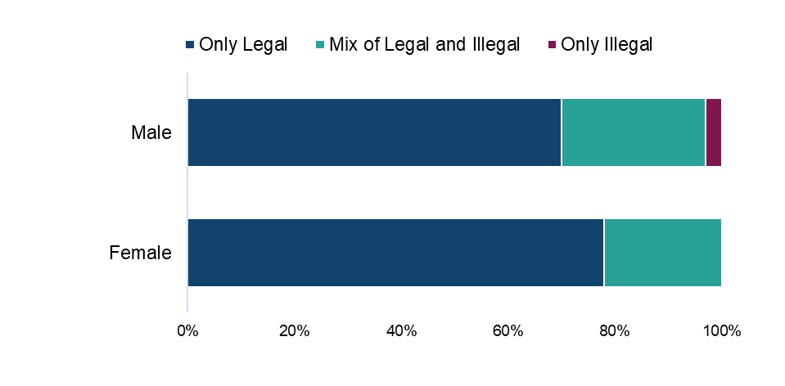
Sample: n = 2,855 (streamed and/or downloaded music from a legal or illegal source, with those who only selected ‘not sure of source’ removed).

Use of illegal sources to download/stream music tends to decrease with age
Figure 22: Legality of downloading/streaming music by age. Download the data from Table 2.16.
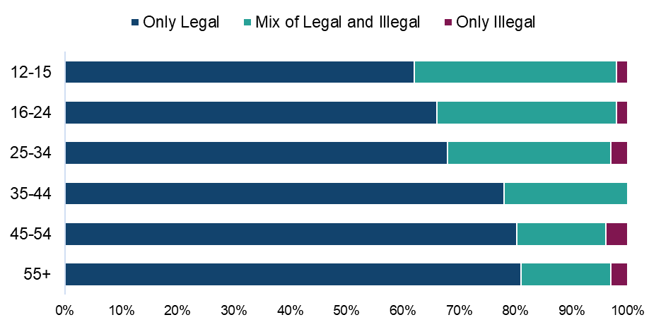

Sample: n = 2,855 (streamed and/or downloaded music from a legal or illegal source, with those who only selected ‘not sure of source’ removed).

Those with a high passion for music are more likely than those with a lower passion to access at least some illegal sources
Figure 23: Legality of downloading/streaming music by passion level for music. Download the data from Table 2.16.
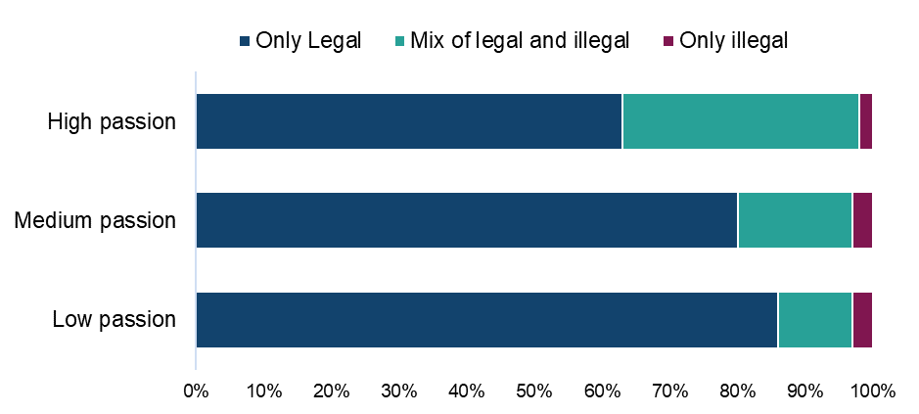
Sample: n = 2,855 (streamed and/or downloaded music from a legal or illegal source, with those who only selected ‘not sure of source’ removed).

Qualitative Insight: accessing music through legal and illegal sources
Access to music was often made up of a mix of legal and illegal sources. Participants in this category often paid for a streaming service but also topped up what they had access to with the use of certain illegal methods. This was often in cases where they couldn’t find a song via their streaming service. One scenario also mentioned was where a streaming service increased its prices and thereby was no longer seen as a tenable option. However, there were also a few participants who only used free methods of accessing music.
Regarding illegal access, participants in our qualitative online community mentioned downloading songs as MP3 files from YouTube, downloading via BitTorrent, downloading from sites such as Y2mate and receiving links from friends and family. These methods were generally seen as quick, easy and crucially free which was the main reason they were accessed. Some acknowledged that downloads could occupy significant storage space and sometimes result in poor quality songs. However, participants felt these drawbacks were outweighed by the advantages of obtaining free music or music unavailable through legal sources.
“The main way I download music is through BitTorrent. The main strengths are that it's very easy and quick to use so that I'm not messing around and taking ages to download whatever I'm wanting.”
Female, Music, 21-30

“YouTube downloader. It is free, quality might not be great but I’m ok with it.”
Female, Music, 31-40

“Download music using Y2mate. Receiving online like through WhatsApp and email. Major drawback about this is piracy issues and it takes up storage space on local device and sometimes you get poor quality due to the transfer platform.”
Male, Music, 21-30

Asked about whether these methods would be important going forward, some believed it was likely that they would keep looking for free access to music. This was because prices overall in daily life were considered to be relatively high. Others, however, said they only used free methods rarely, when they couldn’t find a song via their streaming subscription, making them less important in the future.

“I think with the cost of living recently this is crucial to people being able to listen to and download their favourite music instead of paying monthly subscriptions that they can't afford.”
Female, Music, 21-30

“Not really. Accessing these sources is needed only when a few tracks are not available on official sources and I would like to listen to them again.”
Female, Music, 31-40

Paying for music

Those who had used a paid source to either download or stream music were asked how much they had personally spent on each source in a month. Average monthly expenditure was as follows:

- a paid subscription service (such as Spotify Premium, Amazon Prime Music or Apple Music): £14.60 per month
- downloading individual songs or albums (through services such as iTunes or Amazon): £3.00 per month

Change in use of illegal sources to access music

Detailed demographic analyses related to these findings can be found in Table 2.17 in OCI 2024 Supplementary Tables – Music.

Those who had used an illegal source to download or stream music were asked how the use of these sources compared to the same point a year ago. Analysis of responses found:

- increased illegal source usage (42%) marginally exceeded static illegal source usage (39%) (Figure 24)
- 17% indicated that their usage had decreased
- 1% indicated no use of illegal sources compared to the same point a year ago

Use of illegal sources to download or stream music has increased for over 40% of illegal users
Figure 24: Change in usage of illegal sources to download or stream music compared to last year. Download the data from Table 2.17.
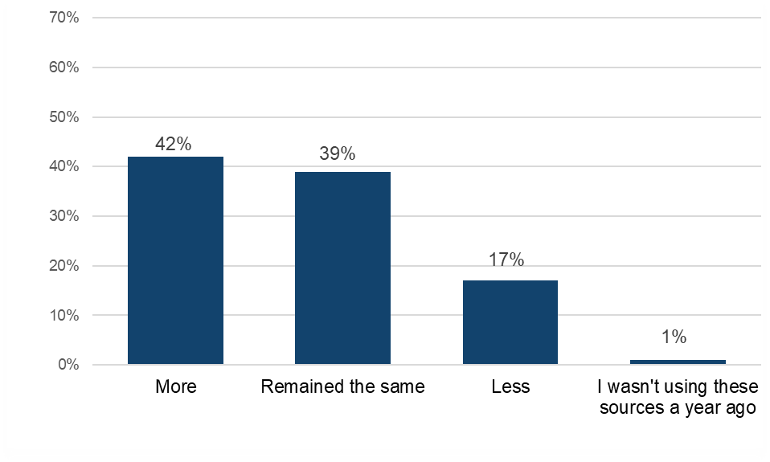
Sample: n = 749 (downloaded and/or streamed music illegally).

Music: Alternatives to infringement

This section will explore what respondents anticipate they would do if they lost access to illegal sources of music.

Detailed demographic analyses related to these findings can be found in Table 2.18 in OCI 2024 Supplementary Tables – Music.

Those who had used illegal sources to either download or stream music were asked which single legal source they would use if they could no longer access music illegally.

The most selected source was a paid one - just under a quarter (22%) of respondents said that they would take out a paid subscription to a music streaming service (Figure 25). This was followed by a free option, with 17% indicating that they would use a site such as YouTube or Dailymotion to watch/listen to music. A free tier of a music streaming service would be used by 14%, with all other answer options selected by between 3% and 10%.

Respondents aged over 45 were more likely to consider listening to radio than younger age groups. Encouragingly, higher proportions across almost every age category would turn to a paid streaming subscription than would use video platforms such as YouTube, on which the lines between legal and illegal content can blur.

In the absence of illegal music sources, the most likely alternative is a paid subscription service
Figure 25: Alternative sources for music if illegal options were unavailable. Download the data from Table 2.18.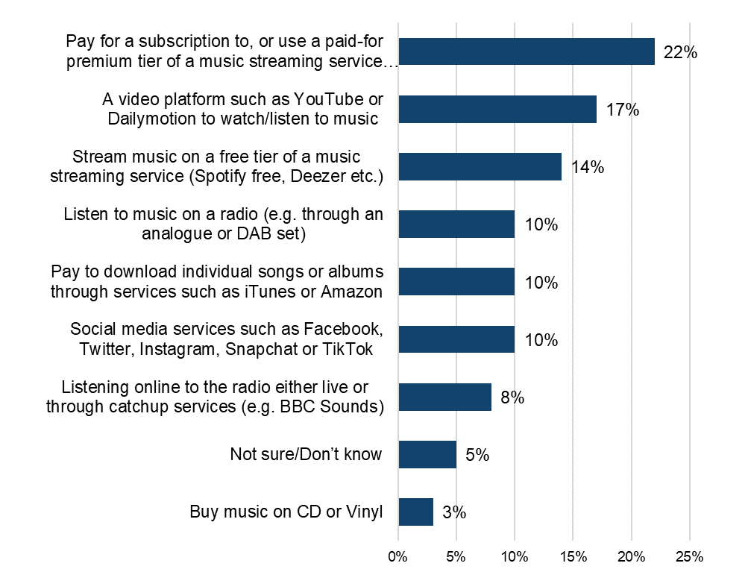
Sample: n = 749 (downloaded and/or streamed music illegally).

Qualitative insight: reactions to the hypothetical loss of illegal music sources
Faced with the hypothetical situation of illegal sources becoming unavailable, participants had varied opinions. Some said they would be disappointed and angry, feeling pressured to pay for more content than they would like to. A few said outright that they could not afford to pay for a subscription. Others felt it wouldn’t have a big impact on them, and they would probably keep paying for their subscription or try to listen to more music via the radio.

“I would feel under severe pressure to try and pay a monthly subscription when I was able to access it for free and I would also feel very stressed. It would mean overall I would definitely consume less music as I wouldn't have the immediate access through a subscription.”
Female, Music, 21-30

“I think I would feel quite angry as it’s been free. I would look for other sources, probably such as the radio. I would probably consume less music as I wouldn’t enjoy searching.”
Male, Music, 51-60

“It wouldn’t have too much of an effect on me. I pay for most of my subscriptions for music and only occasionally search for bits I can’t find but it would be a bit of a pain.”
Male, Music, 61+

Category Insights: Film

Further details and demographic breakdowns for the findings in the Film section can be found in Tables 3.1a – 3.18 in OCI 2024 Supplementary Tables – Film (ODS 156KB), which provide a comprehensive analysis of the data.

Trends in overall film consumption in the UK

Prior to presenting information on film infringement levels, it’s useful to initially consider respondents’ engagement with, and consumption of films overall.

53% had engaged with film in the previous three months (i.e. either by downloading, streaming, sharing or purchasing physical copies). Analysis of the mode of access fond:
- streaming was, by some way, the most common method of accessing films, with 45% having done so (Figure 26)
- among most age groups, over half had streamed films, with this falling for those aged 45 and above
- downloading followed at 27%, with fewer having purchased physical copies (12%)

Detailed demographic analyses related to these findings can be found in Tables 3.1a-3.1d in OCI 2024 Supplementary Tables – Film.

Streaming is the most frequent means of engaging with films
Figure 26: Downloaded/streamed/shared5/purchased physical copies of films in the past three months. Download the data from Tables 3.1a – 3.1d.

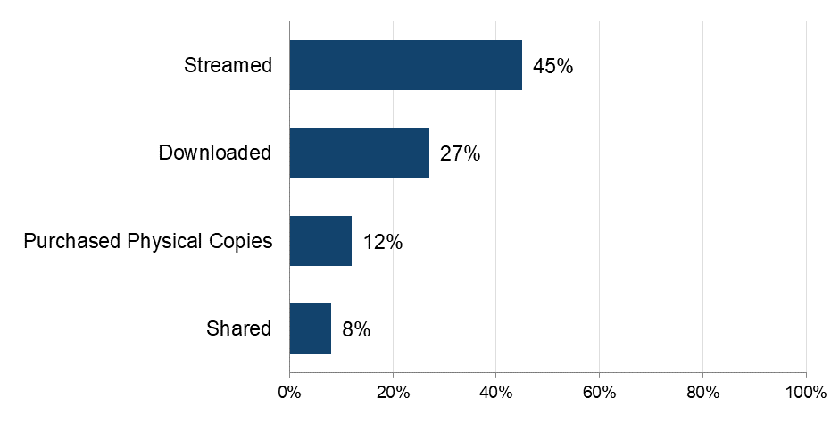
Base: n=5,087 (total sample)
Note: The definition of ‘shared’ was provided as: “By shared we mean that you personally made the file publicly available or sent or uploaded it online for someone else to download or stream/access. This does not include sending links to content that has already been shared by someone else, unless stated in the answer option”.

The importance of film

To get a broader sense of their passion for film, respondents were asked to what extent they agreed with a range of statements and then grouped as High, Medium or Low, based on their responses.

Analysis found that four in ten (41%) displayed a high level of passion for film. Film passion peaked among the youngest age group (12-15), standing at 48%, and was lowest among those aged 55 and above (29%) (Figure 27).

When looking at individual statements, the need to discover new films emerged as a main factor (Figure 28). The most agreed with statement overall (75%) was “I actively search for new films to watch”. The preference of films over other forms of entertainment was also important, with 68% agreeing that “Films are my favourite kind of entertainment”.

Detailed demographic analyses related to these findings can be found in tables 3.2a – 3.2f in OCI 2024 Supplementary Tables – Film.

Over 40% of those who have recently consumed films have a high level of passion for them
Figure 27: Passion levels for films. Download the data from Table 3.3.
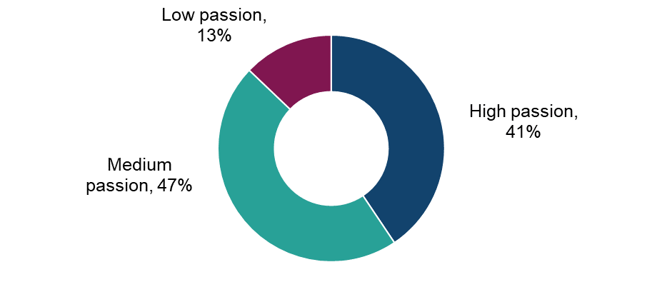
Base: n=2,744 (downloaded, streamed, shared and/or purchased physical copies of films in the past three months)

75% of recent film consumers are actively searching for new films to watch
Figure 28: Extent of agreement with statements in relation to films. Download the data from tables 3.2a – 3.2f.
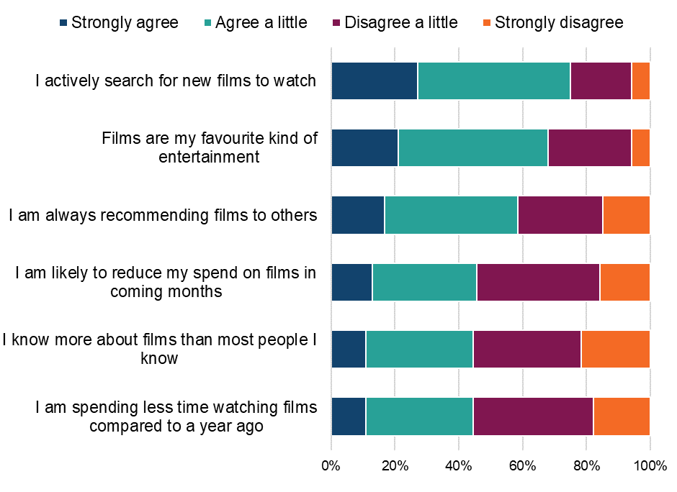
Base: n=2,744 (downloaded, streamed, shared and/or purchased physical copies of films in the past three months)

Qualitative insight: The importance of film in people’s lives

Films were seen as an opportunity to escape and be occupied in an imaginative space for a while which helped them relax. Films were especially seen as a social event, often with partners or family, adding an additional element to film watching.

Participants all mentioned watching films in the evening, as this was typically when they had most time for content of this length and because it was a way to relax after a long day.

“It is a social occasion, to go out with others to watch them or have a night in centred around a film. They are entertaining, relaxing and educational. Usually in the evening or at night, usually around the holidays, or as an everyday 'special' event.”
Female, Film, 31-40

“It's definitely a trip down nostalgia lane when I watch classic movies. It also feeds my imagination and inspires me to do things I would otherwise never have considered. They provide me with a sense of relaxation and is another way to spend time with my family.”
Male, Film, 21-30

“I like to be able to sit down and relax and watch a good film either with my kids or partner. I just want some time to relax and have a bit of time away from normal life.”
Female, Film, 31-40

“Very important role as they are one of the major forms of entertainment I lean toward, they help me escape from my normal hectic work routine and spend time with my family and friends. I usually watch in the evenings when I have free time.”
Male, Film, 31-40

Within our qualitative sample, many had noted no change in their consumption of film content. There was mention of consumption having increased due to having more time on their hands, whilst a few others said their consumption had decreased due to experiencing a rise in costs in other aspects of their lives.

“Yes I access it less often. I access it less because of financial constraints and time constraints.”
Female, Film, 31-40

“I’ve been watching more movies than before which is down to a job change as I have a bit more free time these days and I like watching movies when I’m not busy.”
Male, Film, 21-30

“Yes, been watching movies less than before. I’ve spent less money on subscription platforms, going to the cinema due to the high cost of living and also watched movies less because I’ve been busy working trying to make ends meet so less free time.”
Male, Film, 31-40

Physical purchasing of film

This section refers to the rate of purchasing of physical copies of films followed by rates of online purchasing.

The 12% of respondents who had purchased films in physical formats, such as DVDs or Blu-rays, during the previous three months were asked more questions around frequency and number of purchases made. Analysis found that a quarter (25%) of these consumers were frequent (i.e. at least once a week) purchasers of films in physical formats. Frequent purchasing was highest among those aged 16-34.

In terms of the number of items bought, those who had purchased physical copies of films bought an average of 13 films in the previous three months. Female respondents purchased, on average, a higher number of films (16) than male respondents (11).

Detailed demographic analyses related to these findings can be found in Tables 3.4a – 3.4c in OCI 2024 Supplementary Tables – Film.

Understanding online consumption of film

To better understand the drivers of online consumption, those who had streamed or downloaded films in the previous three months were asked to select their top three reasons for accessing films online.

Two reasons were selected by almost half of respondents - these related to ease of access and the range of options available (Figure 29):
- being able to watch films instantly whenever I want (48%)
- having a wide range of films/movies to watch (45%)
These top two reasons were consistently selected across gender and age groups.

The next most common factors (selected by a quarter or more) related to the social aspect of viewing with friends/family (29%) and price (“getting value for money” and “it’s free or cheap”, 25% respectively). Male respondents were more likely than female respondents to select value for money as a driving factor (29% vs 21%).

No other factors were selected by more than 22% of respondents.

Detailed demographic analyses related to these findings can be found in Tables 3.4a – 3.4c in OCI 2024 Supplementary Tables – Film.

Instant access and variety drive the consumption of online films
Figure 29: Main reasons for accessing films/movies online (i.e. downloading or streaming). Download the data from Table 3.4c.
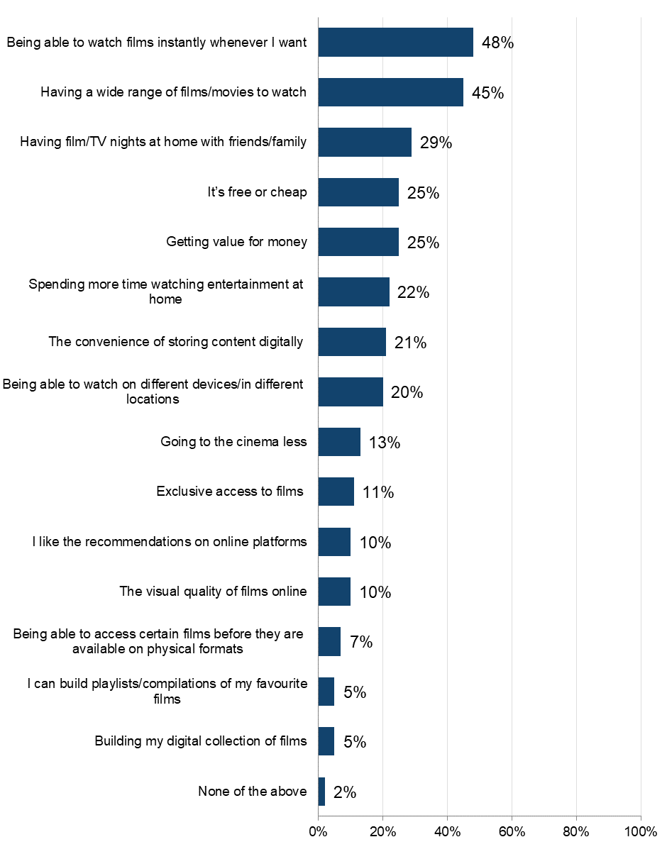
Base: n=2,560 (downloaded or streamed films online in the past three months). Respondents were able to select multiple options, so the percentages presented do not sum to 100%.

Downloading films

Frequency and volume of downloading films

This section details the rates of downloading of films from the internet, followed by a deep dive into infringement within this form of accessing music.

The 27% of respondents who had downloaded films during the previous three months were asked more questions around frequency, volume and sources used.
Over half (52%) of those who downloaded films did so frequently (i.e. at least once a week) (Figure 30). The proportion downloading at least once a week was fairly consistent across all age groups (49-59%). In terms of volume, an average of 29 films were downloaded over a three-month period by those who accessed them in this way.

Detailed demographic analyses related to these findings can be found in Tables 3.5a – 3.5b in OCI 2024 Supplementary Tables – Film.

Over half of those downloading films are doing so at least weekly
Figure 30: Sources used to download films/movies through the internet. Download the data from Table 3.5c.
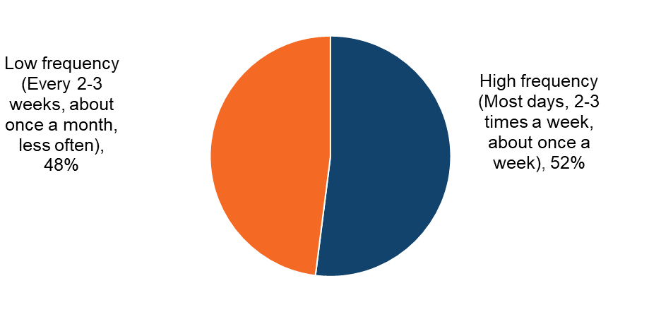
Base: n=1,379 (downloaded films in the past three months)

Film downloading: Infringement behaviours

Sources of downloading film

Respondents were shown a list that encompassed the different ways (legal and illegal) in which they could download films. An ‘unknown’ option was provided to serve as a catch-all for those who were unsure of the exact source.

The most commonly used sources were legal, of which the most frequent, by a large margin, was “Saving offline via a paid for subscription service”, undertaken by almost 70% of all film downloaders (Figure 31). This was followed by a quarter who were “Paying a single fee to download individual films or movies” (25%) and “Saving offline on TV catch-up services” (23%). Use of “Saving offline via a paid for subscription service” was consistently high across all age groups (65%-71%).

The most commonly used illegal methods were downloading feature films using an online converter (15%) or using BitTorrent or another file-sharing peer to peer service (7%). Other than this, no illegal method was selected by more than 7%.

The use of “BitTorrent or another file-sharing or peer to peer service” was at least 3% in all age groups but was highest in those aged 16-34 where it was between 9%-12%. Use of “Downloading feature films from sites such as YouTube using an online converter or a software, app or browser extension” was highest in the youngest age group (23% in those aged 12-15).

Detailed demographic analyses related to these findings can be found in Tables 3.6 – 3.8 in OCI 2024 Supplementary Tables – Film.

Legal subscription services dominate as the number one source for film downloads
Figure 31: Sources used to download films/movies in the past three months. Download the data from Table 3.6.
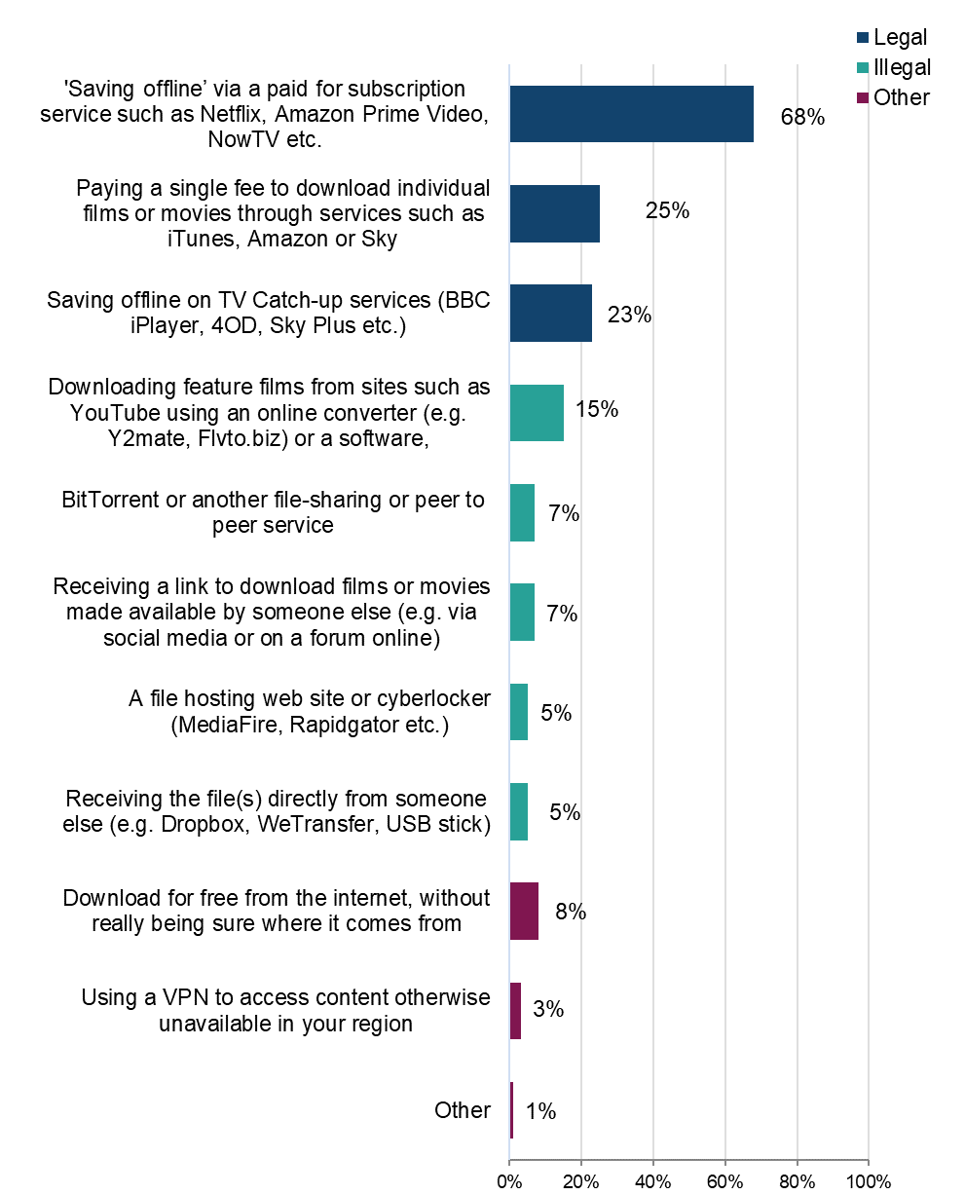
Base: n=1,379 (downloaded films in the past three months). Respondents were able to select multiple options, so the percentages presented do not sum to 100%.

Legality of film downloads

To better understand the distribution of sources across legal and illegal categories, those who had downloaded films in the previous three months were grouped into three (mutually exclusive) categories. These were as follows: using legal sources only; illegal sources only; or a mix of the two.

The answer option “download for free from the internet, without really being sure where it comes from” was not included in the definition of either legal or illegal. Anyone who said they only consumed content this way was not included in the base.

Headline findings for different sources are as follows:
- legal:
  - overall, 90% had used at least one legal source to download films (Figure 32)
  - the highest proportion (73%), by some way, had used legal sources only
  - this was notably higher among female than male respondents (79% vs. 66%) (Figure 33)
  - use of only legal sources largely increases in parallel to the age of respondents (Figure 34)
- illegal
  - 27% had used at least one illegal source to download films (Figure 32)
  - 10% had used illegal sources only to download films
- mixed:
  - 17% had used a mix of legal and illegal sources

Over a quarter of respondents have used at least one illegal source to download films
Figure 32: Legality of downloading films. Get the data from Table 3.7.
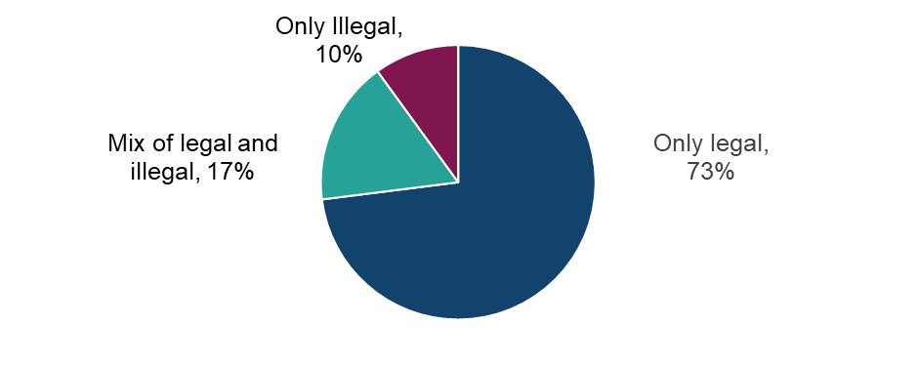

Base: n=1,315 (downloaded films in the past three months, with those who selected ‘other’ or ‘not sure of source’ removed).

Male respondents are more likely than female respondents to use illegal sources to download films
Figure 33: Legality of downloading films by sex. Download the data from Table 3.7.
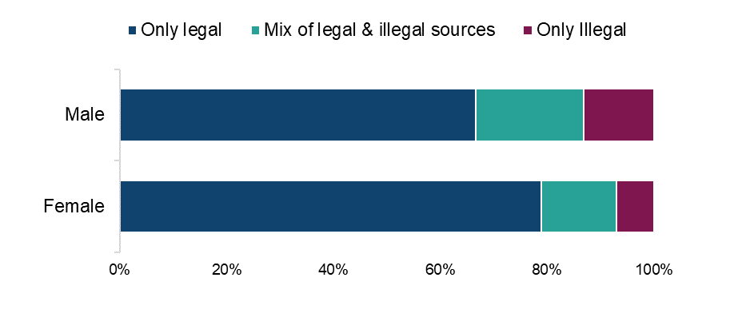
Base: n=1,315 (downloaded films in the past three months, with those who selected ‘other’ or ‘not sure of source’ removed).

Higher use of illegal sources to download films among the younger age groups
Figure 34: Legality of downloading films by age. Download the data from Table 3.7

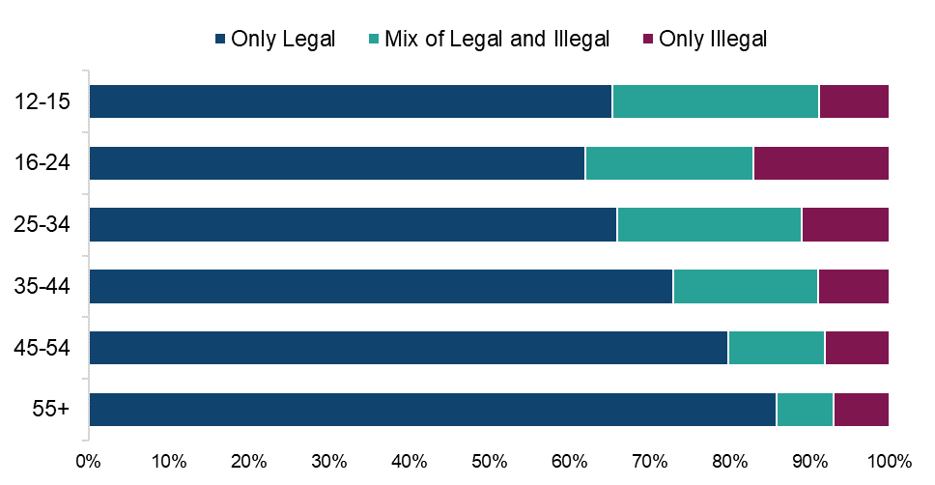

Base: n=1,315 (downloaded films in the past three months, with those who selected ‘other’ or ‘not sure of source’ removed).

Higher use of illegal sources to download films among those with a high passion for films
Figure 35: Legality of downloading films by passion level for film. Download the data from Table 3.7.

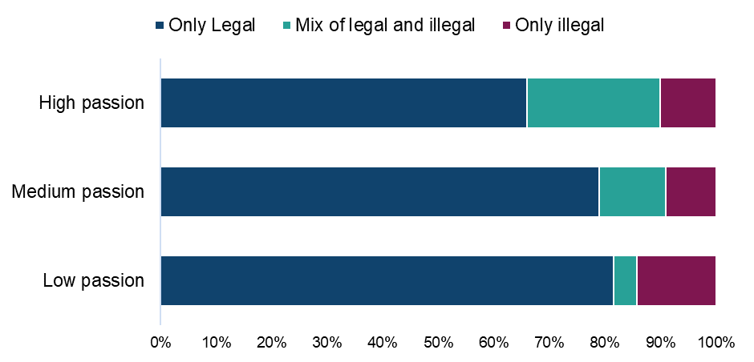

Base: n=1,315 (downloaded films in the past three months, with those who selected ‘other’ or ‘not sure of source’ removed).

Legal sources account for around 80% of all film downloads/download time
Table 3: Distribution of film downloads by source (average % of their time and average number of downloads). Download the data from Table 3.8.
Legality | Source | Average % of usage split
Legal | 'Saving offline’ via a paid for subscription service | 55%
Legal | Paying a single fee to download individual films or movies through services | 12%
Legal | Saving offline on TV Catch-up services | 11%
Illegal | Downloading feature films from sites such as YouTube using an online converter or a software, app or browser extension | 6%
Illegal | BitTorrent or another file-sharing or peer to peer service where links to download files are typically available on sites | 4%
Illegal | A file hosting website or cyberlocker | 2%
Illegal | Receiving a link to download films or movies made available by someone else | 2%
Illegal | Receiving the file(s) directly from someone else | 1%
Other | Download for free from the internet, without really being sure where it comes from | 5%
Other | Other | 1%
Other | Using a VPN to access content otherwise unavailable in your region | 1%

Base: n=1,351 (downloaded films in the past three months)

Film downloading: Cyber security incidents

Respondents were asked if they had experienced any of a list of cyber security incidents in the previous 12 months. These incidents included devices being targeted with ransomware, other types of malware, hacking, phishing, social media and/ or email account takeovers, or any other incidents.
We observed a consistent trend: infringers were significantly more likely than non-infringers to report experiencing a cyber security incident. While a definitive causal link cannot be established, this may be influenced by factors such as higher digital engagement among infringers, increased exposure to unverified sources, or reliance on websites that pose a risk, and compromised content platforms.
Responses indicated that 64% of those who had downloaded films illegally were aware they had experienced at least one cyber security incident (Figure 36). This compares with 45% of those who had used only legal sources.

Those who download films illegally are more likely to have experienced cyber security incidents in the last 12 months than those only using legal sources
Figure 36: Looking back over the past 12 months, to your knowledge, have you personally experienced any of the following cyber security incidents? Download the data table 1.15 of the OCI 2024 Main Data Tables (ODS 103KB).
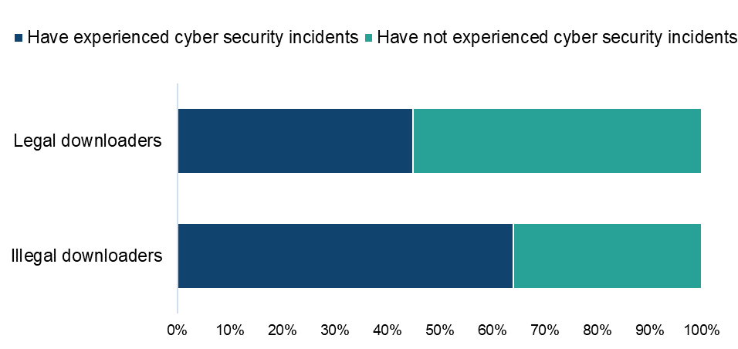
Base: n=1,167 (downloaded films from a legal or illegal source, with those who selected ‘other’ or ‘not sure’ removed)

Qualitative insight: Film and cyber security incidents

“Qualitatively, a few participants in the Film category in our online community had experienced cyber security incidents though they were unsure as to whether this was related to illegal downloads. While some felt put off using illegal sources in the future, others said they would keep using illegal sources unless the consequences became graver. Others simply mentioned being concerned about incidents but had never had any issues to date.
I am afraid of being hacked but have never had any problems.”
Male, Film, 16-20

“Yes I have had viruses on my laptops and computers. This has rendered them harder and slower to use and at times unstable until I had to pay to have them fixed. Having had bad experiences has made me very untrusting and has prevented me from using services that may well have been safe due to not trusting the source and it has also made me miss out on things that I wanted to partake in.”
Female, Film, 31-40

“Yes, my biggest concern is exposing myself to fraudulent activity. These sites expose me to viruses which make me vulnerable to being hacked, I could also face jail time if discovered. The only issues I’ve had is getting my USB devices corrupted but nothing major that could deter me from using them. If I experienced more adverse effects I would never use these sources ever again and would warn other people of the dangers.”
Male, Film, 31-40

Streaming films

Frequency and volume of films

This section details the rate of streaming of films online, followed by a deep dive into infringement within this form of accessing films.

The 45% of respondents who had streamed films online during the previous three months were asked questions around frequency, volume and sources used. Analysis of the responses found that over two-thirds (68%) were frequent streamers of films, doing so weekly (Figure 37). This was notably higher than the proportion who were frequent downloaders of films within the same time period (52%).

A majority across all age groups were frequent streamers of films, ranging from 62%-75%. This peaked among the youngest age group (12-15), (75%) and was lowest among the oldest age group (55 and above), (62%).

Film streamers spent an average of 72 hours streaming in a three-month period. This was relatively high across all age groups, peaking among the 25-34’s (103 hours).

Detailed demographic analyses related to these findings can be found in tables 3.9-3.10 in OCI 2024 Supplementary Tables – Film.

Around two-thirds of those streaming films via the internet are doing so at least weekly
Figure 37: Frequency of streaming films/movies through the internet. Download the data from Table 3.10.

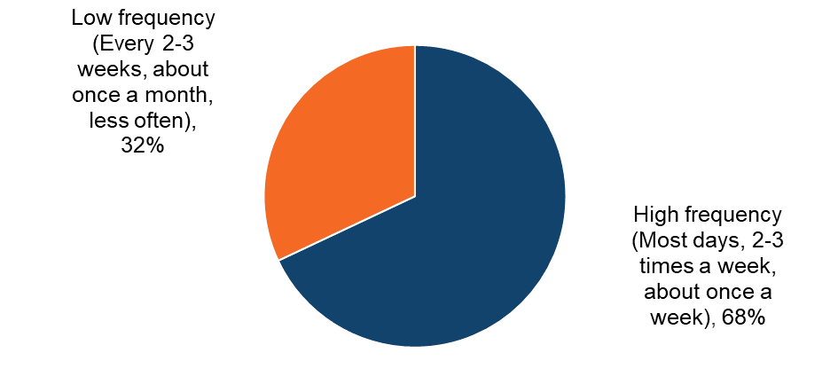
Base: n=2,277 (streamed films in the past three months).

Film streaming: Infringement behaviours

Sources of film streaming

Respondents were shown a list that encompassed the different ways (legal and illegal) that they could stream films. An ‘unknown’ option was provided to serve as a catch-all for those who were unsure of the exact source.

Encouragingly, legal sources were the most used (Figure 38). Furthermore, the top option, by some way, was a paid source: 81% used a “paid subscription to an online video streaming service”. This was followed by “TV Catch-up services” (37%) and “a free streaming video site such as YouTube” (20%).

No single illegal source was used by more than 9% of film streamers. Of these, “a paid subscription to an IPTV provider” (9%) and “a free website which hosts or links to films/movies” (7%) were the most common. Those aged 16-24 were more likely to use “a free website which hosts or links to films” (15%) when compared to older and younger age groups (where it ranged between 4%-8%).

Detailed demographic analyses related to these findings can be found in tables 3.11-3.13 in OCI 2024 Supplementary Tables – Film.

Legal, paid subscription services dominate as the number one source of film streaming channels
Figure 38: Sources used to stream films/movies in the past three months. Download the data from Table 3.11a. 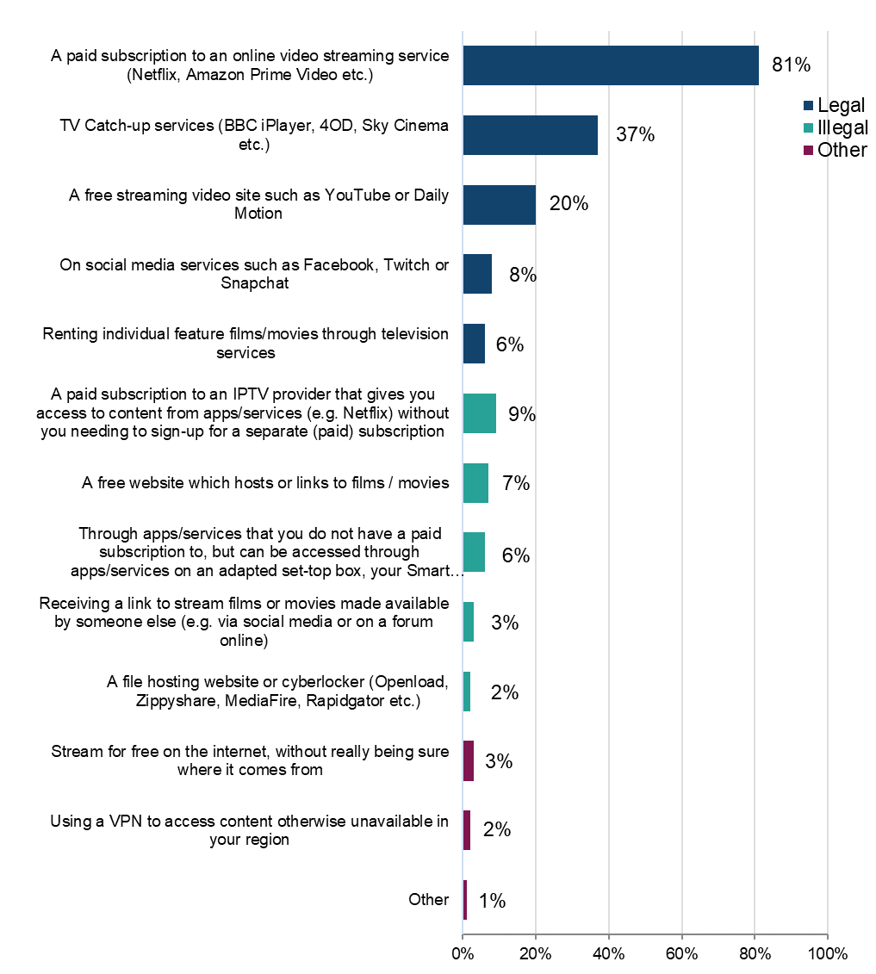
Base: n=2,277 (streamed films in the past three months from the listed sources).

Legality of film streaming

To better understand the distribution of sources across legal and illegal categories, those who had streamed films in the previous three months were grouped into the following (mutually exclusive) categories: using only legal sources; only illegal sources; or a mix of the two.

The answer option “stream for free from the internet, without really being sure where it comes from” was not included in the definition of either legal or illegal. Anyone who said they only consumed content this way was not included in the base.

Headline findings for different sources are as follows:
- legal:
  - 96% had used a legal source to stream films (Figure 39)
  - 79% used legal sources only to stream films
  - Male respondents were more likely than female respondents to use illegal sources to stream films (24% vs 18%) (Figure 40)
  - a majority of respondents in every age group used only legal sources to stream films (66%-85%) (Figure 41)
- illegal:
  - 21% had used an illegal source to stream films (Figure 39)
  - 4% used only illegal sources to stream films
- mixed:
  - 17% used a mix of legal and illegal sources to stream films

Around one in five have used at least one illegal source to stream films
Figure 39: Legality of streaming films. Please also see Table 3.12. Download the data from Table 3.12.

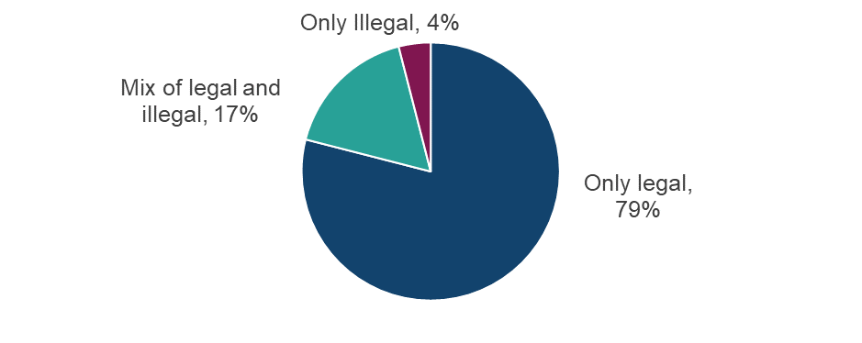

Base: n=2,252 (streamed films in the past three months, with those who selected ‘other’ or ‘not sure of source’ removed)

Male respondents are slightly more likely than female respondents to use illegal sources to stream films
Figure 40: Legality of streaming films by sex. Download the data from Table 3.12.
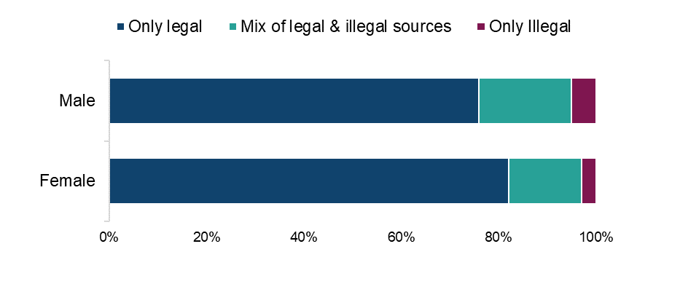
Base: n=2,252 (streamed films in the past three months, with those who selected ‘other’ or ‘not sure of source’ removed)

Higher use of illegal sources to stream films among the younger (under 35) age groups
Figure 41: Legality of streaming films by age. Download the data from Table 3.12.
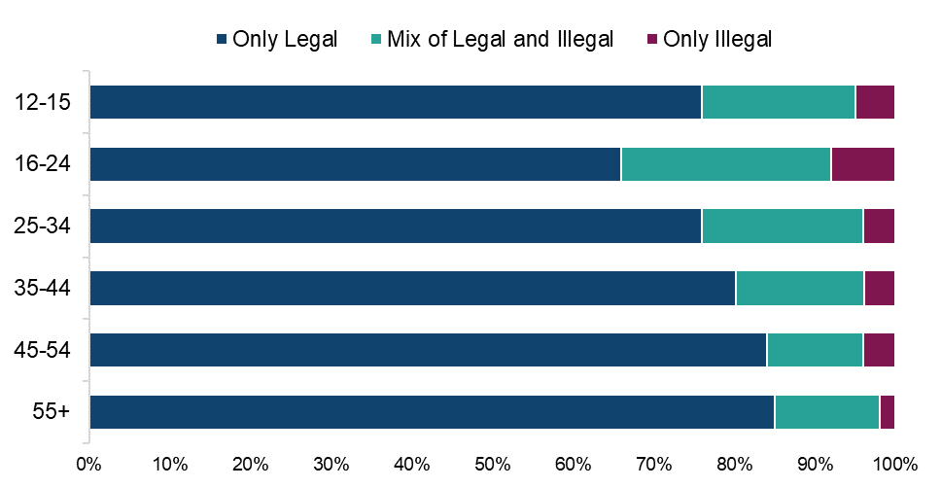

Base: n=2,252 (streamed films in the past three months, with those who selected ‘other’ or ‘not sure of source’ removed)

Higher use of illegal sources to stream films among those with a high passion for films
Figure 42: Legality of streaming films by passion level for film. Download the data from Table 3.12.

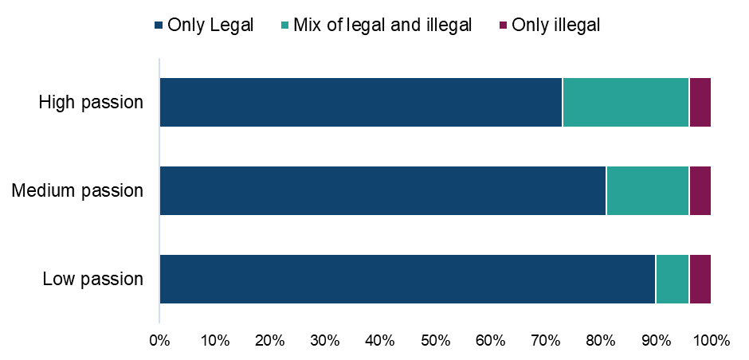

Base: n=2,252 (streamed films in the past three months, with those who selected ‘other’ or ‘not sure of source’ removed)

Paid for subscription services account for around two-thirds of all film streaming time
Table 4: Distribution of film/movie streaming by source. Download the data from Table 3.13.

Legality | Source | Average % of usage split
Legal | A paid subscription to an online video streaming service | 65%
Legal | TV Catch-up services | 14%
Legal | A free streaming video site such as YouTube or Daily Motion | 7%
Legal | On social media services | 2%
Legal | Renting individual feature films / movies through television services | 1%
Illegal | A paid subscription to an IPTV provider that gives you access to content from apps/services without you needing to sign-up for a separate (paid) subscription | 4%
Illegal | A free website which hosts or links to films/movies (WatchFree, Movie4k etc.) | 2%
Illegal | Through apps/services that you do not have a paid subscription to, but can be accessed through apps/services on an adapted set-top box, your Smart TV, mobile devices or entertainment sticks | 2%
Illegal | A file hosting website or cyberlocker | 1%
Illegal | Receiving a link to stream films or movies made available by someone else | 1%
Other | Stream for free on the internet, without really being sure where it comes from | 1%
Other | Other | 1%
Other | Using a VPN to access content otherwise unavailable in your region | 0%

Base: n=2,277 (streamed films in the past three months)

Film streaming: Cyber security incidents

Respondents were asked if they had experienced any of a list of cyber security incidents in the previous 12 months. These incidents included devices being targeted with ransomware, other types of malware, hacking, phishing, social media and/ or email account takeovers, or any other incidents.

Analysis found that 60% of those who had streamed films illegally had experienced at least one cyber security incident (Figure 43). This compares with 39% of those who had used only legal sources.

Those who stream films illegally are more likely to have experienced cyber security incidents in the last 12 months than those only using legal sources
Figure 43: Looking back over the past 12 months, to your knowledge, have you personally experienced any of the following cyber security incidents? Download the data from Table 1.15 of the OCI 2024 Main Data Tables (ODS 103KB).

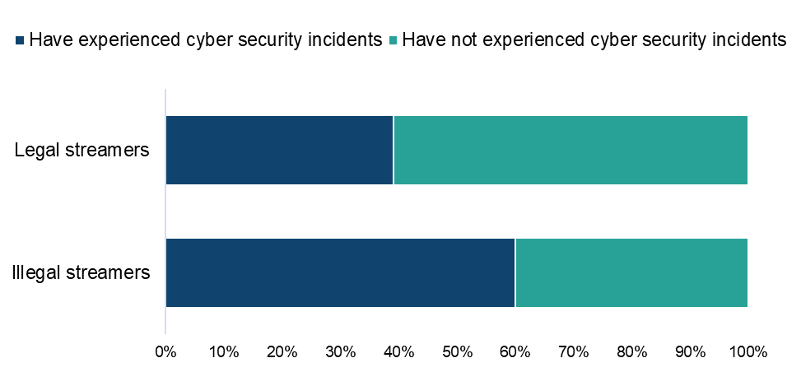

Base: n=2,010 (streamed films from a legal or illegal source, with those who selected ‘other’ or ‘not sure’ removed)

Combined downloading/streaming of film and infringement behaviours

The use of legal and illegal sources for film access (i.e. for both downloading and streaming) were combined to allow us to look at the category as a whole and to examine overall usage behaviours. However, it is important to note that there are significant differences in the relative figures for legal and illegal access when comparing downloading and streaming individually, so caution is advised when interpreting these results.

Headline findings for different sources are as follows:
- legal:
  - just under three-quarters (73%) consumed films online using only legal sources (Figure 44)
  - female respondents are slightly more likely than male respondents (78% v.69%) to use only legal sources (Figure 45)
  - those over the age of 25 were more likely than their younger counterparts to only use legal sources (Figure 46)
  - those with a low or medium passion for films are more likely than those with a high passion to use only legal sources (Figure 47)
- illegal:
  - 2% used illegal sources only to consume films online
- mixed:
  - 25% used a mix of legal and illegal sources to consume films online

The overall infringement level for films for 2024 was therefore 27%.

Detailed demographic analyses related to these findings can be found in table 3.15 in OCI 2024 Supplementary Tables – Film.

Over a quarter have used at least one illegal source to download/stream films
Figure 44: Legality of downloading/streaming films. Download the data from Table 3.15.

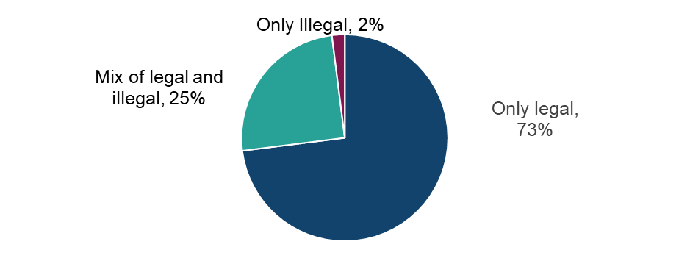

Base: n=2,521 (streamed and/or downloaded films from a legal or illegal source, with those who only selected ‘not sure of source’ removed)

Male respondents are slightly more likely than female respondents to use illegal sources to download/stream films
Figure 45: Legality of downloading/streaming films by sex. Download the data from Table 3.15. 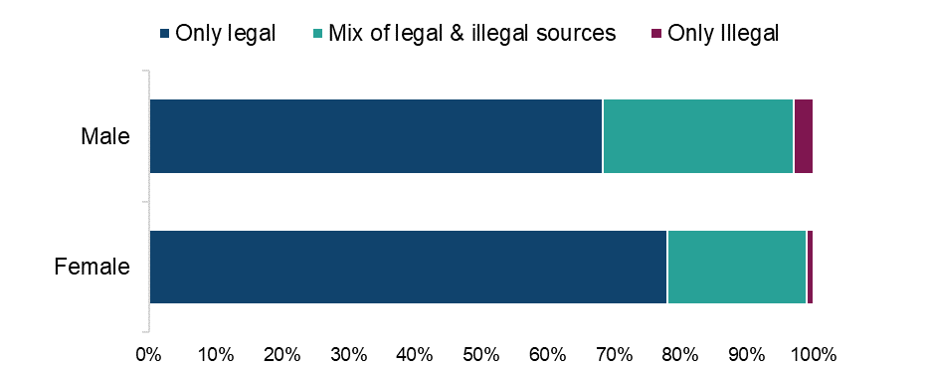
Base: n=2,521 (streamed and/or downloaded films from a legal or illegal source, with those who only selected ‘not sure of source’ removed)

Higher use of illegal sources to download/stream films among the younger age groups
Figure 46: Legality of downloading/streaming films by age. Download the data from Table 3.15.
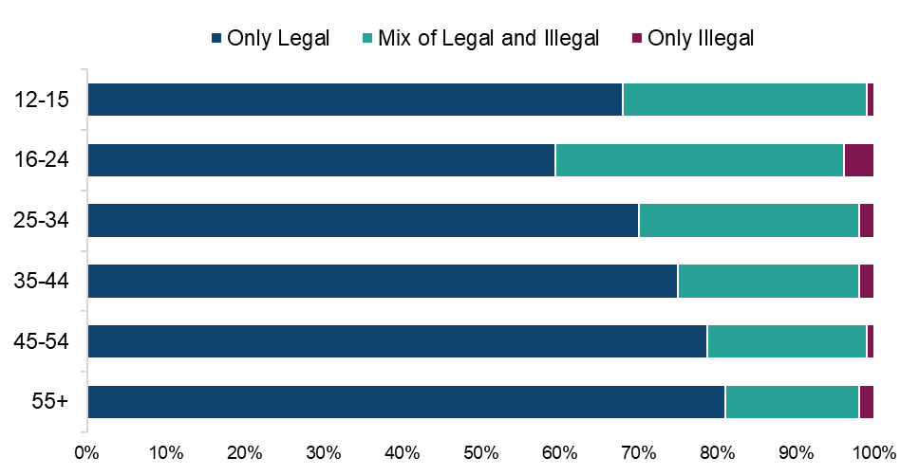
Base: n=2,521 (streamed and/or downloaded films from a legal or illegal source, with those who only selected ‘not sure of source’ removed)

Higher use of illegal sources to download/stream films among those with a high passion for films
Figure 47: Legality of downloading/streaming films by passion level for film. Download the data from Table 3.15.

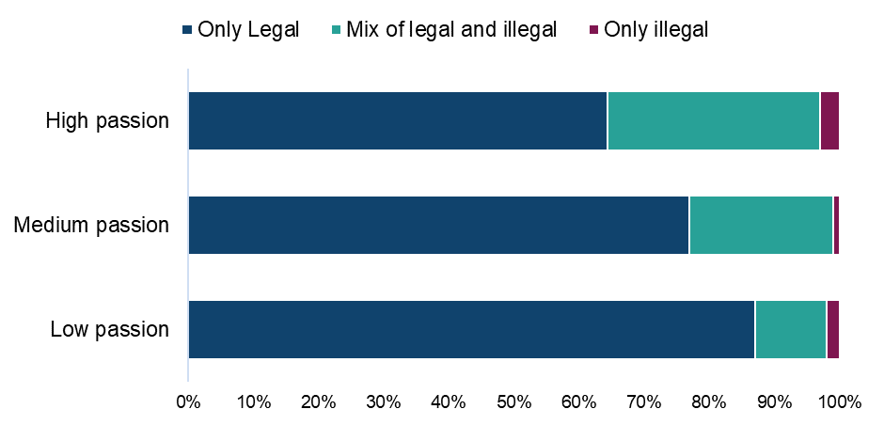

Base: n=2,521 (streamed and/or downloaded films from a legal or illegal source, with those who only selected ‘not sure of source’ removed).

Qualitative insight: accessing film through legal and illegal sources

In terms of accessing film content, most participants in this category used legal streaming services as one source of film content. However, not all paid for this themselves and there was mention of using someone else’s account. A few paid for Sky TV and some mentioned watching films on free streaming platforms such as Channel 4 or BBC iPlayer.

Regarding illegal sources, those mentioned most frequently in our online community were free websites, streaming films on YouTube and Kodi boxes. Many had relied on these sources for years, valuing the benefits of free or low-cost access despite the frequent poor quality and advertisements often associated with illegal sources. Some participants felt particularly negatively about some of the drawbacks of illegal sources. However, they still used them when they didn’t want to take out new subscriptions or pay in some form for content outside what they paid for already.

“I use free websites, sometimes YouTube and am looking into getting a Kodi. YouTube is good but the quality is generally bad. Free websites are amazing but the adverts are annoying. I'm currently researching Kodi and the only downside is you have to pay.”
Male, Film, 16-20

“BitTorrent, uTorrent, downloading from YouTube, receiving via a USB and via Amazon fire stick. The torrent websites have relatively decent quality movies and a wide range of both latest and old movies to choose from but you gave a high risk of viruses as you have to go through a few links to get the best possible one to download the movies. It takes you a while to get the movie after clicking on many links and then most are watermarked which ruins the viewing experience.
YouTube has limited movies you can download and can are cut short or don’t be complete.”
Male, Film, 31-40

“BitTorrent – pros: fast, free, easy. Cons: sometimes you need to wait for things you want to be available.
USB – pros: reliable source, movie comes with recommendations. Cons: depends on other person
Free website – pros: accessible, free. Cons: ads, needs good internet connections, low quality”
Male, Film, 31-40

Most said the illegal sources would be important going forwards, for some simply because they felt they were a good source of content. Others said they could not afford to pay for all the subscriptions they would need to gather all the content they wanted to watch. Some mentioned that they had already been using illegal sources more since feeling an increase in costs in other aspects of life.

“It’s extremely important to be able to access movies for free as they are something that brings people together and helps educate others about different cultures. It's also very valuable for its entertainment value and it's escapism value.”
Female, Film, 31-40

“Very important considering the streaming platforms are getting more and more expensive each year and regular TV has lots of advertising which ruins the viewing experience. Also cinema access of late is not very affordable considering the high cost of living. I have to prioritize essential items over paying for entertainment.”
Male, Film, 31-40

Participants were also asked about whether the division of film content across multiple streaming services impacted their decisions to access content via illegal sources. Many said that this division did indeed push them towards illegal sources due to the expense of signing up to multiple services and the time they felt it took to search different platforms.

The concept of one platform which housed all film content in one place proved popular and participants would be willing to pay between £15 and £25 monthly. There was one mention of a much higher price which the participant felt would be worth it in order to have access to the content they wanted in one place.

“I would be extremely interested in a Spotify-like subscription service for films and I would be willing to pay 10 to 15 pounds per month for it I think it would be extremely popular with the vast majority of people.”
Female, Film, 31-40

“It’s annoying. I wish there were one subscription that gave me everything I wanted to watch. I would pay £100.”
Male, Film, 31-40

“Depending on the movies shown, if it allows access to new releases I would pay £25 a month but if it’s an old catalogue I would rather stick to the regular subscriptions like Netflix and prime video. I find searching through different platforms a bore and time consuming especially if am watching with other people. Yes it causes me to seek content for free on unofficial sites.”
Male, Film, 31-40

“I don't know. It does make me seek content for free sometimes, usually when I have a subscription on another service already and don't want to buy another just for one film.”
Male, Film, 21-30

Paying for films

Those who had used a paid source to either download or stream films were asked how much they had personally spent on each source in the past month. Average monthly expenditure was as follows:

- a paid subscription service (such as Netflix, Amazon Prime Video etc.): £17.80
- paying an individual single fee to download individual films (through services such as iTunes, Amazon or Sky): £2.20
- a paid subscription to an IPTV Provider (such as Insight IPTV, Gears TV etc.): £1.40
- renting individual films through television services (such as Sky, Virgin Media etc.): £0.70
- “other online sources”: £9.60 each month
Detailed demographic analyses related to these findings can be found in Table 3.16 in OCI 2024 Supplementary Tables – Film.

Change in use of illegal sources for film

Those who had used an illegal source to download or stream films were asked how the use of these sources compares to the same point a year ago. Respondents were most likely to indicate that their usage had remained static (48%), followed by having increased (37%) (Figure 48). A relatively small number said their usage had decreased (13%) or that they weren’t using these sources a year ago (1%).

Detailed demographic analyses related to these findings can be found in Table 3.17 in OCI 2024 Supplementary Tables – Film.

37% of those using illegal sources to download or stream films say their use of these sources is increasing
Figure 48: Change in usage of illegal sources to download or stream films/movies compared to last year. Download the data from Table 3.17.
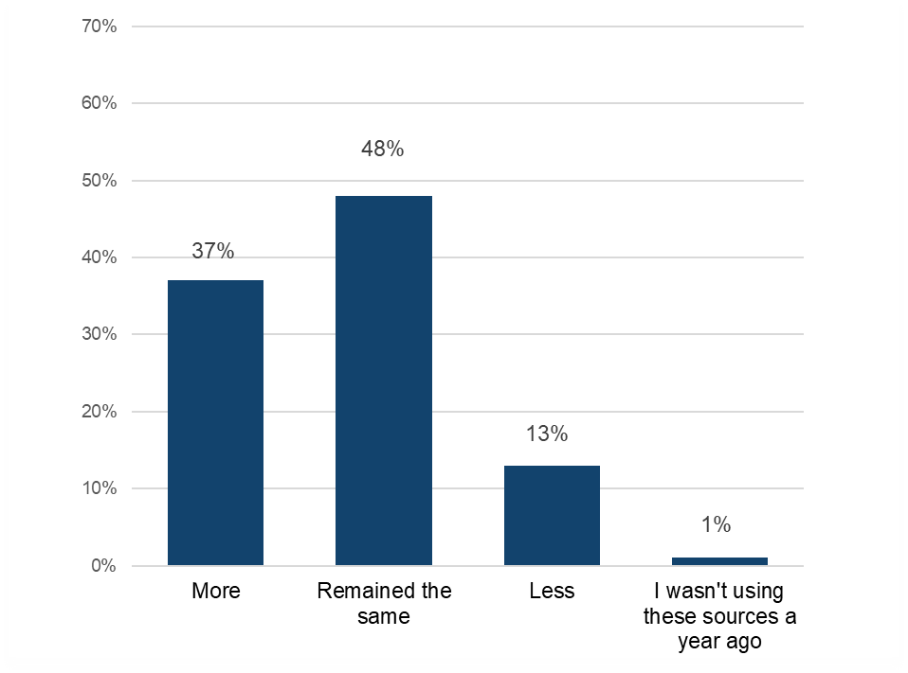
Base: n=673 (downloaded and/or streamed films illegally)

Film: Alternatives to infringement

This section will explore what respondents anticipate they would do if they lost access to illegal sources of films.

Those who had used illegal sources to either download or stream films were asked which single legal source they would use if they could no longer access films illegally. Overall, the most commonly chosen option was a paid one. Almost a third (30%) saying that they would “pay for a subscription or use a paid for premium tier of a video streaming service” (Figure 49). Interestingly, no other single option was selected by more than 16%, with 7% indicating that they were not sure what they would do. However, there did appear to be a slight preference for free options; “TV catch-up services” and “Watch for free via sites such as YouTube” were selected by 16% and 11% respectively.

Detailed demographic analyses related to these findings can be found in Table 3.18 in OCI 2024 Supplementary Tables – Film.

In the absence of illegal film sources, respondents would typically turn to a paid subscription service
Figure 49: Alternative sources for films/movies if illegal options were unavailable. Download the data from Table 2.18.
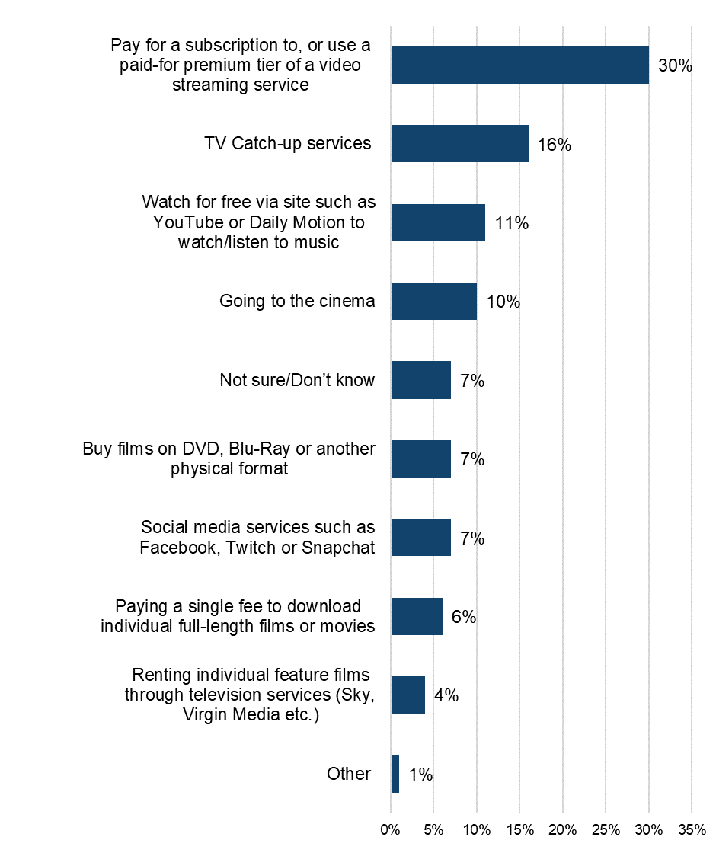
Base: n=673 (downloaded and/or streamed film illegally)

Qualitative insight: reactions to the hypothetical loss of illegal film sources

In the hypothetical situation that illegal methods of access were to disappear, many felt that they would be annoyed and be pushed towards either paying for an additional service or paying for one-off films when needed. Overall, in this qualitative sample most said they would probably pay for content more frequently in some form, but that they might watch less overall.

“This would be very annoying. I guess I’d have to pay for subscriptions. Though I’m not sure all free sources could be abolished. I would keep watching for free where I could.”
Male, Film, 31-40

“I might consider paying one-off fees for films I really wanted to watch.”
Female, Film, 41-50

“I would feel demoralized and as though I wouldn't be able to watch films as regularly or as freely as I used to. Certainly on social occasions and over the holidays particularly Christmas holidays I would feel upset that I'm no longer able to partake in some traditions. I would look for the same content via a different source i.e. for free using Google to find things on YouTube or I would also consider renting or buying from something like sky movies.”
Female, Film, 31-40

“I would pay for the popular-streaming platforms which I already use from time to time like Netflix and Amazon prime because they have lots of movie content I can enjoy with the whole family and also use catch up services which are free like BBC iPlayer. If I paid for these platforms I would definitely consume more because I want to get my money’s worth but if I choose to forgo paying I would consume less content.”
Male, Film, 31-40

Category Insights: TV Programmes/Episodes

Further details and demographic breakdowns for the findings in the TV section can be found in Tables 4.1a – 4.18 in OCI 2024 Supplementary Tables – TV (ODS 139KB), which provide a comprehensive analysis of the data.

Trends in overall TV consumption in the UK

Prior to presenting information on TV programme/episodes infringement levels, it’s useful to initially consider respondents’ engagement with, and consumption of these.

52% had engaged with TV programmes/episodes in the previous three months (i.e. either by downloading, streaming, sharing or purchasing physical copies).

The definition of ‘shared’ was provided as: “By shared we mean that you personally made the file publicly available or sent or uploaded it online for someone else to download or stream/access. This does not include sending links to content that has already been shared by someone else, unless stated in the answer option.

In terms of overall consumption, analysis found that:
- streaming was the most common method of accessing TV programmes/episodes, with 45% having done so (Figure 50)
- it was at least half among those aged 25-54, with the immediate younger (12-24) age groups just slightly behind (45%-46%), while the 55 and above age group were lower (38%)
- the proportion who had downloaded TV programmes/episodes followed by some way behind at 23%, with just 5% having purchased physical copies (Figure 50)

Detailed demographic analyses related to these findings can be found in Tables 4.1a – 4.1d in OCI 2024 Supplementary Tables – TV.

Streaming is the most frequent means of engaging with TV programmes/episodes
Figure 50: Downloaded/streamed/shared/purchased physical copies of TV programmes/episodes in the past three months. Download the data from Tables 4.1a – 4.1d.
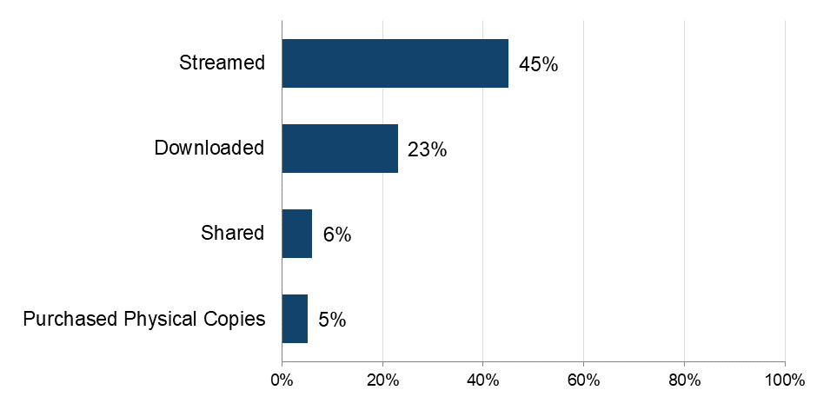

Base: n=5,087 (total sample)

The importance of TV programmes/episodes

To get a broader sense of their passion for TV programmes/episodes, respondents were asked to what extent they agreed with a range of statements and then grouped as High, Medium or Low, based on their responses.

Analysis found that 43% of category consumers displayed high levels of passion for TV programmes/episodes, with passion higher among female respondents (46%) than male respondents (41%) (Figure 51). This level of passion sustained for most age groups, but dipped to fewer than a third (32%) for those aged 55 and above.

Detailed demographic analyses related to these findings can be found in Tables 4.2a – 4.2f in OCI 2024 Supplementary Tables – TV.

Over 40% of those who have recently consumed TV programmes/episodes have a high level of passion for them
Figure 51: Passion levels for TV programmes/episodes. Download the data from Table 2.3.

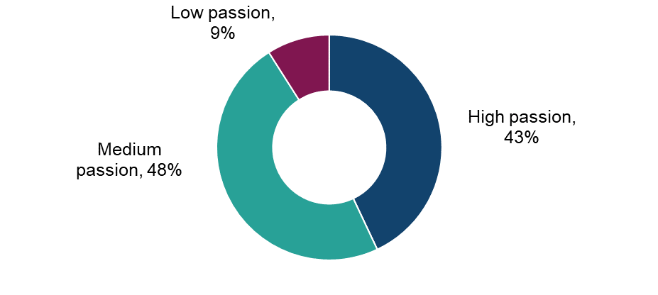
Base: n=2,665 (downloaded, streamed, shared and/or purchased physical copies of TV episodes in the past three months)

Around three-quarters of respondents actively search for new programmes/episodes to watch, regarding them to some extent as their favourite kind of entertainment
Figure 52: Extent of agreement with statements in relation to TV programmes/episodes. Download the data from Tables 4.2a – 4.2f.

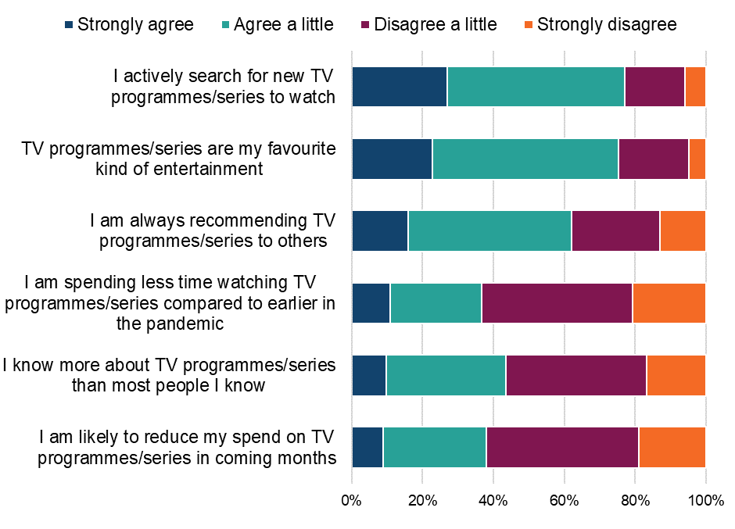
Base: n=2,665 (downloaded, streamed, shared and/or purchased physical copies of TV episodes in the past three months)

Qualitative insight: the importance of TV programmes/episodes in people’s lives

The ideas which came up frequently amongst our qualitative sample around TV were relaxation and escapism and the idea that TV could transport people to different places and take their minds off their daily loves. For this reason, watching TV in the evening was popular to wind down from the rest of the day, though there were some who reported having television running throughout the day.

“It gives me a sense of escapism and takes my mind off other things. Mostly in the evenings when me and mum sit down together.”
Female, TV, 31-40

“I guess the main role of TV programs is a mix of entertainment and information. I like a good documentary so that I can expand my knowledge but also something to take my mind off everything, so a good film or TV show which I don't have to take too seriously. I find it relaxing to watch TV in the evening, after dinner, before I go to bed.”
Male, TV, 41-50

“I find that the tv programmes relax and entertain me, if the series is good, it's possible to become immersed in a different world. They provide me with a sense of escapism. The occasions are watching tv in bed and relaxing, not doing anything else at the same time.”
Male, TV, 41-50

Most reported in our online community that their consumption of TV had remained at similar levels, except a few who reported changes based on having less disposable income at present.

“I would say that over the last year how often I access TV has stayed the same and I don’t think there will be any reason it would change.”
Male, TV, 21-30

“I had a free trial for Disney + so I was using it more often so I don't miss out. I watch from free sites that are ad supported but I spend less time for this option. I think I will splash out on more subscription services when I get an income.”
Male, TV, 21-30

“Yes, it has changed due to my financial challenges and due to my work schedule.”
Female, TV, 31-40

Physical purchasing of TV programmes/series

This section refers to the rate of purchasing of physical copies of TV programmes/series followed by rates of online purchasing.

The 5% of respondents who had purchased TV in physical formats, such as DVDs or Blu-rays, during the previous three months were asked more questions around frequency and number of purchases made. Analysis of the responses found that 49% were frequent purchasers (i.e. at least once a week) of TV programmes/series in physical formats, and on average purchased 30 items in a three-month period.

Detailed demographic analyses related to these findings can be found in tables 4.4a -4.4b in OCI 2024 Supplementary Tables – TV. It should be noted that smaller sample sizes for individual age groups (i.e. all below n=100) means that these results should be interpreted with caution.

Understanding online consumption of TV programmes/series

To better understand the drivers of online consumption, those who had streamed or downloaded TV programmes/series in the previous three months were asked to select their top three reasons for accessing these online.

Two reasons dominated motivations – these focused on ease of immediate access (“being able to watch TV programmes/series instantly whenever I want” 51%) and the range of options available (“having a wide range of TV programmes/series to watch” 48%) (Figure 53). The most selected following factors both related to price, with “it’s free or cheap” and “getting value for money” both chosen by over a quarter of respondents (31% and 26% respectively).

A further group of factors, selected by 18-21% of respondents, related to exclusive access to content, convenience, and the social aspect of watching with loved ones. No other factor was selected by more than 12% of respondents.

Detailed demographic analyses related to these findings can be found in Table 4.4c in OCI 2024 Supplementary Tables – TV.

Instant access and variety drive the consumption of streamed or downloaded TV programmes/episodes
Figure 53: Main reasons for accessing TV programmes/episodes online (i.e. downloading or streaming). Download the data from Table 4.4c.

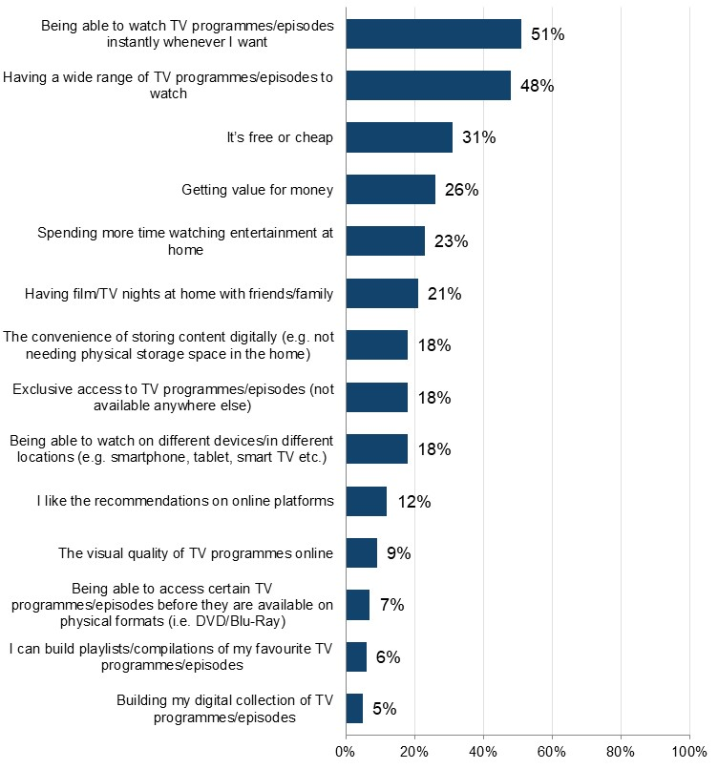
Base: n=2,559 (downloaded or streamed TV programmes/episodes online in the past three months). Respondents were able to select multiple options, so the percentages presented do not sum to 100%.

Downloading TV programmes/episodes

This section details the rates of downloading of TV programmes/episodes from the internet, followed by a deep dive into infringement within this form of accessing TV programmes/episodes.

Frequency and volume of downloading TV programmes/episodes

The 23% who had downloaded TV programmes/episodes during the previous three months were asked more questions around frequency, volume and sources used.

Analysis of these responses found that 61% of those who had downloaded TV programmes/episodes did so frequently (i.e. at least once a week) (Figure 54). This was highest among those aged 35-44 (67%) and exceeded 58% in all age groups.
In terms of volume, over a three-month period, respondents downloaded an average of 63 TV programmes/episodes to watch. This was highest among those aged 25-34 and 55 and above, (76-77%).

Detailed demographic analyses related to these findings can be found in Tables 4.5a – 4.5b in OCI 2024 Supplementary Tables – TV.

61% of those downloading TV programmes/episodes are doing so at least weekly
Figure 54: Frequency of downloading TV programmes/episodes through the internet. Download the data from Table 4.5a.

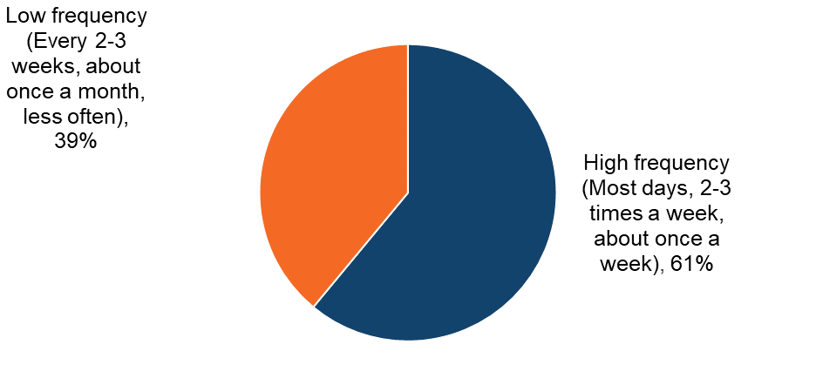
Base: n=1,151 (downloaded TV programmes/episodes in the past three months)

TV programmes/episodes downloading: Infringement behaviours

Sources of downloading TV programmes/episodes

Respondents were shown a list that encompassed the different ways (legal and illegal) that they could download TV programmes/episodes. An ‘unknown’ option was provided to serve as a catch-all for those who were unsure of the exact source.

Analysis found that the top three sources for downloading TV programmes were all legal ones (Figure 55). The most commonly used, which was also the only one selected by more than half of respondents, was “saving offline on a paid subscription service” (65%). This was followed by “saving offline on catch-up services” (34%) and “paying a single fee to download TV programmes/episodes” (18%).

The most used illegal source was an “online converter” which converts YouTube videos to files (10%) – use of this source peaked among those aged 12-34 (13-16%). “BitTorrent or another file-sharing or peer to peer service” and “file hosting website or cyberlocker” followed (5% and 4% respectively). No other illegal sources were used by more than 5%.

Detailed demographic analyses related to these findings can be found in Tables 4.6 – 4.8 in OCI 2024 Supplementary Tables – TV.

Legal, paid for subscription services dominate as the number one source for TV programme/episode downloads
Figure 55: Sources used to download TV programmes/episodes in the past three months. Download the data from Table 4.6.
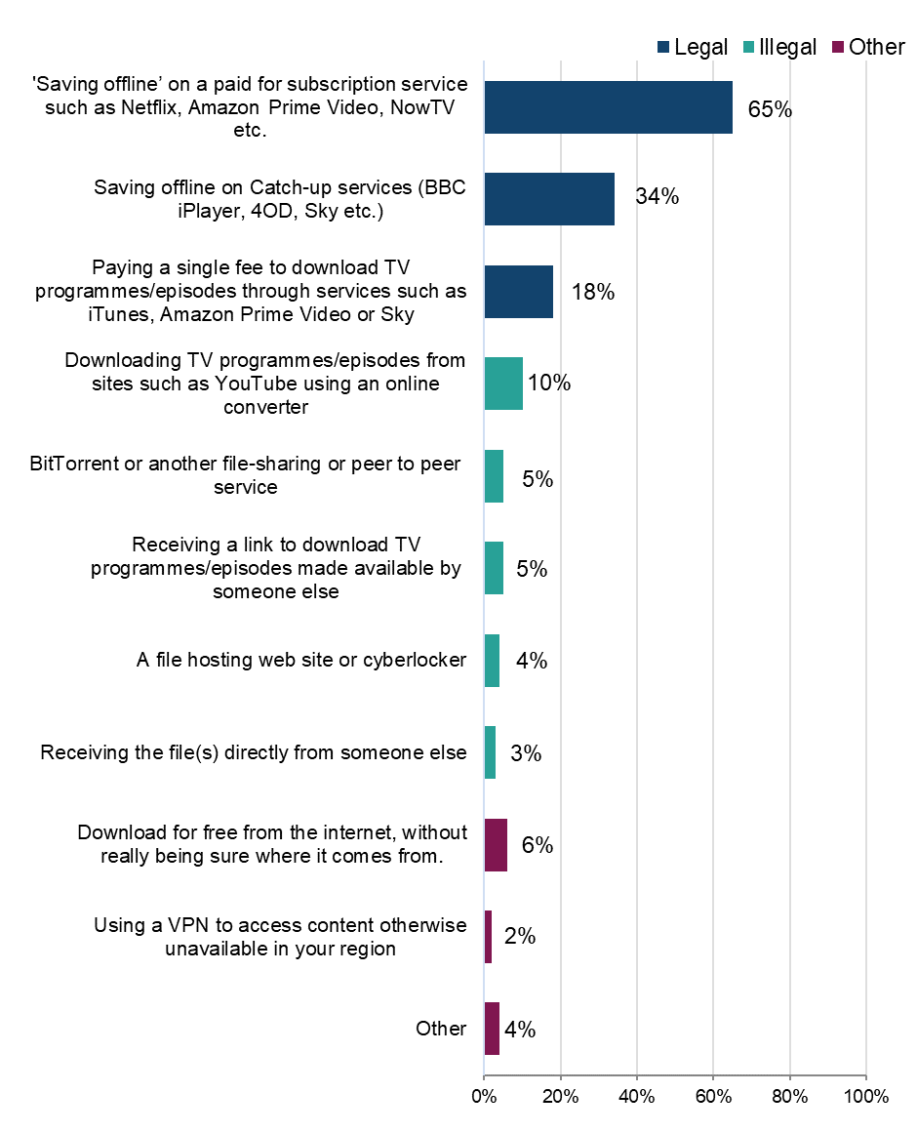
Base: n=1,151 (downloaded TV programmes/episodes in the past three months). Respondents were able to select multiple options, so the percentages presented do not sum to 100%.

Legality of TV programmes/episodes downloads

To better understand the distribution of sources across legal and illegal categories, those who had downloaded TV programmes/episodes in the previous three months were grouped into the following (mutually exclusive) categories: using legal sources only; illegal sources only; or a mix of the two.

The answer option “download for free from the internet, without really being sure where it comes from” was not included in the definition of either legal or illegal. Anyone who said they only consumed content this way was not included in the base.

Headline findings for different sources are as follows:
- legal:
  - 92% had used a legal source to download TV programmes/episodes (Figure 56)
  - an increasing percentage had used legal sources only to download TV programmes/episodes
- illegal:
  - 19% had used an illegal source to download TV programmes/episodes
  - 8% had used illegal sources only to download TV programmes/episodes
  - use of illegal sources was highest among those aged 25-34 (29%) (Figure 58) and those with a high passion for TV (23%) (Figure 59)
- mixed:
  - 11% had used a mix of legal and illegal sources to download TV programmes/episodes
  - use of a mix of sources was notably highest among those with a ‘high’ passion for TV at 15%
  - male respondents were twice as likely as female respondents to use a mix of legal and illegal sources to download TV programmes/episodes (16% vs 8%) (Figure 56)

Around one in five have used at least one illegal source to download TV programmes/episodes
Figure 56: Legality of downloading TV programmes/episodes. Download the data from Table 4.7.
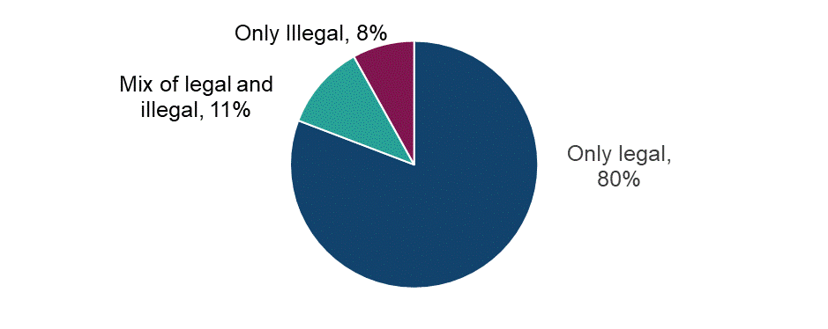Base: n=1,080 (downloaded TV programmes/episodes in the past three months, with those who selected ‘other’ or ‘not sure of source’ removed).

Male respondents are more likely than female respondents to use illegal sources to download TV programmes/episodes
Figure 57: Legality of downloading TV programmes/episodes by sex. Download the data from Table 4.7.
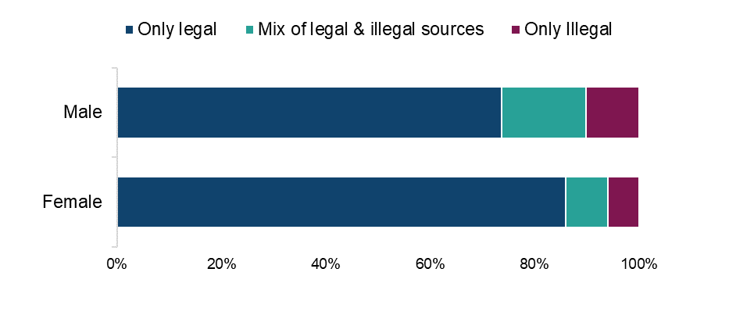
Base: n=1,080 (downloaded TV programmes/episodes in the past three months, with those who selected ‘other’ or ‘not sure of source’ removed).

Higher use of illegal sources to download TV programmes/episodes among those respondents under the age of 45
Figure 58: Legality of downloading TV programmes/episodes by age. Download the data from Table 4.7.
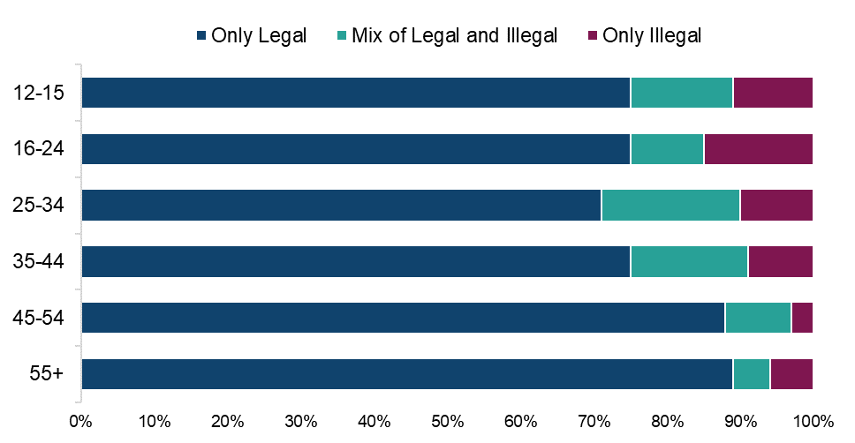

Base: n=1,080 (downloaded TV programmes/episodes in the past three months, with those who selected ‘other’ or ‘not sure of source’ removed).

Higher use of illegal sources to download TV programmes/episodes among those with a high passion for TV
Figure 59: Legality of downloading TV programmes/episodes by passion level for TV. Download the data from Table 4.7.
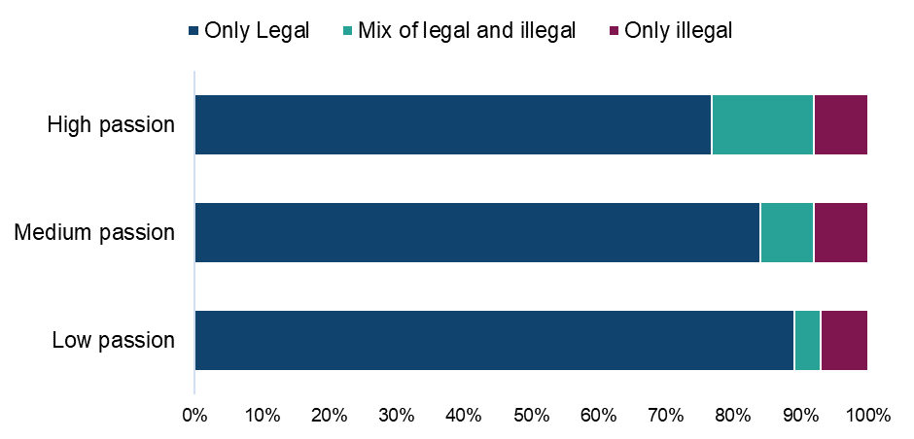

Base: n=1,080 (downloaded TV programmes/episodes in the past three months, with those who selected ‘other’ or ‘not sure of source’ removed).

Detailed demographic analyses related to these findings can be found in tables 4.7-4.8 in OCI 2024 Supplementary Tables - TV.

Legal sources services account for 80% of all TV programme/episode downloads/download time
Table 5 - Distribution of TV programme/episodes downloads by source. Download the data from Table 4.8.
Legality | Source | Average % of usage split
Legal | “Saving offline” on a paid for subscription service such as Netflix, Amazon Prime Video, NowTV etc. | 51%
Legal | Saving offline on Catch-up services (BBC iPlayer, 4OD, Sky etc.) | 21%
Legal | Paying a single fee to download TV programmes/episodes through services such as iTunes, Amazon Prime Video or Sky | 8%
Illegal | BitTorrent or another file-sharing or peer to peer service where links to download files are typically available on sites such as The Pirate Bay | 3%
Illegal | Downloading TV programmes/episodes from sites such as YouTube using an online converter (e.g. Y2mate, Flvto.biz) or a software, app or browser extension | 5%
Illegal | A file hosting website or cyberlocker | 2%
Illegal | Receiving a link to download TV programmes/episodes made available by someone else | 2%
Illegal | Receiving the file(s) directly from someone else for free | 1%
Other | Using a VPN to access content otherwise unavailable in your region | 1%
Other | Download for free from the internet, without really being sure where it comes from | 4%
Other | Other | 4%

Base: n=1,151 (downloaded TV programmes/episodes in the past three months)

TV programmes/episode downloading: Cyber security incidents

Respondents were asked if they had experienced any of a list of cyber security incidents in the previous 12 months. These incidents included devices being targeted with ransomware (a type of malware that locks or encrypts files on a device and demands payment for access), other types of malware, hacking, phishing, social media and/ or email account takeovers, or any other incidents.
We observed a consistent trend: infringers were significantly more likely than non-infringers to report experiencing a cyber security incident. While a definitive causal link cannot be established, this may be influenced by factors such as higher digital engagement among infringers, increased exposure to unverified sources, or reliance on websites that pose a risk, and compromised content platforms.
Of those who had downloaded TV programmes/episodes illegally, 73% had experienced at least one cyber security incident (Figure 60). This compares with 45% of those who had used only legal sources.

Those who download TV programmes/episodes illegally are more likely to have experienced cyber security incidents in the last 12 months than those only using legal sources
Figure 60: Looking back over the past 12 months, to your knowledge, have you personally experienced any of the following cyber security incidents? Download the data from Table 1.15 of the OCI 2024 Main Data Tables (ODS 103KB).
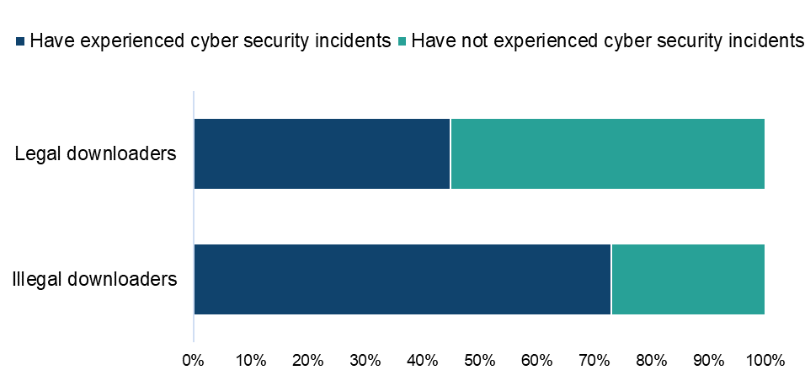

Base: n=989 (downloaded TV programmes/episodes from a legal or illegal source, with those who selected ‘other’ or ‘not sure’ removed)

Qualitative insight: TV programmes/episodes and cyber security incidents

Qualitatively, few people had experienced cyber security incidents and within this sample, they were relatively mild in the form of pop-up windows and annoying ads. However, quite a few mentioned their concerns about being caught for streaming or downloading illegal content, which is mentioned occasionally in other categories too. This shows that some believe they could potentially face legal prosecution or fines which keeps them cautious.

“Only a little concerned if I was ever caught to be honest. I would just change to a different website if I ever encountered a problem.”
Female, TV, 31-40

“I have had concerns about downloading a virus from one file host in particular because of the pop-up windows that I have to deal with, but so far everything's been fine. Other than that, I have no concerns. The pop-up windows didn't have any adverse impacts.”
Male, TV, 41-50

“I would imagine getting caught and perhaps fined so yes I have had concerns about using said resources in the first place.”
Male, TV, 41-50

“I have never had a bad experience to date. But I would be worried about being caught and possibly ending up with a criminal record.”
Male, TV, 51-60

Streaming TV programmes/episodes

This section details the rate of streaming of TV programmes/episodes online, followed by a deep dive into infringement within this form of accessing TV programmes/episodes.

Frequency and volume of streaming TV programmes/episodes

The 45% of respondents who had streamed TV programmes/episodes online during the previous three months were asked questions around frequency, volume and sources used. Of these, 80% were frequent streamers of TV programmes/episodes, doing so weekly (Figure 61). This high frequency of streaming (80%+) was evident among all age groups bar one; among the over 55’s it dropped to 70%.

In terms of volume, respondents spent an average of 122 hours streaming TV programmes/episodes over a three-month period, peaking among those aged 25-34 (150 hours)

Detailed demographic analyses related to these findings can be found in tables 4.9 – 4.11 in OCI 2024 Supplementary Tables – TV.

80% of those streaming TV programmes/episodes via the internet are doing so at least weekly
Figure 61: - Frequency of streaming TV programmes/episodes through the internet. Download the data from Table 4.10.

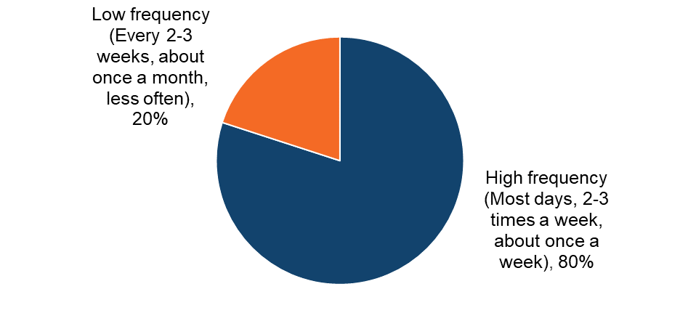
Base: n=2,293 (streamed TV programmes/episodes in the past three months)

TV programmes/episode streaming: Infringement behaviours

Sources of TV programme/episode streaming

Respondents were shown a list that encompassed the different ways (legal and illegal) that they could stream TV programmes/episodes. An ‘unknown’ option was provided to serve as a catch-all for those who were unsure of the exact source.

Analysis found that legal sources were the most used for streaming TV programmes (Figure 62). Furthermore, the top option by some way was a paid source, with 75% using a “paid subscription to an online video streaming service”. This was followed by “TV Catch-up services”, which were used by over half (51%), with “a free streaming video site such as YouTube” in a distant third place (18%). Other legal sources (e.g. social media services, renting programmes/episodes) were used by a small minority of respondents (4-7%). No illegal source was used by more than 7% of respondents

Detailed demographic analyses related to these findings can be found in Table 4.11 in OCI 2024 Supplementary Tables – TV.

Legal, paid subscription services dominate as the number one source of TV programme/episode streaming
Figure 62: Sources used to stream TV programmes/episodes in the past three months. Download the data from Table 4.11.
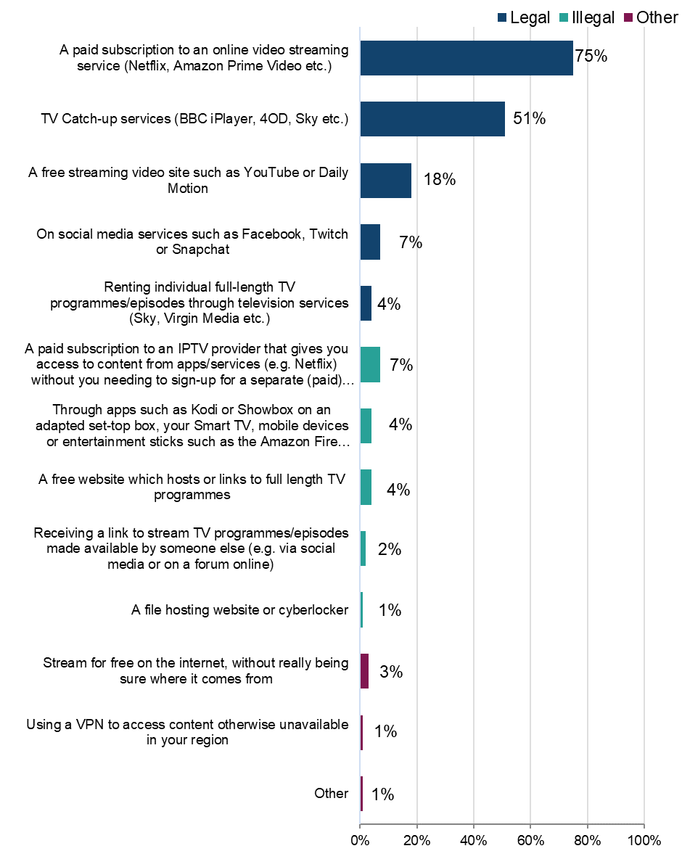
Base: n=2,293 (streamed TV programmes/episodes in the past three months)

Legality of TV programmes/episodes streaming

To better understand the distribution of sources across legal and illegal categories, those who had streamed TV programmes/episodes in the previous three months were grouped into the following (mutually exclusive) categories: using legal sources only; illegal sources only; or a mix of the two.

The answer option “Stream for free from the internet, without really being sure where it comes from” was not included in the definition of either legal or illegal. Anyone who said they only consumed content this way was not included in the base.

Headline findings for different sources are as follows:
- legal:
  - almost all (98%) had used at least one legal source to stream TV programmes/episodes (Figure 63)
  - 85% used legal sources only to stream TV programmes/episodes
  - the majority of male and female respondents use only legal sources to stream TV programmes/episodes, with female respondents (87%) more likely to do so than male respondents (83%) (Figure 64)
- illegal:
  - 15% had used at least one illegal source to stream TV programmes/episodes
  - generally, the younger the respondent, the higher the likelihood of them using illegal sources (Figure 65)
  - 2% had used illegal sources only to stream TV programmes/episodes
- mixed:
  - 13% had used a mix of legal and illegal sources to stream TV programmes/episodes
  - the use of a mix of both legal and illegal sources is higher for those with a high passion (15%) for TV than for those with a low passion (6%) (Figure 66)

15% have used at least one illegal source to stream TV programmes/episodes
Figure 63: Legality of streaming TV programmes/episodes. Download the data from Table 4.12.

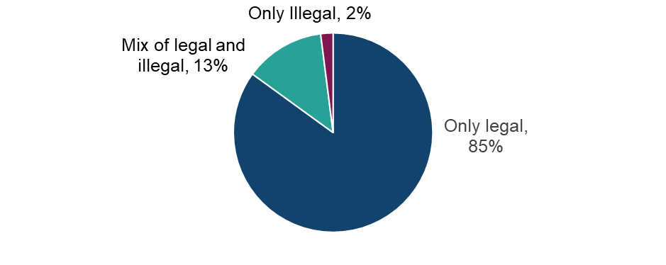
Base: n=2,261 (streamed TV programmes/episodes in the past three months, with those who selected ‘other’ or ‘not sure of source’ removed)

A majority of both male and female respondents most likely to use legal sources to stream TV programmes/episodes
Figure 64: Legality of streaming TV programmes/episodes by sex. Download the data from Table 4.12.
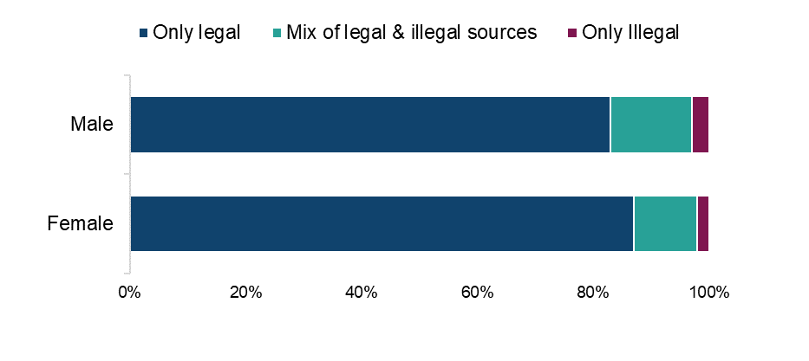
Base: n=2,261 (streamed TV programmes/episodes in the past three months, with those who selected ‘other’ or ‘not sure of source’ removed)

Higher use of illegal sources to stream TV programmes/episodes among the younger age groups
Figure 65: Legality of streaming TV programmes/episodes by age. Download the data from Table 4.12.
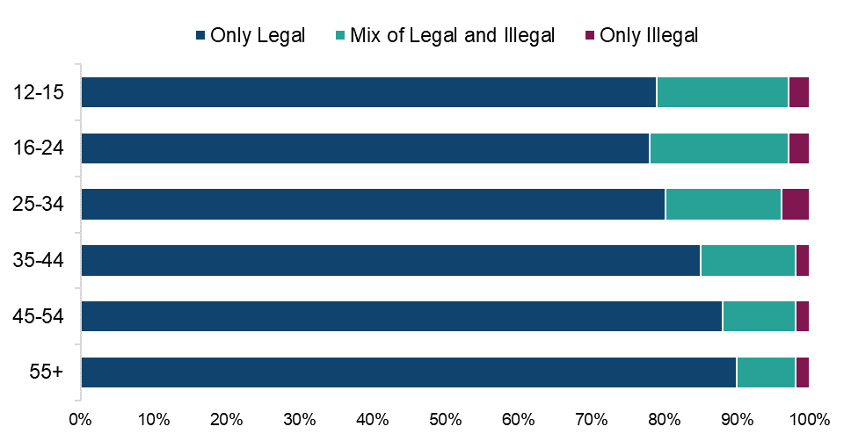

Base: n=2,261 (streamed TV programmes/episodes in the past three months, with those who selected ‘other’ or ‘not sure of source’ removed)
Higher use of illegal sources to stream TV programmes/episodes among those with a high passion for TV
Figure 66: Legality of streaming TV programmes/episodes by passion level for TV. Download the data from Table 4.12.
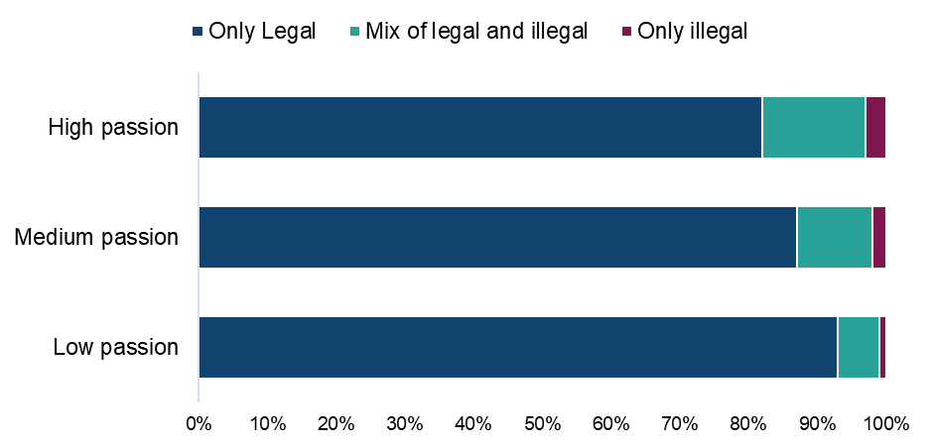
Base: n=2,261 (streamed TV programmes/episodes in the past three months, with those who selected ‘other’ or ‘not sure of source’ removed)

Paid for subscription services account for more than 90% of all TV programme/episodes streaming time
Table 6:- Distribution of TV programmes/episodes streaming by source. Download the data from Table 4.13.
Legality | Source | Average % of usage split
Legal | A paid subscription to an online video streaming service (Netflix, Amazon Prime Video etc.) | 55%
Legal | TV Catch-up services (BBC iPlayer, 4OD, Sky etc.) | 27%
Legal | A free streaming video site such as YouTube or Daily Motion | 6%
Legal | On social media services such as Facebook, Twitch or Snapchat | 2%
Legal | Renting individual full-length TV programmes/episodes through television services (Sky, Virgin Media etc.) | 1%
Illegal | A paid subscription to an IPTV provider (Insight IPTV, Gears TV etc.) that gives you access to content from apps/services (e.g. Netflix) without you needing to sign-up for a separate (paid) subscription | 3%
Illegal | Through apps such as Kodi or Showbox on an adapted set-top box, your Smart TV, mobile devices or entertainment sticks such as the Amazon Fire Stick or the Google Chromecast | 1%
Illegal | A free website which hosts or links to full length TV programmes (WatchFree, Watch Series etc.) | 1%
Illegal | A file hosting web site or cyberlocker (MediaFire, Rapidgator etc.) | 1%
Illegal | Receiving a link to stream TV programmes/episodes made available by someone else (e.g. via social media or on a forum online) | 1%
Other | Stream for free on the internet, without really being sure where it comes from. | 2%

Base: n=2,293 (streamed TV programmes/episodes in the past three months)

TV programmes/episode streaming: Cyber security incidents

Respondents were asked if they had experienced any of a list of cyber security incidents in the previous 12 months. These incidents included devices being targeted with ransomware, other types of malware, hacking, phishing, social media and/ or email account takeovers, or any other incidents. Analysis found that 58% of those who had streamed TV programmes/episodes illegally had experienced at least one cyber security incident (Figure 67). This compares with 41% of those who had used only legal sources.

Those who stream TV programmes/episodes illegally are more likely to have experienced cyber security incidents in the last 12 months than those only using legal sources
Figure 67: Looking back over the past 12 months, to your knowledge, have you personally experienced any of the following cyber security incidents? Download the data from Table 1.15 of the OCI 2024 Main Data Tables (ODS 103KB).
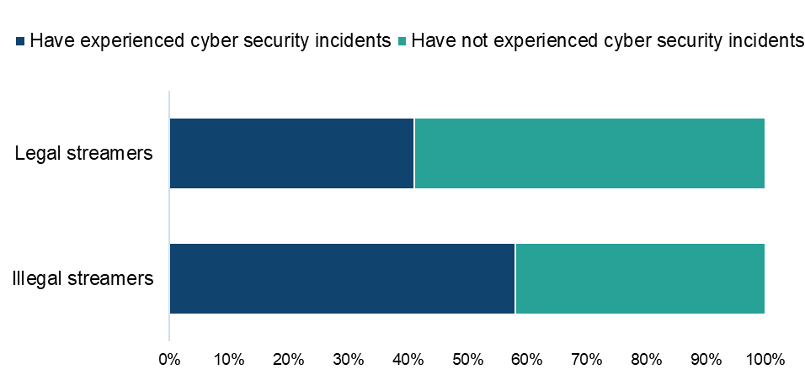

Base: n=2,056 (streamed TV programmes/episodes from a legal or illegal source, with those who selected ‘other’ or ‘not sure’ removed)

Combined downloading/streaming of TV programmes/episodes and infringement behaviours

The use of legal and illegal sources for TV programmes/episodes access (i.e. for both downloading and streaming) were combined to allow us to look at the category as a whole. We would, however, express caution when interpreting these results, owing to the distinct differences in the legal and illegal figures for downloading and streaming independently.

Headline findings for different sources are as follows:
- legal:
  - 81% indicated that they use legal sources only (Figure 68)
  - female respondents (85%) were more likely than male respondents (78%) to use legal sources only (Figure 69)
- illegal:
  - 1% used illegal sources only
- mixed:
  - 18% used a mix of legal and illegal sources
  - using a mix of legal and illegal sources was highest among the younger age groups (under 45) (Figure 70) and among those with a high passion for TV (Figure 71)

The overall infringement level for TV programmes/episodes for 2024 was therefore 18%.

Detailed demographic analyses related to these findings can be found in Table 4.15 in OCI 2024 Supplementary Tables – TV.

19% have used at least one illegal source to download/stream TV programmes/episodes
Figure 68: Legality of downloading/streaming TV programmes/episodes. Download the data from Table 4.15.
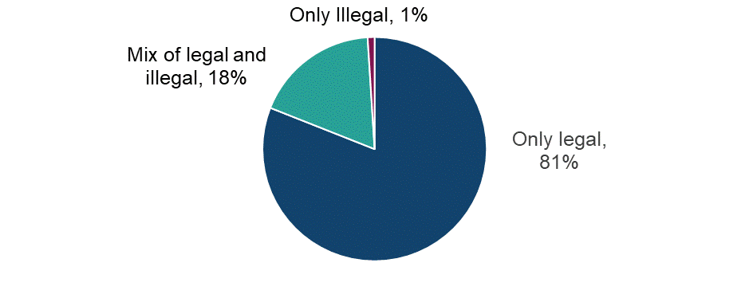Base: n=2,510 (those who have streamed and/or downloaded TV programmes/episodes from a legal or illegal source with those who only selected ‘not sure of source’ counting as illegal)

Male respondents are slightly more likely than female respondents to use illegal sources to download/stream TV programmes/episodes
Figure 69 - Legality of downloading/streaming TV programmes/episodes by sex. Download the data from Table 4.15.
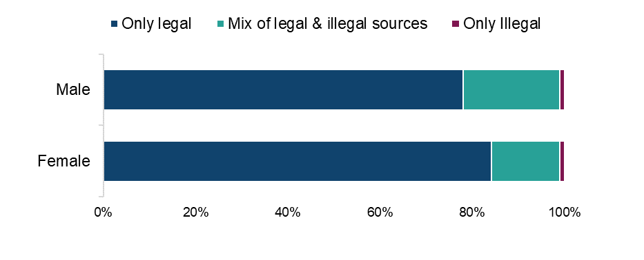
Base: n=2,510 (those who have streamed and/or downloaded TV programmes/episodes from a legal or illegal source with those who only selected ‘not sure of source’ counting as illegal)

Higher use of illegal sources to download/stream TV programmes/episodes among the younger age groups
Figure 70: Legality of downloading/streaming TV programmes/episodes by age. Download the data from Table 4.15.
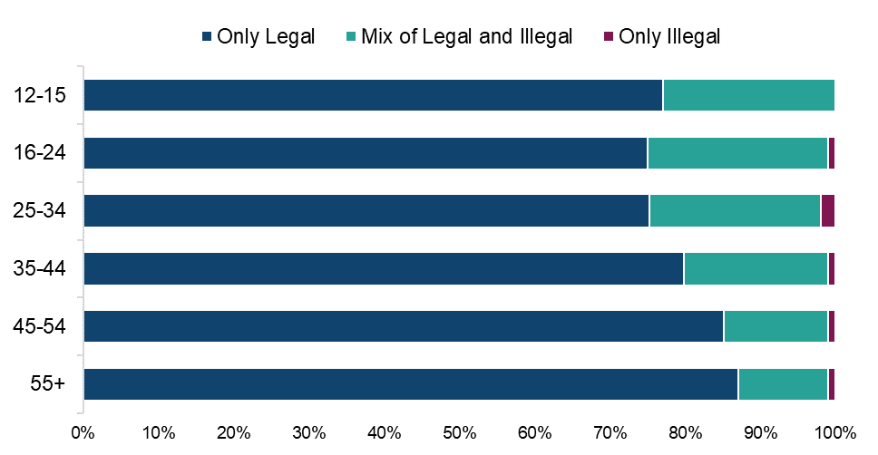

Base: n=2,510 (those who have streamed and/or downloaded TV programmes/episodes from a legal or illegal source with those who only selected ‘not sure of source’ counting as illegal)

Higher use of illegal sources to download/stream TV programmes/episodes among those with a high passion for TV
Figure 71: Legality of downloading/streaming TV programmes/episodes by level of passion for TV. Download the data from Table 4.15.

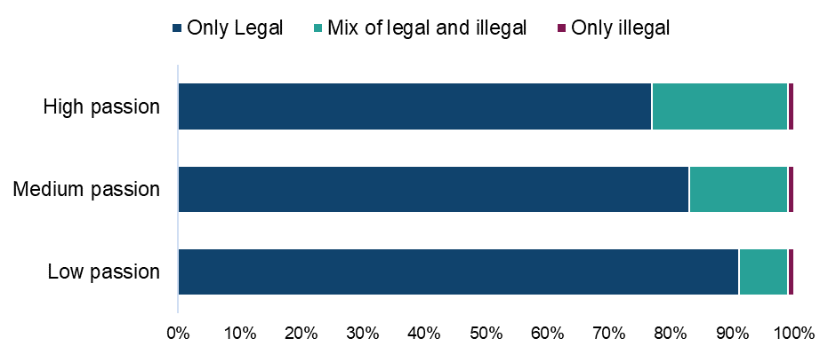

Base: n=2,510 (those who have streamed and/or downloaded TV programmes/episodes from a legal or illegal source with those who only selected ‘not sure of source’ counting as illegal)

Qualitative insight: accessing TV through legal and illegal sources

Many accessed TV through a mix of legal and illegal sources. Most in our online community were subscribed to some form of streaming service i.e. Netflix, Disney+ etc. However, some only watched content on such platforms when they came across a trial but couldn’t afford to keep subscribing afterwards. Free and legal services were also popular and mentioned by most, many saying that BBC iPlayer and Channel 4 had lots of interesting content. YouTube was also used to watch TV programs by some.

Regarding illegal sources, these varied mostly between free websites such as Watch Free or rapidmoviez, and BitTorrent sites. Many cited drawbacks to these illegal sources such as frustrating adverts, interrupted streams or watermarks. However, for most the fact that they were able to access content for free was enough to keep using these, especially in cases where they couldn’t find content on their paid platforms.

“I have used BitTorrent to download but now I'm just concerned about viruses. I have used free unauthorised websites but they tend to lag more often and it's just difficult finding ones that haven't been blocked anymore. The strengths are that you get to access it for free. The weaknesses are that they don't always have everything I'm looking for, they sometimes come with watermarks or don't even have the full content.”
Male, TV, 21-30

“I use free websites sometimes. The benefits are I get to see them for free. In some cases, I get to see programmes before they are aired on TV. The weaknesses are occasional buffering and occasional pop-ups.”
Male, TV, 41-50

“The free websites are incredible as I get access to shows I may not get in the UK. I also get shows before they are released in the UK too. The negative part is that it may be illegal and the pop ups when you’re trying to start a show are annoying.”
Female, TV, 31-40

“To watch tv series and films I download from rapidmoviez. I download WWE shows and pay per views from rlsbb.com. I use rapidmoviez because it has all the latest shows and series, it's easy to view and find what I want on the homepage and one of the filehost's that it uses for storing content is relatively fast.”
Male, TV, 41-50

With regard to the importance of free methods of accessing content in the future, these were seen as crucial by some who had lost jobs or encountered other forms of financial struggles. For others, free sources were seen as likely playing a role into the future due because it would otherwise be hard to find all the content they wanted to watch on legal sources.

“They are very important to me because I am on a low income and I cannot afford to pay for tv. I would have to subscribe to multiple streaming services to watch everything that I currently watch, and that would certainly be unaffordable for me. I don't see my circumstances changing in the near future, so going forwards free services will continue to be important.”
Male, TV, 41-50

“It is great having free access as I recently lost my job so need to cut down on spending.”
Female, TV, 31-40

Participants in the TV category were also asked about what they thought of the division of many TV series across various platforms and what they would be willing to pay for a platform which combined everything in one place.

Many said they did find the division of series across different platforms frustrating, and some pointed to this definitely impacting upon their decisions to seek out illegal sources simply so that they didn’t have to pay for multiple different platforms. Generally, participants were not prepared to pay much above £10 for such a service, though there was one who reported being prepared to pay £100.

“The only thing I find disappointing is when I watched a great show but it doesn't have any of the sequels or spin offs but they were available on another site that requires a new subscription. I would pay up to £10 a month.”
Male, TV, 21-30

“I would say that content being fragmented across so many different services is a reason that I use unofficial sites, it would simply be too expensive to subscribe to every service that has content that I want to watch. If it was all available on one streaming service the maximum I'd be willing to pay would be £10 per month.”
Male, TV, 41-50

“It annoys me that some films and shows only stay on Netflix for a limited time. Also the free websites have everything new and old most of the time and it is just easier to search for something.”
Female, TV, 31-40

Paying for TV programmes/episodes

Those who had used a paid source to either download or stream TV programmes/episodes were asked how much they had personally spent on each source in a month. Average monthly expenditure was as follows:

- a paid subscription service (such as Netflix, Amazon Prime Video etc.): £17.20
- paying an individual single fee to download or stream individual TV programmes or episodes (through services such as iTunes, Amazon or Sky): £2
- a paid subscription to an IPTV Provider (such as Insight IPTV, Gears TV etc.): £1.50
- “other online sources”: £4.90

Detailed demographic analyses related to these findings can be found in Table 4.16 in OCI 2024 Supplementary Tables – TV.

TV programmes/episodes: Change in use of illegal sources

Those who had used an illegal source to download or stream TV programmes/episodes were asked how the use of these sources compares to the same point a year ago. Usage was most likely to have remained static (48%) (Figure 72). However, for almost 40% accessing illegal sources had increased (38%). A relatively small number said their usage had decreased (11%) or that they weren’t using these sources a year ago (3%).

Detailed demographic analyses related to these findings can be found in Table 4.17 in OCI 2024 Supplementary Tables – TV.

Almost 40% of those using illegal sources to download or stream TV programmes/episodes say their use of these sources is increasing
Figure 72: Change in usage of illegal sources to download or stream TV programmes/episodes compared to last year. Download the data from Table 4.17.
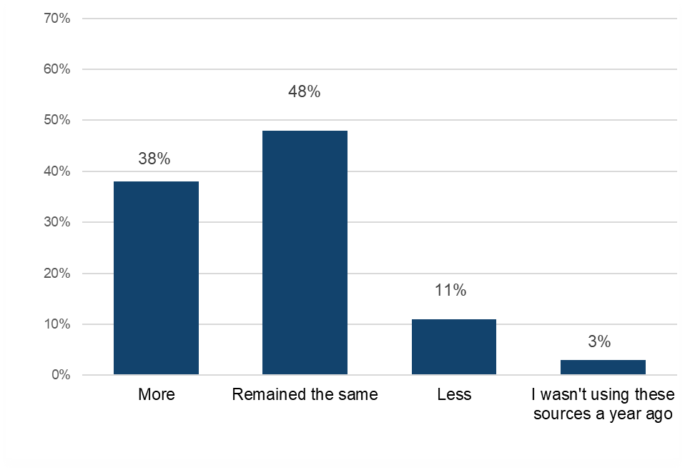Base: n=468 (downloaded and/or streamed TV programmes/episodes illegally)

TV programmes/episodes: Alternatives to infringement

This section will explore what respondents anticipate they would do if they lost access to illegal sources of TV programmes/episodes.

Those who had used illegal sources to either download or stream TV programmes/episodes were asked which single legal source they would use if they could no longer access them illegally. Overall, the most commonly chosen option was a paid one, with just over a quarter (26%) saying that they would pay for “a paid subscription to an online video streaming service (Netflix, Amazon Prime Video, NowTV etc.)” (Figure 73). Using “TV catch-up services” was close behind at 20%, followed by free video sites such as YouTube at 12%. No other single source was selected by more than 9%.

Detailed demographic analyses related to these findings can be found in Table 4.18 in OCI 2024 Supplementary Tables – TV.

In the absence of illegal TV programme/episode sources, respondents would typically turn to a paid subscription or TV catch-up service
Figure 73: Alternative sources for TV programmes/episodes if illegal options were unavailable were no longer available. Download the data from Table 4.18.
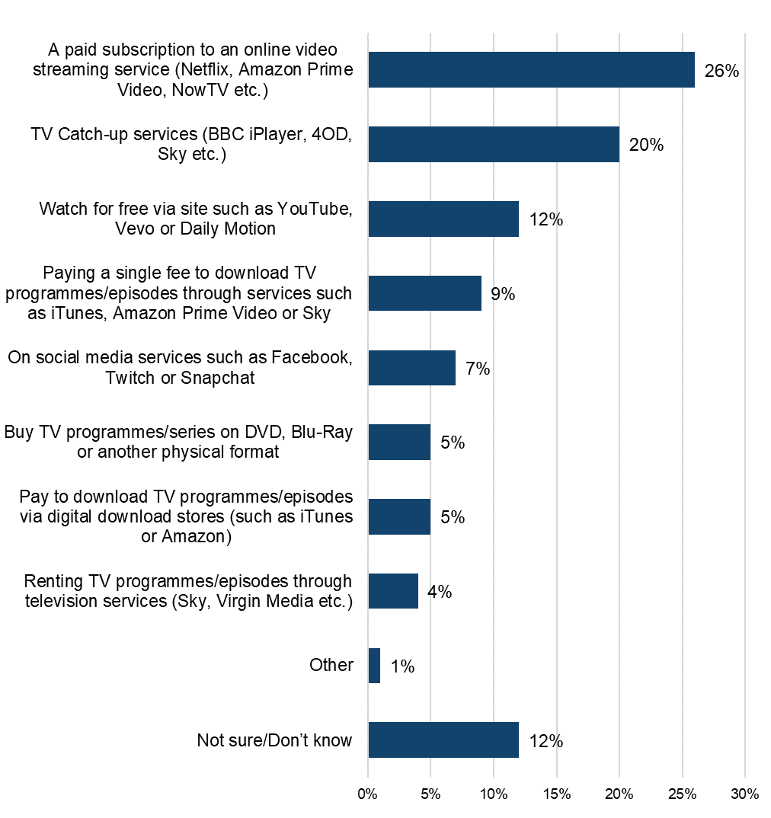
Base: n=468 (downloaded and/or streamed TV programmes/episodes illegally)

Qualitative insight: reactions to the hypothetical loss of illegal TV sources

Lastly, participants were asked how they would feel and whether the amount of TV series they watch would be impacted if they lost access to illegal sources of content. Most said they would be upset and feel a real loss regarding all the content they would no longer have access to. Most said this would reduce the amount they would watch and only one from this qualitative sample said it would spur them to start paying for a subscription.

“Extremely annoyed. I wouldn’t get some shows that I watch. I wouldn’t have the money to pay for a subscription or anything so would only have catch up player to watch shows when I want. I would watch a lot less tv if I could not access my free website. I would have to sign up for free trials and cancel them the moment I knew I would have to pay.”
Female, TV, 31-40

“I would feel disappointed because I don't have the money to pay for programming at the moment and there is nothing on free to air tv that interests me. It would have a big impact on me as I'd have nothing to really watch in the evenings and weekends anymore. If the free services that I use disappeared I couldn't use any other platforms since they cost money and I can't afford to use them. Free services like Pluto tv and bbc iplayer don't have enough that interests me. The service from channel 4 does, but it has too many adverts for me to want to watch. Overall I'd consume far less content.”
Male, TV, 41-50

“I guess I'd have to read more or take up gardening to make up for what's missing in my life, I'd be devastated if I couldn't watch series or films for free. I would try to find a way somehow to keep streaming for free by asking friends and family and other people for recommendations for free streaming sites and services, but it would greatly diminish the amount I watch.”
Male, TV, 51-60

Category Insights: Live Sport

Further details and demographic breakdowns for the findings in the Live Sport section can be found in Tables 5.1a – 5.11 in OCI 2024 Supplementary Tables – Live Sport (ODS 101KB), which provide a comprehensive analysis of the data.

Trends in overall live sport consumption in the UK

Detailed demographic analyses related to these findings can be found in tables 5.1a – 5.1b in OCI 2024 Supplementary Tables – Live Sport.

Prior to presenting information on live sport infringement levels, it’s useful to initially consider respondents’ engagement with, and consumption of these.

17% had of respondents engaged with live sports in the previous three months (i.e. either by streaming or sharing).

Analysis found that:
- overall, 16% had streamed live sports in the previous three months (Figure 74)
- men (22%) were more than twice as likely as women (10%) to stream live sports
- streaming was also highest among those aged between 25 and 44 (20%), decreasing among younger and older age groups

Streaming is the most frequent means of engaging with live sports
Figure 74: Streamed/shared live sports events in the past three months. Download the data from Tables 5.1a – 5.1b.

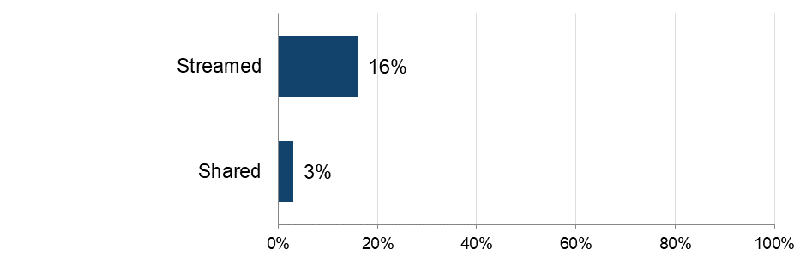
Sample: n = 5,087 (total sample)
Note: The definition of ‘shared’ was provided as: “By shared we mean that you personally made the file publicly available or sent or uploaded it online for someone else to download or stream/access. This does not include sending links to content that has already been shared by someone else, unless stated in the answer option”.

The importance of live sport

Detailed demographic analyses related to these findings can be found in Tables 5.2a – 5.2f in OCI 2024 Supplementary Tables – Live Sport.

To get a broader sense of their passion for live sport, respondents were asked to what extent they agreed with a range of statements and then grouped as High, Medium or Low, based on their answers.

Analysis of responses found that 44% of those who had recently streamed/shared live sports displayed high levels of passion the category (Figure 75). This was most apparent among male respondents (51% compared to 29% of female respondents) and those aged between 12 and 15 (55%) whose passion levels were at least seven percent higher than any other age group.

While scores across all individual statements relating to sport were relatively high, the passion for live sports is perhaps most evident in the fact that 70% agreed to some extent with the statement: “watching live sports is my favourite kind of entertainment” (Figure 76). This was also followed by those who agreed to some extent that they are “actively searching for live sports events to watch” (61%).

Over 40% of those who have recently streamed/shared live sports events have a high level of passion for them
Figure 75: Passion for live sports. Download the data from Table 5.3.
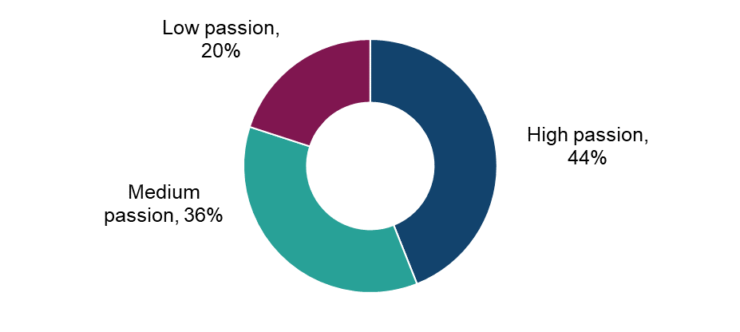

Sample: n = 865 (streamed and/or shared live sports events in the past three months)

70% of recent live sports consumers say watching live sports to some extent is their favourite kind of entertainment
Figure 76: Extent of agreement with statements in relation to live sports. Download the data from Tables 5.2a – 5.2f.

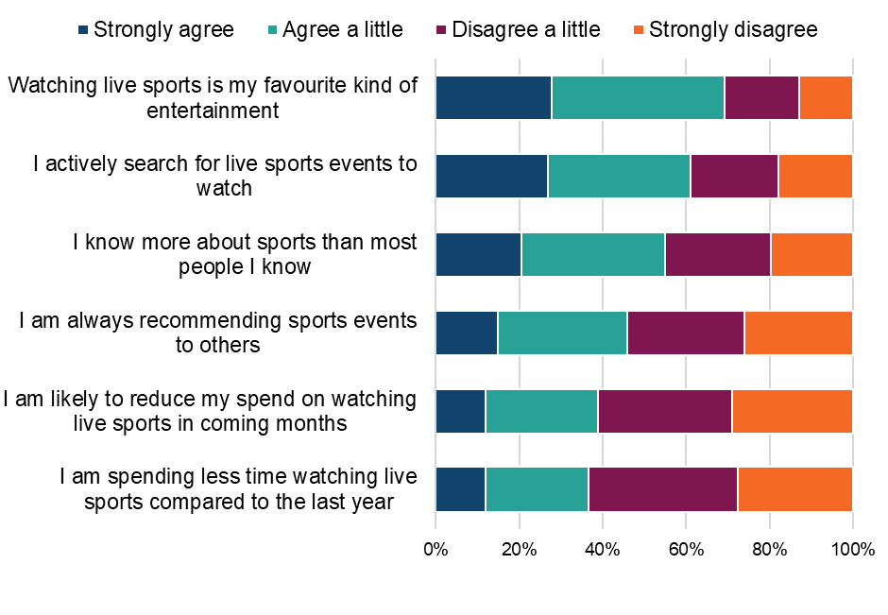
Sample: n = 865 (streamed and/or shared live sports events in the past three months)

Qualitative insight: the importance of live sports in people’s lives

Live sports were seen as allowing participants to experience excitement as well as break their daily routines and to be able to experience sporting events as they happen. It was also seen as a social occasion on which to spend time with family and friends which was valued about the category. Naturally, participants had the occasions on which they watch live sports dictated to them. Being live, participants simply had to tune in on time for event start times. This was often weekends and whenever big sporting events were being held.

“I love to watch big events as they are times to discuss with friends and watch together. I usually watch on weekends or when there are finals/semi-finals etc.”
Male, Live Sports, 21-30

“I love to watch sport especially darts, football and athletics. I never watch sport on catch up tv. I prefer to watch it live so I don`t find out the results before I watch it.”
Female, Live Sports, 41-50

“One of the most important past times for me and being aware of the current sporting competitions. It’s also an occasion to mingle and have fun. I watch on important fixture days, Weekends, when my favourite team or person is playing, milestone competitions like FA cup and Wimbledon Finals.”
Male, Live Sports, 41-50

“It offers a break from daily life activities. It brings friends and family together, even if supporting different teams! I usually access live sports on the weekends, especially during big sporting events. I watch sports on occasions where friends can come over and on big deciders, qualifiers, finals.”
Female, Live Sports, 21-30

The majority of participants reported that their viewing of live sports had remained roughly consistent over the last year. A few, however, said that the way in which they watched had changed, due to circumstances or finances. There was mention that financial constraints meant that it was harder to watch sports both live in stadiums or even on sports streaming services. One mentioned that they had moved more towards illegal streaming recently due to the division of sports across services and their perceived unaffordability.

“I have still watched the same amount of sport, but I have watched less of it live due to my availability and also my studies but once the summer season kicks off again, I will watch more again.”
Female, Live Sports, 21-30

“About the same as last year. Compared to last year I attended more live matches but this year it’s been less. I would watch at the local pub or at home. As my finances improve I am more likely to attend more live matches and buy more merchandise to support my team.”
Female, Live Sports, 31-40

“Yes. I look for more free sites online or apps which is streaming Live Sports. The cost of watching different sports is not really worth the price. Football is split across different platforms.
you need to take add on memberships for F1, Cricket, Tennis etc. I need to seriously consider a limit on the number of Live sports I watch. May be for the important rounds of the matches I might just take a day pass when there is a multitude of important games happening. I will need to cut my spending limit on sports packages.”
Male, Live Sports, 41-50

Understanding online consumption of live sports events

Detailed demographic analyses related to these findings can be found in Tables 5.4 in OCI 2024 Supplementary Tables – Live Sport.
To better understand the drivers of online consumption, those who had accessed live sports online in the previous three months were asked to select their top three reasons for doing so.

No single reason was selected by more than half of respondents, indicating that a broad range of factors are important (Figure 77). However, ease of access emerged as the most common theme - 49% selected “being able to watch live sports instantly whenever I want”, while a further 23% selected “being able to watch via different devices/locations”. It is worth noting that respondents were able to select multiple options, so the percentages presented do not sum to 100%. Other important factors included exclusive access, the range of selection, and cost/price. These included “having a wide range of live sports events to watch” (36%), “exclusive access to live sport events (not available anywhere else)” (34%), “being able to watch sports events that are not broadcast live in the UK” (29%) in addition to “it’s free” (30%) and “getting value for money” (30%). No other reason was selected by more than 17%.

Instantaneous access to live sport is the number one driver of consumption
Figure 77: Main reasons for streaming live sports events online. Download the data from Table 5.4.
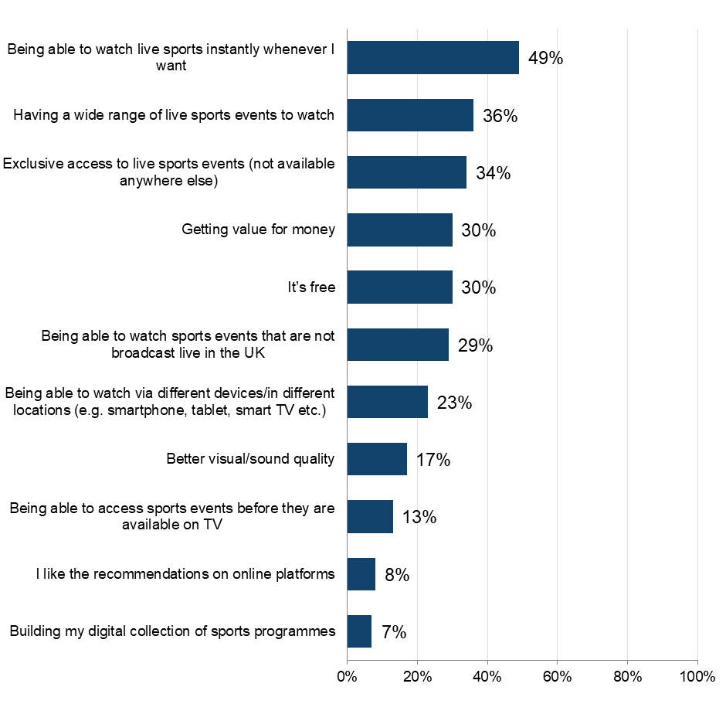Sample: n = 792 (streamed live sports events online in the past three months). Respondents were able to select multiple options, so the percentages presented do not sum to 100%.

Streaming live sports events

Detailed demographic analyses related to these findings can be found in tables 5.5a – 5.5b in OCI 2024 Supplementary Tables – Live Sport.

Frequency and volume of streaming live sports events

The 16% who had streamed live sports events during the previous three months were asked questions around frequency, volume and sources used. Over 60% of those who had streamed live sports did so frequently (at least once a week) (Figure 78). Male respondents (69%) were notably more likely than female respondents (47%) to frequently stream live sports. the highest percentage of frequent live sports consumers was found among the 12 to 15 age group (76%).

In terms of volume, respondents that streamed live sport consumed an average of 36 events over a three-month period. This was notably highest among those aged between 25 and 34 (59%).

More than 60% of recent live sports consumers are watching live sport at least once a week
Figure 78: Frequency of streaming live sports through the internet. Download the data from Table 5.5a.

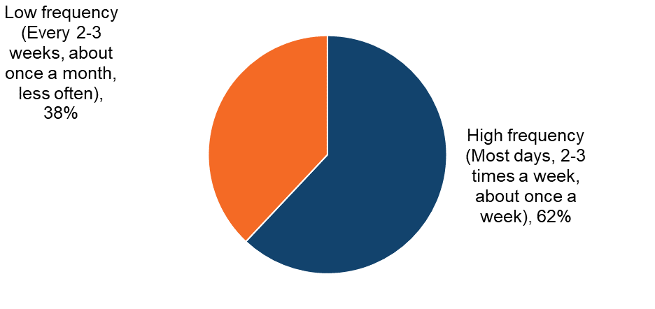
Sample: n = 792 (streamed live sports events online in the past three months

Streaming live sport: infringement behaviours

This section details the various sources used to access live sports streams, both legal and illegal.

Sources of live sport streaming

Detailed demographic analyses related to these findings can be found in tables 5.6-5.8 in OCI 2024 Supplementary Tables – Live Sport.
Respondents were shown a list that encompassed the different ways (legal and illegal) that they could stream live sports. An ‘unknown’ option was also provided to serve as a catch-all for people who were unsure of the source.

The most common source, by a large margin, was legal “A paid subscription to a sports platform that can be accessed online”, which was used by more than half (51%) of live sports streamers (Figure 79). The next most common option was legal “TV Catch-up services”, selected by 30% of respondents.

The most common illegal method was “A paid subscription to an IPTV provider which gives access to content from apps/services without needing to sign-up for a separate (paid) subscription” (12%). No other illegal method was selected by more than 9% of respondents.

Live sport consumers are most likely to access events via legal sources – peaking with a paid subscription to a sports platform
Figure 79: Sources used to stream live sports events in the past three months. Download the data from Table 5.6.
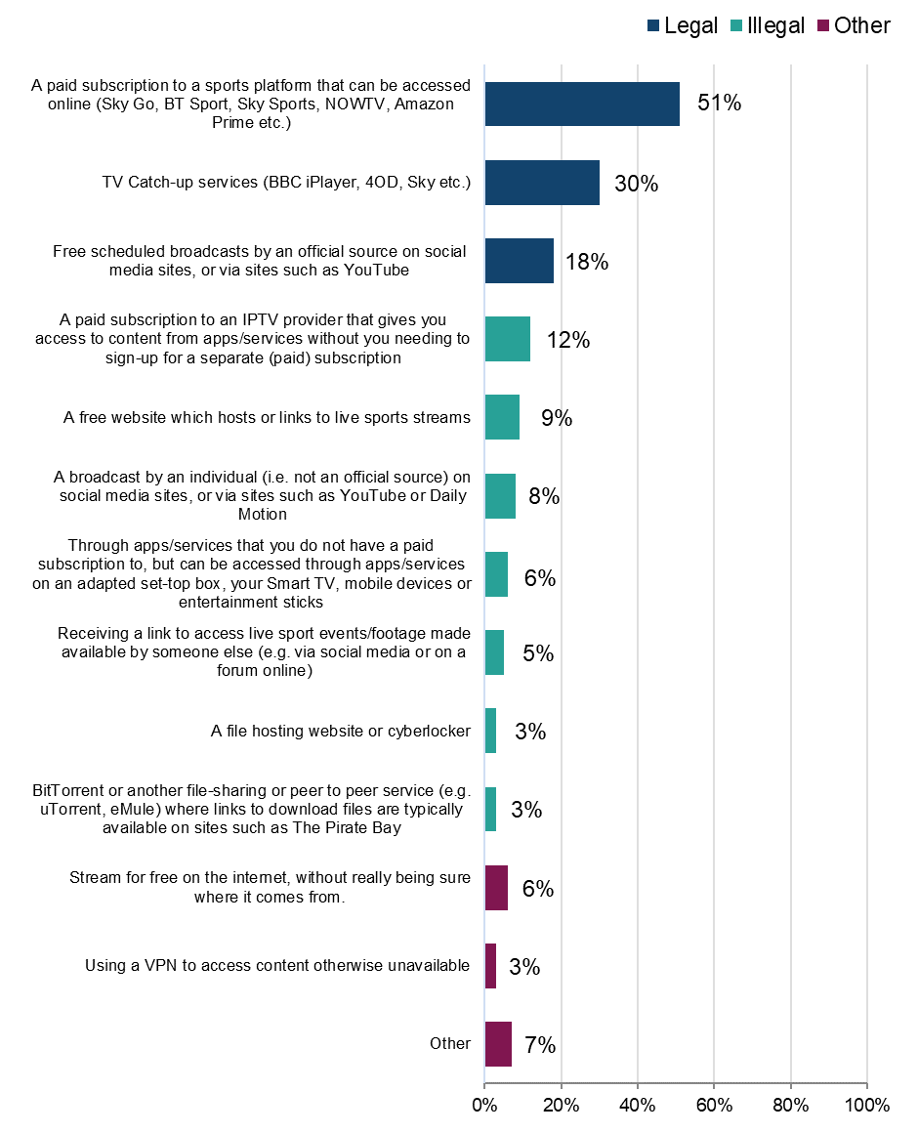
Sample: n = 792 (streamed live sports events in the past three months). Respondents were able to select multiple options, so the percentages presented do not sum to 100%.

Legality of live sport streaming

Detailed demographic analyses related to these findings can be found in Table 5.7 in OCI 2024 Supplementary Tables – Live Sport.
To better understand the distribution of sources across legal and illegal categories, those who had streamed live sport in the previous three months were grouped into the following (mutually exclusive) categories: using legal sources only, illegal sources only, or a mix of legal and illegal sources. The answer option “stream for free from the internet, without really being sure where it comes from” was not included in the definition of either legal or illegal. Anyone who said they only consumed content in this way was not included in the sample.

In overall terms 85% had used at least one legal source to stream live sport (Figure 80). Headline findings for different sources are as follows:
- legal:
  - 61% had used only legal sources
- illegal:
  - 38% had used at least one illegal source to access live sport, this is the overall infringement figure for 2024
  - 14% had used illegal sources only to access live sport
  - use of only illegal sources was highest among those aged between 16 and 24 (28%) with it ranging between 8% and 20% in all other age groups (Figure 82)
  - female respondents who stream live sports were more likely to only use illegal sources (18% vs 12%) (Figure 81)
  - those with a high passion for live sport were most likely to use illegal sources (44%) (Figure 83)
- mixed:
  - 24% had used a mix of legal and illegal sources
  - use of a mix of sources was higher among the younger age groups (under 35) and lower among the over 35 age group (Figure 82)

Over a third (38%) have used at least one illegal streaming source to access live sports
Figure 80: Legality of streaming/accessing live sport. Download the data from Table 5.7.
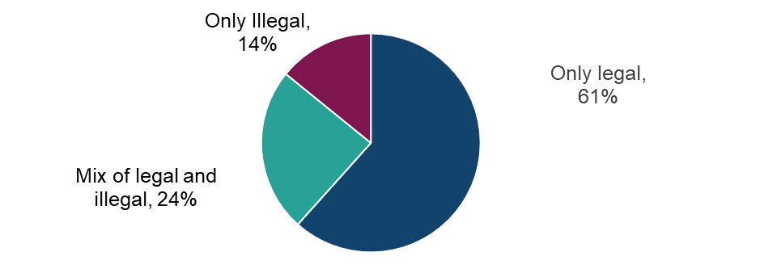
Sample: n = 708 (streamed live sport in the past three months, with those who selected ‘other’ or ‘not sure of source’ removed)

Female respondents are more likely than male respondents to use only illegal sources to access live sports
Figure 81: Legality of streaming/accessing live sports by sex. Download the data from Table 5.7.
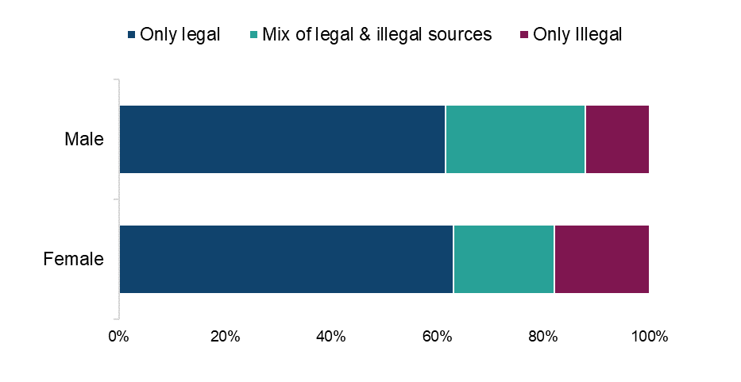
Sample: n = 708 (streamed live sport in the past three months, with those who selected ‘other’ or ‘not sure of source’ removed)

Higher use of illegal sources to access live sports among the younger age groups
Figure 82: Legality of streaming/accessing live sports by age. Download the data from Table 5.7.
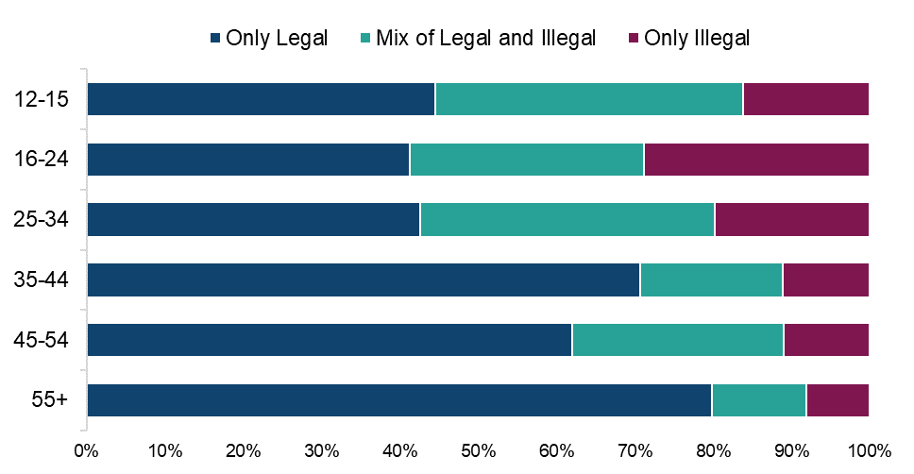

Sample: n = 708 (streamed live sport in the past three months, with those who selected ‘other’ or ‘not sure of source’ removed)

Higher use of illegal sources to access live sports among those with a high passion for live sports events
Figure 83: Legality of streaming/accessing live sports by passion level for live sports. Download the data from Table 5.7.
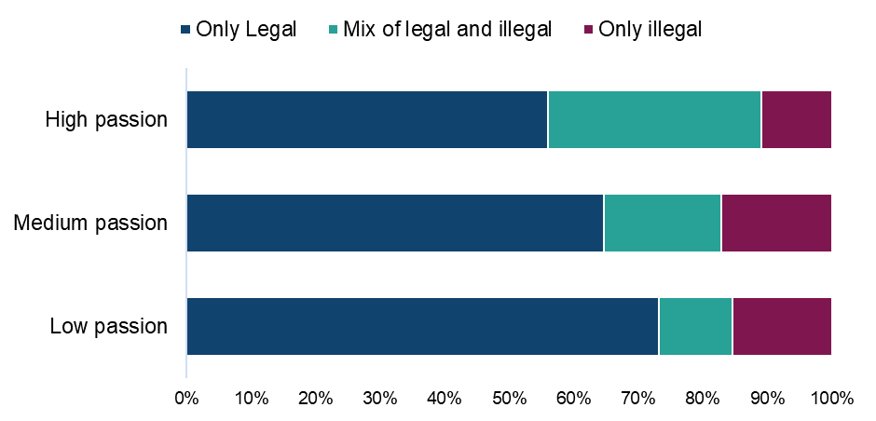

Sample: n = 708 (streamed live sport in the past three months, with those who selected ‘other’ or ‘not sure of source’ removed)

Paid for subscription services account for over 40% of all live sport streaming time
Table 7: Distribution of live sports event streaming by source. Download the data from Table 5.8.
Legality | Source | Average %age of usage distribution
Legal | A paid subscription to a sports platform that can be accessed online (Sky Go, BT Sport, Sky Sports, NOWTV, Amazon Prime etc.) | 41%
Legal | TV Catch-up services (BBC iPlayer, 4OD, Sky etc.) | 16%
Legal | Free scheduled broadcasts by an official source (e.g. the NBA, NFL, FA etc.) on social media sites like as Facebook, Twitter, Instagram, Twitch, Periscope or Snapchat, or via sites such as YouTube or Daily Motion | 9%
Illegal | A paid subscription to an IPTV provider (Insight IPTV, Gears TV etc.) that gives you access to content from apps/services without you needing to sign-up for a separate (paid) subscription | 7%
Illegal | A free website which hosts or links to live sports streams (Wiziwig, First Row Sports, Ronaldo7 etc.) | 5%
Illegal | A broadcast by an individual (i.e. not an official source) on social media sites like as Facebook, Twitter, Twitch, Periscope, TikTok or Snapchat, or via sites such as YouTube or Daily Motion | 3%
Illegal | Through apps/services that you do not have a paid subscription to, but can be accessed through apps/services such as "fully-loaded" Kodi or Showbox on an adapted set-top box, your Smart TV, mobile devices or entertainment sticks such as the Amazon Fire Stick or the Google Chromecast | 3%
Illegal | Receiving a link to access live sport events/footage made available by someone else (e.g. via social media or on a forum online) | 2%
Illegal | A file hosting website or cyberlocker (MediaFire, Rapidgator etc.) | 1%
Illegal | BitTorrent or another file-sharing or peer to peer service (e.g. uTorrent, eMule) where links to download files are typically available on sites such as The Pirate Bay, Torrentz, or Rarbg | 1%
Other | Stream for free on the internet, without really being sure where it comes from. | 5%
Other | Using a VPN to access content otherwise unavailable in your region | 1%
Other | Other | 7%

Sample: n = 792 (streamed live sport in the past three months)

Live sport: cyber security incidents

Respondents were asked if they had experienced any of a list of cyber security incidents in the previous 12 months. These incidents included devices being targeted with ransomware, other types of malware, hacking, phishing, social media and/ or email account takeovers, or any other incidents.
We observed a consistent trend: infringers were significantly more likely than non-infringers to report experiencing a cyber security incident. While a definitive causal link cannot be established, this may be influenced by factors such as higher digital engagement among infringers, increased exposure to unverified sources, or reliance on websites that pose a risk, and compromised content platforms.
Analysis found that 66% of those who had streamed live sports illegally had experienced at least one cyber security incident (Figure 84). This compares with 43% of those who had used only legal sources.

Those who stream live sports illegally are more likely to have experienced cyber security incidents in the last 12 months than those only using legal sources
Figure 84:Looking back over the past 12 months, to your knowledge, have you personally experienced any of the following cyber security incidents? Download the data from Table 1.15 of the OCI 2024 Main Data Tables (ODS 103KB).
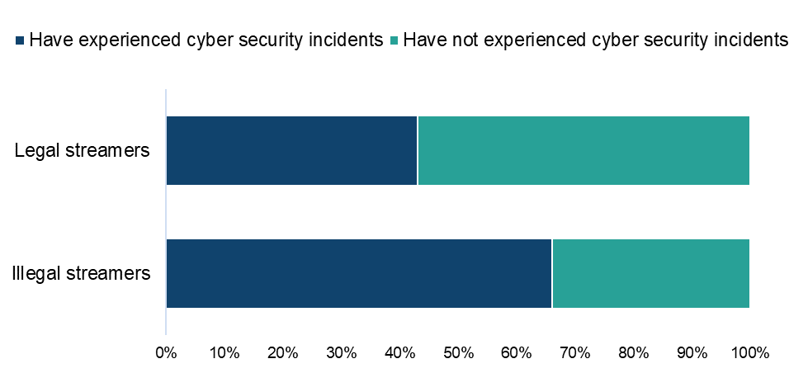

Sample: n = 643 (streamed live sport in the past three months, with those who selected ‘other’ or ‘not sure’ removed from both questions)

Qualitative insight: Live sport and cyber security incidents

Qualitatively, hardly any in the Live Sports category in the far smaller sample of the online community, had experienced issues. However, whether having suffered issues or not, the overall attitude was that issues were to be guarded against but so far, unlikely to deter participants from consuming illegal content.

“I haven’t had any bad experiences. I would consider how safe these sources are and would worry that they will harm my computer.”
Female, Live Sports, 41-50

“I haven't experienced any data theft or anything like that but I did once get a virus which then took me 8 hours to repair the computer. It made me a bit more cautious and put extra protection in place against these attacks but it would not stop me from using these sources.”
Male, Live Sports, 41-50

“Not yet. But I am aware of the dangers of using these sites on my personal devices so I take necessary measures in profiling these sites.”
Male, Live Sports, 31-40

Paying for live sports
Detailed demographic analyses related to these findings can be found in Table 5.9 in OCI 2024 Supplementary Tables – Live Sport.
Those who had used a paid source to stream live sports were asked how much they had personally spent on each source. Average monthly expenditure was as follows:

- a paid subscription to an online sports platform (such as Sky Go, BT Sport etc.): £32.90 per month
- “other online sources”: £12.30 per month

Live sports: Change in use of illegal sources

Detailed demographic analyses related to these findings can be found in Table 5.10 in OCI 2024 Supplementary Tables – Live Sport.
Those who had used an illegal source to stream live sport were asked how the use of these sources compares to the same point a year ago. Whilst usage had remained static at half (50%) of respondents it had increased for 42% (Figure 85).
Usage was less for 6%, with a smaller number saying that they weren’t using these sources a year ago (3%).

Over 40% of those using illegal sources to stream live sports say their use of these sources is increasing
Figure 85: Change in usage of illegal sources to stream live sports compared to last year. Download the data from Table 5.10.
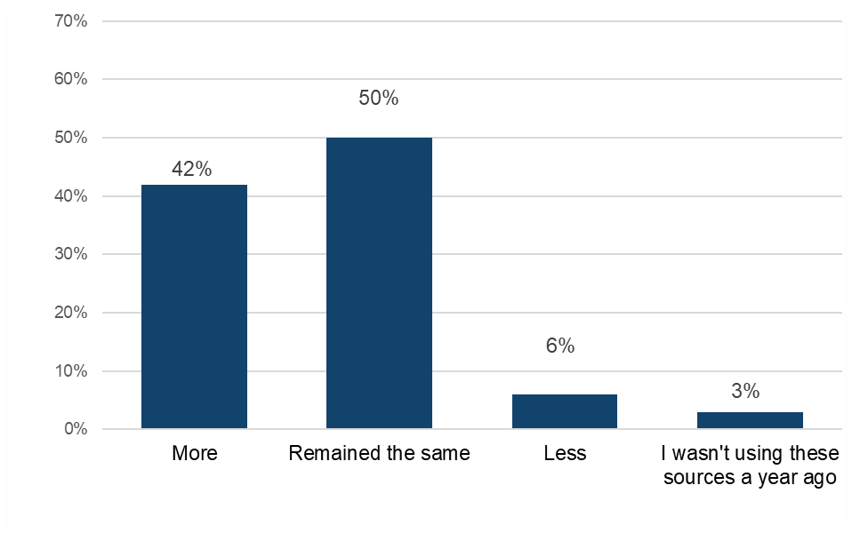
Sample: n = 268 (streamed live sport illegally)

Qualitative insight: accessing live sports through legal and illegal sources

Access to live sports varied among participants in our qualitative sample. Many reported paying for multiple legal sports streaming platforms, such as BT Sports, Sky Sports, NOWTV, and Amazon Prime. Additionally, most participants mentioned using legal free services like BBC iPlayer, ITV and Channel 4 for major fixtures broadcast on these platforms.

However, many mentioned that the cost they incurred through the paid legal services in order to watch all the sport they wanted, was not sustainable and many illegal sources were reported as being used alongside. These most commonly included mentions of free websites or YouTube streams by individuals as well as streams found on the internet from international broadcasters, Amazon firestick and BitTorrent.

“I use a free website which has links to live sports streams and broadcasts on YouTube. Sometimes the links don’t work or the stream buffers a lot and you can’t watch it. Sometimes on YouTube you can be watching a stream and it will be removed.”
Female, Live Sports, 41-50

“The main unofficial sources to accessing content I’ve used are SoccerStreams which is a free website that hosts links to live sport streams. Main strengths are that it’s easy to access and only need Wi-Fi to use. Weaknesses are that connection can sometimes cut out but that depends on the quality of the stream and alternative links are sometimes available. I’ve been using this for at least a year now, and recently I’ve started using broadcasts more from Facebook live or snapchat.”
Female, Live Sports, 21-30

“I use apps on Amazon firestick which means that I can have lots of different games at the same time. Strengths - easy access, good quality, multiple sports from different countries available.
Weakness - quality can be a bit low, sometimes links are lagging behind in real time.”
Male, Live Sports, 21-30

“Bit Torrent or other file sharing sites - used by many and works without any popups to watch premier league football. Free Apps - to watch cricket. Simple and easy to use but there will be buffering. Not bothered about the quality. SmartCric. Hosted websites with streaming from international sports broadcasters like Spanish and Middle eastern feeds. There are links to access live sport which can be searched online or made available by someone if you are really desperate, but I haven't gone in search. YouTube - feeds from individuals.”
Male, Live Sports, 41-50

Asked whether such illegal methods of access would continue to be important going forward, most clearly stated they would always be important due to the cost associated with having to pay for multiple streaming services. This was seen as likely to keep pushing them to illegal sources unless the costs for watching sports across different platforms or even just on one platform, like Sky, came down. There was also mention of more emotional reasons around community and being able to have access to sports whether people could afford it or not.

“They are important for me as I can’t afford to pay for official services such as sky sports or Dazn.”
Female, Live Sports, 41-50

“Free access will always be important to me as it brings the sports community together if everyone has access.”
Female, Live Sports, 21-30

“I don’t see this changing. Hopefully it will cause the paid sports services to become more affordable.”
Male, Live Sports, 41-50

“Unless the broadcasters find cheaper ways of offering combo packages for different sports, free access will be important. You cannot realistically pay £80 full combined sports package with Sky or take individually different packages as add ons. I feel guilty for spending that much just for sports.”
Male, Live Sports, 41-50

The division of sports across different platforms came up spontaneously and when specifically probed, was identified as a main driver towards infringement. Participants indicated they would be willing to pay between prices of £20 to £30 for the hypothetical product in which one service combined all sports streams in one place. However, one said this wouldn’t work and that what would be good instead would be to have more flexible packages on existing platforms.

“If the online platform covered completely all sport streams, I think a reasonable amount per month (such as £20-£30) would gain popularity.”
Female, Live Sports, 21-30

“Yes because all the different packages I would use would be over £100 per month and I can't afford to pay that.”
Male, Live Sports, 41-50

“Division of sports is not well covered and it’s definitely a reason to look for free streams. I don’t think one subscription can realistically cover all live sport events. There needs to be a method of adding or removing or customising some preference which alters the feed of the live sports events. Profile the user and provide different options depending on your interests.”
Male, Live Sports, 41-50

Live sport: Alternatives to infringement

This section will explore what respondents anticipate they would do if they lost access to illegal sources of Live Sports streams. Detailed demographic analyses related to these findings can be found in Table 5.11 in OCI 2024 Supplementary Tables – Live Sport.

Those who had used illegal sources to either download or stream live sport were asked which single legal source they would use if they could no longer access live sport illegally.

Encouragingly, paid options accounted for two of the three top alternative sources that would be used if illegal sources were no longer available: “A paid subscription to a sports platform that can be accessed online” (23%) and “Pay for a TV sports subscription” (18%) (Figure 86). “Free scheduled broadcasts by an official source (e.g. the NBA, NFL, FA etc.) on social media sites like Facebook, Twitter, Instagram, Twitch, Periscope or Snapchat, or via sites such as YouTube, Vevo or Daily Motion” attracted 19% of respondents. No other option was selected by more than 11%, with a proportion of respondents (17%) not sure what they would do if illegal sources were no longer available.

In the absence of illegal live sports sources, respondents would be most likely to turn to a paid subscription to a sports platform
Figure 86: Alternative sources for live sports if illegal options were unavailable. Download the data from Table 5.11.
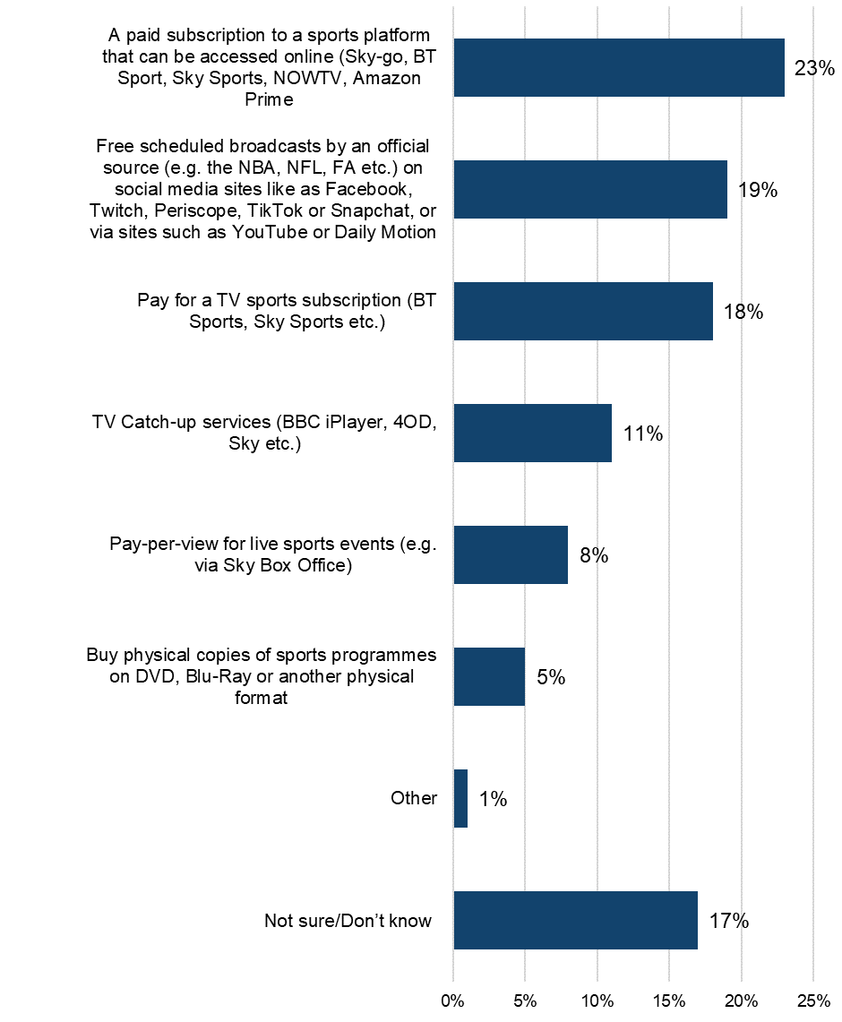

Sample: n = 268 (streamed live sport illegally)

Qualitative insight: reactions to the hypothetical loss of illegal live sport sources

In the eventuality that illegal methods of access to live sports might disappear, participants said they would feel annoyed and that they might not be able to watch as much content. Those who consumed less live sport already said they would make do with the free, legal channels such as BBC iPlayer or ITV. Those who consumed higher amounts said they would have to decide between the best options and pay for one service which covered as much as possible but that they would likely miss out on a lot.

“I would be annoyed and would no longer be able to watch the live games. I would watch the evening highlight shows available on the free official sources instead and would only watch the live games on the free sources such as BBC, ITV & YouTube.”
Male, Live Sports, 41-50

“Would feel a little empty. I usually watch finals and football euros and world cup. I'd usually watch on free channels like BBC or ITV. They have good quality coverage but only broadcast world cup, euros, England matches etc. would not really be able to watch a range of sports or teams.”
Male, Live Sports, 21-30

“It would seriously dent my interest in sports events as a whole. There is a limit to my spending power and I am not going to go beyond my means to take a subscription cutting down on other expenses for e.g. movies, dining out etc. With the rate of inflation, spending power of clubs and events in sports, the ticket rates are going up and the subscription rates are also going to increase. I would look for combination sports packages with one brand. I would opt to choose a sport every year and prioritise. I would just pay per view for the important events and finals etc.
I would definitely consume less content.”
Male, Live Sports, 41-50

Category Insights: Video Games
Further details and demographic breakdowns for the findings in the Video Games section can be found in Tables 6.1a – 6.11 in OCI 2024 Supplementary Tables – Video Games (ODS 95.8KB), which provide a comprehensive analysis of the data.

Trends in overall video game consumption in the UK

Prior to presenting information on video games infringement levels, it’s useful to initially consider respondents’ engagement with, and consumption of these. Detailed demographic analyses related to these findings can be found in Tables 6.1a – 6.1d in OCI 2024 Supplementary Tables – Video Games.

Analysis of responses found that in the previous three months, 29% had engaged with video games (i.e. either by downloading, streaming, sharing or purchasing physical products). Looking at methods of access:
- downloading was the most common method of accessing video games, with 19% having done so (Figure 87)
- streaming followed at 17% and 11% had purchased physical copies
- across downloading, streaming and purchasing physical copies, male respondents were more engaged than female respondents
- 12–15-year-olds were the most engaged with downloading (43%) and streaming (41%) video games
- figures for each of these decreased among subsequent age groups, with just 4% of those aged 55 and above streaming and 5% downloading games

Downloading is the most frequent means of engaging with video games
Figure 87: Downloaded/streamed/shared/purchased physical copies of Video Games in the past three months. Download the data from Tables 6.1a – 6.1d.
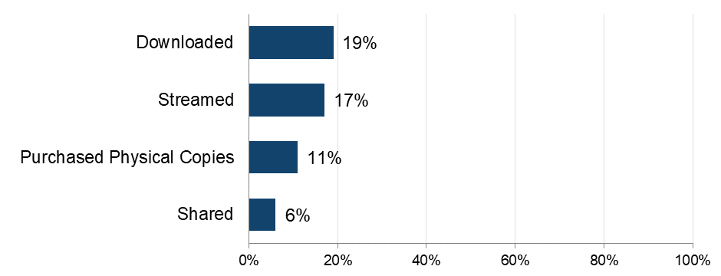
Base: n=5,087 (total sample)
Note: The definition of ‘shared’ was provided as: “By shared we mean that you personally made the file publicly available or sent or uploaded it online for someone else to download or stream/access. This does not include sending links to content that has already been shared by someone else, unless stated in the answer option”.

The importance of video games

To get a broader sense of their passion for video games, respondents were asked to what extent they agreed with a range of statements and then grouped as High, Medium or Low, based on their responses.

Four in ten (40%) displayed a high passion for video games (Figure 88). Those with a high passion for video games were notably more likely to be male respondents (50% compared with 28% of female respondents) and to be younger (at least 43% of those aged between 12-44).

Looking at individual statements, the importance of video games to respondents is evident - they were most likely to agree that “video games are my favourite kind of entertainment” (65%) (Figure 89). Discovery was also important, with 59% agreeing that “I actively search for new video games to play”.

40% of those who consume video games have a high passion for them
Figure 88: Passion for video games. Download the data from Table 6.3.
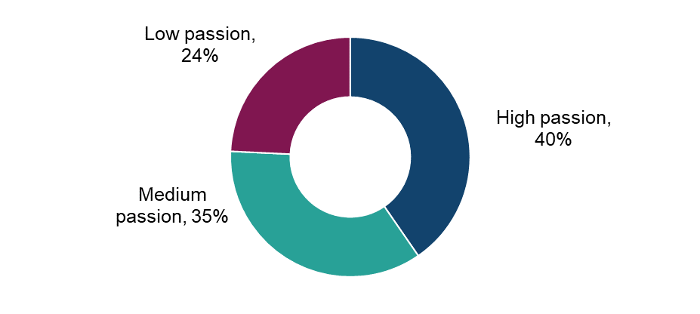
Base: n=1,472 (downloaded, streamed, shared and/or purchased physical copies of video games in the past three months)

Over 60% of those who consume video games regard them to some extent as their favourite form of entertainment
Figure 89: Extent of agreement with statements in relation to video games. Download the data from Tables 6.2a – 6.2f.
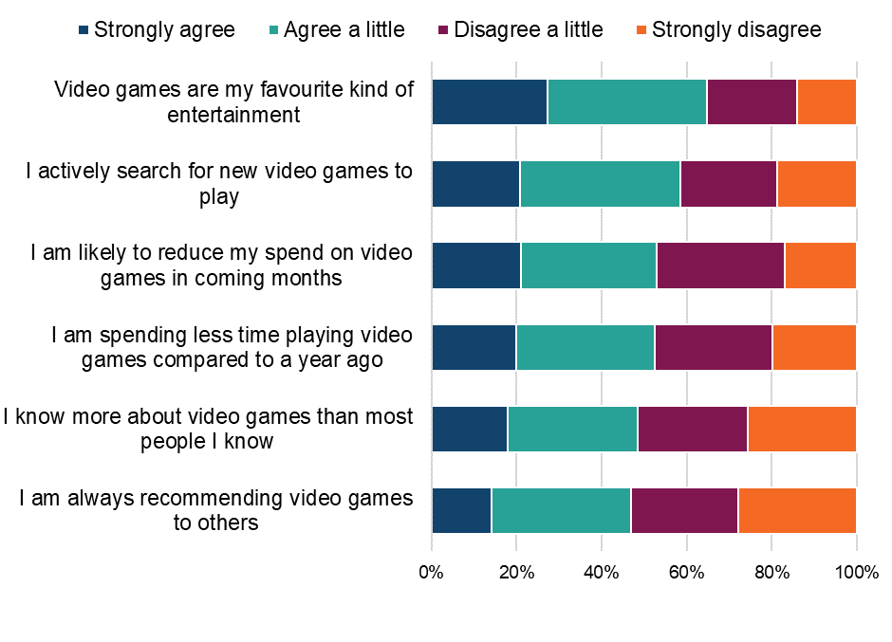
Base: n=1,472 (downloaded, streamed, shared and/or purchased physical copies of video games in the past three months)

Qualitative insight: the importance of video games in people’s lives

Video Games provided participants with the ability to escape to other worlds and distraction from everyday life. Additionally, it provided elements of competitiveness which they could play out and an opportunity both to spend time for themselves, or to connect with others as a joint activity.

Mostly, participants reported playing video games at the weekends, or in the evenings. Importantly, participants required a decent period of free time or when their friends were also available for multi-player games.

“Daily, after work/in my spare time/with family/friends or alone - depending on the game. To de- stress. At weekends, after work in the evenings. To give me a change, a bit of fun, to take my mind off work, something I enjoy.”
Female, Video Games, 31-40

“I play video games for entertainment and I feel a sense of accomplishment after winning a game. I play video games mostly in my spare time, mostly adventure games and multiplayer games.”
Male, Video Games, 21-30

“It’s a time to step out of reality. Usually at night and weekends. Best time to play as all my mates are free at that time too.”
Non-Binary, Video Games, 21-30

“I play video games most weekends as a way of escaping the stresses of work during the week. I also play games on some evenings when time allows. Playing games at Christmas time is also fun and a great way to celebrate the festivities with family and friends. Buying new games for my son and playing the new game with him is a nice activity and great for bonding. Gaming is a great way to relax and enjoy something different.”
Male, Video Games, 31-40

For many participants, the rate at which they played video games had remained the same whereas some had experienced reductions or increases dependent on their personal circumstances. Some linked an increase to greater societal phenomena such as spending more time working from home since the pandemic or increases in costs of other activities or commodities. Some linked a decrease to simply having less free time.

“I don't have as much time to play games as last year. The kids are spending more time on them as they get older so it's harder for me to get on.”
Female, Video Games, 31-40

“I have reduced playing video games. It reduced since I started working more now that I've finished uni.”
Non-Binary, Video Games, 21-30

“I would say I spend more time playing video games now the family get involved too. With the cost of living instead of going out somewhere we have video game night.”
Female, Video Games, 31-40

“The shift to remote work has allowed for more flexibility in my daily schedule. This has led to an increase in gaming frequency, as I can fit in short gaming sessions during breaks or after work without the need for commuting. The increased frequency of accessing video games over the past year is broadly due to the flexibility of remote work, the reduction in social activities, the need for mental health and stress relief, and the limited availability of other entertainment options. These factors have collectively made gaming a more prominent and integral part of my daily life.”
Male, Video Games, 41-50

Physical purchasing of video games

This section refers to the rate of purchasing of physical copies of video games followed by rates of online purchasing.

The 11% of respondents who had purchased video games in physical formats during the previous three months were asked about the number of purchases made. The average number of video games purchased in the previous three months was four. The number of video games purchased peaked among those aged 55 and above (eight), however this was due to an outlying figure among this group.

Detailed demographic analyses related to these findings can be found in Table 6.4a in OCI 2024 Supplementary Tables – Video Games.

Understanding online consumption of video games

To better understand the drivers of online consumption, those who had streamed/accessed video games in the previous three months were asked to select their top three reasons for accessing video games online. It is worth noting that respondents were able to select multiple options, so the percentages presented do not sum to 100%.

No single reason was selected by more than 44% of respondents (Figure 90). This indicates some alignment in motivations among respondents, while also highlighting a diversity of opinions beyond the top selections.

The strongest resonations related to range of options available (“Having a wide range of video games to play” 44%) and convenience (“Being able to play video games instantly whenever I want” 43%). Price factors were selected by over a third - “It's free or cheap” (37%) and “Getting value for money” (32%). Convenience of storing content digitally was selected by 28%. Added value features, such as recommendations from online platforms, visual/sound quality and being able to access video games before they are available on physical formats were selected by smaller proportions.

Detailed demographic analyses related to these findings can be found in Table 6.4b in OCI 2024 Supplementary Tables – Video Games.

Variety and instant access most frequently drive online consumption of video games
Figure 90: Main reasons for accessing video games online. Download the data from Table 6.4b. 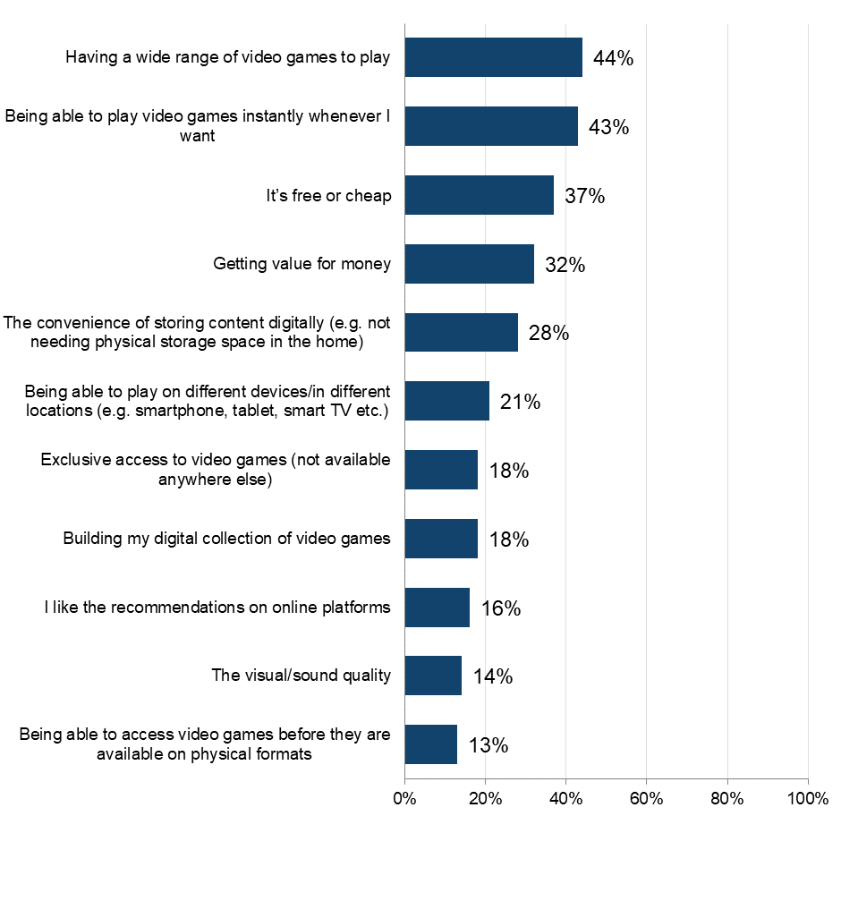
Base: n=1,285 (accessed video games online in the past three months). Respondents were able to select multiple options, so the percentages presented do not sum to 100%.

Accessing video games online

The 27% who had accessed video games online during the previous three months were asked questions around frequency, volume and sources used.

Over half (54%) accessed video games frequently (i.e. at least once a week) (Figure 91). Weekly access was most common among male respondents and those aged 12-44, with over half doing so.

In terms of volume, respondents had accessed 40 video games on average during the previous 3 months. This number was highest among male respondents who, on average, accessed 45 video games in the previous three months, compared to an average of 33 accessed by female respondents. The youngest age group (12-15) had accessed 46 video games.

Detailed demographic analyses related to these findings can be found in Table 6.5 in OCI 2024 Supplementary Tables – Video Games.

Over half of those accessing video games online are doing so at least weekly
Figure 91: Frequency of downloading or accessing video games through the internet. Download the data from Table 6.5.
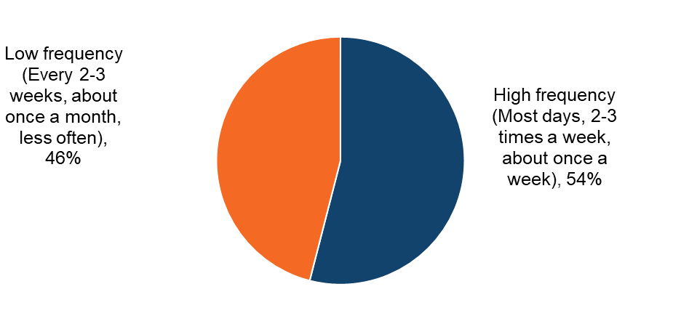
Base: n=1,285 accessed video games online in the past three months)

Video games: Infringement behaviours

This section details the sources of accessing video games, both legal and illegal.

Sources of downloading and streaming/accessing video games

Respondents were shown a list that encompassed the different ways (legal and illegal) that they could access video games. An ‘unknown’ option was also provided to serve as a catch-all for those who were unsure of the exact source.

The two most frequently specified sources for accessing video games by far were legal (Figure 92). Over half accessed video games for free through the Apple App Store, Google Play, PlayStation/Xbox store, Steam, Origin, etc. (51%) and by paying a single fee to download individual video games through services such as the Apple App Store, Google Play, PlayStation or Xbox Store, Steam, Origin, etc. (44%). All illegal sources were used by considerably smaller proportions (3%-4%).

Detailed demographic analyses related to these findings can be found in Table 6.6 in OCI 2024 Supplementary Tables – Video Games.

Downloading video games for free, or paying a single fee are the most frequent means of engagement
Figure 92: Sources used to download/access video games in the past three months. Download the data from Table 6.6.
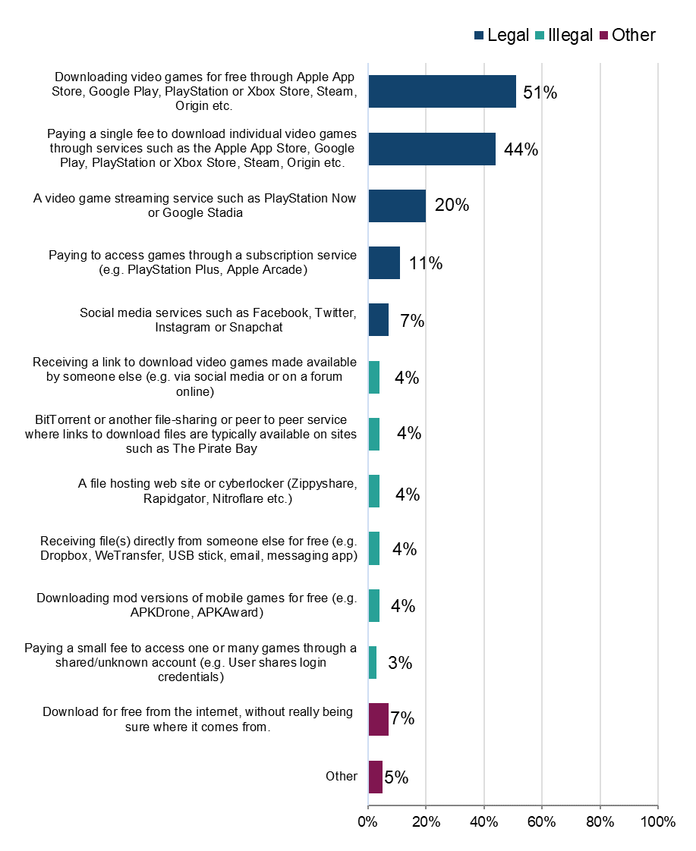
Base: n=1,285 accessed video games online in the past three months). Respondents were able to select multiple options, so the percentages presented do not sum to 100%.

Legality of accessing video games online

To better understand the distribution of sources across legal and illegal categories, those who had accessed video games in the previous three months were grouped into the following (mutually exclusive) categories: using legal sources only; illegal sources only; or a mix of the two.

The answer option “accessed it for free from the internet, without really being sure where it comes from” was not included in the definition of either legal or illegal. Anyone who said they only consumed content in this way was not included in the base.

Headline findings for different sources are as follows:

- legal:
  - overall, 95% had used at least one legal source to access video games (Figure 93)
  - the highest proportion (83%), by some way, had used only legal sources
  - across age groups this was somewhat variable, ranging from 77%-93% (Figure 95)
- illegal:
  - 17% had used at least one illegal source to access video games, which was more common among those aged under 45
  - 5% had used illegal sources only to access video games
  - 21% of those with a high passion for video games had used an illegal source, which was more than those with a low level of passion (8%) (Figure 96). However, high-passion individuals were more likely to use a mix of legal and illegal sources, while reliance on only illegal sources was lower compared to those with medium or low passion levels
- mixed:
  - 12% had used a mix of legal and illegal sources to access video games
  - this was highest among those under the age of 45 (12%-18%)
  - male respondents (14%) were slightly more likely than female respondents (10%) to use a mix of legal and illegal sources to access video games (Figure 94)

Detailed demographic analyses related to these findings can be found in Tables 6.7 – 6.8 in OCI 2024 Supplementary Tables – Video Games.

Over 80% have used only legal download sources to access video games
Figure 93: Legality of downloading/accessing video games. Download the data from Table 6.7.
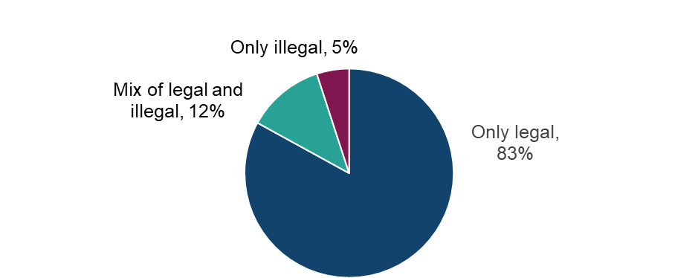

Base: n=1,168 (downloaded or streamed/accessed video games in the past three months, with those who selected ‘other’ or ‘not sure of source’ removed).

Both male and female respondents most likely to use legal sources to download/access video games
Figure 94: Legality of downloading/accessing video games by sex. Download the data from Table 6.7.

Base: n=1,168 (downloaded or streamed/accessed video games in the past three months, with those who selected ‘other’ or ‘not sure of source’ removed).

Higher use of illegal sources to download/access video games among the younger age groups
Figure 95: Legality of downloading/accessing video games by age. Download the data from Table 6.7.
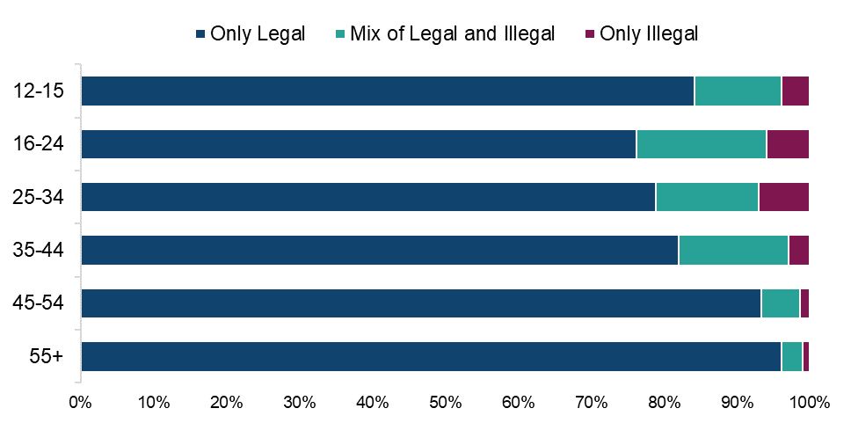

Base: n=1,168 (downloaded or streamed/accessed video games in the past three months, with those who selected ‘other’ or ‘not sure of source’ removed).

Higher use of illegal sources to download/access video games among those with a high and medium passion for video games
Figure 96: Legality of downloading/accessing video games by passion level for video games. Download the data from Table 6.

Base: n=1,168 (downloaded or streamed/accessed video games in the past three months, with those who selected ‘other’ or ‘not sure of source’ removed).

Legal sources account for over 80% of all video game downloads/download time
Table 8: Distribution of methods of downloading/accessing video games by source. Download the data from Table 6.8.

Legality | Source | Average % of usage split
Legal | Downloading video games for free through Apple App Store, Google Play, PlayStation or Xbox Store, Steam, Origin etc | 34%
Legal | Paying a single fee to download individual video games through services such as the Apple App Store, Google Play, PlayStation or Xbox Store, Steam, Origin etc. | 29%
Legal | A video game streaming service such as PlayStation Now or Google Stadia | 9%
Legal | Paying to access games through a subscription service (e.g. PlayStation Plus, Apple Arcade) | 6%
Legal | Social media services such as Facebook, Twitter, Instagram or Snapchat | 3%
Illegal | A file hosting web site or cyberlocker (Zippyshare, Rapidgator, Nitroflare etc.) | 2%
Illegal | BitTorrent or another file-sharing or peer to peer service (e.g. uTorrent, eMule) where links to download files are typically available on sites such as The Pirate Bay, Torrentz, or Rarbg | 1%
Illegal | Receiving a link to download video games made available by someone else (e.g. via social media or on a forum online) | 1%
Illegal | Downloading mod versions of mobile games for free (e.g. APKDrone, APKAward) | 1%
Illegal | Receiving file(s) directly from someone else for free (e.g. Dropbox, WeTransfer, USB stick, email, messaging app) | 1%
Illegal | Paying a small fee to access one or many games through a shared/unknown account (e.g. Usher shares login credentials) | 1%
Other | Download for free from the internet, without really being sure where it comes from | 5%
Other | Other | 5%

Base: n=1,285 (accessed video games online in the past three months)

Video games: Cyber security incidents

Respondents were asked if they had experienced any of a list of cyber security incidents in the previous 12 months. These incidents included devices being targeted with ransomware, other types of malware, hacking, phishing, social media and/ or email account takeovers, or any other incidents.
We observed a consistent trend: infringers were significantly more likely than non-infringers to report experiencing a cyber security incident. While a definitive causal link cannot be established, this may be influenced by factors such as higher digital engagement among infringers, increased exposure to unverified sources, or reliance on websites that pose a risk, and compromised content platforms.
Over three-quarters (77%) of those who had downloaded or accessed video games illegally had experienced at least one cyber security incident (Figure 97). This compares with 46% of those who had used only legal sources.

Those who download/access video games illegally are more likely to have experienced cyber security incidents in the last 12 months than those only using legal sources
Figure 97: Looking back over the past 12 months, to your knowledge, have you personally experienced any of the following cyber security incidents? Download the data from Table 1.15 of the OCI 2024 Main Data Tables (ODS 103KB).
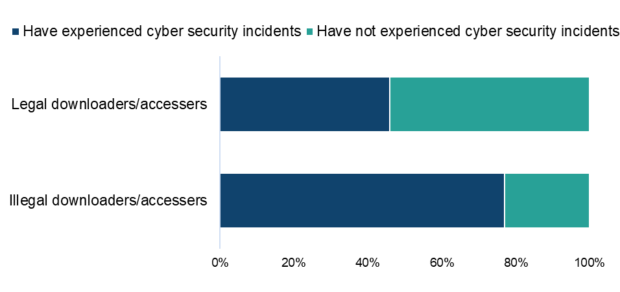
Base: n=1,010 (downloaded/accessed video games in the past three months, with those who selected ‘other’ or ‘not sure’ removed from both questions)

Qualitative insight: Video games and cyber security incidents

In our online community, as in other categories, very few gamers had experienced cyber security issues. However, some were unsure as to whether they had been the victim to incidents based on illegal consumption of content or not. Most spoke about amplifying and strengthening their firewalls in order to protect themselves rather than not consuming illegal video game content due to the risk.

“If I did have a bad experience in the future I would be more cautious in the future or run an anti-virus checker on the site or install ad blockers.”
Female, Video Games, 31-40

“Nothing significant although my old computer seemed to have a virus which might have come from one of these sources. I have thankfully never been the victim of fraud and using these sources means I make sure I have anti-virus software and firewalls etc. no money has been lost by me.”
Male, Video Games, 31-40

“Using unofficial sources for video games and other content comes with a variety of concerns, primarily centered around legal risks, security threats, ethical implications, and the potential negative impact on the quality and enjoyment of the content. If I were to experience bad incidents such as security breaches, malware infections, or legal issues with unofficial sources, it would likely change my attitude towards using them.”
Male, Video Games, 41-50

Paying for video games

Those who had used a paid source to either download or stream video games were asked how much they had personally spent on each source. Average monthly expenditure was as follows:

- a paid subscription service (such as PlayStation Plus or Apple Arcade): £3.50
- paying a single fee to download individual games (through services such as the Apple App store or Google Play): £15.30
- using a video game streaming service (such as PlayStation Now or Google Stadia): £8.30
- paying a small fee to access one or many games through a shared or unknown account (such as Usher shares login credentials): £1.10
- “Other online sources”: £9.30

Detailed demographic analyses related to these findings can be found in Table 6.9 in OCI 2024 Supplementary Tables – Video Games.

Video games: Change in use of illegal sources

Those who had used an illegal source to download/access video games were asked how the use of these sources compares to the same point a year ago.

Over half of respondents said that their use of illegal sources had remained the same (Figure 98). For fewer (31%), usage had increased. A relatively small number said their usage had decreased (15%) or that they weren’t using these sources a year ago (3%).

Detailed demographic analyses related to these findings can be found in Table 6.10 in OCI 2024 Supplementary Tables – Video Games.

Over 30% of those using illegal sources to download or access video games say their use of these sources is increasing
Figure 98: Change in usage of illegal sources to access video games compared to last year. Download the data from Table A9.
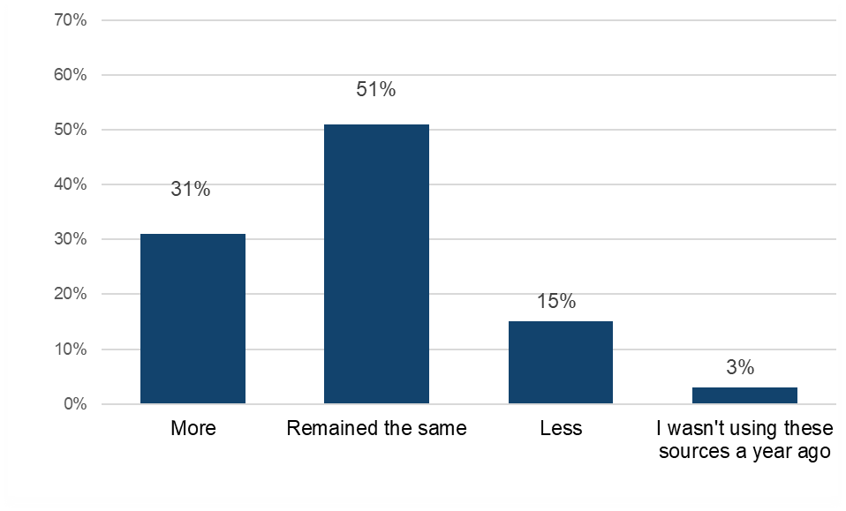
Base: n=202 (accessed video games illegally)

Qualitative insight: accessing video games through legal and illegal sources

In relation to accessing video games online, purchasing games through the official stores on their PlayStation, Xbox or Nintendo, as well as accessing mobile games through the Apple App Store or Google Play were popular. These official sources were seen to be the most reliable and of the best quality.

However, the temptation of ‘modded’ versions of popular games was a big draw towards illegal sources for some, as well as the cost of official games when they could be accessed for free. Receiving links to download games made available by family and friends on social media was a common source which was also noted to be safe as others would have tested it out, as well as mentions of BitTorrent. There was broad awareness of the danger of viruses or malware associated with accessing video games illegally but this appeared to be a risk which participants accepted in exchange for free access.

“Downloads from friends via Facebook. Links from friends and family. They are the most up-to-date games and what we all enjoy playing and can be played with others or alone.”
Female, Video Games, 31-40

“Sometimes I receive a link from social media to download games and I currently use downloading mod version of mobile games for free to get hacked games. The benefits of using links to download games is to easily download the game I want while the benefits of using Apkdrone is I can download different versions of games I want, while the drawback is most of the games might not be compatible with some devices.”
Male, Video Games, 21-30

“I have used BitTorrent and The Pirate Bay in the past to access video games. The primary reason was to access games for free, especially during times when my budget for gaming was limited. BitTorrent or The Pirate Bay provides to me access to a wide range of games without any cost, which is particularly useful when budget constraints are an issue.”
Male, Video Games, 41-50
“I also download free ones and use the mod from time to time. I also receive from friends and family via email or usb. Downloading free does have its own cons. Sometimes you might download the wrong one and in some cases you download a virus. The mod apk or desktop app is beneficial because some tokens or powerups would have been unlocked. However it's not safe. Any files I get from friends or family are safe though.”
Male, Video Games, 21-30

Asked whether such free access would continue to be important, participants mostly stated that the price of video games would be too high if they had to pay full price for everything they were interested in playing.

“It’s very important otherwise it becomes too expensive and not worth playing the games.”
Female, Video Games, 31-40

“The availability of money and cost of living rises mean that free games as long as they are secure are becoming more popular with me.”
Male, Video Games, 31-40

“Very important as the cost of living is higher than normal and the cost of video games etc. is through the roof.”
Female, Video Games, 41-50

“It gives everyone a chance to play, especially families like ours that have a lot of children and money is tight with other household bills.”
Female, Video Games, 31-40

Video games: Alternatives to infringement

This section will explore what respondents anticipate they would do if they lost access to illegal sources of video games.

Those who had used illegal sources to download, stream or access video games were asked which single legal source they would use if they could no longer access video games illegally.

The top two included one free source – “Downloading video games for free” (28%) and one paid – “Paying a single fee to download individual video games through services” (21%) (paying a single fee to download) (Figure 99). The former was particularly of interest to male respondents and the latter to female respondents.
Around one in six would consider a subscription approach. One in nine would buy physical copies.

Detailed demographic analyses related to these findings can be found in Table 6.11 in OCI 2024 Supplementary Tables – Video Games.

In the absence of illegal video game sources, respondents would typically turn to a free site/store or single payment source
Figure 99: Alternative sources for video games if illegal options were unavailable. Download the data from Table 6.11.
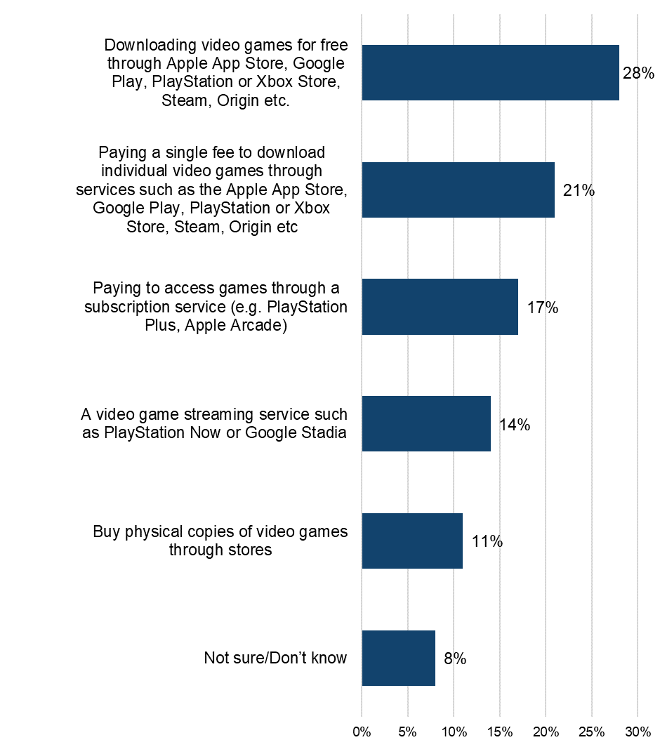Base: n=202 (downloaded/accessed video games illegally)

Qualitative insight: reactions to the hypothetical loss of illegal music sources

Faced with the prospect of losing access to video games via free and illegal methods, many said they would be disappointed. These participants reported that financially, they would not be able to access all the content they used to. This means many said they would look for the most cost-effective options of the legal sources available. A few said they wouldn’t mind too much as they understood the benefits of downloading games legally, including quality, assured safety and feeding back into the industry.

“Disappointed because this offers a cheap way of obtaining entertainment and a way to socialise with family and friends. I would be forced into buying more games which cost money to play.”
Male, Video Games, 31-40

“I wouldn't play it as much. I couldn't afford to buy games and content all the time. I would borrow from friends. I would be spending less time online.”
Female, Video Games, 31-40

“It would largely impact me as I use it quite frequently. I would try to use steam or epic games as substitutes as I trust these apps and wouldn't mind paying for games through it.”
Non-Binary, Video Games, 21-30

“I would feel annoyed and angry but I would still look for something that doesn’t cost too much. Yes I would use other platforms and it would be a case on who gives the best content at the best price.”
Female, Video Games, 41-50

Category Insights: Software

Further details and demographic breakdowns for the findings in the Software section can be found in Tables 7.1a – 7.11 in OCI 2024 Supplementary Tables – Software (ODS 90.6KB), which provide a comprehensive analysis of the data.

Trends in overall software consumption in the UK

Prior to presenting information on software infringement levels, it’s useful to initially consider respondents’ engagement with, and consumption of software.

In the previous three months, 22% had engaged with software (i.e. either by downloading, streaming/accessing, sharing or purchasing physical products).
Analysis of responses by mode of access found that:

- downloading was the most common method of accessing software, with 16% having done so (Figure 100)
- streaming/accessing followed at 10% and 5% had purchased physical copies
- across all types of accessing software, male respondents were more engaged than female respondents
- the younger age groups (12-34’s) were the most engaged with downloading, with rates ranging from 19% to 22%, compared to older age groups, where engagement steadily declined to 11% among those aged 55 and over—a difference of over 10%.
- those streaming and purchasing physical copies were also most likely to be found at the younger end of the age spectrum – typically up to 34

Detailed demographic analyses related to these findings can be found in Tables 7.1a – 7.1d in OCI 2024 Supplementary Tables – Software.

Downloading is the most frequent means of engaging with software
Figure 100: Downloaded/streamed/shared/purchased physical copies of software in the past three months. Download the data from Tables 7.1a – 7.1d.

Base: n=5,087 (total sample)
Note: The definition of ‘shared’ was provided as: “By shared we mean that you personally made the file publicly available or sent or uploaded it online for someone else to download or stream/access. This does not include sending links to content that has already been shared by someone else, unless stated in the answer option”.

The importance of software in people’s lives

To get a broader sense of their passion for software, respondents were asked to what extent they agreed with a range of statements and then grouped as High, Medium or Low, based on their responses.

Over a quarter (27%) displayed a high level of passion for software (Figure 101) – this passion was more apparent among men and those under the age of 35. When looking at individual statements, accessing software appears to be more of a day-to-day necessity rather than a hobby (Figure 102).

Just one positive statement was agreed with by more than half: 57% felt that “Certain software packages (Adobe Suite, Microsoft Office etc.)” were central to their lives.Over half (55%) did however feel that they would be likely to reduce their spend on software in coming months.

Detailed demographic analyses related to these findings can be found in tables 7.2a – 7.2f in OCI 2024 Supplementary Tables – Software.

Over a quarter of those who consume software have a high level of passion for it
Figure 101: Levels of passion for software. Download the data from Table 7.3.

Base: n=1,141 (downloaded, streamed, shared and/or purchased physical copies of Software in the past three months)

Over half of all those who have recently accessed software feel that certain software packages are central to their life
Figure 102: Extent of agreement with statements in relation to software. Download the data from Tables 7.2a – 7.2f.

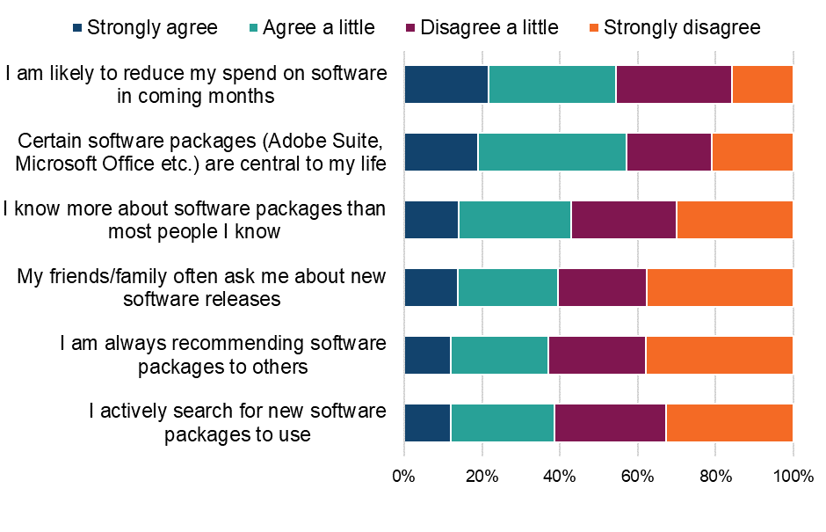
Base: n=1,141 (downloaded, streamed, shared and/or purchased physical copies of Software in the past three months)

Physical purchasing of software

This section refers to the rate of purchasing of physical copies of software followed by rates of online purchasing.

The 5% of respondents who had purchased software in physical formats during the previous three months were asked about the number of purchases made. The average number of physical copies of software purchased in the previous three months (four) was higher for female respondents (six) than male respondents (three). Those aged 55 and above reported purchasing significantly more physical software packages than other age groups - on average, they purchased seven while no other age group purchased more than four.

Detailed demographic analyses related to these findings can be found in Table 7.4a in OCI 2024 Supplementary Tables – Software.

Understanding online consumption of software

To better understand the drivers of online consumption, those who had accessed or downloaded software in the previous three months were asked to select their top three reasons for doing so.

Analysis of responses found that cost, or a lack thereof, was the most popular reason for online access (Figure 102). The top two reasons, selected by more than a third of respondents, were “It’s free or cheap” (40%) and “Getting value for money” (35%). This was true across most groups, the the same top reason “It’s free or cheap” being selected. The only exceptions were the 12-15 and 25-34 age groups, where “Being able to access software packages whenever I want” and “Better quality” were the respective top motivations.

The next group of reasons, selected by over a quarter, related to security, convenience, quality, and variety of choice. It is worth noting that respondents were able to select multiple options, so the percentages presented do not sum to 100%. No other reason was selected by more than 16%.

Detailed demographic analyses related to these findings can be found in Table 7.4b in OCI 2024 Supplementary Tables – Software.

Low/no cost and value for money drive online software consumption, alongside security and protection from malware
Figure 103: Main reasons for accessing software packages online (i.e. downloading or streaming/accessing). Download the data from Table 7.4b.
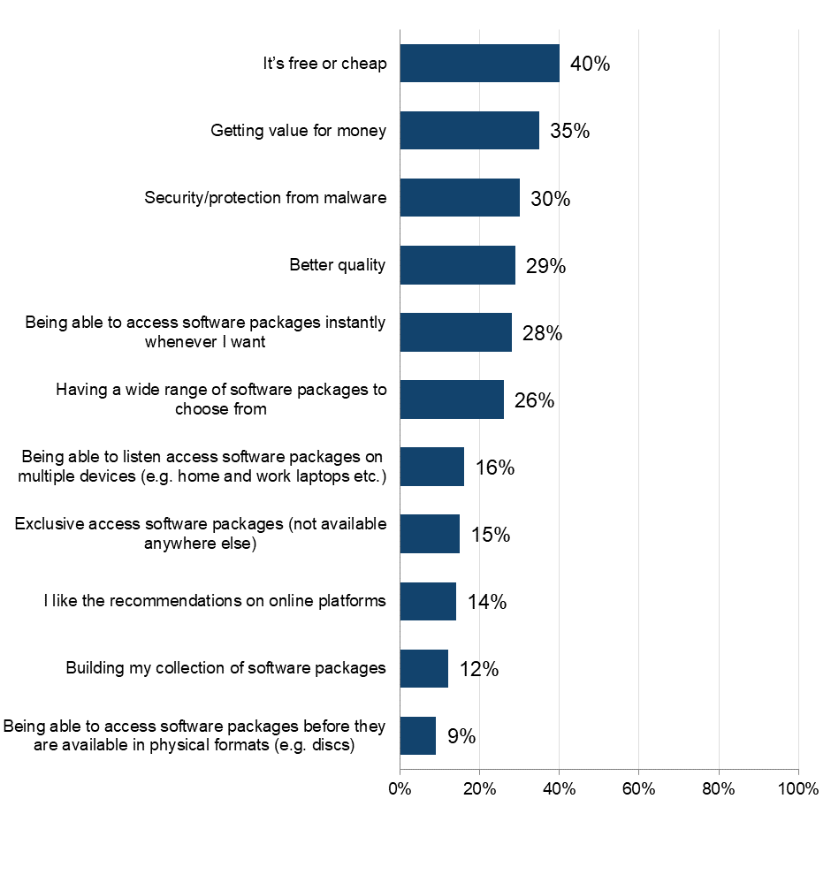
Base: n=1,030 (downloaded or streamed/accessed software packages online in the past three months). Respondents were able to select multiple options, so the percentages presented do not sum to 100%.

Downloading/accessing software

Frequency and volume of downloading/accessing software

The 20% who had accessed software during the previous three months were asked questions around frequency, volume and sources used.

Almost 30% accessed software frequently (i.e. at least once a week) (Figure 104). Weekly access was more common among male respondents (34%) than female respondents (21%). Accessing software frequently (i.e. at least once a week) was most also common in those aged 16-34 (44%-45%).

An average of 24 software packages had been accessed during the past three months. Those aged between 25-34 had downloaded the highest number of software packages by far (74), with all others downloading between 8-15.

Detailed demographic analyses related to these findings can be found in Tables 7.5a -7.5b in OCI 2024 Supplementary Tables – Software.

Almost 30% of those accessing software online are doing so at least weekly
Figure 104: Frequency of downloading or accessing software packages through the internet. Download the data from Table 7.5a.
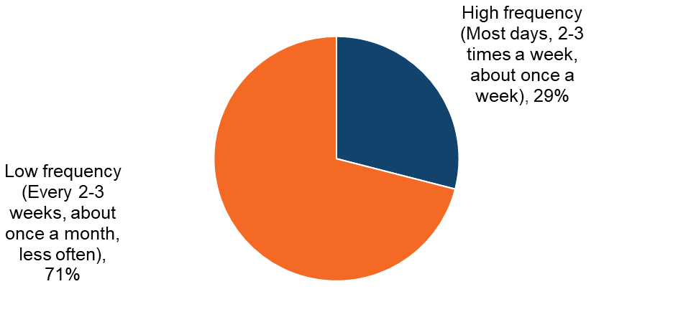

Base: n=1,030 (downloaded/accessed software in the past three months

Software: Infringement behaviours

This section details the sources of accessing software, both legal and illegal.

Sources of downloading/accessing software

Respondents were shown a list that encompassed the different ways (legal and illegal) that they could access software. An ‘unknown’ option was also provided to serve as a catch-all for those who were unsure of the exact source.

The two most used sources by a large percentage for accessing software were legal (Figure 105). Almost half accessed software via a software creator’s store (49%) and by paying a single fee to download individual software packages (31%).

All illegal sources were used by smaller proportions (7-9%). The most commonly used illegal sources were receiving the file from someone else for free (8%) and BitTorrent or another file sharing or peer-to-peer service (9%).

Detailed demographic analyses related to these findings can be found in Tables 7.6 – 7.8 in OCI 2024 Supplementary Tables – Software.

Legal sources dominate software download channels
Figure 105: Sources used to download or access software packages in the past three months. Download the data from Table 7.6.
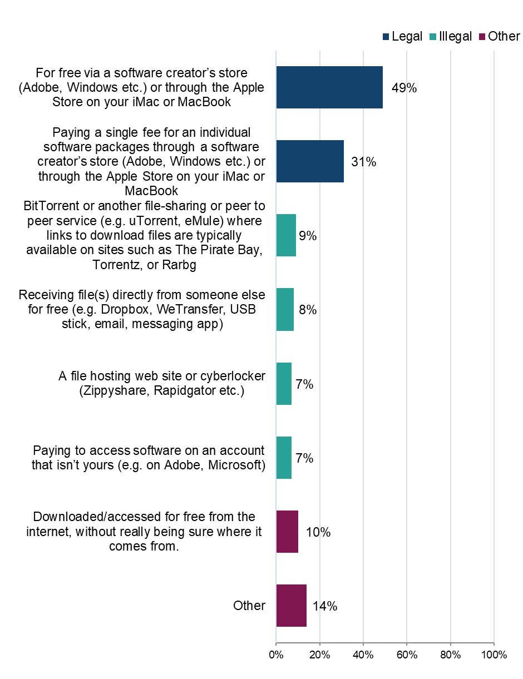
Base: n=1,030 (downloaded/accessed software during the past three months)

Legality of downloading/accessing software packages online

To better understand the distribution of sources across legal and illegal categories, those who had accessed software in the previous three months were grouped into the following (mutually exclusive) categories: using legal sources only; illegal sources only; or a mix of the two.

The answer option “download for free from the internet, without really being sure where it comes from” was not included in the definition of either legal or illegal. Anyone who said they only consumed content in this way was not included in the base.

Headline findings for different sources are as follows:

- legal:
  - Overall, 86% had used at least one legal source to access software (Figure 106)
  - the majority (69%) had used only legal sources
  - The proportion who had only used legal sources was highest amongst those aged 55 and above, with 84% having done so (Figure 108)
  - In all other age groups, this was 57-78%
- illegal :
  - 31% had used at least one illegal source to access software – this is the overall infringement level for software for 2024
  - 14% had only used illegal sources
  - more female respondents (17%) than male respondents (12%) had used only illegal sources to access software (Figure 107)
  - the proportion who had used illegal sources was highest among those aged 25-34, among whom 43% had done so
  - those with a high passion were more likely to turn to illegal sources to access software (Figure 109)
- mixed:
  - 17% had used a mix of legal and illegal sources to access software
  - This was highest amongst 25-34 year olds (22%) (Figure 108)

Detailed demographic analyses related to these findings can be found in Table 7.7 in OCI 2024 Supplementary Tables – Software.

Over 30% have used at least one illegal download source
Figure 106: Legality of downloading/accessing software. Download the data from Table 7.7.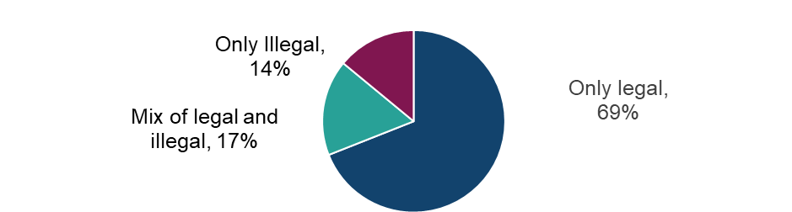

Base: n=826 (downloaded/accessed software in the past three months, with those who selected ‘other’ or ‘not sure of source’ removed).

Female respondents are more likely than male respondents to use only illegal sources to download/access software
Figure 107: Legality of downloading/accessing software by sex. Download the data from Table 7.7. 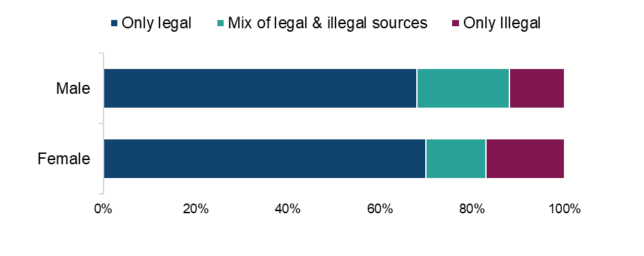
Base: n=826 (downloaded/accessed software in the past three months, with those who selected ‘other’ or ‘not sure of source’ removed).

Higher use of illegal sources to download/access software among the younger age groups
Figure 108: Legality of downloading/accessing software by age. Download the data from Table 7.7.
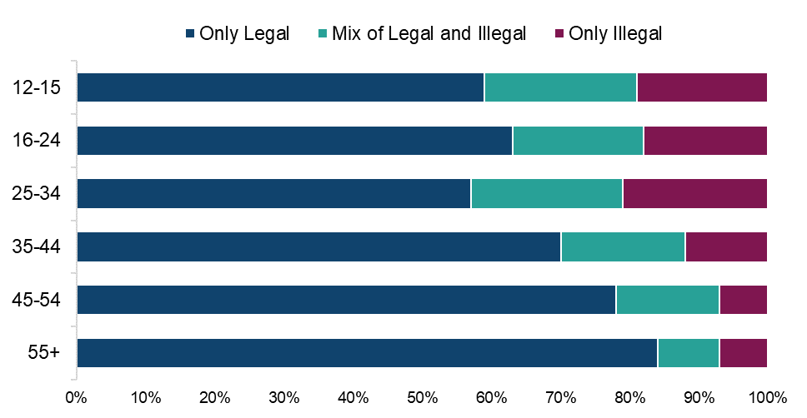

Base: n=826 (downloaded/accessed software in the past three months, with those who selected ‘other’ or ‘not sure of source’ removed).

Higher use of illegal sources to download/access software among those with a high passion for software
Figure 109: Legality of downloading/accessing software by passion level for software. Download data from Table 7.7. 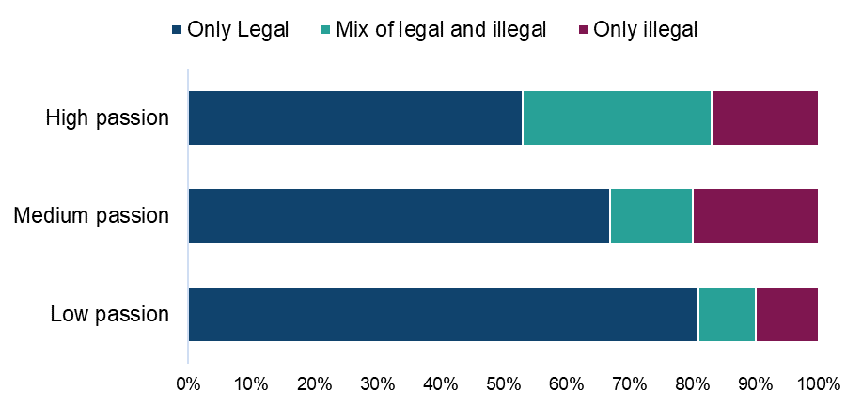

Base: n=826 (downloaded/accessed software in the past three months, with those who selected ‘other’ or ‘not sure of source’ removed).

Legal sources – for free via a software creator’s store or paying a single software package fee account for over 60% of all software downloads/download time
Table 9: Distribution of methods of downloading/accessing software by source. Download the data from Table 7.8.

Legality | Source | Average % of usage split
Legal | For free via a software creator’s store (Adobe, Windows etc.) or through the Apple Store on your iMac or MacBook | 39%
Legal | Paying a single fee for an individual software packages through a software creator’s store (Adobe, Windows etc.) or through the Apple Store on your iMac or MacBook | 23%
Illegal | BitTorrent or another file-sharing or peer to peer service (e.g. uTorrent, eMule) where links to download files are typically available on sites such as The Pirate Bay, Torrentz, or Rarbg | 5%
Illegal | Paying to access software on an account that isn’t yours (e.g. on Adobe, Microsoft) | 4%
Illegal | Receiving the file(s) directly from someone else for free (e.g. Dropbox, WeTransfer, USB stick, email, messaging app) | 4%
Illegal | A file hosting web site or cyberlocker (Zippyshare, Rapidgator etc.) | 4%
Other | Download/access for free from the internet, without really being sure where it comes from | 8%
Other | Other | 13%

Base: n=1,030 (downloaded/accessed software in the past three months)

Software: Cyber security incidents

Respondents were asked if they had experienced any of a list of cyber security incidents in the previous 12 months. These incidents included devices being targeted with ransomware, other types of malware, hacking, phishing, social media and/ or email account takeovers, or any other incidents.
We observed a consistent trend: infringers were significantly more likely than non-infringers to report experiencing a cyber security incident. While a definitive causal link cannot be established, this may be influenced by factors such as higher digital engagement among infringers, increased exposure to unverified sources, or reliance on websites that pose a risk, and compromised content platforms.
Three-quarters (75%) of those who had downloaded/accessed software illegally had experienced at least one cyber security incident (Figure 110). This compares with 55% of those who had used only legal sources.

Those who download/access software illegally are more likely to have experienced cyber security incidents in the last 12 months than those only using legal sources
Figure 110: Looking back over the past 12 months, to your knowledge, have you personally experienced any of the following cyber security incidents? Download the data from Table 1.15 of the OCI 2024 Main Data Tables (ODS 103KB).

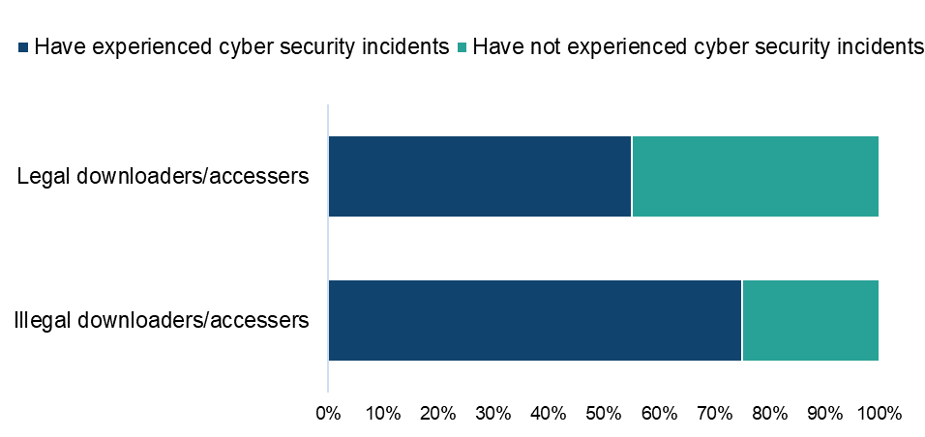

Base: n=744 (downloaded/accessed software in the past three months, with those who selected ‘other’ or ‘not sure’ removed from both questions)

Paying for software

Those who had used a paid source to access/download software were asked how much they had personally spent on each source on a monthly basis. Average monthly expenditure was as follows:

- paying a single fee for an individual software package through a software creator’s store: £21.20
- paying for illegal access: (“access software on an account that isn’t yours”): £3.30

Detailed demographic analyses related to these findings can be found in Table 7.9 in OCI 2024 Supplementary Tables – Software.

Software: Change in use of illegal sources

Those who had used an illegal source to download or access software were asked how their use of these sources compares to the same point a year ago.

The highest proportion (46%) of respondents said that their use of illegal sources had remained static (Figure 111). This was followed by those whose usage had increased (37%). For a relatively small number, usage had decreased (14%) or they weren’t using these sources a year ago (3%).

Detailed demographic analyses related to these findings can be found in Tables 7.10 in OCI 2024 Supplementary Tables – Software.

37% of those using illegal sources to download or access software say their use of these sources is increasing
Figure 111: Change in usage of illegal sources to access software compared to last year. Download the data from Table 7.10.

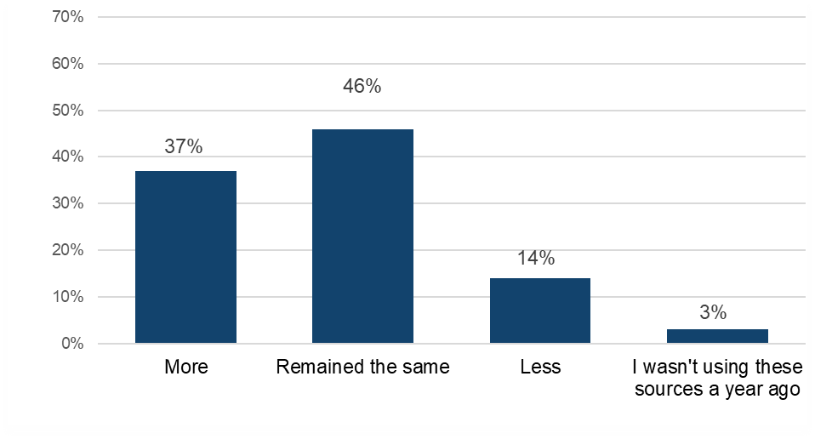
Base: n=257 (downloaded and/or accessed software illegally)

Software: Alternatives to infringement

This section will explore what respondents anticipate they would do if they lost access to illegal sources of software.

Those who had used illegal sources to either download or access software were asked which single legal source they would use if they could no longer access software illegally. The top source was a free one, “For free via a software creator’s store or through the Apple store”, selected by 38% (Figure 112). Around a third (32%) said they would “Pay a single fee for an individual software packages through a software creator's store or through the Apple store”.

Male respondents were more likely to consider “Buying physical copies of software through stores” (22%) compared to female respondents (12%). They were also more likely to turn to “For free via a software creator’s store or through the Apple store”, (41% vs 35%).

Considering age, the youngest age group was also most likely to turn to “For free via a software creator’s store or through the Apple store” (54%). For 16–24 year-olds, “Paying a single fee for an individual software packages through a software creator’s store (Adobe, Windows etc.) or through the Apple Store on your iMac or MacBook” was the most likely alternative (43%).

The older age groups (45+) were more likely than their younger counterparts to consider “Buying physical copies through stores” (21%-29%). However over 20% of 45+ year olds didn’t know/were unsure what they would do.

Detailed demographic analyses related to these findings can be found in Table 7.11 in OCI 2024 Supplementary Tables – Software.

In the absence of illegal software sources, respondents would typically turn to a free software creator’s store or would pay a single software package fee
Figure 112: Alternative sources for accessing software if illegal options were unavailable. Download the data from Table 7.11.
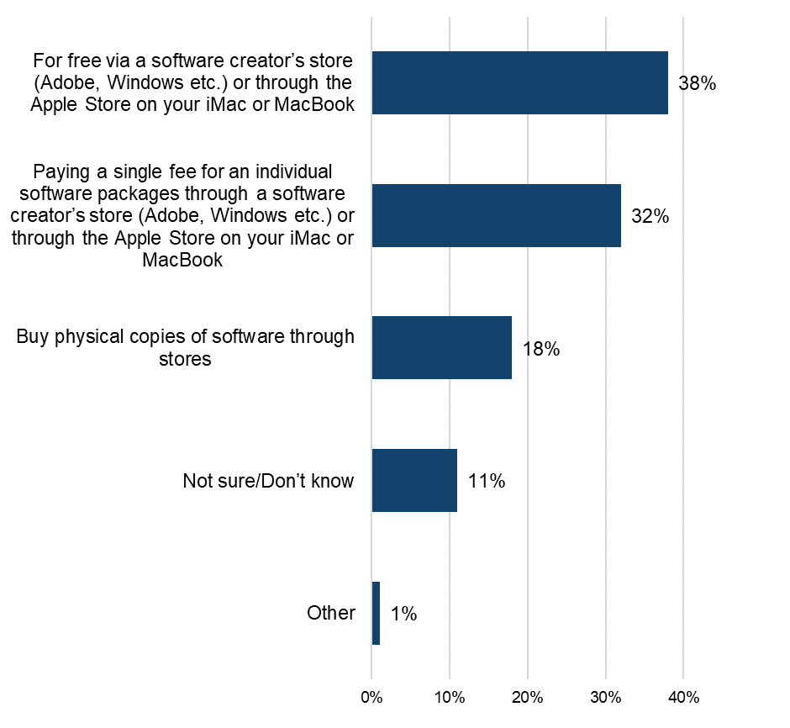
Base: n=257 (downloaded and/or accessed software illegally)

Category Insights: E-books

Further details and demographic breakdowns for the findings in the E-books section can be found in Tables 8.1a – 8.11 in OCI 2024 Supplementary Tables – E-books (ODS 92.8KB), which provide a comprehensive analysis of the data.

Trends in overall e-book consumption in the UK

Prior to presenting information on e-book infringement levels, it’s useful to initially consider respondents’ engagement with, and consumption of these.

38% had engaged with books/e-books in the previous three months (either by downloading, streaming or sharing e-books, or purchasing physical copies).

The most common method of access was purchasing physical copies (27%) (Figure 113). This was followed by downloading (18%) and streaming/accessing online (10%). Purchasing physical copies of books was evenly distributed across all age groups where it was slightly over a quarter for all, with the exception of the 12-15 age group where it exceeded 30%

Detailed demographic analyses related to these findings can be found in Tables 8.1a – 8.1d in OCI 2024 Supplementary Tables – E-books.

Purchasing physical copies is the most typical form of engagement with e-books
Figure 113: Downloaded/streamed/shared/purchased physical copies of e-books in the past three months. Download the data from Tables 8.1a – 8.1d
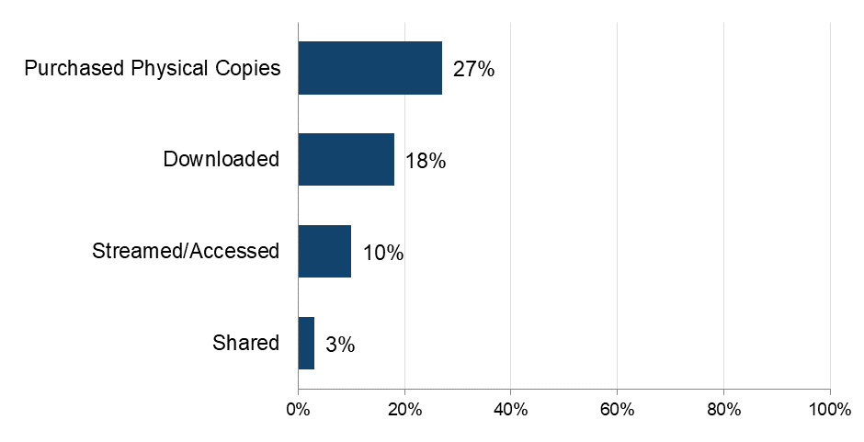
Base: n=5,087 (total sample)
Note: The definition of ‘shared’ was provided as: “By shared we mean that you personally made the file publicly available or sent or uploaded it online for someone else to download or stream/access. This does not include sending links to content that has already been shared by someone else, unless stated in the answer option”.

The importance of e-books

To get a broader sense of their passion for books/e-books, respondents were asked to what extent they agreed with a range of statements and then grouped as High, Medium or Low, based on their responses.

Over 40% of respondents displayed a high level of passion for books/e-books (Figure 114). Respondents were most likely to search for new reading material (“I actively search for new books to read” at 74%), to consider books/e-books their main source of entertainment (“Reading books is my favourite kind of entertainment” at 73%) or to speak to others about them (“I am always recommending books to others” at 54%) (Figure 115).

There was a notably higher level of book/e-book passion among female respondents than male respondents (49%, compared to 38% respectively). Detailed demographic analyses related to these findings can be found in Tables 8.2a – 8.2f in OCI 2024 Supplementary Tables – E-books.

A high passion for e-books is evident among more than 40% of recent consumers
Figure 114: Passion for e-books. Download the data from Table 8.3.

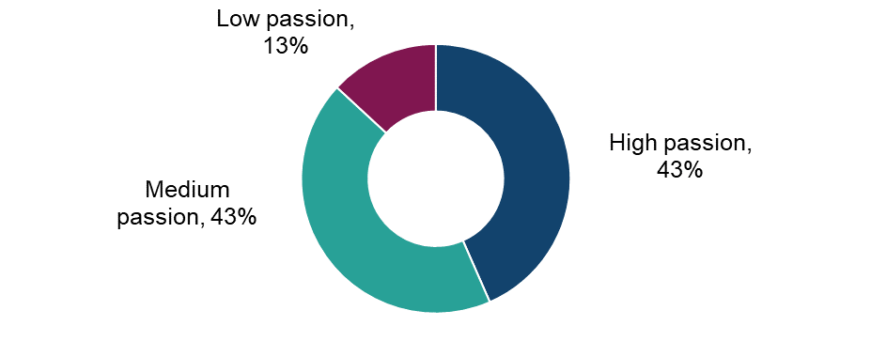
Base: n=1,922 (downloaded, streamed, shared and/or purchased physical copies of publications in the past three months)

Almost three-quarters of those who have recently engaged with books/e-books are actively searching for new titles
Figure 115: Extent of agreement with statements in relation to books. Download the data from Tables 8.2a – 8.2f.
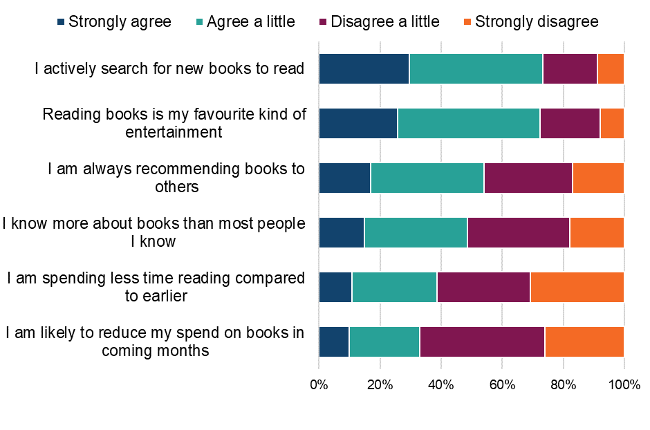
Base: n=1,922 (downloaded, streamed, shared and/or purchased physical copies of publications in the past three months)

Qualitative insight: the importance of e-books in people’s lives

When it came to the role played by e-books and e-magazines in participants’ lives, they told of their appreciation to be able to get lost in a story and relax or even learn about something new. Though still screen based, a few also mentioned the joy of reading versus always watching the television and it was something which could be taken either into the garden, on holiday or to waiting rooms to pass the time.

Most said they tended to read in the evenings and on weekends, with many also specifically mentioning holidays which appeared to provide a distinct opportunity to read for many.

“I love to get lost in a good book and regularly upload books on my kindle. I usually like to read a book quite quickly as I get immersed in the story and if it is a good book then I generally can't put it down! I usually read at weekends or an hour in the evening after work. If we are having nice weather then I will sit in the garden and read.”
Female, e-books/e-magazines, 51-60

“Helps to keep me informed on topics I am interested in. Commuting to work. After work in my free time. On my days off, or when on holiday. Provides me with the chance to 1) increase my knowledge and 2) escape from my day-to-day life/routine.”
Male, e-books/e-magazines, 31-40

“I love to read more so on holidays when I have more time. The magic of a good story cannot be underestimated for the joy the love the fear the excitement it can bring to your life. When we are travelling on holiday as we normally fly, a good read passes the time and when we are relaxing on holiday we can always find an hour or two. More recently we have started to have a free hour when we have the television off no radio so we both have a choice of what we want to do.”
Male, e-books/e-magazines, 61+

“It’s important in my life for when I want to take a break from watching TV and learn something new.”
Male, e-books/e-magazines, 21-30

For most participants, the amount they were reading hadn’t changed noticeably over the year though a couple mentioned working more and therefore reading less compared to previous years, whilst there was also mention of setting intentions to increase time spent reading.

“Over the past year, I have used less e-books compared to recent years (especially during COVID). I think I am using/accessing e-books less because I have less time to spare and stay busy with other things.”
Female, e-books/e-magazines, 51-60

“For me there has been a significant change with less time spent reading e-books as I have just been busier with work.”
Male, e-books/e-magazines, 21-30

“I don't think there has been a huge change, however I have tried to make time for reading in general. I am trying to make more constructive use of my free time, to improve my knowledge, learn something new.”
Male, e-books/e-magazines, 31-40

Physical purchasing of books

This section refers to the rate of purchasing of physical copies of books followed by rates of online purchasing.

The 27% of respondents who had purchased physical copies of books (i.e. paperback, not e-books) during the previous three months were asked a question around the number of purchases made. Respondents had purchased an average of six books over the past three months, with a peak evident among those aged 16-24.

Detailed demographic analyses related to these findings can be found in Table 8.4a in OCI 2024 Supplementary Tables – E-books.

Understanding online consumption of e-books

To better understand the drivers of online consumption, those who had accessed e-books in the previous three months were asked to select their top three reasons for doing so online. It is worth noting that respondents were able to select multiple options, so the percentages presented do not sum to 100%.

Four diverse factors emerged as important to online consumption of e-books and were each selected by around four in ten respondents (Figure 116). These included:
- being easy to store (“the convenience of storing books digitally” 46%),
- ease of access (“being able to access e-books instantly whenever I want” 46%),
- variety (“having a wide range of e-books to choose from” 46%)
- low cost (“it’s free or cheap” 42%)

A further factor relating to price (“getting value for money”) was selected by 33%, with nothing else selected by more than 24% of respondents.

Detailed demographic analyses related to these findings can be found in Table 8.4b in OCI 2024 Supplementary Tables – E-books.
Storage, instant access, variety and low/no cost drive online book consumption Figure 116: Main reasons for accessing books online (i.e. downloading or accessing). Download the data from Table 8.4b.
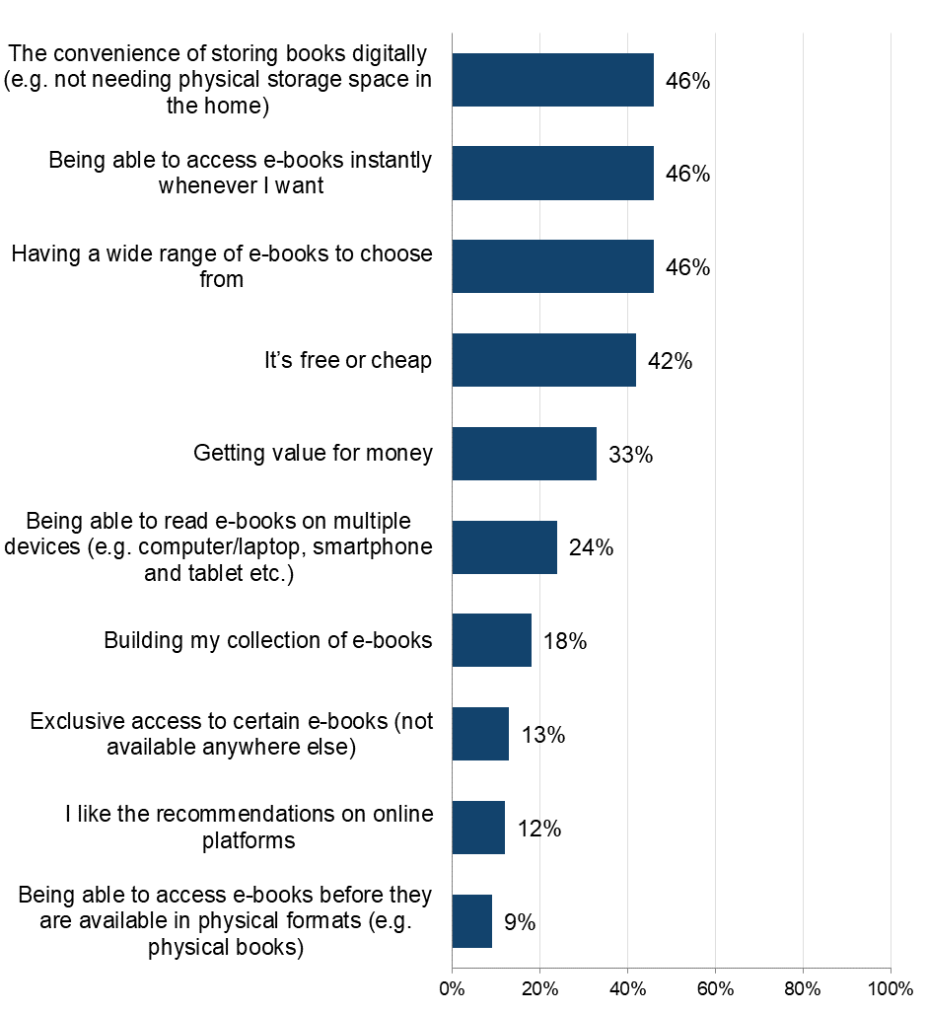
Base: n=1,067 (downloaded or accessed books online in the past three months). Respondents were able to select multiple options, so the percentages presented do not sum to 100%.

Downloading/accessing e-books

This section details the rates of downloading of e-books from the internet, followed by a deep dive into infringement within this form of accessing e-books.

Frequency and volume of downloading/accessing e-books

The 22% who had downloaded/accessed e-books during the previous three months were asked more questions around frequency, volume and sources used.

Around four in ten (39%) of those who downloaded/accessed e-books did so frequently (i.e. at least once a week) (Figure 117). A frequency peak was noted among the youngest age groups – of whom nearly half were downloading/accessing e-books at least weekly.

Over a three-month period, e-book consumers downloaded/accessed an average of 20 e-books. Consumption was higher among female respondents (22%) than it was among male respondents (18%). Higher consumption was also evident among the 16-34 age groups.

Detailed demographic analyses related to these findings can be found in Tables 8.5a – 8.5b in OCI 2024 Supplementary Tables – E-books.

Around 40% of e-book consumers are regularly accessing them via the internet
Figure 117: Frequency of downloading or accessing e-books through the internet. Download the data from Table 8.5a.

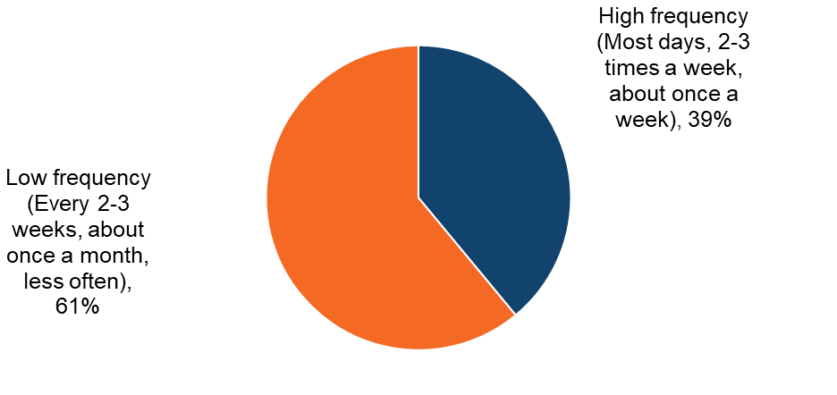
Base: n=1,067 (downloaded or accessed e-books in the past three months)

E-books: Infringement behaviours

Sources of downloading/accessing e-books

Respondents were shown a list that encompassed the different ways (legal and illegal) that they could access e-books. An ‘unknown’ option was also provided to serve as a catch-all for those who were unsure of the exact source.

The most commonly used sources were legal channels (Figure 118). The most popular, by a considerable margin, was “Paying a single fee to download individual e-books through services such as the Amazon Kindle Store” (57%). This was followed by “Pay for a subscription to a service that allows you to download or read e-books online” (23%), with other (largely free) legitimate sources following. No illegal source was used by more than 4%.

Detailed demographic analyses related to these findings can be found in Tables 8.6-8.8 in OCI 2024 Supplementary Tables – E-books.

The most commonly used e-book sources are legal
Figure 118: Sources used to download or access e-books in the past three months. Download the data from Table 8.6
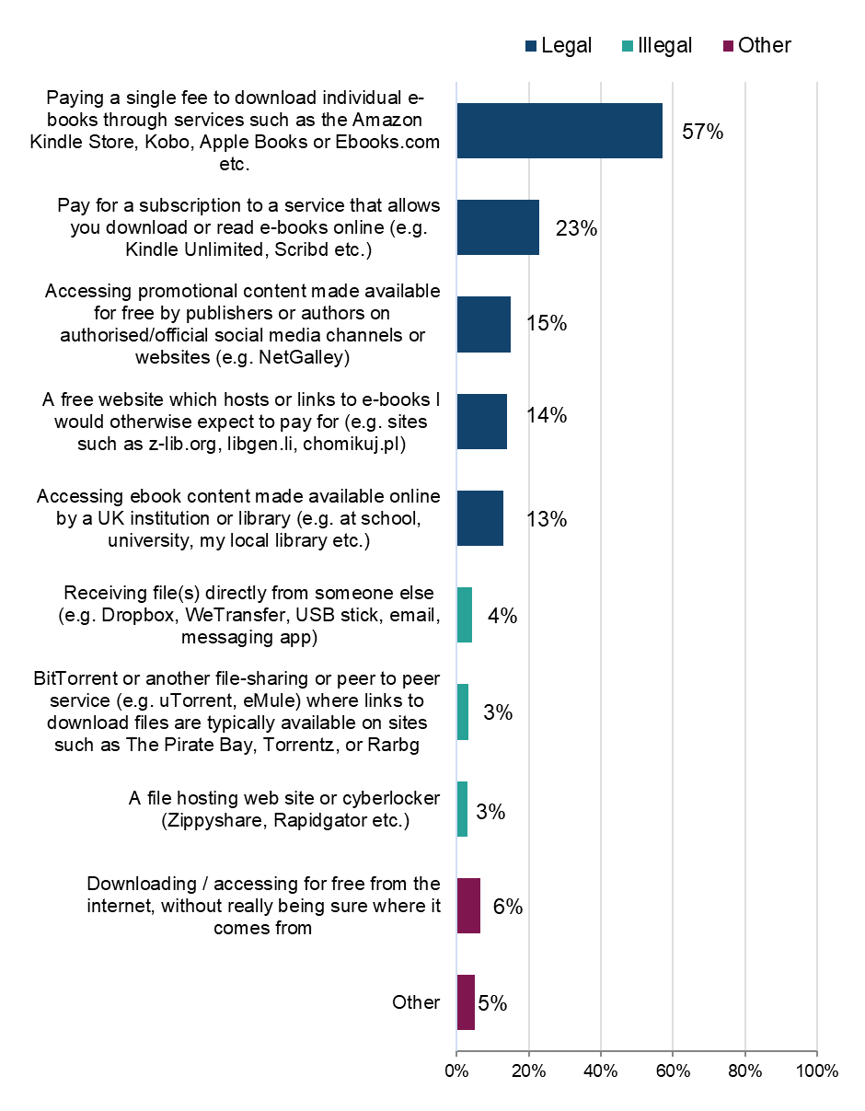
Base: n=1,067 (downloaded or accessed e-books during the past three months)

Legality of downloading/accessing e-books

To better understand the distribution of sources across legal and illegal categories, those who had accessed e-books in the previous three months were grouped into the following (mutually exclusive) categories: using legal sources only; illegal sources only; or a mix of the two.

The answer option “downloading/accessing for free from the internet, without really being sure where it comes from” was not included in the definition of either legal or illegal. Anyone who said they only consumed content this way was not included in the base.

Headline findings for each type of user are as follows:

- legal:
  - overall, 91% had used at least one legal source to access e-books (Figure 119)
  - 78% had used legal sources only
  - use of only legal sources was higher among female respondents than male respondents (Figure 120), and amongst those in the 45+ age groups (84%-86%) than it was in younger age groups (53%-77%) (Figure 121)
- illegal:
  - 22% had used at least one illegal source to download/access e-books - this is the overall infringement level for e-books for 2024
  - 9% had used illegal sources only to download/access e-books
  - use of only illegal sources was twice as high among male respondents than female respondents (12% and 6% respectively) and peaked also within the 16-34 age groups (14%-16%), with the other age groups ranging from 4%-10%
- mixed:
  - 14% had used a mix of legal and illegal sources

Detailed demographic analyses related to these findings can be found in Table 8.7 in OCI 2024 Supplementary Tables – E-books.

Over 20% have used at least one illegal download source
Figure 119: Legality of downloading/accessing e-books. Download the data from Table 8.7.
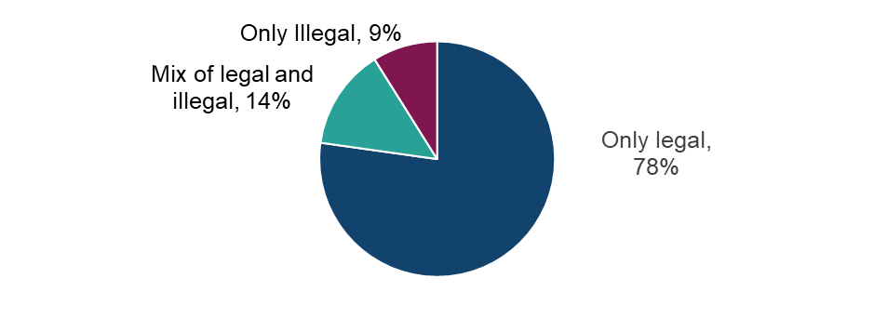
Base: n=992 (downloaded or accessed e-books in the past three months, with those who selected ‘other’ or ‘not sure of source’ removed).

Male respondents are more likely than female respondents to use illegal sources to download/stream e-books
Figure 120: Legality of downloading/streaming e-books by sex. Download the data from Table 8.7.
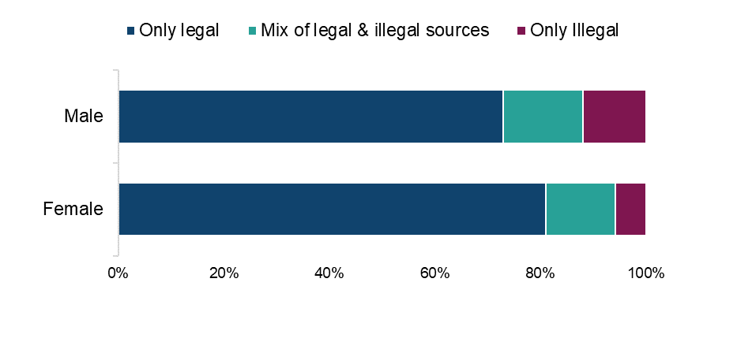
Base: n=992 (downloaded or streamed e-books in the past three months, with those who selected ‘other’ or ‘not sure of source’ removed).

Higher use of illegal sources to download/stream e-books among the younger age groups
Figure 121: Legality of downloading/streaming e-books by age. Download the data from Table 8.7.
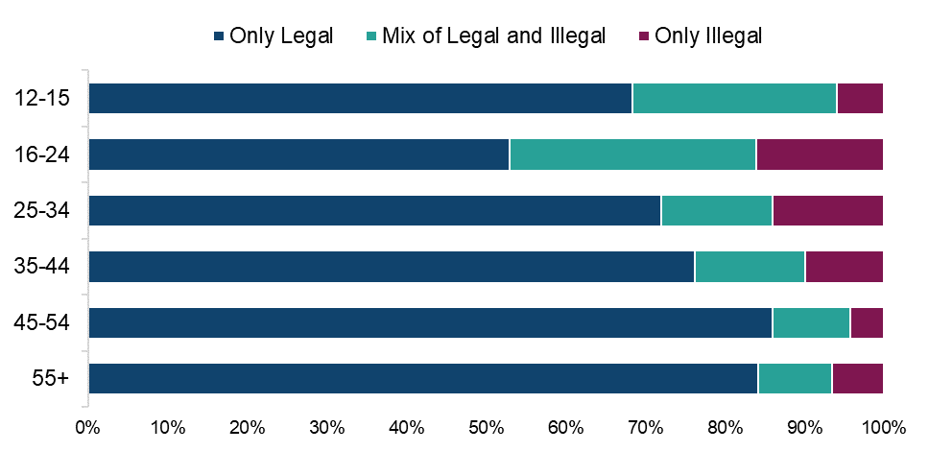

Base: n=992 (downloaded or streamed e-books in the past three months, with those who selected ‘other’ or ‘not sure of source’ removed).

Legal sources account for the vast majority of e-book downloads/access time

Table 10: Distribution of methods of downloading/accessing e-books by source. Download the data from Table 8.8.
Legality | Source | Average % of usage split
Legal | Paying a single fee to download individual e-books through services such as the Amazon Kindle Store, Kobo, Apple Books or Ebooks.com etc. | 47%
Legal | Pay for a subscription to a service that allows you download or read e-books online (e.g. Kindle Unlimited, Scribd etc.) | 16%
Legal | Accessing promotional content made available for free by publishers or authors on authorised/official social media channels or websites (e.g. NetGalley) | 8%
Legal | Accessing e-book content made available online by a UK institution or library (e.g. at school, university, my local library etc.) | 8%
Illegal | A free website which hosts or links to e-books I would otherwise expect to pay for (e.g. sites such as z-lib.org, libgen.li, chomikuj.pl) | 8%
Illegal | BitTorrent or another file-sharing or peer to peer service (e.g. uTorrent, eMule) where links to download files are typically available on sites such as The Pirate Bay, Torrentz, or Rarbg | 2%
Illegal | Receiving file(s) directly from someone else (e.g. Dropbox, WeTransfer, USB stick, email, messaging app) | 2%
Illegal | A file hosting web site or cyberlocker (Zippyshare, Rapidgator etc.) | 1%
Other | Downloading/accessing for free from the internet, without really being sure where it comes from | 4%
Other | Other | 5%

Base: n=1,067 (downloaded/accessed e-books in the past three months)

E-books: Cyber security incidents

Respondents were asked if they had experienced any of a list of cyber security incidents in the previous 12 months. These incidents included devices being targeted with ransomware, other types of malware, hacking, phishing, social media and/ or email account takeovers, or any other incidents.
We observed a consistent trend: infringers were significantly more likely than non-infringers to report experiencing a cyber security incident (Figure 122. While a definitive causal link cannot be established, this may be influenced by factors such as higher digital engagement among infringers, increased exposure to unverified sources, or reliance on websites that pose a risk, and compromised content platforms.
Over three-quarters (76%) of those who had downloaded or streamed e-books illegally had experienced at least one cyber security incident. This compares with 46% of those who had used only legal sources.

Those who download/stream e-books illegally are more likely to have experienced cyber security incidents in the last 12 months than those only using legal sources
Figure 122: Looking back over the past 12 months, to your knowledge, have you personally experienced any of the following cyber security incidents? Download the data from Table 1.15 of the OCI 2024 Main Data Tables (ODS 103KB).
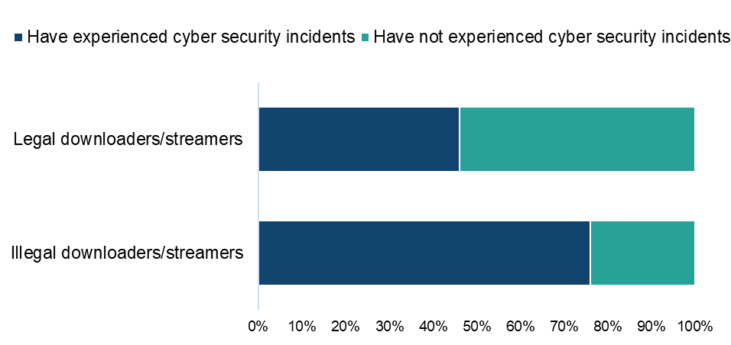

Base: n=946 (downloaded or streamed e-books in the past three months, with those who selected ‘other’ or ‘not sure’ removed from both questions)

Qualitative insight: e-books and cyber security incidents

Qualitatively, most had never experienced any such issues in this category but were quite aware that it was a risk, saying they would rethink their consumption of illegal e-publications if they did suffer an issue. There was also mention of the idea of being liable for fines or legal prosecution for using illegal content which worried some, as in other categories.

“Worried I would get a big bill or even a fine if found out. I haven’t had bad experiences but I think that I would feel guilty if found out.”
Female, e-books/e-publications, 61+

“I sometimes worry if the website has viruses, tracking devices that would be harmful to me. Thankfully nothing has happened so far, but if I had negative experiences that caused me major or minor inconveniences, I mistrust these sources.”
Male, e-books/e-publications, 31-40

“I never had any bad experiences as I know how to protect myself online. In case something like this happens, I will lose my trust in unofficial sources and won’t open any links or unrecognisable websites to avoid any negative experiences in the future.”
Female, e-books/e-publications, 51-60

Paying for e-books

Those who had used a paid source to either download or access e-books were asked how much they had personally spent on each source. Average monthly expenditure was as follows:

- a paid subscription to a service allowing online downloads/access (such as Kindle Unlimited): £5.20
- paying a single fee to downloaded individual e-books (through services such as the Amazon Kindle store): £8.90
- “Other online sources”: £3.90

Detailed demographic analyses related to these findings can be found in Table 8.9 in OCI 2024 Supplementary Tables – E-books.

E-books: Change in use of illegal sources

Those who had used an illegal source to download or access e-books were asked how the use of these sources compares to the same point a year ago. Respondents were most likely to indicate static usage (55%) (Figure 123). This was followed by those who were using them more (29%), with relatively small proportions saying their usage was less (10%) or that they weren’t using these sources a year ago (5%).

Detailed demographic analyses related to these findings can be found in Table 8.10 in OCI 2024 Supplementary Tables – E-books.

29% of those using illegal sources to download or access e-books say their use of these sources is increasing
Figure 123: Change in usage of illegal sources to access e-books compared to last year. Download the data from Table 8.10.
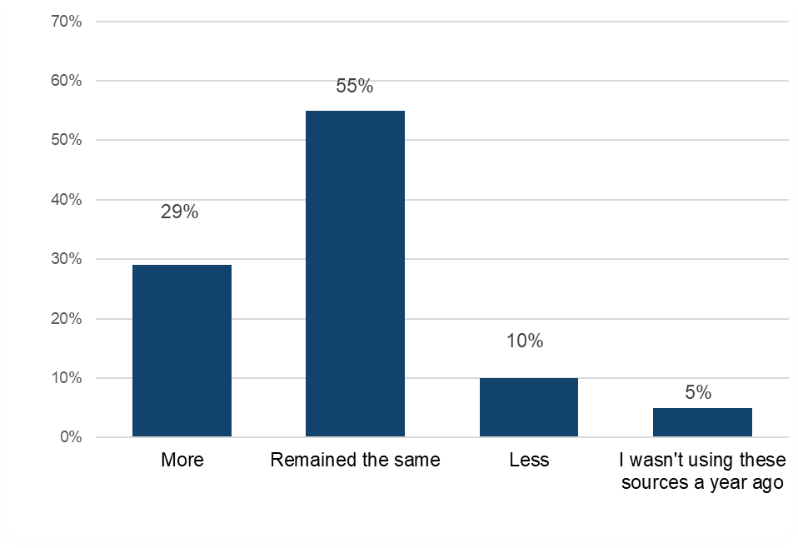
Base: n=222 (downloaded or accessed e-books illegally)

Qualitative insight: accessing e-books through legal and illegal sources

The majority of participants in this qualitative sample paid for e-books and e-magazines, mostly through Amazon for many of those who had a Kindle. Ebooks.com, Google Play Books and Libby for e-books and e-magazines were also mentioned as common ways of accessing these resources legally. Some were also subscribed to certain online magazines.

However, illegal methods of access came in handy when participants couldn’t find certain books or magazines on their usual legal sources. In these cases, Torrent sites as well as Zippyshare and receiving files via friends on USB sticks or Dropbox were the most common ways to gain access. Simply searching the internet for a pdf was also mentioned. Regarding feedback on sources, participants said that Torrent sites were sometimes time consuming to search through and could take a while to download from. A risk of viruses was also mentioned as a drawback to illegal sources though one not many had encountered.

“Occasionally I also use uTorrent and find the book or magazine I want to read via a torrent site. The main strength for using a torrent site is you can download a specific book you’re wanting to get hold of but the downside to this is finding a torrent site with the book you want.”
Female, e-books/e-magazines, 41-50

“For titles I can't find on either kindle or Google play books, I search for it online. I usually end up going to the website that has a free pdf file or online book viewer and read it from there.”
Female, e-books/e-magazines, 51-60

“Zippyshare was one of the pioneers, user interface is very friendly, don't see any weaknesses in this. UTorrent offer latest content, however drawback is it takes a lot of time and the resources are overwhelming. Dropbox is excellent for sharing, no drawbacks.”
Male, e-books/e-magazines, 21-30

“I sometimes use Zippyshare, and occasionally receive files from a USB stick from friends and colleagues. The main benefits are that these options are free, and I can access them from various devices. Weaknesses are that it can be difficult to get the items I want (e.g., on Zippyshare, specifically), there is a risk of viruses and finally sometimes you feel more reassured when buying the official product.”
Male, e-books/e-magazines, 31-40

E-books: Alternatives to infringement

This section will explore what respondents anticipate they would do if they lost access to illegal sources of e-books.

Those who had used illegal sources to either download or access e-books were asked which single legal source they would use if they could no longer access e-books illegally.

More than half of respondents said they would pay for e-books. This included those who would “buy physical copies of books through stores” (25%), “pay for a subscription to a service or publisher that allows you to download or read e-books” (17%) or pay “a single fee to download individual e-books” (11%) (Figure 124).

Detailed demographic analyses related to these findings can be found in Table 8.11 in OCI 2024 Supplementary Tables – E-books.

Switching to purchasing copies of books online or through stores is the most typical single action in the absence of illegal sources
Figure 124: Alternative sources for accessing e-books if illegal options were unavailable. Download the data from Table 8.11.
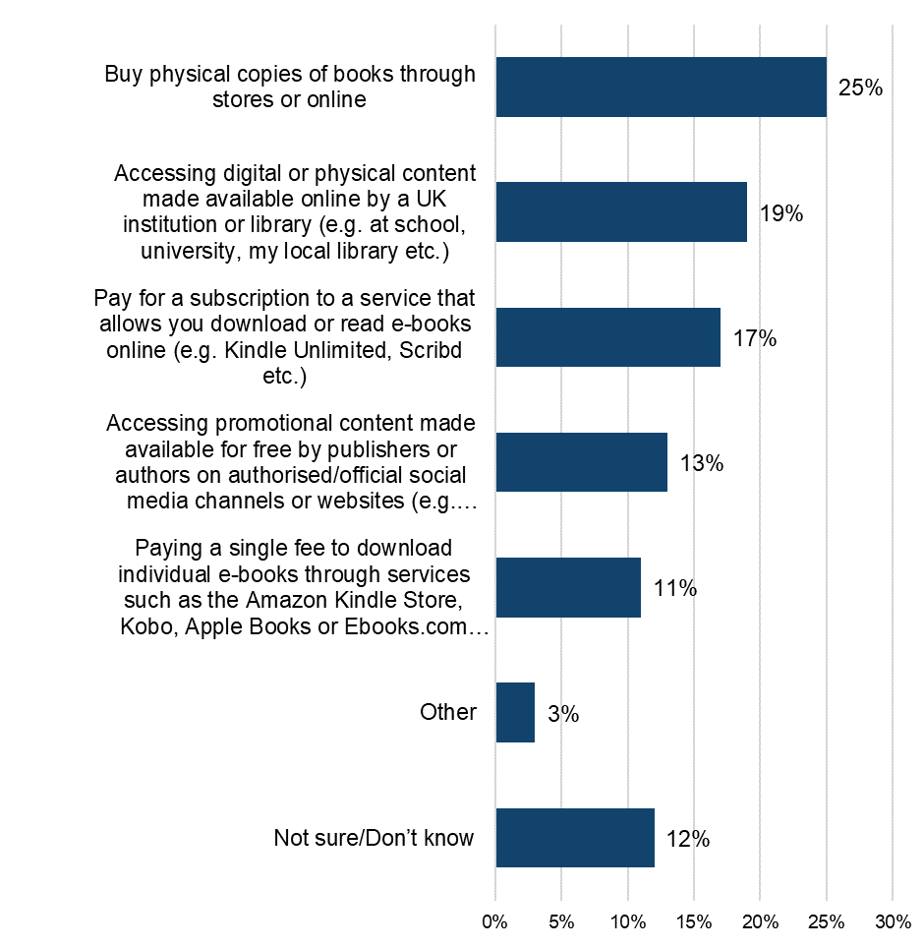
Base: n=222 (downloaded or accessed e-books illegally)

Qualitative insight: reactions to the hypothetical loss of illegal e-book sources

Asked whether access to free, illegal sources would continue to be important in the future, there was a particular altruistic angle regarding the availability of e-books for free. Participants felt it was important for the public to have access to literature, to encourage people to keep reading and the reassurance of free content in case of financial difficulties.

“It’s important because this way lots of quality content is accessible to the public.”
Male, e-books/e-magazines, 21-30

“Overall, I feel it is important to be able to access e-books cheaply so everyone can benefit from it and be encouraged to read more.”
Female, e-books/e-magazines, 51-60

“It is always useful to know that there are these alternative options available. If there are differences in my financial circumstances that mean I need to prioritise saving money, I may start using these cheaper alternatives more often.”
Male, e-books/e-magazines, 31-40

Asked to imagine that the illegal methods of accessing e-book/e-magazine content were to disappear, there was a sense of disappointment (though there were some who said they would be happy to pay if the prices from official sources weren’t too high). Some felt they should have access regardless of price and therefore considered they might have to consume less. Others also mentioned turning back to legal but free sources such as libraries and borrowing books in physical copies from friends and family.

“I would have to think seriously whether I wanted to pay. I believe books should be free to everyone and hate the idea of paying for them. I would consume less content digitally. I would search to find free content but have no idea if they would be readily available.”
Female, e-books/e-magazines, 61+

“I would be very sad if not available. I believe because the unofficial companies offer extra market choice and help keep prices down in the paid market so if choice is removed it means the bigger players who are left like amazon will have power to reduce the overall offering that's available at present and increase prices.”
Male, e-books/e-magazines, 61+

“I would feel a bit disappointed that the option was no longer available to me. I do use these alternative options from time to time and in a way, it is kind of reassuring to know you can always fall back on these free sources. I think overall I would consume the same amount however I would fall back to using more traditional 'old school' methods as a back-up. By which I mean going to libraries, borrowing physical books, second hand shops and also borrowing from friends and families.”
Male, e-books/e-magazines, 31-40

“It wouldn't bother me as long as the fee for downloading books was reasonably priced. If I couldn't access books online then I would use a library or purchase books. I would look for the same content if available but would probably consume less as wouldn't be so easy to access and probably not so much choice.”
Female, e-books/e-magazines, 51-60

Category Insights: Audiobooks

Further details and demographic breakdowns for the findings in the Audiobooks section can be found in Tables 9.1a – 9.11 in OCI 2024 Supplementary Tables – Audiobooks (93.6KB), which provide a comprehensive analysis of the data.

Trends in overall audiobooks consumption in the UK

Prior to presenting information on audiobooks infringement levels, it’s useful to initially consider respondents’ engagement with, and consumption of these.

14% had engaged with audiobooks in the previous three months (either by downloading, streaming or sharing audiobooks). The most common method of access was downloading (10%) (Figure 125). This was followed by streaming or accessing online (9%) and purchasing physical copies (such as a disc or tape) (3%).

Detailed demographic analyses related to these findings can be found in Tables 9.1a – 9.11 OCI 2024 Supplementary Tables – Audiobooks.

Downloading is the most frequent means of engaging with audiobooks
Figure 125 Downloaded/streamed/shared/purchased physical copies of audiobooks in the past three months. Download the data from Tables 9.1a – 9.1d.
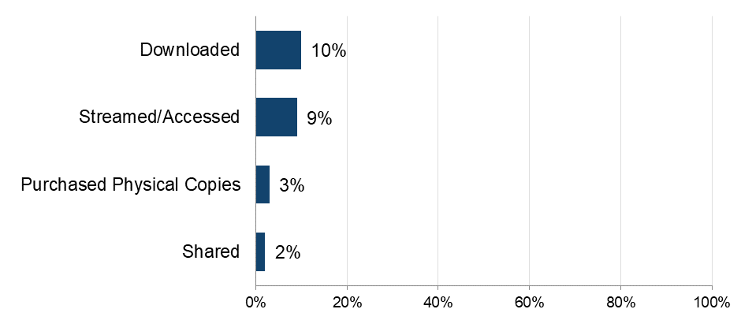
Base: n=5,087 (total sample)
Note: The definition of ‘shared’ was provided as: “By shared we mean that you personally made the file publicly available or sent or uploaded it online for someone else to download or stream/access. This does not include sending links to content that has already been shared by someone else, unless stated in the answer option”.

The importance of audiobooks

To get a broader sense of their passion for audiobooks, respondents were asked to what extent they agreed with a range of statements and then grouped as High, Medium or Low, based on their responses.

Over a third (35%) had a high level of passion for audiobooks (Figure 126). Audiobook passion was highest among the youngest respondents (aged 12-15, 50%), and tended to decrease with age, dropping to just 26% among those in the 55 and above age category.

A common way of displaying/exploring this passion appears to be “actively searching for new audiobooks”, with 61% doing so (Figure 127). Over half (52%) agree that listening to books is their favourite type of entertainment, with 50% saying they speak to others about audiobooks they have listened to.

Detailed demographic analyses related to these findings can be found in Tables 9.2a – 9.2f in OCI 2024 Supplementary Tables – Audiobooks.

Over a third of those who consume audiobooks have a high level of passion for them
Figure 126: Passion level for audiobooks. Download the data from Table 9.3.
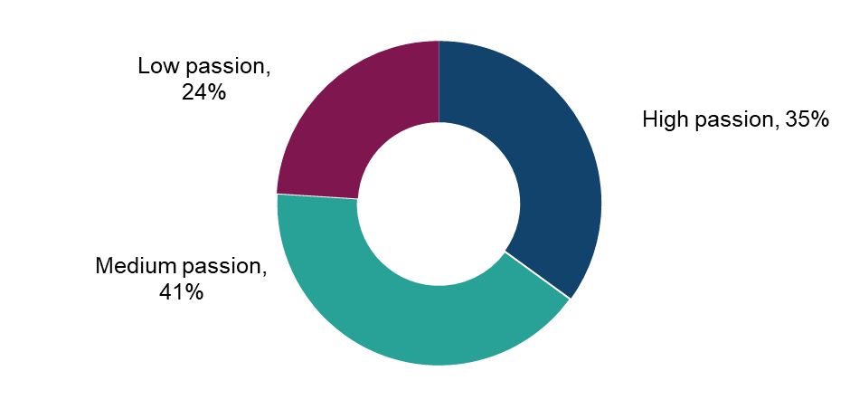

Base: n=696 (those who access, share or purchase physical audiobooks)

Over 60% of those who consume audiobooks actively search for new titles
Figure 127: Extent of agreement with statements in relation to audiobooks. Download the data from Tables 9.2a – 9.2f.

Base: n=696 (those who access, share or purchase physical audiobooks)

Physical purchasing of audiobooks

This section refers to the rate of purchasing of physical copies of audiobooks e.g. on tapes, CDs followed by rates of online purchasing.

The 3% of respondents who had purchased physical copies of audiobooks i.e. on cassette, CD, during the previous three months were asked a question around the number of purchases made. Respondents had purchased, on average, seven audiobooks during the previous three months. This was highest amongst 16-24 year olds who averaged 21 – however note that this was due to an outlying figure among this group.
Detailed demographic analyses related to these findings can be found in Table 9.4a in OCI 2024 Supplementary Tables – Audiobooks.

Understanding online consumption of audiobooks

To better understand the drivers of online consumption, those who had downloaded/accessed audiobooks online in the previous three months were asked to select their top three reasons for doing so.

No single factor was selected by more than half of respondents. The top three options were all in relation to convenience:
- being able to access audiobooks whenever (45%)
- having a wide range to choose from (41%)
- the convenience of storing digitally (36%) (Figure 128)

This theme was followed by cost – “It’s free or cheap” (37%) and “getting value for money” (30%). Just under 30% selected being able to listen to audiobooks on multiple devices, while no other factor was selected by more than 20%.

Detailed demographic analyses related to these findings can be found in Table 9.4b in OCI 2024 Supplementary Tables – Audiobooks.

Convenience and cost most frequently drive the access to audiobooks online
Figure 128: Main reasons for streaming audiobooks online. Download the data from Table 9.4b.
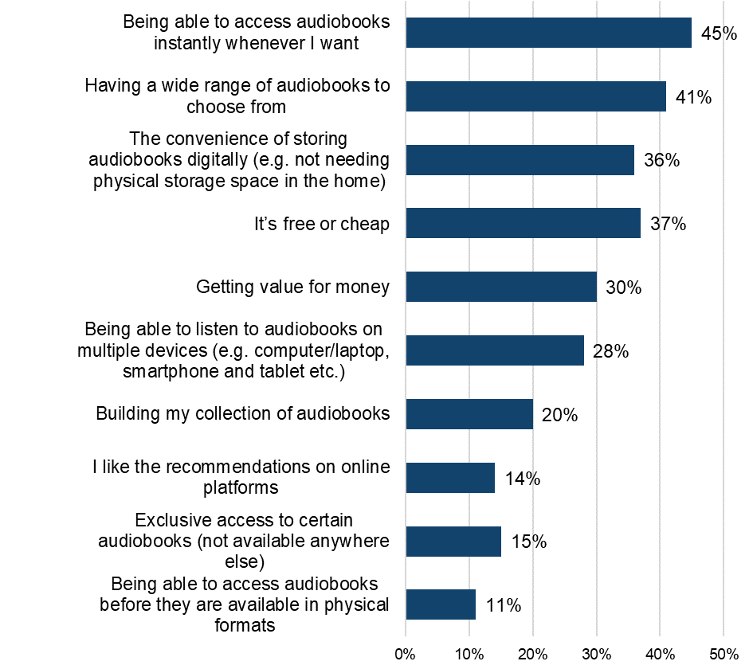

Base: n=637 (downloaded or streamed/accessed audiobooks online in the past three months)

Downloading/streaming audiobooks

Frequency and volume of downloading/streaming audiobooks

The 13% who had downloaded/accessed audiobooks during the previous three months were asked more questions around frequency, volume and sources used.

More than a third (36%) of those who downloaded/streamed audiobooks did so frequently (i.e. at least once a week) (Figure 129). Male audiobook consumers were downloading/streaming more frequently (38%) than female audiobook consumers (34%). Audiobook consumption was higher among younger (under 35) than older (35+) age groups.

An average of five audiobooks were downloaded or streamed during the previous three months – this figure was notably higher among those aged 16-24 (28 audiobooks) – however note that this was due to an outlying figure among this group.

Detailed demographic analyses related to these findings can be found in Tables 9.5a – 9.5b in OCI 2024 Supplementary Tables – Audiobooks.

Around a third of those accessing audiobooks online are doing so at least weekly
Figure 129Figure A128 - Frequency of downloading or streaming audiobooks through the internet. Download the data from Table 9.5.
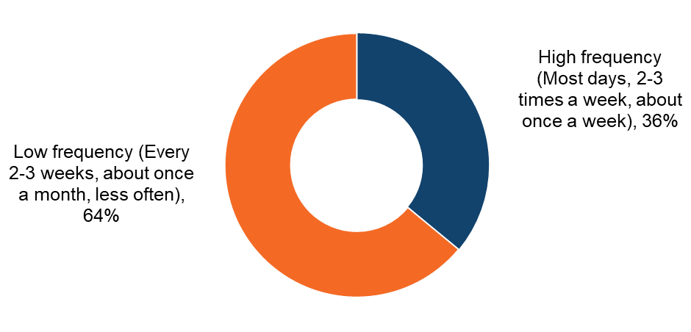
Base: n=637 (downloaded or streamed audiobooks in the past three months)

Audiobooks: Infringement behaviours

This section details the sources of accessing audiobooks, both legal and illegal.

Sources of downloading/streaming audiobooks

Respondents were shown a list that encompassed the different ways (legal and illegal) that they could access audiobooks. An ‘unsure’ option was also provided to serve as a catch-all for those who were not sure of the exact source.

The most commonly used sources were legal ones (Figure 130).The top two sources, by a large margin, were “'Pay for a subscription to a service that allows you listen to Audiobooks online” (40%) and “Paying a single fee to download individual audiobooks through services such as the Audible, Apple etc.” (32%).

The most selected illegal sources were “Streaming audiobooks for free from sites such as YouTube” (11%) and using “A free website which hosts or links to audiobooks I would otherwise expect to pay for” (9%).

Detailed demographic analyses related to these findings can be found in Tables 9.6 – 9.8 in OCI 2024 Supplementary Tables – Audiobooks.

Legal subscriptions and single fee downloads are the most frequent means of engaging with audiobooks
Figure 130: Sources used to download or stream audiobooks in the past three months. Download the data from Table 9.6.
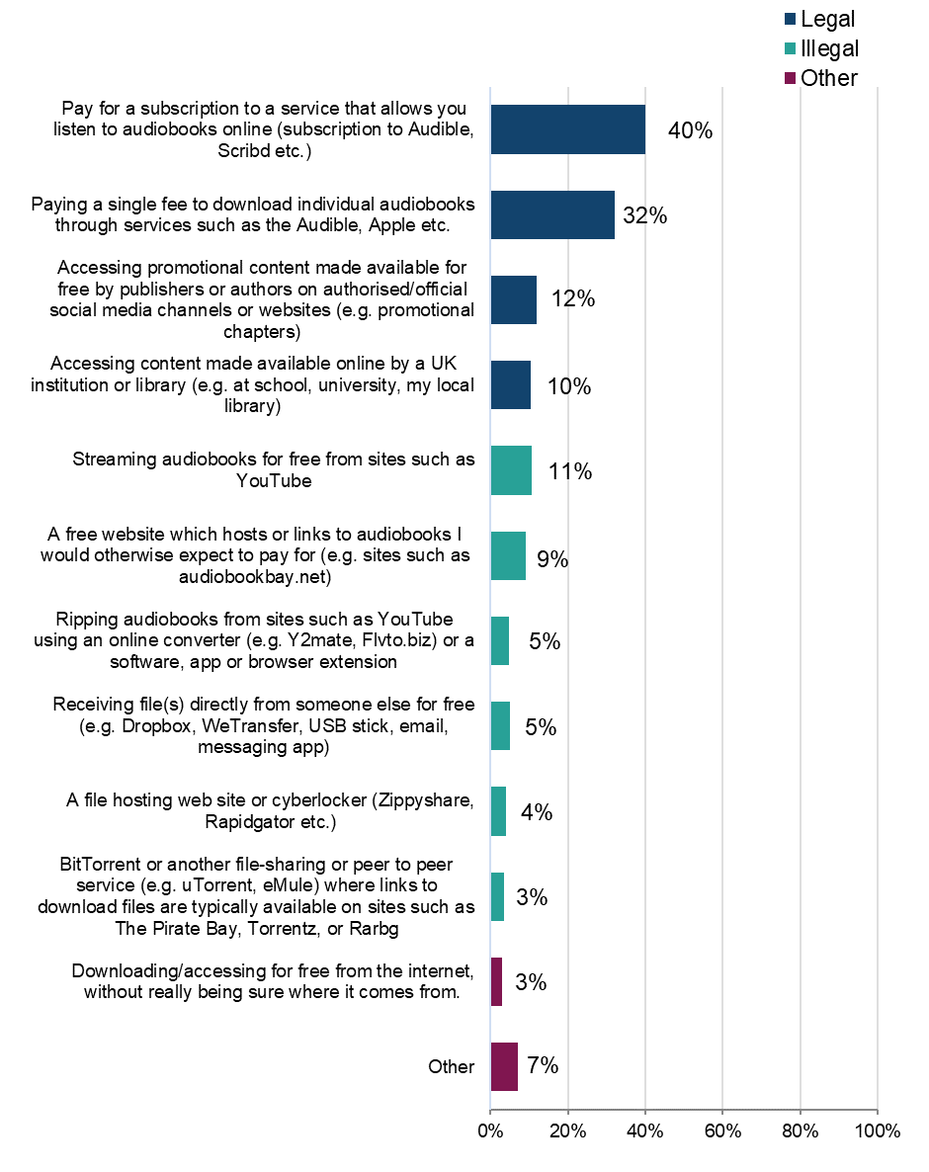
Base: n=637 (downloaded or streamed audiobooks during the past three months). Respondents were able to select multiple options, so the percentages presented do not sum to 100%.

Legality of downloading/accessing audiobooks

To better understand the distribution of sources across legal and illegal categories, those who had downloaded/accessed audiobooks in the previous three months were grouped into the following (mutually exclusive) categories: using legal sources only; illegal sources only; or a mix of the two.

The answer option “downloading/accessing for free from the internet, without really being sure where it comes from” was not included in the definition of either legal or illegal. Anyone who said they only consumed content this way was not included in the base.

Headline findings for each type of user are as follows:
- legal:
  - overall, 85% had used at least one legal source to access audiobooks
  - 70% had used legal sources only (Figure 131)
- illegal:
  - 30% had used at least one illegal source to access audiobooks
  - 15% had used illegal sources only to download audiobooks
  - male respondents were more likely than female respondents to use illegal sources for accessing audiobooks (37% vs 25%) (Figure 132).
  - almost a quarter (24%) of those aged 16-24 had used illegal sources only (Figure 133)

- mixed:
  - 15% had used a mix of legal and illegal sources

Detailed demographic analyses related to these findings can be found in Table 9.7 in OCI 2024 Supplementary Tables – Audiobooks.

30% have used at least one illegal download source
Figure 131: Legality of downloading/accessing audiobooks. Download the data from Table 9.7. 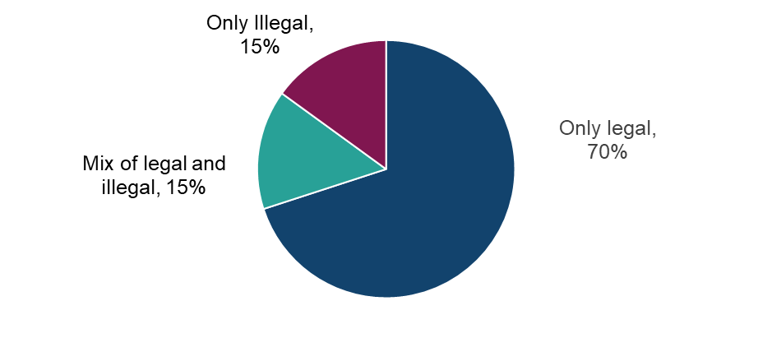
Base: n=588 (downloaded or streamed audiobooks in the past three months, with those who selected ‘other’ or ‘not sure of source’ removed)

Male respondents are more likely than female respondents to use illegal sources to download/access audiobooks
Figure 132: Legality of downloading/accessing audiobooks by sex. Download the data from Table 9.7.

Base: n=588 (downloaded or streamed audiobooks in the past three months, with those who selected ‘other’ or ‘not sure of source’ removed)

Higher use of illegal sources to download/access audiobooks among the younger age groups
Figure 133: Legality of downloading/accessing audiobooks by age. Download the data from Table 9.7.

Base: n=588 (downloaded or streamed audiobooks in the past three months, with those who selected ‘other’ or ‘not sure of source’ removed)

Paid for subscription services account for around a third of all audiobook downloads/streaming time

Table 11: Distribution of methods of downloading/accessing audiobooks by source. Download the data from Table 9.8.

Legality | Source | Average % of usage split
Legal | Pay for a subscription to a service that allows you listen to audiobooks online (subscription to Audible, Scribd etc.) | 33%
Legal | Paying a single fee to download individual audiobooks through services such as the Audible, Apple etc. | 25%
Legal | Accessing promotional content made available for free by publishers or authors on authorised/official social media channels or websites (e.g. promotional chapters) | 7%
Legal | Accessing content made available online by a UK institution or library (e.g. at school, university, my local library) | 6%
Illegal | Streaming audiobooks for free from sites such as YouTube | 7%
Illegal | A free website which hosts or links to audiobooks I would otherwise expect to pay for (e.g. sites such as audiobookbay.net) | 5%
Illegal | Ripping audiobooks from sites such as YouTube using an online converter (e.g. Y2mate, Flvto.biz) or a software, app or browser extension | 2%
Illegal | Receiving file(s) directly from someone else for free (e.g. Dropbox, WeTransfer, USB stick, email, messaging app) | 2%
Illegal | A file hosting web site or cyberlocker (Zippyshare, Rapidgator etc.) | 2%
Illegal | BitTorrent or another file-sharing or peer to peer service (e.g. uTorrent, eMule) where links to download files are typically available on sites such as The Pirate Bay, Torrentz, or Rarbg | 1%
Other | Downloading/accessing for free from the internet, without really being sure where it comes from | 2%
Other | Other | 6%

Base: n=637 (downloaded or streamed audiobooks in the past three months)

Audiobooks: Cyber security incidents

Respondents were asked if they had experienced any of a list of cyber security incidents in the previous 12 months. These incidents included devices being targeted with ransomware, other types of malware, hacking, phishing, social media and/or email account takeovers, or any other incidents.
We observed a consistent trend: infringers were significantly more likely than non-infringers to report experiencing a cyber security incident. While a definitive causal link cannot be established, this may be influenced by factors such as higher digital engagement among infringers, increased exposure to unverified sources, or reliance on websites that pose a risk, and compromised content platforms.
Over half (59%) of those who had downloaded or streamed audiobooks illegally had experienced at least one cyber security incident (Figure 134). This compares with 47% of those who had used only legal sources.

Those who download or stream audiobooks illegally are more likely to have experienced cyber security incidents in the last 12 months than those only using legal sources
Figure 134: Looking back over the past 12 months, to your knowledge, have you personally experienced any of the following cyber security incidents? Download the data from Table 1.15 of the OCI 2024 Main Data Tables (ODS 103KB).
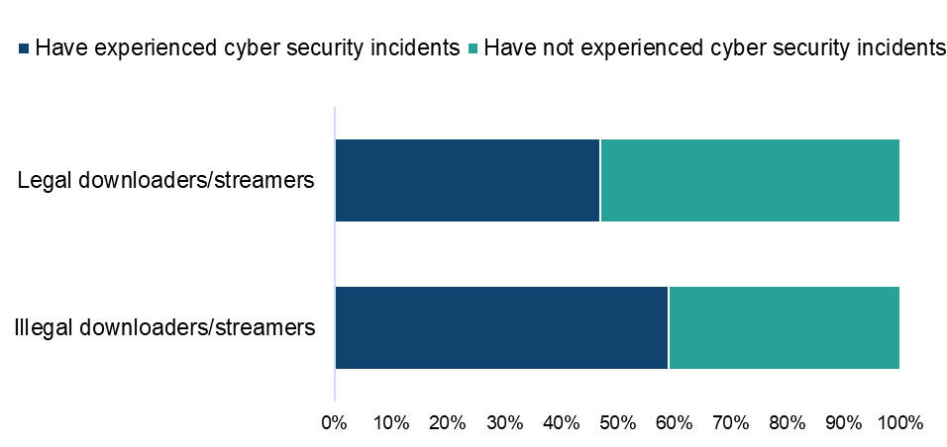

Base: n=551 (downloaded or streamed audiobooks in the past three months, with those who selected ‘other’ or ‘not sure’ removed from both questions)

Paying for audiobooks

Those who had used a paid source to either download or access audiobooks were asked how much they had personally spent on each source. Average monthly expenditure was as follows:

- a paid subscription to a service allowing online listening (such as Audible): £9.00
- downloading individual audiobooks (through services such as Audible): £6.10
- “other online sources”: £3.60

Detailed demographic analyses related to these findings can be found in Table 9.9 in OCI 2024 Supplementary Tables – Audiobooks.

Audiobooks: Change in use of illegal sources

Those who had used an illegal source to download or access audiobooks were asked how the use of these sources compares to the same point a year ago.

Respondents were most likely to indicate that their usage had remained the same (45%) (Figure 135). This was followed by a lower percentage indicating that their use had decreased (21%) compared to those indicating an increase (28%). A further 6% were not using these sources at all a year ago.

Detailed demographic analyses related to these findings can be found in Table 9.10 in OCI 2024 Supplementary Tables – Audiobooks.

Around 30% of those using illegal sources to download or access audiobooks say their use of these sources is increasing
Figure 135: Change in usage of illegal sources to access audiobooks compared to last year. Download the data from Table 9.10.
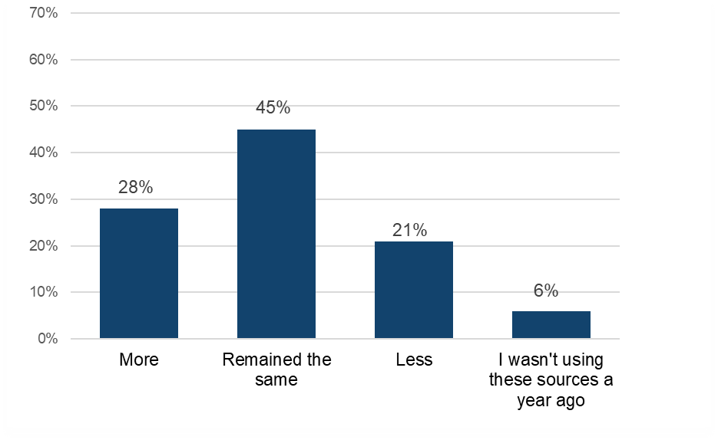
Base: n=178 (downloaded or streamed audiobooks illegally)

Audiobooks: Alternatives to infringement

This section will explore what respondents anticipate they would do if they lost access to illegal sources of audiobooks.
Those who had used illegal sources to either download or access audiobooks were asked which single legal source they would use if they could no longer access audiobooks illegally.

Four methods were indicated by similar proportions of respondents - “Paying a single fee to download individual audiobooks through services such as Audible, Apple etc.” (20%), “Accessing content made available for free by publishers” (19%), “Buying physical copies of audiobooks through stores” (17%) and “Paying for a subscription to a service that allows you to listen to audiobooks through services such as Audible, Apple etc.” (16%) (Figure 136). Over half would be likely to turn to one of the paid options.

Detailed demographic analyses related to these findings can be found in Table 9.11 in OCI 2024 Supplementary Tables – Audiobooks.

In the absence of illegal audiobook sources, respondents would typically turn to a single fee download source or free content from publishers
Figure 136: Alternative sources for accessing audiobooks if illegal options were unavailable. Download the data from Table 9.11.
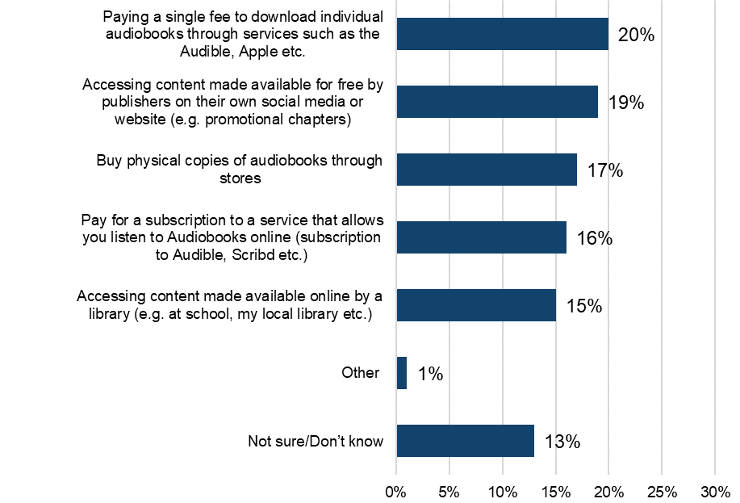

Base: n=130 (downloaded or accessed audiobooks illegally)

Category Insights: Digital Visual Images

Further details and demographic breakdowns for the findings in the Digital Visual Images section can be found in Tables 10.1a – 10.5c in OCI 2024 Supplementary Tables – Digital Visual Images (49.8KB), which provide a comprehensive analysis of the data.

Trends in overall digital visual image consumption in the UK

Prior to presenting information on digital visual image infringement levels, it’s useful to initially consider respondents’ engagement with, and consumption of these.

20% of respondents had engaged with digital visual images in the previous three months (i.e. either by downloading, streaming or sharing).

- downloading (14%) and accessing digital visual images online (13%) were being undertaken by similar proportions of respondents, with 9% having shared them with others (Figure 137)
- across all methods, those aged 12-15 were consistently more engaged than older groups with digital visual images

Detailed demographic analyses related to these findings can be found in Tables 10.1a – 10.1c in OCI 2024 Supplementary Tables – Digital Visual Images.

Downloading is the most frequent means of engaging with digital visual images
Figure 137: Have you downloaded/accessed/shared copies of digital visual images in the past three months?

Base: total sample (n = 5,087)
Note: The definition of ‘shared’ given was: “By shared we mean that you personally made the file publicly available or sent or uploaded it online for someone else to download or stream/access. This does not include sending links to content that has already been shared by someone else, unless stated in the answer option”.

Digital visual images: Infringement behaviours

This section details the sources of accessing digital visual images, both legal and illegal.

Sources of digital visual images

Respondents were shown a list that encompassed the different ways (legal and illegal) that they could access digital visual images.

It was made clear in the survey that we were asking about images that do not belong to the respondent (for example, stock images you may pay to download, images found through searching on Google, images on social media services and images hosted on forums, file-hosting websites or through file-sharing services). Since Wave 10, a follow up question has been included on how respondents go on to use the images (for example, sharing on social media, including within presentations, et cetera).

As with previous waves, the most common sources of downloading/accessing digital visual images were taking screenshots of digital visual images hosted online, from sources such as social media (41%) and Google images (40%) (Figure 138).

Those who accessed images through legal means were most likely to use “Free websites which host free to use images” (27%), with much smaller proportions (7-10%) paying to access. The most commonly selected illegal methods were used by similar proportions as in previous waves: “A free website which hosts or links to images” (15%) and “Receiving the file(s) directly from someone else” (9%). Other than these, no illegal source was selected by more than 2%.

In terms of the distribution across sources, over 40% of digital visual images downloaded or accessed come from saving or screenshotting, with 24% sourced from social media and 17% from Google Images. (Figure 139).

Detailed demographic analyses related to these findings can be found in Table 10.2 in OCI 2024 Supplementary Tables – Digital Visual Images.

Social media and Google images are the most frequent sources used to access digital visual images
Figure 138: Sources used to download or access visual images online that are not yours in the past three months. Download the data from Table 10.2.

Base: 1,007 (downloaded/streamed digital visual images in the past three months)

Saving and screenshotting from social media and Google images accounts for over 40% of digital visual images downloaded or accessed
Figure 139: Distribution of methods of downloading or accessing visual images online by source. Download the data from Table 10.3.

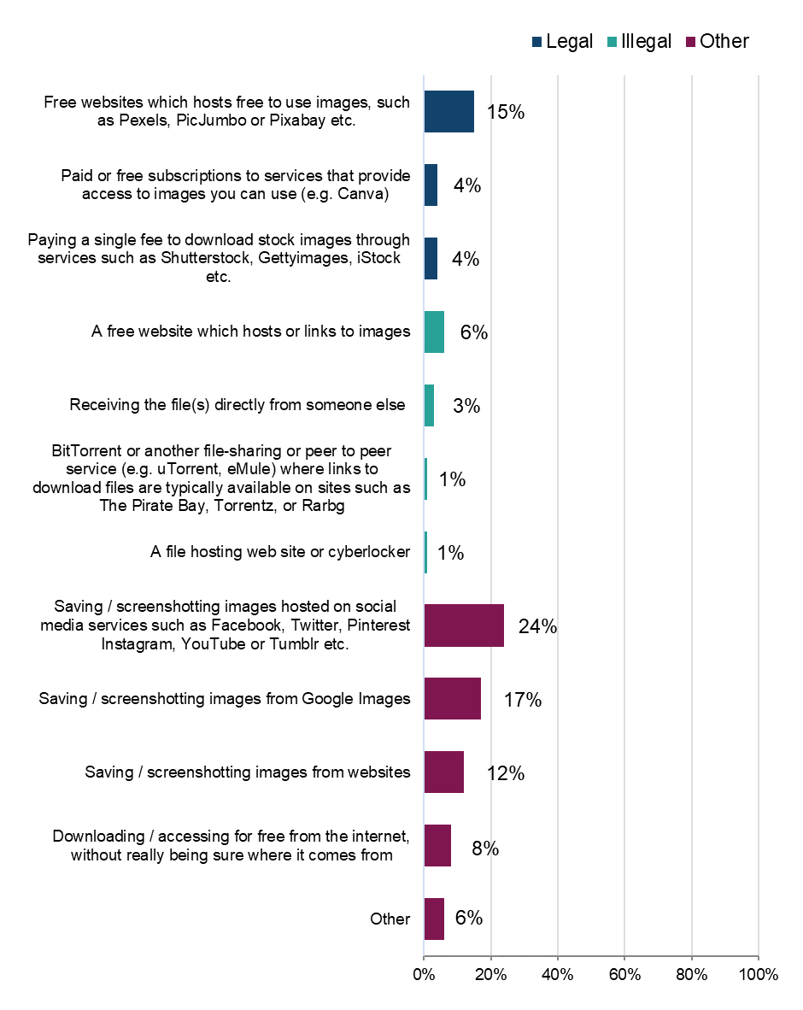
Base: 1,007 (downloaded/streamed digital visual images in the past three months)

Digital visual images: Cyber security incidents

Respondents were asked if they had experienced any of a list of cyber security incidents in the previous 12 months. These incidents included devices being targeted with ransomware, other types of malware, hacking, phishing, social media and/or email account takeovers, or any other incidents.
We observed a consistent trend: infringers were significantly more likely than non-infringers to report experiencing a cyber security incident. While a definitive causal link cannot be established, this may be influenced by factors such as higher digital engagement among infringers, increased exposure to unverified sources, or reliance on websites that pose a risk, and compromised content platforms.
Over three-quarters (68%) of those who had downloaded or streamed digital visual images illegally had experienced at least one cyber security incident This compares with 49% of those who had used only legal sources (Figure 140).

Those who download/stream digital visual images illegally are more likely to have experienced cyber security incidents in the last 12 months than those only using legal sources
Figure 140: Looking back over the past 12 months, to your knowledge, have you personally experienced any of the following cyber security incidents? Download the data from Table 1.15 of the OCI 2024 Main Data Tables (ODS 103 KB).
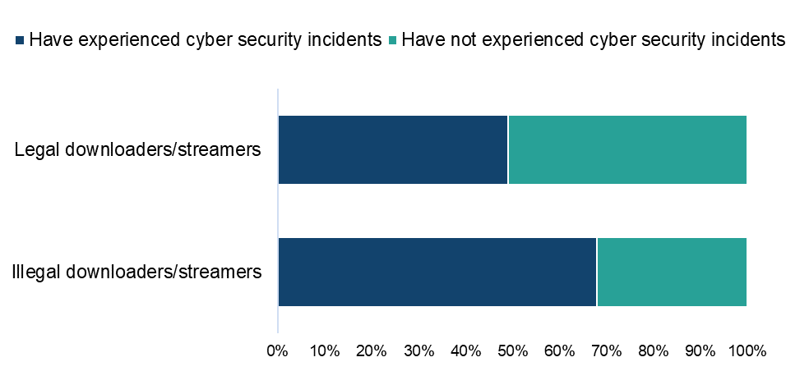
Base: n=914 (downloaded or streamed digital visual images from a legal or illegal source, with those who selected ‘not sure’ of experiencing cyber security incidents removed, and who answered the question on cyber harms)

Use of digital visual images

In a new question added in Wave 10, respondents who had downloaded or accessed digital visual images were asked what they had used them for. From Wave 12 onwards, behaviours were assessed across (grouped) sources, allowing us to identify what people go on to do with digital visual images accessed via legal, illegal and other methods.

Encouragingly, across all access methods, respondents were most likely to share them with a limited group of people – either just themselves or friends and family (Figure 141). The majority saved images for personal use rather than distributing.

While 11% post on social media, commercial use is less common overall and tends to be higher when accessing digital visual images via legal methods.

Detailed demographic analyses related to these findings can be found in tables 10.5a-10.5c in Supplementary Tables – Digital Visual Images.

Use of digital visual images tends to be contained to personal or shared friends/family use
Figure 141: What do you tend to do with the images that you download/access? Download the data from Tables 10.5a – 10.5c.
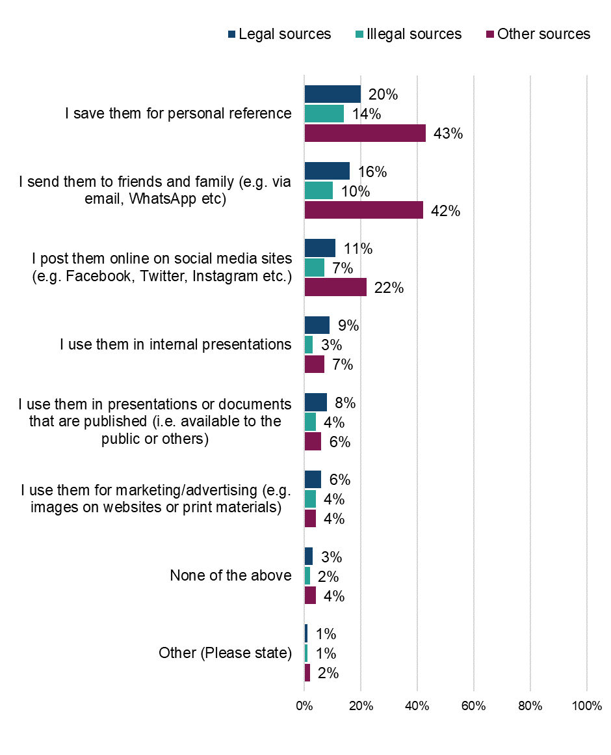Base: 1,007 (downloaded/streamed digital visual images in the past three months)

Category Insights: Digital Magazines

Further details and demographic breakdowns for the findings in the Digital Magazines section can be found in Tables 11.1a – 11.5c in Supplementary Tables – Digital Magazines (ODS 88.6KB), which provide a comprehensive analysis of the data.

Trends in overall digital magazine consumption in the UK

Prior to presenting information on digital magazine infringement levels, it’s useful to initially consider respondents’ engagement with, and consumption of these.

Analysis of responses found that 20% had engaged with magazines in the previous three months (either by downloading, streaming or sharing digital magazines, or purchasing physical copies). Considering different modes of access:

- the most common method of access was purchasing physical copies (14%) (Figure 142)
- this was followed by streaming/accessing online (7%) and downloading (6%)
- the oldest age group (i.e. those aged 55 and above) was most likely to have purchased a physical copy (17%). In all other age groups this ranged between 8%-14%

Detailed demographic analyses related to these findings can be found in Tables 11.1a to 11.1d in Supplementary Tables – Digital Magazines.

Purchasing physical copies the most frequent means of engaging with magazines
Figure 142: Have you downloaded/accessed/shared0F/purchased physical copies of digital magazines in the past three months? Download the data from Tables 11.1a - 11.1d.
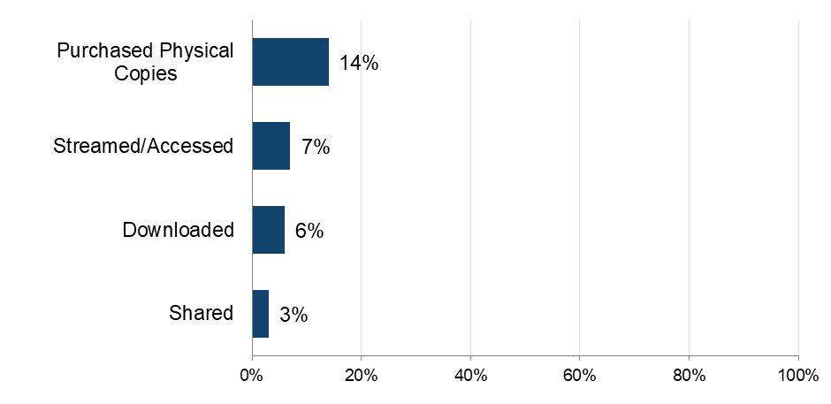

Base: total sample (n = 5,087)

The importance of magazines

To get a broader sense of their passion for magazines/digital magazines respondents were asked to what extent they agreed with a range of statements and then grouped as High, Medium or Low, based on their responses.

Just over one in every five (21%) displayed a high level of passion for magazines/digital magazines (Figure 143).This was notably higher among those aged 12-15, where it exceeded 40%. However, half (50%) of all respondents anticipated a reduction in their magazine spend in the coming months, with a similar figure indicating that they were spending less time reading magazines compared to a year ago (Figure 144).

Detailed demographic analyses related to these findings can be found in Tables 11.2a to 11.2f in Supplementary Tables – Digital Magazines.

Around 20% of those who purchase physical copies of magazines have a high passion for them
Figure 143: Passion for magazines. Download the data from Table 11.3.
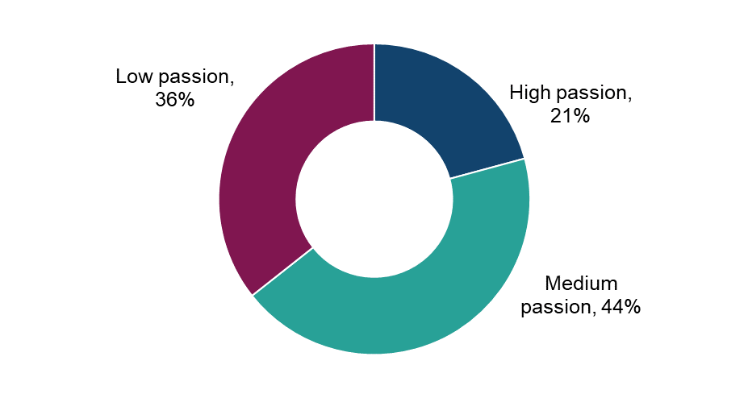
Base: n=1,040 (accessed, shared or purchased physical magazines in the past three months)

Over 40% of those who consume magazines regard them as their favourite form of entertainment. However, many intend to reduce their consumption in the coming months
Figure 144: To what extent do you agree or disagree that each of the following statements describe you? Download the data from Tables 11.2a – 11.2f.
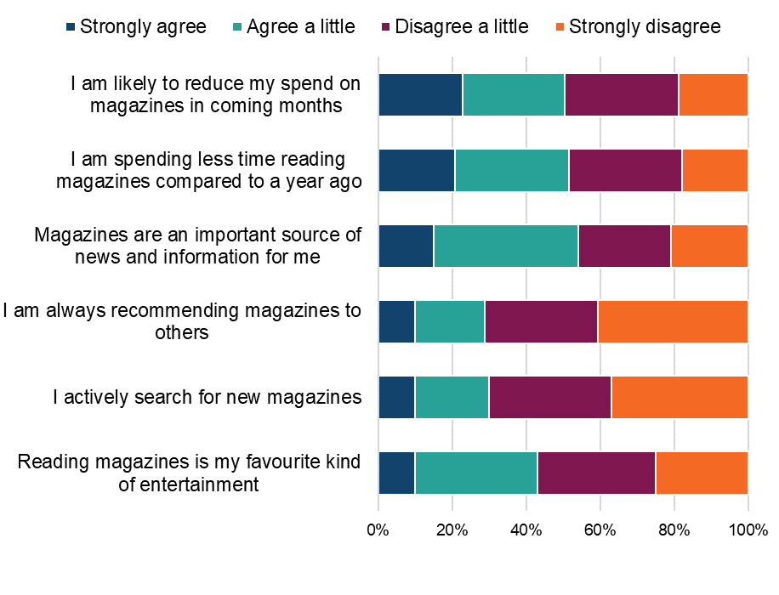
Base: n=1,040 (accessed, shared or purchased physical magazines in the past three months).

Physical purchasing of magazines

The 14% of respondents who had purchased physical copies of magazines during the previous three months were asked a question around the number of purchases made. Respondents had purchased an average of 6 magazines in the previous three months. Those in the oldest age groups (aged 45+) had purchased the highest number of magazines, on average.

Detailed demographic analyses related to these findings can be found in Table 11.4 in Supplementary Tables – Digital Magazines.

Understanding online consumption of digital magazines

To better understand the drivers of online consumption, those who had accessed digital magazines in the previous three months were asked to select their top three reasons for doing so.

Cost was an important factor, with four in ten (42%) accessing digital magazines online because “It’s free or cheap” and a further 31% because they wanted to get “value for money” (Figure 145).

Other prominent reasons related to being able to access anything “whenever” they wanted (39%), the convenience of storing magazines digitally (33%), having a wide range of content to choose from (30%) and multi-device access (25%). No other reason was selected by more than 18% of respondents.

Detailed demographic analyses related to these findings can be found in Table 11.5 Supplementary Tables – Digital Magazines.

Cost and instant access most frequently drive online consumption of digital magazines
Figure 145: What are the main reasons that you choose to access digital magazines online (i.e. downloading or streaming) Please select your top three (%). Download the data from Table 11.5.
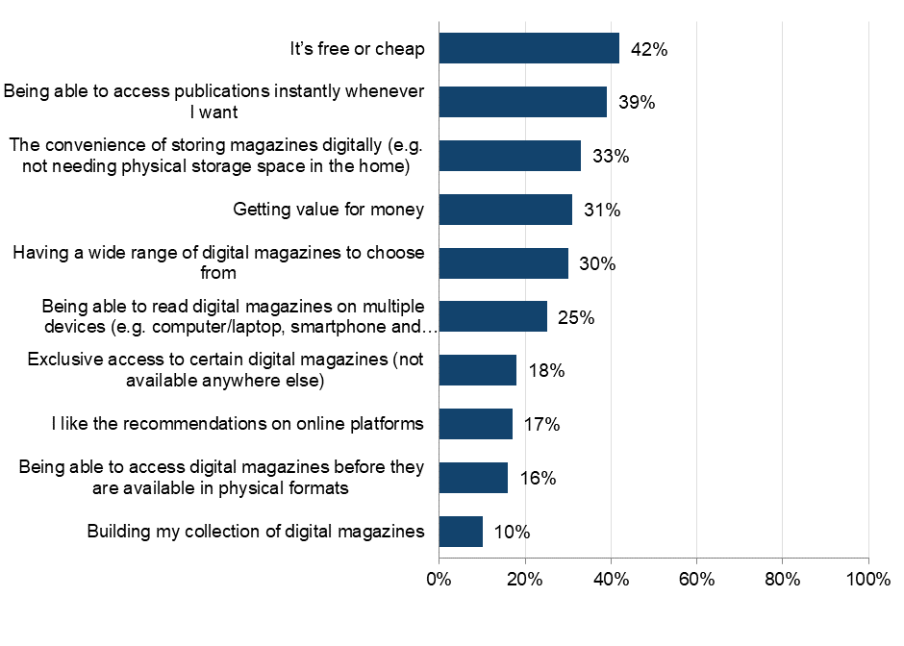

Base: n=522 (downloaded or streamed accessed digital magazines online in the past three months).

Downloading/accessing digital magazines

The 10% who had downloaded/accessed digital magazines during the previous three months were asked more questions around frequency, volume and sources used.

Frequency and volume of downloading digital magazines

Almost 40% of those who downloaded/accessed digital magazines did so frequently (i.e. at least once a week) (Figure 146). Male respondents (48%) were more likely than female respondents (30%) to be frequently downloading or accessing digital magazines. The younger age groups (under 35) were also more likely to be frequently downloading/accessing (47%-51%) compared to their older 35+ counterparts (27%-38%).

Consumers downloaded an average of 19 digital magazines over a three-month period. This rose to 36 among those aged 16-24 and was between 11-18 in all other age groups.

Detailed demographic analyses related to these findings can be found in Tables 11.6 and 11.7 in Supplementary Tables – Digital Magazines.

Around 40% of those accessing digital magazines online are doing so at least weekly
Figure 146: Generally, how often do you download or access digital magazines, or parts of them, through the internet? (%). Download the data from Tables 11.6 and 11.7.

Base: n=522 (accessed digital magazines online in the past three months)

Digital magazines: Infringement behaviours

Sources of downloading or accessing digital magazines

Respondents were shown a list that encompassed the different ways (legal and illegal) that they could access digital magazines. An ‘unknown’ option was also provided to serve as a catch-all for those who were unsure of the exact source.

The most commonly used sources were legal ones. The most popular was “Pay for a subscription to a service or publisher that allows you to download or access multiple issues of digital magazines online” (31%) (Figure 147). “Accessing content made available for free by publishers on their own social media or website” (26%) followed as the most popular free source.

The most used illegal source was “a free website which hosts or links to digital magazines I would otherwise expect to pay for” (20%). Other than this, no illegal source was selected by more than 7%.

Detailed demographic analyses related to these findings can be found in Table 11.8a in Supplementary Tables – Digital Magazines.

A subscription service is the most frequent means of engagement with digital magazines
Figure 147: Which of the following have you used to download or access digital magazines in the past three months? Please select all that apply. (%) Download the data from Table 11.8a.

Base: n=522 (downloaded or streamed/accessed digital magazines in the past three months, with those who selected ‘other’ or ‘not sure of source’ removed

Legality of downloading or accessing digital magazines

To better understand the distribution of sources across legal and illegal categories, those who had accessed digital magazines in the previous three months were grouped into the following (mutually exclusive) categories: using legal sources only; illegal sources only; or a mix of the two.

The answer option “downloading/accessing for free from the internet, without really being sure where it comes from” was not included in the definition of either legal or illegal. Anyone who said they only consumed content this way was not included in the base.

Headline findings for different sources are as follows:
- legal:
  - overall, 78% had used at least one legal source to access digital magazines (Figure 148)
  - 61% had used legal sources only
- illegal:
  - 38% had used at least one illegal source to access digital magazines
  - 21% had used illegal sources only to access digital magazines
  - female respondents (24%) were slightly more likely than male respondents (20%) to use illegal sources only to access digital magazines (Figure 149)
- mixed:
  - 17% had used a mix of legal and illegal sources
  - mixed use of legal and illegal sources was highest for those aged 12-15 (34%) (Figure 150)

Detailed demographic analyses related to these findings can be found in Table 11.8b in Supplementary Tables – Digital Magazines.

Over 60% have used only legal sources to download/access digital magazines
Figure 148: Legality of downloading/accessing digital magazines. Please also see Table 11.8b. Download the data from Table 11.8b.

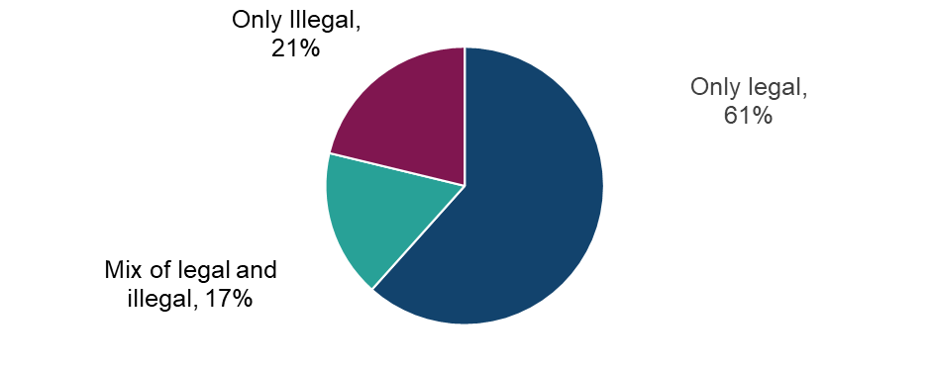

Base: n=419 (downloaded or streamed/accessed digital magazines in the past three months, with those who selected ‘other’ or ‘not sure of source’ removed)

Both male and female respondents most likely to use legal sources to download/access digital magazines
Figure 149: Legality of downloading/accessing digital magazines. Download the data from Table 11.8b.

Base: n=419 (downloaded or streamed/accessed digital magazines in the past three months, with those who selected ‘other’ or ‘not sure of source’ removed)

Higher use of illegal sources to download/access digital magazines among the younger age groups
Figure 150: Legality of downloading/accessing digital magazines. Download the data from Tables 11.8b.

Base: n=419 (downloaded or streamed/accessed digital magazines in the past three months, with those who selected ‘other’ or ‘not sure of source’ removed)

Legal sources account for around 56% of all digital magazine downloads/access time
Table 12: And how is the way you download/access digital magazines typically split across the following sources? Download the data from Table 11.9.
Legality | Source | Average % of usage split
Legal | Pay for a subscription to a service or publisher that allows you to download or access multiple issues of digital magazines online (e.g. a subscription to the digital edition of Vogue or Empire either directly or through services such as Mags Direct, Newsstand.co.uk or Zinio) | 24%
Legal | Accessing content made available for free by publishers on their own social media or website (e.g. individual articles) | 21%
Legal | Paying a single fee to download or read individual issues of digital magazines through services such as the Mags Direct, Newsstand.co.uk or Zinio | 11%
Illegal | A free website which hosts or links to digital magazines I would otherwise expect to pay for | 15%
Illegal | Receiving the file(s) directly from someone else for free (e.g. Dropbox, WeTransfer, USB stick, email, messaging app) | 4%
Illegal | Bittorrent or another file-sharing or peer to peer service (e.g. uTorrent, eMule) where links to download files are typically available on sites such as The Pirate Bay, Torrentz, or Rarbg | 3%
Illegal | A file hosting web site or cyberlocker (Openload, Zippyshare, Rapidgator etc.) | 2%
Other | Downloading/accessing for free from the internet, without really being sure where it comes from | 6%
Other | Other | 15%

Base: n=522 (downloaded or streamed/accessed digital magazines in the past three months)

Digital magazines: Cyber security incidents

Respondents were asked if they had experienced any of a list of cyber security incidents in the previous 12 months. These incidents included devices being targeted with ransomware, other types of malware, hacking, phishing, social media and/ or email account takeovers, or any other incidents.
Of those who had downloaded or accessed digital magazines illegally, 63% had experienced at least one cyber security incident (Figure 151). However, this compares very closely with 65% of those who had used only legal sources. These figures should be treated with caution due to the small sample size

Little difference between those using legal and illegal sources in relation to experiencing cyber security incidents in the last 12 months
Figure 151: Looking back over the past 12 months, to your knowledge, have you personally experienced any of the following cyber security incidents? Download the data from Table 1.15 of the OCI 2024 Main Data Tables (ODS 103KB).
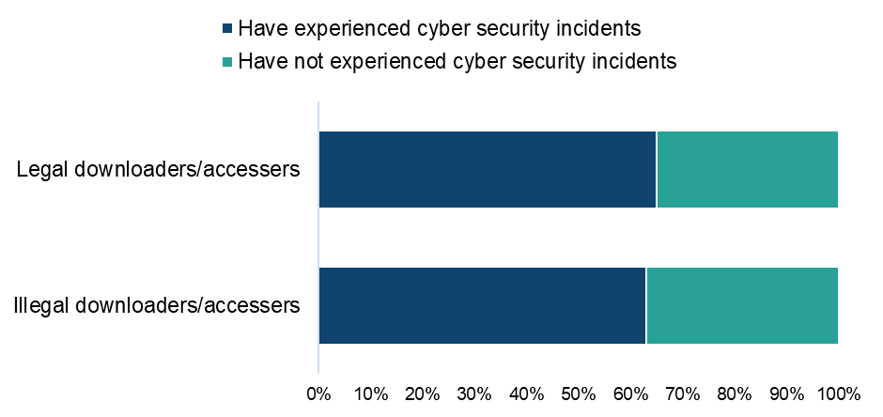

Base: n=392 (downloaded/accessed digital magazines in the past three months, with those who selected ‘other’ or ‘not sure’ removed from both questions)

Paying for digital magazines
Those who had used a paid source to access digital magazines were asked how much they had personally spent on each source. Average monthly expenditure was as follows:

- paying a single fee to download or read individual issues of digital magazines through services such as the Mags Direct, Newsstand.co.uk or Zinio: £5.60
- paying for a subscription to a service or publisher that allows you to download or access multiple issues of digital magazines online (e.g. a subscription to the digital edition of Vogue or Empire either directly or through services such as Mags Direct, Newsstand.co.uk or Zinio): £47.40
- other online sources: £9.40

Detailed demographic analyses related to these findings can be found in Table 11.10 in Supplementary Tables – Digital Magazines.

Digital magazines: Change in use of illegal sources

Those who had used an illegal source to download or access digital magazines were asked how the use of these sources compares to the same point a year ago.

Respondents were most likely to say their usage had remained the same (48%) (Figure 152). This was followed by those who were using these sources more (26%) with smaller numbers saying that they were using them less (19%) or they weren’t using them at all a year ago (7%).

Detailed demographic analyses related to these findings can be found in Table 11.11 in Supplementary Tables – Digital Magazines

Over a quarter of those using illegal sources to download or access digital magazines say their use of these sources is increasing
Figure 152: You said you download/access digital magazines using illegal sources. Compared with the same point a year ago, would you say you are using those sources...? Download the data from Table 11.11.

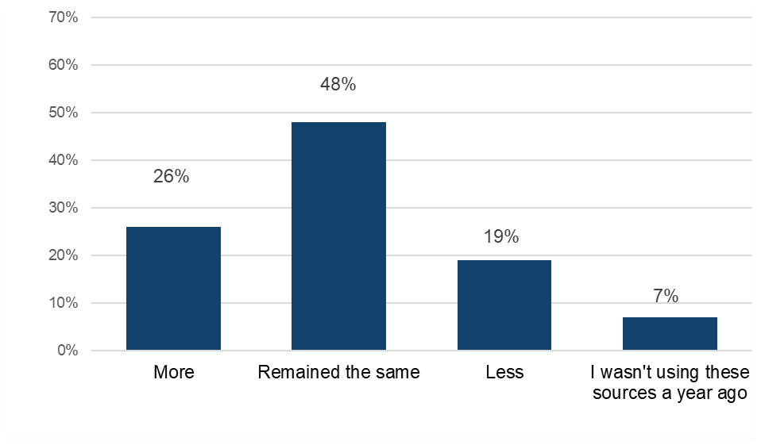
Base: n=162 (accessed digital magazines illegally)

Digital magazines: Alternatives to infringement

Those who had used illegal sources to download/access digital magazines were asked which single legal source they would use if they could no longer access digital magazines illegally.

Respondents were most likely to indicate that they would “access content made available for free by publishers on their own social media or website” (24%) (Figure 153). Paid options accounted for more than half (55%) of responses. These were split between:
- buying “physical copies of magazines through stores (22%)
- paying a single fee to download or read individual issues of digital magazines (18%)
- paying for a subscription to a service or publisher that allows you to download or access multiple issues of digital magazines online (15%)

It was also found that 18% of infringers were unsure what they would do if they could no longer access digital magazines illegally.

Detailed demographic analyses related to these findings can be found in Table 11.12 in Supplementary Tables – Digital Magazines.

In the absence of illegal digital magazines, respondents would typically access free content, or purchase individual physical or digital magazine issues.
Figure 153: If digital magazines were no longer available to download or access via these sources, which other source, if any, would you go to instead? Please choose the method you think you would use most often. (%) Download the data from Table 11.12.
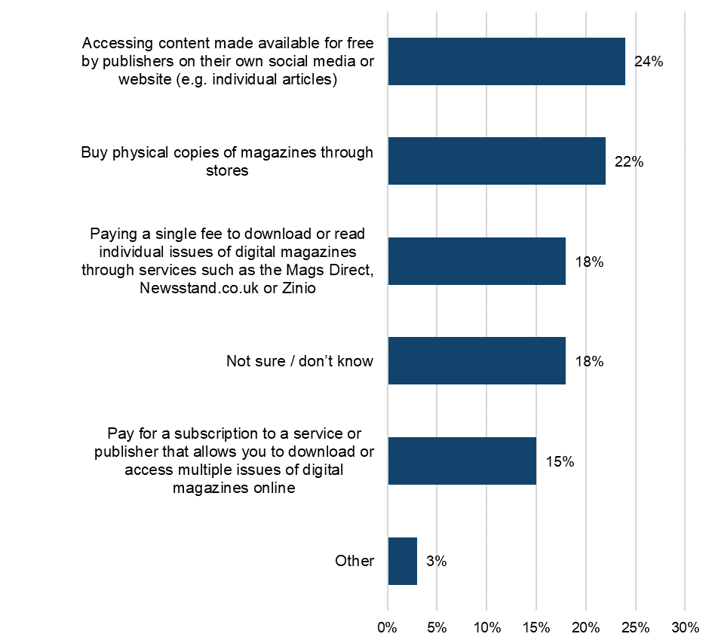

Base: n=162 (downloaded or accessed digital magazines illegally)

Concept House
Cardiff Road
Newport
NP10 8QQ

Tel: 0300 300 2000
Email: information@ipo.gov.uk
Web: www.gov.uk/ipo

Facebook: Intellectual Property Office UK
X: @The_IPO
YouTube: Intellectual Property Office UK
LinkedIn: Intellectual Property Office UK
For copies in alternative formats please
contact our Information Centre.
When you no longer need this booklet,
please recycle it.
© Crown copyright, 2025
This document is free for re-use under the terms of the Open Government Licence.
Published: June 2025
CP2301602

The definition of ‘shared’ given was: “By shared we mean that you personally made the file publicly available, or sent or uploaded it online for someone else to download or stream/access. This does not include sending links to content that has already been shared by someone else, unless stated in the answer option.”

