Returning to Iraq and KRI
- Kurdish

WHAT ASSISTANCE IS PROVIDED?


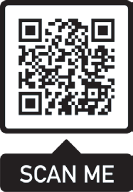
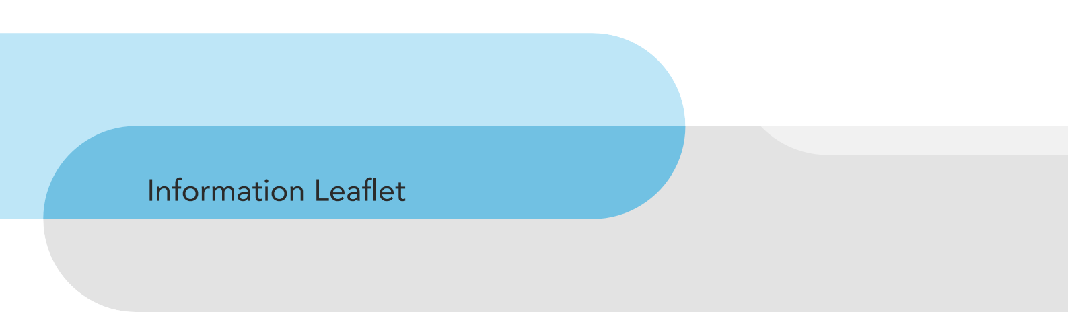




















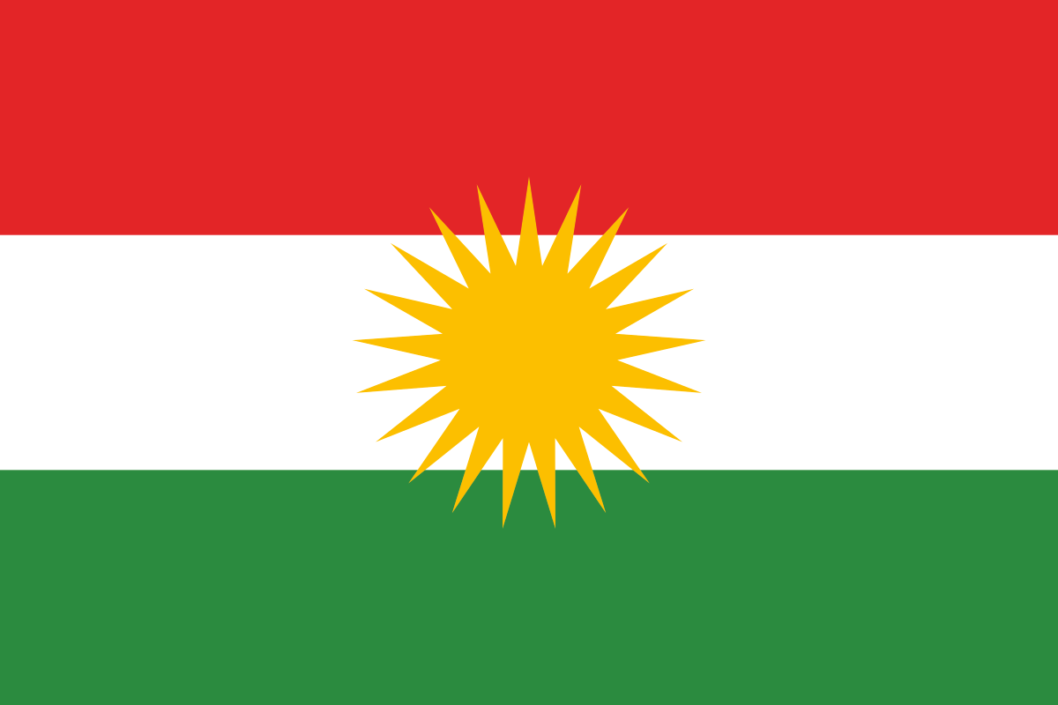
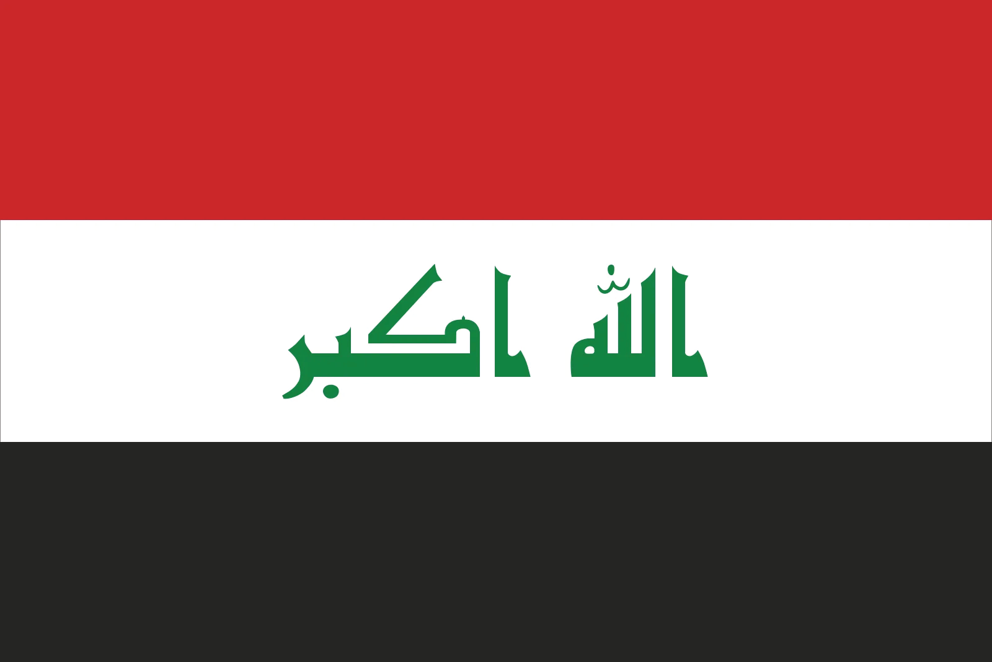
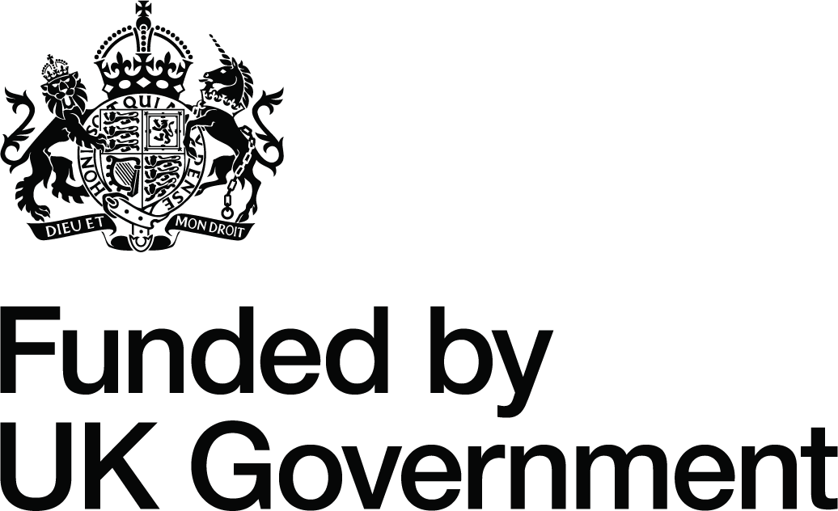
Pre-Departure Information:
Contact information in Iraq:
ETTC: Erbil: Nawroz Street - Next to Municipality No.6, Erbil
Baghdad – Al-Arsat –Babel Neighbourhood / Mahalla 929 – Zuqaq 7 – Building 21,
1st ﬂoor, Apartment NO. 2
Opening hours: Sun to Thurs 8:30 am to 5:30 pm Email: reintegration@irara.org
Tel: +964 750 457 2485 or +964 750 423 5767 +964 773 593 38 65
IRARA in the UK Ofﬁce Hours: 8:30am - 5pm Monday - Friday Tel: +44 (0)1433 627 247
Email: reintegration@irara.org
V2
www.irara.org
- Returning individuals can contact IRARA to discuss reintegration options in Iraq.

Short-Term Assistance:
- Airport Reception (upon request).
- Accommodation for up to ﬁve nights.
- Transportation to an address in-country.
- Care & food provision packs.
- Small cash assistance for immediate needs.

Medium-Term Assistance:
- Assistance with ﬁnding and reuniting with
family.
- Support with in-country documentation.
- Signposting to local services.
- Mental wellbeing and counselling (if required).

Long-Term Assistance:
Access to a Returnee Education and Entrepreneurship Fund for:
- Support with accessing the local job market.
- Support with setting up a business.
- Support with accessing vocational training or further education.
- Assistance with legal migration opportunities.

Who can get support?
If you are an Iraqi national who has returned, or will be returned from the United Kingdom, IRARA can help you rebuild your life in Iraq.
This support is available for up to 12 months following your return to Iraq.

How to access support?
If you are currently in the UK, contact the UK IRARA ofﬁce using the details below.
If you have already returned to Iraq, please contact the ETTC ofﬁce in Erbil using the details below.

About the Programme:
The Home Ofﬁce Returns Reintegration Programme assists the return and reintegration of people in the United Kingdom with no legal status or right to remain.
The programme offers a wide range of services, providing assistance on arrival and longer-term support for persons returning to Iraq.

About IRARA and ETTC:
IRARA and ETTC are committed to helping individuals and families successfully resettle in Iraq.
IRARA partners with ETTC for the delivery of reintegration services in Iraq. ETTC has been implementing reintegration programmes, vocational training and good governance projects since 2009 and together with IRARA provides expert and individual reintegration support and guidance for those returning to Iraq.

ﮔەڕاﻧەوە ﺑﯚ ﻋێﺮاق و ھەرێﻤﯽ ﮐﻮردﺳﺘﺎن
ﻧﺎﻣﯿﻠﮑەی زاﻧﯿﺎری- ﮐﻮردی

چ ھﺎوﮐﺎرﯾﯿەک ﭘێﺸﮑەش دەﮐﺮێﺖ؟

ﮐێ دەﺗﻮاﻧێﺖ ﭘﺸﺘﮕﯿﺮی وەرﺑﮕﺮێﺖ؟
ﺋەﮔـەر ﺗـﯚ ھﺎووﺗﯿﯿەﮐـﯽ ﻋێﺮاﻗﯿـﺖ و ﻟـە ﺑەرﯾﺘﺎﻧﯿـﺎ ﮔەڕاﺑﯿﺘـەوە ﯾـﺎن دەﮔەڕێﻨﺪرێﯿﺘـەوە، IRARA دەﺗﻮاﻧێـﺖ ﯾﺎرﻣەﺗﯿـﺖ ﺑـﺪات ﺑـﯚ دوﺑـﺎرە ﺑﻨﯿﺎﺗﻨﺎﻧـەوەی ژﯾﺎﻧـﺖ ﻟـە ﻋێـﺮاق.
ﺋـەم ﭘﺎڵﭙﺸـﺘﯿە ﺑـﯚ ﻣـﺎوەی ١٢ ﻣﺎﻧـﮓ ﻟـە دوای ﮔەڕاﻧـەوەت ﺑـﯚ ﻋێـﺮاق ﺑەردەﺳـﺘە.

ﭼﯚن دەﺳﺘﻤﺎن ﺑﮕﺎت ﺑە ﭘﺸﺘﮕﯿﺮی؟
ﺋەﮔــەر ﺋێﺴــﺘﺎ ﻟــە ﺑەرﯾﺘﺎﻧﯿﺎﯾــﺖ، ﭘەﯾﻮەﻧــﺪی ﺑــە ﺋﯚﻓﯿﺴــﯿﯽ IRARA ی ﺑەرﯾﺘﺎﻧﯿــﺎ ﺑﮑــە ﻟـە ڕێﮕـەی ﺋـەم زاﻧﯿﺎرﯾﯿﺎﻧـەی ﺧـﻮارەوە ﺋەﮔەرﺋێﺴــﺘﺎ ﻟــە ﻋێﺮاﻗﯿــﺖ، ﺗﮑﺎﯾــە ﭘەﯾﻮەﻧـﺪی ﺑـە ﺑـە ﺋﯚﻓﯿﺴـﯽ ETTC ﺑﮑـە ﻟـە ھەوﻟێـﺮ ﻟـە ڕێﮕـەی ﺋـەم زاﻧﯿﺎرﯾﯿﺎﻧـەی ﺧﻮارەوە.

زاﻧﯿﺎری ﭘێﺶ ﮔەڕاﻧەوە:
ﺋـەو ﮐەﺳـﺎﻧەی دەﮔەڕێﻨـەوە دەﺗﻮاﻧـﻦ ﭘەﯾﻮەﻧـﺪی ﺑـە IRARA وە ﺑﮑـەن ﺑـﯚ ﻗﺴـەﮐﺮدن ﻟەﺳـەر ھەڵﺒﮋاردﻧەﮐﺎﻧــﯽ ﺗێﮑەڵﺒﻮوﻧــەوە ﺑــە ﮐﯚﻣەڵﮕــە ﻟــە ﻋێﺮاق.
•

ھﺎوﮐﺎری ﮐﻮرﺗﺨﺎﯾەن:
• ﭘێﺸــﻮازی ﻓڕۆﮐەﺧﺎﻧــە )ﺑەﭘێــﯽ داواﮐﺎری.(
• ﺷـﻮێﻨﯽ ﻧﯿﺸـﺘەﺟێﺒﻮون ﺑـﯚ ﻣـﺎوەی ﭘێﻨـﺞ ﺷـەو.
• ﮔﻮاﺳــﺘﻨەوە ﺑــﯚ ﻧﺎوﻧﯿﺸــﺎﻧێﮏ ﻟەﻧﺎوﺧــﯚی وت.
• ﭘﺎﮐێﺠـﯽ ﭼﺎودێـﺮی و داﺑﯿﻨﮑﺮدﻧـﯽ ﺧـﻮاردن.
• ھــﺎوﮐﺎری ﻧەﺧﺘﯿﻨەﯾــﯽ ﺑﭽــﻮک ﺑــﯚ ﭘێﺪاوﯾﺴــﺘﯿە ﺧێﺮاﯾﯿــە.ﮐﺎن.

ھﺎوﮐﺎری ﻣﺎوەی ﻣﺎﻣﻨﺎوەﻧﺪ:
دەرﺑﺎرەی ﭘڕۆﮔﺮاﻣەﮐە:
ﭘڕۆﮔﺮاﻣـﯽ ﮔەڕاﻧـەوەی ھـﯚم ﺋﯚﻓﯿـﺲ ﯾﺎرﻣەﺗـﯽ ﮔەڕاﻧـەوە و ﯾەﮐﺨﺴـﺘﻨەوەی ﺋـەو ﮐەﺳـﺎﻧە دەدات ﮐـە ﻟـە ﺑەڕﯾﺘﺎﻧﯿـﺎ ھﯿـﭻ ﭘێﮕەﯾەﮐـﯽ ﯾﺎﺳـﺎﯾﯽ و ﻣﺎﻓـﯽ ﻣﺎﻧەوەﯾـﺎن ﻧﯿﯿـە.
ﭘڕۆﮔﺮاﻣەﮐــە ﮐﯚﻣەڵێــﮏ ﺧﺰﻣەﺗﮕــﻮزاری ﺑەرﻓــﺮاوان ﭘێﺸــﮑەش دەﮐﺎت، ھـﺎوﮐﺎری ﻟـە ﮐﺎﺗـﯽ ﮔەﯾﺸـﺘﻨﯿﺎن و ﭘﺸـﺘﯿﻮاﻧﯽ درێﮋﺧﺎﯾەﻧﺘـﺮ ﺑـﯚ ﺋـەو ﮐەﺳـﺎﻧەی دەﮔەڕێﻨـەوە ﻋێـﺮاق.

: ETTC و IRARA دەرﺑﺎرەی
ﭘﺎﺑەﻧـﺪن ﺑـە ﯾﺎرﻣەﺗﯿﺪاﻧـﯽ ﺗﺎﮐـەﮐﺎن و ﺧێﺰاﻧـەﮐﺎن ﺑـﯚ دووﺑـﺎره ﻧﯿﺸــﺘەﺟێﺒﻮﻧﯿﺎن ﺑــە ﺳــەرﮐەوﺗﻮوی ﻟــە ﻋێــﺮاق.
IRARA ھﺎوﺑەﺷــﯽ ETTC دەﮐﺎت ﺑــﯚ ﭘﻴﺸﮑەﺷــﮑﺮدﻧﯽ ﺧﺰﻣەﮔﻮزارﯾەﮐﺎﻧـﯽ ﯾەﮐﮕﺮﺗﻨـەوە ﻟـە ﻋێـﺮاق. ETTC ﻟـە ﺳـﺎﻟﯽ ٢٠٠٩ وە ﺑەرﻧﺎﻣەﮐﺎﻧــﯽ ﯾەﮐﮕﺮﺗﻨــەوەو ڕاھێﻨﺎﻧــﯽ ﭘﯿﺸــەﯾﯽ و ﭘڕۆژەﮐﺎﻧــﯽ ﺣﻮﮐﻤڕاﻧــﯽ ﺑــﺎش ﺟێﺒەﺟێــﺪەﮐﺎت ﻟەﮔــەل IRARA ﭘﺎﻟﭙﺸــﺘﯽ و ڕێﻨﻤﺎﯾــﯽ ﺑــﯚ ﯾەﮐﮕﺮﺗﻨــەوەی ﭘﺴــﭙﯚرو ﺗﺎﮐەﮐەﺳــﯽ ﭘێﺸــﮑەش دەﮐﺎت ﺑــەو ﮐەﺳــﺎﻧﯽ ﮐــە دەﮔەرێﻨـەوە ﻋێـﺮاق.
• ھـﺎوﮐﺎری ﻟـە دۆزﯾﻨـەوە و ﯾەﮐﮕﺮﺗﻨـەوە ﻟەﮔـەڵ ﺧێﺰاﻧـﺪا.
• ﭘﺸـﺘﮕﯿﺮی ﺑـﯚ ﺑەڵﮕەﻧﺎﻣـەی ﻧـﺎو وت.
• ڕێﻨﻤﺎﯾــﯽ وﺋﺎﻣــﺎژەدان ﺑــﯚ ﺧﺰﻣەﺗﮕﻮزارﯾﯿــە ﻧﺎوﺧﯚﯾﯿــەﮐﺎن.
• ﺗەﻧﺪرو .ﺳـﺘﯽ دەرووﻧـﯽ و ڕاوێـﮋﮐﺎری ) ﺋەﮔـەر
ﭘێﻮﯾﺴـﺘﯽ ﺑـﻮو.(

ھﺎوﮐﺎری درێﮋﺧﺎﯾەن:
ﺑەﮐﺎرھێﻨﺎﻧـﯽ ﺳـەرﭼﺎوەی داراﯾـﯽ ﭘەروەردەﯾـﯽ و ﮐﺎرﺳـﺎزی ﮔـەڕاوە ﺑﯚ:
• ﭘﺸـﺘﮕﯿﺮی ﻟـە دەﺳـﺖ ڕاﮔەﯾﺸـﺘﻦ ﺑەﺑـﺎزاڕی ﮐﺎری ﻧﺎوﺧﯚﯾـﯽ.
• ﭘﺸـﺘﮕﯿﺮی ﻟـە داﻣەزراﻧﺪﻧـﯽ ﮐﺎرێـﮏ.
• ﭘﺸــﺘﮕﯿﺮی ﻟــە دەﺳﺘڕاﮔەﯾﺸــﺘﻦ ﺑــە ڕاھﻴێﻨﺎﻧــﯽ ﭘﯿﺸـەﯾﯽ ﯾـﺎن ﺧﻮێﻨﺪﻧـﯽ زﯾﺎﺗـﺮ. ھﺎوﮐﺎرﯾﮑـﺮدن
ﻟەدەرﻓەﺗـﯽ ﮐﯚﭼـﯽ ﯾﺎﺳـﺎﯾﯽ.






















www.irara.org V2

وردەﮐﺎری ﭘەﯾﻮەﻧﺪﯾﮑﺮدن ﻟە ﻋێﺮاق:
ETTCھەوﻟێــﺮ: ﺷـەﻗﺎﻣﯽ ﻧـەورۆز - ﺗەﻧﯿﺸـﺖ ﺷـﺎرەواﻧﯽ ٦ ی ھەوﻟێـﺮ.
ﺋﯚﻓﯿﺴــﯽ ﺑەﻏــﺪاد: ﺋەرەﺳـﺎت - ﮔەڕەﮐـﯽ ﺑﺎﺑـﻞ /ﮐﻮﭼـە ٩٢٩ – ﻛـﯚن ٧ – ﺑﺎڵەﺧﺎﻧـەی ٢١ , ﻧﮫﯚﻣـﻰ ﻳەﮐـەم , ﺷـﻮﻗەى ژﻣـﺎرە ٢
ﮐﺎﺗــﯽ ﮐﺎرﮐــﺮدن: ﯾـەك ﺷـەﻣﻤە ﺗـﺎ ﭘێﻨـﺞ ﺷـەﻣﻤە / 8:30 ی ﺑەﯾﺎﻧـﯽ ﺗـﺎ 5:30 ی ﺋێـﻮارە
reintegration@irara.org :ﺋﯿﻤەﯾﻞ
+964 750 457 2485 or +964 750 423 5767 +964 773 593 38 65 :ت.ژ
8:30am - 5pm Monday - Friday :IRARA in the UK Ofﬁce Hours
+44 (0 )1433 627 247 :Tel
reintegration@irara.org :Email

