NOTICE OF ORDER

Highways Act 1980
Norfolk County Council

Norfolk County Council (Brisley Footpath No. 14 (part) and Brisley Footpath No. 15 (part)) Diversion Order 2023

Notice is hereby given that the above referenced Order has been submitted to the Secretary of State for Environment, Food and Rural Affairs for determination. An Inspector will be appointed by the Secretary of State to determine the Order.

The start date for the above Order is 4 November 2025.

Consideration of the Order will take the form of exchanges of statements of case and comments on statements of case.

The effect of the Order, if confirmed without modifications, will be to divert the full widths of the public footpaths as follows;
Brisley Footpath No. 14
From a line starting at grid reference TF 9534 2021 and running in a generally north easterly direction for approximately 414 metres to grid reference TF 9571 2038.
To a line starting at grid reference TF 9534 2020 and runs in a generally north easterly direction for approximately 368 metres to grid reference TF 9567 2035. The width of the path is 3 metres. Limitations and conditions: none.

Brisley Footpath No. 15
From a line starting at grid reference TF 9567 2036 and running in a generally south easterly direction for approximately 10 metres to grid reference TF 9567 2035.
To a line starting at grid reference TF 9567 2035 and runs in a generally north easterly direction for approximately 44 metres to grid reference TF 9571 2038. The width of the path is 3 metres. Limitations and conditions: none.
Any queries relating to this Order should be referred to Paul Scrivener by email: paul.scrivener@planninginspectorate.gov.uk quoting reference number ROW/3351261 on all correspondence. Alternatively, queries may be sent in writing to The Planning Inspectorate, Rights of Way Section, Room 3/A Eagle Wing, Temple Quay House, 2 The Square, Temple Quay, Bristol, BS1 6PN. Telephone: 0303 444 5000.

Any person wishing to view the statements of case and other documents relating to this Order may do so by appointment at Norfolk County Council, County Hall, Martineau Lane, Norwich, NR1 2DH.

Contact: email - Lawrence.malyon@norfolk.gov.uk Tel - 01603 224253 Timetable for sending in statements of case and comments Within 2 weeks of the start date by 18 November 2025.
The Order Making Authority, or where the Order Making Authority is taking a neutral stance and the applicant or other party are taking the case forward in support of the order, must ensure their statement of case is received by the Secretary of State. As soon as possible after the deadline, the Secretary of State will send a copy (excluding copies of any supporting documents - these will be available to view at the Authority’s offices) to everyone who has made an objection or representation, the applicant and any other person who has written to us in respect of the Order.

Within 8 weeks of the start date by 30 December 2025.
Everyone who has made an objection or representation or any other written representation or any other person wishing to make representations in writing must ensure their statement of case is received by the Secretary of State. As soon as possible after the deadline, the Secretary of State will send full copies to the Authority. Copies (excluding copies of any supporting documents - these will be available to view at the Authority’s offices) will also be sent to the applicant, every person who has made an objection or representation and any other person who has written to us in respect of the Order.
Within the same period the applicant (if applicable) must ensure their statement of case is received by the Secretary of State. As soon as possible after the deadline, Secretary of State will send a full copy to the Authority. Copies will also be sent to everyone who has made an objection or representation and any other person who has written to us in respect of the Order (excluding copies of any supporting documents - these will be available to view at the Authority’s offices).

Within 14 weeks of the start date by 10 February 2026.
Everyone who has made an objection or representation, the Authority, the applicant (if applicable) and anyone who has written to us in respect of the Order must ensure that their comments on any or every other statement of case is received by the Secretary of State. As soon as possible after the deadline, the Secretary of State will send copies of these comments to everyone else.
In fairness to the other parties everyone should keep to the timetable to ensure that statements of case and comments are received on time. Late documents will be returned.

We cannot accept any inflammatory, discriminatory or abusive comments. Any documents containing such comments will be returned.
If you use Artificial Intelligence (AI) to create or alter any part of your documents, information or data, you should tell us that you have done this when you provide the material to us. See the detailed guidance for further information.

Notice of order for w/r

PUBLIC PATH DIVERSION ORDER HIGHWAYS ACT 1980

NORFOLK COUNTY COUNCIL
(BRISLEY FOOTPATH NO. 14 {PART) AND BRISLEY FOOTPATH NO.15 (PART))
DIVERSION ORDER 2023

This order is made by Norfolk County Council ("the authority") under section 119 of the Highways Act 1980 ("the 1980 Act") because it appears to the authority that in the interests of the owner of the land crossed by the footpaths described in paragraph 1 of this order it is expedient that the line of the paths should be diverted.

Brisley Parish Council and Breckland District Council have been consulted as required by section 120(2) of the 1980 Act.

BY THIS ORDER:

- The public rights of way over the land situate at Brisley and shown by bold continuous lines on the map contained in this order and described in Part 1 of the Schedule to this order shall be stopped up with effect from the date on which Norfolk County Council certifies that the work to bring the new routes of the footpaths as described in paragraph 2 of this order in to a fit condition for use by the public has been carried out.- Certification shall not take place prior to the creation of the new route as described in paragraph 2 below.

- There shall at the end of 90 days from the date of confirmation of this order be public footpaths over the land situate at Brisley and described in Part 2 of the Schedule and shown by bold broken lines on the map contained in this order.

- Where immediately before the date on which the highway is diverted in pursuance of this Order there is apparatus on, under or over that highway belonging to statutory undertakers for the purpose of carrying on their undertaking, the undertakers shall continue to have the same rights in respect of the apparatus as they then had.
Dated this ILl\.-. day of Dl.u--.W

THE COMMON SEAL of the NORFOLK COUNTY COUNCIL
was hereunto affixed in the presence of:-

2023.



Director of Legal Services
Director Legal Services �np awJ Norfolk County Council
Authorised to sign on b�ha,lf o���onltoring Officer
........................................rnc.0.1,11- .........

Date:,......................................·.11:(i�f.?�?:}...

SCHEDULE

PART1

DESCRIPTION OF SITE OF EXISTING PATH OR WAY

Footpath No. 14 (Part) The full width of the path starting at grid reference TF 9534 2021 (point A on the map contained in this order) and running in a generally north easterly direction for approximately 414 metres to grid reference TF 9571 2038 (point C on the map contained in this order).

Footpath No. 15 (Part) The full width of the path starting at grid reference TF 9567 2036 (point B on the map contained in this order) and running in a generally south easterly direction for approximately 10 metres to grid reference TF 9567 2035 (point G on the map contained in this order).

PART2

DESCRIPTION OF SITE OF NEW PATH OR WAY

Footpath No. 14 (Part) Starts at grid reference TF 9534 2020 (point Don the map contained in this order) and runs in a generally north easterly direction for approximately 368 metres to grid reference TF 9567 2035 (point G on the map
J contained in this order). The width of the path is 3 metres.

Footpath No. 15 (Part) Starts at grid reference TF 9567 2035 (point G on the map contained in this order) and runs in a generally north easterly direction for approximately 44 metres to grid reference TF 9571 2038 (point C on the map contained in this order). The width of the path is 3 metres.

PART3

LIMITATIONS AND CONDITIONS

No limitations or conditions.
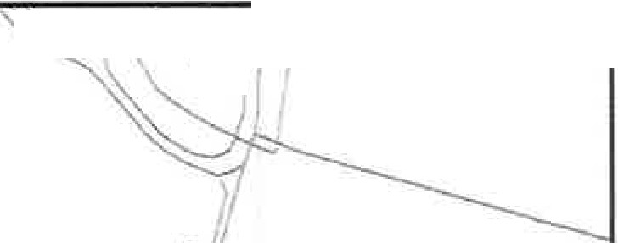
595200 595400 595600 595800 ;, _.
,
'\
��"r."_ ;2
'
�\

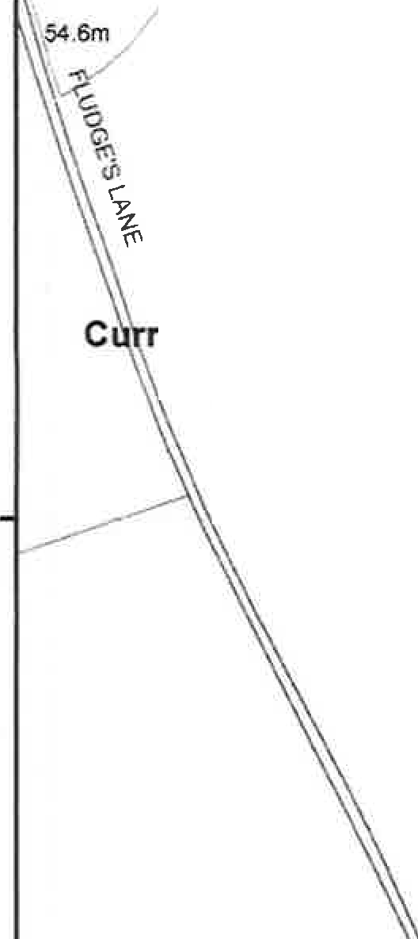
�
\\
(J
i-:

0
0
�..,

·ent route to be diverted (A to B to C) and (B to G) --- New route to be created (D to E to F to G to C) - - - -
Unaffected footpath - - - - - - -
\

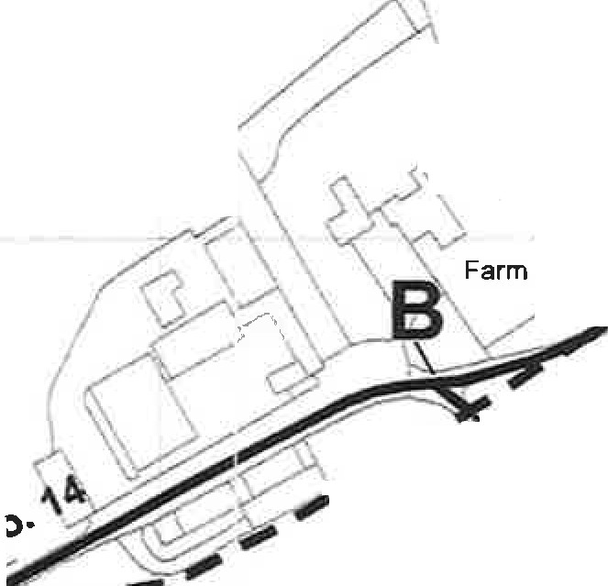
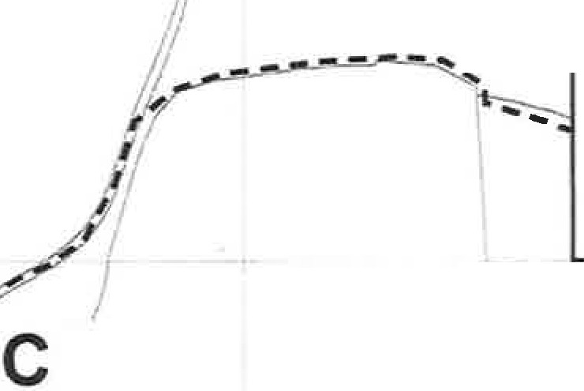
, ,..g
�
�Ponds
r�
�
� I'\
�
,
--E\
� G\
'f:
\\
it,
't'
'i
\, Ul
i.,"U_"I·
"G' c::, N
..,

�
�

.I.,
0

oo\9

,.,,,,,. ,
A ,_.--'
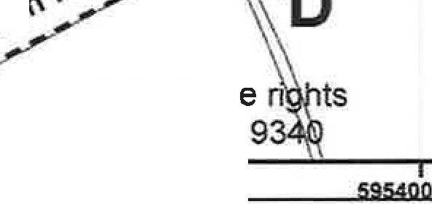
�,--
�o-
�\.y,.
-\� -
II ,..
(,,-
-"I""\
.\I :r
)',f.
C,
c::,
..
N C, N
'\��
i\
'
,

��"(\�I
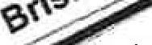
.,.....,--��� .--

�
'J"'
',\ "'1'\
I O
It.I 9.
i·
-t,
l. I !),)

-;
.J:,.

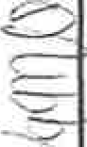


.
��ght and databas Ordnance Survey 10001
NORFOLK COUNTY COUNCIL (BRISLEY FOOTPATH NO. 14 (PART) A DIVERSION ORDER 2023
ND BRISLEY FOOTPATH NO. 15 (PART)) Centre of map:  ;..�Norfolk County Council 595,544.2946 320,355.1782 | Date created: 12/12/2023 | N  A
 | Scale:  1:2,500 | N  A

