NOTICE OF ORDER
Highways Act 1980
OLDHAM BOROUGH COUNCIL

OLDHAM BOROUGH COUNCIL (FOOTPATH 44 CROMPTON) PUBLIC PATH DIVERSION AND DEFINITIVE MAP AND STATEMENT MODIFICATION ORDER 2024

Notice is hereby given that the above referenced Order has been submitted to the Secretary of State for Environment, Food and Rural Affairs for determination. An Inspector will be appointed by the Secretary of State to determine the Order.
The start date for the above Order is 20 October 2025.

Consideration of the Order will take the form of exchanges of statements of case and comments on statements of case.

The effect of the Orders if confirmed as made, will divert that part of Footpath 44 Crompton which commences at Weeder Square, off Buckstones Road, Shaw, Oldham at point A (GRSD95196 09632) proceeding in a north east- erly direction for a distance of approximately 55 metres to point B (GR SD95233 09668) then continues in a generally south easterly direction for a distance of approximately 75 metres to point C (GR SD95277 09612) and continues southeast for a distance of approximately 142 metres to the track south of the Scout Camp, off Buckstones Road, Shaw at point D (GR SD95325 09482) where it joins existing Footpath 47 Crompton as shown on the order map.

The diverted route will commence at point A proceeding in a southerly di- rection for a distance of approximately 82 metres to point E (GR SD95213 09554) then continuing south for a distance of approximately 109 metres to north of Hill Cottage, off Buckstones Road, Shaw at point F (GR SD95217 09447) to join existing Footpath 47 Crompton. From here the route pro- ceeds east, northeast and east again following the aligment of Footpath 47 Crompton for a distance of approximately 139 metres to point D where it joins existing Footpath 47 Crompton as shown on the order map.
Any queries relating to this Order should be referred to Ian Aston by email: rightsofway2@planninginspectorate.gov.uk quoting reference number ROW/3353782 on all correspondence. Alternatively, queries may be sent in writing to The Planning Inspectorate, Rights of Way Section, Room 3/A Eagle Wing, Temple Quay House, 2 The Square, Temple Quay, Bristol, BS1 6PN. Telephone: 0303 444 5670.
Any person wishing the statements of case and other documents relating to this Order may do so online at the Civic Entrance, Oldham Council Civic Centre, West Street, Oldham, Contact: Alan Evans Tel: (0161) 770 3019: Email alan.evans@oldham.gov.uk

Timetable for sending in statements of case and comments Within 2 weeks of the start date [03 November 2025]
The Order Making Authority must ensure their statement of case is received by the Secretary of State. As soon as possible after the deadline, the Secretary of State will send a copy (excluding copies of any supporting documents - these will be available to view at the Authority’s offices) to everyone who has made an objection or representation, the applicant and any other person who has written to us in respect of the Order.

Within 8 weeks of the start date [15 December 2025]
Everyone who has made an objection or representation or any other written representation or any other person wishing to make representations in writing must ensure their statement of case is received by the Secretary of State. As soon as possible after the deadline, the Secretary of State will send full copies to the Authority. Copies (excluding copies of any supporting documents - these will be available to view at the Authority’s offices) will also be sent to the applicant, every person who has made an objection or representation and any other person who has written to us in respect of the Order.

Within the same period the applicant (if applicable) must ensure their statement of case is received by the Secretary of State. As soon as possible after the deadline, Secretary of State will send a full copy to the Authority. Copies will also be sent to everyone who has made an objection or representation and any other person who has written to us in respect of the Order (excluding copies of any supporting documents - these will be available to view at the Authority’s offices).

Within 14 weeks of the start date [26 January 2026]
Everyone who has made an objection or representation, the Authority, the applicant (if applicable) and anyone who has written to us in respect of the Order must ensure that their comments on any or every other statement of case is received by the Secretary of State. As soon as possible after the deadline, the Secretary of State will send copies of these comments to everyone else.

In fairness to the other parties everyone should keep to the timetable to ensure that statements of case and comments are received on time. Late documents will be returned.
We cannot accept any inflammatory, discriminatory or abusive comments. Any documents containing such comments will be returned.
Notice of order for w/r
PUBLIC PATH DIVERSION AND DEFINITIVE MAP AND STATEMENT MODIFICATION ORDER

HIGHWAYS ACT 1980 WILDLIFE AND COUNTRYSIDE ACT 1981

OLDHAM BOROUGH COUNCIL (FOOTPATH 44 CROMPTON) PUBLIC PATH DIVERSION AND DEFINITIVE MAP
AND STATEMENT MODIFICATION ORDER 2024

This order is made by Oldham Borough Council ("the Council") under section 119 of the Highways Act 1980 ("the 1980 Act") because it appears to the Council that in the interests of the owner of the land crossed by the footpath described in paragraph 1 of this order it is expedient that the line of the path should be diverted.

This order is also made under section 53A(2) of the Wildlife and Countryside Act 1981 ("the 1981 Act") because it appears to the Council that the Oldham Metropolitan Borough Council Definitive Map of Public Rights of Way definitive map and statement require modification in consequence of the occurrence of an event specified in section 53(3)(a)(i) of the 1981 Act, namely, the diversion (as authorised by this order) of a highway shown or required to be shown in the map and statement.

BY THIS ORDER:
.

- The public right of way over the land situate at Runge Farm, Shore Edge Farm and Hollows Farm, off Buckstones Road, Shaw, Oldham and shown by a bold continuous line on the map contained in this order and described in Part 1 of the Schedule to this order shall be stopped up after 28 days from the date of confirmation of this order and thereupon the Oldham Metropolitan Borough Council Definitive Map of Public Rights of Way definitive map shall be modified by deleting from it that public right of way.

- There shall at the end of 28 days from the date of confirmation of this order be a public footpath over the land situate at Weeder Square and Hill Cottage, off Buckstones Road, Shaw, Oldham described in Part 2 of the Schedule and shown by a bold broken line on the map contained in this order and thereupon the Oldham Metropolitan Borough Council Definitive Map of Public Rights of Way definitive map shall be modified by adding that path to it.
- The Oldham Metropolitan Borough Council Definitive Map of Public Rights of Way definitive statement shall be modified as described in Part 3 of the Schedule to this order.

SCHEDULE PART 1
DESCRIPTION OF SITE OF EXISTING PATH OR WAY

Part of existing Footpath 44 Crompton which commences off Weeder Square, off Buckstones Road, Shaw, Oldham at point A (GR SD95196 09632) proceeding in a north easterly direction for a distance of approximately 55 metres to point B (GR SD95233 09668) then continues in a generally south easterly direction for a distance of approximately 75 metres to point C (GR SD95277 09612) and continues southeast for a distance of approximately 142 metres to the track south of the Scout Camp, off Buckstones Road, Shaw at point D (GR SD95325 09482) where it joins existing Footpath 47 Crompton.

PART2
DESCRIPTION OF SITE OF NEW PATH OR WAY

Part of Footpath 44 Crompton commencing at point A (GR SD95196 09632) proceeding in a southerly direction for a distance of approximately 82 metres to point E (GR SD95213 09554) then continuing south for a distance of approximately 109 metres to north of Hill Cottage, off Buckstones Road, Shaw at point F (GR SD95217 09447) to join existing Footpath 47 Crompton. From here the route proceeds east, northeast and east again following the alignment of Footpath 47 Crompton for a distance of approximately 139 metres to point D (GR S095325 09482).

PART3
MODIFICATION OF DEFINITIVE STATEMENT

Variation of particulars of path or way Statement to be deleted
District and  Path Number | Page  Number | Status | Length | Description | Comments
Crompton 44 | 6 | Footpath | 965 | From Buckstones Road (No.
Crompton 44 | 6 | Footpath | metres | 479) to Buckstones Road
 |  |  |  | (Shore Edge). Path
 |  |  |  | commences in Buckstones
 |  |  |  | Road near No. 479 and for
 |  |  |  | short length of occupation
 |  |  |  | road follows line of path No.
 |  |  |  | 43 and thence continues in

northerly direction past Top o'th Dog Hill Farm (unoccupied) across two field areas to wall marking boundary of Top o'th Scarr Farm Unit. Path crosses line of path No. 45 to stile in next wall. Path then joins occupation road to east of Cutts Farm and turns west for a distance of 36 metres and passes through stiles into field area and thence northwards to join highway near Runge Farm; leading past Hollows Farm and Weeder Square to link with Buckstones Road adjacent to No. 249 Buckstones Road

Statement to be added

District and Path Number | Page Number | Status | Length | Description | Comments
Crompton 44 | 6 | Footpath | 1163 | Footpath commencing at | Footpath
 |  |  | metres | GR SD95088 09701 on | widths -
 |  |  |  | Buckstones Road next to | from GR
 |  |  |  | Shore Edge Methodist | SD95196
 |  |  |  | Church proceeding along | 09632
 |  |  |  | the track to Weeder Square | to
 |  |  |  | for a distance of | GR SD95213
 |  |  |  | approximately 149 metres | 09554:
 |  |  |  | to GR SD95196 09632 then | 2.2 - 2.4
 |  |  |  | proceeding south continuing | metres width
 |  |  |  | along the track for a
 |  |  |  | distance of approximately | From GR
 |  |  |  | 191 metres to GR SD95217 | SD95213
 |  |  |  | 09447 then proceeding east | 09554
 |  |  |  | and north-east along a track | to
 |  |  |  | towards the scout camp for | GR SD95325
 |  |  |  | a distance of approximately | 09482:
 |  |  |  | 101 metres to GR SD95289 | 2.6 - 3 metres
 |  |  |  | 09483 and proceeding east | width
 |  |  |  | on another track for a
 |  |  |  | distance of approximately
 |  |  |  | 38 metres to GR SD95354
 |  |  |  | 09483 then proceeding in a
 |  |  |  | generally southerly direction
 |  |  |  | for a distance of
 |  |  |  | approximately 113 metres
 |  |  |  | to GR SD95381 09371

where the route meets Footpath 45 CROMPTON, continuing south for a distance of approximately 55 metres to GR 8D95389 09317 where the route meets Footpath 46
CROMPTON. Continuing in a general southerly direction past the former Top o'th Dog Hill Farm for a distance of approximately 432 metres to GR 8D95557 08954 to join Footpath 43 CROMPTON for a distance of approximately 55 metres to GR 8D95553 08895 to
terminate on Buckstones
Road.


THE COMMON SEAL of
OLDHAM BOROUGH
COUNCIL was hereunto affixed on 14th March 2024 in the presence of: -
A.£

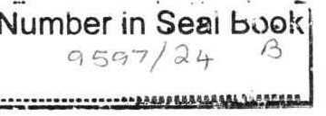
� [)/lo..M
ALAI� EVANS
GROUP, OLICITOR


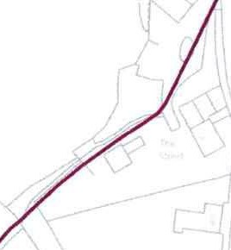
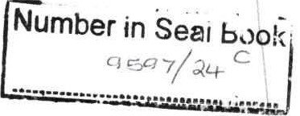
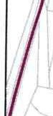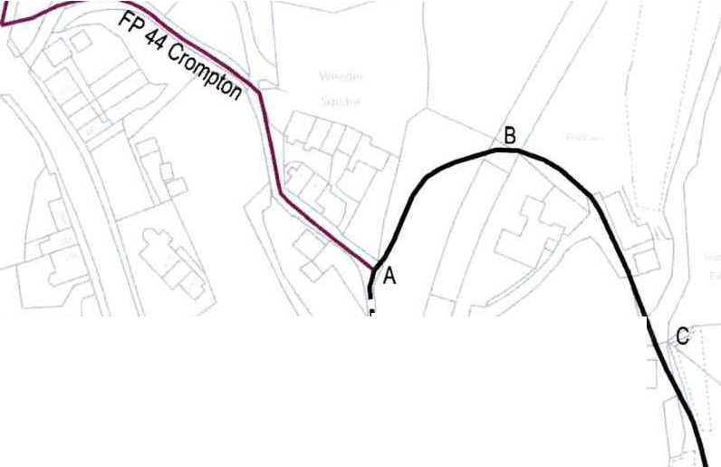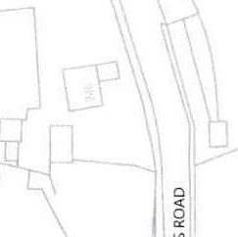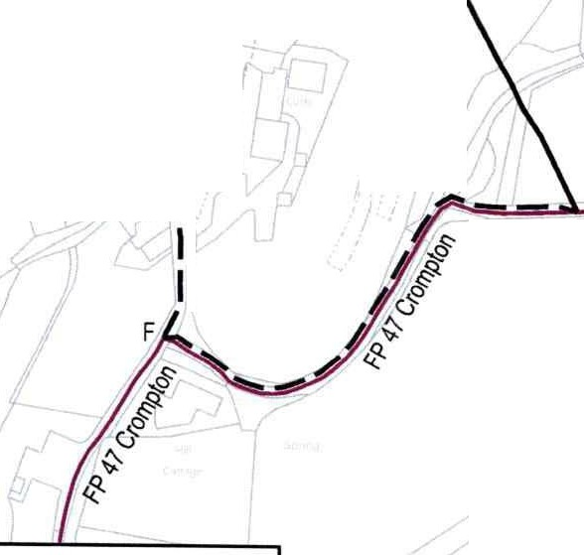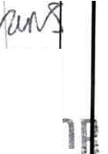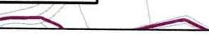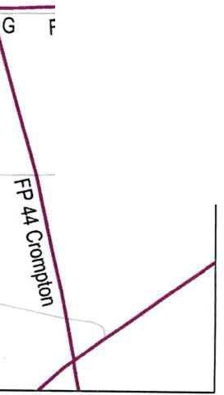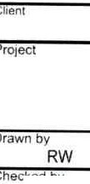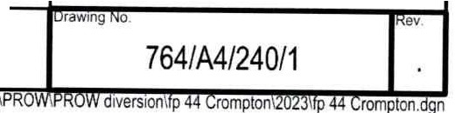
ORDNANCESURVEY LICENCE ClCrown topynGhl and datahase � 2023Ordnance Surve1lcenca0100019668
I I
\
\
\
\
E,)
I
\
\
\
�E
ALANEVANS
�ROUPSOLICIT.
\
\ I I
D
FP 47 Crompton
KEY
DefinitiveFootpath 44 (Part): (A-B-C-D) Proposed DivertedRoute:(A-E-F-D)
ExistingFootpath
,,.
Rev1s1on details
0.tle
OldhamMSC
Diversionof PublicHighwa_yCombined Order s119 Highways Act 1980 Diversion of Public
Shore Edge,Shaw
Oldham
Council
Place and Economic Growth HIGHWAYS & ENGINEERING
Henshaw House, Cheapsj(!e. Oldham OL1 INY
Footpath 44 Crompton \part) and Wil(2)
dlifeand Countryside Ac 1981S53
Modification of the Definitive Map and
urpose orissueStatement
information
eckttd y
1-,AW-=.,.,-,eo"'"•,-,---+=.,,-. -I
LK08123
atecale at size
1:2000
ate
08/23
App
hk.
By

