NOTICE OF ORDER
Wildlife and Countryside Act 1981
Lancashire County Council

The Lancashire CC - (Restricted Byway along Sod Hall Lane, South Ribble)
DMMO 2022

Notice is hereby given that the above referenced Order has been submitted to the Secretary of State for Environment, Food and Rural Affairs for determination. An Inspector will be appointed by the Secretary of State to determine the Order.

The start date for the above Order is 11 November 2025.

Consideration of the Order will take the form of exchanges of statements of case and comments on statements of case.

The effect of the Order, if confirmed without modifications, will be the recording of a Restricted byway known as part of Sod Hall Lane, from the end of the adopted length of Jane Lane (U5419) Leyland adjacent to Whitegate Farm running along a tarmac road in approximately a west south westerly direction to the entrance to Gate House Farm and junction with the route currently recorded as footpath 7-1-FP50. The Order also upgrades to Restricted byway the part of Sod Hall Lane currently recorded as footpath 7-1-FP50 and running from the end of the tarmac road to be recorded as a restricted byway (as described above), at the entrance to Gate House Farm in a north north westerly direction past a junction with footpath 7-1-FP1a and continuing along the tarmac roadway to cross the railway at Sod Hall Crossing. Immediately north of the railway crossing it is joined by footpath 7-1-FP37 and continues as a compacted stone and earth track past the junction with footpath 7-1-FP48 and past the entrance to Heath House to the junction with footpath 7-7-FP45 from where it continues east north east along that part of Sod Hall Lane currently recorded as part of footpath 7-7- FP45 for 40 metres to a sharp bend from where it continues in a northerly direction (currently recorded as footpath 7-7-FP51) through to a junction with Long Moss Lane, Longton.

Any queries relating to this Order should be referred to Paul Scrivener by email: paul.scrivener@planninginspectorate.gov.uk quoting reference number ROW/3350875 on all correspondence. Alternatively, queries may be sent in writing to The Planning Inspectorate, Rights of Way Section, Room 3/A Eagle Wing, Temple Quay House, 2 The Square, Temple Quay, Bristol, BS1 6PN. Telephone: 0303 444 5000.
Any person wishing to view the statements of case and other documents relating to this Order may do so by appointment at County Hall, Fishergate, Preston, PR1 0LD, for further information please contact Simon Moore at simon.moore@lancashire.gov.uk or on 01772 531280. Documents have also been made available online. To access the documents, please use the following URL address: https://www.lancashire.gov.uk/council/transparency/dmmos/sod-hall-lane- 2022

Timetable for sending in statements of case and comments
Within 2 weeks of the start date by 25 November 2025.
The Order Making Authority, or where the Order Making Authority is taking a neutral stance and the applicant or other party are taking the case forward in support of the order, must ensure their statement of case is received by the Secretary of State. As soon as possible after the deadline, the Secretary of State will send a copy (excluding copies of any supporting documents - these will be available to view at the Authority’s offices) to everyone who has made an objection or representation, the applicant and any other person who has written to us in respect of the Order.

Within 8 weeks of the start date by 6 January 2026.
Everyone who has made an objection or representation or any other written representation or any other person wishing to make representations in writing must ensure their statement of case is received by the Secretary of State. As soon as possible after the deadline, the Secretary of State will send full copies to the Authority. Copies (excluding copies of any supporting documents - these will be available to view at the Authority’s offices) will also be sent to the applicant, every person who has made an objection or representation and any other person who has written to us in respect of the Order.
Within the same period the applicant (if applicable) must ensure their statement of case is received by the Secretary of State. As soon as possible after the deadline, Secretary of State will send a full copy to the Authority. Copies will also be sent to everyone who has made an objection or representation and any other person who has written to us in respect of the Order (excluding copies of any supporting documents - these will be available to view at the Authority’s offices).

Within 14 weeks of the start date by 17 February 2026.
Everyone who has made an objection or representation, the Authority, the applicant (if applicable) and anyone who has written to us in respect of the Order must ensure that their comments on any or every other statement of case is received by the Secretary of State. As soon as possible after the deadline, the Secretary of State will send copies of these comments to everyone else.
In fairness to the other parties everyone should keep to the timetable to ensure that statements of case and comments are received on time. Late documents will be returned.

We cannot accept any inflammatory, discriminatory or abusive comments. Any documents containing such comments will be returned.

If you use Artificial Intelligence (AI) to create or alter any part of your documents, information or data, you should tell us that you have done this when you provide the material to us. See the detailed guidance for further information.

Notice of order for w/r
WILDLIFE AND COUNTRYSIDE ACT 1981

THE DEFINITIVE MAP AND STATEMENT OF PUBLIC RIGHTS OF WAY FOR THE COUNTY OF LANCASHIRE

THE LANCASHIRE COUNTY COUNCIL RESTRICTED BYWAY ALONG SOD HALL LANE, SOUTH RIBBLE
DEFINITIVE MAP MODIFICATION ORDER 2022

This Order is made by Lancashire County Council (11the authority") under Section 53(2)(b) of the Wildlife and Countryside Act, 1981 ("the Act") because it appears to that authority that The Definitive Map and Statement of Public Rights of Way for the County of Lancashire require modification in consequence of the occurrence of an event specified in Section 53(2)(b) and 53(3)(c)(i) namely the discovery by the Surveying Authority of evidence which (when considered with all other relevant evidence available to them) shows that a right of way which is not shown in the map and statement subsists or is reasonably alleged to subsist over land in the area to which the map relates, namely a restricted byway and Section 53(3)(c)(ii) namely the discovery by the Surveying Authority of evidence which (when considered with all other relevant evidence available to them) shows that a highway shown in the map and statement as a highway of a particular description, namely a public footpath ought to be there shown as a highway of a different description, namely a restricted byway.

The authority have consulted with every local authority whose area includes the land to which the Order relates. Lancashire County Council hereby order that:
- For the purposes of this Order, the "relevant date•• is 20 July 2022.

- The Definitive Map and Statement of Public Rights of Way for the County of Lancashire shall be modified as described in Part I and Part II of the Schedule and shown on the map attached to the Order.

- This Order shall take effect on the date it is confirmed and may be cited as The Lancashire County Council Restricted Byway along Sod Hall lane, South Ribble Definitive Map Modification Order 2022.

Dated this 20th day of July 2022.

THE COMMON SEAL of the )
Lancashire County Council ) was hereunto affixed in the presence of )

Authorised Signatory �
SCHEDULE

PARTI

MODIFICATION OF THE DEFINITIVE MAP

DESCRIPTION OF PATH OR WAY TO BE ADDED

Restricted byway known as part of Sod Hall Lane, from the end of the adopted length of Jane Lane (U5419) Leyland adjacent to White Gate Farm (point A on the Order Map) running along a tarmac road in approximately a west south westerly direction to the entrance to Gate House Farm (point B) and junction with the route currently recorded as footpath 7-1-FPS0.

The route is shown on the Order Map between points A-B as a bold green coloured broken line and is 110 metres long.

DESCRIPTION OF PATHS OR WAYS TO BE UPGRADED

Restricted byway known as part of Sod Hall Lane, currently recorded as footpath 7-1-FPS0 and running from the end of the tarmac road to be recorded as a restricted byway (as described above), at the entrance to Gate House Farm (point Bon the Order Map) in a north north westerly direction past a junction with footpath 7-1-FP1a and continuing along the tarmac roadway to cross the railway at Sod Hall Crossing (points D-E). Immediately north of the railway crossing it is joined by footpath 7-1-FP37 (E) and continues as a compacted stone and earth track past the junction with footpath 7-1-FP48 (F) and past the entrance to Heath House to the junction with footpath 7-7-FP45 (point G) from where it continues east north east along that part of Sod Hall Lane currently recorded as part of footpath 7-7-FP45 for 40 metres to a sharp bend (point H) from where it continues in a northerly direction (currently recorded as footpath 7-7-FP51) through to a junction with Long Moss Lane, Longton (point I).

The route is shown on the Order Map between points B-C-D-E-F-G-H-I as a bold green coloured broken line.

PART II

MODIFICATION OF DEFINITIVE STATEMENT VARIATION OF PARTICULAR_S OF PATH OR WAY
The Statement to b�rnended for Leyland 50. 1a. 37 and 48 to re�d as follows:

Leyland 50:

No. of path: •50"

Kind of path: 11Restricted Byway"

Position: 0Restricted Byway known as Sod Hall Lane continuing from the end of the adopted length of Jane Lane (U5419) Leyland at White Gate Farm Grid Reference SD 5141 2338 running along a tarmac road in a west south westerly direction to the
entrance to Gate House Farm at SD 5130 2334 from where it continues in a north north westerly direction past a junction with footpath 1a at SD 5129 2337 and continues along the tarmac roadway to cross the railway at Sod Hall Crossing by way of a gated level crossing at SD 5123 2361. The route then continues as a compacted stone/earth roadway joined by footpath 37 at SD 5123 2962 and footpath 48 at SD 5114 2395 and continues past the entrance to Heath House to the parish boundary at SD 5109 2421 from where it continues as a Restricted Byway in Longton parish.11

Length: "1.00 km11

Width: "Width varies between 5 and 10 metres (except across the railway where the width is 3.Sm) as shown on the Ordnance Survey 1:2500 Sheets SD 5123 & SD 5124 published 1963."

Limitations:

11Railway crossing pedestrian and vehicular gates at SD 5123 2360 and 5123 2962
Field Gate at SD 5108 2420"

Leyland 1a:

No. of path: 111a11

Kind of path: "Footpath11

Position: •Branch from No. 1 path just south of railway past Gate House Farm to Restricted Byway 50 (Sod Hall Lane) at SD 5129 2337"
Length: "0.20 miles"

Leyland 37:

No. of path: "37•

Kind of path: •Footpath"

Position: "From opposite Globe Mill, Midge Hall Lane north-east along the north-west side of the railway crossing path No. 1 to Sod Hall Meanygate, Restricted byway 50 at SD 5123 2362 and Jane Lane."
Length: •o.36 miles"

Leyland 48:

No. of path: 114811

Kind of path: 11Footpath11

Position: "From Restricted Byway 50 (Sod Hall Meanygate) at SD 5114 2395 west to Singleton's farm joining Path No. 1 to Midge Hall Lane."
Length: 110.11 miles"

The Statement to be amended for Longton 45 and 51 to read as follows:

Longton 45:

No. of path: 1145"

Kind of path: "Footpath"

Position: "Midge Hall Lane to parish boundary and junction with Restricted Byway Leyland 50 and Restricted Byway Longton 51 SD 5109 2421 on Sod Hall Lane "

Length: 110.41 miles"

Longton 51:

No. of path: 1151"

Kind of path: "Restricted Byway"

Position: "Restricted Byway known as part of Sod Hall Lane from SD 5114 2395 at parish boundary and junction with Footpath Longton 45 and Restricted Byway Leyland 50 running along a roadway in an east north easterly direction for 40 metres before turning to continue in a northerly direction past the entrance to Willow Farm and Orchard Barn through to a junction with Long Moss Lane, Longton at Adlington Gate Farm (SD 5111 2481)."

Length: "0.62 kilometres"

Width: 11Width varies between 5 and 7 metres as shown on the Ordnance Survey 1:2500 Sheet SD 5124 published 1963."

Limitations: "None"

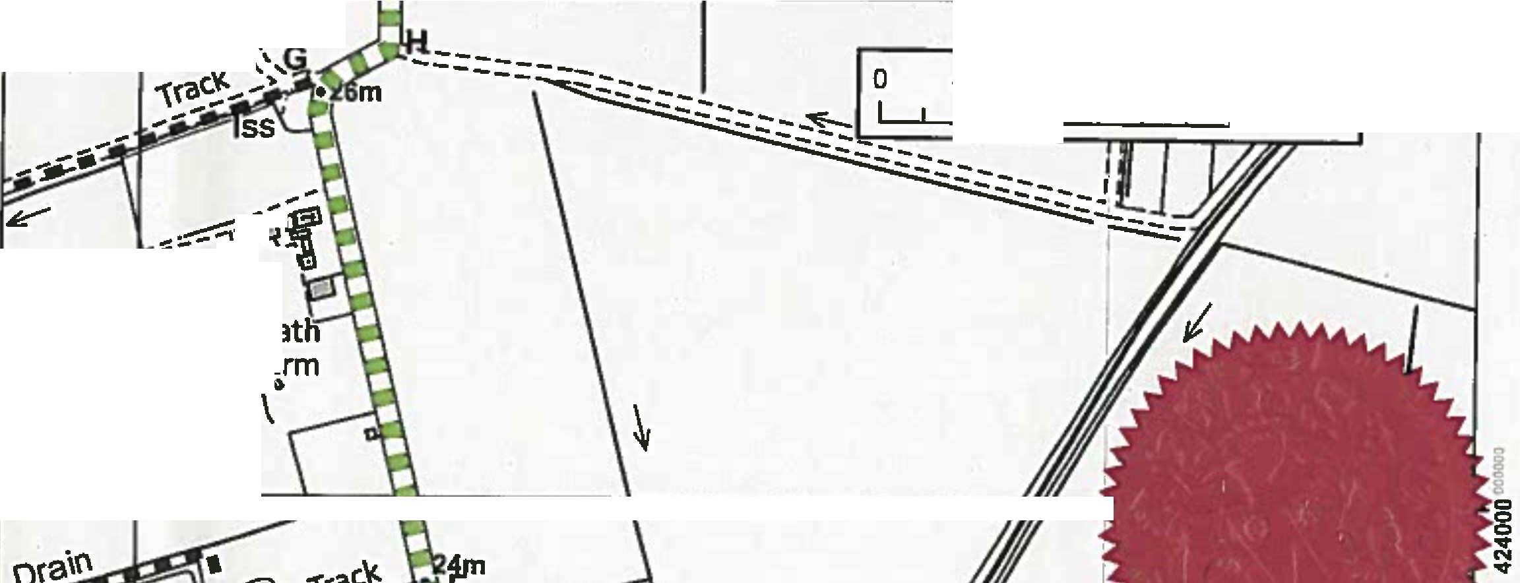
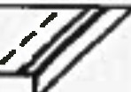
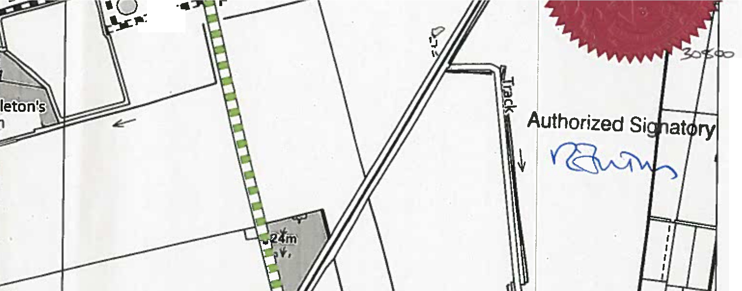
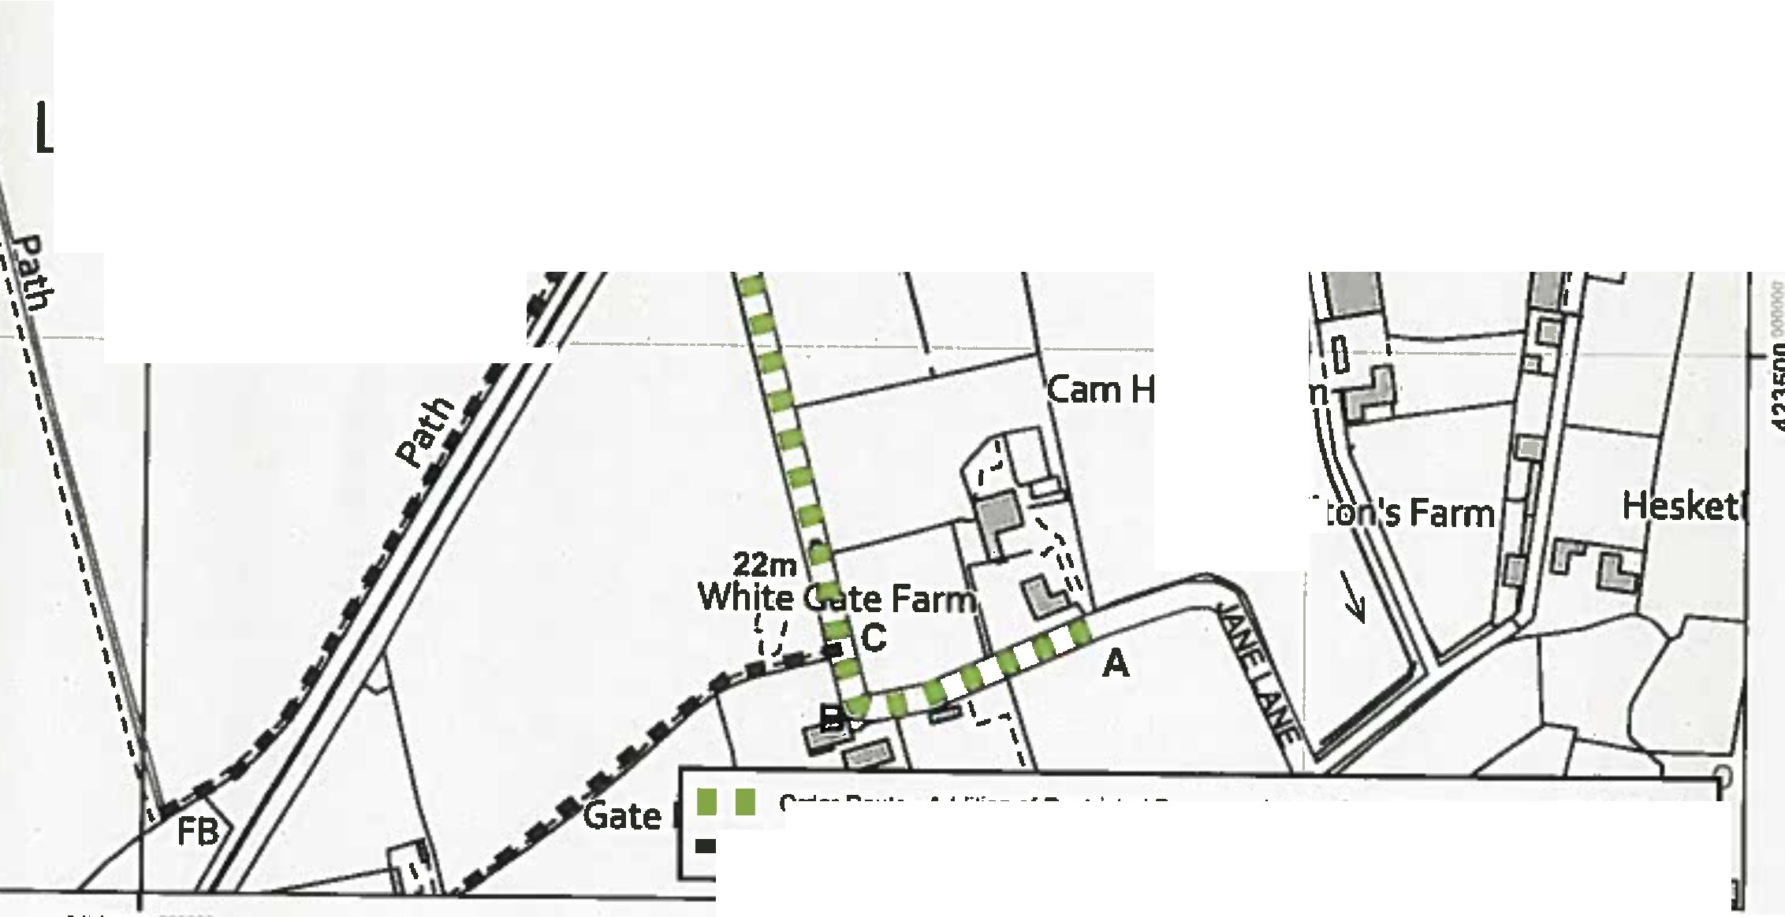
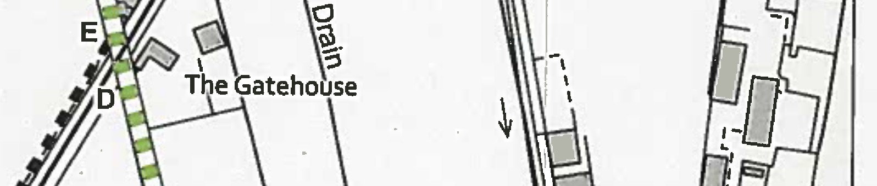
351000
l
·II ·

351500

45 90
1

180 Meters
J

.,-,-�-1,ti:-
Pie
House F.

08 I I ,
'i :::::sA 1
v� i

,ta
-�-,J:J
J� •

. 0
Leyiland Moss

� --·• �.
I
�v

I
Lanca. Public Flights of W•y  Countv PROWC!l■ncashlre.gov.11k  Coul'CI 01772 530317 | Wlldllfe and Countryside Act 1981  Upgrade of footpath and addition of Restricted Byway along Sod Hall Lane, Leyland/ Longton | 1:4,000 | �"♦·  •
Th• dJglll111d Rlgllll or Wr,lnlonn1Uon shouldb• used lor 1ukl1nc1only 11111 accuracy cannotb1gu•antNd.Rlghll ofWaylnlonnlllon must b1vertlltd on th• cumnt Dlllnillv• 11,p btforabtlng 1uppli1d or Vied for 111y P•fPOI'-
This Map 11raproductd from Onlnanct Surv.,.mallriil with lh1.,.nniulan DIOrdn111ce Survey onb1h.if 011111controllerof Her M,jnty'1S1Mion1ry Dllic1{CI Crown Copy,tghl Plan 1/2
Un1ulhori11d np,oducUan lnfringn Crown Copyrighl andmay lladIOPronculion or c:lvll procltdlngs. Lancnhlrt Counly Coundl Uc1nc1No 100D23320

351000 35150D

House Fa

H

Order Roule • Addition of Reslricted Byway and u�e of Footpath to Restricted Byway
- • Public footpaths

c::,
�
M
vN
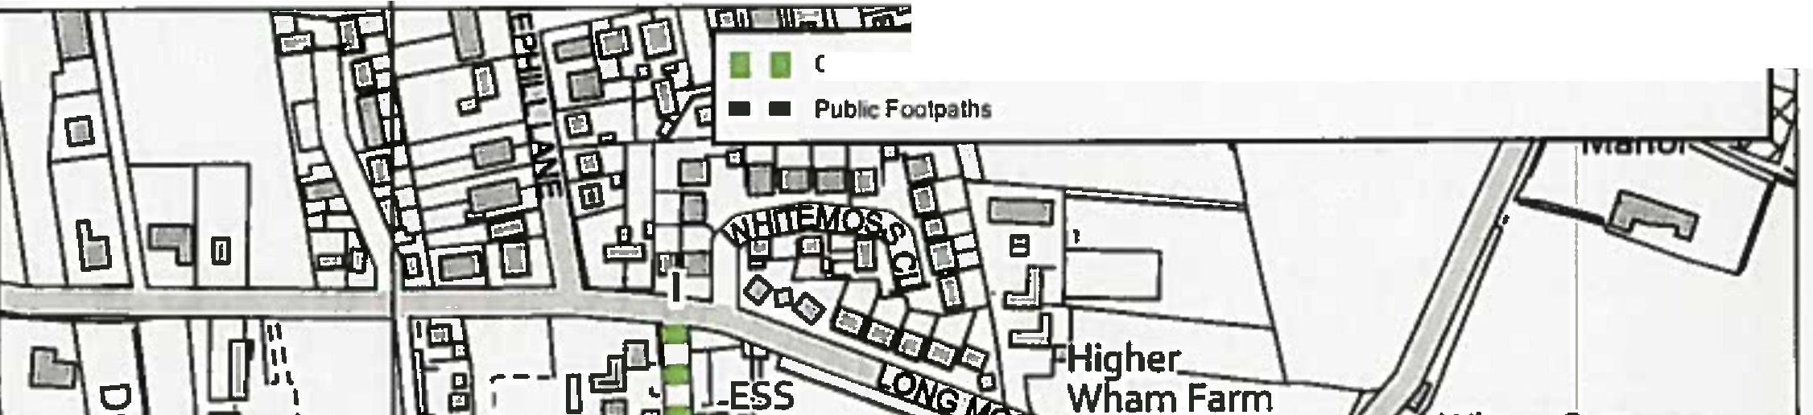

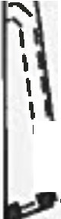
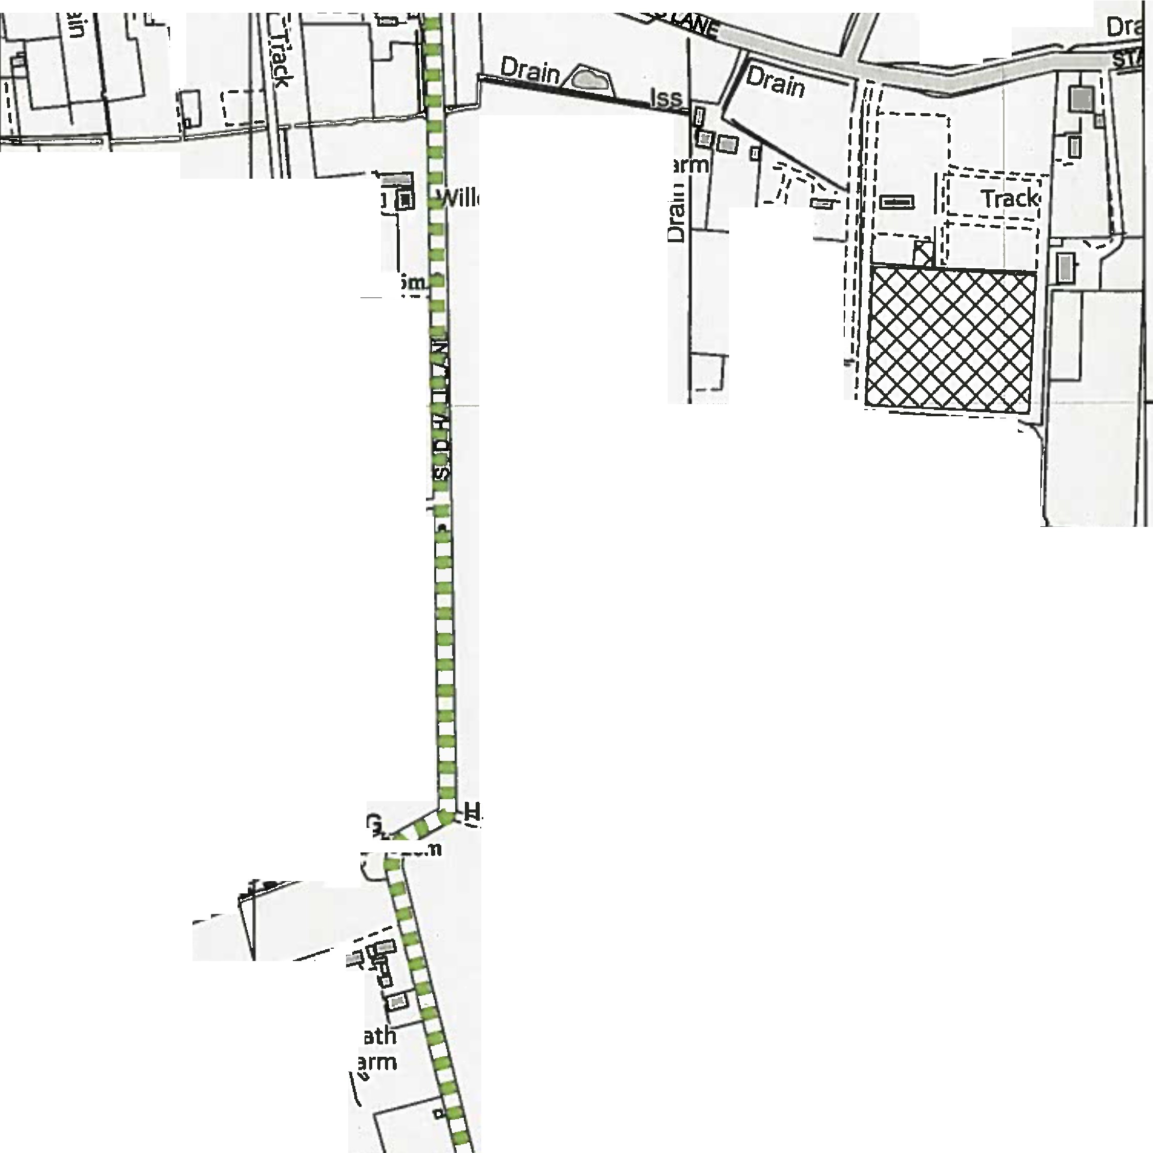
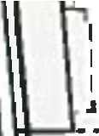
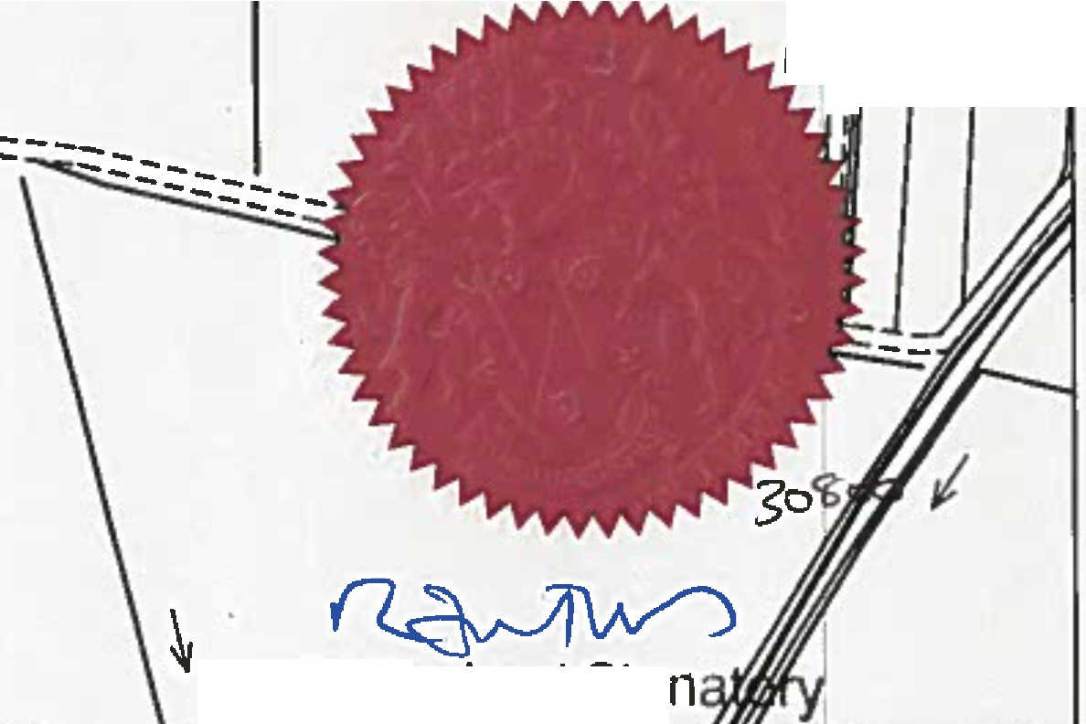
351ODO- 351500 000000

Order Route -Addition or Restricted Byway and upgrade of Footpath to Restricted Byway

I Wham Cottages
,,,,

\I ora\nI
,,

I..
I

ow Farm
Baker's F
,
I.,'11,
I..1.1 2
-,
--
0
�
I
�
, ,

=,·= c::i Cir:
0
8-4----1----1------•--•·••----
� N 'II'

----•�u�---=----
l1LF ,
l
---- - I
I
I
0
l5
�
'II'
IL,-----I----------------
·�
'
I
I
I GI
\9.-
1
I
I
I I
\ r:---
11\ 26m
11
II
..�.
nII ��o
,ll ,:::3
II
I\
II
II
,II ,_

Longton Moss
C:
-�
Cl
I
:f¼.:: 11
,.
Iii
Iii
II
I I, II II.

��:·I:1,-'1.9
1
g
I
I
I
\ I I I I I
l
I .,
I ..,.,.-
_,_.��
I\ \I ..,, :..�--:,)!;
'\,;;-�...-!:,.:.�

11

II
l'
'-'�
�{�(.��--"'�

---�lss

--�--...f-:
�-- �
Pie
House F.

--------

:t 3
0� 1 �·
�fl I
.--.,
Iii

Authorized Sig
1
o\'a,\�'('\
��c�y,, tm -
IO 45 90
w -
oc,::::::-=■ o
1B0 Meters
re�

'II'
I ' I I I ""' , '..I......
351000 O<IOOOO 351500
'II'

La�;le | Public Rights of Way PROW@tann•hlro.gav.uk 01772 530317 | Wlldllfa and Countryslda Act 1981  Upgrada of footpath and addition of Restrlctad Byway along Sod Hall lane, Leyland / Longton | 1:4,000 | •♦. •  w
lht lllgltiud Rlghll of Way lnlomiatiH1houl1I b1uHd fgr guldanc:. onlyn lu lcturacy c111nDI bl gu•anltld. Rlghll DIW1r lntonn1don must be vlrifftd onIlle culTIIII DlflnlM Map blfore balng 1upplltd or uud I• any parp011,
1h11�P ii rep111d11Ctd from Ordnanct 5'1rvayrn1C11f1lwltlllht ptnnlulon ol 0rdnanct SUM)' on bthal1 ol tht cantlllller of Her M1Jnty'1Slltlonuy Offlct (Cl Crow11 CclpyrighL Plan 2/2
llnluthartstd repniductlon lnlrlngn c-n Coprri9ht and may l11d lo Pniucullon ar cMI p,oc11dln91. Lancuhlrl Count)' Coundl Ucenc■Na.100023320

