NOTICE OF ORDER

HIGHWAYS ACT 1980 WILDLIFE AND COUNTRYSIDE ACT 1981

The Oxfordshire County Council, Noke Bridleway No.10 (part) and Woodeaton Bridleway No.11, Public Path Diversion and Definitive Map and Statement Modification Order 2023
The Oxfordshire County Council, Beckley & Stowood Bridleway No. 21, Noke Bridleway No. 18 and Woodeaton Footpath No. 12, Public Path Creation and Definitive Map and Statement Modification Order 2023
Notice is hereby given that the above referenced Orders have been submitted to the Secretary of State for Environment, Food and Rural Affairs for determination. An Inspector will be appointed by the Secretary of State to determine the Orders.
The start date for the above Orders is 11 November 2025

Consideration of the Order will take the form of a public local inquiry.
The Inquiry will be held at Barton Neighbourhood Centre, Underhill Circus, Headington, Oxford, OX3 9LS.on 21 April 2026 at 10.00am.

The effect of the The Diversion Order made on 10 July 2023, if confirmed as made, will modify the Definitive Map and Statement for the area by diverting, as shown on the Order map:- Noke BR No.10 running from OS Grid Ref SP 5486 1162 west-north-westwards for 358m to SP 5453 1177,
and from SP 5447 1184 west-north-westwards for 62m to SP 5441 1185 to a new line running from OS Grid Ref SP 5486 1162 south- southwestwards for 319m to SP 5468 1135 and north-north-westwards for 98m to SP 5464 1144 and from OS Grid Ref SP 5464 1144 north-north westwards for 163m to SP 5456 1158; Woodeaton BR No.11 running from OS Grid Ref 5453 1177 north-westwards for 94m to SP 5447 1184 to a new line running from OS Grid Ref SP 5456 1158 north- northwestwards for 302m to SP 5441 1185.

The effect of the Creation Order made on 10 July 2023, if confirmed as made will modify the Definitive Map and Statement for the area by adding, as shown on the Order map:- a 5m wide bridleway running from Noke BR18 at OS Grid Ref SP 5468 1135 southwestwards for 17m to SP 5468 1134, south-south-eastwards for 237m to SP 5479 1113, and south-westwards for 4m to SP 54796 11131; a 5m wide bridleway from Noke BR10 at OS Grid Ref SP 5468 1135 south-southwestwards for 10m to SP 5468 1135;
a 2m wide footpath from Woodeaton BR11 at OS Grid Ref SP 5452 1164 westwards for approximately 24m via SP 5451 1164 to SP 5450 1164.

Any queries relating to this Order should be referred to Ian Aston by email: rightsofway2@planninginspectorate.gov.uk quoting reference number ROW/3357784 and ROW/3357790 on all correspondence. Alternatively, queries may be sent in writing to The Planning Inspectorate, Rights of Way Section, Room 3/A Eagle Wing, Temple Quay House, 2 The Square, Temple Quay, Bristol, BS1 6PN. Telephone: 0303 444 5670.

Any person wishing to view the statements of case and other documents relating to this Order may do so online at https://letstalk.oxfordshire.gov.uk/noke-woodeaton-03601 . Alternatively, copies can be obtained free of charge on request from countrysideaccesslegal@oxfordshire.gov.uk. They will also be held on deposit at Oxfordshire County Council, County Hall, New Road, Oxford, OX1 1ND, where they can be viewed by appointment during regular opening hours, Tel: 01865 897135 or email countrysideaccesslegal@oxfordshire.gov.uk, quoting the case number 03601

Timetable for sending in statements of case and proofs of evidence

Within 8 weeks of the start date by [06 January 2026]
The Order Making Authority must ensure their statement of case is received by the Secretary of State. As soon as possible after the deadline, the Secretary of State will send a copy (excluding copies of any supporting documents - these will be available to view at the Authority’s offices) to everyone who has made an objection or representation and the applicant and any other person who has written to us in respect of the Order.

Within 14 weeks of the start date [17 February 2026]
Everyone who has made an objection or representation and anyone who wishes to give evidence at the Inquiry must ensure their statement of case1 is received by the Secretary of State. As soon as possible after the deadline, the Secretary of State will send full copies to the Authority. Copies will also be sent to the applicant, every person who has made an objection or representation and any other person who has written to us in respect of the Order (excluding copies of any supporting documents - these will be available to view at the Authority’s offices).

1 If you wish to make a legal submission, this should be submitted at the same time as your statement of case. Otherwise legal submissions will have to be submitted in writing on the day of the inquiry.
Within the same period the applicant (if applicable) must ensure their statement of case is received by the Secretary of State. As soon as possible after the deadline, the Secretary of State will send a full copy to the Authority. Copies will also be sent to everyone who has made an objection or representation and any other person who has written to us in respect of the Order (excluding copies of any supporting documents - these will be available to view at the Authority’s offices).

4 weeks before the date of the inquiry [by 24 March 2026]
The Authority, everyone who has made an objection or representation, the applicant (if applicable) and anyone who wishes to give evidence at the Inquiry must ensure their proof of evidence (together with any summary) is received by the Secretary of State. As soon as possible after the deadline, the Secretary of State will send copies of:

- the Authority’s proof of evidence to everyone who has made an objection or representation, the applicant and anyone who has submitted a statement of case (including copies of any supporting documents – although none should be submitted with a proof of evidence);
- the applicant’s proof of evidence to the Authority, everyone who has made an objection or representation and anyone else who has submitted a statement of case (including copies of any supporting documents – although none should be submitted with a proof of evidence); and

- all other proofs of evidence to the Authority, the applicant, everyone who has made an objection or representation and anyone else who has submitted a statement of case (including copies of any supporting documents – although none should not be submitted with a proof of evidence).

All parties must keep to the timetable set out above and ensure that statements of case and proofs of evidence are received by the Secretary of State on time. Late documents will be returned.

We cannot accept any inflammatory, discriminatory or abusive comments. Any documents containing such comments will be returned.
If you use Artificial Intelligence (AI) to create or alter any part of your documents, information or data, you should tell us that you have done this when you provide the material to us. See the detailed guidance for further information.

Notice of order for inquiry
PUBLIC PATH DIVERSION AND DEFINITIVE MAP AND STATEMENT MODIFICATION ORDER
HIGHWAYS ACT 1980 WILDLIFE AND COUNTRYSIDE ACT 1981
The Oxfordshire County Council,
Noke Bridleway No.10 (part) and Woodeaton Bridleway No.11, Public Path Diversion and Definitive Map and Statement Modification Order 2023

This Order is made by The Oxfordshire County Council ('the authority') under section 119 of the Highways Act 1980 because it appears to the authority that in the interests of the public the public rights of way described in Article 1 of this Order it is expedient that the line of the ways should be diverted.

This Order is also made under section 53A(2) of the Wildlife and Countryside Act 1981 (''the 1981 Act") because it appears to the authority that the Oxfordshire County Council Definitive Map and Statement of Public Rights of Way for Oxfordshire require modification in consequence of the occurrence of an event specified in section 53(3)(a)(i) of the 1981 Act, namely, the diversion (as authorised by this Order) of a highway shown or required to be shown in the map and statement.

The landowner has agreed to defray any compensation which becomes payable in consequence of the coming into force of this Order and any expenses which are incurred in bringing the new site of the ways into a fit condition for use by the public.

Cherwell District Council has been consulted as required by Section 120(2) of the Highways Act 1980.

BY THIS ORDER:

  - The public rights of way over the land situated at Beckley Manor in the parishes of Noke and Woodeaton and shown by a bold continuous line on the map contained in this Order and described in Part 1 of the Schedule to this Order shall be extinguished on the date upon which Oxfordshire County Council certifies that the routes described in paragraph 2 (below) have been brought into a fit condition for use by the public and thereupon the Oxfordshire County Council Definitive Map of Public Rights of Way for Oxfordshire shall be modified by deleting from it that public right of way, and the Definitive Statement shall be modified as described in Part 3 of the Schedule to this Order.
  - There shall be from the date of confirmation public bridleways over the land situated at Beckley Manor in the parishes of Beckley & Stowood, Noke and Woodeaton (as described in Part 2 of the Schedule) and shown by a bold broken line on the map attached to this Order, and thereupon the Oxfordshire County Council Definitive Map of Public Rights of Way for Oxfordshire shall be modified by adding those rights of way to it, and the Definitive Statement shall be modified as described in Part 3 of the Schedule to this Order.
  - Notwithstanding this Order, statutory undertakers with apparatus over/under the land described in Article 1 above shall continue to have the same rights in respect of such apparatus as they had immediately before the date of this Order.

Dated this � �� day of 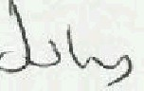 2023 THE COMMON SEAL OF THE OXFORDSHIRE COUNTY COUNCIL

was hereto affixed in the presence of:-

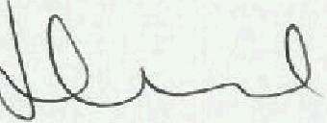

County Solicitor/Designated Officer

SCHEDULE

PART 1

DESCRIPTION OF SITE OF EXISTING WAY

Noke Bridleway No. 10
The entire width of Noke BR No. 10 running from OS Grid Ref SP 5486 1162 (Point A on the Order plan) west-north-westwards for approximately 358m to SP 5453 1177 (Point B), and from SP 5447 1184 (Point C) west-north-westwards for approximately 62m to SP 5441 1185 (Point D).

Woodeaton Bridleway No. 11
The entire width of Woodeaton BR No. 11 running from OS Grid Ref 5453 1177 (Point B on the Order plan) north-westwards for approximately 94m to SP 5447 1184 (Point C).
PART2

DESCRIPTION OF SITE OF NEW WAY

Beckley & Stowood Bridleway No. 20
A new bridleway with a width of 4.5m running from OS Grid Ref SP 5464 1144 (Point Fon the Order plan) north-north-westwards for approximately 163m to SP 5456 1158 (Point G).

Noke Bridleway No. 10
A new bridleway running from OS Grid Ref SP 5486 1162 (Point A on the Order plan) generally south-south-westwards for approximately 319m to SP 5468 1135 (Point E) and north-north-westwards for approximately 98m to SP 5464 1144 (Point F).

Widths:
7.0m from SP 5486 1162 (Point A on the Order plan) to SP 5468 1135 (Point E).
4.5m from SP 5468 1135 (Point E) to SP 5464 1144 (Point F).

Woodeaton Bridleway No. 11
A new bridleway with a width of 4.5m running from OS Grid Ref SP 5456 1158 (Point G on the Order plan) generally north-north-westwards for approximately 302m to SP 54411185 (Point D).

PART3
Modification of Definitive Statement Variation of particulars of path or way
Path Number | Status | Description | Width | Conditions Remarks  & I(not forming part of Limitations the Definitive  , Statement)
Beckley & Stowood 20 | BR | From Noke BR10 at the Noke Parish boundary, NNW to Woodeaton BR11 at the Woodeaton Parish boundary. | 4.5 m. | - | [Diversion Order confirmed
 |  |  |  |  | . ) *
 |  |  |  |  | (* date of confirmation to be advised)

I
Path Number | Status | Description | Width | Conditions & Limitations  - | Remarks  (not forming part of  the Definitive  Statement}
Noke 10 | BR | From BR 16 at SP 5524 1134 N of  Roberts's Copse, leading W, NW and SSW and NNW to Beckley & Stowood BR20 at the Beckley & Stowood Parish boundary and then continuing from the NW end of Woodeaton BR11, leading WNW to the Wheatley road (84027), E of  Woodmoor Copse. | 7.0m from  SP 5486  1162 to SP  5468 1135;  4.5m from SP 5468  1135 to SP  5464 1144. |  | - Formerly lslip  BRs 14 and 16.  - Diversion Order,
 |  |  |  |  | confirmed
19.08.2010
diverted part into Woodeaton parish where it was renumbered as Woodeaton BR11.
3) Extinguishment Order, confirmed 19.01.2012.
[Diversion Order confirmed
. ].
(* date of confirmation to be advised)
Woodeaton 11 | BR | From Beckley & Stowood BR20 at the Beckley & Stowood Parish boundary NNW to Noke BR10 at the Noke Parish boundary. | 4.5m |  | 1) Diversion Order confirmed 19.08.2010  diverted part of Noke BR10 into Woodeaton parish where it was renumbered as Woodeaton BR11.  {Diversion Order confirmed  . ] *  (* date of confirmation to be advised)

I

- -

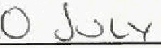
Dated 2023

The Oxfordshire County Council, Noke Bridleway No.10 (part) and Woodeaton Bridleway No.11, Public Path Diversion and Definitive Map and Statement Modification Order 2023

The Common Seal of The Oxfordshire County Council
was hereto affixed the day of 2023
in confirmation of the diversion and modification in the within-written Order in the presence of:-

Designated Officer
Tha Oxfordshire County Council Noke Bridleway No.10 {part) and Woodeaton Bridleway No.11 Public Path Diversion and Definitive MaP and Statement Modification Order 2023
4�400 45il600 454800 <155000
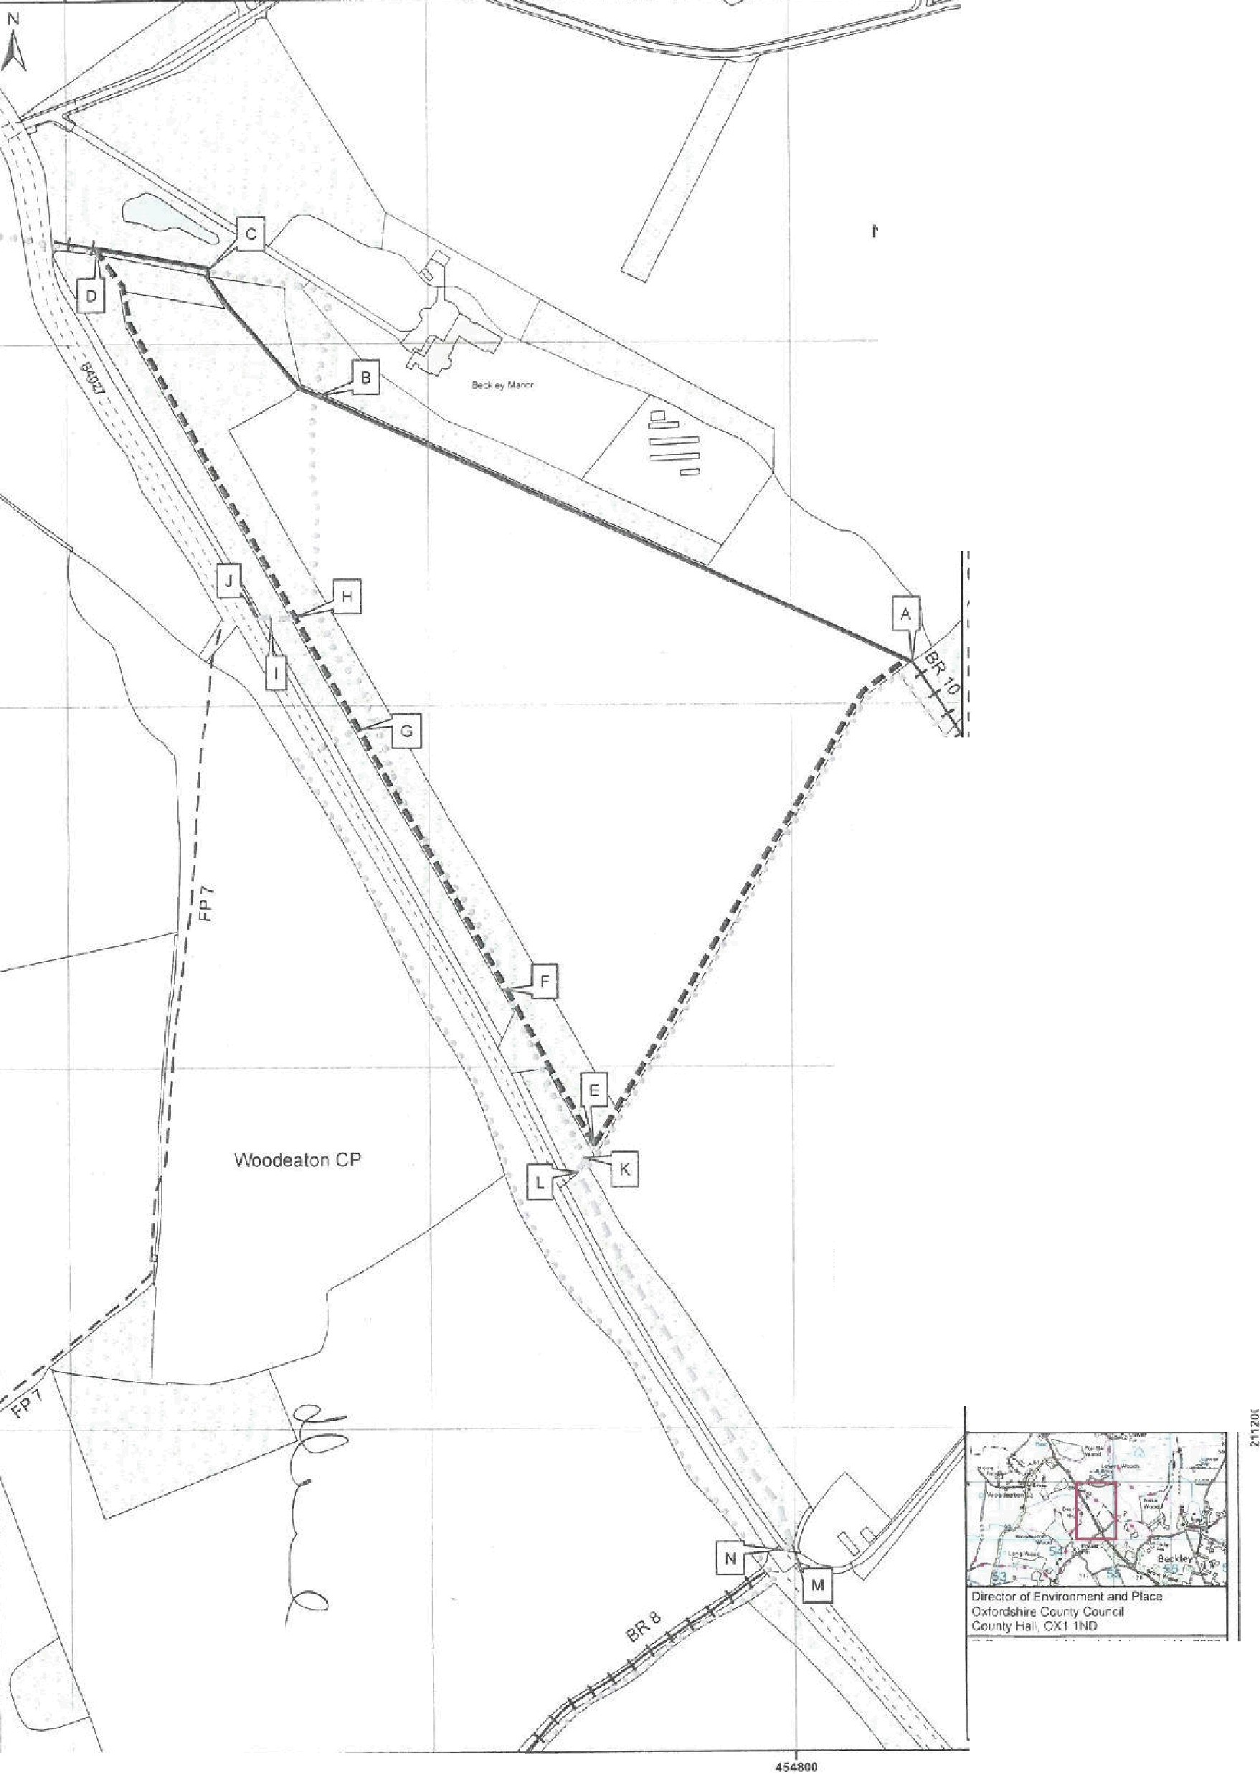
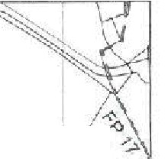
C)
(

I
j
I
I
Noke CP

0
I
/
�OXFORDSHIRE
�COUNTY COUNCIL
Existing Noke BrldlewayNo.10
(part•) la ba divarted
A-B. C-D
Lerigtri .420 m appro'I(

Existing Woodeaton Bridleway No.11 to bo divertec;t
D-C
Lei-,;iu,. 9� 111. aJ:prax.
, New route of Beckley & Stowood "\ Bridleway No. 20
F-G
Lengln: 103m 10:irox. Wl(l1h·45m
New route of Noke Bridleway
No.1D(P"rt)
A-E-F
len:11n. 427 m ;.i:,,rox.
IM:fths 70m lo\-E)
4.5m 1E-F)
New rcu1e of Woodeaton Bridleway No. 11 (part)
G-H-0 •
L;1;1'1tl1 3:l2m .:1:.iwtir
\IYimrt �.Sm
l-lew routes to� Cft!,:;it!td undei cc..r1t..·-uncnt ':i .2d G,eo.1llot1 O1tft1, (Drawin!j No HA11JU0ft>76t,J03!:01l
E-K, H-1-.J K-L-M-N
Lc.r-,th� It• TI ,!lpft1,( ([ K1
2t: 111 i.ii.�rv� t-i I J1
?4)11\i'!jpl<:,, ◄·,>l·P,J..IJI W,dlhli �o.1111 (H.:.JJ
i;n m 1F-K. l',-I P,,,,-Nf
Approwlmc1t,e r<WJte e.f un;1ff1u:mul rlgh�
Beckley and Stowood CP
nf�y
?ubicF�h
Pw,c&(llew<tJ

I I I
ParishSoun

Seal•: 1:2 500 ll; Al Dato: 2!1104/2023 OS r-e-t: $P Sl S.W Dre111rn by: CC Drawing No! HA.19801676w 00601

C: CIO"Jwfl CO::J),'ighl and dalilbiliit nyl11i 2(}23
OS IOOU23J4J V:>u are pe1n1:ted to IIM Iii s
°'"
<!ill• wtvi,, to 11:lrable ,ou to rnpofld lo. l'llteract wilh. the :1ryanis::11·011that pio,.,�e,j you witn 11\edat! Y<it1 ere no1 permlttec:i tD COP)' �J�-lica11ce.d11ir bute Qr .$011ifl)' c-f thr� dOtl)"' t!ti'tl r,,P,,;. 1-, l' Wffl

45-4400 .45"'600 4511000
PUBLIC PATH CREATION AND DEFINITIVE MAP AND STATEMENT MODIFICATION ORDER
HIGHWAYS ACT 1980 WILDLIFE AND COUNTRYSIDE ACT 1981
The Oxfordshire County Council,
Be-ckley & Stowood Bridleway No. 21, Noke Bridleway No. 18 and Woodeaton Footpath No. 12,
Public' Path Creation and Definitive Map and Statement Modification Order
2023

This Order is made by The Oxfordshire County Council ('the authority') under section 26 of the Highways Act 1980 because it appears to the authority that, having regard to the matters set out in section 26(1), there is a need for a public bridleway and a public footpath over the land to which this Order relates, and that it is expedient that the ways should be created,

This Order is also made under section 53A(2) of the Wildlife and Countryside Act 1981 ("the 1981 Act") because it appears to the authority that the Oxfordshire County Council Definitive Map and Statement of Public Rights of Way for Oxfordshire require modification in consequence of the occurrence of an event specified in section 53(3)(a)(iii) of the 1981 Act, namely, the creation (as authorised by this Order) of new rights of way over land in the area to which the map relates, being rights of way such that the land over which the right subsists are public a bridleway and a public footpath,

The landowner has agreed to defray any compensation which becomes payable in consequence of the coming into force of this Order and any expenses which are incurred in bringing the new site of the ways into a fit condition for use by the public,
Cherwell District Council has been consulted as required by Section 26(3) of the Highways Act 1980,

BY THIS ORDER:
1, There shall be from the date of confirmation of this Order public rights of way over the land at Beckley Manor in the parishes of Beckley & Stowood, Noke and Woodeaton and shown by bold broken lines on the map attached to this Order and described in Part 1 of the Schedule to this Order, and thereupon the Oxfordshire County Council Definitive Map of Public Rights of Way for Oxfordshire shall be modified by adding those public rights of way, and the Definitive Statement shall be modified as described in Part 3 of the Schedule to this Order,
Dated this I')�"" day of 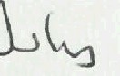 2023 THE COMMON SEAL OF THE OXFORDSHIRE COUNTY COUNCIL

was hereto affixed in the presence of :-

�

County Solicitor/Designated Officer

SCHEDULE

PART 1

Description of Land

Beckley & Stowood Bridleway No. 21

ALL THAT strip of land at Beckley & Stowood, Oxfordshire shown as a bold broken line on the map attached to this Order running from Noke BR18 at OS Grid Ref SP 5468 1135 (Point Kon the Order plan) generally south-westwards for approximately 17m to SP 5468 1134 (Point L), south-south-eastwards for approximately 237m to SP 5479 1113 (Point M), and south-westwards for approximately 4m to SP 54796 11131 (Point N).

Width: 5 m.

Noke Bridleway No. 18

ALL THAT strip of land at Noke, Oxfordshire shown as a bold broken line on the map attached to this Order running from Noke BR10 at OS Grid Ref SP 5468 1135 (Point E on the Order plan) generally south-south-westwards for approximately 1Orn to SP 5468 1135 (Point K).
Width: 5 m.

Woodeaton Footpath No. 12

ALL THAT strip of land at Woodeaton, Oxfordshire shown as a bold broken line on the map attached to this Order running from Woodeaton BR11 at OS Grid Ref SP 5452 1164 (Point Hon the Order plan) westwards for approximately 24m via SP 5451 1164 (Point I) to SP 5450 1164 (Point J).

Width: 2 m.

PART2 LIMITATIONS AND CONDITIONS
The right of the landowner to install and maintain a pedestrian gate at SP 5451 1164 (Point I) and bridle gates at SP 5468 1134 (Point L) and SP 5479 1113 (Point M).

PART3
Modification of Definitive Statement Variation of particulars of path
Path Number | Status | Description | Width | Conditions & Limitations | Remarks  (not forming part of the Definitive  Statement)
Beckley & Stowood 21 | BR | From Noke BR18 at the Noke Parish boundary, SW and SSE to the 84027 opposite BR8. | 5.0 m | The right of the landowner to install and maintain bridle gates at SP 5468  1134 and at  SP 5479  1113. | [Creation Order confirmed  . ] *  (* date of confirmation to be advised)
Noke 18 | BR | From Noke BR10 SSW to Beckley & Stowood BR21 at the Beckley & Stowood Parish boundary. | 5.0 m | - | [Creation Order confirmed  . ] *  (* date of confirmation to be advised)
Woodeaton 12 | FP | From Woodeaton BR11 W to the B4027 opposite FP7. | 2.0m | The right of the landowner to install and maintain a pedestrian gate at SP 5451 1164. | [Creation Order confirmed  " ..." ] *  (* date of confirmation to be advised)

Dated 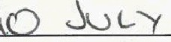 2023

The Oxfordshire County Council, Beckley & Stowood Bridleway No. 21, Noke Bridleway No. 18 and Woodeaton Footpath No. 12 Public Path Creation and Definitive Map and Statement Modification Order 2023

The Common Seal of The Oxfordshire County Council

was hereto affixed the day of
in confirmation of the creation and modification in the within-written Order in the presence of:-
2023

Designated Officer
The Oxfordshire County Council Beckley & Stowood Bridleway No.21, Noke Bridleway No. 18
and Woodeaton Footpath No.12 Public Path Creation and Definitive Map and Statement Modification Order 2023
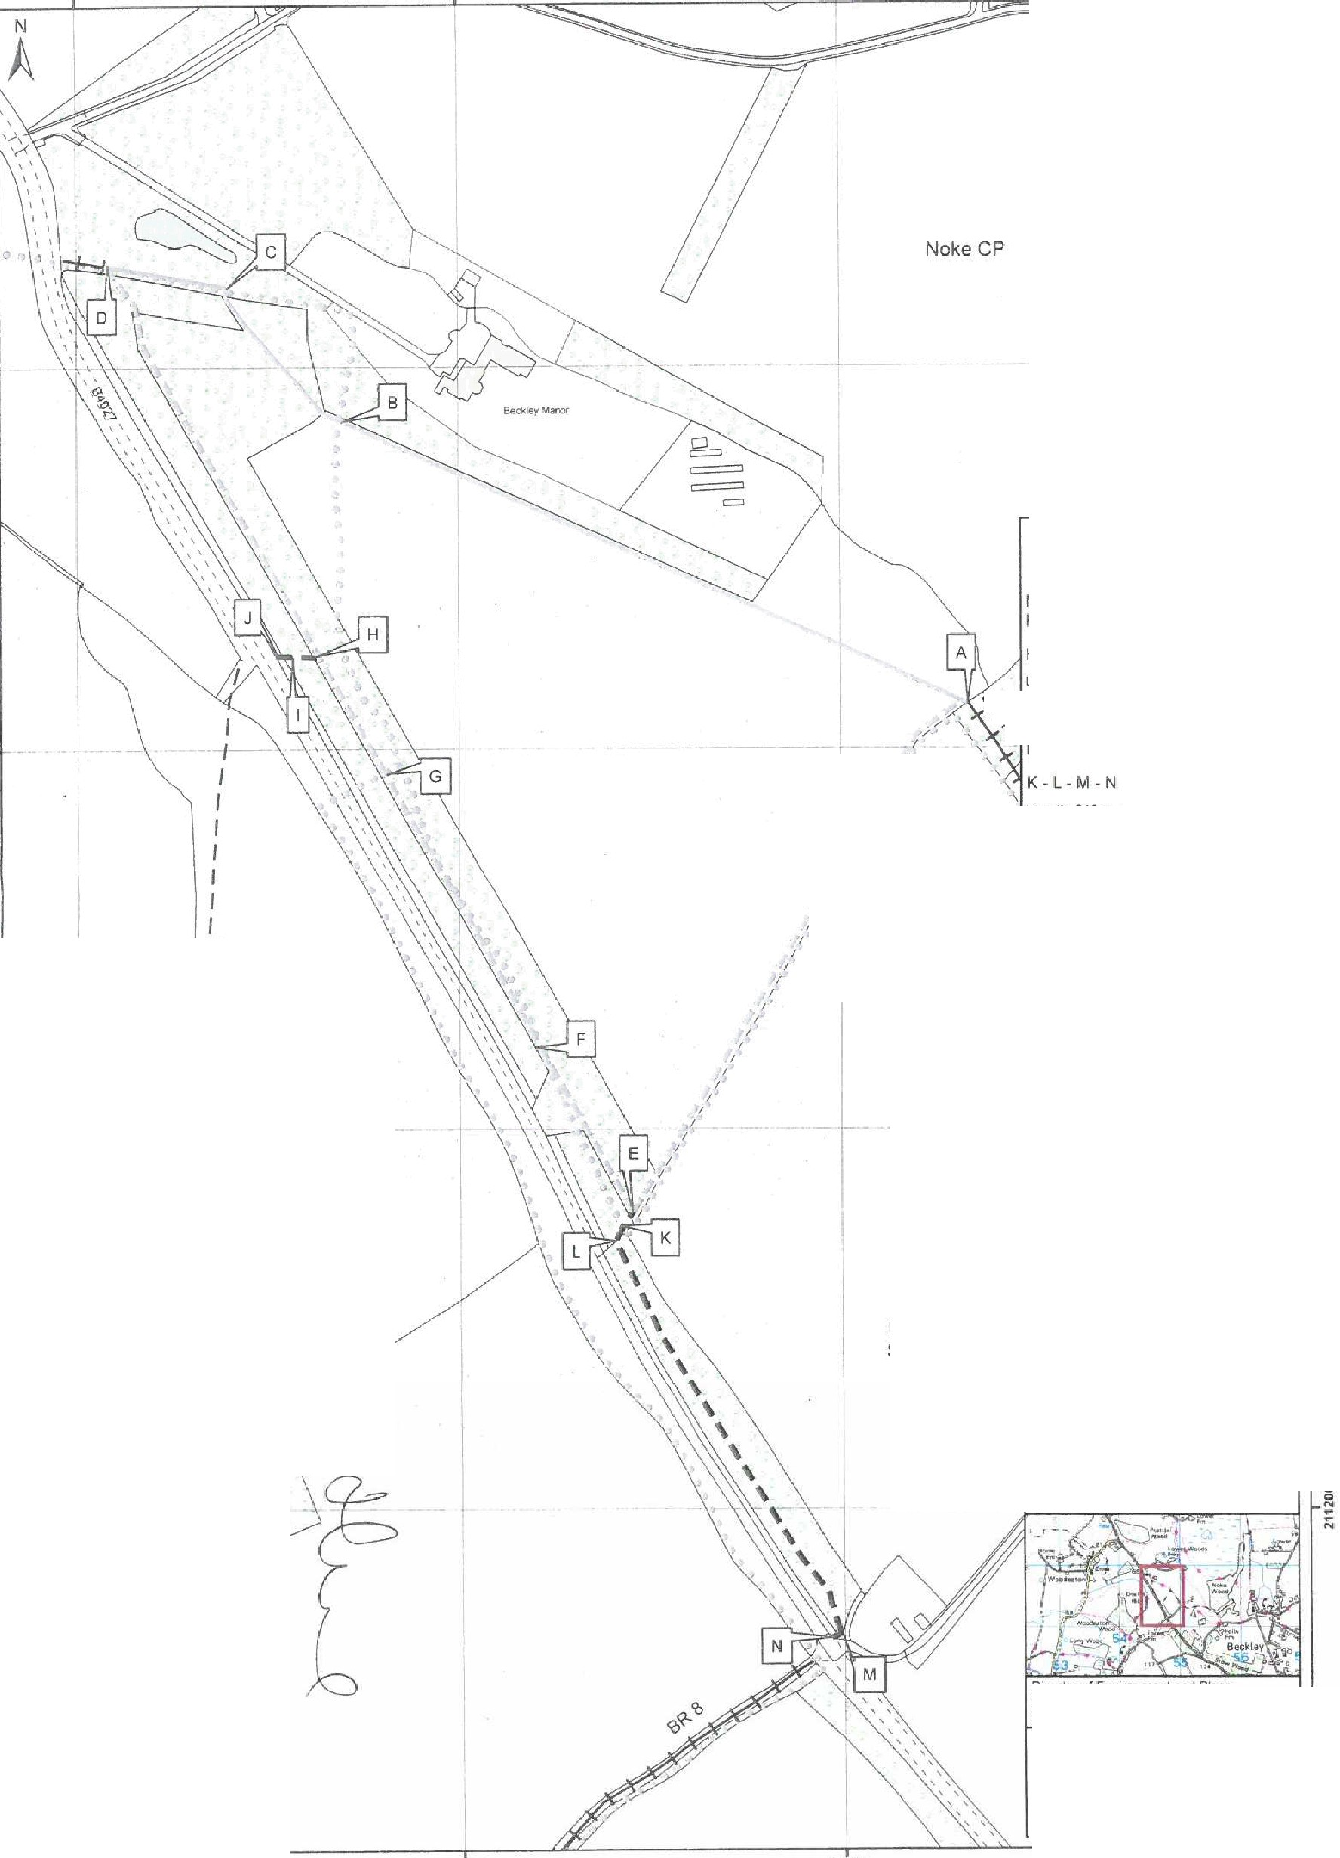
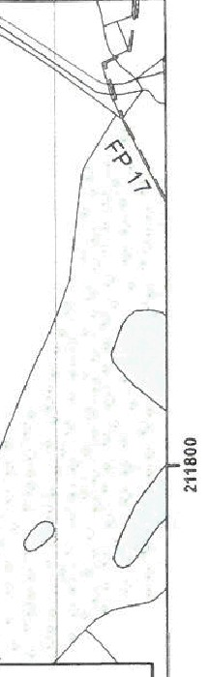
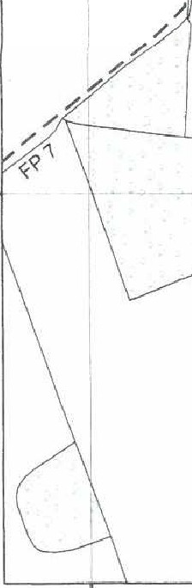
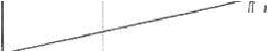
4544-00 454600 454800 455000

0

·�/ u.
J
I
I I I I I
I I I

Woodeaton CP
�OXFORDSHIRE
�COUNTY COUNCIL
New route of Woodeaton Public
Footpath No. 12 to be created
H -I-J
Length· 24 m approx.
�-'? \/Vid1h 20m
'a New route of Beckley & Stowood Bridleway No. 21 to be created
'
y
I
I
I length 2-45 m approx
; I Vv'id1h 50m
I
V New route of Noke Bridleway
I No. 18 to be created
I'
I
'
E-K
I
Length 10 m app1ox
1Nid1h 50m
Existing Moke 9ndle't¥ay No.10 (parts) and WooLle�lon Bridleway No. 11 to be dive,ttu.J under c:oncuwrnt s.1IO Di1,1ersion Ordar (Drawing No. HA1980/6/6a/03601)
A-8,C-D(BRI0) 8-C (BRI I)

Mew routes of Bridleway diverted under concurrent s. 119 Diversion Order
(Drawing No. llAl9801676a/0360·I)
A-E-F F-G.G-H-D

Beckley and Stowood CP

Approximate route of unaffected rights
of way
Public Foo1pa1h
Pubbc Bnaleway
I I I
Parish Bounda
50 100Met1es

Scale: 1:2,500 @A3 Date: 04/0512023
OS ref: SP 51 SW Drawn by: CC Drawing No: HA1980 !676bJ 03601

Director of Emmonment and Place Oxfordshire Coonly Counc� County Halt OX1 1NO
0 Crown copyright and dalabase rigl1s 2023 OS 100023343 You are perm1tled lo use this da1a solel'j 10 enable you to respond 10. or mteraci with, the otgamsat10n thal provided you with the dala Yoo are no, perm,ueo to COl)y, :1-ub-heence,d1s1r1bute ors.ell any of lhlS data to third parties 1nan form

454400 454600 454800 455000

