NOTICE OF ORDER

Highways Act 1980 - Section 118
Essex County Council
PUBLIC PATH EXTINGUISHMENT ORDER 2024 FOOTPATH 70 WIMBISH
IN THE DISTRICT OF UTTLESFORD

Notice is hereby given that the above referenced Order has been submitted to the Secretary of State for Environment, Food and Rural Affairs for determination. An Inspector will be appointed by the Secretary of State to determine the Order.

The start date for the above Order is 13 November 2025.

Consideration of the Order will take the form of a public local inquiry.

The Inquiry will be held at Central Baptist Church, Victoria Road South, Chelmsford, Essex CM1 1LN on 21 April 2026 at 10.00am.

The effect of the Order, if confirmed without modifications, will be to
extinguish a part length of Footpath 70 Wimbish of unknown width shown by a bold continuous line on the order map commencing from the point where it connects to Byway 98 Wimbish running in a generally south westerly then south south easterly direction across common land, gardens
and fields for a total distance of 463 metres to the point where it connects to Footpath 67 Wimbish and continues unaffected.

Any queries relating to this Order should be referred to Joanne Reid by email: rightsofway2@planninginspectorate.gov.uk quoting reference number ROW/3360619 on all correspondence. Alternatively, queries may be sent in writing to The Planning Inspectorate, Rights of Way Section, Room 3/A Eagle Wing, Temple Quay House, 2 The Square, Temple Quay, Bristol, BS1 6PN. Telephone: 0303 444 5136.

Any person wishing to view the statements of case and other documents relating to this Order may do so by appointment at Essex County Council, County Hall, E block main reception, Market Road, Chelmsford CM1 1GG. Please email Robert Lee at: publicpathorders@essexhighways.org or Tel: 07395 602121. Alternatively the documents can be viewed online at https://www.essexhighways.org/permanent-closures-or-diversions/opposed-orders

Timetable for sending in statements of case and proofs of evidence

Within 8 weeks of the start date by [by 8 January 2026]

The Order Making Authority must ensure their statement of case is received by the Secretary of State. As soon as possible after the deadline, the Secretary of State will send a copy (excluding copies of any supporting documents - these will be available to view at the Authority’s offices) to everyone who has made an objection or representation and the applicant and any other person who has written to us in respect of the Order.

Within 14 weeks of the start date [19 February 2026]

Everyone who has made an objection or representation and anyone who wishes to give evidence at the Inquiry must ensure their statement of case is received by the Secretary of State. As soon as possible after the deadline, the Secretary of State will send full copies to the Authority. Copies will also be sent to the applicant, every person who has made an objection or representation and any other person who has written to us in respect of the Order (excluding copies of any supporting documents - these will be available to view at the Authority’s offices).

Within the same period the applicant (if applicable) must ensure their statement of case is received by the Secretary of State. As soon as possible after the deadline, the Secretary of State will send a full copy to the Authority. Copies will also be sent to everyone who has made an objection or representation and any other person who has written to us in respect of the Order (excluding copies of any supporting documents - these will be available to view at the Authority’s offices).

4 weeks before the date of the inquiry [by 24 March 2026]

The Authority, everyone who has made an objection or representation, the applicant (if applicable) and anyone who wishes to give evidence at the Inquiry must ensure their proof of evidence (together with any summary) is received by the Secretary of State. As soon as possible after the deadline, the Secretary of State will send copies of:

- the Authority’s proof of evidence to everyone who has made an objection or representation, the applicant and anyone who has submitted a statement of case (including copies of any supporting documents – although none should be submitted with a proof of evidence);

- the applicant’s proof of evidence to the Authority, everyone who has made an objection or representation and anyone else who has submitted a statement of case (including copies of any supporting documents – although none should be submitted with a proof of evidence); and

- all other proofs of evidence to the Authority, the applicant, everyone who has made an objection or representation and anyone else who has submitted a statement of case (including copies of any supporting documents – although none should not be submitted with a proof of evidence).

All parties must keep to the timetable set out above and ensure that statements of case and proofs of evidence are received by the Secretary of State on time. Late documents will be returned.

NOTE: If you use Artificial Intelligence (AI) to create or alter any part of your documents, information or data, you should tell us that you have done this when you provide the material to us. See the detailed guidance for further information.

We cannot accept any inflammatory, discriminatory or abusive comments. Any documents containing such comments will be returned.

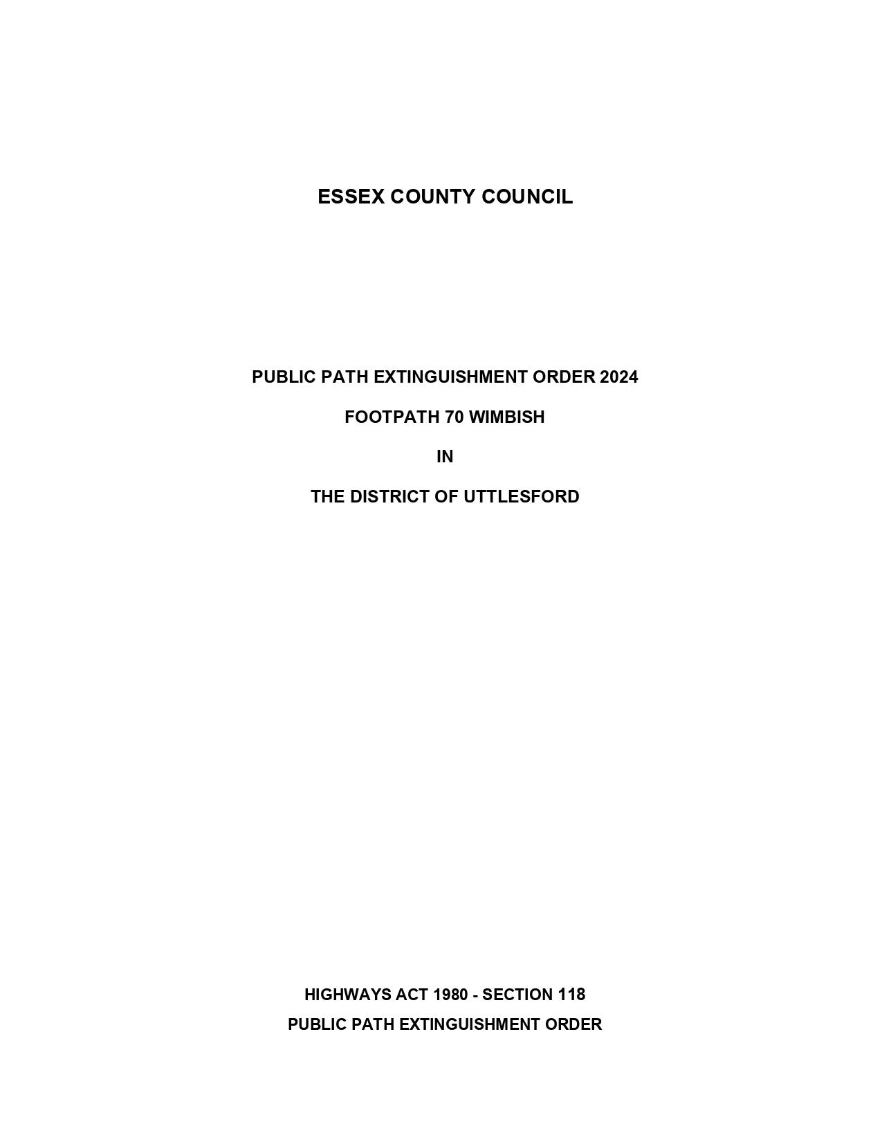

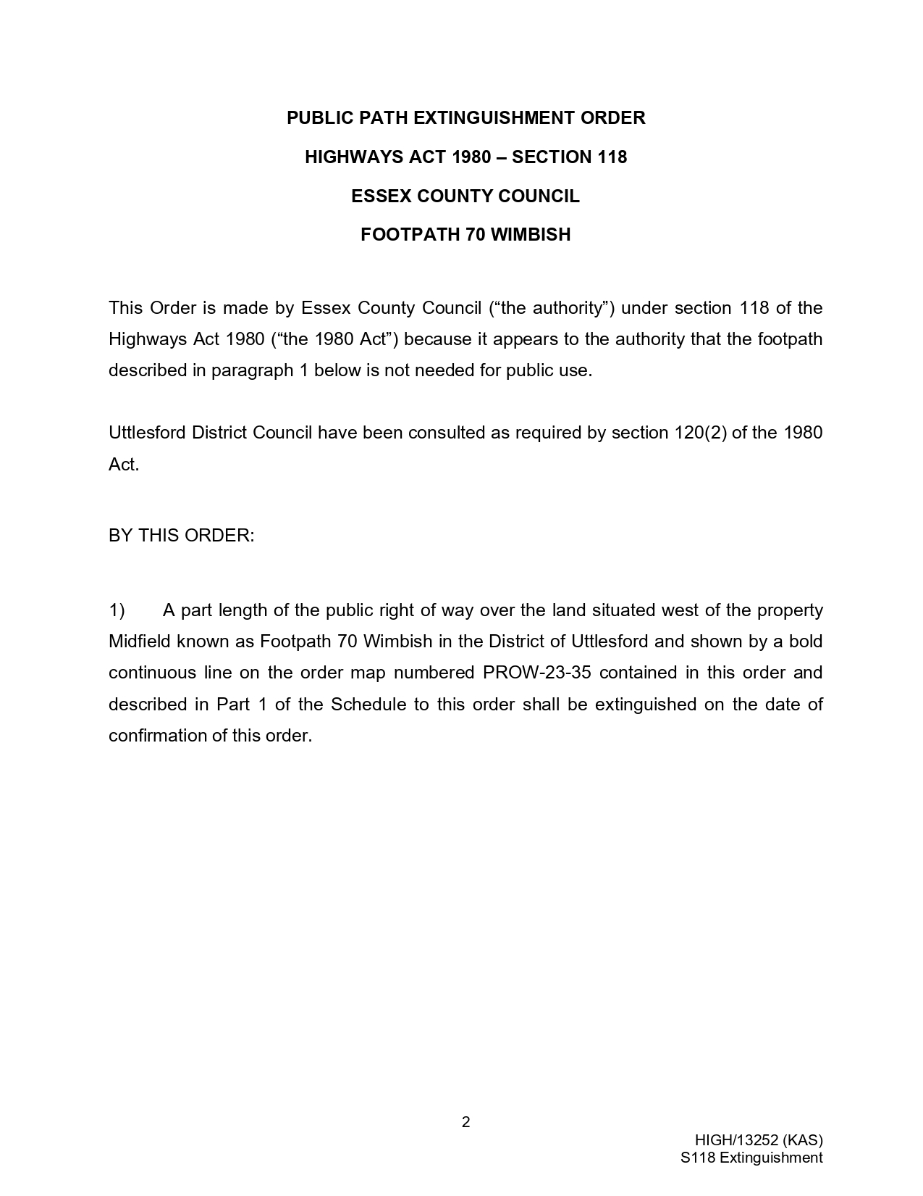

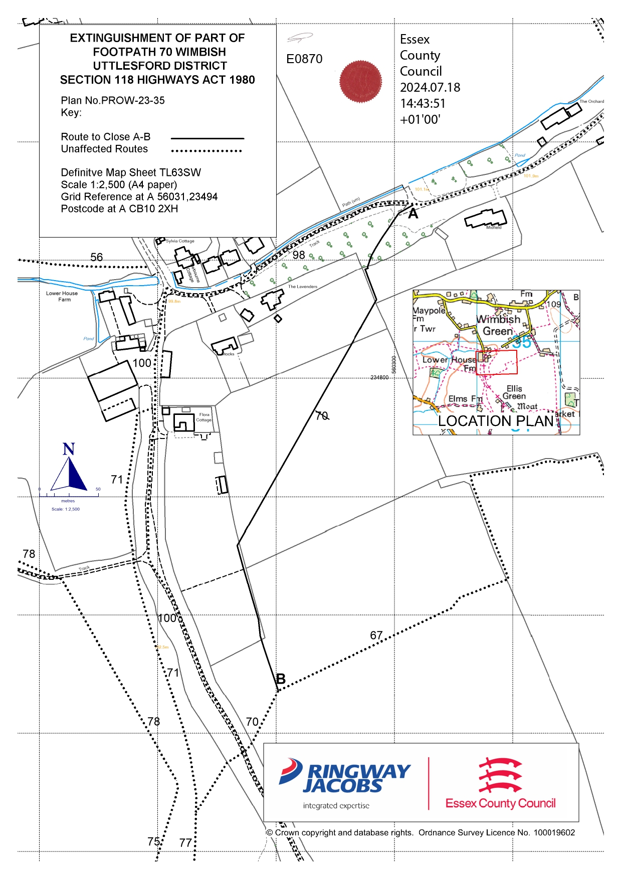

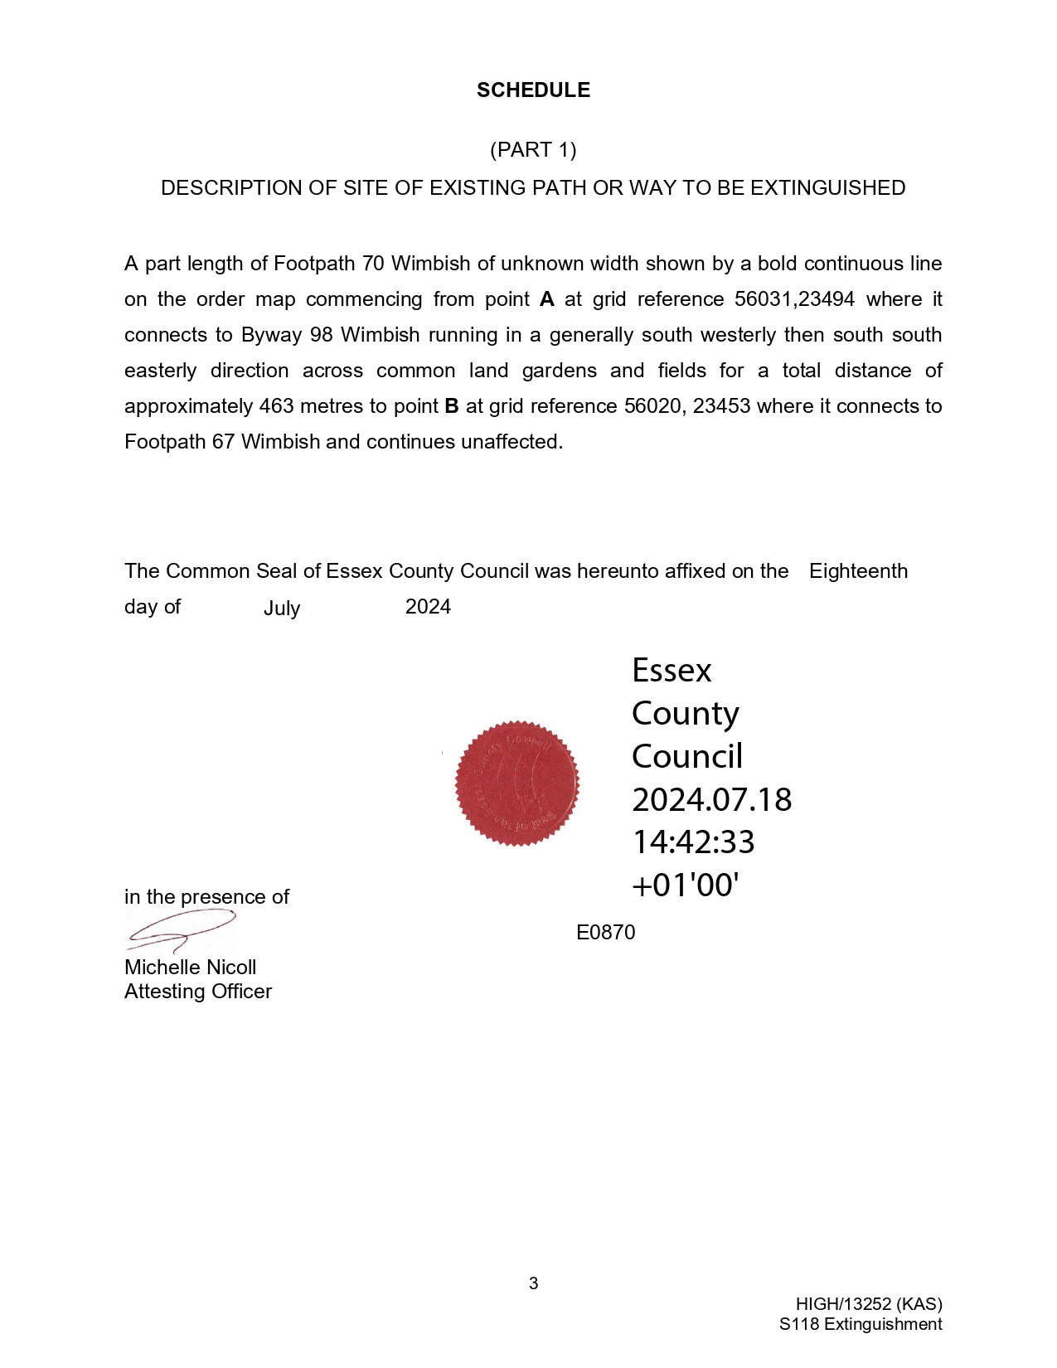

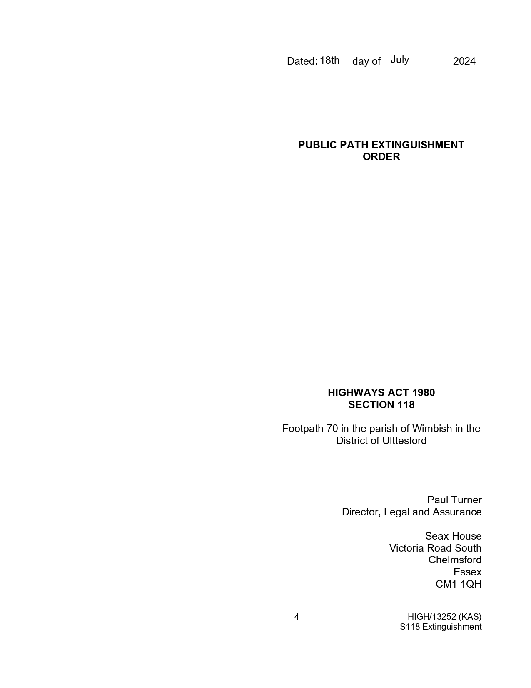

If you wish to make a legal submission, this should be submitted at the same time as your statement of case. Otherwise legal submissions will have to be submitted in writing on the day of the inquiry.

