NOTICE OF ORDER
Town and Country Planning Act 1990 - Section 257 Wildlife & Countryside Act 1981 Section 53A
Oldham Metropolitan Borough Council (Footpath 26 Oldham) Public Path Diversion & Definitive Map & Statement Modification Order 2022
Notice is hereby given that the above referenced Order has been submitted to the Secretary of State for Environment, Food and Rural Affairs for determination. Following an earlier exchange of written representations, the Inspector appointed to determine the Order(s) issued a letter in which he proposed to make modifications to the Order as drafted. Following advertisement of those proposals objections/representations have been received.
The start date for the above Order is 04 November 2025
Consideration of the Order will take the form of a public local inquiry.
It is being held so that the Inspector can hear evidence in respect of the Inspector’s proposed modifications only.
The Inquiry will be held at JR Clynes Building, Cultural Quarter, Greaves Street, Oldham, OL1 1AL on 7 April 2026 at 10.00am.
The effect of the Order, if confirmed without modifications, will be to divert Footpath 26 Oldham – commencing at GR SD95648 04292 off Rhodes Hill proceeding in an easterly direction for a distance of approximately 480 metres to its junction with Footpath 25 Oldham at GR SD96048 04267 will be diverted to a route commencing at GR SD95648 04292 off Rhodes Hill and proceeding for a distance of 168 metres in an easterly direction to point A (GR SD95808 04305) then turning to and proceeding in a south-easterly direction for a distance of 35 metres following stepped route to point C (GR SD95831 04289). Proceeding east across link road for a distance of 15 metres to point D (GR SD95851 04289) then heading east and north-east for a distance of 36 metres following stepped route to point B (GR SD95851 04289) and proceeding east and south-east for a distance of 181 metres to (GR96048 04267) where Footpath 26 Oldham joins Footpath 25 Oldham, a total distance of 435 metres or thereabouts as shown on the order map. The route follows the proposed layout of development in MMA/344723/20 Section 73 application. Variation of Conditions 8 (landscaping management) and amendments to approved plans within condition 13 (link road plans) to PA/343269/19 for up to 265 new homes (outline) and new link road between Knowls Lane and Ashbrook Road (full).
The effect of the proposed modifications would be to amend the Order as follows:-
Delete from paragraph 3 the words ‘confirmation of this order‘ and insert ‘date on which Oldham Borough Council certify that the terms of paragraph 2 above have been complied with’
Delete from the Schedule Part 3 Statement to be added: the words ‘435 metres’ and insert ‘519 metres’
After the words ‘for a distance of 35 metres following stepped route’ insert the words ‘of 2 metres width’
After the words ‘for a distance of 36 metres following stepped route’ insert the words ‘of 2 metres width’
After the words ‘where Footpath 26 Oldham joins footpath 25 Oldham’ insert the words ‘then proceeding in a generally north easterly direction for a distance of approximately 84 metres before joining FP197 Saddleworth at GR
96088 04334, a total distance of 519 metres or thereabouts.’
In the Comments column delete the words: -
‘Min. width 1 metre’ and ‘79 steps with treads @178 mm riser’
In the Comments column add the words: ‘Kissing gates at points C and D’
‘Between points A and C 30 steps and between points D and B 30 steps’
Any queries relating to this Order should be referred to Ian Aston by email: rightsofway2@planninginspectorate.gov.uk quoting reference number ROW/3303492 on all correspondence. Alternatively, queries may be sent in writing to The Planning Inspectorate, Rights of Way Section, Room 3/A Eagle Wing, Temple Quay House, 2 The Square, Temple Quay, Bristol, BS1 6PN. Telephone: 0303 444 5670
Any person wishing the statements of case and other documents relating to this Order may do so at: JR Clynes Building, Cultural Quarter, Greaves Street, Oldham, OL1 1AL. Contact: Alan Evans Tel: (0161) 770 3019, Email alan.evans@oldham.gov.uk
Timetable for sending in statements of case and proofs of evidence

Within 8 weeks of the start date [by 30 December 2025]
The Order Making Authority, the applicant and everyone who has made an objection or representation following the proposed modifications and anyone who wishes to give evidence at the Inquiry must ensure their statement of case is received by the Secretary of State. As soon as possible after receiving it the Secretary of State will send a full copy to the Authority. Copies (excluding copies of any supporting documents - these will be available to view at the Authority’s offices) will also be sent to everyone who has made an objection or representation following the modifications, the applicant and anyone else who has previously written to us in respect of the Order.

weeks before the date of the inquiry [by 10 March 2026]
The Authority, everyone who has made an objection or representation following the proposed modifications, the applicant (if applicable) and anyone who wishes to give evidence at the Inquiry must ensure their proof of evidence (together with any summary) is received the Secretary of State. As soon as possible after receiving them, the Secretary of State will send copies of:
- the Authority’s proof of evidence to everyone who has made an objection or representation following the proposed modifications, the applicant, anyone who has submitted a statement of case and anyone else who has previously written to us in respect of the Order;
- the applicant’s proof of evidence to the Authority, everyone who has made an objection or representation following the proposed modifications, anyone who has submitted a statement of case and anyone else who has previously written to us in respect of the Order; and
- all other proofs of evidence to the Authority, the applicant and anyone else who has either submitted a statement of case or who has previously written to us in respect of the Order .
All parties must keep to the timetable set out above and ensure that statements of case and proofs of evidence are received by the Secretary of State on time. Late documents will be returned.
We cannot accept any inflammatory, discriminatory or abusive comments. Any documents containing such comments will be returned.
If you use Artificial Intelligence (AI) to create or alter any part of your documents, information or data, you should tell us that you have done this when you provide the material to us. See the detailed guidance for further information.
Notice of order for inquiry mods
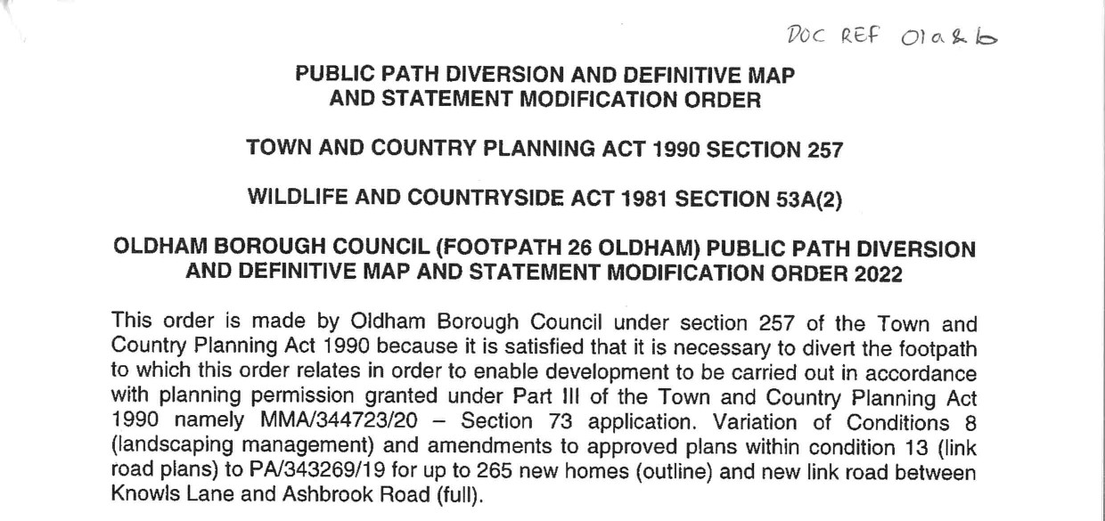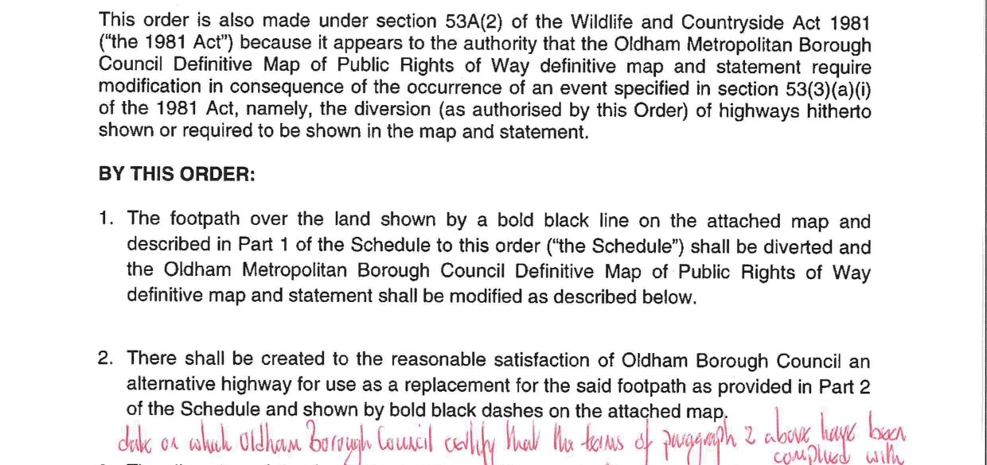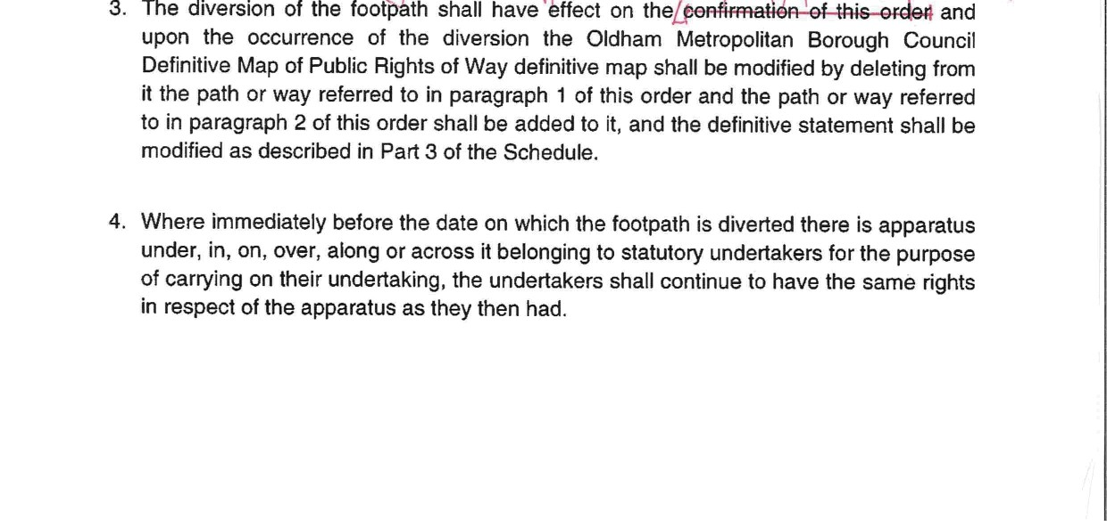
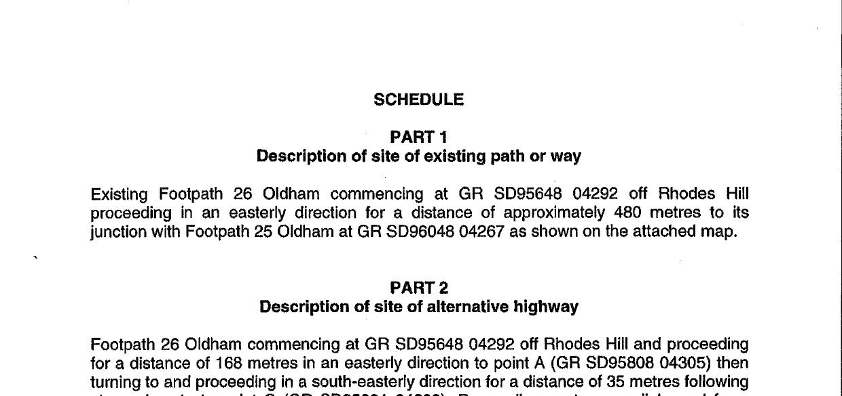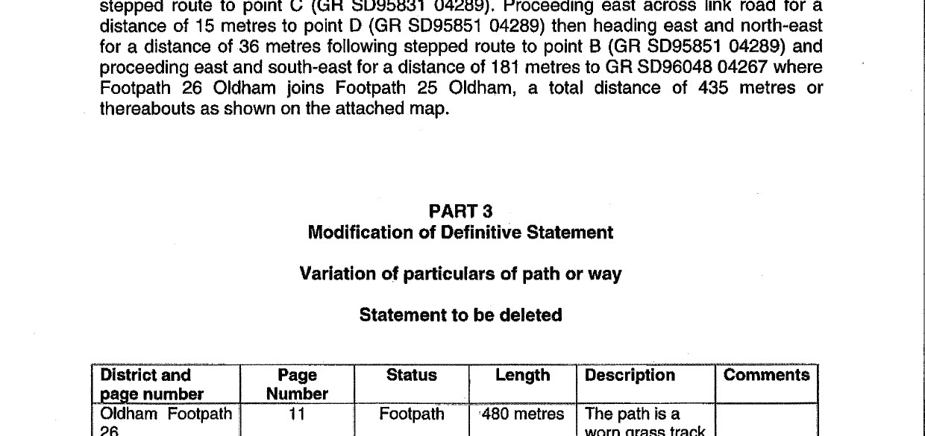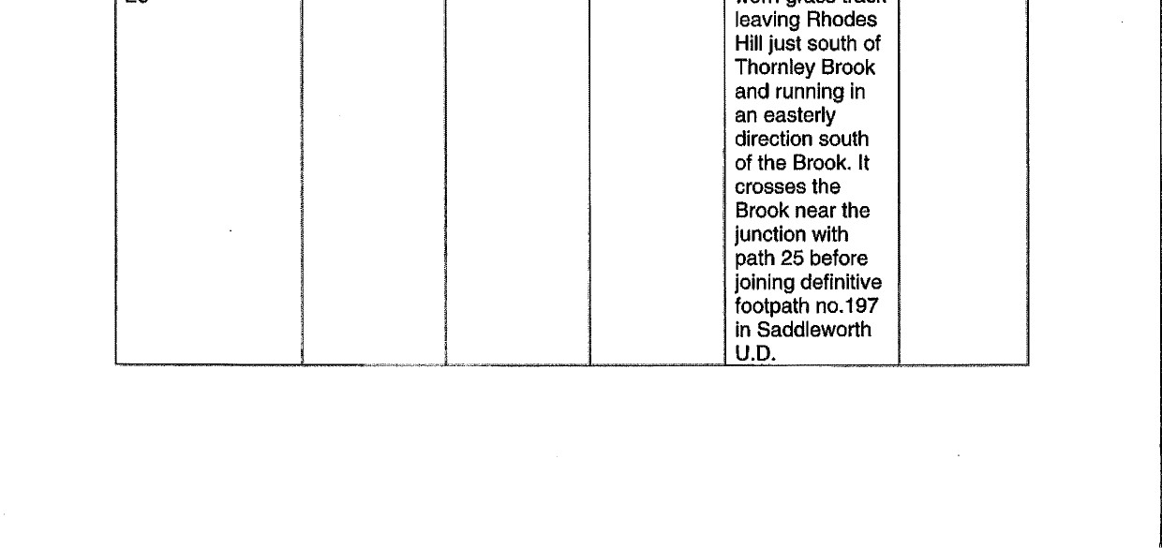
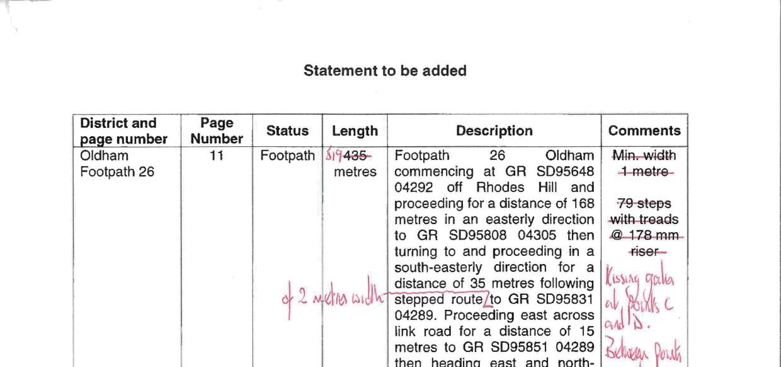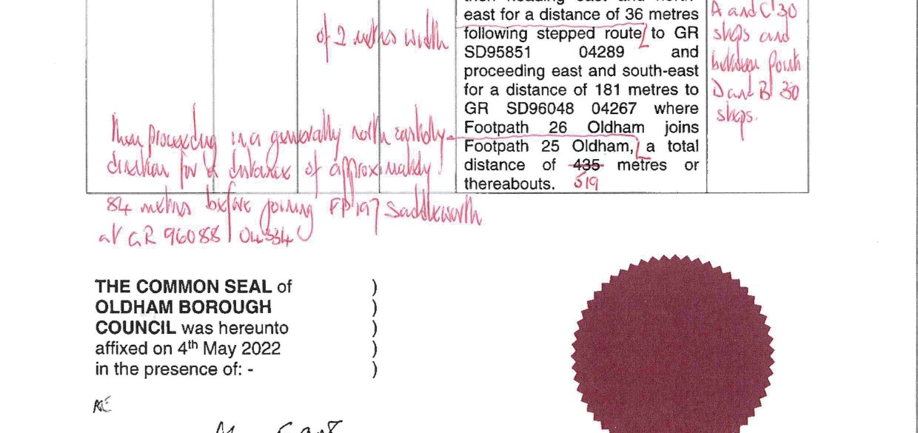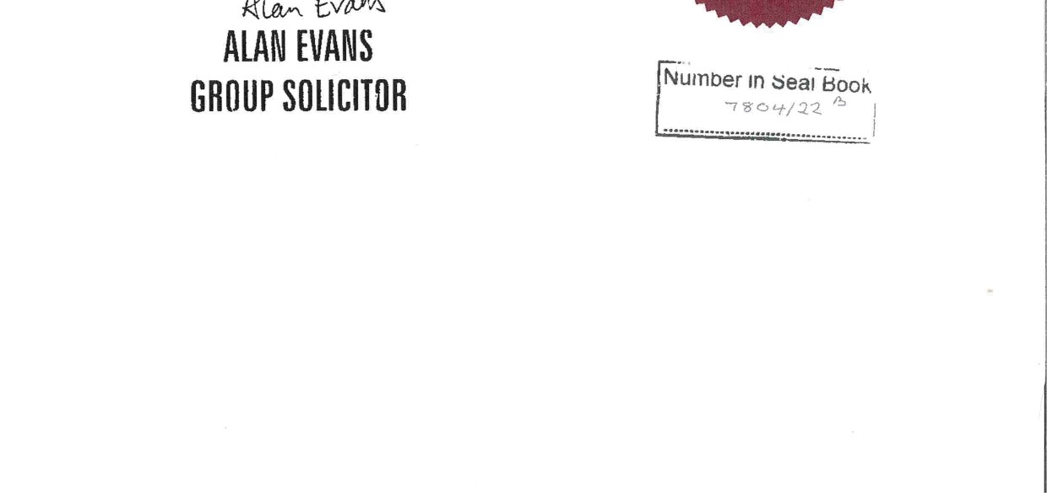
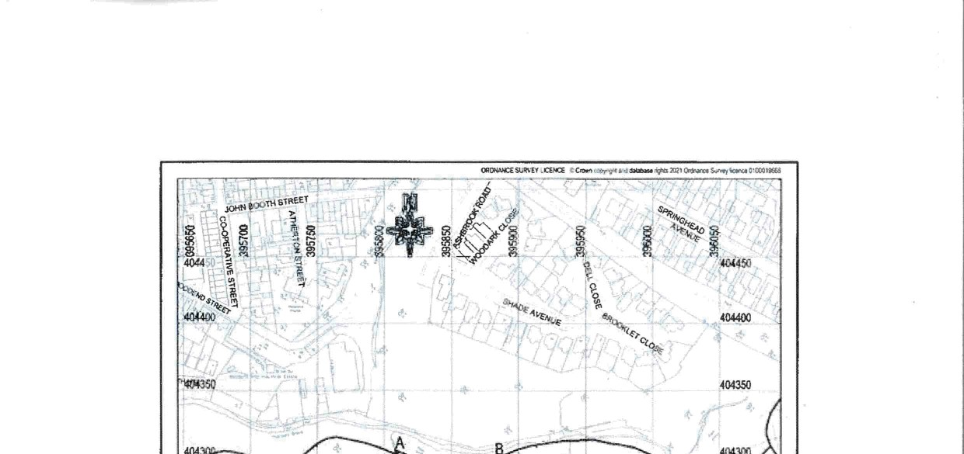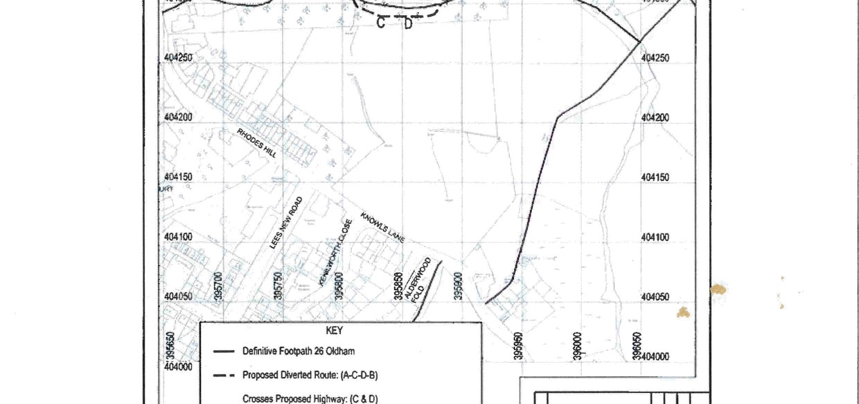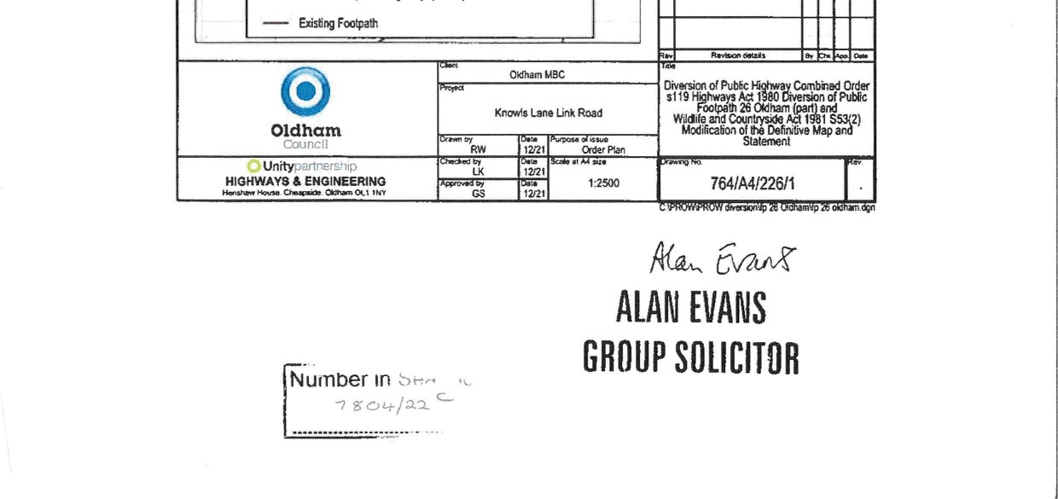

If you wish to make a legal submission, this should be submitted at the same time as your statement of case. Otherwise legal submissions will have to be submitted in writing on the day of the inquiry.

