

Application Decision
Hearing held on 9 September 2025
by D M Young JP BSc (Hons) MA MRTPI MIHE
An Inspector appointed by the Secretary of State for Environment Food and Rural Affairs
Decision date: 10 November 2025

Application Ref: COM/3363391 Hayle Towans
Register Unit: CL676 (Original provisional registration number)
Registration Authority: Cornwall Council
- The application, dated 30 December 2020 is made under Schedule 2 paragraph 4 of
the Commons Act 2006.
- The application is made by the Dr V Nicholson
- The application is to register waste land of a manor as common land in the register of common land.

Decision
- The application is refused.

Preliminary Matters
- I held a hearing at Cambourne Rugby Club on 9 September 2025. In addition to the applicant’s representative (Mr Tomas Hill), five objectors appeared at the hearing. Stephen Whale of Counsel represented Sennybridge (Hayle) Ltd, Rob Jefferies for Riviere Towans Chalet Camp Management Ltd (RTCCMC), Gary Cartmell and Ged Egan both local residents. Representatives of Cornwall Council (the Common Registration Authority (CRA)) also attended but took a neutral position.
- I carried out an unaccompanied site visit prior to the hearing on 8 September. This was supplemented by a formal site visit on 12 September where I was accompanied by a representative of Sennybridge, RTCCMC and the applicant.

The Application Land
- As originally submitted, the application land comprised the entirety of the provisionally registered land being approximately 54.339 hectares of land at Hayle Towans, south of the mean high-water mark in St Ives Bay, east of the mean high-water mark at the mouth of the River Hayle Estuary and south-west of Common Towans (see Appendix A).
- Following consideration of the original objections and in agreement with the CRA, the applicant submitted an amended plan (see Appendix B). This removed significant areas of land from the application (see uncoloured and hatched areas on the amended plan). The remaining application land comprises areas of sand dunes and cliffs traversed by the Coastal Path in addition to a number of areas within and adjacent to the Riviere Towans Chalet Camp.
- At the hearing it became apparent that the amended plan contained some drafting errors which had led to duplication of some areas of land with the River Hayle Estuary and Beaches application (COM/3363395). In order to rectify the matter, it was agreed between the parties that where overlaps exist (see the hatched areas on the plan at Appendix C) the land will be treated as part of the Hayle Estuary and Beaches application.

Main Issues
- The main issue is whether the land was waste land of a manor, at the date of the application on 31 December 2020, and whether before 1 October 2008:
- the land was provisionally registered as common land under section 4 of the Commons Registration Act 1965 (the 1965 Act);
- an objection was made in relation to the provisional registration; and
- the provisional registration was cancelled in the circumstances specified in sub-paragraphs (3), (4) or (5) of the Commons Act 2006 (the 2006 Act).
- Sub-paragraph (5), on which the applicant relies, requires the person who made the application for the provisional registration to request or agree to its cancellation (whether before or after its referral to a Commons Commissioner).
- The onus of proving the case in support of the correction of the register rests with the person making the application and it is for the applicant to adduce sufficient evidence to merit granting the application. The burden of proof is the normal civil standard, namely, the balance of probabilities.

Reasons

The requirements of paragraph 4 of Schedule 2
- The application land was provisionally registered as common land under the 1965 Act pursuant to application ref: 1934 made by Mebyon Kernow (Hayle Branch) on 18 December 1969. A number of objections disputing that the land was common land were made to the application (see appendix ii to the applicant’s Statement of Case (SoC)). In all cases the grounds of objection were that part of the land was not common land at the date of registration. It should be noted that the 1969 application included the adjacent Common Towans. This land does not form any part of the current application.
- The Register Sheet for CL676 (Appendix iii to the applicant’s SoC) states that the registration had been cancelled in consequence of the objections and that “the land involved in the registration has been removed from the register pursuant to an application dated the 27th June, 1973 made by Mebyon Kernow”.
- In consequence of the above, the application did not proceed to a Hearing. Sennybridge Ltd allege that the application is procedurally invalid on the basis that there is no evidence that the registration was cancelled at the request of the applicant as required by paragraph 5 of Schedule 2 of the 2006 Act. In response the applicant pointed out that the wording used on the Register Sheets is the same in all Commons cases across Cornwall and hitherto no concerns have been raised by the CRA or the Planning Inspectorate with regards the validity of this or other applications.
- I accept the wording on the Register Sheets maybe similar, or the same, as that used in other recent registration cases in Cornwall. However, the CRA confirmed at the Hearing that the substantive arguments raised by Sennybridge were new and to their knowledge had not been raised in any of the other cases. To that end, I am not persuaded that other decisions in the county are of much assistance.
- In my view, the words “cancelled in consequence of the objections” leaves little doubt as to why the original registration was cancelled. The next question is whether those words can be reasonably interpreted as meaning cancelled “at request of the applicant”. Having carefully considered the matter, I consider that the requirements of paragraph 5 of Schedule 2 of the 2006 Act are clear and specific and do not convey the kind of flexibility suggested by the applicant.
- While the applicant may well disagree, the interpretation of paragraph 5 of Schedule 2 would be a matter for the Courts rather than an Inspector. My role is therefore solely to determine whether the application accords or not with the requirements of paragraph 5 of Schedule 2 of the 2006 Act. In light of the wording used on the Register Sheet, I consider the applicant has failed to make out its case that the original application was “cancelled at the request” of Mebyon Kernow.
- In light of the circumstances set out above, it has not been demonstrated on the balance of probabilities that the application land is eligible for re-registration under paragraph 4(5) of Schedule 2 of the 2006 Act.

Conclusion
- Having regard to all other matters raised at the Hearing and in the written representations, I conclude that the application land does not fulfil the necessary criteria for registration. Consequently, the application is refused.

D M Young

INSPECTOR

Appendix A

Original Plan

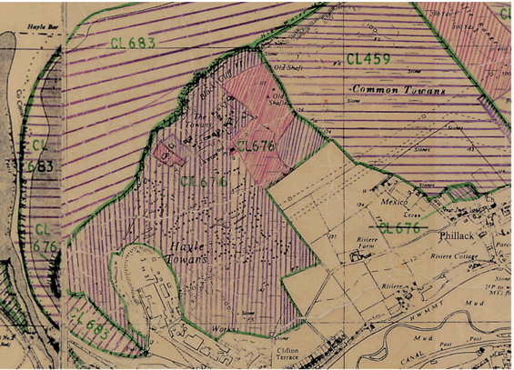

Appendix B

Amended Plan

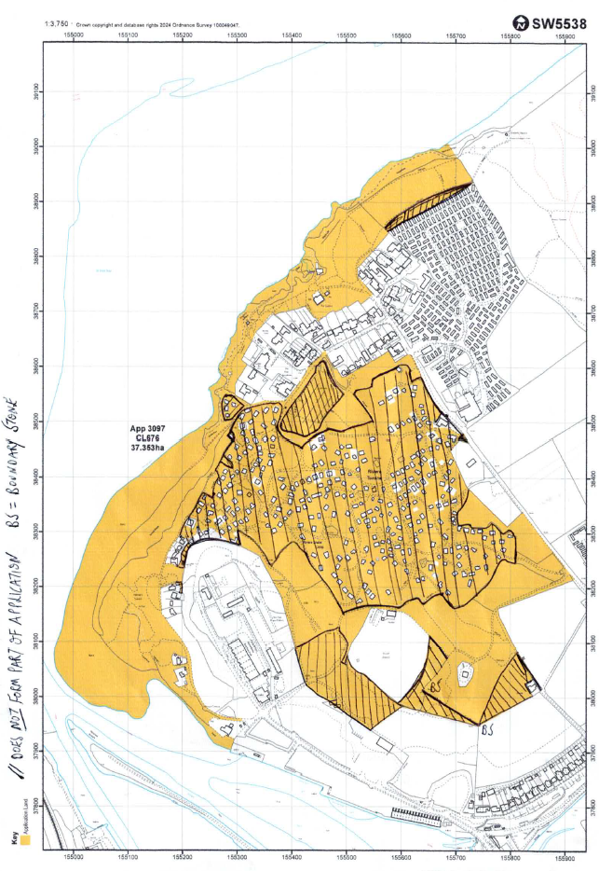

Appendix C

Plan showing areas of overlap with the River Hayle Estuary and Beaches application

