

Application Decision
by Harry Wood
Appointed by the Secretary of State for Environment, Food and Rural Affairs
Decision date: 30 October 2025

Application Ref: COM/3364872
Murton Fell Common, Cumbria
Register Unit Number: CL26
Commons Registration Authority: Westmorland and Furness Council

- The application, dated 24 April 2025, is made under Section 38 of the Commons Act 2006 (the 2006 Act) for consent to carry out restricted works on common land.
- The application is made by the Murton Fell, Hilton Fell & Burton Fell Graziers Association.
- The works comprise:
- two temporary fences measuring approximately 2655m and 380m long and each will be 1.2m high, enclosing 23.37ha and 1.92ha respectively
- eleven kissing gates along the lengths of the fences.

Decision
- Consent is granted for the works in accordance with the application dated 24 April 2025 and the plans submitted with it subject to the following conditions:
- the works shall begin no later than three years from the date of this decision;
REASON: To provide certainty to users of Murton Fell Common.
- the land shall be fully reinstated within one month from the completion of the works (note that this does not apply to any physical changes or permanent features introduced as part of the works for which consent is granted);
REASON: To retain access for commoners, public and livestock across Murton Fell Common
- the fencing and associated structures shall be removed and the Common re-instated no later than 20 years from the date of this decision
REASON: To assess the need/requirement for the fencing to be retained or removed.
- For the purposes of identification only the location of the works is shown in red on the attached plans.

Preliminary Matters
- I have had regard to Defra’s Common Land Consents Policy Guidance (November 2015) in determining this application under section 38, which has been published for the guidance of both the Planning Inspectorate and applicants. However, every application will be considered on its merits and a determination will depart from the guidance if it appears appropriate to do so. In such cases, the decision will explain why it has departed from the guidance.

- This application has been determined solely on the basis of written evidence. I have taken account of the representations made by the Open Spaces Society (OSS), Natural England (NE), Historic England (HE), Friends of the Lake District (FLD) and Westmorland & Furnes Council.

- I am required by section 39 of the 2006 Act to have regard to the following in determining this application:
- the interests of persons having rights in relation to, or occupying, the land (and in particular persons exercising rights of common over it);
- the interests of the neighbourhood;
- the public interest; Section 39(2) of the 2006 Act provides that the public interest includes the public interest in; nature conservation; the conservation of the landscape; the protection of public rights of access to any area of land; and the protection of archaeological remains and features of historic interest;
- any other matter considered to be relevant.

Reasons

- The applicant explains that the fencing is required to create two grazing exclosures in which native shrubs and trees will be planted to provide winter habitat for black grouse, which is part of the Appleby Fells SSSI interest in this area for the breeding birds.

The interests of those occupying or having rights over the land
- The Ministry of Defence (MOD) are the owners of the land. It is understood that the applicant will acquire any necessary permissions required to carry out works on MOD land. The common land register records no rights over the whole of the common land at Murton Fell Common. It is understood that the land is leased by the MOD for the purpose of grazing.

- I am satisfied that the applicant has carried out the required consultation and no further comments were received, and the planned works would not interfere with the interest of those occupying or having rights over the land.
The interests of the neighbourhood and public access
- The interests of the neighbourhood relate to whether the works will unacceptably interfere with the way the common land is used by local people and is closely linked with interests of public access.

- Murton Fell Common is a large area of open moorland adjacent to Murton village. I believe the Common is an active space for open air recreational activities for the public, especially for walking/hiking. Murton Fell Common is also part of an area of high landscape value.

- The addition of temporary fencing to the Common would add new barriers to the Common, affecting people’s ability to access and cross it. It is also noted that there is a public footpath across this area of the Common.

- In order to mitigate the impact this fencing will have to the Common the applicant has outlined their plan to add 11 gates at points across the two new fences. A number of these gates will be across the public footpath to allow for access to continue.

- A Country Access Officer on behalf of Westmorland and Furness Council has outlined that they have no objection to the proposal and that gates are being installed where the fence crosses with “public footpath 349033”. There are also a number of additional gates planned to be added to fences off the footpath to allow for access across the Common.

- When considering the above comments, on balance, I do not believe the addition of the fences as outlined in this application will add an unacceptable impediment to people’s access to and across the Common.

- NE have been consulted on the application and stated that the new fence lines will inevitably affect the ability of people to roam freely across the Common and introduce to some degree a sense of restriction in an otherwise open landscape. However, access is still possible through the provision of gates at appropriate points as set out in the application. Overall, they are supportive of the proposal.

- OSS have highlighted that Murton Pike is an area of interest to walkers, and it has multiple routes of access in and around the application area. Some of these routes may be within the proposed areas of exclosure, and if so, there could be a significant landscape and access issue.

- In response the applicant has stated that there is a clear desire line crossing the western end of the Murton Crag exclosure and kissing gates have been placed at either end of this to allow people to continue to use it.

- The FLD have raised concerns that the current levels of public access could be compromised by the introduction of the fences as well as the open character of the landscape. This is particularly important here because the area is adjacent to Warcop Training Area where access is restricted. They request that any explanatory signage at the site also includes the open access symbol.

- In response the applicant has outlined that they have endeavoured to ensure that all currently used routes will still be available to walkers through the provision of gates and they are happy to add an open access symbol to the signage.

- They are also agreeable to increase the no planting buffer zone along paths and walking routes explaining that it is not the intention to plant the whole of the exclosures with the planting being open in nature.

- On concerns of the openness of the landscape the applicant has outlined that wherever possible the Murton Crag fence will be kept more than 2m from the public bridleway. However, the steepness of the ground in some places means that to provide an effective barrier to sheep the fence will have to be brought up to within 2m of the track edge. This should only be for short sections of the fence.

- The FLD in general were happy with the applicant’s response however, they still had concerns that in order “to provide an effective barrier to sheep, the fence will have to be brought up to within 2m of the track edge”. In response the applicant outlined that the height of the section of fence running alongside the track will be raised to 1.4m and wherever possible will be kept approximately 5m from the track were this is viable.

- The applicant has considered the use of GPS collars as an alternative to fencing. They argue that currently the technology is not suitable for sheep. Furthermore, the costs are estimated at £199 each, which for a total flock of 530 sheep would be more than £100,000. There are also ongoing running costs on top of this so it is not viewed as a viable option.

- In this case it is clear that the introduction of fences onto the Common will introduce barriers to peoples access on to and across the Common as well as affect the open nature of the landscape. I have considered the comments of the representation parties above and the applicant, and although concede that the openness of the Common would be affected here, I do not believe the fences as planned would introduce an unacceptable impediment to people’s abilities to access or cross the Common.

- The planned access points will allow for access to areas across the Common and are also located so that the public footpath across the Common can continue to be used. I also do not believe the planned works would seriously interfere with the way the Common is currently used by members of the public and overall would not impact the recreational value of the Common.

The public interest
- As well as having regard to the public interest in the protection of public rights of access, I must also have regard to the public interest in nature conservation, the conservation of the landscape and the protection of archaeological remains and features of historic interest.

Nature conservation and conservation of the landscape
- The proposed works within this application are intended to be temporary in nature and the applicant has requested that the fencing be granted consent for a period of 20 years.

- NE has supported this plan, outlining that in exposed areas of upland fell such as this a relatively significant period of consent will be needed. This will ensure that trees and scrub can become established and subsequently protected from damage by grazing stock once the fencing is removed.

- The OSS and FLD were opposed to a 20-year period with the OSS stating that in their view a 15-year period would be suitable.

- The applicant outlined that the reason for applying for a 20-year permission is to remove the need to renew the permission once it has expired. It has been noted that it is common for fencing permissions on common land which are 10 or 15 years in length often end up having to be renewed. They confirm that there will be regular checks on the condition of the fencing and that monies will be held back to cover the costs of repairs.

- The Common land consent policy outlines that where fencing is concerned the aims of the proposal should be achievable within its time frame. From the information provided to me by NE, a 20-year period appears the more suitable option here to fully allow the planted trees and shrub to be established before the fencing is removed.

- The applicant has outlined the plan to remove the fencing after the period of 20 years and this can be secured by attaching the appropriate condition to this effect.

Visual impact on the landscape

- The addition of new fencing on the Common will introduce new artificial features onto the Common. This would have a negative impact on the visual qualities of the Common, where there are currently few artificial features. The visual impact of the fencing will be mitigated by the use of wooden posts which are in keeping with the natural surroundings. The height of the fences is also planned to be 1.2m high where possible (with some small sections being 2m) to mitigate the impact on sightlines across the Common.

- NE have stated that overall, the temporary loss of visual amenity for people using the public right of way that cross the Common will be compensated by the creation and extension of a diverse range of habitats, connecting previous planting along Trundale and Murton Beck and slowing the flow of water off the Fell.

- The FLD have outlined that they agree that tree cover is low across the North Pennines as a whole and this project will encourage a more structurally diverse transition into moorland habitat, by developing a structurally richer and more biodiverse fringe of scrub. However, there is likely to be a significant visual impact from the tree guards and they request that the tree guards are regularly checked, along with the actual saplings.

- The FLD continue that they are pleased that the fencing appears to avoid skylines and uses “dips and hollows” to reduce its impact but are concerned about its impact on the character of the Common.

- In response the applicant has outlined that they acknowledge the FLD’s points on the potential for the fences to create visual differences between the fenced and unfenced land. Initially at least this will come from the development of tall potentially tussocky grassland within the exclosures and the buildup of plant litter due to the lack of grazing. This is likely to be most prominent in winter, when the exclosures will be paler than the surrounding grazed land, with a sharp edge. In the summer the visual impact will be much reduced as the green of the new grass will obscure the litter.

- However, they conclude that once the fences are removed, grazing will rapidly soften these sharp edges and within a few years they will entirely blend into the landscape of the surrounding fellside. They suggest that this is in line with the North Pennines National Landscape Management Plan aim to structurally diversify the moorland edge. This management plans aim is likely unattainable without some temporary fencing on the moorland edge.

- Overall, I am of the view that the visual impact that the introduction of the new fencing will have on the Common is outweighed by the conservation benefits that would be introduced as part of the planned works.

Landscape designations

- The land relating to this application sits within the Appleby Fells SSSI, the North Pennines National Landscape and SPA and the Moor House SAC. Additionally, the River Eden and Tributaries SSSI & SAC are down stream of this area.

- The Planning Inspectorate, in making a decision, on behalf of the Secretary of State on the consent of the works under section 38, is acting as an authority under paragraph (3) of section 28G of the Wildlife and Countryside Act 1981. Under section 28I of the Wildlife and Countryside Act a s28G the authority must give notice to Natural England before permitting the carrying out of operations likely to affect these sites.

- NE have provided their advice in this matter and outlined that the NE advisor responsible for Appleby Fells SSSI has been closely involved with the development of the proposals, which have been designed to enhance the condition of the features of interest of the SSSI.

- NE advises that there are small areas of base-rich flushes within the larger proposed enclosure, and exclusion of livestock will enhance flowering and seed-set within these habitats. In addition, remnant dwarf shrubs within the sward are likely to flourish, increasing the area of dry heath habitat, and improving habitat structure and condition for breeding birds. Black grouse, which forms part of the breeding bird assemblage, and a red-list species of particular conservation significance within the North Pennines, is likely to particularly benefit from such changes. Increased scrub cover also enhances winter survival for Black grouse. This location does not include or overlook habitat favoured by breeding waders, and therefore there are unlikely to be adverse impacts on these species arising from the proposals.

- The River Eden and Tributaries SSSI and SAC is downstream of the proposals. There may a beneficial effect on the site, by increasing bankside habitat structure and diversity upstream.

- NE has undertaken a Habitats Regulation Assessment (HRA) of the proposals and has concluded that there is unlikely to be a significant effect on the features of interest of the above designated landscapes.

Protection of archaeological remains and features of historic interest.
- HE has been consulted on the application and commented that they do not see any reason to suspect that any non-designated nationally important archaeological sites would be impacted by the scheme. They have no objection to the granting of consent for the proposed works under section 38 of the Commons Act 2006.

- There is no evidence before me to suggest that these interests will be harmed by the proposed works.

Conclusion

- In this case I conclude that the works will have an impact on the landscape character of the Common. However, the applicant has taken steps to mitigate the impact where able. Additionally, the use of the fences within the application are necessary to deliver a plan that is likely to have long term conservation and environmental benefits for the Common. The negative impacts of the works will also be mitigated once the fencing is removed. I do not consider that the works will introduce an unacceptable barrier to public access to the Common or seriously affect its recreational value, and the works will not seriously harm the other interests set out in paragraph 5 above. Consent for the works is therefore granted subject to the conditions set out at paragraph 1 above.

Harry Wood

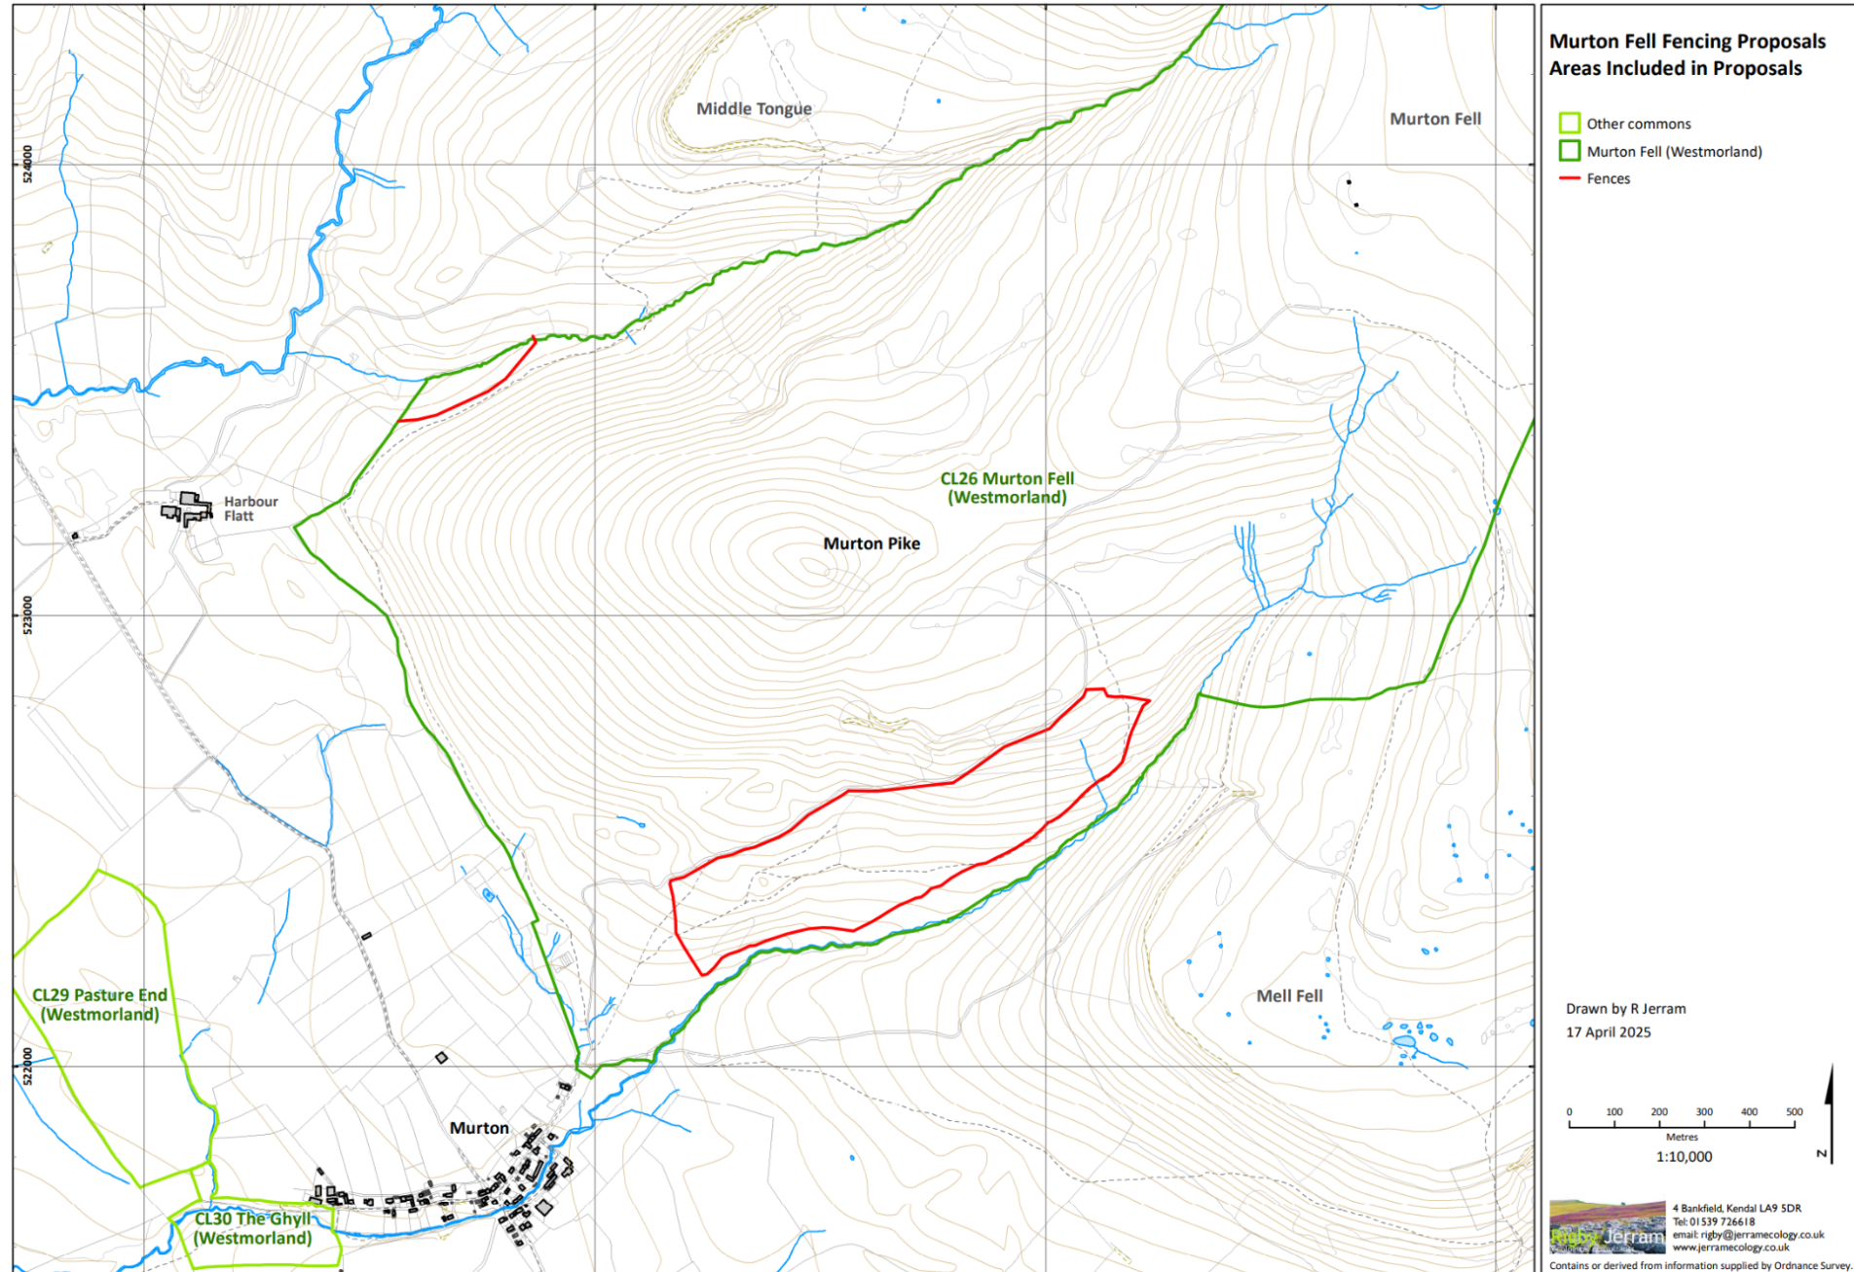
Plan 1 – Location of works on the Common

