Lucas Milligan, Runner-up
Question 3: Only one-third of places in undergraduate economics programmes in the UK are taken up by women. But women who choose to study economics are more likely to achieve a 2:1 (or above) in their undergraduate degree compared to male students from the same socio-economic background and ethnicity. Why are women disproportionally not choosing the economic profession and how can academic institutions and governments reduce the barriers to participation?
Dear Foreign Secretary,

The gender gap in economics is a market failure in talent allocation. Female undergraduates (in economics) are more likely to be awarded a ‘good degree’ (2:1 or above) than male students from the same socio-economic background and ethnicity (Cesilia Sinur, 2023), yet comprise just 27% of economics undergraduates and 15% of UK professors (University of Cambridge, 2021). This letter draws on identity economics, signalling theory, and institutional design to explain under-representation. It proposes two main interventions: Tradable Talent Allocation Bonds (TABs) to reward structural change and AI-powered mentorship platforms to break down cultural barriers.
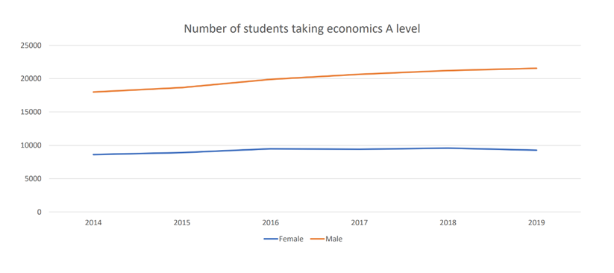
The roots of the gender gap lie in institutional inertia, asymmetric information and misaligned incentives, not individual choice. Economics is often perceived as abstract, male-dominated, and disconnected from social relevance and impact, a view that discourages female students who might otherwise thrive. Figure 1, “Number of Students taking economics A level”, shows a stagnating trend for girls studying A level economics compared to a steady increase for boys (Psyllou. M, 2024). According to
Figure 1: Number of students taking economics A level, 2014-2019 (Psyllou.M, 2024)
identity economics (Akerlof & Kranton, 2000), such stereotypes shape self-perception and deter talented individuals from entry. When girls internalise the notion that economists are “competitive individualists”, they self-select out, even when academically capable. Additionally, research has shown girls often place “contributing to society”, “the environment”, and “the opportunity to care for others” (Britner, 2008) as key motivations for choosing their subject to study, therefore making a rebranding for economics as a discipline championing social impact a crucial step in attracting more young women towards economics.
One approach could be training teachers to highlight economics’ impact on issues such as climate change and social justice, policy areas that young women are significantly more likely to identify with (UCL, 2024; Plan International UK, 2024). Mandating the inclusion of these topics and areas like gender-responsive case studies, such as Iceland’s parental leave policy, which resulted in the unadjusted gender pay gap narrowing from 17.5% in 2010 to 12.6% in 2020 (Arnalds, Eydal and Gíslason, 2022), within the GCSE or A level syllabi would realign perceptions early. These curriculum nudges can shift entrenched assumptions without imposing heavy bureaucratic costs. By correcting information gaps early, they help prevent girls from backing out of economics before their potential is realised.
The first major initiative I propose is Tradable Talent Allocation Bonds (TABs), which are market-based incentives designed to rewire institutional behaviour. Institutions that boost female participation in economics by at least 10% annually would earn allocation bonds, representing tradable credits of government funding. Institutions exceeding their targets could sell surplus bonds to those that fall short, creating a dynamic secondary market, similar to Tradable Pollution Permits. This mechanism draws from principal-agent theory, aligning the incentives of education providers (agents) with social goals of increasing inclusivity (principals). By rewarding verified outcomes including enrolment rates, degree completion, and graduate placement, the scheme reduces the risk of performative compliance while preserving institutional autonomy. Moreover, funding would be conditional, with bonds only redeemable after independent audits verify that targets were achieved without grade inflation or quality erosion. If institutions regress, the government could withdraw funding, embedding a strong incentive for genuine reform.
The current labour market fails, as it underprovides female economists due to the mismatch between private benefits (e.g. wages) and social benefits (e.g. improved policy design, institutional legitimacy), making this Pigouvian subsidy an effective way of internalising the positive externalities associated with greater female participation in economics.
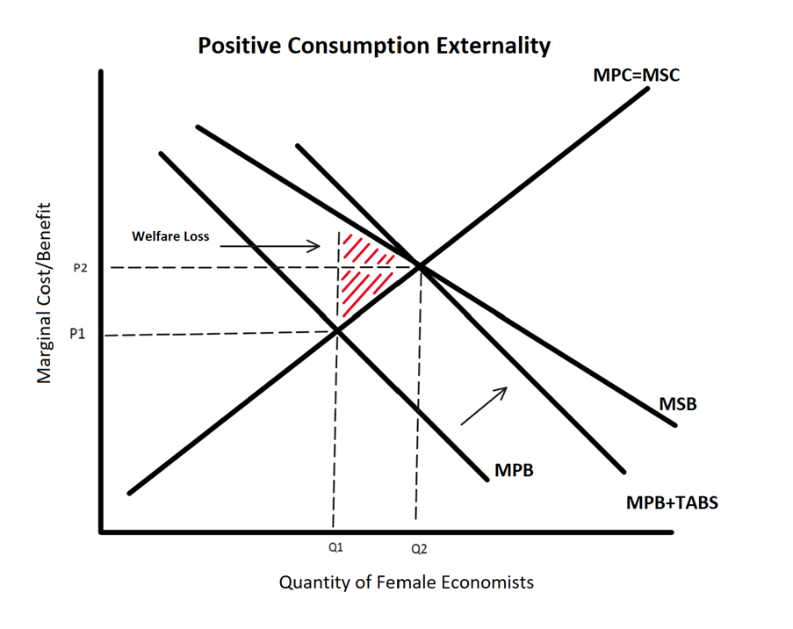

By subsidising the institutions that bridge this gap, TABS effectively shift incentives closer to the socially efficient quantity of female talent in the profession. Additionally, the tradable design introduces allocative efficiency, correcting the labour market failure using a decentralised, incentive-compatible mechanism.
Critics may argue that TABs could favour already-advantaged institutions or result in superficial compliance. However, tying bond eligibility not only to enrolment rates but also to post-graduate outcomes (such as placement rates in internships and further study) would create safeguards against tokenistic behaviour.
Moreover, a complementary policy, the HER Hub AI mentorship platform, should be piloted. This platform would match female economics students of all ages with leading economists for monthly virtual mentoring sessions, providing a female role model for students to look up to. Machine learning algorithms would ensure matches are based on academic interests, further boosting persistence and ambition. Game theory teaches us that in repeated interactions, positive reinforcement raises cooperation and participation. Additionally, by linking participation in HER Hub to outcomes measured under the TABS scheme, an environment of engagement could be fostered and reinforced. HER Hub offers a modern, tech-driven solution to a historic problem, appealing to curious students and altruistic mentors alike.
Though not all students may have digital access, HER Hub can still support post-16 economics students by connecting them with motivated mentors. A lack of monetary incentive may also restrict long term commitment, however female economists often experience firsthand the problems with gender disparity in economics, making a decent proportion of them likely to offer their help continuously.
At its core, these initiatives are about inclusivity and impact. Economics’ undeserved reputation as disconnected from social concerns has discouraged many girls. Yet economics is, fundamentally, about how to make the world a better place. By reframing it as a vehicle for social change, we can make the subject resonate with young women who are otherwise excluded by outdated stereotypes. The Tradable Allocation Bonds initiative connects the government, institutions, and students, increasing incentives and making economics more supportive for female students. HER Hub builds social proof, role modelling, and personalised support for young women in economics. Together, these interventions address both the pipeline and the culture, not only expanding access but reshaping the experience of economics for the next generation. Empowering more women to become economists is not just a matter of fairness; it is also a smart investment in better policy, stronger institutions, and more resilient economies, making it a necessary step to advance the field of economics.
Yours Sincerely,
Lucas Milligan

Bibliography
Akerlof, G. and Kranton, R. (2000). QUARTERLY JOURNAL OF ECONOMICS ECONOMICS AND IDENTITY*. [online] Available at: https://www.brown.edu/Departments/Economics/Faculty/Glenn_Loury/louryhomepage/teaching/Ec%20237/Akerlof%20and%20Kranton%20(QJE)%202000.pdf
Arnalds, Á.A., Eydal, G.B. and Gíslason, I.V. (2022). Paid Parental Leave in Iceland. Successful Public Policy in the Nordic Countries, [online] pp.370–387. doi:https://doi.org/10.1093/oso/9780192856296.003.0018.
Britner, S.L. (2008). Motivation in high school science students: A comparison of gender differences in life, physical, and earth science classes. Journal of Research in Science Teaching, 45(8), pp.955–970. doi:https://doi.org/10.1002/tea.20249.
Cesilia Sinur (2023). Who Studies Economics? An Analysis of Diversity in the UK Economics Pipeline - Royal Economic Society. [online] Royal Economic Society. Available at: https://res.org.uk/who-studies-economics-an-analysis-of-diversity-in-the-uk-economics-pipeline/
Plan International UK. (2024). State of Girls Rights. [online] Available at: https://plan-uk.org/state-of-girls-rights.
Psyllou, M. (2024) Gender gaps in economics: Evidence and policy implications. Keynote lecture presented at the RES/LSE Conference, London, October 2024. Available at: https://res.org.uk/wp-content/uploads/2024/11/LSE-Keynote-Talk.pdf
UCL (2024). Girls more anxious about climate change than boys. [online] UCL News. Available at: https://www.ucl.ac.uk/news/2024/aug/girls-more-anxious-about-climate-change-boys.
University of Cambridge. (2021). Women economists underrepresented ‘at every level’ in UK academia – report. [online] Available at: https://www.cam.ac.uk/research/news/women-economists-underrepresented-at-every-level-in-uk-academia-report.

