**Examples of Groupings for Variations**

Version: 1 October 2025

This guidance document provides advice on grouping and bulking of changes to Marketing Authorisations with emphasis on purely national variations. Examples of acceptable and non-acceptable groupings are given as well as submission strategies. General information on grouping of variations can be found in the MHRA guidance on variations and the examples given here should be read in conjunction with that guidance published on the [MHRA](http://www.mhra.gov.uk/Howweregulate/Medicines/Licensingofmedicines/Marketingauthorisations/Variationstolicences/QualityAuditReportofNewTIANotifications/index.htm#2) website.

Guidance is also available on the EU Heads of Medicines Agencies website and EMA website:

[Heads of Medicines Agencies: Variation](https://www.hma.eu/human-medicines/cmdh/procedural-guidance/variation.html): <https://www.ema.europa.eu/en/documents/regulatory-procedural-guideline/european-medicines-agency-post-authorisation-procedural-advice-users-centralised-procedure_en.pdf>

It should be kept in mind that, unless the grouping follows an example published by [CMDh](http://www.hma.eu/fileadmin/dateien/Human_Medicines/CMD_h_/procedural_guidance/Variations/CMDh_173_2010_Rev10_2013_07_clean.pdf) or [MHRA](http://www.mhra.gov.uk/Howweregulate/Medicines/Licensingofmedicines/Marketingauthorisations/Variationstolicences/QualityAuditReportofNewTIANotifications/index.htm#2) or [EMA](https://www.ema.europa.eu/en/human-regulatory-overview/post-authorisation/variations-including-extensions-marketing-authorisations) or is listed in [Annex III](http://eur-lex.europa.eu/LexUriServ/LexUriServ.do?uri=OJ:L:2008:334:0007:0024:en:PDF) of Commission Regulation 1234/2008 (as amended) or is similar to a grouping request that was previously approved by the MHRA, acceptance of the proposed grouping requires prior approval via the Regulatory Information Service (RIS; [variationqueries@mhra.gov.uk](mailto:variationqueries@mhra.gov.uk)).

The template for submitting queries is published here: <https://assets.publishing.service.gov.uk/government/uploads/system/uploads/attachment_data/file/902296/grouping_template.doc>

In the majority of cases, MAHs are able to submit a grouped variation directly to the MHRA without the need for prior approval using the above published examples as justification. However, prior grouping approval should always be sought for complex cases or when a very large number of changes are submitted (greater than 15) or when the changes span multiple sections of the dossier.

The following examples may help further in identifying suitable scenarios in which changes to a Marketing Authorisation (MA) may be grouped. Unless indicated, prior approval is not required for the listed examples of acceptable groupings however the proposed grouping should be justified in the application by reference to the relevant example by providing this in the cover letter or the variation form.

Grouped variations attract grouped variation fees; see [here](https://www.gov.uk/government/publications/mhra-fees/current-mhra-fees#variations-licence-variations-applications-groups-fees) for current fee information and apply the MHRA [Application Fees Calculator](https://applicationfeescalculator.mhra.gov.uk/) to check the correct variation Type and fees have been applied.

Note: For the purposes of grouping variations, the definitions of a MA and MAH as stated in Commission Regulation 1234/2008 (as amended) are applicable. Grouped changes may be applied to more than one marketing authorisation where appropriate and a fee reduction applies for these so-called ‘bulk variations’.

MAH is defined in the variation form as: *Same applicant /marketing authorisation holder: as per the Commission Communication (98/C 299/03) (I.e. belonging to the same mother company or group of companies or which are “licencees”).*

Table of Contents

Examples of quality grouped variations2

Examples of clinical grouped variations6

Examples of grouping of Type IA changes only8

Examples of common non-approved groupings and alternative submission strategies9

Bulking of variations………………………………………………………………………..12

1. **Examples of quality grouped variations**

1.1 Grouping of similar (not identical) changes between different formulations/presentations/strengths, e.g.

* + 1. Grouped variation to extend the shelf-life to 48 months for two products of a MA which contain the same active substance in different presentations and currently have different shelf-lives (24 and 36 months) provided there is some overlap in the supporting stability data.

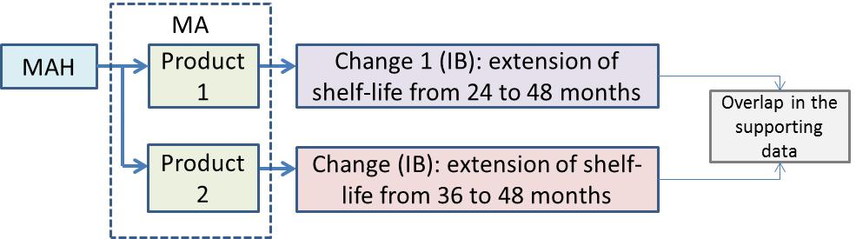

Grouped Type II where extrapolation is applied not in accordance with stability guidelines

1.2 Variation to the active substance and finished product sections, e.g.

1.2.1 Change of the manufacturing site of an active substance that is manufactured in-situ, i.e. as the finished product. Does not require prior RIS approval for grouping if they are clearly consequential but is not allowable if they are totally unrelated. This is in line with [CMDh examples of acceptable and not acceptable groupings](https://www.hma.eu/fileadmin/dateien/Human_Medicines/CMD_h_/procedural_guidance/Variations/CMDh_173_2010_Rev.23_2025_02_clean_-_Examples_for_groupings_for_MRP_DCP_MPs.pdf) *(“CMDh : The inclusion of changes to the active substance and finished product, unless they are totally related”).*

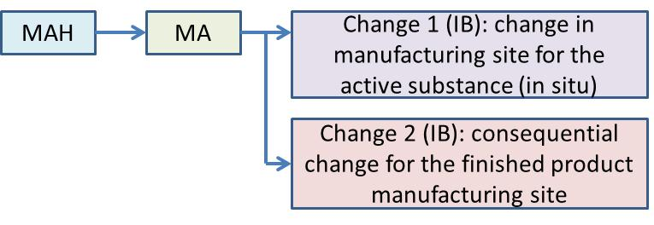

1.3 Changes to the Active Substance section (3.2.S), e.g.

1.3.1 The update of an Active Substance Master File (ASMF) and any consequential changes to the active substance and exceptionally, if relevant, finished product specifications may be grouped. The update – including changes of the open as well as the restricted part - can be submitted as a grouped variation according to the highest type of the single changes. This definition of grouping is in line with condition 5 of Annex III of the Variation Regulation; prior approval is therefore not required. In the example below the variation concerning minor updating of an ASMF would be submitted as a Type IB.

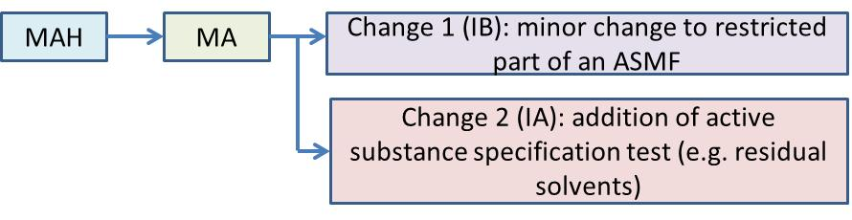

*Note: In case of substantial changes or significant or large number of changes in the updated version of the ASMF it is recommended to submit a single (rather than a grouped) variation of type II under category B.I.z.* This is in line with [CMDh examples of acceptable and not acceptable groupings](https://www.hma.eu/fileadmin/dateien/Human_Medicines/CMD_h_/procedural_guidance/Variations/CMDh_173_2010_Rev.23_2025_02_clean_-_Examples_for_groupings_for_MRP_DCP_MPs.pdf) *(Section 3: Acceptable as a single change instead of grouping)*

1.3.2 Submission of a new CEP that does not state a re-test period grouped with submission of additional stability data in support of the re-test period. This submission should be made as a Type IB.

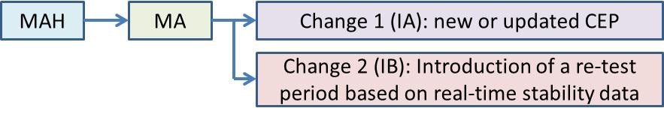

1.4 Changes to the Finished Product section (3.2.P), e.g.

1.4.1 Introduction of a new manufacturing site for the finished product grouped with other changes, e.g. in batch size, manufacturing process, including in-process controls, changes in site responsible for packaging (primary and secondary), batch release and quality control.

All these changes are regarded as belonging to the same project as described in Annex III of the Regulation *“All variations in the group relate to a project intended to improve the manufacturing process and the quality of the medicinal product concerned or its active substance”* and therefore do not require prior approval. This submission should be made as a single Type II under the category B.II.z. This is in line with [CMDh examples of acceptable and not acceptable groupings](https://www.hma.eu/fileadmin/dateien/Human_Medicines/CMD_h_/procedural_guidance/Variations/CMDh_173_2010_Rev.23_2025_02_clean_-_Examples_for_groupings_for_MRP_DCP_MPs.pdf) *(Section 3: Acceptable as a single change instead of grouping)*:.

*Note: If a site change results in a few changes to the dossier, a grouped Type IB variation is acceptable e.g..*

*Note: Prior dialogue with the MHRA is recommended if a site change results in:-*

* *a large number of changes to the dossier*
* *Other quality changes that might be related (but not directly consequential) to the site change e.g. changes to excipients packaging or specifications as described below. In this case a request for a Type II B.II.z. grouped variation should be submitted*

1.4.2 Replacement of the finished product manufacturing site and change of the active substance manufacturing site (supported by CEP and all data for the finished product is obtained using the new drug substance supplier). This grouping may be submission as a Type IB/II (as appropriate) – refer to above examples.

1.4.3 Addition of more than one pack size, where at least one of the proposed pack sizes is outside the range of currently approved pack sizes. This submission should be made as a grouped Type IB.

1.4.4 Changes to excipient specifications, parameters, tests or acceptance limits. Grouping of changes to more than one excipient is acceptable. This submission should be made as a Type II.

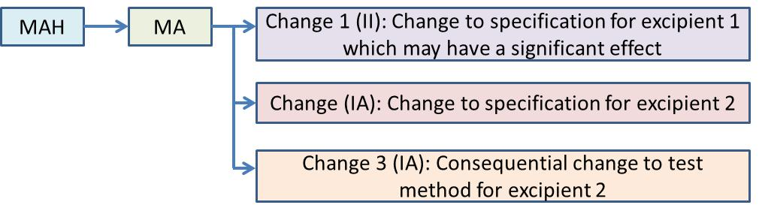

1.5 Other quality changes (3.2.S or 3.2.P), e.g.

1.5.1 Changes to multiple analytical methods within one specification, e.g. the finished product specification in example A below, or if the same method is applied to the drug substance and finished product (example B). This submission should be made as a grouped Type IB.

*Note: This should usually not be grouped with changes to manufacturing sites, see also comments above under 1.4.1, unless prior approval of the grouping has been agreed with the MHRA.*

Example A

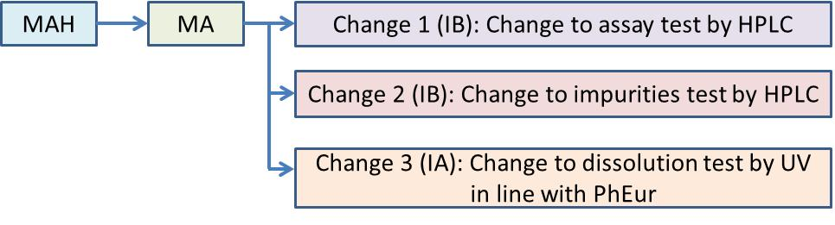

Example B

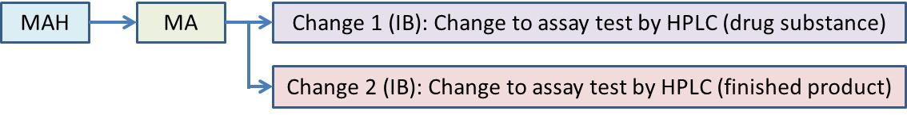

1.6 Including of product information changes with quality variations, e.g.

1.6.1 Label and leaflet changes that fall under the [self-certification scheme](https://www.gov.uk/government/publications/submitting-changes-to-labelling-and-patient-information-leaflets/submitting-changes-to-labelling-and-patient-information-leaflets#submissions-for-self-certification-notification) can be included with quality changes that affect the product information, e.g. change in storage condition. A separate self-certification submission is not necessary for the additional non-consequential changes which should be included in the variation form. This submission should be made as a Type IB.

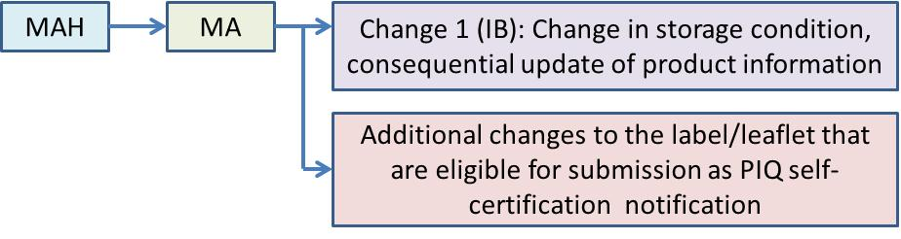

*Note: Self-certification notification changes may also be included with clinical variations (see under 2.4.3) but should not be included with quality/clinical changes that do not affect the label or leaflet.*

1.7 Product name changes, e.g.

1.7.1 Invented product name change can be grouped with minor changes to the product literature e.g. typographical changes or wording in line with the QRD template or introduction of an own label supplier which should be included in the variation form. This submission should be made as a Type IB.

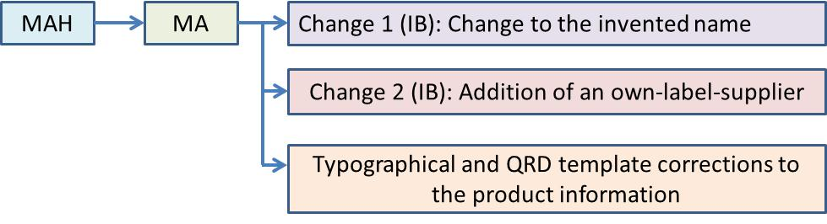

Note: if the change to the invented name is associated with major changes to the product literature, a separate Regulation 267 application should be submitted for evaluation of the mock-ups, however a CCC application is recommended (see 4.6.1).

1.7.2 A change in the product name in more than one MS of a MRP/DCP marketing authorisation can be submitted as a grouped application in case a different product name in each MS is proposed, since it falls under situation 4 listed in Annex III of the Variation Regulation (provided all variations in the group relate solely to changes of administrative nature to the SmPC, labelling and package leaflet). No prior approval is required.

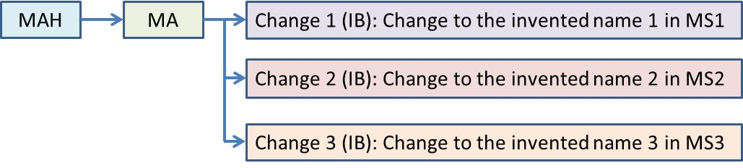

1. **Examples of clinical grouped variations**

2.1 Combined groupings arising from PSUR work-sharing or PRAC/CHMP recommendations are allowed as long as they do not lead to a delay in implementing a PRAC/CHMP decision, e.g.

* + 1. The SmPC is updated following PSUR and PRAC changes; does not require prior approval as in line with CMDh guidance.

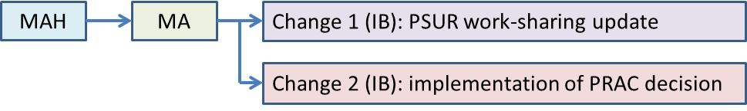

* + 1. The SmPC is updated following PRAC and also in line with the brand leader; does not require prior approval as in line with CMDh guidance.

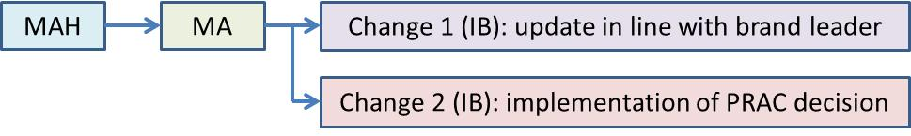

2.2 Update of the SmPC in line with an updated company core datasheet, e.g.

2.2.1 To update sections 4.4, 4.6, 4.8 and 4.9 of the SmPC, in line with an updated company core datasheet (CCDS). QRD and/or editorial changes have also been incorporated throughout the SmPC, leaflet and labelling and should be included in the application form. Does not require prior approval as in line with CMDh guidance if the changes are related and do not require separate supporting data sets; otherwise prior approval is required.

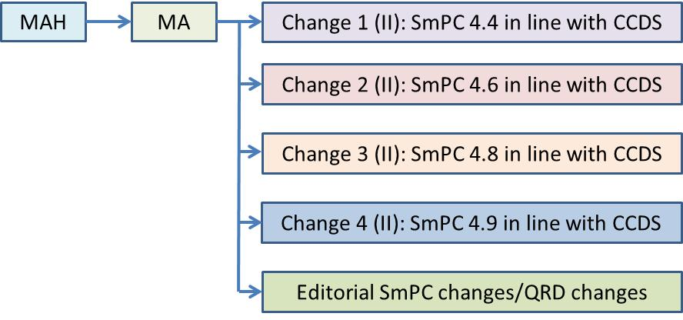

2.2.2 Multiple changes to section 4 in line with the CCDS and as a result of the same data package plus changes to section 5 which require no assessment (e.g. addition of ATC code, update in line with reference product or Martindale => IA or IB only). This submission should be made as a Type II.

*Note: changes to section 4.1 and 4.2 which are a result of separate/specific studies, even if incorporated into the CCDS, should be submitted as separate variation applications.*

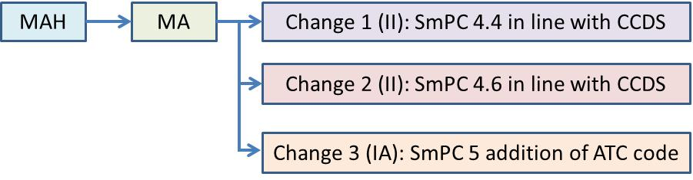

2.3 Update of the SmPC in line with an updated company core datasheet and following work-sharing, e.g.

2.3.1 The SmPC is updated following PSUR and a paediatric work-sharing procedure and sections 4.4 and 4.6 are updated in line with the CCDS. This submission should be made as a Type II.

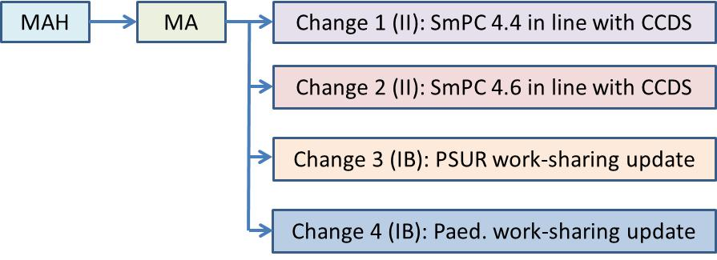

* 1. Other SmPC changes, e.g.

2.4.1 Minor/editorial changes to update the product information in line with the QRD template.

* + 1. Change in legal status (e.g. POM to P) including additional associated changes (e.g. posology, warnings, pack size) and non-consequential updates in line with the CCDS or brand-leader. This submission should be made as a Type II major.

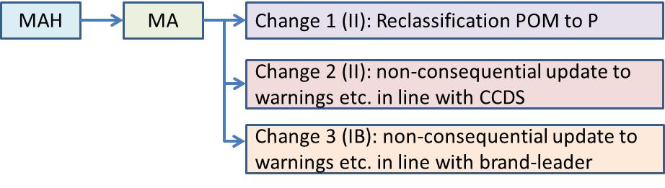

*Note: Changes in the legal status for products where an analogous product has already been reclassified would be submitted as a Type IB or Type II. See* [*here*](http://www.mhra.gov.uk/Howweregulate/Medicines/Licensingofmedicines/Legalstatusandreclassification/) *for further information on reclassification applications. Please note that a product licence can only have one legal status associated with it; if the MAH wished to keep the previous legal status another licence would be required.*

2.4.3 Label and leaflet changes that fall under the the [self-certification scheme](https://www.gov.uk/government/publications/submitting-changes-to-labelling-and-patient-information-leaflets/submitting-changes-to-labelling-and-patient-information-leaflets#submissions-for-self-certification-notification) can be included with clinical changes that affect the product information, e.g. update in line with the CCDS. A separate self-certification submission is not necessary for the additional non-consequential changes which should be included in the application form. This submission should be made as a Type II.

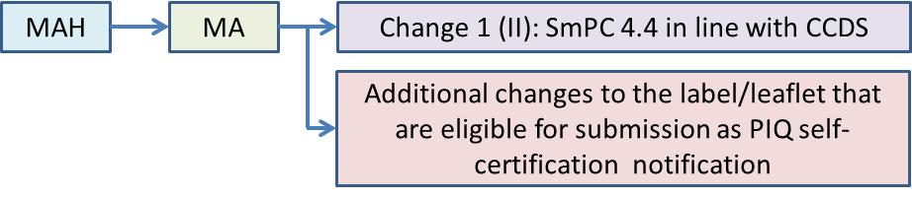

*Note: Self-certification notification changes may also be included with quality variations (see under 1.6.1) but should not be included with quality/clinical changes that do not affect the label or leaflet.*

1. **Examples of grouping of type 1A changes only**

**Note:** **Type IA variations which do not require immediate notification should be collected and submitted as a Type IA annual update, within 12 months after the oldest variation IA implementation date. There should be a single submission covering all minor variations of Type IA implemented during the period. The application should be submitted no earlier than 9 months and no later than 12 months after the first implementation date of the Type IA variation included in the annual update.**

3.1 Grouping of type IA variations only, e.g.

*Note: All minor notifications of type IA and type IAIN may be grouped in one application without any relation to each other, if the group includes only type IA and type IAIN. If a Type IA change is totally dependent on another type IB or Type II and cannot be independently implemented before submission, it should be grouped with the related variation.*

3.1.1 Multiple changes to the same MA, e.g. the deletion of a manufacturing site and tightening of specification limits. No prior approval is required.

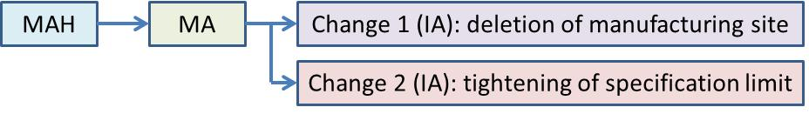

3.1.2 Identical change to multiple MAs from the same Marketing Authorisation Holder (MAH), e.g. change in the name and/or address of a manufacturer of the active substance. No prior approval is required.

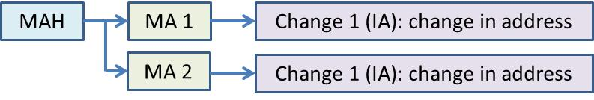

3.1.3 Identical changes to multiple MAs from the same MAH; e.g. deletion of a manufacturing site and tightening of specification limits. No prior approval is required.

*Note: The same set of type IA variations must be submitted for all MAs covered by the grouping. Supergrouping (where there is more than one RMS) may be applied for purely administrative changes and other changes that do not contain product-specific information. National and MR/DC procedures cannot be mixed.*

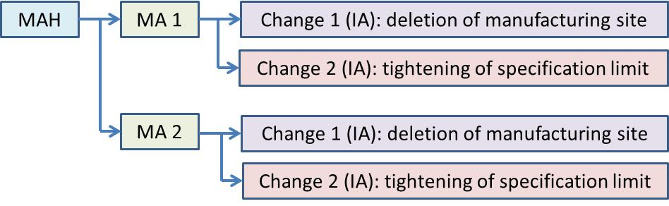

3.2 Introduction/update of a summary of the pharmacovigilance system and concurrent changes in the QPPV, e.g.

3.2.1 Introduction/update of a summary of the pharmacovigilance system and concurrent changes in the QPPV in several MA.

*Note: If the changes relate to one MA only they can be submitted as a single (rather than grouped) variation.*

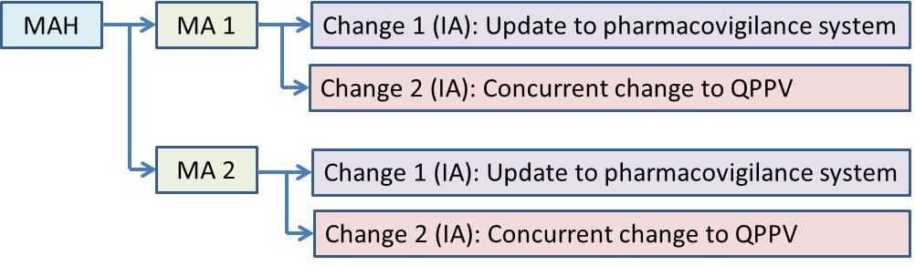

3.3 Variations following a union referral (Article 30 or 31(1) procedure), e.g.

3.3.1 If during the union referral (Article 30 or 31(1) procedure) not only the product information, but also Module 3 has been harmonised, a grouped application can be submitted.

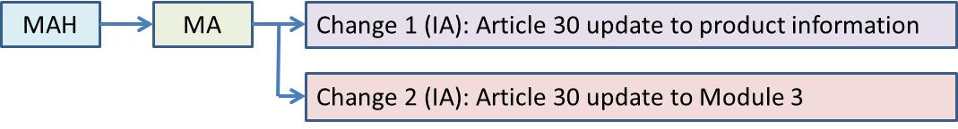

* 1. CEP updates with consequential changes, e.g.

3.4.1 New or updated CEP with consequential changes to the drug substance specification.

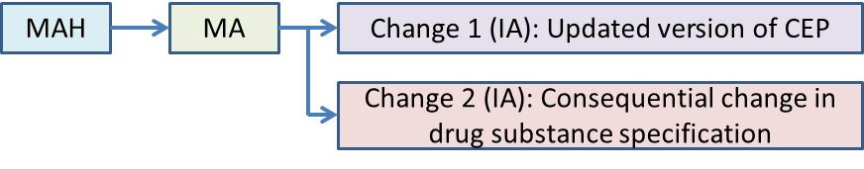

1. **Examples of common non-approved groupings and alternative submission strategies**

4.1 Insufficient information provided with the grouping request/submission, e.g.

4.1.1 No description and/or justification of the proposed grouping is provided in the grouping approval request template sent to RIS.

* The relevant information to decide on the suitability of the grouping proposal should be provided.

4.1.2 New (replacement) product manufacturer with new API manufacturer and other changes is rejected as per CMDh guidance where no (or insufficient) justification given.

* Ensure that grouped changes are in line with published guidance or sufficiently justified. The relevant information to decide on the suitability of the grouping proposal should be provided.
* Submission of a new/updated CEP (Type IA) for an active substance manufacturer may be grouped with the change to a finished product manufacturing site in line with example 1.4.2.

4.2 Grouping of similar (not identical) changes (between different formulations/presentations/strengths) if supported by distinct data sets, e.g.

* + 1. Replacement of the finished product manufacturing site and replacement of the active substance manufacturing site (supported by a new ASMF).
* These changes are unrelated and require separate variations.
  + 1. New (additional) product manufacturing site with changes to process and/or process controls that also apply to multiple already registered sites.
* The data requirements are complex and would require full justification and prior RIS approval.
  1. Unrelated changes to the SmPC, e.g.
     1. Mixed quality (section 1, 2, 3, 6) and clinical (Section 4, 5) updates to the SmPC, e.g. extension of shelf-life and new posology.
* Only accepted if updates are minor and in line with QRD (e.g. extension of shelf-life and update of section headings in line with QRD template).
  + 1. Updates to the patient information leaflet (PIL) that are not related to a grouping request (e.g. quality variation to add a new finished product manufacturing site with consequential change to the batch release site and unrelated update to the SmPC and PIL to include excipient warnings).
* Changes need to be related/consequential to be grouped together. In this example the update to the SmPC and PIL could be submitted separately or grouped with other changes to the product information.
  + 1. Updates to section 4 and 5 of the SmPC that are supported by individual data packages, e.g. new indication plus new safety warning plus new unrelated contraindication.
* Individual changes are not related to each other and supported by separate data sets; they need to be submitted as individual variation applications.
* Safety changes need to be approved within 30 days and can therefore not be grouped with other type II changes which have a 60 or 90 day timetable.
  1. Grouping of product information changes with full Regulation 267 PIQU applications (change code P1-P4), e.g.
     1. Changes to the product information due to an extension in the shelf-life and change in the storage conditions together with a change in the layout of the mock-ups
* Grouping of full Article 61(3) applications (change codes P1-P4) with variations is not foreseen by the variation regulation. A co-ordinated, parallel assessment process can be requested in these instances, see guidance for the [Composite Coordination Collection](https://www.gov.uk/guidance/medicines-apply-for-a-variation-to-your-marketing-authorisation#composite-coordination-collection-ccc) (CCC) scheme for more information.

4.6 Product name changes, e.g.

4.6.1 Invented product name with changes to the pack size or major changes to the product literature.

* Separate variations should be submitted. Major changes to the product literature require the submission of a Regulation 267 application to PIQU. A co-ordinated, parallel assessment process can be requested in these instances, see guidance for the [Composite Coordination Collection](https://www.gov.uk/guidance/medicines-apply-for-a-variation-to-your-marketing-authorisation#composite-coordination-collection-ccc) (CCC) scheme for more information.

4.6.2 If the proposed product name in all MS affected by the variation is identical and the same change is applied for in all MS, then grouping is not applicable.

* The change in product name can be submitted as a single variation.

1. **Bulking of variations**

5.1 Bulking of variations variations is desirable to avoid duplication of work and ensuring consistency. [Bulk fees](http://www.mhra.gov.uk/Howweregulate/Medicines/Licensingofmedicines/Feespayablefortheregulationofmedicines/Licencevariationsapplications/index.htm) are applicable in the UK if the same change is applied to multiple product licences, e.g.

*Note: Type IA variations can be grouped with Type IB or Type II variations, as appropriate.*

5.1.1 Identical variations (either individual or grouped) affecting more than one product/strength/presentation in the same MA mustbe submitted as “bulk” applications. This is applicable to National and MR/DC procedures. .

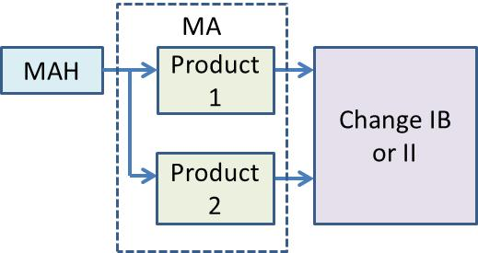

Where the same change(s) result in slightly different product-specific amendments, they should still be submitted as a bulk application and not as individual variations to each MA. Any differences between the MAs may be summarised in table format. In this scenario, it is recommended to apply to Regulatory Information Service (RIS; [variationqueries@mhra.gov.uk](mailto:variationqueries@mhra.gov.uk)) to confirm the bulking is acceptable.

5.1.2 Grouping of Identical changes (either individual or grouped) affecting more than one MA belonging to the same MAH must unless justified, be submitted in one application as

* “bulk” applications for National procedures.
* Worksharing applications for MR/DC procedures.

Note: the above grouping and bulking of purely national MAs may be applied:

* To variations submitted to MAs held by the s*ame applicant /marketing authorisation holder: as per the Commission Communication (98/C 299/03) (I.e. belonging to the same mother company or group of companies or which are “licencees”).*
* (exceptionally) to MAs held by different MAHs with prior approval from [variationqueries@mhra.gsi.gov.uk](mailto:variationqueries@mhra.gsi.gov.uk)