NOTICE OF ORDER
Wildlife and Countryside Act 1981
Lancashire County Council

THE LANCASHIRE COUNTY COUNCIL DEFINITIVE MAP AND STATEMENT OF PUBLIC RIGHTS OF WAY (DEFINITIVE MAP MODIFICATION) (NO. 6) ORDER
2012

Notice is hereby given that the above referenced Order has been submitted to the Secretary of State for Environment, Food and Rural Affairs for determination. An Inspector will be appointed by the Secretary of State to determine the Order.

The start date for the above Order is 4 November 2025.

Consideration of the Order will take the form of exchanges of statements of case and comments on statements of case.

The effect of the Order, if confirmed without modifications, will be to modify the Definitive Map and Statement of Public Rights of Way for the area, by adding a public footpath from the picnic site at Conder Green, Lancaster City (Grid Reference SD 4567 5610) along the marsh for a distance of 1600 metres to Nan Bucks Cottage Thurnham, Lancaster City (Grid Reference SD 4570 5758). As shown between Points A and J on the Order Plan.

Any queries relating to this Order should be referred to Paul Scrivener by email: paul.scrivener@planninginspectorate.gov.uk quoting reference number ROW/3360001 on all correspondence. Alternatively, queries may be sent in writing to The Planning Inspectorate, Rights of Way Section, Room 3/A Eagle Wing, Temple Quay House, 2 The Square, Temple Quay, Bristol, BS1 6PN. Telephone: 0303 444 5000.
Any person wishing to view the statements of case and other documents relating to this Order may do so by appointment at County Hall, Fishergate, Preston, PR1 0LD, for further information please contact Simon Moore at simon.moore@lancashire.gov.uk or on 01772 531280. Documents have also been made available online. To access the documents, please use the following URL address: https://www.lancashire.gov.uk/council/transparency/dmmos/nans-buck- 2012.

Timetable for sending in statements of case and comments

Within 2 weeks of the start date by 18 November 2025
The Order Making Authority, or where the Order Making Authority is taking a neutral stance and the applicant or other party are taking the case forward in support of the order, must ensure their statement of case is received by the Secretary of State. As soon as possible after the deadline, the Secretary of State will send a copy (excluding copies of any supporting documents - these will be available to view at the Authority’s offices) to everyone who has made an objection or representation, the applicant and any other person who has written to us in respect of the Order.
Within 8 weeks of the start date by 30 December 2025
Everyone who has made an objection or representation or any other written representation or any other person wishing to make representations in writing must ensure their statement of case is received by the Secretary of State. As soon as possible after the deadline, the Secretary of State will send full copies to the Authority. Copies (excluding copies of any supporting documents - these will be available to view at the Authority’s offices) will also be sent to the applicant, every person who has made an objection or representation and any other person who has written to us in respect of the Order.

Within the same period the applicant (if applicable) must ensure their statement of case is received by the Secretary of State. As soon as possible after the deadline, Secretary of State will send a full copy to the Authority. Copies will also be sent to everyone who has made an objection or representation and any other person who has written to us in respect of the Order (excluding copies of any supporting documents - these will be available to view at the Authority’s offices).
Within 14 weeks of the start date by 10 February 2026.
Everyone who has made an objection or representation, the Authority, the applicant (if applicable) and anyone who has written to us in respect of the Order must ensure that their comments on any or every other statement of case is received by the Secretary of State. As soon as possible after the deadline, the Secretary of State will send copies of these comments to everyone else.
In fairness to the other parties everyone should keep to the timetable to ensure that statements of case and comments are received on time. Late documents will be returned.

We cannot accept any inflammatory, discriminatory or abusive comments. Any documents containing such comments will be returned.
If you use Artificial Intelligence (AI) to create or alter any part of your documents, information or data, you should tell us that you have done this when you provide the material to us. See the detailed guidance for further information.

Notice of order for w/r

WILDLIFE AND COUNTRYSIDE ACT 1981

THE DEFINITIVE MAP AND STATEMENT OF PUBLIC RIGHTS OF WAY FOR THE COUNTY OF LANCASHIRE

THE LANCASHIRE COUNTY COUNCIL DEFINITIVE MAP AND STATEMENT OF PUBLIC RIGHTS OF WAY (DEFINITIVE MAP MODIFICATION) (NO. 6) ORDER 2012

This Order is made by Lancashire County Council ("the Authority") under Section 53(2)(b) of the Wildlife and Countryside Act, 1981 ("the Act") because it appears to that Authority that The Definitive Map and Statement of Public Rights of Way for the County of Lancashire require modification in consequence of the occurrence of an event specified in Section 53(3)(c)(i) namely the discovery by the Surveying Authority of evidence which (when considered with all other relevant evidence available to them) shows that a right of way which is not shown in the map and statement subsists or is reasonably alleged to subsist over land in the area to which the map relates, namely a public footpath

The Authority have consulted with every local authority whose area includes the land to which the Order relates. Lancashire County Council hereby order that:

- For the purposes of this Order, the "relevant date" is the 21st November 2012.
- The Definitive Map and Statement of Public Rights of Way for the County of Lancashire shall be modified as described in Part I and Part II of the Schedule and shown on the map attached to the Order.

- This Order shall take effect on the date it is confirmed and may be cited as The Lancashire County Council Definitive Map and Statement of Public Rights of Way (Definitive Map Modification) (No. 6) Order 2012.

Dated this 21st day of November 2012. THE COMMON SEAL of the )
Lancashire County Council ) was hereunto affixed in the presence of )

Authorised Signatory

SCHEDULE

PARTI

MODIFICATION OF THE DEFINITLVE MAP

DESCRIPTLON OF PATH OR WAY TO BE ADDED

A 2 metre wide public footpath from the Lune Estuary Cycleway railway line starting at the entrance to Conder Green picnic site (Point A on the Order plan) in a general northerly direction along the edge of the estuary passing to the west of Pennyhill and Waterloo and continuing in a northerly direction along the edge of the estuary for a total distance of 1.6 kilometres to Point J on the Order plan which is a point on the same dismantled railway line (Lune Estuary Cycleway) at Nans Buck cottage.

PART II

MODIFICATION OF DEFINITIVE STATEMENT

THE FOLLOWING ENTRY BE ADDED:

"From the Lune Estuary Cycleway at SD 4567 5610 in a generally northerly direction along the edge of the estuary (above the mean high water mark) passing west of Pennyhill and Waterloo and continuing along the edge of the estuary to a point on the same dismantled railway line (Lune Estuary Cycleway) at Nans Buck cottage, SD 4570 5758.

Width: 2 metres

Limitations and Conditions: Gate at SD 4567 5610 and SD 4570 5758 Length: 1.6km"
..
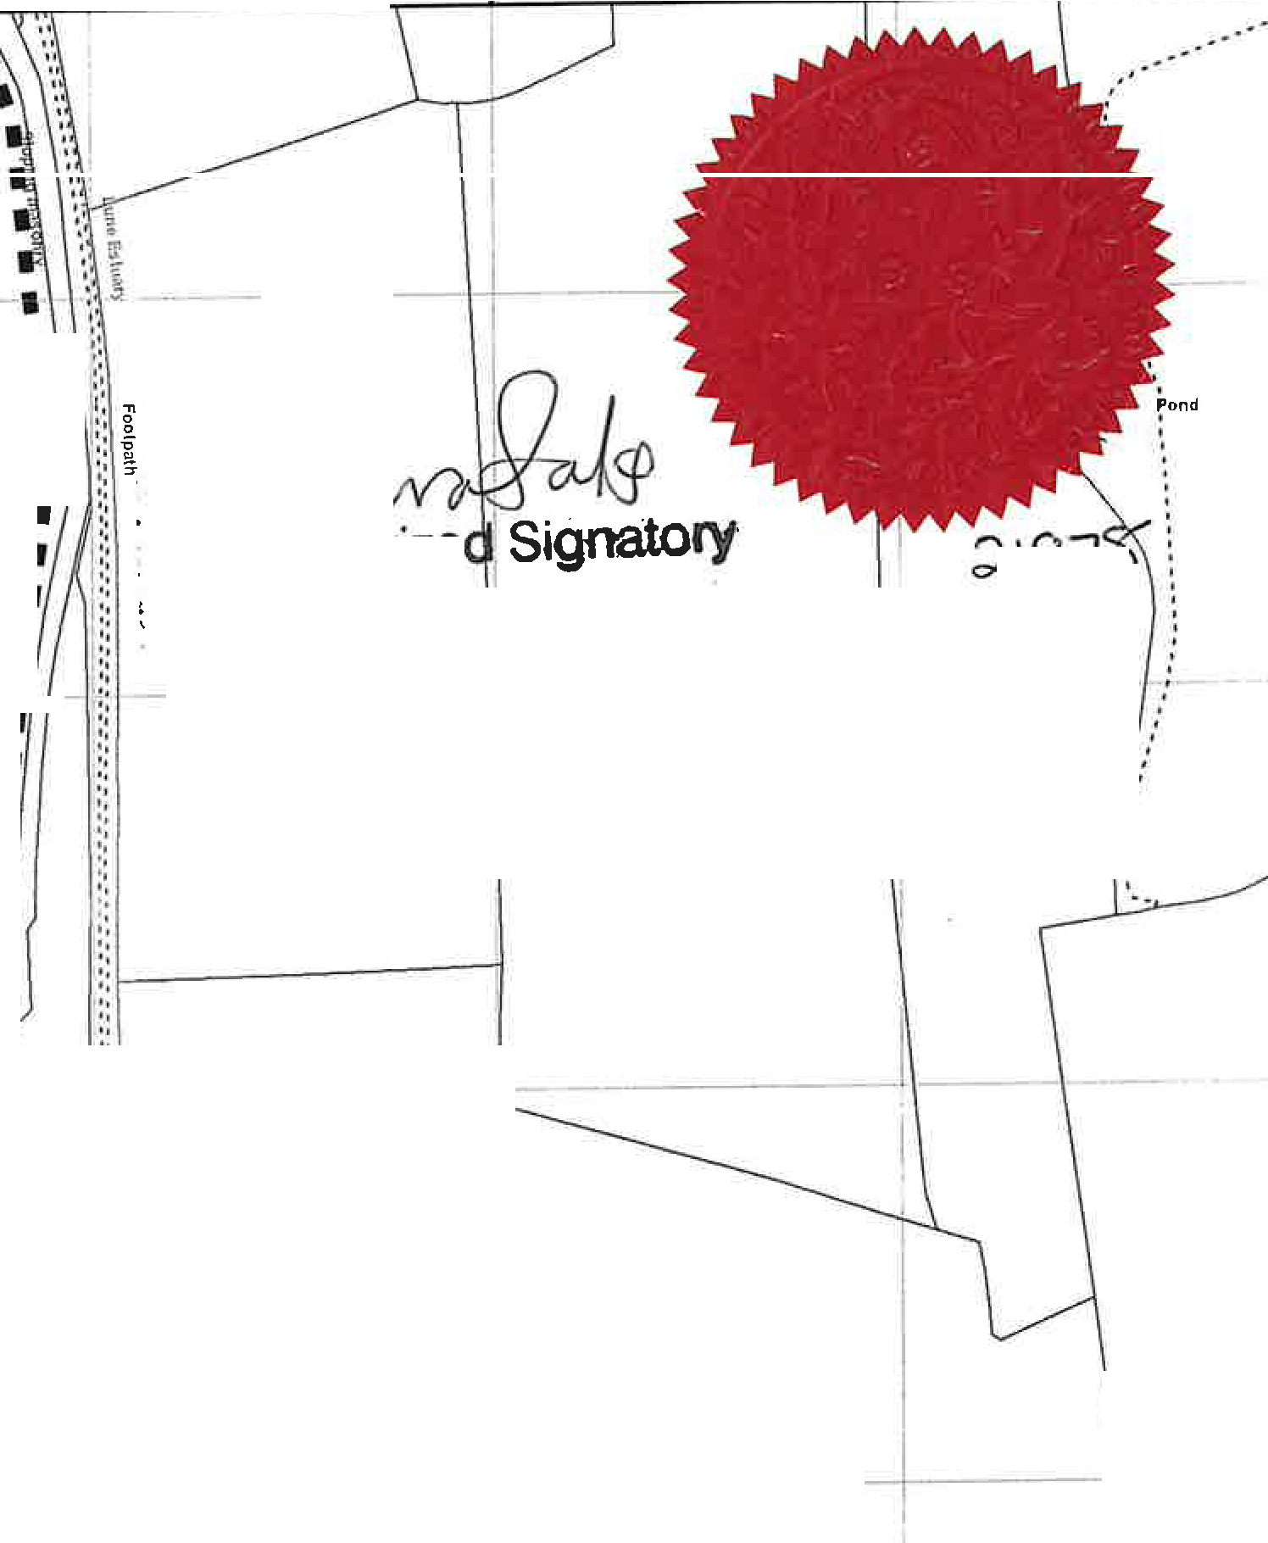
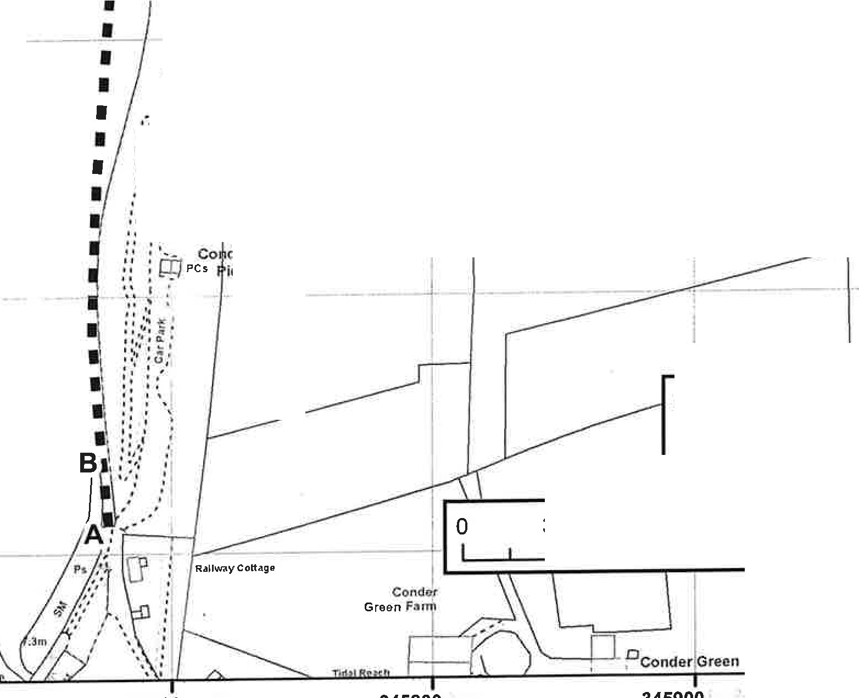
345600 345700 345800 345900 346000

0
0
:D
�
I
:D
"" I
I
0
0
IO
IO
.I.I,) .
Ca
Sand �.

Authonz

d-\97
( ·-'
-,- - ,
I

--1 l·L

0
0
II)
IO
�

0
0
�":D"
""

Sand

Sand

Sand
I
--■
I I I I I I I
,::
,","·,
...
,,,
'•
1..
'"

..
:":
"
..
I .,.,
.,,.!.'•
·.,�..

,..,_:i
:: I
"I f �'
",, .'
" .

7,Dm

0..,.
.I.I),.
0
IO

0
0
M
IO
.II.) ,.
,• .•: I
"

0
0
N
�
:D
""

derGree11
icnic Area

0
0
N
IO
.II.),.
: • • ■ Claimed Route
- Public Footpath

0...
0
�
:D
""

Sand
35 70 140 Meters I

0....
0
IO
.II.) ,.

345600 345700 345800 345900 346000

Lancas(i)h.ire  gi��·t | Jo Turton Executive Director for the Environment | WIidiife and Countryside Act 1981 Section 53 I1 :2,500 1�-t,  Clalmed publlc footpath from Conder Green to Nan Bucks Cottage, Thurnham, Lancaster District  PLAN 1
The digitised Rights of Way Information should be used for guidance only as Its accuracy cannot be guaranteed, Rights of Way Information must be verified on the current Definitive Map before being supplied or used for any purpose,
This Map Is roproduced from Ordnance Survey material with the permission of Ordnance Survey on behalf of the controller of Her Majesty's Stationery Office (C) Crown Copyright.
Unauthoris•ed reproduction Infringes Crown Copyright and may lead to ProsecuUon or civil proceedings, Lancashire County Council Licence No, 100023320

.. �

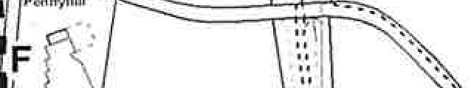
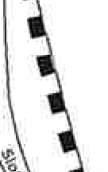
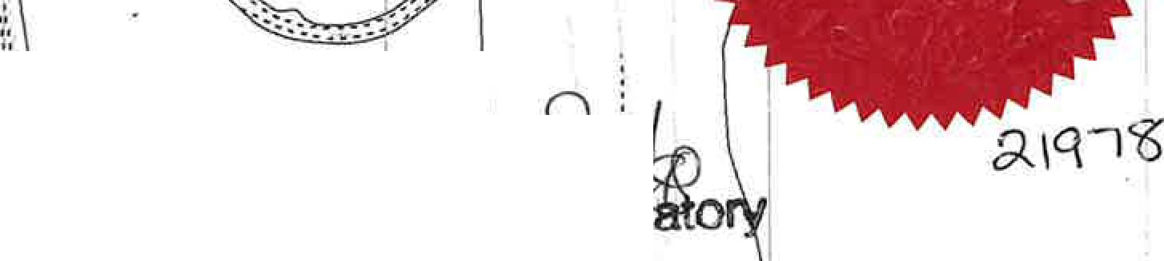
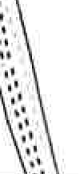
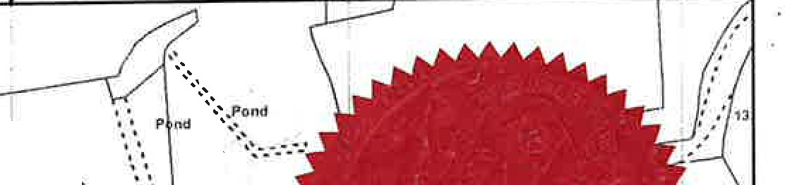
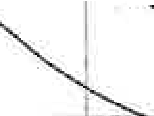
0
345500
345.600
345700
345800
345900
,,
.''.••
,,,,
•,,',,
•,.',.
ncI
''
I
.:,;-
"t?'
.c:
'\: ::..I.,
.....
...�..
..._:..
0
.inti

····•-:
0....
C)
- .
""'
It)
"
.
'
'
A�z
-------
Sig'
��:-;----
0
0
en
0
0
I'-- LO
st

0
0en
:0 U)
LO It)
""'
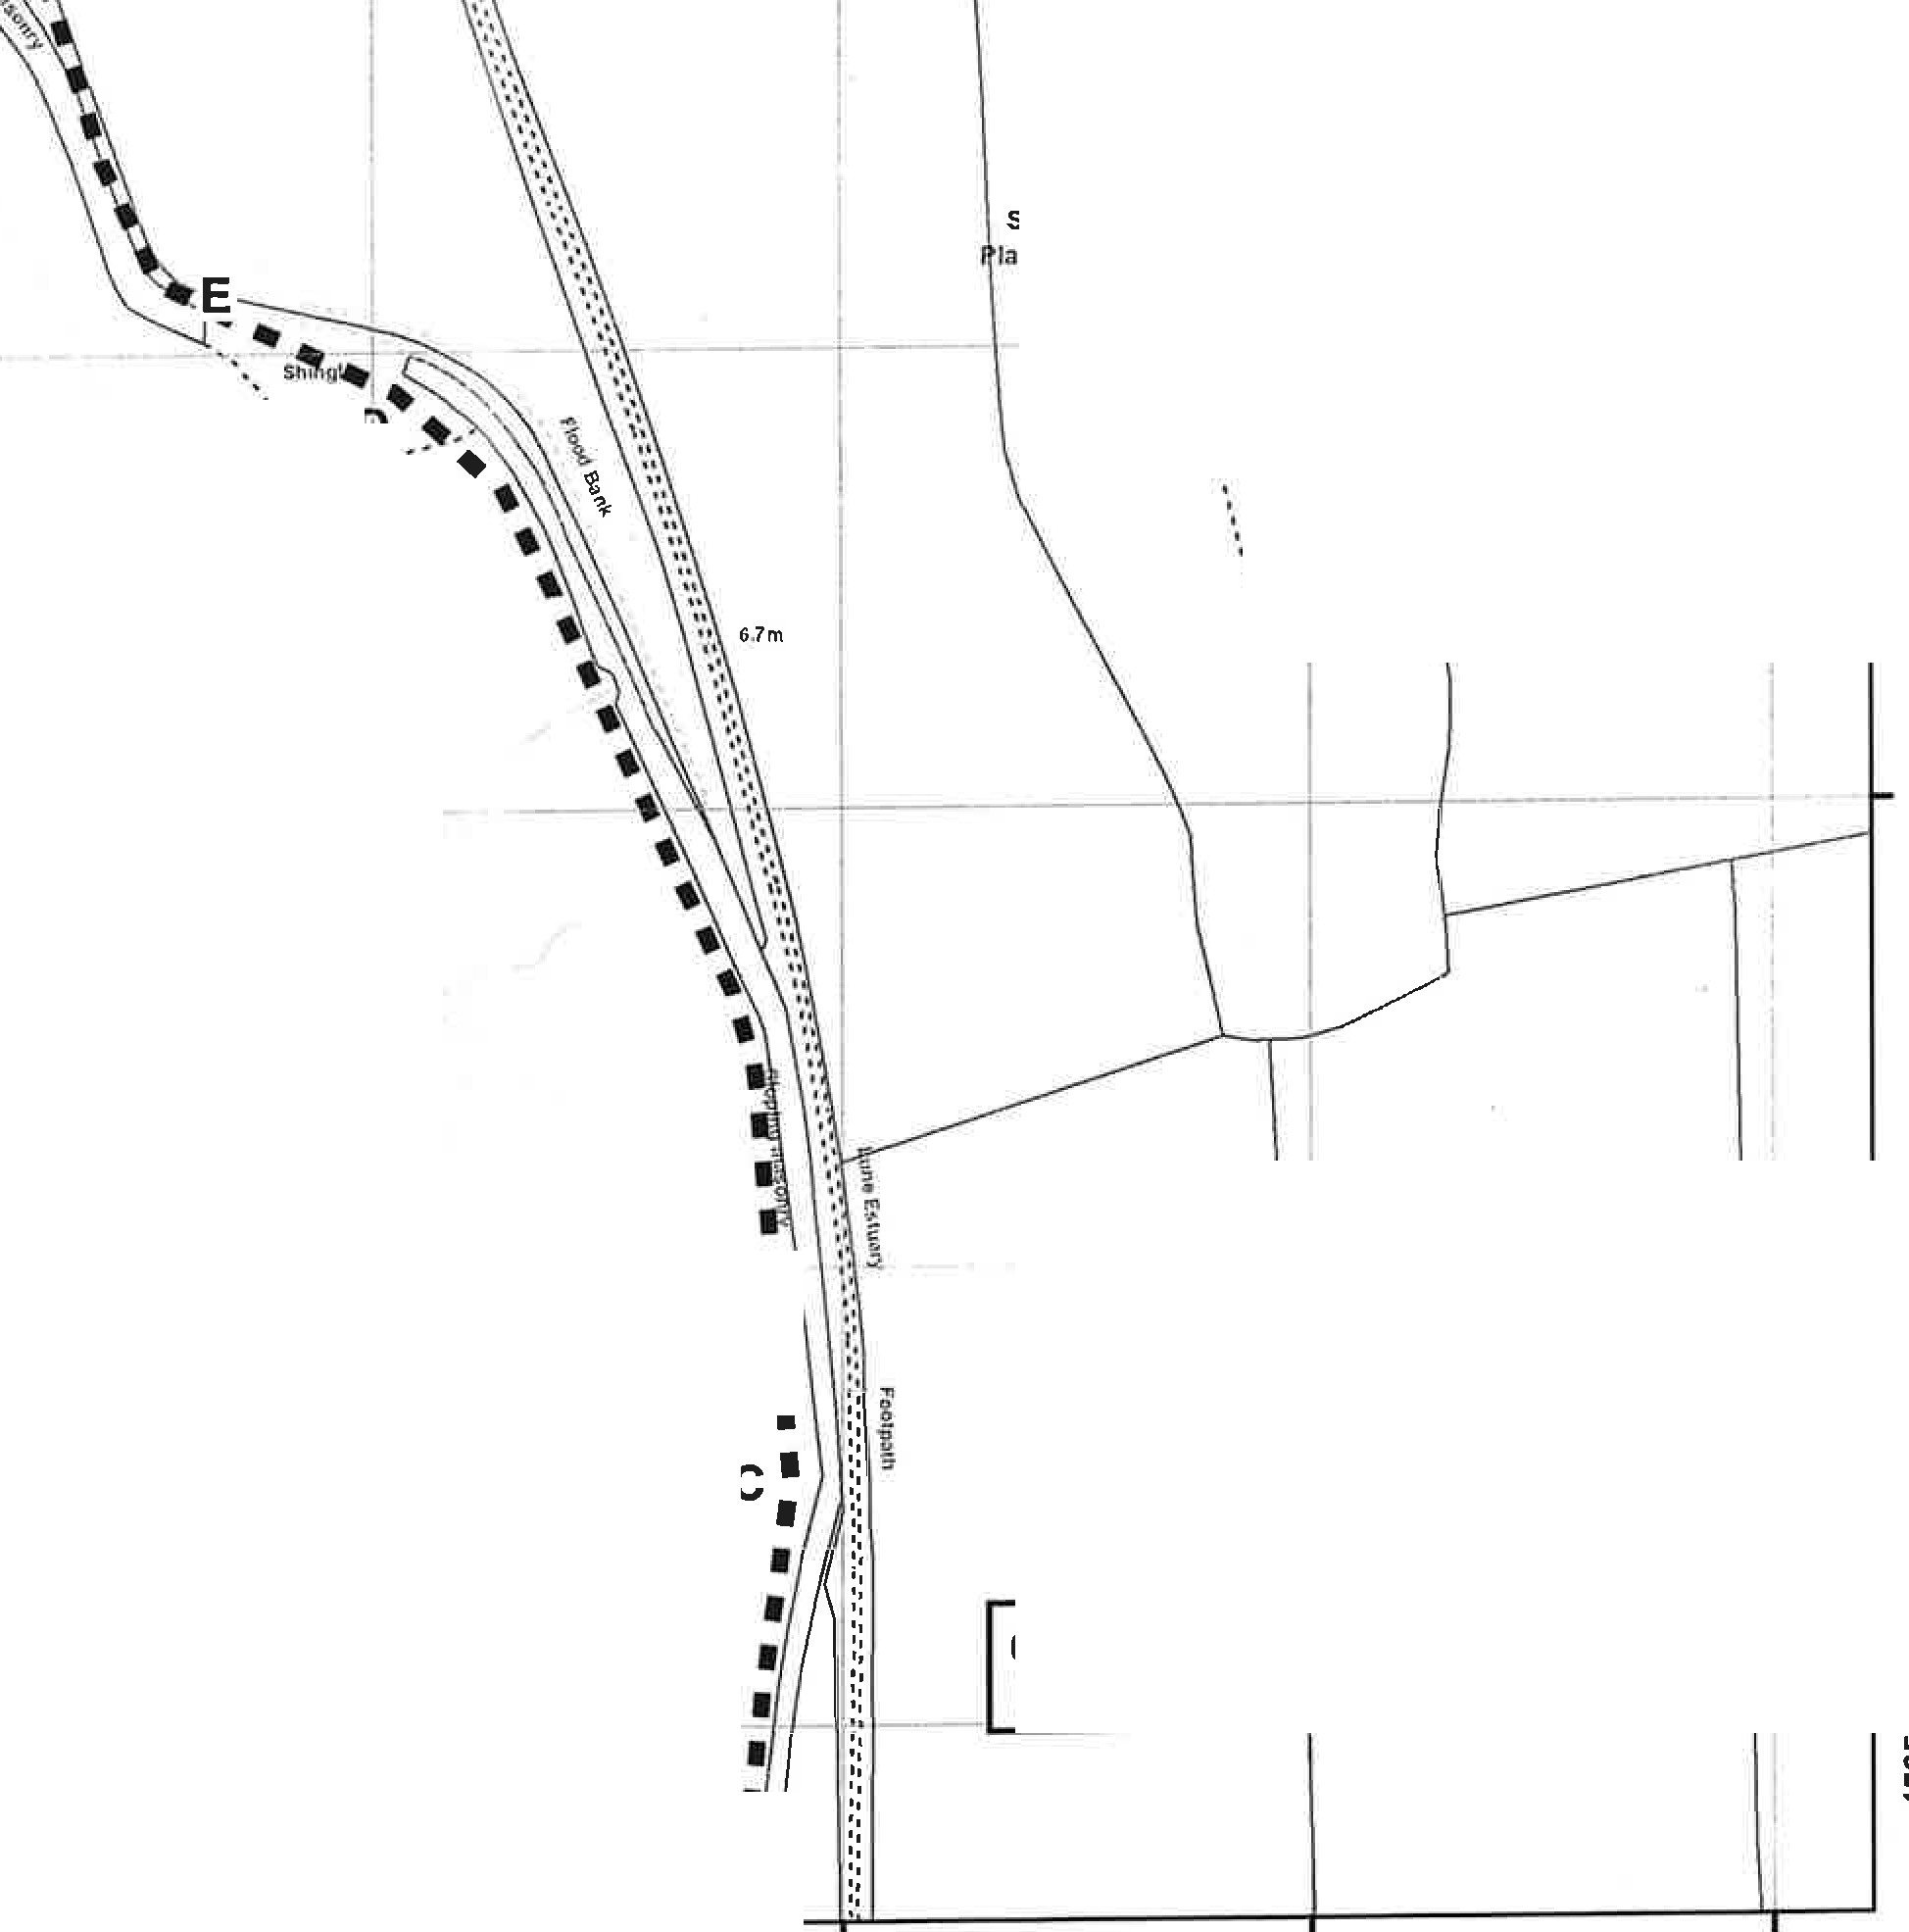
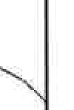
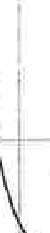
st



0
0
,0
:0
- I
LO ... ....
st
Seafield
lantation

.·
. I

..., ·- I

0
0co
U)
It)
""'

SMd

0
0
l'-
:0
LO
st

0
0
:0
:0
LO
st
- • • Claimed Route
Public Footpath

S�nd

I I I

C)

0....
U)
It)
""'

0
0
U)
U)
It)
""'

Sand f
d ••·-·-...l
I'\'• ...,-.
0
0
LO
:0
I
LO
st
I
I

0 35 70 140 Meters
I I I

0
0
It)
U)
It)
""'
345500 345600 345700 345800 345900

The digitised Rights of Way Information should be used for guidance only as Its accuracy cannot be guaranteed. Rights of Way Information must be verifled on the current Definitive Map before being supplied or used for any purpose.
This Map Is reproduced from Ordnance Survey material with the permission of Ordnance Survey on behalf of the controller of Her Majesty's Stationery Office (C) Crown Copyright.
UnaUlhorised reproduction infringes Crown Copyrighl and may lead to Prosecution or civil proceedings. Lancashire County Council Licence No.100023320
1:2,500
WIidiife and Countryside Act 1981 Section 53
Claimed public footpath from Conder Green to Nan Bucks Cottage, Thurnham, Lancaster District
PLAN 2
JoTurton Executive Director for the Environment
County •lff'/i!..
Council�
Lancashire
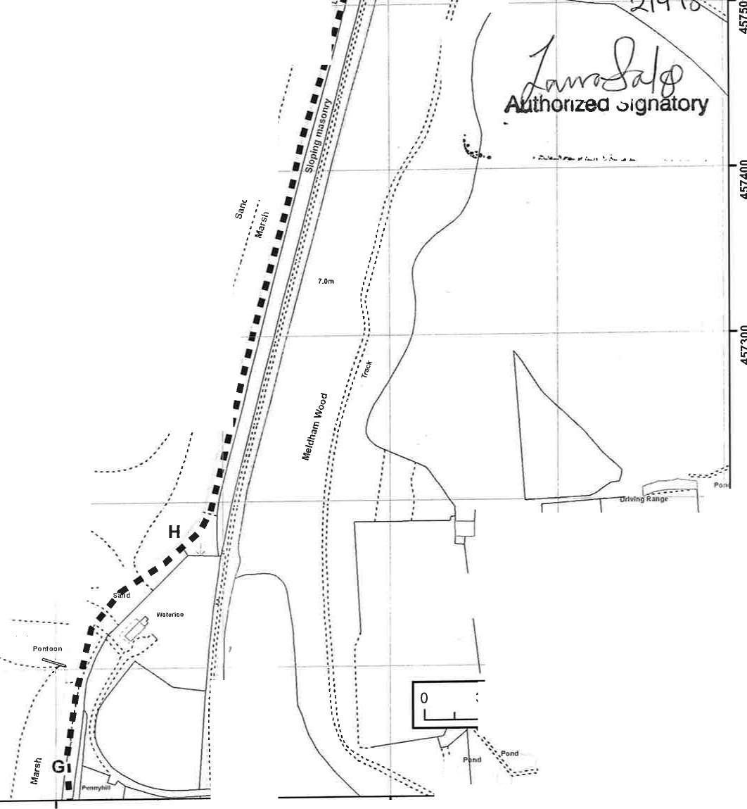

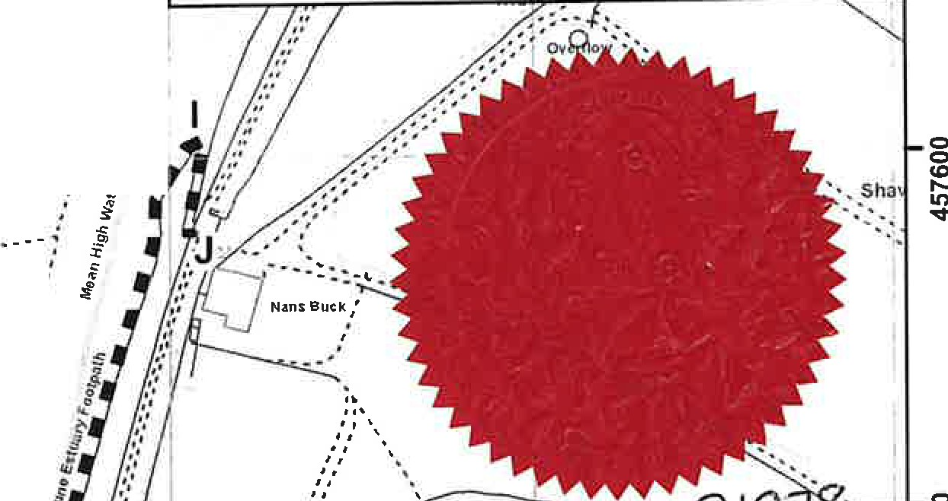
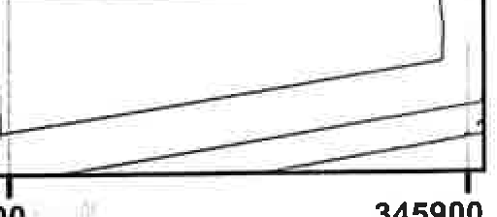
345500 345600 345700 345800 345900
Sand
,'
Shmgle
,'
(I.I
::,
..J
C
-
if
�
Q
..
7
j
--.
,J
.(
-.':I
''
Shingll?
,.''
'
'
, '
'
I • •
Shingle
SMd
Stringle
I.Orn
.",
Sand

0
0
co
.....
�

0
0
in r- in
<I'

0
0
<I'
r-
in
<I'

0
0
:')
r-
in
<I'

0
0
N
r-
in
<I'
..,..,..----
''••
..
,'',••
.,,.
.,,,
.,,,
, ,
..
'•
•'

Pon

C> C>
.I.(.)..
�

0
0
.s..:.t.
I()
v

0
0
.M....
I()
s:t

0
C>
.N....
I()
v

0
...
0
r-
in
<I'

.,..
,.,
.
''
••'·,

35 70
- • • Claimed Route
- Public Footpath
I

140 Meters
I

C> C>
.....
...
I()
s:t
345500 345600 345700 345800 345900

The digitised Rights of Way Information should be used for guidance only as Its accuracy cannot be guaranteed. Rights of Way Information must be verified on the current Definitive Map before being supplied or used for any purpose.
This Map Is roptoduced r,om Ordnance Survey material with the permission of Ordnance Survey on behalf of the controller of Her Majesty's StaUonery Office (C) Crown Copyright.
Unauthorised reproduction Infringes Crown Copyright and may lead to ProsecuUon or clvll proceedings. Lancashire County Council Licence No. 100023320
1:2,500
WIidiife and Countryside Act 1981 Section 53
Claimed public footpath from Conder Green to Nan Bucks Cottage, Thurnham, Lancaster District
PLAN 3
Jo Turton Executive Director for the Environment
CountY 1!ri'lJ,
Councll �
Lancasti.ire

