NOTICE OF ORDER
Wildlife and Countryside Act 1981
Shropshire Council

The Shropshire Council (Footpaths 73Y & 74 Deletions, Parish of Worthen-with-
Shelve) DMMO 2023

Notice is hereby given that the above referenced Order has been submitted to the Secretary of State for Environment, Food and Rural Affairs for determination. An Inspector will be appointed by the Secretary of State to determine the Order.

The start date for the above Order is 4 November 2025.

Consideration of the Order will take the form of exchanges of statements of case and comments on statements of case.

The effect of the Order, if confirmed without modifications, will be to delete the full width of Footpath 74 from Point A on the Order Map grid reference SO 3516 9801 where it leaves the County Road, running first in a general east-south-eastly direction, crossing a cattle grid and field gate, and along a grass and stone surfaced access track for approximately 178m. It then crosses a second cattle grid and turning to run in a general SSE to meet a field gate at Point Bon the Order Map grid reference SO3532 9823. It then continues as Footpath 73Y, passing the buildings of Bog Farm, in a general south-south-easterly direction through the yard and along a sealed surface for approximately 48m. From there It then runs in a general southerly direction on a grass surface for approximately 53m to a field gate. It then turns to run along a grass surface for approximately 69m to meet Footpath UN3 at Point Con the Order Map grid reference SO 3551 9829. A total distance of 348m

Any queries relating to this Order should be referred to Paul Scrivener by email: paul.scrivener@planninginspectorate.gov.uk quoting reference number ROW/3347510 on all correspondence. Alternatively, queries may be sent in writing to The Planning Inspectorate, Rights of Way Section, Room 3/A Eagle Wing, Temple Quay House, 2 The Square, Temple Quay, Bristol, BS1 6PN. Telephone: 0303 444 5000.
Any person wishing to view the statements of case and other documents relating to this Order may do so by appointment at Shrewsbury Library, Castle Gates, Shrewsbury, Shropshire SY1 2AS, by contacting outdoor.recreation@shropshire.gov.uk.
Timetable for sending in statements of case and comments

Within 2 weeks of the start date by 18 November 2025.
The Order Making Authority, or where the Order Making Authority is taking a neutral stance and the applicant or other party are taking the case forward in support of the order, must ensure their statement of case is received by the Secretary of State. As soon as possible after the deadline, the Secretary of State will send a copy (excluding copies of any supporting documents - these will be available to view at the Authority’s
offices) to everyone who has made an objection or representation, the applicant and any other person who has written to us in respect of the Order.

Within 8 weeks of the start date by 30 December 2025.
Everyone who has made an objection or representation or any other written representation or any other person wishing to make representations in writing must ensure their statement of case is received by the Secretary of State. As soon as possible after the deadline, the Secretary of State will send full copies to the Authority. Copies (excluding copies of any supporting documents - these will be available to view at the Authority’s offices) will also be sent to the applicant, every person who has made an objection or representation and any other person who has written to us in respect of the Order.
Within the same period the applicant (if applicable) must ensure their statement of case is received by the Secretary of State. As soon as possible after the deadline, Secretary of State will send a full copy to the Authority. Copies will also be sent to everyone who has made an objection or representation and any other person who has written to us in respect of the Order (excluding copies of any supporting documents - these will be available to view at the Authority’s offices).

Within 14 weeks of the start date by 10 February 2026.
Everyone who has made an objection or representation, the Authority, the applicant (if applicable) and anyone who has written to us in respect of the Order must ensure that their comments on any or every other statement of case is received by the Secretary of State. As soon as possible after the deadline, the Secretary of State will send copies of these comments to everyone else.
In fairness to the other parties everyone should keep to the timetable to ensure that statements of case and comments are received on time. Late documents will be returned.

We cannot accept any inflammatory, discriminatory or abusive comments. Any documents containing such comments will be returned.
If you use Artificial Intelligence (AI) to create or alter any part of your documents, information or data, you should tell us that you have done this when you provide the material to us. See the detailed guidance for further information.

Notice of order for w/r

a Shropshire
Council

SHROPSHIRE COUNCIL WILDLIFE AND COUNTRYSIDE ACT 1981
DEFINITIVE MAP AND STATEMENT OF RIGHTS OF WAY FOR SHROPSHIRE

THE SHROPSHIRE COUNCIL
(FOOTPATHS 74 & 73Y DELETIONS, PARISH OF WORTHEN WITH SHELVE) MODIFICATION ORDER 2023

This Order is made by the Shropshire Council ("the Council") under section 53(2)(b) of the Wildlife and Countryside Act 1981 ("the Act") because it appears to the Council that the Shropshire Definitive Map and Statement require modification because in accordance with the provisions of Section 53(3)(c)(iii) the Council has discovered evidence which (when considered with all other relevant evidence available to them) shows:-

- that there are no public rights of way over the land shown in the map and statement as a highway of any description, or any other particulars contained in the map and statement require modification.

The Council hereby order that:-

  - For the purpose of this Order the relevant date is 30th June 2023.

  - The Shropshire Definitive Map and Statement shall be modified as described in Part I and Part II of the Schedule and shown on the map attached to the Order.

  - This Order shall take effect on the date it is confirmed and may be cited as The Shropshire Council (Footpaths 74 & 73Y Deletions, Parish of Worthen with Shelve) Modification Order 2023.

SCHEDULE PARTI
Modification of Definitive MaQ Description of path or way to be deleted
The full width of Footpath 74 from Point A on the Order Map grid reference SO 3516 9801 where it leaves the County Road, running first in a general east-south-eastly direction, crossing a cattle grid and field gate, and along a grass and stone surfaced access track for approximately 178m. It then crosses a second cattle grid and turning to run in a general SSE to meet a field gate at Point Bon the Order Map grid reference SO3532 9823. It then continues as Footpath 73Y, passing the buildings of Bog Farm, in a general south-south-easterly direction through the yard and along a sealed surface for approximately 48m. From there It then runs in a general southerly direction on a grass surface for approximately 53m to a field gate. It then turns to run along a grass surface for approximately 69m to meet Footpath UN3 at Point Con the Order Map grid reference SO 3551 9829. A total distance of 348m.

PART II

Modification of Definitive Statement

Removal of the statement for footpath 74 which reads RUPP 74 to be modified to footpath status from a gate at point A on Order Plan 27 with a minimum width of 1.5 metres, running in a general westerly direction along an access track for approximately 200 metres to a gate at Bog Farm shown as point Bon the plan where it connects with Footpath 73.

There is no Shropshire Definitive Statement for footpath 73Y

Executed as a deed by affixing the Common Seal of Shropshire Council on 24th August 2023
in the presence of:-

�w�
kJ-i:r..� 1),M:.c.A""ZN, '

l,.� � C,c.,e�'ll..\..
_5\lbtb
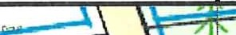
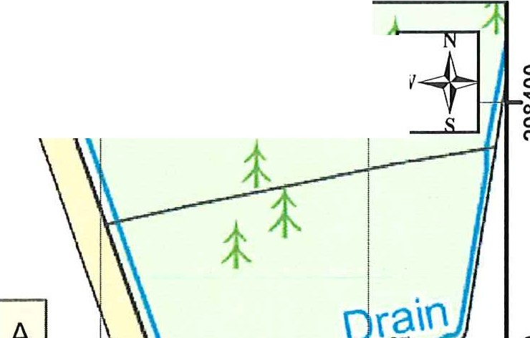
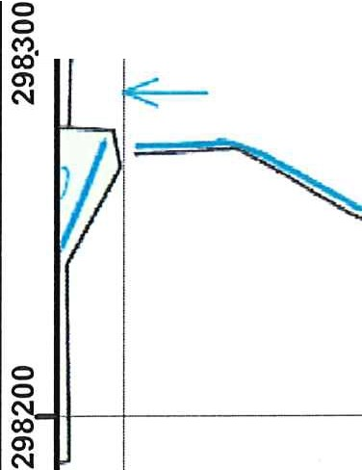
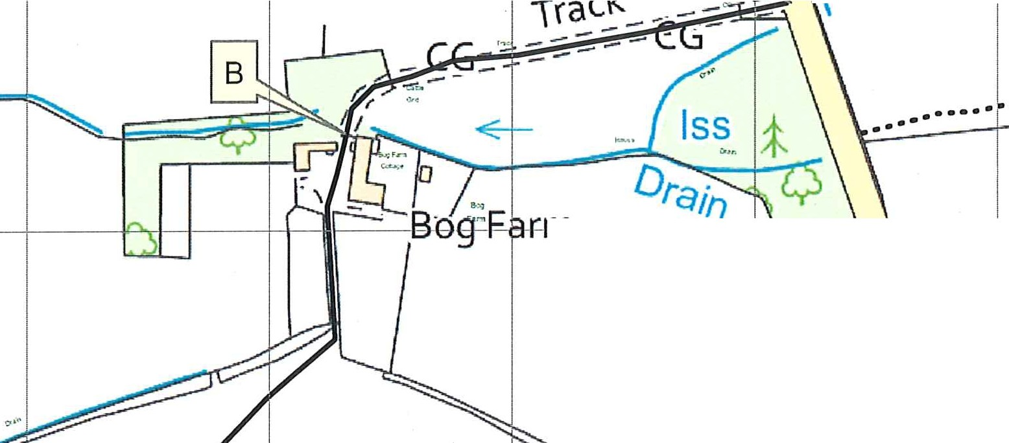
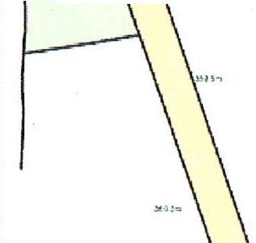
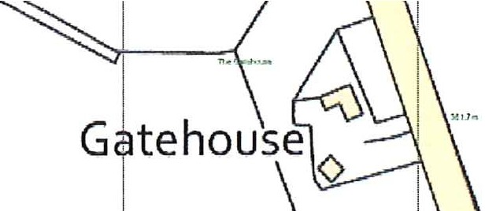
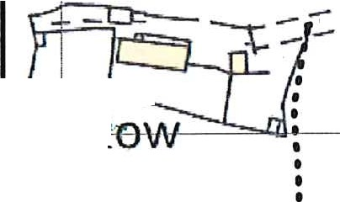
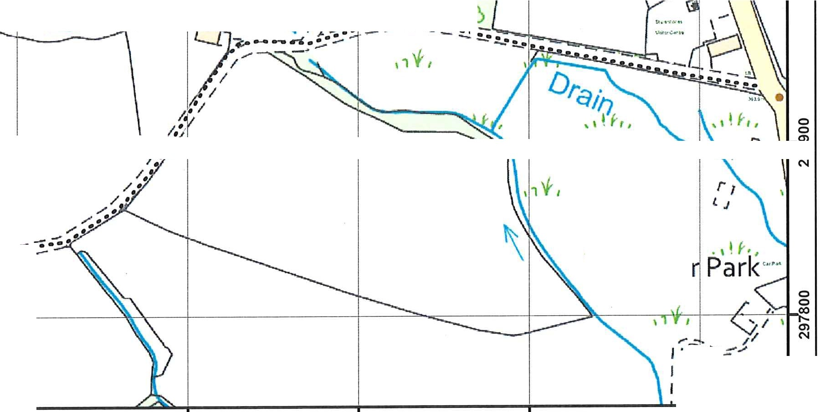
SHROPSHIRE COUNCIL
WILDLIFE AND COUNTRYSIDE ACT 1981
Definitive Map Modification Order 2023
335.100 335..200 335.300
::t

335.400
Parish of Worthen with Shelve Footpath 73V and Footpath 74 OS Sheet No: SO3598
�33[5.500 335_600
11
� I -f-..--····.······J - I 1
�,-- ,......,,;,.\(\ ...
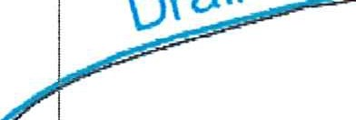
N

0
0
·�
"N '

i�I I I I I I ,. ��� � I�
"'
N

···-·····

r-n

'I'I
0
0
1 r::::
\,, gi

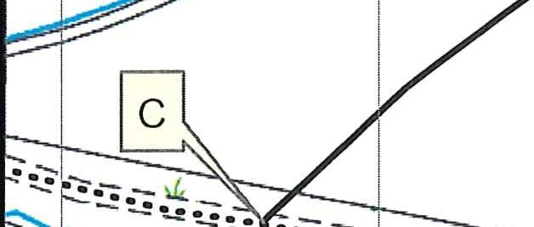
�gJ
Sll
I � / I 1� I ,\\ IJ W"t..
70 �� T \\�
·116 •
��

goi - ��------�t- -� .
00 00
The

rog
"'
N �
1 "'
� /. - -•• - - ••:7;.l; N

o�I I I ��.fI I�I�\ I ' I'\·tJ 1 -
"N'

"N'
��

-.•;.1- •

.
•
•
1�
,,f I

, I j f1,

Ca

,-I ...._
I -,.
I i'Y,
335·100 335·200 335·300 335·400 335·500 335"600
¥;Shrop���:�
The Shirehall, Abbey Foregate Shrewsbury, Shropshire, SY2 6ND
Key
Scale:
Route to be extinguished
Existing to remain
.........
1:3,000 ©Crown copyright (2023) Ordnance Survey
100049049
You are not permitted to copy, sub-licence, distribute or sell any of this data to third parties in any form.

DATED 24TH AUGUST 2023

SHROPSHIRE COUNCIL

WILDLIFE AND COUNTRYSIDE ACT 1981

DEFINITIVE MAP AND STATEMENT OF RIGHTS OF WAY FOR SHROPSHIRE

THE SHROPSHIRE COUNCIL
(FOOTPATHS 74 & 73Y DELETIONS, PARISH OF WORTHEN WITH SHELVE) MODIFICATION ORDER 2023

SHROPSHIRE OUTDOOR PARTNERSHIPS SERVICE HOMES AND COMMUNITES

THE SHIREHALL ABBEY FOREGATE SHREWSBURY

This information is supplied in connection with an Order made by Shropshire Council under the Wildlife and Countryside Act 1981 and is not to be used for any other purpose. Shropshire Council asserts its right to the copyright of this Order. It may not be reproduced or transmitted in any form or by any means or stored in any retrieval system of any nature except with prior written permission except for the purposes of this consultation.

Footpaths 74 & 73Y Deletions, Worthen with Shelve Modification Order

