**NOTICE OF ORDER**

**Wildlife and Countryside Act 1981**

Lancashire County Council

Lancashire County Council - Footpath from Warburton Street to Grane Road, Haslingden (Definitive Map Modification) Order 2021.

Notice is hereby given that the above referenced Order has been submitted to the Secretary of State for Environment, Food and Rural Affairs for determination. An Inspector will be appointed by the Secretary of State to determine the Order.

The **start date** for the above Order is **14 October 2025.**

Consideration of the Order will take the form of a public local inquiry.

The Inquiry will be held at St Mary's Chambers, Haslingden Road, Rawtenstall, Rossendale, BB4 6QX on **17 March 2026** at 10.00am.

The effect of the Order, if confirmed without modifications, will be to add a Footpath from the southern end of Warburton Street at its junction with Musbury View (point A on the Order Map) running in an east north easterly direction along the front of the terraced properties numbered 6-24 Warburton Buildings for approximately 50 metres to point B from where it continues in a north easterly direction along the eastern edge of the car park of a former Cantonese restaurant to Grane Road at point C.

The length of the footpath is approximately 100 metres.

Any queries relating to this Order should be referred to Paul Scrivener by email: [paul.scrivener@planninginspectorate.gov.uk](mailto:paul.scrivener@planninginspectorate.gov.uk) quoting reference number ROW/3353411 on all correspondence. Alternatively, queries may be sent in writing to The Planning Inspectorate, Rights of Way Section, Room 3/A Eagle Wing, Temple Quay House, 2 The Square, Temple Quay, Bristol, BS1 6PN. Telephone: 0303 444 5000.

Any person wishing to view the statements of case and other documents relating to this Order may do so by appointment at County Hall, Fishergate, Preston, PR1 8XJ, for further information please contact Simon Moore at [simon.moore@lancashire.gov.uk](mailto:simon.moore@lancashire.gov.uk) or on 01772 531280. Documents have also been made available online. To access the documents, please type the following URL address into your web browser: [**https://www.lancashire.gov.uk/council/transparency/dmmos/gr**](https://www.lancashire.gov.uk/council/transparency/dmmos/grane-road-2021/)[**ane-road-2021/**](https://www.lancashire.gov.uk/council/transparency/dmmos/grane-road-2021/)

### Timetable for sending in statements of case and proofs of evidence Within 8 weeks of the start date by 9 December 2025.

The Order Making Authority, or where the Order Making Authority is taking a neutral stance and the applicant or other party are taking the case forward in support of the order, must ensure their statement of case is received by the Secretary of State. As soon as possible after the deadline, the Secretary of State will send a copy (excluding copies of any supporting documents - these will be available to view at the Authority’s offices) to everyone who has made an objection or representation and the applicant and any other person who has written to us in respect of the Order.

### Within 14 weeks of the start date 20 January 2026.

Everyone who has made an objection or representation and anyone who wishes to give evidence at the Inquiry must ensure their statement of case1 is received by the Secretary of State. As soon as possible after the deadline, the Secretary of State will send full copies to the Authority. Copies will also be sent to the applicant, every person who has made an objection or representation and any other person who has written to us in respect of the Order (excluding copies of any supporting documents - these will be available to view at the Authority’s offices).

Within the same period the applicant (if applicable) must ensure their statement of case is received by the Secretary of State. As soon as possible after the deadline, the Secretary of State will send a full copy to the Authority. Copies will also be sent to everyone who has made an objection or representation and any other person who has written to us in respect of the Order (excluding copies of any supporting documents - these will be available to view at the Authority’s offices).

### 4 weeks before the date of the inquiry by 3 February 2026.

The Authority, everyone who has made an objection or representation, the applicant (if applicable) and anyone who wishes to give evidence at the Inquiry must ensure their proof of evidence (together with any summary) is received by the Secretary of State. As soon as possible after the deadline, the Secretary of State will send copies of:

1. the Authority’s proof of evidence to everyone who has made an objection or representation, the applicant and anyone who has submitted a statement of case (including copies of any supporting documents – although none should be submitted with a proof of evidence);

1 If you wish to make a legal submission, this should be submitted at the same time as your statement of case. Otherwise legal submissions will have to be submitted in writing on the day of the inquiry.

1. the applicant’s proof of evidence to the Authority, everyone who has made an objection or representation and anyone else who has submitted a statement of case (including copies of any supporting documents – although none should be submitted with a proof of evidence); and
2. all other proofs of evidence to the Authority, the applicant, everyone who has made an objection or representation and anyone else who has submitted a statement of case (including copies of any supporting documents – although none should not be submitted with a proof of evidence).

All parties must keep to the timetable set out above and ensure that statements of case and proofs of evidence are received by the Secretary of State on time. Late documents will be returned.

We cannot accept any inflammatory, discriminatory or abusive comments. Any documents containing such comments will be returned.

If you use Artificial Intelligence (AI) to create or alter any part of your documents, information or data, you should tell us that you have done this when you provide the material to us. [See the detailed guidance for further](https://www.gov.uk/guidance/use-of-artificial-intelligence-in-casework-evidence) [information.](https://www.gov.uk/guidance/use-of-artificial-intelligence-in-casework-evidence)

Notice of order for inquiry

**WILDLIFE AND COUNTRYSIDE ACT 1981**

**DEFINITIVE MAP AND STATEMENT OF PUBLIC RIGHTS OF WAY FOR THE COUNTY OF LANCASHIRE**

**LANCASHIRE COUNTY COUNCIL**

**FOOTPATH FROM WARBURTON STREET TO GRANE ROAD, HASLINGDEN (DEFINITIVE MAP MODIFICATION) ORDER 2021**

This Order is made by Lancashire County Council under Section 53(2)(b) of the Wildlife and Countryside Act, 1981 (''the Act") because it appears to that Authority that The Definitive Map and Statement of Public Rights of Way for the County of Lancashire require modification in consequence of the occurrence of an event specified in Section 53(3)(c)(i) namely the discovery by the Surveying Authority of evidence which (when considered with all other relevant evidence available to them) shows that a right of way which is not shown in the map and statement subsists or is reasonably alleged to subsist over land in the area to which the map relates, namely a public footpath.

The Authority have consulted with every local authority whose area includes the land to which the Order relates. Lancashire County Council hereby order that:

* 1. For the purposes of this Order, the "relevant date" is the 14th April 2021.
  2. The Definitive Map and Statement of Public Rights of Way for the County of Lancashire shall be modified as described in Part I and Part 11 of the Schedule and shown on the map attached to the Order.
  3. This Order shall take effect on the date it is confirmed and may be cited as the Public Rights of Way Footpath from Warburton Street to Grane Road, Haslingden (Definitive Map Modification) Order 2021.

Dated this *141-"--* day of *A,;r;}* 2021.

THE COMMON SEAL of the )

Lancashire County Council ) was h�n the presence of )

**Authorised Signatory**

SCHEDULE

PARTI

MODIFICATION OF THE DEFINITIVE MAP

DESCRIPTION OF PATH OR WAY TO BE ADDED

The addition of a Footpath from the southern end of Warburton Street at its junction with Musbury View (point A on the Order Map) running in an east north easterly direction along the front of the terraced properties numbered 6-24 Warburton Buildings for approximately 50 metres to point B from where it continues in a north easterly direction along the eastern edge of the car park of a former Cantonese restaurant to Grane Road at point C.

The length of the footpath is approximately 100 metres.

PART II

MODIFICATION OF DEFINITIVE STATEMENT VARIATION OF PARTICULARS OF PATH OR WAY

The Statement to be added for Haslingden 415 to read as follows: Haslingden 415:

No. of Path: "415"

Kind of Path: "Footpath"

Position: " Footpath commencing at the southern end of Warburton Street at its junction with Musbury View (grid reference SD 7788 2243) running in an east north easterly direction along the front of the terraced properties numbered 6-24 Warburton Buildings for approximately 50 metres to SD 7794 2244 from where it continues in a north easterly direction along the eastern edge of the car park of a former Cantonese restaurant to pass through a 2 metre wide gap in a wall to Grane Road at SD 7796 2249.AII distances and compass bearings are approximate."

Length: "0.1 kilometres" Other Particulars:

"Width - SD 7788 2243 to SD 7794 2244- varies between 1 and 1.5 metres

SD 7794 2244 to SD 7796 2249 - 2 metres "

Limitations and Conditions: None."

377900

7.

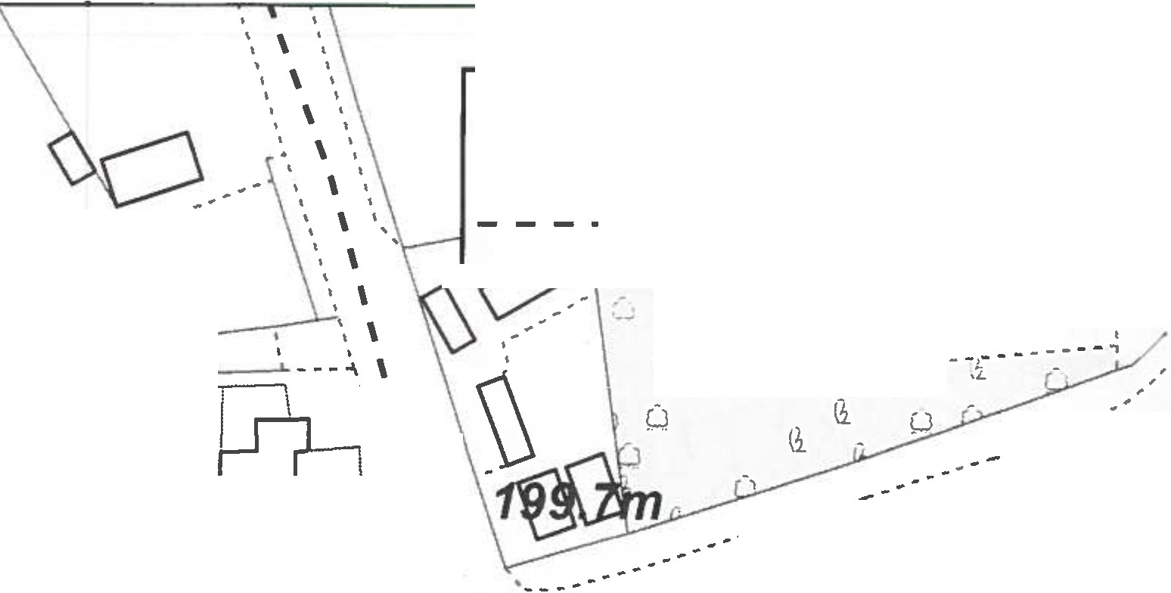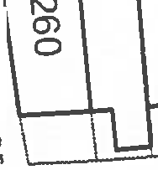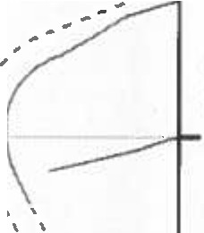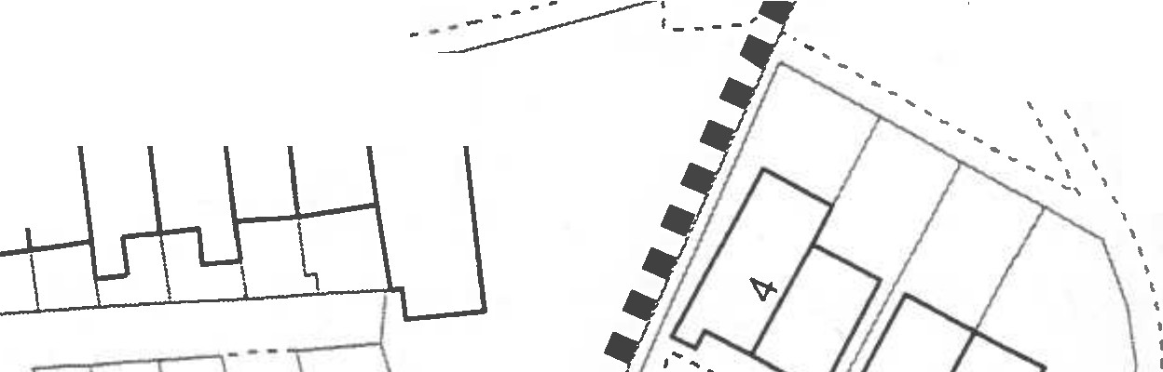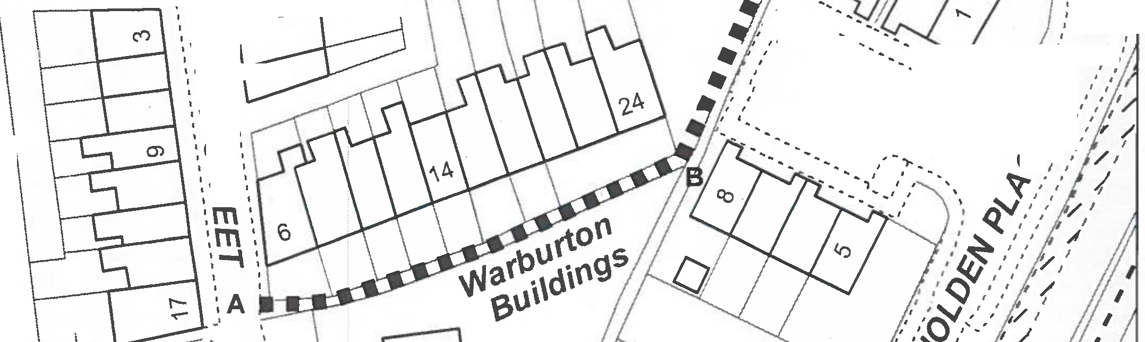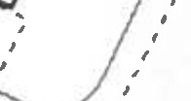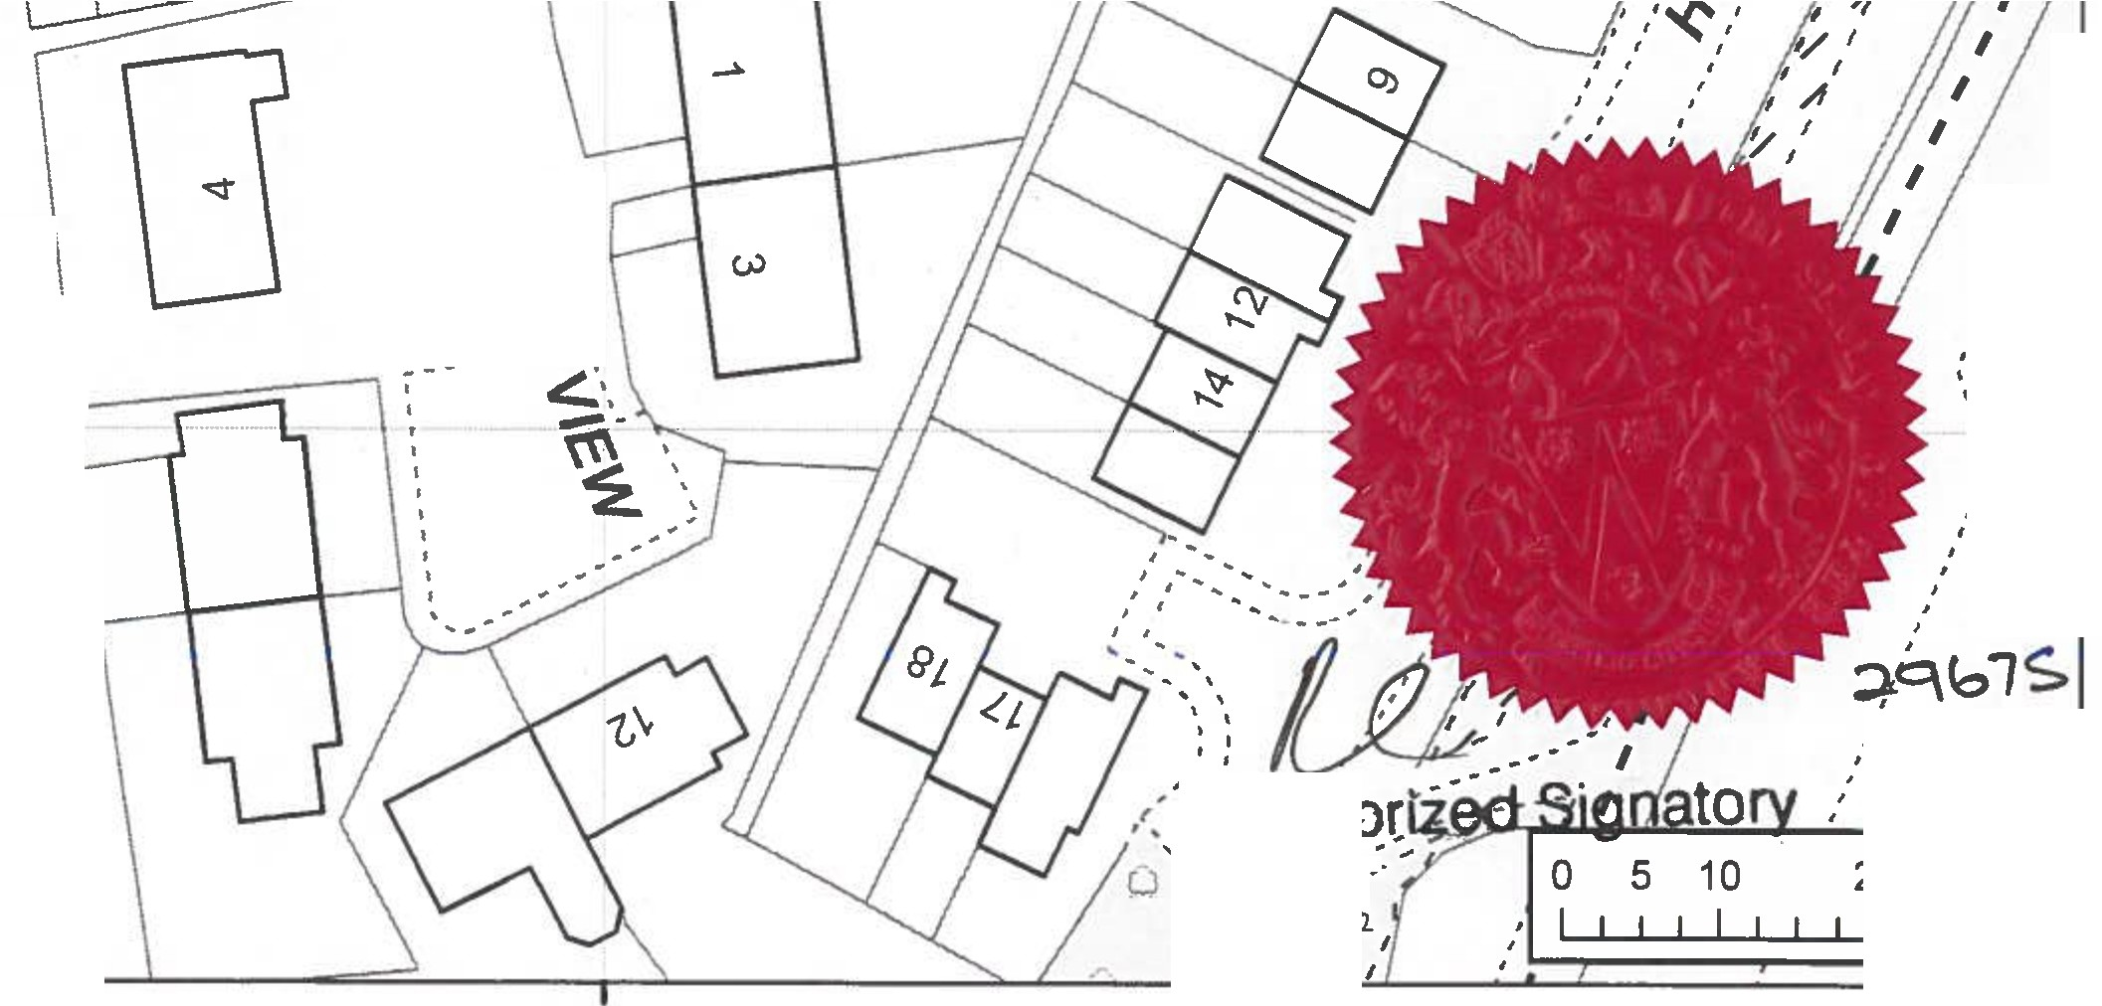

D

* ■ ■ **1** Order route

## Existing Public Footpaths

o□ ' : --.. ,

'. \

''. \

i

r,l Q:.. - - ..- -�- -�--

, , ' '

.-

C):

:ti:

�:

�: 85

('")

t-­

N

261

.. \

'. \

\

\

**56232**

-·

*:*

0 *en:* i-I--I -.I l l l I 1 1 I 1 1 � _ _ _ _ _ �

0

in

-

N

## •N \ ----------------------------------------- *r* \

*.-::*· *··:··;.*·;·-,·. "i�\.""f•• ov�

, ,

\

'

-..\.. -

•••�-�.-�.o- ·-:.·-�*-*�*�:·::,:,*·.

--� \\

'. \ \

\ ' '

\..

0

0

II)

N

•N

CX)

\

\ \

\ \

\ \

\ \

\ \

co

C:92:

\ \'.\

N ''<.'

·�·

\ )>'

-,�·

**'oC:,:',**: ,..-:-_ 7

# ::0\' N

**-I** . r �

*I* ' *r* •

..

r,., *I* ""

*I*

-·..-,.-2/ *I.:*

' '

'I' I

\

f I

I I

**o\** I *I*

I

**z**

----*&:'*

(/)

**-I**

# ::0

' ,

""'- .... -- ,' *I*

\ \.

'I

**C)**

�1 '**\**"**t\**

g

� /)

�

•

\ .

\. ,,...' ,

·�\

\'---\

'(/)• *I* '

\�\

### '-,c.\

**'""I'\•**

, ,

--�l\

--

0

0

* •i

·- **-::I0** , N

**m** *I*

--�\**1!\**

-�

' li

*-_,:·***Aut'tl**

' ... / ,,.

...,,"," ,' , ,","

0

*t'* , ' .. *I*

*I* ,,w

377900

LCaoun=ty 1e• l [PROW@lancashire.gov.uk](mailto:PROW@lancashire.gov.uk)

Public Rights of Way I

Counc:U

01772 530317

Wildlife and Countryside Act 1981

Addition of Footpath from Warburton Street to Grane Road, Hasllngden

I

**1:750**

·•·

>

The digitisedRlghb al Wr,y infannatian should be used far guidance only II ill accuracy cannot be guaranteld. Rlghtl al Way inlannetian must be vlrified an the current Definitive Map blfare being supplied or used far any purpose.

This Map Is repraduc1d from Ordnance Survay material with the pennls■ion al Ordnance Survey an behalf of the controller al H.- Majesty's Stationery Office (C) Crawn CopyrighL Unautharl11d reproduction infringes Crown Copyright and may lead *to* Prasacutian or civil pracNdings. Lancashlnt County Council Ucence Na.100023320

20 Meters

l