NOTICE OF ORDER
Wildlife and Countryside Act 1981

Leicestershire County Council

Addition of Public Footpath N111 within the Unparished Area of Coalville -
DMMO 2022

Notice is hereby given that the above referenced Order has been submitted to the Secretary of State for Environment, Food and Rural Affairs for determination. An Inspector will be appointed by the Secretary of State to determine the Order.

The start date for the above Order is 14 October 2025.

Consideration of the Order will take the form of exchanges of statements of case and comments on statements of case.

The effect of the Order, if confirmed without modifications, will be to modify the Definitive Map and Statement for the area by adding Footpath N111 which will extend from a point marked “A” on the plan situated at a junction with Forest Road (grid reference 44315 31376) in generally south south-easterly and southerly directions along the access drive and through the parking area of Scotlands Playing Fields for a distance of approximately 82 metres to a point marked “B” on the plan situated at Grid Reference 44318 31369. Then continuing in generally southerly and south easterly directions along the tarmac path of Scotlands Playing Fields for a distance of approximately 237 metres to a point marked “C” on the plan situated at the access gate for the Bowling Club (44335 31353). Then continuing in a generally south easterly direction through the curtilage of the bowling club and storage area for a distance of approximately 68 metres to a point marked “D” on the plan situated at Grid Reference 44341 31349. Finally continuing in a generally east south-easterly direction for a distance of approximately 175 metres to a point marked “E” on the plan situated at a junction with Public Footpath N86 (grid reference 44355 31340) as shown on the Order Map.
The Additional Footpath will have a specified width of 3 metres.

Any queries relating to this Order should be referred to Paul Scrivener by email: paul.scrivener@planninginspectorate.gov.uk quoting reference number ROW/3349549 on all correspondence. Alternatively, queries may be sent in writing to The Planning Inspectorate, Rights of Way Section, Room 3/A Eagle Wing, Temple Quay House, 2 The Square, Temple Quay, Bristol, BS1 6PN. Telephone: 0303 444 5000.
Any person wishing to view the statements of case and other documents relating to this Order may do so by appointment at Room 200, Main Building, County Hall, Glenfield, Leicester and the offices of North West Leicestershire District Council, Whitwick Road, Coalville Leicestershire LE67 3FJ.

Contact: kevin.jukes@leics.gov.uk tel: 0116 305 1272
Timetable for sending in statements of case and comments
Within 2 weeks of the start date by 28 October 2025
The Order Making Authority, or where the Order Making Authority is taking a neutral stance and the applicant or other party are taking the case forward in support of the order, must ensure their statement of case is received by the Secretary of State. As soon as possible after the deadline, the Secretary of State will send a copy (excluding copies of any supporting documents - these will be available to view at the Authority’s offices) to everyone who has made an objection or representation, the applicant and any other person who has written to us in respect of the Order.

Within 8 weeks of the start date by 9 December 2025
Everyone who has made an objection or representation or any other written representation or any other person wishing to make representations in writing must ensure their statement of case is received by the Secretary of State. As soon as possible after the deadline, the Secretary of State will send full copies to the Authority. Copies (excluding copies of any supporting documents - these will be available to view at the Authority’s offices) will also be sent to the applicant, every person who has made an objection or representation and any other person who has written to us in respect of the Order.

Within the same period the applicant (if applicable) must ensure their statement of case is received by the Secretary of State. As soon as possible after the deadline, Secretary of State will send a full copy to the Authority. Copies will also be sent to everyone who has made an objection or representation and any other person who has written to us in respect of the Order (excluding copies of any supporting documents - these will be available to view at the Authority’s offices).

Within 14 weeks of the start date by 20 January 2026
Everyone who has made an objection or representation, the Authority, the applicant (if applicable) and anyone who has written to us in respect of the Order must ensure that their comments on any or every other statement of case is received by the Secretary of State. As soon as possible after the deadline, the Secretary of State will send copies of these comments to everyone else.

In fairness to the other parties everyone should keep to the timetable to ensure that statements of case and comments are received on time. Late documents will be returned.
We cannot accept any inflammatory, discriminatory or abusive comments. Any documents containing such comments will be returned.
If you use Artificial Intelligence (AI) to create or alter any part of your documents, information or data, you should tell us that you have done this when you provide the material to us. See the detailed guidance for further information.

Notice of order for w/r

#

LEICESTERSHIRE COUNTY COUNCIL

SECTION 53 - WILDLIFE AND COUNTRYSIDE ACT 1981

DEFINITIVE MAP AND STATEMENT FOR THE COUNTY OF LEICESTERSHIRE

ADDITION OF PUBLIC FOOTPATH N111

WITHIN THE UNPARISHED AREA OF COALVILLE

DEFINITIVE MAP MODIFICATION ORDER 2022

._
LEICESTERSHIRE COUNTY COUNCIL

SECTION 53 - WILDLIFE AND COUNTRYSIDE ACT 1981

DEFINITIVE MAP AND STATEMENT FOR THE COUNTY OF LEICESTERSHIRE

ADDITION OF PUBLIC FOOTPATH N111

WITIHIN THE UNPARISHED AREA OF COALVILLE DEFINITIVE MAP MODIFICATIQNQBQE_R 2022
This Order is made by Leicestershire County Council (hereinafter called "the surveying authority") under Section 53(2)(b) of the Wildlife and Countryside Act 1981 because it appears to the surveying authority, that the Definitive Map and Statement for the County of Leicestershire require modification in consequence of the occurrence of an event specified in Section 53(3)(c)(i) namely the discovery by the surveying authority of evidence which (when considered with all relevant evidence available to the surveying authority) shows that a right of way which is not shown in the map and statement subsists or is reasonably alleged to subsist over land in the area to which the map relates being a right of way such that the land over which the right subsists is a public footpath within the Unparished Area of Coalville and the District of North West Leicestershire as shown by a broken black line on Plan N,o.M1207 annexed hereto and described in the Schedule hereto.

The surveying authority has consulted with every local authority whose area includes the land to which the Order relates. The surveying Authority hereby order that:-

- For the purpose of this Order the relevant date is 26th May 2022.
- The Definitive Map and Statement for the County of Leicestershire shall be modified as described in Part I and Part II of the Schedule and shown on the map attached to the Order.
- This Order shall take effect on the date it is confirmed and may be cited as the "Leicestershire County Council (Addition of Public Footpath N111 within the Unparished Area of Coalville) Definitive Map Modification Order 2022."

SCHEDULE

PART 1

#
MODIFICATION OF DEFINITIVE MAP OF LEICESTERSHIRE

Description of Public Footpath N111 within the Unparished Area of Coalville to be added to the Definitive Ma_p_ of Leicestershire

A footpath within the Unparished area of Coalville and the District of North West Leicestershire, shown by a broken black line on Plan No. M1207, will extend from a point marked "A" on the plan situated at a junction with Forest Road (grid reference 44315 31376) in generally south south-easterly and southerly directions along the access drive and through the parking area of Scotlands Playing Fields for a distance of approximately 82 metres to a point marked "B" on the plan situated at Grid Reference 44318 31369. Then continuing in generally southerly and south easterly directions along the tarmac path of Scotlands Playing Fields for a distance of approximately 237 metres to a point marked "C" on the plan situated at the access gate for the Bowling Club (44335 31353). Then continuing in a generally south easterly direction through the curtilage of the bowling club and storage area for a
distance of approximately 68 metres to a point marked "D" on the plan
't
situated at Grid Reference 44341 31349. Finally continuing in a generally east south-easterly direction for a distance of approximately 175 metres to a point marked "E" on the plan situated at a junction with Public Footpath N86 (grid reference 44355 31340).

Width of 3 metres

PART2
MODIFICATION OF DEFINITIVE STATEMENT OF LEICESTERSHIRE ADDITION OF PARTICULARS OF FOOTPATH N111
,
The entry for footpath A118 to be added to read:-

Reference Number N111
O.S MaQ SK41 SW
Status Location

Footpath From Forest Road to
Public Footpath N86, Coalville

Parish: Unparished area of Coalville

Width

3 metres
Limitations and Conditions None
Relevant Date 25th May 2022

THE COMMON SEAL of THE LEICESTE�SHIRE COUNTY COUNCIL was
v�
hereunto affixed this
P1 Day of June 2022 in the presence of:-
3�->'151
ff
Authorised Officer
;I_,�
!�Ld�d_iicteist··e·r·s-hie·r c�11-n�y �ou.ncil
r . . on �f.public Foot - �
Location Plan
D,���m- 1tive M�ap IVIOd\ if�iC6a�(\t�t��N�11oJ
�y�,ri�_t�-���}hW�USn/4p?]a�r;i�s�hl�dArea ofCoalville•" Ill\ II I, ...

", ...:. ......
',,,I

3M51(o)
I I F--
I ,\\\���\ \\� \i\ I �

Key
I /72 \\ \\\v�
---

Public Footpath to be
Added(A-B-C-D-E)

Existing Public Footpaths
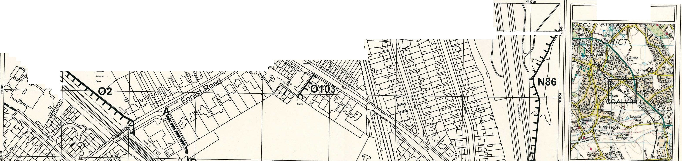
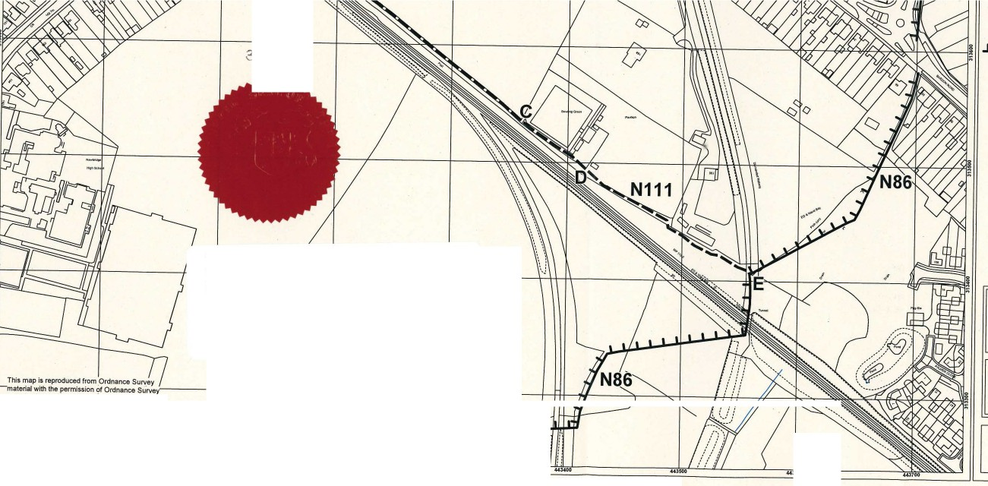
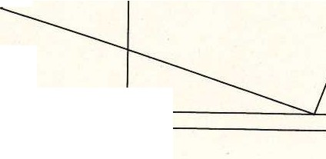
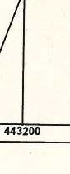

THE COMMON SEAL of THE LEICESTERSHIRE COUNTY COUNCIL was
Environment & Transport Department, County Hall, Glenfield,
Leicestershire LE3 8RJ email footpaths@leics.gov.uk Director Ann Carruthers
h!Leicestershire
County Council

hereunto affixed this
1st Day of June 2022 in the presence of:-
/1-
(j,rJ-,-✓_J
Authorised Officer

!!I This map is reproduced from _Ordnance Su"(ey , �
1
;? material with the permission of Ordnance Surve
" on behalf of the Controller of Her Majesty's, Stationary Office 10 Crown coryright.
Plan No.M1207
Scale 1:2500 @A3
Unauthorised reproduction infringes Crown copyright and may lead to prosecution or civil proceedings. Leicestershire County
Council 100019271. Published 30 October 2020
443000 443100 � .moo mToo

