NOTICE OF ORDER
Highways Act 1980
Norfolk County Council

Norfolk County Council (Shipdham Footpath No. 19a) Creation Order 2023 and Norfolk CC (Shipdham Footpath No. 19) Extinguishment Order 2023

Notice is hereby given that the above referenced Order has been submitted to the Secretary of State for Environment, Food and Rural Affairs for determination. An Inspector will be appointed by the Secretary of State to determine the Order.

The start date for the above Order is 7 October 2025.

Consideration of the Orders will take the form of exchanges of statements of case and comments on statements of case.
Creation Order - The effect of the Order, if confirmed without modifications will be to create a public footpath starting from the U31172, Parklands Avenue at grid reference TF9566 0706 and runs in a generally south easterly direction for approximately 36.4 metres to grid reference TF9569 0705 and continues in a generally south westerly direction for approximately 11.4 metres to grid reference TF9569 0705 and continues in a generally south easterly direction for approximately
3.8 metres to grid reference TF9569 0703, as shown on the Order map.

The route's width is as follows; Between grid reference TF9566 0706 and grid reference TF9569 0705 - 1.6 metres Between grid reference TF9569 0705 and grid reference TF9569 0705 - varies between 1.5 and 1.6 metres & Between grid reference TF9569 0705 and grid reference TF9569 0703- varies between 1.4 and 1.6 metres.
Limitations and Conditions: none.

Extinguishment Order - The effect of the Order, if confirmed without modifications, will be to extinguish the full width of the public footpath starting at the U31172, Parklands Avenue at grid reference TF9566 0706 and running in a generally south easterly direction for approximately 33.5 metres to grid reference TF9569 0704 and continuing in a generally south south westerly direction for approximately 11.6 metres to grid reference TF9568 0703 and continuing in a generally east north easterly direction for approximately 16 metres to grid reference TF9570 0703 and continuing in a generally south easterly direction for approximately 11.9 metres to grid reference TF9571 0703, as shown on the Order map.

Any queries relating to this Order should be referred to Paul Scrivener by email: paul.scrivener@planninginspectorate.gov.uk quoting reference number ROW/3355768 on all correspondence. Alternatively, queries may be sent in writing to The Planning Inspectorate, Rights of Way Section, Room 3/A Eagle Wing, Temple Quay House, 2 The Square, Temple Quay, Bristol, BS1 6PN. Telephone: 0303 444 5000.

Any person wishing to view the statements of case and other documents relating to this Order may do so by appointment at Norfolk County Council, County Hall, Martineau Lane, Norwich, NR1 2DH. Contact Lawrence Malyon by email: Lawrence.malyon@norfolk.gov.uk tel: 01603 224253

Timetable for sending in statements of case and comments
Within 2 weeks of the start date [by 21 October 2025]
The Order Making Authority, or where the Order Making Authority is taking a neutral stance and the applicant or other party are taking the case forward in support of the order, must ensure their statement of case is received by the Secretary of State. As soon as possible after the deadline, the Secretary of State will send a copy (excluding copies of any supporting documents - these will be available to view at the Authority’s offices) to everyone who has made an objection or representation, the applicant and any other person who has written to us in respect of the Order.
Within 8 weeks of the start date by 9 December 2025
Everyone who has made an objection or representation or any other written representation or any other person wishing to make representations in writing must ensure their statement of case is received by the Secretary of State. As soon as possible after the deadline, the Secretary of State will send full copies to the Authority. Copies (excluding copies of any supporting documents - these will be available to view at the Authority’s offices) will also be sent to the applicant, every person who has made an objection or representation and any other person who has written to us in respect of the Order.
Within the same period the applicant (if applicable) must ensure their statement of case is received by the Secretary of State. As soon as possible after the deadline, Secretary of State will send a full copy to the Authority. Copies will also be sent to everyone who has made an objection or representation and any other person who has written to us in respect of the Order (excluding copies of any supporting documents - these will be available to view at the Authority’s offices).

Within 14 weeks of the start date by 20 January 2026
Everyone who has made an objection or representation, the Authority, the applicant (if applicable) and anyone who has written to us in respect of the Order must ensure that their comments on any or every other statement of case is received by the Secretary of State. As soon as possible after the deadline, the Secretary of State will send copies of these comments to everyone else.
In fairness to the other parties everyone should keep to the timetable to ensure that statements of case and comments are received on time. Late documents will be returned.

We cannot accept any inflammatory, discriminatory or abusive comments. Any documents containing such comments will be returned.

If you use Artificial Intelligence (AI) to create or alter any part of your documents, information or data, you should tell us that you have done this when you provide the material to us. See the detailed guidance for further information.

Notice of order for w/r
PUBLIC PATH CREATION ORDER HIGHWAYS ACT 1980

NORFOLK COUNTY COUNCIL (SHIPDHAM FOOTPATH NO. 19a) CREATION ORDER 2023

This order is made by Norfolk County Council ("the authority") under section 26 of the Highways Act 1980 ("the 1980 Act") because it appears to the authority that, having regard to the matters set out in section 26(1), there is a need for a public footpath over the land to which this order relates, and that it is expedient that the path should be created.

Breckland District Council has been consulted as required by section 26(3) of the 1980 Act.

BY THIS ORDER:

- There shall be at the end of 42 days from the date of confirmation of this order a public footpath over the land at Shipdham described in the Schedule to this order and shown by bold broken lines on the map contained in this order.

- Notwithstanding paragraph 1 of this order the public right of way over the land situate at Shipdham described in the Schedule to this order and shown by bold broken lines on the map attached to this order shall not be created unless the concurrent 'Norfolk County Council (Shipdham Footpath No. 19) Extinguishment Order 2023' is confirmed.

SCHEDULE PART1
DESCRIPTION OF LAND

Starts from the U31172, Parklands Avenue at grid reference TF9566 0706 (point A on the map attached to this order) and runs in a generally south easterly direction for approximately 36.4 metres to grid reference TF9569 0705 (point B on the map attached to this order) and continues in a generally south westerly direction for approximately 11.4 metres to grid reference TF9569 0705 (point C on the map attached to this order) and continues in a generally south easterly direction for approximately 3.8 metres to grid reference TF9569 0703 (point D on the map attached to this order).

The route's width is as follows;
Between grid reference TF9566 0706 and grid reference TF9569 0705 - 1.6 metres Between grid reference TF9569 0705 and grid reference TF9569 0705 - varies between 1.5 and 1.6 metres
Between grid reference TF9569 0705 and grid reference TF9569 0703 - varies between 1.4 and 1.6 metres.

PART2 LIMITATIONS AND CONDITIONS
None.

Dated this J.��c.\ day of tvave,...-.\aif 2023.

THE COMMON SEAL of the NORFOLK COUNTY COUNCIL
was hereunto affixed in the.----------::-:-: 7
presence
f Authorised to sign on behalf of the
O :-
Director Legal Services (nplaw) & Monitoring Officer Norfolk County Council
.........................�. ) ......�..................
r/._',<. - - )\ . '1- {_
Date:.......,............................:z. ..........•. ...•.• ..
Director of Legal Services

J

J
......
595600 000000 595700 000000 595800 000000
::=--1 \,,/'

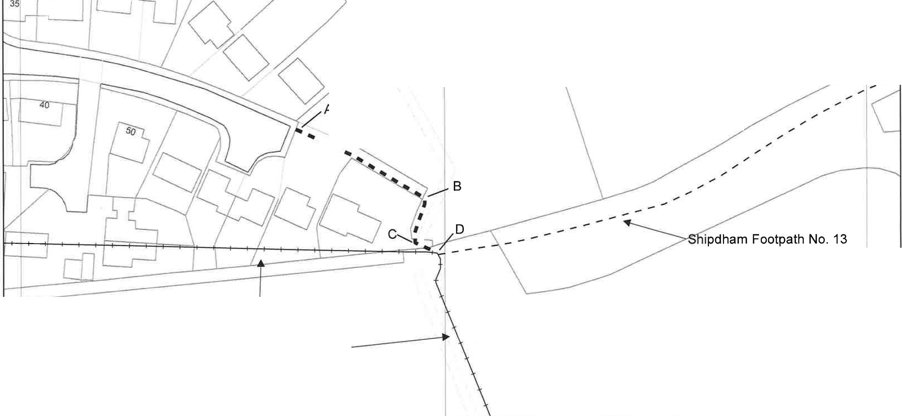
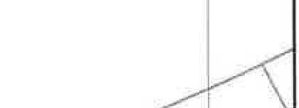
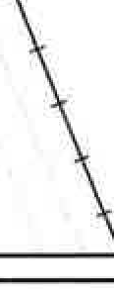
F77j�' � ,I ,I I _J ..._ / I
�/'
._ ._
"B'o"u"r ''� <

\:�,)

0

� I �. "II

5)
Shipdham Bridleway No. 15 - °k
o/

g➔-1--
0,.._
..,
0

© [Crown copyright and database rights 019 Ordnance Survev 100019340
5
Scale:
1:750
Date created: 20/11/2023
N
A
Unaffected public footpath - - - - - Unaffected public bridleway
Highways Act 1980, Section 26
Norfolk County Council (Shipdham) Creation Order 2023

Public footpath to be created (A-B-C-0) - - - - - - - 595,701.9i�te3°67�5�7.1892

PUBLIC PATH EXTINGUISHMENT ORDER HIGHWAYS ACT 1980

NORFOLK COUNTY COUNCIL (SHIPDHAM FOOTPATH NO. 19) EXTINGUISHMENT ORDER 2023

This order is made by Norfolk County Council ("the authority") under section 118 of the Highways Act 1980 ("the 1980 Act") because it appears to the authority that the footpath described in paragraph 1 of this order below is not needed for public use.

The Shipdham Parish Council and Breckland District Council have been consulted and have consented to the making of the order as required by section 120(2) of the 1980 Act.

BY THIS ORDER:

- The public right of way over the land situate at Shipdham shown by a continuous bold line on the map attached to this order and described in the Schedule to this order shall be extinguished after 42 days from the date of confirmation of this order.

- Notwithstanding paragraph 1 of this order the public right of way over the land situate at Shipdham shown by a continuous bold line on the map attached to this order and described in the Schedule to this order shall not be extinguished unless the concurrent 'Norfolk County Council (Shipdham Footpath. 19a) Creation Order 2023' is confirmed.

- Notwithstanding paragraph 1 of this order statutory undertakers shall continue to have the same rights over the land referred to in paragraph 1 above for the purpose of carrying on their undertaking where, immediately before the date on which the highway is extinguished in pursuance of this Order, there is apparatus owned by them on, under or over that highway.
, I

Dated this � ! day of � �

2023.

THE COMMON SEAL of the NORFOLK COUNTY COUNCIL
was hereunto affixed in the presence of:-
Director Legal sign
Authorised to
Services
?n behalf of the
r tnP1
aw
) & Monitoring Officer
Norfolk County Council
•••••••••••••••••••••F••••••••·D••••I••)•••....,,
Date: ........,...,.._L....-.....•..).1...•...'..1...-.'.3.......................

Director of Legal Services
SCHEDULE

Shipdham Footpath No. 19 The full width of the public footpath starting at the U31172, Parklands Avenue at grid reference TF9566 0706 (point A on the map attached to this order) and running in a generally south easterly direction for approximately 33.5 metres to grid reference TF9569 0704 (point B on the map attached to this order) and continuing in a generally south south westerly direction
) for approximately 11.6 metres to grid reference TF9568 0703 (point C on the map attached to this order) and continuing in a generally east north easterly direction for approximately 16 metres to grid reference TF9570 0703 (point D on the map attached to this order) and continuing in a generally south easterly direction for approximately 11.9 metres to grid reference TF9571 0703 (point E on the map attached to this order).

j

J
\,_
595600 oooaoc 595700 000000 595800000000
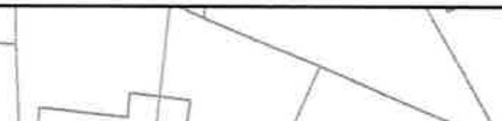

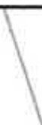
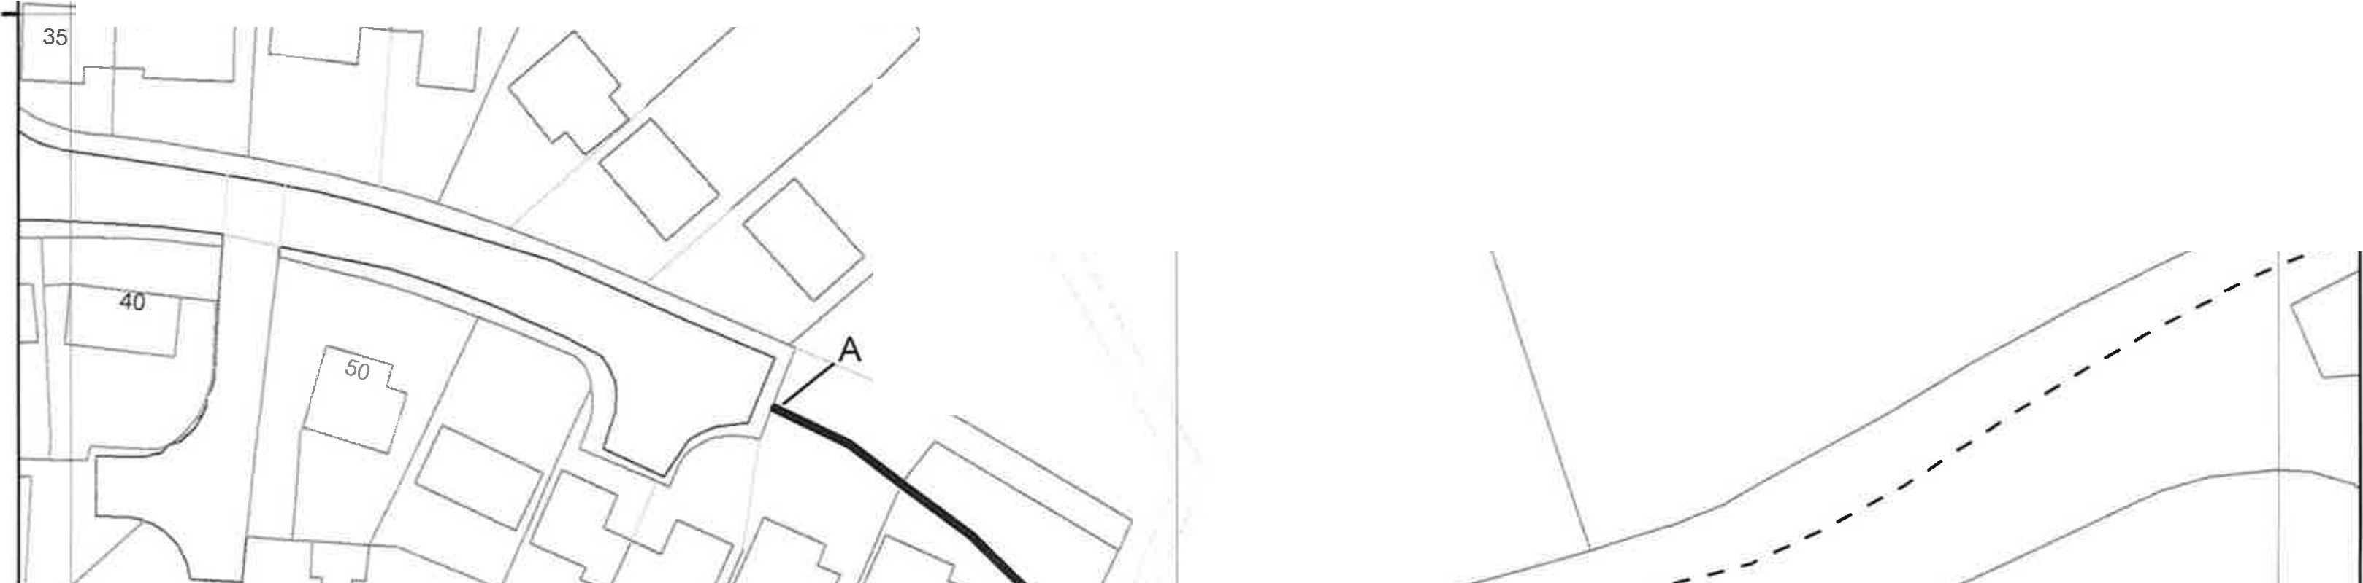
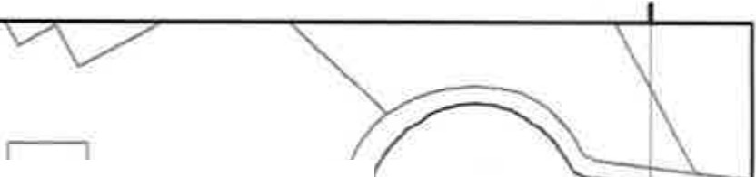
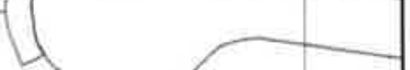
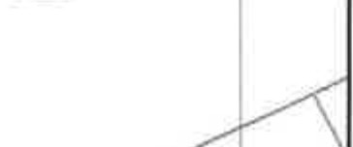
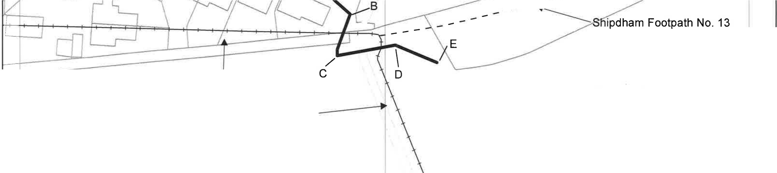
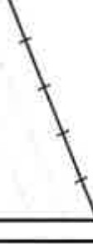
L_

0
0
...
....
0

�� I

- rI L

IT /
�/ ----"\
>'--- I
--' I I I
M
Bour 0

� I 1

-- --....

Shipdham Bridleway No. 15 -
...D
�.-c

0
0
0....
0
M
---.; , -+---ji-g
0....
0
M
I
© Crown copyright and database rights
2019 Ordnance Survev 100019340 �

Norfolk County Council (Shipdham Footpath No. 19) Extinguishment Order 2023  Route to be extinguished (FP19) A-B-C-D-E  Unaffected Footpath - - - - - - - Centre of maP.:  Unnaffected Bridlewav -+--+---+---+--+- 595,701.3647 307,047.3657 | Date created: 20/11/2023 | N  A
 | Scale:  1:750 | N  A

