NOTICE OF ORDER
Wildlife and Countryside Act 1981
Lancashire County Council

The Lancashire County Council - Footpath at Ayrefield Road and Ayrefield
House, Up Holland DMMO 2019

Notice is hereby given that the above referenced Order has been submitted to the Secretary of State for Environment, Food and Rural Affairs for determination. An Inspector will be appointed by the Secretary of State to determine the Order.
The start date for the above Order is 23 September 2025

Consideration of the Order will take the form of exchanges of statements of case and comments on statements of case.
The effect of the Order, if confirmed without modifications, will be to add a footpath from a point on Ayrefield Road immediately east of 59 Ayrefield Road at SD 5229 0758 (point A on the Order Map) to continue along Ayrefield Road in an approximately easterly direction to SD 5257 0763 (point B) where the footpath leaves the road immediately before the gated entrance into Ayrefield House and passes through a gate to continue in a generally easterly direction along a track through the grounds of Ayrefield House to SD 5265 0763 (point C) where it turns to continue in a generally south south easterly direction across an open area to a kissing gate on the field boundary to meet Footpath Up Holland 2 at SD 5267 0760 (point D) as shown on the Order Map by a broken black line.

Any queries relating to this Order should be referred to Paul Scrivener by email: paul.scrivener@planninginspectorate.gov.uk quoting reference number ROW/3351718 on all correspondence. Alternatively, queries may be sent in writing to The Planning Inspectorate, Rights of Way Section, Room 3/A Eagle Wing, Temple Quay House, 2 The Square, Temple Quay, Bristol, BS1 6PN. Telephone: 0303 444 5000.

Any person wishing to view the statements of case and other documents relating to this Order may do so by appointment at County Hall, Fishergate, Preston, PR1 0LD, for further information please contact Simon Moore at simon.moore@lancashire.gov.uk or on 01772 531280. Documents have also been made available online. To access the documents, please use the following URL address: https://www.lancashire.gov.uk/council/transparency/dmmos/ayrefield-road- 2019/
Timetable for sending in statements of case and comments Within 2 weeks of the start date by 7 October 2025
The Order Making Authority, or where the Order Making Authority is taking a neutral
stance and the applicant or other party are taking the case forward in support of the order, must ensure their statement of case is received by the Secretary of State. As soon as possible after the deadline, the Secretary of State will send a copy (excluding copies of any supporting documents - these will be available to view at the Authority’s
offices) to everyone who has made an objection or representation, the applicant and any other person who has written to us in respect of the Order.
Within 8 weeks of the start date by 19 November 2025
Everyone who has made an objection or representation or any other written representation or any other person wishing to make representations in writing must ensure their statement of case is received by the Secretary of State. As soon as possible after the deadline, the Secretary of State will send full copies to the Authority. Copies (excluding copies of any supporting documents - these will be available to view at the Authority’s offices) will also be sent to the applicant, every person who has made an objection or representation and any other person who has written to us in respect of the Order.

Within the same period the applicant (if applicable) must ensure their statement of case is received by the Secretary of State. As soon as possible after the deadline, Secretary of State will send a full copy to the Authority. Copies will also be sent to everyone who has made an objection or representation and any other person who has written to us in respect of the Order (excluding copies of any supporting documents - these will be available to view at the Authority’s offices).
Within 14 weeks of the start date by 31 December 2025
Everyone who has made an objection or representation, the Authority, the applicant (if applicable) and anyone who has written to us in respect of the Order must ensure that their comments on any or every other statement of case is received by the Secretary of State. As soon as possible after the deadline, the Secretary of State will send copies of these comments to everyone else.

In fairness to the other parties everyone should keep to the timetable to ensure that statements of case and comments are received on time. Late documents will be returned.
We cannot accept any inflammatory, discriminatory or abusive comments. Any documents containing such comments will be returned.

If you use Artificial Intelligence (AI) to create or alter any part of your documents, information or data, you should tell us that you have done this when you provide the material to us. See the detailed guidance for further information.

Notice of order for w/r
WILDLIFE AND COUNTRYSIDE ACT 1981

THE DEFINITIVE MAP AND STATEMENT OF PUBLIC RIGHTS OF WAY FOR THE COUNTY OF LANCASHIRE

THE LANCASHIRE COUNTY COUNCIL
FOOTPATH AT AYREFIELD ROAD AND AYREFIELD HOUSE, UP HOLLAND DEFINITIVE MAP MODIFICATION ORDER 2019

This Order is made by Lancashire County Council ("the authority11) under Section 53(2)(b) of the Wildlife and Countryside Act, 1981 ("the Act") because it appears to that authority that The Definitive Map and Statement of Public Rights of Way for the County of Lancashire require modification in consequence of the occurrence of an event specified in Section 53(3)(b) and/or 53(3)(c)(i) namely the expiration of any period such that the enjoyment by the public of the way during that period raises a presumption that the way has been dedicated as a public path and/or the discovery by the surveying authority of evidence which (when considered with all other relevant evidence available to them) shows that a right of way which is not shown in the map and statement subsists or is reasonably alleged to subsist over land in the area to which the map relates, namely a public footpath

The authority have consulted with every local authority whose area includes the land to which the Order relates. Lancashire County Council hereby order that:
- For the purposes of this Order, the "relevant date" is 13th February 2019.

- The Definitive Map and Statement of Public Rights of Way for the County of Lancashire shall be modified as described in Part I and Part II of the Schedule and shown on the map attached to the Order.

- This Order shall take effect on the date it is confirmed and may be cited as The Lancashire County Council Footpath at Ayrefield Road and Ayrefield House, Up Holland Definitive Map Modification Order 2019.

Dated this 13th day of February 2019.

THE COMMON SEAL of the )
Lancashire County Council ) was hereunto affixed in the presence of )

Authorised Signatory ��

ZTlto5>

SCHEDULE

PARTI
MODIFICATION OF THE DEFINITIVE MAP

QESCRIPTION OF PATH OR WAY TO BE ADDED

Footpath from a point on Ayrefield Road immediately east of 59 Ayrefield Road (point A on the Order Map) to continue along Ayrefield Road in an approximately easterly direction for a distance of approximately 285 metres to point Bon the Order Map where the footpath leaves the road immediately before the gated entrance into Ayrefield House and passes through a gate to continue in a generally easterly direction along a track through the grounds of Ayrefield House to point C where it turns to continue in a generally south south easterly direction across an open area to a kissing gate on the field boundary to meet Footpath Up Holland 2.
The route is shown on the Order Map between points A-8-C-D as a broken bold black line.

The total length of the route is 0.40 km and the width varies between 3.5 and 7 metres along Ayrefield Road (between points A-8) and 4.5 and 2.5 metres through the grounds of Ayrefield House (points B-C-D).

PART II

MODIFlCATION OF_ DEFINITIVE STATEMENT

VARIATION OF PARTICULARS OF PATH OR WAY

The Statement to be amended for Up Holland 2 to read as follows: No. of path: 11211
Kind of path: 11Footpath11

Position: •commencing at the eastern end of the publicly maintainable section of Ayrefield Road (U1167) at SD 5229 0758 immediately east of 59 Ayrefield Road to continue east along Ayrefield Road in an easterly direction for 285 metres to point SD 5257 0763 where the footpath leaves the road immediately before the gated entrance into Ayrefield House and passes through a gate to continue in an easterly direction along a track through the grounds of Ayrefield House to SD 5265 0763 where it turns to continue in a south south easterly direction immediately south of a brick building to continue across an open area to a kissing gate on the field boundary at SD 5267 0760. The footpath continues southerly and thence easterly to weir near Dean Cottage.

All compass directions given are approximate." Length: "1.23 km"
Other particulars:
"SD 5229 0758 to SD 5257 0763 -Width varies between 3.5 and 7 metres.
SD 5265 0763 to SD 5267 0760 - width varies between 4.5 and 2.5 metres

Limitations between SD 5229 0758 and SD 5267 0760:
Gate at SD 5257 0763
Kissing gate at SD 5267 0760"
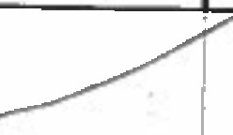
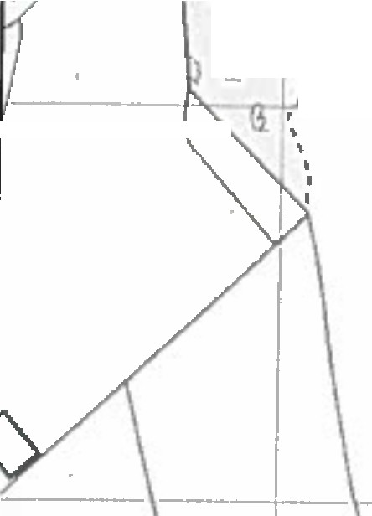

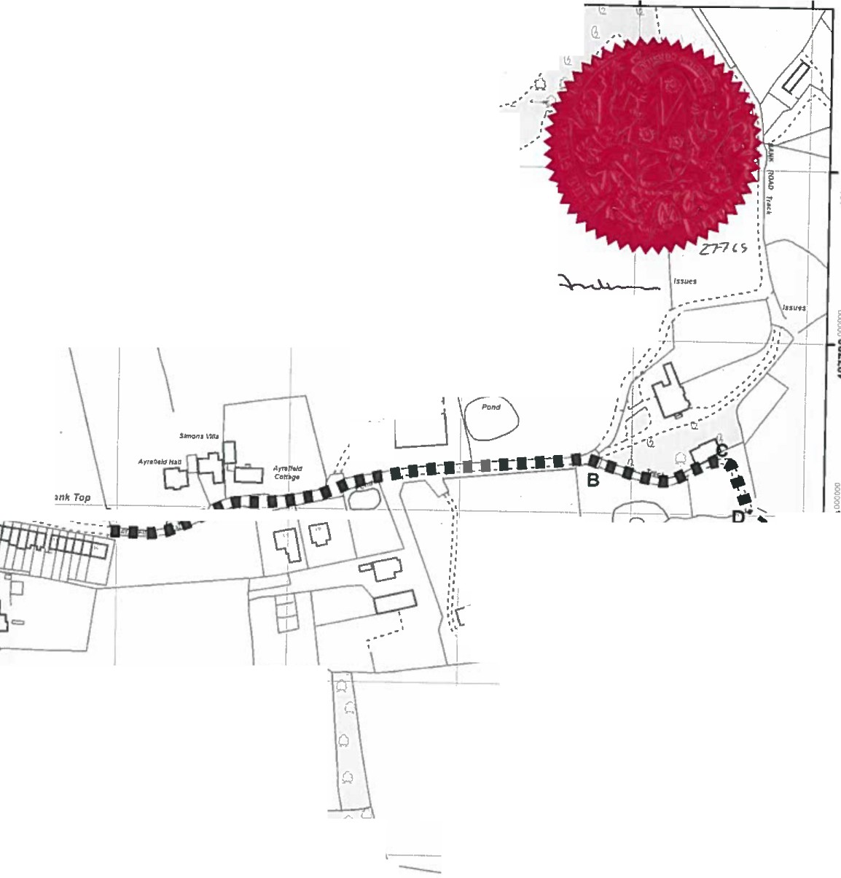
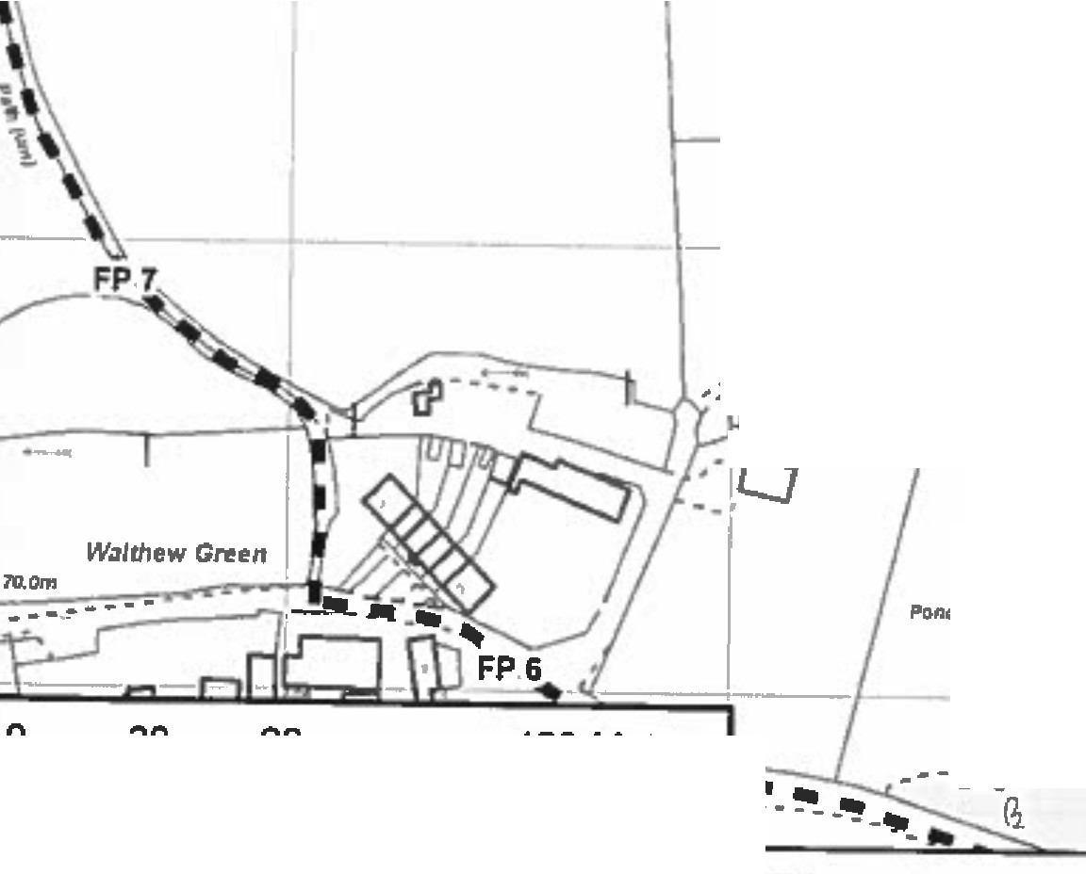
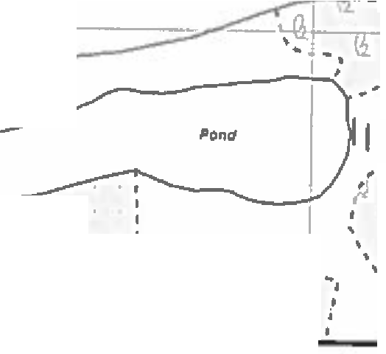

""�"" Jo..:4uu-=0 352500oc, 352600OOlml
35270ooooooc
I 12. Q I , I .
,
'c:. ,
,
Q ,
r1 .,_.._
t', Q \ I -- J 1· -
I
!.,.,.l • , ... I
G. o
17. G. Q,_
.,,
n I \'
G. •
,.I•.

�\
I
'
g ...l.l' 1"'-r
.....\ d G.
\�-------- a- ...o-......

,C.I_O
..,
Q
' \.'.
I'.\,IS,: .
.
\ ..
\\,.

fSl1'H
i
---
i
�..
..''.
''
''....
'.
\ I
�
I ••',',,, I
ot_., \----+--\--------
,.
�
•,' ,-----\--+ 1--
,,
\\"..... ... t \ \ J Ar�n�,r1 Hou3e
1
I I (C'DnVffl1 ot NOlrtDam�,
C
�..
�

,, ,
,,, ,

I

, , , ,
,
.
," .''.I
.
--..

§
t
§
8�•-••••_:--••m ,v,- \:,;------..;..�-�---\\-✓-
.I.:,;
CO

1
::i;l

�nd

I J - �\I
t-,C
�..
5
;:: I
'
,,1
,.,,,
O
•:
,I.0
.

I
F�f
I

§
§
0
�,._
..,
Q
•�---·.·---·-·-------·.--·- • -·---·-·.-.-..-.·--.-.·-·-----·.·-·----.-. .·--..· .I'
•,'.
'.,
...

§
§
C
C
.u..
.C.

I
..g..,.
1r--- \.IQ�
+--,o:I""\°-,

..- -. :;.; ............

---
i
.C.
C
0..,
I I..-:/J:j0_··- I
. -. . Q - ·i-f.1•
�..
.• r ' I ' .. '.·. CL
-o·
••-..: : : : 1• : : : ,. . I
- :,.._;_r-•-1!·;'/.i ,- t··u··
•' G_ A
,•(1 w
1··-�.sK G.
', ,'t" ....
- Q •I I ••
1J
f
,..• ,�
I

'I I
)
�.::.:,
1

0 30 60

120 Meters
'-L_f�•
,i',
\ ,·,, ·1··
- ,(I

- -�rder Route Footpath to be added A-B-C-O

C
C
�.".
1 I
  - li."I • • • Public Footpath

352300 352400 352500 352600 352700

L=ancaw | Andrew Mullaney  Head of Planning and Envlronmtnt | WIidlife and Countryside Act 1981  Footpath at Ayrefleld Road and Ayrefleld House, Up Holland | 1:2500 | �'♦·
'
Th, •g1t11d Rights of Way Information 1hould b1uI1dl01guidance only H Ill acmxy canMIn gu•&nltld,Rlghb ol Ww,lnformrion must b1.. 11n,d onlhtcurnnt DlllniUnMl9btl,nbtlngIupplllld or uI11d lor any purpoIL
This Map 11hpnlductcl from 0nlnanct Surwy matlrial withlht pennlnlon al 0rdnanc, Su!Ylyan bwft ollht canhll• olllff Mljnty't Slaliona1y 0lf1ce (Clt,vwn Copynghl.
Unall1hciri1tcl f'llllllductlon!nfrtngn Crawn Copyright .. dmay l11dlll l'loI1eU11an or clvHpracndlngs, Lancuhlrt Co1811)' Coundl Ucs,,ceNo.100DZJ12D

