NOTICE OF ORDER
Wildlife and Countryside Act 1981 - Section
53(2)(b)
THE BUCKINGHAMSHIRE COUNCIL
(PUBLIC FOOTPATH BETWEEN PUBLIC FOOTPATH NO. 81 AND NORTH MILL
LANE, PARISH OF BLEDLOW-CUM-SAUNDERTON) DEFINITIVE MAP
MODIFICATION ORDER 2023
Notice is hereby given that the above referenced Order has been submitted to the Secretary of State for Environment, Food and Rural Affairs for determination. An Inspector will be appointed by the Secretary of State to determine the Order.
The start date for the above Order is 14 October 2025
Consideration of the Order will take the form of a public local inquiry.
The Inquiry will be held at The Princes Suite at the Princes Risborough Golf Club, Saunderton Lee, Aylesbury, Bucks, HP27 9NX on 24th March 2026 at 10.00am.
The effect of the Order, if confirmed without modifications, will be to modify the definitive map and statement for the area by: Adding to them
a length of public footpath from point A on the Order map at SP7683804450 then in a generally south east direction for approximately 56 metres to point B at SP76872-04406 as shown by a bold broken line with a width of 3 metres throughout and a field gate at point A.
Any queries relating to this Order should be referred to Ian Aston by email: rightsofway2@planninginspectorate.gov.uk quoting reference numbers ROW3349755 on all correspondence. Alternatively, queries may be sent in writing to The Planning Inspectorate, Rights of Way Section, Room 3/A Eagle Wing, Temple Quay House, 2 The Square, Temple Quay, Bristol, BS1 6PN. Telephone: 0303 444 5670.
Any person wishing to view the statements of case and other documents relating to this Order may do so by appointment at Walton Street Offices, Aylesbury, Buckinghamshire, HP20 1UA or a link can be emailed on request. Contact Helen Francis: Email helen.francis@buckinghamshire.gov.uk Tel 01296 387123.
Timetable for sending in statements of case and proofs of evidence

Within 8 weeks of the start date [by 09 December 2025]
The Order Making Authority must ensure their statement of case is received by the Secretary of State. As soon as possible after the deadline, the Secretary of State will send a copy (excluding copies of any supporting documents - these will be available to view at the Authority’s offices) to everyone who has made an objection or representation and the applicant and any other person who has written to us in respect of the Order.

Within 14 weeks of the start date [20 January 2026]
Everyone who has made an objection or representation and anyone who wishes to give evidence at the Inquiry must ensure their statement of caseis received by the Secretary of State. As soon as possible after the deadline, the Secretary of State will send full copies to the Authority. Copies will also be sent to the applicant, every person who has made an objection or representation and any other person who has written to us in respect of the Order (excluding copies of any supporting documents - these will be available to view at the Authority’s offices).
Within the same period the applicant (if applicable) must ensure their statement of case is received by the Secretary of State. As soon as possible after the deadline, the Secretary of State will send a full copy to the Authority. Copies will also be sent to everyone who has made an objection or representation and any other person who has written to us in respect of the Order (excluding copies of any supporting documents - these will be available to view at the Authority’s offices).

weeks before the date of the inquiry [by 24 February 2026]
The Authority, everyone who has made an objection or representation, the applicant (if applicable) and anyone who wishes to give evidence at the Inquiry must ensure their proof of evidence (together with any summary) is received by the Secretary of State. As soon as possible after the deadline, the Secretary of State will send copies of:
- the Authority’s proof of evidence to everyone who has made an objection or representation, the applicant and anyone who has submitted a statement of case (including copies of any supporting documents – although none should be submitted with a proof of evidence);
- the applicant’s proof of evidence to the Authority, everyone who has made an objection or representation and anyone else who has submitted a statement of case (including copies of any supporting documents – although none should be submitted with a proof of evidence); and
- all other proofs of evidence to the Authority, the applicant, everyone who has made an objection or representation and anyone else who has submitted a statement of case (including copies of any supporting documents – although none should not be submitted with a proof of evidence).
All parties must keep to the timetable set out above and ensure that statements of case and proofs of evidence are received by the Secretary of State on time. Late documents will be returned.
NOTE: If you use Artificial Intelligence (AI) to create or alter any part of your documents, information or data, you should tell us that you have done this when you provide the material to us. See the detailed guidance for further information.
We cannot accept any inflammatory, discriminatory or abusive comments. Any documents containing such comments will be returned.
Notice of order for inquiry
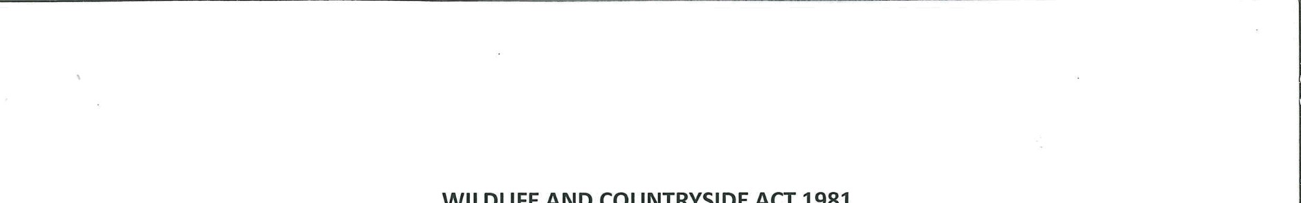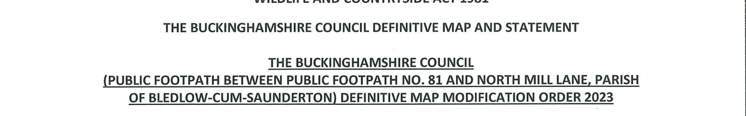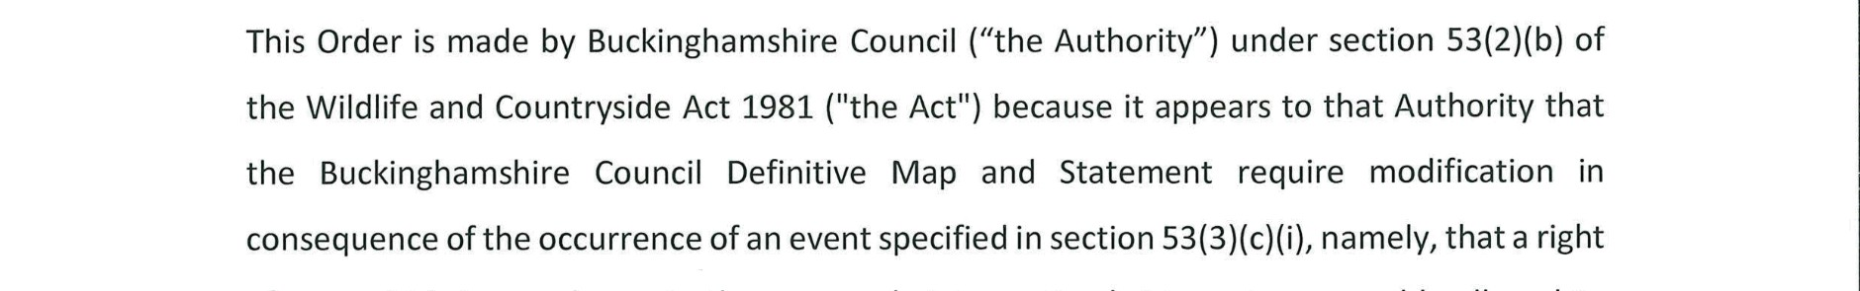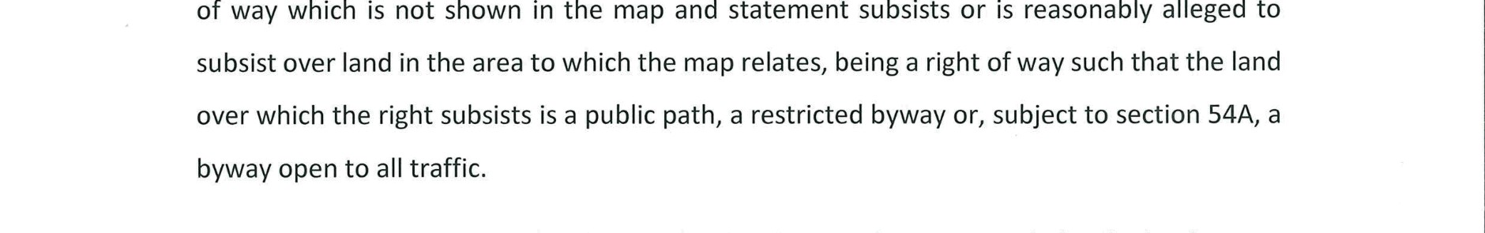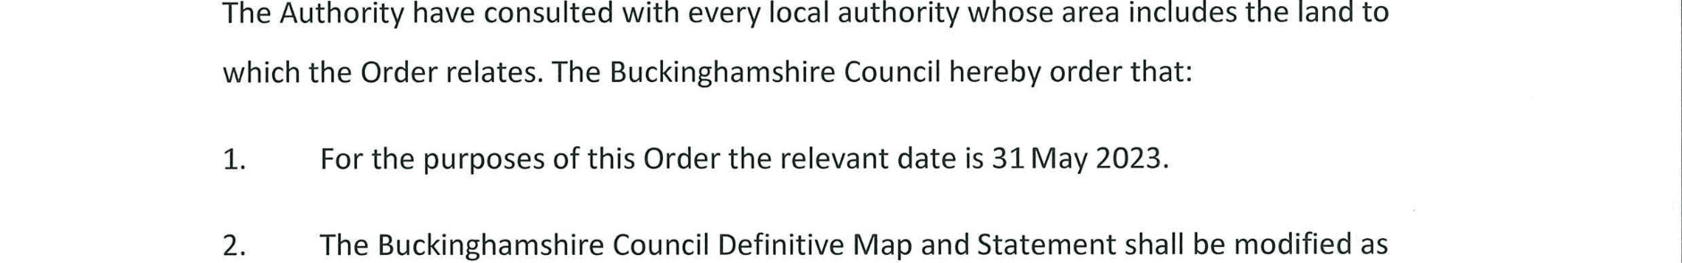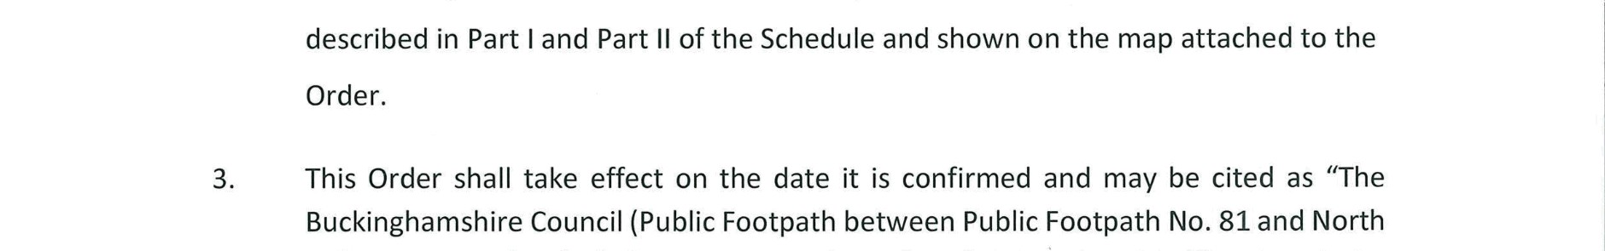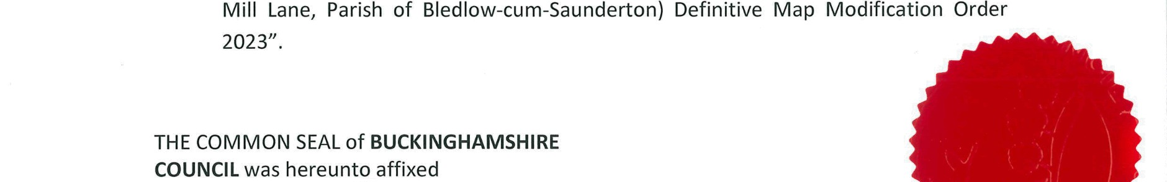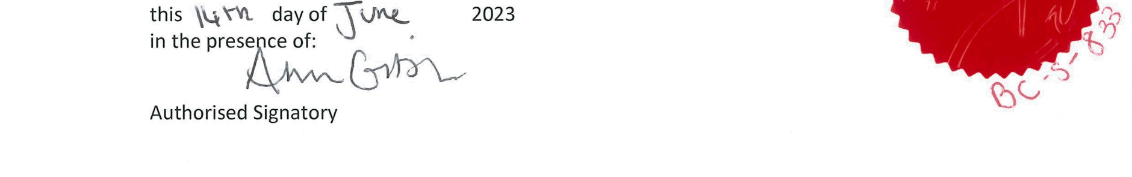
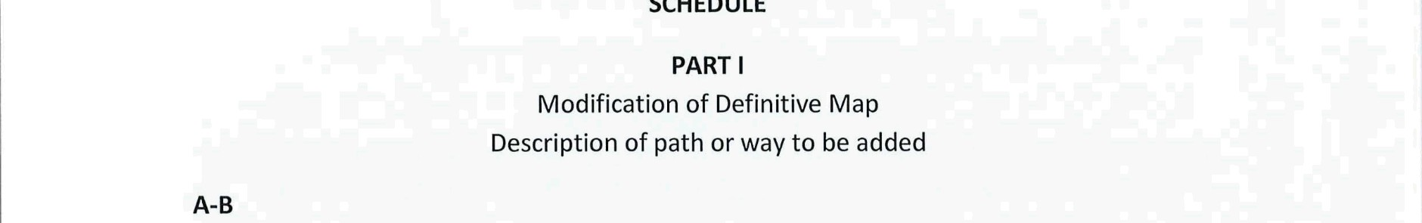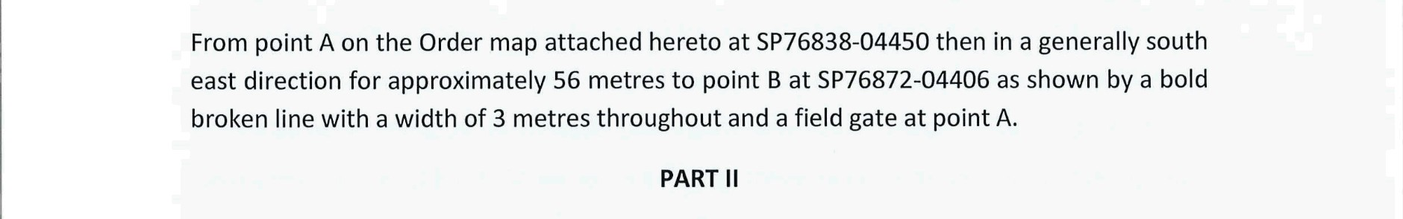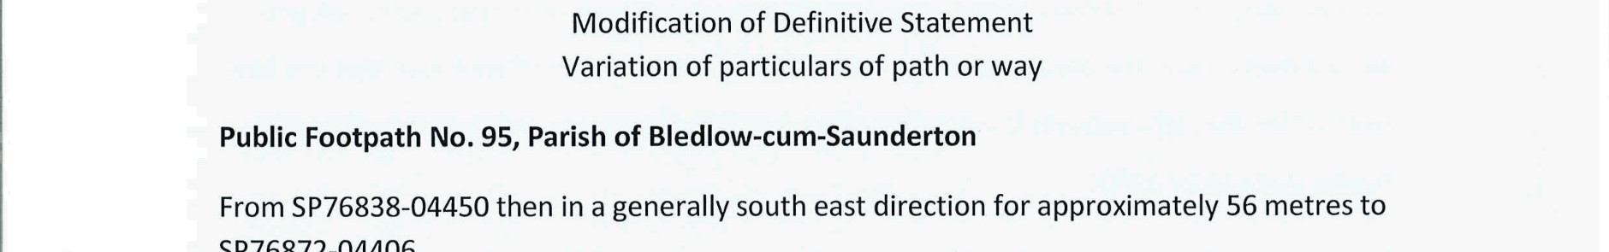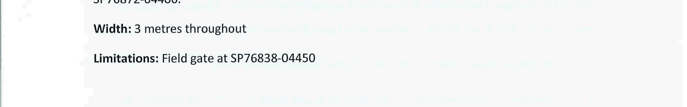

If you wish to make a legal submission, this should be submitted at the same time as your statement of case. Otherwise legal submissions will have to be submitted in writing on the day of the inquiry.

