

|  |
| --- |
| **Application Decision** |
|  |
| **by Harry Wood** |
| **Appointed by the Secretary of State for Environment, Food and Rural Affairs** |
| **Decision date: 7 October 2025** |

|  |
| --- |
| **Application Ref:** COM/3364618  **Portland Bill Car Park, Portland Bill, Portland**  Register Unit Number: CL2  Commons Registration Authority: Dorset County Council |
| * The application, dated 24 April 2025, is made under Section 38 of the Commons Act 2006 (the 2006 Act) for consent to carry out restricted works on common land. * The application is made by The Crown Estate Commissioners. * The works comprise:  1. The resurfacing and reconfiguration of the car park including improvements to the drainage on site. 2. The creation of pedestrian routes throughout the car park with tactile paving and pedestrian crossings. 3. Addition and removal of boulders. 4. Addition of timber bollards and knee rails. 5. Re-designed access and exit routes and introduction of controlled access barriers contained within one location. 6. Replacement and provision of litter and recycling bins and provision of a new information board. 7. Provision of 4 twin station electric vehicle charging points. |

**Decision**

1. Consent is granted for the works in accordance with the application dated 24 April 2025 and the plans submitted with it subject to the following conditions:
2. the works shall begin no later than three years from the date of this decision;

REASON: To provide certainty to users of Portland Bill.

1. the land shall be fully reinstated within one month from the completion of the works (note that this does not apply to any physical changes or permanent features introduced as part of the works for which consent is granted);

REASON: To retain access for commoners across Portland Bill

1. For the purposes of identification only the location of the works is shown on the attached plans.

**Preliminary Matters**

1. I have had regard to Defra’s Common Land Consents Policy Guidance (November 2015) in determining this application under section 38, which has been published for the guidance of both the Planning Inspectorate and applicants. However, every application will be considered on its merits and a determination will depart from the guidance if it appears appropriate to do so. In such cases, the decision will explain why it has departed from the guidance.
2. This application has been determined solely on the basis of written evidence. I have taken account of the representations made by the Open Spaces Society (OSS) and The Island and Royal Manor of Portland Court Lee (The Manor)
3. I am required by section 39 of the 2006 Act to have regard to the following in determining this application:
4. the interests of persons having rights in relation to, or occupying, the land (and in particular persons exercising rights of common over it);
5. the interests of the neighbourhood;
6. the public interest; Section 39(2) of the 2006 Act provides that the public interest includes the public interest in; nature conservation; the conservation of the landscape; the protection of public rights of access to any area of land; and the protection of archaeological remains and features of historic interest;
7. any other matter considered to be relevant.

**Reasons**

1. The applicant explains that the works have been requested as Portland Bill holds significant ecological importance and is designated as a Site of Special Scientific Interest (SSSI) and that large volumes of visitors can have a negative impact on such a sensitive environment. The Crown Estate are developing their visitor management strategy to mitigate this impact which includes encouraging visitors to respect the SSSI status by following designated paths, providing a new information board and a keeping a well maintained car park, with controlled access, information boards, litter bins and visitor facilities.

***The interests of those occupying or having rights over the land***

1. The applicant outlines that The Crown Estate Commissioners are the owners of the land and are also the applicants in this case. It follows that the works are in the interest of the owner of the land. The common land register records multiple rights over the land at Portland including; herbage of animals, pannage of pigs, turbary, piscary, estovers, to quarry, dig and remove stone and pebble, the right to gather green fuel and dry fuel as well as clots or cow dung and the right of pasture for multiple animals.
2. I have received no comments that the works would interfere with the above rights. I am therefore satisfied that the planned works would not interfere with the interest of those occupying or having rights over the land.

***The interests of the*** ***neighbourhood and public access***

1. The interests of the neighbourhood relate to whether the works will unacceptably interfere with the way the Common is used by local people and is closely linked with interests of public access.
2. Portland Common is comprised of several land parcels located on the Isle of Portland. The works themselves are located on a small section of the Common close to Portland Bill Lighthouse. I believe the Common is an active space for open air recreational activities for the public and an area of high landscape value. The recreation value and visual quality of the area of the area of Common relating to this application is limited by its size and it being urbanised.
3. The applicant explains that these works are linked to a wider, long-term project aimed at enhancing the natural environment, biodiversity, economic health and social value of The Crown Estate Commons at Portland. The Crown Estate are working collaboratively with Natural England and local stakeholders including the Manor.
4. The resurfacing and reconfiguration work is to alter the existing carpark and repair and replace surfaces already in situ. As such, the works would not introduce any new barriers onto the Common and would improve drainage at the site.
5. The introduction of new pedestrian ways would also not introduce any new barriers onto the Common or effect people’s abilities to access the Common
6. The addition of boulders to act as natural barriers around the car park would introduce new barriers onto the Common. However, the boulders can be placed in such a way that access on foot around them is possible, so they do not impede access to the Common. The bollards to be introduced are also spaced as not to introduce any new obstructions to the Common.
7. The knee-high timber bollards would introduce new barriers onto the Common, however they are short in length and can be navigated on foot and are unlikely to introduce any real impediment to access on the Common.
8. The new bins, information board and charging points will add new barriers to the Common at the points where they are located. These will be small in size, however, and the Common can still be accessed around them. They will also sit within the existing footprint of the car park so would not take away from the existing natural space of the Common.
9. The Manor has stated that they are broadly in support of the application although consider it essential that “the plastic containment system for the stone chippings in the parking spaces is adequately robust and long lasting.” They continue that the litter bins should be of adequate size and design “as windblown litter is always an issue at this location.” They recommend there are at least four in the vicinity and adequate collection measures are in place. They also note that consultation should occur about what information is included on the planned information board.
10. In response the applicant has stated that the plastic containment system being deployed will be designed and installed as per manufacturers recommendations to ensure that “any loose gravel does not migrate from the grid.” The addition of new raised walkways will further ensure the parking spaces will only be driven into slowly and from one direction vastly reducing the risk of gravel migration. The applicant continues that there are already two bins in situ and they note the wish for more bins and a good system for making sure they are emptied regularly. The applicant also welcomes the opportunity to work collaboratively on the information to be presented on the new signage.
11. Overall, I do not believe the works as planned would create any unacceptable impediment to people’s access to and across the Common or affect the recreational value of the Common.

***The public interest***

1. As well as having regard to the public interest in the protection of public rights of access, I must also have regard to the public interest in nature conservation, the conservation of the landscape and the protection of archaeological remains and features of historic interest.

***Nature conservation and conservation of the landscape***

1. The site at Portland Bill Carpark sits within a Site of Special Scientific Interest (SSSI). Natural England have been consulted on the impact of these works and do not have any issues with the works as planned. Natural England staff have also visited the site recently to discuss the SSSI with the applicant, and no issues were raised regarding the works and the SSSI. They continue “The new car park has the same footprint as the existing one and as there is a reduction in the number of parking spaces, if anything this will lead to reduced recreational damage to the Sites protected features.”
2. The features that are being added to the Common sit within the existing footprint of the car park and would not significantly affect the natural features surrounding this area of the Common.
3. It is also noted that maintaining the carpark would likely have a positive impact on the Common and the surrounding landscape rather than letting it fall to disrepair through neglect.
4. On balance I do not view that the works would adversely impact the visuals or landscape value of the Common or the Common’s status as a SSSI.

***Protection of archaeological remains and features of historic interest.***

1. Historic England has been consulted on the application and have not provided comment.
2. There is no evidence before me to suggest that these interests will be harmed by the proposed works.

***Conclusion***

1. In this case I conclude that the works will not introduce an unacceptable barrier to public access to the Common and the recreational value of the Common will not be affected. Additionally, the nature conservation***,*** landscape value and historic interests of the Common will not be affected. The proposed the works will not seriously harm the other interests set out in paragraph 5 above and are consistent with the current use of this area of the Common. Consent for the works is therefore granted subject to the conditions set out at paragraph 1 above.

Harry Wood

Figure 1 – Location of works on the Common

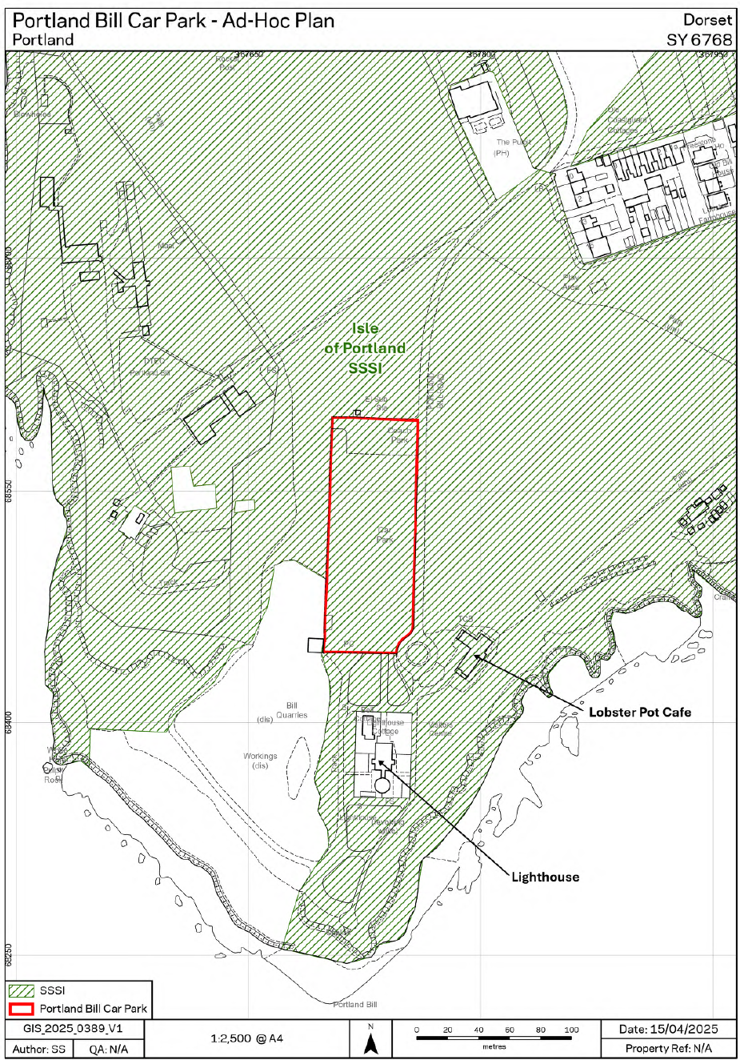

Figure 2 – Detailed plan

