

|  |
| --- |
| **Order Decision** |
| Site visit made on 11 August 2025 |
| **by Claire Tregembo BA(Hons) MIPROW** |
| **An Inspector appointed by the Secretary of State for Environment, Food and Rural Affairs** |
| **Decision date: 04 September 2025** |

|  |
| --- |
| **Order Ref: ROW/3343500** |
| * This Order is made under section 53(2)(b) of the Wildlife and Countryside Act 1981 and is known as the Norfolk County Council (Ringstead) Modification Order 2023. |
| * The Order is dated 27 September 2023 and proposes to modify the Definitive Map and Statement for the area by adding two footpaths as shown in the Order plan and described in the Order Schedule. |
| * There were two objections outstanding when Norfolk County Council submitted the Order to the Secretary of State for Environment, Food and Rural Affairs for confirmation. |
| **Summary of Decision: The Order is confirmed.** |
|  |

Procedural Matters

1. An Inquiry was arranged to determine the Order. However, shortly before the proofs of evidence were due to be submitted one of the objectors withdrew their objection. The second objection only concerned matters which could not legally be taken into consideration. With the agreement of all parties, the Inquiry was cancelled, and the Order determined using the written representations procedure.

The Main Issues

1. The Order has been made under section 53(2)(b) of the Wildlife and Countryside Act 1981 in consequence of the occurrence of an event specified in section 53(3)(b). This requires me to consider if the routes have been enjoyed by the public for a period that raises a presumption that the ways have been dedicated as public footpaths.
2. The evidence submitted in support of the Order relies on the presumption of dedication arising from tests laid out in section 31 of the Highways Act 1980 (the 1980 Act). This requires me to consider if the public have used the route as of right and without interruption, for a period of twenty years immediately prior to its status being brought into question. I must establish the date when the public’s right to use the Order route was brought into question and determine if use by the public occurred for a twenty year period prior to this that is sufficient to raise a presumption of dedication. If this is the case, I must then consider if there is sufficient evidence that there was no intention on the part of the landowner to dedicate public footpaths during this period.
3. Section 32 of the 1980 Act also requires me to take into consideration any map, plan or history of the locality, or other relevant document provided, giving it such weight as is appropriate, before determining whether or not a way has been dedicated as a highway.

Reasons

1. There are two routes in the Order; Route 1 runs between Docking Road (C93) and Peddars Way South (U22302) as shown between points A and B on Order Map 1. Route 2 runs between Thornham Road (C93B) and Foundry Lane (U22154) as shown between points A and D on Order Map 2. I have appended a copy of the Order maps to the end of my decision for ease of reference.

***Documentary Evidence***

*Commercial Maps*

1. The very southern end of Route 2 to the side of the properties on Foundry Lane is shown on Faden’s map of Norfolk 1797 in the same way as Foundry Lane.
2. Bryant’s map of Norfolk 1826 shows section B to D of Route 2 as a *‘Lane or Bridle Road’*. This track continues on a different line to Bluestone Farm where a *‘Good Cross or Driving Road’* then heads north to Thornham Road.
3. Section B to D of Route 2 is shown on Bartholomew’s 1936-1943 map of Great Britain with double solid edges. It then continues on a different line from point B through Bluestone Farm to Thornham Road.

*Ringstead Tithe Map 1841*

1. The very southern end of Route 2 to the side of the properties on Foundry Lane is shown with double solid edges in the same way as Foundry Lane.

*Ordnance Survey Maps*

1. Route 1 is not shown on the 1882 first edition or 1905 second edition 1:2500 Ordnance Survey (OS) maps. It is shown as an unenclosed track alongside a field boundary on the 1974 1:2500 OS map.
2. On the 1882 first edition 1:2500 OS map, Route 2 is largely shown as an unenclosed track between points B and D with the very southern end shown as an enclosed track. It forms part of the track to Bluestone Farm where another track continues north to Thornham Road. It is shown in the same way on the second edition 1905 1:2500 OS map and in a similar way on the 1973 1:2500 OS map.
3. The OS maps provide evidence of the physical existence of the claimed bridleways. However, since the late 19th Century, OS maps have carried a disclaimer that tracks and paths shown provide no evidence of the existence of public rights.

*Aerial Photographs*

1. Route 1 is clearly visible as a track on the 1946, 1988, 1999, and 2011 aerial photographs and the 2010 Google Earth aerial photograph.
2. Section B to D of Route 2 is visible as part of the track to Bluestone Farm on the 1946, 1988, 1999, and 2011 aerial photographs. The access into the field at point A can be clearly seen on the aerial photographs from 1988.

*Peddars Way Long Distance Path Creation*

1. On 5 February 1979, Norfolk County Council (the Council) contacted the le Strange Estate (the Estate) asking if Route 2 could be used as part of a long distance footpath they were seeking to establish called Peddars Way. The Estate responded on 2 April 1979 stating they were *‘firmly opposed to the scheme’* and this opposition was reiterated in a letter dated 11 June 1979.

*Countryside Stewardship Agreement*

1. The Estate entered into a Countryside Stewardship Agreement (CSA) which ran from 1 October 2000 to 30 September 2010. Under the CSA, permissive access for horse riding and cycling (and presumably walking) was granted along Route 2 as shown on the CSS Agreement map.

*Footpath Map of Hunstanton*

1. Both routes are shown on the Footpath Map of Hunstanton, Holme, Docking and Heacham by Wilfrid George as *‘other tracks’*. Public footpaths, bridlepaths, and roads are shown with different line styles. This map is for sale locally and was first published in 1987. A copy of the sixth edition published in 2004 was provided. An annotation on this edition indicates that Route 2 was a *‘permissive bridleway (in 2004)’*. This map indicates that the Order routes exist as tracks and Route 2 was a permissive bridleway. However, I do not consider they indicate any public rights of way over them.

*Deposited Statement, Map, and Statutory Declaration*

1. On 10 March 2005, the Estate deposited a Section 31(6) statement and map with the Council, and a statutory declaration was submitted on 12 August 2011. Both Routes were within the area covered by the deposits and Statutory Declaration but were not indicated to be public rights of way.

*Google Street View*

1. On the January 2009 Google Streetview image Route 1 is visible from point A as a stone track with no gates or notices visible.
2. On the January 2009 Google Streetview image, there appears to be a notice at point A on Route 2, but it is not clear what it says. There is no hedge at this time and there are vehicular tracks along the Order route. A hedge south of point A is visible on the August 2016 image with a different notice alongside it. From its size and position, this appears to be the *‘Private No public right of way’* notice shown in the March 2016 site photographs provided by the applicant and described in paragraph 23 below. There is a clear vehicular track on the west side of the hedge, but not along the Order Route on the east side and the crop is planted to the hedge.
3. On the Google Streetview 2009 and 2016 images of Route 2 at point D, the Order route appears to be a stone track with grass along the edges and centre. It runs between the residential property to the west and the field hedge to the east. No gates or notices are visible.

*Photographs*

1. Photographs of Route 1 taken in May 2016 submitted with the application show a wide stone surfaced farm track alongside a hedge. There is a notice stating *‘PRIVATE LAND No public right of way’* at point A. Photographs provided by the Estate show notices erected at point A and B on 14 September 2016. This is a different notice to the one shown in the application photographs and states *‘le Strange Estate Private Land No public right of way’*.
2. Photographs of Route 2 taken in March 2016 submitted with the application show a notice at point A which states, *‘Private No public right of* way’. Section B to C is visible as an unenclosed track with worn tyre tracks and a grass strip along the centre. From point C the track continues alongside a hedge, and the last section runs between the residential property to the west and the field hedge to the east.
3. Photographs of Route 2 provided by the Estate show a notice erected at point A and just north of point D on 14 September 2016 which states *‘le Strange Estate Private Land No public right of way’*. There appears to be a grass verge along the Order route. An earlier, but undated photograph shows the notice in the photographs provided with the application.

*Summary of Documentary Evidence*

1. The documentary evidence shows Route 1 has physically existed since at least 1946. Section B to D of Route 2 has physically existed since at least 1826 with the section alongside the houses on Foundry Lane existing since at least 1797. The documentary evidence indicates it would have been possible to use the Order routes. However, I do not consider the documentary evidence indicates public rights or status. Therefore, it is not sufficient, on the balance of probabilities, to show public footpath rights over the Order routes.

***User Evidence***

*Bringing into question*

1. To bring into question the right of the public to use the Order route some actions or events must have occurred that brought home to at least some of those using it that their right to do so was being challenged. These must have been sufficiently overt to bring that challenge to the attention of the public using the route.
2. Five people were stopped by a gamekeeper on Route 1 who told them it was not a public path with four stating they were challenged in 2013. Path users saw a notice stating *‘PRIVATE LAND No public right of way’* at Docking Road (Point A) in April 2015. The Estate claim they first erected notices stating, *‘Private No Public Access’* at either end of Route 1 in August 2013 with notices before these stating *‘Private’*. The Estate state notices were regularly taken down by unknown parties. Their Gamekeeper challenged people walking on the track when they could reach them but did not provide any dates.
3. Three people were stopped on Route 2 with two stating they were challenged in 2015. However, one was stopped in another part of the field and told he was on the wrong path and directed to the Order route. The applicant states a notice was erected at Thornham Road (Point A) stating *‘Private, No Public right of way’* in 2014. The Estate state they erected private notices at each end of this route in 2010 following the expiration of the CSA with new signs erected in 2016 stating *‘Private Land No public right of way’*. The Gamekeeper and tenants state they have challenged people walking on the track, but no dates are given.
4. I consider the challenges to the public and the notices erected made it clear to the public that their use of the Order routes were being brought into question between 2013 and 2015.
5. The Estate also considers the Statutory Declaration and CSA brought use of the Order routes into question. The public are unlikely to have been aware of the 2005 deposits and Defra’s view is that for a deposited map and statement to be effective, it must be followed up by a statutory declaration as a separate event within 20 years. Therefore, the deposits did not successfully bring into question the use of the Order routes until 12 August 2011 when the Statutory Declaration was submitted.
6. I consider use of Route 1 was first brought into question when the statutory declaration was submitted to the Council. Therefore, the relevant twenty year period of use for Route 1 is 5 August 1991 to 5 August 2011.
7. The CSA gave permission for the public to use Route 2 from 1 October 2000 to 30 September 2010. Two path users state Route 2 was permissive in the past and one refers to permissive notices which could be the one visible in the January 2009 Google Streetview image. The 2004 Footpath Map states Route 2 was a permissive bridleway at that time and made the public aware of this permission. I consider the CSA brought into question use of Route 2.
8. I consider use of Route 2 was first brought into question when the Permissive Agreement came into effect. Therefore, I consider the relevant twenty year period of use for Route 2 is 1 October 1980 to 1 October 2000.

*Analysis of use*

1. To satisfy the requirements of section 31, use must be by those who can be regarded as the public. For use to be as of right it must be without force, secrecy, or permission. Use should be without interruption, and to be effective, any interruption must be by the landowner, or someone acting on their behalf. The interruption should be with the intention of preventing use of the way by the public and not for other purposes such as car parking or building works. I must also be satisfied that there was sufficient use by the public to raise a presumption of dedication.

*Route 1*

1. Twenty eight people submitted user evidence forms for Route 1 showing use between the 1950s and 2016. Everyone used Route 1 on foot, one person also used it on a bicycle and another on a horse. Frequency of use varied from daily to several times a year, but fourteen people used it at least once a week. Use appears to have been open, without secrecy, permission, or force.
2. All 28 used Route 1 during the relevant twenty year period between 1991 and 2011, with sixteen people using it for the full twenty years. None of those using Route 1 were challenged until 2013 and nobody saw notices until April 2015. Nobody encountered obstructions during the relevant twenty year period.
3. I am satisfied there is sufficient evidence of uninterrupted use during the relevant period without permission, force, or secrecy to demonstrate a presumption of dedication of footpath rights over Route 1. I do not consider there is sufficient evidence of use by horse riders or cyclists to indicate higher rights.

*Route 2*

1. Twenty three people submitted user evidence forms for Route 2 showing use between 1928 and 2016. However, not everyone who completed user evidence forms used it during the relevant twenty year period between 1980 and 2000.
2. Fifteen people used Route 2 during the relevant twenty year period with four people using it for the full twenty years. All fifteen used Route 2 on foot with two people also claiming use on a bicycle and one on a horse. Frequency of use varied from daily to several times a year, with six people using it at least once a week and three people monthly. Use appears to have been open, without secrecy, permission, or force. No one was challenged, saw notices, or encountered obstructions during the relevant twenty year period.
3. The evidence of use of Route 2 during the relevant twenty year period is less than Route 1. This is not surprising given the relevant period of use ended over ten years before the application was made. However, I am satisfied there is sufficient evidence of uninterrupted use during the relevant period without permission, force, or secrecy to demonstrate a presumption of dedication of footpath rights over Route 2. I do not consider there is sufficient evidence of use by horse riders or cyclists to indicate higher rights.

*Lack of intention to dedicate*

1. To demonstrate a lack of intention to dedicate, a landowner must take action to make the public aware that they have no intention of dedicating a public right of way. There are various ways of demonstrating this, but the most common ways are erecting notices denying public rights or granting permission, physical obstructions, or verbal challenges.
2. The Estate claim their Gamekeepers and tenants challenged use of the Order routes, but no dates are given. None of those using the Order routes were challenged during the relevant twenty year periods.
3. The Estate claim *‘Private’* notices existed on the Order routes prior to the *‘no public right of way’* notices first seen by path users in 2014 and 2015. The Estate state a notice on Route 2 was first erected in 2010 when the CSA ended. However, none of the path users recall these notices and the 2010 notices were after the relevant twenty year period for Route 2 ended.
4. The 1979 letters about the creation of Peddars Way indicate that the Estate did not intend to dedicate public rights over Route 2. However, these letters are before the relevant twenty year period. Furthermore, path users are unlikely to have been aware of them.
5. Therefore, I do not consider there is sufficient evidence before me to demonstrate a lack of intention to dedicate public footpaths over the Order routes during the relevant twenty year periods.

*Conclusions on section 31*

1. I consider use of route 1 was brought into question in 2011 when the Council received a Statutory Declaration under section 31(6) of the 1980 Act. I have found there is sufficient evidence of use of Route 1 on foot as of right and without interruption between 5 August 1991 and 5 August 2011. I do not consider there is sufficient evidence of challenges, permission, or other actions by the landowner to demonstrate they had no intention of dedicating a public footpath during the relevant twenty year period.
2. I consider use of Route 2 was called into question in 2000 when a CSA granted a permissive bridleway along the Order route. I have found there is sufficient evidence of use of Route 2 on foot as of right and without interruption between 1 October 1980 and 1 October 2000. I do not consider there is sufficient evidence of challenges, permission, or other actions by the landowner to demonstrate they had no intention of dedicating a public footpath during the relevant twenty year period.
3. I am satisfied the evidence before me is sufficient to show, on the balance of probabilities, that public footpaths subsist over the Order routes.

**Other Matters**

1. Concerns are raised about public safety due to agricultural machinery and heavy goods vehicles using the Order routes and shooting on the land. There are also concerns about the negative impact the footpaths would have on farm security and operations and an increase in public liability insurance. Although I understand these concerns, they are not matters I can legally take into consideration when making my decision.

Conclusions

1. Having regard to these and all other matters raised in the written representations I conclude that the Order should be confirmed.

Formal Decision

1. I confirm the Order.

Claire Tregembo

INSPECTOR

**Order Maps**

**Route 1**

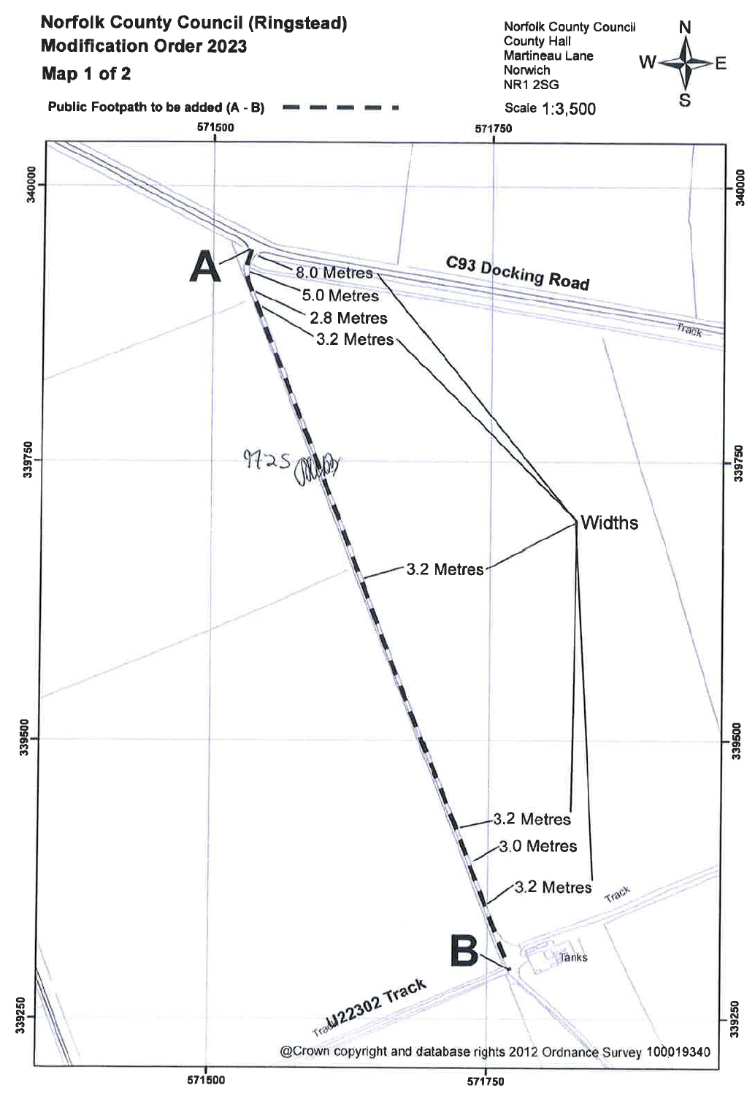

**Route 2**

