

|  |
| --- |
| **Order Decisions**  Site visit made on 26 August 2025 |
| **by D M Young JP BSc (Hons) MPlan MRTPI MIHE** |
| **an Inspector appointed by the Secretary of State for Environment, Food and Rural Affairs** |
| **Decision date: 25 September 2025** |

|  |
| --- |
| **Order Ref: ROW/3342456 (Order A)** |
| * This Order is made under Section 26 of the Highways Act (the 1980 Act) and is known as the Oxfordshire County Council, Hook Norton Bridleway No. 38 and Hook Norton Footpath No 39, Public Path Creation and Definitive Map and Statement Modification Order 2021 (“the Creation Order”). |
| * The Order is dated 17 May 2021 and proposes to modify the Definitive Map and Statement for the area by adding a new public footpath and bridleway as shown in the Order plan and described in the Order Schedule. |
| * There were two objections outstanding when the Order was submitted to the Secretary of State. |
| **Summary of Decision: The Order is Confirmed.** |

|  |
| --- |
|  |
| **Order Ref: ROW/3342458 (Order B)** | |
| * This Order is made under Section 118 of the 1980 Act and is known as the Oxfordshire County Council Hook Norton Bridleway No 32 (part) Public Path Extinguishment and Definitive Map and Statement Modification Order 2021 (“the Extinguishment Order”). | |
| * The Order is dated 17 May 2021 and proposes to modify the Definitive Map and Statement for the area by extinguishing a part of Hook Norton Bridleway 32 (BR32) as shown in the Order plan and described in the Order Schedule. | |
| * There were two objections outstanding when the Order was submitted to the Secretary of State. | |
| **Summary of Decision: The Order is Confirmed.** | |

|  |
| --- |
|  |

Preliminary Matters

1. An application to extinguish part of BR32 and create a new bridleway running parallel to it within the adjacent field was made by Parvest Ltd (the current owners of Swerford House) on 17th June 2020. The reasons for the applications was to remove the length of BR32 running across the private frontage and car parking area of the property (Swerford Park) to improve the owner’s privacy.
2. The Creation Order would provide a new public footpath along part of the driveway approaching the main house. This footpath would then link to the new bridleway running parallel to the extinguished section of BR32 within an adjacent field.
3. Following consideration of the application, Oxfordshire County Council (the Order Making Authority (OMA)) was satisfied the application met the relevant statutory tests as provided under the 1980 Act. The Order were subsequently made on 17 May 2021 and advertised publicly between 20 May and 18 June 2021. Two objections were received from the Open Spaces’ Society (OSS) and The Ramblers.
4. None of the parties requested an inquiry or hearing into the Orders. I have therefore considered this case on the basis of the written representations forwarded to me.
5. I carried out a site visit on 26 August where I was also able to walk the line of the existing and proposed routes.

The Main Issues

Order A

1. Section 26 (1) of the 1980 Act requires that the factors to be considered in regard to the creation of a footpath are whether there is a need for a footpath and that it is expedient to create that footpath having regard to:

(a) the extent to which the footpath would add to the convenience or enjoyment of a substantial section of the public, or to the convenience of persons resident in the area; and

(b) the effect which the creation would have on the rights of persons interested in the land, taking account of the provisions as to compensation in Section 28 of the 1980 Act.

Order B

1. Section 118 (2) of the 1980 Act requires that before confirming the Order I should be satisfied that it is expedient to stop up the footpaths in question having regard to the extent that it appears that they would, apart from the Order, be likely to be used by the public; and that I should consider the effect which the extinguishment of the rights of way would have as respects land served by the path, account being taken of the provisions as to compensation.
2. Section 118 (5) provides that where proceedings preliminary to the confirmation of a public path extinguishment order are taken concurrently with proceedings preliminary to the confirmation of a public path creation or diversion order (as is the case here) then in considering the likely extent of use of the path proposed to be extinguished, regard may be had to the extent to which the creation or diversion order would provide an alternative path.

Orders A and B

1. In determining whether or not to confirm the Orders, sections 26 (3), 118 (6A) and 119 (6A) of the 1980 Act require that I should give consideration to any material provision of a rights of way improvement plan (ROWIP) prepared by any local highway authority whose area includes land over which the Order would create or extinguish a public right of way.
2. Also of relevance is paragraph 5.54 of the Rights of Way Circular (1/09) which in relation to creation Orders made concurrently with extinguishment Orders states:

“*The extent to which a creation or diversion order (but not a public path creation agreement) or rail crossing diversion order, made in association with an extinguishment order would, if confirmed, provide an alternative way to that proposed for extinguishment may be taken into consideration in determining whether or not to confirm the extinguishment order. Account should be taken of the convenience of the alternative path compared to that which is to be extinguished and if this is significantly less than that enjoyed by users of the existing path, authorities will need to consider whether the criteria set out in section 118(1) of the 1980 Act have been met. Care should also be taken to ensure that full consideration is given to all of the matters set out in both section 26 …and section 118*”.

**The Route**

Order A

1. The section of bridleway to be created is shown between points A-E-F-G-D on the Order Plan at Appendix A. From the track leading to Swerford Park at OS Grid Ref SP 3631 3140 the route would pass across the southern parts of the adjacent fields in an easterly direction. In so doing it would avoid the driveway and forecourt area to the front of the property. The newly created bridleway rejoin the track at point D approximately 200m east of the property.
2. The Order would provide a width of 5m for the new bridleway between point A and F, 7m between point F and G and 3m between point G and D.
3. The section of footpath to be created is shown between points F-C-D on the Order Plan at Appendix A. It would commence at point F and pass through the trees in a southerly direction to meet the main drive leading to Swerford Park after which it would run along the drive in an easterly direction to point D in the same manner as the existing bridleway.

Order B

1. The section of BR32 to be extinguished is shown between the points A-B-C-D on the Order Plan at Appendix A. Existing sections of BR32 north of Point A and east of Point D are unaffected by the Order.

**The Objections**

1. The objections from the OSS and The Ramblers are similar and raise the following issues:
2. The objective of these Orders is to prevent members of the public enjoying the views of the house and farm buildings and to increase the value of the property.
3. BR32 is necessary for public use and gives. It passes through a historic landscaped park of great beauty. If the extinguishment is implemented the public will be largely deprived of the opportunity to view and enjoy views of Swerford Park, part of Swerford Park Farm, the valley to the south and the River Swere. Only relatively distant glimpses of the house would be available from the section A-E-F on the creation route.
4. As the creations have not happened – and may never happen – it is necessary to consider the position and use of BR32 on its present alignment. It is unclear how the creation of the footpath could render unnecessary the bridleway which is also open to riders and cyclists.
5. If using the created footpath (D-C-F) in combination with the created bridleway would encounter, instead of the one bend at B, three bends at A, F (right-angled), and C. The proposed new bridleway follows no natural or historic route but crosses two fields currently down to grass and therefore is liable to ploughing.
6. The bridleway is needed for public use as was clear from the number and character of the objections made to the Council’s previous attempt to divert it.

OMA’s Response to the Objections

1. In response the numbered points above the OMA makes the following response:
2. The purpose of the Orders is not to ‘prevent’ members of the public enjoying the views of the house and farm buildings. The OSS themselves accept that the front of Swerford Park is ‘fully visible from the current route. Accordingly, the purpose is to relocate the bridleway further away from the house as use of the existing bridleway impacts on the privacy of the owner and his family due to the proximity of the route to the house. The Council accepts that the consequence of the extinguishment is that views of the farm building and archway will be lost but this consequence is distinct from prevention. Indeed, the owner is providing a new bridleway that will retain views of the house whilst at the same time giving him and his family greater privacy and enjoyment of their home.
3. The owner accepts that there are those who enjoy the driveway and he is happy for pedestrians to continue to walk part way along the drive to view the Swere Valley and house before they turn toward the new bridleway at Point C. Whether the Orders would increase the value of Swerford Park is irrelevant as the owners are entitled to make the application in accordance with the provisions of the 1980 Act.

Whilst BR32 gives views of Swerford Park and Farm, the new bridleway (BR39) will give alternative attractive views of Swerford Park, and the new footpath (FP38) will retain much of the existing views of the landscaped parkland for walkers along the drive. BR39 would run along the edge of the open landscaped park beside mature trees with views over open parkland and pass immediately past the northern boundary of the formal garden. Views of Swerford Park with its Doric columns in its rural setting within the parkland would be visible. Walkers will be able to travel along the driveway within the landscaped park and continue to see the same views as they currently can between points C-D including views over the Swere valley. The Council acknowledges that views of the farm will be lost, particularly the archway but for many walkers the alternative views will be enjoyable and will provide views of the historic property.

1. The OSS incorrectly interpret the legislation available to the OMA (see Main Issues above). In particular Circular 1/09 provides that the extent to which a creation order made in association with an extinguishment order would, if confirmed, provide an alternative way to that proposed for extinguishment may be taken into consideration in determining whether or not to confirm the extinguishment order.

In this regard the Council considers the Creation Order would provide alternative routes for the public enabling part of the existing bridleway to be extinguished. As the Orders are made concurrently, the creations (if confirmed) will take place at the same time as the extinguishment of the bridleway. In other words, the creation will take place if the extinguishment takes place and the OSS’s concerns that the creations may never happen are unfounded.

The OSS states they are uncertain as to how the creation of the footpath could render the existing bridleway ‘unnecessary’. The proposed footpath is not being used to render the existing bridleway as unnecessary. The creation of the bridleway A-E-F-G is the alternative route for the existing bridleway. The footpath being retained along the drive is the additional route being provided by the owners and its creation needs to be seen in the context of using concurrent Orders under s26 and s118 of the 1980 Act. The Council considers that, on balance, equestrians would prefer the new route of the bridleway over the tarmacadamed drive which is free from traffic and therefore safer for horses offering a more enjoyable riding surface. Neither the British Horse Society nor local riders have objected to the Orders.

1. The OMA does not consider the ‘bends’ that will be generated as a result of the Orders to be detrimental to walker’s use of the path network. In general paths within the countryside take bends as a matter of course and consequently do not follow straight lines. Following bends for many walkers is interesting and adds variety and in the context of the length of the new footpath (190m) the angle and number of bends will not inconvenience walkers. If anything, the removal of the right-angle bend at point B would benefit users as it is located at a crossroad with limited visibility northwards and eastwards. Point C has good visibility for walkers along the drive as does point A.

The OMA accept that the new bridleway does not follow an historic route. However, it would provide a route through the historic landscaped parkland with views of the house and its woods. The owner has confirmed that the route of the new bridleway crosses land that is not liable to ploughing.

1. The OSS’s reference to a previous proposal in 2017-18 has no relevance to the current Orders. Each case has its own merits. In respect of the new route to be created under the diversion Order in 2017 there were no improvements proposed to the existing surface to ensure compliance with the British Horse Society’s guidance on bridleway surfaces. The British Horse Society point out that they are pleased that their concerns raised to the 2017-18 proposals have now been addressed. It must also be borne in mind that the Council is seeking to secure paths that have wider value to the public whilst enabling the landowner to divert the route from the front of his property.

The current proposal provided the Council with the opportunity to secure the new bridleway with a better surface whilst also retaining public footpath rights along part of the drive which the 2017-18 proposal did not. The 2017-18 proposal is not relevant to the current Orders, but the Council wishes to point out that the Society’s reference to that application and the s119 convenience and enjoyment tests does not take account of the new footpath route now being created in addition to the footpath, the support to this proposal that has been received, and the lack of any public objection. It is also notable that the consultations carried out in advance of the Orders did not lead to objections whereas the 2017-18 proposal received seven objections and it was for that reason that the proposal was withdrawn.

Reasons

Order A

***Whether it is expedient that there is a need for a new footpath and a new bridleway having regard to the extent to which the paths would add to the*** ***convenience or enjoyment of a substantial section of the public, or to the convenience of persons resident in the area.***

1. As I saw when I carried out my site visit, BR32 currently passes very close to the front of the house and at an elevated level. This provides a direct line of sight into windows in the front elevation. The OSS themselves acknowledge that there are direct views of the house from BR32. Accordingly, I find it entirely reasonable that the current occupiers would wish to divert BR32 on privacy grounds. In my view such reasons are consistent with the legal framework under the 1980 Act.
2. The creation route (BR38) would address this problem by moving the path into an adjacent field. Not only would this vastly improve the privacy for the occupiers of Swerford Park but would also provide a more suitable surface and width (between 5-7m) for equestrians. While I accept that close quarter views of the house would no longer be possible, users of the routes would still be able to appreciate views of the house as they travel south along BR32 to point A. New and enjoyable views of Swerford Park and its fine parkland setting would be available from BR38 which would connect to other routes in the area in much the same way as existing and so would not be substantially less convenient.
3. Although there would be some loss of views of the house and particularly Swerford Park Farm, the creation of a new footpath (FP39) between points F-C-D would retain the pleasant route along the tree-lined driveway with users being able to enjoy the wooded entranceway towards the house.
4. Taking all these matters in the round, I consider there is a genuine need for the section of BR32 between points A-B-C to be stopped up based on the legitimate desire of the occupiers of Swerford Park to enjoy a reasonable level of privacy. Given the popularity of BR32 and to maintain overall connectivity of the local rights of way network, I consider it is expedient to create an alternative route through BR38 and FP39. In my judgement these routes would retain the essential qualities of BR32 and would not therefore materially diminish the public’s enjoyment of the route or be substantially less convenient.

***Whether it is expedient that there is a need for the footpath and the new bridleway having regard to the effect which their creation would have on the rights of persons interested in the land.***

1. The OMA advise that the landowner is agreeable to the Order. Moreover, there is no suggestion from any party that the new routes would have any adverse effects on the owner of the land over which the routes run I therefore consider that it is expedient that there is a need for the footpath and the new bridleway having regard to the effect which the creation would have on the rights of those interested in the land.

***Whether it is expedient to confirm the order having regard to any material provisions of a ROWIP***

1. The OMA advise that there would be no conflict with the Oxfordshire Rights of Way Management Plan and I see no reason to take a contrary view.

***The impact upon forestry, agriculture, nature conservation and natural beauty***

1. There is no evidence before me to suggest that the confirmation of the creation and extinguishment Orders would have any adverse impact in relation to forestry, agriculture, biodiversity or the natural beauty of the countryside.

***Conclusion***

1. I conclude that the requirements of section 26 (1) which are set out in paragraph 6 above are met in respect of Order A and that it is therefore expedient that it be proposed for confirmation.

Order B

***The extent to which the footpath would, apart from the Order, be likely to be used by the public*** ***taking into account the extent to which the Creation Order for Bridleway No 38 and Footpath No 39 would provide alternative ways.***

1. The OMA argue that the creation route would provide a safer, traffic free and more suitable shared path for equestrians and pedestrians. I concur. The additional width would benefit all users of the route, and the surface would be much more suitable for equestrians. Those walkers wishing to continue to use part of the length of the driveway will be able to do so by virtue of FP39 between points C-D. The new footpath would connect to the new bridleway through the woodland belt between points C-F.
2. As with any diversion the new route would not offer exactly the same experience for users of the existing route. While there would be some loss of views of the farm and the house from the area around point B, I do not consider this would significantly detract from one’s enjoyment of the route given that views of the façade would still be available along the driveway north of point A. Other notable views of the house, its gardens and wider parkland setting would be available between points A-E-F.
3. I acknowledge, absent the Creation Order, that some users, notably cyclists and some pedestrians might prefer the existing alignment of BR32. Despite that, the section of BR32 that would be unavailable to pedestrians would be fairly limited in its extent given they would still be able to use the route of the existing bridleway until the point it leaves the driveway at point C. There is nothing before me to suggest BR32 is a well-used cycling route, and I note there has been no objection to the Orders from local cycling groups. No cogent reasons have been provided by the objectors to explain why the proposed routes would not be made available in a timely manner.
4. In conclusion, I consider it expedient to confirm Order B having regard to the extent to which the bridleway would, apart from the Order, be likely to be used by the public taking into account the extent to which the concurrent Creation Order would provide alternatives.

***The effect which the extinguishment of the right of way would have as respects land served by the path, account being taken of the provisions as to compensation***

1. There is no evidence before me from which I could conclude that the extinguishment of the Order route would have any adverse effect in respect of this requirement of Section 118 of the 1980 Act.

***Conclusion***

1. I conclude that the requirements of section 118 (2) which are set out in paragraph 7 above are met in respect of this Order and that it is therefore expedient that it be confirmed.

Formal Decisions

**Order A**

1. The Order is confirmed.

**Order B**

1. The Order is confirmed.

D M Young

INSPECTOR

**Appendix A – Order Plans**

Order A

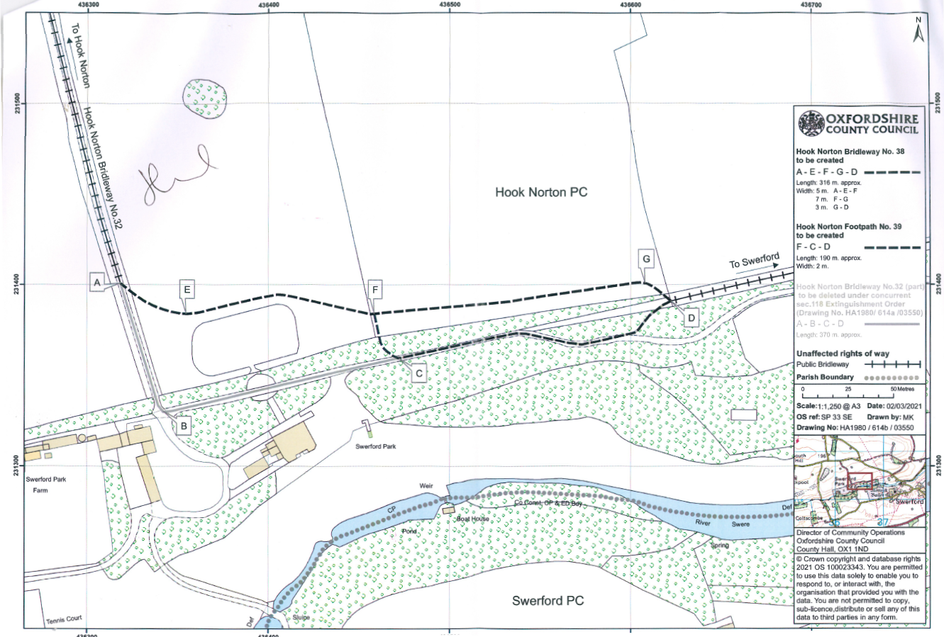

Order B

