PINS logo (black) (A4 sizing)

|  |
| --- |
| **Order Decisions** |
| Site visit made on 27 December 2023 |
| **by Grahame Kean B.A. (Hons), Solicitor, MIPROW** |
| **An Inspector appointed by the Secretary of State** **for Environment, Food and Rural Affairs** |
| **Decision date: 08 August 2025** |

|  |
| --- |
| **Order Ref: ROW/3285066 (Order 1)** |
| * This Order is made under Section 53(2)(b) of the Wildlife and Countryside Act 1981 (WCA1981) and is known as the West Sussex County Council (Chichester No.1 (Climping and Town of Littlehampton: Upgrade of a Public Footpath 829 to a Restricted Byway)) Definitive Map Modification Order 2020. |
| * The Order is dated 7 April 2020 and proposes to modify the Definitive Map and Statement (DMS) for the area by upgrading FP829 to a restricted byway. |
| * There were six objections outstanding when West Sussex County Council (the “Council”) submitted the Order to the Secretary of State for Environment, Food and Rural Affairs for confirmation. |
| **Summary of Decision: The Order is not confirmed** |
|  |
| **Order Ref: ROW/3285368 (Order 2)** |
| * This Order is made under Section 53(2)(b) WCA1981 and is known as the West Sussex County Council (Chichester No.2 (Climping and Town of Littlehampton: Upgrade of a Public Footpath 174 to a Restricted Byway)) Definitive Map Modification Order 2020. |
| * The Order is dated 24 September 2020 and proposes to modify the DMS for the area by upgrading FP174 to a restricted byway. |
| * There were five objections outstanding when West Sussex County Council (the Council) submitted the Order to the Secretary of State for Environment, Food and Rural Affairs for confirmation. |
| **Summary of Decision: The Order is not confirmed** |
|  |

**Preliminary matters regarding both Orders**

1. The applications were made by the British Horse Society (BHS). The Council as Order Making Authority (OMA) made the two Orders which, taken together would establish a continuous route with the status of a restricted byway between Climping Street, Climping to Rope Walk, Littlehampton.
2. Order 1 (ROW/3285066) deals with the western half of the overall route and proposes the upgrade of FP829 to restricted byway along the route A-B-C shown on the Order map attached to ROW/3285066.
3. Order 2 (ROW/3285368) deals with the eastern half of the route and proposes the upgrade of FP174 to restricted byway between points A-B-C as shown on the Order map attached to ROW/3285368.
4. The applications were considered by the relevant committee of the OMA, having a detailed report from its officers which recommended that no order be made for either section of the route. The committee agreed with its officers as far as concerned the upgrade of FP174 but resolved to make Order 1 for the proposed upgrade of FP829. The applicants appealed the refusal to make the order to upgrade FP174 resulting in Appeal Decision dated 23 July 2022 (Ref FPS/P3800/14A/7) directing the OMA to make Order 2.
5. For clarity and reference purposes I will refer to the plan annexed to the Appeal Decision and annex it here also. The plan was prepared by the OMA showing the overall claimed route (OMA Plan). Points A and B in the OMA Plan correspond to the same points A and B in Order 1. Point C/D corresponds to the point next to Climping Mill which on the two Order maps before me is Point C in the Order 1 map and Point A in the Order 2 map. Points D, E and F in the OMA Plan correspond to Points A, B and C on the Order 2 map. Henceforth I refer to the points in the OMA Plan which each have a different letter, for clarification.
6. Also marked on the OMA Plan is Point X. This marks the point at which the Order route ceases to run eastwards along the foreshore but turns northward up to Climping Mill. Representations made by the affected landowner regarding points X-D were not relevant to the Appeal Decision but are relevant here.
7. One further annotation on the OMA Plan is relevant, the section marked C-Y-Z. The application to add a restricted byway across Littlehampton golf course from D-E on the eastern half of the claimed route, was made without knowledge of the prior diversion of that part of FP174 onto its current definitive line of C-Y-Z, by order of the Quarter Sessions on 31 December 1936.
8. I see no reason to disagree with Inspector Saward that the wording of this particular 1936 order was capable of diverting all highway rights, so it is for consideration whether those rights were limited to rights on foot only. Section D-E across part of the golf course is not currently used by the public. The Inspector therefore considered whether an order should be made to upgrade the existing footpath between points C-Y-Z. She concluded on the evidence available that on the balance of probabilities the evidence was sufficient to allege a restricted byway between points C-Y-Z-F, ie the whole of the claimed route in Order 2. The Council has a neutral position as regards confirmation of Order 2.
9. I made an unaccompanied site inspection of the claimed Routes in inclement weather but with good visibility.

The main issue and legal framework

1. For a footpath to be upgraded, s53(3)(c)(ii) states that an order to modify the DMS shall be made where evidence is discovered which (when considered with other relevant evidence available) shows that a highway, shown in the map and statement as a highway of a particular description, ought to be there shown as a highway of a different description.
2. The main issue is whether the evidence is sufficient to show, on the balance of probability, that the Order routes of existing public footpaths (FP829 and FP174) should be recorded, in each case, as a restricted byway.
3. A restricted byway includes rights on foot as well as the right to ride or lead a horse and to ride a bicycle (unless restricted) along with a right to use non-mechanically propelled vehicles e.g. a horse and carriage.
4. Issues about suitability and safety of the path and damage to wildlife, concerns over future development, the proximity of the claimed route to the golf course and works required to facilitate an upgrade of its condition, and encouraging more users, although they are understandably concerns of objectors, are not matters I can take into account.
5. The applications rely solely on historic documentary evidence. By s32 of Highways Act 1980 (HA1980) I must consider any “*map, plan or history of the locality or other relevant document”* offered in evidence and give such weight to it as is justified by the circumstances, including its antiquity, the status of the person who made or compiled it, including for what purpose, and the custody in which it has been kept and from whence it is produced.

**Order 1 ROW/3285066**

1. The OMA supports confirmation of the Order to upgrade the existing public footpath A-C/D to a restricted byway on the route of FP829.
2. The Appeal Decision did not deal with this section of the claimed route. It starts east of the car park at Climping Beach, point A going along the definitive line of FP829 which runs along the top of the beach from point B for c750 metres to a footpath sign, then through a gate by Littlehampton golf course at Point X where it turns northward on the definitive line of FP829, for c230 metres, toward the mill at C/D where FP829 meets FP174.
3. From point B to X a private lane runs alongside and parallel to FP829 to the Mill, now a residential property. Title WSX63711 describes the road from Atherington to Climping Mill, B to C, stating that the land has the benefit of a right of way granted by a conveyance dated 1982 “*together with a right of way with or without vehicles at all times and for all purposes*”. For any horses and carts bound for the Mill, travelling from the west, the deed does not discount the possibility that they would use the claimed route. It is recent drafted for a sale and may be overly cautious if it was uncertain of the status of ways across the land. However, it does suggest to me that the road to the Mill was private and not public.
4. The applicant’s case was that the Order Route is shown to have higher status in maps of Atherington Manor 1606, Bailiff’s Court Farm 1772, Yeakell and Gardner 1778 and 1795, the Ordnance Survey map 1813, Greenwood & Greenwood 1825 and the Climping Tithe Map 1843. It is described as an historic route to Littlehampton in the Victoria County History of Sussex (VCH), thus said to be likely to be used by horse and cart. The VCH material suggests that a route from A to F existed, possibly a road to access Littlehampton.
5. Reliance is also placed on two documents referring to the claimed Route as “the Common Lane” or “Mill Lane”. An assignment deed of 1660 is said to indicate the claimed route had higher rights between A and X. It mentions a “common lane” leading past the mill, perhaps suggesting the route was public but there is no map and it is unclear if the route led from Atherington at Point A. Indeed, the section A to just before C is not mentioned.
6. The second document is a mortgage deed dated 1780 describing the land around the Mill and the claimed route. It refers to “Mill Lane”, said to provide strong evidence of the exact route of that lane. However, it is insufficiently clear not only whether Mill Lane is the claimed route but also, and as is the case with the assignment, whether the lane had public or private status. Mention of “Climping Common field on N” indicates a common field north of Climping Mill. Mortgages do not usually refer to public rights of way and the status of the claimed route derived from the deed is inconclusive. The description states:

*“Between (a) William Challen of Climping, Miller, and Abigail his wife, devisee named in will of Henry Heather late of Bramber, Miller, and (b) John Bonniface of Beeding, Alehousekeeper Messuage, lately erected, on that parcel of land where a dwellinghouse and barn stood the plot of land with the gateroom formerly held by Ewen by copyhold of the manor of Atherington (5 perches) in Atherington; windmill called Totlesham Mill or Climping Windmill and the Bolting Mill[1] lately set up within said windmill together with the millstone, sails; the Mill Plott (19 rods), lying between Climping Poor House on E.; lands of John Boniface called the Twenty Acres on W.; Climping Common Field on N. and a lane called Mill Lane leading to the coast on S.; all in Climping, lately in occ. of Thomas Cooper and William Challen, now in occ. of William Challen”*

1. Mention of a common lane in the VCH fits with the description of a road leading to Climping Mill from 1378, supported by an historical account in “Sussex Notes and Queries” of how millers, including those of Climping Mill would take their wagons at low tide across the sand and shingle at the Bar. In 1824 a horse ferry opened to cross the Arun mouth ford. It was said that this supports evidence that the claimed route from the mill would have been used by horse and cart historically. This may be so but is not determinative of public status and the evidence here would be equally suggestive of a route across the top of the beach to the mouth of the river.
2. A route along this section is interpreted as a road in the OS survey map of 1873. Greenwoods’ 1825 map also depicts this section as a cross road, which was considered public highway at the time. The Sussex series of “local view” OS maps (dated 1863 through to 1946) show a route along A to B as for other known roads. B to X is depicted by double dashed lines, possibly indicating a bridle road but in OS series 4 (1930-46) this section is interpreted as a road.
3. The historic mapping evidence as a whole is said by the applicant to describe the claimed route. It is possible that there was but one road at the time and not two routes in that area. However, only Greenwoods’ map 1825 has a key to clearly determine the status of the claimed route. The claimed route for this Order is not shown or mentioned as a route in Manor of Atherington estate map 1606, Map of Bailiff Court Farm 1772, Yeakell and Gardner’s Sussex 1778, Gardner & Green map 1795 or the Climping Tithe map 1843. These historic sources to my mind do not show that it is more likely that the claimed route carried public rights of passage rather than a private road leading to Climping Mill.
4. Yeakell and Gardner’s Sussex 1778 map has a route depicted as “other roads” on the map (two parallel solid lines) that follows just before points C and D but there is no indication of the route as public or private. Therefore, the status of the route from this map is not certain.
5. Turning to the tithe maps made under the Tithe Commutation Act 1836 their purpose was to establish the boundaries between titheable land and a way over it, not to establish whether such a way was public or private. However, if the cartographer used colours or other symbols, that may be relevant to consider. The tithe map is coloured sienna from around point E but unfortunately does not show the claimed route running from point A to just before the route turns northward to the Mill.
6. The tithe map shows Climping Mill as "House Mill Garden etc" (apportionment no 261), owned and occupied by William Barnard. It appears as a self enclosed plot distinct from the way that leads up to it, which land appears to be vicarial glebe land. Apportionment 260 is the large field on the north boundary of Climping Mill, the “Great Mill Field” and further along is “the Millers Marsh” another substantial area of land owned by William Barnard that sits north of what appears to be the area of the claimed route, which area is termed “Outwards and Salt marshes”, occupied by Joseph Coote.
7. Apportionments 250 “The little common (arable)” and 251 “Little Mill field (arable)” could be the Millfield Common mentioned in the assignment of 1660, however this is speculation. In this respect reliance is also placed on the Ford and Climping Estate auction particulars dated 1915. The “Common Barn and Yard (Pt. 201 on Plan)” is highlighted. The interpretations placed on the various descriptions of the apportionments , as with the later auction particulars, are not in my opinion strong evidence to support the actual status of the claimed route. As for common land, it is well established that common land does not itself import any right to traverse a specific route on it as a public right of way, or indeed alongside it.
8. I agree with the officers’ appraisal that, without a clear key, the depiction of the claimed route on the tithe map as a road does not carry great weight and is not conclusive in determining whether the route had a higher status or whether or not the route at this time was public or private.
9. I note also the 1894 county map of maintainable roads, known as Adcocks map. The legend clarifies that the Order route along FP829 (and FP174) is not included in any class of roads maintainable within the county save possibly (the map is indistinct) for an isolated short section from the “Old Windmill” (Climping Mill) down to what might be a road or path shown with parallel double lines. The parallel lines run from Atherington across the top of the foreshore or dunes area, to the Fort[2] close to the mouth of the river, whereas the Order route along FP174 which is significantly distant from this road or path, appears not to be marked on the 1894 map save for a very short section with a single dotted line.
10. Concerning the 1894 map the officers’ report points out that the parallel solid lines between A and X continuing along the foreshore could be the sea wall, remnants of which I saw on my inspection. Whether this is correct or not, the map does not provide strong evidence of public rights on the claimed route itself. The County’s records dating from Adcock’s map in 1894 show that at no point has any of the claimed route been maintained at public expense other than as a footpath.
11. The Stocks and Shares accounts from Climping highway parish for 1880-1889 have also been considered. A “highway parish”, after constitution of a highway district, separately maintained its own highways. I note the entries made by the parish surveyor but cannot conclude that the claimed route was regarded as a parish highway at the time. Attention is drawn to costs for “Street and Millborough”, “Millborough Hill” and Millborough Hill Road” but these names do not appear to relate to the claimed route and even if they did, it does not establish that the route was maintained as more than a footpath.
12. Greenwoods’ 1825 map is the only document which clearly indicates a route with a status as a public road for section A-X. All maps which show the claimed route between points A to X as possibly having higher status cannot be distinguished from the private road leading to the mill. In addition, when the draft and provisional definitive maps were prepared the claimed route was shown as a footpath, distinct from the private road to the mill. From the evidence supplied, it is just as likely as not in my view that the current tarmacked track parallel to B-X and beyond may have been the only vehicular access to the mill.
13. The applicant lays some emphasis on the significance of the historic mill itself, generally arguing that the existence of a mill indicates public access to it (“*the existence of a mill indicates public access to it and also access by horse drawn cart, since bags of grain are heavy”*) but that is not necessarily the case. In addition, the officers’ report considered the application in detail but the Rights of Way committee overturned its recommendation, after hearing from the applicant and the objector on behalf of the golf club. It decided that the evidence for Order route A to D did show that the footpath should be shown as a restricted byway: “*given that this provided access to the Mill and the Committee infers from this that use was by horse and cart*.”
14. In the first place one has to take into account that the claimed route is along a footpath that appears separate from the road that provided access to the mill when it operated as such. Secondly, although the concept of a mill that is a “public” mill is not difficult to understand, and instances do occur of facilities generally available to the public or residents of a locality, I have not been able to find evidence of public rights of access granted to mills generally, nor is there information submitted specifically in relation to Climping Mill. Of course, an obvious implied invitation could well have existed to access the mill expressly for business purposes (but therefore a limited form of access) as with similar other trading outlets, yet the position of a mill is not exactly the same as other retail units.
15. A mill, unlike for example with some ferries, is not a creature of statute with in-built public rights of access. In almost all cases they are privately owned and there is scant reference to “public mills” or mills held in common. In *Loder v Timothy Roger Gaden, Vera Anne Gaden and Thomas Gaden (1999) 78 P. & C.R. 223* the Court of Appeal provided examples of a private road in medieval times including a bridge built for the Countess of Pembroke between Kelvedon and Great Braxted to afford her access to her mill at Braxted.[3] In 1729 a private Act of Parliament authorised John Woods, William Woods, and John Challen, merchants, to erect one or more tide mills for grinding corn and grain upon a creek in the manor and parish of Bishopston, Sussex[4].
16. Hale C.J. in *Katherine Austin's Case (1672) 2 Vent. 186* had established that “*If a way lead to a market, and were a way for all travellers, and did communicate with a great road, &c, it is an highway; but if it leads only to a church, to a private house or village, or to fields, then it is a private way.*” What was required, therefore, was evidence of dedication to the public *qua* public rather than of use by local people for the enjoyment of private rights.
17. Windmills generally were of three types, the 'post mill', the 'smock mill' and the 'tower mill'. A feudal mill, common in medieval times, was a mill owned by a lord and used by his tenants to grind grain. The lord controlled the mill and required his tenants to use it, often taking a portion of the grain as payment. A demesne mill was a mill on land that a lord of the manor held for his own use and benefit, as opposed to land granted to tenants. It was part of the lord's demesne, or the portion of the manor that he directly controlled and utilized for his own needs and income.

|  |
| --- |
| 1. However, there is uncertainty over how these particular duties owed to manorial lords, known as “suit of mill”, became customary or how they applied in different parts of the country. There is little statute law concerning mills and the local customary law pertaining to them is complex. The Court of Common Pleas in 1310 entertained a “Sute de Molyn”, ie a suit of mill, from one Alan Burnhill against J. de R. William de Bereford, Chief Justice of Common Pleas observed that: *“the duty to grind corn grown on certain lands at somebody's mill is not imposed by common law, but follows the usage of the country.[5]”* However, it should also be noted that tenants with holdings based on special customs set out in their leases, might well have been free to grind where they pleased. 2. Climping was a settlement in Domesday Book. A mill is not mentioned but the survey pre-dated the introduction of windmills. Lyminster was the more populous settlement in that hundred and did have a mill, value 5 shillings. VCH states: “*A windmill on Atherington manor is mentioned from 1378. (fn. 516) In 1485 and later it was called Totsham mill and by 1780 alternatively Climping mill. (fn. 517).”* This later wind-powered corn mill was a smock mill built in 1799, also called Tottisham Mill. Parts of Climping parish lie on brickearth, of which Climping Mill occupies an outlier further east. The 1606 Map of Atherington Manor in Littlehampton and Climping, by John Norden depicts a windmill in very approximately the position of Climping Mill at Point C/D. It is shown as a post-mill, drawn in perspective view. |

1. As appears from the Notes and Queries extract, Littlehampton had its own mill. Initially called Cudlow Mill (later Arun Mill) when it was built in 1831, it was a landmark used by mariners navigating to the port. The mill was run as a very successful milling and corn merchants. It was sold in 1832 and a dwelling built on the land. At the time, Littlehampton Station had not yet been built so cartage was done to the former station of Lyminster. It is likely therefore, that Climping Mill served communities to the west. Climping was part of the Atherington Manor existing at the time of the Domesday survey.
2. By 1750, suit of mill, or mill soke, was being replaced by a system where millers bought grain from farmers and sold flour directly to the public. Thus, mills were enlarged and the tall tower windmill appeared. VCH then states: “*The present octagonal, weatherboarded building of 1799 is an early example of a smock mill. (fn. 518) In the 19th century it was kept by members of the Barnard family. A steam engine had been added to supplement wind power by 1895, but the mill ceased to be used soon afterwards, (fn. 519).”*
3. This weatherboarded building of 1799 was a smock mill at Climping, used for grain grinding. In the 19thc it was kept by the Barnard family, a steam engine was added by 1895, but the mill ceased to be used soon afterwards. By 1914 it had become two cottages, in the 1920s it was converted to a single dwelling and from c1959 the mill and adjacent buildings were for a period used as a school.
4. So, the mill at Climping existed in manorial times where tenants would be bound to have their corn ground there to a greater or lesser extent but due to the piecemeal nature of the manorial system that would not necessarily be the nearest mill to their farms. At any rate it is reasonable to infer that with ancient mills such as this one on Atherington manor, access by most would be by permission of the lord of the manor or pursuant to a customary right or obligation. There is insufficient evidence before me to know how in those times or indeed in more modern times, access to Climping Mill may have been arranged, tolerated or established as a public right of passage before became a private residence and the mill was no longer used.
5. The Rights of Way committee stated further grounds (other than the issue of historic access to the Mill by horse and cart) on which it considered FP829 should be upgraded as follows:

* some of the historic line of the route A to X is no longer in existence due to coastal erosion, over time, along the foreshore.
* the concrete surfacing along A to X facilitated use of the gun emplacements.
* for points X to C the current footpath follows the historic route shown in archive evidence.
* the flint wall bordering part of the golf course was possibly indicative of the border of part of the historic route along X to E.

1. However, it is difficult to tell with precision where the line of the claimed route may have lain previously, but as A-X runs along the foreshore this is unsurprising. It is not an argument that necessarily supports higher status of the route. The gun emplacements and concrete referred are readily visible, but they date from the WWII era. Their presence is of very limited weight in favour of the application.
2. For section X to C, the relevant historic documents are the assignment of 1660, Baliff’s Court Farm map, 1772, Yeakells & Gardners map 1778, Gardner & Green Map 1795, Greenwoods’ map 1825, OS map 1873 and Climping tithe map 1843. Whilst this section may have historically been used by horse and cart and potentially have a higher status as restricted byway this is by no means determinative of public status. Most of these sources do not have keys, or define the status of the route. Greenwoods’ map is the only document clearly outlining the status of the route at this section as a public road at the time. The 1606 estate map is unclear as to this section’s status and the area is enclosed by parcels. The mortgage deed of 1780 has no plan making it difficult to determine the route of the common lane, Mill Lane. The officers’ report concluded that while a route of higher status could have subsisted along X to C/D there was insufficient evidence that the route was a restricted byway on the balance of probabilities. Given the uncertainties expressed in relation to the documents and having examined them myself, I would agree.
3. As to other part of the Order route, section A to X, it is not possible to say on the balance of probabilities that this is the claimed route. There is some synergy amongst the historical map evidence to indicate that the precise route might have carried public rights of a higher order than those of a footpath only but I cannot conclude that on the balance of probability that such was the case. The draft and provisional definitive maps show the whole of the claimed route as a footpath. There is no evidence before me that this was disputed at the time or that higher rights were contended for. Also, there is a lack of evidence of any public expenditure on maintenance of the claimed route or its being metalled or repaired in consequence of the passage of mechanical vehicles including any historic use of horses and carts. As to historic access to the mill, I have recognised, as did the Inspector in the Appeal Decision, this may well have included use by horse and cart but does not itself establish that public rights of access to it were in place even if the route were a thoroughfare.
4. There were procedural objections to the way in which the Order was made that in light of the foregoing do not need to be considered in detail. However, the application did not submit evidence of any clear and consistent width shown in the mapping evidence. Secondly, some objections focussed on the safety of the path as during storms the sea wall was destroyed, affecting the line of the footpath. Indeed, at high tide there is little doubt some of the route can be underwater. Whilst safety is not a relevant consideration, the constantly changing landscape over the years compounds the difficulty in pinpointing the precise line of any road claimed to be used by horse and cart or other mechanically operated vehicle on the foreshore part of the Order route.
5. Considering the foregoing matters I find on the balance of probability that the documentary materials, taken singly, together or in combination one with another do not demonstrate that a highway maintainable at public expense with vehicular rights existed on the Order route.

*Order Two: ROW/3285368*

1. The Appeal Decision found that there was “*a credible case that the entirety of the route would have been used with horse and cart, on horseback as well as on foot. It is quite finely balanced but overall, I am satisfied that there is sufficient evidence of higher public rights along the claimed route, including D-E. All such rights between points D-E were diverted onto the current alignment C-Y-Z by Quarter Sessions in 1936*”. The decision also stated that it “*seems plausible that Climping Mill was served by a road, but whether that was between points D-F along a route available to the public remains to be established from other documents*.” It should be noted that E-F, not specifically concluded on, is a significantly long stretch of this order route, following the line of a fairly tortuous path by the embankment above the golf course.
2. The application relies on archival evidence only, examined by the Inspector at paragraphs 16 to 36 of the Appeal Decision. No single map was conclusive, but it was considered that together they formed “*a reasonable body of evidence in favour of the application which needs to be considered in the context of the times*”. The OMA accepts that from the 1400’s to late 1800’s a road was described from the mill to the River Arun to access a ferry or bridge to Littlehampton, suggesting such road was used by horse and cart which could have been public. The OMA considered, and I agree, that only Greenwoods’ Map of 1825 (for D-E denoted by solid parallel lines labelled as Turnpike road & Toll Bar in the key) and the Atherington estate map indicates higher rights.
3. The Tithe Map, Yeakell and Gardner’s Sussex, Gardner & Gream’s Map of Sussex and Bailiff’s Court Farm Map possibly suggest a road with higher rights than currently recorded. None of the maps have a key, and it remains uncertain whether they show the claimed route. I accept that they should be considered in the context of the times but would place limited weight on the supposition that they are demonstrably in favour of the application. It is noteworthy that the 1825 map by Greenwood and Greenwood, well-known commercial map makers who set new standards for large scale surveys, does not show the claimed route at all from Point E to F.
4. The Yeakall and Gardner Map has no route from point E that clearly aligns with the claimed route at all, it does proceed along what might be supposed to be the embankment from the shading, but then goes northward, away from the riverside near which point F, the end of the claimed route, lies. The 1813 OS map also shows no through route. On the base map used for the application plan, point F at the end of the claimed route is a short distance from what is marked as Arun Wharf where it is likely there would be warehouses on the east bank of the river in Littlehampton. However, after the chain ferry opened in 1825 it is reasonable to suppose that industry focused on the west bank as well.
5. The Appeal Decision concluded that Climping Mill was connected with Rope Walk, Littlehampton by a road of some description. That may be so. A road corresponding with the claimed route appears on early maps and no other possible route has been identified to fit the description. The Historic England 2018 publication is submitted as it notes that good road access for windmills is regarded as essential but that is a generalisation. Whether there was a public route to the ferry to the north before an alternative route was built and if so, on what precise alignment, remains unclear on the submitted documents.
6. As with the first Order considered above, none of the maps are conclusive and the absence of keys makes it difficult to be certain that they show the claimed route in relation to this Order. Whilst in general terms a road corresponding with the Order route for FP174 appears on early maps, and no other possible route has been identified to fit the description, this still leaves the question whether the evidence has demonstrated that public rights of the status claimed, existed.
7. My overall impression of the sources from VCH and Notes and Queries, is that there may well have been a way across the shingle bar, used by carts as well as those on foot, including users from the Climping Mill (and other mills in the area). However, the passage at low tide was dangerous and alternative routes were sought out. The exact route used from Climping Mill is not certain. It may well have been across the foreshore. At any rate the passage was said to be disused after the Horse Ferry opened in 1824. The Appeal Decision states:

*“The section of route from A-X for which an Order is already to be made runs along the foreshore which appears most likely to be the route described. The Mill may still have been accessible from the opposite direction along the claimed route from point F-D. In any event, whether or not the claimed route fell into disuse by horse drawn wagons would not affect its legal status.”*

1. On the above point as it relates to section F-D, this may have afforded a route for horses and carts to and from the mill, but it is no less likely in my opinion that any higher status usage than by foot took place across the foreshore using the way down from the mill and along to the mouth of the river. I agree that disuse does not affect legal status once established, for even if the route described in the VCH and Notes and Queries did correspond to the Order route, the evidence is not persuasive that it became established as a public route with status higher than a footpath.
2. The Rights of Way committee, in reversing the recommendations of the officers’ report on FP829, considered the significance of the embankment on the long section E to F. They acknowledged the physically restrictive conditions on the ground and noted that the only historical evidence suggesting the route had a higher status than a path was the Atherington Estate map. They concluded that the embankment was likely put in place by the estate for drainage purposes, inferring, on balance, that the route was used as a footpath and unlikely to have been a byway or a means of cart access from Littlehampton to the Mill. I see no good reason to disagree with that conclusion.
3. An objector also maintains that when the large sewage drain was constructed from the treatment facility at Ford to the sea the embankment was cut through halfway along the route E to F and there was no sign of a previous metalled surface or significant deposits of gravel or flints. Although not determinative of whether a surface suitable for vehicles had existed (having regard to what historically may have been acceptable for a horse and cart) any sustained vehicular usage by the public in more modern times over such a narrow path, for example during the currency of the “highway parish” noted above, might well have evinced some publicly available comment about the need to maintain it but there is none.
4. I would agree that the “practices of the time” make it possible that the public used the claimed route with horse and cart to reach the mill and when it closed during the 1800’s, the need for such would have declined. However, the question is whether the evidence is sufficient from which to infer a dedication by the landowner and acceptance by the public for the claimed status prior to its closure. That the OS Sussex Series 2 from 1863-95 recorded only a footpath may be down to such disuse but it could be indicative of it never having attained a higher status in the first place. The Appeal Decision acknowledges that this and later OS maps weigh against the application, whilst they may reflect known use at that time as circumstances changed. The purpose of such maps was not to identify public rights of way. In my opinion this evidence does not point one way or the other, so one is left with little in the way of persuasive argument based on the documents.
5. Objector P’s analysis of the VCH and material from Sussex Notes and Queries, is in my view helpful. The shingle bar which was the crossing point of the Arun was outside the piers[6] of Littlehampton harbour which would place it close to the mouth of the Arun, a considerable distance from point F on the plan. If this bar were only usable at low tide, a crossing point further up the river would not mention sand, whereas one closer to the current mouth of the Arun probably would. Even so, the position of the ferry is uncertain and if the route were used regularly and often by laden carts one might expect to see some evidence that FP174 was either metalled or furnished with materials that assisted its maintenance for such purposes.
6. Having examined the documents submitted for consideration I am unable to find anything that that persuades me on the balance of probabilities, that D-F was a route available to and used by the public on horse-back with or without carts such that a presumption of dedication and acceptance of as such can be established, whether that evidence is taken severally, in combination one document with another or having regard to its totality.

**Overall Conclusion**

1. The applications are based on archive evidence. The officers’ report to the committee made a careful analysis of it. The grounds for reaching contrary views in relation to the upgrading of FP829 have been noted and with respect to both orders, the additional information submitted by applicant and objectors has been considered. I am not satisfied on the balance of probability that the documentary evidence demonstrates the existence of public rights higher than currently recorded on the definitive map and statement as public footpaths.
2. Having regard to these and all other matters raised in the written representations I conclude that the Orders should not be confirmed.

**Formal Decisions**

ROW/3285066

1. The Order is not confirmed.

ROW/3285368

1. The Order is not confirmed.

Grahame Kean

INSPECTOR

**ANNEX - OMA PLAN**

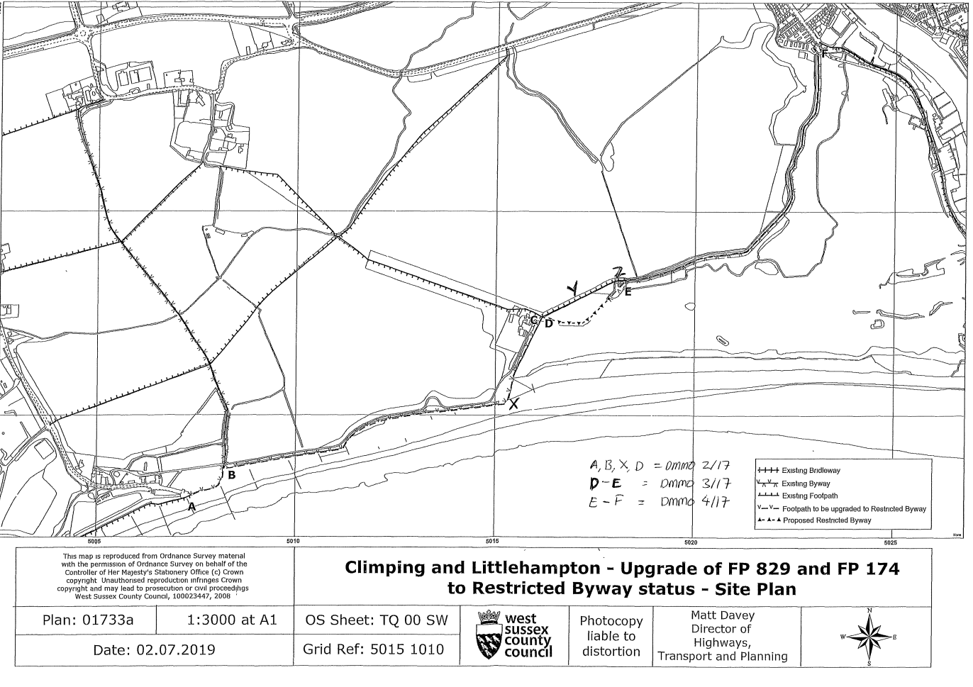

ORDER MAP 1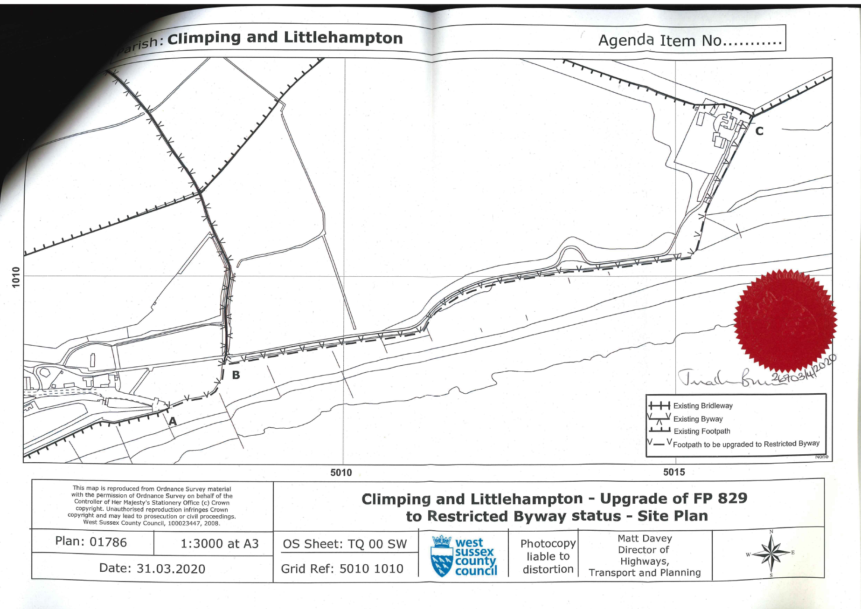

ORDER MAP 2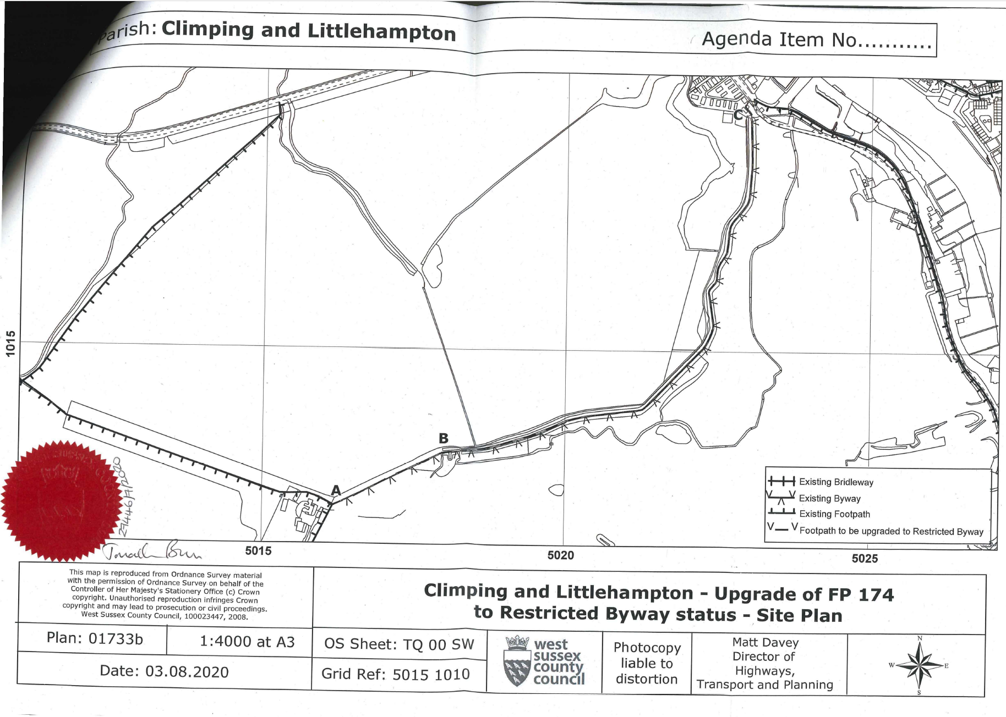

1. A bolting mill was a small building in which flour was sifted or boulted
2. A fort built in 1854 to protect the mouth of the river against the threat of Napoleon III of France.
3. *Flower, Public Works in Medieval Law*: see the Introduction (at pp. *l-li* ).
4. 2 Geo. II., c. 12.
5. F.W. Maitland, Year Books of Edward II, vol. 3: 3 Edward II (1309-1310), 20 SS 200-202 (London 1905)  
   Trin. 3 Edw. 2, pl. [14], Vulgate p. 81
6. Littlehampton Pier 1811–2, by Sir Augustus Wall Callcott, shows Climping Mill to the west, in an elevated position in the background.