

August 2024
Research into the customs intermediaries sector
Wave 8 summary report:
HM Revenue and Customs Research Report

Author: Rebecca Klahr and Jacob Bellamy (Ipsos)

Disclaimer

The views in this report are the author’s own and do not necessarily reflect those of HM Revenue and Customs.

© King’s Printer and Controller of HMSO 2024
This publication is licensed under the terms of the Open Government Licence v3.0 except where otherwise stated. To view this licence, visit nationalarchives.gov.uk/doc/open-government-licence/version/3.
Where we have identified any third party copyright information you will need to obtain permission from the copyright holders concerned.
Published by HM Revenue and Customs, October 2025.

Acknowledgements
Ipsos would like to thank all the customs intermediaries who gave up their time to take part in any of the 8 waves of this research.

Contents
Glossary and abbreviations 1
Executive summary 6
1 Survey introduction 8
2 Overview of the customs intermediaries sector 10
3 Customs declarations service for imports 13
4 Customs declarations service for exports 15
5 Goods Vehicle Movement Service (GVMS) 20
6 Pricing 22
7 Supply Chain Management Systems 25
8 Quality of service 27
9 Bulk Import Reduced Data Set 31
10 Businesses’ use of BIRDS 33
11 BIRDS supply chain 36
12 Compliance 38
13 Costs 41
14 Challenges and changes 43
15 Appendix A – survey design 45
16 Appendix B – BIRDS Topic Guide 52

Glossary and abbreviations
Term | Definition
Application Programming Interface (API) | An API, or Application Programming Interface, is a set of rules and protocols that allows different software applications to communicate and share data with each other.
Bulk Import Reduced Data Set (BIRDS) | The Bulk Import Reduced Data Set (BIRDS) is a customs simplification that allows businesses to declare one or more low value parcels into a single import declaration.
Business to Consumer (B2C) | Selling products directly to customers and thereby bypassing any third-party retailers, wholesalers, or middlemen.
Client | A person or company that commissions and receives services from another person or organisation.
Community System Providers (CSPs) | Community System Providers (CSPs) are commercial entities that directly interface with HMRC systems, including the Customs Declaration Service. CSPs provide community network services to specific port and airport communities which are formed by HMRC along with other government agencies.
Customs agent | Customs agents or brokers complete declaration forms on behalf of businesses importing and/or exporting goods. They do not primarily deal with the physical movement of goods.
Customs declaration | A form listing the details of goods being imported or exported. It is a legal requirement, although some countries or trading areas, for example the European Union (EU) have agreements in place which means they are not required.
Customs Declaration Service (CDS) | The Customs Declaration Service (CDS) is a HMRC system designed to replace the Customs Handling of Import and Export Freight (CHIEF) system (please see definition in the row below). Businesses who have yet to move their export declarations to CDS have until 4 June 2024. After this date, customs declarations cannot be submitted through the Customs Handling of Import and Export Freight (CHIEF) service.
Customs Handling of Import and Export Freight (CHIEF) | The Customs Handling of Import and Export Freight (CHIEF) system records the movement of goods by land, air, and sea. It allows importers, exporters, and freight forwarders to complete customs formalities electronically and automatically checks entry errors. CHIEF was closed for import declarations at the end of September 2022. Businesses who have yet to move their export declarations to CDS have until 4 June 2024. After this date, customs declarations cannot be submitted through the Customs Handling of Import and Export Freight (CHIEF) service.1
Customs intermediary | These are businesses that help traders to move goods across borders. They offer a range of different services including providing or arranging transportation of goods, completing customs declarations, and paying tariffs or import duties. This research focused on those who currently make declarations on behalf of traders (either in-house or outsourced).
Entry in Declarants Records | Entry in Declarants Records allow Customs Simplified Declaration Procedures (SDP) goods to be released into circulation. The customs intermediary or trader records the goods’ details at the time of import and provides a supplementary declaration to HMRC at a later date.
Export(ing) | Selling goods or services to a customer in a different country. This research focused purely on goods as customs declarations are not required for services.
Fast Parcel Operators (FPO) | A company that specialises in providing fast and time definite shipments of parcels.
Freight forwarder | A company that arranges the transportation of goods, which could include any customs clearance.
Full customs export declaration | A full customs export declaration contains all the information about an export. Completion requirements will be dependent on the Commodity Code and Procedure Code entered as these will influence the mandatory fields required to support that declaration. It is completed electronically.
Full customs import declaration | A full customs import declaration contains all the information about an import. Completion requirements will be dependent on the Commodity Code and Procedure Code entered as these will influence the mandatory fields required to support that declaration. It is completed electronically.
Goods | Tangible products such as books, clothes, or tools.
Goods Vehicle Movement Service (GVMS) | The Goods Vehicle Movement Service (GVMS) is a UK Government IT platform for moving goods into or out of Northern Ireland (NI) and Great Britain (GB). Hauliers moving goods through a port in the UK that uses the GVMS need to register for the service to get goods through customs.
GOV.UK customs agent register | The GOV.UK website includes a register of customs agents and fast parcel operators to help businesses find someone to deal with customs for them.
Haulier | Hauliers deal mainly with the physical transportation of goods.
Import(ing) | Purchasing goods or services from sellers in a different country. This research focused purely on goods, as customs declarations are not required for services.
In-house | When customs intermediaries’ complete declarations themselves.
Large business | Firms with 250+ employees.
Last-mile | Last-mile delivery, sometimes referred to as ‘final mile’, is the movement of goods from a transportation hub to their final destination, typically a customer’s home address.
Logistics partner | A person or company that contracts with a logistics service provider to fulfil transportation and logistics-related responsibilities.
Medium business | Firms with 50-249 employees.
Micro business | Firms with 1 to 9 employees. In this report, sole traders (firms with 0 employees) have been included with micro businesses. This is due to small base sizes for sole traders.
Outsourcing | When customs intermediaries pay other intermediaries to complete their customs declarations for them.
Safety and security entry summary declaration (ENS) | The Entry Summary Declaration (ENS), or Safety and security declaration, provides customs authorities with information on goods, for safety and security purposes, prior to goods arriving in the customs territory.
Shipper | A person or company that transports goods by sea, land, or air.
Simplified frontier declaration (SFD) | This is a shortened declaration that reduces the number of data elements. SFDs must be completed electronically, accepted before goods are released, and then followed by a supplementary declaration at a later date. SFDs can only be used by customs intermediaries or traders who are Simplified Customs Declaration Process (SCDP) authorised.
Small business | Firms with 10-49 employees.
Supplementary declaration | This is used following an SFD or Entry in Declarants Records. The declaration is collated by specialist software and provides the additional data needed to meet the same standard as a full declaration.
Supply chain management system (SCMS) | These are IT systems that help manage supply chain information, including for the purposes of managing business processes, documentation, processing customer information, and route planning. These systems are sometimes referred to as Freight Management Systems (FMS) or Customs Management Systems (CMS). Some of these functions may be provided by in-house systems or by commercial software products.
Third-party | Any individual, group, or entity that is not directly involved in a transaction, agreement, or relationship between two primary parties.
Trader | Businesses who import goods or services to the UK or export to other countries. This research focused purely on goods as customs declarations are not required for services.
Trader Dress Rehearsal service | The Trader Dress Rehearsal is a free service that is designed to help traders and customs intermediaries prepare for the live Customs Declaration Service. It enables different declaration scenarios to be submitted in a simulated Customs Declaration Service.
Trader Support Service | The Trader Support Service provides free online courses and training materials for businesses moving goods between Great Britain and Northern Ireland, as well as enabling businesses to complete declarations without the need for specialist advice or software.

Executive summary
Background and methodology
This report presents findings from the eighth wave of research with customs intermediaries, conducted on behalf of HM Revenue and Customs (HMRC), alongside a piece of follow-on qualitative research on the Bulk Import Reduced Data Set (BIRDS). This part of the report focuses on the customs intermediaries’ survey, with the findings from the BIRDS research starting at section 9.
Wave 8 of the survey examined intermediaries’ experiences of service provision, changing customs procedures, and challenges in the market. For findings covering a broader set of themes within the intermediary sector, please refer to wave 1, wave 2, and waves 3 to 5 of the research.
The wave 8 survey took place between 5 October and 1 December 2023. In total, 493 interviews were conducted with intermediaries, including 252 who had taken part in earlier surveys.
Key findings from the wave 8 survey
Around 3 in 10 customs intermediaries reported that they had already transitioned to the Customs Declaration Service (CDS) for exports, an increase from wave 7 (from 3% to 28%). Among those who had not fully transitioned, 8 in 10 (81%) felt confident about doing this successfully.
Almost half of customs intermediaries were registered with the Goods Vehicle Movement Service (GVMS), and of these 9 in 10 (92%) felt confident that the service would process declarations for goods moving through borders accurately and quickly.
Full customs import declarations generally took more time to complete than export declarations and safety and security entry summary declarations (ENS). Half of intermediaries (52%) noted that the type and complexity of declarations determined how much they charged for a declaration.
Around 6 in 10 intermediaries (59%) had a supply chain management system in place, with half having a system for at least 5 years. A range of costs was given for implementing and operating the system among intermediaries who were able to provide an amount.
Around a third of intermediaries (35%) felt there was at least one aspect of the sector that needed improvement. Among those who felt it was difficult to demonstrate the quality of service, 56% indicated that this was due to lots of competition within the market.
Key findings from the BIRDS research
BIRDS is primarily used for the movement of B2C goods from e-commerce sites such as Ebay, Amazon, Teemu, Shein, Alibaba and Tik Tok shop.
Intermediaries tended to manage the submission of BIRDS declarations themselves, with some completing these declarations manually and others using automated systems.
Compliance checks for goods moved and cleared under BIRDS centred on whether goods met the £135 value limit, but intermediaries conducted these checks in different ways.
Intermediaries generally liked the BIRDS system, with suggestions for improvement focused on increasing the £135 threshold and reducing uncertainty around compliance.

1 Survey introduction
HMRC commissioned Ipsos to conduct a series of research waves with the customs intermediary sector. Intermediaries provide a range of services, including transporting goods, completing customs declarations, and paying tariffs or import duties. This research focused on intermediaries’ perceptions and experiences of customs declarations specifically. The main objectives of wave 8 were to explore:
        - the extent to which intermediaries have already transitioned to CDS for exports and how long it has taken them to do so
        - the measures that intermediaries have taken to aid the transition, and the barriers they still expect to face
        - intermediaries’ experience of transitioning to CDS for imports
        - the experience of intermediaries who are signed up to GVMS
        - what customs intermediaries charge for completing declarations and what influences this price
        - how many intermediaries use an SCMS system, and what are the costs involved in doing so
  - Method
For wave 8, interviews were conducted with 493 intermediaries between 5 October and 1 December 2023.
For a more detailed account of the methodology used in previous waves of this research, please refer to the wave 6 report.
  - Reporting notes
Survey results are subject to margins of error, which vary with the sample size and the percentage figure concerned. The report only comments on subgroup differences where these were found to be statistically significant at the 95% level of confidence. The following symbols in charts denote significant differences between Wave 8 and Wave 7 of the survey: ▲▼. We have not highlighted changes where they are not statistically significant at the 95% level of confidence. There is a further guide to statistical reliability in the appendix of this report. Where figures do not sum to 100% this is due to rounding of percentages or because the questions allowed more than one response. Similarly, figures based on aggregating categories may not always reflect the sum of the individual answer categories due to rounding. Responses greater than 0% but less than 0.5% are denoted by a ^.
Average figures are reported using mean and median values to demonstrate the full scale of responses. Mean values were derived by taking the average of the actual figure given or the midpoint of banded responses. Median values were derived by taking the midpoint of the frequency distribution of the values. Median figures are useful where very high or low outlying figures were reported, to provide a more accurate and balanced account.
- Overview of the customs intermediaries’ sector
A range of firmographic questions is asked at each wave of research to understand the profiles of intermediaries taking part, and to build further understanding of the customs intermediaries’ sector at the time of research.

Trading areas
A total of 493 customs intermediaries took part in the wave 8 survey. In terms of the geographic areas for which they facilitated trade, these were as follows:
- 90% facilitated trade to or from the European Union (EU), including the Republic of Ireland
- 82% facilitated trade to or from the rest of the world (RoW) excluding the EU and including Iceland, Norway, and Switzerland
- 59% facilitated trade to or from Northern Ireland (NI)

Process for completing customs declarations
Around half of intermediaries (47%) completed customs declarations via a combination of in-house and outsourced delivery. There was a broadly even split between the remaining intermediaries, with (25%) completing all their declarations in-house and (28%) outsourcing them to other organisations.

Types of declarations completed by businesses who process at least some declarations in-house
Customs export declarations remained the most common type of declaration completed by customs intermediaries with at least some in-house processing (84%), followed by full customs import declarations (80%). Less than half completed safety and security entry summary declarations (ENS) (38%), simplified frontier declarations (SFD) (37%), supplementary declarations (34%) and entry in declarants records (30%). A small minority completed Bulk Import Reduced Data Set (BIRDS) (7%).

Group structure
Just under two-thirds of customs intermediaries (63%) had an independent group structure, while 28% were subsidiaries and 7% were a parent or holding company.

Size
As per Table 2.1, the size of intermediaries varied, with 31% being micro firms, 32% small, 20% medium and 14% large.
Table 2.1: Size of intermediaries that took part in the survey
Micro (sole trader-9 employees) | 31%
Small (10-49 employees) | 32%
Medium (50-249 employees) | 20%
Large (250+ employees) | 14%
Base (unweighted): all customs intermediaries (442). Note: 2% of respondents answered ‘Don’t know’ when asked about business size.

Turnover
Intermediaries had a range of turnovers. After excluding those who either did not know or refused to answer (32% of all intermediaries), just under a quarter (23%) of intermediaries reported a turnover between £1 million and £5 million in the 2022 to 2023 financial year. Around a sixth (17%) had a turnover of between £5 million and less than £50 million, while 8% turned over more than £50 million. This left around 1 in 5 with less than £1 million of revenue in the 2022 to 2023 financial year, split evenly between less than £500,000 (9%) and between £500,000 and less than £1 million (10%).

Figure 2.1: Turnover in the last financial year (2022 to 2023)
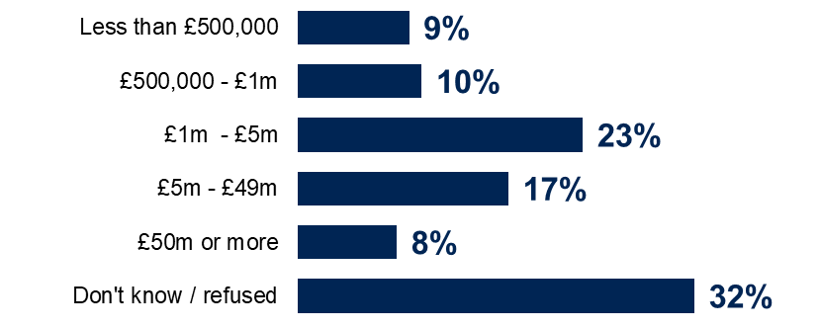
Base (unweighted): all customs intermediaries (493).

HQ location
Most customs intermediaries had their central headquarters based in England (78%), with 6% based in Scotland, 3% in Wales and 5% in Northern Ireland. In addition, 4% were based in the EU and 3% in the rest of the world.

Business activities
When asked to describe the activities that their business undertook, 63% of intermediaries said that their business was a freight forwarder, while 55% said they were a logistics company and 50% a customs broker or agent. Intermediaries were also described as being a haulier (35%), a customs warehouse (21%), a courier (18%) and a fast parcel operator (FPO) or express operator (EO) (8%).

- Customs declarations service for imports
On 30 September 2022, the previous system for processing customs declarations, CHIEF, closed for the processing of import declarations, meaning all import declarations needed to be processed through the new CDS system instead.
  - Time taken to complete import declarations on CDS compared with CHIEF when first transitioning
Intermediaries were asked to think about when their businesses initially transitioned from CHIEF to CDS for imports, excluding those that had not heard of CDS. As shown in Figure 3.1, around half of these intermediaries (49%) said that it took longer to complete import declarations on CDS compared with CHIEF. Specifically, 28% said it took a lot more time and 21% a little more time. By contrast, 5% said it took less time, split between a little less time (4%) and a lot less time (<1%). Around 1 in 5 (21%) said the time was about the same and 25% did not know.
Figure 3.1: Time taken to complete import declarations on CDS compared with CHIEF when first transitioning
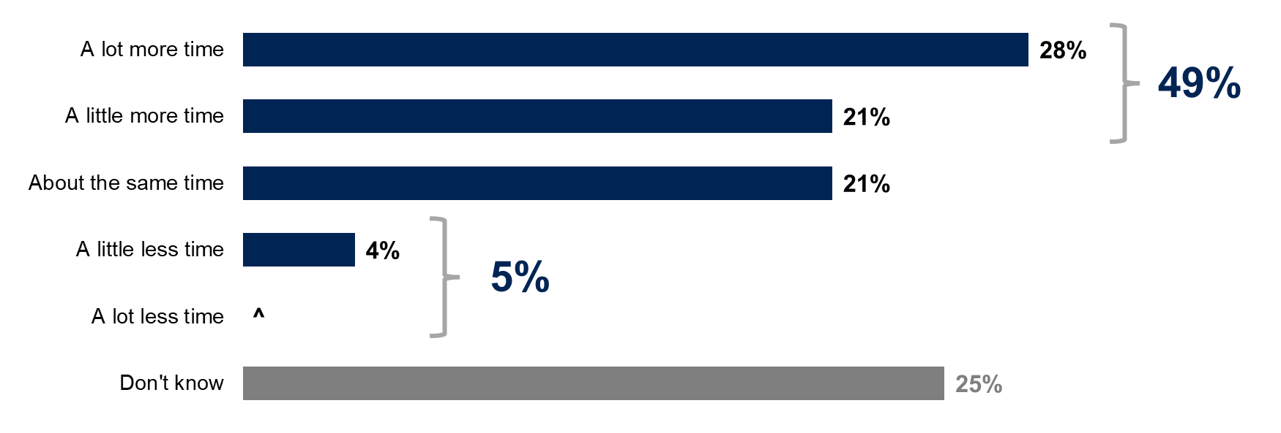
Base (unweighted): all customs intermediaries, excluding those who hadn’t heard of CDS (477).
  - Time taken to transition from CHIEF to CDS for imports
Intermediaries who said it initially took longer to complete import declarations on CDS were asked how long it took before this time was equal to or less than the time taken on CHIEF. Intermediaries gave a range of answers, with 14% saying it took less than a month, while 22% said it took between a month to less than 3 months. A further 12% said it took between 3 months to less than 6 months, 9% between 6 months to less than a year and 1% more than a year. The mean response was 2.6 months. Around 4 in 10 (41%) said they did not know.
All intermediaries, excluding those that had not heard of CDS, were asked how long it took their business to stop using CHIEF and fully transition to CDS for imports. Around a quarter (26%) said it took them less than a month, while 24% said it took between a month and 3 months, 15% between 3 and 6 months, 5% between 6 months and a year and 1% more than a year. The mean response was 2 months. Around 3 in 10 (29%) said they did not know, as shown in Figure 3.2.
Figure 3.2: Time taken to transition fully to CDS for imports
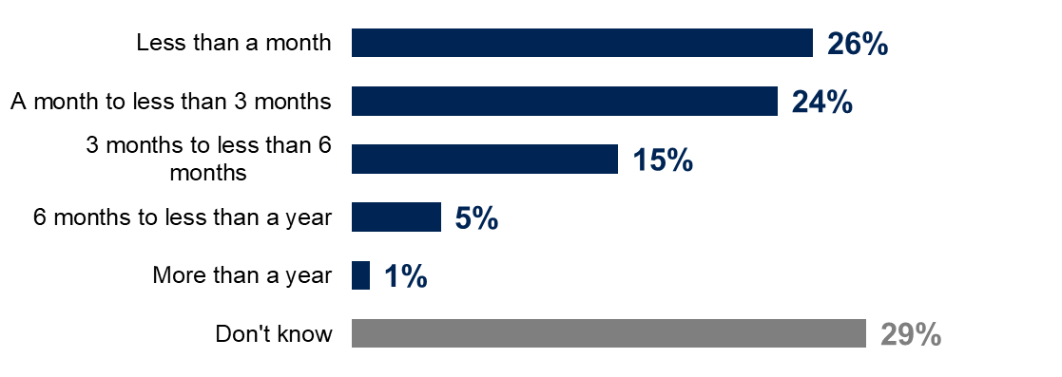
Base (unweighted): all customs intermediaries, excluding those who had not heard of CDS (477).

- Customs declarations service for exports
The deadline for making export declarations on CHIEF was scheduled for 30 March 2024 when this survey was conducted. A transition period was subsequently agreed allowing businesses until 4 June 2024 to move their declarations across to the Customs Declaration Service. From this date, all export declarations will need to be processed through the new CDS system instead.
  - Whether intermediaries have transitioned to CDS for exports
At the time of the wave 8 survey (October to December 2023), only export declarations using the Goods Vehicle Movement Service (GVMS) could be submitted through the CDS. When the survey was conducted just over a quarter of customs intermediaries (28%) said that they had already transitioned from CHIEF to CDS for exports. Around 6 in 10 intermediaries (61%) had not yet fully transitioned to CDS for exports.
Figure 4.1: Whether customs intermediaries had transitioned to CDS for exports
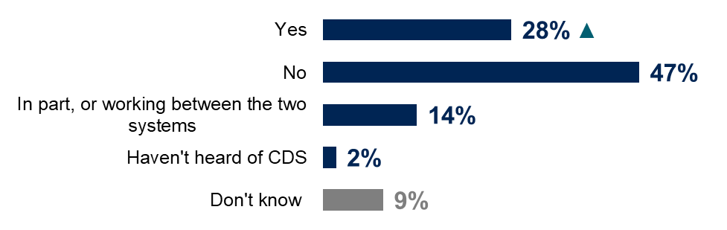
Base (unweighted): all customs intermediaries (493).
  - Confidence in transitioning ahead of CDS deadline
Among intermediaries that had not fully transitioned to CDS for exports, the majority (81%) said they felt confident about successfully transitioning ahead of the March 2024 deadline. A minority (15%) did not feel confident, as shown in Figure 4.2.
Figure 4.2: Confidence about successfully transitioning to CDS
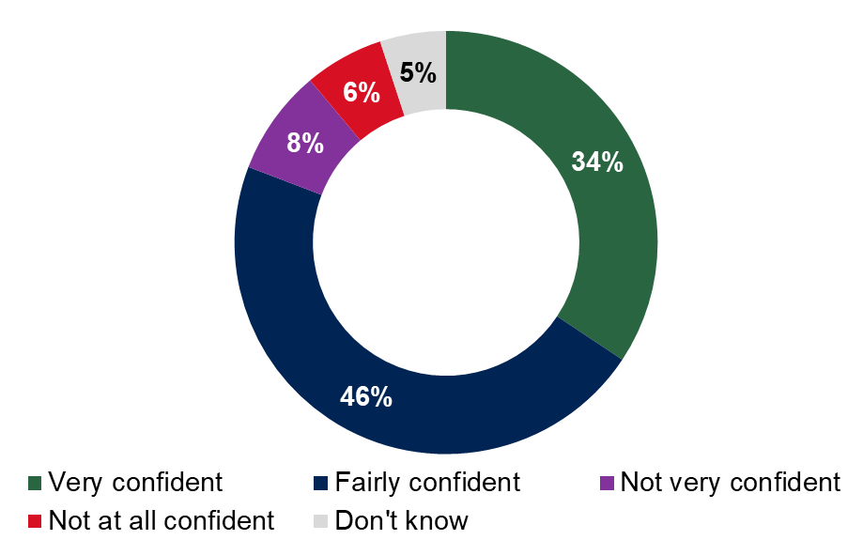
Base (unweighted): all customs intermediaries who had not fully transitioned to CDS for exports (301).
  - Steps taken ahead of the CDS export transition deadline
Customs intermediaries were asked about the steps they had taken, or would need to take, before transitioning to CDS for exports. The results for this question are analysed according to the progress intermediaries had made in the transitioning process, as shown in Table 4.1.
Firstly, intermediaries that had already transitioned to CDS for exports were asked what additional steps their businesses had taken before it transitioned. The 3 most common steps were to train staff members, either in-house or externally (49%), research on the internet, including checking the CDS export guidance on GOV.UK (47%) and subscribe with CDS and/or get customers to register (46%). Around one fifth (19%) said that they had not taken any additional steps.
If intermediaries had partially transitioned to CDS for exports, they were asked what steps the business had taken before it started to transition. These intermediaries reported a number of steps, most commonly researching on the internet, including checking the CDS export guidance on GOV.UK (75%), engaging with their software providers (73%) and training staff members (72%). Only 1% of these intermediaries said they had not taken any steps.
Finally, intermediaries that had not transitioned to CDS for exports were asked what additional steps they felt their business would need to take before it could make the transition ahead of the March 2024 deadline. These businesses were most likely to say they would need to train staff members (59%), research on the internet, including checking the CDS export guidance on GOV.UK (51%) and test the new system to identify bugs or errors (49%). In this group, 18% said that they would not need to take any additional steps.
Table 4.1: Steps that intermediaries had taken, or would need to take, before transitioning to CDS for exports
 | Fully transitioned to CDS | Partially transitioned to CDS | Not transitioned to CDS
Train staff members, either in-house or externally | 49% | 72% | 59%
Research on the internet, including checking the CDS export guidance on the GOV.UK webpage | 47% | 75% | 51%
Subscribe with CDS and/or got customers to register | 46% | 69% | 33%
Speak to external sources, such as professional bodies or trade organisations | 40% | 65% | 41%
Run both systems in parallel for a period, verifying that CDS is providing the same outputs as CHIEF | 34% | 66% | 46%
Test the new system to identify bugs or errors | 33% | 68% | 49%
Engagement with your current software provider | 33% | 73% | 41%
Set up access to the Trader Dress Rehearsal service to practice submission of export declarations | 30% | 53% | 40%
Purchase, installation, or upgrade of software | 24% | 42% | 25%
Produce a timeline for transition between CHIEF and CDS | 21% | 51% | 38%
Application for new Economic Operator Registration and Identification number (EORI) numbers if you don’t have one already | 16% | 6% | 7%
Other | 1% | 1% | 2%
No additional steps have been or will be taken | 19% | 1% | 18%
Don’t know | 8% | 4% | 7%
Base (unweighted): all customs intermediaries who had transitioned to CDS for exports (133); All intermediaries who had partially transitioned to CDS for exports (69); All intermediaries who had not transitioned to CDS for exports (244). Please note that the response option ‘Haven’t heard of CDS’ has been integrated into the ‘Not transitioned to CDS’ column. Also, the response option ‘Don’t know’ has been excluded from the cross-break due to low base size.
  - Time needed for staff training
If intermediaries had transitioned to CDS (fully or partially) and had trained staff members as an additional step, they were asked how much additional time was required to train their staff in completing export declarations on CDS. One fifth (20%) said that ‘significant’ additional time was required, while 58% said that they needed ‘some’ additional time. Around a quarter said either that ‘minimal’ additional time was needed (16%) or none at all (6%).
Figure 4.3: Amount of additional time required to train staff in completing export declarations on CDS for those that had already transitioned
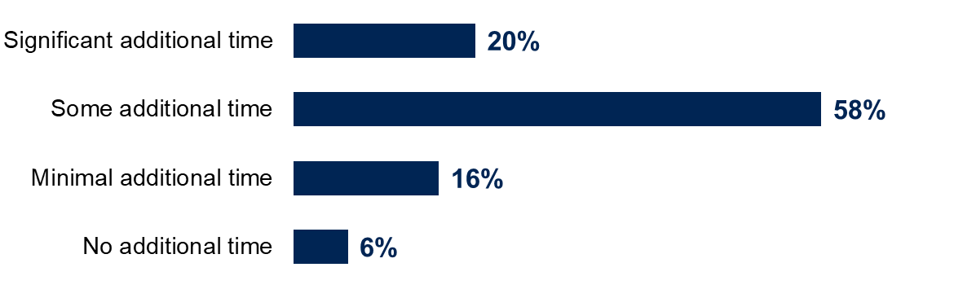
Base (unweighted): all customs intermediaries who have transitioned to CDS for exports (113)
Findings were similar among intermediaries that had not transitioned to CDS and who expected to need to train staff members. Among these intermediaries, 23% expected to need a ‘significant’ amount of additional time to train staff in completing export declarations on CDS, while 56% expected ‘some’ additional time, 14% ‘minimal’ time and 4% none at all.
Where there was an expectation of ‘significant’ or ‘some’ additional time for staff training, intermediaries were asked to specify how much additional time they expected. Half of these intermediaries expected to need at least 4 weeks (23% between 4 and 8 weeks, 27% more than 8 weeks), while 31% expected to need between 1 and 4 weeks, 8% between 1 day and 1 week and 10% less than a day. The mean number of days specified by intermediaries was 33.
  - Barriers to transition to CDS for exports
Customs intermediaries that had not yet fully transitioned to CDS were asked what barriers, if any, they were experiencing in the transition to CDS ahead of the exports declarations deadline of 30 March 2024. The most common responses were that CDS or the software was not user friendly or did not work as it should (21%), however this was a significant decline from wave 7 when this was mentioned by 40% of intermediaries.
Around 1 in 5 intermediaries felt there was a perceived lack of information or support from HMRC (20%), were awaiting IT functionality to submit all export declarations via CDS (19%) or that they lacked knowledge of how to declare on CDS (18%). Other barriers included having enough time to learn or use the new system (15%); a perceived lack of training (13%); waiting for ports or the Community System Provider to update systems (13%); and using the free Trader Dress Rehearsal service (10%). Three in 10 (30%) said they experienced no barriers at all in the transition to CDS, as shown in Figure 4.4.
Figure 4.4: Barriers experienced in the transition to CDS
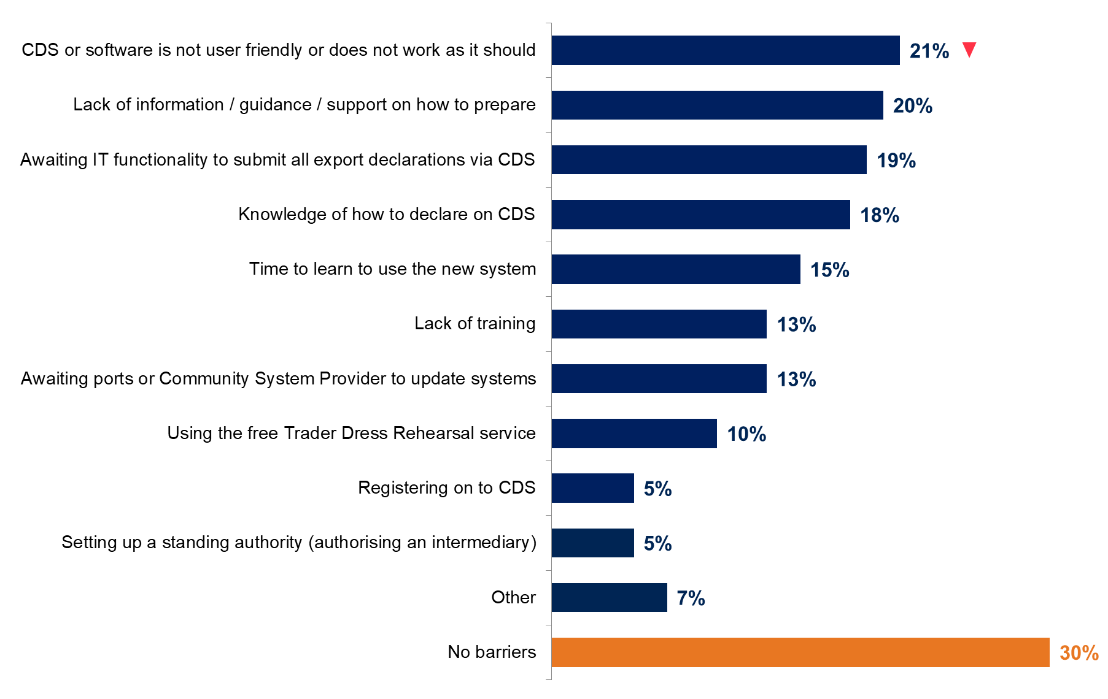
Base (unweighted): all customs intermediaries who had not fully transitioned to CDS for exports (301). This question was multicode. See Table 15.3: in the appendix.

- Goods Vehicle Movement Service (GVMS)
The Goods Vehicle Movement Service (GVMS) is a UK Government IT service for moving goods into or out of Northern Ireland (NI) and Great Britain (GB). Hauliers moving goods through a port in the UK that uses the GVMS need to register for the service to get goods through customs.
  - Confidence in the GVMS
Almost half of customs intermediaries (47%) said they were registered with the GVMS at the time of the survey.
The majority (92%) of those who were registered with the GVMS said they were confident that goods would be processed accurately and quickly, when they were completing declarations for goods moving through border locations where the GVMS was used. This included over half (53%) that were very confident, as shown in Figure 5.1.
Figure 5.1: Confidence in the GVMS
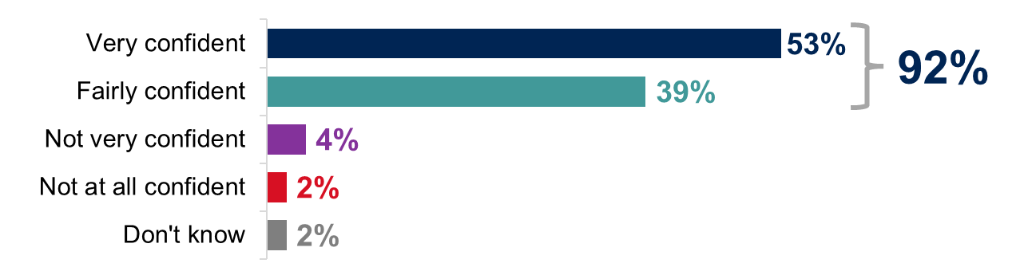
Base (unweighted): all customs intermediaries who were registered with the GVMS (236).
  - Improvements to the GVMS system
Customs intermediaries who were registered with the GVMS were asked what improvements, if any, they would make to the process of entering declarations into the GVMS.
Intermediaries made a number of suggestions for improvement. Most commonly, they suggested that explanations for invalid or rejected registrations should be provided (73%) or that they should be notified about location-specific customs requirements (71%). Other common responses included allowing businesses to track their records (69%) and storing frequent user data (66%). Full details are shown in Figure 5.2.
Figure 5.2: Suggested improvements to the GVMS system
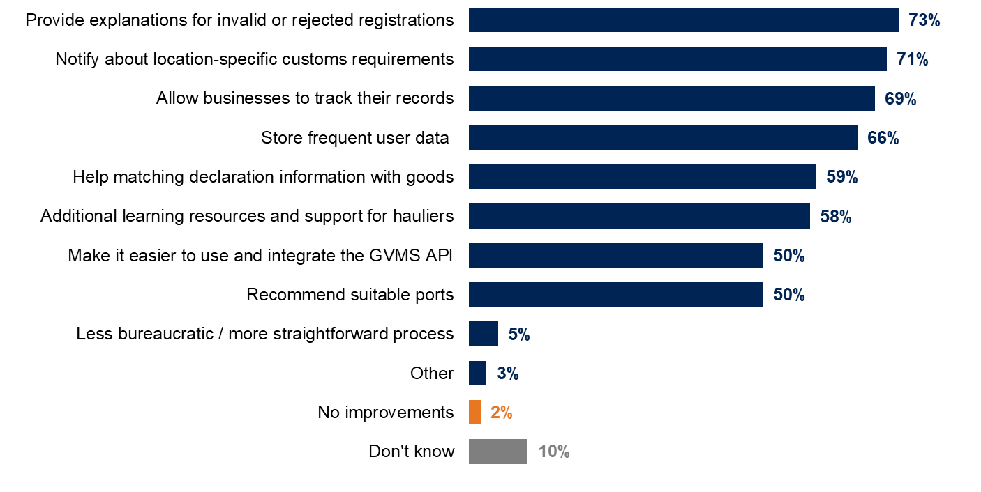
Base (unweighted): all customs intermediaries who were registered with the GVMS (236). This question was multicode.

- Pricing
  - Time taken to complete declarations
Intermediaries that completed at least some declarations in-house (72% of those surveyed) were asked how long it took to complete different types of custom declarations for their last customer. Details are shown in Table 6.1.
Similarly, to previous waves, the time needed to complete a full customs import declaration was typically longer than for the other types of declaration. A quarter (25%) of those who completed full customs import declarations in-house said they took more than an hour to complete for their last customer. This compares with 17% for the completion of customs export declarations and 9% for safety and security entry summary (ENS) declarations. The median number of minutes taken to complete a full customs import declaration was 25, compared to 15 for both the customs export declaration and ENS declaration.
Table 6.1: Time needed to complete customs declarations for last customer
 | Full customs import declaration | Customs export declaration | Safety and security entry summary declaration (ENS)
Over 0 to 10 minutes | 24% | 41% | 46%
Over 10 to 20 minutes | 24% | 21% | 12%
Over 20 to 30 minutes | 14% | 7% | 12%
Over 30 to 60 minutes | 9% | 6% | 12%
Over 60 minutes, up to a day | 16% | 14% | 6%
More than a day | 9% | 3% | 4%
Don’t know | 4% | 6% | 8%
Median minutes | 25 | 15 | 15
Base (unweighted): all intermediaries who complete at least some declarations in-house: full customs import declarations (269), customs export declarations (296), safety and security entry summary declarations (124).
  - Pricing for different types of declaration
In line with findings at previous waves, customs intermediaries said they charged the most for completing full customs import declarations, with the most common pricing range being £40 to £50 by 28% of businesses. The mean price for completing full customs import declarations was £42, compared with £33 for customs export declarations and £24 for safety and security entry summary (ENS) declarations.

Table 6.2: Amount charged for each type of custom declaration for last customer
 | Full customs import declaration | Customs export declaration | Safety and security entry summary declaration (ENS)
Up to £30 | 6% | 21% | 34%
More than £30 - £40 | 13% | 25% | 19%
More than £40 - £50 | 28% | 18% | 8%
More than £50 - £60 | 14% | 5% | 3%
More than £60 - £70 | 17% | 3% | 3%
More than £70 | 11% | 10% | 4%
No charge | 5% | 8% | 16%
Don’t know/don’t keep records | 7% | 9% | 12%
Mean | £42 | £33 | £24
Median | £45 | £35 | £25
Base (unweighted): all customs intermediaries who complete in-house: full customs import declarations (270), customs export declarations (295), safety and security entry summary declarations (125).
  - Pricing models
The majority (65%) of customs intermediaries said that they charged per customs declaration, while 18% did not have a specific charge and included the cost of the declaration in the overall cost of moving goods, and 10% reported using a mixture of different models.
Intermediaries were more likely at wave 8 than at wave 7 to say that they did not have a specific charge and included the cost of the declaration in the overall cost of moving goods (18% compared with 11%). They were less likely to say that they charged per customs declaration (65% compared with 75%).
Figure 6.1: Pricing model intermediaries use for completing declarations
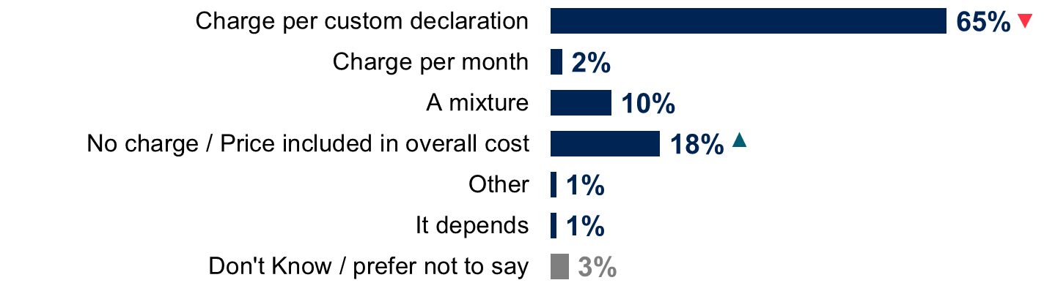
Base (unweighted): all customs intermediaries (493).
  - Factors that influence pricing
Customs intermediaries said that the type of declaration or the complexity involved was the main factor influencing how much they charged for completing customs declarations (52%). Other key factors included the volume of customer business (39%), the time taken to complete the declarations (38%) and the market rate (37%), as shown in Figure 6.2.
Figure 6.2: Factors influencing how much is charged for completing declarations
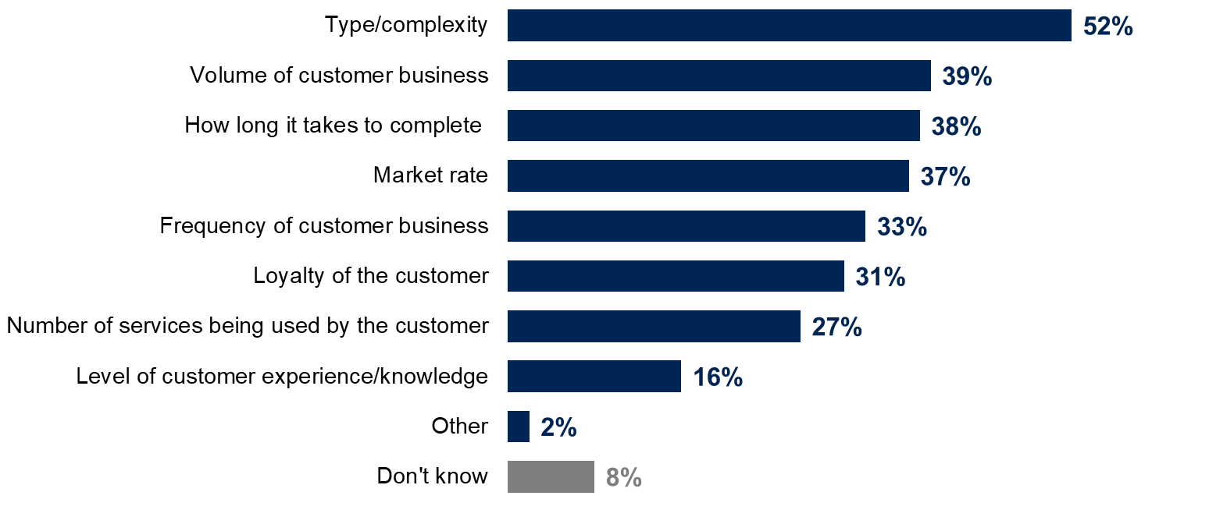
Base (unweighted): all customs intermediaries (493). Top answers shown only. See Table 15.4 in the appendix. This question was multicode.

- Supply Chain Management Systems
  - Use of Supply Chain Management Systems
Customs intermediaries were asked about their use of supply chain management systems. They were given the following description of these systems:
‘A Supply Chain Management System is an IT system that helps manage supply chain information. These systems are sometimes referred to as Freight Management Systems (FMS) or Customs Management Systems (CMS). Some of these functions may be provided by in-house systems or by commercial software products, for example Descartes, MultiFreight, Cargowise, Sequoia, Mandata.’
Around 6 in 10 customs intermediaries (59%) said that they used a supply chain management system. Half of these intermediaries (49%) put the system in place or purchased it at least 5 years ago, as shown in Figure 7.1.
Figure 7.1: When intermediaries put in place a supply chain management system
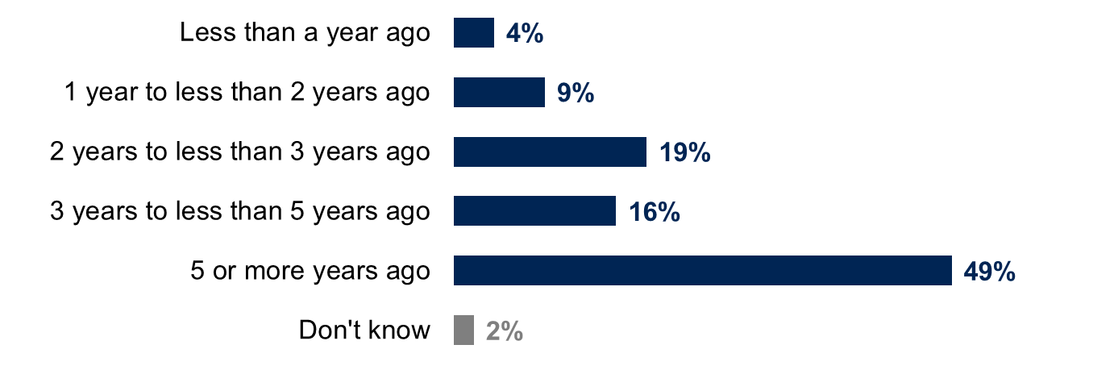Base (unweighted): all customs intermediaries who used a supply chain management system (286).

Up-front costs
Customs intermediaries that had put a supply chain management system in place in the last 3 years were asked how much it had cost them to purchase and implement the system, over the course of the year in which it was put in place.
Costs were most likely to be in the region of £2,500 to £4,999 (15%), £5,000 to £9,999 (16%) or £10,000 to £29,999 (11%), as in Figure 7.2. More than a third of businesses (38%) could not specify an amount.
Figure 7.2: Cost of purchasing and implementing an SCMS
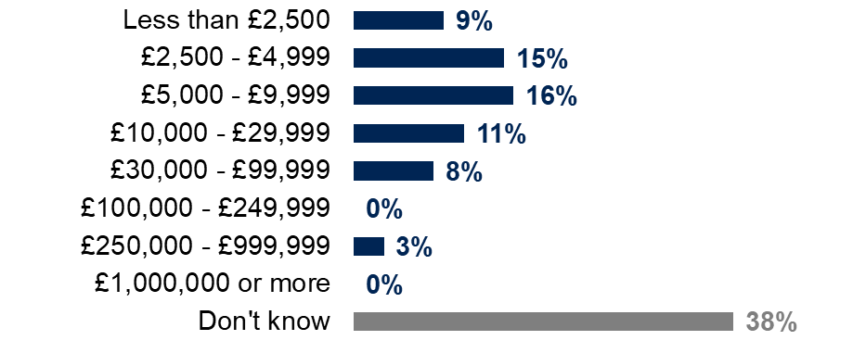
Base (unweighted): all customs intermediaries who put in place an SCMS system within the last 3 years (97).
  - Maintenance costs
Intermediaries that used a supply chain management system were asked how much it had cost to operate and maintain the system over the previous year. This annual cost varied considerably, from under £1,000 (9%) to £50,000 or more (12%). More than 4 in 10 intermediaries (44%) did not specify an amount, as shown in Figure 7.3.
Figure 7.3: Cost of operating and maintaining a supply chain management system over the past year
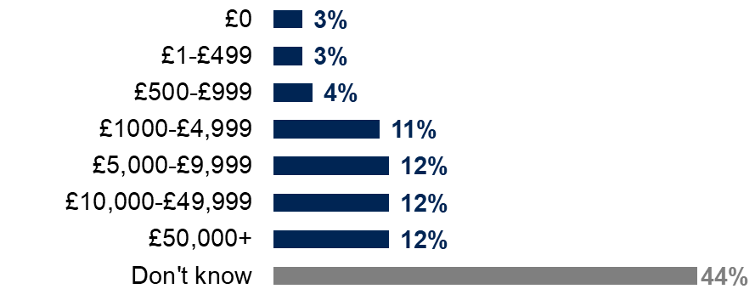
Base (unweighted): all customs intermediaries who used a supply chain management system (286).
- Quality of service
  - Level of knowledge of customs processes
Almost half of customs intermediaries (47%) felt that there was an excellent (7%) or good (40%) level of knowledge of customs processes across the sector. This is compared with around a quarter (23%) that felt either that there was some lack of knowledge (17%) or a significant lack of knowledge (6%), as shown in Figure 8.1.
Perceived levels of knowledge increased from wave 7 to wave 8. Specifically, the proportion that said there was a good level of knowledge increased from 33% at wave 7 to 40% at wave 8.
Figure 8.1: Reported level of knowledge of customs processes across the sector
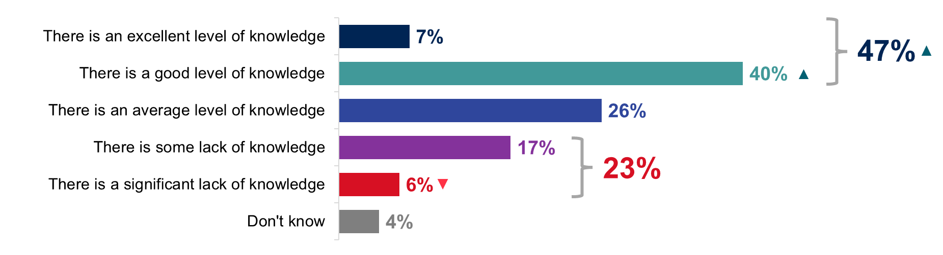Base (unweighted): all customs intermediaries (493).
  - Priority areas for improvement of quality of service
When asked about the sector overall, 35% felt the quality of service offered by customs intermediaries needed improving. The aspect of service most likely to be seen as needing improvement, similar to wave 7, was unsatisfactory understanding of customs requirements and processes (14% compared to 12% at wave 7). A similar proportion of intermediaries answered support and contact from HMRC (13%), unsatisfactory local knowledge (12%), poor speed of service (11%), low accuracy (10%), low efficiency (10%) and delays in communication with customers (10%). Details are shown in Figure 8.2.
Compared with wave 7, intermediaries at wave 8 were more likely to mention unsatisfactory local knowledge (12% compared with 6%), speed of service (11% compared with 4%) and efficiency (10% compared with 5%).
Figure 8.2: Aspects of services needing improvement across the sector
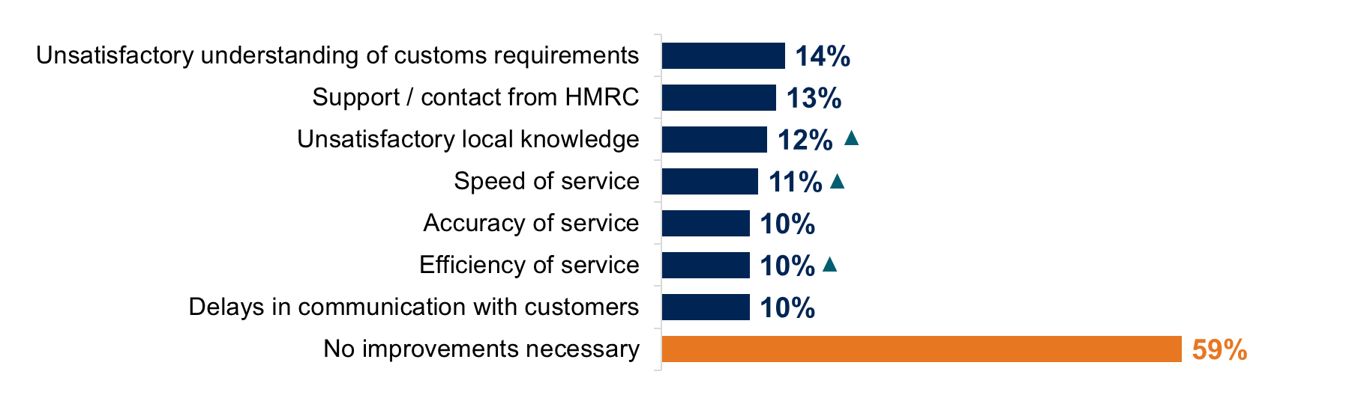Base (unweighted): all customs intermediaries (493). Top answers shown only. See Table 15.5: in the appendix. This question was multicode.
  - Challenges to improving quality of service
Customs intermediaries were asked what challenges, if any, they faced in improving the quality of their service. Around 6 in 10 intermediaries (61%) identified at least one challenge. The most common responses were a lack of staff (12%), access to finance (11%) and levels of expertise in the workforce (10%). Around 3 in 10 (31%) reported no challenges, as shown in Figure 8.3.
Figure 8.3: Challenges to improving quality of service
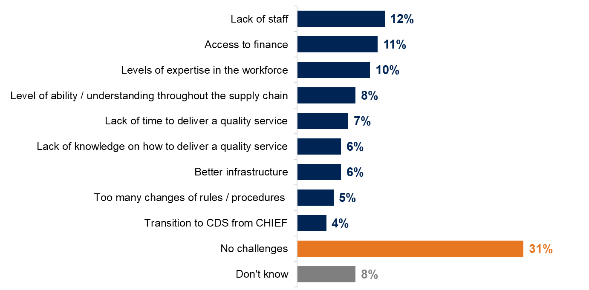
Base (unweighted): all customs intermediaries (493). Top answers shown only. See Table 15.6: in the appendix. This question was multicode.
  - Ease of demonstrating quality to customers
Four in ten customs intermediaries (40%) did not think it was easy to demonstrate the quality of service they provided to their customers (including 26% who felt it was neither easy nor difficult and 14% who said it was difficult), as shown in Figure 8.4.
Figure 8.4: Ease of demonstrating the quality of service provided to customers
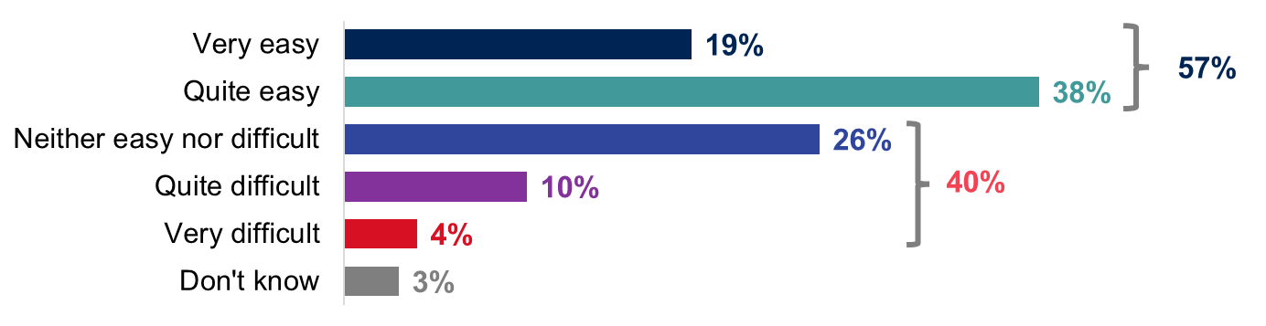Base (unweighted): all customs intermediaries (493).
Customs intermediaries that said it was easy to demonstrate service quality were asked how this was demonstrated. They were most likely to say that it was through the service they provided (89%), by word of mouth (80%) or by liaising with other parts of the supply chain (66%), as shown in Figure 8.5.
Compared with wave 7, intermediaries at wave 8 were more likely to say they demonstrated the quality of their service through word of mouth (80% compared with 70%), by liaising with other parts of the supply chain (66% compared with 57%), through external marketing (45% compared with 30%) and by sharing statistics on customer satisfaction (36% compared with 22%).
Figure 8.5: How customs intermediaries demonstrate the quality of their service
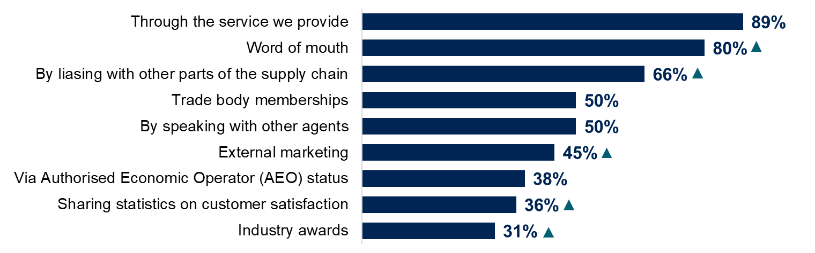
Base (unweighted): all customs intermediaries who said it was easy to demonstrate the quality of their service (409). Top answers shown only. See Table 15.7: in the appendix. This question was multicode.
Customs intermediaries that said it was difficult to demonstrate service quality to customers were asked to explain why they found it difficult. They were most likely to say that it was because of the competition within the market (56%), while other reasons included lack of time (34%) and the cost of advertising and marketing (33%).

- Bulk Import Reduced Data Set
  - Background to the research
As part of wave 8 of the customs intermediaries research, Ipsos conducted a more extensive qualitative phase concerning two types of customs processes: safety and security declarations and the Bulk Import Reduced Data Set (BIRDS). This section of the report focuses on the Bulk Import Reduced Data Set, while safety and security declarations will be covered in a separate report.
  - Primary research objectives
The Bulk Import Reduced Data Set (BIRDS) is a customs simplification that allows businesses to declare one or more low value parcels into a single import declaration. Goods moved via BIRDS must have a value of less than £135, and those moving and clearing goods via BIRDS must be authorised to do so. This qualitative research aimed to uncover:
- which types of customs sector businesses use BIRDS and what goods they move
- what role intermediaries that use BIRDS play in the small package supply chain, and what processes and systems they have in place when moving goods into the UK via BIRDS
- how businesses navigate and manage regulatory aspects of the BIRDS supply chain
- how businesses’ costs for BIRDS compare to other declarations
- the main challenges that businesses experience when using BIRDS, and how these might be mitigated
  - Sample framework
The sample was drawn from two sources:
- respondents from the customs intermediaries wave 8 survey who reported using BIRDS and agreed to be recontacted for further research
- HMRC’s BIRDS authorisations database
20 interviews were conducted with intermediaries and took place between the 10 January and 1 February 2024, lasting up to 60 minutes each. Interviews were conducted with a mix of intermediary types and sizes, as shown in Table 9.1.

Table 9.1: Interview breakdown
 | 0 – 9 employees | 10 – 49 employees | 50 – 249 employees | 250+ employees | Total
Customs agents | 4 | 4 | 1 | 0 | 9
Express operators | 1 | 1 | 0 | 2 | 4
Freight forwarders | 0 | 2 | 2 | 3 | 7
Total | 5 | 7 | 3 | 5 | 20
  - Limitations of the findings
The findings in this report are intended to provide insight into the behaviours and experiences of a range of businesses. By design, the research set out to capture a rich and detailed understanding of different BIRDS users’ behaviours and experiences, not to determine the prevalence of these behaviours and experiences. Where the report indicates that ‘few’, ‘some’, or ‘many’ participants experienced or felt something, this is in relation to the research participants only. Findings cannot be considered representative of the BIRDS user population and should not be interpreted as generalisable to these populations.
The research addressed sensitive issues around compliance, and steps were taken to encourage open and honest engagement. However, it’s less likely that those who are deliberately non-compliant would agree to take part.
No traders were interviewed as part of this research. As such, the experience of traders using BIRDS is not represented.
We did not talk to any businesses that dropped out or stopped using BIRDS for any reason, as these would not appear in either sample source.
  - Case studies
We present several case studies throughout this section of the report. These examples highlight key findings related to specific participants. These case studies do not represent the entire sample of participants, nor do they reflect the overall characteristics of the BIRDS user population.

- Businesses’ use of BIRDS
  - Intermediaries’ use of BIRDS
Intermediaries preferred to use the Bulk Import Reduced Data Set (BIRDS) when moving low-value parcels. They tended not to move these items in any other way and would only submit full import declarations for these items if they were ineligible for BIRDS. Most participants tended to use BIRDS regularly, with higher-volume BIRDS users sending parcels via BIRDS daily. BIRDS accounted for a smaller proportion of the declarations submitted by businesses, but a large number of the goods cleared.
“We're doing daily clearances. If the goods qualify for BIRDS we will always use BIRDS. It’s a simplification and it's less cost to us from a business perspective.”
Customs agent, small business

Case study 1
A very large, technology-oriented fast parcel operator delivering mostly for Business-to-Consumer (B2C) clients. The business operated with a large European supply chain of partner businesses, using automated information exchange. The business moved and cleared 10,000 goods a day, of which 4,000 were covered by full declarations. The remaining 6,000 items were moved using around 30 BIRDS declarations.
“It’s kind of an odd one. It’s a less used declaration type, but it probably covers more parcels than a lot of the other declaration types.”

For some intermediaries, BIRDS was a smaller, less frequently used element of their service. These participants tended to move and clear items above the £135 threshold as their primary business. One freight forwarder felt this was because BIRDS was a simplification designed specifically for couriers and fast parcel operators and was not easy to use for other types of intermediaries.
Intermediaries generally adopted a ‘BIRDS first’ approach in the movement and clearance of goods. This meant that goods were first considered for processing via BIRDS, with a full import declaration used only if BIRDS was not feasible.
“What can go BIRDS does go BIRDS.”
FPO, large business

  - Sellers and types of goods moved through BIRDS
Intermediaries mostly used BIRDS to move and clear goods sourced from e-commerce platforms, with an emphasis on sellers based in Asia. These transactions were generally Business-to-Consumer (B2C), reflecting a trend towards low-value, consumer-oriented individual purchases.
The sources of goods moved and cleared using BIRDS were often e-commerce platforms such as Temu, Shein, Alibaba, and TikTok Shop, with a significant proportion originating from China. The research found that intermediaries also moved a large number of parcels from Amazon and eBay. Examples of the types of goods being moved and cleared through BIRDS included phone cases, kitchenware, chargers, cables, clothing, and cosmetics.
While most goods moved and cleared via BIRDS were B2C, Business-to-Business (B2B) goods were also moved using BIRDS, although with a lower frequency. Examples of these goods included building materials and small machine parts. Intermediaries using BIRDS in this way tended to be lower-volume BIRDS users, who only used the simplification for a specific client. However, not all intermediaries that used BIRDS for a single client were low-volume users. One participant used BIRDS exclusively for Amazon, moving and clearing thousands of parcels each week.
  - Knowledge of BIRDS in the supply chain
Awareness and knowledge of BIRDS varied among businesses involved in the BIRDS supply chain. Some intermediaries noted that their customers were aware of BIRDS, and that this constituted a selling point of their service due to the low cost of moving goods using BIRDS.
Other participants felt that their customers were not aware of BIRDS and were more concerned with moving and clearing goods in a timely manner. These differences depended on how close the client was to the customs process. Where clients had their own logistics operations and were involved in the physical movement of the goods, they tended to be more aware of BIRDS.
"Some of the larger customers or even some of the smaller ones to an extent are aware of it (BIRDS) and challenge us on a frequent basis… Some of the other traders they don't know because as far as they're concerned, their goods come in, we never contact them, we never delay anything at the border. They're super happy that service is achieved."
FPO, large business
  - BIRDS pricing
Some intermediaries did not want to advertise the existence of BIRDS as they were concerned that if their clients became aware of the BIRDS simplification, it could lead to increased expectations for lower prices, potentially impacting their ability to maintain competitive pricing and profit margins. This depended on the nature of the goods and the type of customer, rather than on the size or type of intermediary. Intermediaries with clients that did not know about BIRDS were less likely to flag it as part of their service.
"The client doesn’t know much about BIRDS – they just need this small parcel delivered."
Customs agent, micro business
- BIRDS supply chain
  - BIRDS declaration process
Intermediaries submitted BIRDS declarations themselves, based on information provided by the seller or shipper. Their approach to this process varied by intermediary size and structure. Some larger, high-volume businesses had automated systems for BIRDS submissions. Other intermediaries had employees fill out BIRDS forms manually and submit these directly into CDS.
“We don’t do the last mile, but we manage that handover to them. We have an office in Heathrow – and what we do is we collect from the planes, we park tyres on the ground, and we get things ready.”
Customs agent, micro business
  - Involvement of third-party businesses and approaches to information exchange
The degree of third-party involvement in the BIRDS supply chain varied depending on intermediary type. Customs agents were more likely to handle only the documentation associated with BIRDS and were less involved in the transport and logistics of low-value goods. As a result, they relied on other businesses to manage this aspect of the import process. Fast parcel and express operators were more likely to offer a ‘full-service’ package that took the goods from the seller and delivered them to the buyer’s door. They relied less heavily on third-party businesses, although they used them for services such as compliance, logistics in the country of origin, and warehouse management.
Intermediaries and third-party businesses used different modes to share information about the goods being moved. The information being exchanged across the supply chain was of two broad types:
- product information, including goods descriptions, commodity codes, value and weight
- logistics information, including true sender, receiver, EORI number, and end delivery point
While the information exchanged was similar among participants, the ways in which this exchange occurred varied by business size and structure. Intermediaries with direct involvement in the physical transportation of goods were more likely to have automated, Application Programming Interface (API) driven information transfer between those clearing and those moving the goods. Intermediaries that outsourced this part of the movement, such as the smaller customs agents, were more likely to communicate via email. There were examples of informal communication, with one business’s primary form of contact with the e-commerce sellers being via WeChat.
“We are giving instructions to them (logistics partner) on what container will arrive, when they need to deliver it, what time we load the container, when it will be ready to deliver or distribute.”
Customs agent, micro business
“Our communication is with the shipper. They have English offices. We speak to the English office, then they speak to the Chinese office. They all insist on using WeChat. All of our customers insist on WeChat.”
Customs agent, micro business
  - Ease of Information management and information storage
Overall, Intermediaries found the transfer of information across the supply chain easy to manage. For businesses with API-driven data exchange, the process was made faster and more efficient via automation. Automated information exchange also helped minimise delays and errors. One business noted that their major BIRDS client had a 24-hour operational response team to deal with queries. For businesses using manual information exchange, this process was effective when other parts of the supply chain were helpful and communicative, with all parties sharing a common interest in ensuring goods were moved and cleared successfully.
Participants suggested that receiving inaccurate information was rare, as errors were only found in a small number of their compliance checks. However, it was often the case that only a small proportion of movements were checked. Intermediaries were not able to assess how common these errors might be across their BIRDS movements as a whole.
Intermediaries all held and stored information as part of their BIRDS movements, often electronically. Intermediaries that held physical documents tended to be the businesses involved in the physical movement of BIRDS parcels.
“Information-wise, we're all on the same page I think, and we're all working towards the same goal… Everybody’s after ‘What’s in it?’, ‘Is there anything I need to be aware of?’, ‘Are there any aerosols?’, ‘Are there any pressurised containers, any lithium-ion batteries?’ So, we try and highlight that, and pull it out straight away, and stick a label on the box.”
Customs agent, micro business
- Compliance
  - Goods compliance checks
In the BIRDS supply chain, intermediaries performed checks on the type and value of goods moved, using a variety of approaches. Businesses conducted a range of compliance checks, with the aim of meeting regulatory requirements and mitigating against potential risks.
Intermediaries typically performed checks on the type and value of goods being moved via BIRDS but approaches to checks varied. The types of compliance checks performed by intermediaries fell into two broad categories:
Preventative checks performed before the goods cleared, including:
- an automatic weight check that flagged unusually heavy items
- a tool for customs teams in the country of origin to check value and weights before transit
- spot checks on the physical contents of BIRDS parcels
- sense checks on manifests, comparing the item description to weight, value, and country of origin
Post-clearance checks performed after the goods had cleared, to ensure that last-mile delivery information was accurate. These checks included:
- post-clearance audits on place of delivery and buyer
- an outsourced partner who managed any queries raised by buyers, such as goods not being delivered as specified
There were differences in the types of checks intermediaries performed by business type. Post-clearance audits tended to be conducted by express operators, or other intermediary types with some involvement in the movement of the goods after they had cleared. Smaller, customs-focused businesses used more preventative checks, as this was the only time they came into contact with the goods.
Some intermediaries exercised additional caution around product categories that might be prohibited and were more likely to conduct compliance checks on these goods. The types of products mentioned included electronics, batteries, aerosols and vapes. The frequency of these checks conducted by businesses varied, with some participants noting that they conducted compliance checks purely at random.

Case study 2
A micro customs agent that had only recently acquired BIRDS authorisation. Prior to acquiring this authorisation in summer 2023, the business was moving and clearing low-value goods without using BIRDS. As part of their compliance checks, the business opened a pallet of goods once a week and compared the contents with the information provided by the shipper. The intermediary had the seller’s express permission to conduct these checks and would contact them if anything appeared incorrect.
“We would pick some box randomly to check. We’d open it, after getting approval from the client, and then see if the paperwork they provided matches what’s inside.”

  - Response to compliance issues
When checks revealed inaccuracies, intermediaries first contacted the seller or shipper of the goods for clarification. If these inaccuracies persisted, intermediaries tended to escalate by engaging with Border Force, HMRC, or other relevant government bodies. Failed compliance checks were often attributed to incorrect information provided by sellers or shippers, prompting intermediaries to seek updated information. In cases where doubts persisted and inaccuracies could not be quickly resolved, intermediaries opted to move the item to a full declaration.
“If the goods don’t match the paperwork, we’d hold the goods, then go back to the shipper and say that it doesn’t match. Then hold the goods until they give us more information and it clears properly.”
Customs agent, micro business
Participants interacted with HMRC and Border Force as required. Border Force were seen as most relevant whilst goods were in transit. HMRC was thought to have a wider remit relevant to all aspects of cross-border compliance. Intermediaries felt that their ability to be compliant relied upon the accuracy of information provided by their clients. Without relying on accurate information, they felt that they could not conduct exhaustive checks.
“If a region in Europe sees an account coming in globally that looks like a risk… if it’s trying to abuse the low value process, they'll share the details and we'll then put the country-level checks in to stop the freight being cleared and refer it to Border Force or refer it to HMRC.”
Express operator, large business
  - Concerns regarding intentional non-compliance with BIRDS
Some intermediaries expressed concerns regarding potential abuse of BIRDS by sellers, shippers, and other intermediaries. Participants noted that although they were themselves compliant, some aspects of the system could mean that less scrupulous businesses could take advantage of BIRDS. Intentional avoidance of VAT and duty payments could take place through tactics such as separating larger value items into smaller packets, so they appeared within the BIRDS threshold. Through avoiding full declarations for goods above the threshold or on prohibited items, intermediaries felt that deliberately non-compliant businesses had fewer parcels delayed, making them more likely to win and retain contracts.

- Costs
  - Time and Cost Savings
BIRDS saved significant time and cost to businesses within the supply chain, although the extent to which intermediaries passed on cost savings varied. The decision to pass on cost savings to customers depended on clients’ awareness of the cost of BIRDS.
Businesses recognised that BIRDS resulted in a considerable saving as compared with full declarations. While the time taken to submit a BIRDS declaration compared with a full declaration was similar, the ability to process hundreds of parcels under a single declaration made the process more efficient. This minimised businesses’ administrative burden and saved time. Larger businesses making use of automated processes could process BIRDS declarations within a few seconds, whereas manual submissions took between 5 and 15 minutes, depending on their complexity. Additionally, businesses reported a reduction in the staff resources they required to allocate for import clearances. Some businesses noted that they could manage similar import volumes with fewer employees when using BIRDS.
“We already have the document prepared, with the csv and all the information. We just need 15 minutes to fill that in and submit the declaration.”
Customs agent, micro business
Although the cost to intermediaries of BIRDS clearances was lower than the cost of a full declaration, this did not always mean that BIRDS business was more profitable. While BIRDS offered advantages in time and cost-efficiency, its impact on overall profitability varied depending on factors such as client awareness and bargaining power. Some encountered challenges when clients who were aware of the time-saving benefits associated with BIRDS, demanded lower prices.
“Full declarations, that's really where we do make a little bit of money. Because, as I say, it's quite easy to do BIRDS, it's very, very simple.”
Customs agent, micro business

Case study 3
Very large express operator clearing between 60 and 100 BIRDS declaration per day. Like other large FPOs, the costing for customs clearance was baked into an overall shipping cost. As a result, BIRDS has a lower cost to them, rather than a lower price to the customer.
“It's around about £3, the cost... It's round about £3 per formal customs declaration, is the cost. Of course, compared to BIRDS, there is no formal customs declaration, so there's no cost to us.”

Case study 4
Micro customs agent that charged customers per parcel, and only managed the clearing of goods via BIRDS. The business did not have fixed-price contracts, and so charged their clients based on a per-parcel basis based on the declaration type required.
“Through BIRDS, we charge very small amount. About £2-£3… for full declarations, around £15-£20 per item.”

- Challenges and changes
  - Challenges
Intermediaries expressed high overall satisfaction with BIRDS, reporting that it was an efficient and effective system without any significant pain points. However, challenges were noted by infrequent users, who were more likely to identify concerns with compliance. Overall, BIRDS was thought to offer considerable time and cost savings when compared to full declarations.
“Generally, for us, BIRDS is an incredibly useful and valuable system. I don’t really have any issues.”
Express Operator, large business
In general, intermediaries had a positive view of BIRDS and several compared BIRDS favourably to its EU counterpart, the H7 system. However, some had concerns regarding their ability to comply with BIRDS, particularly around their reliance on accuracy of information provided by sellers. Some also had concerns around a perceived lack of clarity on BIRDS exclusion criteria. Low-frequency users were more likely to highlight difficulties, feeling that the system catered more to fast parcel and express operators.
“With an H7… you have to make an individual line still, so I'd have to do 5,000 lines. And that would hurt us, because if we're doing 5,000 lines instead of 1, we're not making any money whatsoever.”
Customs agent, micro business
  - Suggestions for Improvement
Businesses offered recommendations aimed at enhancing BIRDS' commercial viability and minimising scope for non-compliance. Some improvements suggested by businesses included:
Threshold Increase
Intermediaries suggested raising the threshold for the value of BIRDS, with suggested increases ranging from £150 to £250, and even as high as £800. Participants noted that the current threshold had not kept up with inflation and increasing it would bring BIRDS more in line with other low-value customs simplifications worldwide.
Clear Exclusion Criteria
Participants emphasized the need for clearer BIRDS exclusion criteria, expressing uncertainty about the existing guidelines.

Universal Compliance Guide
The absence of official guidance on BIRDS compliance checks left intermediaries cautious. They called for a universal compliance guide to mitigate the risk of non-compliance and ensure consistency across the industry.
Advance Communication of Changes
Participants highlighted the importance of timely communication regarding any changes to the BIRDS system. Given the automated nature of systems and checks, unexpected changes could be costly and time-consuming to implement.

- Appendix A – survey design
The Appendix provides further technical details on the survey design and overall methodology, as well as supporting data not shown in the main body of the report.
  - Fieldwork outcomes and response rates
A telephone survey, based on a random probability sampling design, was undertaken with 493 customs intermediaries. With the probability sample nature of the survey, each lead was called a minimum of 7 times unless it had already achieved a final outcome, and an outcome was sought for every lead in the sample. The following information contains mathematical calculations.
Please note the following:
      - ineligible leads were those found to have permanently stopped trading (due to COVID-19 or another reason), who made customs declarations on behalf of non-UK businesses only, did not currently make declarations or were currently undecided about whether to make declarations
      - this excludes ‘soft’ refusals, where respondents were hesitant about taking part, so interviewers backed away and avoided a definitive refusal
      - this includes sample where there was communication difficulty making it impossible to carry out the survey (either a bad line, or language difficulty), as well as numbers called 7 or more times over the fieldwork period without ever being picked up
      - this is sample where the number was in a valid format, so was loaded into the main survey sample batches, but which turned out to be wrong numbers, fax numbers or disconnected
      - this includes sample that had a working telephone number but where the respondent was unreachable or unavailable for an interview during the fieldwork period, so eligibility could not be assessed
      - eligibility has been calculated as: (completed interviews) ÷ (completed interviews + leads established as ineligible during screener)
      - the unadjusted response rate has been calculated as completed interviews ÷ total sample loaded
      - the adjusted response rate has been calculated as completed interviews ÷ (completed interviews + incomplete interviews + (refusals x eligibility) + (working numbers with unknown eligibility x eligibility) + (appointments x eligibility)
      - the cooperation rate has been calculated as: (completed interviews) ÷ (completed interviews + refusals), refusals have been based on expected eligibility (39%)

Table 15.1: Wave 8 fieldwork outcomes and response rate calculation
Outcome | Total | Longitudinal | Cross-sectional
Total sample loaded | 4,658 | 544 | 4,114
Completed interviews | 493 | 258 | 235
Ineligible leads, including established pre-screener | 1,176 | 28 | 1,148
Refusals | 680 | 60 | 620
Unusable leads with working numbers | 98 | 40 | 58
Unusable numbers | 980 | 24 | 956
Working numbers with unknown eligibility | 1,231 | 134 | 1,097
Eligibility of screened respondents | 30% | 90% | 17%
Unadjusted response rate | 11% | 47% | 6%
Adjusted response rate | 47% | 60% | 45%
Cooperation rate | 42% | 81% | 28%
  - Data cleaning, processing, and weighting

Waves 1-7 weighting scheme
For information on the weighting processes behind previous waves, please refer to the previous reports.

Wave 8 weighting scheme
The wave 8 weights were generated in a similar way to the previous survey waves. The first step was to remove any known biases that have been introduced into the sample as a result of the sampling and interviewing process. In previous waves of the survey, businesses were sampled in relation to their sampling ‘score’, an adjustment was therefore made to ensure businesses that were over-sampled were not over-represented in the final sample. This was effectively a selection weight, generated as the inverse of the selection probabilities. However, at wave 8 the cross-sectional sample was generated by targeting the remaining cases on the sampling frame with a score of three or more. The score adjustment was therefore not generated.
However, in line with previous waves, an adjustment was made for businesses that formed part of a subsidiary and did not answer on behalf of all businesses in their group. This adjustment is made for both longitudinal and new businesses at each wave, meaning it is calculated fresh for longitudinal businesses at each wave as the adjustment is only necessary where the business responds on behalf of their wider group. In addition, the size of the adjustment depends on the current business size. The weight for these businesses is equivalent to the number of businesses currently in their business group; it weights up the subsidiary’s responses to be representative of their entire group. These weights are checked for outliers. Any large weights are capped to avoid any detrimental impact on the survey design effects. This is the sole weight for the fresh, cross-sectional sample members.
The longitudinal respondents are additionally weighted to the turnover and size profile of the full, weighted sample from the preceding wave. The aim is to correct for drop out between waves, rather than to weight back to an external population. The longitudinal adjustment is then combined with the weights from earlier steps, meaning the final longitudinal weight corrects for current group membership and non-response between waves.
No attempt is made to weight the whole, combined longitudinal and cross-sectional sample back to an external population since the target sample is a very specific sub-section of businesses and there are no population figures available.
  - Margin of error
Final data from the survey were based on a weighted sample rather than the entire population of customs intermediaries. Percentage results are therefore subject to margins of error, which vary with the size of the sample and the percentage figure concerned. A margin of error shows how many percentage points the results in this survey differ from the real population value. For example, for a question where 50% of the 493 customs intermediaries sampled in the survey give a particular answer, the chances are 95 in 100 that this result would not vary more or less than 5 percentage points from the true figure, the figure that would have been obtained had the entire UK customs intermediary population responded to the survey. The margins of error that are assumed to apply in this report are given in Table 9.2.
Table 15.2: Margins of error
Outcome | 10% or 90% | 20% or 80% | 30% or 70% | 40% or 60% | 50%
493 customs intermediaries | ± 3.1 | ± 4.1 | ± 4.7 | ± 5.0 | ± 5.1
  - Back coding of open responses
As part of the survey design process, some questions have an option to answer ‘Other’, where respondents can input an open-text response instead of a pre-defined code. During the data processing stage, some of these ‘other’ responses are back-coded in one of two ways. The first is to put these answers into an existing code where there is sufficient similarity. The second is to create new response codes if enough respondents have answered similarly. Responses are left in the ‘other’ category if they do not fit into an existing code or if there are too few similar responses to create a new code.
  - Supporting data tables
Table 15.3: Barriers experienced in the transition to CDS ahead of the export declarations deadline - Complementary to Figure 4.4
Barriers experienced in the transition to CDS | W7 | W8
CDS / software is not user friendly or does not work as it should | 40% | 21%
Lack of information / guidance / support on how to prepare | 19% | 20%
Awaiting remaining IT functionality to submit all export declarations through CDS | Not applicable | 19%
Knowledge of how to declare on CDS | 13% | 18%
Time to learn / use the new system | 19% | 15%
Awaiting ports or community system provider to update their systems | Not applicable | 13%
Lack of training | 10% | 13%
Using the free Trader Dress Rehearsal service to practise your declarations and train your staff on CDS | 3% | 10%
Setting up a standing authority (authorising an intermediary) | <1% | 5%
Registering on to CDS | 5% | 5%
Lack of customer awareness / incorrect information / not registering | 5% | 2%
Ports / airports not ready to accommodate CDS | Not applicable | 2%
Constantly changing deadlines/delays | Not applicable | 2%
Error codes are difficult to understand | 2% | 1%
Lack of responsiveness from HMRC / slow responses | 2% | 1%
Getting used to the new system / process | Not applicable | 1%
Software provider is not ready / up to date | Not applicable | 1%
Other (please specify) | 10% | 7%
No barriers | 24% | 30%
Don’t know | 4% | 7%
Not applicable - have not started the transition to use CDS | 2% | 5%
Base (unweighted): all customs intermediaries that had not yet fully transitioned to CDS (W7: 212, W8:301).

Table: 15.4: Factors that influence how much intermediaries charge for completing customs declarations - Complementary to Figure 6.2
Factors that influence charges | Total
The type or complexity of the customs declaration | 52%
Volume of business / declarations from the customer | 39%
How long it takes to complete the declaration | 38%
Market rate / looking at what others charge | 37%
Frequency of business / declarations from the customer | 33%
Loyalty of the customer | 31%
Number of services being used by the customer | 27%
Level of customer experience / knowledge | 16%
We do not charge / we outsource customs declarations | 9%
The costs we incur | 4%
Costs are set at a fixed rate | 2%
Value of the goods / restrictions on the goods | 1%
Other (please specify) | 2%
Don’t know | 8%
Base (unweighted): W8, all customs intermediaries (493).
Table: 15.5: Aspects of services across the customs intermediaries sector of poor quality or in need of improvement - Complementary to Figure 8.2
Aspects of service quality | W7 | W8
Unsatisfactory understanding of customs requirements and process / better specialist knowledge needed | 12% | 14%
Support and contact from HMRC | Not applicable | 13%
Unsatisfactory local knowledge | 6% | 12%
Speed of service / delays in completion of customs documentation | 4% | 11%
Accuracy of service / inaccurate completion of customs documentation / too many mistakes | 7% | 10%
Efficiency of service | 5% | 10%
Untimely / delays in communication with customers | 4% | 10%
Transition to new system / CDS from CHIEF / CDS / GVMS not working | 9% | 9%
Unsatisfactory communication with customers | 4% | 8%
Lack of compliance / consistency | 1% | 2%
Too complex / should be simplified | 1% | 1%
Costly | Not applicable | 1%
Other delays | 1% | 1%
Lots of new intermediaries / agents taking advantage | 1% | <1%
Lack of training | 2% | <1%
Issues with exporting / importing to / from Northern Ireland or Ireland | Not applicable | <1%
Issues with the Trader Support Service | <1% | <1%
Other (please specify) | 1% | 3%
None / not aware of poor quality service across the sector | 56% | 59%
Don’t know | 6% | 6%
Base (unweighted): W8, all customs intermediaries (493). W7, all customs intermediaries (369).
Table 15.6: Challenges to developing and improving quality of service - Complementary to Figure 8.3
Challenges to service quality | Total
Lack of staff | 12%
Access to finance | 11%
Levels of expertise in the workforce | 10%
Levels of ability / understanding throughout the supply chain | 8%
Lack of time to deliver a quality service | 7%
Better infrastructure | 6%
Lack of knowledge on how to deliver a quality service | 6%
Too many changes of rules / procedures / systems / not being informed | 5%
Transition to new system / CDS from CHIEF / CDS not working | 4%
Lack of guidance from HMRC / difficult to find information / codes | 3%
Competition in the sector | 3%
Dealing with customs / getting clearance | 2%
Lack of demand / customers | 2%
Customers’ lack of knowledge / understanding | 2%
Lack of training / learning on the job | 2%
We outsource / use a third party / are dependent on others | 2%
Dealing with HMRC / HMRC website / TSS | 2%
Brexit/things were easier pre-Brexit | 1%
Market / industry conditions | 1%
Delays / supply chain issues | 1%
Economic conditions | 1%
Fuel prices | 1%
Effects of Covid / change in working habits | <1%
Increased paperwork / bureaucracy | <1%
Other (please specify) | 5%
Happy with current quality of service / not looking to develop | 4%
No challenges | 31%
Don’t know | 8%
Base (unweighted): all customs intermediaries (493).
Table 15.7: How customs intermediaries demonstrate quality of service to customers - Complementary to Figure 8.5
Methods of demonstrating quality | W7 | W8
Through the service we provide to customers | 89% | 89%
Word of mouth | 70% | 80%
By liaising with other parts of the supply chain | 57% | 66%
By speaking with other agents | 49% | 50%
Trade body memberships | 43% | 50%
External marketing and advertising | 30% | 45%
Via AEO (Approved Economic Operator) status | 1% | 38%
Sharing statistics on customer satisfaction | 22% | 36%
Industry awards | 14% | 31%
Quality / accuracy of our service | 1% | 1%
Receiving / asking for feedback from customers | 2% | <1%
Other (please specify) | 2% | 1%
None of the above | 1% | 1%
Refused | <1% | <1%
Don’t know | <1% | 1%
Base (unweighted): all customs intermediaries who feel demonstrating quality is easy (W7: 313, W8: 409).
Table 15.8: How intermediaries would best describe the activities of their business
Business type | Total
Freight forwarder | 63%
Logistics | 55%
Customs broker or agent | 50%
Haulier | 35%
Customs warehouse | 21%
Courier | 18%
Fast Parcel Operator or Express Operator | 8%
Manufacturing | 3%
Distribution | 1%
Warehouse | 1%
Importing | 3%
Wholesale | <1%
Other (please specify) | 8%
Don’t know | 1%
Base (unweighted): all customs intermediaries (493).
.
- Appendix B – BIRDS Topic Guide

HMRC Customs Intermediaries – Bulk Import Reduced Data Set (BIRDS) Qualitative Research

Qualitative topic guide V1

INTRODUCTORY NOTE FOR INTERVIEWERS

Background to the research
HMRC has worked with Ipsos to produce 8 waves of the customs intermediaries research, with the most recent wave focusing on understanding intermediaries’ experiences of changing customs procedures, pricing of services, and perceptions of quality, training and education across the sector. As part of this wave, Ipsos is conducting a more extensive qualitative phase concerning two types of customs processes: Safety and security declarations and Bulk Import Reduced Data Set (BIRDS). This qualitative research focuses on BIRDS.

Qualitative interviews
The primary objective of this research is to understand more about how traders and intermediaries use BIRDS. Specifically, the research aims to explore:
- which types of customs sector businesses use BIRDS and what goods are they moving?
- what role do intermediaries that use BIRDS play in the small package supply chain and what processes and systems do they have in place when moving goods into the UK via BIRDS?
- how do businesses navigate and manage regulatory aspects of the BIRDS supply chain?
- how do businesses’ costs for BIRDS compare to other declarations?
- what are the main challenges that businesses experience when using BIRDS, and how might these be mitigated?
The qualitative research will comprise of 20 follow-up telephone interviews with businesses who use BIRDS. These comprise of two sources: intermediaries that took part in the telephone survey and businesses from HMRCs BIRDS user database.
Each interview will last up to an hour and will take place via Zoom or MS Teams, to be recorded (with permission) for note-taking and analytical purposes.
Each participant will receive £80 as a thank for you for their participation, either as a Love2Shop voucher or as a charity donation. Please record interviewee preference for the purpose of administering incentives, and make sure to inform the Ipsos team that your interview has been completed.

TOPIC GUIDE:
1. Introduction | Timings and coverage (45-60 mins total)
Provide background to the research:  Thank participant for taking part.  Introduce self, Ipsos UK.  HMRC has commissioned Ipsos to understand the views and experiences of those using the Bulk Import Reduced Data Set (BIRDS) when moving or importing goods to Great Britain.  Role of Ipsos UK – independent research organisation (i.e. independent of Government), gather all opinions: all opinions valid.  This is one of a number of one-to-one interviews with those involved in the movement or import of goods into Great Britain using BIRDS.  Remind that there are no right or wrong answers.  As a thank you for taking part in this project we’ll be offering a Love2Shop voucher or charity donation worth £80.  CONFIRM ANONYMITY/CONFIDENTIALITY:  Just to remind you, participation in this research is entirely voluntary.  Your contribution to this research will be confidential.  Findings from the research will also be anonymised.  All our research adheres to the Market Research Society Code of Conduct and the General Data Protection Regulation/Data Protection Act.  We hold your personal data (like your email address and phone number) securely and will not share it with anyone. The data we collect from you during this research will be securely deleted from our systems 12 months after interview takes place.  We have a privacy notice that outlines more about how we use and store your data, which I can send you if you haven’t read it already. Have you received and read the privacy notice?  Does that all sound okay to you? Do you have any questions for me before we start?  CHECK RECORDING PERMISSION AND RECORD CONSENT:  Before I start recording, can you confirm that you are happy for me to record what we are both saying? START RECORDING  And can I just ask you to confirm for the recording that you are happy to proceed based on the information I just provided? | 5 min
2. Warm-up and overview of business and customs processes | 5 minutes
To start us off, can you tell me a bit about your business and your role within it?  - What does the business do?  - How long has the business been operating?  - What’s your job title/role?  - How long have you been at this company?  - How long have you been in the industry?  (MODERATOR NOTE: ASK IF TRADER)  What sort of international trade is your business involved in?  - Does your business just import goods or services into Great Britain, or do you export too?  - How long have you been importing goods into Great Britain?  - How would you describe the volume of imports your business undertakes?  - What countries or regions does your business typically import from?  (MODERATOR NOTE: ASK IF TRADER)  (if not covered above) What is your role in submitting declarations on behalf of your business?  - Do you outsource any elements or liaise with an intermediary? If so, who to (customs agents, express operators, freight forwarders)? For which part/s of the process?  - Has your role changed over time?  (MODERATOR NOTE: ASK IF INTERMEDIARY)  How would you describe your business?  - Is it a freight forwarder, customs broker/agent, haulier, courier, logistics provider, express operator, fast parcel operator?  - What types of services do you provide to your customers?  (MODERATOR NOTE: ASK IF INTERMEDIARY)  Can you tell me a bit about what your customer base looks like?  - Size, sector, location, nature of trade | Warming up the participant to the interview situation, and building rapport  Build an understanding of their professional role and background
3. Businesses’ use of BIRDS | Up to 10 minutes
Thank you for that, that’s really helpful. I’d now like to ask you some questions about your use of Bulk Import Reduced Data Sets, and how and why your business uses this simplification.  Bulk Import Reduced Data Sets is sometimes referred as BIRDS. Have you heard it referred to in this way?  - Do you refer to this simplification in another way?  (MODERATOR NOTE: CONFIRM THAT FOR REMAINDER OF INTERVIEW WE WILL REFER TO THE SIMPLIFICATION AS ‘BIRDS’ FOR SIMPLICITY)  How often does your business use BIRDS?  - How many times a week? A month? A year?  - How does the frequency with which you use BIRDS compare to other customs processes that your business uses?  When does your business tend to use BIRDS?  - Any particular circumstances?  - Any particular types of goods movement/ import?  - (IF INTERMEDIARY) For any particular types of clients/ businesses?  What types of goods does your business typically move or clear on behalf of other businesses (IF TRADER: import) via BIRDS?  - Could you give specific examples?  - Are these from any particular country? Any particular seller?  - Does your businesses move or clear (IF TRADER: import) any low-value items without BIRDS?  - If so, what are the main reasons for this?  - In what circumstances would you decide to use BIRDS? Why is this? Probe for types of goods, seller, country.  (MODERATOR NOTE: ASK IF TRADER)  What proportion of your businesses’ import trade with other countries involves the movement of low-value goods?  - Has this changed over time?  - Has this increased or decreased?  - What do you think has caused this change?  (MODERATOR NOTE: ASK IF INTERMEDIARY)  What proportion of the customs work you do for other businesses involves the movement of low-value goods?  - Has this changed over time?  - Has this increased or decreased?  - What do you think caused this change?  (MODERATOR NOTE: ASK IF INTERMEDIARY)  What type of business / customer typically asks your business to move and clear low-value goods?  - Are they large or small businesses?  - Is there a specific industry where this is more common?  - Are these businesses typically aware of BIRDS when they ask for help with importing low-value items? | Exploring what businesses know about BIRDS, when and where BIRDS is being used, and how BIRDS fits into the model of traders / intermediaries that use it.
4. Business and wider supply chain roles and interaction with BIRDS | Up to 10 minutes
Thank you. This next set of questions looks at the other businesses involved in the movement of low-value parcels, how you work with them, and what kinds of information you get from them.  Do you use another business or third party when moving and clearing (IF TRADER: importing) goods into Great Britain using BIRDS, or is the full process managed by someone within your business?  - Which other types of businesses are involved?  - How many other businesses tend to be involved in one movement of goods?  (IF USES ANOTHER BUSINESS)  - What role in the movement of low-value goods do(es) these other business(es) play?  - (MODERATOR NOTE: ASK IF UNCLEAR) Please consider the whole process of moving (TRADER: buying) low-value goods from abroad, from deciding what to purchase to actually receiving it. What role do(es) these other business(es) play in this process?  - Which parts of the process does your business complete?  - Which parts of the process are completed by others?  - Does your business provide some information, such as commodity codes, to this other business?  - Does your business directly input this information into the Customs Declaration Service? (CDS) (ADD IF NECESSARY: The CDS is the online government portal for processing declarations)  Can you describe the kind of information you get from or provide to other businesses that help you move and clear (TRADER: import) a low-value item?  - What information do you receive from/ provide to each type of business? Prompt on:  - What types of information do you receive from sellers?  - What types of information do you receive from businesses who transport / move the goods?  - What types of information do you receive from customs officials / HMRC?  - Do you have any processes in place to facilitate receiving/ transferring this information?  - Is this process manual or automatic?  - And how do you exchange this information?  - What medium is information exchanged by? Email, telephone, video call etc.  - How often do you receive this information?  - How do you make sure the information you receive or provide about the goods you’re moving and clearing (TRADER: importing) is correct?  - Are any processes in place to check the accuracy of information provided?  - Whose responsibility do you think it is to ensure that the information provided is accurate?  - Could you share what steps you would take if you think the information might not be accurate?  - How easy or difficult is it to gather this information?  - What are the main reasons for this?  - Have you encountered any difficulties working with other businesses in your supply chain?  - If so, have you done anything about these difficulties?  What documents does your business retain as part of your records on BIRDS movements?  - What types of documents are included in the records? | Looking to understand the supply chain for the import of low-value goods – including what businesses are involved, the extent of their involvement, and how these businesses work with one another
5. Compliance and quality checks | Up to 10 minutes
Thanks, that’s really useful. I’ll now move on to some questions about any checks you do on goods being imported via BIRDS, and any measures or steps your business takes if things don’t look quite right.  What checks does your business perform on the details of the goods you move and clear (TRADER: import) via BIRDS?  - (MODERATOR NOTE: ASK IF UNCLEAR) This could include:  - Checks on the data provided by the seller – product type, value of the product  - Physical checks on the goods themselves, such as checking product packaging / labelling or making sure they’re as expected  Does your business perform any checks on the other businesses that you work with in the movement and clearance (TRADER: import) of goods via BIRDS?  - This could include checks on the seller of the goods, like looking at their website or financial details  - (IF USES OTHER BUSINESSES TO HELP WITH MOVEMENT) Does your business do any checks on other businesses involved in the movement of the goods, such as making sure the information they’re using is the same as yours  - Is doing these checks part of a written agreement, like a contract, with another business?  How frequently do you check the details of the goods you’re moving and clearing (TRADER: importing)?  - Do you check some types of goods more than others? If so, which types? How would you decide which goods to check?  - What information do you receive?  - How often do you receive this information?  If you thought something wasn’t quite right with a postal packet moved (TRADER: imported) using BIRDS, what would you typically do?  - How would you aim to resolve this? What processes are in place?  - Who would you talk to about this, if anyone?  - Would you discuss it with HMRC? What is your experience of this?  - (IF REPORTED TO SOMEONE OUTSIDE THE BUSINESS) Could you tell me what this reporting process was like, and what the outcome of it was?  What support could HMRC provide to help businesses ensure that conditions are met when using BIRDS?  - Any changes to the regulations? If so, what?  - Any changes to HMRC guidance? Any other help or support from HMRC?  - What support could be provided to help businesses when something goes wrong? | Looking at the due diligence, compliance and quality checks businesses do for BIRDS-related parcels.
6. Costs | Up to 5 mins
Thank you. I’d now like to ask some questions about the costs associated with BIRDS.  (MODERATOR NOTE: ASK IF INTERMEDIARY)  How much would you typically charge a customer for moving and clearing an import through BIRDS?  - What might cause this cost to change? (i.e. number of items included in the bundled declaration, country goods are being bought from, number of services customer purchases from the business)  How does this cost compare to other declarations you could use to move and clear low-value goods?  - Could you give an example?  - What difference does this make to your business?  To what extent are customers aware of when their goods are cleared using BIRDS?  - Do you charge customers on a per declaration basis or do you charge customers for the moving and clearing of goods?  (ASK ALL)  How much time does it typically take to submit a BIRDS declaration?  - Does it vary by the number of items being bundled into the single declaration?  How does the time taken compare to other declarations?  - Could you give an example comparing BIRDS to another type of declaration?  - What difference does this time saving make to your business? | Looking at costs when using BIRDS relative to other declarations
7. Experience of using BIRDS | Up to 5 minutes (depends how many sections to cover in guide)
Thank you. This final set of questions is about any challenges you face using BIRDS, and what you think HMRC could do to help.  What do you think are the main challenges or pain points that your business faces when using BIRDS?  - Are there any issues that you regularly face?  - What do you think causes these challenges/ issues?  - What impacts do these challenges have on your business?  Has your business put in place any measures or processes to manage these challenges?  - When did you put these measures or processes in place?  - Have you reached out to anyone outside of your business to help with these challenges or to look for advice?  - Have you contacted HMRC for any help with BIRDS?  - (IF YES) How helpful was the HMRC in this instance? How easy or difficult do find it to access or use HMRC guidance?  From your perspective, what could HMRC do to help you overcome these challenges?  - What could HMRC do now?  - What could HMRC do in the future?  - Do you think there’s something that would help that HMRC can’t do? | Challenges and pain points of using BIRDS, and what HMRC can do to help.
8. Thank and close | 2 minutes
Thank you for your time today, we’ve come to the end of my questions.  IF TIME: Is there anything you haven’t had a chance to talk about that you would like to tell me?  As I mentioned at the beginning, we are offering a Love2Shop voucher or a charity donation of £80 as a ‘thank you’ from Ipsos UK for your time and contribution.  Check if details for incentives have been provided. If not interviewer to record whether they would like a voucher OR the name of the charity to be donated to.  Thank and reiterate confidentiality. | End, recording details for incentives

For more information
Ipsos
3 Thomas More Square
London
E1W 1YW
t: +44 (0)20 3059 5000
www.ipsos.com/en-uk
http://twitter.com/IpsosUK

For export declarations, the deadline by which CHIEF would close was originally scheduled for March 2024. However, on 18 March 2024, this deadline was extended to June 2024. All references to the CDS transition date in this report concerns the March 2024 deadline.
502 total interviews were conducted, with 9 being removed during quality assurance processes.
Note that data for BIRDS was only included after the pilot. This means the BIRDS percentage has been calculated using the post-pilot base among businesses that handled at least some processes in-house (321).
A question concerning the size of the respondent’s business was added after the pilot.
Please note that this deadline was moved to 4 June 2024 after the completion of fieldwork.
Note small base size for those that had partially transitioned to CDS for exports (69).
Note small base size for those that had put a supply chain management system in place in the last 3 years (97).
Note that bands were adjusted following the pilot to allow more distinction at lower cost levels. Respondents were asked to include up-front costs and external payments and exclude subscription costs.
Note small base size for those that said it was difficult to demonstrate service quality to customers (69).
In total 502, with 9 being removed during quality assurance processes

