
      - Twenty years of UK health system strengthening programming in Nigeria - Thematic Evaluation
Annexes to the report
March 2025

Prepared for:
British High Commission Nigeria

Business District, Plot 1137 Diplomatic Dr
Central Business District Abuja 900103
Federal Capital Territory, Nigeria

Cadmus acquired Nathan Associates in February 2023, deepening Cadmus’ commitment to international development, and significantly expanding our technical expertise and global footprint information.
This proposal is submitted by:
Cadmus International UK Limited (previously Nathan Associates London Ltd.)
Kirkaldy House, 99 Southwark Street
London, SE1 OJF
United Kingdom
www.cadmusgroup.com

Annex A – Terms of Reference

Annex B – Inception report

Annex C – Bibliography
Adedini, A., S. Babalola, C. Ibeawuchi, O. Omotoso, A. Akiode, and M. Odeku. Role of Religious Leaders in Promoting Contraceptive Use in Nigeria: Evidence From the Nigerian Urban Reproductive Health Initiative. Global Health: Science and Practice Oct 2018, 6 (3) 500-514; DOI: 10.9745/GHSP-D-18-00135
Ahmad, M. (2019). An empirical study of the challenges facing Zakat and Waqf institutions in northern Nigeria. ISRA International Journal of Islamic Finance, 11(2), 338–356. https://doi.org/10.1108/IJIF-04-2018-0044
Alawode, G., and D. Adewole. Assessment of the design and implementation challenges of the National Health Insurance Scheme in Nigeria: a qualitative study among sub-national level actors, healthcare and insurance providers. Bmc Public Health. 2021;21(1). doi:10.1186/ s12889-020-10133-5
Anifalaje, K. (2012). ‘Exploring the Role of Health Management Information Systems (HMIS) in Strengthening Health Systems: A Case Study of Enugu, Jigawa, and Kano States, Nigeria.’ Ph.D. thesis, London School of Economics.
Amundsen, I (2010). Good Governance in Nigeria: A Study in Political Economy and Donor Support. Oslo: Norwegian Agency for Development Cooperation.
Anyebe, W. (2005). Assessment of Local Government Capacity for Delivery of Quality Primary Health Care in Bauchi State, Nigeria. Abuja: DFID Nigeria.
Anyebe, W., Bezzano, J. & Foot, S. (2005). Analytical Framework for Understanding the Political Economy of Sectoral Policy Arenas. Country Level Testing: The Health Sector in Nigeria. London: DFID.
Arise News (2023). Tinibu unveils Ambitious Healthcare Plan for Nigerians, 13th December.
Asoka, T. (2013) Much Ado about a National Health Bill: why the President may not sign the bill again. Africa Health (Nigeria Edition). 36 (1): 2 - 5. https://www.dropbox.com/s/8vae9j2frhdcnnt/AH-Nigeria%20Nov%20%202013.pdf?dl=0
Asoka, T. (2015). Political leadership change is not a system change: Overcoming the inertia of change in the Nigeria health sector. Africa Health (Nigeria Edition). 37 (4): 5 – 6.
Awosusi, A. (2022). Nigeria's mandatory health insurance and the march towards universal health coverage. The Lancet 10(11): E1555-E1556. Retrieved from https://www.thelancet.com/journals/langlo/article/PIIS2214-109X(22)00369-2/fulltext
Babajide, O., J. Akinyemi and O. Ayeni. (2023). Subnational estimates of maternal mortality in Nigeria: Secondary Data Analysis of female siblings’ survivorship histories. Afr J Reprod Health 27(10), 133-147.
Bertone, M. P., Palmer, N., Kruja, K., Witter, S., & Group 1, H. W. (2023). How do we design and evaluate health system strengthening? Collaborative development of a set of health system process goals. The International Journal of Health Planning and Management, 38(2), 279–288. https://doi.org/10.1002/hpm.3607
BHCPFP. (2022). Implementation Completion and Results Report. https://documents1.worldbank.org/curated/en/448121655819922948/pdf/Nigeria-Basic-Healthcare-Provision-Fund-Project.pdf
Bloomberg. (2023). Nigeria Inflation Quickens Before Currency Devaluation, Fuel Subsidy Removal Filter Through. 15 June 2023. https://www.bloomberg.com/news/articles/2023-06-15/nigeria-inflation-quickens-before-devalued-naira-fuel-subsidy-removal-are-felt
Canada, G. A. (2024). Project profile - Nigeria Evidence-Based Health Systems Initiative (NEHSI) - Canada.ca. https://w05.international.gc.ca/projectbrowser-banqueprojets/project-projet/details/a031274001?Lang=eng&wbdisable=true
Chukwuma, J. N. (2023). Implementing health policy in Nigeria: The Basic Health Care Provision Fund as a catalyst for achieving universal health coverage? Development and Change, 54(6), 1480–1503. https://doi.org/10.1111/dech.12808
Cropper, S. (1996). Collaborative working and the issue of sustainability. In: Huxham, C. (ed.) Creating Collaborative Advantage. London: Sage Publications Ltd.
Daily Trust. (2023). FG urges states to lift embargo on health workers employment, 6th April.
DFID. (2007). Programme Memorandum: Partnership for Transforming Health Systems, Phase II. Abuja: DFID Nigeria.
DFID. (2013). Advocacy for Primary Health Care Reform (PHC REFORM) Business Case. Abuja: DFID Nigeria.
Effiong, F. B., Ogbonna, C. P., Agughalam, P. I., Okwukwu, M. O., Dike, I. C., Elebesunu, E. E., & Uwishema, O. (2023). The role of community-based approaches in achieving universal health coverage: addressing the Nigerian narrative. Annals of Medicine and Surgery, 85(5), 1769–1773. https://doi.org/10.1097/MS9.0000000000000443
Etokidem, A., Nkpoyen, F., Ekanem, C. et al. Potential barriers to and facilitators of civil society organization engagement in increasing immunization coverage in Odukpani Local Government Area of Cross River State, Nigeria: implementation research. Health Res Policy Sys 46 (2021). https://doi.org/10.1186/s12961-021-00697-y
Eze, O., A. Iseolorunkanmi, and D. Adeloye. (2024). The National Health Insurance Scheme (NHIS) in Nigeria: current issues and implementation challenges. Journal of Global Health Economics and Policy 4. 8 https://doi.org/10.52872/001c.120197
Fagbenro-Bryon, (2024) A Response to the Report “Twenty Years of UK Government Programmes in Nigeria: Achievements, Challenges, Lessons, and Implications Future Support. Abuja: Mothergold Consulting.
Federal Ministry of Health (FMoH). (2004). Health Sector Reform Program: Strategic Thrusts and Log Framework. Abuja: Federal Ministry of Health.
FMoH. (2020). National Health Accounts Report, FMoH: FCT Abuja.
FMoH. (2021). National Health Management Information Systems (NHMIS) Annual Report: Data analysis of Key Health Indicators, January-December 2021.
FMoH. (2022). Second National Strategic Health Development Plan (NSHDP II) 2018 – 2022, Abuja.
Federal Republic of Nigeria. (2004). Constitution of the Federal Republic of Nigeria, 1999 CAP. C23 L.F.N. Lagos: Federal Government Printer.
Federal Republic of Nigeria. (2014). National Health Act, 2014. Act No. 8. Vol. 101. Pages A139 – 172 (2014) Lagos: Federal Government Printer.
Findley, S. E., Uwemedimo, O. T., Doctor, H. V., Green, C., Adamu, F., & Afenyadu, G. Y. (2013). Early results of an integrated maternal, newborn, and child health program, Northern Nigeria, 2009 to 2011. BMC Public Health, 13(1). https://doi.org/10.1186/1471-2458-13-1034
Fusch, P. and L. Ness. (2015). ‘Are We There Yet? Data Saturation in Qualitative Research.’ The Qualitative Report 20(9): 1408-1416. http://www.nova.edu/ssss/QR/QR20/9/fusch1.pdf
Gadanya M, Ibrahim I, Madaki M, et al. Exploring community organizations’ role in addressing health sector corruption in Kano, Nigeria: using a multifaceted iterative qualitative approach. BMJ Open 2024;14: Doi: 10.1136/bmjopen-2024-UCL-QHRN2024.15
Hayes, S., S. Jones, N. Chuku and A. Abubakar. (30 March 2016). ‘Study on PATHS2 Capacity Development: Final Report.’ The Independent Monitoring and Evaluation Project for the State Level Programmes (IMEP).
Heymans, C. & Pycroft, C. (2003). Drivers of Change in Nigeria: A preliminary Overview. Abuja: DFID Nigeria.
HMG Magenta Book. https://assets.publishing.service.gov.uk/media/5e96cab9d3bf7f412b2264b1/HMT_Magenta_Book.pdf
Human Rights Watch. (26 April 2024). African Governments Falling Short on Healthcare Funding: Slow Progress 23 Years after Landmark Abuja Declaration. Retrieved 14 February 2025 from https://www.hrw.org/news/2024/04/26/african-governments-falling-short-healthcare-funding
Ibrahim U, Wan-Puteh SE. An overview of civil society organizations' roles in health project sustainability in Bauchi State, Nigeria. Pan Afr Med J. 2018 Jun 20; 30:150. Doi: 10.11604/pamj.2018.30.150.15851. PMID: 30374396; PMCID: PMC6201623.
ITAD. (2023). Health Systems Strengthening Evaluation Collaborative. https://www.itad.com/project/health-systems-strengthening-evaluation-collaborative/
Johnson, D. (2000). Nigeria Country Health Briefing Paper. London: DFID Health System Resource Centre.
Knoke, D. & Chen, X. (2008). Political Perspectives on Inter-organisational Networks. In: Cropper, S. et al. (eds.) The Oxford Handbook of Inter-organisational Relations. Oxford: Oxford University Press. https://doi.org/10.1093/oxfordhb/9780199282944.003.0017
Manyazewal, T. (2017). Using the World Health Organization health system building blocks through survey of healthcare professionals to determine the performance of public healthcare facilities. Archives of Public Health, 75, 50. https://doi.org/10.1186/s13690-017-0221-9
Mercer, T. and P. Lacey. (2021). ‘A brief introduction of realist evaluation.’ London: Public Health England.
Meredith, S., N. Kabatereine, and K. Tesfazghi. (2 February 2016). ‘Mid-Term Evaluation – Northern Nigeria Integrated Neglected Tropical Diseases Control (UNITED) Programme, Nigeria.’ Tropical Health LLP.
Morton, W. (2021). Health systems strengthening for global health security and universal health coverage. In FCDO Position Paper. https://assets.publishing.service.gov.uk/media/61b093eae90e0704423dc07c/Health-Systems-Strengthening-Position-Paper.pdf
National Bureau of Statistics (NBS) & United Nations Children’s Fund (UNICEF). (2022). Multiple Indicator Cluster Survey 2021, Survey Findings Report. Abuja, Nigeria.
National Primary Healthcare Development Agency (December, 2022). Scorecard Six Report on Implementation Status of Primary Healthcare Under One Roof (PHCUOR).
Nelson, E., Bloom, G., & Shankland, A. (2018). Accountability for Health Equity: Galvanising a movement for universal health coverage. IDS Bulletin, 49(2). https://doi.org/10.19088/1968-2018.131
Nigeria Basic Health Care Provision Fund Project (BHCPFP). (2018). Environmental and Social Management Framework (ESMF). https://documents1.worldbank.org/curated/en/931571525766066170/pdf/Environmental-and-social-management-framework.pdf
Nigeria Demographic and Health Survey (NDHS). (2003).
O’Brien, G. et al. (2008). Climate adaptation from a poverty perspective. In: Kok M. T. J. & Metz, B. (eds.) Development Policy as a way to Manage Climate Change Risks. London: Earthscan Routledge.
OECD. (2023). Applying a Human Rights and Gender Equality Lens to the OECD Evaluation Criteria. Organisation for Economic Co-operation and Development. https://www.oecd-ilibrary.org/development/applying-a-human-rights-and-gender-equality-lens-to-the-oecd-evaluation-criteria_9aaf2f98-en.
Oguntunde O, Yusuf FM, Nyenwa J, Dauda DS, Salihu A, Sinai I. Emergency transport for obstetric emergencies: integrating community-level demand creation activities for improved access to maternal, newborn, and child health services in northern Nigeria. Int J Womens Health. 2018; 10:773-78. https://doi.org/10.2147/IJWH.S180415
Okpani, A., and S. Abimbola. 2015. Operationalizing universal health coverage in Nigeria through social health insurance. Niger Med J. 56(5):301-10. Doi: 10.4103/0300-1652.170382
Oladimeji, O. J., & Fatusi, A. O. (2022). Realist evaluation of the “Abiye” Safe Motherhood Initiative in Nigeria: unveiling the Black-Box of program implementation and health system strengthening. Frontiers in Health Services, 2. https://doi.org/10.3389/frhs.2022.779130
One.org. (2022). Post-Pandemic Health Financing by State Governments in Nigeria 2020 to 2022. Retrieved https://ngfrepository.org.ng:8443/bitstream/123456789/5407/1/2022%20Nigeria_Budgetary%20Health%20Report_v3_digital%20-%20_221014_124607.pdf
Onyedinma, C. A., Okeke, C. C., & Onwujekwe, O. (2023). Examining the roles of partnerships in enhancing the health systems response to COVID-19 in Nigeria. BMC Health Services Research, 23(1). https://doi.org/10.1186/s12913-023-09827-4
Ozor, O., Etiaba, E. & Onwujekwe, O. Strengthening the effectiveness of community health system: Assessing the factors that enhance or constrain the delivery of health services within communities in Nigeria. Health Res Policy Sys 22, 124 (2024). https://doi.org/10.1186/s12961-024-01204-9
Pillah, T. (2023). Evaluation of the Performance and Challenges of the National Health Insurance Scheme (NHIS) in Nigeria (2004-2021). Journal of Good Governance and Sustainable Development in Africa (JGGSDA), 7(3): 36-47.
Piron, L.-H., Cummings, C., Williams, G., Derbyshire, H. and Hadley, S. (2021). Twenty years of UK governance programmes in Nigeria: Achievements, challenges, lessons and implications for future support. ODI report. London: ODI Available from http://www.odi.org/en/publications/twenty-years-of-uk-governance-programmes-in-nigeria-achievements-challenges-lessons-andimplications-for-future-support
Rhodes, R.A.W.; Carmichael, P.; McMillan, J.; and Massey, A. (2003). Decentralizing the civil service: From Unitary state to Differentiated Polity in the United Kingdom. Buckingham: Open University Press.
Shobowale, A. (August 2023). Challenges and opportunities in implementation of the Primary Health Care Under One Roof Policy at State Levels. West African Institute of Public Health.
Soyibo, A. (2004). National Health Accounts of Nigeria, 1998-2002. Ibadan, University of Ibadan.
Sunday A. Adedini, Stella Babalola, Charity Ibeawuchi, Olukunle Omotoso, Akinsewa Akiode, Mojisola Odeku. Role of Religious Leaders in Promoting Contraceptive Use in Nigeria: Evidence From the Nigerian Urban Reproductive Health Initiative. Global Health: Science and Practice Oct 2018, 6 (3) 500-514; DOI: 10.9745/GHSP-D-18-00135
The International Development Research Centre (2014). Proof of influence Evaluation of the Nigeria Evidence‐based Health System Initiative (NEHSI) by Evaluation Technical Advisory Committee, IDRC, Canada.
Tulloch, O. Cummings, C. Ogunbayo, D. and Oreh, C. (2017) A Case Study of the Implementation of the 2014 Nigeria Health Act – what can we learn for public policy reform? Abuja: Partnerships to Engage Reforms and Learn (PERL) - Learning, Evidencing, and Advocacy Pillar (LEAP). http://www.perlnigeria.net/storage/casestudies/June2018/ajcSQsA69fLeSgvzRdFK.pdf
Uguru, N., U. Ogu, C. Uguru and O. Ibe. (2024). Is the national health insurance scheme a pathway to sustained access to medicines in Nigeria? BMC Health Serv Res 24, 403. https://doi.org/10.1186/s12913-024-10827-1
UNFPA. (2018). Mid-term evaluation of the UNFPA Supplies Programme (2013-2016). https://www.unfpa.org/sites/default/files/Nigeria_Country_Case_Study_Report.pdf
UNICEF Nigeria. (2022). Multiple Indicator Cluster Survey/ National Immunization Coverage Survey Report 2021. https://www.unicef.org/nigeria/media/6316/file/2021%20MICS%20full%20report%20.pdf
USAID. (2024). U.S. President’s Malaria Initiative (PMI) factsheet. https://d1u4sg1s9ptc4z.cloudfront.net/uploads/2024/04/Nigeria_PMI-Fact-Sheet-InCountry_FY2024_CP.pdf
USAID. (2012). Access to Clinical and Community Maternal, Neonatal & Women’s Health (ACCESS) and Maternal and Child Health Integrated Program (MCHIP) evaluation. https://www.mchip.net/sites/default/files/MCHIP%20%20Final%20Evaluation%20Report-4-13-12.pdf
USAID. (2012). Maternal and Child Health Integrated Program (MCHIP) End of Project Report. https://www.mchip.net/wp-content/uploads/2017/12/Nigeria.pdf
USAID GHSC-PSM. (9 March, 2022). Operationalising Drug Revolving Funds to provide health supplies for mothers and families in several Nigerian states. USAID Global Health Supply Chain Program. https://www.ghsupplychain.org/news/operationalizing-drug-revolving-funds-provide-health-supplies-mothers-and-families-several
U.S. PMI. (2017). Assessment of malaria interventions in four Nigerian states - Final report. https://www.measureevaluation.org/resources/publications/tr-17-191_en/at_download/document
Waife, N., Witter, S., & Jones, S. (2019). Evaluation of DFID’s Approach to Making Country Health Systems Stronger (MCHSS) Literature Review Report.
Walker, J. A., Hashim, Y., & Oranye, N. (2018). Impact of Muslim opinion leaders’ training of healthcare providers on the uptake of MNCH services in Northern Nigeria. Global Public Health, 14(2), 200–213. https://doi-org.lse.idm.oclc.org/10.1080/17441692.2018.1473889
Weaver, A., A. Okoro, C. Vanderick, M. Okoh, and U. Ekpo. (24 June 2019). ‘UNITED Northern Nigeria Integrated Neglected Tropical Diseases Control Programme: End of Term Evaluation Report.’ Tropical Health.
Weaver, A., A. Okoro, C. Vanderick, M. Okoh, and U. Ekpo. (16 August 2019). ‘UNITED Northern Nigeria Integrated Neglected Tropical Diseases Control Programme: Lessons Learned.’ Tropical Health.
Wickremasinghe D, Alkali Hamza Y, Umar N, Willey B, Okolo M, Gana A, Shuaibu A, Anyanti J, Marchant T, Spicer N. 'A seamless transition': how to sustain a community health worker scheme within the health system of Gombe state, northeast Nigeria. Health Policy Plan. 2021 Aug 12;36(7):1067-1076. Doi: 10.1093/heapol/czab063. PMID: 34131728; PMCID: PMC8359746.
Williamson RT, Rodd J. Civil society advocacy in Nigeria: promoting democratic norms or donor demands? BMC Int Health Hum Rights. 2016 Jul 11;16(1):19. Doi: 10.1186/s12914-016-0093-z. PMID: 27400871; PMCID: PMC4940692.
World Bank. (2009). International Development Assistance Country Partnership Strategy for the Federal Republic of Nigeria, 2010 – 2013. Washington D.C.: Word Bank.
WHO. (2000). World Health Report 2000: Health Systems - Improving Performance. Geneva: WHO.
WHO. (2000). The World Health Report 2000: Health Systems: Improving Performance. Geneva: WHO.
WHO. (2001). Macroeconomics and Health: Investing in Health for Economic Development, WHO.
WHO. (2010). Monitoring the building blocks of health systems: A handbook of indicators and their measurement strategies. World Health Organization. https://iris.who.int/handle/10665/258734
White, H. (June 2009). Theory-Based Impact Evaluation: Principles and Practice. New Delhi: International Initiative for Impact Evaluation (I3) Working Paper 3.
Williamson RT, Rodd J. Civil society advocacy in Nigeria: promoting democratic norms or donor demands? BMC Int Health Hum Rights. 2016 Jul 11;16(1):19. Doi: 10.1186/s12914-016-0093-z. PMID: 27400871; PMCID: PMC4940692.
Wilson-Grau, R., Macfarlane, S., & Lecky, M. (2014). Proof of influence evaluation of the Nigeria evidence‐based health system initiative (NEHSI).
Witter, S; Ozano, K.; Keatinge, J.; Scott, B. and Wardrop, N. (2022). What Works for Health Systems Strengthening: An Overview of the Evidence, K4D, Brighton: Institute of Development Studies, DOI: 10.19088/K4D.2022.102.
Witter, S., Palmer, N., Balabanova, D., Mounier-Jack, S., Martineau, T., Klicpera, A., Jensen, C., Pugliese-Garcia, M., & Gilson, L. (2019). Health system strengthening - Reflections on its meaning, assessment, and our state of knowledge. The International Journal of Health Planning and Management, 34(4), e1980–e1989. https://doi.org/10.1002/hpm.2882

Annex D – List of people consulted

Annex E - Evaluation approach and methodology

Our theory-based evaluation approach
To evaluate what has worked and what hasn’t worked in FCDO health programming in Nigeria, we followed a theory-based evaluation approach. This defines a set of common themes based on a portfolio theory of change covering all of FCDO’s health programming in the country over the last 20 years. This approach is suitable for evaluating complex intervention portfolios, including health systems strengthening programmes, as it places a greater focus on considering the context alongside delivery mechanisms (HMG Magenta Book, 2020) and is more appropriate for informing learning.
In line with the theory-based approach, we first constructed an overall portfolio-level theory of change using a synthesis of logframes and other programme documents to identify common outputs, intermediate outcomes, outcomes and impacts. We also identified a range of contextual factors, as well as differences in delivery methods that could explain why some interventions were sustained and/or transformational and others not. Figure 1 below shows the overall portfolio theory of change. Annex B has more detail on our approach.
This exercise allowed us to identify five thematic intermediate outcome areas that are common across FCDO’s health system strengthening portfolio in Nigeria. From this, we structured our research and analysis to provide findings across the evaluation questions. We also mapped contextual factors (CFs), including risks, that programme documentation identified during programme design and implementation (See Figure 1 below). Annex H includes theory of change models for all outcome-level logic models.

Evaluation questions
This evaluation follows OECD DAC criteria and has a set of evaluation questions defined by four evaluation criteria, including relevance, coherence, value for money and effectiveness. We developed clear analytical methods and data sources for each evaluation question (see below) and these were reviewed and agreed with the EQUALS reviewer to ensure a focused approach to learning. The evaluation matrix in Table 2 below sets out the evaluation questions, judgement criteria, analytical methods and data sources, including thematic codes used throughout the evaluation.

A mixed methods approach based on thematic and case-based analysis
We used a mixed-methods approach to answer the evaluation questions, including a combination of thematic and case-based analysis.

Thematic analysis
Based on the portfolio theory of change developed for this evaluation, we identified five themes at intermediate outcome level, aligned with latest research on health systems strengthening and developed in close collaboration with both FCDO and Professor Sophie Witter of Queen Margaret University. The themes structured our research tools, analysis and findings, allowing us to test how far different interventions across FCDO’s health programming have contributed to them. The five intermediate outcome themes are:
- IO1: Improved quality of public healthcare facilities and skilled frontline healthcare workers,
- IO2: Building capacity of government decision-making, budgeting and policymaking.
- IO3: Timely procurement and distribution of medicine, supplies and vaccines.
- IO4: Awareness-raising and communication.
- IO5: Improved reporting and information management systems.
Full theories of change for these outcome areas are included in Annex H.
We constructed theories of change for each of the five identified intermediate outcome themes (see Annex H) by reviewing programme design documents, and then used an iterative process to refine them following preliminary analysis of primary data gathered during the evaluation implementation phase. Annex I explains how cross-cutting issues were addressed in the evaluation.
Our five intermediate outcome themes align with the WHO health system building blocks (WHO, 2010), although we included healthcare financing in IO2, as FCDO’s approach to healthcare financing has been to build capacity of government to improve governance, planning and budgeting of civil society and other organisations to improve accountability.
Table 1 - Mapping of WHO building blocks to evaluation thematic areas
WHO building block | Evaluation thematic area
Health workforce | Outcome 1 - Improved quality of public healthcare facilities, frontline healthcare workers  Human Resources for Health
Leadership and governance | Outcome 2 - Building capacity of government decision-making, budgeting, policymaking
Health system financing
Medical products, vaccines and technologies | Outcome 3 - Timely procurement and distribution of medicine, supplies, and vaccines
Service delivery | Outcome 4 – Awareness-raising and communication  Parts of Outcome 1
Health information systems | Outcome 5 – Improved reporting and information management systems
The five intermediate outcome themes inform our analysis and findings across evaluation questions, as indicated in the evaluation matrix. We draw on the themes more extensively for responses to EQs 4.2, 4.5 and 4.6. We also structure the intervention cases described below by theme.

Case-based approach and paired cases
We note Witter’s observation (2019, 2021) that most HSS interventions are a bundle of activities which result in different outcomes in different contexts. Evaluation is rarely able to separate the contributions of individual activities, which is a challenge to generalising from existing studies. We therefore decided that the most appropriate unit of analysis would be individual cases of interventions. We define cases as an intervention that was implemented through one or several FCDO health system strengthening programmes. For the purpose of this evaluation, we identified and constructed 19 intervention cases around HSS interventions across all five thematic areas. All cases are described at length and form the basis of our analysis. We reference them throughout the report where they have informed a finding or lesson.
Cases were built inductively based on the availability of supporting primary data from multiple respondent categories, and then further supported by secondary sources including programme documentation, quantitative data and other relevant literature. We did not build cases out of all HSS interventions mentioned by respondents because we did not always have enough supporting information from different sources to triangulate our findings. See triangulation section for details.
In a few limited instances, we identified a quasi-experimental setup in which one programme achieved different results across different states during the same time period. Here we used a paired cases approach to analyse the differences in delivery and context of the states.
Table 2: Evaluation matrix
No. | Evaluation Question | Judgment criteria | Analytical method(s) | Data sources
Effectiveness
1.1 | What approaches work and don’t work to strengthen health systems in various Nigerian contexts? What contextual factors have aided or impeded progress? | Difference in one or more contextual factors (CF1 to CF9), which varied by state or phase and resulted in a different level of success | Thematic analysis, paired cases approach | Thematic analysis of CF1-CF4, CF8.  Cases 1, 3, 9, 10, 12, 13 and 18, paired cases 1-4
1.2 | Why have health systems strengthening interventions succeeded or failed? | Transformative change - significant change to 'business as usual'  Sustained change - intervention still used/active at least a year after programme closure | Thematic analysis, descriptive statistics | Thematic analysis of contextual factors (CFs): CF1-CF4, CF8.  Case 2, 7, 8, 17, paired case 3
1.3 | What examples are there of effective health systems strengthening in UK programmes in Nigeria? | Case studies of programme elements which are both transformative and sustained | Thematic analysis,  case studies | Cases 1-11.
1.4 | Is there evidence of health systems strengthening interventions that appear not to have worked well, and why? | Case studies of programme elements which were either not transformative or were not sustained | Thematic analysis,  case studies | Cases 12-19.
1.5 | How well do they mitigate risks (such as dependency) of longer-term damage to health and governance systems? | Unintended consequences | Thematic analysis | Programme document review, including mapping of risks in logframes, BCs and PCRs.  Thematic analysis of CF0 and CF1  Cases 1, 6, 7, 10, 11 and 14
1.6 | How have outcomes and impacts been measured for FCDO Nigeria health programmes, and could this be improved? | Mapping of outcome and impact indicators in programme logframes | Framework analysis | This can be addressed indirectly through a literature review and the availability of secondary data.
Relevance
2.1 | Are HSS interventions appropriate to the local context? | Descriptions and examples of how implementation was adapted to different states, LGAs, etc. | Thematic analysis,  focus group analysis, document review | Thematic analysis of CF2, CF3 and CF8.  Cases 3, 4 and 13, paired case 3.
2.2 | Are the health systems strengthening interventions and methodologies sensitive to the situation and needs of people in Nigeria and the targeted states? | Strength of evidence given in the Business Case and by key respondents | Thematic analysis, document review | Thematic analysis of CF8  Programme documents: BCs and PCRs  Cases 1 and 9, paired case 3
2.3 | How well are HSS interventions aligned to national or state health priorities and plans? | Mentions of national and state programmes, minister and governor priorities  Degree of alignment | Thematic analysis, document review | Thematic analysis of CF2 and CF3  Case 16  Programme documents, PCRs
2.4 | Do FCDO HSS programmes consider social inequalities relating to gender, age, disability and other relevant identities? | Mentions of social categories, assessment of adaptation to different social categories, disaggregation | Thematic analysis,  focus group analysis, document review | Thematic analysis of CF8.  Document review, including BCs, logframes and PCRs  Cases 1 and 8
Coherence
3.1 | Were HSS interventions well-coordinated with the Government of Nigeria? | Mentions of GoN counterparts, assessment of strength of coordination | Thematic analysis, document review | Thematic analysis of CF6. Programme document reviews.
3.2 | How well do the health systems strengthening interventions relate to and co-ordinate with each other, as well as with other BHC Nigeria programmes? Are they complementary or in competition? | Mentions of other HSS interventions, assessment of strength of coordination | Thematic analysis, document review | Thematic analysis of CF5.  Programme BCs, ARs, MTRs and PCRs.  Cases 4, 9, 14 and 7.
3.3 | Are HSS interventions coordinated with other development partners? | Mentions and examples of other Development Partners (DP) programmes, assessment of strength of coordination | Thematic analysis | Thematic analysis of CF6 and CF7.  Programme document reviews.  Cases 2, 4, 9 and 17.
3.4 | Do the approaches to health systems strengthening used by BHC Nigeria in Nigeria align with those that the international evidence suggests are effective? | Summaries of findings of literature review by thematic areas | Literature review | Literature review and evidence synthesis.  Programme BCs, ARs, PCRs, logframes and VfM frameworks.  Cases 1, 2, 6, 7, 8, 9 and 11 and paired case 7
3.5 | Where are the gaps, what isn’t being covered? | Summaries of findings of literature review by thematic areas | Literature review
Value for Money
4.1 | Under what conditions are health system strengthening interventions able to provide better value for money? |  | Secondary data analysis  Thematic analysis | Programme BCs, VfM reporting, PCRs and endline evaluations.  Case 10.

Figure 1 - HSS portfolio-level theory of change diagram
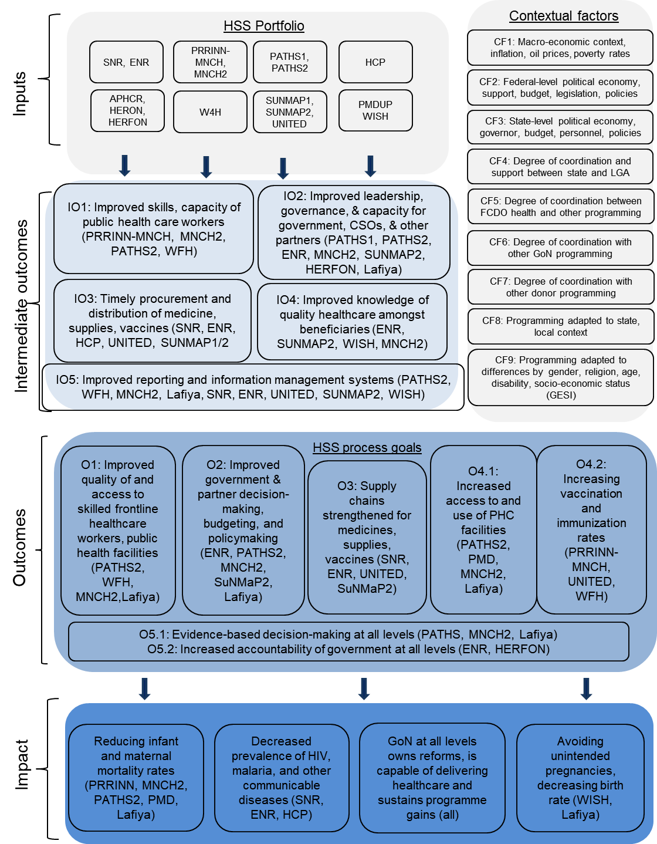

Data collection methods

Literature review and secondary data
Our literature review was led by Professor Sophie Witter, an academic specialising in health systems who led a comprehensive review of health systems strengthening for FCDO in 2019 and 2021 and an evidence review of monitoring and evaluation of HSS frameworks in 2023. These two reviews used inclusion criteria of recency, peer review and relevance of the subject matter to identify credible studies on health interventions in lower and middle-income countries from the published and grey literature. This literature review has been updated to include the most recent evaluation material within the health sector in Nigeria and elsewhere.
The Nigeria governance portfolio review found that context was a key determinant in the success or failure of FCDO programming in Nigeria, including health programmes, while the evidence review and refresh on health systems strengthening noted a lack of context specificity as a key evidence gap. Secondary data sources included programme business cases, annual reviews, project completion reports, monitoring reports and evaluation reports, as well as third-party data sources such as the Nigeria MICS, Nigeria Demographic Health Survey (NDHS) and WHO country reports.

Primary data collection

Stakeholder identification and mapping
We used a purposive quota sampling method to select three states and identify respondents from five different stakeholder groups for all programmes in the study. We mapped and identified stakeholders by programme and outcome area to ensure adequate coverage of each outcome area and the opportunity to triangulate responses between different stakeholder groups. Annex D provides a full list of respondents.
Table 3 - Primary respondent stakeholder groups
Acronym | Description
FCDO | FCDO government officials from BHC Nigeria
GoN | Nigerian government officials at federal, state and local authority level, and representatives of GoN ministries, departments and agencies (MDAs) such as central medical stores and drug management agencies under HCP and state primary health care development agencies which were set up or supported by these programmes at federal and state levels
IPs | Implementing partners: Team and technical leads from programme implementers
CSOs | Civil society organisations: Members of CSOs and committees created or supported to hold stakeholders to account, such as facility health committees and ward development committees
FHCWs | Frontline healthcare workers: including nurses, midwives, community health influencers, promoters and services (CHIPS), community health care extension workers (CHEWs) and other healthcare workers trained or supported by these programmes.
DPs | Development partners: Representatives from other donor and multilateral institutions such as the WHO and Gates Foundation who worked on health programming in Nigeria.

Sampling strategy for primary data
The TORs specified that primary data were to be collected in three states. We selected states that had large numbers of active FCDO programmes during the period under review, which maximised our exposure to gather data on FCDO interventions. Final state selection was made on a balance of geographic and social diversity (south v. north, rural v. urban, Christian v. Muslim), taking into account the available resources and security situation. The three states we selected were Enugu, Jigawa and Kano
- UK-focused: Two of the three states – Jigawa and Enugu – have limited international donor presence. The third state, Kano, has been targeted by other donors, and demonstrates how UK interventions have complemented or duplicated the efforts of other donors.
- Programme coverage: Four programmes – PATHS1, HCP, PATHS2 and APHCR – were present in all three states, which allows a fuller comparison of differences in context and implementation. The remaining programmes were present in two states, which supported a paired cases approach.
- Regional representation: Jigawa and Kano are in the north of the country, where the UK has more recent and concentrated programming, while Enugu represents a different operational context, with initial UK engagement withdrawing over time as the focus shifted to the north. Inclusion of Enugu provides a window on the sustainability of UK programming after withdrawal of programming.
- Governance review: Two states – Jigawa and Kano – were included in the FCDO governance review (Piron et al., 2021).
We initially selected Kaduna state but replaced it with Kano due to its red-rated FCDO travel advisory and security concerns around conducting primary data collection. Due to lack of access to project sites because of ongoing insecurity, our findings may not reflect the full range of complications of working in conflict-affected areas such as Yobe and Kaduna. Annex G lists which FCDO programmes were active in each state.

Target and achieved sample
The evaluation draws on the perspectives and reflections of over 150 stakeholders involved in Nigeria HSS programming. With our three Nigerian HSS experts, we held 62 key informant interviews (KIIs) (50 male, 12 female) and 14 focus group discussions (FGDs) with 96 participants (55 male, 41 female).
Selection of participants, particularly for FGDs, was designed to promote a mix of gender, age and location, although we did not enforce demographic quotas for participants. Selection of participants for KIIs was based primarily on seniority; in Nigeria, males are more likely to hold senior roles.
Table 4 below shows the total sampling frame for primary data collection, including the types of key stakeholders interviewed, the states visited and the number of KIIs and FGDs targeted and achieved in each state. Stakeholders to be interviewed include current or former programme implementers, federal officials, local government officials, frontline health service delivery workers and CSO representatives.
Table 4 - Sampling frame for primary data collection
Key Stakeholders | State | Targeted | Achieved
Key Informant Interviews
Implementing partners | Abuja | 2-3 | 10
Implementing partners | Jigawa | 2-3 | 4
Implementing partners | Kano | 2-3 | 3
Implementing partners | Enugu | 2-3 | 2
Implementing partners | Remote | - | 8
Federal officials  FCDO officials | Abuja  Remote | 3-4  - | 2  5
State and local government officials (GoN) | Jigawa | 2-3 | 4
State and local government officials (GoN) | Enugu | 2-3 | 3
State and local government officials (GoN) | Kano | 2-3 | 11
State and local government officials (GoN) | Remote | - | 3
Civil society organisations (CSOs) | Abuja | - | 2
Frontline healthcare workers | Abuja  Enugu | -  - | 1  1
Development partners | Abuja  Remote | -  - | 1  2
 | Total | 42-47 KIIs | 62 KIIs
Focus Group Discussions
Representatives from organisations supported by programmes - IPs and CSOs | Abuja | - | 1 (9 participants)
 | Jigawa | 2 | 2 (6 participants)
 | Kano | 2 | 4 (30 participants)
 | Enugu | 2 | 2 (14 participants)
Frontline health service workers (FHCW) | Jigawa | 2 | 2 (14 participants)
Frontline health service workers (FHCW) | Kano | 2 | 2 (14 participants)
Frontline health service workers (FHCW) | Enugu | 2 | 1 (8 participants)
 | Total | 12 FGDs | 14 FGDs (95 participants)

Development of tools
We developed general topic guides for key informant interviews and focus group discussions, based on the evaluation questions, intermediate outcome areas and contextual factors relevant to each type of respondent. These topic guides, alongside review of programme documentation relevant to each respondent, were used to facilitate semi-structured respondent interviews. Annex B gives further details.
Digital tools were not employed in data collection, except for digital audio recordings of KIIs and FGDs to enable the research team to analyse the interviews and eliminate mistakes in transcription.
We held a training with the Nigerian consultants responsible for conducting the primary qualitative research in Abuja, which included several days of pre-testing or piloting the tools with respondent groups in Abuja, including federal and state government officials, representatives from civil society organisations, and frontline service delivery personnel. We made minor adjustments to the data collection tools for length and clarity.

Analytical methods

Thematic coding against contextual factors and deriving sub-codes
We coded cases based on themes using Atlas.ti qualitative coding software. Initial themes were the contextual factors identified in the overall programme theory of change; these categories also formed the basis of topic guides for our primary respondents. We then developed sub-codes iteratively as our research team went through the material and assigned cases to intermediate outcome areas. Annex O shows a list of the codes and sub-codes used. Four researchers were involved in coding the transcripts. We promoted inter-rater reliability by double-coding a portion of transcripts, and the team lead reviewed all final codes. Saturation was achieved for contextual factors analysis (Fusch & Ness, 2015), as the team lead observed no new codes emerging after around 70% of transcripts had been coded.

Triangulation of data
We improved the rigour of our analysis by triangulating our findings robustly. We acknowledge several potential sources of bias in primary and secondary sources of data, including primary respondents’ self-reporting bias and recall bias (Table 5 below). To guard against these biases, we triangulated findings from multiple stakeholder categories, as well as secondary sources including programme documentation. Table 2 above shows the evaluation matrix and details of data sources used for each evaluation question.
As a general principle, all findings presented in the Findings section of the main report were supported by data from a minimum of three different types of sources. This included at least one primary respondent category and could include different categories of primary respondent, programme documents, and/or other secondary sources including third party programme monitoring and evaluation, academic or other professional publications, or government or other sources of standard health indicator.
Table 5: Strengths and weaknesses of different data sources
Source | Potential advantages | Potential disadvantages | Mitigation
Primary KIIs | - Data tailored to evaluation  - Focus on contextual factors  - Can assess sustainability | - Self-reporting bias  - Positive response bias  - Recall bias | - Triangulation with other primary response categories and secondary sources, informed consent  - Prompt respondents
Primary FGDs | - Data tailored to evaluation  - Focus on contextual factors  - Multiple viewpoints  - Can assess sustainability | - Group power dynamics  - Recall bias  - Positive response bias | - Facilitation that draws out all participants  - Prompting and building from group responses  - Triangulation with other primary response categories and secondary sources, informed consent
Programme reporting | - Timely  - More objective assessment  - Good programme knowledge | - Self-reporting bias  - Positive response bias  - Data not tailored to evaluation  - Not all available for all programmes  - Can’t address sustainability | - Triangulation with secondary sources  - Triangulation with primary sources
Independent monitoring | - Most objective assessment  - Good programme knowledge | - Data not tailored to evaluation  - Not available for many programmes | - Triangulation with secondary sources  - Triangulation with primary sources
Independent evaluations | - Most objective assessment | - Data not tailored to evaluation  - Not available for most programmes  - Limited impact-level data | - Triangulation with secondary sources  - Triangulation with primary sources
GoN health indicators | - Objective data source | - Issues with methodology, data quality | - Triangulation with other secondary sources  - Acknowledgment of limitations
Academic and grey literature | - Disinterested authors  - In-depth and local perspective | - Variable quality  - Not available for all interventions | - Sift for quality  - Triangulation with other secondary sources
Primary respondents are most prone to self-reporting bias, and may exaggerate the successes of their interventions or their roles in them. We guarded against this by drawing from multiple categories of respondent, including those who may be disinterested in the programme, and by including self-criticism by respondents, which is contrary to what might be expected. Primary data were also subject to recall bias, as some interventions were concluded years or decades ago. We guarded against this by reviewing programme documentation and prompting respondents; interviewers often also had knowledge or involvement of the programmes being asked about. We also triangulated findings with programme documents, which were written during implementation.
FCDO programme documentation is also prone to self-reporting bias, as senior responsible owners (SROs) and stakeholders have a reputational stake in wanting the programme to succeed. FCDO project completion reports are typically led by someone external to the programme implementation, but these may also be FCDO staff who want the programme to succeed. Annual reviews are often written by the implementing partners themselves and then verified by FCDO staff implementing the programmes, and so subject to self-reporting bias. We guarded against this by triangulating with primary sources, particularly when assessing the sustainability (continuing existence) of different interventions, and drawing on other secondary sources where available.

Participation of stakeholders in evaluation design; use and influence plan
The EQUALS review of the evaluation inception report suggested an iterative approach to developing the evaluation within the time available. The evaluation team built up our understanding of the portfolio programmes, beginning with a review of the available programme documentation and wider literature, then engaging with the programme team and constructing outcome logic models for each of five identified outcome areas, then conducting a first round of stakeholder interviews, refining the logic models and coding categories, and going back for supplemental stakeholder interviews. See Annex B, Inception Report, Section 4 for more details on the wider literature.
The evaluation team engaged frequently with the BHC Nigeria Health team, including:
- Kick-off meeting: Presented the proposed approach to the evaluation, engaged with the team, addressed questions on our proposal, and agreed next steps
- Scope discussions: Ongoing dialogue with the senior responsible owner (SRO) on the definition and scope of the evaluation, and which additional identified programmes may be in scope.
- Stakeholder definition: Collaborated with the SRO on 13 June to identify and locate initial stakeholders, including those who may have moved on within FCDO.
- ToC discussion: Engaged with the health adviser from BHC Nigeria, the senior national health expert, and the international health systems expert from the evaluation team to review the implied ToC narrative and rationale for FCDO’s programming in HSS in Nigeria.
- Team validation: Coordinated with the wider FCDO Nigeria Health team to review and validate the implied ToC, finalised evaluation questions, and proposed selection of states for primary research.
- Draft evaluation inception report feedback: Gathered input from FCDO Nigeria on the draft report, which produced additional areas of interest for FCDO not in the scope of the original ToRs which the evaluation team could still address through existing analysis.
- Partner collaboration: Engaged with FCDO Nigeria on identifying respondents from other development partners and the Partnership to Engage, Reform and Learn (PERL) programme, to guide further primary research.

Limitations
Although this evaluation does provide valuable insights into health systems strengthening in Nigeria, several methodological and contextual limitations must be considered. These limitations affect the general applicability, completeness and scope of the findings, as outlined below.
- Limitation 1 - Respondent reach and bias: Assessing programmes spanning a 20-year period means that some potential respondents were no longer identifiable, which hindered efforts to gather insights on earlier interventions. In addition, given several key informants were unavailable or declined to participate, the individuals who did respond may represent a more engaged group, which could potentially introduce bias into the findings
- Limitation 2 - Applicability and selection bias: Findings centre on only three states (Enugu, Kano and Jigawa), while others such as Kaduna and Yobe were excluded due to security concerns. Consequently, the conclusions may not hold in all contexts or under future conditions
- Limitation 3 - Interview reliability: Respondents were queried about long-concluded programmes and may have struggled with recall accuracy. To mitigate, interviewers used structured questioning techniques. More assertive participants, by dominating discussions, may have overshadowed contributions by others. Facilitators did make efforts to promote inclusive participation. No significant impact of gender or age on participant contributions was observed
- Limitation 4 - Recording issues: Initial interviews conducted in Abuja and Enugu were not recorded. Instead, the team relied on their written notes, which may have missed certain details. Later interviews were recorded, but audio quality issues affected some transcriptions.
- Limitation 5 - Qualitative limits: While the evaluation does span twenty years of programming, the qualitative findings may not be fully applicable. However, the results do offer valuable insights into contextual factors shaping HSS outcomes
- Limitation 6 - Time constraints: Respondents had limited availability to engage in in-depth discussions across multiple programmes. Follow-up interviews were conducted to clarify or expand on key points as needed.
- Limitation 7 - Scope limitations: By focusing on five intermediate outcomes, the evaluation does not assess broader HSS impacts such as clinic attendance, government and civil society organisation capacity, or evidence use in decision-making.
- Limitation 8 - Impact data: Few programmes (e.g., UNITED, PATHS, HCP, WISH) underwent independent evaluations and a planned longitudinal study on SUNMAP was cancelled due to budget constraints. As a result, there is limited access to independent outcome data.
- Limitation 9 - Coding bias: Given qualitative analysis is inherently subjective, double-coding was applied to ensure consistency across data interpretation and thus minimise bias.
- Limitation 10 - Sustainability assessment: Although the evaluation identifies the conditions necessary for achieving HSS outcomes, it does not systematically assess long-term sustainability or transformational impact across all 20 states where FCDO operated.
- Limitation 11 – Change in delivery context since completion of fieldwork: The international development landscape changed significantly over the months in which this evaluation report was being presented and finalised. This means that FCDO will no longer be able to fund comprehensive multi-level health systems strengthening programmes going forwards. The lessons and recommendations sections have been revised to reflect this new reality.
FCDO Nigeria has led on producing the use and influence plan for the evaluation – please see Annex J.

Coordination with policies and evaluations of other donors
The midterm evaluation for Lafiya started on 25 November 2024. Draft findings and lessons from the HSS evaluation were presented to the FCDO Nigeria Health team on 25 November and one team member, the senior national health systems expert, is also on the Lafiya review team, and has conveyed messages from the present evaluation to Lafiya. FCDO has identified that USAID may be conducting an evaluation of the joint-sponsored HERON component in 2025; the final evaluation report will be available to inform this.

‘Do no harm’ and adherence to international best practice and standards of ethical conduct
We have adhered to FCDO’s Ethical Guidance for Research, Evaluation and Monitoring Activities, which includes the principles of maximising benefit and 'do no harm’, respecting people’s rights and dignity, acting with honesty, competence and accountability, and delivering work of integrity and merit.
Specifically, we have adhered to the ‘do no harm’ principles of confidentiality, informed consent, and data integrity and data protection. We did not identify specific safeguarding risks based on geographic, thematic or political sensitivities of the content of the questions or any vulnerability of targeted respondents. For further details of our approach to ethics and safeguarding, please see Annex M.

Ethical review board approval
The National Code of Health Research Ethics (NHREC) for Nigeria states that programme evaluations are exempt from ethical review requirements: ‘Studies that are meant to evaluate the outcome of procedures, programmes and services are exempt because they are designed to produce information leading to improvement in the delivery of procedures, programmes and services. Such studies usually evaluate measures that are already in use and considered part of standard practice. They may include collection and analysis of data or collection of new data, but they do not involve allocation into groups or randomisation.’

Stipend payments and compensation
FGD participants and selected KII participants were offered a small travel stipend as compensation for participation in the interview when they travelled to an interview location instead of being interviewed at their place of work. Participants signed to acknowledge receipt of the stipend, and these were paid by mobile money. Stipends were used to incentivise participation by beneficiaries who otherwise might not have had the time or resources to visit the research site and so encouraged inclusion by those from remote areas or low socio-economic status. Bias was guarded against by explaining that the valuation was not looking for certain answers and was interested in understanding what did or did not work. Participants were also reminded that they could stop participating in the research at any time and this did not affect their receipt of a stipend.

Annex F – Programmes considered for the evaluation

Framework for evaluation
The inclusion criteria for establishing which programmes should be considered as health system strengthening (HSS) were drawn from Witter et al. (2019). The overarching point was that the programme should focus on “permanently making the systems function better, not just filling gaps or supporting the systems to produce better short-term outcomes”. By their own definition, this means that the interventions which were included should have 1) benefits beyond a single disease or geographical area, 2) addressed policy and organisational constraints or strengthened the relationship between building blocks or process goals adapted to a specific country’s context and 3) the impact is long term and extends beyond the singular organisation level. The interventions should further consider whether the effects will last even after it ends and, ideally, integrate communities. Initially, in the inclusion process WHO’s HSS building blocks have been considered when assessing whether programmes should be considered for evaluation. These will be further complexified with more recent process goals.

Selected programmes
The Table 6 below lists the programmes under evaluation, including short descriptions, measures, geographic coverage, relevant HSS process goals, reasons for their inclusion and links to documentation on Devtracker.
Table 6 - Programmes under evaluation
Name & Date | Description | Location | Measures & Cross-cutting issues | Logic for inclusion
PATHS 1  2004-2008 | PATHS 1 was designed to improve the health status of the poor in Nigeria and was tightly linked to HCP (below). The focus was initially heavily on stewardship and the programme operated at a federal level. The 2007 election was noted to have been influential in the programme’s running with changes in personnel and heightened security risks. | Started in Benue, Ekiti, Jigawa and Enugu  Left Benue and Ekiti (2006)  Expanded to Kano and Kaduna | Measures  - The strengthening of government stewardship of the sector (this was the main focus for a while)  - Improved management systems  - Better quality preventive and curative services for priority conditions  - Increased consumer awareness  Cross-cutting issues  - Gender: some focus on Maternal and Newborn Health  - Poverty (especially in Enugu) - The programme seems to be aligned with MDG to reduce poverty  - Measures to avoid corruption within the programme were suggested in the 2006 report but I can’t find evidence of a more systemic approach in the documentation  - At least partial focus on HIV/AIDS - “had some input into the costed strategic plan for [...] HIV/AIDS” and some of the OVIs were focused on HIV/AIDS  - Capacity building: various training was carried out across the programme including training in IT skills, training nurses etc | - At least some focus on systems strengthening - explicitly mentioned in the monitoring report (2006).
Health commodities programme (HCP)  2005 - 2009 | - Making "essential commodities" and equipment available to government and non-government facilities for PHC and emergency obstetric care. Aims:  - Assist PATHS to identify the needs for health equipment and commodities within the PATHS programme implementation phase  - Prepare overall and individual state plans for the ‘roll-out’ process to the selected states in conjunction with PATHS.  - Establish logistics management arrangements that will ensure secure and timely rollout to the states.  - Deliver the agreed procurement plans for each state on time and to budget, ensuring VFM at all stages. | Unclear at least in Enugu | Measures  - Essential medicines procured for use in government primary and secondary facilities in states where FCDO is supporting the development and implementation of a SEEDS  - Vaccines, syringes and cold chain equipment provided for government routine immunisation services in states where FCDO is supporting the strengthening of routine immunisation services.  - Essential equipment for the management of priority health conditions procured for government primary health care and emergency obstetric care in SEEDS states.  - Medicines, vaccines and essential equipment provided to non-governmental facilities that operate functional primary health care facilities and a functional referral system  Cross-cutting issues:  - Gender: reducing maternal mortality was one of the indicators on the logframe  - Poverty: targeted at the poor “improved health status of poor Nigerians”  - Measures to avoid corruption: not mentioned  - HIV/AIDS: indicators to reduce the spread of AIDS  - Capacity building: has undertaken large training programmes with 2000 people trained in only a year but mentions this should be a future focus | Various blocks across various areas of the country with explicit claims to want to strengthen health financing and health systems
Partnership for Reviving Routine immunisation in Northern Nigeria – Maternal, Newborn and Child Health Programme (PRRINN - MNCH)  2006 - 2013 | This programme was originally aimed at routine immunisation in four Northern states and was extended to maternal health and newborns/children in 2008. The success was measured in terms of reduction in the under-five mortality rate and the proportion of births attended by a skilled birth attendant.  The project also had a wider approach by focussing on broader issues of governance and interlinkages between this and PHC as well as on Operational Research with the explicit goal of “strengthen[ing] the health policy and strategy framework within which the health system functions"  The programme was renewed in 2010 until 2013 when it ended. | Katsina, Jigawa, Yobe, Zamfara | Measures  - Strengthened State and LGA governance of PHC systems geared to RI and MNCH  - Improved human resource policies and practices for PHC  - Improved delivery for routine immunisation and maternal, neonatal and child health services via the primary health care system (this did not focus on Jigawa though)  - Operational research providing evidence for primary health care stewardship, routine immunisation and MNCH policy, planning, service delivery, and effective demand creation  - Improved information generation with knowledge being used in policy and practice  - Increased demand for routine immunisation and maternal, neonatal and child health services  - Improved capacity of Federal Ministry level to enable States´ MNCH (including RI) activities  Cross-cutting issues:  - Gender: focus on maternal health and advocacy for the posting of additional female staff in rural areas  - HIV/AIDS: no  - Corruption: not initially but some anti-corruption action was taken after the 2012 review which found fraudulent activities - not at a health system level but internal to the programme  - Poverty: not specifically  - Capacity building: training of staff on MNCH Services in output 2 | The programme tackles broad systemic issues within healthcare provision through some of their aims which cut across HSS blocks and extend beyond the organisational level. In particular, some of the measures show a concern for improving the policy context of the healthcare system and working towards enabling better coordination between local and federal actors.
Partnership for Transforming Health Systems 2 (PATHS 2)  2008 - 2016 | This programme was the continuation of the PATHS project, and its aim was to “support Nigeria in achieving the MDGs related to maternal and child health”. More broadly, PATHS2 aimed to help Nigeria use its own resources effectively and efficiently as well as improve planning, financing and delivery of sustainable and replicable pro-poor services for common health problems. In Southern states, there is also a focus on improving the regulatory framework for private health provision and private-public partnership strategies for healthcare delivery. | Jigawa, Kano, Kaduna (ended in Jan 2015)  Lagos, Enugu | Measures  - Strengthened stewardship role for health at the National level  - Improved State systems to support appropriate health services  - Improved Service Delivery and access to health services and supplies  - Strengthened the ability of citizens and civil society to hold local health services to account and increase the responsiveness of the health system  - Strengthened capacity of citizens to make informed choices about prevention, treatment and care  Cross-cutting issues  - Poverty: designed to help Nigeria improve the planning financing and delivery of sustainable and replicable pro-poor services but also highlights the importance of targeting poor people further  - None of the indicators are explicit about this  - Gender: maternal care services central to the programme  - HIV/AIDS: no  - Corruption: no  - Capacity building: training of healthcare workers, especially midwives, in LSS, IT training | The PATHS2 project’s aim clearly cuts across different states and building blocks with aims to develop long-term solutions to issues within the healthcare system as a whole. Its rarer focus on the involvement of civil society in developing healthcare system also makes this programme interesting to evaluate from a HSS perspective.
Enhancing Nigeria’s Response to HIV/AIDS (2007 - 2016) | The programme was split into two phases:  First phase (2009-2014): focused on the institutional strengthening of government and civil society organisations/networks as well as the implementation of a condom market modulation. There is explicit mention of “system strengthening” at the state level during this phase.  Second phase (January 2015 – December 2016): During this phase, the market modulation was upgraded to ensure the long-term sustainability of condom access for Nigeria's HIV/AIDS and Family Planning efforts. | Enugu, Kaduna, Kano, Jigawa, Lagos | Measures  - National health sector governance and management systems improved  - State and LGA/District health sector governance and management systems to support appropriate health services improved  - Replicable model to deliver quality maternal and child health services demonstrated in selected LGAs  - The ability of citizens and civil society to demand accountability and responsiveness of the health system improved  - The capacity of citizens to make informed choices about prevention, treatment and care strengthened  Cross-cutting issues  - Gender: yes, focus on inclusion and empowerment of women  - HIV/AIDS: yes  - Poverty: no, concern that it might have negative effects on the poorest  - Capacity-building: training testers and counsellors  - Corruption: no | This programme, despite its focus on one disease, cuts across multiple states and multiple HSS process goals, with its intention to involve civil society and improve the organisational capacities of the healthcare systems explicitly mentioned. There is also a focus on improving and streamlining data collection, management and use at state and national levels. It also includes the HIV/AIDS cross-cutting theme.
Advocacy for Primary HC reform (APHCR) (2013 - 2016), including Support to Health Reform Foundation of Nigeria (HERFON) | This programme tried to remedy the problems in governance in the health sector regarded as being responsible for underperformance and poor health indices across Nigeria. To do so, it sought to engage political leaders, civil society and the media to raise the political profile of health issues and advocate for the passage of key health reform bills and policies. It also aimed to develop systems to hold accountable the leadership, particularly within child and maternal mortality. | Abia, Ebonyi, Edo. Enugu, FCT, Kaduna, Kano, Katsina, Jigawa | Measures  - Coalitions for PHC reform and FMCH established  - Relevant stakeholders support key PHC reforms, FMCH and National Health Bill  - Change agents for Health reform developed and strengthened  - Evidence-based policy analysis leads to policy changes  - HERFON’s institutional sustainability strengthened - Score C  Cross-cutting issues  - Gender: Not specifically although beneficiaries are expected to be women and children  - HIV: no  - Poverty: same as gender, the poorest and most vulnerable were most likely to benefit from the programme and project directly linked to reducing poverty  - Corruption: no  - Capacity building: training on advocacy and health management | This programme is included because its main goals are targeted towards HSS both in terms of governance and policy with a particular focus on Maternal and child health. Thus, its impacts were aimed at the system as a whole rather than on individual organisations within states.
Maternal and Newborn Child Health Programme (MNCH 2)  2014-2019 | This programme followed the PRRINN-MNCH programme and worked to improve access to and utilisation of quality healthcare and routine immunisation for pregnant women, newborns and children in six northern states. It also aimed to improve health system coordination through health sector planning and financing. | Zamfara, Yobe, Kaduna, Kano, Katsina, Jigawa | Measures  - Supported health facilities providing quality integrated RMNCH services  - Increased demand for quality integrated RMNCH services in supported states/LGAs  - Improved evidence-based decision-making and accountability at all levels for the delivery of quality integrated RMNCH services in supported states/LGAs  - Supported state/LGA health departments plan and manage resources to deliver quality integrated RMNCH services  - Operational research informed MNCH2 programme delivery and national and global RMNCH policy and practice  Cross-cutting issues  - Poverty: not particularly  - Gender: maternal care (included in indicators)  - HIV: no  - Corruption: in partnership principles (not considered in the original business case) no money going directly to the gov of Nigeria for corruption reasons/anti-corruption measure  - Capacity building: training for health workers on integrated PHC service delivery, recommended training on management information systems, training in integrated MNCH (Output 1) | The programme cuts across various HSS building blocks and is trying to build system capacity and change the policy surrounding MNCH services
Support to the National Malaria Programme in Nigeria (SUNMAP) | SUNMAP was designed to support the management, coordination, and delivery of malaria control services in six Nigerian states, subsequently expanded to a further four states (around 40% of the Nigerian population). | Enugu, Kano, Jigawa, Anambra, Kaduna, Katsina, Lagos, Niger, Ogun, Yobe | Measures  - Developed training modules for management, planning and malaria case management, reaching 22,000 health workers.  - Developed a coordinated response through federal and state partners and other development partners.  - Distribution of long-lasting insecticide treated nets (LLINs), ACT and RDT doses, and scale-up of effective malaria diagnosis and treatment  - Development of sustainable private sector markets for malaria commodities through a Making Markets Work for the Poor (M4P) approach  - Generation of evidence and support to evidence based policymaking at federal and state level.  Cross-cutting issues  - Capacity building: Training of community outreach extension workers and government officials  - Gender: Women disproportionately exposed to malaria and involved in treatment  - Poverty: Focus on rural households and last-mile distribution | The programme cuts across various HSS building blocks and is trying to build system capacity for malaria control. SUNMAP was inadvertently left off the list of programmes originally identified in the TORs.
Support to the National Malaria Programme - Phase II in Nigeria (SUNMAP II)  2018-2021 | SUNMAP II was designed to improve the planning, financing and delivery of sustainable and replicable pro-poor services for malaria in 6 states. It aimed not only to improve local capacity to provide medicines and services but also to “increase domestic ownership and funding for malaria control”. | Yobe, Lagos, Kaduna, Kano, Katsina, Jigawa | Measures  - Strengthened government stewardship at national level and in SUNMAP2 supported states  - Increased sustainable availability of antimalarial commodities  - More efficient and equitable malaria prevention and treatment services delivery  - Better informed citizens and institutions  - An evidence-based learning environment embedded in NMEP and SMEP  - SUNMAP2 programme operational  Cross-cutting themes  - Poverty: pro-poor focus highlighted in outputs  - Gender: targeted at most vulnerable groups, notably women  - HIV: no  - Capacity-building: yes, staff training on site  - Corruption: no | One of the programme’s aims is to strengthen Nigeria’s healthcare system’s response to malaria through service delivery and medication but also through a deeper enhancement of the links between states and national service. However, the programme focuses only on one disease and has limited criteria to show long-term development.
LAFIYA -UK Support for Health in Nigeria  2019 - 2027 | This programme aims to improve the government’s political and financial commitment to health, with a focus on the poorest. This took the form of improving basic health and nutrition service provision through upstream systems strengthening, as well as increasing the proportion of Nigerians using modern contraceptives, particularly women of reproductive age. However, it might be helpful to note that the project has faced some budgetary, security and political issues since 2022 | Yobe, Jigawa, Kano, Kaduna and Borno. | Measures  - Strengthened governance for the delivery of integrated health and nutrition services  - Strengthened health financing, including use of Basic Health Care Provision Fund (BHCPF) and innovative financing approaches  - Strengthened health workforce and health information systems, including use of data for decision-making  - Improved health security through a One Health approach, including response to emergencies  - Improved access to essential health and nutrition services in north-east Nigeria  - Improved access to sexual and reproductive health and rights, including strengthened access and demand in north-east Nigeria, and support to accelerate the demographic transition  Cross-cutting issues:  - Poverty: in core aims for the poorest, both in terms of service provision and financing (targeting policy to reduce catastrophic health expenditure)  - Gender: increase use of contraceptives for women  - Corruption: no  - HIV/AIDS: no  - Capacity building: yes, notably in health systems use and data use (although was noted as challenging), training of CHIPS | This programme is included as it is cutting across multiple HSS building blocks and was operational at quite a large scale across Nigeria. It also has an exceptional focus on financing and information systems which a lot of the other programmes seem to lack, making it interesting for evaluation.
Women's Integrated Sexual Health programme  2017 - May 2024 | The WISH programme is operating in 17 countries in Africa, with the aim of supporting women and their partners to safely plan their pregnancies and improve their sexual and reproductive health. The programme has a specific focus on increasing access for adolescents (defined as those below 20 years old), the poorest and people with disabilities, meaning it is tackling inequities within the target groups. They combine supply and demand-side interventions to reduce maternal deaths, unsafe abortions, and unintended pregnancies. | This programme was carried out across a wide range of different countries, including Nigeria. While the documents refer to Nigeria and, occasionally, a few states the programme documents do not detail exactly where the project operated within the country | Measures  - Poor and marginalised women and men, and adolescent girls and boys are accessing high-quality family planning services and have the knowledge and community support to make informed SRHR decisions  - Sustainable national engagement in changing and/or implementing policies, Government financing, commodity security and public sector SRHR capacity  - Access to quality, voluntary family planning and other sexual and reproductive health services, eliminating barriers for young and marginalised women  - Evidence-based innovations and practices shared globally to increase women’s choice and access to SRHR services  Cross-cutting themes  - Gender: yes  - Poverty: yes, tackled through some indicators for output 3 (access to services)  - HIV/AIDS: no  - Corruption: no  - Capacity building: yes, especially in equity: disability inclusion | The focus of this programme being on the long-term capacity and interest of the national government to improve the provision of Sexual and Reproductive Health and Rights (SRHR) services, it qualifies for evaluation. It is also interesting to analyse alongside similar programmes which have operated in Nigeria alone as this was part of a larger project in 17 countries.
Health Reform Foundation of Nigeria (HERON)  Phase 1:  2005 - 2009 | The HERON foundation’s aim is “to foster broad sector reforms that lead to better health outcomes for all Nigerians with emphasis on the poor”. It led to the HERFON initiative (below). | FCT Abuja | Measures  - Approximately 200 Change Agents enhance their understanding of the need for and means of Health Sector Reform through exposure to international debate and good practice  - Effective information and technical assistance provided to Change agents to allow them to improve systems and develop and propagate a reform agenda within their spheres of work  - Supportive networking and information exchange between change agents and other individuals and groups interested in reform encouraged  - Research, analysis and advocacy for HSR undertaken in 6 selected States  - Research, Analysis and Advocacy to Strengthen routine immunisation undertaken in 6 selected States  - Establish a robust governance and financial operational capacity, which would make HERFON recognised as a lead organisation and financial sustainable within five years  Cross cutting issues  - Poverty: no  - Gender: no  - Capacity-building: some training of staff  - HIV/AIDS: no  - Corruption: no | Connected to the HERFON initiative and a good point of comparison. However, we have access only to one (rather negative) review for now. It is provisionally included for evaluation, contingent on eventually gaining access to more information about the programme.
Support to Health Reform Foundation of Nigeria (HERFON) Phase 2  2009- 2013 | The Health Reform Foundation of Nigeria (HERFON) whose main purpose is to advocate for “better health for all Nigerians” is a national membership organisation which was supported initially through the HERON project (above) and then HERFON. The foundation’s goal is to undertake reform within the healthcare sector in Nigeria by advocating and developing partnerships as well as through policy analysis, research and capacity building. The centralised foundation is broken down into state-level sub-groups. The self-avowed “core mandate” of the programme is “advocacy for health sector reforms, as well as building institutional capacity with robust systems, sound governance, in addition to achieving long term financial sustainability.” |  | Measures  - Partnerships and Networks for health sector reform strengthened (Partnerships)  - Enabling environment for health care support (Advocacy)  - Capacity for health Sector reform in Nigeria strengthened (Capacity Building)  - Evidence-based policy analysis and development strengthened (Evidence Generation and use)  - HERFON institutional, human and financial capacity improved (Institutional strengthening)  Cross-cutting issues:  - Poverty: no  - Gender: no  - HIV/AIDS: no  - Capacity-building: yes, mostly training  - Corruption: no | HERFON’s aims cut across various HSS blocks and advocated for strategies and policies which would enable the health system to function better in the long term. It also is a product of the HERON project, inscribing it in a longer tradition of intervention which is interesting to evaluate from a health system strengthening approach. However, there is little data available on this programme now which might make its evaluation difficult.

Prevention of Maternal Deaths (PMD)  2011-2018 | The aim of the programme was to reduce the recourse to unsafe abortion, increase the use of family planning and overall reduce the number of maternal deaths. This means the programme also focuses on developing the capacity of the healthcare sector to access the appropriate abortion/family planning  services as well as policy and societal beliefs. | This programme was carried out across a wide range of different countries, including Nigeria. While the documents refer to Nigeria and, occasionally, a few states it is not possible to know exactly where the project operated within the country. | Measures  - Fewer women (especially marginalised and young) have recourse to unsafe abortion and fewer women have unintended pregnancy  - Increased choice of sites for post-abortion care and where permitted comprehensive abortion care provided as an alternative to unsafe abortion and for modern FP services  - Improved capacity of the health sector which enables women to access post-abortion care, and where permitted comprehensive abortion care services provided as an alternative to unsafe abortion and to choose modern methods of FP  - Locally led changes to the national and regional environment on safe abortion and modern FP services  - Evidence-based practice and innovations shared to increase women’s choice and access to post-abortion care and, where permitted, comprehensive abortion care and modern FP  Cross-cutting themes  - Gender: yes, more systemic approach; gender audit and gender working group, recruitment processes for gender equality  - Poverty: yes, focus on the poorest although acknowledged to be an area of challenge  - HIV: no  - Corruption: no  - Capacity building: yes, training of healthcare workers | This programme’s aim was to improve the healthcare system’s capacity to provide services for pregnant women as well as lead initiatives and advocacy for policy change that supported this. As such, the programme has a long-term and sustainable goal across multiple HSS blocks and at a system level, qualifying it for evaluation.

Women for Health Programme (W4H)  2012 - 2020 | - Improving children's and women's access to healthcare in areas of high unmet need  - Increase the number of female health workers in training to serve in rural health facilities in Northern Nigeria | Yobe, Zamfara, Kano, Katsina, Jigawa, Borno | - Increased, appropriate and better-quality training for nurses and midwives in conflict-affected areas in Yobe and Borno  - Dissemination of the W4H approach to facilitate learning for sustainability and scale-up (Kano, Kaduna)  - Federal capacity, policy and systems strengthened for better and more gender-equal HRH planning, production, recruitment, deployment and retention  - State governments and HTIs in four states (Jigawa, Kano, Katsina and Zamfara) have the capacity, policy and systems strengthened for sustainability | W4H focused on HRH - a major health system challenge in Nigeria and one of the HSS pillars. In addition, the programme worked across other health system pillars relevant to this with interventions and impact across health governance, financing, service delivery and information systems. As well as training nurses, it built the capacity of other cadres and building systems for task shifting, regulation, tackling gender norms, sustainable financing, recruitment and retention, political engagement and community participation.
Strengthening Nigeria's Response to HIV/AIDS  2004-2011 | The project aims were to "reduce the impact and the transmission of HIV/AIDS on the lives and livelihoods of people in Nigeria". To do so, the project focused essentially on enabling local government to provide HIV-related services while developing leadership at the state and federal levels. The programme aimed to take a human rights approach and wished to destigmatise HIV/AIDS services as well as reduce gender bias in service providers and provision as well as within civil society. | Documentation requested. | Measures  - Enhanced capacity of SACA to coordinate a multi-sectoral response to HIV/AIDS  - Increased access in selected high-impact locations to effective community-based services (Prevention, VCT, HBC, OVC) by women, men, boys and girls vulnerable to HIV/AIDS  - Reduction in HIV/AIDS-related stigma and promotion of the rights of vulnerable people through SACA-coordinated interventions of CSOs, CISGHAN, and NEPWHAN  - Strengthen local leadership to mobilise and sustain a multi-sectoral response.  - Lessons learned inform ongoing programme activities and the broader national response.  Cross-cutting themes  - Poverty: no explicit focus  - Gender: yes  - HIV: yes  - Capacity-building: some training around gender  - Corruption: no | This programme focused on at least 3 of the HSS building blocks: Human Resources, Leadership and Governance and Service Delivery and this is reflected in its outcome measures. These reflect the programme’s intention to improve coordination and communication between services to strengthen the response to HIV/AIDS in Nigeria, as well as tackle discrimination and gender imbalances in service provision. Despite its focus on only one disease, it is aware of its own position in relation to other programmes and how it fits into a wider narrative of strengthening the healthcare system and can thus be included within this analysis.
Tackling Neglected Tropical Diseases through an Integrated Approach  2012-2019 | The main aim of this programme was to tackle Neglected Tropical Diseases which affect poorer populations disproportionately. This was carried out through Mass Drug Administration (MDA) and the programme focused on making this a sustainable practice which should be able to continue following its end. | Kaduna, Kano, Katsina, Zamfara | Measures  - Mass drug administration: sustainable integrated mass drug administration in all targeted states  - Sustainable drug supply chain management  - Behaviour change communication  - Health System Strengthening  Cross-cutting issues  - Gender: yes - programme acknowledged difficulties that women face in accessing health and the importance of working with women's groups but was not explicit in the outputs  - Poverty: yes, but not inherently target poorer people but does not have any systemic impact on poor people  - HIV: no  - Corruption: no  - Capacity building: supply chain management and training of CDDs; recognised as important | Although it may seem counterintuitive to include this programme given its narrow focus, the elements of capacity building and enabling of long-term systemic changes like drug SCM make it interesting to evaluate in this context. One of its measures is also explicitly “Health System Strengthening”.

Programmes excluded from analysis
The table below lists the programmes excluded from analysis, including short descriptions, measures, geographic coverage, relevant HSS process goal outcomes and impact, reasons for their exclusion and links to documentation on Devtracker.
Table 7 - Programmes excluded from analysis
Name & Date | Logic for exclusion
Working to Improve Nutrition in Northern Nigeria (WINNN) - 2011-2021  Sanitation, Hygiene & Water in Nigeria Phase 2 - 2013-2021 | These two programmes seem to focus more on predictors of health rather than strengthening healthcare systems specifically. As a result, they are out of scope for this project even if they have impacts on health outcomes.
Access to Family Planning Commodities  2011-2021 | The choice to exclude this programme was since its focus was mostly on improving delivery and access to medical aid but did not seem to focus sufficiently on strengthening the healthcare system, even within reproductive health. Though there was some focus on the procurement of contraceptives as well as the delivery, this was not deemed to be developed enough to qualify as a health system strengthening programme to the same extent as other similar SHR programmes which were running in Nigeria around the same time, and which have been considered in this analysis (see above).

Annex G – Programme mapping: Co-financing, outputs, outcomes, VFM, risks

Annex H – Intermediate outcome level theories of change

Annex I – Departures from Terms of Reference and cross-cutting issues

Cross-cutting issues
The Terms of Reference identify gender, poverty reduction, anti-corruption (transparency and accountability), capacity building and power relations as the cross-cutting issues relevant to this evaluation.
Evaluation Question 2.4 addresses the extent to which HSS programming has considered social inequalities including gender, age, disability, and socio-economic status. In the analysis, specific codes were developed to identify capacity building for both frontline healthcare workers and government officials and corruption when these were mentioned by respondents. Power relations were addressed in terms of donors to partner countries, relationships between the Government of Nigeria at federal, state, and local level, and accountability mechanisms.
In addressing these cross-cutting issues, this learning evaluation is constrained by the availability of disaggregated programme and secondary data. Few programme documents (Annual Reviews, PCRs) disaggregated indicators by gender, although several outcome indicators, such as maternal health and ante-natal care, are relevant for women. Only one disaggregated by socio-economic status, and none disaggregated by disability. Given that most programmes have closed, most raw programme data used to populate logframes and Annual Reports was not made available to consultants. This means we can only analyse programme outcomes by gender, and none by other cross-cutting categories.
We therefore rely on contextual questions to understand the extent to which programming was adapted for needs by gender, socio-economic status, and other cross-cutting issues including religious and cultural practice, ethnic and language group, and disability status.
While FCDO’s remit is about alleviating poverty, most health programmes adopted goal or impact statements around saving lives (reducing neonatal, infant, and maternal mortality rates) and decreasing the prevalence of communicable diseases (HIV/AIDS, malaria, and neglected tropical diseases). See Annex G for a full mapping of programme indicators. Stakeholders understood that poverty alleviation would be addressed by complementary programming in education, governance, and other sectors. Some programmes did incorporate indicators around poverty alleviation, for example, DALYs or burden of healthcare expenditure that was out of pocket. Some earlier programmes expressed a rationale for health care by keeping income earners healthy and free from HIV/AIDS (SNR) and other communicable diseases (UNITED). Later programmes mention equitable access to health care (SUNMAP2, Lafiya) and reducing poverty by improving access to voluntary contraception (MNCH, WISH, AFPC).
BHC Nigeria shifted its focus to Northern states from PATHS1 to PATHS2, which multiple indicators showed were amongst the most deprived in terms of health and economy. This choice may have initially been driven by FCDO’s mandate for alleviating poverty, or because these were states where most gains could be made. Because of the importance of relationship-building for achieving success in healthcare, BHC Nigeria programming snowballed, and states like Jigawa and Kano have had UK government support for over 20 years. Value for money considerations may also have steered programming away from replicating successes in new states, because of high political and relational barriers to entry. Although programme documentation said that several programmes would ‘focus on the poorest’, few programmes disaggregated any indicators by socio-economic status.
Many programmes stated that they benefitted women and girls by design, and a plurality of programmes in the portfolio included impact level objectives of reducing neonatal, infant and maternal mortality rates through improving access to clinics, skilled birth attendants, and the like. Women were the focus for only PRRINN-MNCH, MNCH2, WISH, and W4H, and no programming dealt explicitly with disability.
Most programme documents do not explicitly mention anti-corruption. Interviews with stakeholders confirmed that BHC Nigeria’s approach has been guided by partnership principles, and they decided to avoid channelling money through the Government of Nigeria at any level due to concerns around corruption. The World Bank funding of the BHCPF was seen as a workaround to this. Stakeholders also mentioned that BHC Nigeria’s approach to anti-corruption has been to push for transparency and accountability at all levels of government.
Capacity building and power relations feature prominently in most programming, and most logframes have output or even outcome-level indicators tracking government and healthcare worker capacity.

Policy context with regard to cross-cutting issues
Nigeria’s underperforming health system has contributed to persistent poverty and low economic development. According to the WHO Commission on Macroeconomics and Health, improving health and longevity, especially of the poor, is a fundamental goal of economic development and is also a means of achieving other development goals relating to poverty reduction. However, significant disparities in healthcare access persist across socio-economic groups, gender, and geography.
However, the Nigerian health system is dogged by inequality. There are significant disparities by socio-economic status in access to services as demonstrated by results of studies conducted in Nigeria and elsewhere. For example, there is a direct correlation between socio-economic quintile and immunisation rates: in other words, the poorer a Nigerian is, the less likely they are to be vaccinated. The 2003 NDHS noted that only 3.4% of children in the lowest quintile were fully vaccinated compared to 39.9% in the highest. This means that the richest children are almost 12 times more likely to be fully vaccinated than the poorest children. Children from the middle wealth quintile are two and a half times more likely to be fully vaccinated than children in the poorest group. Also, approximately 40% of women in the two lowest wealth quintiles attend ante-natal care (ANC) compared to 92% in the highest wealth quintile. The NDHS also highlights other disparities in access to services and in health status based on age and gender, as well as socio-economic status.
Poverty remains a major barrier to access to ante-natal and emergency obstetric care, immunisation, malaria treatment or other health services in Nigeria. The costs of drugs, consumables, and even travel to a health facility act as significant barriers to access to the poor for services such as tuberculosis treatment, family planning or ante-natal care. This is particularly the case for young men and women for whom the costs of products such as condoms are too high, and thus high-risk behaviours are perpetuated. Women also frequently lack access to cash resources which are required for many services. These factors provide an economic rationale for the UK government’s intervention in the Nigerian health sector.
UK health system strengthening programmes have been supporting Nigeria’s policies for poverty reduction reforms. The earlier programmes supported the NEEDS, which sets governance reform at its heart and includes measures for better transparency and accountability at the federal level, reform of resource management systems and the civil service, and key improvements in service delivery, economic management and non-oil sector growth. At state level, the programmes also worked within the context of SEEDS. Programme support also attempted to help ensure that improved health outcomes are placed centre-stage in the development of subsequent rounds of NEEDS and SEEDS approaches and documents. It was envisaged that by incorporating broader elements of health sector priorities into NEEDS2 and SEEDS2 processes and documents, health would receive higher visibility and more resource allocation at all levels of government. Overall, the strategic focus of health set out in NEEDS is on preventive and primary health care services and comprehensive health sector reform aimed at strengthening the national health system and its management.
Several UK-supported HSS programmes included strategies to help reduce financial barriers to health services for the poor and the vulnerable, including promoting community loan schemes, community emergency transport schemes and birth preparedness plans. However, most of these options have not been scaled up to the point of providing enough financial risk protection for majority of poor people in the lead states. Later programmes worked to improve government financial risk protection schemes aimed at dramatically improving access for the poor and vulnerable populations (pregnant women, children under five years, the elderly, persons with disability etc.) especially those in rural areas. These are incorporated within health insurance schemes operated by federal and state health insurance programmes.
With regard to gender, deeply embedded gender inequality has remained a powerful driving force of maternal and child mortality outcomes. In Nigeria, gender plays out differently by region, ethnicity, income level, and lifecycle, especially in BHC Nigeria focus states in the North. Maternal mortality rates are closely linked with and influenced by women’s adult literacy (just 24% in the North West, compared to 77% in the South East) and median age of first marriage (14.6 years in the North West and 21.8 in the South East). Harmful practices such as female genital cutting are also prevalent, particularly in the Southeast, where 41% of adult women have been subjected to the practice. Girls in large parts of Nigeria, and especially across much of the North have lower primary enrolment and completion rates than boys.
In Hausa and Fulani areas in Northern states, the determination that a woman has a serious medical problem requiring hospital care is a male responsibility, and usually women must be accompanied by their husbands or by a male relative. Unmarried girls and women may avoid the public sector for reproductive health needs due to the stigma associated with seeking care. In the south, women have historically had considerably more social and economic freedom. Even so, they are rarely permitted significant political power. Independent incomes can generate some renegotiation in marital relationships and confer greater power in decision making. This connection must be analysed in the context of a range of factors which also influence outcomes, such as extra household support systems, and perceptions about contributions and needs. Ideologies that affect how work and economic contributions are valued, and views about the division of labour regarding domestic tasks, play influential roles.
In relation to the environment, the UK government-supported health system strengthening programmes are primarily technical assistance and governance programmes, and thus are unlikely to have direct environmental impacts but may have indirect impacts in several ways. A positive impact can be expected from programme-funded improvements to water and sanitation at health facilities and through community education. Improved healthcare waste management that was supported through improved systems, training and supervision also included the promotion of universal precautions against hospital-acquired infections. The programmes also helped to reduce the prevalence of expired stocks of medicines at health facilities by supporting rational planning, procurement and management of drug stocks.

Addressing cross-cutting issues identified in TOR
The TORs identify gender, poverty reduction, anti-corruption, capacity building and power relations as the cross-cutting issues relevant to this evaluation.
We were limited by the general lack of disaggregation in programme data by gender and socio-economic status. Some indicators, i.e. for maternal mortality or number of women trained as frontline healthcare workers, specifically apply to women, but data for men either do not exist or aren’t comparable.
We addressed gender and poverty reduction, alongside other GESI categories of disability status, ethnicity and language, socio-economic status, religious and cultural practices through contextual factor CF9, the extent to which programming was adapted to GESI categories.
We addressed capacity building and power relations through Outcome 2, Building capacity of government decision-making, budgeting, and policymaking and Outcome 5, Improved reporting and information management systems.
On anti-corruption, the FCDO has made use of partnership principles and taken an approach not to fund the Government of Nigeria directly. Not many programmes have components dealing with financing of health systems, but several components strengthening the transparency and accountability of programmes. We addressed anti-corruption through Outcome 4, Improved demand for quality healthcare amongst beneficiaries, as well by speaking to non-governmental organisations set up or supported by FCDO programming to hold the health system to account.

Departures from the Terms of Reference
There are two departures from the TORs as originally written (See Annex A).
The evaluation covers more programmes than originally identified in the TORs. The TORs listed 10 Nigeria HSS programmes over the last 20 years. After searching Devtracker, we identified eight additional programmes that met the definition of health systems strengthening, including two centrally managed programmes. See Annex F for more details. These are:
- Change Agents Programme (CAP)
- Support for National Malaria Programme Phase 1 (SUNMAP)
- Women’s Integrated Sexual Health programme (WISH, a centrally managed programme)
- Health Reform Foundation of Nigeria Phases I and II (HERON and HERFON)
- Tackling Neglected Diseases through an Integrated Approach (UNITED)
- Prevention of Maternal Deaths and Unplanned Pregnancies (PMDUP, a centrally managed programme)
- Strengthening Nigeria’s Response to HIV/AIDS (SNR).
The focus of the evaluation is on learning rather than accountability, and the original list of evaluation questions from the TORs has been pared down to reflect this. As clarified with the programme team, the present piece of work is primarily a thematic learning evaluation. We note that only a handful of health systems strengthening programmes have undergone full programme evaluations. This evaluation is not a substitute for fully costed independent programme evaluations, but it does touch on accountability for programming in the three focus states, Enugu, Jigawa, and Kano.
The EQUALS review of the draft inception report was critical of the broad range of evaluation questions proposed in the TORs given the limits in terms of time and resources and the evaluation focus on learning. Following these recommendations, we met with the Nigeria health team to prioritise evaluation questions, identify which were out of scope, and re-focus the evaluation on answering the key evidence gaps of understanding what assumptions are necessary and sufficient for change at intermediate outcome level.
Annex I contains the long list of evaluation questions from the TORs, with questions outside the scope of the learning evaluation marked with dark grey. Those questions which the learning evaluation can answer partially have been marked with light grey. This means that the evaluation was not intended generate lessons around impact and sustainability as outlined in the TORs.

Departures from the inception report
The inception report stated that all interviews would be recorded. For the first few respondents in Enugu and Abuja, evaluation team members in Enugu instead worked in pairs and took detailed notes of the interview, producing summaries of key points rather than transcripts. This was corrected in later interviews in Enugu and Abuja and for all interviews in Kano and Jigawa. The evaluation team continued to take notes even when interviews were recorded, which helped reconstruct several transcripts in which the recording quality was poor.
The inception report stated that focus group discussions would be conducted separately with males and females, as appropriate. Our local experts advised that this was not needed, even in the North, and so FGDs were conducted in mixed groups.

Annex J – Use and influence plan
The final products of the evaluation are a final report, PowerPoint slide pack, 2-page summary or research digest, infographic brief summarizing key findings and recommendations, and blog summarizing the findings of the project. The evaluation team presented findings both to BHC Nigeria health team and to the wider office, with two more presentations to state leads and development partners expected in March-April 2025.
The findings of the evaluation are expected to inform future programme design and delivery in Nigeria. The team will share lessons with other BHC Nigeria teams, including the Portfolio MEL team who can take strategic learning into discussions around BHC Nigeria portfolio management.
The potential users of the findings from this project are FCDO staff, staff working for other development agencies, and Government of Nigeria health officials. Key stakeholders within BHC Nigeria who have shown a strong interest in this evaluation include the BHC Nigeria Development Director, the FCDO Head of Profession for Health, the BHC Nigeria health team and Human Development and Demography Block, and the BHC Nigeria Governance and Social Development team.
It is anticipated that findings can inform the Nigerian Minister of Health’s ongoing health reform agenda, and health systems programmes by other donors. The evaluation product will be presented to the following fora:
- FCDO Health Network.
- BHC Nigeria Delivery Board.
- Human Development and Demography Block dedicated seminar.
- Nigeria Health Development Partners Group (BHC Nigeria currently co-chairs this group).
- BHC Health Programme (Lafiya) Steering Board, chaired by the Nigerian Minister of Health.
- Global Symposium on Health Systems Research.
The primary use of the evaluation will include internal learnings for BHC Nigeria; lessons for the Nigerian government and partners in preparation for upcoming reforms in the Nigerian health system; learnings for other FCDO country offices and across FCDO more generally for designing health systems programmes; and learnings more generally across the health systems community, through for instance, presenting the findings in conferences or publishing results.
We will consult with FCDO and BHC Nigeria on how they deem best to circulate the outputs of the evaluation for internal use as well as share them externally with key stakeholders. Table 8 below details the use and influence plan for the evaluation outputs, including the key target audience, internal or external nature of communication, outlets through which outputs will be shared, responsible parties and timing. We will incorporate FCDO/BHC Nigeria’s guidance regarding the suggested key stakeholders to share with and how to best circumvent sensitivity issues around sharing evaluation outputs.
Table 8 - Use and influence plan of evaluation outputs
Output | Target audience / key stakeholders | Internal / External | Outlets | Responsible | Timing
Final evaluation report | BHC Nigeria Health team, portfolio MEL team | Internal | Presentation | Cadmus | 10 Jan 2025
PowerPoint slide pack, research digest, infographic | FCDO Health Network, Lafiya Steering Board,  Nigeria HDP Group | Internal  External | HDD Block seminar | Cadmus, FCDO | 10 Jan 2025
Blog | Public, outside experts | External | FCDO Website | Cadmus, FCDO | 31 Jan 2025

Annex K – Changes in headline indicators, 2002-2022
Nigeria has demonstrated notable improvement in several key health indicators over the period of FCDO support. In FCDO supported states:
- Child mortality dropped significantly over the period 2003-2024. Nationally, under-5 mortality rates dropped by 45%, infant mortality dropped by 37% and neonatal mortality decreased by 15% (NDHS).
- The LiST methodology estimates that FCDO Nigeria programmes saved the lives of 75,550 children and 4,800 mothers between 2011 and 2015 (Lafiya BC, Annex 10).
- Women receiving at least four antenatal care visits jumped from 35% to 90% in Enugu during PRRINN-MNCH, and increased from below 20% in Kano and below 10% in Jigawa to almost 50% (MICS).
- The percentage of under-1s fully immunized rose by over 35 percentage points in Enugu and Jigawa and by over 20 percentage points in Kano. In Jigawa and Kano these were near zero at baseline.
- Malaria prevalence in under-5s decreased by 37% in Kano, Jigawa, and Enugu. The percentage of children sleeping under insecticide-treated nets (ITNs) rose from almost zero to 80% in Kano, 90% in Jigawa, and 60% in Enugu.
- HIV/AIDS prevalence more than halved in Kano, Jigawa, and Enugu, exceeding the national average.
- The percentage of state budget dedicated to health more than doubled in Kano and tripled in Jigawa.
- The percentage of women receiving at least 4 ANC visits increased in Kano, Jigawa, and Enugu.
- The number of women giving birth with a skilled birth attendant increased by 10 percentage points in Enugu and over 15 percentage points in Kano and Jigawa.
FCDO Nigeria’s HSS programmes were aligned to several common impact indicators, reflecting MDGs, SDGs, and/or GoN priorities. Over the course of the last 20 years, improvements are noticeable across many of these indicators. These indicators are influenced by a variety of factors and only show the correlation of indicators with FCDO programming over the period, but they can be interpreted alongside other information in this and other evaluations to assess FCDO contribution. Thus, the below impact indicators can help visualise changes during the time the programmes were active in 3 states: Enugu, where support was scaled down after the extension phase of PATHS2 due to the state’s comparative wealth, Jigawa and Kano.
As such the selected indicators cover four thematic areas in relation to FCDO programming: Improved quality of public healthcare facilities / skilled frontline healthcare workers; building capacity of government decision-making, budgeting, and policymaking; timely procurement and distribution of medicine, supplies, and vaccines; improved knowledge and demand for quality healthcare among beneficiaries. At impact level, it is likely that the data cuts across multiple of these outcomes. For example, the use of ITNs by children under 5 does not only depend on access to ITNs but also on knowledge of proper use and acceptance of the prevention mechanism.

Improved quality of public healthcare facilities / skilled frontline healthcare workers
Despite gains over the past 20 years, Nigeria has the second highest rate of maternal and under-five deaths in the world. Its malaria burden is the highest in the world, and HIV and TB are second and fourth highest, respectively (Lafiya BC p.2). It also has significant regional disparities; a woman living in the North East is 10 times more likely to die related to childbirth, as compared to a woman living in the South West, and a child born in the North West is 2.6 more likely to die under the age of five, as compared to a child born in the South West (DHS, 2013).
The five indicators targeted at evaluating the improved quality of public healthcare facilities and skilled frontline healthcare workers included maternal mortality, child and neonatal mortality, HIV/AIDS prevalence and malaria prevalence in under 5s. These indicators show how effective the facilities and the workforce are at providing care.
Improvements were measured in all three states across all give measures. Generally, Enugu, a wealthier state, seemed to start and remain better than the national average. Only for malaria prevalence rates in children under 5 would it seem that Enugu worsened over time. This could be related to lesser success in the training of PMVs in Enugu during SUNMAP1 and SUNMAP2 not being active in this state. Jigawa and Kano followed positive trends overall while the programmes were active. It is also important to acknowledge that the success of these high-level indicators also relies on other aspects of programming such as improved knowledge and acceptance among the population and the timely procurement of equipment, for example.

Figure 2: Antenatal care visits (2011-2021)
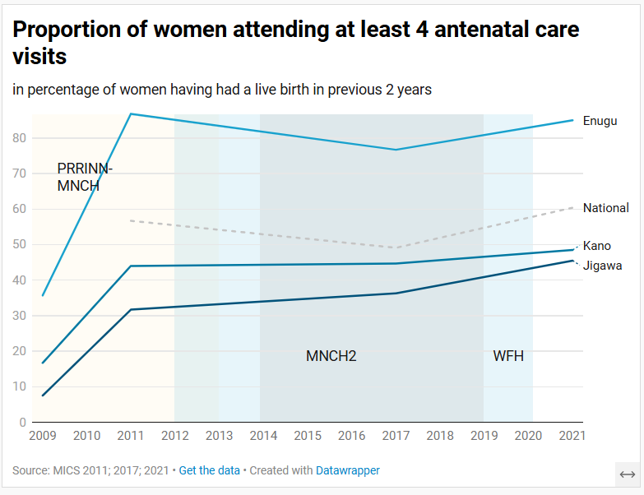
The proportion of women attending at least 4 ANC visits shows some progress between 2009 and 2021. In all three states, an initial sharp increase happens before stabilising (this could be due to different data sources though). Note that MNCH2 and W4H did not operate in Enugu.

Figure 3: Child Mortality Rate (1990-2023)
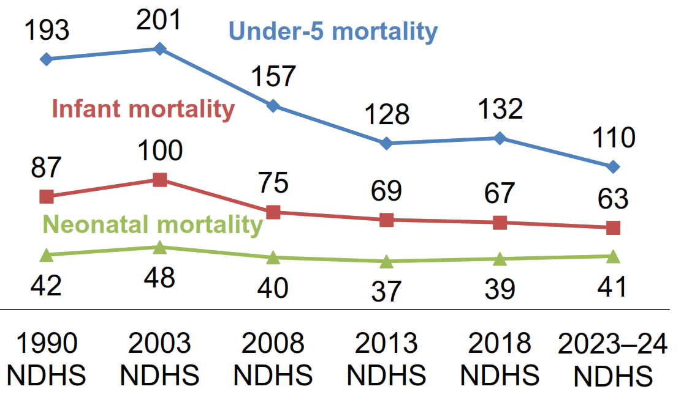
Child mortality dropped significantly over the period 2003-2024. Under-5 mortality rates dropped by 45%, infant mortality dropped by 37% and neonatal mortality decreased by 15%.

Figure 4: Neonatal Mortality Rates by state (2005-2021)
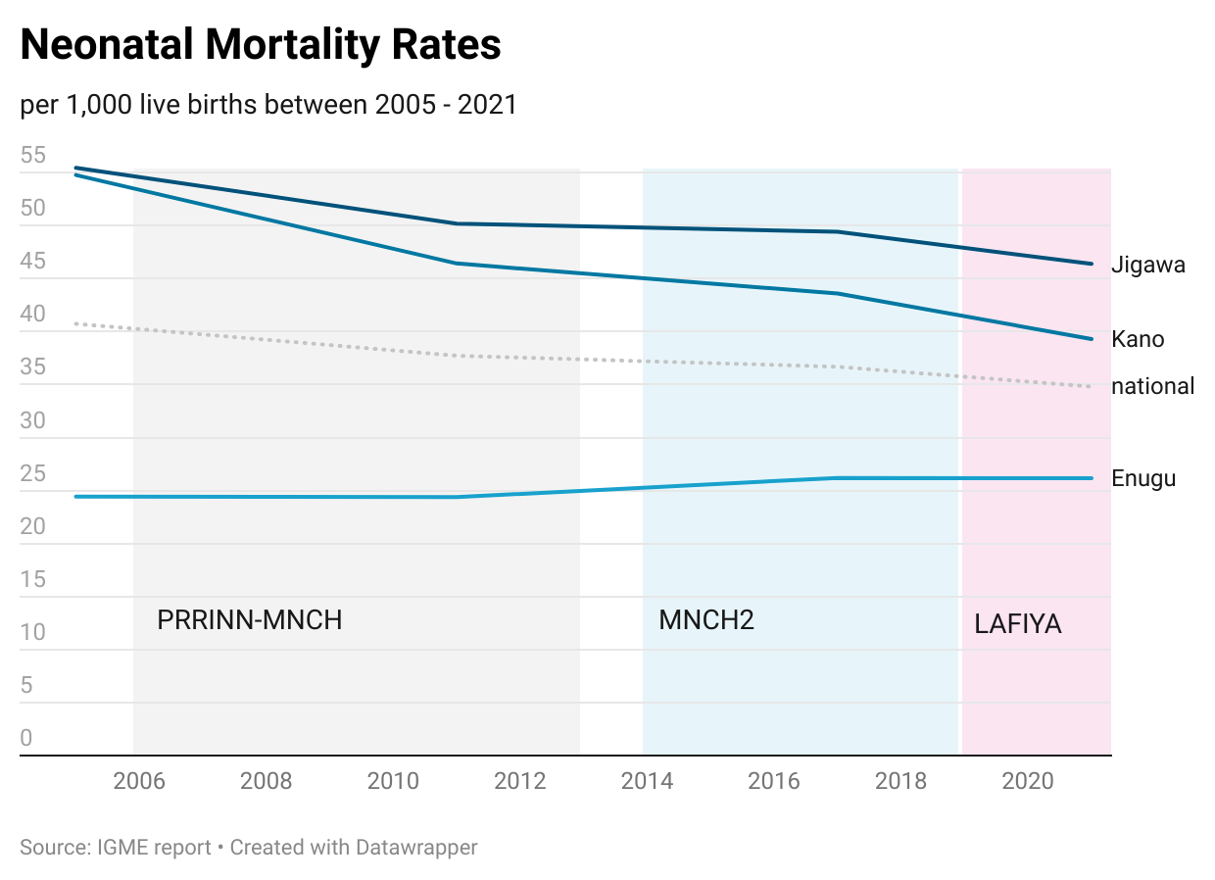
Neonatal mortality, within the first month of the child’s life, has decreased by 18% in Jigawa and 27% in Kano over the last 20 years. In Enugu, where rates were already below national average, the rate has stayed steady at around 25 per 1,000 live births.

Improved knowledge and demand for quality healthcare among beneficiaries
In terms of improving the knowledge and demand for quality healthcare among beneficiaries, two indicators measured the proportion of women who attended at least 4 antenatal care (ANC) visits and the proportion of births attended by a skilled birth attendant. These reveal not only the presence and availability of the healthcare workers but also how well accepted and sought out they are by communities. In both cases, slight improvements or stabilisation were observed over time in all of the states. It should be taken into account that some states faced higher difficulties in either attracting or retaining the workers which was identified and led to the development of specific colleges which encouraged newly-trained staff to work in these areas. Sometimes, this was compounded by cultural resistance to certain practices which may have reduced uptake amongst the local population. For example, where Enugu started with very high levels of ANC and skilled birth attendants, there seems to have been more resistance in Jigawa and Kano, although an increase is still observable.
The knowledge of all mother-to-child transmission routes for HIV/AIDS among women aged 15-49 was used to assess the success of information campaigns regarding HIV/AIDS in line with UN guidelines. It seemed to decrease over time in Enugu and Kano. In Jigawa, the rate decreased sharply before returning to its original rate. All three states had similar levels of knowledge as the Nigerian average at the last poll. It should be noted that the indicator was dropped from the latest MICS report in 2021 and it is unclear if the knowledge rate has decreased as it has become less relevant or if campaigns were unsuccessful.

Timely procurement and distribution of medicine, supplies, and vaccines
To assess the timely procurement of medicine, supplies and vaccines, 2 indicators were retained. First, the immunisation rates of children under 1 which was the focus of many of the programmes, including MNCH2, PRRINN-MNCH, PATHS and PATHS2. Second, the use of insecticide treated nets (ITNs) by children under 5 in the night preceding the survey which were measured by SUNMAP 1 & 2.
The full immunisation rate of under 1s increased significantly in all of the states. This is especially true in Jigawa where nearly no children had received all the recommended vaccinations in 2007 but nearly 40% had in 2021. Similarly, the use of ITNs, notably in Jigawa and Kano increased rapidly between 2007 and 2018. In these states, where malaria is more prevalent, 90% and 80% of children had slept under an ITN the day before the survey in 2018.
This suggests that programmes which focused on the provision of vaccines (PRRINN-MNCH, MNCH2) and of nets (SUNMAP 1 & 2) were successful not only in distributing these commodities but also in having them accepted by the population.

Figure 5: Malaria prevalences in under 5s (2010-2021)
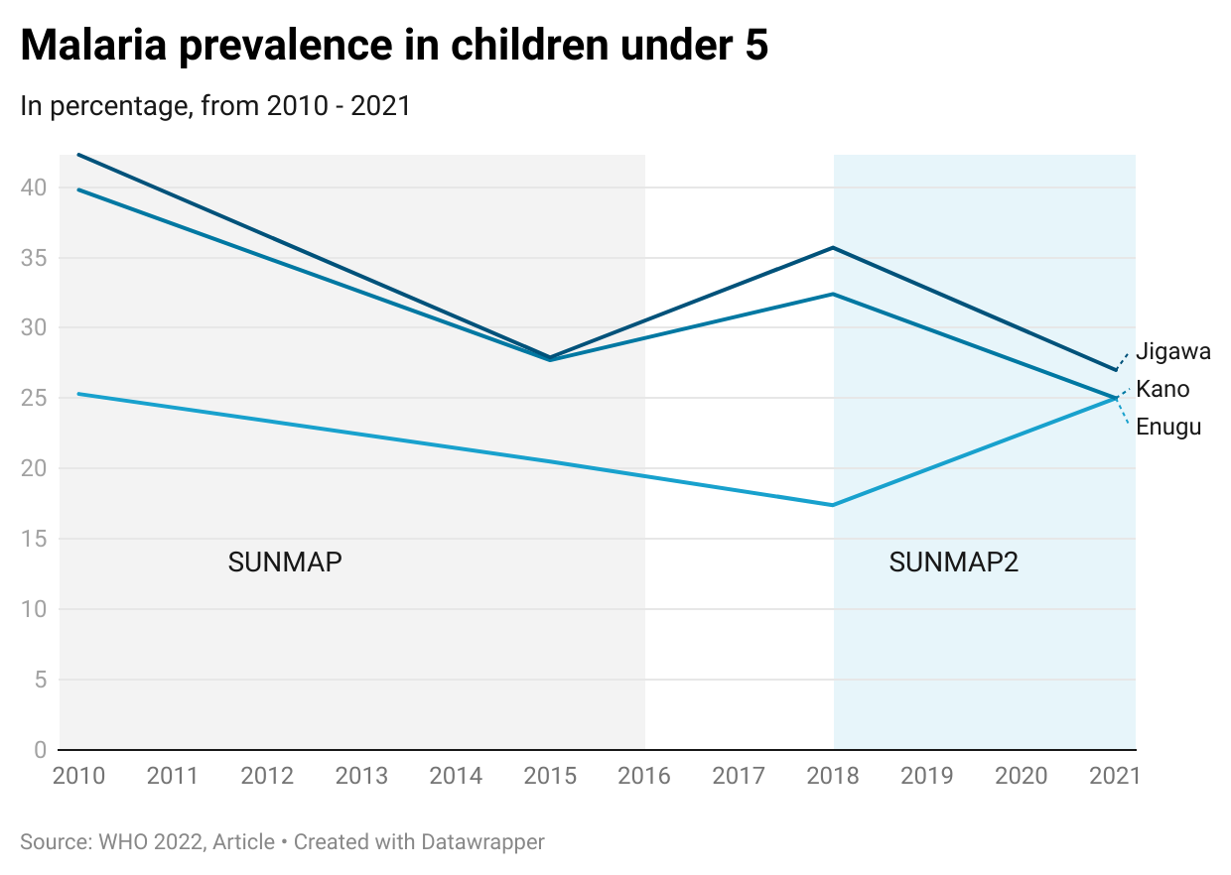
Malaria rates in children under 5 decreased in Jigawa and Kano with a small increase between 2015 and 2018 which may reflect more thorough data collection and testing. In Enugu, rates decreased, then increased again from 2018. At last reporting, all three states had comparable rates of malaria prevalence in children.
SUNMAP 1 and 2 ran from 2010 to 2016 and 2018 to 2021 respectively; SUNMAP2 was not active in Enugu. They focused on improving knowledge, treatment and healthcare provision in relation to malaria, with an aim to decrease malaria rates.

Figure 6: HIV/AIDS prevalence among adults (2001-2018)
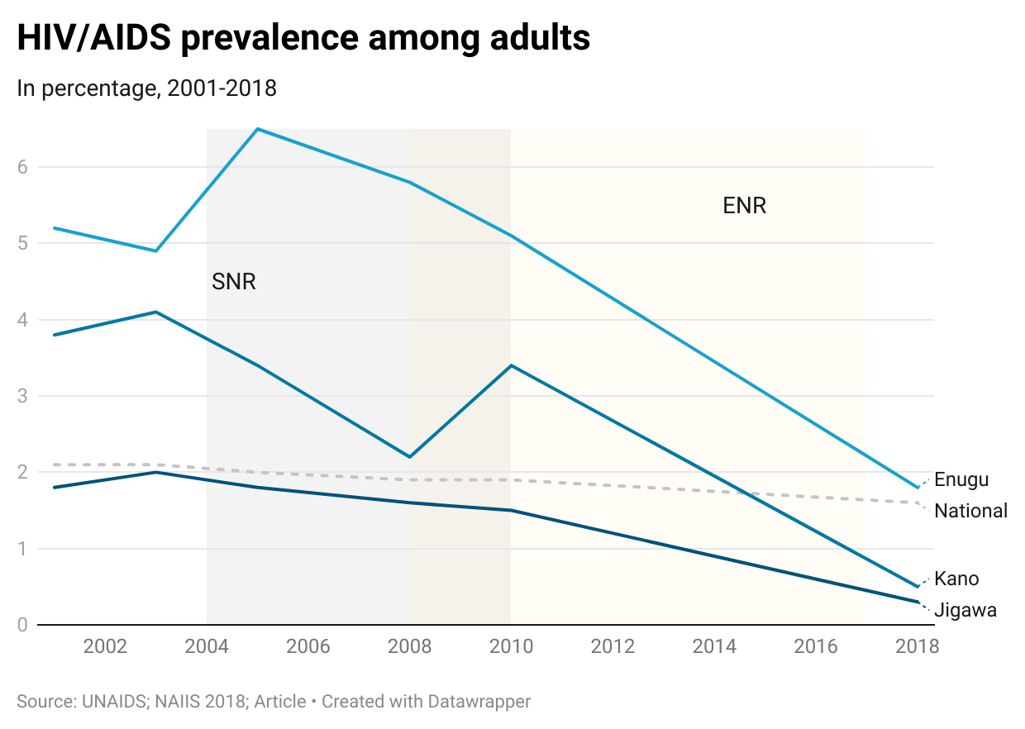
The prevalence of HIV/AIDS among adults in Enugu and Kano dropped significantly between 2001 and 2018 in all 3 states, but mostly notably in Enugu. In Kano and Enugu sharp but short-term increases in the prevalence of HIV/AIDS can be observed around the inception of the ENR and SNR programmes. This could be due to increased testing and reporting as both of these programmes centred on the healthcare related to HIV/AIDS including improving knowledge, decreasing stigma and developing prevention measures.

Building capacity of government decision-making, budgeting, and policymaking
Government budgeting was evaluated through the evolution of the proportion of budget allocated to health in Kano and Jigawa, the data being inaccessible for Enugu. In Jigawa, the proportion of the budget allocated to healthcare more than tripled over the course of 15 years and in Kano it more than doubled. This suggests that there was a growing prioritisation of healthcare at a government level which was translated into budgeting changes.
Service delivery indicators

Health system financing indicators

Figure 7: Budget allocation by focus state (2003 - 2018)
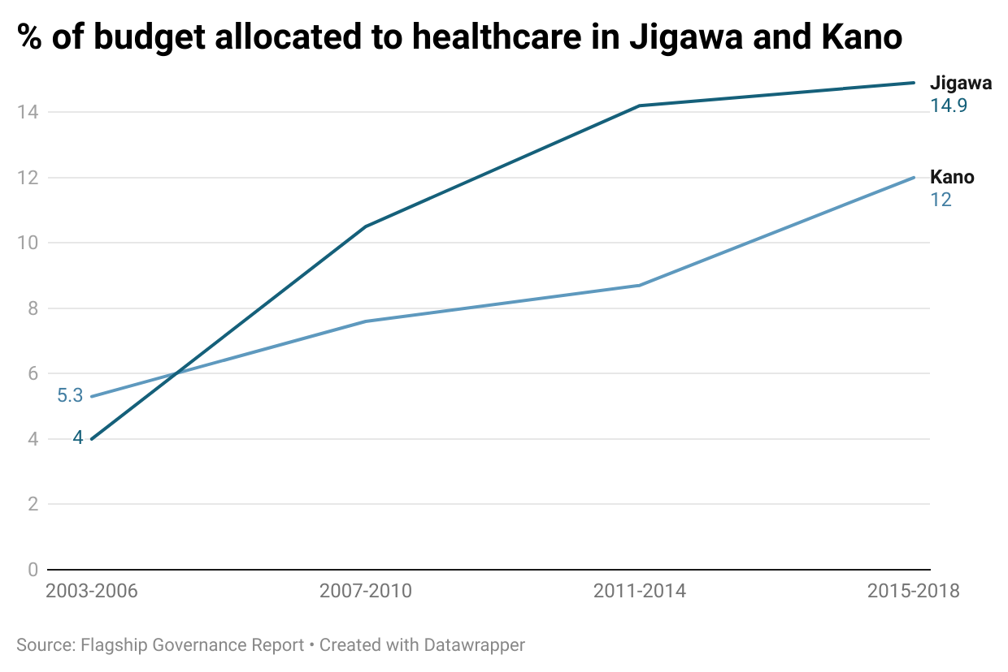
The percentage of the state budget allocated to healthcare reflects the prioritisation of healthcare at a government level. In both Jigawa and Kano, drastic increases can be noted over the course of 15 years, with Jigawa having met the 15% target in the Abuja Declaration.
Data for Enugu was not made available.

Figure 8: Out-of-pocket payments (2000-2021)
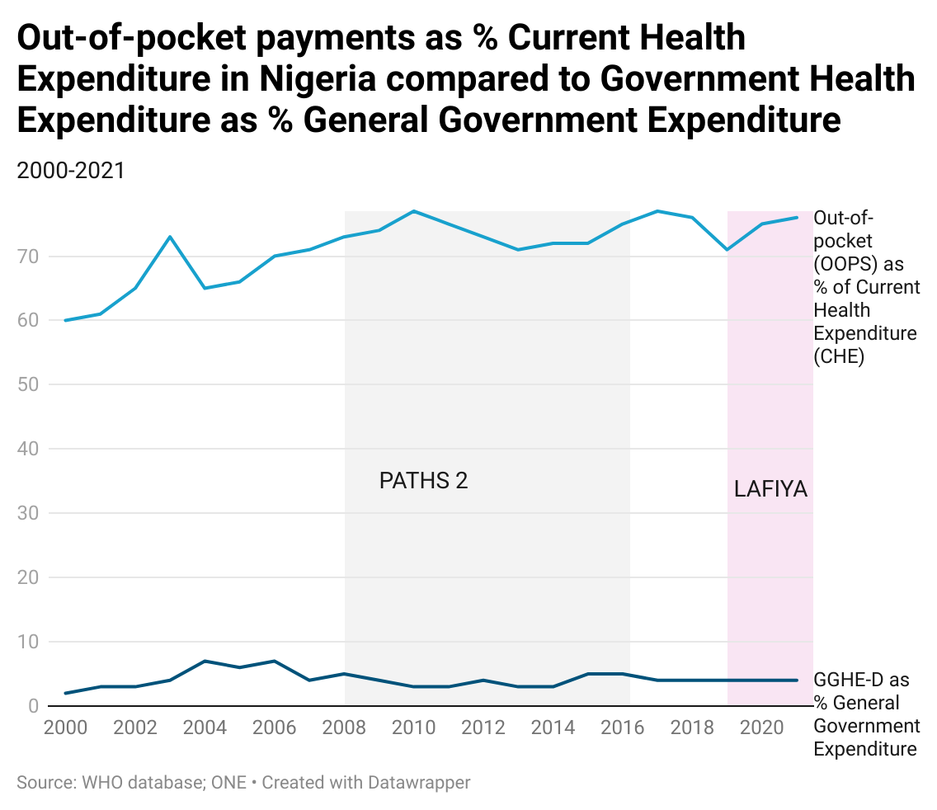
This indicator shows the evolution of out-of-pocket payments for healthcare as % of Current Health Expenditure in Nigeria over the last 20 years. Despite efforts from both PATHS2 and LAFIYA in diminishing these, it would seem that there has been a significant increase. Considering government spending on health as a proportion of their general expenditure has remained stable, this suggests that perhaps efforts were not so well received.

Health workforce and service delivery indicators

Figure 9: Antenatal care visits with skilled birth attendant (2007-2020)
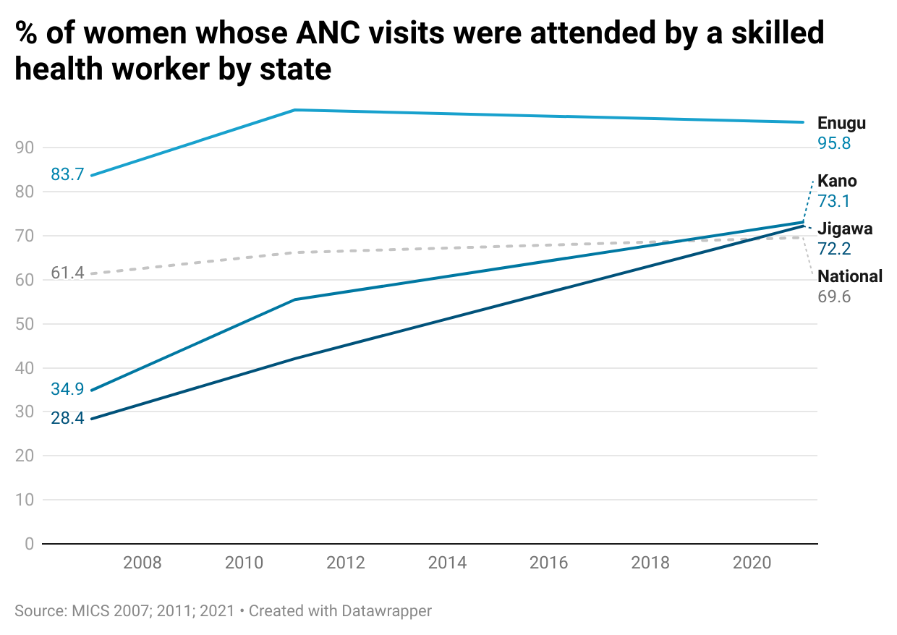
The percentage of women whose antenatal care visits were attended by a skilled health workier rose in all states from 2007 to 2010. During Women for Health (2012-2020), this percentage rose further in target states including Kano and Jigawa, until surpassing the national average at the end of the programme.

Figure 10: Skilled birth attendants (2008-2021)
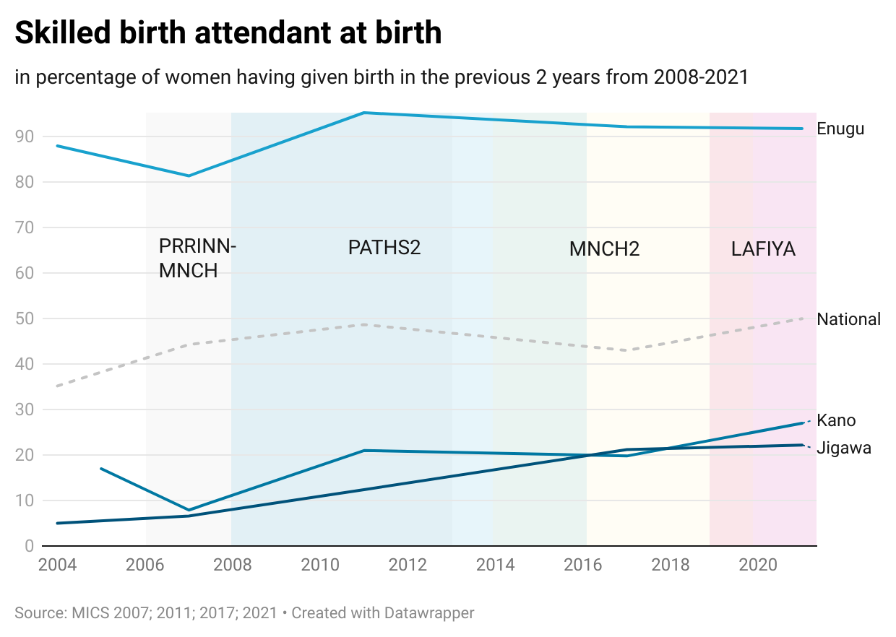
The proportion of women using the assistance of a skilled birth attendant increased in both Kano and Jigawa in line with national trends. A notable increase in both Enugu and Kano between 2008 and 2011 can be observed, at the same time as the inception of PATHS2. Despite certain reservations about these types of attendants in Jigawa as well as difficulties in securing staff, rates steadily increased although they still remain low.

Indicators for medical products, vaccines and technologies

Figure 11: Immunisation of under 1s (2007-2021)
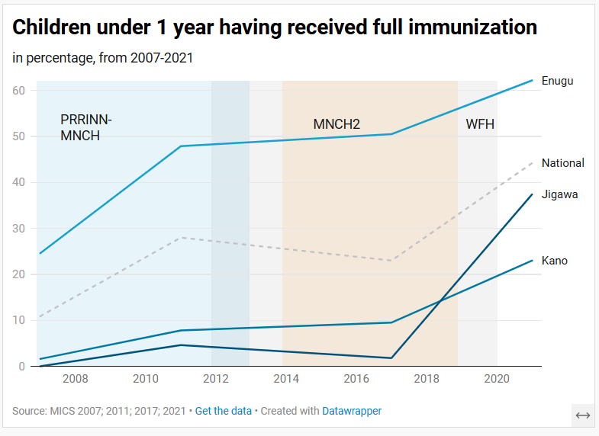
The immunisation rates of children under 1 in the three target states has increased considerably, in line with national trends. Even in Jigawa where there was originally some resistance surrounding the administration of vaccines, the increase has been particularly notable, overtaking Kano.
Note that MNCH2 and W4H were not operational in Enugu.

Figure 12: Insecticide Treated Nets (2007-2018)
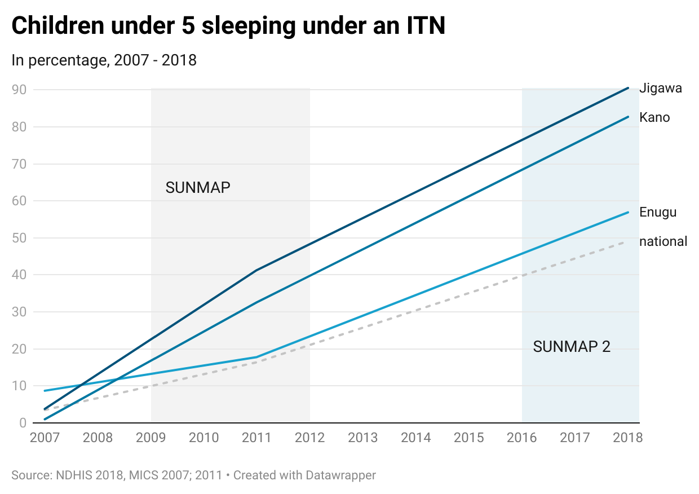
Sharp increases in all states in the use of ITNs for children under 5 can be seen, even in Enugu where SUNMAP 2 was not active. In Jigawa and Kano, particularly affected by malaria, it is clear that the distribution and the uptake of these nets has been successful.
Indicators for Health Management Information Systems
Figure 13: % of facilities timely reporting HMIS data
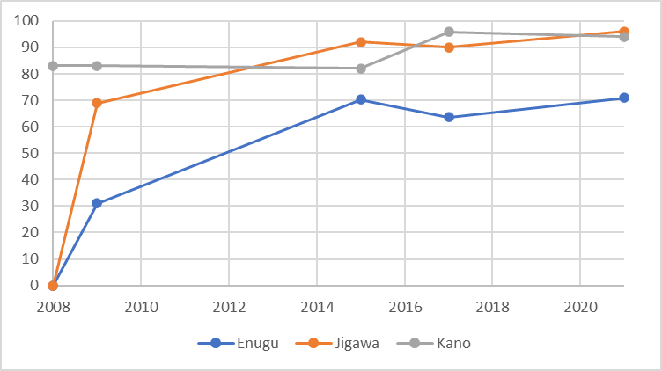
Source: FMoH NHMIS reporting

- Annex L – Timeline of FCDO Nigeria programming
The health sector in Nigeria and the UK development sector have gone through several phases over the 20-year period on which the evaluation is focussing. The main inflection points were:
Table 9 - 20-year UK's Nigeria HSS programming
Dates | Description
Pre-1999 | Military rule. Most donors withdraw support, but UK government maintains presence, including in some of the states targeted by subsequent interventions.
1999 | Nigeria returns to democracy. UK government re-initiates bilateral aid programme. World Bank establishes Health Systems Fund.
2001 | DFID Nigeria office is established, signalling the UK government’s sustained commitment to bilateral development partnership. State and Local Government Programme (SLGP, 2000-2008), seeking to increase and improve interaction between citizens and state governments in six states including Enugu, Jigawa, and Kano.
2004-05 | The first round of UK health programming within the scope of the evaluation, including SNR, PATHS1, and HERON. PRRINN-MNCH follows in 2006. Nigeria Governance and Accountability Programme (NGAP) in 2005, targeting five states including Kano, Jigawa, and Enugu. Launch of the GoN’s National Health Insurance Scheme (NHIS) in 2005 to reduce out-of-pocket spending on health and ensure access to health care services for every Nigerian.
2007-09 | The second round of health programming, with second-phase programmes of ENR, PATHS2, and HERFON. State-Led Programmes (SLPs) in complementary sectors including:  - Education Sector Support Programme in Nigeria (ESSPIN, 2008-2017), targeting six states including Enugu, Kano, and Jigawa.  - Growth and Employment in States programmes (GEMS, 2009-18) targeting different states including Kano (wholesale and retail, construction and real estate, meat and leather, and business environment reform) and Enugu (hospitality and tourism).  - State Partnership for Accountability, Responsiveness and Capability (SPARC, 2007-16), operating full scale in five states including Enugu, Kano, and Jigawa.  - States Accountability and Voice Initiative (SAVI, 2008-16), which worked to build the capacity of state houses of assembly, civil society, media and citizens for accountable governance in five focal states, including Enugu, Kano, and Jigawa.
2012 | GoN’s Saving One Million Lives Initiative, launched to scale up access to essential primary health services and commodities for women and children, targeting major causes of maternal and child mortality.
2014 | Passage and signing into law of the Nigeria National Health Act, which establishes a National Health System and provides a framework for its regulation, development, and management.
2016 | Launch of Basic Health Care Provision Fund (BHCPF), designed to improve access to basic healthcare services by providing funding to primary healthcare centres across the country.  Partnership to Engage, Reform and Learn (PERL, 2015-2025), supporting governments and citizens work together to improve basic services by supporting policymaking, planning, budgeting, project monitoring and accountability. Active in seven states including Kano and Jigawa.
2019 | DFID launches New Africa Strategy, announced with a focus on boosting economic partnerships, security cooperation, and mutual prosperity, with Nigeria as a key partner.
2020 | COVID pandemic. Merger of DFID and FCO, further integration of diplomacy and development approaches. UK government reduces ODA target to 0.5% of GDP, many development programme budgets are cut substantially.
2021 | Passage of Primary Health Care Under One Roof (PHCOUR), designed to integrate and coordinate primary health care services under state-level agencies under a single management structure.

Pre-1999: Support under the military regime
In the immediate years to prior to 1999, Nigeria was considered as an international pariah state, and most of the international donors left the country. The UK government stayed on but refused to work with the Federal and State governments but rather re-directed their support to NGOs mainly around capacity development and organisational strengthening, as well as supporting Local Government Councils to directly improve health services provided by Primary Health Care (PHC) facilities in the communities. At this time the Nigerian health system was performing very poorly – the World Health Report 2000 which compared aspects of health systems around the world ranked Nigeria 187 out of 190 countries (WHO 2000).

1999-2003: Return to democracy and re-engagement with the federal government
With the election of President Olusegun Obasanjo, Nigeria returned to civilian rule, and donors began to re-engage with the Government of Nigeria at the federal and state levels. This heralded the beginning of the UK government’s support to health systems strengthening programmes in Nigeria. Given the level of political and fiscal autonomy exercised by the 36 State Governments and their control of over 50% of the national government resources, DFID Nigeria employed a state-focussed approach with a suite of programmes on political governance, access to justice, socio-economic reforms, as well as health system strengthening. Thus, the first phase of PATHS worked in the four focal states of Benue, Ekiti, Enugu, and Jigawa.
The UK government also recognised that change within the Nigerian system would need to be championed from within by agents of change. This led to the Change Agents Programme (CAP) that brought together Nigerians from different backgrounds (civil servants, political office holders, representatives of health professional groups, academia etc) with a collective interest for change in the health delivery apparatus to act as ‘Change Agents’. Change agents were selected from across the country and put into working groups to define and initiate reform agendas within the health sector, independent of government and donors. The enactment of an overarching national health law to compensate for the lack of clarity about the roles and responsibilities of the three tiers of government (federal, state, and local) in the country’s constitution was identified as an important reform initiative The Director of CAP, Prof Eyitayo Lambo - a health economist - was appointed as the Federal Minister of Health in President Obasanjo’s second term of office in 2003.

2003-2014: The long road to the passage of the National Health Act
The public health system in Nigeria is simple in design but complex in operation. On paper, it is split into three tiers, with the tertiary Federal level, secondary State level, and primary LGAs. However, in practice, healthcare delivery is highly fragmented, with many different agents responsible for different aspects of the same service. This could be attributed to the differentiated polity, characterized by political devolution into 36 States, institutional fragmentation and inter-dependencies where state-level public sector MDAs have no direct line relationship with the federal counterparts but rely on them to give national policy direction, and functional decentralisation with parastatal federal level agencies having direct health programme implementation mandates.
Thus, the Nigerian healthcare system exhibits certain characteristics that undermine the performance of the health sector. These include organisational confusion among various actors on their respective roles, economic constraints on the capacity of government to deliver a basic package of care to all citizens, widespread corruption in the public sector that permeates into the health sector, and inappropriate interference by international donors as they try to implement their global mandates. However, it is vested interests and a tendency to maintain the status quo that has mainly caused the lingering disjuncture in policy and strategy development, which in turn has led to the continuous fragmentation of care.
With a reform-minded Minister in office, and a growing pack of ‘change agents’ the stage was set for broad-based reforms in the health sector. In 2004, a health reform programme led by the Federal Ministry of Health (FMoH) was initiated under this Health Minister. Its main goal was to resolve the conflicts of roles and responsibilities among the tiers of government, as well as advance a shared vision for a national health service with all actors. Again, the drafting of a National Health Act and its passage into law was central to these reforms.
Meanwhile, the Change Agents Programme transitioned from being a donor-funded programme into a Nigerian-run NGO, the Health Reform Foundation of Nigeria (HERFON), with a large and diverse membership base from well-connected individuals across several sectors including those within and outside government. Drawing upon this pool of resources and taking advantage of UK government support, HERFON engaged both the National Assembly and the Federal Ministry of Health to drive the passage of the Health Bill through the legislature.
Beyond taking an overt campaigning role, HERFON fostered a partnership of stakeholders including other civil society organisations, developed their capacity to carry out advocacy initiatives in relation to the Health Bill, and undertook operational research to generate evidence to support its advocacy endeavours using MNCH services as a focus. Interestingly, though the drafting and processing of the first version of the National Health Bill in 2004 was well received, it soon generated a lot of interest from several quarters and concerns about some of its provisions were raised by several entities including Health Professional Associations, religious bodies, and others. For example, Health Professional Associations insisted that a particular section contravenes already existing laws guiding standards and regulation of health professional practices in the country. They also found another section ambiguous and in conflict with the statutory functions of the National Council on Establishment, which is empowered by the law to prescribe duties and responsibilities for all cadres of workers in the public service. Furthermore, the appropriateness of the section on Functions of the Federal Ministry of Health was questioned by some stakeholders given that this section has assigned too much power to the Federal Ministry of Health (FMoH) in a federal country such as Nigeria where States and LGAs have been assigned considerable power and autonomy by the constitution. This led to several revisions of the bill, which caused long delays in the legislative process. Between 2005 and 2010 six versions of the bill were drafted, and eventually it was passed by the National Assembly (the Senate and the Federal House of Representatives) in 2011 but failed to receive Presidential assent presumably due to unresolved contentious issues in the Bill.
Given this impasse and with the passage of the Health Bill becoming a ‘wicked problem’ where the answers are incomplete, contradictory, and set against changing requirements, it necessitated a change of tactics whereby rather than an individual organisation acting on its own, a specific coalition of civil society organisations targeted at getting the Bill passed was formed to help navigate the politically volatile environment and manage the diversity of interests. With HERFON as Secretariat, the Health Sector Reform Coalition (HSRC) as it was named became the platform through which concerted efforts were expected to be directed towards sustained advocacy to get the Bill passed and signed into law. It encompassed a diverse and multi-disciplinary range of stakeholders, including indigenous health delivery civil society organisations, professional bodies (legal, health sector), International non-governmental organisations (INGOs) and the media. While organising a coalition of this nature to achieve a common goal was a daunting task with individual members still having their respective agendas, the HSRC managed to hold the collective by ‘force of purpose’ to deliver its outcome. The second phase of the UK government-supported Partnership for Transforming Health Services (PATHS2) was a major player in this coalition.
Following a landscape analysis of the Health Bill, it became clear to the coalition that enacting a national health law in a country as complex and diverse as Nigeria was more of a political process than a technical one. Therefore, extensive political analysis and dialogue among various interest groups were required on an ongoing basis to support the process. This insight, along with the consistency of efforts by HSRC members, paved the way for more targeted advocacy, lobbying, consensus building, reconciling differences among various groups, and stimulating responsiveness and ownership of the process and the product by all concerned, including the public. Despite opposition by the Federal Ministry of Finance, which was not behind the financial commitments of the Bill, the sitting Head of State, President Goodluck Jonathan, was persuaded through a combination of high-level domestic and international political pressure to sign the Act in the twilight of his administration in 2014.
During this period there were also other reforms such as the institution of the National Strategic Health Development Plan (NSHDP, 2010-15) that incorporated State Strategic Health Development Plans (SSHDPs) from each of the 36 States and the FCT. Led by the FMoH with support from international development partners during the tenure of Prof Osotimehin as Minister, it was reckoned that such a rational plan would lead to a significantly improved health status of Nigerians through the development of a strengthened and sustainable healthcare delivery system.
Another important reform that was also linked to the National Health Act was Primary Health Care Under One Roof (PHCUOR), a policy targeted at addressing the fragmentation, underfunding and mismanagement of primary health care that is at the heart of Nigeria’s underperforming health system. This reform was particularly critical to UK government support at that time. DFID Nigeria’s 2011-2015 operational plan included targets to enable an additional 500,000 births to be delivered under the care of a skilled birth attendant. These results were expected to be delivered by PRRINN-MNCH, PATHS2 and the successor MNCH project, MNCH2. However, these results could not be delivered by these projects working on their own, and the UK government realised that success was largely dependent on the level of political commitment and willingness to make fundamental reforms to health services. HERFON was given the advocacy role for this reform through an accountable grant from DFID, aiming to create the sort of synergy required to secure its investments in the Nigeria health system.

2015-present: Implementation of the National Health Act and the Basic Health Care Provision Fund (BFHPF)
Considering the lengthy and convoluted course the Bill took to become an Act, and the excitement that greeted the anticipated socio-economic change of the last federal administration of President Muhammadu Buhari in 2015, a note of caution was given that ‘political office change is not necessarily a system change’. and sustained advocacy would be required to get the National Health Act implemented. Almost 10 years down the line, progress has been slow and there have been several obstacles at the Federal government level including ongoing tussles about funding for the Act, how these should be managed, and by whom (See Case 14). The end of FCDO funding to HERFON programmes, including APHCR (2012-2020), and HERFON’s struggle for sustainability (see Case 12) may have contributed to the slow and weak implementation of the NHA.
In the meantime, the institutional blockages with significant impact on the governance systems for healthcare in Nigeria continue to linger on. As State and LGA governments control 50% of national resources, they have considerable financial and political autonomy. These subnational entities have direct responsibility for providing public education, healthcare, water and sanitation services, but most of them have serious capacity constraints to effectively deliver these mandates. They are neither responsive nor accountable to the Federal government. And federal-state relationships tend to be conflictive. For example, federal legislation could be interpreted in the states in several ways, and the parts of it that were relevant would be implemented, others would be disregarded. While this may seem potentially unlawful, states in exercising their constitutional powers have been tested in this way in many different fields with numerous cases where state interpretations have stood, both in judgement and in practice.
On the surface, this institutional context may represent ‘the existing arrangement of territories, functions and practices, and how these are organisationally, professionally and politically demarcated and defended’. In reality, the institutional environment of healthcare reflects the wider political economy and social milieux that exist in Nigeria. Reflectively, the key driver is the federal system, which, if it has contributed to the survival of Nigeria as a cohesive nation, has also maintained the potential cleavages resulting from the complexity of holding together over 300 ethnic groups with 500 indigenous languages and adopting two major foreign religions, Islam and Christianity, alongside around 10% of the population continuing to practice indigenous religions.
While tensions between federal and state governments playing out in health policy and strategy development disjuncture are partly technical, they are also manifest in vested interests displayed by both federal and state health authorities. State Ministries of Health are protective of their independence in decision-making and tend to favour large, visible, capital-intensive physical projects, such as the construction of new hospitals. By contrast, the behaviour of the Federal Ministry of Health and its agencies is influenced by a desire to retain existing channels of expenditure and the political and financial opportunities that these provide. Dealing with this issue requires agents both within and outside the system who can act differently to progress a reform agenda.
Even the 2014 National Health Act, the overarching national health law, has failed to compensate for this lack of legal mandate. For instance, constitutionally the State Commissioners for Health are accountable to State Governors and not to the Federal Minster of Health. State Governors and Chairmen of Local Governments often follow their own agendas rather than the health sector strategic direction set by the FMoH. Meanwhile, the Federal Minister of Health is responsible for the health of the nation, but (even with the new health law) does not have the authority or means to exercise the necessary managerial accountability.
Despite its limitations, the enactment of the National Health Act represented a significant reform agenda, which with donor support enabled a broad range of national stakeholders to advocate for the creation of an overarching health system legislation aimed at improving the quality and efficiency of health services nationwide. Additionally, the Act stipulated the establishment of the Basic Health Care Provision Fund (BHCPF), where the Federal Government would set aside a minimum of 1% of its consolidated revenue along with contributions from donor grants to provide a basic minimum package of health services for all Nigerians. The design and implementation of the BHCPF was a complex process that involved the inclusion of many stakeholder groups with divergent interests working together to achieve a common goal, taking over 15 years and running across four election cycles, meaning that new advocacy effort was required after every national election. There has also been poor progress in its implementation, blamed on obstructions at the federal government level and lack of leadership and interest from successive Federal Ministers of Health and the past federal administration.
Nonetheless, the limited political prominence of health sector reforms in the States remains the main difficulty in promoting the Act at the level where service delivery happens. It was noted that in domesticating the Act in their domains, States are only creating an appearance of change by setting up the Agencies as demanded by the Act without addressing the functions these Agencies are meant to carry out. As an unfunded mandate, the Act is legally binding for Federal level institutions and sets out guidance for changes at State and Local Government levels. The absence of any additional financing from State governments appears to be of little interest to stakeholders in implementing these provisions at the subnational levels.
Using the BHCPF as the basis for new investments in the health system, the present Health Minister, Prof Ali Pate, is championing another wave of health sector reforms aligned with the broad political agenda of the current President, Bola Ahmed Tinubu. This entails fashioning a health sector renewal programme that seeks to derive the full benefits of the National Health Act by revitalising public health services, increasing the effectiveness of public health financing and alignment of spend with strategic priorities, improving the ability to detect, prevent, and respond to public health threats (e.g., cholera, lassa), as well as building climate resiliency for the health system in collaboration with other sectors. Meanwhile, these sectoral reforms are being initiated at the same period as the far-reaching macroeconomic reforms of the present administration that are having adverse effects on the health and well-being of the population. As observers note, the removal of petroleum subsidies and the devaluation of the currency, though necessary, immediately created a snowball effect on the various sectors of the economy. Moreover, the success of the emergent health sector reforms is still subject to the current political administration’s ability to navigate the complex economic and political dynamics inherent in Nigeria - managing powerful individuals within the ruling coalition, in addition to balancing reform-minded policies with fulfilling informal obligations.

Contemporaneous health programmes and donors
Several other large donors have implemented HSS programmes in Nigeria over the past 20 years, with important lessons learnt from evaluations of the impact on health systems process goals of these programmes.
Canada’s Department of Foreign Affairs, Trade and Development (DFATD) implemented the Nigeria Evidence-based Health System Initiative (NEHSI) , a $17 million programme from 2008 to 2014 to improve health governance and capacity in Bauchi and Cross River states by developing a gender-sensitive health information system to improve primary health care. It aimed to strengthen the consistency and availability of gender-sensitive health data, strengthen institutional capacity to plan and deliver primary health services and increase participation by community members and local ownership to promote extension into more states. Amongst others, the programme assisted state governments in transitioning from paper-based health forms to mobile technology, increased capacity and evidence use in planning and budgeting for health services through training to government employees, informed over 40,000 adults and youth on maternal health and child health, improved women’s use of maternal health services and engagement by the community in health services. Evaluations have shown that there was improved evidence used for planning and improved governance processes including resource and budget allocation at the institutional level and at the state level the programme has achieved improvements that are sustainable in the Nigerian primary health care system.
The United Nations Population Fund (UNFPA) has implemented the Supplies Partnership, a multilateral, multi-donor fund launched in 2007, aiming to strengthen the health system by providing sexual and reproductive health services and supplies. The mid-term evaluation of implementation in Nigeria between 2013 and 2016 has shown that the programme improved the supply and availability of reproductive health and family planning services and products, particularly for poor and marginalized women, and increased demand for such commodities by these groups. It further increased access to contraceptive methods and strengthened the capacity for sustainable health service delivery and the enabling environment for reproductive health commodity security and family planning, including alignment with policies and national commitments.
The U.S. Agency for International Development (USAID) has run a range of programmes over the past 20 years, some implemented through the Centers for Disease Control and Prevention (CDC). The Maternal and Child Health Integrated Program (MCHIP) in 2009-2011, as a continuation of the Access to Clinical and Community Maternal, Neonatal and Women’s Health (ACCESS) project in 2006-2009, aimed to prevent maternal and neonatal deaths by increasing the use of quality newborn care services by women in Kano, Zamfara, and Katsina states. The MCHIP trained health workers, set up mobilization teams to engage communities on maternal and newborn care, and supported maternal and child health, family planning and reproductive health stakeholders to develop National Performance Standards. Evaluations demonstrated that the programme successfully increased use and demand for family planning and newborn care, antenatal visits and institutional deliveries, and improved the quality of these services. It further fostered the enabling environment to extend and sustain positive outcomes beyond programme duration at the state and national levels. However, high turnover and shortages of providers, equipment, and adequate infrastructure limited improvements in access to these services and there was limited capacity at the state and community levels to ensure the funding and continuation of activities.
The U.S. President’s Malaria Initiative (PMI) has provided over $900 million in funding and technical assistance to the Nigerian government for fighting malaria. It has financed insecticide-treated nets, malaria diagnosis and treatment, and provided training to health workers, enhanced data monitoring, and promoted health policies to strengthen the resilience of the health system. Since its launch in 2011, the programme has contributed to reducing child mortality from malaria by 16%, reduced malaria parasite prevalence from 42% to 23%, and increased coverage and use of mosquito nets, malaria medication and preventive treatment for children and pregnant women in 36 states across the country. An evaluation of 2008-2016 in Cross River, Ebonyi, Nasarawa, and Sokoto states has shown improved availability of malaria products, supply chain management, training of health workers and malaria data reporting, which lead to increased net ownership and use and malaria care quality. Other similar HSS programmes by USAID in Nigeria included the President’s Emergency Plan for AIDS Relief (PEPFAR), the National Public Health Institutes (NPHI) Programme, and the Field Epidemiology Training Program (FETP). USAID is also currently funding the HERON component of the BHC Nigeria-funded Lafiya programme.

Annex M – Ethical considerations

Safeguarding participants in primary research
We did not identify any specific risks for interviewing participants in primary research outside of considerations for all data collection in Nigeria. We did not ask specific questions about gender, age, ethnicity, disability, religion, geographic location, socio-economic status, or hard to reach groups, but respondents sometimes raised these issues during the primary data collection.
The evaluation sought honest opinions on the successes and failures of HSS programming in Nigeria from UK government and Government of Nigeria (GoN) officials. For government stakeholders, we have safeguarded issues around political sensitivity by ensuring the confidentiality of responses and reminding respondents that the evaluation is looking to learn from challenges as well as successes. BHC Nigeria has a good working relationship with the GoN, and we are looking to produce a single evaluation report and findings that can be published online. Nevertheless, we have given our national consultants and BHC Nigeria a chance to review the draft report and identify misunderstandings or politically sensitive findings.
Other local stakeholders have been working in implementation or frontline health care delivery. While English was sufficient for most IDIs and FGDs, two FGDs were conducted in Hausa and translated into English. We provided travel stipends for stakeholders to come into state capitals to ensure that a range of stakeholders, including those from rural areas and lower socio-economic backgrounds, could take time off to participate and have their voices heard. We had both a male and female national consultant lead the FGDs.
In conjunction with our security manager, we chose secure hotels in state capitals in which to hold the IDIs and FGDs. Following travel advice from FCDO and our security manager RSM, international consultants’ travel was restricted to Abuja and Enugu and only the national consultants travelled to Kano and Jigawa. National consultants stayed in a secure hotel in Kano and travelled to Jigawa during the day, respecting curfew.
We have complied with FCDO’s safeguarding policies and requirements and the Evidence Fund Safeguarding Policy. We have proactively taken measures to eliminate, prevent or minimise the risk of misconduct by our evaluation team, downstream partners, and others we engage under the evaluation. We have ensured adequate policies in place amongst our staff and evaluation partners to prevent and address bullying, harassment, abuse, and harm by ensuring they adhere to Cadmus’ robust policies and procedures on safeguarding, whistleblowing, human resources, risk management, code of conduct, governance and accountability. Cadmus maintains an organisational culture that prioritises safeguarding, including by providing training to our staff and keep detailed records of incidents or allegations of misconduct, maintain clear reporting lines and reporting to the Fund Manager’s Director of Operations and Research in case of serious misconduct or potential investigations into allegations. No such incidents were reported during this primary data collection.

‘Do no harm’ and adherence to international standards of ethical practice
We have adhered to the ‘do no harm’ principles of confidentiality, informed consent, and data integrity and data protection.

Confidentiality
We have upheld strict confidentiality around all information acquired. We have used confidential information only for evaluation purposes and have not disclosed this beyond our personnel and partners to anyone not already authorised for access. This confidentiality extends beyond our direct engagement with this evaluation and applies to the entire duration of the Evidence Fund.
Maintaining respondent confidentiality is a paramount consideration in our research approach. To safeguard participant identities, each respondent was assigned a unique identifier. During the data cleaning and analysis process, all identifying information in respondent quotations has been altered or removed so it is not possible to identify individual respondents based on the available metadata and demographic information. Although respondents are listed in Annex D, they are referred to generally in giving quotations.
All team members, including researchers and support staff, have undergone comprehensive training on the importance of confidentiality, ethical considerations, and the specific measures in place to protect respondent privacy. During the data collection process, whether through focus group discussions, in-depth interviews, or interactions with local partners, researchers emphasized the confidentiality measures in place and reiterated our ethical obligation to protect participants' identities. Besides using suitable venues and appropriate seating arrangements while conducting in-depth interviews and focus group discussions, the Research Team has been mindful of cultural values and undertones in the states visited.
Access to research data was restricted to authorized personnel only, and any data shared within the research team prioritized the use of coded identifiers rather than personal details. Through these measures, created a secure and confidential environment that respects and upholds the privacy of our respondents throughout the research process.

Informed consent
Our approach to informed consent prioritized transparency, respect, and the voluntary participation of individuals on the day of their engagement in focus group discussions, in-depth interviews, or local partner interviews. The literacy level of most of prospective respondents was considered adequate to communicate effectively in standard English language used in Nigeria. However, in two FGDs a regional language, Hausa, was used, with which both the respondents and one interviewer were fluent. We clearly explained the purpose of the research to participants on the day of the survey and obtained informed consent from each participant, including permission to record responses by audio, prior to commencing. Researchers addressing any questions or concerns that participants brought up, emphasized that participation is voluntary, and participants could refuse to answer any questions or withdraw from the study at any time without any loss of stipend or consequences for program participation.

Data integrity and data protection
We uphold principles of data integrity and data protection. Data integrity begins with standardized data collection procedures. This involves implementing consistent methodologies across all research activities, coupled with comprehensive training for researchers to guarantee that data is gathered uniformly and accurately. Transcripts have been stored securely on encrypted sites with limited access to protect sensitive information. Data has been backed up regularly to prevent data loss and ensure continuity.
Privacy and confidentiality have been maintained throughout the research process. Data has been anonymized to prevent identification of individual participants. Personal identifiers have been separated from the main data set and stored securely. During data analysis, researchers have employed techniques that protect the identity of participants, ensuring that no sensitive information is inadvertently disclosed. Moreover, regular audits and reviews of data handling practices have been conducted to ensure compliance with ethical standards and legal requirements.

Participation of underage respondents
We did not intend that underage respondents would participate in the primary data collection. Prior to engaging individuals in focus group discussions, in-depth interviews, or local partner interviews, researchers confirmed the age of potential participants. This verification step was integrated into the informed consent process, ensuring that only individuals above the specified age threshold are included in the study.
To further emphasize the exclusion of children from participation, researchers used explicit language in the informed consent documents and in recruiting FGD participants, clearly stating that the survey is intended only for adults. Additionally, during the training sessions for researchers, child safeguarding protocols and ethical considerations were emphasized, underscoring the importance of diligence in checking that respondents are adults. No children were reported to have been involved in the research.

Adverse events
Our Nigerian experts have significant experience conducting research in all parts of the country, including Northern states. The timing of the primary data collection was designed to be flexible and the safety and well-being of both participants and the research team. Prior to the initiation of primary data collection, a thorough risk assessment was conducted by our security partner, RSM, considering factors such as weather conditions, accessibility, and political protests.
Our national consultants and security partner communicated with local authorities, community leaders, and participants to stay informed about instability or weather-related developments or challenges that could affect the research activities. Flexible scheduling was implemented to allow for adjustments in response to any interruptions, ensuring the safety of participants and the research team.
Additionally, the research team have had access to emergency resources and support services in collaboration with our security provider, Risk and Strategic Management (RSM), to ensure that assistance can be mobilized quickly if needed. Regular debriefing sessions have been conducted to address any challenges faced during adverse events, allowing the team to learn from experiences and continuously improve the safety protocols in place.
By integrating these proactive measures and maintaining open lines of communication with local stakeholders and where possible following preventive safety measures and precautions they have put in place, our qualitative study aims to respond effectively to any adverse events that may occur during the primary data collection period, prioritizing the safety and well-being of all involved parties.

Supplier duty of care
Cadmus implements contracts across the globe, including in poor and fragile states, in which we apply our well-tested duty of care and security policies, which have been applied to this evaluation and minimised security risks for personnel and third parties. Cadmus fully accepts responsibility for security and duty of care and have the capability to manage duty of care responsibilities throughout the evaluation. We have completed an initial assessment of potential risks to the evaluation project, understand the risk management implications, and prepared a plan for managing these risks we implemented effectively and continuously reviewed throughout the evaluation.
We ensured comprehensive duty of care for the entire evaluation team with the support of our trusted security company RSM, our long-standing risk advisory partner who has developed the organisation’s risk management platform for worldwide operations. RSM is an internationally renowned security provider that works with other international development companies in high-risk environments such as Afghanistan, Iraq, South Sudan, and DRC, as well as across Nigeria. RSM recently supported Cadmus operations in Zambia, Ghana, and Nigeria, and provides technical backstopping to Cadmus' head of security and crisis management team. Cadmus worked with RSM to assess and understand the risks before starting operations, design and implement adequate security plans, obtain regular updates on security issues, and update and adjust security plans to ensure full duty of care.
RSM works closely with Cadmus’ head of security to design and implement appropriate safety and security systems for team members and partner organisations. We developed the tactical movement plan based on the assignment-specific risk assessment shared with RSM’s in-country security risk management partner. We ensured all staff are met at points of entry and transferred to initial accommodation. The team received a detailed briefing from RSM’s in-country security risk management partner on the movement plan, their responsibilities and clear direction on actions to take in response to high-threat situations. All road movements were tracked and RSM’s in-country partner reported daily on location and status. Road movements were followed by soft-skinned SUV, with an English-speaking, security-trained driver and unarmed (per Nigerian law) security escort (an experienced security professional). We lowered security risks by limiting travel to Abuja and three state capitals and using internal flights to avoid interstate road travel.
All staff and consultants were trained on managing safety, security, and health risks during travel through the Cadmus College, with specialised HEAT training for travel to high-risk regions. As part of the pre-deployment training, staff received training on incident and emergency management as part of implementing the security management plan through scenario-based exercises. We monitored risks live using International SOS’s intelligence alert channels that notify events and risks to the safety and security of staff. RSM undertook a security audit survey, including threat and intelligence assessment, the drafting of safety policies, plans and procedures and briefing of staff on the findings of the audit and recommendations. Detailed risk assessments were carried out as the three states have been identified during inception. Risks were monitored on an ongoing basis against the initial risk assessment and augmented as new risks were identified, with mitigation measures reflecting a proportionate approach to the probability and severity of risks.
We have not encountered any incidents or emergencies throughout the evaluation. Nevertheless, in the event of an incident or emergency, RSM’s Incident Management Team were planned to be activated with Cadmus’s security focal point and crisis management team. RSM have robust, strategic and operational emergency response protocols developed through extensive and direct operational experience. Incident and crisis management guides ensured emergencies are navigated in a structured manner, best using the capabilities of RSM. International SOS 24h travel assistance including medical assistance and repatriation or evacuation were intended to be used in the event of political instability, natural hazards or similar. Local staff were provided appropriate medical insurance coverage and assistance to return to the local residence. Cadmus maintained open channels of communication with local teams remaining in the country. Partners had appropriate insurance coverage, including for medical assistance, and Cadmus extended International SOS travel assistance to staff from partners without adequate emergency systems.

Annex N – Qualitative coding framework

The EQUALS review of the draft inception report was critical of the broad range of evaluation questions proposed in the ToRs given the limits in terms of time and resources and the evaluation focus on learning rather than accountability. Following these recommendations, we met with the Nigeria health team to prioritise evaluation questions, identify which were accountability questions and therefore out of scope, and re-focus the evaluation on answering the key evidence gap of understanding what assumptions are necessary and sufficient for change at the outcome level.
The changeover of the US administration has resulted in the closure of around 90% of USAID programmes by February 2025, including all Nigeria health programmes, and substantial reduction of budget for the WHO and UN, among other development partners. FCDO followed suit in March by announcing a further reduction of ODA to 0.3% of GNI by 2027.
Witter, S., Palmer, N., Balabanova, D., Mounier-Jack, S., Martineau, T., Klicpera, A., Jensen, C., Pugliese-Garcia, M., & Gilson, L. (2019). Health system strengthening - Reflections on its meaning, assessment, and our state of knowledge. The International Journal of Health Planning and Management, 34(4), e1980–e1989. https://doi.org/10.1002/hpm.2882
Manyazewal, T. (2017). Using the World Health Organization health system building blocks through survey of healthcare professionals to determine the performance of public healthcare facilities WHO. (2010). Monitoring the building blocks of health systems: A handbook of indicators and their measurement strategies. World Health Organization. https://iris.who.int/handle/10665/258734
Bertone, M. P., Palmer, N., Kruja, K., Witter, S., & Group 1, H. W. (2023). How do we design and evaluate health system strengthening? Collaborative development of a set of health system process goals. The International Journal of Health Planning and Management, 38(2), 279–288. https://doi.org/10.1002/hpm.3607
WHO (2001). Macroeconomics and Health: Investing in Health for Economic Development, WHO.
Nigeria Demographic and Health Survey (NDHS), 2003
Rural Kano and Jigawa both have a predominantly Hausa/Fulani Islamic population. Kano city has a sizable mix. Kaduna is heterogeneous both in terms of religion and ethnicity. Enugu is largely Igbo and Catholic, although there is also a sizeable population of minority ethnic and religious groups there.
Nigeria Demographic and Health Survey (NDHS), 2003.
The NDHS (2003) found that only 23% of married women have any say in decisions concerning their own health care and only 26% have a say in decisions concerning their children’s health care.
World Bank. (2009). International Development Assistance Country Partnership Strategy for the Federal Republic of Nigeria, 2010 - 2013. Washington D.C.: Word Bank.
Federal Ministry of Health (FMoH). (2004). Health Sector Reform Program: Strategic Thrusts and Log Framework. Abuja: Federal Ministry of Health
Rhodes, R.A.W.; Carmichael, P.; McMillan, J.; and Massey, A. (2003). Decentralizing the civil service: From Unitary state to Differentiated Polity in the United Kingdom. Buckingham: Open University Press
Federal Ministry of Health. (2004). Federal Ministry of Health (FMoH). (2004). Health Sector Reform Program: Strategic Thrusts and Log Framework. Abuja: Federal Ministry of Health
O’Brien, G. et al. (2008). Climate adaptation from a poverty perspective. In: Kok M. T. J. & Metz, B. (eds.) Development Policy as a way to Manage Climate Change Risks. London: Earthscan Routledge.
Asoka, T. (2015). Political leadership change is not a system change: Overcoming the inertia of change in the Nigeria health sector. Africa Health (Nigeria Edition). 37 (4): 5 – 6.
DFID. (2013). Advocacy for Primary Health Care Reform (PHC REFORM) Business Case. Abuja: DFID Nigeria.
Asoka, T. (2015). Political leadership change is not a system change: Overcoming the inertia of change in the Nigeria health sector. Africa Health (Nigeria Edition). 37 (4): 5 – 6
Anyebe, W. (2005). Assessment of Local Government Capacity for Delivery of Quality Primary Health Care in Bauchi State, Nigeria. Abuja: DFID Nigeria.
Asoka, T. (2013) Much Ado about a National Health Bill: why the President may not sign the bill again. Africa Health (Nigeria Edition). 36 (1): 2 - 5. https://www.dropbox.com/s/8vae9j2frhdcnnt/AH-Nigeria%20Nov%20%202013.pdf?dl=0
Cropper, S. (1996). Collaborative working and the issue of sustainability. In: Huxham, C. (ed.) Creating Collaborative Advantage. London: Sage Publications Ltd.
Amundsen, I (2010). Good Governance in Nigeria: A Study in Political Economy and Donor Support. Oslo: Norwegian Agency for Development Cooperation.
DFID. (2007). Programme Memorandum: Partnership for Transforming Health Systems, Phase II. Abuja: DFID Nigeria.
Tulloch, O. Cummings, C. Ogunbayo, D. and Oreh, C. (2017) A Case Study of the Implementation of the 2014 Nigeria Health Act – what can we learn for public policy reform? Abuja: Partnerships to Engage Reforms and Learn (PERL) - Learning, Evidencing, and Advocacy Pillar (LEAP). http://www.perlnigeria.net/storage/casestudies/June2018/ajcSQsA69fLeSgvzRdFK.pdf.
Ibid.
Bloomberg. (2023). Nigeria Inflation Quickens Before Currency Devaluation, Fuel Subsidy Removal Filter Through. 15 June 2023. https://www.bloomberg.com/news/articles/2023-06-15/nigeria-inflation-quickens-before-devalued-naira-fuel-subsidy-removal-are-felt
Canada, G. A. (2024, June 12). Project profile - Nigeria Evidence-Based Health Systems Initiative (NEHSI) - Canada.ca. https://w05.international.gc.ca/projectbrowser-banqueprojets/project-projet/details/a031274001?Lang=eng&wbdisable=true
Ibid.
Wilson-Grau, R., Macfarlane, S., & Lecky, M. (2014). Proof of influence evaluation of the Nigeria evidence‐based health system initiative (NEHSI).
UNFPA. (2018). Mid-term evaluation of the UNFPA Supplies Programme (2013-2016). https://www.unfpa.org/sites/default/files/Nigeria_Country_Case_Study_Report.pdf
USAID. (2012). Maternal and Child Health Integrated Program (MCHIP) End of Project Report. https://www.mchip.net/wp-content/uploads/2017/12/Nigeria.pdf
USAID. (2012). Access to Clinical and Community Maternal, Neonatal & Women’s Health (ACCESS) and Maternal and Child Health Integrated Program (MCHIP) evaluation. https://www.mchip.net/sites/default/files/MCHIP%20%20Final%20Evaluation%20Report-4-13-12.pdf
USAID. (2024). U.S. President’s Malaria Initiative (PMI) factsheet. https://d1u4sg1s9ptc4z.cloudfront.net/uploads/2024/04/Nigeria_PMI-Fact-Sheet-InCountry_FY2024_CP.pdf
U.S. PMI. (2017). Assessment of malaria interventions in four Nigerian states - Final report. https://www.measureevaluation.org/resources/publications/tr-17-191_en/at_download/document

