Evidence Fund ITT/CFP- Application Guidance
  - Background to the Evidence Fund
The purpose of The Evidence Fund is to generate research, evaluation, and synthesis to inform better policies and programmes at the country, regional and central level in response to demand within the Foreign, Commonwealth and Development Office (FCDO)
The FCDO believes that the use of local expertise and equitable partnerships between local and global research providers can significantly enhance the quality of research outputs and facilitate stronger uptake. Given the importance of contextual knowledge and in-country expertise, the Evidence Fund seeks to enhance the engagement of local/regional organisations based in FCDO’s target countries with the Evidence Fund.
FCDO has appointed a Supplier (PwC) to oversee and manage the Evidence Fund (EF). The primary responsibility of the Supplier will be to manage procurement competitions for research and evaluation projects, conduct due diligence assessments on prospective sub-contracted Research Pool providers. It’s important to remember that the FCDO remain with the sole decision on the awarding of work to Suppliers.

Purpose of this guidance
This guide is a useful resource for any supplier seeking to take part in bidding events in a successful and competitive way. It aims to help research providers fully grasp the ITT and CfP procedures. It also guides bidders on how to make their proposals shine by being clear, accurate, and matching the requirements. The guidance highlights common mistakes made during the application process and gives research providers helpful advice on how to avoid them. By using this guidance, suppliers can learn how to submit strong proposals and increase their chances of success.
The guidance will be updated periodically. Suppliers should ensure they are reading the latest version provided in each ITT/CfP pack launched with a new bidding opportunity.

The Evidence Fund procurement mechanisms
The Evidence Fund uses a variety of mechanisms to choose the right supplier for each project.

Table 1. Evidence Fund procurement mechanisms
Procurement Mechanism
Competitive Invitation to Tender (ITT) | Open Competition: All organisations are invited to participate in a competitive bidding process that has been announced on FCDO channels. This process allows these organisations to submit their proposals, with the goal of selecting the most advantageous bid based on the quality and cost-effectiveness of the proposals submitted.  Restricted Competition: This shall be a one-stage process. This procurement method shall restrict the Invitation to Tender to a limited number of prospective suppliers identified through market engagement activities. This option may be selected under special circumstances where it is recognised that suppliers with specialised expertise or experience are limited or where the research topic requires specialised skills, experience, and experts. Contracts are awarded to the highest combined technical and commercial scores.
Call for Proposal (Cfp) | Competed Grant: This involves a competitive application process. Applications are evaluated based on a pre-published set of criteria, and the grant is awarded based on the assessment results.  Non-Competed Grant: This is directly awarded to an individual or organization without a competition. It’s typically given when a lead advisor identifies a single supplier with the necessary expertise for a specific research task. The grant is awarded as long as the applicant meets the set qualifying criteria.

  - High level overview of the Evidence Fund procurement cycle
Figure 2 outlines the procurement life cycle. It begins with the launch of an Invitation to Tender (ITT) or Call for Proposals (CFP). Please note that Invitations to Tender will be procured through a contracting mechanism, while Calls for Proposals will be managed through a grant agreement. Organisations such as registered charities submitting proposals for ITTs must verify their eligibility to enter contractual arrangements before applying.

Once the proposals are submitted, the process advances through stages of application review, commercial and technical scoring, and ultimately, the awarding of the supplier. The cycle concludes with due diligence, contracting, and an inception meeting with FCDO and the chosen supplier. Notably, a 10-day standstill period is observed if the contract value, inclusive of VAT, exceeds one hundred and thirty-nine thousand, six hundred and eighty-eight pounds (£139,688), underscoring the commitment to transparency and due diligence in procurement. This flowchart serves as a structured guide for efficient and transparent supplier selection and contract awarding.

Figure 1. Procurement cycle
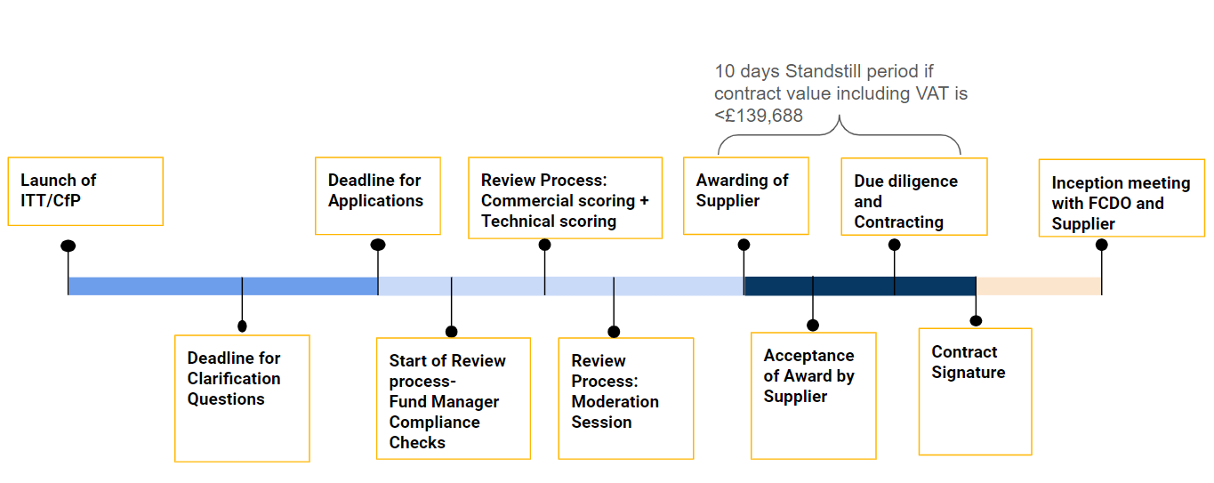

ITT & CfP Packs
Each time an opportunity arises under the Evidence Fund, an ITT/CfP pack is released with the call. ITT/CfP packs are used in the bidding process, providing a structured and comprehensive framework for potential bidders to submit their proposals.

The ITT and CfP packs contain all the necessary information, guidelines, and forms that bidders need to understand the project requirements, prepare their proposals, and submit their bids. This includes details about the project, evaluation criteria, application forms, budgeting tools, and important policies on conflicts of interest and safeguarding.

Figure 2. CfP & ITT Packs
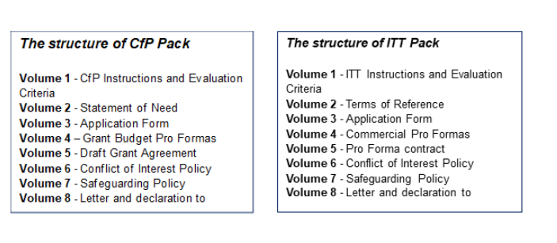

Understanding Volume 1 - Instructions and Evaluation Criteria
6.1 Purpose
Before suppliers draft their proposal, it is crucial to review Volume 1- Instructions and Evaluation of the ITT/CfP pack. This volume provides essential instructions and highlights key documentation required alongside the proposal. Failure to adhere to these instructions may result in the proposal failing to meet eligibility and completeness checks. It’s important to note that the requirements and evaluation criteria will vary with each opportunity, so it’s advisable not to assume that the contents of Volume 1- Instructions and Evaluation are universally applicable to all Evidence Fund opportunities.
Each Invitation to Tender (ITT) or Call for Proposals (CfP) comes with specific evaluation criteria and scoring method. The evaluation committee strictly assesses each submission based on technical and commercial criteria. To increase chances of success, suppliers should carefully study these criteria, address each point in their proposal, and provide solid evidence of understanding. Conducting a self-assessment is recommended to avoid oversights and effectively showcase supplier capabilities. The evaluation criteria are typically divided into 80% for technical aspects and 20% for commercial aspects. By aligning their approach with the specific evaluation criteria in Volume 1- Instructions and Evaluation, suppliers can enhance the competitiveness of their proposal.
6.2 Fund Manager eligibility and completeness checks
As a first step in the selection process, The Fund Manager will conduct eligibility and completeness checks to ensure proposals meet the basic requirements of the call. This step ensures only compliant proposals advance in the evaluation process. Completeness and eligibility checks include verifying that all required documents are attached in the specified format. The Fund Manager reviews all proposals and, if eligibility requirements are met, advances them to the next stage for technical scoring by the FCDO, and commercial scoring by the Fund Manager. Key considerations during completeness and eligibility checks are included in Table 2.

Table 2. Eligibility and completeness checklist
Eligibility and completeness checklist | 
All sections completed in Form A: Organisation and Contact Details
All sections completed in Form B: Grounds for Mandatory Exclusion
All sections completed in Form C: Grounds for Discretionary Rejection
All sections completed in Form D: Duty of Care
All sections completed in Form F: Technical Proposal
Volume 8 Letter and Declaration
Registration certificate
Tax compliance certificate
ITT Covering Letter- follow format shared in Volume 1- Instructions and Evaluation
Organisation brochure/link to website
Completed commercial proposal – has all applicable taxes and rationale

Completeness and Eligibility-common mistakes & how to mitigate them:
- Exceeding the Page Limit: Suppliers should adhere to the specified page limit. Concise language and effective formatting should be used to fit content within the limit. Tools such as Microsoft Word can help keep track of the page count.
- Incorrect Format: Suppliers should ensure the proposal is in the prescribed format. The format requirements in the Volume 1- Instructions and Evaluation in ITT pack should be double-checked before submission.
- Incomplete Submissions: Suppliers should ensure their proposal is complete and includes all required sections. A checklist in table 2 can be used to ensure nothing is missed.
- Missing Volume 8 Letter and Declaration: The Letter and Declaration should always be included in the proposal. This is a mandatory requirement, and its absence can lead to the proposal being deemed incomplete.
- Lack of Necessary Compliance Documents: The proposal should be accompanied by all necessary compliance documents. These should include licenses, certifications, and other legal documents.
- Late Submissions: Suppliers should ensure that they submit the proposal within the stipulated deadline. Even a few minutes late may result in the proposal being considered ineligible.
- Incorrect Email Structure: The submission email should be structured as per the instructions in Volume 1- Instructions and Evaluation. This often includes specific subject lines and body text.
- Non-English Submissions: The proposal should be submitted in English. A proposal that is not in English will automatically be deemed as ineligible.

6.3 Technical Scoring
The technical evaluation focuses on the evaluation team's confidence in the proposal's content and the implementing team's ability to deliver the outputs effectively, with emphasis on the supplier's experience and knowledge.
During technical evaluation a higher degree of confidence is gained where:
- The proposal presents a well-balanced team with the right mix of skills and assured availability for the project duration.
- Collaborations with regionally based researchers, who have existing local networks, are highly encouraged. The proposal must explain the recruitment methodology and how the selection of both regional and international team members ensures value for money.
- A deep understanding of key issues is clearly demonstrated. Merely providing general statements of information and a can-do attitude will not generate high scores.
- A convincing methodology is provided to achieve results, whilst ensuring optimal value for money over the lifetime of the contract. The methodology should include clear links between performance outputs and pricing mechanisms (such as milestones for payment linked to clear deliverables).
- The methodology includes monitoring & performance management tools where appropriate, such as: critical path analysis, risk strategies/mitigation plans, communications plan etc.
- A detailed Work Plan is provided that breaks down activities and outputs, which are clearly cross referenced (where appropriate) to payment mechanisms and governance/quality assurance mechanisms to ensure effective delivery on time and within budget.
- Strong examples demonstrate the proposed methodology has been applied successfully in environments relevant to the ITT.
- Greater effort has been made to provide certainty in the Tender detail so that it can be relied on from a contractual perspective (for example, poor management processes, lack of performance measures and vague terminology represent a potential performance risk).

Example of Technical Evaluation Criteria and Scoring:
Below is an example of Technical Evaluation Criteria. This may differ with each opportunity.

Table 3. Technical Evaluation Criteria
Criteria | Sub-Criteria | Total Score per component
Project Team  (30%) | Team Leader with relevant academic and professional qualification, experience of similar research projects, strong regional network. Strong leadership capability, proven ability to deliver quality projects at pace and leading research teams in conducting quality-assured mixed-method research. | 10
Project Team  (30%) | Composition and strength of project team; including diversity and quality of expertise (academic and professional) and meaningful inclusion of researchers/ research institutions based in the region (i.e., as principal or co-investigators), including access to researchers with local contextual knowledge and experience of using collaborative approaches. | 20
Capacity to Undertake Work (20%) | Organisation / team experience and track record in undertaking similar studies, using collaborative research approaches, and getting research products into use. Demonstrable strong local presence and/or network (this could also include meaningful partnership with a local organisation) and experience/expertise working on similar issues in the region/locally; and demonstrated ability to work at pace and deliver excellent outputs within tight timelines. | 10
Capacity to Undertake Work (20%) | Familiarity with subject matter and context as described in the ToRs. Knowledge and demonstrated experience in rigorous evidence synthesis products and mixed-method research methods and getting research products into use through policy relevant formats and peer reviewed academic papers for publication. | 10
Methodology (30%) | Adherence to ToRs; articulation of methodology; justification of appropriate methods; robustness of approach to sampling (including demonstrated ability to gain the trust and cooperation of targeted study respondents) and data collection; presentation of findings; and clarity of outcomes. | 10
Methodology (30%) | Robustness of proposed research and data analysis methods; approach to assess the strength of the evidence and quality assure outputs | 10
Methodology (30%) | Robustness of proposed work-plan, programme, and risk management (a risk matrix to identify potential risks that may arise throughout the research and how they will be mitigated). | 5
Methodology (30%) | Approach to research uptake and communicating research findings, including strategies for disseminating research findings. This includes stakeholder identification, and identification of clear, practical dissemination options targeting specific stakeholders. | 5
Maximum SCORE |  | 80%

6.4 Commercial Scoring
Bidders should aim to demonstrate within the Commercial Tender that their overall Tender offers the best mix of quality and effectiveness for the least outlay over the period of providing the services required. The Commercial Tender should therefore be clear on whole life costs over the duration of the contract, including (but not limited to) cost elements such as capital, maintenance, management, operating and disposal costs. Where appropriate, the Tender should highlight where it continues to add value beyond the life of the contract.
The Team evaluating the commercial proposal will review overall balance provided by all sections of the Commercial Tender. More confidence will be gained where convincing information is provided.
In particular, the evaluation will lookout for the following:
- Benchmarking and determination of fee rates- Provide details on how the professional fees have been arrived supported by the basis and evidence used in setting (or benchmarking) the fees.
- Risk management- Analysis of financial risk, programmatic and management risks that may affect the research while providing the mitigation measures put in place.
- Value for Money (VfM) - Analyze how VfM will be achieved with reference to the 4E’s- Economy, Efficiency, Equity and Effectiveness. Ensure you explain how each of the 4E’s is likely to be achieved during implementation of the project.
- Notes/Budget narrative. Provide Brief explanations of the budget lines. This enables better understanding of budget costs.
- Include proof of exchange rates if applicable.
- Provide a Financial Breakdown by milestone of professional fees charged in the template provided.
Commercial Evaluation and Scoring
Criteria | Score
Compliance to format requirements: Providing information as required by Instructions to Suppliers clause (3E); Using the prescribed commercial template | 5
Value for Money: Analysis of how VfM will be achieved with reference to the 4E’s- Economy, Efficiency, Effectiveness and Equity over the lifetime of the programme (3 marks)  Risk Management: Analysis of financial risk and mitigation measures to be undertaken (2 marks) | 5
Benchmarking of professional fees: Competitiveness of consultant rates and demonstration of Benchmarking of the rate; Competitiveness of reimbursable expenditure | 5
Competitiveness of cost of commercial proposal | 5
Total Score | 20%

  - Understanding Volume 2- Terms of Reference
7.1 Purpose
The Terms of Reference (ToR) outlined in Volume 2 should be thoroughly reviewed by suppliers as an essential initial step in crafting their proposal. This section of the guide will enable suppliers to leverage the ToR effectively to shape the content in their technical and commercial proposals. The ToR offers insights into various areas of the research project, including its background, scope, objectives, methodology, and key research questions. By comprehending and addressing each of these elements in their proposal, suppliers can ensure their approach aligns with the project’s requirements, thereby enhancing their chances of a successful bid. It’s important for suppliers to note that while this section emphasises the ToR, these tips can also be applied to the Call for Proposals (CfP) version, sometimes referred to as the Statement of Need (Volume 2 of CfP).

7.2 Outlined below are typical sections included in a ToR or Statement of Need:
- Background: Suppliers should use the context of the research, including key details related to the study, to align their proposal with the project’s context. Understanding the context helps suppliers to develop a realistic and feasible proposal, that anticipates potential challenges and outlines strategies to overcome them, ensuring that the proposed methods and timelines are practical and achievable. When a proposal clearly reflects an understanding of the project's context, it builds confidence in the supplier's ability to deliver high-quality work. It shows that the supplier has done their homework and is serious about addressing the specific requirements of the project.

- Project Scope / Objectives of the study: Demonstrating a clear understanding of the project scope and objectives can give the supplier a competitive edge. It shows that the supplier has carefully considered the FCDO’s needs and is prepared to deliver a proposal that is both relevant and targeted. Understanding the scope helps the supplier propose sufficient resource allocation, budget, and personnel. Any limitations or sensitivities should also be considered in the proposal.

- Methodology/Expected Approach: By determining the type of research/evaluation study required and the anticipated methodologies, suppliers can propose a detailed methodology that addresses the project’s unique challenges and opportunities. Demonstrating an understanding of the specific standards or best practices that need to be followed will result in a stronger proposal.

- Research/evaluation questions: Suppliers should familiarise themselves with the key research/evaluation questions and tailor their proposal accordingly. Understanding the evaluation questions helps the supplier design a methodology that is tailored to answer those specific questions. These questions are sometimes refined during the inception phase with the successful supplier.

- Recipient: Suppliers should consider the recipients of the study and tailor their methodology, data collection, and analysis to address their specific questions and concerns. Demonstrating an understanding of the recipients' needs and context can build credibility and trust with the selection panel.

- Uptake and Dissemination: Suppliers should understand any plans for uptake and dissemination, including their role in uptake and dissemination processes. Proposals with a well-considered uptake and dissemination plan will be scored more favourably.

- Time frame, deliverables, and budget (upper limit): This section in the ToR/ Statement of Need, provides clarity about the time frame, deliverables, and budget for the study. This can help suppliers plan their resources effectively. Costs related to workshops and travel should be explicitly built into the budget (Volume 4-Commercial proposal/Grant budget pro formas).

- Skill Requirements / expertise needed: The experience of the project team is typically given significant consideration during the technical scoring of the bid. Awareness of the specialist knowledge and skills required to complete the scope of the research can help suppliers assemble a team that meets these requirements.

- Bidding process: Technical and financial proposals should be sent as two separate files. They should not be combined into one file. Familiarity with the instructions (Volume 1-Instructions and Evaluation Criteria) for submitting the tender and details on scoring methodology and evaluation criteria can help suppliers submit a compliant and competitive bid.

- Ethical principles and standards: It is advised that suppliers thoroughly review the ethical guidelines. It is crucial to include a statement in their proposals, affirming that the study will adhere to these guidelines. By understanding FCDO ethical standards, the supplier can ensure that the research is conducted ethically, addressing any potential impacts on participants, and ensuring their interests are protected.

- Duty of care: Suppliers should be aware that they are responsible for the safety and well-being of their personnel and relevant third parties affected by their activities under this assignment. This should be planned accordingly.

- General Data Protection Regulation (GDPR): Suppliers should be aware of the details of the GDPR relationship status and personal data for this project

- Safeguarding: Suppliers should be aware of the importance FCDO places on all potential partners’ ability to safeguard children, young people, and vulnerable adults they work with from sexual exploitation and abuse, and their ability to protect staff and volunteers.

- Research for Development outputs (R4D): Suppliers should be aware that FCDO requires that all final research output(s) from this funding are uploaded to Research for Development Outputs (R4D) on GOV.UK.
While points 11 to 14 do not directly affect the writing of the technical proposal, suppliers need to be aware of these points and strongly consider them when preparing to bid for an opportunity under The Evidence Fund.

Understanding Volume 3 - Application form
8.1 Purpose
The application form can be found in Volume 3 of the ITT/CfP pack. This form is designed to gather comprehensive information about suppliers. It is imperative for suppliers to meticulously fill out all sections of the form. Any sections left blank will result in the disqualification of the proposal. Volume 3 also provides instructions for submitting supplementary documents with the proposal. These additional documents are integral to the application process and should be provided as per the guidelines outlined in Volume 3. Please ensure all required documents are included to avoid complications in evaluating your proposal. Volume 3 includes form A to E with the last section referring to the technical proposal template.

  - Suppliers should consider the following tips when writing their technical proposal:

      - Clear, easy-to-navigate proposal:
  - Start with a clear, well-organized structure.
  - Use headings, subheadings, and bullet points to enhance readability.
  - Include a table of contents and clear signposting to help evaluators quickly find relevant sections.

      - Respond to requirements first:
  - Address the FCDO’s requirements directly and succinctly at the beginning of each section.
  - Clearly demonstrate understanding of the requirements before diving into the details.

      - Detail how requirements will be met:
  - After addressing the requirements, provide detailed explanations of how they will be met.
  - Use specific examples and methodologies to illustrate the approach.

      - Explain added value:
  - Clearly articulate how added value beyond the basic requirements.
  - Highlight innovative approaches, cost-effectiveness, or unique benefits the proposal offers.

    - Demonstrate relevant experience:
  - Include case studies showcasing relevant experience and expertise.
  - Select case studies that align closely with the research topic and methodologies required.

    - Include stakeholder engagement:
  - Outline a strategy for engaging key stakeholders throughout the research process.

    - Clear delivery plan:
  - Provide a comprehensive plan outlining how the research will be delivered.
  - Include timelines, milestones, resource allocation, and risk management strategies.

- Professional Presentation:
  - Ensure the proposal is professionally presented, free of errors, and visually appealing.
  - Use charts, graphs, and visuals where appropriate to convey complex information clearly.

- Demonstrate Value for Money:
- Articulate how the proposal offers the best quality and effectiveness for the least cost over the service period.

- Show Flexibility:
- Demonstrate ability to adapt to changes and unexpected situations.

Technical Proposal -common mistakes & how to mitigate them:
- Demonstrating a lack of understanding: Suppliers should thoroughly read and understand the Volume 2, Terms of Reference. If there are any ambiguities, suppliers should seek clarification from the Fund Manager. Suppliers should remember that they have an opportunity to ask clarifying questions before submitting a proposal.
- Failure to address all the evaluation criteria: Proposals must be tailored to meet each criterion in turn, linking skills and experience to the specific requirements. do not recommend re-purposing proposals from other bid submissions.
- Insufficient evidence: Suppliers should provide concrete evidence such as case studies or references to similar projects to demonstrate technical capabilities and past success. This can helps build trust and increase confidence during the technical evaluation process.
- Inadequate research design: Suppliers should propose a research design that adequately addresses the requirements outlined in Volume 2 ToR. The research approach must be comprehensive. Suppliers may wish to consider having their proposal quality assured by a third party prior to submission.
- Lack of clarity: Suppliers’ proposals should be clear, concise, and well-structured and avoid the unnecessary use of complex language.
- Ignoring evaluation weightage: Suppliers should consider the weightage assigned to various technical evaluation criteria. Suppliers should prioritize the most critical aspects in your response. This can help the supplier’s proposal score higher in the evaluation process.
- Failure to demonstrate innovation: Suppliers should showcase your innovative ideas or approaches. This can make suppliers proposal stand out from competitors.

- Understanding Volume 4 - Commercial/Grant Budget Pro Form
9.1 Purpose
All commercial proposals must be submitted using the provided budget template - Volume 4 - Commercial /Grant Budget Pro Forma. The commercial pro forma must include a cost breakdown for each individual research output (i.e., output 1. inception report, output 2. draft report, output 3. final report, output 4. workshop). The commercial pro-forma template includes a worksheet for each output and a summary worksheet that consolidates all output costs.
The Commercial pro forma should detail the total life costs of the project, including both fees and expenses.
Suppliers are advised to refer to Section 6 of this guide for a comprehensive understanding of how the Fund Manager evaluates commercial proposals.
Suppliers are advised to refer to Section 6 of this guide for a comprehensive understanding of how the Fund Manager evaluates commercial proposals.
9.2 How to complete the Volume 4 commercial grant budget pro forma:
Each output worksheet corresponds to a specific deliverable or output of the project. The following instructions apply to all output worksheets from "Output 1" to "Output 10". Please note, you only need to complete worksheets for the total number of outputs, typically between 4 - 6, according to the Terms of Reference (ToRs):
      - Start by completing the outputs worksheets.
Align the output name with the deliverables/outputs stated in the Terms of Reference (ToR) or Statement of Need (Volume 2). You may suggest additional outputs as long as the overall budget does not exceed that as stipulated in the ToR.
      - Populate Fees and Expense
For each output worksheet you must input both Fees and Expenses.
Fees Section:
- Column A: Enter the names of team members.
- Column B: Enter team member job titles on the project.
- Column C: Provide the daily rate/cost for each team member on the project.
- Column D: Indicate the number of days allocated to each team member for work under the specified output.
- Column E: This will auto-populate with the Cost, calculated as Rate (from Column C) multiplied by Days (from Column D).
- Column F: Enter any applicable taxes, excluding UK VAT, as The Evidence Fund contracts don’t include UK VAT. Please indicate if any local taxes specific to the regions where your business operates has been included in this section as well.
Expenses Section:
- Column A: Provide details of the expense.
- Column B: Specify the type of expense (e.g., Travel Cost for a flight to a workshop).
- Column C: Provide the cost of the expense expressed in a single unit.
- Column D: Indicate the volume, referring to the units per item related to the expenses.
- Column E: This will auto-populate with the Cost, calculated as the cost in Column C multiplied by the Volume in Column D.
- Column F: Enter any applicable taxes, excluding UK VAT. The Evidence Fund contracts do not include UK VAT, but suppliers can include UK VAT in their invoices.
- Column H (Additional Commentary): Use this section to indicate what type of tax has been included and any additional details relevant to the expense. Please indicate if any local taxes specific to the regions where your business operates has been included in this section as well.
Column G (Total Cost) has been formulated and will auto-populate.
      - Summary Section
The Summary worksheet consolidates all costs from the individual output worksheets. This section is mostly automated:
- Automatic Population: The total costs from each output worksheet (fees, expenses, and applicable taxes) will auto-populate in the Summary worksheet.
- Review: Ensure that the totals accurately reflect the inputted data from all output worksheets. Double-check for any discrepancies or errors.
- Downstream partner/ Subcontractor: The supplier should manually provide a detailed breakdown of the total cost or budget, highlighting the specific amount that will be paid to subcontractors. This is only applicable in cases where there are downstream partners/ subcontractors.

Commercial Proposal – common mistakes & how to mitigate them:
- Not Using the Provided Templates: Suppliers must submit the budget using the commercial pro forma or grant budget pro forma templates provided in Volume 4. These templates are designed to standardise submissions and make it easier for reviewers to assess suppliers’ commercial proposal.
- Incomplete Costing of ITT Outputs/Deliverables: It’s crucial to account for all outputs or deliverables included in Volume 2, Terms of Reference.
- Inclusion of Taxes Without Justification: If commercial proposals include UK or local taxes in the budget, a clear written justification must be provided. Without this, the inclusion of these costs may be seen as unnecessary or inappropriate.
- Misclassification of Costs: Suppliers should not record fees or management costs as expenses. These are separate categories and misclassification can distort the true cost structure of the proposal.
- Incorrect Sum Totals: Suppliers should always double-check calculations. Incorrect sum totals can result from simple calculation errors and can affect the perceived accuracy and reliability of the commercial proposal.

9.3 Figure 3-5 shows some the of common mistakes presented in commercial proposal:
Please note that this is an extract from the commercial proposal and doesn’t constitute the full proposal.
Figure 3. Fees Section of Commercial Proposal- Incorrectly Completed
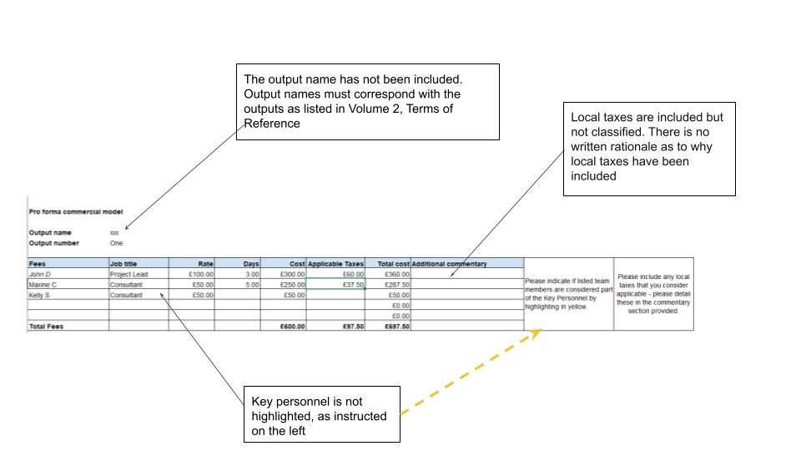

Figure 4. Expense Section of Commercial Proposal- Incorrectly Completed
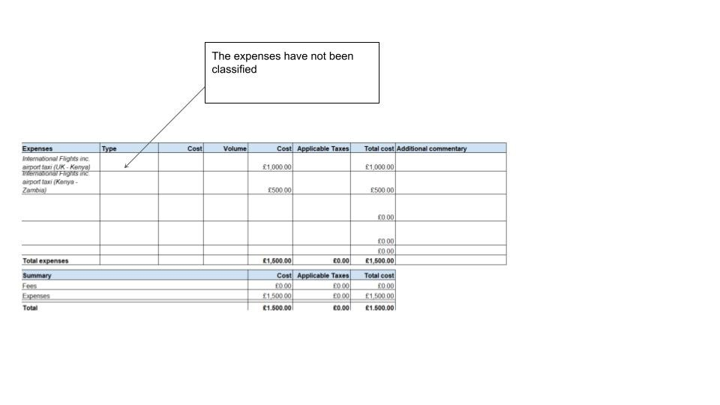

Figure 5. Summary Table Section of Commercial Proposal -Incorrectly Completed
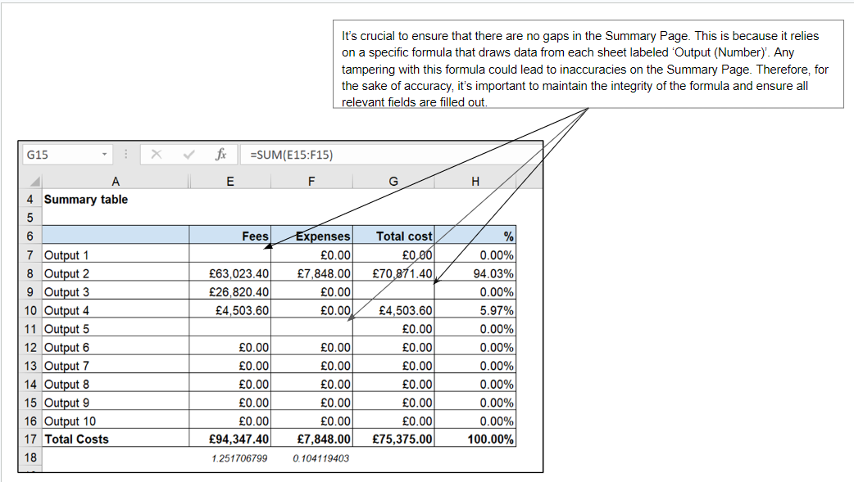

9.2 Figure 6-7 are examples of a commercial proposal completed correctly:
Figure 6. Summary Table Section of Commercial Proposal -Correctly Completed
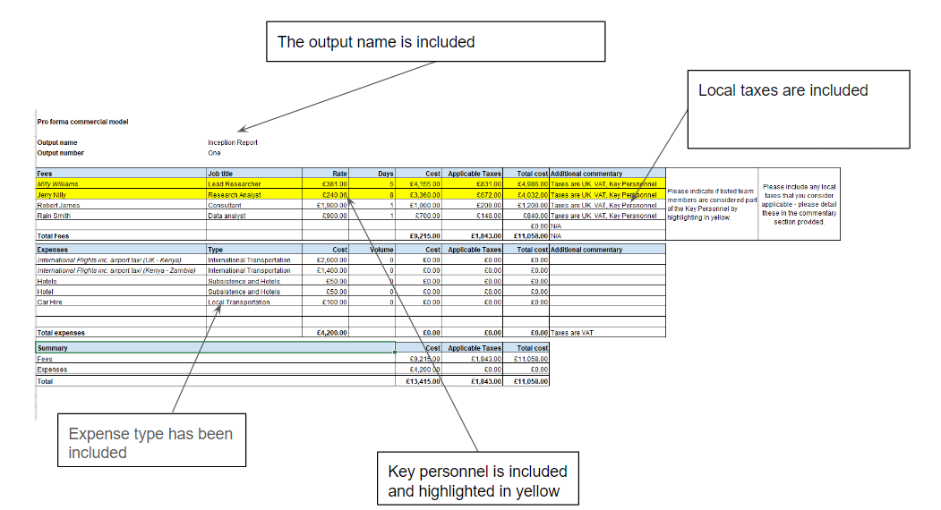
Figure 7. Summary Table Section of Commercial Proposal -Correctly Completed
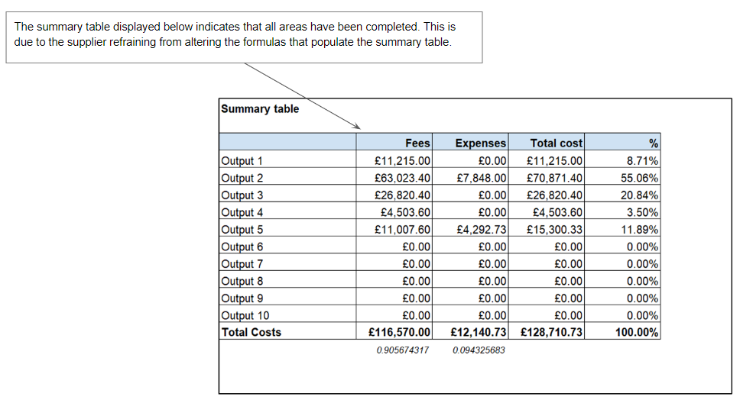
  - Understanding Volume 5 - Draft Contract/Grant Agreement
This volume presents a draft of the contract/grant agreement, which outlines the terms and conditions governing the grant. It is crucial for potential suppliers to understand their obligations, rights, and responsibilities under this agreement. This draft includes standard FCDO clauses that are non-negotiable. Suppliers are strongly advised to review the agreement thoroughly before applying to the Evidence Fund to ensure they are satisfied with and can comply with the conditions. Additionally, this document will help ascertain whether this type of agreement is feasible within your local jurisdiction and suitable for your type of organisation. Please note, the agreement is governed by United Kingdom Law. The Evidence Fund is demand-responsive, and timely production of research is essential, therefore rapid mobilisation is required, and there will be no allowance for protracted contracting timelines once a supplier has been chosen.
  - Understanding Volume 6 - Conflict of Interest Policy
This policy is designed to help suppliers identify, disclose, and manage any potential conflicts of interest. By understanding and adhering to this policy, suppliers can ensure the integrity and fairness of the procurement process, thereby protecting the reputation of both the supplier and The Evidence Fund.
  - Understanding Volume 7 - Safeguarding Policy
This policy details the measures in place to protect individuals, especially children and vulnerable adults, from harm. Suppliers should familiarise themselves with this policy to ensure they meet the Evidence Fund’s expectations regarding the safety and well-being of all individuals involved in activities funded by the grant.
  - Frequently Asked Questions
Below is a list of frequently asked questions. If a supplier has any additional queries regarding the Evidence Fund procurement process, please note that each bidding window includes a few weeks during which a supplier may submit clarifying.
questions. You can also send general enquires to uk_evidence_fund_administration@pwc.com. If you would like to be added to our supplier database for future Evidence Fund opportunities, please email uk_evidence_fund_administration@pwc.com.
Table 5. FAQ - General
 | FAQ | Answer
1 | Can individuals bid for this opportunity? | Opportunities under the Evidence fund are open to the entities that are registered under their regional authorities.
2 | Is there any page limitation for the detailed CV of our team members? | Typically, there is no page limitation for the detailed CVs that can be appended under Form E of ITT Volume 3. However, this may vary so please check the requirements outlined in Volume 1 and 2 of the ITT/CfP pack.
3 | How many years of experience do you prefer for each expert for this project? | Please refer to the requirements as provided under the relevant sections in the ITT pack Volumes 1 and 2.
4 | In Form A of the application, details of the lead organisation are required. Is it necessary to list a subcontractor in the same section (1a) of the application form, or is there a separate form where the subcontractor can be listed? | Volume 3 explains which organisations need to complete Forms A, B and C. Form F only needs to be completed by the Lead Organisation.
5 | Is there a particular fee structure you expect bidders to use? | There are no specific guidelines or limitations on how fees are allocated.
6 | Can a newly incorporated organisation apply for this opportunity? | Yes, newly incorporated organisations can apply, unless stated otherwise in Volume 2.
7 | Do we need prior experience where our organisation has been awarded work from an international donor? | Prior experience with the research subject matter and the specific geographical context is preferred. This expertise enhances the proposal's credibility and demonstrates the supplier's capability to effectively address the project's unique challenges and opportunities.
8 | Are the opportunity value/fees fixed or capped? | The opportunity/contract/ grant value is capped to the maximum stated in the Volume 2-Terms of Reference/Statement of Need.
9 | We would like it clarified who the point of contact is for sending the invoice. Is it PwC or FCDO? | Invoices must be submitted to PwC, subject to the formal approval of deliverables by FCDO.
10 | Any formatting specifics, if any such as font type and size, whether text should be justified or otherwise and any other formatting styles that apply to proposals submitted to FCDO. | The proposal must be submitted electronically. This should be submitted in PDF format in  two Electronic Files by e-mail (one containing the Technical Tender and one containing the  Commercial Tender (the Electronic File must not exceed 10MB in size)
11 | Is there any preference by FCDO that a UK company be involved? | No. What matters most is the quality of the proposal and suitability of the team. Proposals from local suppliers are encouraged.
12 | Kindly confirm if the six-page limit for the Technical Proposal includes or excludes the long form CVs | Typically, the technical proposal has a limit of six pages excluding long CVs, but always refer to requirements set out in Volume 1 and Volume 2.
13 | What is meant by “governance structure” on page 9 of Volume 3 - application form? | Governance structure refers to the framework that defines decision-making roles and responsibilities. It steers project execution, facilitates issue resolution, and ensures alignment with the organizational strategy for successful delivery. Furthermore, it defines the decision-makers and the communication process for those decisions.
14 | Why is there a breakpoint included in the contract after the initial phase?? | Break points at the end of inception are standard practice for FCDO to safeguard against performance issues or contextual changes, amongst other factors.
15 | What are the procurement rules for purchasing equipment under an accountable grant? | Please see FCDO guidelines on grant expenditure:  https://assets.publishing.service.gov.uk/media/613225c6d3bf7f05b166a4df/Programme_Expenditure_Eligible_Cost_Guidance_for_August_2021.pdf

Table 6. FAQ – Handling of Confidential Information
 | FAQ | Answer
1 | Who manages the Evidence Fund? | In 2023, the Foreign Commonwealth and Development Office (FCDO) appointed PwC and Integrity Global Ltd as Fund Managers to oversee and manage the Evidence Fund.
2 | What are the primary responsibilities of the Fund Manager? | The Fund Manager is responsible for managing procurement competitions for research and evaluation projects, conducting due diligence assessments on prospective sub-contracted Research Pool providers, and managing research and evaluation contracting.
3 | How does the Fund Manager handle applications and proposals? | The Fund Manager processes applications to the fund and conducts commercial evaluations of all proposals. The Fund Manager does not handle the technical evaluation of proposals.
4 | How is commercial sensitivity maintained? | The Fund Manager implements a strict ethical wall. The Evidence Fund inbox is restricted to personnel specifically assigned to the Evidence Fund, preventing other PwC and Integrity employees from accessing commercially sensitive information. Both technical and commercial proposals are stored on a dedicated FCDO SharePoint with access limited to those working on the Evidence Fund.
5 | Can PwC and Integrity Global bid for Evidence Fund opportunities? | No, as Fund Managers, PwC and Integrity Global are conflicted out of bidding for Evidence Fund opportunities.
6 | Who owns the intellectual property of research outputs? | Research providers own the intellectual property of their research outputs. PwC needs to be granted a licence only as necessary to fulfill its obligations under the FCDO head contract, as research providers do not have any direct contractual agreement with the FCDO
7 | Who can access the Evidence Fund inbox? | Access to the Evidence Fund inbox is strictly controlled and can only be granted by the Evidence Fund Director of Operations and Research. It is limited to named fund management personnel from PwC network firms (PwC UK, PwC Kenya, PwC India) and Integrity Global Ltd.
8 | Where are research provider proposals stored? | Proposals are stored on a designated SharePoint managed by the FCDO, with access restricted to named personnel from the fund management team. Access to this SharePoint expires after one year, and individuals who have rolled off the Evidence Fund lose access.
9 | Are proposals downloaded or stored offline by the Fund Manager? | No, commercial and technical proposals submitted by research providers are not downloaded or stored offline by the Fund Manager.
10 | Who can access commercial and technical proposals? | Proposals are shared with FCDO personnel only when necessary, including programme managers for relevant FCDO regional research hubs and designated FCDO evaluation panels for each Invitation to Tender or Call for Proposals. Commercial information is solely used for evaluating commercial competitiveness and is not shared outside The Evidence Fund.
 | Where are approved deliverables/research outputs stored? | All approved deliverables/research outputs are uploaded to the FCDO Evidence Fund SharePoint, with access limited to named personnel from the fund management team.
11 | How long are proposals retained? | All commercial and technical proposals are retained on the Evidence Fund SharePoint, managed by FCDO in compliance with FCDO data retention policies. When the Fund Manager's contract with the FCDO terminates, their access to research provider information will expire.

The team at The Evidence Fund extends their best wishes to all suppliers as they prepare their proposals!

