Statement to Parliament regarding the UK Ratification of Agreement between the Government of the United Kingdom of Great Britain and Northern Ireland and the Government of the French Republic on the prevention of dangerous journeys done at London on 29 July 2025 and at Paris on 30 July 2025
Presented to Parliament as an un-numbered Act Paper pursuant to Section 22(3)(c) of the Constitutional Reform and Governance Act 2010
Statement to Parliament regarding the UK Ratification of Agreement between the Government of the United Kingdom of Great Britain and Northern Ireland and the Government of the French Republic on the prevention of dangerous journeys (the “Hillmore Treaty”)
On 10 July 2025, the Prime Minister and the President of the French Republic reached a ground-breaking agreement, to be formalised in the Hillmore Treaty, on the prevention of dangerous journeys. This included a trial pilot to deter illegal journeys across Europe to the UK and dangerous small boat crossings. The Prime Minister and President Macron stressed the urgency of implementing the treaty - an innovative approach to reduce the risk to life at sea and to break the business model of organised criminal gangs.
As the Home Secretary explained in her statement of 14 July, securing UK borders is a fundamental part of the Government’s plan for change.
This Government is committed to both the principle and practice of parliamentary scrutiny of the UK’s treaties. However, the Home Secretary sought the advice of FCDO Ministers on the use of Section 22(1) of the Constitutional Reform and Governance Act 2010 (CRaG) which in exceptional cases allows that a treaty should be ratified without the requirements of Section 20 having been met. The Home Secretary strongly believed this course of action was necessary in light of the exceptional circumstances posed by dangerous Channel crossings and the imperative to act quickly. If we were to wait until Parliament had returned, and then fulfil the 21 sitting day scrutiny period, we would not be able to ratify and implement the Treaty until the end of October at the earliest. She anticipated that the high number of small boat crossings would continue, with an unacceptable risk to human life, and we would miss the opportunity to deter these dangerous crossings during this period.
I agreed with the Home Secretary that the circumstances were exceptional and therefore determined under Section 22(1) that the Treaty should be ratified without the requirements of Section 20 having been met.
In accordance with Section 22(3) of the Constitutional Reform and Governance Act 2010 this statement is being laid at the earliest opportunity. I further note that, despite Parliament being in Recess, the Government has sought to inform Parliamentarians of the actions it was taking to implement the Hillmore Treaty, including through the correspondence issued by the Home Secretary.
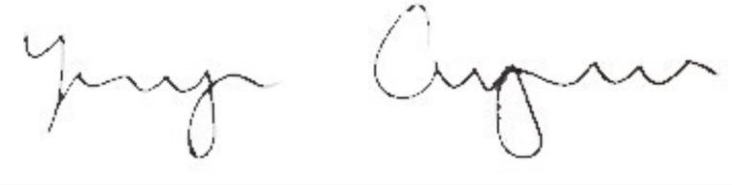
MINISTER OF STATE FOR INTERNATIONAL DEVELOPMENT, LATIN AMERICA AND THE CARIBBEAN
DATE: 5 August 2025

