

Skynet Integrated Enterprise Solution Evaluation Plan

Evaluation Task Force

August 2025


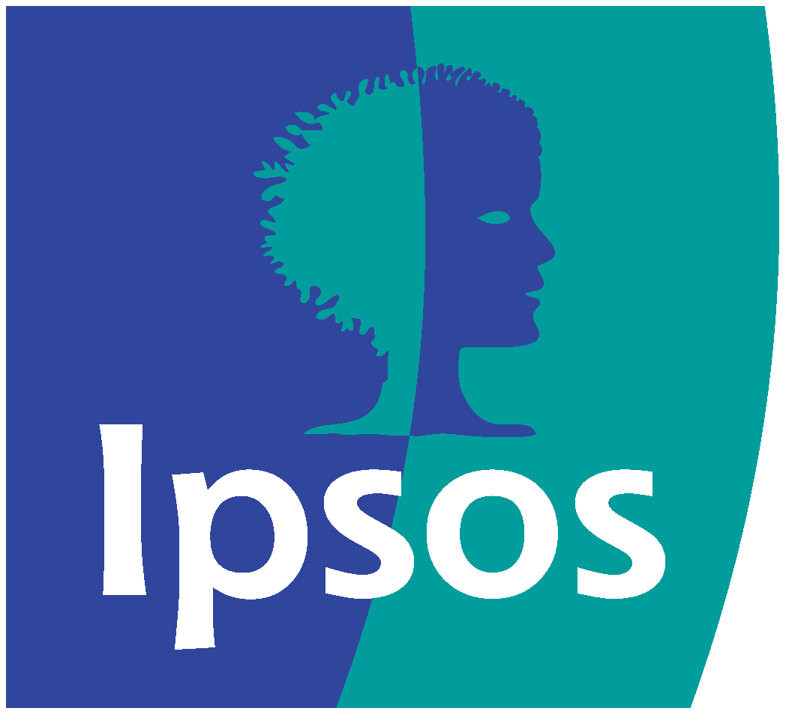

Contents
Key terms 3
Introduction 4
Background 4
Aims and objectives 4
Methodological approach 4
Structure of the report 5
Intended application of the evaluation plan 6
Scope 6
Target audience of the evaluation plan 6
Section 1 Theory of Change 7
About the Theory of Change 7
Rationale 7
Assumptions 11
Key risks 12
SKIES evaluation questions 14
Section 2 Process evaluation options 18
Process evaluation framework 18
Proposed data sources 26
Analysis of data 30
Section 3 Impact evaluation options 31
Impact evaluation framework 31
Proposed data sources 35
Section 4 Economic Evaluation 36
Data requirements 36
4E’s analytical approach 37
Section 5 Recommended evaluation approach 39
Recommended approach 39
Analytical approaches 39
Section 6 Benefits management 42
Section 7 Implementation and Management 46
Approach towards project management of the evaluation 46
Project management of the evaluation and budget 49

Key terms
Term | Definition
Monitoring | Monitoring is the systematic collection of information and data from projects and programmes. This information can then be analysed and used to manage performance. Monitoring can provide data from the outset of a project or programme, to help shape implementation in advance of an evaluation.  There can be a strong alignment with benefits realisation and management approaches.
Process evaluation | Process evaluation is the systematic assessment of the design and implementation of an intervention. This builds on-going monitoring to understand in detail how efficiently and effectively programmes have been implemented and how delivery arrangements might be improved.
Outcome / impact evaluation | Outcome / impact evaluation focuses on establishing how far programmes have produced their intended results, and the extent to which these results can be attributed directly to the activities funded.
Theory of Change | A Theory of Change is a description of how a programme is expected to deliver its intended outputs, outcomes and impacts. It also identifies the key risks and assumptions, and dependencies of these outcomes and impacts being achieved.
Evaluation questions | High-level inquiries that guide the evaluation, determining what information needs to be collected and analysed to understand the effectiveness, impact, and value of a programme or intervention.

Introduction

Background
The Evaluation Task Force (ETF) has commissioned Ipsos UK in partnership with Rand Europe to develop an evaluation plan for a Government Major Projects Portfolio (GMPP) intervention to form the basis for robust evaluations for the government’s largest and most complex projects. This work will generate examples of best practice, and selected programmes will act as demonstrator sites for the wider portfolio.
The Skynet Integrated Enterprise Solution (SKIES) programme has been selected as one of the ETF demonstrator projects. SKYNET is the overall capability, including auxiliary systems such as ground infrastructure and terminals for a family of military communications satellites, currently operated for the Ministry of Defence (MoD), that provides strategic communication services to the UK Armed Forces and its allies. The SKIES Project will develop and implement the future commercial/delivery model for the SKYNET programme, whilst exploring the implementation of a new operating model to enable more collaborative working between industry and the MoD.
The SKIES Project is currently in Assessment Phase 1, which culminates in the delivery of an Outline Business Case. During Assessment Phase 1, delivery options are being developed and compared, and a recommended option will be selected. Following this, the competition phase will be designed. The SKIES Project will then move into Assessment Phase 2, culminating in the delivery of the Full Business Case and a contract award. Once this is complete, the team will then move into operational capability phases. The initial operating capability phase will be a transitional phase where integration, co-ordination and implementation are transferred to the responsibility of the SKIES arrangement. At the end of this transition, the Skynet Service Delivery Wrap (SDW) contract will end, and the SKIES project will move into its final phase – full operational capability. See Figure 1 for an overview of the programme phasing.

Aims and objectives
The key objectives of this work are to:
- develop a high-quality, proportionate evaluation plan designed for the SKIES Project
- determine the feasibility of a range of evaluation approaches for the SKIES Project
- generate examples of best practice in designing evaluations for complex major projects, including by producing accessible summaries of each evaluation plan and the challenges they seek to overcome

Methodological approach
This evaluation plan is based on the following research activity:
- a review of SKIES documentation, including documentation about the SKIES Project, benefits maps, and benefit assessment reports
- a participatory workshop with key SKIES stakeholders to develop the Theory of Change
- a series of consultations with stakeholders involved in the SKIES Project to refine evaluation questions

Figure 1: SKIES Project phasing

Assessment Phase 1

Recommended option selected.
Competition phase designed.
Outline Business Case delivered.

Assessment Phase 2

Competition completed.
MOD organisation adjusted and right sized in time for initial operating capability.
Approval for Contract Award
Full Business Case delivered and contract award.
Initial Operating Capability

Integration co-ordination and implementation transferred to responsibility of SKIES arrangement.
Preparation for superseding the SDW contract.
Transition complete and Skynet Service Delivery Wrap (SDW) contract ends
Full Operational Capability

The SKIES Operating Model is the ‘only game in town’.
The SKIES Operating Model = SKYNET

Structure of the report
The remaining sections of this report are structured in the following way:
- A presentation of the Theory of Change for the SKIES Project.
- A description of the process evaluation framework.
- A description of the impact evaluation framework.
- Timings and steps required to implement an evaluation of the SKIES Project.

Intended application of the evaluation plan
An evaluation plan serves as a strategic roadmap for assessing the implementation and effectiveness of a programme, project, or intervention. It outlines the steps, methods, and timelines for conducting a comprehensive evaluation, ensuring that the process is systematic, objective, and ultimately leads to valuable insights and informed decision-making.
This evaluation plan will provide a clear framework to detail how the SKIES Project can be evaluated, outlining the process and impact evaluation questions, data collection methods and analysis techniques. By providing a methodology and data analysis techniques upfront, the plan will provide guidance on how to conduct a robust evaluation, minimising any possible bias and enhancing the credibility of the findings of the evaluation.
This plan will also help serve as a communication tool, outlining timelines for all stakeholders involved in the evaluation process. This will help ensure that all the information required is available to enable informed decisions to be made. Finally, the plan and subsequent evaluation will help to demonstrate a commitment to accountability and transparency, which will help showcase the programme’s effectiveness and responsible use of resources.
In essence, an evaluation plan is a critical tool for ensuring that an evaluation is well-designed, effectively implemented, and ultimately contributes to programme improvement and positive change.

Scope
The evaluation plan has been designed around the phasing of the SKIES Project. This will allow the learning from the evaluation to inform refinements and improvements to the programme ahead of the operating phases.
The evaluation plan is primarily focused on the process evaluation which sits across Assessment Phase 1 and 2, as well as an outcome and impact evaluation which is designed to take place during the operational phases. Timelines and considerations for the evaluation, as well as how this aligns with SKIES phasing is discussed in further detail in chapter 7.

Target audience of the evaluation plan
The primary audience for this evaluation plan is the SKIES Project team. However, the impact of this evaluation extends beyond the SKIES Project. As an Evaluation Task Force (ETF) demonstrator project within the Government Major Project Portfolio (GMPP), the approach and findings will serve as a valuable learning resource for other major projects. By showcasing the development and implementation of a robust evaluation plan, this project aims to guide and inspire other GMPP initiatives in incorporating effective evaluation practices.

Section 1 Theory of Change
This section presents the Theory of Change (ToC) for the SKIES Project. It sets out the key objectives and challenges that the programme aims to address, the long-term impacts that the programme aims to achieve, and the inputs and activities required to achieve the impacts and outcomes. It also presents the key underpinning assumptions for the ToC.

About the Theory of Change
The ToC informs the design of the evaluation and acts as the foundation against which the evaluation framework is designed. The process of developing a ToC brings stakeholders together to develop a shared vision and common understanding of the problem a programme aims to address, the changes it is intended to bring about, and through which activities the changes are meant to be achieved. Furthermore, it seeks to identify the causal links that are expected to bring about the desired change. This includes defining the main actors providing the inputs or delivering activities as part of the programme, and which outcomes need to be achieved in the short term so that longer term outcomes can be realised.
The ToC also identifies the expected conditions required for the intervention to succeed, which make up a set of assumptions upon which it is based. The evaluation will test these assumptions by gathering evidence which supports or challenges these expected causal links. If evidence challenges the logic of a causal chain, the evaluation will examine whether this could be due to assumptions not holding, as well as other potential explanations such as poor implementation or the influence of external factors. Finally, a ToC helps situate an intervention within its wider context and should consider how external influences may affect how the programme is delivered and to what effect.

Rationale
The rationale of the SKIES Project is to develop, assess and ultimately implement new delivery models for the SKYNET programme, which provides space-based communication services to the UK Armed Forces and its allies. The SKIES Project aims to address the significant challenges faced by the SKYNET programme by establishing a collaborative model with industry and implementing more efficient ways of working.
This new operating model intends to facilitate more effective decision-making in areas such as the route to market, programme and system integration, and the optimised use of limited resources. It will also aim to exploit future technologies and innovations. The SKIES Project is designed to align with broader UK Government and defence policies and strategies. Through this programme, the MoD plans to manage the delivery of the SKYNET capability with industry into the medium and long-term future. The implementation will be incremental and evolutionary, with a focus on continuous improvement.

Inputs
There are three types of inputs into the SKIES Project – financial inputs (money spent on preparing for and delivering the programme), human capital inputs – namely the skills, knowledge and expertise of staff involved in the development and delivery of the programme and more widely – and infrastructure. See Table 2.2.1 for more detail on each input.
Table 2: Inputs and their definitions
Input | Definition
Financial | The total financial input over the course of the programme.
Human capital | The skills, knowledge and expertise of staff involved in the development and delivery of the programme.  There are a variety of skills (SATCOM skills and skills for SATCOM) residing both within the MoD and within industry as well as knowledge inputs which are crucial to the delivery of SKIES.
Organisational model | This defines and guides how the organisation structures their operations and aims to achieve strategic goals.
Business case | The business case will outline the strategic fit, commercial viability and define how the programme will be delivered.
Technology | Technology such as suitable IT systems and databases are required to deliver the programme.
Case for change | The case for change outlines why the programme is needed and what needs to change.
Prior learning and case studies | Knowledge from similar programmes to guide how the programme is delivered and inform best practice to help develop the SKIES delivery model options and learn lessons from best practice across other areas of Defence and Space programmes.
Market intelligence | This involves understanding the existing markets, available services and future trends.
Governance | Programme governance is required to ensure the programme is delivered as intended and any risks are effectively managed.
Sponsorship | Buy-in from Space Command, Strategic Command and Defence Digital.
User need | A comprehensive understanding of what the user requires and needs from the programme.
Threat Landscape | This involves understanding the threat vectors from adversaries, which are continually changing and evolving.

Activities
There are multiple activities which need to take place as part of the SKIES Project. These activities have been split into three categories: contract, operational model and procurement activities.
Contract activities include:
- considering risk/reward share as part of the incentives model
- creating incentivisation of the right outcomes and behaviours
- defining Enterprise performance metrics as part of incentives model, which will define and attach incentives to desired enterprise performance thresholds
- developing a Behavioural Charter in order to create a charter defining the desired behaviours and culture of the MoD and its partner(s) under the SKIES operational model
- developing a process for carrying out large procurements, and for responding to new Requirements
- creating a pricing and commercial model to promote optimal risk-transfer
- setting up Industry Forum and Market Days
- defining proportionate conflict of interest (CoI) management provisions to ensure VfM
- setting requirements for VfM reviews and transparent reporting from the supplier to ensure outcomes are being met
- defining a governance model which integrates and unifies governance between the MoD and the supplier
- defining an Intellectual Property Rights (IPR) approach which encourages industry to innovate whilst safeguarding the benefits to the UK government and MoD
Operational model activities include:
- designing an effective operational model which is capable of carrying out effective Programme, Risk and Financial Management, and enable greater collaboration between the MoD and its industry partner(s)
- conducting skills assessment and target-state Organisational Design that is the “right size” for MoD in order to determine the shape and size of the MoD team that will be required under the new operational model
- developing an exchange/secondment model with Allies and OGDs as part of the wider skills and workforce planning activity where SKIES will consider the benefits of creating formal secondment routes into allied STACOM organisations and OGDs
- creating a cross-programme skills and workforce plan and career pathways to foster a sustainable workforce for the future needs of the programme/capability
- defining clear roles for academia and wider industry bodies to input as SKIES will broaden the input from academic and industrial organisations to improve its institutional intelligence
Procurement activities include:
- conducting market engagement to communicate SKIES’s approach to the market
- carrying out a competition and selecting a preferred Bidder
- developing an effective Transition Plan defining how the supplier contract and new operational model will come into effect in relation to the preceding arrangements

Outputs
The activities discussed above are expected to then lead to the following SKIES outputs:
- a Collaboration Schedule, defining the nature and expectations of the collaboration between the MoD and supplier
- a Supply Chain Schedule, defining the requirements on the supplier to make the Skynet supply chain agile and transparent
- a “Joint” Governance Schedule, defining the unified governance structure between the MoD and supplier
- a process for innovation and to bring low TRL solutions into service
- a process to exploit Access, Collaborate, Own decisions, whereby the programme needs to determine whether to access existing capability (for example, of allies), collaborate to generate new capability, or procure a new sovereign capability
- a ‘To-be’ MoD Operating Model,defining what the future operating model is for MoD (i.e. the roles MoD will conduct) and ensuring that MoD has a resource strategy that supports them being able to fulfil their roles in a SKIES model.
- selection of Preferred Bidder through the defined process

Outcomes
The outputs produced by the SKIES activities are expected to lead to the following outcomes. These outcomes have been split into two stages to reflect the order in which these are expected to happen, as some of the early outcomes will lead into the later outcomes.
The early outcomes are that:
- comprehensive and robust evidence has been collated to support a timely FBC
- the selected contractor’s proposed solution recognises the need to access wider markets
- the selected contractor is bought into the sustainable operating model for Skynet
- the MoD can discharge its responsibilities required by the solution
- the selected contractor’s behaviours, culture and ways of working align with expectations
- the selected solution is affordable, compliant and satisfies all governance hygiene factors
- the selected contractor understands the complex operating context and can navigate transition
Outcomes that are expected to materialise in later stages include:
- the development of a collaborative, open and transparent environment between MoD, Industry and Suppliers as moving away from a traditional transactional contract with suppliers removes constraints on industry and barriers to early innovation and collaboration
- appropriately allocated and transferred risk to the entity best placed to manage it
- reduced acquisition timelines, improved commercial agility, and improved VfM when procuring
- integrated, coherent programme systems and services across the enterprise leading to improved efficiency and reduces management overheads
- ability to cater to changing user demands, allowing war fighters to have the latest technology in an environment where there is a significant rate of technological change
- opportunities to exploit innovation and technological improvements
- ability to look forward to enable future decisions such as “Own, Collaborate, and Access”
- MoD is an intelligent customer of what it has outsourced, with a full understanding of control over its contracts and the future direction of the capability
- increased (two-way) collaboration with allies and OGDs to find opportunities for jointly developing capability, skills and expertise
- industry skills and expertise are harnessed and the MoD has improved capability, enabling MoD to make better decisions and access SQEP that does not organically reside within the organisation

Impacts
The key longer-term impact for SKIES is to create a sustainable partnership built on transparency and trust, that allows MoD to keep pace with the threat landscape and technological advancements by increasing the pace of delivery to meet user needs and the pace of innovation, whilst developing MoD Suitably Qualified and Experienced Persons (SQEP) in the MoD roles.

Assumptions
Several key assumptions have been made while developing the ToC, these are core underlying hypotheses about how the intervention will bring about change. Key assumptions include:
- that the programme can respond to changing requirements in an agile way and can react to change to remain world-leading (for instance by adopting new technologies etc)
- that providers understand all technologies and that those can be accessed and delivered if required
- that the project develops over time (future business cases) to respond to change
Furthermore, there are some core dependencies for delivering the SKIES Project, the first of which is having a sustainable workforce and SQEP. This originates in the need for the MoD to make better decisions, within which the MoD needs to access SQEP that does not organically reside within the organisation. This will ensure that the MoD reaches a necessary skill ceiling and capacity level, as major projects such as SKIES span several years, and therefore a sustainable workforce ensures continuity and expertise throughout the project lifecycle. This avoids disruptions and knowledge gaps that can arise from high turnover. By investing in workforce development and recruitment, SKIES can reduce costs associated with regularly replacing departing staff as well as fostering knowledge sharing and collaboration through a consistent and stable workforce. Having a stable procurement model is also key to delivering the SKIES Project, as this will enable the programme to access the right suppliers when required. Finally, having a strong and interested supply chain to draw from is also central to the successful delivery, as the SKIES Project will need to be able to access the full range of providers in the market. This will enable the SKIES Project to access the most appropriate providers available for what they require, such as innovative technology.

Key risks
Two key risks for the SKIES Project in achieving its outcomes and impacts have been identified.
Firstly, managing an unconventional contract poses a challenge. Part of the SKIES Project is expected to be delivered by an external supplier. Robust contract management is key to ensuring activities and outputs are delivered to the expected standards.
Additionally, due to the timescales of the SKIES Project, there is a risk that some of the legacy knowledge around how best to procure functions for the SKIES Project and later SKYNET may be lost, leading to sub-optimal results.
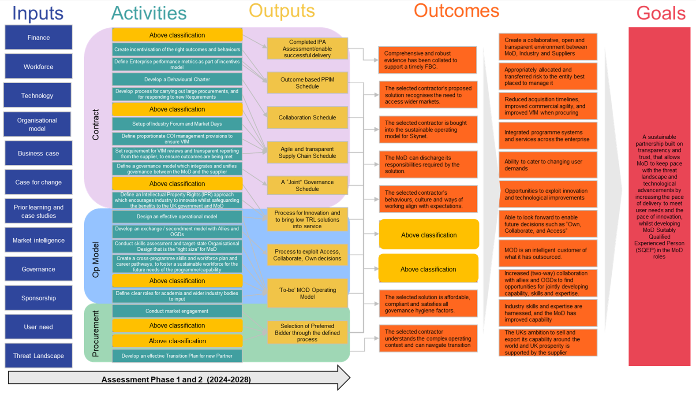
Figure 2: Theory of Change diagram
Figure SEQ Figure \* ARABIC 2 SKIES Project Theory of Change

SKIES evaluation questions
The evaluation questions that will need to be answered as part of the evaluation are set out in the table below. The table identifies which evaluation questions are core and should form part of the evaluation, as well as additional questions that are optional, allowing the evaluation plan to be applied flexibly and respond to different evaluation budgets and requirements. These questions are discussed in more detail in the subsequent sections of this document.
Table 3: SKIES evaluation questions
Evaluation type | Theme | Evaluation questions | Is this a core question?
Process | Relevance | 1.1 To what extent is SKIES designed to directly address its strategic goals, as well as those of the wider market, supply chain and the Defence Space Strategy? | No
Process | Relevance | 1.2 To what extent has the implemented SKIES operating model worked to enhance more collaborative working between Industry and the MoD? | Yes
Process | Efficiency | 2.1 To what extent has the SKIES Project been delivered to plan, on time, and to budget? | Yes
Process | Efficiency | 2.2. To what extent has the SKIES delivery model achieved its stated aims (i.e. this particular contracting model and the balance of work between contractor-MoD)? | Yes
Process | Efficiency | 2.3 To what extent has SKIES resolved the problem of ineffective governance over divergent projects and contracts to avoid an inefficient and cumbersome management overhead? | No
Process | Efficiency | 2.4 To what extent has SKIES reduced acquisition timescales and improved commercial agility when procuring SKYNET capabilities? | Yes
Process | Efficiency | 2.5 How appropriate and effective was the competition and procurement process? | Yes
Process | Coherence with wider strategic goals | 3.1 To what extent do SKIES’ activities and those of the service delivery contractors adhere to the strategies of the space defence landscape? E.g., in line with the UK Space Strategy and Defence Space Strategy | Yes
Process | Coherence with wider strategic goals | 3.2 To what extent are SKIES and broader Skynet activities and phases effectively working together in harmony towards the same ultimate goals? | No
Process | Coherence with wider strategic goals | 3.3 How have the new contractual and technical interfaces introduced by SKIES worked in (terms of their interconnections and interdependencies) to reduce unidentified or unquantified risk? | No
Process | Coherence with wider strategic goals | 3.4 To what extent has SKIES led to the creation and maintenance of a coherent full system view, whilst forming a whole Skynet enterprise forward looking view (of capabilities, technologies, etc.) and linked these two together? | No
Impact | Effectiveness | 4.1 To what extent have SKIES activities so far contributed to SKYNET’s intermediate benefits? | No
Impact | Effectiveness | 4.2 To what extent has MoD enabled access to Suitably Qualified and Experienced Personnel (SQEP) through SKIES to fulfil its assigned roles within the operating model; as well as having harnessed industry SQEP in an effective way? | Yes
Impact | Effectiveness | 4.3 To what extent has MoD been able to reduce acquisition timelines and enable more flexible and responsive routes to market? | Yes
Impact | Effectiveness | 4.4 To what extent has MoD established an ‘evergreen’ approach to process and tech development, enabling the early adoption of new technologies and capabilities? | Yes
Impact | Effectiveness | 4.5 To what extent has MoD built a model to incentivise appropriate sharing of risk management with industry? | No
Impact | Effectiveness | 4.6 To what extent has MoD maintained its ability to be an informed customer of what it has outsourced? | Yes
Impact | Effectiveness | 4.7 To what extent has MoD created a collaborative, open and transparent environment between MoD, Industry and Suppliers? | Yes
Impact | Effectiveness | 4.8 To what extent has SKIES increased (two-way) collaboration with allies and OGDs? | Yes
Impact | Effectiveness | 4.9 To what extent has SKIES enabled MoD to understand and analyse future trends to enable future decisions such as Own, Collaborate, and Access? | No
Impact | Impact | 5.1 To what extent has SKIES led to effective decision making in areas such as route to market, programme and system integration and the utilisation of constrained resources? | Yes
Impact | Impact | 5.2 To what extent does SKIES support the UK’s ambition to develop UK prosperity? | No
Impact | Impact | 5.3 To what extent have SKIES activities so far contributed to SKYNET 6’s ultimate end benefits? | Yes
Impact | Learning and improvement | 6.1 To what extent has SKIES been delivered with a constant focus on continuous improvement, and what has the effect of any resultant changes to delivery been? | No
Impact | Learning and improvement | 6.2 How has the MoD’s approach to SKIES built in an ability to respond to changing current and future requirements of the End User? | No
Economic | Economic evaluation | 7.1 How far were target timelines for the launch and conclusion of the procurement process met? | No
Economic | Economic evaluation | 7.2 To what extent did the procurement competition process improve the quality and value for money associated with proposals received? | No
Economic | Economic evaluation | 7.3 To what extent did the risk / reward approach result in ensuring value for money? | No
Economic | Economic evaluation | 7.4 To what extent can we identify efficiencies or savings achieved through an agile supply chain schedule? | No
Economic | Economic evaluation | 7.5 How effective was the preferred bidder approach in securing VfM bids? | No
Economic | Economic evaluation | 7.6 How effective is the approach to developing low TRL products and services? | No
Economic | Economic evaluation | 7.7 To what extent did the cross-programme skills and workforce plan help achieve VfM through efficient recruitment and retention of SQEP? | No

Section 2 Process evaluation options
This section sets out an approach to the process evaluation for the SKIES Project. This identifies key questions that would need to be addressed by an evaluation and describes the types of information which could be used to provide an assessment of the delivery processes.
A process evaluation framework, presenting key process evaluation questions and the metrics and data sources which can be used to assess the processes used is presented below in Table 2. It is envisaged that completion of the process evaluation will require evidence of the following types:
- programme documentation
- programme data
- stakeholder interviews
The programme documentation will provide a large amount of information about the processes used in delivery as well as the individuals involved in decision making processes. Additionally, the SKIES Project will collect a large amount of data as the programme is being delivered, including administrative data and monitoring data which is being collected for the benefit management work. This data will provide essential information for the process evaluation, providing objective measures of the performance of the processes used to implement the SKIES Project.
To provide further evidence and explanations on what is observed in the data it will be important to engage with stakeholders directly involved in the delivery of the SKIES Project (for example, staff from the successful supplier, SKIES staff, SKIES contractors) and wider stakeholders to gather their perspectives and knowledge on programme implementation.

Process evaluation framework
The process evaluation framework identifies where the evaluation expects to gather data from to answer each evaluation question and the key metrics required (see Table 4 for the key evaluation questions).
- Existing data
- Programme documentation Programme data
- New programme artifacts
- Primary research
- SKIES team
- Wider stakeholders within MoD
- Successful bidders

Table 4: Evaluation questions and data in process evaluation framework
Evaluation Questions | Sub-questions | Programme documentation | Programme data | New programme artifacts | SKIES team | Wider stakeholders within MoD | Successful bidders
1.1 To what extent is SKIES designed to directly address its strategic goals, as well as those of the wider market, supply chain and the Defence Space Strategy? | To what extent is there alignment and is SKIES addressing its strategic goals? | Yes | Yes | No | Yes | Yes | No
1.2 To what extent has the implemented SKIES operating model worked to enhance more collaborative working between Industry and the MoD? | What was the approach taken to choosing options and why? Were there significant changes? If so, why?  To what extent were the right stakeholders effectively consulted and engaged with throughout the process/at key points?  To what extent did the approach promote collaboration between industry and the MoD as a result? | Yes | No | Yes | Yes | Yes | No
2.1 To what extent has the SKIES Project been delivered to plan, on time, and to budget? | To what extent has each strand of the SKIES Project been delivered to plan and why?  To what extent has each strand of the SKIES Project been delivered on time and why?  To what extent has SKIES been delivered to budget and why?  What was the impact of any changes made to the programme? | No | Yes | No | Yes | No | No
2.2. To what extent has the SKIES delivery model achieved its stated aims (i.e. this particular contracting model and the balance of work between contractor-MoD)? | What alternative models were considered at the design stage, if any?  Why was this model chosen over those alternatives?  To what extent do stakeholders believe an alternative model would have brought about the same or better results? | No | No | No | Yes | Yes | Yes
2.3 To what extent has SKIES resolved the problem of ineffective governance over divergent projects and contracts to avoid an inefficient and cumbersome management overhead? | How has the governance arrangement been delivered?  To what extent is the governance appropriate and proportionate? What alternatives were considered?  To what extent has the governance arrangement contributed to and/or addressed issues around inefficiencies and management overheads? | No | No | No | Yes | Yes | No
2.4 To what extent has SKIES reduced acquisition timescales and improved commercial agility when procuring SKYNET capabilities? | To what extent have acquisition timescales been reduced (if at all), and why? How could this be improved?  To what extent (if at all) have the SKIES early phases improved commercial agility when procuring SKYNET capabilities? Why is this the case? How could this be improved? | Yes | Yes | No | Yes | No | Yes
2.5 How appropriate and effective was the competition and procurement process? | To what extent was there a healthy/minimum viable number of quality bids received? What were the barriers and enablers?  To what extent was scoring and rating consistent against well-defined and clear success criteria? And why?  To what extent was the competition run in a timely manner?  Was the supply market kept informed at appropriate points? How could communication be improved?  Were the correct level/seniority of stakeholders (from all sides) engaged?  Did resultant contract(s) contain all the elements of outsourcing that was intended at the outset, to a sufficiently high quality and which represented satisfactory value for money? | No | Yes | Yes | Yes | Yes | Yes
3.1 To what extent do SKIES’ activities and those of the service delivery contractors adhere to the strategies of the space defence landscape? E.g., in line with the UK Space Strategy and Defence Space Strategy | What SKIES activities and those of the service delivery contractors are aligned within the wider context of the space defence landscape?  Are there any elements that are less aligned and if so, why? | No | No | No | Yes | Yes | Yes
3.2 To what extent are SKIES and broader Skynet activities and phases effectively working together in harmony towards the same ultimate goals? | How aligned are the SKIES/SKYNET activities?  Was there duplication of activities? Were there any bottlenecks or capacity problems?  Were stakeholders effectively engaged through design and delivery across the phases? Could they have been engaged better? | No | Yes | No | Yes | Yes | No
3.3 How have the new contractual and technical interfaces introduced by SKIES worked in (terms of their interconnections and interdependencies) to reduce unidentified or unquantified risk? | How has the programme been designed to reduce unidentified or unquantified risk?  Would an alternative delivery programme have worked better in this regard?  What was the risk tolerance?  Were any compromises made during the competitive process which has changed the risk position for the MoD? If so, why?  Were any opportunities realised that emerged during the competitive process which were not identified beforehand? | No | No | No | Yes | No | Yes
3.4 To what extent has SKIES led to the creation and maintenance of a coherent full system view, whilst forming a whole Skynet enterprise forward looking view (of capabilities, technologies, etc.) and linked these two together? | What specific features and mechanisms within the SKIES Project have led to the creation of a full system view?  Has this been delivered as planned? If not, why? | Yes | No | No | Yes | No | Yes
3.5 How has MoD built in feedback and engagement with industry across each phase of SKIES; and how has this been received? | Has feedback been built into each phase of SKIES?  What has happened as a result of this? | Yes | Yes | No | Yes | No | Yes

Proposed data sources
The sources of information described in detail below will be required to collect evidence to assess the processes used and form the process evaluation.

Programme documentation
The SKIES Project will collect a lot of documentation about the delivery of the programme. It is essential that evaluation teams are given access to this documentation, as it will provide important information about the performance of the programme. It is anticipated that the key documentation required for the evaluation will include:
Table 5: SKIES Programme documentation
Data required | Use in process evaluation
Programme risk registers and mitigating actions taken | The SKIES team keeps a live risk register document, which identifies the risks the SKIES Project faces, and the mitigating actions required to ensure the programme delivers. This documentation will be crucial to the evaluation as it will show both current and previous risks to the programme and actions taken to ensure risks are mitigated.
Programme timelines and how these have altered over time | The SKIES team keeps a detailed programme timeline, outlining key tasks, when they are expected to be delivered and any slippage to delivery. It will be important to keep this document updated regularly and to share this document with the evaluation team to demonstrate when key milestones are achieved and whether this is in line with expectations.
Original Business Case and iterations of the Business Case | As the Original Business Case and Final Business Case for the SKIES Project is developed and updated over time, it will be important to share iterations of this with the evaluation team to ensure information about the programme's aims and objectives are available. These documents will also outline the costs of the SKIES Project, as well as the economic and strategic case for implementation.
Steering group and board meeting minutes | The evaluation team should be given access to the minutes from relevant board meetings, as they will highlight key decisions made about the programme, challenges faced, and individuals involved in key decision making.
Organograms, team structures, and resources dedicated to the SKIES Project | A description of the individuals (either internal staff or contractors) involved in the SKIES Project and resources they devote to the programme should be provided to the evaluator. This will outline information about the roles, skills and experience of individuals involved in the programme delivery as well as help identify key stakeholders.
Skills assessment, skills and workforce plan and target-state organisational design documentation | As part of the SKIES Project a skills assessment, skills and workforce plan and target-state organisational design will be developed. It is important that these documents are shared with evaluators as this will provide key information about what is required to deliver the SKIES Project.
Documentation from the procurement competition | All documentation from the competition process should be made available to the evaluation team to support an assessment of the procurement and competition process. This includes: documentation provided to potential suppliers about the SKIES service requirements, materials from supplier engagement events, feedback from market engagement activities, and any information provided to potential suppliers during the process (for example, responses to questions).

Programme data
The SKIES Project will also collect data relating to the delivery of the programme, which can be used to support an assessment of the effectiveness of the processes used in delivery. The key information that should be collected and held is set out in Table 6.
Table 6: SKIES Project data
Data category | Data required | Use in process evaluation
Financial data | - Public sector expenditure on the SKIES Project  - Expenditure disaggregated by key tasks | This data will be used to support an assessment of the financial resources directed to different activities provided during the programme.
Resource data | - Data on the number and type of internal and external roles required to deliver the SKIES Project  - Data on vacancies for these roles  - Data on training delivered | This data will be used to support an assessment of the resources, skills and experience used to deliver the programme.
Market engagement data | - Number of suppliers contacted about SKIES competitions  - Types of suppliers contacted (size of organisation, scope of services, etc.)  - Number of suppliers attending market engagement events  - Types of suppliers attending market engagement activities | This data will be used to support an assessment of the success of the market engagement activities and whether sufficient potential suppliers were interested in the available competitions.
Procurement data | - Number of suppliers engaging in the procurement process  - Types of suppliers engaging in the process  - Assessment of bids received (scores)  - Types of suppliers successful and unsuccessful in applying for competitions | This data will be used to assess the effectiveness of the procurement processes.
Enterprise performance metrics and other KPI data | - Metrics measuring performance as part of the incentives model  - Benefit management metrics  - KPI data | This data will be used to assess performance and adherence to the supplier agreement.

Primary research
Primary research will collect crucial information to support the process evaluation. It is recommended that primary research is undertaken with four main stakeholder groups, which are:
- stakeholders directly involved in the delivery of the SKIES Project, such as the Senior Responsible Officers for the SKIES Project and members of SKIES Project boards/steering groups, including both internal staff and contractors with key roles on the programme.
- wider SKYNET and MoD personnel, including stakeholders involved in the wider SKYNET programme
- successful suppliers and the wide range of stakeholders amongst successful bidders, including those that led the procurement exercise, as well as those involved in the SKIES Project
The aim of the primary research will be to gather wider contextual information about the set-up and delivery of the SKIES Project, identify any issues faced in delivery and how these were overcome, and to assess the performance of the programme and how delivery could be improved in the future. The outputs and outcomes of the programme will also be discussed, and how the processes used have supported their achievement.
It is anticipated that the primary research with stakeholders involved in the programme delivery, suppliers, and wider armed forces and MoD personnel would be undertaken as depth interviews, conducted either in person or over the phone/via video conferencing, and by an organisation who is independent and impartial.
Table 7 outlines the key topics to be covered with each stakeholder group. It is however important to ensure these are tailored to each individual and their particular role on the programme as, for instance, some SKIES delivery staff may not be in a position to discuss wider strategic fit.
Table 7: Process evaluation stakeholder interview topics
Stakeholder group | Topics covered
Stakeholders directly involved in the delivery of the SKIES Project – delivery staff | - Key context for the SKIES Project and rationale  - Approach to choosing options and ensuring the right model was chosen  - How appropriate and effective the procurement process was  - Processes and governance used in the delivery of the SKIES Project  - Success of delivery to date  - Wider strategic fit
Wider SKYNET and MoD personnel | - Key context for the SKIES Project and rationale  - Wider strategic fit
Successful bidders | - The effectiveness of market engagement activities and programme requirements  - The appropriateness and effectiveness of the procurement process.  - The effectiveness of the processes used to deliver the programme are, such as the transition plan, incentivisation etc

Analysis of data
A large volume of data will be collected to support the process evaluation. It is recommended that two main approaches are used to analyse the data, which are:
- descriptive quantitative analysis
- thematic analysis of qualitative responses
The descriptive quantitative approach will be undertaken to analyse the quantitative data which will be collected to undertake the process evaluation, such as the number and type of bids received.
In addition to this, much of the data collected for the process evaluation will come from undertaking qualitative interviews with key stakeholders. This data will be analysed using a thematic approach. Key areas of interest will be identified throughout the research phase, which should align to each of the process evaluation questions. The findings from each qualitative interview should then be coded into the framework against these key themes.
The quantitative and qualitative evidence will be synthesised against the process evaluation framework. The approach will have the following steps:
- The quantitative evidence can be used to judge whether the processes are performing as expected in the intervention logic and process evaluation framework.
- Some qualitative evidence will also be used to identify whether processes are performing as expected where quantitative evidence is unavailable or inappropriate.
- The qualitative evidence and theory of change will be used to establish the array of explanations for the patterns observed.

Section 3 Impact evaluation options
This section sets out the approach to an impact evaluation for the SKIES Project. This identifies key questions that would need to be addressed by an evaluation and describes the information which could be used.

Impact evaluation framework
The impact evaluation framework identifies where the evaluation expects to gather data from to answer each evaluation question (see Table 8).
Table 8: Impact evaluation framework and required data sources
Evaluation Questions | Programme documentation | Programme  data | New  programme artifacts | SKIES team | Wider stakeholders within MoD | Successful bidders
4.1 To what extent have SKIES activities so far contributed to SKYNET’s intermediate benefits? | No | Yes | No | Yes | Yes | No
4.2 To what extent has MoD enabled access to Suitably Qualified and Experienced Personnel (SQEP) through SKIES to fulfil its assigned roles within the operating model; as well as having harnessed industry SQEP in an effective way? | Yes | Yes | No | Yes | Yes | No
4.3 To what extent has MoD been able to reduce acquisition timelines and enable more flexible and responsive routes to market? | No | Yes | Yes | Yes | Yes | Yes
4.4 To what extent has MoD established an ‘evergreen’ approach to process and tech development, enabling the early adoption of new technologies and capabilities? | No | Yes | No | Yes | Yes | Yes
4.5 To what extent has MoD built a model to incentivise appropriate sharing of risk management with industry? | Yes | Yes | No | Yes | No | Yes
4.6 To what extent has MoD maintained its ability to be an informed customer of what it has outsourced? | No | No | No | Yes | No | No
4.7 To what extent has MoD created a collaborative, open and transparent environment between MoD, Industry and Suppliers? | No | Yes | No | Yes | Yes | Yes
4.8 To what extent has SKIES increased (two-way) collaboration with allies and OGDs? | No | No | No | Yes | Yes | No
4.9 To what extent has SKIES enabled MoD to understand and analyse future trends to enable future decisions such as Own, Collaborate, and Access? | No | No | Yes | Yes | Yes | No
5.1 To what extent has SKIES led to effective decision making in areas such as route to market, programme and system integration and the utilisation of constrained resources? | No | No | No | Yes | Yes | Yes
5.2 To what extent does SKIES support the UK’s ambition to develop UK prosperity? | No | Yes | No | Yes | Yes | Yes
5.3 To what extent have SKIES activities so far contributed to SKYNET6’s ultimate end benefits? | No | No | No | Yes | Yes | No
6.1 To what extent has SKIES been delivered with a constant focus on continuous improvement, and what has the effect of any resultant changes to delivery been? | Yes | No | No | Yes | Yes | Yes
6.2 How has the MoD’s approach to SKIES built in an ability to respond to changing current and future requirements of the End User? | No | Yes | Yes | Yes | Yes | Yes

Proposed data sources
Similar to the process evaluation, the programme documentation and data will provide some of the evidence required for the impact evaluation. Programme documentation and data should be reviewed and a gap analysis should be conducted to identify any metrics that are not being captured as part of programme delivery.
Stakeholder interviews will be a core part of the impact evaluation and key stakeholder groups will be interviewed on different topics, which are outlined in Table 9. More detailed information about which evaluation questions each stakeholder group will contribute to can be found in Table 8.
Table 9: Impact evaluation stakeholder interview topics
Stakeholder group | Topics covered
Stakeholders directly involved in the delivery of the SKIES Project – delivery staff | - Wider strategic fit  - Contribution to SKYNET goals i.e. access to SQEP, impact on acquisition timelines, early adoption of technology.
Wider SKYNET and MoD personnel | - Wider strategic fit  - Contribution to SKYNET goals i.e. access to SQEP, impact on acquisition timelines, early adoption of technology.
Successful bidders | - Contribution to SKYNET goals i.e. access to SQEP, impact on acquisition timelines, early adoption of technology.

Section 4 Economic Evaluation
This section sets out the approach to an economic evaluation for the SKIES Project. This identifies key questions that would need to be addressed by an evaluation and describes the information which could be used and the recommended analytical approach for the evaluation.
The questions below outline the key economic evaluation questions which have been developed for the evaluation of the SKIES Project. These economic evaluation questions should not be addressed until after the SKIES Project has been implemented and had time to achieve outcomes.
Table 10: Key economic evaluation questions
Evaluation question | Economy | Efficiency | Effectiveness | Equity
7.1 How far were target timelines for the launch and conclusion of the procurement process met? | Yes | N/A | N/A | N/A
7.2 To what extent did the procurement competition process improve the quality and value for money associated with proposals received? | Yes | Yes | N/A | N/A
7.3 To what extent did the risk / reward approach result in ensuring value for money? | Yes | Yes | Yes | N/A
7.4 To what extent can we identify efficiencies or savings achieved through an agile supply chain schedule? | Yes | Yes | N/A | N/A
7.5 How effective was the preferred bidder approach in securing VfM bids? | N/A | Yes | Yes | N/A
7.6 How effective is the approach to developing low TRL products and services. | N/A | N/A | Yes | N/A
7.7 To what extent did the cross-programme skills and workforce plan help achieve VfM through efficient recruitment and retention SQEP? | N/A | Yes | Yes | N/A

Data requirements
The data required for the economic evaluation will largely come from the process and impact evaluations. This will provide evidence of the outputs and outcomes achieved, and how effective and efficient the SKIES Project has been in achieving these outcomes.
In addition to the data from the process and impact evaluation, the economic evaluation will need to draw on further data sources, namely financial data and additional qualitative data. Financial data concerns the level of programme expenditure which was needed to deliver the intervention. This information would need to be provided by year, and ideally disaggregated by the activity it was used for (for example, market engagement activity).
The additional qualitative information required can be collected using the existing qualitative interviews set out for the process and impact evaluations. It would need to cover how the SKIES Project approached spending and minimising spending on the intervention (for example through the procurement and contract management approach). It would also need to address factors which either enabled the programme to be delivered at minimum cost or maximised outcomes for the budget available, and challenges which impacted upon the cost of the programme.

4E’s analytical approach
It is recommended that the overarching approach to the economic evaluation is guided by the National Audit Office’s (NAO) 4E’s framework, focusing on the economy, efficiency, effectiveness and equity of the programme.
The economy aspect is concerned with minimising the cost of resources used while having regard to quality, while the efficiency principle considers the relationship between outputs and the resources used to produce them. Effectiveness concerns the extent to which objectives are achieved, and the relationship between the intended and actual impacts of the service. Finally, the equity aspect concerns the extent to which outcomes reached all intended people. These are summarised further in Figure 3.
The questions in Table 5 fit into the 4E’s framework and should therefore be used to undertake the economic evaluation. The economic evaluation would be qualitative in nature, utilising the outcome metrics collected in the intervention impact evaluation and data collected in qualitative interviews.

Figure 3: NAO 4’E’s framework
Ipsos adaptation of NAO 3’E’s diagram

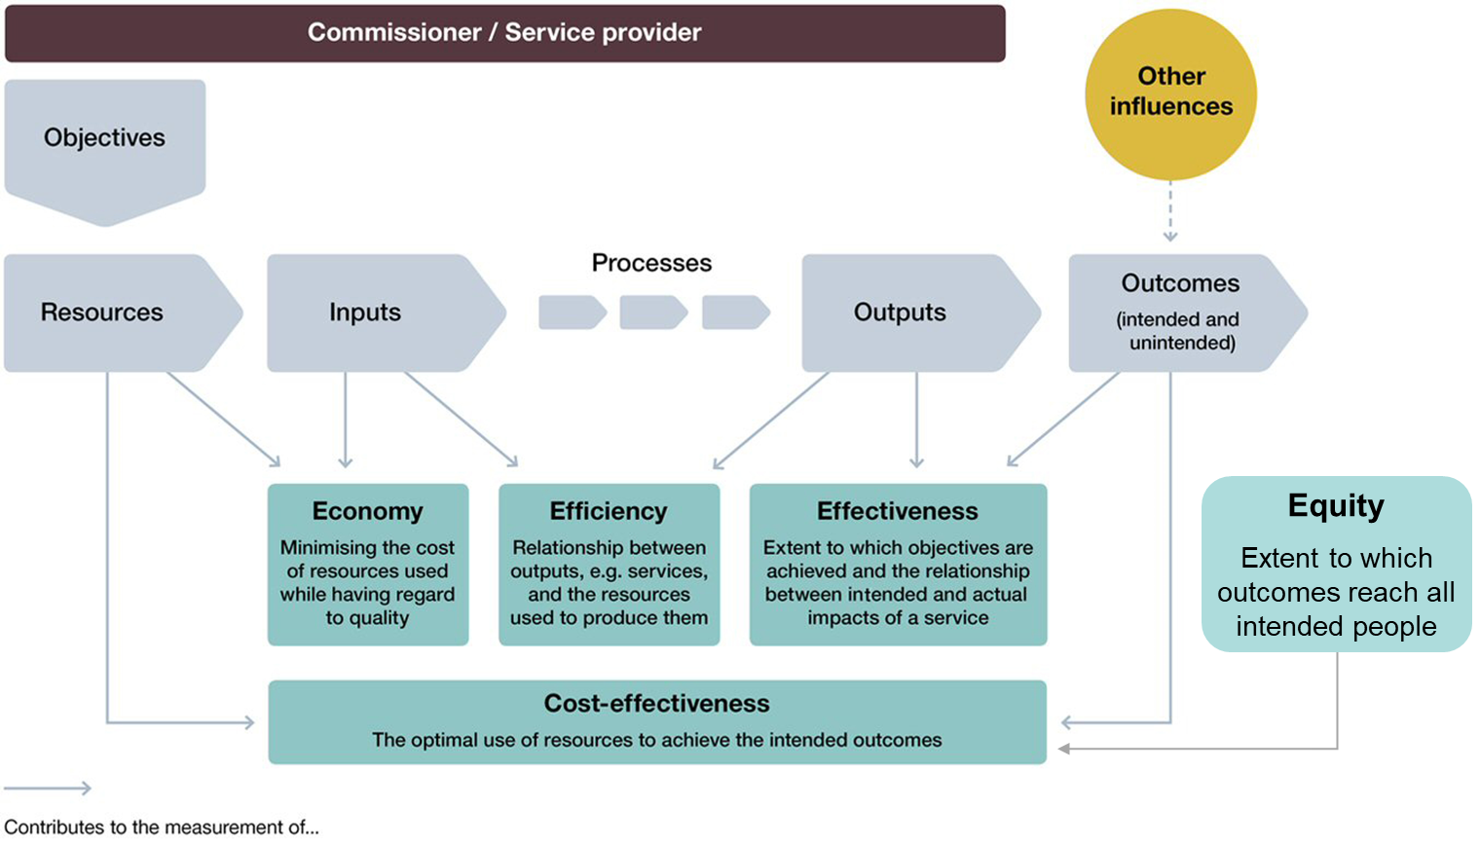
Section 5 Recommended evaluation approach

Recommended approach
The recommended approach for the evaluation of the SKIES Project is to use a realist approach to process and impact evaluation using before and after monitoring, as well as an economic evaluation using the National Audit Office’s 4E’s framework. This section details the different evaluation options available and why this is the chosen approach.

Analytical approaches

Counterfactual
The opportunity to identify a counterfactual for this evaluation was explored. This would usually consist of either withholding an intervention in certain areas, or finding a similar intervention that can be used as a comparison site (Quasi-Experimental Design). However, due to the universal nature of the programme as well as how unique it is, this was discounted as there are no credible counterfactual cases, or opportunities for comparison for this to take place.

Before and after analysis
As described above, there is no opportunity to form a counterfactual case for the SKIES Project. Therefore, quasi-experimental evaluation approaches will not be feasible for the evaluation. Therefore, it is recommended that before and after analysis is undertaken as part of the evaluation.
Quantitative evidence should collect pre- and post-measures of the metrics of interest. This analysis will require at least one observation point for each outcome before the SKIES Project goes into the implementation phase.
This approach can explore the impact of the SKIES Project in two different scenarios. Firstly, where a single data point is available prior to the implementation, the analysis can measure the change in the metric from the baseline point to what has been achieved post-implementation. This approach would not be able to take account for any direction of travel prior to the implementation, as there will likely be insufficient data points to infer this.
Secondly, where data exists for multiple time periods prior to the implementation (for instance if collected as part of ongoing monitoring), the analysis can potentially extrapolate a trend, or direction of travel for the metric prior to implementation, and use this to compare the outcomes achieved post implementation to. However, this approach comes with some risks – in that the trend observed prior to implementation may not have continued in the same manner in future years (for example it may reach a maximum or minimum level), or the trend may be driven by external factors which have changed post implementation.

Evaluation approaches
Different evaluation approaches which do not use a counterfactual (a non-experimental approach) could be used to assess the SKIES Project. These evaluation approaches should be used alongside the before and after monitoring approach set out above, to improve the explanatory power of the evaluation findings and to help answer questions about how the intervention was delivered (process evaluation) and whether the intervention caused an impact, and if so how and why (impact evaluation). There are a variety of evaluation approaches that could potentially be used, and these are presented in the table below, with an assessment of their feasibility and appropriateness.
Based on the assessment summarised below in Table 11, it is recommended that the evaluation takes a realist approach which can be used for both process and impact evaluation and is used to evaluate complex interventions. A realist evaluation is a theory-led approach that seeks to understand what works, in what circumstances and understands how the different programme activities cause or contribute to outcomes and impacts. This approach uses both quantitative and qualitative data, however there is more emphasis on gathering qualitative data which allows the theory to be explored.
Table 11: Assessment of non-experimental evaluation approaches
Method Options | Summary and pros and cons (source Magenta Book) | First cut assessment and recommendation
Qualitative Comparative Analysis (QCA) | Used to compare multiple cases and systematically understand patterns of characteristics associated with desired or undesired outcomes based on qualitative knowledge. Can account for both complex causation (combinations of factors) and ‘equifinality’ (multiple causes of outcomes).  Can identify groups of causal factors in post-hoc evaluation. Systematically analyses case study evidence. Works best with 10-50 cases. Needs consistent data about how those factors affect outcomes and assessment of which are the more successful across case studies | This approach would require a counterfactual group, which as discussed above, is challenging, and is therefore infeasible for this evaluation.
Realist evaluation | Specific, hypothesised causal ‘mechanisms’ for an ‘outcome’ are articulated in ‘context’ and evidence gathered for each. The ‘mechanism’ explains why participants may take advantage of an opportunity or not depending on the ‘context’, and their understanding is key to causal inference.  Refined theory of change can identify causal mechanisms. Can inform impact conclusions if a counterfactual is not feasible. However, approaches are time consuming, resource intensive and need subject-matter expertise. Often difficult to communicate/interpret due to complexity. Does not provide a quantitative effect size. | This approach requires a large volume of qualitative data collection with a wide variety of stakeholders to ensure different mechanisms and contexts are fully explored. This approach could be useful to explore what aspects of the SKIES approach are successful in achieving outcomes and why.
Process tracing | A structured method examining a single case of change to test whether a hypothesised causal mechanism, such as that proposed by the Theory of Change, explains the outcome.  Can test causal hypotheses post-hoc. Must be used with rigour to prevent inferential errors; alternative explanations must be carefully considered. Support for one causal mechanism may not preclude others. | This approach could use data collected through qualitative interviews with stakeholders. However, this approach would not necessarily identify what mechanisms were driving the achievement of outcomes.
Contribution analysis | Step-by-step process used to examine if an intervention has contributed to an observed outcome by exploring a range of evidence for the Theory of Change. It gives an evidenced line of reasoning rather than definitive proof.  The contribution claim depends on the quality of thinking about the attribution problem and Theory of Change. Works on average effects – not to be used if there is large variability in implementation or outcomes. | This approach would determine whether contribution claims are valid, however this approach would not provide detailed evidence on why the approach works in the particular context.
Bayesian updating | Added to other theory-based methods to more rigorously assess whether evidence supports contribution claims. Probabilities of a small number of contribution claims are estimated prior to observation then tested.  Requires highly skilled facilitation. | This approach is unlikely to be feasible due to the type of data that would need to be collected.
Contribution tracing | Participatory mixed method to establish the validity of contribution claims with explicit criteria to guide evaluators in data collection and Bayesian updating to quantify the level of confidence in a claim. Includes a contribution ‘trial’ with all stakeholders to establish what will prove/disprove the claim.  Efficiently focuses on evidence that can increase confidence in a claim. Minimises confirmation bias using ‘critical friends’ in a testing phase. Intervention needs time to have detectable effects. Must explore other potential causes. Not for comparing interventions. | This approach is unlikely to be feasible due to the type of data that would need to be collected.
Most significant change | Participatory method for impact evaluation of complex interventions. Involves collection of significant change stories from the field and systematic selection of the most significant by panels of stakeholders. Interventions are often participatory too.  Useful when it is not possible to predict outcomes or when prioritisation of outcomes cannot be agreed. Builds understanding across stakeholders. Is time consuming and resource intensive and needs robust facilitation | This approach is not appropriate for the evaluation.

Section 6 Benefits management
The SKIES Project has identified 14 intermediate benefits which will be monitored and measured. A gap analysis has been conducted to highlight areas where the 14 intermediate benefits contribute to the evaluation questions. This also identifies core areas where the evaluation adds value to the benefit management work, by gathering additional information and analysis.
Table 12: Benefit management and evaluation gap analysis
Evaluation questions | Overlap with SKIES intermediate benefit
1.1 To what extent is SKIES designed to directly address its strategic goals, as well as those of the wider market, supply chain and the Defence Space Strategy? | No
1.2 To what extent has the implemented SKIES operating model worked to enhance more collaborative working between Industry and the MoD? | No
2.1 To what extent has the SKIES Project been delivered to plan, on time, and to budget? | No
2.2. To what extent has the SKIES delivery model achieved its stated aims (i.e. this particular contracting model and the balance of work between contractor-MoD)? | No
2.3 To what extent has SKIES resolved the problem of ineffective governance over divergent projects and contracts to avoid an inefficient and cumbersome management overhead? | No
2.4 To what extent has SKIES reduced acquisition timescales and improved commercial agility when procuring SKYNET capabilities? | Partial
2.5 How appropriate and effective was the competition and procurement process? | No
3.1 To what extent do SKIES’ activities and those of the service delivery contractors adhere to the strategies of the space defence landscape? E.g., in line with the UK Space Strategy and Defence Space Strategy | Partial
3.2 To what extent are SKIES and broader Skynet activities and phases effectively working together in harmony towards the same ultimate goals? | No
3.3 How have the new contractual and technical interfaces introduced by SKIES worked in (terms of their interconnections and interdependencies) to reduce unidentified or unquantified risk? | No
3.4 To what extent has SKIES led to the creation and maintenance of a coherent full system view, whilst forming a whole Skynet enterprise forward looking view (of capabilities, technologies, etc.) and linked these two together? | No
3.5 How has MoD built in feedback and engagement with industry across each phase of SKIES; and how has this been received? | Partial
4.1 To what extent have SKIES activities so far contributed to SKYNET’s intermediate benefits? | No
4.2 To what extent has MoD enabled access to Suitably Qualified and Experienced Personnel (SQEP) through SKIES to fulfil its assigned roles within the operating model; as well as having harnessed industry SQEP in an effective way? | Partial
4.3 To what extent has MoD been able to reduce acquisition timelines and enable more flexible and responsive routes to market? | Partial
4.4 To what extent has MoD established an ‘evergreen’ approach to process and tech development, enabling the early adoption of new technologies and capabilities? | Partial
4.5 To what extent has MoD built a model to incentivise appropriate sharing of risk management with industry? | No
4.6 To what extent has MoD maintained its ability to be an informed customer of what it has outsourced? | Partial
4.7 To what extent has MoD created a collaborative, open and transparent environment between MoD, Industry and Suppliers? | No
4.8 To what extent has SKIES increased (two-way) collaboration with allies and OGDs? | Partial
4.9 To what extent has SKIES enabled MoD to understand and analyse future trends to enable future decisions such as Own, Collaborate, and Access? | No
5.1 To what extent has SKIES led to effective decision making in areas such as route to market, programme and system integration and the utilisation of constrained resources? | No
5.2 To what extent does SKIES support the UK’s ambition to develop UK prosperity? | No
5.3 To what extent have SKIES activities so far contributed to SKYNET6’s ultimate end benefits? | No
6.1 To what extent has SKIES been delivered with a constant focus on continuous improvement, and what has the effect of any resultant changes to delivery been? | No
6.2 How has the MoD’s approach to SKIES built in an ability to respond to changing current and future requirements of the End User? | No
7.1 How far were target timelines for the launch and conclusion of the procurement process met? | No
7.2 To what extent did the procurement competition process improve the quality and value for money associated with proposals received? | No
7.3 To what extent did the risk / reward approach result in ensuring value for money | No
7.4 To what extent can we identify efficiencies or savings achieved through an agile supply chain schedule? | No
7.5 How effective was the preferred bidder approach in securing VfM bids? | No
7.6 How effective is the approach to developing low TRL products and services. | No
7.7 To what extent did the cross-programme skills and workforce plan help achieve VfM through efficient recruitment and retention SQEP? | Partial

Section 7 Implementation and Management

Approach towards project management of the evaluation
This section covers the phasing of any evaluation activity and the resources/budget required to manage an evaluation, based on an unconfirmed assumption that it will be outsourced.

Evaluation timings
It is key that the timing of evaluation activities are well thought through to ensure data can be collected at the right time and findings can be fed back into the programme. Table 8.1.1 provides an indication of key milestones for the evaluation work and key considerations for when each milestone is scheduled. It is important that evaluation timescales are regularly reviewed in line with any changes to programme milestones to consider any dependencies, for instance, if the Initial Operating Capability timescales move back, it is important to review how this would affect the viability of an early outcome evaluation and if so, timescales should be amended to reflect this. See Figure 8.1.1 for a high-level indication of when the process and impact evaluation should take place alongside the SKIES Project phases.
Table 13: Key considerations for the timing of the evaluation
Evaluation phase | Key considerations
Process evaluation Invitation to Tender and procurement | The invitation to tender will provide key information about the evaluation that is being commissioned and will outline the core requirements to potential suppliers. A successful supplier should be appointed 3 months before data collection begins to enable the evaluation team to mobilise and prepare for data collection activity. Active market engagement with suitable evaluation suppliers should begin approximately 3 months prior to evaluation start date. The Invitation To Tender (ITT) for the evaluation should begin 2 months prior to evaluation start date.
Process evaluation data collection | Data collection should take place before and during the preparation for assessment phases to capture baseline and follow-up monitoring. This involves identifying the key components of a programme, developing indicators to measure these, selecting appropriate data collection intervals (i.e. annually, quarterly), designing the data collection tools (such as interview topic guides), and then gathering the data, before it needs to be analysed.  The evaluation team will be able to feed learning back into the programme at regular intervals (usually at least quarterly) as data collection takes place.
Process evaluation reporting | A scoping report will be the first report that is delivered as part of the SKIES evaluation. The purpose of a scoping report is to provide a preliminary assessment of the programme and sets out a framework for the evaluation of the programme. It also provides a record of the work completed to date and the results of early fieldwork.  An interim report will set out early process evaluation findings. This will provide early insights and learning which can be used to refine programme delivery. It is therefore sensible to schedule this report ahead of key programme gateways and consider how learning will be embedded into programme delivery in a timely manner.  The final report is the last deliverable and will conclude the process evaluation contract. It is sensible to schedule the delivery of this in advance of the Full Business Case to allow learning to be used to refine the programme before it goes into operation.
Impact evaluation | It is key to schedule impact evaluation at a time where early outcomes can start being measured.  Due to the sequencing (see Figure 8.1.1), it is likely that this evaluation could be implemented separately from the process evaluation. A successful supplier should be appointed 3 months before data collection timeframes to enable the evaluation team to mobilise and prepare for data collection.
Knowledge Transfer | It is vital to make note of the need for effective knowledge transfer/sharing between evaluations.  When an evaluation is completed, there is a risk that some of the niche insights that develop throughout this process are lost, especially if key personnel move on from their roles or the evaluation provider changes. This can hinder future evaluations and therefore should be mitigated, this can be achieved through effective sharing of these insights, with this likely being through comprehensive role handovers and programme documents.  In Figure 8.1.1, there are three Knowledge Transfer points, with these each sitting in the periods between evaluations. These are the points in which the provider of the evaluations and key personnel is most likely to change and therefore the risk of poor knowledge transfer is highest.

Figure 4: Evaluation phasing

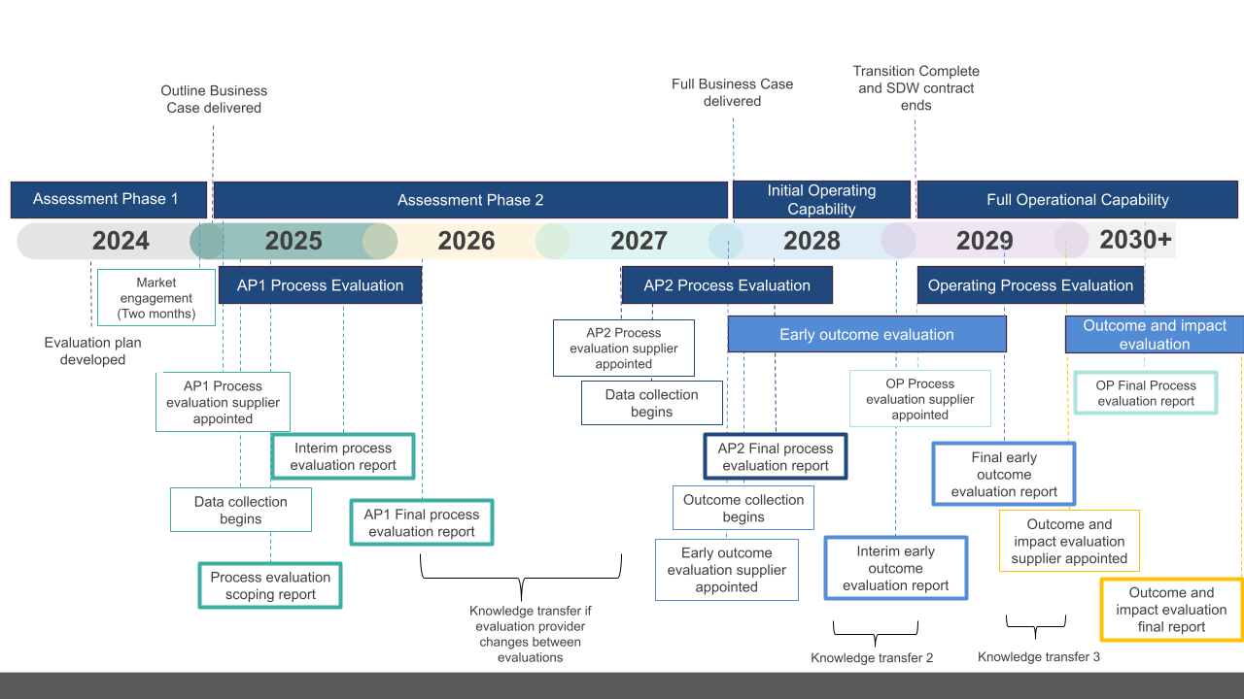
Project management of the evaluation and budget
It is recommended that the evaluation of the SKIES Project takes place over multiple years in line with the programme delivery. This presents a challenge to the management of the evaluation, as the responsibility of managing the intervention will change over time as the SKIES Project moves through different phases of implementation. Therefore, it is recommended that a plan for the management of the evaluation is set out to ensure that the MoD can be an active partner throughout the evaluation process.
It is recommended that the management of the evaluation is either undertaken by or has a close working partnership with the same team responsible for the benefits realisation work. This is because this team will have a good level of oversight of the SKIES Project, as well as the data being used to monitor the benefits of the intervention, which the evaluation will also utilise.
There are three key recommendations relating to the structure. First, that the governance board or steering group for the SKIES Project provides oversight of the evaluation. The team responsible for the management of the evaluation should report to the steering group about progress, and the steering group should review and comment on all major outputs. Further, the evaluator should present the key findings from each evaluation to the steering group, which includes a questions and answers session for all steering group members to obtain clarity about the findings and how these were obtained.
The second recommendation is that a senior team member should be included in the benefits realisation team. This is so that they can develop Invitations to Tender (ITTs) for the evaluation, describing the requirements and assessment criteria, sign off on research tools, critically assess the evaluation approaches being proposed and used, the findings presented and any changes to the evaluation approach which are required during the delivery (for example certain data collection methodologies no longer being feasible, and the evaluator suggesting alternatives). This would not be a full-time role, potentially an average of 0.2 – 0.4 FTE over the course of the delivery of the SKIES Project. This staff member could be seconded into the team from other areas of the MoD to support the evaluation, and continue to work elsewhere in the MoD simultaneously.
Finally, it is recommended that a junior team member be responsible for ongoing contact with the evaluation contractor, sharing information and data and administering the evaluation contract. This role could potentially be combined with existing junior benefits realisation roles.

Budget
It is important that the SKIES team considers the budget for commissioning and delivery of the evaluation as set out in this evaluation plan. Setting the evaluation budget needs to consider the scale of the SKIES Project and delivery timeline. At this stage it is prudent to set out a guide range budget for the delivery of the evaluation of AP1 only as subsequent phase evaluations will be dependent upon the findings of the evaluation of AP1.
The evaluation of AP1 as set out above would typically require a budget range of £250-300k at current market rates and exclusive of value added tax and any other costs (expenses, room hire, 3rd party data licences where appropriate). However, it is recommended that the budget be tested with potential suppliers through the market engagement process described above, to ensure that it is realistic. Additionally, it may be necessary to consider the impact of inflation beyond the time of writing of this evaluation plan.

SKIES Options Analysis Approach
SKIES partner annual report on acquisitions and competitions
Measurement of acquisition timelines.
Market intelligence inputs into the Strategic Decision Maker
Market intelligence inputs undertaken as new requirements.
see National Audit Office’s (NAO) toolkit. Available at: https://www.nao.org.uk/successful-commissioning/general-principles/value-for-money/assessing-value-for-money/
see National Audit Office’s (NAO) toolkit. Available at: https://www.nao.org.uk/successful-commissioning/general-principles/value-for-money/assessing-value-for-money/

