NOTICE OF ORDER
Wildlife and Countryside Act 1981
Lancashire County Council

The Lancashire CC (Restricted Byway from Clerk Hill Rd to Moor Lane, Wiswell,
Ribble Valley) DMMO 2017

Notice is hereby given that the above referenced Order has been submitted to the Secretary of State for Environment, Food and Rural Affairs for determination. An Inspector will be appointed by the Secretary of State to determine the Order.
The start date for the above Order is 2 September 2025.

Consideration of the Order will take the form of exchanges of statements of case and comments on statements of case.
The effect of the Order, if confirmed without modifications, will be to modify the Definitive Map and Statement of Public Rights of Way for the area, by adding a restricted byway from Clerk Hill Road to Moor Lane.

For location purposes the claimed route runs from SD 7538 3677 via SD 7531 3625, SD 7528 3688, SD 7528 3698, SD 7520 3698, SD 7496 3687, SD 7484 3682, SD
7471 3706 & SD 7471 3710 to SD 741 3712.
Any queries relating to this Order should be referred to Paul Scrivener by email: paul.scrivener@planninginspectorate.gov.uk quoting reference number ROW/3349028 on all correspondence. Alternatively, queries may be sent in writing to The Planning Inspectorate, Rights of Way Section, Room 3/A Eagle Wing, Temple Quay House, 2 The Square, Temple Quay, Bristol, BS1 6PN. Telephone: 0303 444 5000.
Any person wishing to view the statements of case and other documents relating to this Order may do so by appointment at County Hall, Fishergate, Preston, PR1 0LD, for further information please contact Simon Moore at simon.moore@lancashire.gov.uk or on 01772 531280. Documents have also been made available online. To access the documents, please use the following URL address:

https://www.lancashire.gov.uk/council/transparency/dmmos/clerk- hill-2017

Timetable for sending in statements of case and comments Within 2 weeks of the start date by 16 September 2025
The Order Making Authority, or where the Order Making Authority is taking a neutral
stance and the applicant or other party are taking the case forward in support of the order, must ensure their statement of case is received by the Secretary of State. As soon as possible after the deadline, the Secretary of State will send a copy (excluding copies of any supporting documents - these will be available to view at the Authority’s offices) to everyone who has made an objection or representation, the applicant and any other person who has written to us in respect of the Order.

Within 8 weeks of the start date by 28 October 2025
Everyone who has made an objection or representation or any other written representation or any other person wishing to make representations in writing must ensure their statement of case is received by the Secretary of State. As soon as possible after the deadline, the Secretary of State will send full copies to the Authority. Copies (excluding copies of any supporting documents - these will be available to view at the Authority’s offices) will also be sent to the applicant, every person who has made an objection or representation and any other person who has written to us in respect of the Order.

Within the same period the applicant (if applicable) must ensure their statement of case is received by the Secretary of State. As soon as possible after the deadline, Secretary of State will send a full copy to the Authority. Copies will also be sent to everyone who has made an objection or representation and any other person who has written to us in respect of the Order (excluding copies of any supporting documents - these will be available to view at the Authority’s offices).

Within 14 weeks of the start date by 9 December 2025
Everyone who has made an objection or representation, the Authority, the applicant (if applicable) and anyone who has written to us in respect of the Order must ensure that their comments on any or every other statement of case is received by the Secretary of State. As soon as possible after the deadline, the Secretary of State will send copies of these comments to everyone else.

In fairness to the other parties everyone should keep to the timetable to ensure that statements of case and comments are received on time. Late documents will be returned.
We cannot accept any inflammatory, discriminatory or abusive comments. Any documents containing such comments will be returned.
If you use Artificial Intelligence (AI) to create or alter any part of your documents, information or data, you should tell us that you have done this when you provide the material to us. See the detailed guidance for further information.

Notice of order for w/r
WILDLIFE AND COUNTRYSIDE ACT 1981

THE DEFINITIVE MAP AND STATEMENT OF PUBLIC RIGHTS OF WAY FOR THE COUNTY OF LANCASHIRE

THE LANCASHIRE COUNTY COUNCIL
(RESTRICTED BYWAY FROM CLERK HILL ROAD TO MOOR LANE, WISWELL, RIBBLE VALLEY)
DEFINITIVE MAP MODIFICATION ORDER 2017

This Order is made by Lancashire County Council rthe Authority11) under Section 53(2)(b) of the Wildlife and Countryside Act, 1981 ("the Act") because it appears to that Authority that The Definitive Map and Statement of Public Rights of Way for the County of Lancashire require modification in consequence of the occurrence of an event specified in Section 53(3)(b) and Section 53(3)(c)(i) and (ii) namely the expiration of any period such that the enjoyment by the public of the way during that period raises a presumption that the way has been dedicated as a restricted byway, the discovery by the Surveying Authority of evidence which (when considered with all other relevant evidence available to them) shows that a right of way which is not shown in the map and statement subsists or is reasonably alleged to subsist over land in the area to which the map relates, being a restricted byway and also shows that a highway shown in the map and statement as a highway of a particular description, namely a public footpath ought to be there shown as a highway of a different description, namely a restricted byway.
The Authority have consulted with every local authority whose area includes the land to which the Order relates. Lancashire County Council hereby order that:
- For the purposes of this Order, the "relevant date" is 4th October 2017.

- The Definitive Map and Statement of Public Rights of Way for the County of Lancashire shall be modified as described in Part I and Part II of the Schedule and shown on the map attached to the Order.

- This Order shall take effect on the date it is confirmed and may be cited as The Lancashire County Council (Restricted Byway from Clerk Hill Road to Moor Lane, Wiswell, Ribble Valley) Definitive Map Modification Order 2017.

Dated this 4th day of October 2017.

THE COMMON SEAL of the )
Lancashire County Council ) was hereunto affixed in the presence of )

Authorised Signatory

� 264 c:,s;-
SCHEDULE

PARTJ

MODIFICATION_QF THE DEFINITIVE MAP

DESCRIPTION OF PATHS OR WAYS TO BE ADDED OR UPGRADEQ

Addition of restricted byway Wiswell 24 from Clerk Hill Road at point A on Order Map 1 (also recorded as Bridleway Sabden 21) running in a north westerly direction to the junction with Footpath 23 at point C along a track through Wiswell Moor Quarry (disused) then through a series of bends to cross Footpath 23 at point D and Footpath 11 at point E then at point F it is joined by Footpath 23 east of a gateway and Footpath 9 west of the gateway.

The restricted byway to be added then continues west south west through a gateway at point G on Order Map 2 to point H where it turns to continue in a generally north westerly direction to point I where it meets Footpath 8; a total distance of 1.08 km and at a width varying between 3 and 5 metres.

The route to be upgraded to restricted byway is a continuation of that added above, currently recorded as Footpath 8, from point I on Order Map 2 northwards to pass through a gateway at point J and continuing for a short distance to the unmarked junction with Moor Lane at point K; a total distance of 60 metres and at a width varying between 3 and 5 metres.

All Footpath numbers above refer to those in Wiswell Parish and all distances are given in metres and lengths are approximate.

PART II

MODIFICATION OF DEFINITIVE STATEMENT

VARIATION OF PARTICULARS OF PATH OR WAY

Add to the Definitive Statement for Wiswell the following:

Wiswell 24:

No. of path: 112411

Kind of path: "Restricted Byway"

Position: •Restricted byway 24 from parish boundary at SD 7538 3677 on Clerk Hill Road (also recorded as Bridleway Sabden 21) running in a north westerly direction along a stone surfaced track to the junction with Footpath 23 at SD 7531 3685 and continuing along a winding track ascending a steep hill on an unbounded surfaced track through Wiswell Moor Quarry (disused) passing through a series of bends to cross Footpath 23 at SD 7528 3688 and Footpath 11 at SD 7528 3698 and then in a generally westerly direction along the track to the junction with Footpath 23 east of a gateway at SD 7520 3698 and the junction with Footpath 9 immediately west of the gateway.
The route passes through the gateway at SD 7520 3698 and then continues in a straight line in a generally west south west direction to the north of a stone wall and fenced off from the adjacent field passing through a further gateway at SD 7496 3687 and continuing in a straight line to SD 7484 3682 where it turns to continue downhill in a generally north westerly direction to the junction with Footpath 8 at SD 7471 3706.

It then continues in a northerly direction descending along a track to pass through a gateway at SD 7471 3710 and then along a roughly tarmacked road to the unmarked junction with Moor Lane (U22866) and the continuation of Footpath 8 (which runs along Moor Lane from this point) at SD 7471 3712. All compass directions given are approximate:

Length: 111.14 km11 Other particulars:
"Width: Varies between 3 and 5 metres.

Limitations and conditions:
SD 7520 3698 - field gate
SD 7496 3697 - field gate
SD 7471 3710 - field gate11

The statements to be amended for Wiswell 8, 11, 21 and 23 to read as follows:

Wiswell 8:

No. of path: 11811

Kind of path: "Footpath"
Position: "East side of Manor House Farm to junction with Restricted Byway 24 at SD 7471 7712 and then continuing from a further point on Restricted Byway 24 at SD 7471 3706 to Whalley Parish Boundary near Clitheroe Rural District Council Reservoir_.
Length: 110.47km •

Wiswell 11:

No. of path: "11"

Kind of path: 11Footpath"

Position: " Junction Unclassified County Road 4/80 and Keator Lane to junction with Restricted Byway 24 formerly known as unclassified County Road 4/84 at SD 7528 3698 north - east of Castle Wood.11
Length: •o.ss miles"
Wiswell 21:

No. of path: 1121"
Kind of path: "Bridleway"
Position: "Unclassified County Road No. 4/84 west of Wiswell Moor Farm passing junction with Restricted Byway 24 Wiswell at SD 7538 3677 to Sabden parish boundary."

Length: "0.27 miles"

Wiswell 23:

No. of path: "23"

Kind of path: "Footpath11

Position: "Footpath extending for a total distance of 170 metres from a point on Unclassified County Road No. 4/84 (also recorded as Restricted Byway 24), west of Wiswell Moor Farm, (SD 7531 3685), in a generally north-westerly direction, across a well-trodden grass track between 0.5 metres and 2.0 metres wide, adjacent to the western boundary wall to Wiswell Moor Quarry, to join another point on Unclassified County Road No. 4/84 (Restricted Byway 24) west of the now disused quarry, (SD 7520 3698)."

:1-
375100 375200 375300 375400

I
--
I
I 0g
,�!
-r '\
Wllf ,...
'\
'\

-.. ,,.,-�
, '", <,.),. -'--� ,; ,.� '
..

Wlreles
.I.;,
� , ,
'�' '
FP,11
�
, "' '�
,' / ,I t :5-."' \"
, I ,1 ' ._ ' \
'\ ,
,,I
,,' '\', I I
�,· , I . I .:::•.::,l'\,} ,
, 'I ,,

"..J
,
. •
:II,' I
, ' •:f
� ,.,a-,111,a.- '- r..,
,,
•"-
i FP9"---- �.:�-�--:�, · ·•:#.:·...:.�:· r• --f--·. -----,-,' .I,,,'L,••� _r=
1 --- ,:, ,� ""· Q
. E ..;.. ----:--------.,--.-I--======
�--·· '
�-,,--• -• • •• .-• :=· r ... '\,
�

�(')
�
ii,_4; ,.;,- .., .. i9. ::•� - - n'• '
�.·$:if=t�,
.,,
4,,. ;)o.
..;;.:.-•"
_a1!1iw,11:MoO",Q ,···1. •
'£.'' . ,iii!""
.'.'',.,,
,
�. =�. .«=�FP 23
- "' u"
-1!11•1-
ua,,y. ' '.
=� �
".*- t•-· =�
''"''
G ··-
'""• -.,,•,·
,.� .,ti � � -
'
)
= tt
11"-' "
a
� "" , ,�"-''-ti•i 44';**-'-l
i - *-.• _.M...,, .. .,.!.
u"--a--
- --I- I ..G._ ·1 i
IQ
a
a
1 �- *-·_:4 -�-�-1$.\ *- ,: *- f--*-_, '1,'1\ o"-J;••.-i a 4- it ......
)
¼I-s�***...-.
� � \ 1. -.�
S,.". . *-. l"1''t,.r�-· '.1; - Ji *,.. 4; *- *- �•••�•I-�...' - G.
-•
' ,.*.' / *. � ,t - �;.' ....
,. ••
�
i

,._ ""' �
,1'r-{.
Q
� �--6· - i
� 1 Q
I
'

Authorized Signatory
�

L-G'-+°1)
I I
0 20 40 80 Meters
I I I I I I I I I
Q
�
!
I ■ I Order Route Restricted Byway A-B-C-D-E-F-G-H-1-J-K
- - • Public Footpath
1-1- Public Bridleway
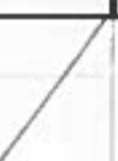
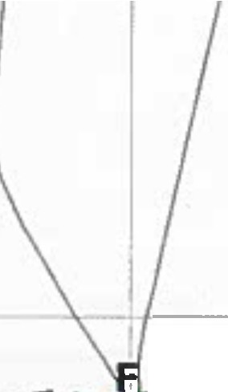
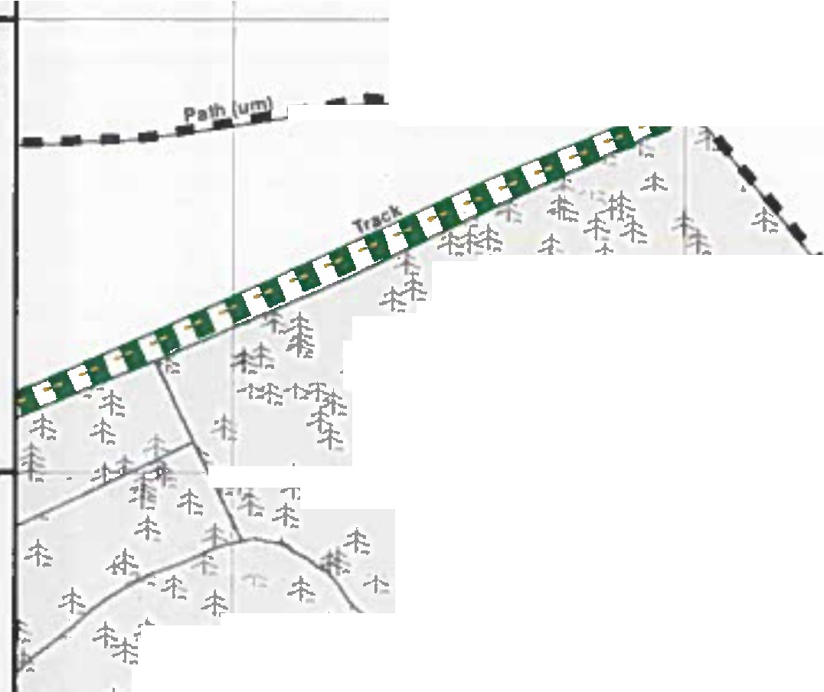
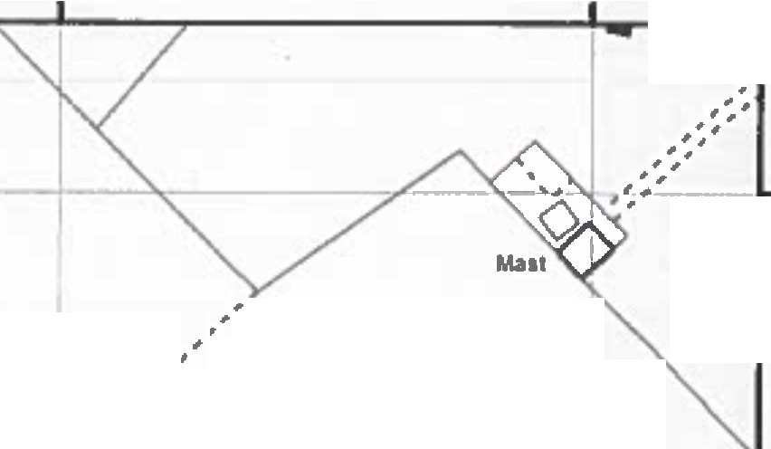

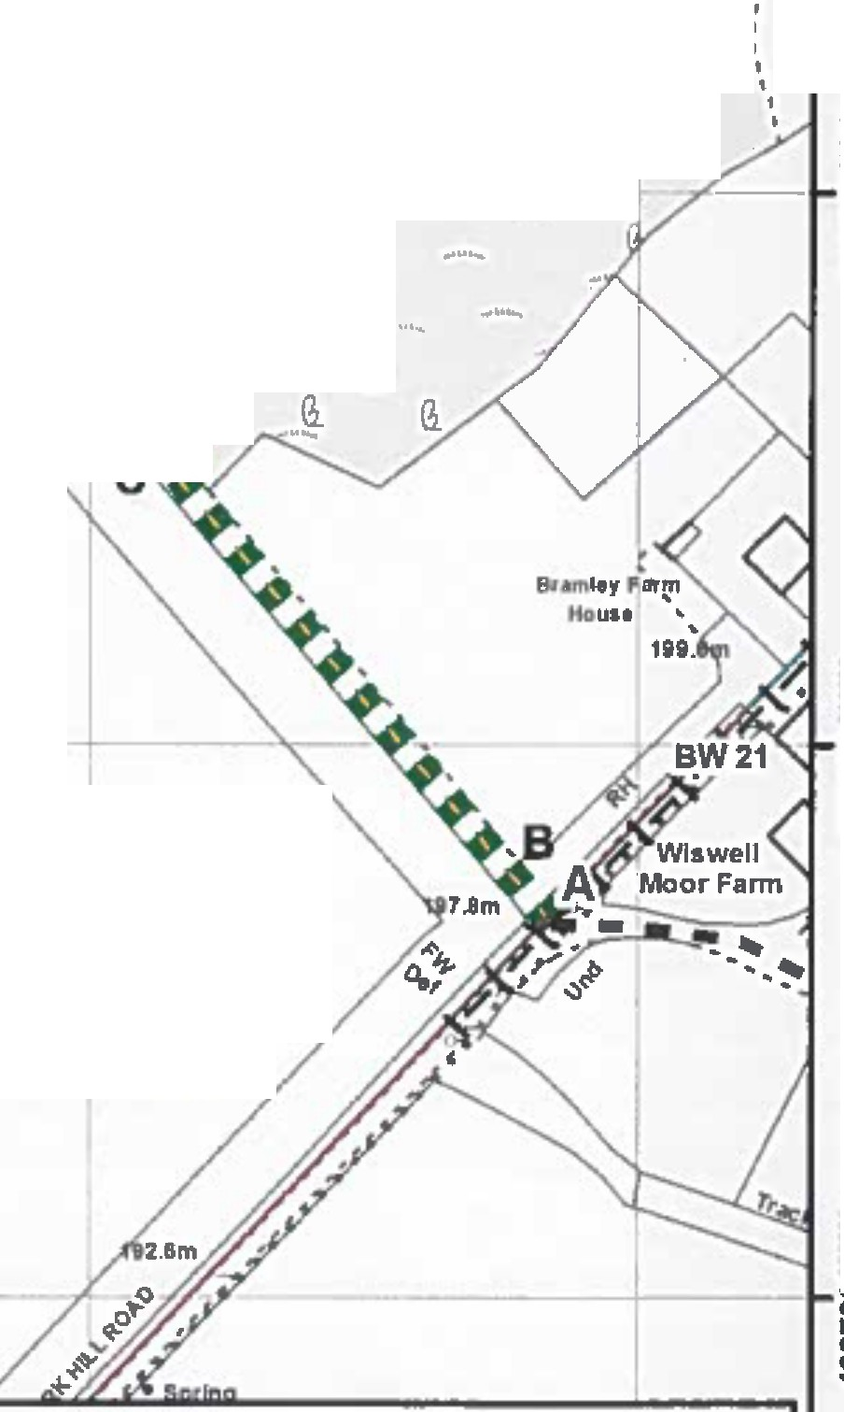

375100 375300 375400

L=anca.e | Andraw Mullanay  Head 11f Planning a Environment | wndllfe and Countryside Act 1981  Addition of restricted byway  from Public Bridleway 21Sabden (Clerk HIii Road) to Moor Lane, Wiswell | 1:2,000 | •  -$• -·
Tlol dlgltiNd Rlghls al WrJlnfonNllafl tllould be111td lor g,,icllnca onlJ11111■CNXY canllal be g...-ted.� al Wr, lnform■llotl mat bt ffllflecl an1111 currelll DtflnlM, ll■p bcl<n bft.g _...iled m .-.I br_,,piq,ose.
Thi,11,p II r■pl'Oducadfrom0rdftanca Sur,■y llllltrlal wlll Ult penm»bi af Ordn■- Surwy on btlulf ol lht cantrolllr ol H1rlhjestf• SlatlaMr/ Olllcs IC) c,-,C"""'9IL Plan 1/2
UnaullHlriNd n,produdlon lnlrlngn CIIIWII Copyrighl ■nd nYY llld to Ptoucullon mclvlt pn,tffdlngs. l.ancahn Counly Colllldl Uanu No..10002l320

l74700 • 374800 374900 375000

�.".. .. -- ........

g
.N...
I')
- I' 1
0. p···.
t" ••• i
.
....G,: ...... ---

.i,..

Q
.Q..
....
�
C
C
•
�..

Authorized Signatory
�
F
I
I
I
I �\y" J
..
I
::,Ir,
� I
� 'I
I I I
...
G.
r ...

G. , ,.
Spring• ..'
'•
•
I I
'
.
•
o.l
I

I,,..
''...
.
G.
G.

'.a..
�
i:
�.,
� '..,
G. '�, .. '"
��\ :
- "'fl,-,
�
,
�
.,..
g
*-* *- *
*-� -it * ¼ *-
'.lf:, � *- ,.
� 1.· ���
4:� - ��*-
::=-t- it *- 4:
·-. , I ?
  - , -·

40
I I I LJ
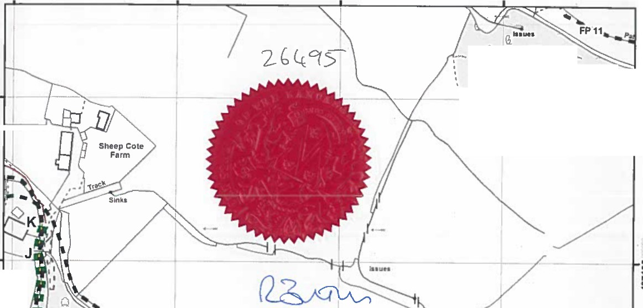
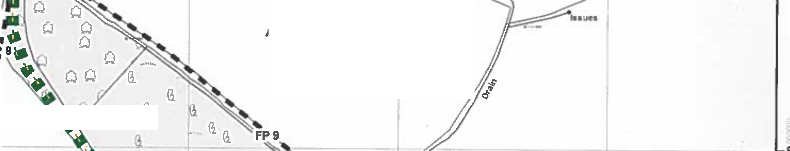
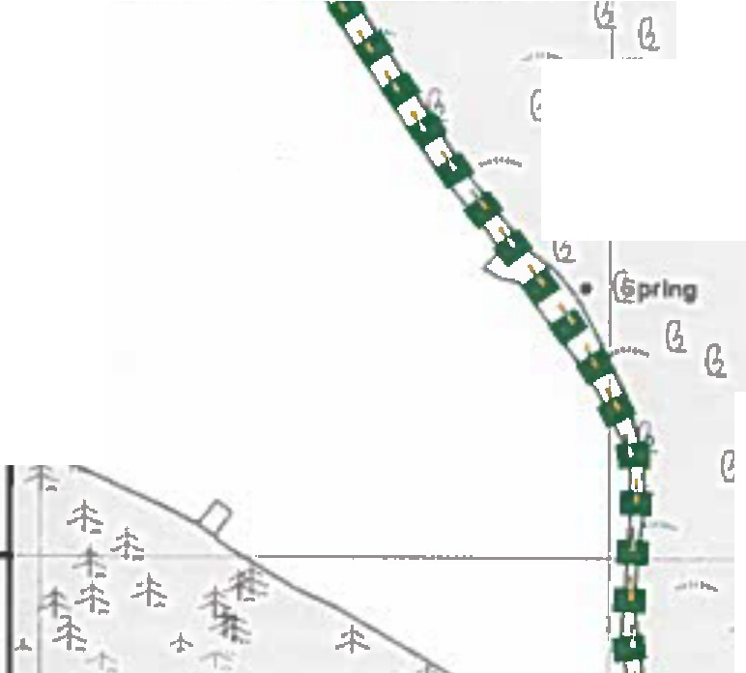
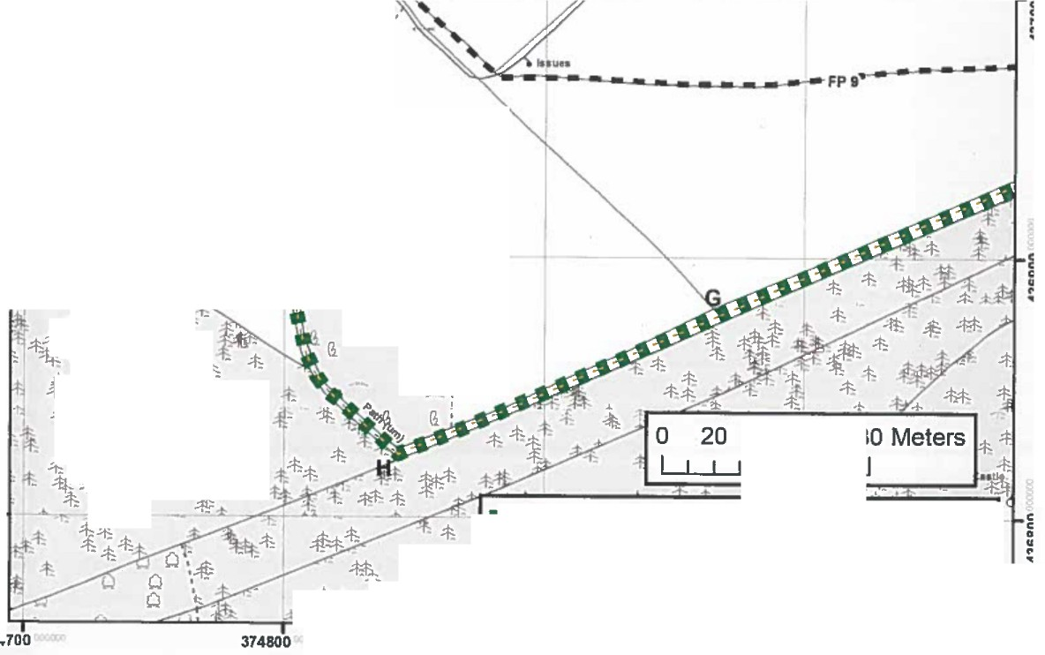
�, -�ff;-t*s-=
I
'
�
°""""' | AndrllW Mullaney  Hwad of Planning & Environment | vv1l<l'llfe ana countryside Act 1981  Addition of restricted byway  from Public Bridleway 21 Sabden (Clerk HIii Road) to Moor Lane, Wiswell | 1:2,000 | -♦� •  I
The digitis-ed Rights of Wa, lnlannltlon .._Id be UHd kit guldan� IIIIIJ H Ill acancy CMlnol be gunnleed. Rlghll ol Wa, lnlcnna!lon 1111111 be vorllled on the curffll1 0elinlllff !lap b■lan be-ig supplied or used for a, PIIIJIOH•
Thie Uap It rwplDduced lrom Dntnana lurver malllrill will!the pennlllilln al Ordnance lumy on behaW ol lhe conlnlller al Her Uljffty'1Slallonety Ollie■(CJC.- Con� Plan 2/2
UtwllariMdlWpCIICb:llon lnltlllgn c,_ Coprright 111d-, Ind lo l'nlHUl!iotl GI' cMI procetdagl. l.acalllre County Collncll� No.1DOCl2m0

·*-

    - --T:=
�*-�
_l:-',f!-1� t r_ .;t_

- • I I I Order Route Restricted Byway A-B-C-D-E-F-G-H-1-J-K
-t, I - - - Public Footpath

_±-t
4-;· If-I- Public Bridleway

37490D 375000

