NOTICE OF ORDER

Wildlife and Countryside Act 1981
Lancashire County Council

THE LANCASHIRE COUNTY COUNCIL (DEFINITIVE MAP MODIFICATION) (NO.
11) ORDER 2007

Notice is hereby given that the above referenced Order has been submitted to the Secretary of State for Environment, Food and Rural Affairs for determination. An Inspector will be appointed by the Secretary of State to determine the Order.
The start date for the above Order is 26 August 2025

Consideration of the Order will take the form of exchanges of statements of case and comments on statements of case.
The effect of the Order, if confirmed without modifications, will be to modify the Definitive Map and Statement of Public Rights of Way for Bamber Bridge in the Borough of South Ribble, County of Lancashire, by adding to the Definitive Map and Statement of Public Rights of Way a public footpath from a point at GR 5794 2504 on Kellet Lane, Bamber Bridge, immediately adjacent to Unit 429, Ranglet Road, running in a general north westerly direction for a distance of 52 metres to join Ranglet Road, Bamber Bridge at GR SD 5791 2508.
Any queries relating to this Order should be referred to Paul Scrivener by email: Paul.Scrivener@planninginspectorate.gov.uk quoting reference number ROW/3348617 on all correspondence. Alternatively, queries may be sent in writing to The Planning Inspectorate, Rights of Way Section, Room 3/A Eagle Wing, Temple Quay House, 2 The Square, Temple Quay, Bristol, BS1 6PN. Telephone: 0303 444 5000.
Any person wishing to view the statements of case and other documents relating to this Order may do so by appointment at County Hall, Fishergate, Preston, PR1 0LD, for further information please contact Simon Moore at simon.moore@lancashire.gov.uk or on 01772 531280. Documents have also been made available online. To access the documents, please use the following URL address: https://www.lancashire.gov.uk/council/transparency/dmmos/kellet-
lane-2007
Timetable for sending in statements of case and comments Within 2 weeks of the start date 9 September 2025
The Order Making Authority, or where the Order Making Authority is taking a neutral
stance and the applicant or other party are taking the case forward in support of the order, must ensure their statement of case is received by the Secretary of State. As soon as possible after the deadline, the Secretary of State will send a copy (excluding
copies of any supporting documents - these will be available to view at the Authority’s offices) to everyone who has made an objection or representation, the applicant and any other person who has written to us in respect of the Order.
Within 8 weeks of the start date 21 October 2025
Everyone who has made an objection or representation or any other written representation or any other person wishing to make representations in writing must ensure their statement of case is received by the Secretary of State. As soon as possible after the deadline, the Secretary of State will send full copies to the Authority. Copies (excluding copies of any supporting documents - these will be available to view at the Authority’s offices) will also be sent to the applicant, every person who has made an objection or representation and any other person who has written to us in respect of the Order.

Within the same period the applicant (if applicable) must ensure their statement of case is received by the Secretary of State. As soon as possible after the deadline, Secretary of State will send a full copy to the Authority. Copies will also be sent to everyone who has made an objection or representation and any other person who has written to us in respect of the Order (excluding copies of any supporting documents - these will be available to view at the Authority’s offices).

Within 14 weeks of the start date 2 December 2025
Everyone who has made an objection or representation, the Authority, the applicant (if applicable) and anyone who has written to us in respect of the Order must ensure that their comments on any or every other statement of case is received by the Secretary of State. As soon as possible after the deadline, the Secretary of State will send copies of these comments to everyone else.

In fairness to the other parties everyone should keep to the timetable to ensure that statements of case and comments are received on time. Late documents will be returned.
We cannot accept any inflammatory, discriminatory or abusive comments. Any documents containing such comments will be returned.

If you use Artificial Intelligence (AI) to create or alter any part of your documents, information or data, you should tell us that you have done this when you provide the material to us. See the detailed guidance for further information.

Notice of order for w/r


. .
"

WILDLIFE AND COUNTRYSfDE ACT 1981
THE LANCASHIRE COUNTY COUNCIL
(DEFINITIVE MAP AND STATEMENT OF PUBLIC RIGHTS OF WAY) (DEFINITfVE MAP MODfFICATIONl (NO. 11) ORDE�20Q7

This Order is made by the Lancashire County Council under Section 53(2)(b) of the Wildlife and Countryside Act, 1981 ("the Act'') because it appears to that Authority that the Definitive Map and Statement of Public Rights of Way for the County of Lancashire require modification in consequence of the occurrence of an event specified in Section 53(3)(c)(i) namely the discovery by the Surveying Authority of evidence which (when considered with all other relevant evidence available to them) shows that a right of way which is not shown in the map and statement subsists or is reasonably alleged to subsist over land in the area to which the map relates, being a right of way to which Part Ill of the Act applies, namely a public footpath.
The Authority have consulted with every local authority whose area includes the land to which the Order relates. The Lancashire County Council hereby order that:
- For the purposes of this Order, the "relevant date" is the 5th December 2007.
- The Definitive Map and Statement of Public Rights of Way for the County of Lancashire shall be modified as described in Part I and Part II of the Schedule and shown on the map attached to the Order.

- This Order shall take effect on the date it is confirmed and may be cited as the Lancashire County Council (Definitive Map and Statement of Public Rights of Way) (Definitive Map Modification) (No. 11) Order 2007.

Dated this 5th day of December 2007.

THE COMMON SEAL of the Lancashire County Council was hereunto affixed in the pursuance of a Resolution passed at a meeting of the Regulatory Committee
duly convened and held on the 10th October 2007

/�
Authorised Signatory



' .

SCHEDULE
PARTI
MODIFICATION OF THE DEFINITIVE MAP D_ESCRIPTION_OF FOOTPATH_ TO BE ADDED
Public Footpath 2 metres wide from a point on Kellet Lane, Bamber Bridge, immediately adjacent to Unit 429, Rang/et Road, running in a general north westerly direction for a distance of 52 metres to join Ranglet Road, Bamber Bridge, and shown as A- B on the attached plan.

PART II
MODIFICATION OF DEFINITIVE_SIATEMENT
The following entry be added:
'Public Footpath from a point at GR SD 5794 2504 on U10725 Kellet Lane, Bamber Bridge, Borough of South Ribble, passing through a metal giggle-gaggle and running in a general north westerly direction for a distance of 52 metres, the footpath being 2 metres wide for the whole of its length and running along a tarmac surface to join Ranglet Road, Bamber Bridge, Borough of South Ribble, at GR SD 5791 2508.'

.•1, ,1
..
..• .••'/
6 ' ..-··
357900C0<.100II 358000 cooooc
- ,.
.. •... •:,•···"'"r-o?> .,' '1••• �� ..r ••
.. .

::-..··:,•·t"' ,o• . I
, ..•,•,••• _..-
. ••
....
--::::::::::::-. \ \; ··: •••• ••••-••• ••--··••
·-:-. . •./ ••• •··
'\ •, •• '. •• •• ,• G� ••••
·-\-----··.�•.-.•.--••�• -- ••••.-_.·J..·._"'o:<'•"• "••" •• -·
', ·•.·, '.\,.. ••·...
-•••�•-- -.o·.p�,·•••-• -.
..·. •. . I ..•· ••••·.-··
·.·•. ·•.::.··1·.....- •
/.
'. ,' .
\ ....-•\'•
..
\',..
..,'.
..
I
',·
\\ •,
I ' I
'I..I
.
'.
I I
� � '.\
\ ', -.•,
''It
I I I I
Key:
Claimed route.• • • I
·�· ....
..:r··
.-. �--. ..
.·�
- .I
I I I I
........•· '•\, ',", •; ·,·•�--:.�� •,..
.
It... I I
I I I I
I I I I
11, I I
f ·... '. '.
\'. '1 ..
.. ._ '. \
j � t I I
.:,. ..._-::•-•••··•., .. I .. I•
.:.>·:::::.:·.:·:-� II '1.". •,\
... _/ \ E.I ··.'-. ';\
- I , I I I
,It• 11 \ •.,
I 0
--•-'_1.1, _

,-- . A--·· ,·:
"'•t .,.: :
•• • I ... I ,, •,•
\ '\ '-, ......·� •,,
. ', ·'
,•. .-::�•.-· !,
•.·
\ ,,• .. ,J#-Tt '-( \. t :,...,.;,j,V" �- •
•, • ..: • • • •
_.. • \'.. ',, -\ i \;\
.. -· ·:. \, \, t •• };,,.
..·�·1._· ...::• ..•••',•:
0. Harding B.Eng., C Eng.,
- ,.
,....
't. ....·.
.
'lldlile and Countryside Act 1
�c�:_.��7
FICE., FlHT. MCML
Environment Ol,.cu,r
Claimed public footpath from Kellet Lane lo Ringlet Road, Wallon•lt•Oale,
South Rlbble Borough Cou� 8041454,
1:1,250
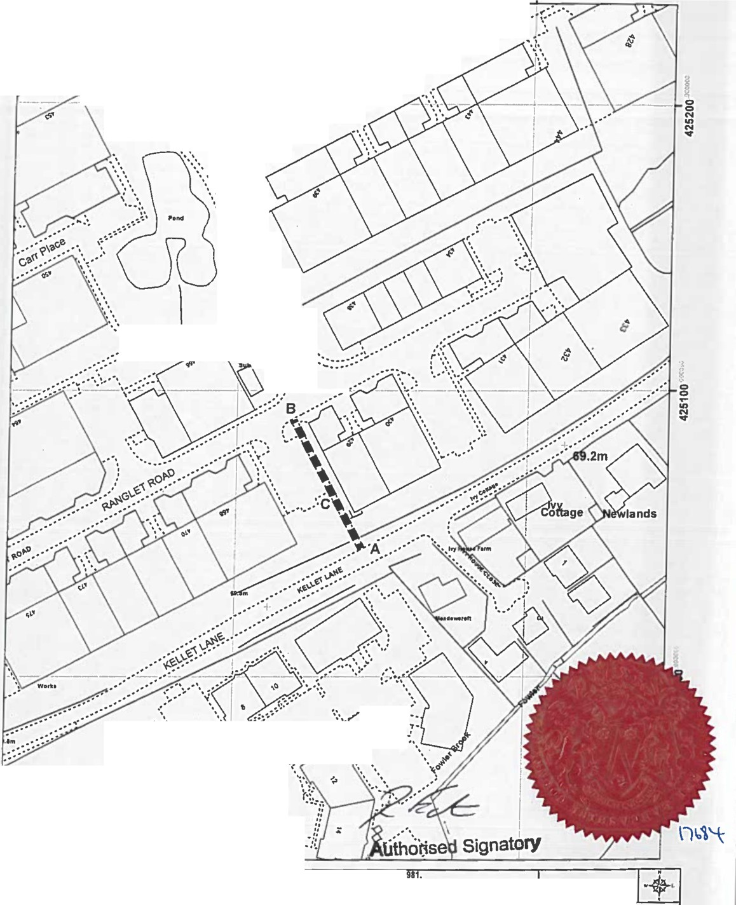
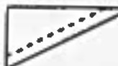

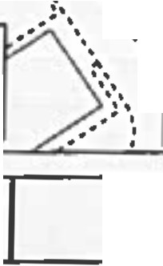
n,, dlgllud Al9h!1d Way lnloffllltloft ,llowd bo Ultd tor.,,c11... only •• b ,ccuncy CIMOl bo;uarllllood. Althll al w.,lri...,,.don ""''' ta nrllod.., .,,,....,.. 0,nn1... lllp btlort being •"""1td ., tor • ., pi.rpott.
Thl1.i.111op,vcl,c1d h..,Oldnanct S111Yaymalltd1Iwill!U,t ptnnlulon o/ Oldnanco SuMJ on behllt d dlt '°"trol,rol Htt llljnt)"t Slalloflll)' Olllct (C}C,- l:Gfl,rlghl
UnaudltdMd rtprodldon lnldn;t1c...,.. C.,,rl;hl ind mar Ind lo Pro11eulon or II.ti ,,,_ng1.Lanca1hl11co...i, Coundl Uconoo No. 100022129

