NOTICE OF ORDER
Wildlife and Countryside Act 1981
Lancashire County Council

THE LANCASHIRE CC (FOOTPATH FROM BLACKBURN ROAD TO NORMAN ROAD, OSWALDTWISTLE) DMMO 2023

Notice is hereby given that the above referenced Order has been submitted to the Secretary of State for Environment, Food and Rural Affairs for determination. An Inspector will be appointed by the Secretary of State to determine the Order.
The start date for the above Order is 2 September 2025.

Consideration of the Order will take the form of exchanges of statements of case and comments on statements of case.
The effect of the Order, if confirmed without modifications, will be to modify the Definitive Map and Statement of Public Rights of Way for the area, by recording footpath from a junction with Blackburn Road immediately to the east of West End Methodist Church, Oswaldtwistle running south between the eastern boundary of the Methodist Church and the rear boundaries of properties 372 Blackburn Road and 2 -
12 Norman Road for a distance of 30 metres before turning to continue in a more south easterly and then easterly direction to exit onto Norman Road north of 14 Norman Road.

The total length of the route is 0.06 km and the width is 3 metres.

Any queries relating to this Order should be referred to Paul Scrivener by email: paul.scrivener@planninginspectorate.gov.uk quoting reference number ROW/3347450 on all correspondence. Alternatively, queries may be sent in writing to The Planning Inspectorate, Rights of Way Section, Room 3/A Eagle Wing, Temple Quay House, 2 The Square, Temple Quay, Bristol, BS1 6PN. Telephone: 0303 444 5000.
Any person wishing to view the statements of case and other documents relating to this Order may do so by appointment at County Hall, Preston, PR1 0LD, for further information please contact Annabel Mayson at annabel.mayson@lancashire.gov.uk or on 01772 533244.

Documents have also been made available online. To access the documents, please use the following URL address:
https://www.lancashire.gov.uk/council/transparency/dmmos/norman-road-2023/
Timetable for sending in statements of case and comments Within 2 weeks of the start date by 16 September 2025
The Order Making Authority, or where the Order Making Authority is taking a neutral
stance and the applicant or other party are taking the case forward in support of the order, must ensure their statement of case is received by the Secretary of State. As
soon as possible after the deadline, the Secretary of State will send a copy (excluding copies of any supporting documents - these will be available to view at the Authority’s offices) to everyone who has made an objection or representation, the applicant and any other person who has written to us in respect of the Order.
Within 8 weeks of the start date by 28 October 2025
Everyone who has made an objection or representation or any other written representation or any other person wishing to make representations in writing must ensure their statement of case is received by the Secretary of State. As soon as possible after the deadline, the Secretary of State will send full copies to the Authority. Copies (excluding copies of any supporting documents - these will be available to view at the Authority’s offices) will also be sent to the applicant, every person who has made an objection or representation and any other person who has written to us in respect of the Order.

Within the same period the applicant (if applicable) must ensure their statement of case is received by the Secretary of State. As soon as possible after the deadline, Secretary of State will send a full copy to the Authority. Copies will also be sent to everyone who has made an objection or representation and any other person who has written to us in respect of the Order (excluding copies of any supporting documents - these will be available to view at the Authority’s offices).
Within 14 weeks of the start date by 9 December 2025
Everyone who has made an objection or representation, the Authority, the applicant (if applicable) and anyone who has written to us in respect of the Order must ensure that their comments on any or every other statement of case is received by the Secretary of State. As soon as possible after the deadline, the Secretary of State will send copies of these comments to everyone else.

In fairness to the other parties everyone should keep to the timetable to ensure that statements of case and comments are received on time. Late documents will be returned.

We cannot accept any inflammatory, discriminatory or abusive comments. Any documents containing such comments will be returned.

If you use Artificial Intelligence (AI) to create or alter any part of your documents, information or data, you should tell us that you have done this when you provide the material to us. See the detailed guidance for further information.

Notice of order for w/r
WILDLIFE AND COUNTRYSIDE ACT 1981

THE DEFINITIVE MAP AND STATEMENT OF PUBLIC RIGHTS OF WAY FOR THE COUNTY OF LANCASHIRE

THE LANCASHIRE COUNTY COUNCIL
FOOTPATH FROM BLACKBURN ROAD TO NORMAN ROAD, OSWALDTWISTLE DEFINITIVE MAP MODIFICATION ORDER 2023

This Order is made by Lancashire County Council ("the authority") under Section 53(2)(b) of the Wildlife and Countryside Act, 1981 ("the Act") because it appears to that authority that
- The Definitive Map and Statement of Public Rights of Way for the County of Lancashire require modification in consequence of the occurrence of an event specified in Section 53(3)(c)(i) namely the discovery by the surveying authority of evidence which (when considered with all other relevant evidence available to them) shows that a right of way which is not shown in the map and statement subsists or is reasonably alleged to subsist over land in the area to which the map relates, namely a footpath.
The authority have consulted with every local authority whose area includes the land to which the Order relates. Lancashire County Council hereby order that:

  - For the purposes of this Order, the "relevant date" is 12 July 2023.

  - The Definitive Map and Statement of Public Rights of Way for the County of Lancashire shall be modified as described in Part I and Part II of the Schedule and shown on the map attached to the Order.

  - This Order shall take effect on the date it is confirmed and may be cited as The Lancashire County Council Footpath from Blackbum Road to Norman Road, Oswaldtwistle Definitive Map Modification Order 2023.

Dated this 12th day of July 2023.

THE COMMON SEAL of the )
Lancashire County Council ) was hereunto affixed in the presence of )

Authorised Signatory

Authorized Signatory

SCHEDULE

PARTI

MODIFICATION OF THE DEFINITIVE MAP

DESCRIPTION OF PATH OR WAY TO BE ADDED

Footpath from a junction with Blackbum Road immediately to the east of West End Methodist Church, Oswaldtwistle (point A on the Order Map) running south between the eastern boundary of the Methodist Church and the rear boundaries of properties 372 Blackburn Road and 2 - 12 Norman Road for a distance of 30 metres before turning to continue in a more south easterly and then easterly direction to exit onto Norman Road north of 14 Norman Road (point B).

The route is shown on the Order Map between points A-B as a bold broken black line. The total length of the route is 0.06 km and the width is 3 metres

PART II

MODIFICATION OF DEFINITIVE STATEMENT

VARIATION OF PARTICULARS OF PATH OR WAY

The Statement to be added for Oswaldtwistle 308 to read as follows:

Oswaldtwistle 308:

No. of path: •30811

Kind of path: "Footpath11

Position:• Footpath from a junction with Blackburn Road immediately to the east of West End Methodist Church, Oswaldtwistle at Grid Reference SD 7314 2828 running south between the eastern boundary of West End Methodist Church and the rear boundaries of properties 372 Blackburn Road and 2 - 12 Norman Road for a distance of 30 metres before turning to continue for a further 30 metres in a more south easterly and then easterly direction to exit onto Norman Road north of 14 Norman Road at SD 7316 2824. All compass directions and distances given are approximate.•

Length: "0.06 km"

Other particulars: "None".
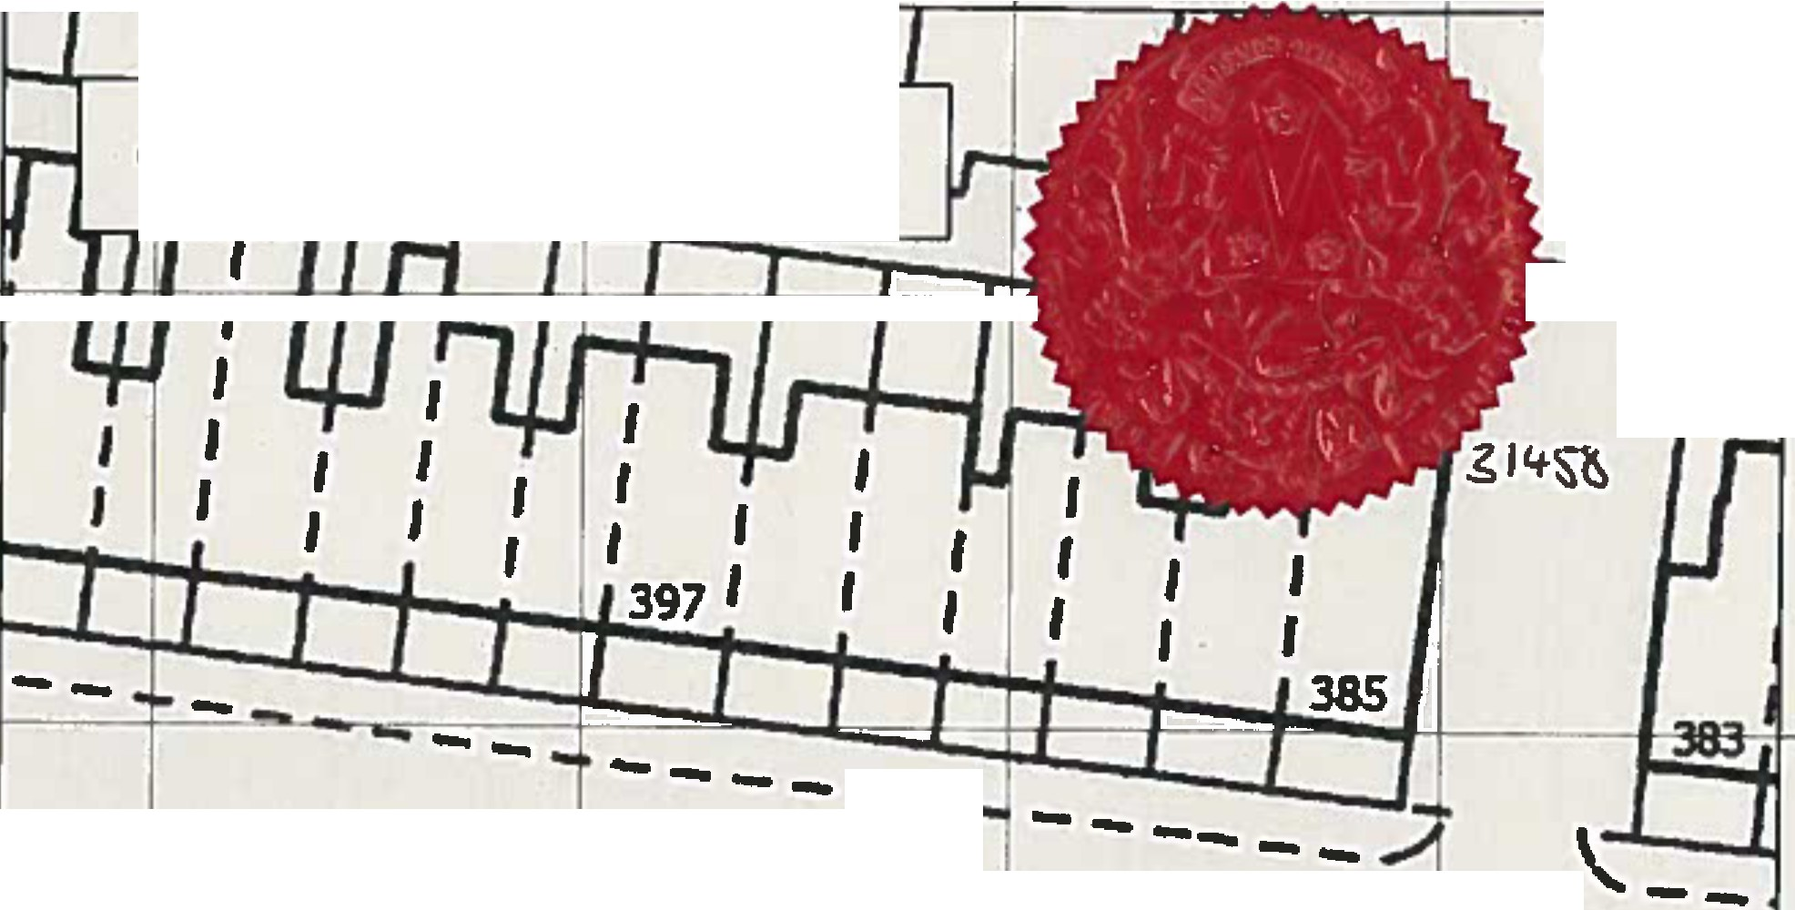
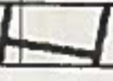
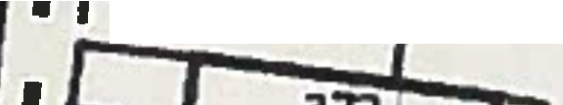
37312.0 3731•0 373160 3731B0
Authotiz

�inn�fOr'\

- • Order Route - Addition of Footpath A-B

428320 II • I � • I I I I I I f 1• I I '
�- �
42B32.0

428300 --
143,9m
- -,--- ---l: A_ -- - :,--, ,--, --
1

428300
,I, •- L _ ..- -.JI , ,
1
I

r_--:..:,.-=--=rr428280
,,.,.,I
�-T• ,Iii�..--•,•_ I
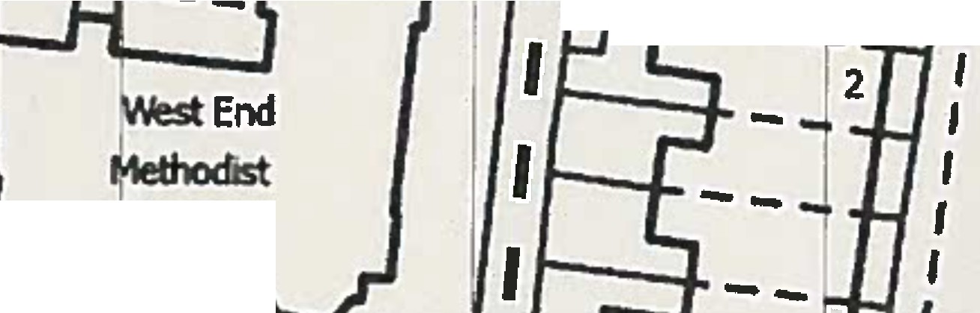
1 . 1 .

Church
I I I
'w---- ' I

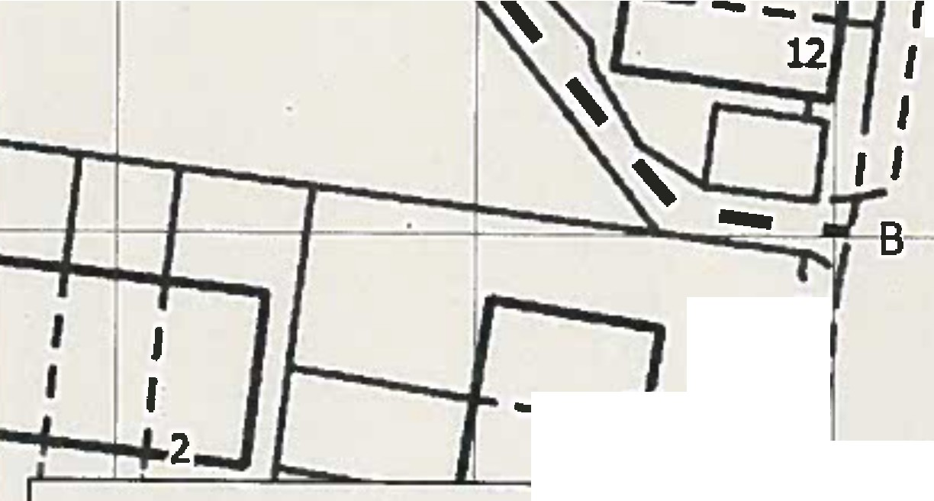
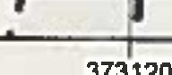
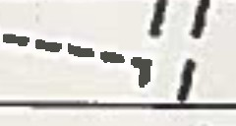
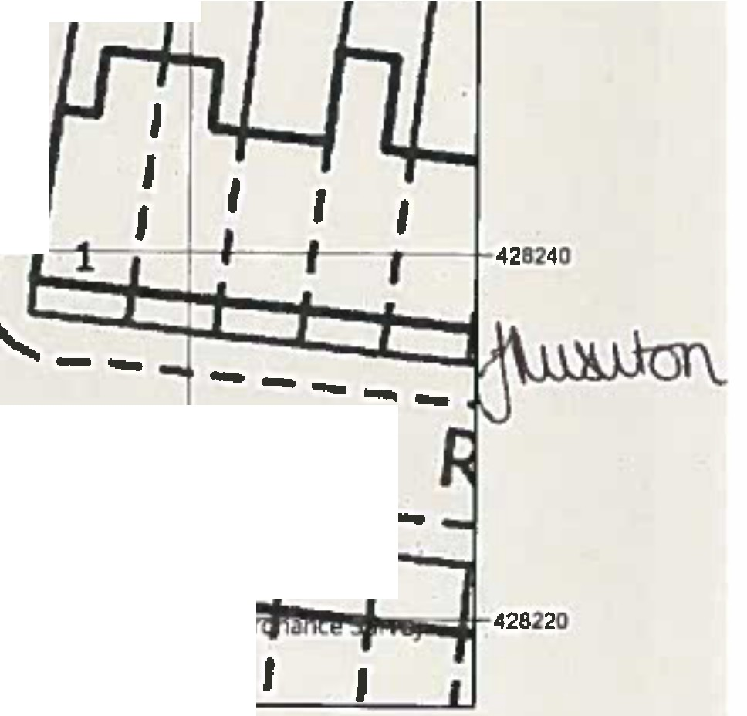
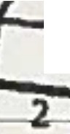
428240
I
I
'I
-
-
I I
.i1.:1'·,
.. l II I
I
0510
20 Meters
J
I I
I
---
I ,1
---

428220

373120 373140 373160 373180
�-
 | Public Rights of Way PROW@lancashlre.gov.uk 01n2 530311 | Wildlife and Countryside Act1981  Addition of Footpath from Blackbum Road lo Norman Road, OswaldtwisUe' | 1:500 | N  A
Th• dlglliud Rlghtl of Way lnlann&lian 1houkl bt uud I« guldanc1 only u III accuracy cannat INguarantnd.Rltllll afWay lnfonNlion must bnlflffld an111• eunnt Dtllnlllve 11111btlon bllng .. ppllld ar usod far any purpoM,
This llap 1, repraductd mmOnlnanc, Survey ffllllrial wllh lhe p11ml11lan olOnlnann Survey an blhaN atth,camrall• al Her IIIJ11ty'• SbtlonlfY 0fllc1(Cl Crown CopyrighL Unautl1orl1ed npraductlon Infringes c,- Copyright and may lead taPnHecutian °' civilpracffdlllgs. uncnhlrl County Council Uc1nc1No.100023320

