NOTICE OF ORDER
Wildlife and Countryside Act 1981
Lancashire County Council
Lancashire CC (Upgrading of Buckhurst Rd, Ramsbottom - Public Footpath to
Restricted Byway) DMMO 2015

Notice is hereby given that the above referenced Order has been submitted to the Secretary of State for Environment, Food and Rural Affairs for determination. An Inspector will be appointed by the Secretary of State to determine the Order.
The start date for the above Order is 19th August 2025.

Consideration of the Order will take the form of exchanges of statements of case and comments on statements of case.

The effect of the Order, if confirmed without modifications, will be to modify the Definitive Map and Statement of Public Rights of Way for the area, by upgrading Public Footpath 207 Ramsbottom (commonly known as Buckhurst Road) to a Restricted Byway from the junction with Bury Old Road shown at Point A1 on the Order Map (SD 8089 1548) running in a generally easterly direction past Ridshaw Farm and Buckhurst Farm to Public Bridleway 206 at Point F2 (SD 82007 1538) for a total distance of approximately 1.28 kilometres, as shown on the Order Map.
Any queries relating to this Order should be referred to Paul Scrivener by email: Paul.Scrivener@planninginspectorate.gov.uk quoting reference number ROW/3349093 on all correspondence. Alternatively, queries may be sent in writing to The Planning Inspectorate, Rights of Way Section, Room 3/A Eagle Wing, Temple Quay House, 2 The Square, Temple Quay, Bristol, BS1 6PN. Telephone: 0303 444 5000.
Any person wishing to view the statements of case and other documents relating to this Order may do so by appointment at County Hall, Fishergate, Preston, PR1 0LD. for further information please contact Simon Moore at simon.moore@lancashire.gov.uk or on 01772 531280. Documents have also been made available online. To access the documents, please use the following URL address: https://www.lancashire.gov.uk/council/transparency/dmmos/buckhurst- road-2015
Timetable for sending in statements of case and comments Within 2 weeks of the start date by 2nd September 2025
The Order Making Authority, or where the Order Making Authority is taking a neutral
stance and the applicant or other party are taking the case forward in support of the order, must ensure their statement of case is received by the Secretary of State. As soon as possible after the deadline, the Secretary of State will send a copy (excluding copies of any supporting documents - these will be available to view at the Authority’s offices) to everyone who has made an objection or representation, the applicant and any other person who has written to us in respect of the Order.

Within 8 weeks of the start date by 14th October 2025
Everyone who has made an objection or representation or any other written representation or any other person wishing to make representations in writing must ensure their statement of case is received by the Secretary of State. As soon as possible after the deadline, the Secretary of State will send full copies to the Authority. Copies (excluding copies of any supporting documents - these will be available to view at the Authority’s offices) will also be sent to the applicant, every person who has made an objection or representation and any other person who has written to us in respect of the Order.

Within the same period the applicant (if applicable) must ensure their statement of case is received by the Secretary of State. As soon as possible after the deadline, Secretary of State will send a full copy to the Authority. Copies will also be sent to everyone who has made an objection or representation and any other person who has written to us in respect of the Order (excluding copies of any supporting documents - these will be available to view at the Authority’s offices).

Within 14 weeks of the start date by 25th November 2025
Everyone who has made an objection or representation, the Authority, the applicant (if applicable) and anyone who has written to us in respect of the Order must ensure that their comments on any or every other statement of case is received by the Secretary of State. As soon as possible after the deadline, the Secretary of State will send copies of these comments to everyone else.

In fairness to the other parties everyone should keep to the timetable to ensure that statements of case and comments are received on time. Late documents will be returned.
We cannot accept any inflammatory, discriminatory or abusive comments. Any documents containing such comments will be returned.
If you use Artificial Intelligence (AI) to create or alter any part of your documents, information or data, you should tell us that you have done this when you provide the material to us. See the detailed guidance for further information.

Notice of order for w/r

WILDLIFE AND COUNTRYSIDE ACT 1981

THE DEFINITIVE MAP AND STATEMENT OF PUBLIC RIGHTS OF WAY FOR THE COUNTY OF LANCASHIRE

THE LANCASHIRE COUNTY COUNCIL (UPGRADING OF BUCKHURST ROAD, RAMSBOTTOM FROM PUBLIC FOOTPATHTO RESTRICTED BYWAY) DEFINITIVE MAP MODIFICATION ORDER 2015

This Order is made by Lancashire County Council f'the Authority•) under Section 53(2)(b) of the Wildlife and Countryside Act, 1981 ("the Act'') because it appears to that Authority that The Definitive Map and Statement of Public Rights of Way for the County of Lancashire require modification in consequence of the occurrence of an event specified in Section 53(3)(c)(ii) namely the discovery by the Surveying Authority of evidence which (when considered with all other relevant evidence available to them) shows that a highway shown in the map and statement as a highway of a particular description, namely a public footpath ought to be there shown as a highway of a different description, namely a restricted byway.
The Authority have consulted with every local authority whose area includes the land to which the Order relates. Lancashire County Council hereby order that:

- For the purposes of this Order, the "relevant date" is 22nd July 2015.
- The Definitive Map and Statement of Public Rights of Way for the County of Lancashire shall be modified as described in Part I and Part II of the Schedule and shown on the map attached to the Order.

- This Order shall take effect on the date it is confirmed and may be cited as The Lancashire County Council (Upgrading of Buckhurst Road, Ramsbottom from Public Footpath to Restricted Byway) Definitive Map Modification Order 2015.

Dated this 22nd day of July 2015.

THE COMMON SEAL of the )
Lancashire County Council ) was hereunto affixed in the presence of )
r
Authorisegnatory

24.W

;.

§CHEQULE
PARTI
MODIFICATION OF THE_ OEEINITIVE MAP

DESCRIPTION OF PATH OR WAY TO BE UPGRADED
Public Footpath Ramsbottom 207 (commonly known as Buckhurst faoad) to be ypgraded to a restricted byway from the junction with Bury Old Road at point A1 on Order M�p 1 running ih a.generally easterly direction past Ridshaw,Farm and Buckhutst Farm to P.ublic
Bridleway Ramsbottom 206 (commonly known as Croston Close Road) fat point F2 on
Order Map 2; a total distance of approximately �.28 kilometres and at @ width varying between 3 and 6 metres.
PAF.Uf II

MODIFICAffil@N 0F 0EF-INITIVE STATEMENT VARIATION OF PARTICULARS OF eAmhf@F.LWAY
The statements to be amended for Ramsbottom 207, 208,222,223, 226 andf227)to read
as follows:

Ramsbottom 207:

No. of path: "20711

Kind of path: "Restricted Byway"
f?osition: MRestricteq byway commencing from a point on Byry @ml Road (X6178) at SD ·8089 1548 and running in a generally east north easterly direction aJong a rough tarmac track past a junction with Footpaths 227 at SD[8Q9:8l1550 and 222 �t SD 81121�53,and past Ridshaw!Farmto SD 81211555 atthe1junction with Footpath 2_23.
The restricted !byway then continues in li.generally east south eas!_erly direction along a
grass track,bounded on the southern side,lby a stone wall to SD 8147 1551 where it meets
footpath 226. It then continues along a grass and compacted earth track bounded on the southern side for the full length and on th,enorthern side by the broken remains of a wall to the junction with the nonftern end of Salas's L�ne (F-ootpath 208) at SD 8191 ;1538. It then passes through Buckhurst Farm to continue in an easterly direction past Buckhurst.ilodge (formerly Buckhurst National School) to terminate at the junction with Bridleway 206 (Croston Close Road) at SD 8207 1538.H

Length: "1.28km"

Other particulars: "Width: Varies 1between 3 and 6 metres as shown (ofillOrdnance Survey 25 inch sh� 80.13 surveyed 1891 ijnq published 1893. Limitations and conditions: Field gate S@.809.w1550."

Ramsbottom 208:

No. of Path: 1120811
Kind of path: "Footpath11
Position: •Bury Boundary (Bentley Lane) north-eastwards across path No. Restricted Byway 207 (Buckhurst Road) at SD 8191 1538. (Salas's Lane).'' | 232 | to
Length: "0.75 miles•
Ramsbottom 222:
No. of path: "222"
Kind of path: "Footpath•
Position: "Bury Old Road (Lane Head) eastwards to Restricted Byway | 207 | at
SD 81121553."
Length: "0.17 miles"
Ramsbottom 223:
No. of path: 11223•
Kind of path: 11Footpath11
Position: "Restricted Bridleway 207 at SD 8121 1555 northwards to path No. 220."
Length: "0.32 miles•
Ramsbottom 226:
No. of path: "226"
Kind of path: 11Footpath11

Position: "Restricted Byway 207 at SD 8147 1551 southwards and westwards to Bury Boundary.•

Length: •o.36 miles"

Ramsbottom 227:

No. of path: "22711

Kind of path: "Footpath"

Position: "Bury Boundary northwards to Restricted Byway 207 at SD 8098 1550." Length: "0.09 miles"

and the Statement for Ramsbottom Bridleway 206 as modified by the Lancashire County Council (Definitive Map and Statement of Public Rights of Way)(Definitive Map Modification)(No. 4) Order 2002 be further amended as follows:
In paragraph 16 of the 11Position11 after 11Continuing south, still on a 3-4 metre wide roughly surfaced track, the route approaches a small reservoir to the east. To the west/ replace "Public Footpath No. 207• with 11Aestricted Byway 207 at SD 8207 1538.11

]8QIOO »0900 l81000

311100
.,. 311300 31«80 311500

...3.11600 Hf700

8
:,i

75 150
1

300 Meters
J

�:.,...
..............

....
..
-
I..
;

Footpath to be upgraded to Restricted Byway
....4.,. !"t!":�.
-�� �- ·.i.:"'=�
··•)i,.i... - -�- ·>t:,►.,,._
....

1-1-1- Public Bridleway
Public Footpath
e
;
···-�:lt::o!';�- --.:�Jr.

•e

.I.

.x.

..... _
..,,·····-·.-........
:

E1•
F•■-ui;ltluretllfow
I...

- ​::.�I..
--
;

.�.,

-- _, ;--

- ... ._;--. ;r-i

FP226
·:::•.:-. =
·•:::::::�
� ··:·-•,.:=:::
--.......-:::·---�-=..:":N:.:. .. :-:
8 ----- • -�•.�•.W'-«••--W.,,...1"'•.-"""""•W'•'ft"•':'l:!f:ff:"•,. ..,. ...... I
� I /t---.._ '\.:� - .. ��
FP226 � •-
�.

I\
...

.I.
r �\

s.. ,.Htl
\,
:�
S�

J!:1
�

(2)

V.

- I...
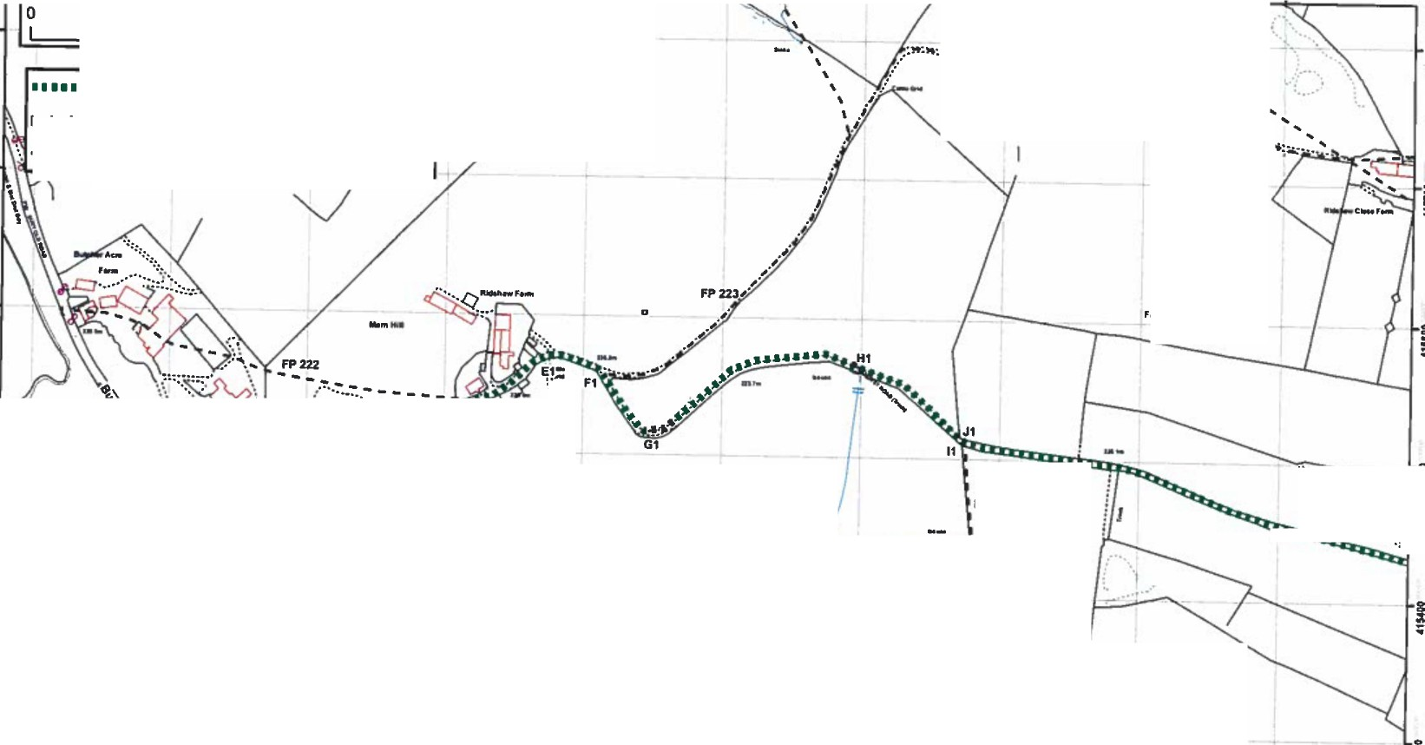
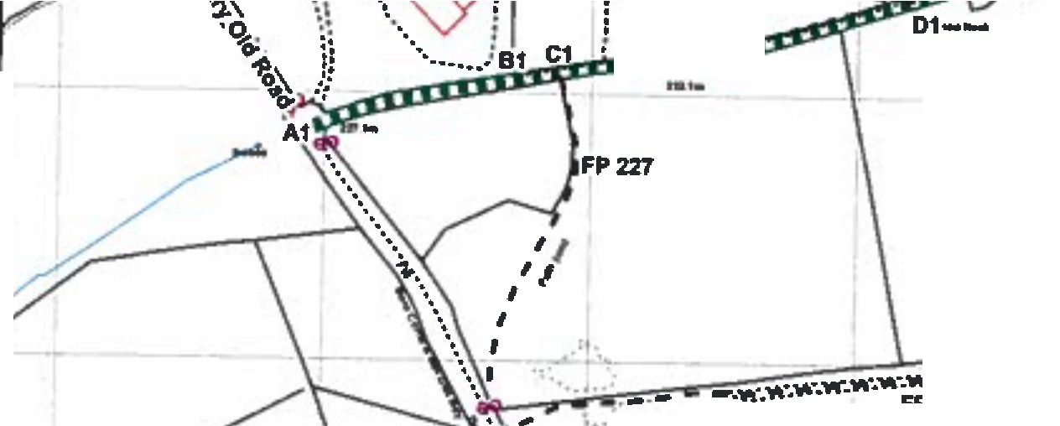
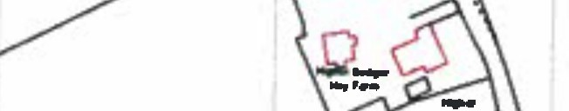
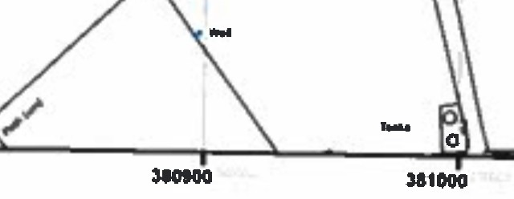
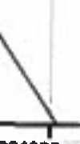
n,, dlvlliHcl Rlghta of Way lnfomlallon should be tned torguidance only a 119 ace11...cy cannac b• guaranlNcl. lllghta ol Way lnlofflllUon must 1111werlli■d on th■ cu,..nl Oellnlllwe Map belore being suppli.d o, uaed lar eny pu,pose.
n,19 Map Is ,.produced from Ordnance Burwey materiel wllh Iha permhMICI ol Ordnenc• Surrey on beh.. ol lhe contJoller of Htr Ma)Nly's si.tlontf)' Olllce IC) Cmwn Capyriglll. UneuthorlalJd rep,oductlon lnlringes C,own Copyright a,ct mar l•ad lo PNINCutlon or clvl promedlnga. unushlre COW1ty Coundl Licence No.1000UJZO
I)
Plan 112
FIie 804-540
lor"" En•-··
1:2500
I
Wlldtlf, and Countryalde Act 1981
Upgrading of Ramsbottom Footpath 207 lo Rntrlcled Byway from Bury Old Road lo Ramsbotton Bridleway 206, Rassendale
Jolultol
Eucilllwe Onclot
�-l

JIOIOII � 311000 ll1100 ll1200 311,00 )11400 311SOI 31,eoo 311700
2....44- 2- s

�-
orized Si�Jnatory
.;.
311200 31UOO 31UOO 311500 311&ao :181700 llllUOO Jl1100 312900 312100
�..

.I.

......
..
1:

� �
FP2236
D ;,"
�,I,

;, �

Fa, l.cWlutet Bnl•

..
• '\•�:��---�-:-·-
........

. ,_

I
:;
..

,-;-.. ...... .............
_.'.1\\..
:; =�
H
��
1 �
..
:i
�i
\,\,
.-. --
..
g�.,...'P.'t.'!'.'·".'.�. -.....-..............\.,A·..-·.,,,.-,NO.._,,.._... ,_..
: ...

•:::::,,,::,,::�
� '•:::..
·�:::=:::
l!::J :.. ... •

-.. :;
I

:;
!

£)
I IJ-_ s0
:; � ..
  - ■1 u Footpath to be upgraded to Restricted Byway
'I
1-1-1- Public Bridleway �
Public Footpath
g
::
:;:
:; b
0

75 150 300 Meters
-1-
r'/
g
:;t
:.
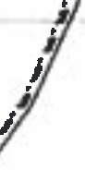
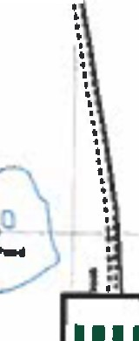
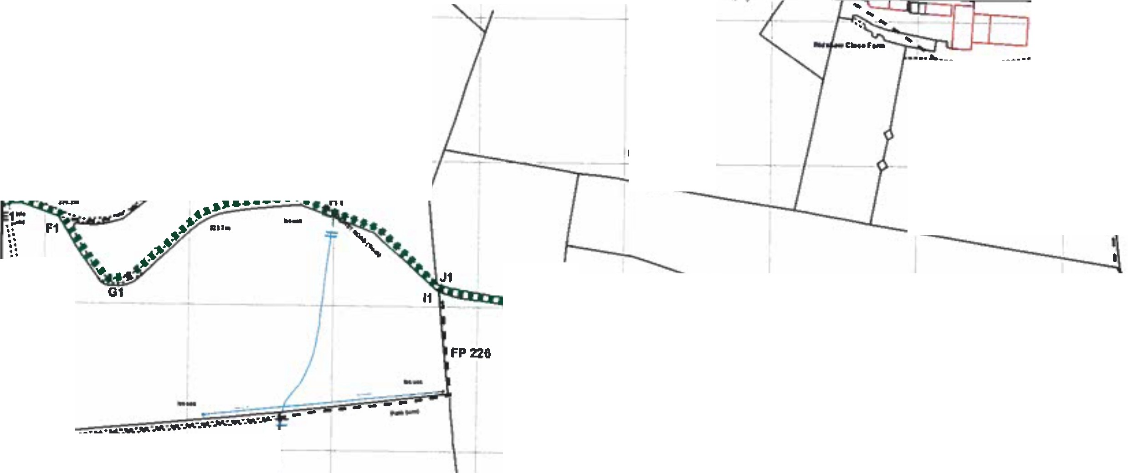

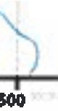
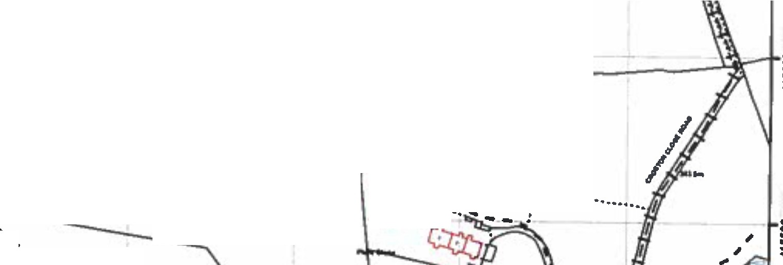

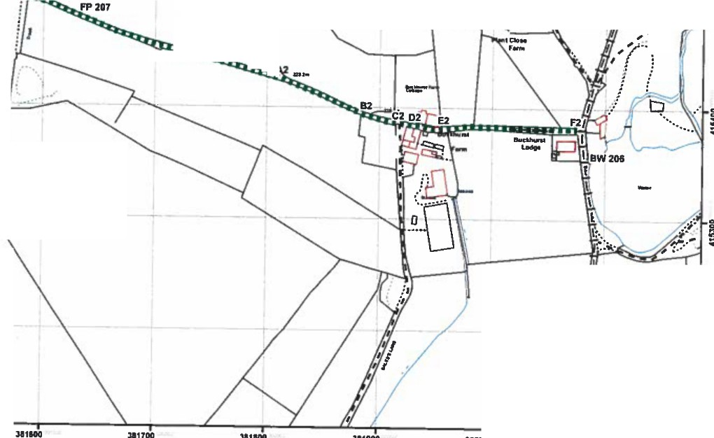
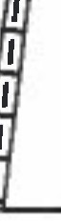
I I
Th■dl91tlsed Rights c,f W•y lnfllnnatlo11 ■llould be uHd for guidance only • Ila accu,acy eannoc be a,,■nalffd. Rights ol way lnfc,nudon must be v■rllled an th■cumnt Definitive llap before being■uppli.d o, used for any purpose.
TIiis llap Is reproduced lrom On:tnanc■Sur,")' mateflal illtlh Ille permlulon of On:lnanc■Sur,■y on -■If of the conttoller of Her llajnly'■SUllonery Olllce CCI C,own Copr,tghL Unauthorl■ed t■producllan lnfrlnoe■ CIOWR Copyrlvhe
- .. .,,P-ullonOfchi�ng■. unca1hlre Caunty Council UcllflCa No. 10002l3ZD
31121G
�l
JoTuoton1
Eaecullve Director
kK lh■Eavi.-on-111
FIie 804-540
I
Platl 2/2
Ll

,.
,.,_ ,.,_
111500
Jl11GO
311700
311800
U1900
ll:rotKI
312100
WIidiife and Counbylldcl Act 1981
Upgrading of Ramsbottom Foolpath 207 to Rntrlcled Byway from Bury Old Road lo Ramsbotton Brldi.way 206, Rossendate
1:2500






